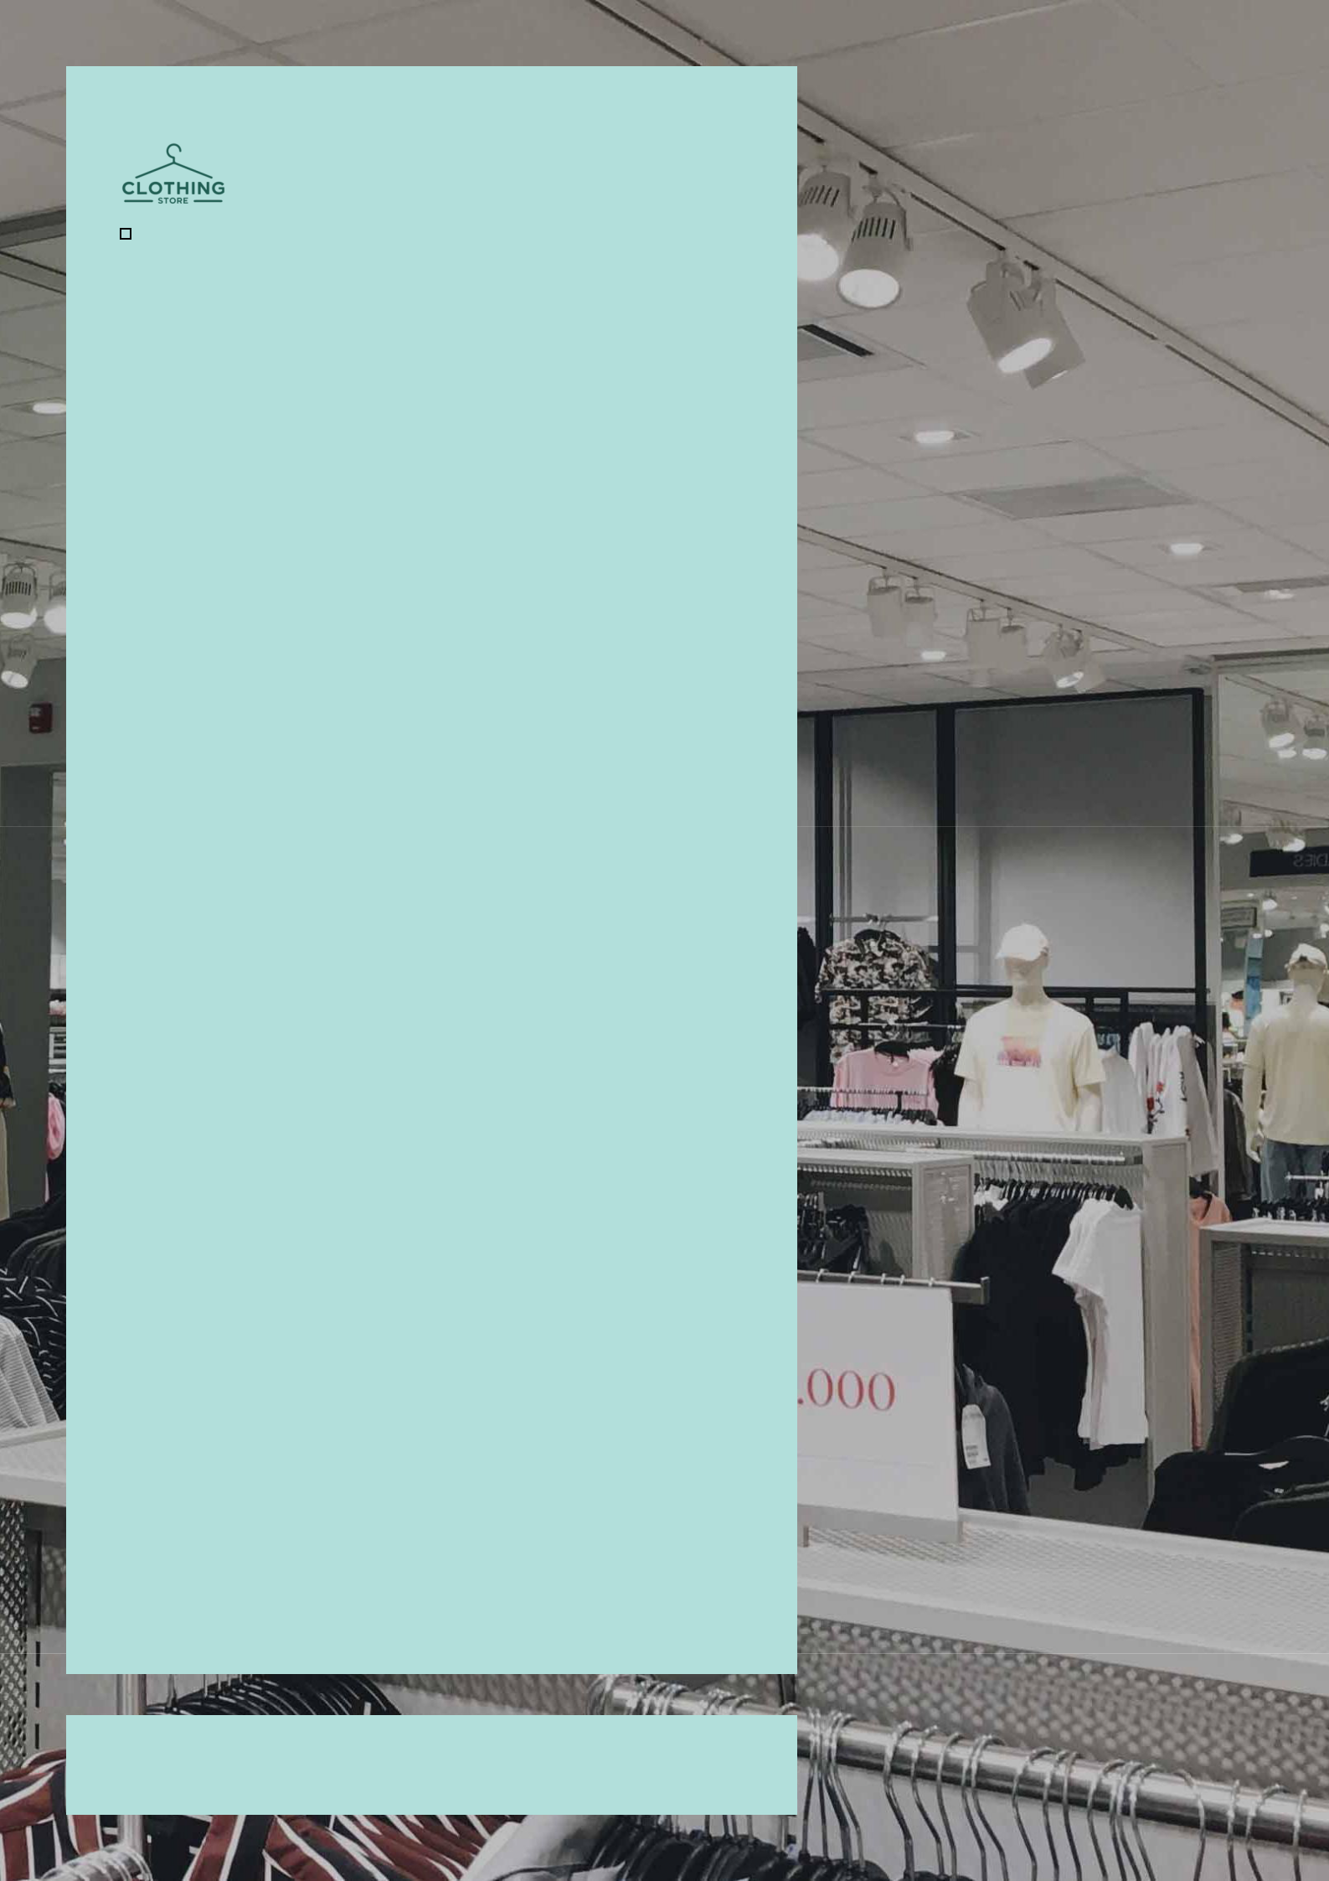

Clothing Store Business Plan

Elevate Your Wardrobe, Elevate Yourself

Business

Plan

2023

John Doe

10200 Bolsa Ave, Westminster, CA, 92683

- 359-3153 info@example.com http://www.example.com

CONFIDENTIAL

Table of Contents

Executive Summary | 6
Market opportunity | 6
Services Offered | 6
Management team | 7
John Doe | 7
Alice Brown | 7
Robert Brown | 7
Financial Highlights | 8
Units Sold v/s Revenue | 8

Company Overview | 9
Ownership | 9
Business Owners | 9
Mission statement | 10
Business history | 10
Future goals | 10

Market Analysis | 11
Target Market | 11
Market size and growth potential | 11
Market Size | 12
Competitive analysis | 12
The Trendsetter | 12
The Vintage Maven | 13
The Eco-Fashionista | 13
Market trends | 13
Regulatory environment | 14

Products and Services | 15
Products | 15

Men's Casual Shirt 15

Women's A-line Dress | 16
Kids Denim Jacket | 16
Luxury Silk Scarf | 17
Clothing Customization Service | 17
Online Delivery Service | 17
Inventory Management | 18

Sales And Marketing Strategies | 19
Unique Selling Proposition (USP) | 19
Pricing Strategy | 19
Marketing strategies | 20
Online | 20
Offline | 20
Sales strategies | 21
Customer retention | 21

Operations Plan | 22
Hiring Plan | 22
Operational Process | 22
Software & Technology | 23

Management Team | 24
Key managers | 24
John Doe | 24
Jane Doe | 25
Alice Brown | 25
Robert Brown | 25
Organizational structure | 26
Organization chart | 26
Compensation plan | 26
Board of advisors | 27
[ADVISOR NAME] | 27
[ADVISOR NAME] | 27
Financial Plan | 28
Profit & loss statement | 28
Cash flow statement | 31
Balance sheet | 33
Break-even Analysis | 35
Financing needs | 37
Appendix
Appendix | 39
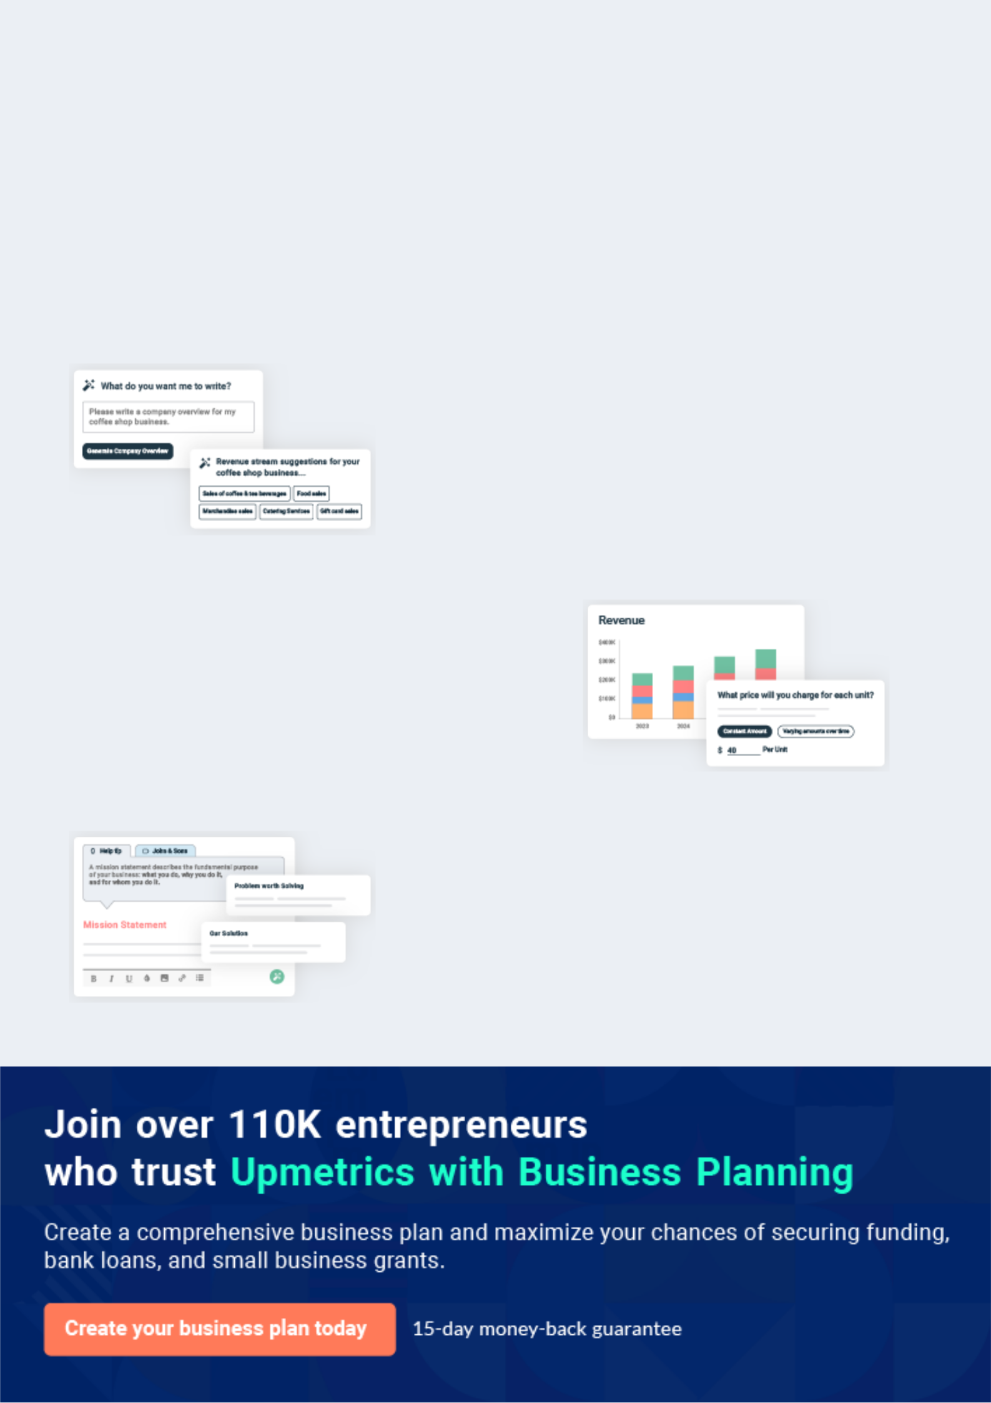
Business planning that’s simpler and faster than you think

Creating a business plan using Upmetrics to start and grow a business is literally the easiest thing in the World. Simply read the instructions and fill in the blanks. It’s as simple as that.

❛ | Upmetrics has everything you need to create a | ❜
❛ | comprehensive business plan. | ❜

AI-powered Upmetrics Assistant

AI-powered insights to streamline your plan

Not sure where to start? Upmetrics’ AI Assistant will automatically generate ideas for each section of your plan and offer improved versions of your writing, adjusting for tone, voice, and grammar or spelling errors.

Financial Forecasting Tool

All the financials are calculated for you

Forget the complex formulas and clumsy spreadsheets — with automatic financials and drag-and-drop forecasting, you can finish your plan faster and be confident that your numbers are accurate.

Business Plan Builder

Guides you like a business mentor

Upmetrics’ step-by-step instructions, prompts, and the library of 400+ sample business plans will guide you through each section of your plan as a business mentor.
Executive Summary


An executive summary is the first section of the business plan intended to provide an overview of the whole business plan.
To unlock help try Upmetrics! 

 Help tip  Clothing Store Business Plan


Start your executive summary by introducing your idea behind starting a clothing store and explaining what it does.
To unlock help try Upmetrics! 

Start writing here..

Market opportunity

 Help tip  Clothing Store Business Plan

Describe the target market in brief, and explain the demographics, geographic location, and psychographic attributes of your customer.
To unlock help try Upmetrics! 

Start writing here..

Services Offered

 Help tip  Clothing Store Business Plan

Concisely describe what products or services a customer can expect from your clothing store.

Also, Incorporate brief information mentioning the quality measures you implement, keeping
To unlock help try Upmetrics! 

Start writing here..

 Help tip


Name all the key members of your management team with their duties, responsibilities, and qualifications.
To unlock help try Upmetrics! 

Management team


JOHN DOE

CEO - john.doe@example.com

The visionary behind "[Fashion Forward]" is [John Doe], acting as the [CEO and Head Curator]. Assisting him in strategic decisions is [Jane Doe], the [COO], with a background in [retail operations and logistics]


ALICE BROWN

CFO - alice.brown@example.com

The finance sector is helmed by [Alice Brown], our [CFO], who brings with her vast experience in [retail financial management].


ROBERT BROWN

CMO - robert.brown@example.com

Our marketing efforts are spearheaded by [Robert Brown], the [CMO], whose creative strategies have been instrumental in [defining brand identities for numerous fashion brands].
Financial Highlights

 Help tip  Clothing Store Business Plan

Provide a summary of your financial projections for the store’s initial years of operation. Include capital or investment requirements, startup costs, projected revenues, and profits.
To unlock help try Upmetrics! 

Start writing here..

Units Sold v/s Revenue

 |  | Units Sold | Revenue
15.00k
10.00k
5.00k
0
Year 1 | Year 2 | Year 3
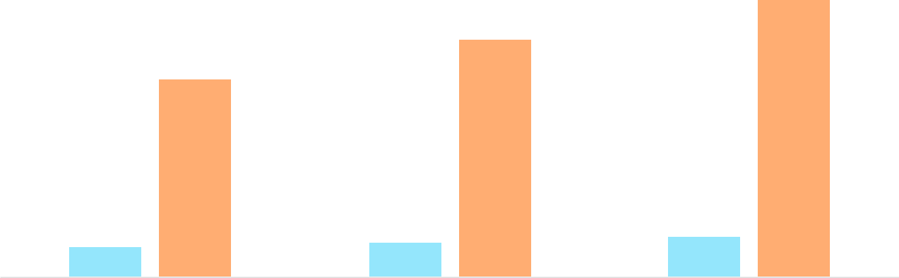

Financial Year |  |  | Units Sold | Revenue
Year 1 | 1,550 |  |  | $10,000
Year 2 | 1,800 |  |  | $12,000
Year 3 | 2,050 |  |  | $14,000
 Help tip |  |  Clothing Store Business Plan


After briefly explaining your business plan, end your summary with a call to action, inviting potential investors or readers to the next meeting if they are interested in your business.
To unlock help try Upmetrics! 

Write a call to action for your business plan.

Company Overview

Depending on what details of your business are essential, you’ll need different elements in your business overview.
To unlock help try Upmetrics! 

 Help tip  Clothing Store Business Plan

Provide all the basic information about your business in this section like:

• The name and type of your clothing business: mention whether you are a retail business,
To unlock help try Upmetrics! 

Start writing here..

Ownership

 Help tip  Clothing Store Business Plan

Describe the owners of your business and mention their roles in running it. Who owns what shares, and how each owner helps in the business?
To unlock help try Upmetrics! 

Start writing here..

Business Owners



60% John Doe



40% Jane Doe
Mission statement
To unlock help try Upmetrics!

 Help tip  Clothing Store Business Plan

Add a mission statement summarizing your clothing business’s objectives and core principles.

This statement needs to be memorable, clear, and brief.
To unlock help try Upmetrics! 

❛ At [Fashion Forward], we aspire to elevate everyday fashion, merging the timeless with the contemporary, ensuring every
individual finds their unique style narrative.
❜

Business history

 Help tip  Clothing Store Business Plan

Include an outline of your clothing store’s history and how it came to be in its current position.

If you can, add some personality and intriguing details, especially if you got any achievements
To unlock help try Upmetrics! 

Start writing here..

Future goals

 Help tip  Clothing Store Business Plan

It’s crucial to convey your aspirations and your vision. Include the vision of where you see your business in the near future and if you plan on scaling or expanding your business to another city or state.



Start writing here..

Market Analysis


 |  | Market analysis provides a clear understanding of the market in which your
 |  | printing business will run along with the target market, competitors, and
 |  | growth opportunities.
 |  |  |  | To unlock help try Upmetrics! 
 Help tip |  |  Clothing Store Business Plan

To write the introduction section of your market analysis, start by clearly identifying your primary target market.
To unlock help try Upmetrics! 

Start writing here..

Target Market

 Help tip  Clothing Store Business Plan

Identify your target market and define your ideal customer. Know more about your ideal customer and what services they prefer: luxury clothing, vintage clothing, women’s clothing, etc.
To unlock help try Upmetrics! 

Start writing here..

Market size and growth potential

 Help tip  Clothing Store Business Plan

Provide an overview of the clothing industry. It will include market size, trends, growth potential, and regulatory considerations.
To unlock help try Upmetrics! 

Start writing here..

Market Size

Available Market | 10M
All individuals buying clothing within the | 10M
US.


Served Market | 2M
Shoppers seeking high-quality, | 2M
sustainable clothing options in the US. | 2M
Target Market | 500k
Men and women (20-40) in CA valuing | 500k
luxury & sustainability in fashion. | 500k

 Help tip  Clothing Store Business Plan

Identify and analyze all other clothing stores in the local market, including direct and indirect competitors.
To unlock help try Upmetrics! 

Competitive analysis

The Trendsetter

Brand A is a modern retail store with a strong online presence, catering mainly to the younger demographic with trendy, fast-fashion pieces.

Features

Extensive collection updated weekly.

Collaboration with popular influencers for capsule collections.

An intuitive mobile shopping app with virtual try-ons.

Strengths

Rapid inventory turnover ensures they always have the latest trends.

Strong digital marketing campaigns, especially on platforms like Instagram and TikTok.

Economical pricing strategy, attracting the budget-conscious shopper.

Weaknesses

Often criticized for unsustainable fast-fashion practices.

Quality inconsistency was reported across different product lines.

Limited personalized in-store shopping experiences.

The Vintage Maven

Nestled in a cozy corner of Westminster, Brand B specializes in vintage and retro-inspired clothing, making it a favorite for those seeking unique statement pieces.

Features | Strengths | Weaknesses
Curated collections of genuine | Authentic, rare items that cater | Limited stock due to the nature
vintage items. | to niche vintage enthusiasts. | of vintage sourcing.
In-house tailoring services for | Strong community engagement | Lack of a strong online presence,
perfect fit alterations. | through workshops and events. | limiting their reach.
Monthly vintage-themed events | A dedicated customer base | Higher price points which might
and workshops. | willing to pay a premium for | alienate the average shopper.
 | exclusivity.

The Eco-Fashionista

Brand C is all about sustainable fashion. They offer eco-friendly alternatives and champion transparency in their sourcing and manufacturing processes.

Features | Strengths
Clothing made from organic, | Positioned well in a market
recycled, or upcycled materials. | increasingly leaning towards
Detailed product labeling | sustainable practices.
showcasing the sustainability | Educative approach in
journey. | marketing, fostering informed
Collaboration with eco- | consumer choices.
conscious influencers and | Positive brand image and
advocates. | frequent features in eco-
 | conscious publications.

Weaknesses

Challenges in scaling up while maintaining sustainability standards.

Relatively higher prices due to sustainable sourcing, potentially alienating some demographics.

Dependence on a specific niche may limit broader market appeal.

Market trends

 Help tip  Clothing Store Business Plan

Analyze current and emerging trends in your industry, such as technological changes or customer preferences. Explain how your business will cope with all the trends.
To unlock help try Upmetrics! 

Start writing here..

Regulatory environment

 Help tip  Clothing Store Business Plan

Describe any regulations or licensing requirements that affect the clothing industry, such as business registration, sales tax, environmental and employment regulations, etc.
To unlock help try Upmetrics! 

Start writing here..
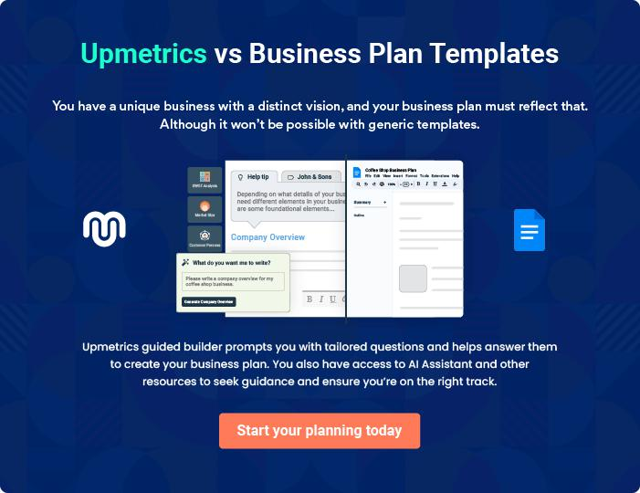
Products and Services
To unlock help try Upmetrics!

The product and services section of a clothing store business plan should describe the specific services and products that will be offered to customers. To write this section should include the following:



 Help tip  Clothing Store Business Plan

To craft the introduction for your "Products and Services" chapter, begin by positioning your business within its industry, emphasizing its unique strengths or value proposition.
To unlock help try Upmetrics! 

Start writing here..

 Help tip

Create a list of the products your business will sell, men’s or women’s apparel, luxury clothing, kids wear, etc. Clothing customizations and online delivery can be some of your services.
To unlock help try Upmetrics! 

Products

Men's Casual Shirt


Price: [$49.99]

A comfortable, versatile shirt tailored for everyday wear.

Product Specifications

- Material: 100% Organic Cotton

- Fit: Regular and Slim options

- Colors: Blue, Black, White, Grey

- Sizes: S, M, L, XL, XXL
Women's A-line Dress

Price: [$89.99]

An elegant A-line dress perfect for both work and evening outings.

Product Specifications

- Material: 70% Rayon, 30% Linen

- Fit: True to size

- Colours: Red, Navy, Black, Teal

- Sizes: XS, S, M, L, XL

Kids Denim Jacket

Price: [$39.99]

A stylish and durable denim jacket for kids, suitable for all seasons.

Product Specifications

- Material: Denim (100% Cotton)

- Fit: Regular

- Colors: Classic Blue, Stone Washed, Black

- Sizes: 4Y, 6Y, 8Y, 10Y, 12Y
Luxury Silk Scarf

Price: [$129.99]

A luxurious silk scarf, featuring hand-painted designs, offering elegance to any outfit.

Product Specifications

- Material: 100% Pure Silk

- Design: Hand-painted patterns

- Dimensions: 35" x 35"

- Colors: Floral Red, Oceanic Blue, Midnight Black

Clothing Customization Service

Price: Starting at [$20] (Varies based on customization)

Personalized alterations ensuring the perfect fit and look for our customers.

Service Specifications

- Turnaround: Typically 2-3 days

- Alterations: Hemming, tailoring, mending

- Custom Add-ons: Embroidery, patches

Online Delivery Service

Price: [$5.99], Express - [$14.99]

Convenient delivery options, bringing Fashion Forward directly to your doorstep.

Service Specifications

- Delivery Window: Standard (3-5 days), Express (1-2 days)

- Coverage: Nationwide

- Package Tracking: Real-time tracking provided
Inventory Management
- To unlock help try Upmetrics!

 Help tip  Clothing Store Business Plan

You should also discuss the strategies you will implement for clothing procurement and inventory management as well as any tools or systems you will use for tracking inventory levels and sales.



Start writing here..
Sales And Marketing Strategies

Writing the sales and marketing strategies section means a list of strategies you will use to attract and retain your clients.
To unlock help try Upmetrics! 

 Help tip  Clothing Store Business Plan

To create an effective introduction for your "Sales and Marketing Strategies" chapter, start by setting the stage within your specific industry or market.
To unlock help try Upmetrics! 

Unique Selling Proposition (USP)

 Help tip  Clothing Store Business Plan

Clearly define your business’s unique selling propositions, which can be your products or services, brand reputation, unique designs, customizations, and so on.
To unlock help try Upmetrics! 

Start writing here..

Pricing Strategy

 Help tip  Clothing Store Business Plan

Develop a pricing strategy that is competitive and affordable yet profitable. Consider offering promotions, discounts, or packages for your clothing business to attract new customers.
To unlock help try Upmetrics! 

Start writing here..

 Help tip  Clothing Store Business Plan
To unlock help try Upmetrics!

Develop a marketing strategy that includes a mix of online and offline marketing tactics. Consider social media, email marketing, content marketing, brochures, print marketing, and events.



Marketing strategies

Online


Social Media

Engaging content on platforms like [Instagram, Facebook, and Pinterest], including influencer partnerships.

Content Marketing

Blog posts on fashion trends, sustainability, and more, enhancing our SEO and brand authority.

Offline

Brochures

Elegantly designed brochures are available in-store and distributed at key locations.

Email Marketing

Personalized newsletters, exclusive deals, and fashion tips for our subscriber base.

Print Marketing

Ads in [local magazines, newspapers, and fashion journals].

Events

Pop-up shops, fashion shows, and

workshops to engage with the

community and showcase our

collections.

 Help tip

Mention your sales strategy as in—creating customer loyalty programs, planning contests, offering seasonal discounts, etc.
To unlock help try Upmetrics! 

Sales strategies

Loyalty Programs

Reward points for every purchase, redeemable on future buys.

Seasonal Contests

Engaging contests during [holiday seasons, summer, and winter] with attractive prizes.

Exclusive Discounts

Time-bound offers for members,

early-bird sale access, and more.

 Help tip

Describe how your business will retain customers and build loyalty, such as through loyalty programs, special events, or personalized service.
To unlock help try Upmetrics! 

Customer retention

Loyalty Programs

Apart from discounts, members get sneak peeks into upcoming collections and invites to exclusive events.

Exceptional Services

From shopping assistance to after-sales support, ensuring every customer's experience is unparalleled

Special Events

Members-only events, fashion previews, and personalized shopping days.

Operations Plan

 |  | When writing the operations plan section, it’s important to consider the
 |  | various aspects of your business operations.
 |  |  |  | To unlock help try Upmetrics! 
 Help tip |  |  Clothing Store Business Plan


To create an effective introduction for your "Operational Plan" chapter, start by emphasizing the
pivotal role of efficient operations in the success of your business, underscoring how they
directly impact the quality of services delivered.
 |  |  |  | To unlock help try Upmetrics! 
Start writing here..
Hiring Plan
 Help tip |  |  Clothing Store Business Plan

Tell the staffing requirements of your business, including the number of employees needed, their qualifications, and the duties they will perform.
To unlock help try Upmetrics! 

Start writing here..

Operational Process

 Help tip  Clothing Store Business Plan

Outline the processes and procedures you will use to run your clothing business. It includes inventory management, sales and marketing, customer service, financial management, etc.
To unlock help try Upmetrics! 

Start writing here..

Software & Technology
To unlock help try Upmetrics!

 Help tip  Clothing Store Business Plan

Describe the software and technologies used in your business operations depending on your services, such as a POS (point-of-sale) system, accounting software, e-commerce platform(optional), tailoring and alternation equipment, etc.



Start writing here..
Management Team

The management team section provides an overview of the individuals responsible for running your business plan.
To unlock help try Upmetrics! 

 Help tip  Clothing Store Business Plan

To craft an introduction for your "Management Team" chapter, begin by emphasizing the crucial role of leadership in the success of any business.
To unlock help try Upmetrics! 

Start writing here..

Key managers

 Help tip  Clothing Store Business Plan

Describe your management team’s key members, roles, and responsibilities.

It should include the owners, senior management, sales and marketing managers, sales
To unlock help try Upmetrics! 

Start writing here..

JOHN DOE

CEO & Co-founder - john.doe@example.com

As the driving force behind Fashion Forward, John merges his deep industry knowledge with an entrepreneurial spirit.

With a keen eye for trends and a knack for business strategy, he sets the overarching direction for the brand.


- Educational Background: MBA from the Wharton School of Business.

- Professional Background: Over 15 years in fashion retailing, with a decade as a strategic consultant for major global fashion brands.

JANE DOE

Chief Operating Officer (COO) - jane.doe@example.com

Jane's operational expertise ensures that Fashion Forward runs like a well-oiled machine.

From inventory management to overseeing daily operations, she ensures efficiency at every touchpoint.


- Educational Background: Degree in Fashion Merchandising from the Fashion Institute of Design & Merchandising (FIDM).

- Professional Background: A decade of experience in store operations, retail management, and supply chain coordination with notable brands.


ALICE BROWN

Sales and Marketing Manager - alice.brown@example.com

Alice brings a unique blend of creativity and analytical prowess to the table.

Overseeing marketing campaigns, sales strategies, and customer engagement initiatives, she's instrumental in expanding Fashion Forward's footprint.

- Educational Background: MA in Marketing from Stanford University.

- Professional Background: 8 years spearheading marketing campaigns for top-tier apparel brands, with a specialization in digital strategies.

ROBERT BROWN

Head Accountant - robert.brown@example.com

Robert's fiscal acumen ensures that Fashion Forward remains financially prudent and transparent.

From daily financial tracking to long-term fiscal strategy, he is the bedrock of the company's economic stability.

- Educational Background: Certified Public Accountant (CPA) with a Bachelor's in Accounting from New York University.

- Professional Background: 12 years in retail accounting, with a stint as a financial strategist for a leading clothing brand.
Organizational structure

 Help tip  Clothing Store Business Plan

Describe the organizational structure of the management team, including reporting lines and how decisions will be made.
To unlock help try Upmetrics! 

Start writing here..

Organization chart


John Doe

CEO


Alice Brown


Sales and Marketing Manager Jane Doe

COO


Emily White

Robert Brown Lead Designer

Head Accountant

Compensation plan

 Help tip  Clothing Store Business Plan

Describe your compensation plan for the management team and staff, including salaries, bonuses, and other benefits.
To unlock help try Upmetrics! 

Start writing here..

 Help tip

If you have a board of advisors for your business, then mention them along with their roles and experience.
To unlock help try Upmetrics! 

Board of advisors


[ADVISOR NAME]

Advisor

Former CEO of [Major Fashion House], bringing strategic insights and global market perspectives.

[ADVISOR NAME]

Advisor

Digital marketing guru, offering expertise in online engagement and e-commerce strategies.
Financial Plan

When writing the financial plan section of a business plan, it’s important to provide a comprehensive overview of your financial projections for the first few years of your business, You may provide the following:
To unlock help try Upmetrics! 

 Help tip  Clothing Store Business Plan


To create an effective introduction for your "Financial Plan" chapter, begin by stressing the critical role of a well-structured financial plan in the success of your venture.
To unlock help try Upmetrics! 

Start writing here..

 Help tip


Create a projected profit & loss statement that describes the expected revenue, cost of products sold, and operational costs. Your business’s anticipated net profit or loss should be computed and included.
To unlock help try Upmetrics! 

Profit & loss statement

Revenue

Cost Of Sales

General Costs

Revenue Specific Costs

Personnel Costs (Direct

Labor)

Gross Margin

Gross Margin (%)

Operating Expense

Payroll Expense

(Indirect Labor)

General Expense

Bad Debt

Amortization of Current

Assets

2023-24 | 2024-25 | 2025-26 | 2026-27 | 2027-28
$0 | $0 | $0 | $0 | $0

$0 | $0 | $0 | $0 | $0
$0 | $0 | $0 | $0 | $0
$0 | $0 | $0 | $0 | $0
$0 | $0 | $0 | $0 | $0

$0 | $0 | $0 | $0 | $0
0% | 0% | 0% | 0% | 0%

$0 | $0 | $0 | $0 | $0
$0 | $0 | $0 | $0 | $0
$0 | $0 | $0 | $0 | $0
$0 | $0 | $0 | $0 | $0
$0 | $0 | $0 | $0 | $0

EBITDA

Additional Expense

Long Term

Depreciation

Gain or loss from Sale

of Assets

EBIT

Interest Expenses

EBT

Income Tax Expense

Total Expense

Net Income

Net Income (%)

2023-24 | 2024-25 | 2025-26 | 2026-27 | 2027-28
$0 | $0 | $0 | $0 | $0
$0 | $0 | $0 | $0 | $0
$0 | $0 | $0 | $0 | $0
$0 | $0 | $0 | $0 | $0
$0 | $0 | $0 | $0 | $0
$0 | $0 | $0 | $0 | $0
$0 | $0 | $0 | $0 | $0
$0 | $0 | $0 | $0 | $0
$0 | $0 | $0 | $0 | $0
$0 | $0 | $0 | $0 | $0
0% | 0% | 0% | 0% | 0%
 | 2023-24 | 2024-25 | 2025-26 | 2026-27 | 2027-28
Retained Earning | $0 | $0 | $0 | $0 | $0
Opening
Owner's Distribution | $0 | $0 | $0 | $0 | $0
Retained Earning | $0 | $0 | $0 | $0 | $0
Closing

 Help tip

Estimate your cash inflows and outflows for the first few years of operation. It should include cash receipts from clients, vendor payments, loan payments, and any other cash inflows and outflows.
To unlock help try Upmetrics! 

Cash flow statement

 | 2023-24 | 2024-25 | 2025-26 | 2026-27 | 2027-28
Cash Received | $0 | $0 | $0 | $0 | $0
Cash Paid | $0 | $0 | $0 | $0 | $0
COS & General Expenses | $0 | $0 | $0 | $0 | $0
Salary & Wages | $0 | $0 | $0 | $0 | $0
Interest | $0 | $0 | $0 | $0 | $0

Sales Tax

Income Tax

Net Cash From

Operations

Assets Sell

Assets Purchase

Net Cash From

Investments

Amount Received

Loan Received

Common Stock

Preferred Stock

Owner's Contribution

Amount Paid

2023-24 | 2024-25 | 2025-26 | 2026-27 | 2027-28
$0 | $0 | $0 | $0 | $0
$0 | $0 | $0 | $0 | $0
$0 | $0 | $0 | $0 | $0

$0 | $0 | $0 | $0 | $0
$0 | $0 | $0 | $0 | $0
$0 | $0 | $0 | $0 | $0

$0 | $0 | $0 | $0 | $0
$0 | $0 | $0 | $0 | $0

$0 | $0 | $0 | $0 | $0
$0 | $0 | $0 | $0 | $0
$0 | $0 | $0 | $0 | $0

Loan Capital $0 $0 $0 $0 $0

 | 2023-24 | 2024-25 | 2025-26 | 2026-27 | 2027-28
Dividends & Distributions | $0 | $0 | $0 | $0 | $0
Net Cash From | $0 | $0 | $0 | $0 | $0
Financing

Summary
Starting Cash | $0 | $0 | $0 | $0 | $0
Cash In | $0 | $0 | $0 | $0 | $0
Cash Out | $0 | $0 | $0 | $0 | $0
Change in Cash | $0 | $0 | $0 | $0 | $0
Ending Cash | $0 | $0 | $0 | $0 | $0

 Help tip

Prepare a projected balance sheet, which shows the business’s assets, liabilities, and equity.

To unlock help try Upmetrics! 

Balance sheet

 | 2023-24 | 2024-25 | 2025-26 | 2026-27 | 2027-28
Assets | $0 | $0 | $0 | $0 | $0
Current Assets | $0 | $0 | $0 | $0 | $0
Cash | $0 | $0 | $0 | $0 | $0
Accounts Receivable | $0 | $0 | $0 | $0 | $0
Inventory | $0 | $0 | $0 | $0 | $0
Other Current Assets | $0 | $0 | $0 | $0 | $0
Long Term Assets | $0 | $0 | $0 | $0 | $0
Gross Long Term Assets | $0 | $0 | $0 | $0 | $0
Accumulated Depreciation | $0 | $0 | $0 | $0 | $0

Liabilities & Equity | $0 | $0 | $0 | $0 | $0
Liabilities | $0 | $0 | $0 | $0 | $0
Current Liabilities | $0 | $0 | $0 | $0 | $0
Accounts Payable | $0 | $0 | $0 | $0 | $0
Income Tax Payable | $0 | $0 | $0 | $0 | $0
Sales Tax Payable | $0 | $0 | $0 | $0 | $0
Short Term Debt | $0 | $0 | $0 | $0 | $0
 | 2023-24 | 2024-25 | 2025-26 | 2026-27 | 2027-28
Long Term Liabilities | $0 | $0 | $0 | $0 | $0
Long Term Debt | $0 | $0 | $0 | $0 | $0
Equity | $0 | $0 | $0 | $0 | $0
Paid-in Capital | $0 | $0 | $0 | $0 | $0
Common Stock | $0 | $0 | $0 | $0 | $0
Preferred Stock | $0 | $0 | $0 | $0 | $0
Owner's Contribution | $0 | $0 | $0 | $0 | $0
Retained Earnings | $0 | $0 | $0 | $0 | $0

Check | $0 |  |  | $0 | $0 | $0 | $0
 Help tip |  |  Clothing Store Business Plan


The point at which your store will break even or generate enough revenue to cover its operating costs. This will help you understand how much revenue you need to generate to make a profit.
To unlock help try Upmetrics! 

Break-even Analysis

 | 2023-24 | 2024-25 | 2025-26 | 2026-27 | 2027-28
Starting Revenue | $0 | $0 | $0 | $0 | $0
Net Revenue | $0 | $0 | $0 | $0 | $0
Closing Revenue | $0 | $0 | $0 | $0 | $0

Starting Expense | $0 | $0 | $0 | $0 | $0
Net Expense | $0 | $0 | $0 | $0 | $0
Closing Expense | $0 | $0 | $0 | $0 | $0

Is Break Even? | 0 | 0 | 0 | 0 | 0
Break Even Month | 0 | 0 | 0 | 0 | 0
Days Required | 0 | 0 | 0 | 0 | 0
Break Even Revenue | $0 | $0 | $0 | $0 | $0
Break Even Units
Financing needs

 Help tip  Clothing Store Business Plan

Estimate how much financing you will need to start and operate your store. It should include short-term and long-term financing needs, such as loans or investment capital.
To unlock help try Upmetrics! 

Start writing here..
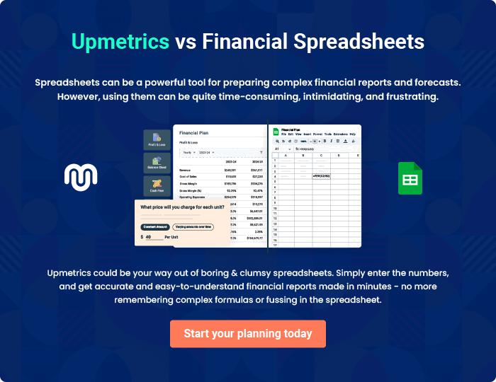
Appendix

When writing the appendix section, you should include any additional information that supports the main content of your plan. This may include financial statements, market research data, legal documents, and other
To unlock help try Upmetrics! 
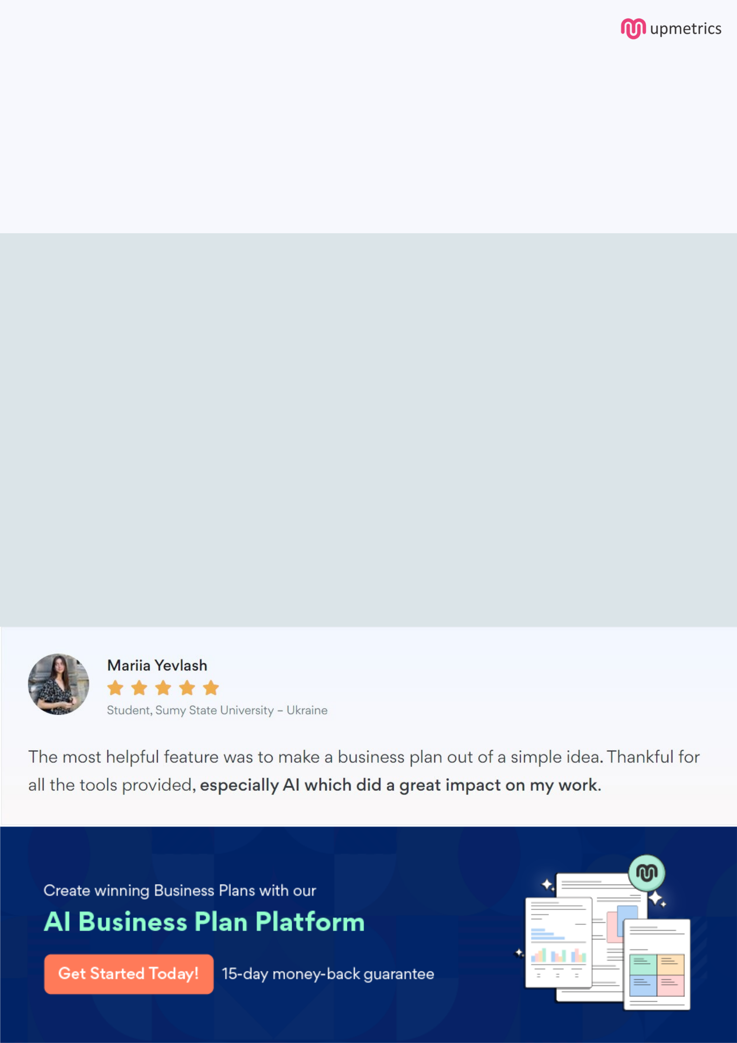
Create a winning business plan that gets you funded

Creating a stunning and investment-ready plan requires no writing, graphic designing, or financial planning expertise.

Upmetrics has all the features required to help you create a comprehensive business plan—from start to finish. Make no mistakes, it’s the modern way of planning to structure ideas, make plans, and create stunning pitch decks to awe investors.

Pitch decks that impress investors

Create pitch decks that provide a visual representation of your business, engage investors, and make them want to invest in your business idea.

Interactive plans in no time

Import business plan sections like—SWOT analysis, comparison tables, and others to create an interactive business plan. No designing skills are required.

Stunning cover page designs

With Upmetrics, you have the liberty to choose from multiple stunning cover page designs. Choose a creative design and make your plan stand out.

Online sharing made simple

Upmetrics makes online sharing quick and easier for users. Easily share your business plans with a link while tracking reader activity.

500+ sample business plans

Simply import a template from our library of sample plans into the editor and start customizing it to make it yours. It takes only a few clicks to get started.

Collaborate with team in real-time

Invite team members, initiate conversations, discuss ideas & strategies, share feedback, and work on a business plan in real-time.

