
Charter Boat Business Plan

BUSINESS PLAN

Navigating Waves of Luxury

Prepared By

John Doe

10200 Bolsa Ave, Westminster, CA, 92683

info@example.com

(650) 359-3153 http://www.example.com

Table of Contents

Executive Summary | 6
Market opportunity | 6
Services Offered | 6
Marketing & Sales Strategies | 7
Financial Highlights | 7
Units Sold v/s Revenue | 8

Company Overview | 9
Ownership | 9
Mission statement | 10
Business history | 10
Future goals | 10

Market Analysis | 11
Target Market | 11
Market size and growth potential | 11
Market Size | 12
Competitive analysis | 12
OceanWave Ventures | 12
MarineEscape Charters | 13
AquaBliss Boats | 13
Market trends | 13
Regulatory environment | 14

Products and Services | 15
Services | 15
Luxury Yacht Charters | 15
Guided Fishing Expeditions | 16
Sunset Cruises | 16
Scuba Diving Adventures | 17
Event Organizing Services | 17
Safety Measures | 18
Additional Services | 18

Sales And Marketing Strategies | 19
Unique Selling Proposition (USP) | 19
Pricing Strategy | 19
Marketing strategies | 20
Online | 20
Offline | 20
Sales strategies | 21
Customer retention | 22

Operations Plan | 23
Staffing & Training | 23
Operational Process | 23
Equipment & Machinery | 24

Management Team | 25
Key managers | 25
John Doe | 25
Alice Brown | 26
Robert Brown | 26
Organizational structure | 26
Organization chart | 27
Compensation plan | 27
Advisors/Consultants | 28
Jane Doe | 28
William Green | 28

Financial Plan | 29
Profit & loss statement | 29
Cash flow statement | 31
Balance sheet | 32
Break-even Point | 34
Financing needs | 35
Appendix
Appendix | 36
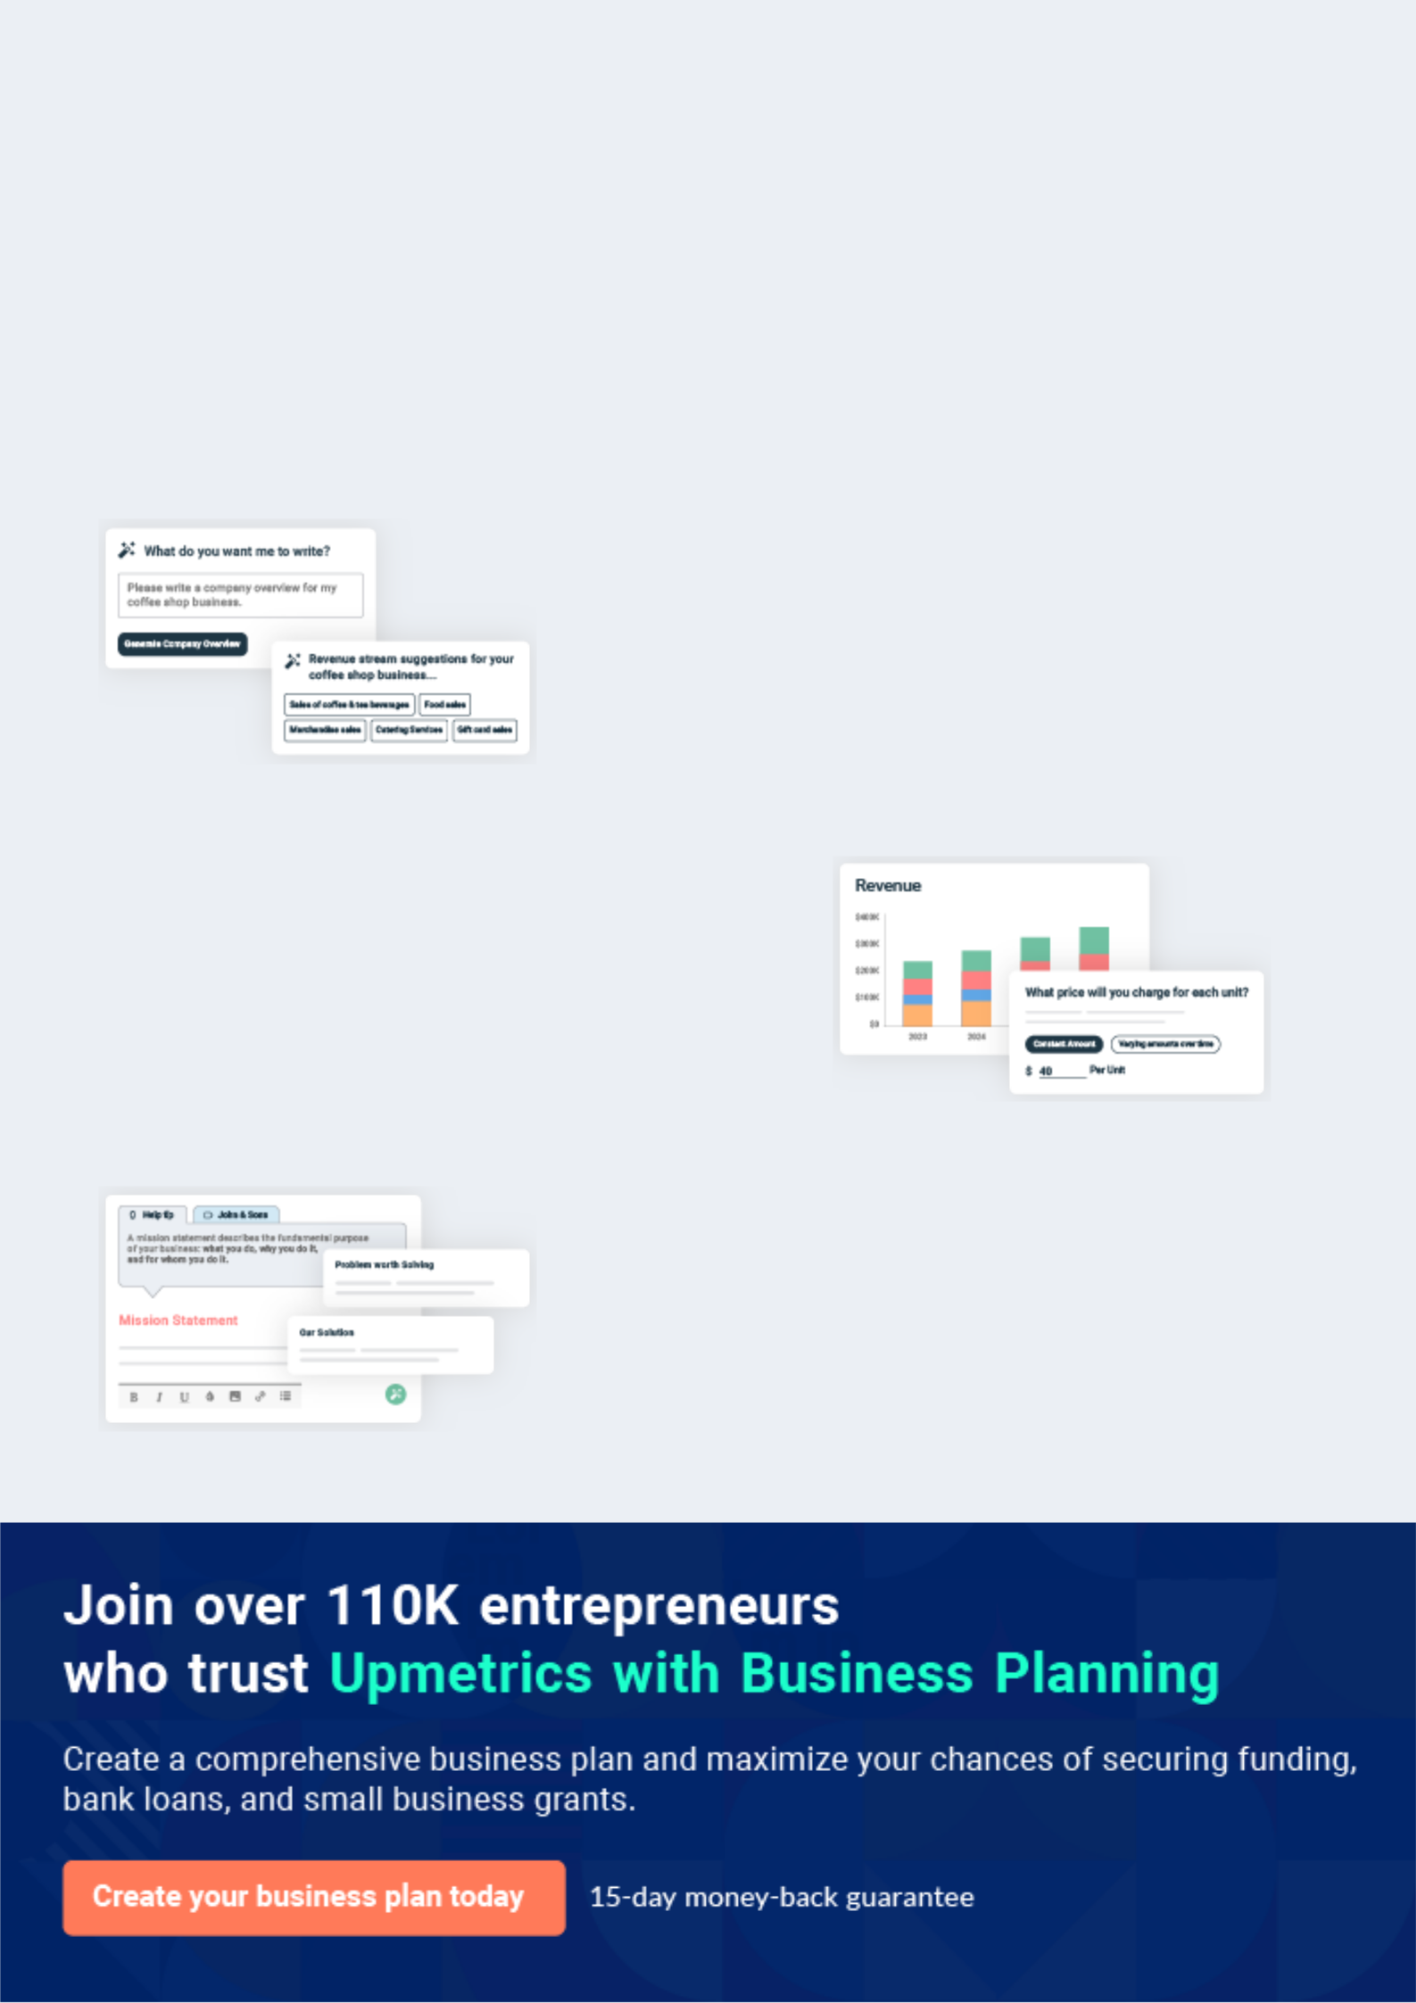
Business planning that’s simpler and faster than you think

Creating a business plan using Upmetrics to start and grow a business is literally the easiest thing in the World. Simply read the instructions and fill in the blanks. It’s as simple as that.

❛ | Upmetrics has everything you need to create a | ❜
❛ | comprehensive business plan. | ❜

AI-powered Upmetrics Assistant

AI-powered insights to streamline your plan

Not sure where to start? Upmetrics’ AI Assistant will automatically generate ideas for each section of your plan and offer improved versions of your writing, adjusting for tone, voice, and grammar or spelling errors.

Financial Forecasting Tool

All the financials are calculated for you

Forget the complex formulas and clumsy spreadsheets — with automatic financials and drag-and-drop forecasting, you can finish your plan faster and be confident that your numbers are accurate.

Business Plan Builder

Guides you like a business mentor

Upmetrics’ step-by-step instructions, prompts, and the library of 400+ sample business plans will guide you through each section of your plan as a business mentor.
Executive Summary


An executive summary is the first section of the business plan intended to provide an overview of the whole business plan.
To unlock help try Upmetrics! 

 Help tip  Charter Boat Business Plan


Start your executive summary by briefly introducing your business to your readers.

This section may include the name of your charter boat business, its location, when it was
To unlock help try Upmetrics! 

Start writing here..

Market opportunity

 Help tip  Charter Boat Business Plan

Summarize your market research, including market size, growth potential, and marketing trends. Highlight the opportunities in the market and how your business will fit in to fill the gap.
To unlock help try Upmetrics! 

Start writing here..

Services Offered

 Help tip  Charter Boat Business Plan

Highlight the charter boat services you offer your clients. The USPs and differentiators you offer are always a plus.
To unlock help try Upmetrics! 

Start writing here..

Marketing & Sales Strategies
To unlock help try Upmetrics!

 Help tip  Charter Boat Business Plan

Outline your sales and marketing strategies—what marketing platforms you use, how you plan on acquiring customers, etc.
To unlock help try Upmetrics! 

Start writing here..

Financial Highlights

 Help tip  Charter Boat Business Plan

Briefly summarize your financial projections for the initial years of business operations. Include any capital or investment requirements, associated startup costs, projected revenues, and profit forecasts.



Start writing here..
Units Sold v/s Revenue

 |  | Units Sold | Revenue
15.00k
10.00k
5.00k
0
Year 1 | Year 2 | Year 3


Financial Year |  |  | Units Sold | Revenue
Year 1 | 1,550 |  |  | $10,000
Year 2 | 1,800 |  |  | $12,000
Year 3 | 2,050 |  |  | $14,000
 Help tip |  |  Charter Boat Business Plan


Summarize your executive summary section with a clear CTA, for example, inviting angel investors to discuss the potential business investment.
To unlock help try Upmetrics! 

Write a call to action for your business plan.
Company Overview

Depending on what details of your business are essential, you’ll need different elements in your business overview.
To unlock help try Upmetrics! 

 Help tip  Charter Boat Business Plan

Describe your business in this section by providing all the basic information:

Provide a description of the name of your business and the types of charter boats you provide.
To unlock help try Upmetrics! 

Start writing here..

Ownership

 Help tip  Charter Boat Business Plan

List the names of your coffee roaster business’s founders or owners. Describe what shares they own and their responsibilities for efficiently managing the business.
To unlock help try Upmetrics! 

Start writing here..
Mission statement

 Help tip  Charter Boat Business Plan

Summarize your business’ objective, core principles, and values in your mission statement. This statement needs to be memorable, clear, and brief.
To unlock help try Upmetrics! 

❛ At [Your Charter Boat Business Name], our mission is to provide unparalleled nautical experiences, seamlessly blending adventure and luxury. Rooted in a commitment to safety, customer satisfaction, and environmental stewardship, we strive to make

every voyage with us a cherished memory.
❜

Business history

 Help tip  Charter Boat Business Plan

If you’re an established charter boat service provider, briefly describe your business history, like —when it was founded, how it evolved over time, etc.
To unlock help try Upmetrics! 

Start writing here..

Future goals

 Help tip  Charter Boat Business Plan

It’s crucial to convey your aspirations and vision. Mention your short-term and long-term goals; they can be specific targets for revenue, market share, or expanding your services.
To unlock help try Upmetrics! 

Start writing here..

Market Analysis
To unlock help try Upmetrics!


 |  | Market analysis provides a clear understanding of the market in which your
 |  | printing business will run along with the target market, competitors, and
 |  | growth opportunities.
 |  |  |  | To unlock help try Upmetrics! 
 Help tip |  |  Charter Boat Business Plan

To write the introduction section of your market analysis, start by clearly identifying your primary target market.
To unlock help try Upmetrics! 

Start writing here..

Target Market

 Help tip  Charter Boat Business Plan

Start this section by describing your target market. Define your ideal customer and explain what types of services they prefer. Creating a buyer persona will help you easily define your target market to your readers.



Start writing here..

Market size and growth potential

 Help tip  Charter Boat Business Plan

Describe your market size and growth potential and whether you will target a niche or a much broader market.
To unlock help try Upmetrics! 

Start writing here..

Market Size

Available Market

All potential customers in the region | 1M
who have shown interest in marine | 1M
activities.
Served Market | 500k
who can access our services due to | 500k
Individuals within the available market
proximity or awareness.
Target Market | 250k
The subset of the served market | 250k
specifically interested in luxury yacht | 250k

experiences.

 Help tip  Charter Boat Business Plan

Identify and analyze your direct and indirect competitors. Identify their strengths and weaknesses, and describe what differentiates your services from them.
To unlock help try Upmetrics! 

Competitive analysis

OceanWave Ventures

OceanWave Ventures has been a staple in the charter boat industry for over a decade. Located just a few miles from our base, they primarily focus on luxury yacht experiences tailored for corporate events and private parties.

Features | Strengths | Weaknesses
Private yacht charter for events | Established brand reputation | Premium pricing, making it
On-board catering services with | A diverse fleet of luxury yachts | inaccessible for a wider audience
gourmet food options | Strong partnerships with | Limited focus on eco-friendly
 | Strong partnerships with | initiatives
Special packages for corporate | gourmet catering companies | initiatives
team-building events |  | Relatively slower digital and
Yacht maintenance and rental |  | technological adoption
for third-party owners

MarineEscape Charters

MarineEscape Charters, a relatively newer entrant, caters to adventure seekers. They offer sailing experiences, fishing expeditions, and water sports activities.

Features Strengths

Group and solo fishing Diverse range of adventure-

expeditions focused packages

Sailing classes for beginners Collaborations with local

and intermediates marine trainers and guides

Water sports activities like jet Competitive pricing

skiing, parasailing, and diving

Customizable adventure

packages

AquaBliss Boats

Weaknesses

Limited fleet size Lacks luxury offerings

Newer in the market, hence lesser brand recognition

AquaBliss Boats specializes in family-oriented boating experiences. They offer family packages, sunset cruises, and dolphin-watching tours.

Features

Family-friendly boat tours

Dolphin and whale-watching excursions

Sunset and dinner cruises

Special packages for school and educational trips

Strengths | Weaknesses
Strong focus on family and | Limited appeal to corporate
educational experiences | clients and adventure seekers
Safety measures tailored for | Seasonal demand with peaks
children and elderly | during school vacations
passengers | Limited offerings outside family
Collaborations with local | packages
marine biologists for
informative sessions

Market trends

 Help tip  Charter Boat Business Plan

Analyze emerging trends in the industry, such as technology disruptions, changes in customer behavior or preferences, etc. Explain how your business will cope with all the trends.
To unlock help try Upmetrics! 

Start writing here..

Regulatory environment

 Help tip  Charter Boat Business Plan

List regulations and licensing requirements that may affect your charter boat company, such as business registration, insurance, environmental regulations, state and federal regulations, etc.
To unlock help try Upmetrics! 

Start writing here..
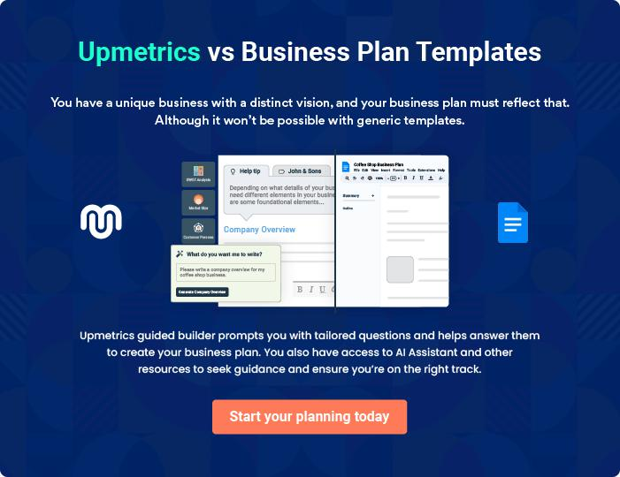
Products and Services
To unlock help try Upmetrics!

The product and services section of a charter boat business plan should describe the specific services and products that will be offered to customers. To write this section should include the following:



 Help tip  Charter Boat Business Plan

To craft the introduction for your "Products and Services" chapter, begin by positioning your business within its industry, emphasizing its unique strengths or value proposition.
To unlock help try Upmetrics! 

Start writing here..

 Help tip


Mention the charter boat services your business will offer. This list may include services like

• Boat charters
To unlock help try Upmetrics! 

Services

Luxury Yacht Charters


Price: [$2,000 for 4 hours]

Experience opulence on water with our state-of-the-art luxury yachts. Ideal for private events, corporate gatherings, or just to indulge in a lavish marine escapade.

Specifications

- Length: 70 feet

- Capacity: Up to 50 guests

- Amenities: Sun deck, lounging area, mini-bar, entertainment system

- Crew: Captain and 2 attendants included
Guided Fishing Expeditions

Price: [$500 for 6 hours]

Dive deep into the world of angling with our guided fishing tours. Suitable for both novices and seasoned anglers.

Specifications

- Boat Type: Fishing vessel with specialized equipment

- Duration: 6 hours with options for extended tours

- Equipment: Rods, reels, bait, and tackle provided

- Guide: Expert local fishing guide included

Sunset Cruises

Price: [750 for 3 hours]

Experience the magic of the horizon at sunset. Enjoy breathtaking views complemented by [e.g., "a live music session"].

Specifications

- Boat Type: Sailing boat or motor yacht (based on preference)

- Capacity: Up to 20 guests

- Features: Comfortable seating, ambient music, complimentary drinks

- Crew: Captain and attendant included
Scuba Diving Adventures

Price: [$300 per person]

Explore the underwater world with certified instructors. Dive into crystal clear waters and witness the vibrant marine life.

Specifications

- Duration: 3 hours, including a brief training session

- Equipment: Scuba gear, oxygen tanks, and fins provided

- Guide: Certified diving instructor for every group of 5 participants

- Safety: First aid and emergency response equipment onboard

Event Organizing Services

Price: Starting at [$5,000] (custom pricing based on requirements)

Transform our boats into the perfect venue for your event, be it birthdays, anniversaries, or corporate gatherings.

Specifications

- Boat Type: Luxury yacht or specialized event boat

- Capacity: Varies based on the boat selected (from 20 to 100 guests)

- Features: Customized decoration, lighting, music, and catering options

- Crew: Event manager, captain, attendants, and additional staff as required
Safety Measures

 Help tip  Charter Boat Business Plan

This section should explain how you will ensure the safety and well-being of your customers.

This may include details about safety protocols, emergency response procedures, and details
To unlock help try Upmetrics! 

Start writing here..

Additional Services

 Help tip  Charter Boat Business Plan

Mention if your charter boat company offers any additional services. You may include services like catering and dining options, entertainment systems, photographers, etc.
To unlock help try Upmetrics! 

Start writing here..
Sales And Marketing Strategies

Writing the sales and marketing strategies section means a list of strategies you will use to attract and retain your clients.
To unlock help try Upmetrics! 

 Help tip  Charter Boat Business Plan

To create an effective introduction for your "Sales and Marketing Strategies" chapter, start by setting the stage within your specific industry or market.
To unlock help try Upmetrics! 

Unique Selling Proposition (USP)

 Help tip  Charter Boat Business Plan

Define your business’s USPs depending on the market you serve, the equipment you use, and the unique services you provide. Identifying USPs will help you plan your marketing strategies.
To unlock help try Upmetrics! 

Start writing here..

Pricing Strategy

 Help tip  Charter Boat Business Plan

Describe your pricing strategy—how you plan to price your services and stay competitive in the local market. You can mention any discounts you plan on offering to attract new customers.
To unlock help try Upmetrics! 

Start writing here..

 Help tip  Charter Boat Business Plan
To unlock help try Upmetrics!

Discuss your marketing strategies to market your services. You may include some of these marketing strategies in your business plan—social media marketing, Google ads, brochures, email marketing, content marketing, and print marketing.



Marketing strategies

Online


Social Media Marketing

Leveraging platforms like [specific platforms, e.g., "Instagram, Facebook, and Twitter"] for promotions, stories, and customer engagement.

Content Marketing

Engaging blogs and articles on [topics, e.g., "marine life, boating safety, and fishing tips"] to drive organic traffic to our website.

Email Marketing

Curated newsletters and promotional offers sent to our subscriber base.

Google Ads

Targeted advertisements to capture potential clients actively seeking charter boat experiences.

Offline

Brochures

High-quality printed materials available at [specific places, e.g., "tourist centres, hotels, and airports"].

Print Marketing

Collaborations with [specific magazines or newspapers, e.g., "local tourism magazines"] for feature articles and advertisements.

 Help tip
To unlock help try Upmetrics!

Outline the strategies you’ll implement to maximize your sales. Your sales strategies may include providing excellent customer service, attending trade shows and events, and partnering with local businesses.



Sales strategies

Excellent Customer Service

Ensuring every query, booking, and feedback is addressed promptly and professionally.

Partnerships

Collaborations with local businesses, like [specific businesses, e.g., "hotels, travel agencies, and restaurants"], for package deals and referrals.

Trade Shows and Events

Participation in [specific events, e.g., "marine exhibitions and tourism fairs"] to network and showcase our offerings.

 Help tip

Describe your customer retention strategies and how you plan to execute them. For instance, introducing loyalty programs, special discounts, personalized service, etc.
To unlock help try Upmetrics! 

Customer retention

Loyalty Programs

Rewarding frequent customers with [specific rewards, e.g., "discounts, complimentary services, or priority bookings"].

Special Discounts

Exclusive offers for repeat clients, ensuring they feel valued.

Personalized Service

Tailoring voyages based on past

preferences and feedback,

ensuring a bespoke experience

every time.

Operations Plan
To unlock help try Upmetrics!

 |  | When writing the operations plan section, it’s important to consider the
 |  | various aspects of your business operations.
 |  |  |  | To unlock help try Upmetrics! 
 Help tip |  |  Charter Boat Business Plan


To create an effective introduction for your "Operational Plan" chapter, start by emphasizing the
pivotal role of efficient operations in the success of your business, underscoring how they
directly impact the quality of services delivered.
 |  |  |  | To unlock help try Upmetrics! 
Start writing here..
Staffing & Training
 Help tip |  |  Charter Boat Business Plan

Mention your business’s staffing requirements, including the number of employees needed.

Include their qualifications, the training required, and the duties they will perform.
To unlock help try Upmetrics! 

Start writing here..

Operational Process

 Help tip  Charter Boat Business Plan

Outline the processes and procedures you will use to run your charter boat business. Your operational processes may include trip planning, crew and boat preparation, boat operations, safety and repair, maintenance and repair, etc.



Start writing here..

Equipment & Machinery
To unlock help try Upmetrics!

 Help tip  Charter Boat Business Plan

Include the list of equipment and machinery required for a charter boat business, such as safety equipment, boats, fishing equipment, docking facilities, maintenance and repair tools, etc.



Start writing here..
Management Team

The management team section provides an overview of the individuals responsible for running your business plan.
To unlock help try Upmetrics! 

 Help tip  Charter Boat Business Plan

To craft an introduction for your "Management Team" chapter, begin by emphasizing the crucial role of leadership in the success of any business.
To unlock help try Upmetrics! 

Start writing here..

Key managers

 Help tip  Charter Boat Business Plan

Introduce your management and key members of your team, and explain their roles and responsibilities.
To unlock help try Upmetrics! 

Start writing here..


JOHN DOE

CEO & Co-founder - john.doe@example.com

John leads the strategic direction of the company, focusing on business development, partnership formation, and financial oversight.

He holds an MBA from [University Name, e.g., "Harvard Business School"] and has over [XX years, e.g., "15 years"] of experience in the charter boat industry, having previously worked with [Notable Company, e.g., "MarineLux Yachts"] in senior management roles


ALICE BROWN

Operations Manager - alice.brown@example.com

Alice is at the helm of daily operations, ensuring each charter runs seamlessly.

She graduated with a [specific degree, e.g., "Bachelor's in Marine Operations"] from [University Name, e.g., "Stanford University"] and has accumulated over [XX years, e.g., "10 years"] of operational expertise, particularly from her tenure at [Notable Company, e.g., "SeaScape Charters"].



ROBERT BROWN

Safety and Compliance Manager - robert.brown@example.com

Championing safety standards across our fleet, Robert's background includes certifications like [specific certifications, e.g., "Certified Marine Safety Officer"].

He studied [specific subject, e.g., "Marine Safety"] at [University Name, e.g., "MIT"] and has honed his expertise with [XX years, e.g., "12 years"] in roles at organizations like [Notable Company, e.g., "SafeSeas Inc."].

Organizational structure

 Help tip  Charter Boat Business Plan

Explain the organizational structure of your management team. Include the reporting line and decision-making hierarchy.
To unlock help try Upmetrics! 

Start writing here..

Organization chart



Emily Black

Safety Officer

Robert Smith



Safety & Compliance Manager


David Grey

Maintenance Head

John Doe

CEO


Alice Brown

Operations

Manager


Jane White


Crew Lead William Green

Admin Lead

Compensation plan

 Help tip  Charter Boat Business Plan

Describe your compensation plan for the management and staff. Include their salaries, incentives, and other benefits.
To unlock help try Upmetrics! 

Start writing here..

 Help tip  Charter Boat Business Plan

Mentioning advisors or consultants in your business plans adds credibility to your business idea.
To unlock help try Upmetrics! 

Advisors/Consultants


JANE DOE

Advisor

Serving as our maritime consultant, Jane brings in [XX years] of experience in [specific areas, e.g., "yacht design and sustainable boating practices"].


WILLIAM GREEN

Consultant

As our business growth consultant, William has been instrumental in [specific contributions, e.g., "expanding our operations to new regions and forging strategic partnerships"].
Financial Plan
To unlock help try Upmetrics!

When writing the financial plan section of a business plan, it’s important to provide a comprehensive overview of your financial projections for the first few years of your business, You may provide the following:
To unlock help try Upmetrics! 

 Help tip  Charter Boat Business Plan

To create an effective introduction for your "Financial Plan" chapter, begin by stressing the critical role of a well-structured financial plan in the success of your venture.
To unlock help try Upmetrics! 

Start writing here..

 Help tip

Describe details such as projected revenue, operational costs, and service costs in your projected profit and loss statement. Make sure to include your business’s expected net profit or loss.



Profit & loss statement

 | 2023-24 | 2024-25 | 2025-26 | 2026-27 | 2027-28
Revenue | $0 | $0 | $0 | $0 | $0

Cost Of Sales | $0 | $0 | $0 | $0 | $0
General Costs | $0 | $0 | $0 | $0 | $0
Revenue Specific Costs | $0 | $0 | $0 | $0 | $0
Personnel Costs (Direct | $0 | $0 | $0 | $0 | $0
Labor)

Gross Margin $0 $0 $0 $0 $0

Gross Margin (%)

Operating Expense

Payroll Expense

(Indirect Labor)

General Expense

Bad Debt

Amortization of Current Assets

EBITDA

Additional Expense

Long Term

Depreciation

Gain or loss from Sale of Assets

EBIT

Interest Expenses

EBT

Income Tax Expense

Total Expense

Net Income

Net Income (%)

2023-24 | 2024-25 | 2025-26 | 2026-27 | 2027-28
0% | 0% | 0% | 0% | 0%
$0 | $0 | $0 | $0 | $0
$0 | $0 | $0 | $0 | $0
$0 | $0 | $0 | $0 | $0
$0 | $0 | $0 | $0 | $0
$0 | $0 | $0 | $0 | $0
$0 | $0 | $0 | $0 | $0
$0 | $0 | $0 | $0 | $0
$0 | $0 | $0 | $0 | $0
$0 | $0 | $0 | $0 | $0
$0 | $0 | $0 | $0 | $0
$0 | $0 | $0 | $0 | $0
$0 | $0 | $0 | $0 | $0
$0 | $0 | $0 | $0 | $0
$0 | $0 | $0 | $0 | $0
$0 | $0 | $0 | $0 | $0
0% | 0% | 0% | 0% | 0%
 | 2023-24 | 2024-25 | 2025-26 | 2026-27 | 2027-28
Retained Earning | $0 | $0 | $0 | $0 | $0
Opening
Owner's Distribution | $0 | $0 | $0 | $0 | $0
Retained Earning | $0 | $0 | $0 | $0 | $0
Closing

 Help tip

The cash flow for the first few years of your operation should be estimated and described in this section.
To unlock help try Upmetrics! 

Cash flow statement

Cash Received

Cash Paid

COS & General Expenses

Salary & Wages

Interest

Sales Tax

Income Tax

Net Cash From

Operations

Assets Sell

Assets Purchase

Net Cash From

Investments

2023-24 | 2024-25 | 2025-26 | 2026-27 | 2027-28
$0 | $0 | $0 | $0 | $0
$0 | $0 | $0 | $0 | $0
$0 | $0 | $0 | $0 | $0
$0 | $0 | $0 | $0 | $0
$0 | $0 | $0 | $0 | $0
$0 | $0 | $0 | $0 | $0
$0 | $0 | $0 | $0 | $0
$0 | $0 | $0 | $0 | $0

$0 | $0 | $0 | $0 | $0
$0 | $0 | $0 | $0 | $0
$0 | $0 | $0 | $0 | $0

 | 2023-24 | 2024-25 | 2025-26 | 2026-27 | 2027-28
Amount Received | $0 | $0 | $0 | $0 | $0
Loan Received | $0 | $0 | $0 | $0 | $0
Common Stock
Preferred Stock | $0 | $0 | $0 | $0 | $0
Owner's Contribution | $0 | $0 | $0 | $0 | $0
Amount Paid | $0 | $0 | $0 | $0 | $0
Loan Capital | $0 | $0 | $0 | $0 | $0
Dividends & Distributions | $0 | $0 | $0 | $0 | $0
Net Cash From | $0 | $0 | $0 | $0 | $0
Financing

Summary
Starting Cash | $0 | $0 | $0 | $0 | $0
Cash In | $0 | $0 | $0 | $0 | $0
Cash Out | $0 | $0 | $0 | $0 | $0
Change in Cash | $0 | $0 | $0 | $0 | $0
Ending Cash | $0 | $0 | $0 | $0 | $0

 Help tip

Create a projected balance sheet documenting your charter boat business’s assets, liabilities, and equity
To unlock help try Upmetrics! 

Balance sheet

 | 2023-24 | 2024-25 | 2025-26 | 2026-27 | 2027-28
Assets | $0 | $0 | $0 | $0 | $0
 | 2023-24 | 2024-25 | 2025-26 | 2026-27 | 2027-28
Current Assets | $0 | $0 | $0 | $0 | $0
Cash | $0 | $0 | $0 | $0 | $0
Accounts Receivable | $0 | $0 | $0 | $0 | $0
Inventory | $0 | $0 | $0 | $0 | $0
Other Current Assets | $0 | $0 | $0 | $0 | $0
Long Term Assets | $0 | $0 | $0 | $0 | $0
Gross Long Term Assets | $0 | $0 | $0 | $0 | $0
Accumulated Depreciation | $0 | $0 | $0 | $0 | $0

Liabilities & Equity | $0 | $0 | $0 | $0 | $0
Liabilities | $0 | $0 | $0 | $0 | $0
Current Liabilities | $0 | $0 | $0 | $0 | $0
Accounts Payable | $0 | $0 | $0 | $0 | $0
Income Tax Payable | $0 | $0 | $0 | $0 | $0
Sales Tax Payable | $0 | $0 | $0 | $0 | $0
Short Term Debt | $0 | $0 | $0 | $0 | $0
Long Term Liabilities | $0 | $0 | $0 | $0 | $0
Long Term Debt | $0 | $0 | $0 | $0 | $0
Equity | $0 | $0 | $0 | $0 | $0
Paid-in Capital | $0 | $0 | $0 | $0 | $0
Common Stock | $0 | $0 | $0 | $0 | $0
Preferred Stock | $0 | $0 | $0 | $0 | $0
Owner's Contribution | $0 | $0 | $0 | $0 | $0
Retained Earnings | $0 | $0 | $0 | $0 | $0
 | 2023-24 |  |  | 2024-25 | 2025-26 | 2026-27 | 2027-28
Check | $0 |  |  | $0 | $0 | $0 | $0
 Help tip |  |  Charter Boat Business Plan

Determine and mention your business’s break-even point—the point at which your business costs and revenue will be equal.
To unlock help try Upmetrics! 

Break-even Point

 | 2023-24 | 2024-25 | 2025-26 | 2026-27 | 2027-28
Starting Revenue | $0 | $0 | $0 | $0 | $0
Net Revenue | $0 | $0 | $0 | $0 | $0
Closing Revenue | $0 | $0 | $0 | $0 | $0

Starting Expense | $0 | $0 | $0 | $0 | $0
Net Expense | $0 | $0 | $0 | $0 | $0
Closing Expense | $0 | $0 | $0 | $0 | $0

Is Break Even? | 0 | 0 | 0 | 0 | 0
Break Even Month | 0 | 0 | 0 | 0 | 0
Days Required | 0 | 0 | 0 | 0 | 0
Break Even Revenue | $0 | $0 | $0 | $0 | $0
Break Even Units
Financing needs

 Help tip  Charter Boat Business Plan

Calculate costs associated with starting a charter boat business, and estimate your financing needs and how much capital you need to raise to operate your business.
To unlock help try Upmetrics! 

Start writing here..
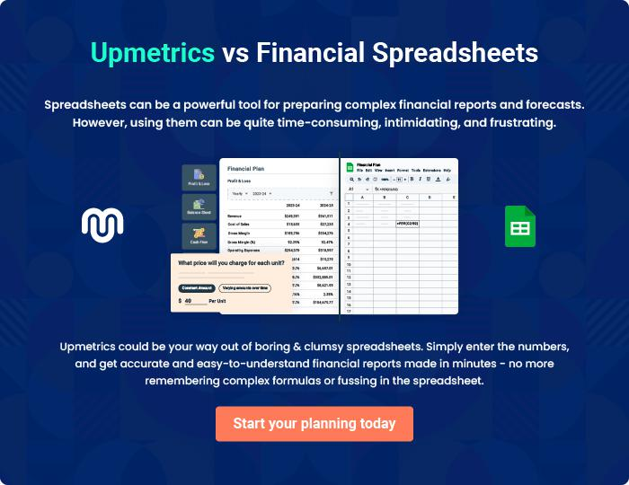
Appendix

When writing the appendix section, you should include any additional information that supports the main content of your plan. This may include financial statements, market research data, legal documents, and other
To unlock help try Upmetrics! 
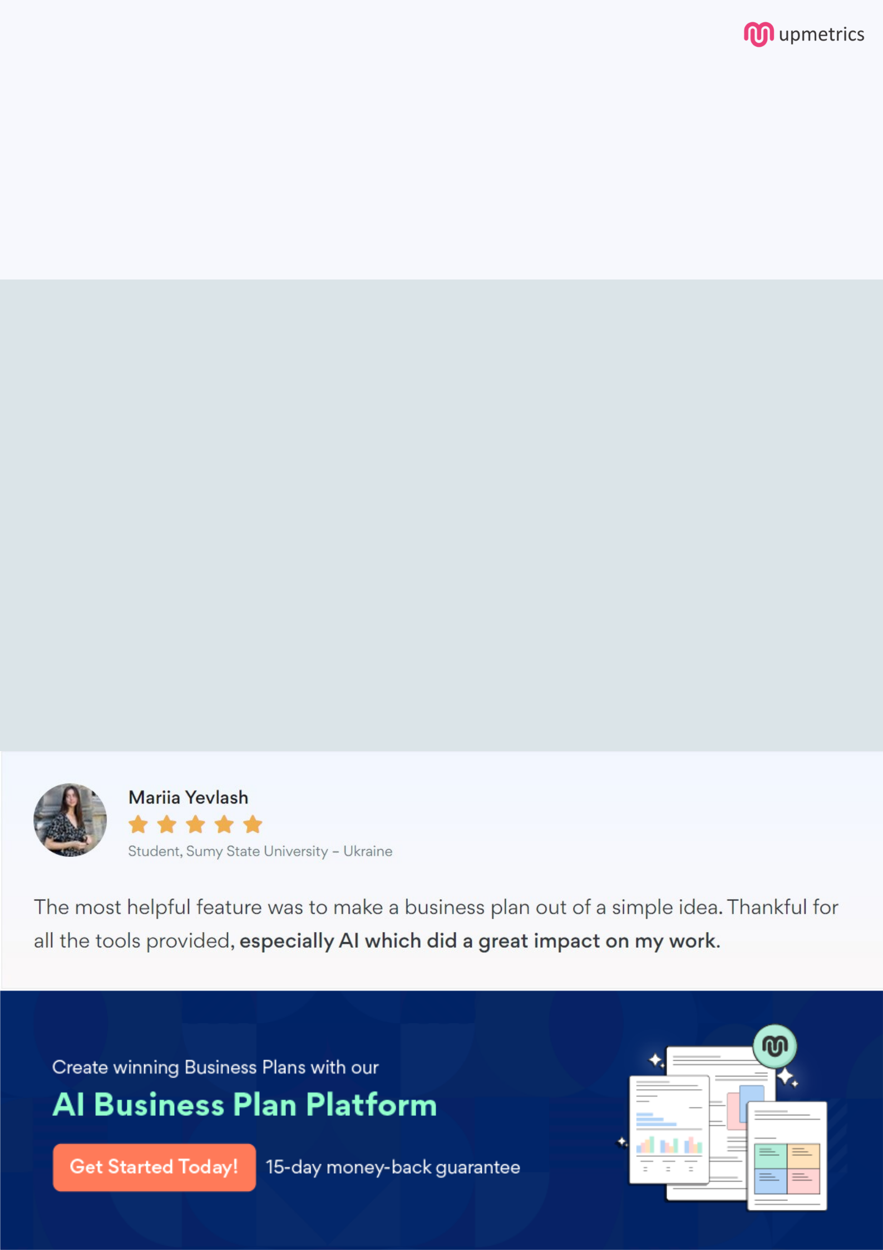
Create a winning business plan that gets you funded

Creating a stunning and investment-ready plan requires no writing, graphic designing, or financial planning expertise.

Upmetrics has all the features required to help you create a comprehensive business plan—from start to finish. Make no mistakes, it’s the modern way of planning to structure ideas, make plans, and create stunning pitch decks to awe investors.

Pitch decks that impress investors

Create pitch decks that provide a visual representation of your business, engage investors, and make them want to invest in your business idea.

Interactive plans in no time

Import business plan sections like—SWOT analysis, comparison tables, and others to create an interactive business plan. No designing skills are required.

Stunning cover page designs

With Upmetrics, you have the liberty to choose from multiple stunning cover page designs. Choose a creative design and make your plan stand out.

Online sharing made simple

Upmetrics makes online sharing quick and easier for users. Easily share your business plans with a link while tracking reader activity.

500+ sample business plans

Simply import a template from our library of sample plans into the editor and start customizing it to make it yours. It takes only a few clicks to get started.

Collaborate with team in real-time

Invite team members, initiate conversations, discuss ideas & strategies, share feedback, and work on a business plan in real-time.

