
 Charity Business Plan

ADDRESS CONTACT

10200 Bolsa Ave, Westminster, CA, 92683 (650) 359-3153

http://www.example.com info@example.com


Business Plan

2023

Prepared By

John Doe


Changing Lives, Together

Information provided in this business plan is unique to this business and confidential; therefore, anyone reading this plan agrees not to disclose any of the information in this business plan without prior written permission of the company.

Table of Contents

Executive Summary | 6
Market opportunity | 6
Programs | 6
Marketing & Sales Strategies | 7
Financial Highlights | 7
Units Sold v/s Revenue | 8

Company Overview | 9
Ownership | 9
Business Owners | 10
Mission statement | 11
Business history | 11
Future goals | 11

Market Analysis | 12
Target Market | 12
SWOT Analysis | 12
Market size and growth potential | 13
Market Size | 13
Competitive analysis | 14
Hopeful Hands Foundation | 14
Green Tomorrow Initiative | 14
Wellness & Beyond Trust | 15
Market trends | 15
Regulatory environment | 15

Products and Services | 17
Programs | 17
Direct Assistance Program: | 17
Education and Training Program | 19
Healthcare & Medical Services Program: | 19
Social Services Program | 20
Advocacy and Awareness Program: | 20
Supportive Services | 21

Sales And Marketing Strategies | 22
Unique Selling Proposition (USP) | 22
Pricing Strategy | 22
Marketing strategies | 23
Online | 23
Offline | 23
Sales strategies | 24
Donor retention | 25

Operations Plan | 26
Staffing & Training | 26
Operational Process | 26
Equipment & Software | 27

Management Team | 28
Key managers | 28
John Doe | 28
Jane Doe | 29
Alice Brown | 29
Robert Brown | 29
Organizational structure | 30
Organization chart | 30
Compensation plan | 30
Board of advisors | 31
Dr. Emily Clark | 31
Mr. Michael O'Brien | 31
Financial Plan
Financial Plan | 32

Profit & loss statement 32

Cash flow statement | 34
Balance sheet | 35
Break-even Point | 37
Financing needs | 38
Appendix
Appendix | 39
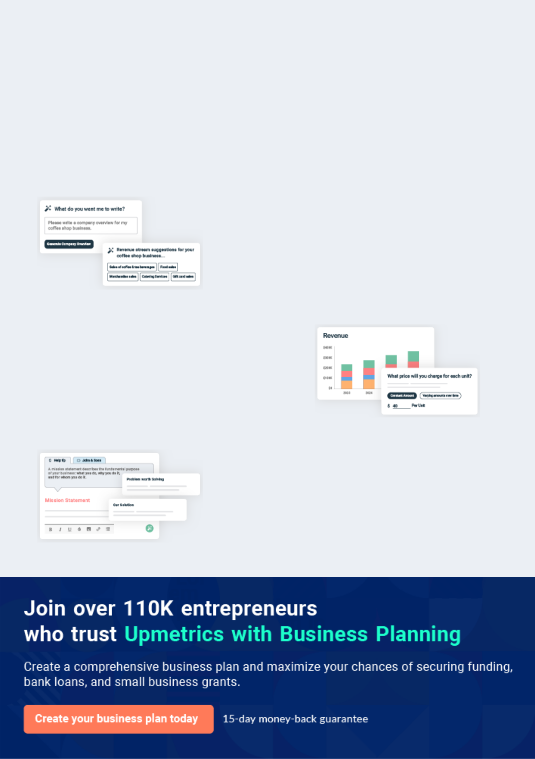
Business planning that’s simpler and faster than you think

Creating a business plan using Upmetrics to start and grow a business is literally the easiest thing in the World. Simply read the instructions and fill in the blanks. It’s as simple as that.

❛ | Upmetrics has everything you need to create a | ❜
❛ | comprehensive business plan. | ❜

AI-powered Upmetrics Assistant

AI-powered insights to streamline your plan

Not sure where to start? Upmetrics’ AI Assistant will automatically generate ideas for each section of your plan and offer improved versions of your writing, adjusting for tone, voice, and grammar or spelling errors.

Financial Forecasting Tool

All the financials are calculated for you

Forget the complex formulas and clumsy spreadsheets — with automatic financials and drag-and-drop forecasting, you can finish your plan faster and be confident that your numbers are accurate.

Business Plan Builder

Guides you like a business mentor

Upmetrics’ step-by-step instructions, prompts, and the library of 400+ sample business plans will guide you through each section of your plan as a business mentor.
Executive Summary


An executive summary is the first section of the business plan intended to provide an overview of the whole business plan.
To unlock help try Upmetrics! 

 Help tip  Charity Business Plan


Start your executive summary by briefly introducing your business to your readers.

This section may include the name of your charity business, its location, when it was founded,
To unlock help try Upmetrics! 

Start writing here..

Market opportunity

 Help tip  Charity Business Plan

Summarize your market research, including market size, growth potential, and marketing trends. Highlight the opportunities in the market and how your business will fit in to fill the gap.
To unlock help try Upmetrics! 

Start writing here..

Programs

 Help tip  Charity Business Plan

Highlight the charity programs you offer your clients. The USPs and differentiators you offer are always a plus.
To unlock help try Upmetrics! 

Start writing here..

Marketing & Sales Strategies
To unlock help try Upmetrics!

 Help tip  Example title..


Outline your sales and marketing strategies—what marketing platforms you use, how you plan on acquiring customers, etc.
To unlock help try Upmetrics! 

Start writing here..

Financial Highlights

 Help tip  Charity Business Plan

Briefly summarize your financial projections for the initial years of business operations. Include any capital or investment requirements, associated startup costs, projected revenues, and profit forecasts.



Start writing here..
Units Sold v/s Revenue

 |  | Units Sold | Revenue
15.00k
10.00k
5.00k
0
Year 1 | Year 2 | Year 3


Financial Year |  |  | Units Sold | Revenue
Year 1 | 1,550 |  |  | $10,000
Year 2 | 1,800 |  |  | $12,000
Year 3 | 2,050 |  |  | $14,000
 Help tip |  |  Charity Business Plan


Summarize your executive summary section with a clear CTA, for example, inviting angel investors to discuss the potential business investment.
To unlock help try Upmetrics! 

Write a call to action for your business plan.
Company Overview

Depending on what details of your business are essential, you’ll need different elements in your business overview.
To unlock help try Upmetrics! 

 Help tip  Charity Business Plan

Describe your business in this section by providing all the basic information:

Describe what kind of charity company you run and the name of it. You may specialize in one of
To unlock help try Upmetrics! 

Start writing here..

Ownership

 Help tip  Charity Business Plan

List the names of your charity company’s founders or owners. Describe what shares they own and their responsibilities for efficiently managing the business.
To unlock help try Upmetrics! 

Start writing here..
Business Owners



40% John Doe



30% Jane Doe



20% Alice Brown



10% Robert Brown
Mission statement

 Help tip  Charity Business Plan

Summarize your business’ objective, core principles, and values in your mission statement. This statement needs to be memorable, clear, and brief.
To unlock help try Upmetrics! 

❛ At [Charity Business Name], our mission is "[Mission Statement, e.g., To foster a world where nature thrives, communities prosper, and future generations inherit a planet in balance.]". This encapsulates our dedication to creating lasting change, our commitment to ethical practices, and our unwavering belief in the

strength of community collaboration.
❜

Business history

 Help tip  Charity Business Plan

If you’re an established charity service provider, briefly describe your business history, like— when it was founded, how it evolved over time, etc.
To unlock help try Upmetrics! 

Start writing here..

Future goals

 Help tip  Charity Business Plan

It’s crucial to convey your aspirations and vision. Mention your short-term and long-term goals; they can be specific targets for revenue, market share, or expanding your services.
To unlock help try Upmetrics! 

Start writing here..

Market Analysis


 |  | Market analysis provides a clear understanding of the market in which your
 |  | printing business will run along with the target market, competitors, and
 |  | growth opportunities.
 |  |  |  | To unlock help try Upmetrics! 
 Help tip |  |  Charity Business Plan

To write the introduction section of your market analysis, start by clearly identifying your primary target market.
To unlock help try Upmetrics! 

Start writing here..

Target Market

 Help tip  Charity Business Plan


Start this section by describing your target market. Define your ideal customer and explain what
types of services they prefer. Creating a buyer persona will help you easily define your target
market to your readers.
 |  |  |  | To unlock help try Upmetrics! 
Start writing here..
SWOT Analysis
 Help tip |  |  Charity Business Plan

Conduct a SWOT analysis (Strengths, Weaknesses, Opportunities, and Threats) to determine the internal and external factors that may have an impact on the success of the charity.
To unlock help try Upmetrics! 

Start writing here..

Market size and growth potential

 Help tip  Charity Business Plan

Provide an overview of the printing industry. It will include market size, trends, growth potential, and regulatory considerations.
To unlock help try Upmetrics! 

Start writing here..

Market Size

Available Market

Total people donating to charitable 10M causes annually.

Served Market
Those donating to causes similar to 2M [Charity Business Name].

Target Market
Individuals inclined to our specific 500k initiatives and outreach methods.
 Help tip  Charity Business Plan

Identify and analyze your direct and indirect competitors. Identify their strengths and weaknesses, and describe what differentiates your charity from them.
To unlock help try Upmetrics! 

Competitive analysis

Hopeful Hands Foundation

Established in 2005, Hopeful Hands Foundation has gained traction primarily in the southern regions, focusing on education and vocational training for underprivileged children.

Features | Strengths | Weaknesses
Scholarship programs for | Strong local community ties | Limited digital presence, missing
higher education. | leading to grassroots impact. | out on online donations.
Vocational training centers in | Effective collaboration with | Restricted to one domain
collaboration with local | industries ensuring job | (education), limiting diversified
industries | placements post-training. | donor interest.
Mentorship programs
partnering students with
industry professionals.

Green Tomorrow Initiative

A front-runner in environmental conservation since 2010, Green Tomorrow Initiative champions reforestation projects and urban green drives.

Features | Strengths | Weaknesses
Citywide tree plantation drives. | High visibility in urban areas, | Predominantly urban-focused,
Workshops and seminars on | attracting corporate | neglecting rural environmental
Workshops and seminars on | sponsorships. | challenges.
sustainable living. | sponsorships. | challenges.
Partnerships with schools for | Robust digital campaigns, | Reliance on a few major
Partnerships with schools for | amplifying online engagement | corporate donors, risking
environmental education. | amplifying online engagement | corporate donors, risking
environmental education. | and fundraising. | financial sustainability.

Wellness & Beyond Trust
To unlock help try Upmetrics!

With a focus on mental health, Wellness & Beyond Trust, founded in 2015, offers counseling services, helplines, and community outreach programs.

Features | Strengths | Weaknesses
24/7 helpline for immediate | Addressing the critical and | High operational costs due to
counselling assistance. | timely issue of mental health. | professional services.
Community workshops | A vast network of professional | Limited reach in remote areas.
promoting mental well-being. | therapists and counsellors.
Collaborations with educational
institutions for student
counseling.

Market trends

 Help tip  Charity Business Plan

Analyze emerging trends in the industry, such as technology disruptions, changes in customer behavior or preferences, etc. Explain how your business will cope with all the trends.
To unlock help try Upmetrics! 

Start writing here..

Regulatory environment

 Help tip  Charity Business Plan

List regulations and licensing requirements that may affect your charity company, such as legal structure & registration, tax-exempt status, reporting & financial transparency, fundraising regulations, etc.



Start writing here..
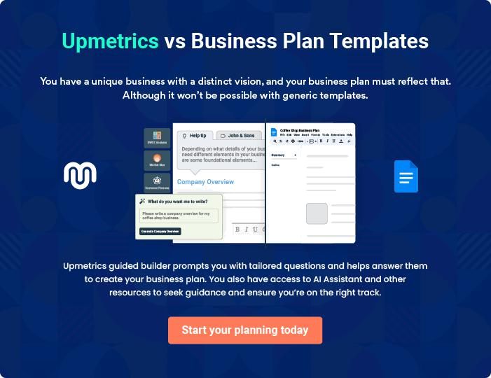
Products and Services

 |  | The product and services section of a charity business plan should describe
 |  | the specific services and products that will be offered to customers. To write
 |  | this section should include the following:
 |  |  |  | To unlock help try Upmetrics! 
 Help tip |  |  Charity Business Plan

To craft the introduction for your "Products and Services" chapter, begin by positioning your business within its industry, emphasizing its unique strengths or value proposition.
To unlock help try Upmetrics! 

Start writing here..

 Help tip


Mention the charity programs your business will offer. This list may include:

◦ ^{Direct assistance} To unlock help try Upmetrics! 

Programs

Direct Assistance Program:


Price: Donations and grants primarily fund this program, with occasional collaborations with local businesses for in-kind assistance. Beneficiaries receive services free of charge

Our Direct Assistance program is the first line of response for those in immediate need, providing essentials such as food, shelter, and financial aid to victims of unforeseen crises like natural disasters or personal emergencies.
Specifications

- Emergency packs containing food, water, and basic supplies.

- Temporary shelter arrangements.

- Short-term financial aid.
Education and Training Program

Price: This program is subsidized, with minimal fees for certain vocational courses. Scholarships are available based on need and merit.

This initiative focuses on empowering individuals, especially the underprivileged, with education and vocational training, ensuring they have the skills and knowledge to improve their life quality and attain self-sufficiency.

Specifications

- Vocational training courses in fields like sewing, carpentry, and basic computer skills.

- Scholarships for higher education.

- Study material distribution, including books and e-resources.

Healthcare & Medical Services Program:

Price: Medical services are provided at minimal costs or free for the underprivileged. Collaborations with pharmaceutical companies help subsidize medication costs.

Recognizing the fundamental right to health, this program provides medical services, health check-up camps, and free or subsidized medicines to marginalized communities.

Specifications

- Free medical check-up camps.

- Subsidized or free medicines for specific diseases.

- Health seminars and workshops.
Social Services Program

Price: Services are largely free, funded by donations, and grants, though some specialized rehabilitation programs might have a nominal fee.

Addressing various societal challenges, from addiction to homelessness, this program offers rehabilitation, counseling, and support services to integrate individuals back into society.

Specifications

- Rehabilitation centers for addiction and trauma.

- Counseling sessions.

- Community reintegration programs.

Advocacy and Awareness Program:

Price: Public awareness campaigns and workshops are free for attendees, funded through donations and partnerships with other organizations.

This program champions various causes, from environmental conservation to mental health, through campaigns, workshops, and community drives, aiming to bring pivotal issues to the forefront.

Specifications

- Awareness campaigns across various platforms.

- Workshops and seminars on pivotal issues.

- Community mobilization events.
Supportive Services

 Help tip  Charity Business Plan

Describe these services and how they support your primary programs if your charity offers them in addition to your core offerings, such as counseling, advocacy, or educational resources.
To unlock help try Upmetrics! 

Start writing here..
Sales And Marketing Strategies

Writing the sales and marketing strategies section means a list of strategies you will use to attract and retain your clients.
To unlock help try Upmetrics! 

 Help tip  Charity Business Plan

To create an effective introduction for your "Sales and Marketing Strategies" chapter, start by setting the stage within your specific industry or market.
To unlock help try Upmetrics! 

Unique Selling Proposition (USP)

 Help tip  Charity Business Plan

Define your business’s USPs depending on the market you serve, the equipment you use, and the unique services you provide. Identifying USPs will help you plan your marketing strategies.
To unlock help try Upmetrics! 

Start writing here..

Pricing Strategy

 Help tip  Charity Business Plan

Describe your marketing mix to reach your target audience, including product, price, promotion, and place elements of your marketing strategy.
To unlock help try Upmetrics! 

Start writing here..

 Help tip  Charity Business Plan

Describe how your organization intends to reach its target audience.

In addition to social media, email marketing, public relations, events, webinars, partnerships,
To unlock help try Upmetrics! 

Marketing strategies

Online


Social Media

Platforms like [Specific Platforms, e.g., "Facebook, Instagram, and Twitter"] enable us to share stories, updates, and engage in real-time with our community.

Online Fundraising

Utilizing platforms like [Specific Platforms, e.g., "GoFundMe and Kickstarter"] to reach a global audience.

Offline

Public Relations

Collaborating with media houses to spotlight our initiatives and successes.

Events and Webinars

Hosting [Specific Events, e.g., "annual galas, community outreach webinars, and donor meet-and-greets"].

Email Marketing

Regular newsletters highlighting impact stories, upcoming events, and opportunities for engagement.

Partnerships

Joint ventures with [Specific Partners, e.g., "corporate entities and educational institutions"] to amplify reach.

 Help tip
To unlock help try Upmetrics!


Describe the fundraising strategies you plan on implementing to generate revenue for your nonprofit. Your nonprofit may generate income from grants, major gifts, individual giving, charity events, online fundraising, corporate sponsorship, etc.



Sales strategies

Grants

Applying for grants that align with our mission from [Specific Entities, e.g., "governmental bodies and private foundations"].

Individual Giving

Encouraging the community to contribute, be it one-time donations or monthly contributions.

Major Gifts

Engaging with philanthropists and high-net-worth individuals for substantial contributions.

Corporate Sponsorship

Forming alliances with businesses for mutual branding and CSR initiatives.

 Help tip
Donor Recognition Programs
Acknowledging and celebrating our major donors through [Specific Methods, e.g., "annual award ceremonies and features in newsletters"].
To unlock help try Upmetrics!

Describe how your nonprofit will retain donors and build loyalty. Your donor retention strategies may involve sending regular updates and impact reports, creating donor recognition programs, or asking for feedback and input.



Donor retention

Regular Updates

Keeping donors informed about how their contributions are making a difference

Feedback Channels

Encouraging donors to share their

feedback, ensuring they feel valued

and heard.
Operations Plan

 |  | When writing the operations plan section, it’s important to consider the
 |  | various aspects of your business operations.
 |  |  |  | To unlock help try Upmetrics! 
 Help tip |  |  Charity Business Plan


To create an effective introduction for your "Operational Plan" chapter, start by emphasizing the
pivotal role of efficient operations in the success of your business, underscoring how they
directly impact the quality of services delivered.
 |  |  |  | To unlock help try Upmetrics! 
Start writing here..
Staffing & Training
 Help tip |  |  Charity Business Plan

Mention your business’s staffing requirements, including the number of employees or fundraising coordinator, program manager, or other staff needed.
To unlock help try Upmetrics! 

Start writing here..

Operational Process

 Help tip  Charity Business Plan

Outline the processes and procedures you will use to run your charity business. Your operational processes may include program development & management, fundraising & donor management, financial management, marketing & communications, etc._{To unlock help try Upmetrics!} 

Start writing here..

Equipment & Software
To unlock help try Upmetrics!

 Help tip  Charity Business Plan

Include the list of equipment and software required for charity, such as office equipment, software & IT infrastructure, communication & presentation tools, fundraising equipment, vehicles & transportation, etc.



Start writing here..
Management Team

The management team section provides an overview of the individuals responsible for running your business plan.
To unlock help try Upmetrics! 

 Help tip  Charity Business Plan

To craft an introduction for your "Management Team" chapter, begin by emphasizing the crucial role of leadership in the success of any business.
To unlock help try Upmetrics! 

Start writing here..

Key managers

 Help tip  Charity Business Plan

Introduce your management and key members of your team, and explain their roles and responsibilities.
To unlock help try Upmetrics! 

Start writing here..


JOHN DOE

CEO & Co-founder - john.doe@example.com

John holds a Master's in Nonprofit Management from Stanford University and has over 20 years of experience in the charitable sector.

Prior to establishing [Charity Business Name], he served as the Vice President of Philanthropy at Helping Hands Global.


John's vision, leadership, and unwavering commitment to community welfare drive our organization's strategic direction and growth.

JANE DOE

Chief Operating Officer (COO) - jane.doe@example.com

A Harvard graduate with an MBA in Social Enterprise, Jane brings 15 years of operational expertise to the team.

Before joining [Charity Business Name], she was the Director of Operations at CharityMakers Inc.


Her efficiency, problem-solving abilities, and leadership skills ensure our day-to-day operations align with our overarching mission.


ALICE BROWN

CMO - alice.brown@example.com

Alice possesses a Bachelor's in Marketing from UCLA and an MSc in Digital Marketing from MIT.

With over 18 years in the sector, including a decade as Senior Marketing Strategist at DonateMore Global, she spearheads our marketing, public relations, and donor engagement initiatives, ensuring our message resonates far and wide.


ROBERT BROWN

Finance Manager - robert.brown@example.com

Holding a degree in Accountancy from the University of Chicago and an ACCA certification, Robert boasts 12 years of financial expertise in the nonprofit domain.

Previously the Financial Analyst at BigHeart Charities, his meticulous approach to budgeting, compliance, and reporting ensures our financial health and sustainability.
Organizational structure

 Help tip  Charity Business Plan

Explain the organizational structure of your management team. Include the reporting line and decision-making hierarchy.
To unlock help try Upmetrics! 

Start writing here..

Organization chart


John Doe

CEO
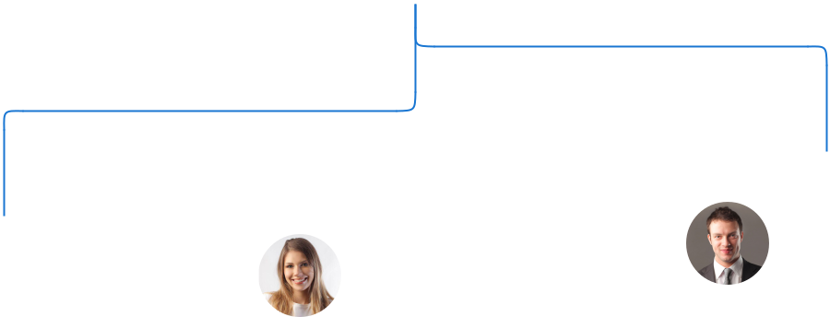

 |  |  | Robert Brown
Alice Brown | Jane Doe |  | Robert Brown
Alice Brown |  |  | Finance Manager
Marketing Director | Operations Manager



Chris Black


Marketing Assistant Mary Green

Admin Assistant

Compensation plan

 Help tip  Charity Business Plan

Describe your compensation plan for the management and staff. Include their salaries, incentives, and other benefits.
To unlock help try Upmetrics! 

Start writing here..

 Help tip

Mentioning advisors or consultants in your business plans adds credibility to your business idea.
To unlock help try Upmetrics! 

Board of advisors


DR. EMILY CLARK

Advisor

A veteran in [Specific Domain, e.g., "public health"], Dr. Clark advises us on [Specific Responsibilities, e.g., "healthcare program development"] with over [X years] of industry experience.


MR. MICHAEL O'BRIEN

Consultant

An expert in [Specific Domain, e.g., "non-profit legal compliance"], Michael ensures we remain compliant with regulations, bringing in [X years] of experience.
Financial Plan

When writing the financial plan section of a business plan, it’s important to provide a comprehensive overview of your financial projections for the first few years of your business, You may provide the following:
To unlock help try Upmetrics! 

 Help tip  Charity Business Plan

To create an effective introduction for your "Financial Plan" chapter, begin by stressing the critical role of a well-structured financial plan in the success of your venture.
To unlock help try Upmetrics! 

Start writing here..

 Help tip

Describe details such as projected revenue, operational costs, and service costs in your projected profit and loss statement.
To unlock help try Upmetrics! 

Profit & loss statement

 | 2023-24 | 2024-25 | 2025-26 | 2026-27 | 2027-28
Revenue | $0 | $0 | $0 | $0 | $0

Cost Of Sales | $0 | $0 | $0 | $0 | $0
General Costs | $0 | $0 | $0 | $0 | $0
Revenue Specific Costs | $0 | $0 | $0 | $0 | $0
Personnel Costs (Direct | $0 | $0 | $0 | $0 | $0
Labor)

Gross Margin $0 $0 $0 $0 $0

Gross Margin (%)

Operating Expense

Payroll Expense

(Indirect Labor)

General Expense

Bad Debt

Amortization of Current Assets

EBITDA

Additional Expense

Long Term

Depreciation

Gain or loss from Sale of Assets

EBIT

Interest Expenses

EBT

Income Tax Expense

Total Expense

Net Income

Net Income (%)

2023-24 | 2024-25 | 2025-26 | 2026-27 | 2027-28
0% | 0% | 0% | 0% | 0%
$0 | $0 | $0 | $0 | $0
$0 | $0 | $0 | $0 | $0
$0 | $0 | $0 | $0 | $0
$0 | $0 | $0 | $0 | $0
$0 | $0 | $0 | $0 | $0
$0 | $0 | $0 | $0 | $0
$0 | $0 | $0 | $0 | $0
$0 | $0 | $0 | $0 | $0
$0 | $0 | $0 | $0 | $0
$0 | $0 | $0 | $0 | $0
$0 | $0 | $0 | $0 | $0
$0 | $0 | $0 | $0 | $0
$0 | $0 | $0 | $0 | $0
$0 | $0 | $0 | $0 | $0
$0 | $0 | $0 | $0 | $0
0% | 0% | 0% | 0% | 0%
 | 2023-24 | 2024-25 | 2025-26 | 2026-27 | 2027-28
Retained Earning | $0 | $0 | $0 | $0 | $0
Opening
Owner's Distribution | $0 | $0 | $0 | $0 | $0
Retained Earning | $0 | $0 | $0 | $0 | $0
Closing

 Help tip

The cash flow for the first few years of your operation should be estimated and described in this section.
To unlock help try Upmetrics! 

Cash flow statement

Cash Received

Cash Paid

COS & General Expenses

Salary & Wages

Interest

Sales Tax

Income Tax

Net Cash From

Operations

Assets Sell

Assets Purchase

Net Cash From

Investments

2023-24 | 2024-25 | 2025-26 | 2026-27 | 2027-28
$0 | $0 | $0 | $0 | $0
$0 | $0 | $0 | $0 | $0
$0 | $0 | $0 | $0 | $0
$0 | $0 | $0 | $0 | $0
$0 | $0 | $0 | $0 | $0
$0 | $0 | $0 | $0 | $0
$0 | $0 | $0 | $0 | $0
$0 | $0 | $0 | $0 | $0

$0 | $0 | $0 | $0 | $0
$0 | $0 | $0 | $0 | $0
$0 | $0 | $0 | $0 | $0

 | 2023-24 | 2024-25 | 2025-26 | 2026-27 | 2027-28
Amount Received | $0 | $0 | $0 | $0 | $0
Loan Received | $0 | $0 | $0 | $0 | $0
Common Stock
Preferred Stock | $0 | $0 | $0 | $0 | $0
Owner's Contribution | $0 | $0 | $0 | $0 | $0
Amount Paid | $0 | $0 | $0 | $0 | $0
Loan Capital | $0 | $0 | $0 | $0 | $0
Dividends & Distributions | $0 | $0 | $0 | $0 | $0
Net Cash From | $0 | $0 | $0 | $0 | $0
Financing

Summary
Starting Cash | $0 | $0 | $0 | $0 | $0
Cash In | $0 | $0 | $0 | $0 | $0
Cash Out | $0 | $0 | $0 | $0 | $0
Change in Cash | $0 | $0 | $0 | $0 | $0
Ending Cash | $0 | $0 | $0 | $0 | $0

 Help tip

Create a projected balance sheet documenting your charity business’s assets, liabilities, and equity.
To unlock help try Upmetrics! 

Balance sheet

 | 2023-24 | 2024-25 | 2025-26 | 2026-27 | 2027-28
Assets | $0 | $0 | $0 | $0 | $0
 | 2023-24 | 2024-25 | 2025-26 | 2026-27 | 2027-28
Current Assets | $0 | $0 | $0 | $0 | $0
Cash | $0 | $0 | $0 | $0 | $0
Accounts Receivable | $0 | $0 | $0 | $0 | $0
Inventory | $0 | $0 | $0 | $0 | $0
Other Current Assets | $0 | $0 | $0 | $0 | $0
Long Term Assets | $0 | $0 | $0 | $0 | $0
Gross Long Term Assets | $0 | $0 | $0 | $0 | $0
Accumulated Depreciation | $0 | $0 | $0 | $0 | $0

Liabilities & Equity | $0 | $0 | $0 | $0 | $0
Liabilities | $0 | $0 | $0 | $0 | $0
Current Liabilities | $0 | $0 | $0 | $0 | $0
Accounts Payable | $0 | $0 | $0 | $0 | $0
Income Tax Payable | $0 | $0 | $0 | $0 | $0
Sales Tax Payable | $0 | $0 | $0 | $0 | $0
Short Term Debt | $0 | $0 | $0 | $0 | $0
Long Term Liabilities | $0 | $0 | $0 | $0 | $0
Long Term Debt | $0 | $0 | $0 | $0 | $0
Equity | $0 | $0 | $0 | $0 | $0
Paid-in Capital | $0 | $0 | $0 | $0 | $0
Common Stock | $0 | $0 | $0 | $0 | $0
Preferred Stock | $0 | $0 | $0 | $0 | $0
Owner's Contribution | $0 | $0 | $0 | $0 | $0
Retained Earnings | $0 | $0 | $0 | $0 | $0
 | 2023-24 |  |  | 2024-25 | 2025-26 | 2026-27 | 2027-28
Check | $0 |  |  | $0 | $0 | $0 | $0
 Help tip |  |  Charity Business Plan

Determine and mention your business’s break-even point—the point at which your business costs and revenue will be equal.
To unlock help try Upmetrics! 

Break-even Point

 | 2023-24 | 2024-25 | 2025-26 | 2026-27 | 2027-28
Starting Revenue | $0 | $0 | $0 | $0 | $0
Net Revenue | $0 | $0 | $0 | $0 | $0
Closing Revenue | $0 | $0 | $0 | $0 | $0

Starting Expense | $0 | $0 | $0 | $0 | $0
Net Expense | $0 | $0 | $0 | $0 | $0
Closing Expense | $0 | $0 | $0 | $0 | $0

Is Break Even? | 0 | 0 | 0 | 0 | 0
Break Even Month | 0 | 0 | 0 | 0 | 0
Days Required | 0 | 0 | 0 | 0 | 0
Break Even Revenue | $0 | $0 | $0 | $0 | $0
Break Even Units
Financing needs

 Help tip  Charity Business Plan

Calculate costs associated with starting a charity business, and estimate your financing needs and how much capital you need to raise to operate your business.
To unlock help try Upmetrics! 

Start writing here..
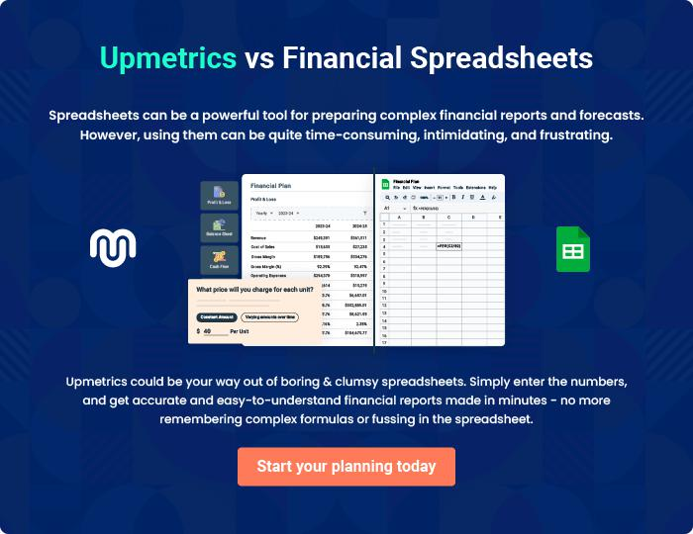
Appendix

When writing the appendix section, you should include any additional information that supports the main content of your plan. This may include financial statements, market research data, legal documents, and other
To unlock help try Upmetrics! 
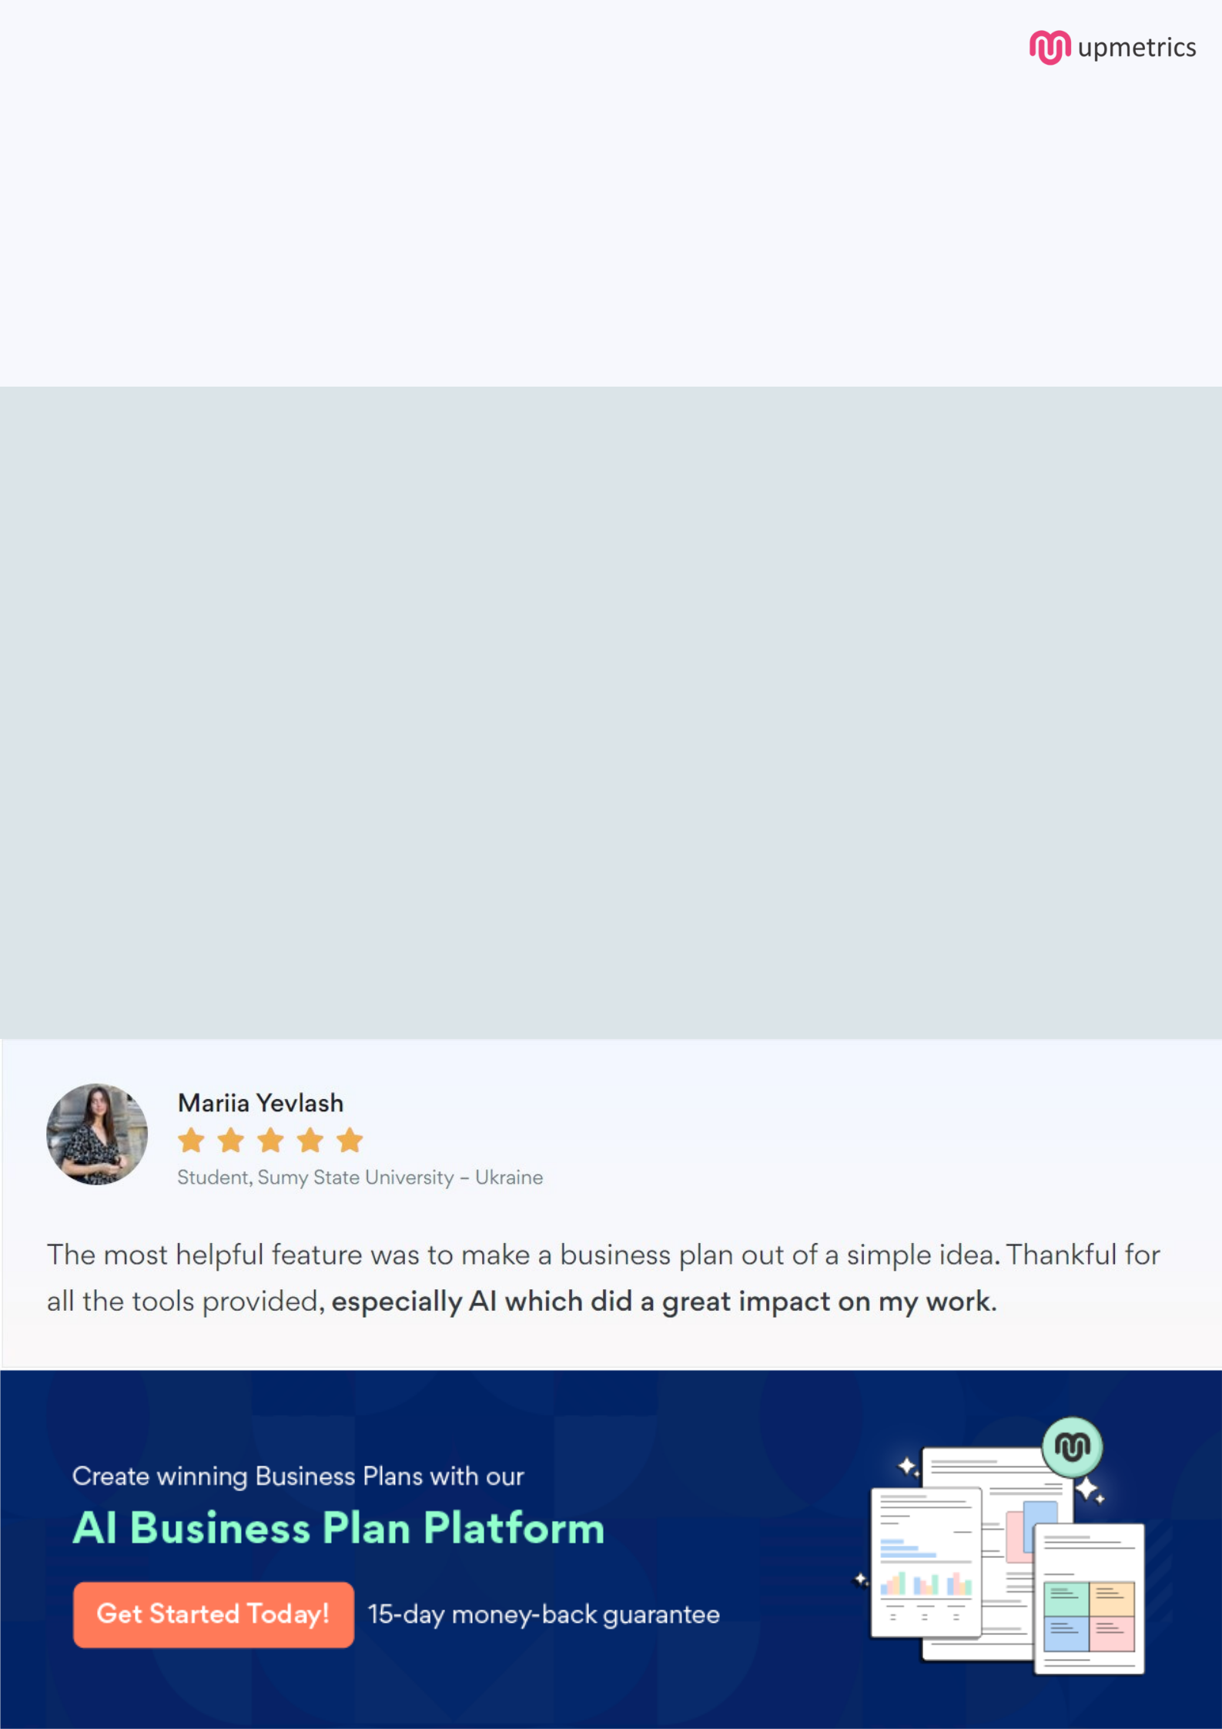
Create a winning business plan that gets you funded

Creating a stunning and investment-ready plan requires no writing, graphic designing, or financial planning expertise.

Upmetrics has all the features required to help you create a comprehensive business plan—from start to finish. Make no mistakes, it’s the modern way of planning to structure ideas, make plans, and create stunning pitch decks to awe investors.

Pitch decks that impress investors

Create pitch decks that provide a visual representation of your business, engage investors, and make them want to invest in your business idea.

Interactive plans in no time

Import business plan sections like—SWOT analysis, comparison tables, and others to create an interactive business plan. No designing skills are required.

Stunning cover page designs

With Upmetrics, you have the liberty to choose from multiple stunning cover page designs. Choose a creative design and make your plan stand out.

Online sharing made simple

Upmetrics makes online sharing quick and easier for users. Easily share your business plans with a link while tracking reader activity.

500+ sample business plans

Simply import a template from our library of sample plans into the editor and start customizing it to make it yours. It takes only a few clicks to get started.

Collaborate with team in real-time

Invite team members, initiate conversations, discuss ideas & strategies, share feedback, and work on a business plan in real-time.

