
BUSINESS PLAN

2023


Carpet Cleaning Business Plan

Elevating Comfort, Revitalizing Homes

John Doe

10200 Bolsa Ave, Westminster, CA, 92683

- 359-3153 info@example.com http://www.example.com

Information provided in this business plan is unique to this business and confidential; therefore, anyone reading this plan agrees not to disclose any of the information in this business plan without prior written permission of the company.
Table of Contents

Executive Summary | 6
Market opportunity | 6
Services Offered | 6
Marketing and sales strategies | 7
Financial Highlights | 7
Units Sold v/s Revenue | 8

Company Overview | 9
Ownership | 9
Business Owners | 9
Mission statement | 10
Business history | 10
Future goals | 10

Market Analysis | 11
Target Market | 11
Market size and growth potential | 11
Market Size | 12
Competitive analysis | 12
Spotless Solutions | 12
Clean Carpet Consortium | 13
Pristine Rug Revivers | 13
Market trends | 13
Regulatory environment | 14

Products and Services | 15
Services | 15
Steam Cleaning | 16
Odor Removal | 17
Spot Cleaning | 18
Eco-friendly Cleaning: | 18
Carpet Restoration | 19
Quality Measures | 19
Additional Services | 19

Sales And Marketing Strategies | 20
Unique Selling Proposition (USP) | 20
Pricing Strategy | 20
Marketing strategies | 21
Online | 21
Offline | 21
Sales strategies | 22
Customer retention | 23

Operations Plan | 24
Staffing & Training | 24
Operational Process | 24
Equipment & Machinery | 25

Management Team | 26
Key managers | 26
John Doe | 26
Alice Brown | 27
Robert Brown | 27
Jane Doe | 27
Organizational structure | 28
Organization chart | 28
Compensation Plan | 28
Advisors/Consultants | 29
Dr. James Smith | 29
Mrs. Lydia Green | 29
Financial Plan
Financial Plan | 30

Profit & loss statement 30

Cash flow statement | 32
Balance sheet | 33
Break-even Point | 35
Financing needs | 36
Appendix
Appendix | 37
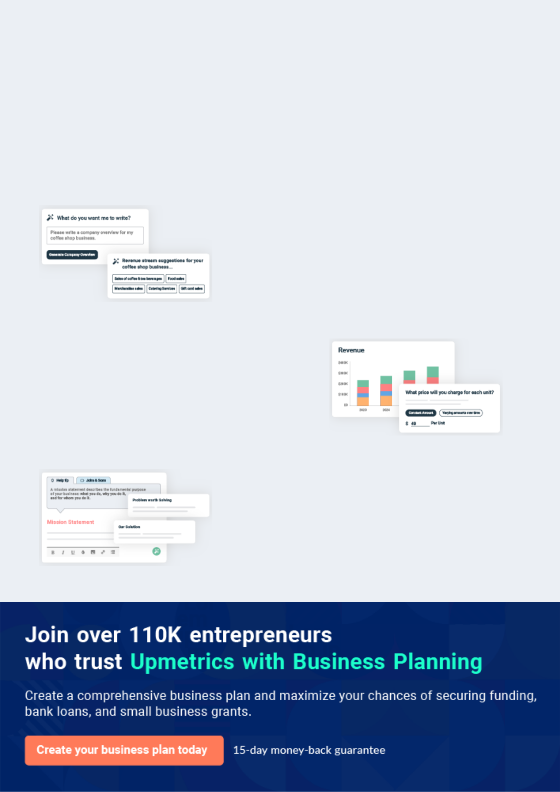
Business planning that’s simpler and faster than you think

Creating a business plan using Upmetrics to start and grow a business is literally the easiest thing in the World. Simply read the instructions and fill in the blanks. It’s as simple as that.

❛ | Upmetrics has everything you need to create a | ❜
❛ | comprehensive business plan. | ❜

AI-powered Upmetrics Assistant

AI-powered insights to streamline your plan

Not sure where to start? Upmetrics’ AI Assistant will automatically generate ideas for each section of your plan and offer improved versions of your writing, adjusting for tone, voice, and grammar or spelling errors.

Financial Forecasting Tool

All the financials are calculated for you

Forget the complex formulas and clumsy spreadsheets — with automatic financials and drag-and-drop forecasting, you can finish your plan faster and be confident that your numbers are accurate.

Business Plan Builder

Guides you like a business mentor

Upmetrics’ step-by-step instructions, prompts, and the library of 400+ sample business plans will guide you through each section of your plan as a business mentor.
Executive Summary


An executive summary is the first section of the business plan intended to provide an overview of the whole business plan.
To unlock help try Upmetrics! 

 Help tip  Carpet Cleaning Business Plan


Start your executive summary section by briefly introducing your business to your readers.

This section may include the name of your carpet cleaning business, its location when it was
To unlock help try Upmetrics! 

Start writing here..

Market opportunity

 Help tip  Carpet Cleaning Business Plan

Summarize your market research, including market size, growth potential, and marketing trends.
To unlock help try Upmetrics! 

Start writing here..

Services Offered

 Help tip  Carpet Cleaning Business Plan

Highlight the carpet cleaning services you offer your clients. The USPs and differentiators you offer are always a plus.
To unlock help try Upmetrics! 

Start writing here..

Marketing and sales strategies
To unlock help try Upmetrics!

 Help tip  Carpet Cleaning Business Plan

Outline your sales and marketing strategies—what marketing platforms you use, how you plan on acquiring customers, etc.
To unlock help try Upmetrics! 

Start writing here..

Financial Highlights

 Help tip  Carpet Cleaning Business Plan

Briefly summarize your financial projections for the initial years of business operations. Include any capital or investment requirements, associated startup costs, projected revenues, and profit forecasts.



Start writing here..
Units Sold v/s Revenue

 |  | Units Sold | Revenue
15.00k
10.00k
5.00k
0
Year 1 | Year 2 | Year 3


Financial Year |  |  | Units Sold | Revenue
Year 1 | 1,550 |  |  | $10,000
Year 2 | 1,800 |  |  | $12,000
Year 3 | 2,050 |  |  | $14,000
 Help tip |  |  Carpet Cleaning Business Plan


Summarize your executive summary section with a clear CTA, for example, inviting angel investors to discuss the potential business investment.
To unlock help try Upmetrics! 

Write a call to action for your business plan.
Company Overview

Depending on what details of your business are essential, you’ll need different elements in your business overview.
To unlock help try Upmetrics! 

 Help tip  Carpet Cleaning Business Plan

Describe your business in this section by providing all the basic information:

Business name and type: Describe what kind of carpet cleaning company you run and the name
To unlock help try Upmetrics! 

Start writing here..

Ownership

 Help tip  Carpet Cleaning Business Plan

List the names of your carpet cleaning company’s founders or owners. Describe what shares they own and their responsibilities for efficiently managing the business.
To unlock help try Upmetrics! 

Start writing here..

Business Owners



60% John Doe



40% Jane Doe
Mission statement

 Help tip  Carpet Cleaning Business Plan

Summarize your business’ objective, core principles, and values in your mission statement. This statement needs to be memorable, clear, and brief.
To unlock help try Upmetrics! 

❛ At [Carpet Cleaning Excellence], our mission is to rejuvenate every carpet we touch, infusing spaces with hygiene and aesthetics. Committed to eco-friendly solutions, we aim to serve with integrity, dedication, and a passion for customer satisfaction.

❜

Business history

 Help tip  Carpet Cleaning Business Plan

If you’re an established carpet cleaning service provider, briefly describe your business history, like—when it was founded, how it evolved over time, etc.
To unlock help try Upmetrics! 

Start writing here..

Future goals

 Help tip  Carpet Cleaning Business Plan

It’s crucial to convey your aspirations and vision. Mention your short-term and long-term goals; they can be specific targets for revenue, market share, or expanding your services.
To unlock help try Upmetrics! 

Start writing here..

Market Analysis
To unlock help try Upmetrics!


 |  | Market analysis provides a clear understanding of the market in which your
 |  | printing business will run along with the target market, competitors, and
 |  | growth opportunities.
 |  |  |  | To unlock help try Upmetrics! 
 Help tip |  |  Carpet Cleaning Business Plan

To write the introduction section of your market analysis, start by clearly identifying your primary target market.
To unlock help try Upmetrics! 

Start writing here..

Target Market

 Help tip  Carpet Cleaning Business Plan

Start this section by describing your target market. Define your ideal customer and explain what types of services they prefer. Creating a buyer persona will help you easily define your target market to your readers.



Start writing here..

Market size and growth potential

 Help tip  Carpet Cleaning Business Plan

Describe your market size and growth potential and whether you will target a niche or a much broader market.
To unlock help try Upmetrics! 

Start writing here..

Market Size

Available Market

Total potential customers needing 2M carpet cleaning in [City/Region].

Served Market
Customers within our operational areas 1M in [City/Region].

Target Market
Commercial entities and offices seeking 400k eco-friendly carpet cleaning.

 Help tip  Carpet Cleaning Business Plan

Identify and analyze your direct and indirect competitors. Identify their strengths and weaknesses, and describe what differentiates your carpet cleaning services from them.
To unlock help try Upmetrics! 

Competitive analysis

Spotless Solutions

Established in [Year], Spotless Solutions is one of the prominent names in the [City/Region] carpet cleaning industry.

With a vast service network and a decade of experience, they have catered to both residential and commercial clients.

Features | Strengths
Hot water extraction cleaning | Extensive industry experience
Stain protection services | Broad service portfolio
Upholstery cleaning | Robust client base from both
Allergen removal | residential and commercial
Allergen removal | sectors

Weaknesses

Limited focus on eco-friendly solutions

High pricing model

Reported inconsistencies in service quality across different branches

Clean Carpet Consortium

A relatively newer entrant, Clean Carpet Consortium was founded in [Year]. They have quickly risen in ranks due to their tech-driven approach and customer-centric services.

Features

Robotic carpet cleaning Eco-friendly cleaning products 24/7 online booking system

Membership-based service packages

Strengths | Weaknesses
Innovative use of technology in | Limited offline presence
services | Lack of extensive industry
Competitive pricing | experience
Strong online presence and | Dependence on technology can
digital marketing strategies | sometimes alienate traditional
 | clients

Pristine Rug Revivers

Pristine Rug Revivers, operating since [Year], have carved a niche for themselves by specializing in high-end, luxury carpet cleaning for elite clientele.

Features | Strengths
Luxury rug restoration | Exclusive focus on luxury
Organic cleaning solutions | market segment
Home consultation and carpet | Expertise in handling delicate
Home consultation and carpet | and expensive rugs
care guidance | and expensive rugs
Personalized cleaning plans | Strong word-of-mouth referrals

Weaknesses

Limited to a specific clientele, missing out on the broader market

Premium pricing, making it inaccessible to many

Longer turnaround time due to meticulous cleaning processes

Market trends

 Help tip  Carpet Cleaning Business Plan

Analyze emerging trends in the industry, such as technology disruptions, changes in customer behavior or preferences, etc. Explain how your business will cope with all the trends.
To unlock help try Upmetrics! 

Start writing here..

Regulatory environment
To unlock help try Upmetrics!

 Help tip  Carpet Cleaning Business Plan

List regulations and licensing requirements that may affect your carpet cleaning company, such as business registration, insurance, environmental regulations, state and federal regulations, etc.



Start writing here..
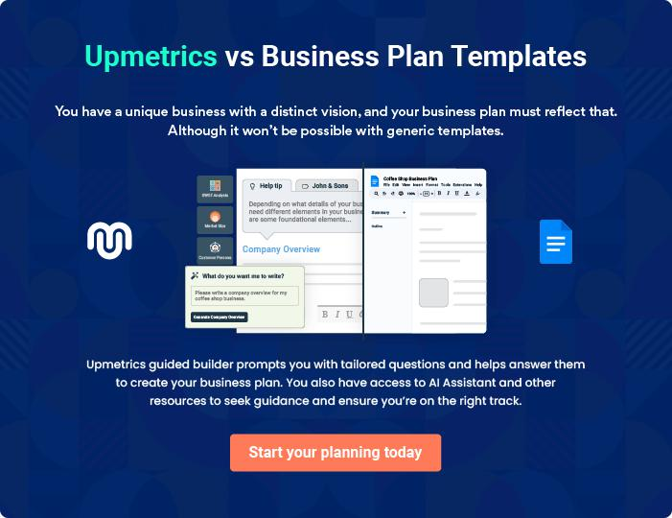
Products and Services
To unlock help try Upmetrics!

The product and services section of carpet cleaning business plan should describe the specific services and products that will be offered to customers. To write this section should include the following:



 Help tip  Carpet Cleaning Business Plan

To craft the introduction for your "Products and Services" chapter, begin by positioning your business within its industry, emphasizing its unique strengths or value proposition.
To unlock help try Upmetrics! 

Start writing here..

 Help tip


Mention the carpet cleaning services your business will offer. This list may include services like,

• Steam cleaning
To unlock help try Upmetrics! 

Services
Steam Cleaning


Price: Standard Room (up to 200 sq.ft): [$70], Large

Room (201-400 sq.ft): [$120], Extra Large Room (400+

sq.ft): [$150], Staircase: [$2 per step]

- Our steam cleaning process is a comprehensive method designed to penetrate deep into carpet fibers, removing embedded dirt, bacteria, and allergens.

- Using high-temperature steam generated from [specific brand or type of equipment], this method effectively lifts the dirt that regular vacuuming misses.

Service Specifications

- After a pre-treatment to address any stains or high-traffic areas, the steam cleaning process commences, usually taking [2-3 hours] for an average-sized room.

- The result is a thoroughly cleaned carpet with a refreshed appearance and feel.

- Additionally, we only utilize [specific eco-friendly or brand-name cleaning agents], ensuring a safe environment for both children and pets.
Odor Removal

Price: Standard Room: [$30], Large Room: [$50], Whole

House (up to 2000 sq.ft): [$200], Additional charges for

severe odor: Starting from [$20]

Persistent odours in carpets can be challenging, but our specialized odour removal process ensures a fresh-smelling environment:

- Identifying the Source: The first step is pinpointing the exact source of the odour, be it pet stains, food spills, or mould growth.

- Using Specialized Cleaning Agents: Our choice of cleaning agent, particularly the enzymatic cleaners, targets odor-causing bacteria. These cleaners break down the odor molecules, rather than just masking the smell.

- Eliminating Odor Molecules: Post cleaning, the area is treated with [specific deodorizers or neutralizers] that ensure any residual odor molecules are neutralized, leaving the carpet smelling fresh.

Service Specifications

- The entire odor removal process typically takes between [1-2 hours], depending on the severity and size of the affected area.
Spot Cleaning

Price: Standard Stain: [$10], Large or Aged Stain: [$20],

Wine, Ink, or Oil Stain: [$30]

- Accidental spills and stubborn stains require a targeted approach. Our spot cleaning service is meticulously designed to address such challenges.

- Starting with a thorough assessment of the stain type, we then apply a [specific pre-treatment agent] that helps in loosening the stain particles.

- Using [specific equipment, e.g., a portable extractor], the stain is then lifted from the carpet.

Service Specifications

- The spot-cleaning process is both gentle and effective, ensuring the carpet fibres are not damaged.

- On average, spot cleaning a stain might take anywhere from [15 minutes to an hour], depending on stain age and type.

Eco-friendly Cleaning:

Price: Standard Room: [$80], Large Room: [$130], Whole

House (up to 2000 sq.ft): [$500]

- In our commitment to sustainability and client well-being, our eco-friendly cleaning service ensures minimal environmental impact.

- We employ [specific brand or type of green cleaning agents] that are biodegradable and non-toxic.

- These agents effectively clean while ensuring no harmful residues are left behind.

- The process is similar to our standard cleaning but with the assurance that every product used is eco-friendly.

Service Specifications

- An average room cleaned using our eco-friendly methods typically takes [2-3 hours].

Carpet Restoration

Price: Patchwork: Starting from [$50] (based on size),

Re-dyeing: Starting from [$100] (based on color and

size), Complete Restoration (Standard Room): [$200],

Complete Restoration (Large Room): [$300]

- Carpets that are extensively worn out or damaged require more than just cleaning. Our carpet restoration service aims to revive such carpets.

- Starting with an assessment of the damage, we employ methods like [re-dyeing, patching, or re-fraying] to restore its appearance.

- Any deep-set stains or embedded dirt are addressed using [specific cleaning agents]. Finally, the carpet is treated with protective agents to prevent future wear and tear.

Service Specifications

- Depending on the extent of damage, carpet restoration can take anywhere from [3-5 hours].

Quality Measures

 Help tip  Carpet Cleaning Business Plan

This section should explain how you maintain quality standards and consistently provide the highest quality service.
To unlock help try Upmetrics! 

Start writing here..

Additional Services

 Help tip  Carpet Cleaning Business Plan

Mention if your carpet cleaning company offers any additional services. You may include services like, mattress cleaning, carpet installation, cushion or upholstery cleaning, etc.
To unlock help try Upmetrics! 

Start writing here..

Sales And Marketing Strategies
To unlock help try Upmetrics!

Writing the sales and marketing strategies section means a list of strategies you will use to attract and retain your clients.
To unlock help try Upmetrics! 

 Help tip  Carpet Cleaning Business Plan

To create an effective introduction for your "Sales and Marketing Strategies" chapter, start by setting the stage within your specific industry or market.
To unlock help try Upmetrics! 

Unique Selling Proposition (USP)

 Help tip  Carpet Cleaning Business Plan


Define your business’s USPs depending on the market you serve, the equipment you use, and
the unique services you provide. Identifying USPs will help you to plan your marketing
strategies.
 |  |  |  | To unlock help try Upmetrics! 
Start writing here..
Pricing Strategy
 Help tip |  |  Carpet Cleaning Business Plan

Describe your pricing strategy—how you plan to price your cleaning services and stay competitive in the local market. You can mention any discounts you plan on offering to attract new customers to your cleaning service.



Start writing here..

 Help tip  Carpet Cleaning Business Plan
To unlock help try Upmetrics!

Discuss your marketing strategies to market your services. You may include some of these marketing strategies in your business plan—social media marketing, Google ads, brochures, email marketing, content marketing, and print marketing.



Marketing strategies

Online


Social Media Marketing

Active engagement on platforms like [Facebook, Instagram, and Twitter], showcasing our work, sharing cleaning tips, and promoting special offers.

Content Marketing

Sharing informative articles and blogs on carpet care on our website, positioning us as industry experts.

Email Marketing

Regular newsletters and promotions sent to our customer base, keeping them informed about seasonal offers and new services.

Google Ads

Targeted ads aimed at [City/ Region] residents, ensuring visibility when potential customers search for carpet cleaning services.

Offline

Brochures

Distributed in [local stores, residential complexes, and commercial buildings], providing insights into our services and USPs.

Print Marketing

Local newspaper ads and community bulletin board postings to tap into the local audience.

 Help tip
To unlock help try Upmetrics!

Outline the strategies you’ll implement to maximize your sales. Your sales strategies may include direct sales calls, partnering with other cleaning or housekeeping businesses, offering referral programs, etc.



Sales strategies

Partner with Businesses

Collaborating with [housekeeping businesses or property management companies] to offer our services as part of their packages.

Referral Programs

Encouraging our satisfied clients to refer our services to friends and family in exchange for discounts on future services.

Direct Sales Calls

Proactively reaching out to [businesses, property managers, and real estate agents] showcasing our services.

 Help tip

Describe your customer retention strategies and how you plan to execute them. For instance, introducing loyalty programs, discounts on annual membership, personalized service, etc.
To unlock help try Upmetrics! 

Customer retention

Loyalty Programs

Regular clients can avail of loyalty cards, accumulating points with each service that can be redeemed for discounts

Personalized Service

Keeping track of customer preferences, ensuring each visit is tailored to their specific needs and feedback.

Annual Membership

Offering a yearly membership that includes periodic cleaning at discounted rates and priority scheduling.

Operations Plan
To unlock help try Upmetrics!

 |  | When writing the operations plan section, it’s important to consider the
 |  | various aspects of your business operations.
 |  |  |  | To unlock help try Upmetrics! 
 Help tip |  |  Carpet Cleaning Business Plan


To create an effective introduction for your "Operational Plan" chapter, start by emphasizing the
pivotal role of efficient operations in the success of your business, underscoring how they
directly impact the quality of services delivered.
 |  |  |  | To unlock help try Upmetrics! 
Start writing here..
Staffing & Training
 Help tip |  |  Carpet Cleaning Business Plan

Mention your cleaning business’s staffing requirements, including the number of employees or
cleaning staff needed. Include their qualifications, the training required, and the duties they will
perform.
 |  |  |  | To unlock help try Upmetrics! 
Start writing here..
Operational Process
 Help tip |  |  Carpet Cleaning Business Plan

Outline the processes and procedures you will use to run your carpet cleaning business. Your operational processes may include sending quotations, scheduling appointments, site visits, training employees, and carpet cleaning.



Start writing here..

Equipment & Machinery
To unlock help try Upmetrics!

 Help tip  Carpet Cleaning Business Plan

Include the list of equipment and machinery required for carpet cleaning, such as scrubbing machines, cleaning sprays, vacuum cleaners, air movers, specialized cleaning agents, dehumidifiers, etc.



Start writing here..
Management Team

The management team section provides an overview of the individuals responsible for running your business plan.
To unlock help try Upmetrics! 

 Help tip  Carpet Cleaning Business Plan

To craft an introduction for your "Management Team" chapter, begin by emphasizing the crucial role of leadership in the success of any business.
To unlock help try Upmetrics! 

Start writing here..

Key managers

 Help tip  Carpet Cleaning Business Plan

Introduce your management and key members of your team, and explain their roles and responsibilities.
To unlock help try Upmetrics! 

Start writing here..


JOHN DOE

Founder and CEO - john.doe@example.com

John is the visionary behind [Carpet Cleaning Excellence].

Holding an MBA from [Harvard Business School], he embarked on his entrepreneurial journey [XX] years ago.


John's professional trajectory began in [Company Name], where he rose to the rank of [Senior Position, e.g., Director of Operations] before venturing into the carpet cleaning industry.

His leadership acumen, combined with his profound industry insights, makes him the driving force of the company.

ALICE BROWN

Chief Operating Officer (COO) - alice.brown@example.com

Alice, with her BA in Business Management from [Stanford University], possesses over [XX] years of operational expertise.

Starting her career with [Company Name], Alice played pivotal roles in streamlining operations and optimizing processes.


Her adeptness at ensuring operational efficiency is instrumental in our daily operations.


ROBERT BROWN

CMO - robert.brown@example.com

A marketing maestro, Robert holds a Master's in Marketing from [Yale School of Management].

With [XX] years under his belt, he served in leading roles in renowned firms like [Company Name], strategizing their global marketing campaigns.

At Carpet Cleaning Excellence, Robert crafts ingenious marketing strategies that bolster our brand and customer outreach.


JANE DOE

Operations Manager - jane.doe@example.com

Jane graduated with a degree in [Operational Management] from [University of California, Berkeley].

With [XX] years in the cleaning industry, she's honed her skills in ensuring smooth and efficient service delivery.

Prior to joining our team, Jane was the [Position, e.g., Regional Operations Head] at [Company Name], managing a team of over [XX] personnel.
Organizational structure

 Help tip  Carpet Cleaning Business Plan

Explain the organizational structure of your management team. Include the reporting line and decision-making hierarchy.
To unlock help try Upmetrics! 

Start writing here..

Organization chart


John Doe

CEO


Jane Doe

Robert Brown Operations Manager Alice Brown

CMO COO


[EMPLOYEE2] [EMPLOYEE3] [EMPLOYEE1]

Compensation Plan

 Help tip  Carpet Cleaning Business Plan

Describe your compensation plan for the management and staff. Include their salaries, incentives, and other benefits.
To unlock help try Upmetrics! 

Start writing here..

 Help tip  Carpet Cleaning Business Plan

Mentioning advisors or consultants in your business plans adds credibility to your business idea.
To unlock help try Upmetrics! 

Advisors/Consultants

DR. JAMES SMITH

An industry stalwart with over [XX] years in the cleaning business, Dr. Smith provides insights into market trends, technological advancements, and business expansion strategies.

MRS. LYDIA GREEN

Specializing in sustainable cleaning solutions, Mrs. Green advises on eco-friendly practices and product selections.
Financial Plan
To unlock help try Upmetrics!

When writing the financial plan section of a business plan, it’s important to provide a comprehensive overview of your financial projections for the first few years of your business, You may provide the following:
To unlock help try Upmetrics! 

 Help tip  Carpet Cleaning Business Plan

To create an effective introduction for your "Financial Plan" chapter, begin by stressing the critical role of a well-structured financial plan in the success of your venture.
To unlock help try Upmetrics! 

Start writing here..

 Help tip

Describe details such as projected revenue, operational costs, and service costs in your projected profit and loss statement. Make sure to include your business’s expected net profit or loss.



Profit & loss statement

 | 2023-24 | 2024-25 | 2025-26 | 2026-27 | 2027-28
Revenue | $0 | $0 | $0 | $0 | $0

Cost Of Sales | $0 | $0 | $0 | $0 | $0
General Costs | $0 | $0 | $0 | $0 | $0
Revenue Specific Costs | $0 | $0 | $0 | $0 | $0
Personnel Costs (Direct | $0 | $0 | $0 | $0 | $0
Labor)

Gross Margin $0 $0 $0 $0 $0

Gross Margin (%)

Operating Expense

Payroll Expense

(Indirect Labor)

General Expense

Bad Debt

Amortization of Current Assets

EBITDA

Additional Expense

Long Term

Depreciation

Gain or loss from Sale of Assets

EBIT

Interest Expenses

EBT

Income Tax Expense

Total Expense

Net Income

Net Income (%)

2023-24 | 2024-25 | 2025-26 | 2026-27 | 2027-28
0% | 0% | 0% | 0% | 0%
$0 | $0 | $0 | $0 | $0
$0 | $0 | $0 | $0 | $0
$0 | $0 | $0 | $0 | $0
$0 | $0 | $0 | $0 | $0
$0 | $0 | $0 | $0 | $0
$0 | $0 | $0 | $0 | $0
$0 | $0 | $0 | $0 | $0
$0 | $0 | $0 | $0 | $0
$0 | $0 | $0 | $0 | $0
$0 | $0 | $0 | $0 | $0
$0 | $0 | $0 | $0 | $0
$0 | $0 | $0 | $0 | $0
$0 | $0 | $0 | $0 | $0
$0 | $0 | $0 | $0 | $0
$0 | $0 | $0 | $0 | $0
0% | 0% | 0% | 0% | 0%
 | 2023-24 | 2024-25 | 2025-26 | 2026-27 | 2027-28
Retained Earning | $0 | $0 | $0 | $0 | $0
Opening
Owner's Distribution | $0 | $0 | $0 | $0 | $0
Retained Earning | $0 | $0 | $0 | $0 | $0
Closing

 Help tip

The cash flow for the first few years of your operation should be estimated and described in this section.
To unlock help try Upmetrics! 

Cash flow statement

Cash Received

Cash Paid

COS & General Expenses

Salary & Wages

Interest

Sales Tax

Income Tax

Net Cash From

Operations

Assets Sell

Assets Purchase

Net Cash From

Investments

2023-24 | 2024-25 | 2025-26 | 2026-27 | 2027-28
$0 | $0 | $0 | $0 | $0
$0 | $0 | $0 | $0 | $0
$0 | $0 | $0 | $0 | $0
$0 | $0 | $0 | $0 | $0
$0 | $0 | $0 | $0 | $0
$0 | $0 | $0 | $0 | $0
$0 | $0 | $0 | $0 | $0
$0 | $0 | $0 | $0 | $0

$0 | $0 | $0 | $0 | $0
$0 | $0 | $0 | $0 | $0
$0 | $0 | $0 | $0 | $0

 | 2023-24 | 2024-25 | 2025-26 | 2026-27 | 2027-28
Amount Received | $0 | $0 | $0 | $0 | $0
Loan Received | $0 | $0 | $0 | $0 | $0
Common Stock
Preferred Stock | $0 | $0 | $0 | $0 | $0
Owner's Contribution | $0 | $0 | $0 | $0 | $0
Amount Paid | $0 | $0 | $0 | $0 | $0
Loan Capital | $0 | $0 | $0 | $0 | $0
Dividends & Distributions | $0 | $0 | $0 | $0 | $0
Net Cash From | $0 | $0 | $0 | $0 | $0
Financing

Summary
Starting Cash | $0 | $0 | $0 | $0 | $0
Cash In | $0 | $0 | $0 | $0 | $0
Cash Out | $0 | $0 | $0 | $0 | $0
Change in Cash | $0 | $0 | $0 | $0 | $0
Ending Cash | $0 | $0 | $0 | $0 | $0

 Help tip

Create a projected balance sheet documenting your carpet cleaning business’s assets, liabilities, and equity.
To unlock help try Upmetrics! 

Balance sheet

 | 2023-24 | 2024-25 | 2025-26 | 2026-27 | 2027-28
Assets | $0 | $0 | $0 | $0 | $0
 | 2023-24 | 2024-25 | 2025-26 | 2026-27 | 2027-28
Current Assets | $0 | $0 | $0 | $0 | $0
Cash | $0 | $0 | $0 | $0 | $0
Accounts Receivable | $0 | $0 | $0 | $0 | $0
Inventory | $0 | $0 | $0 | $0 | $0
Other Current Assets | $0 | $0 | $0 | $0 | $0
Long Term Assets | $0 | $0 | $0 | $0 | $0
Gross Long Term Assets | $0 | $0 | $0 | $0 | $0
Accumulated Depreciation | $0 | $0 | $0 | $0 | $0

Liabilities & Equity | $0 | $0 | $0 | $0 | $0
Liabilities | $0 | $0 | $0 | $0 | $0
Current Liabilities | $0 | $0 | $0 | $0 | $0
Accounts Payable | $0 | $0 | $0 | $0 | $0
Income Tax Payable | $0 | $0 | $0 | $0 | $0
Sales Tax Payable | $0 | $0 | $0 | $0 | $0
Short Term Debt | $0 | $0 | $0 | $0 | $0
Long Term Liabilities | $0 | $0 | $0 | $0 | $0
Long Term Debt | $0 | $0 | $0 | $0 | $0
Equity | $0 | $0 | $0 | $0 | $0
Paid-in Capital | $0 | $0 | $0 | $0 | $0
Common Stock | $0 | $0 | $0 | $0 | $0
Preferred Stock | $0 | $0 | $0 | $0 | $0
Owner's Contribution | $0 | $0 | $0 | $0 | $0
Retained Earnings | $0 | $0 | $0 | $0 | $0
 | 2023-24 |  | 2024-25 | 2025-26 | 2026-27 | 2027-28
Check | $0 |  | $0 | $0 | $0 | $0
 Help tip |  |  Carpet Cleaning Business Plan

Determine and mention your business’s break-even point—the point at which your business costs and revenue will be equal.
To unlock help try Upmetrics! 

Break-even Point

 | 2023-24 | 2024-25 | 2025-26 | 2026-27 | 2027-28
Starting Revenue | $0 | $0 | $0 | $0 | $0
Net Revenue | $0 | $0 | $0 | $0 | $0
Closing Revenue | $0 | $0 | $0 | $0 | $0

Starting Expense | $0 | $0 | $0 | $0 | $0
Net Expense | $0 | $0 | $0 | $0 | $0
Closing Expense | $0 | $0 | $0 | $0 | $0

Is Break Even? | 0 | 0 | 0 | 0 | 0
Break Even Month | 0 | 0 | 0 | 0 | 0
Days Required | 0 | 0 | 0 | 0 | 0
Break Even Revenue | $0 | $0 | $0 | $0 | $0
Break Even Units
Financing needs

 Help tip  Carpet Cleaning Business Plan

Calculate costs associated with starting a carpet cleaning business, and estimate your financing needs and how much capital you need to raise to operate your business.
To unlock help try Upmetrics! 

Start writing here..
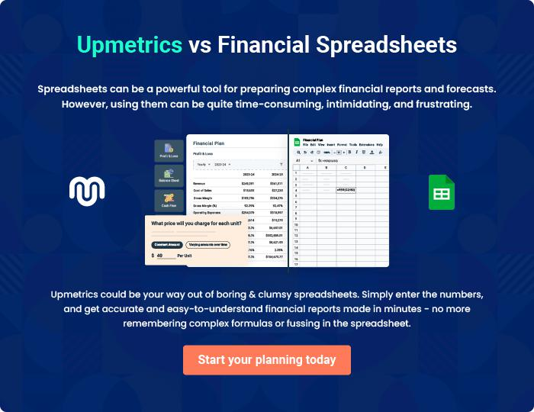
Appendix

When writing the appendix section, you should include any additional information that supports the main content of your plan. This may include financial statements, market research data, legal documents, and other
To unlock help try Upmetrics! 
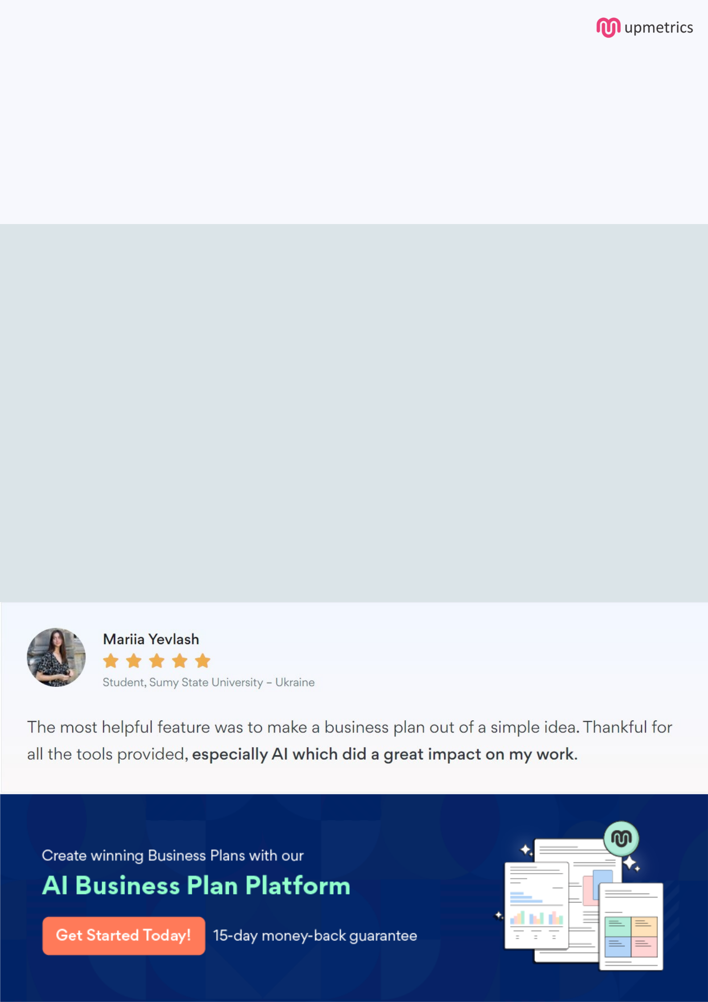
Create a winning business plan that gets you funded

Creating a stunning and investment-ready plan requires no writing, graphic designing, or financial planning expertise.

Upmetrics has all the features required to help you create a comprehensive business plan—from start to finish. Make no mistakes, it’s the modern way of planning to structure ideas, make plans, and create stunning pitch decks to awe investors.

Pitch decks that impress investors

Create pitch decks that provide a visual representation of your business, engage investors, and make them want to invest in your business idea.

Interactive plans in no time

Import business plan sections like—SWOT analysis, comparison tables, and others to create an interactive business plan. No designing skills are required.

Stunning cover page designs

With Upmetrics, you have the liberty to choose from multiple stunning cover page designs. Choose a creative design and make your plan stand out.

Online sharing made simple

Upmetrics makes online sharing quick and easier for users. Easily share your business plans with a link while tracking reader activity.

500+ sample business plans

Simply import a template from our library of sample plans into the editor and start customizing it to make it yours. It takes only a few clicks to get started.

Collaborate with team in real-time

Invite team members, initiate conversations, discuss ideas & strategies, share feedback, and work on a business plan in real-time.

