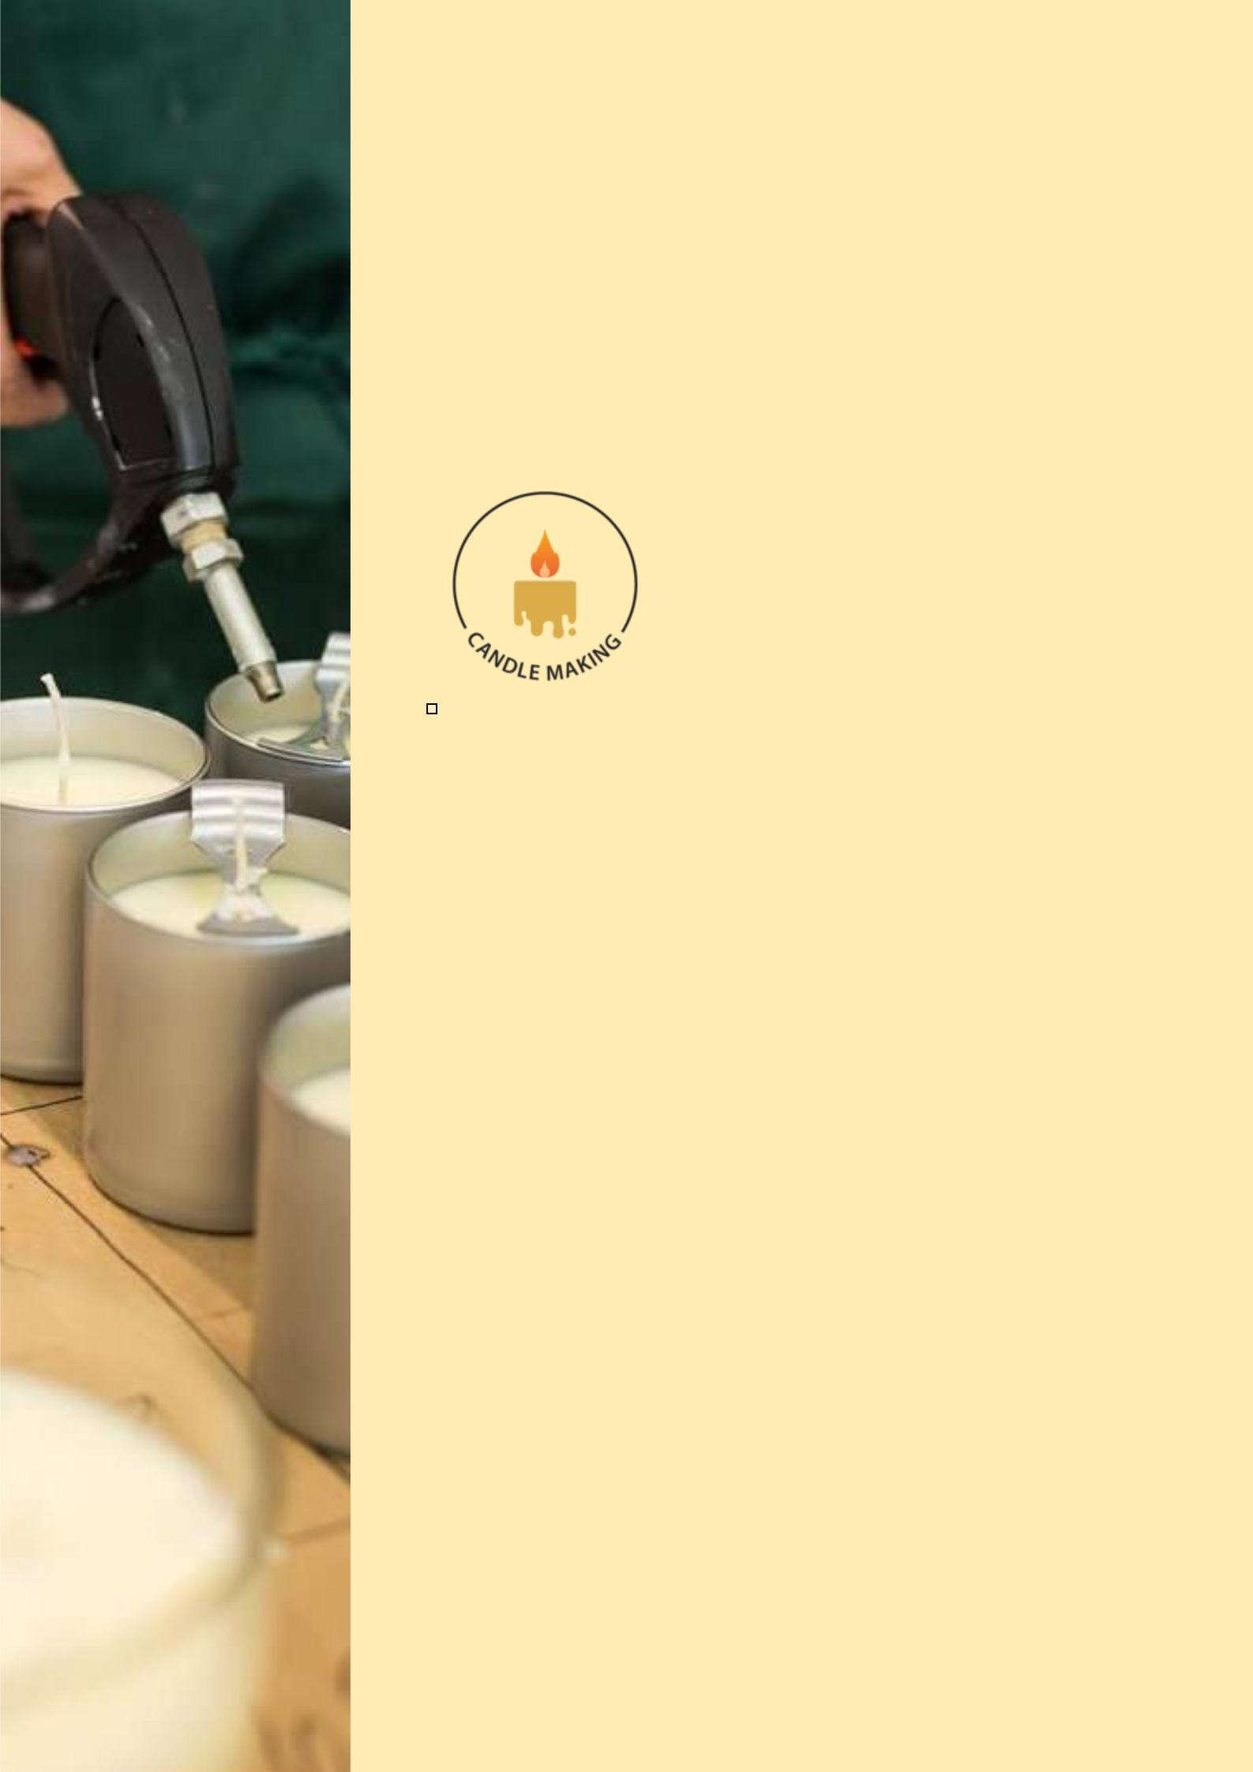
BUSINESS PLAN

2023

Candle Making

Business Plan

Illuminating Moments, Crafted by Light

John Doe

10200 Bolsa Ave, Westminster, CA, 92683

- 359-3153 info@example.com http://www.example.com

Information provided in this business plan is unique to this business and confidential; therefore, anyone reading this plan agrees not to disclose any of the information in this business plan without prior written permission of the company.
Table of Contents

Executive Summary | 6
Market opportunity | 6
Product Description | 6
Management team | 7
John Doe | 7
Jane Doe | 7
Alice Brown | 7
Robert Brown | 7
Financial Highlights | 8
Units Sold v/s Revenue | 8

Company Overview | 9
Ownership | 9
Business Owners | 9
Mission statement | 10
Business history | 10
Future goals | 10

Market Analysis | 11
Target Market | 11
Market size and growth potential | 11
Market Size | 12
Competitive analysis | 12
Radiant Aromas Co. | 12
LuminaCandles Inc. | 13
NatureGlow Enterprises | 13
Market trends | 13
Regulatory environment | 14
Products and Services | 15
Products | 15
Scented Candles | 15
Decorative Candles | 17
Taper Candles | 17
Pillar Candles | 18
Soy Candles | 18
Shipping and Delivery | 19
Emphasize safety and quality | 19

Sales And Marketing Strategies | 20
Unique Selling Proposition (USP) | 20
Pricing Strategy | 20
Marketing strategies | 21
Online | 21
Offline | 21
Sales strategies | 22
Customer retention | 22

Operations Plan | 23
Hiring Plan | 23
Operational Process | 23
Equipment and Raw Materials | 24

Management Team | 25
Key managers | 25
John Doe | 26
Jane Doe | 27
Alice Brown | 27
Robert Johnson | 27
Organizational structure | 28
Organization chart | 28

Compensation plan 28

Board of advisors | 29
[ADVISOR NAME] | 29
[ADVISOR NAME] | 29

Financial Plan | 30
Profit & loss statement | 30
Cash flow statement | 32
Balance sheet | 33
Break-even Point | 35
Financing needs | 36
Appendix
Appendix | 37
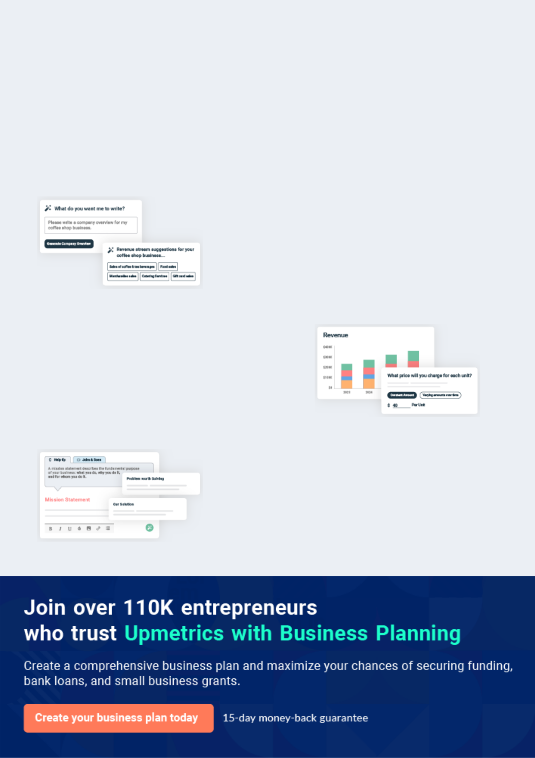
Business planning that’s simpler and faster than you think

Creating a business plan using Upmetrics to start and grow a business is literally the easiest thing in the World. Simply read the instructions and fill in the blanks. It’s as simple as that.

❛ | Upmetrics has everything you need to create a | ❜
❛ | comprehensive business plan. | ❜

AI-powered Upmetrics Assistant

AI-powered insights to streamline your plan

Not sure where to start? Upmetrics’ AI Assistant will automatically generate ideas for each section of your plan and offer improved versions of your writing, adjusting for tone, voice, and grammar or spelling errors.

Financial Forecasting Tool

All the financials are calculated for you

Forget the complex formulas and clumsy spreadsheets — with automatic financials and drag-and-drop forecasting, you can finish your plan faster and be confident that your numbers are accurate.

Business Plan Builder

Guides you like a business mentor

Upmetrics’ step-by-step instructions, prompts, and the library of 400+ sample business plans will guide you through each section of your plan as a business mentor.
Executive Summary
To unlock help try Upmetrics!


An executive summary is the first section of the business plan intended to provide an overview of the whole business plan.
To unlock help try Upmetrics! 

 Help tip  Candle Making Business Plan


Start your executive summary by introducing your idea behind starting a candle making business and explaining what it does.
To unlock help try Upmetrics! 

Start writing here..

Market opportunity

 Help tip  Candle Making Business Plan

Describe the target market in brief, and explain the demographics, geographic location, and psychographic attributes of your customer.
To unlock help try Upmetrics! 

Start writing here..

Product Description

 Help tip  Candle Making Business Plan

Briefly describe what products customers can expect from your business. Also, incorporate brief information mentioning the quality measures you implement, keeping product quality and consumer satisfaction in mind.



Start writing here..

 Help tip


Name all the key members of your management team with their duties, responsibilities, and qualifications.
To unlock help try Upmetrics! 

Management team


JOHN DOE

CEO - john.doe@example.com

bringing over [10 years] of experience in the crafts industry and a passion for sustainable products.


JANE DOE

Chief Marketing Officer - jane.doe@example.com

with a background in digital marketing and a keen understanding of consumer behavior.


ALICE BROWN

Product Development Head - alice.brown@example.com

holding a degree in [aromatherapy] and [7 years] of experience in scented product creation.


ROBERT BROWN

Operations Manager

streamlining processes with his [8 years] in logistics and operations management.

Financial Highlights

 Help tip  Candle Making Business Plan

Provide a summary of your financial projections for the company’s initial years of operation.

Include any capital or investment requirements, startup costs, projected revenues, and profits.
To unlock help try Upmetrics! 

Start writing here..

Units Sold v/s Revenue

 |  | Units Sold | Revenue
15.00k
10.00k
5.00k
0
Year 1 | Year 2 | Year 3
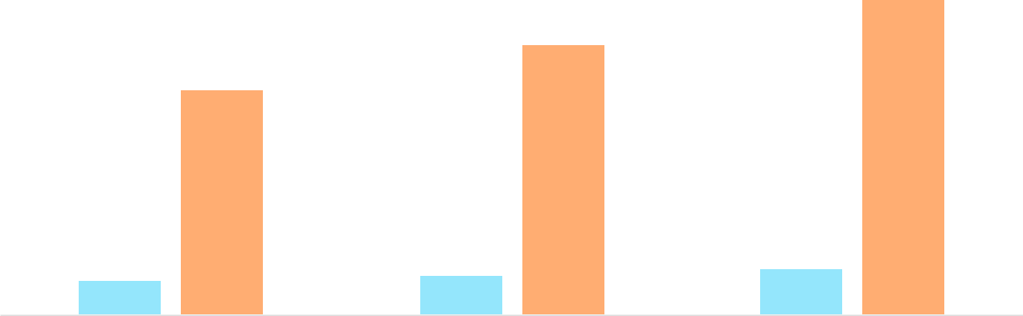

Financial Year |  |  | Units Sold | Revenue
Year 1 | 1,550 |  |  | $10,000
Year 2 | 1,800 |  |  | $12,000
Year 3 | 2,050 |  |  | $14,000
 Help tip |  |  Candle Making Business Plan
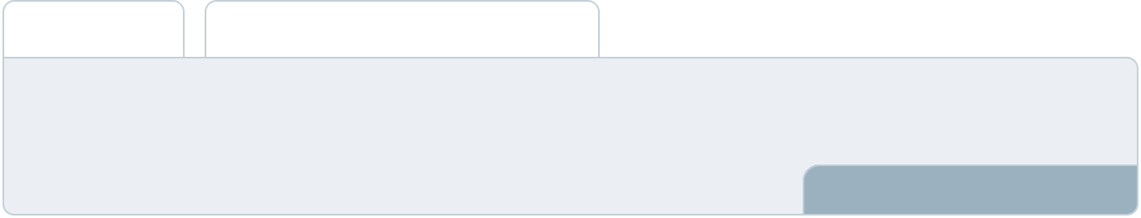

After briefly explaining your business plan, end your summary with a call to action, inviting potential investors or readers to the next meeting if they are interested in your business.
To unlock help try Upmetrics! 

Write a call to action for your business plan.

Company Overview

Depending on what details of your business are essential, you’ll need different elements in your business overview.
To unlock help try Upmetrics! 

 Help tip  Candle Making Business Plan

Provide all the basic information about your business in this section like:

• The name and type of your candle business: mention whether you are a homemade
To unlock help try Upmetrics! 

Start writing here..

Ownership

 Help tip  Candle Making Business Plan

Describe the owners of your candle making business and mention their roles in running it. Who owns what shares in the corporation, and how each owner helps in the business?
To unlock help try Upmetrics! 

Start writing here..

Business Owners



60% John Doe



30% Jane Doe



10% Alice Brown

Mission statement
To unlock help try Upmetrics!

 Help tip  Candle Making Business Plan

Add a mission statement that sums up your business objectives and core principles. This statement needs to be memorable, clear, and brief.
To unlock help try Upmetrics! 

❛ At [Candle Creations], we ignite emotions. Our mission is to craft candles that are more than just sources of light – they are vessels of memories, relaxation, and warmth. With sustainability at our core, every flicker embodies our commitment to the earth

and to unmatched quality.
❜

Business history

 Help tip  Candle Making Business Plan

Include an outline of your business’s history and how it came to be in its current position.

If you can, add some personality and intriguing details, especially if you got any achievements
To unlock help try Upmetrics! 

Start writing here..

Future goals

 Help tip  Candle Making Business Plan

It’s crucial to convey your aspirations and your vision. Include the vision of where you see your business in the near future and if you plan to expand your business overseas, to another state, or another city.



Start writing here..

Market Analysis


 |  | Market analysis provides a clear understanding of the market in which your
 |  | printing business will run along with the target market, competitors, and
 |  | growth opportunities.
 |  |  |  | To unlock help try Upmetrics! 
 Help tip |  |  Candle Making Business Plan

To write the introduction section of your market analysis, start by clearly identifying your primary target market.
To unlock help try Upmetrics! 

Start writing here..

Target Market

 Help tip  Candle Making Business Plan

Identify your target market and define your ideal customer.

Know more about your ideal customer and what type of products they prefer: scented candles,
To unlock help try Upmetrics! 

Start writing here..

Market size and growth potential

 Help tip  Candle Making Business Plan

Provide an overview of the candle making industry. It will include market size, trends, growth potential, and regulatory considerations.
To unlock help try Upmetrics! 

Start writing here..

Market Size


Available Market | 10M
All individuals buying candles in the U.S. | 10M

Served Market
Those preferring artisanal, handcrafted 7M candles.

Target Market
Aged 25-45, seeking sustainable & 2M premium scented candles.

 Help tip  Candle Making Business Plan

Identify and analyze all other candle making businesses in the local market, including direct and indirect competitors.
To unlock help try Upmetrics! 

Competitive analysis

Radiant Aromas Co.

Established in [2010], Radiant Aromas Co. has been a household name, renowned for its vast range of fragrances. From fresh florals to mystic woods, they've crafted scents for every mood.

Features Strengths

Weaknesses

A monthly subscription box offering varied scents.

Eco-friendly packaging.

Collaborations with celebrity influencers for limited edition scents.

Broad fragrance portfolio catering to diverse preferences.

Strong online presence with an engaging social media strategy.

Loyalty programs lead to high customer retention.

Largely deploys synthetic fragrances which might not appeal to the natural-centric market.

Higher price points due to celebrity collaborations, potentially alienating budget-conscious customers.

LuminaCandles Inc.

A newer entrant, LuminaCandles Inc. began its journey in [2018]. They've quickly gained traction for their innovative candle designs and interactive workshops.

Features

DIY candle-making kits for a personalized experience.

Workshops conducted in various cities on the art of candle crafting.

Limited edition 'Artisan Series' featuring intricate designs.

Strengths

Unique value proposition with DIY kits attracting the creative market segment.

Strong community engagement through workshops.

Quick adaptation to market trends, ensuring they remain contemporary.

Weaknesses

Smaller scent range compared to older, established brands.

Occasional quality inconsistencies in the DIY kits, as reported by some users.

Limited online distribution channels.

NatureGlow Enterprises

With a foundation rooted in sustainability, NatureGlow Enterprises, since [2015], has been championing the cause of eco-friendly candles made from 100% natural ingredients.

Features | Strengths
Candles crafted exclusively | Appeals strongly to the
from beeswax and essential | environmentally conscious
oils. | demographic.
Packaging made from recycled | Transparent ingredient list,
materials. | building trust among
Partnerships with | consumers.
environmental NGOs, | Positive brand image due to
dedicating a percentage of | eco-initiatives and
profits to green causes. | partnerships.

Weaknesses

Limited to only beeswax, missing out on the vegan market segment.

Premium pricing due to eco-friendly materials.

Slower production rate owing to the commitment to handcrafted processes.

Market trends

 Help tip  Candle Making Business Plan

Analyze current and emerging trends in your industry, such as technological changes or customer preferences.
To unlock help try Upmetrics! 

Start writing here..

Regulatory environment

 Help tip  Candle Making Business Plan

Describe any regulations or licensing requirements that affect candle making, such as business & tax registration, candle labeling requirements, safety regulations, etc.
To unlock help try Upmetrics! 

Start writing here..
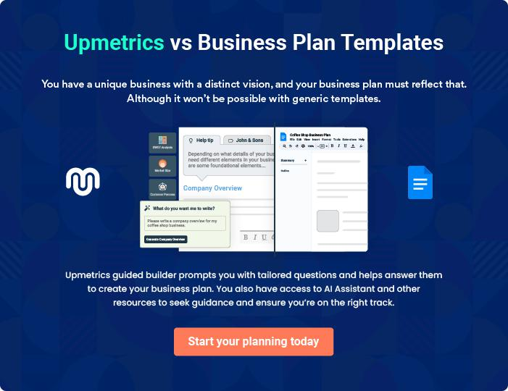
Products and Services
To unlock help try Upmetrics!

The product and services section of a candle making business plan should describe the specific services and products that will be offered to customers. To write this section should include the following:



 Help tip  Candle Making Business Plan

To craft the introduction for your "Products and Services" chapter, begin by positioning your business within its industry, emphasizing its unique strengths or value proposition.
To unlock help try Upmetrics! 

Start writing here..

 Help tip

Create a list of the type of candles your candle business will offer, including scented, decorative, taper, pillar, soy, etc.
To unlock help try Upmetrics! 

Products

Scented Candles


Price: [$15.99] each

Our scented candles are crafted to immerse spaces in captivating fragrances.
Product Specifications

- Dimensions: 3 inches (width) x 4 inches (height)

- Weight: 300 grams

- Burn Time: Approx. 40 hours

- Fragrance Variants: Lavender, Vanilla, Rose, Jasmine, and Sandalwood

- Wax Type: Paraffin and soy blend

- Packaging: Recyclable cardboard box with a ribbon tie
Decorative Candles

Price: [$24.99] each

Merging form and function, these candles are masterpieces of design and illumination

Product Specifications

- Dimensions: Varies by design

- Weight: Varies by design

- Burn Time: Approx. 30 hours

- Designs: Floral, Geometric, Abstract

- Wax Type: Paraffin blend

- Packaging: Protective bubble wrap with a decorative box

Taper Candles

Price: [$9.99] for a set of 2

Tall and slender, these candles exude grace and are perfect for dinners and ceremonial events.

Product Specifications

- Dimensions: 1 inch (width) x 12 inches (height)

- Weight: 100 grams each

- Burn Time: Approx. 10 hours

- Colors: White, Cream, Red, Green, Blue

- Wax Type: Paraffin blend

- Packaging: Box set with a clear viewing window
Pillar Candles

Price: [$19.99] each

These robust candles offer prolonged burn times and are perfect standalone pieces or as part of candle arrangements.

Product Specifications

- Dimensions: 4 inches (width) x 6 inches (height)

- Weight: 600 grams

- Burn Time: Approx. 60 hours

- Colours: White, Cream, Charcoal, Rustic Red

- Wax Type: Paraffin blend

- Packaging: Wrapped in branded parchment paper with a sticker seal

Soy Candles

Price: [$17.99] eac

Made from 100% soy wax, these eco-friendly candles offer a cleaner burn and are a testament to our commitment to sustainability.

Product Specifications

- Dimensions: 3 inches (width) x 3 inches (height)

- Weight: 250 grams

- Burn Time: Approx. 45 hours

- Fragrance Variants: Unscented, Lemongrass, Mint, Eucalyptus

- Wax Type: 100% Soy

- Packaging: Recyclable tin container with a branded label
Shipping and Delivery

 Help tip  Candle Making Business Plan

Explain how your business will handle the shipping of your products and if you will charge any additional fee for these services.
To unlock help try Upmetrics! 

Emphasize safety and quality

 Help tip  Candle Making Business Plan

In all descriptions of your products, emphasize the importance of product quality and how your candle making company will ensure it.
To unlock help try Upmetrics! 

Start writing here..
Sales And Marketing Strategies

Writing the sales and marketing strategies section means a list of strategies you will use to attract and retain your clients.
To unlock help try Upmetrics! 

 Help tip  Candle Making Business Plan

To create an effective introduction for your "Sales and Marketing Strategies" chapter, start by setting the stage within your specific industry or market.
To unlock help try Upmetrics! 

Unique Selling Proposition (USP)

 Help tip  Candle Making Business Plan

Clearly define your business’s unique selling propositions, which can be your expertise in the market, customizations you offer, prime project locations, and so on.
To unlock help try Upmetrics! 

Start writing here..

Pricing Strategy

 Help tip  Candle Making Business Plan

Develop a pricing strategy that is competitive and affordable yet profitable. Consider offering promotions, discounts, or packages for your candle making services to attract new customers.
To unlock help try Upmetrics! 

Start writing here..

 Help tip  Candle Making Business Plan
To unlock help try Upmetrics!

Develop a marketing strategy that includes a mix of online and offline marketing tactics. Consider social media, email marketing, content marketing, brochures, print marketing, and events.



Marketing strategies

Online


Social Media

Platforms like Instagram and Pinterest, showcasing our candles in aesthetic setups and behind-the-scenes craftsmanship.

Content Marketing

Blog posts on the art of candle-making, the benefits of different waxes, and more.

Offline

Brochures

High-quality print materials detailing our product range, available at our store and partner outlets.

Email Marketing

Newsletters detailing new launches, exclusive discounts, and candle care tips.

Events

Workshops on candle crafting and scent blending, fostering community and brand engagement.

 Help tip  Candle Making Business Plan

Mention your sales strategy as in – offering competitive pricing, seasonal discounts, product customizations, attending trade shows and events, etc.
To unlock help try Upmetrics! 

Sales strategies

Competitive Pricing

While ensuring profitability, our prices resonate with the value we offer.

Seasonal Discounts

Catering to peak buying seasons, ensuring increased sales volume.

Product Customizations Trade Shows & Events

Addressing unique customer needs, from scent blends to candle shapes.

Presence in major craft and lifestyle exhibitions, introducing our brand to wider audiences.

 Help tip  Candle Making Business Plan

Describe how your business will retain customers and build loyalty, through loyalty programs, by offering free samples or personalized service.
To unlock help try Upmetrics! 

Customer retention

Loyalty Programs

Points-based systems, where accumulated points can be redeemed on future purchases

Personalized Service

Free Samples

Introducing customers to new fragrances through complimentary mini-candles with sizeable purchases.

Offering consultations on custom

blends and personalized candle

engravings for special occasions.

Operations Plan

 |  | When writing the operations plan section, it’s important to consider the
 |  | various aspects of your business operations.
 |  |  |  | To unlock help try Upmetrics! 
 Help tip |  |  Candle Making Business Plan
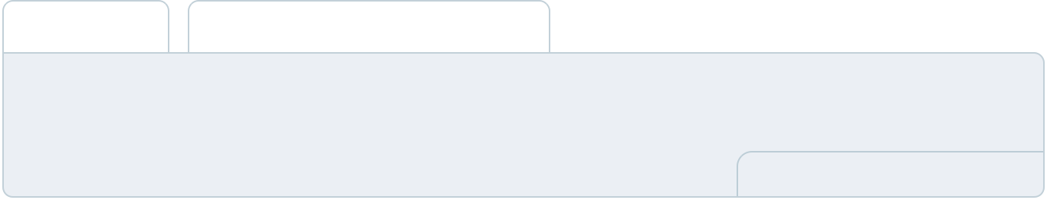

To create an effective introduction for your "Operational Plan" chapter, start by emphasizing the
pivotal role of efficient operations in the success of your business, underscoring how they
directly impact the quality of services delivered.
 |  |  |  | To unlock help try Upmetrics! 
Start writing here..
Hiring Plan
 Help tip |  |  Candle Making Business Plan

Tell the staffing requirements of your candle making business, including the number of employees needed, their qualifications, and the duties they will perform.
To unlock help try Upmetrics! 

Start writing here..

Operational Process

 Help tip  Candle Making Business Plan

Outline the processes and procedures you will use to run your business. It includes manufacturing, inventory management, distribution, Quality Control, etc.
To unlock help try Upmetrics! 

Start writing here..

Equipment and Raw Materials

 Help tip  Candle Making Business Plan

Describe the equipment and raw materials used in your business operations, such as pouring pots, molds, wick holders, stirring tools, scales, wax, labels, packaging materials, etc.
To unlock help try Upmetrics! 

Start writing here..
Management Team

The management team section provides an overview of the individuals responsible for running your business plan.
To unlock help try Upmetrics! 

 Help tip  Candle Making Business Plan

To craft an introduction for your "Management Team" chapter, begin by emphasizing the crucial role of leadership in the success of any business.
To unlock help try Upmetrics! 

Start writing here..

Key managers

 Help tip  Candle Making Business Plan

Describe your management team’s key members, roles, and responsibilities.

It should include the owners, senior management, sales and marketing managers, packaging
To unlock help try Upmetrics! 

Start writing here..
JOHN DOE

CEO & Founder - john.doe@example.com

John's entrepreneurial spirit combined with his dedication to craftsmanship led to the establishment of Candle Creations.

Holding a Master's in Business Administration from Harvard University, he ventured into the artisanal world of candle-making after a successful stint at a leading management consultancy firm.


His passion for sustainable and handcrafted goods positions the company at the forefront of the industry.

- Educational Background: MBA, Harvard University

- Professional Background: Senior Consultant at EliteManagement Corp for 5 years
JANE DOE

Sales & Marketing Manager - jane.doe@example.com

With a flair for understanding market dynamics and consumer behavior, Jane is the force behind Candle Creations' branding and outreach initiatives.

A Marketing graduate from Stanford University, she spent her initial years mastering the art of brand storytelling at Lumina Aromas, a renowned candle company.

- Educational Background: BSc in Marketing, Stanford University

- Professional Background: Brand Strategist at Lumina Aromas for 4 years


ALICE BROWN

Packaging & Shipping Manager - alice.brown@example.com

Ensuring that every meticulously crafted candle reaches its owner in pristine condition is Alice's primary mission.

With a degree in Supply Chain Management from MIT, she's optimized the logistics and distribution channels of Candle Creations, making it a benchmark for competitors.

- Educational Background: MSc in Supply Chain Management, MIT

- Professional Background: Logistics Manager at FastTrack Couriers for 6 years

ROBERT JOHNSON

Quality Control Inspector - robert.johnson@example.com

Robert's keen eye ensures that every candle not only looks perfect but also burns with consistency.

An alumnus of UCLA with a degree in Chemical Engineering, he understands the nuances of wax compositions and fragrance diffusions. His tenure at Aromatique Candles enriched him with hands-on experience in quality assurance.

- Educational Background: B.Tech in Chemical Engineering, UCLA

- Professional Background: Quality Assurance Lead at Aromatique Candles for 3 years
Organizational structure

 Help tip  Candle Making Business Plan

Describe the organizational structure of the management team, including reporting lines and how decisions will be made.
To unlock help try Upmetrics! 

Start writing here..

Organization chart


John Doe

CEO




Alice Brown Jane Doe

Packaging & Shipping Manager Sales and Marketing Manager



Lily Turner Robert Johnson

Operations Manager Quality Control Inspector

Compensation plan

 Help tip  Candle Making Business Plan

Describe your compensation plan for the management team and staff, including salaries, bonuses, and other benefits.
To unlock help try Upmetrics! 

Start writing here..

 Help tip

If you have a board of advisors for your business, then mention them along with their roles and experience.
To unlock help try Upmetrics! 

Board of advisors


[ADVISOR NAME]

Advisor

Former CEO of [Company Name, e.g., "Aromatique Candles"], [Advisor Name]'s insights into the industry are invaluable. With [X years] in the candle-making sector, [he/she] advises us on strategic expansion and partnerships.

[ADVISOR NAME]

Consultant

With a rich background in sustainability and eco-conscious ventures, [Advisor Name] helps align our operations with green initiatives, ensuring we remain environmentally responsible.
Financial Plan
To unlock help try Upmetrics!

When writing the financial plan section of a business plan, it’s important to provide a comprehensive overview of your financial projections for the first few years of your business, You may provide the following:
To unlock help try Upmetrics! 

 Help tip  Candle Making Business Plan

To create an effective introduction for your "Financial Plan" chapter, begin by stressing the critical role of a well-structured financial plan in the success of your venture.
To unlock help try Upmetrics! 

Start writing here..

 Help tip

Create a projected profit & loss statement that describes the expected revenue, cost of products sold, and operational costs. Your business’s anticipated net profit or loss should be computed and included.



Profit & loss statement

 | 2023-24 | 2024-25 | 2025-26 | 2026-27 | 2027-28
Revenue | $0 | $0 | $0 | $0 | $0

Cost Of Sales | $0 | $0 | $0 | $0 | $0
General Costs | $0 | $0 | $0 | $0 | $0
Revenue Specific Costs | $0 | $0 | $0 | $0 | $0
Personnel Costs (Direct | $0 | $0 | $0 | $0 | $0
Labor)

Gross Margin $0 $0 $0 $0 $0

Gross Margin (%)

Operating Expense

Payroll Expense

(Indirect Labor)

General Expense

Bad Debt

Amortization of Current Assets

EBITDA

Additional Expense

Long Term

Depreciation

Gain or loss from Sale of Assets

EBIT

Interest Expenses

EBT

Income Tax Expense

Total Expense

Net Income

Net Income (%)

2023-24 | 2024-25 | 2025-26 | 2026-27 | 2027-28
0% | 0% | 0% | 0% | 0%
$0 | $0 | $0 | $0 | $0
$0 | $0 | $0 | $0 | $0
$0 | $0 | $0 | $0 | $0
$0 | $0 | $0 | $0 | $0
$0 | $0 | $0 | $0 | $0
$0 | $0 | $0 | $0 | $0
$0 | $0 | $0 | $0 | $0
$0 | $0 | $0 | $0 | $0
$0 | $0 | $0 | $0 | $0
$0 | $0 | $0 | $0 | $0
$0 | $0 | $0 | $0 | $0
$0 | $0 | $0 | $0 | $0
$0 | $0 | $0 | $0 | $0
$0 | $0 | $0 | $0 | $0
$0 | $0 | $0 | $0 | $0
0% | 0% | 0% | 0% | 0%
 | 2023-24 | 2024-25 | 2025-26 | 2026-27 | 2027-28
Retained Earning | $0 | $0 | $0 | $0 | $0
Opening
Owner's Distribution | $0 | $0 | $0 | $0 | $0
Retained Earning | $0 | $0 | $0 | $0 | $0
Closing

 Help tip

Estimate your cash inflows and outflows for the first few years of operation. It should include client cash receipts, vendor payments, loan payments, and other cash inflows and outflows.
To unlock help try Upmetrics! 

Cash flow statement

Cash Received

Cash Paid

COS & General Expenses

Salary & Wages

Interest

Sales Tax

Income Tax

Net Cash From

Operations

Assets Sell

Assets Purchase

Net Cash From

Investments

2023-24 | 2024-25 | 2025-26 | 2026-27 | 2027-28
$0 | $0 | $0 | $0 | $0
$0 | $0 | $0 | $0 | $0
$0 | $0 | $0 | $0 | $0
$0 | $0 | $0 | $0 | $0
$0 | $0 | $0 | $0 | $0
$0 | $0 | $0 | $0 | $0
$0 | $0 | $0 | $0 | $0
$0 | $0 | $0 | $0 | $0

$0 | $0 | $0 | $0 | $0
$0 | $0 | $0 | $0 | $0
$0 | $0 | $0 | $0 | $0

 | 2023-24 | 2024-25 | 2025-26 | 2026-27 | 2027-28
Amount Received | $0 | $0 | $0 | $0 | $0
Loan Received | $0 | $0 | $0 | $0 | $0
Common Stock
Preferred Stock | $0 | $0 | $0 | $0 | $0
Owner's Contribution | $0 | $0 | $0 | $0 | $0
Amount Paid | $0 | $0 | $0 | $0 | $0
Loan Capital | $0 | $0 | $0 | $0 | $0
Dividends & Distributions | $0 | $0 | $0 | $0 | $0
Net Cash From | $0 | $0 | $0 | $0 | $0
Financing

Summary
Starting Cash | $0 | $0 | $0 | $0 | $0
Cash In | $0 | $0 | $0 | $0 | $0
Cash Out | $0 | $0 | $0 | $0 | $0
Change in Cash | $0 | $0 | $0 | $0 | $0
Ending Cash | $0 | $0 | $0 | $0 | $0

 Help tip

Prepare a projected balance sheet, which shows the business’s assets, liabilities, and equity.

To unlock help try Upmetrics! 

Balance sheet

 | 2023-24 | 2024-25 | 2025-26 | 2026-27 | 2027-28
Assets | $0 | $0 | $0 | $0 | $0
 | 2023-24 | 2024-25 | 2025-26 | 2026-27 | 2027-28
Current Assets | $0 | $0 | $0 | $0 | $0
Cash | $0 | $0 | $0 | $0 | $0
Accounts Receivable | $0 | $0 | $0 | $0 | $0
Inventory | $0 | $0 | $0 | $0 | $0
Other Current Assets | $0 | $0 | $0 | $0 | $0
Long Term Assets | $0 | $0 | $0 | $0 | $0
Gross Long Term Assets | $0 | $0 | $0 | $0 | $0
Accumulated Depreciation | $0 | $0 | $0 | $0 | $0

Liabilities & Equity | $0 | $0 | $0 | $0 | $0
Liabilities | $0 | $0 | $0 | $0 | $0
Current Liabilities | $0 | $0 | $0 | $0 | $0
Accounts Payable | $0 | $0 | $0 | $0 | $0
Income Tax Payable | $0 | $0 | $0 | $0 | $0
Sales Tax Payable | $0 | $0 | $0 | $0 | $0
Short Term Debt | $0 | $0 | $0 | $0 | $0
Long Term Liabilities | $0 | $0 | $0 | $0 | $0
Long Term Debt | $0 | $0 | $0 | $0 | $0
Equity | $0 | $0 | $0 | $0 | $0
Paid-in Capital | $0 | $0 | $0 | $0 | $0
Common Stock | $0 | $0 | $0 | $0 | $0
Preferred Stock | $0 | $0 | $0 | $0 | $0
Owner's Contribution | $0 | $0 | $0 | $0 | $0
Retained Earnings | $0 | $0 | $0 | $0 | $0
 | 2023-24 |  |  | 2024-25 | 2025-26 | 2026-27 | 2027-28
Check | $0 |  |  | $0 | $0 | $0 | $0
 Help tip |  |  Candle Making Business Plan

Determine how your candle-making business will break even or generate enough revenue to cover its operating costs.
To unlock help try Upmetrics! 

Break-even Point

 | 2023-24 | 2024-25 | 2025-26 | 2026-27 | 2027-28
Starting Revenue | $0 | $0 | $0 | $0 | $0
Net Revenue | $0 | $0 | $0 | $0 | $0
Closing Revenue | $0 | $0 | $0 | $0 | $0

Starting Expense | $0 | $0 | $0 | $0 | $0
Net Expense | $0 | $0 | $0 | $0 | $0
Closing Expense | $0 | $0 | $0 | $0 | $0

Is Break Even? | 0 | 0 | 0 | 0 | 0
Break Even Month | 0 | 0 | 0 | 0 | 0
Days Required | 0 | 0 | 0 | 0 | 0
Break Even Revenue | $0 | $0 | $0 | $0 | $0
Break Even Units
Financing needs
To unlock help try Upmetrics!

 Help tip  Candle Making Business Plan

Estimate how much financing you will need to start and operate your candle making business. It should include short-term and long-term financing needs, such as loans or investment capital.



Start writing here..
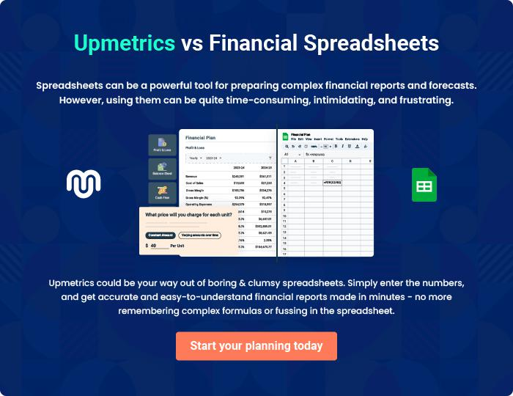
Appendix

When writing the appendix section, you should include any additional information that supports the main content of your plan. This may include financial statements, market research data, legal documents, and other
To unlock help try Upmetrics! 
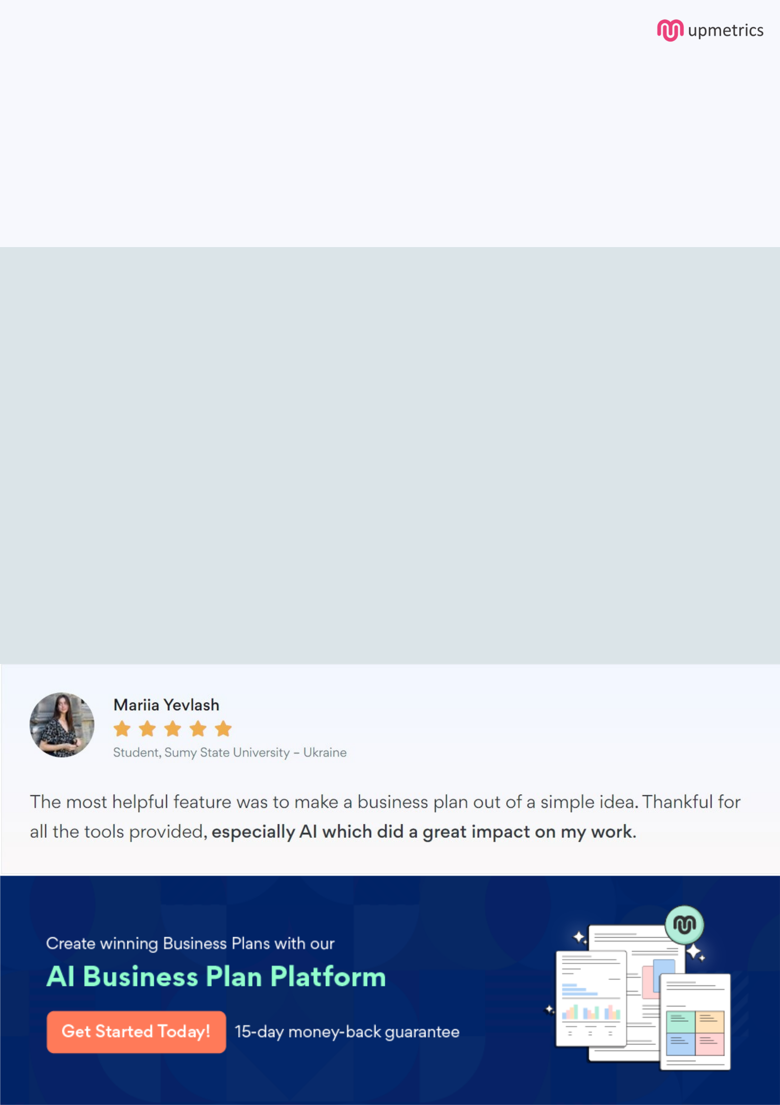
Create a winning business plan that gets you funded

Creating a stunning and investment-ready plan requires no writing, graphic designing, or financial planning expertise.

Upmetrics has all the features required to help you create a comprehensive business plan—from start to finish. Make no mistakes, it’s the modern way of planning to structure ideas, make plans, and create stunning pitch decks to awe investors.

Pitch decks that impress investors

Create pitch decks that provide a visual representation of your business, engage investors, and make them want to invest in your business idea.

Interactive plans in no time

Import business plan sections like—SWOT analysis, comparison tables, and others to create an interactive business plan. No designing skills are required.

Stunning cover page designs

With Upmetrics, you have the liberty to choose from multiple stunning cover page designs. Choose a creative design and make your plan stand out.

Online sharing made simple

Upmetrics makes online sharing quick and easier for users. Easily share your business plans with a link while tracking reader activity.

500+ sample business plans

Simply import a template from our library of sample plans into the editor and start customizing it to make it yours. It takes only a few clicks to get started.

Collaborate with team in real-time

Invite team members, initiate conversations, discuss ideas & strategies, share feedback, and work on a business plan in real-time.

