

Cafe Business Plan

Aroma & Ambiance in Every Cup


Business
Plan

2023

Prepared By

John Doe

10200 Bolsa Ave, Westminster, CA, 92683

info@example.com

(650) 359-3153 http://www.example.com

Table of Contents

Executive Summary | 6
Market opportunity | 6
Services Offered | 6
Management team | 7
John Doe | 7
Jane Doe | 7
Alice White | 7
Robert Green | 7
Financial Highlights | 8
Units Sold v/s Revenue | 8

Company Overview | 9
Ownership | 9
Mission statement | 10
Business history | 10
Future goals | 10

Market Analysis | 11
Target Market | 11
Market size and growth potential | 11
Market Size | 12
Competitive analysis | 12
Bean Bliss Cafe | 12
Mocha Melodies | 13
Market trends | 13
Regulatory environment | 13

Products and Services | 15
Products and Services | 15
Espresso | 15
Cappuccino | 16
Avocado Toast | 16
Vegan Berry Smoothie | 17
Private Event Hosting | 17
Catering Services | 18
Quality Standards | 18

Sales And Marketing Strategies | 19
Unique Selling Proposition (USP) | 19
Pricing Strategy | 19
Marketing strategies | 20
Online | 20
Offline | 20
Sales strategies | 21
Customer retention | 21

Operations Plan | 22
Hiring Plan | 22
Operational Process | 22
Equipment | 23

Management Team | 24
Key managers | 24
John Doe | 24
Jane Doe | 25
Alice Brown | 25
Robert Brown | 25
Organizational structure | 25
Organization chart | 26
Compensation plan | 26
Board of advisors | 27
Mr. Samuel Lee | 27
Dr. Michelle Smith | 27
Financial Plan | 28
Profit & loss statement | 28
Cash flow statement | 30
Balance sheet | 31
Break-even Point | 33
Balance Sheet | 33
Financing needs | 34
Appendix
Appendix | 36
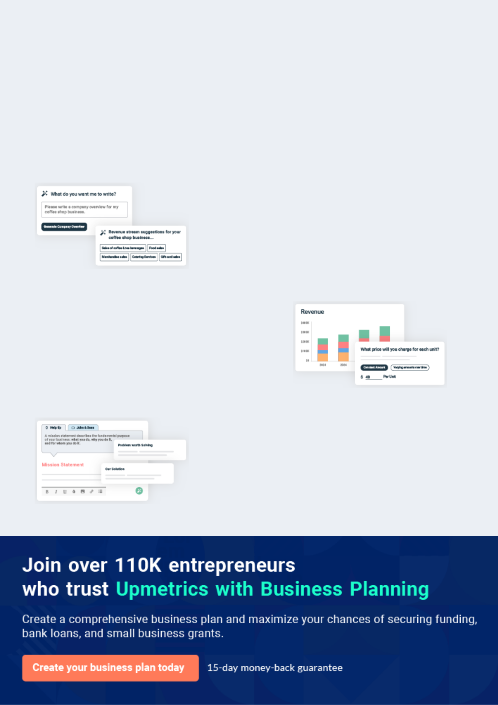
Business planning that’s simpler and faster than you think

Creating a business plan using Upmetrics to start and grow a business is literally the easiest thing in the World. Simply read the instructions and fill in the blanks. It’s as simple as that.

❛ | Upmetrics has everything you need to create a | ❜
❛ | comprehensive business plan. | ❜

AI-powered Upmetrics Assistant

AI-powered insights to streamline your plan

Not sure where to start? Upmetrics’ AI Assistant will automatically generate ideas for each section of your plan and offer improved versions of your writing, adjusting for tone, voice, and grammar or spelling errors.

Financial Forecasting Tool

All the financials are calculated for you

Forget the complex formulas and clumsy spreadsheets — with automatic financials and drag-and-drop forecasting, you can finish your plan faster and be confident that your numbers are accurate.

Business Plan Builder

Guides you like a business mentor

Upmetrics’ step-by-step instructions, prompts, and the library of 400+ sample business plans will guide you through each section of your plan as a business mentor.
Executive Summary


An executive summary is the first section of the business plan intended to provide an overview of the whole business plan.
To unlock help try Upmetrics! 

 Help tip  Cafe Business Plan


Start your executive summary by introducing your idea behind starting a cafe business and explaining what it does.
To unlock help try Upmetrics! 

Start writing here..

Market opportunity

 Help tip  Cafe Business Plan

Describe the target market in brief, and explain the demographics, geographic location, and psychographic attributes of your customer.
To unlock help try Upmetrics! 

Start writing here..

Services Offered

 Help tip  Cafe Business Plan

The plan outlines the menu, culinary procedures, inventory control, and other operational specifics necessary to guarantee the cafe’s offerings are of a high standard and consistency.
To unlock help try Upmetrics! 

Start writing here..

 Help tip


Name all the key members of your management team with their duties, responsibilities, and qualifications.
To unlock help try Upmetrics! 

Management team


JOHN DOE

CEO - john.doe@example.com

Founder & CEO with over [number, e.g., "10"] years of experience in the hospitality industry.


JANE DOE

Senior Manager - jane.doe@example.com

Operations Manager, responsible for [specific duties, e.g., "daily operations, supplier relations, and inventory control"], boasting a stellar track record in [specific achievements, e.g., "boosting operational efficiency in her previous roles"].


ALICE WHITE

Culinary Director - alice.brown@example.com

Culinary Director, whose culinary prowess ensures our offerings are top-notch. Alice has worked in [specific background, e.g., "renowned cafes and patisseries in Paris"].


ROBERT GREEN

Marketing & Community Engagement Head - robert.brown@example.com

Marketing & Community Engagement Head, tasked with [specific duties, e.g., "branding, promotions, and establishing local partnerships"]. His expertise in [specific field, e.g., "digital marketing and event organization"] is invaluable.

Financial Highlights
To unlock help try Upmetrics!

 Help tip  Cafe Business Plan

Provide a summary of your financial projections for the company’s initial years of operation.

Include any capital or investment requirements, startup costs, projected revenues, and profits.
To unlock help try Upmetrics! 

Start writing here..

Units Sold v/s Revenue

 |  | Units Sold | Revenue
15.00k
10.00k
5.00k
0
Year 1 | Year 2 | Year 3


Financial Year |  |  | Units Sold | Revenue
Year 1 | 1,550 |  |  | $10,000
Year 2 | 1,800 |  |  | $12,000
Year 3 | 2,050 |  |  | $14,000
 Help tip |  |  Cafe Business Plan


After giving a brief about your business plan, end your summary with a call to action, for example; inviting potential investors or readers to the next meeting if they are interested in your business.



Write a call to action for your business plan.

Company Overview

Depending on what details of your business are essential, you’ll need different elements in your business overview.
To unlock help try Upmetrics! 

 Help tip  Cafe Business Plan

Provide all the basic information about your business in this section like:

• The name of the cafe and the concept of your cafe: a drive-through cafe, a cafe bakery, a
To unlock help try Upmetrics! 

Start writing here..

Ownership

 Help tip  Cafe Business Plan

Describe the owners of your cafe and mention their roles in running it. Whose shares in the corporation are they, and how each owner helps in the business?
To unlock help try Upmetrics! 

Start writing here..
Mission statement
To unlock help try Upmetrics!

 Help tip  Cafe Business Plan

Add a mission statement that sums up the objectives and core principles of your cafe. This statement needs to be memorable, clear, and brief.
To unlock help try Upmetrics! 

❛ [Your Cafe's Name] aims to [specific mission, e.g., 'blend the magic of cinema with the comfort of a cup of coffee, offering an escape into the golden era of Hollywood while ensuring sustainability, community connection, and unparalleled customer

satisfaction'].
❜

Business history

 Help tip  Cafe Business Plan


Include an outline of the cafe’s history and how it came to be in its current position. If you can,
add some personality and intriguing details, especially if you got any achievements or
recognitions till now for your incredible services.
 |  |  |  |  | To unlock help try Upmetrics! 
Start writing here..
Future goals
 Help tip |  |  |  Cafe Business Plan

It’s crucial to convey your aspirations and your vision. Include the vision of where you see your business in the near future and if you have any plans of opening a new franchise of your business in the same city in the future.



Start writing here..

Market Analysis
To unlock help try Upmetrics!
To unlock help try Upmetrics!

Market analysis provides a clear understanding of the market in which your printing business will run along with the target market, competitors, and growth opportunities.



 Help tip  Cafe Business Plan

To write the introduction section of your market analysis, start by clearly identifying your primary target market.
To unlock help try Upmetrics! 

Start writing here..

Target Market

 Help tip  Cafe Business Plan

Identify your target market and define your ideal customer. Know more about your customers and which services they prefer: what menu do the customers prefer, do they prefer takeout or delivery or dive in, do they prefer bakery too?



Start writing here..

Market size and growth potential

 Help tip  Cafe Business Plan

Provide an overview of the cafe industry. It will include market size, trends, growth potential, and regulatory considerations.
To unlock help try Upmetrics! 

Start writing here..

Market Size

Available Market

Total coffee drinkers in [Region/City, 1M e.g., "Westminster"].

Served Market
Those preferring specialty cafes over 500k regular diners.

Target Market
Young professionals seeking themed 100k cafes in Westminster.

 Help tip  Cafe Business Plan

Identify and analyze all other cafes in the local area, including direct and indirect competitors.

Evaluate their strengths and weaknesses, and explain how your cafe can offer qualitative
To unlock help try Upmetrics! 

Competitive analysis

Bean Bliss Cafe

Established in [year, e.g., "2015"], Bean Bliss Cafe has quickly risen to be a local favorite, with its [specific theme or concept, e.g., "rustic decor and live music evenings"].

Features | Strengths
Extensive range of coffee | Diverse coffee menu catering
blends from global origins. | to connoisseurs.
Vegan and gluten-free pastry | Strong brand loyalty due to
options. | their rewards program.
Weekly live music nights. | Engaging in-house events,
Loyalty program with mobile | attracting consistent evening
Loyalty program with mobile | crowds.
app integration. | crowds.

Weaknesses

Limited seating capacity.

Lack of dairy-free alternatives in beverages.

The mobile app often faces technical glitches.

Mocha Melodies

Mocha Melodies, operating since [year, e.g., "2018"], has carved its niche by [specific theme or concept, e.g., "pairing curated playlists with coffee flavors, offering a unique sensory experience"].

Features Strengths Weaknesses

Coffee and music pairing sessions.

Monthly coffee subscription boxes.

In-house roasted beans with an open roastery concept.

The unique concept attracts experimental coffee enthusiasts.

Freshness guaranteed with beans roasted on-site.

The growing subscriber base for their monthly coffee boxes.

Premium pricing might deter budget-conscious customers.

Relatively new in the market, hence lesser brand recognition.

Absence of food options beyond basic pastries.

Market trends

 Help tip  Cafe Business Plan

Analyze current and emerging trends in your industry, such as changes in customer preference or menu. Explain how your business will cope with all the trends.
To unlock help try Upmetrics! 

Start writing here..

Regulatory environment

 Help tip  Cafe Business Plan

Describe any regulations or licensing requirements that affect the cafe, such as safety codes, quality control, waste disposal regulations, and others.
To unlock help try Upmetrics! 

Start writing here..

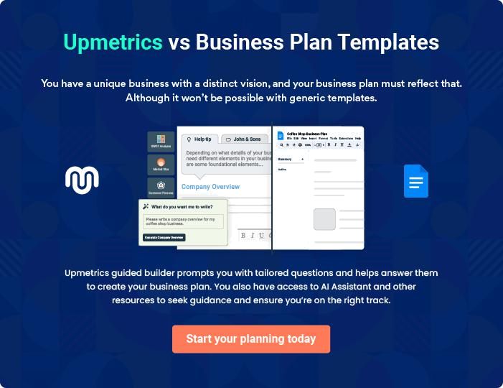
Products and Services
To unlock help try Upmetrics!

The product and services section of a cafe business plan should describe the specific services and products that will be offered to customers. To write this section should include the following:



 Help tip  Cafe Business Plan

To craft the introduction for your "Products and Services" chapter, begin by positioning your business within its industry, emphasizing its unique strengths or value proposition.
To unlock help try Upmetrics! 

Start writing here..

 Help tip

Create a list of the services that your cafe will offer, this could involve catering services, takeaway or delivery choices, or organizing private events.
To unlock help try Upmetrics! 

Products and Services

Espresso


Price: [$3.50]

A rich, full-bodied shot of espresso made from premium Arabica beans, sourced from the highlands of Ethiopia.

Specifications

- Serving Size: 30 ml

- Caffeine Content: Approximately 63 mg
Cappuccino

Price: [$4.50]

A classic Italian coffee drink, our cappuccino combines equal parts of espresso, steamed milk, and frothed milk, garnished with a sprinkle of cocoa powder.

Specifications

- Serving Size: 180 ml

- Caffeine Content: Approximately 63 mg

- Milk: Frothed and steamed to 150°F

Avocado Toast

Price: [$7.00]

Crunchy artisanal toast topped with freshly mashed avocados, sprinkled with chili flakes, and drizzled with olive oil. A healthy and delicious choice

Specifications

- Bread: Whole grain, freshly baked

- Toppings: Organic avocado, chili flakes, extra virgin olive oil

- Dietary: Vegan-friendly
Vegan Berry Smoothie

Price: [$6.50]

A refreshing blend of mixed berries, almond milk, and a touch of organic agave syrup. Perfect for a health boost on the go!

Specifications

- Serving Size: 300 ml

- Main Ingredients: Blueberries, strawberries, almond milk, agave syrup

- Dietary: Vegan, Gluten-Free

Private Event Hosting

Price: Starting at [$500] (Varies based on requirements)

Book our cozy cafe space for your private events. Be it birthdays or corporate functions, our team ensures impeccable service, customizable menus, and a memorable experience

Specifications

- Maximum Capacity: 50 guests

- Duration: Up to 4 hours (extensions available)

- Includes: Dedicated wait staff, audio-visual equipment, customizable decor
Catering Services
- To unlock help try Upmetrics!

Price: Varies (Based on menu selection and number of guests)

Bringing our cafe's culinary expertise to your event. From appetizers to main courses, our catering services offer a wide range of options to fit any occasion.

Specifications

- Minimum Order: Serves 20 guests

- Lead Time: At least 5 days' notice

- Options: Buffet style or plated meals, customizable menu

Quality Standards

 Help tip  Cafe Business Plan

The quality requirements that the cafe will follow should be described in this area, such as the use of fresh, locally sourced foods and making sure that every food is cooked by strict sanitation and safety guidelines.



Start writing here..
Sales And Marketing Strategies

Writing the sales and marketing strategies section means a list of strategies you will use to attract and retain your clients.
To unlock help try Upmetrics! 

 Help tip  Cafe Business Plan

To create an effective introduction for your "Sales and Marketing Strategies" chapter, start by setting the stage within your specific industry or market.
To unlock help try Upmetrics! 

Unique Selling Proposition (USP)

 Help tip  Cafe Business Plan

A cafe requires a differentiating feature to stand out from its competitors in a crowded market.

The cafe’s distinctive selling characteristics, such as a particular cuisine, an innovative menu, or
To unlock help try Upmetrics! 

Start writing here..

Pricing Strategy

 Help tip  Cafe Business Plan

Develop a pricing strategy that is competitive and affordable, yet profitable. Consider offering promotions, discounts, or packages for your cafe services to attract new customers.
To unlock help try Upmetrics! 

Start writing here..

 Help tip  Cafe Business Plan
To unlock help try Upmetrics!

Develop a marketing strategy that includes a mix of online and offline marketing tactics. Consider social media, email marketing, content marketing, brochures, print marketing, and events.



Marketing strategies

Online


Social Media

Engaging posts, behind-the-scenes looks, and interactive content on platforms like [specific platforms, e.g., "Instagram, Facebook, and Twitter"].

Content Marketing

Blog posts on our website related to [specific topics, e.g., "coffee brewing techniques, movie reviews, and thematic events"].

Offline

Print Marketing

Brochures, flyers, and posters placed in strategic locations around [specific city, e.g., "Westminster"].

Email Marketing

Regular newsletters with updates, special offers, and cafe news.

Events

Hosting [specific events, e.g., "movie nights, coffee tasting sessions, and themed parties"] to engage the local community.

 Help tip

Mention your sales strategy as in – partner with other local businesses like gyms, colleges, and universities to cross-promote your services.
To unlock help try Upmetrics! 

Sales strategies

Partner with Businesses

Partnering with [specific businesses, e.g., "gyms, universities, and boutique stores"] for cross-promotions, where patrons of these establishments receive special deals at our cafe.

Event Collaborations

Hosting joint events with [specific entities, e.g., "local theaters or book clubs"] to merge audiences and offer mutual value.

 Help tip  Cafe Business Plan

Describe how your cafe will retain customers and build loyalty, such as through loyalty programs, special events, or personalized service.
To unlock help try Upmetrics! 

Customer retention

Loyalty Programs

Points-based rewards system where patrons earn points for every purchase, redeemable for discounts or free items.

Special Events

Exclusive events, sneak peeks, or early bird specials for our regulars.

Personalized Service

Recognizing and remembering our

frequent patrons, their preferences,

and ensuring they always feel

valued.

Operations Plan


 |  | When writing the operations plan section, it’s important to consider the
 |  | various aspects of your business operations.
 |  |  |  | To unlock help try Upmetrics! 
 Help tip |  |  Cafe Business Plan


To create an effective introduction for your "Operational Plan" chapter, start by emphasizing the
pivotal role of efficient operations in the success of your business, underscoring how they
directly impact the quality of services delivered.
 |  |  |  | To unlock help try Upmetrics! 
Start writing here..
Hiring Plan
 Help tip |  |  Cafe Business Plan

Tell the staffing requirements of your cafe, including the number of employees needed, their
qualifications, and the duties they will perform. Also mention the perks you will provide to your
employees.
 |  |  |  | To unlock help try Upmetrics! 
Start writing here..
Operational Process
 Help tip |  |  Cafe Business Plan

Outline the processes and procedures that you will use to run your cafe. Who will cook, who will provide the training, and what is the organizational structure, mention everything in this section.
To unlock help try Upmetrics! 

Start writing here..

Equipment

 Help tip  Cafe Business Plan

Describe the types of equipment that will be used in your cafe like an espresso machine, refrigerator, oven, and storage spaces.
To unlock help try Upmetrics! 

Start writing here..
Management Team

The management team section provides an overview of the individuals responsible for running your business plan.
To unlock help try Upmetrics! 

 Help tip  Cafe Business Plan

To craft an introduction for your "Management Team" chapter, begin by emphasizing the crucial role of leadership in the success of any business.
To unlock help try Upmetrics! 

Start writing here..

Key managers

 Help tip  Cafe Business Plan

Describe the key members of your management team, their roles, and their responsibilities. It should include the owners, senior management, the head chef, and the other assistant chefs.
To unlock help try Upmetrics! 

Start writing here..

JOHN DOE

CEO & Co-founder - john.doe@example.com

John Doe holds an MBA from the prestigious [University Name, e.g., "Harvard Business School"].

With over [X years, e.g., "10 years"] of experience in the cafe industry, he has honed his skills by working with renowned cafe chains in both managerial and operational roles.


His vision for [Your Cafe's Name] stems from his passion for coffee and his drive to create unique cafe experiences that resonate with the community.
JANE DOE

Senior Manager - jane.doe@example.com

Jane graduated with a degree in [Specific Field, e.g., "Hospitality Management"] from [University Name, e.g., "Cornell University's School of Hotel Administration"].


She has since spent over [X years, e.g., "8 years"] in the cafe and restaurant sector, managing teams, streamlining operations, and improving customer experiences across various establishments.


ALICE BROWN

Head Chef - alice.brown@example.com

Alice's culinary journey began at the esteemed [Institution Name, e.g., "Le Cordon Bleu in Paris"], from where she acquired her degree in Culinary Arts.

Over the past [X years, e.g., "12 years"], Alice has worked with upscale cafes and bistros, curating menus and infusing them with her signature flair.

Her dedication to the craft and her innovative approach to classic dishes make her an invaluable asset to [Your Cafe's Name].

ROBERT BROWN

Assistant Chef - robert.brown@example.com

Robert Brown: An alumnus of [Culinary School, e.g., "The Culinary Institute of America"], Robert has been the driving force behind kitchens in [specific city, e.g., "San Francisco"] for over [X years, e.g., "5 years"].

His meticulous approach and skillset complement our head chef's vision perfectly.

Organizational structure

 Help tip  Cafe Business Plan

Describe the organizational structure of the management team, including reporting lines and how decisions will be made.
To unlock help try Upmetrics! 

Start writing here..

Organization chart


John Doe

CEO


 |  |  | Robert Brown
Jane Doe | Alice Brown |  | Robert Brown
Jane Doe |  |  | Assistant Chef
Senior Manager | Head chef

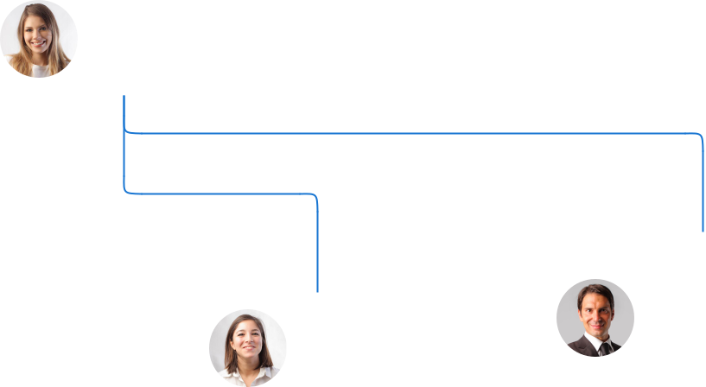

Employee 2

Employee 1 Front of House Staff

Barista

Compensation plan

 Help tip  Cafe Business Plan

Describe your compensation plan for the management team and staff, including salaries, bonuses, and other benefits.
To unlock help try Upmetrics! 

Start writing here..
 Help tip

If you have a board of advisors for your business, then mention them along with their roles and experience.
To unlock help try Upmetrics! 

Board of advisors


MR. SAMUEL LEE

Advisor 1

An industry veteran with [X years, e.g., "20 years"] in the cafe business, Mr. Lee provides guidance on sourcing, vendor relationships, and menu innovations.

DR. MICHELLE SMITH

Advisor 2

With a rich background in [specific field, e.g., "hospitality and business management"], Dr. Smith advises on business growth strategies.
Financial Plan
To unlock help try Upmetrics!

When writing the financial plan section of a business plan, it’s important to provide a comprehensive overview of your financial projections for the first few years of your business, You may provide the following:
To unlock help try Upmetrics! 

 Help tip  Cafe Business Plan

To create an effective introduction for your "Financial Plan" chapter, begin by stressing the critical role of a well-structured financial plan in the success of your venture.
To unlock help try Upmetrics! 

Start writing here..

 Help tip

Create a projected profit & loss statement that describes the expected revenue, cost of products sold, and operational costs. Your cafe’s anticipated net profit or loss should be computed and included.



Profit & loss statement

 | 2023-24 | 2024-25 | 2025-26 | 2026-27 | 2027-28
Revenue | $0 | $0 | $0 | $0 | $0

Cost Of Sales | $0 | $0 | $0 | $0 | $0
General Costs | $0 | $0 | $0 | $0 | $0
Revenue Specific Costs | $0 | $0 | $0 | $0 | $0
Personnel Costs (Direct | $0 | $0 | $0 | $0 | $0
Labor)

Gross Margin $0 $0 $0 $0 $0

Gross Margin (%)

Operating Expense

Payroll Expense

(Indirect Labor)

General Expense

Bad Debt

Amortization of Current Assets

EBITDA

Additional Expense

Long Term

Depreciation

Gain or loss from Sale of Assets

EBIT

Interest Expenses

EBT

Income Tax Expense

Total Expense

Net Income

Net Income (%)

2023-24 | 2024-25 | 2025-26 | 2026-27 | 2027-28
0% | 0% | 0% | 0% | 0%
$0 | $0 | $0 | $0 | $0
$0 | $0 | $0 | $0 | $0
$0 | $0 | $0 | $0 | $0
$0 | $0 | $0 | $0 | $0
$0 | $0 | $0 | $0 | $0
$0 | $0 | $0 | $0 | $0
$0 | $0 | $0 | $0 | $0
$0 | $0 | $0 | $0 | $0
$0 | $0 | $0 | $0 | $0
$0 | $0 | $0 | $0 | $0
$0 | $0 | $0 | $0 | $0
$0 | $0 | $0 | $0 | $0
$0 | $0 | $0 | $0 | $0
$0 | $0 | $0 | $0 | $0
$0 | $0 | $0 | $0 | $0
0% | 0% | 0% | 0% | 0%
To unlock help try Upmetrics!
 | 2023-24 | 2024-25 | 2025-26 | 2026-27 | 2027-28
Retained Earning | $0 | $0 | $0 | $0 | $0
Opening
Owner's Distribution | $0 | $0 | $0 | $0 | $0
Retained Earning | $0 | $0 | $0 | $0 | $0
Closing

 Help tip

Estimate your cash inflows and outflows for the first few years of operation. It should include cash receipts from clients, payments to vendors, loan payments, and any other cash inflows and outflows.



Cash flow statement

Cash Received

Cash Paid

COS & General Expenses

Salary & Wages

Interest

Sales Tax

Income Tax

Net Cash From

Operations

Assets Sell

Assets Purchase

Net Cash From

Investments

2023-24 | 2024-25 | 2025-26 | 2026-27 | 2027-28
$0 | $0 | $0 | $0 | $0
$0 | $0 | $0 | $0 | $0
$0 | $0 | $0 | $0 | $0
$0 | $0 | $0 | $0 | $0
$0 | $0 | $0 | $0 | $0
$0 | $0 | $0 | $0 | $0
$0 | $0 | $0 | $0 | $0
$0 | $0 | $0 | $0 | $0

$0 | $0 | $0 | $0 | $0
$0 | $0 | $0 | $0 | $0
$0 | $0 | $0 | $0 | $0

 | 2023-24 | 2024-25 | 2025-26 | 2026-27 | 2027-28
Amount Received | $0 | $0 | $0 | $0 | $0
Loan Received | $0 | $0 | $0 | $0 | $0
Common Stock
Preferred Stock | $0 | $0 | $0 | $0 | $0
Owner's Contribution | $0 | $0 | $0 | $0 | $0
Amount Paid | $0 | $0 | $0 | $0 | $0
Loan Capital | $0 | $0 | $0 | $0 | $0
Dividends & Distributions | $0 | $0 | $0 | $0 | $0
Net Cash From | $0 | $0 | $0 | $0 | $0
Financing

Summary
Starting Cash | $0 | $0 | $0 | $0 | $0
Cash In | $0 | $0 | $0 | $0 | $0
Cash Out | $0 | $0 | $0 | $0 | $0
Change in Cash | $0 | $0 | $0 | $0 | $0
Ending Cash | $0 | $0 | $0 | $0 | $0

 Help tip

Prepare a projected balance sheet, which shows the cafe’s assets, liabilities, and equity.

To unlock help try Upmetrics! 

Balance sheet

 | 2023-24 | 2024-25 | 2025-26 | 2026-27 | 2027-28
Assets | $0 | $0 | $0 | $0 | $0
 | 2023-24 | 2024-25 | 2025-26 | 2026-27 | 2027-28
Current Assets | $0 | $0 | $0 | $0 | $0
Cash | $0 | $0 | $0 | $0 | $0
Accounts Receivable | $0 | $0 | $0 | $0 | $0
Inventory | $0 | $0 | $0 | $0 | $0
Other Current Assets | $0 | $0 | $0 | $0 | $0
Long Term Assets | $0 | $0 | $0 | $0 | $0
Gross Long Term Assets | $0 | $0 | $0 | $0 | $0
Accumulated Depreciation | $0 | $0 | $0 | $0 | $0

Liabilities & Equity | $0 | $0 | $0 | $0 | $0
Liabilities | $0 | $0 | $0 | $0 | $0
Current Liabilities | $0 | $0 | $0 | $0 | $0
Accounts Payable | $0 | $0 | $0 | $0 | $0
Income Tax Payable | $0 | $0 | $0 | $0 | $0
Sales Tax Payable | $0 | $0 | $0 | $0 | $0
Short Term Debt | $0 | $0 | $0 | $0 | $0
Long Term Liabilities | $0 | $0 | $0 | $0 | $0
Long Term Debt | $0 | $0 | $0 | $0 | $0
Equity | $0 | $0 | $0 | $0 | $0
Paid-in Capital | $0 | $0 | $0 | $0 | $0
Common Stock | $0 | $0 | $0 | $0 | $0
Preferred Stock | $0 | $0 | $0 | $0 | $0
Owner's Contribution | $0 | $0 | $0 | $0 | $0
Retained Earnings | $0 | $0 | $0 | $0 | $0
 | 2023-24 |  |  | 2024-25 | 2025-26 | 2026-27 | 2027-28
Check | $0 |  |  | $0 | $0 | $0 | $0
 Help tip |  |  Cafe Business Plan

Determine the point at which your cafe will break even, or generate enough revenue to cover its operating costs.
To unlock help try Upmetrics! 

Break-even Point

Balance Sheet

 | 2023-24 | 2024-25 | 2025-26 | 2026-27 | 2027-28
Assets | $0 | $0 | $0 | $0 | $0
Current Assets | $0 | $0 | $0 | $0 | $0
Cash | $0 | $0 | $0 | $0 | $0
Accounts Receivable | $0 | $0 | $0 | $0 | $0
Inventory | $0 | $0 | $0 | $0 | $0
Other Current Assets | $0 | $0 | $0 | $0 | $0
Long Term Assets | $0 | $0 | $0 | $0 | $0
Gross Long Term Assets | $0 | $0 | $0 | $0 | $0
Accumulated Depreciation | $0 | $0 | $0 | $0 | $0

Liabilities & Equity | $0 | $0 | $0 | $0 | $0
Liabilities | $0 | $0 | $0 | $0 | $0
Current Liabilities | $0 | $0 | $0 | $0 | $0
Accounts Payable | $0 | $0 | $0 | $0 | $0
Income Tax Payable | $0 | $0 | $0 | $0 | $0
Sales Tax Payable | $0 | $0 | $0 | $0 | $0
 | 2023-24 | 2024-25 | 2025-26 | 2026-27 | 2027-28
Short Term Debt | $0 | $0 | $0 | $0 | $0
Long Term Liabilities | $0 | $0 | $0 | $0 | $0
Long Term Debt | $0 | $0 | $0 | $0 | $0
Equity | $0 | $0 | $0 | $0 | $0
Paid-in Capital | $0 | $0 | $0 | $0 | $0
Common Stock | $0 | $0 | $0 | $0 | $0
Preferred Stock | $0 | $0 | $0 | $0 | $0
Owner's Contribution | $0 | $0 | $0 | $0 | $0
Retained Earnings | $0 | $0 | $0 | $0 | $0

Check | $0 | $0 | $0 | $0 | $0

Financing needs

 Help tip  Cafe Business Plan

Estimate how much financing you will need to start and operate your cafe business. It should include both short-term and long-term financing needs, such as loans or investment capital.
To unlock help try Upmetrics! 

Start writing here..
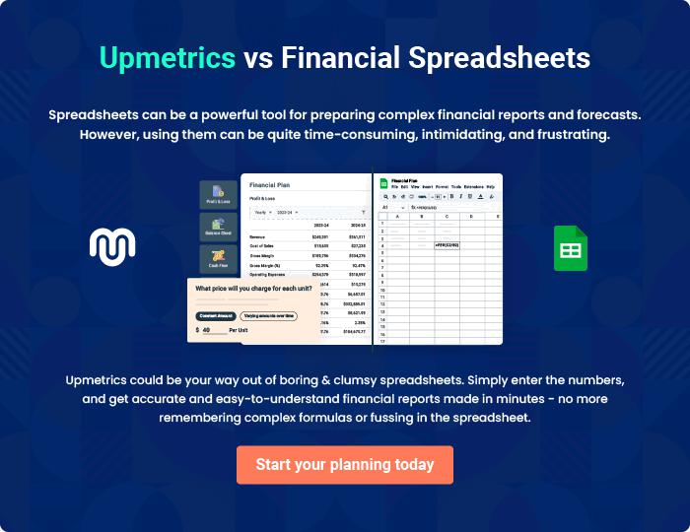
Appendix

When writing the appendix section, you should include any additional information that supports the main content of your plan. This may include financial statements, market research data, legal documents, and other
To unlock help try Upmetrics! 
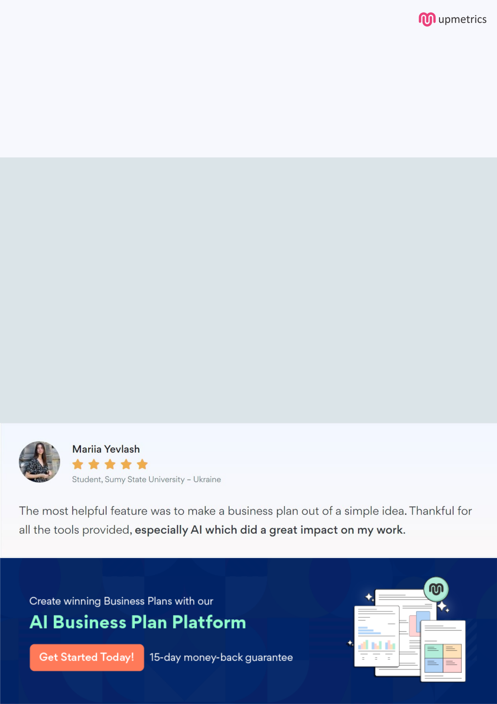
Create a winning business plan that gets you funded

Creating a stunning and investment-ready plan requires no writing, graphic designing, or financial planning expertise.

Upmetrics has all the features required to help you create a comprehensive business plan—from start to finish. Make no mistakes, it’s the modern way of planning to structure ideas, make plans, and create stunning pitch decks to awe investors.

Pitch decks that impress investors

Create pitch decks that provide a visual representation of your business, engage investors, and make them want to invest in your business idea.

Interactive plans in no time

Import business plan sections like—SWOT analysis, comparison tables, and others to create an interactive business plan. No designing skills are required.

Stunning cover page designs

With Upmetrics, you have the liberty to choose from multiple stunning cover page designs. Choose a creative design and make your plan stand out.

Online sharing made simple

Upmetrics makes online sharing quick and easier for users. Easily share your business plans with a link while tracking reader activity.

500+ sample business plans

Simply import a template from our library of sample plans into the editor and start customizing it to make it yours. It takes only a few clicks to get started.

Collaborate with team in real-time

Invite team members, initiate conversations, discuss ideas & strategies, share feedback, and work on a business plan in real-time.

