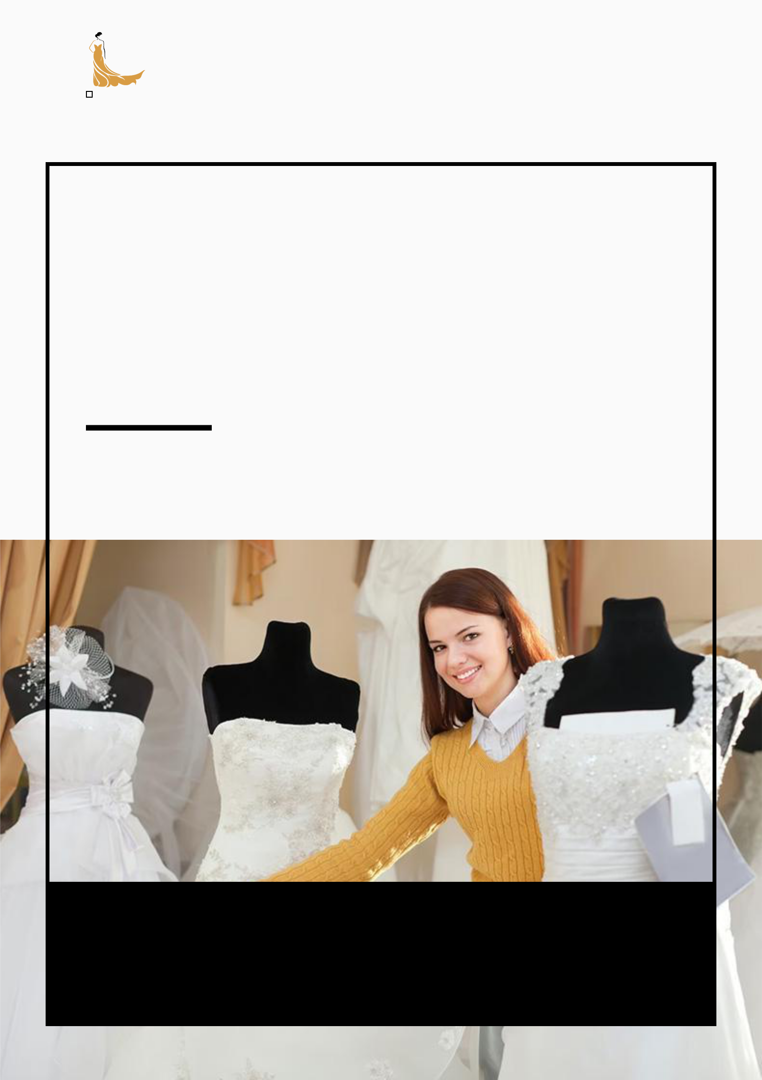
Bridal Shop Business Plan

BUSINESS PLAN

Bridal Beauty, Your Way

Prepared By

John Doe

10200 Bolsa Ave, Westminster, CA, 92683

info@example.com

(650) 359-3153 http://www.example.com

Table of Contents

Executive Summary | 6
Market opportunity | 6
Bridal Products | 6
Marketing & Sales Strategies | 7
Financial Highlights | 7
Units Sold v/s Revenue | 8

Company Overview | 9
Ownership | 9
Mission statement | 10
Business history | 10
Future goals | 10

Market Analysis | 11
Target Market | 11
Market size and growth potential | 11
Market Size | 12
Competitive analysis | 12
Blissful Brides Boutique | 12
Timeless Trousseau | 13
Ethereal Elegance | 13
Market trends | 13
Regulatory environment | 14

Products and Services | 15
Products and Services | 15
Classic Bridal Gown | 15
Bridesmaid Midi Dress | 16
Bridal Veil | 16
Satin Bridal Heels | 17
Custom Design | 17
Alterations and Tailoring | 17
Bridal Styling and Consultation | 18
Wedding Dress Cleaning | 18
Quality Measures | 18
Additional Services | 19

Sales And Marketing Strategies | 20
Unique Selling Proposition (USP) | 20
Pricing Strategy | 20
Marketing strategies | 21
Online | 21
Offline | 21
Sales strategies | 22
Customer retention | 23

Operations Plan | 24
Staffing & Training | 24
Operational Process | 24
Equipment & Machinery | 25

Management Team | 26
Key managers | 26
John Doe | 27
Jane Doe | 27
Alice Brown | 28
Robert Brown | 29
Organizational structure | 29
Organization chart | 30
Compensation plan | 30
Board of advisors | 31
[ADVISOR NAME] | 31
[CONSULTANT NAME] | 31
Financial Plan | 32
Profit & loss statement | 32
Cash flow statement | 34
Balance sheet | 35
Break-even Point | 37
Financing needs | 38
Appendix
Appendix | 39
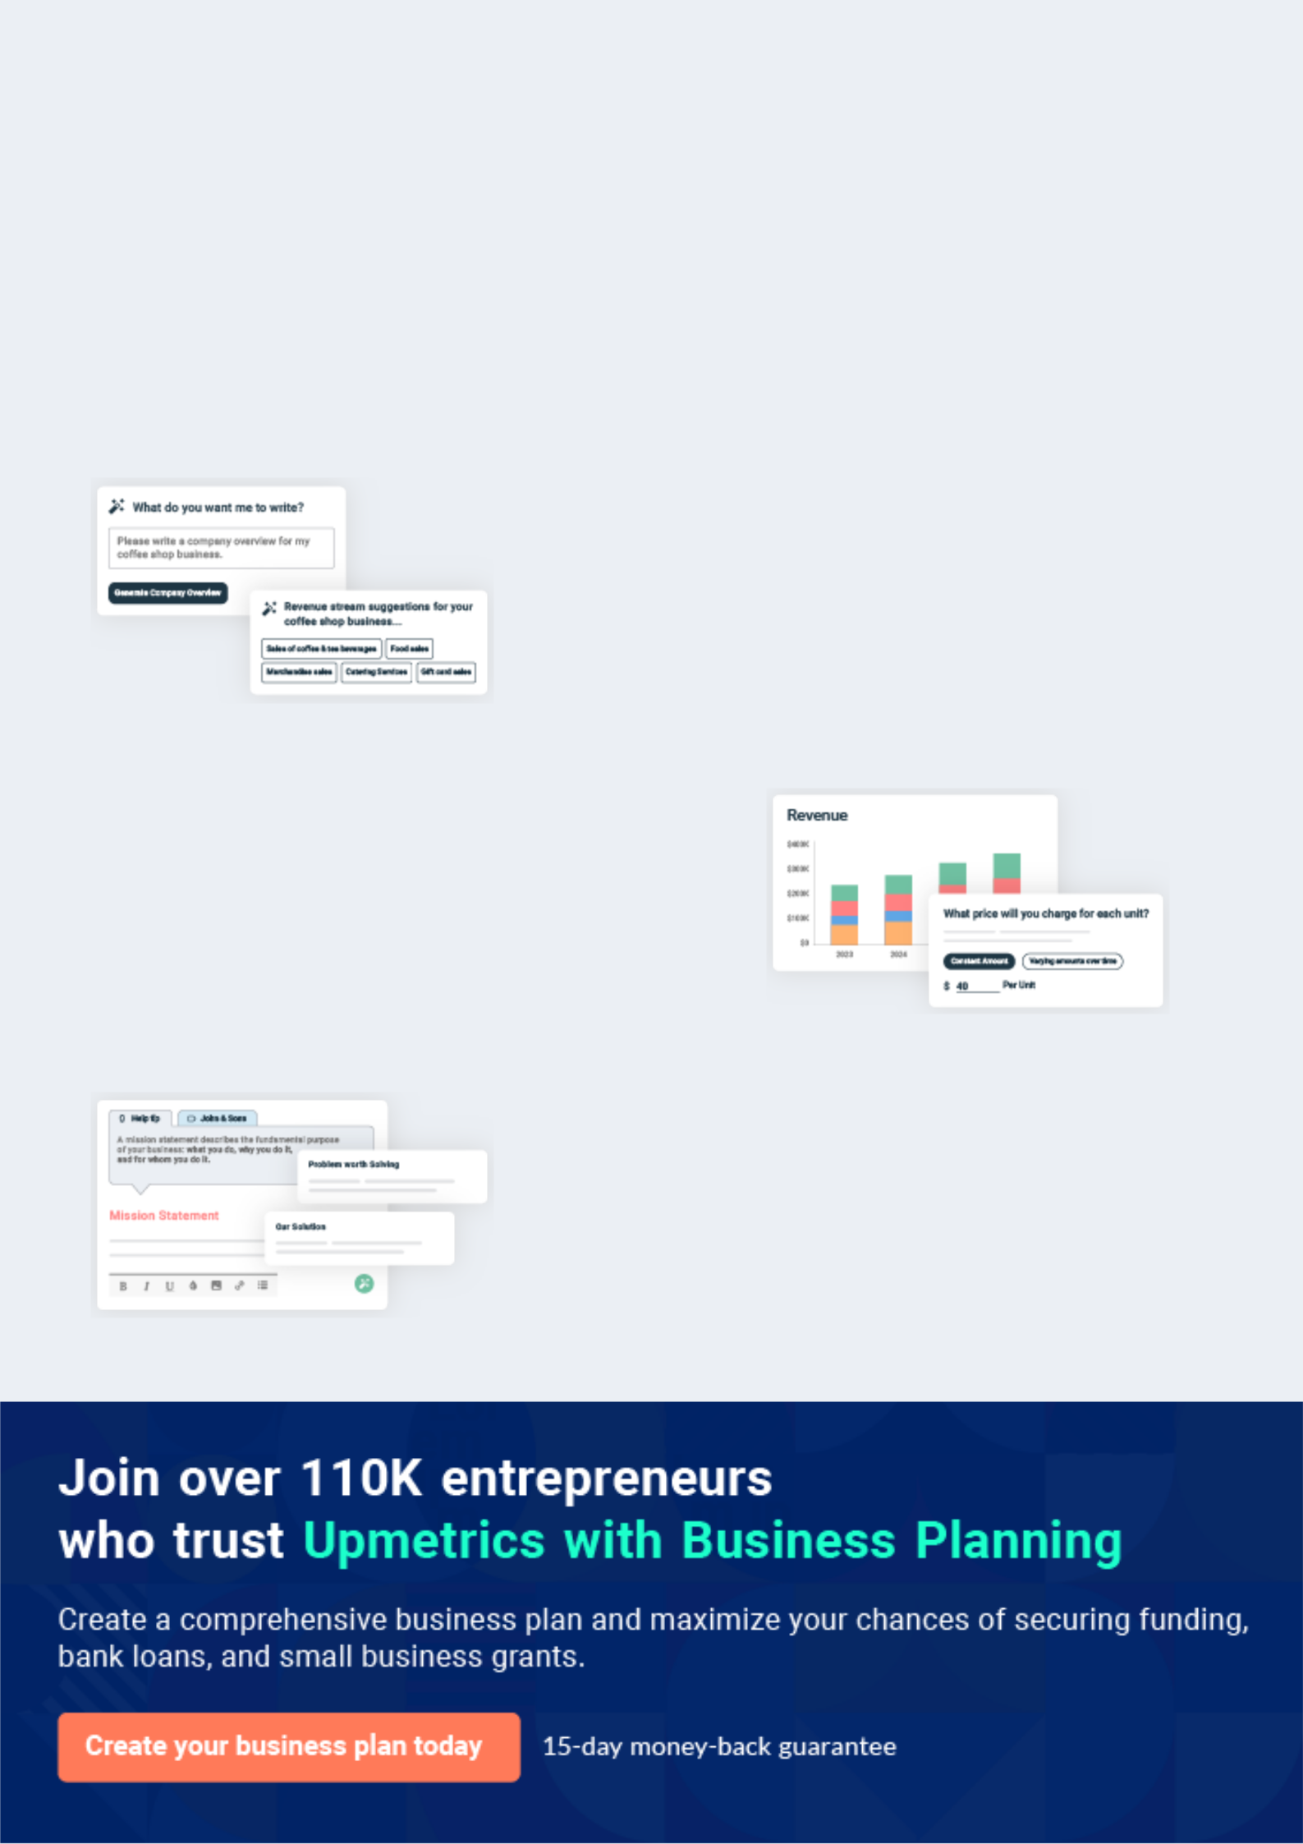
Business planning that’s simpler and faster than you think

Creating a business plan using Upmetrics to start and grow a business is literally the easiest thing in the World. Simply read the instructions and fill in the blanks. It’s as simple as that.

❛ | Upmetrics has everything you need to create a | ❜
❛ | comprehensive business plan. | ❜

AI-powered Upmetrics Assistant

AI-powered insights to streamline your plan

Not sure where to start? Upmetrics’ AI Assistant will automatically generate ideas for each section of your plan and offer improved versions of your writing, adjusting for tone, voice, and grammar or spelling errors.

Financial Forecasting Tool

All the financials are calculated for you

Forget the complex formulas and clumsy spreadsheets — with automatic financials and drag-and-drop forecasting, you can finish your plan faster and be confident that your numbers are accurate.

Business Plan Builder

Guides you like a business mentor

Upmetrics’ step-by-step instructions, prompts, and the library of 400+ sample business plans will guide you through each section of your plan as a business mentor.
Executive Summary


An executive summary is the first section of the business plan intended to provide an overview of the whole business plan.
To unlock help try Upmetrics! 

 Help tip  Bridal Shop Business Plan


Start your executive summary by briefly introducing your business to your readers.

This section may include the name of your bridal shop business, its location, when it was
To unlock help try Upmetrics! 

Start writing here..

Market opportunity

 Help tip  Bridal Shop Business Plan

Summarize your market research, including market size, growth potential, and marketing trends.
To unlock help try Upmetrics! 

Start writing here..

Bridal Products

 Help tip  Bridal Shop Business Plan

Highlight the bridal shop products you offer your clients. The USPs and differentiators you offer are always a plus.
To unlock help try Upmetrics! 

Start writing here..

Marketing & Sales Strategies
To unlock help try Upmetrics!

 Help tip  Bridal Shop Business Plan

Outline your sales and marketing strategies—what marketing platforms you use, how you plan on acquiring customers, etc.
To unlock help try Upmetrics! 

Start writing here..

Financial Highlights

 Help tip  Bridal Shop Business Plan

Briefly summarize your financial projections for the initial years of business operations. Include any capital or investment requirements, associated startup costs, projected revenues, and profit forecasts.



Start writing here..
Units Sold v/s Revenue

 |  | Units Sold | Revenue
15.00k
10.00k
5.00k
0
Year 1 | Year 2 | Year 3


Financial Year |  |  | Units Sold | Revenue
Year 1 | 1,550 |  |  | $10,000
Year 2 | 1,800 |  |  | $12,000
Year 3 | 2,050 |  |  | $14,000
 Help tip |  |  Bridal Shop Business Plan


Summarize your executive summary section with a clear CTA, for example, inviting angel investors to discuss the potential business investment.
To unlock help try Upmetrics! 

Write a call to action for your business plan.
Company Overview

Depending on what details of your business are essential, you’ll need different elements in your business overview.
To unlock help try Upmetrics! 

 Help tip  Bridal Shop Business Plan

Describe your business in this section by providing all the basic information:

Describe what kind of bridal shop company you run and the name of it. You may specialize in
To unlock help try Upmetrics! 

Start writing here..

Ownership

 Help tip  Bridal Shop Business Plan

List the names of your bridal shop company’s founders or owners. Describe what shares they own and their responsibilities for efficiently managing the business.
To unlock help try Upmetrics! 

Start writing here..
Mission statement

 Help tip  Bridal Shop Business Plan

Summarize your business’ objective, core principles, and values in your mission statement. This statement needs to be memorable, clear, and brief.
To unlock help try Upmetrics! 

❛ At [Elegance Bridals], our mission is to embody the essence of every bride's dream. Through curated collections, personalized experiences, and unwavering commitment to quality, we aim to make every bride's journey to find her perfect dress as beautiful

as the day she wears it.
❜

Business history

 Help tip  Bridal Shop Business Plan

If you’re an established bridal shop service provider, briefly describe your business history, like— when it was founded, how it evolved over time, etc.
To unlock help try Upmetrics! 

Start writing here..

Future goals

 Help tip  Bridal Shop Business Plan

It’s crucial to convey your aspirations and vision. Mention your short-term and long-term goals; they can be specific targets for revenue, market share, or expanding your services.
To unlock help try Upmetrics! 

Start writing here..

Market Analysis
To unlock help try Upmetrics!


 |  | Market analysis provides a clear understanding of the market in which your
 |  | printing business will run along with the target market, competitors, and
 |  | growth opportunities.
 |  |  |  | To unlock help try Upmetrics! 
 Help tip |  |  Bridal Shop Business Plan

To write the introduction section of your market analysis, start by clearly identifying your primary target market.
To unlock help try Upmetrics! 

Start writing here..

Target Market

 Help tip  Bridal Shop Business Plan

Start this section by describing your target market. Define your ideal customer and explain what types of services they prefer. Creating a buyer persona will help you easily define your target market to your readers.



Start writing here..

Market size and growth potential

 Help tip  Bridal Shop Business Plan

Describe your market size and growth potential and whether you will target a niche or a much broader market.
To unlock help try Upmetrics! 

Start writing here..

Market Size

Available Market | 10M
All brides-to-be globally seeking bridal | 10M
wear.
Served Market | 1M
Brides-to-be in North America preferring | 1M
boutique bridal wear. | 1M
Target Market | 300k
Style-conscious brides-to-be in | 300k
California. | 300k


 Help tip  Bridal Shop Business Plan

Identify and analyze your direct and indirect competitors. Identify their strengths and weaknesses, and describe what differentiates your bridal shop services from them.
To unlock help try Upmetrics! 

Competitive analysis

Blissful Brides Boutique

Established in [Year], Blissful Brides Boutique is a well-known brand in the [City/Region], offering an extensive range of designer bridal gowns.

Their collaboration with international designers has made them a popular choice among brides seeking exclusive international designs.

Features | Strengths
Exclusive designer | Strong brand recognition in the
collaborations | market
In-house bridal consultants | Extensive collection of
Personalized fittings and | international designs
alterations | Experienced bridal consultants
Pre-wedding gown trials

Weaknesses

Premium pricing, making it inaccessible for budget-conscious brides

Limited size range, lacking in inclusive sizing options

Timeless Trousseau

Timeless Trousseau, operational since [Year], focuses on vintage and timeless bridal wear designs. They have carved a niche for themselves by specializing in recreating classic, vintage designs with a modern touch.

Features | Strengths | Weaknesses
Unique vintage gown | Niche specialization in vintage | Limited contemporary designs
collections | designs | might deter modern brides
Custom design services | Strong community engagement | Longer lead times for custom
Periodic bridal wear workshops | through workshops | creations
and events | Personalized custom design
 | services

Ethereal Elegance

A newer entrant, Ethereal Elegance began its journey in [Year]. They have quickly gained traction for their sustainable and eco-friendly bridal wear, catering to the environmentally conscious bride.

Features

Eco-friendly bridal wear collection

Sustainable sourcing and ethical manufacturing

Biodegradable packaging

Strengths

Strong emphasis on sustainability appeals to a growing segment of eco-conscious consumers

Ethical manufacturing practices build strong brand loyalty

Weaknesses

Relatively new in the market, hence lower brand recognition

Limited collection compared to established competitors

Market trends

 Help tip  Bridal Shop Business Plan

Analyze emerging trends in the industry, such as technology disruptions, changes in customer behavior or preferences, etc. Explain how your business will cope with all the trends.
To unlock help try Upmetrics! 

Start writing here..

Regulatory environment
To unlock help try Upmetrics!

 Help tip  Bridal Shop Business Plan

List regulations and licensing requirements that may affect your bridal shop company, such as business registration, insurance, intellectual property rights, environmental regulations, state and federal regulations, etc.



Start writing here..
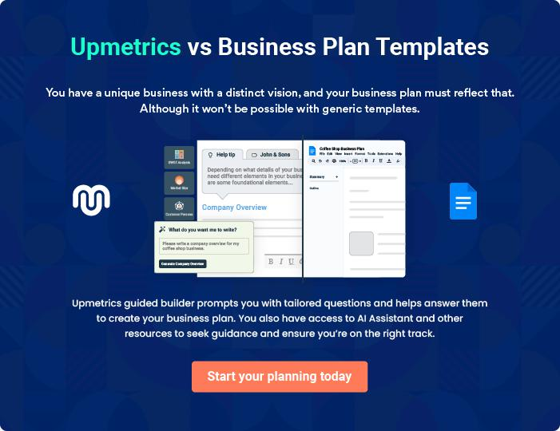
Products and Services
To unlock help try Upmetrics!

The product and services section of a bridal shop business plan should describe the specific services and products that will be offered to customers. To write this section should include the following:



 Help tip  Bridal Shop Business Plan

To craft the introduction for your "Products and Services" chapter, begin by positioning your business within its industry, emphasizing its unique strengths or value proposition.
To unlock help try Upmetrics! 

Start writing here..

 Help tip


Mention the bridal products your business will offer. This list may include products like,

• Bridal dresses
To unlock help try Upmetrics! 

Products and Services

Classic Bridal Gown


Price: [$1,500]

A timeless A-line bridal gown made with intricate lace details, a romantic sweetheart neckline, and a flowing train.

Specifications

- Material: Premium lace and silk

- Sizes: Available from 0 to 28

- Colors: White, Ivory, Off-White

- Train Length: 1.5 meters
Bridesmaid Midi Dress

Price: [$250]

A versatile midi dress with a draped silhouette, perfect for bridesmaids. Features a soft V-neckline and is available in multiple colors to match any wedding palette.

Specifications

- Material: Chiffon with satin lining

- Sizes: XS to XXL

- Colors: Navy, Blush Pink, Burgundy, Champagne, Emerald

- Length: Midi (ends mid-calf)

Bridal Veil

Price: [$120]

A cathedral-length veil adorned with delicate hand-sewn pearls, providing the perfect finishing touch to any bridal ensemble.

Specifications

- Material: Soft tulle with pearl detailing

- Length: 2.5 meters

- Attachment: Comb attachment for secure fitting
Satin Bridal Heels

Price: [$80]

Elegant satin heels with a pointed toe and a delicate ankle strap. The cushioned insole ensures comfort for all-day wear.

Specifications

- Material: Satin with leather sole

- Sizes: 5 to 11

- Colors: White, Ivory, Nude

- Heel Height: 3 inches

Custom Design

Price: Starting at [$2,000]

Collaborate with our in-house designers to craft a one-of-a-kind gown that captures your vision perfectly.

Specifications

- Number of Consultations: Up to 5 sessions

- Lead Time: 3 to 6 months

- Fittings: Up to 3 fitting sessions included

Alterations and Tailoring

Price: Starting at [$100] (Varies based on complexity)

Expert tailoring services to ensure your dress fits like a glove, whether it's a minor adjustment or a major alteration.

Specifications

- Duration: Typically 1 to 2 weeks

- Fittings: Up to 2 fitting sessions included

- Materials: Original material used for consistency
Bridal Styling and Consultation

Price: [$150] per session

A 90-minute session with our bridal stylists to help you finalize your wedding look, from selecting accessories to offering makeup and hairstyle suggestions.

Specifications

- Duration: 90 minutes

- Takeaways: Personalized lookbook with recommended products and styles

- Follow-up: One 30-minute follow-up session included

Wedding Dress Cleaning

Price: [$180]

Professional cleaning services to ensure your gown remains in pristine condition after your special day

Specifications

- Duration: 7 to 10 days

- Packaging: Delivered in a protective storage box

- Preservation: Option for preservation treatment at an additional cost

Quality Measures

 Help tip  Bridal Shop Business Plan

This section should explain how you maintain quality standards and consistently provide the highest quality service.
To unlock help try Upmetrics! 

Start writing here..

Additional Services
To unlock help try Upmetrics!

 Help tip  Bridal Shop Business Plan

Mention if your bridal shop company offers any additional services. You may include services like cleaning of wedding dresses, image consultation, bridal styling, destination wedding assistance, etc.



Start writing here..
Sales And Marketing Strategies

Writing the sales and marketing strategies section means a list of strategies you will use to attract and retain your clients.
To unlock help try Upmetrics! 

 Help tip  Bridal Shop Business Plan

To create an effective introduction for your "Sales and Marketing Strategies" chapter, start by setting the stage within your specific industry or market.
To unlock help try Upmetrics! 

Unique Selling Proposition (USP)

 Help tip  Bridal Shop Business Plan

Define your business’s USPs depending on the market you serve, the equipment you use, and the unique services you provide. Identifying USPs will help you plan your marketing strategies.
To unlock help try Upmetrics! 

Start writing here..

Pricing Strategy

 Help tip  Bridal Shop Business Plan

Describe your pricing strategy—how you plan to price your bridal dress services and stay competitive in the local market.
To unlock help try Upmetrics! 

Start writing here..

 Help tip  Bridal Shop Business Plan

Discuss your marketing strategies to market your services.

You may include some of these marketing strategies in your business plan—targeted
To unlock help try Upmetrics! 

Marketing strategies

Online


Social Media

Harnessing platforms like Instagram, Pinterest, and Facebook, with visually appealing content, bridal tips, and success stories.

Content Marketing

Blog posts and articles offering bridal advice, fashion tips, and more, establishing [Elegance Bridals] as a thought leader in the industry.

Email Marketing

Regular newsletters highlighting new collections, bridal trends, and special offers.

Google Ads

Targeted pay-per-click ads to reach brides actively searching for bridal boutiques.

Offline

Wedding Expos Print Marketing

Participating in regional and Elegant brochures and catalogs

national wedding expos, available in-store and at partnered

showcasing our exclusive wedding service providers.

collections.

 Help tip  Bridal Shop Business Plan
To unlock help try Upmetrics!

Outline the strategies you’ll implement to maximize your sales. Your sales strategies may include consultative sales, partnering with influencers, wedding expos, and wedding stylists, offering referral programs, etc.



Sales strategies

Consultative Sales

Our trained staff will offer personalized consultations, understanding each bride's vision and suggesting the best options.

Wedding Expos

Exclusive stalls to engage with potential customers directly, offering special discounts for on-the-spot bookings

nfluencer Collaborations

Partnering with bridal influencers for gown reviews, styled shoots, and event appearances.

Referral Programs

Incentivizing satisfied brides to refer friends and family through discounts and loyalty benefits.

 Help tip  Bridal Shop Business Plan
To unlock help try Upmetrics!

Describe your customer retention strategies and how you plan to execute them. For instance, exceptional services and extensive collection will ensure that the bride spreads the good word in her social circles.



Customer retention

Loyalty Programs

Offering repeat customers exclusive previews, discounts, and first dibs on new collections.

Exceptional Service

Ensuring a seamless shopping experience, from personalized consultations to after-sales support.

Engagement

Staying in touch post-purchase through newsletters, wishing them on anniversaries, and inviting them to store events.

Extensive Collection

Regularly updating our collection, enticing brides to return for other wedding-related apparel.

Operations Plan

 |  | When writing the operations plan section, it’s important to consider the
 |  | various aspects of your business operations.
 |  |  |  | To unlock help try Upmetrics! 
 Help tip |  |  Bridal Shop Business Plan


To create an effective introduction for your "Operational Plan" chapter, start by emphasizing the
pivotal role of efficient operations in the success of your business, underscoring how they
directly impact the quality of services delivered.
 |  |  |  | To unlock help try Upmetrics! 
Start writing here..
Staffing & Training
 Help tip |  |  Bridal Shop Business Plan

Mention your bridal business’s staffing requirements, including the number of seamstresses, sales associates, stylists, and administrative staff needed.
To unlock help try Upmetrics! 

Start writing here..

Operational Process

 Help tip  Bridal Shop Business Plan

Outline the processes and procedures you will use to run your bridal shop business.

Your operational processes may include inventory management, making alterations, addressing
To unlock help try Upmetrics! 

Start writing here..

Equipment & Machinery

 Help tip  Bridal Shop Business Plan

Include the list of equipment and machinery required for the bridal shop, such as sewing machines, cutting tables, POS, fitting rooms, steamer, pressing equipment, etc.
To unlock help try Upmetrics! 

Start writing here..
Management Team

The management team section provides an overview of the individuals responsible for running your business plan.
To unlock help try Upmetrics! 

 Help tip  Bridal Shop Business Plan

To craft an introduction for your "Management Team" chapter, begin by emphasizing the crucial role of leadership in the success of any business.
To unlock help try Upmetrics! 

Start writing here..

Key managers

 Help tip  Bridal Shop Business Plan

Introduce your management and key members of your team, and explain their roles and responsibilities.
To unlock help try Upmetrics! 

Start writing here..

JOHN DOE

CEO and Founder - john.doe@example.com

John steers the strategic vision of Elegance Bridals, overseeing all functions from procurement to customer service.

With over 15 years in the bridal industry, he combines his keen business acumen with an intrinsic understanding of bridal fashion, ensuring Elegance Bridals remains a luminary in the world of bridal elegance.


- Educational Background: John graduated with a Bachelor's Degree in Business Management from Harvard University. He further enhanced his industry understanding with a diploma in Fashion Retail from Parsons School of Design.

- Professional Background: Before establishing Elegance Bridals, John served as a Senior Manager for 'Ethereal Brides,' a globally recognized bridal wear brand. Under his leadership, the brand saw an increase in sales by 40% over three years


JANE DOE

Chief Operating Officer (COO) - jane.doe@example.com

Jane is the operational maestro behind the seamless day-to-day functions at Elegance Bridals.

From inventory management to store aesthetics, she leaves no stone unturned to ensure optimal resource utilization and an unmatched shopping experience for brides.

- Educational Background: Jane holds a Master's Degree in Retail Management from Stanford University.

- Professional Background: Before joining Elegance Bridals, Jane was the Operational Head at 'Celestial Brides' where she introduced innovative store layouts and customer service protocols that enhanced customer experience.

ALICE BROWN

Chief Marketing Officer (CMO) - alice.brown@example.com

Alice orchestrates the symphony of Elegance Bridals' branding and marketing initiatives. With a penchant for storytelling, she ensures every campaign resonates with the dreams and aspirations of modern brides.

- Educational Background: Alice graduated with honors in Fashion Marketing from the London School of Fashion.

- Professional Background: Alice has a rich experience palette, having served as the Marketing Director at 'Bridal Bliss.' She is credited with some of the industry's most memorable marketing campaigns.

ROBERT BROWN

Designing Manager - robert.brown@example.com

Robert is the artistic soul of Elegance Bridals. With an impeccable eye for detail and a deep understanding of global bridal trends, he crafts collections that are at once timeless and avant-garde.

- Educational Background: Robert earned his Bachelor's in Fashion Design from the esteemed Fashion Institute of Technology, New York.

- Professional Background: Robert's designs have been showcased in Paris, Milan, and New York Fashion Weeks.

Prior to Elegance Bridals, he was the Lead Designer at 'Nuptial Nouveau,' curating collections that became global bestsellers.

Organizational structure

 Help tip  Bridal Shop Business Plan

Explain the organizational structure of your management team. Include the reporting line and decision-making hierarchy.
To unlock help try Upmetrics! 

Start writing here..
Organization chart


John Doe

CEO
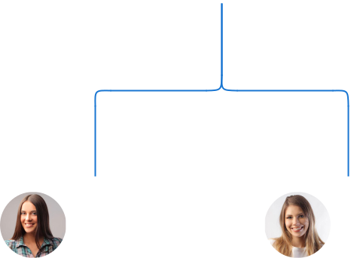

Alice Brown Jane Doe

CMO COO




Laura White | Michael Green | Robert Brown
Laura White | Marketing | Designing
Stylist Lead | Marketing | Designing | Emily Smith
Stylist Lead | Coordinator | Manager | Emily Smith
 | Coordinator | Manager | Head of Sales




Compensation plan

 Help tip  Bridal Shop Business Plan

Describe your compensation plan for the management and staff. Include their salaries, incentives, and other benefits.
To unlock help try Upmetrics! 

Start writing here..
 Help tip

Mentioning advisors or consultants in your business plans adds credibility to your business idea.
To unlock help try Upmetrics! 

Board of advisors


[ADVISOR NAME]

Bridal Fashion Consultant

With over [X years] in the bridal industry, [Advisor Name] provides insights into global trends and design innovations


[CONSULTANT NAME]

Business Strategy Consultant

Having steered multiple retail brands to success, [Consultant Name] advises on growth strategies and market positioning.
Financial Plan
To unlock help try Upmetrics!

When writing the financial plan section of a business plan, it’s important to provide a comprehensive overview of your financial projections for the first few years of your business, You may provide the following:
To unlock help try Upmetrics! 

 Help tip  Bridal Shop Business Plan

To create an effective introduction for your "Financial Plan" chapter, begin by stressing the critical role of a well-structured financial plan in the success of your venture.
To unlock help try Upmetrics! 

Start writing here..

 Help tip

Describe details such as projected revenue, operational costs, and service costs in your projected profit and loss statement. Make sure to include your business’s expected net profit or loss.



Profit & loss statement

 | 2023-24 | 2024-25 | 2025-26 | 2026-27 | 2027-28
Revenue | $0 | $0 | $0 | $0 | $0

Cost Of Sales | $0 | $0 | $0 | $0 | $0
General Costs | $0 | $0 | $0 | $0 | $0
Revenue Specific Costs | $0 | $0 | $0 | $0 | $0
Personnel Costs (Direct | $0 | $0 | $0 | $0 | $0
Labor)

Gross Margin $0 $0 $0 $0 $0

Gross Margin (%)

Operating Expense

Payroll Expense

(Indirect Labor)

General Expense

Bad Debt

Amortization of Current Assets

EBITDA

Additional Expense

Long Term

Depreciation

Gain or loss from Sale of Assets

EBIT

Interest Expenses

EBT

Income Tax Expense

Total Expense

Net Income

Net Income (%)

2023-24 | 2024-25 | 2025-26 | 2026-27 | 2027-28
0% | 0% | 0% | 0% | 0%
$0 | $0 | $0 | $0 | $0
$0 | $0 | $0 | $0 | $0
$0 | $0 | $0 | $0 | $0
$0 | $0 | $0 | $0 | $0
$0 | $0 | $0 | $0 | $0
$0 | $0 | $0 | $0 | $0
$0 | $0 | $0 | $0 | $0
$0 | $0 | $0 | $0 | $0
$0 | $0 | $0 | $0 | $0
$0 | $0 | $0 | $0 | $0
$0 | $0 | $0 | $0 | $0
$0 | $0 | $0 | $0 | $0
$0 | $0 | $0 | $0 | $0
$0 | $0 | $0 | $0 | $0
$0 | $0 | $0 | $0 | $0
0% | 0% | 0% | 0% | 0%
To unlock help try Upmetrics!
 | 2023-24 | 2024-25 | 2025-26 | 2026-27 | 2027-28
Retained Earning | $0 | $0 | $0 | $0 | $0
Opening
Owner's Distribution | $0 | $0 | $0 | $0 | $0
Retained Earning | $0 | $0 | $0 | $0 | $0
Closing

 Help tip

The cash flow for the first few years of your operation should be estimated and described in this section. This may include billing invoices, payment receipts, loan payments, and any other cash flow statements.



Cash flow statement

Cash Received

Cash Paid

COS & General Expenses

Salary & Wages

Interest

Sales Tax

Income Tax

Net Cash From

Operations

Assets Sell

Assets Purchase

Net Cash From

Investments

2023-24 | 2024-25 | 2025-26 | 2026-27 | 2027-28
$0 | $0 | $0 | $0 | $0
$0 | $0 | $0 | $0 | $0
$0 | $0 | $0 | $0 | $0
$0 | $0 | $0 | $0 | $0
$0 | $0 | $0 | $0 | $0
$0 | $0 | $0 | $0 | $0
$0 | $0 | $0 | $0 | $0
$0 | $0 | $0 | $0 | $0

$0 | $0 | $0 | $0 | $0
$0 | $0 | $0 | $0 | $0
$0 | $0 | $0 | $0 | $0

 | 2023-24 | 2024-25 | 2025-26 | 2026-27 | 2027-28
Amount Received | $0 | $0 | $0 | $0 | $0
Loan Received | $0 | $0 | $0 | $0 | $0
Common Stock
Preferred Stock | $0 | $0 | $0 | $0 | $0
Owner's Contribution | $0 | $0 | $0 | $0 | $0
Amount Paid | $0 | $0 | $0 | $0 | $0
Loan Capital | $0 | $0 | $0 | $0 | $0
Dividends & Distributions | $0 | $0 | $0 | $0 | $0
Net Cash From | $0 | $0 | $0 | $0 | $0
Financing

Summary
Starting Cash | $0 | $0 | $0 | $0 | $0
Cash In | $0 | $0 | $0 | $0 | $0
Cash Out | $0 | $0 | $0 | $0 | $0
Change in Cash | $0 | $0 | $0 | $0 | $0
Ending Cash | $0 | $0 | $0 | $0 | $0

 Help tip

Create a projected balance sheet documenting your bridal shop business’s assets, liabilities, and equity.
To unlock help try Upmetrics! 

Balance sheet

 | 2023-24 | 2024-25 | 2025-26 | 2026-27 | 2027-28
Assets | $0 | $0 | $0 | $0 | $0
 | 2023-24 | 2024-25 | 2025-26 | 2026-27 | 2027-28
Current Assets | $0 | $0 | $0 | $0 | $0
Cash | $0 | $0 | $0 | $0 | $0
Accounts Receivable | $0 | $0 | $0 | $0 | $0
Inventory | $0 | $0 | $0 | $0 | $0
Other Current Assets | $0 | $0 | $0 | $0 | $0
Long Term Assets | $0 | $0 | $0 | $0 | $0
Gross Long Term Assets | $0 | $0 | $0 | $0 | $0
Accumulated Depreciation | $0 | $0 | $0 | $0 | $0

Liabilities & Equity | $0 | $0 | $0 | $0 | $0
Liabilities | $0 | $0 | $0 | $0 | $0
Current Liabilities | $0 | $0 | $0 | $0 | $0
Accounts Payable | $0 | $0 | $0 | $0 | $0
Income Tax Payable | $0 | $0 | $0 | $0 | $0
Sales Tax Payable | $0 | $0 | $0 | $0 | $0
Short Term Debt | $0 | $0 | $0 | $0 | $0
Long Term Liabilities | $0 | $0 | $0 | $0 | $0
Long Term Debt | $0 | $0 | $0 | $0 | $0
Equity | $0 | $0 | $0 | $0 | $0
Paid-in Capital | $0 | $0 | $0 | $0 | $0
Common Stock | $0 | $0 | $0 | $0 | $0
Preferred Stock | $0 | $0 | $0 | $0 | $0
Owner's Contribution | $0 | $0 | $0 | $0 | $0
Retained Earnings | $0 | $0 | $0 | $0 | $0
 | 2023-24 |  |  | 2024-25 | 2025-26 | 2026-27 | 2027-28
Check | $0 |  |  | $0 | $0 | $0 | $0
 Help tip |  |  Bridal Shop Business Plan

Determine and mention your business’s break-even point—the point at which your business costs and revenue will be equal.
To unlock help try Upmetrics! 

Break-even Point

 | 2023-24 | 2024-25 | 2025-26 | 2026-27 | 2027-28
Starting Revenue | $0 | $0 | $0 | $0 | $0
Net Revenue | $0 | $0 | $0 | $0 | $0
Closing Revenue | $0 | $0 | $0 | $0 | $0

Starting Expense | $0 | $0 | $0 | $0 | $0
Net Expense | $0 | $0 | $0 | $0 | $0
Closing Expense | $0 | $0 | $0 | $0 | $0

Is Break Even? | 0 | 0 | 0 | 0 | 0
Break Even Month | 0 | 0 | 0 | 0 | 0
Days Required | 0 | 0 | 0 | 0 | 0
Break Even Revenue | $0 | $0 | $0 | $0 | $0
Break Even Units
Financing needs

 Help tip  Bridal Shop Business Plan

Calculate costs associated with starting a bridal shop business, and estimate your financing needs and how much capital you need to raise to operate your business.
To unlock help try Upmetrics! 

Start writing here..
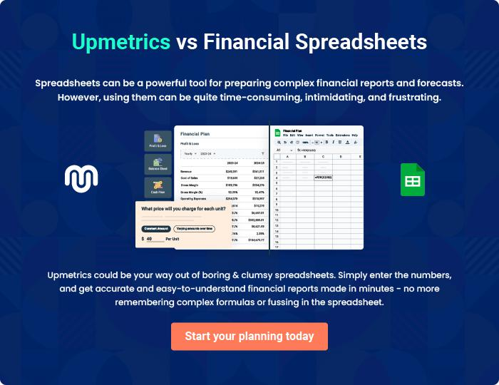
Appendix

When writing the appendix section, you should include any additional information that supports the main content of your plan. This may include financial statements, market research data, legal documents, and other
To unlock help try Upmetrics! 
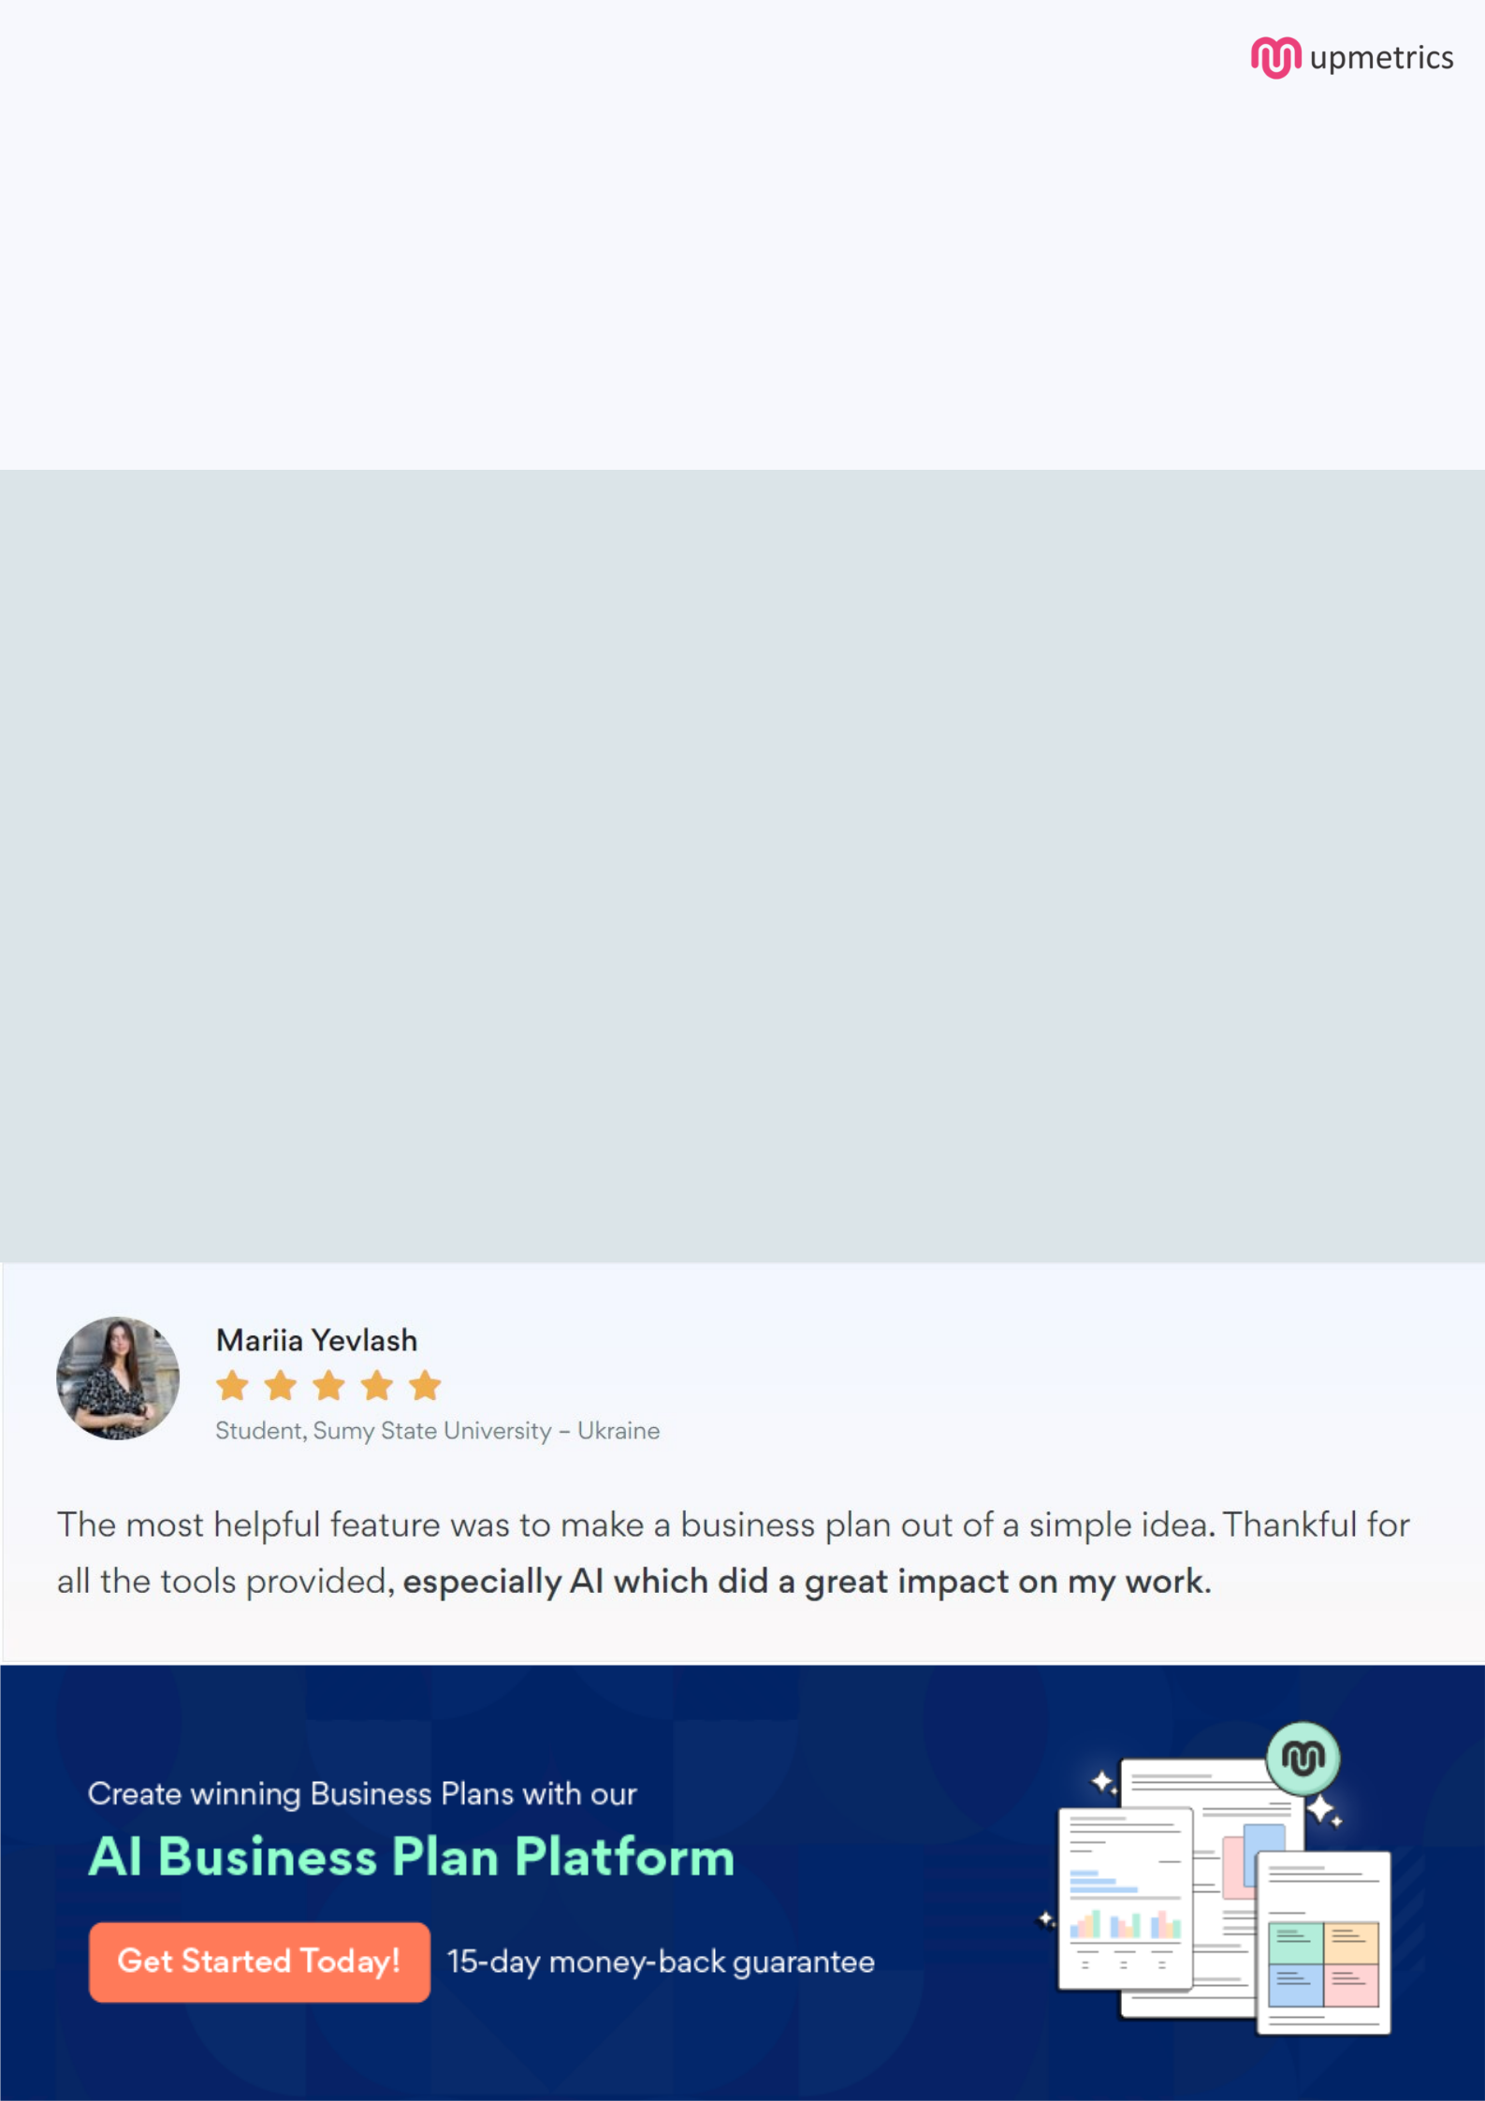
Create a winning business plan that gets you funded

Creating a stunning and investment-ready plan requires no writing, graphic designing, or financial planning expertise.

Upmetrics has all the features required to help you create a comprehensive business plan—from start to finish. Make no mistakes, it’s the modern way of planning to structure ideas, make plans, and create stunning pitch decks to awe investors.

Pitch decks that impress investors

Create pitch decks that provide a visual representation of your business, engage investors, and make them want to invest in your business idea.

Interactive plans in no time

Import business plan sections like—SWOT analysis, comparison tables, and others to create an interactive business plan. No designing skills are required.

Stunning cover page designs

With Upmetrics, you have the liberty to choose from multiple stunning cover page designs. Choose a creative design and make your plan stand out.

Online sharing made simple

Upmetrics makes online sharing quick and easier for users. Easily share your business plans with a link while tracking reader activity.

500+ sample business plans

Simply import a template from our library of sample plans into the editor and start customizing it to make it yours. It takes only a few clicks to get started.

Collaborate with team in real-time

Invite team members, initiate conversations, discuss ideas & strategies, share feedback, and work on a business plan in real-time.

