
 Boutique Business Plan

ADDRESS CONTACT

10200 Bolsa Ave, Westminster, CA, 92683 (650) 359-3153

http://www.example.com info@example.com


Business Plan

2023

Prepared By

John Doe


Curating Fashion, Tailored for You

Information provided in this business plan is unique to this business and confidential; therefore, anyone reading this plan agrees not to disclose any of the information in this business plan without prior written permission of the company.

Table of Contents

Executive Summary | 6
Market opportunity | 6
Products | 6
Management team | 7
John Doe | 7
Jane Doe | 7
Alice Brown | 7
Robert Brown | 7
Financial Highlights | 8
Units Sold v/s Revenue | 8

Company Overview | 9
Ownership | 9
Business Owners | 9
Mission statement | 9
Business history | 10
Future goals | 10

Market Analysis | 11
Target Market | 11
Market size and growth potential | 11
Market Size | 12
Competitive analysis | 12
Bella Couture | 12
Urban Threads | 13
Ethical Elegance | 13
Market trends | 13

Products and Services | 15
Products | 15

T-Shirts 15

Tops | 17
Jeans | 17
Pants | 18
Handbags | 18
Sweaters | 18
Trousers | 19
Inventory Management | 19

Sales And Marketing Strategies | 20
Unique Selling Proposition (USP) | 20
Pricing Strategy | 20
Marketing strategies | 21
Online | 21
Offline | 21
Sales strategies | 22
List title | 22
Customer retention | 23
List title | 23

Operations Plan | 24
Hiring Plan | 24
Operational Process | 24
Facilities | 25

Management Team | 26
Key managers | 26
John Doe | 26
Jane Doe | 27
Alice Brown | 27
Robert Brown | 27
Organizational structure | 28
Organization chart | 28

Compensation plan 28

Board of Advisors | 29
Emma Green | 29
David White | 29

Financial Plan | 30
Profit & loss statement | 30
Cash flow statement | 32
Balance sheet | 33
Break-even Point | 35
Financing needs | 36
Appendix
Appendix | 37
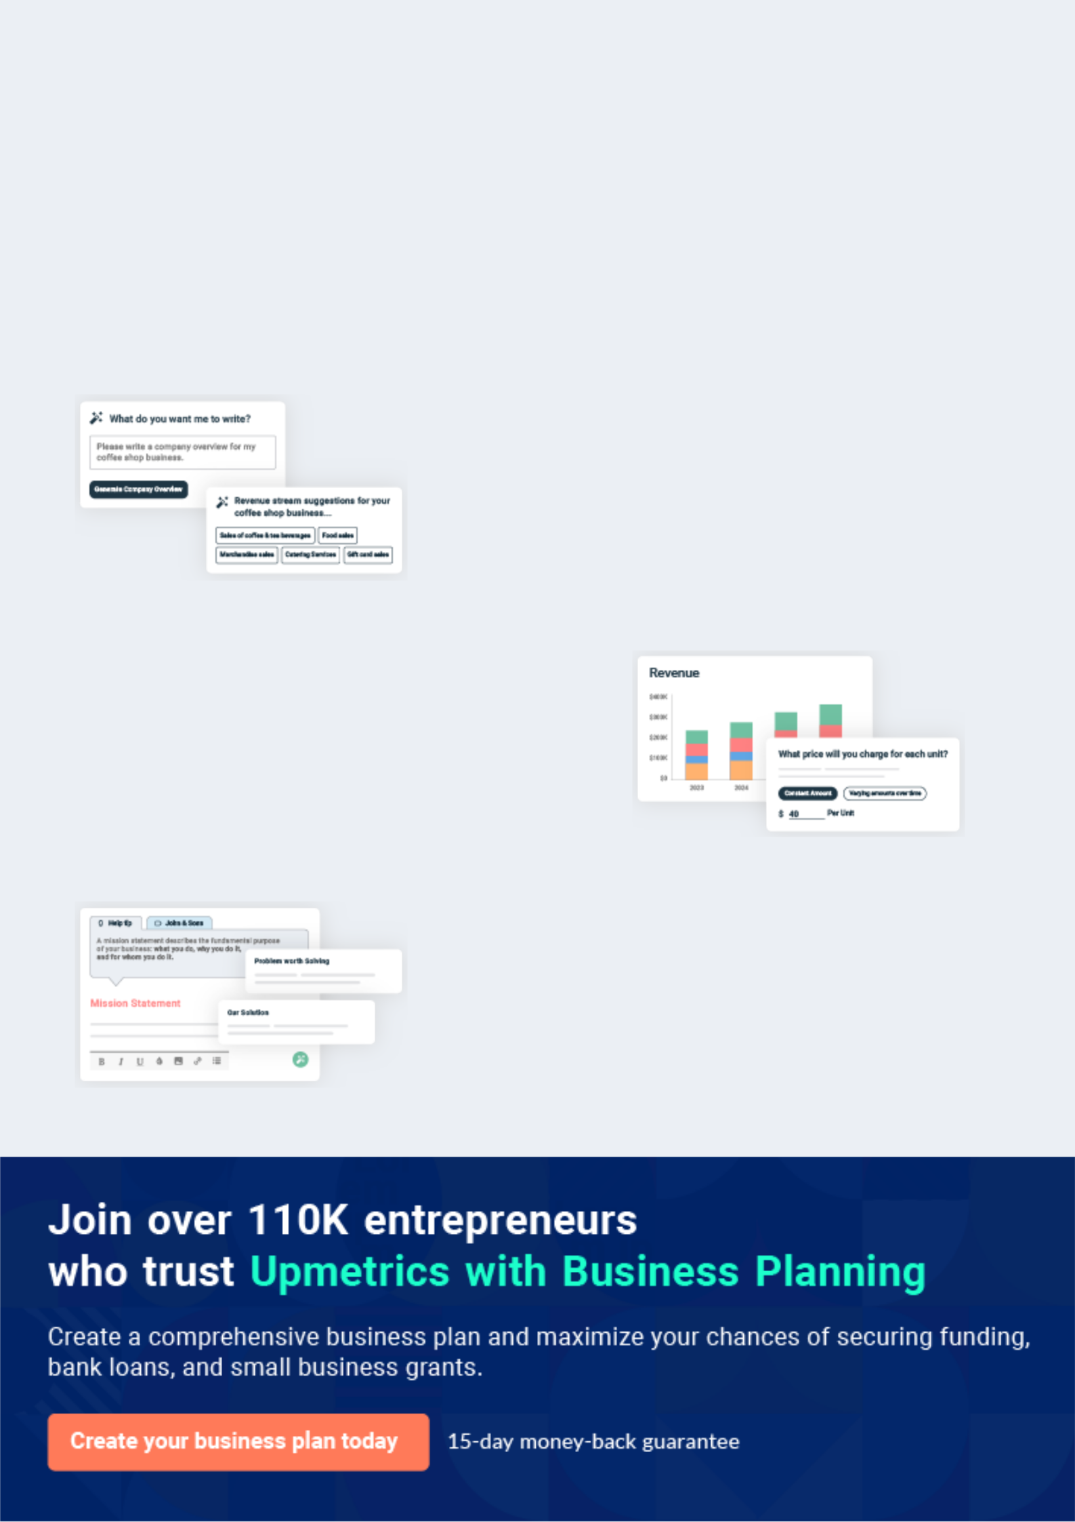
Business planning that’s simpler and faster than you think

Creating a business plan using Upmetrics to start and grow a business is literally the easiest thing in the World. Simply read the instructions and fill in the blanks. It’s as simple as that.

❛ | Upmetrics has everything you need to create a | ❜
❛ | comprehensive business plan. | ❜

AI-powered Upmetrics Assistant

AI-powered insights to streamline your plan

Not sure where to start? Upmetrics’ AI Assistant will automatically generate ideas for each section of your plan and offer improved versions of your writing, adjusting for tone, voice, and grammar or spelling errors.

Financial Forecasting Tool

All the financials are calculated for you

Forget the complex formulas and clumsy spreadsheets — with automatic financials and drag-and-drop forecasting, you can finish your plan faster and be confident that your numbers are accurate.

Business Plan Builder

Guides you like a business mentor

Upmetrics’ step-by-step instructions, prompts, and the library of 400+ sample business plans will guide you through each section of your plan as a business mentor.
Executive Summary


An executive summary is the first section of the business plan intended to provide an overview of the whole business plan.
To unlock help try Upmetrics! 

 Help tip  Boutique Business Plan


Start your executive summary by introducing your idea behind starting a boutique business and explaining what it does.
To unlock help try Upmetrics! 

Start writing here..

Market opportunity

 Help tip  Boutique Business Plan

Describe the target market in brief, and explain the demographics, geographic location, and psychographic attributes of your customer.
To unlock help try Upmetrics! 

Start writing here..

Products

 Help tip  Boutique Business Plan

Describe in detail the clothing, jewelry, cosmetics, and accessories that your boutique will sell.

To unlock help try Upmetrics! 

Start writing here..

 Help tip


Name all the key members of your management team with their duties, responsibilities, and qualifications
To unlock help try Upmetrics! 

Management team


JOHN DOE

CEO - john.doe@example.com

With over a decade of experience in the retail industry, John possesses an acute business acumen coupled with a vision for future fashion trends.


JANE DOE

Chief Financial Officer - jane.doe@example.com

A seasoned financial strategist, Jane oversees the company's finances, ensuring sustainable growth and profitability.


ALICE BROWN

Head of Product Procurement - alice.brown@example.com

Alice's vast network within the fashion industry enables "[Boutique Name]" to source exclusive collections.


ROBERT BROWN

Marketing and Branding Head - robert.brown@example.com

Robert's innovative strategies are pivotal in shaping the brand's image and reaching our target clientele.

Financial Highlights
To unlock help try Upmetrics!

 Help tip  Boutique Business Plan

Provide a summary of your financial projections for the company’s initial years of operation.

Include any capital or investment requirements, startup costs, projected revenues, and profits.
To unlock help try Upmetrics! 

Start writing here..

Units Sold v/s Revenue

 |  | Units Sold | Revenue
15.00k
10.00k
5.00k
0
Year 1 | Year 2 | Year 3


Financial Year |  |  | Units Sold | Revenue
Year 1 | 1,550 |  |  | $10,000
Year 2 | 1,800 |  |  | $12,000
Year 3 | 2,050 |  |  | $14,000
 Help tip |  |  Boutique Business Plan


After giving a brief about your business plan, end your summary with a call to action, for example; inviting potential investors or readers to the next meeting if they are interested in your business.



Write a call to action for your business plan.

Company Overview

Depending on what details of your business are essential, you’ll need different elements in your business overview.
To unlock help try Upmetrics! 

 Help tip  Boutique Business Plan

Provide all the basic information about your business in this section like:

• The name of the boutique and the concept behind it like – a jewelry boutique, cosmetic
To unlock help try Upmetrics! 

Start writing here..

Ownership

 Help tip  Boutique Business Plan

Describe the owners of your boutique and mention their roles in running it. Whose shares in the corporation are they, and how each owner helps in the business?
To unlock help try Upmetrics! 

Start writing here..

Business Owners



60% John Doe



40% Jane Doe

Mission statement

 Help tip  Boutique Business Plan
To unlock help try Upmetrics!

Add a mission statement that sums up the objectives and core principles of your boutique. This statement needs to be memorable, clear, and brief.
To unlock help try Upmetrics! 

❛ At [Boutique Name], we [mission, e.g., "strive to craft unique fashion narratives, bridging the past's artistry with today's fashion-forward trends"]. Our commitment is to offer [specific mission details, e.g., "exclusive, ethically sourced, and meticulously crafted pieces that resonate with individuality and

elegance."]
❜

Business history

 Help tip  Boutique Business Plan

Include an outline of the boutique’s history and how it came to be in its current position.

If you can, add some personality and intriguing details, especially if you got any achievements
To unlock help try Upmetrics! 

Start writing here..

Future goals

 Help tip  Boutique Business Plan

It’s crucial to convey your aspirations and your vision. Include the vision of where you see your business in the near future and if you have any plans of opening a new franchise of your business in the same city in the future.



Start writing here..

Market Analysis


 |  | Market analysis provides a clear understanding of the market in which your
 |  | printing business will run along with the target market, competitors, and
 |  | growth opportunities.
 |  |  |  | To unlock help try Upmetrics! 
 Help tip |  |  Boutique Business Plan

To write the introduction section of your market analysis, start by clearly identifying your primary target market.
To unlock help try Upmetrics! 

Start writing here..

Target Market

 Help tip  Boutique Business Plan

Identify your target market and define your ideal customer. Know more about your customers and which products they prefer: accessories, clothes, jewelry, or hand-picked items.
To unlock help try Upmetrics! 

Start writing here..

Market size and growth potential

 Help tip  Boutique Business Plan

Provide an overview of the boutique industry. It will include market size, trends, growth potential, and regulatory considerations.
To unlock help try Upmetrics! 

Start writing here..

Market Size

Available Market

Total individuals seeking boutique 5M fashion in the state.

Served Market
Those in urban areas with boutique 1M access and purchasing power.

Target Market
Women, ages 25-40, valuing sustainable, 250k unique fashion in city X.

 Help tip  Boutique Business Plan

Identify and analyze all other boutiques in the local market, including direct and indirect competitors.
To unlock help try Upmetrics! 

Competitive analysis

Bella Couture

Bella Couture is a high-end boutique that has been a staple in Westminster for over a decade. Catering predominantly to the elite, it offers a mixture of designer labels and exclusive in-house creations.

Features | Strengths
Extensive range of designer | Established brand recognition.
labels. | Loyalty programs for frequent
In-house custom tailoring | shoppers.
services. | Exclusive access to some
Personal shopper and styling | global designer collections.
consultation.

Weaknesses

High price point, making it inaccessible to a broader audience.

Limited focus on sustainable or eco-friendly products.

Slow to adapt to digital platforms and online shopping trends.

Urban Threads

Urban Threads appeals to the younger demographic with trendy, fast-fashion pieces. Their collections are refreshed frequently, mirroring global fashion trends.

Features | Strengths | Weaknesses
Seasonal collections inspired | Quick inventory turnover | Fast fashion models can lead to
by global trends. | ensures fresh styles. | quality inconsistencies.
Collaborations with social | Strong online presence and | Limited sizes and options for
media influencers. | social media engagement. | plus-sized individuals.
E-commerce platform with | Affordable pricing. | Dependence on overseas
next-day delivery options. |  | manufacturing can lead to supply
 |  | chain issues.

Ethical Elegance

Ethical Elegance is a boutique that merges fashion with sustainability. All their products are sourced ethically, ensuring fair wages and eco-friendly practices.

Features | Strengths | Weaknesses
A curated range of sustainable | Appeals to the growing base of | Limited variety compared to fast-
and ethically produced fashion. | eco-conscious consumers | fashion competitors.
Eco-friendly packaging and | Transparent sourcing with | Higher price points due to ethical
store practices. | details provided for each | sourcing.
Workshops and events | product. | Niche market appeal might limit
promoting sustainable living. | Collaborations with local | broader market penetration.
 | artisans and craftspeople.

Market trends

 Help tip  Boutique Business Plan

Analyze current and emerging trends in your industry, such as changes in customer preference or fashion. Explain how your business will cope with all the trends.
To unlock help try Upmetrics! 

Start writing here..

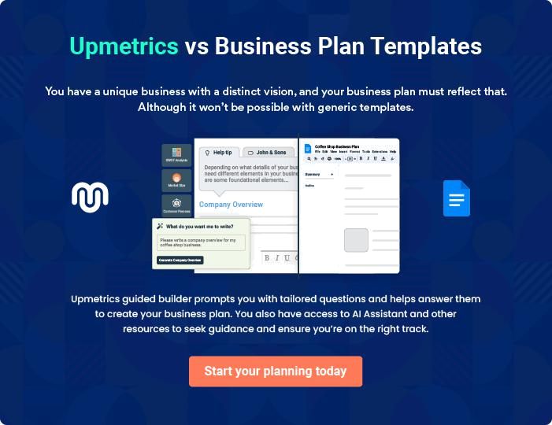
Products and Services
To unlock help try Upmetrics!

The product and services section of a boutique business plan should describe the specific services and products that will be offered to customers. To write this section should include the following:



 Help tip  Boutique Business Plan

To craft the introduction for your "Products and Services" chapter, begin by positioning your business within its industry, emphasizing its unique strengths or value proposition.
To unlock help try Upmetrics! 

Start writing here..

 Help tip

Create a list of the products that your boutique will sell, which may include t-shirts, tops, jeans, pants, handbags, sweaters, trousers, and other things.
To unlock help try Upmetrics! 

Products

T-Shirts


Price: Between [$25 and $40], depending on design complexity and size.

Our T-shirts undergo a meticulous process where the cotton is handpicked, ensuring only the highest quality fibres are selected.

These are then woven into the fabric using sustainable practices, dyed with eco-friendly colours, and tailored to perfection.
Product Specifications

Each T-shirt features unique designs and prints, created by local artists.

The organic material ensures a reduced carbon footprint, and the softness of the fabric offers unparalleled comfort.
Tops

Price: Range from [$50 to $80], reflecting design intricacy and material quality.

The silk and viscose are intertwined to produce a fabric that's both luxurious to the touch and durable. The tops are then crafted with attention to detail, ensuring flawless stitching and fit.

Product Specifications

Our tops range from casual wear to semi-formal blouses, making them suitable for various occasions.

Each piece resonates with contemporary fashion while retaining timeless charm.

Jeans

Price: Between [$60 and $100], depending on style and size.

The denim is sourced from ethical manufacturers, treated to achieve the desired texture, and then tailored using modern techniques to ensure a perfect fit.

Product Specifications

Offering both classic fits and modern styles, our jeans cater to a wide demographic.

They're designed to be both stylish and comfortable, making them a wardrobe staple.
Pants

Price: Between [$40 and $70], reflecting style and size.

The fabric is meticulously woven, dyed using eco-friendly methods, and then shaped into various styles of pants, ranging from formal trousers to casual chinos.

Product Specifications

Our pants are known for their versatility, easily transitioning from office wear to casual evening outings.

The elastane ensures they retain their shape even after multiple washes.

Handbags

Price: Range from [$40 to $120], depending on material and design.

The leather is treated and tanned using eco-friendly methods, then hand-stitched by skilled artisans to create elegant handbags.

Product Specifications

Each handbag, whether crafted from genuine leather or vegan materials, is a testament to artisanal craftsmanship.

Functional yet stylish, they're perfect for both everyday use and special occasions.

Sweaters

Price: Between [$50 and $90], reflecting style and size.

The wool is sourced from ethically managed farms, spun into yarn, and then knitted into various sweater designs.

Product Specifications

Our sweaters are perfect for keeping warm without adding bulk.

The natural properties of merino wool ensure breathability, making them suitable for varying climates.
Trousers
To unlock help try Upmetrics!

Price: Between [$50 and $80], depending on style and size.

The fabric is woven with precision, dyed, and then tailored to create trousers that offer both comfort and a sharp silhouette.

Product Specifications

Suitable for both formal and semi-formal occasions, our trousers are a blend of traditional tailoring techniques and modern fashion sensibilities.

Inventory Management

 Help tip  Boutique Business Plan

Explain your product procurement strategy. Provide information about any contracts or alliances you have with suppliers, as well as any tools or systems you’ll use to track inventory levels and sales numbers.



Start writing here..
Sales And Marketing Strategies

Writing the sales and marketing strategies section means a list of strategies you will use to attract and retain your clients.
To unlock help try Upmetrics! 

 Help tip  Boutique Business Plan

To create an effective introduction for your "Sales and Marketing Strategies" chapter, start by setting the stage within your specific industry or market.
To unlock help try Upmetrics! 

Unique Selling Proposition (USP)

 Help tip  Boutique Business Plan

Explain your store’s competitive advantage or unique selling proposition.

What distinguishes your goods and services from those of your competitors? These can
To unlock help try Upmetrics! 

Start writing here..

Pricing Strategy

 Help tip  Boutique Business Plan

Develop a pricing strategy that is competitive and affordable, yet profitable. Consider offering promotions, discounts, or packages for your boutique to attract new customers.
To unlock help try Upmetrics! 

Start writing here..

 Help tip  Boutique Business Plan

Develop a marketing strategy that includes a mix of online and offline marketing tactics.

Consider social media, email marketing, content marketing, brochures, print marketing, and
To unlock help try Upmetrics! 

Marketing strategies

Online


Social Media

Leveraging platforms like Instagram, Pinterest, and Facebook to showcase our collections, share fashion tips, and engage with our community.

Content Marketing

A dedicated blog offering fashion insights, styling advice, and spotlighting our artisan partners.

Offline

Brochures

Elegantly designed brochures, available both in-store and at strategic locations, highlighting our USP and collections.

Events

Hosting fashion events, pop-up shops, and collaboration events with local designers.

Email Marketing

Regular newsletters updating subscribers on new arrivals, exclusive promotions, and upcoming events.

Print Marketing

Collaborations with local magazines and newspapers for features and adverts.

Sales strategies

 Help tip  Boutique Business Plan

Mention your sales strategy as in – partner with other local businesses and cross-sell. Consider offering incentives for referrals or special discounts for partnerships.
To unlock help try Upmetrics! 

Start writing here..

List title

Partnerships

We aim to foster partnerships with other local businesses, from cafes to spas, to introduce cross-selling opportunities.

Exclusive discounts

Exclusive discounts for customers referred by our partners or special packages developed in collaboration, like a "[specific package, e.g., 'Shop and Spa Day']," are some initiatives in the pipeline.

Customer retention

 Help tip  Boutique Business Plan

Describe how your boutique will retain customers and build loyalty, such as through loyalty programs, special events, or personalized service.
To unlock help try Upmetrics! 

Start writing here..

List title

Loyalty Programs

Points accumulated with each purchase, leading to discounts or exclusive products.

Special Events

Members-only events, pre-launch previews, and exclusive workshops.

Personalized Service

Offering services like personal

styling sessions, custom tailoring,

and post-purchase care advice.

Operations Plan
To unlock help try Upmetrics!

 |  | When writing the operations plan section, it’s important to consider the
 |  | various aspects of your business operations.
 |  |  |  | To unlock help try Upmetrics! 
 Help tip |  |  Boutique Business Plan


To create an effective introduction for your "Operational Plan" chapter, start by emphasizing the
pivotal role of efficient operations in the success of your business, underscoring how they
directly impact the quality of services delivered.
 |  |  |  | To unlock help try Upmetrics! 
Start writing here..
Hiring Plan
 Help tip |  |  Boutique Business Plan

Tell the staffing requirements of your boutique, including the number of employees needed, their qualifications, and the duties they will perform.
To unlock help try Upmetrics! 

Start writing here..

Operational Process

 Help tip  Boutique Business Plan

Outline the processes and procedures that you will use to run your boutique. It includes the scheduling of appointments for any special customers, making personalized orders, and ordering raw materials.



Start writing here..

Facilities

 Help tip  Boutique Business Plan

Mention all the facilities you will require to operate. It might include details about the design of the store, the available storage, and the inventory control methods.
To unlock help try Upmetrics! 

Start writing here..
Management Team

The management team section provides an overview of the individuals responsible for running your business plan.
To unlock help try Upmetrics! 

 Help tip  Boutique Business Plan

To craft an introduction for your "Management Team" chapter, begin by emphasizing the crucial role of leadership in the success of any business.
To unlock help try Upmetrics! 

Start writing here..

Key managers

 Help tip  Boutique Business Plan

Describe the key members of your management team, their roles, and their responsibilities.

It should include the owners, senior management, and any other designer with their
To unlock help try Upmetrics! 

Start writing here..

JOHN DOE

Co-owner and CEO - john.doe@example.com

John brings a wealth of experience, knowledge, and leadership to [Boutique Name].

With a Master’s degree in Business Administration from [Prestigious University, e.g., "Harvard Business School"], he has spent over a decade navigating the intricacies of the retail domain.


Before co-founding [Boutique Name], John held pivotal roles at [Leading Retail Chain, e.g., "Macy's"], gaining invaluable insights into retail operations, strategy formulation, and customer experience design.
JANE DOE

Co-owner and Head of Design - jane.doe@example.com

A creative tour de force, Jane is the heart and soul of [Boutique Name]'s design philosophy.

A proud alumna of [Prestigious Fashion School, e.g., "Parsons School of Design"], Jane's design acumen is shaped by her international stints with brands like [Famous Brand, e.g., "Gucci"].


Her avant-garde approach, combined with a deep understanding of sustainable fashion, defines the boutique's unique collections


ALICE BROWN

Senior Manager, Sales & Customer Relations - alice.brown@example.com

Alice is the bridge between [Boutique Name] and its cherished clientele.

Holding a degree in [Relevant Field, e.g., "Consumer Psychology"] from [Notable University, e.g., "Stanford University"], Alice's expertise lies in crafting impeccable customer experiences.

Her previous roles at [Prominent Retailer, e.g., "Nordstrom"] have honed her skills in sales strategy, team leadership, and customer engagement.

ROBERT BROWN

Chief Financial Officer - robert.brown@example.com

Ensuring the fiscal robustness of [Boutique Name], Robert is an astute financial strategist.

A Certified Public Accountant (CPA) with a Finance degree from [Leading University, e.g., "MIT Sloan"], Robert's portfolio spans risk management, financial planning, and budgeting.

His prior experiences with [Big Financial Firm, e.g., "Goldman Sachs"] provide [Boutique Name] with an edge in financial prudence and strategy.
Organizational structure

 Help tip  Boutique Business Plan

Describe the organizational structure of the management team, including reporting lines and how decisions will be made.
To unlock help try Upmetrics! 

Start writing here..

Organization chart


John Doe

CEO


Alice Brown Jane Doe

CFO Head of Design


Tom Black Sara Blue
Finance Associate Junior Designer Bob Green

Lead Designer

Compensation plan

 Help tip  Boutique Business Plan

Describe your compensation plan for the management team and staff, including salaries, bonuses, and other benefits.
To unlock help try Upmetrics! 

Start writing here..

 Help tip  Boutique Business Plan

If you have a board of advisors for your business, then mention them along with their roles and experience.
To unlock help try Upmetrics! 

Board of Advisors

EMMA GREEN

Advisor 1

A stalwart in the fashion industry, Emma brings insights from her time at [Renowned Brand, e.g., "Chanel"], advising on global trends and strategic collaborations.


DAVID WHITE

Advisor 2

With an entrepreneurial background and a string of successful ventures, David provides guidance on business strategy and expansion.
Financial Plan
To unlock help try Upmetrics!

When writing the financial plan section of a business plan, it’s important to provide a comprehensive overview of your financial projections for the first few years of your business, You may provide the following:
To unlock help try Upmetrics! 

 Help tip  Boutique Business Plan

To create an effective introduction for your "Financial Plan" chapter, begin by stressing the critical role of a well-structured financial plan in the success of your venture.
To unlock help try Upmetrics! 

Start writing here..

 Help tip

Create a projected profit & loss statement that describes the expected revenue, cost of products sold, and operational costs. Your boutique’s anticipated net profit or loss should be computed and included.



Profit & loss statement

 | 2023-24 | 2024-25 | 2025-26 | 2026-27 | 2027-28
Revenue | $0 | $0 | $0 | $0 | $0

Cost Of Sales | $0 | $0 | $0 | $0 | $0
General Costs | $0 | $0 | $0 | $0 | $0
Revenue Specific Costs | $0 | $0 | $0 | $0 | $0
Personnel Costs (Direct | $0 | $0 | $0 | $0 | $0
Labor)

Gross Margin $0 $0 $0 $0 $0

Gross Margin (%)

Operating Expense

Payroll Expense

(Indirect Labor)

General Expense

Bad Debt

Amortization of Current Assets

EBITDA

Additional Expense

Long Term

Depreciation

Gain or loss from Sale of Assets

EBIT

Interest Expenses

EBT

Income Tax Expense

Total Expense

Net Income

Net Income (%)

2023-24 | 2024-25 | 2025-26 | 2026-27 | 2027-28
0% | 0% | 0% | 0% | 0%
$0 | $0 | $0 | $0 | $0
$0 | $0 | $0 | $0 | $0
$0 | $0 | $0 | $0 | $0
$0 | $0 | $0 | $0 | $0
$0 | $0 | $0 | $0 | $0
$0 | $0 | $0 | $0 | $0
$0 | $0 | $0 | $0 | $0
$0 | $0 | $0 | $0 | $0
$0 | $0 | $0 | $0 | $0
$0 | $0 | $0 | $0 | $0
$0 | $0 | $0 | $0 | $0
$0 | $0 | $0 | $0 | $0
$0 | $0 | $0 | $0 | $0
$0 | $0 | $0 | $0 | $0
$0 | $0 | $0 | $0 | $0
0% | 0% | 0% | 0% | 0%
To unlock help try Upmetrics!
 | 2023-24 | 2024-25 | 2025-26 | 2026-27 | 2027-28
Retained Earning | $0 | $0 | $0 | $0 | $0
Opening
Owner's Distribution | $0 | $0 | $0 | $0 | $0
Retained Earning | $0 | $0 | $0 | $0 | $0
Closing

 Help tip

Estimate your cash inflows and outflows for the first few years of operation. It should include cash receipts from clients, payments to vendors, loan payments, and any other cash inflows and outflows.



Cash flow statement

Cash Received

Cash Paid

COS & General Expenses

Salary & Wages

Interest

Sales Tax

Income Tax

Net Cash From

Operations

Assets Sell

Assets Purchase

Net Cash From

Investments

2023-24 | 2024-25 | 2025-26 | 2026-27 | 2027-28
$0 | $0 | $0 | $0 | $0
$0 | $0 | $0 | $0 | $0
$0 | $0 | $0 | $0 | $0
$0 | $0 | $0 | $0 | $0
$0 | $0 | $0 | $0 | $0
$0 | $0 | $0 | $0 | $0
$0 | $0 | $0 | $0 | $0
$0 | $0 | $0 | $0 | $0

$0 | $0 | $0 | $0 | $0
$0 | $0 | $0 | $0 | $0
$0 | $0 | $0 | $0 | $0

 | 2023-24 | 2024-25 | 2025-26 | 2026-27 | 2027-28
Amount Received | $0 | $0 | $0 | $0 | $0
Loan Received | $0 | $0 | $0 | $0 | $0
Common Stock
Preferred Stock | $0 | $0 | $0 | $0 | $0
Owner's Contribution | $0 | $0 | $0 | $0 | $0
Amount Paid | $0 | $0 | $0 | $0 | $0
Loan Capital | $0 | $0 | $0 | $0 | $0
Dividends & Distributions | $0 | $0 | $0 | $0 | $0
Net Cash From | $0 | $0 | $0 | $0 | $0
Financing

Summary
Starting Cash | $0 | $0 | $0 | $0 | $0
Cash In | $0 | $0 | $0 | $0 | $0
Cash Out | $0 | $0 | $0 | $0 | $0
Change in Cash | $0 | $0 | $0 | $0 | $0
Ending Cash | $0 | $0 | $0 | $0 | $0

 Help tip

Prepare a projected balance sheet, which shows the boutique’s assets, liabilities, and equity.

To unlock help try Upmetrics! 

Balance sheet

 | 2023-24 | 2024-25 | 2025-26 | 2026-27 | 2027-28
Assets | $0 | $0 | $0 | $0 | $0
 | 2023-24 | 2024-25 | 2025-26 | 2026-27 | 2027-28
Current Assets | $0 | $0 | $0 | $0 | $0
Cash | $0 | $0 | $0 | $0 | $0
Accounts Receivable | $0 | $0 | $0 | $0 | $0
Inventory | $0 | $0 | $0 | $0 | $0
Other Current Assets | $0 | $0 | $0 | $0 | $0
Long Term Assets | $0 | $0 | $0 | $0 | $0
Gross Long Term Assets | $0 | $0 | $0 | $0 | $0
Accumulated Depreciation | $0 | $0 | $0 | $0 | $0

Liabilities & Equity | $0 | $0 | $0 | $0 | $0
Liabilities | $0 | $0 | $0 | $0 | $0
Current Liabilities | $0 | $0 | $0 | $0 | $0
Accounts Payable | $0 | $0 | $0 | $0 | $0
Income Tax Payable | $0 | $0 | $0 | $0 | $0
Sales Tax Payable | $0 | $0 | $0 | $0 | $0
Short Term Debt | $0 | $0 | $0 | $0 | $0
Long Term Liabilities | $0 | $0 | $0 | $0 | $0
Long Term Debt | $0 | $0 | $0 | $0 | $0
Equity | $0 | $0 | $0 | $0 | $0
Paid-in Capital | $0 | $0 | $0 | $0 | $0
Common Stock | $0 | $0 | $0 | $0 | $0
Preferred Stock | $0 | $0 | $0 | $0 | $0
Owner's Contribution | $0 | $0 | $0 | $0 | $0
Retained Earnings | $0 | $0 | $0 | $0 | $0
 | 2023-24 |  |  | 2024-25 | 2025-26 | 2026-27 | 2027-28
Check | $0 |  |  | $0 | $0 | $0 | $0
 Help tip |  |  Boutique Business Plan

Determine the point at which your boutique will break even, or generate enough revenue to cover its operating costs.
To unlock help try Upmetrics! 

Break-even Point

 | 2023-24 | 2024-25 | 2025-26 | 2026-27 | 2027-28
Starting Revenue | $0 | $0 | $0 | $0 | $0
Net Revenue | $0 | $0 | $0 | $0 | $0
Closing Revenue | $0 | $0 | $0 | $0 | $0

Starting Expense | $0 | $0 | $0 | $0 | $0
Net Expense | $0 | $0 | $0 | $0 | $0
Closing Expense | $0 | $0 | $0 | $0 | $0

Is Break Even? | 0 | 0 | 0 | 0 | 0
Break Even Month | 0 | 0 | 0 | 0 | 0
Days Required | 0 | 0 | 0 | 0 | 0
Break Even Revenue | $0 | $0 | $0 | $0 | $0
Break Even Units
Financing needs
To unlock help try Upmetrics!

 Help tip  Boutique Business Plan

Estimate how much financing you will need to start and operate your boutique business. It should include both short-term and long-term financing needs, such as loans or investment capital.



Start writing here..
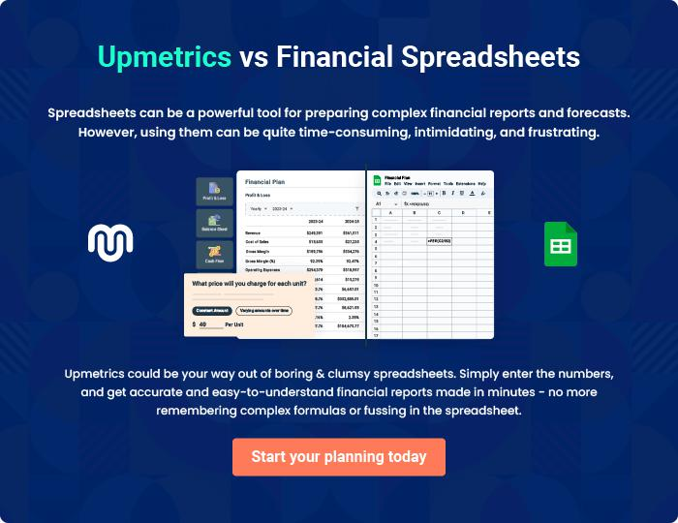
Appendix

When writing the appendix section, you should include any additional information that supports the main content of your plan. This may include financial statements, market research data, legal documents, and other
To unlock help try Upmetrics! 
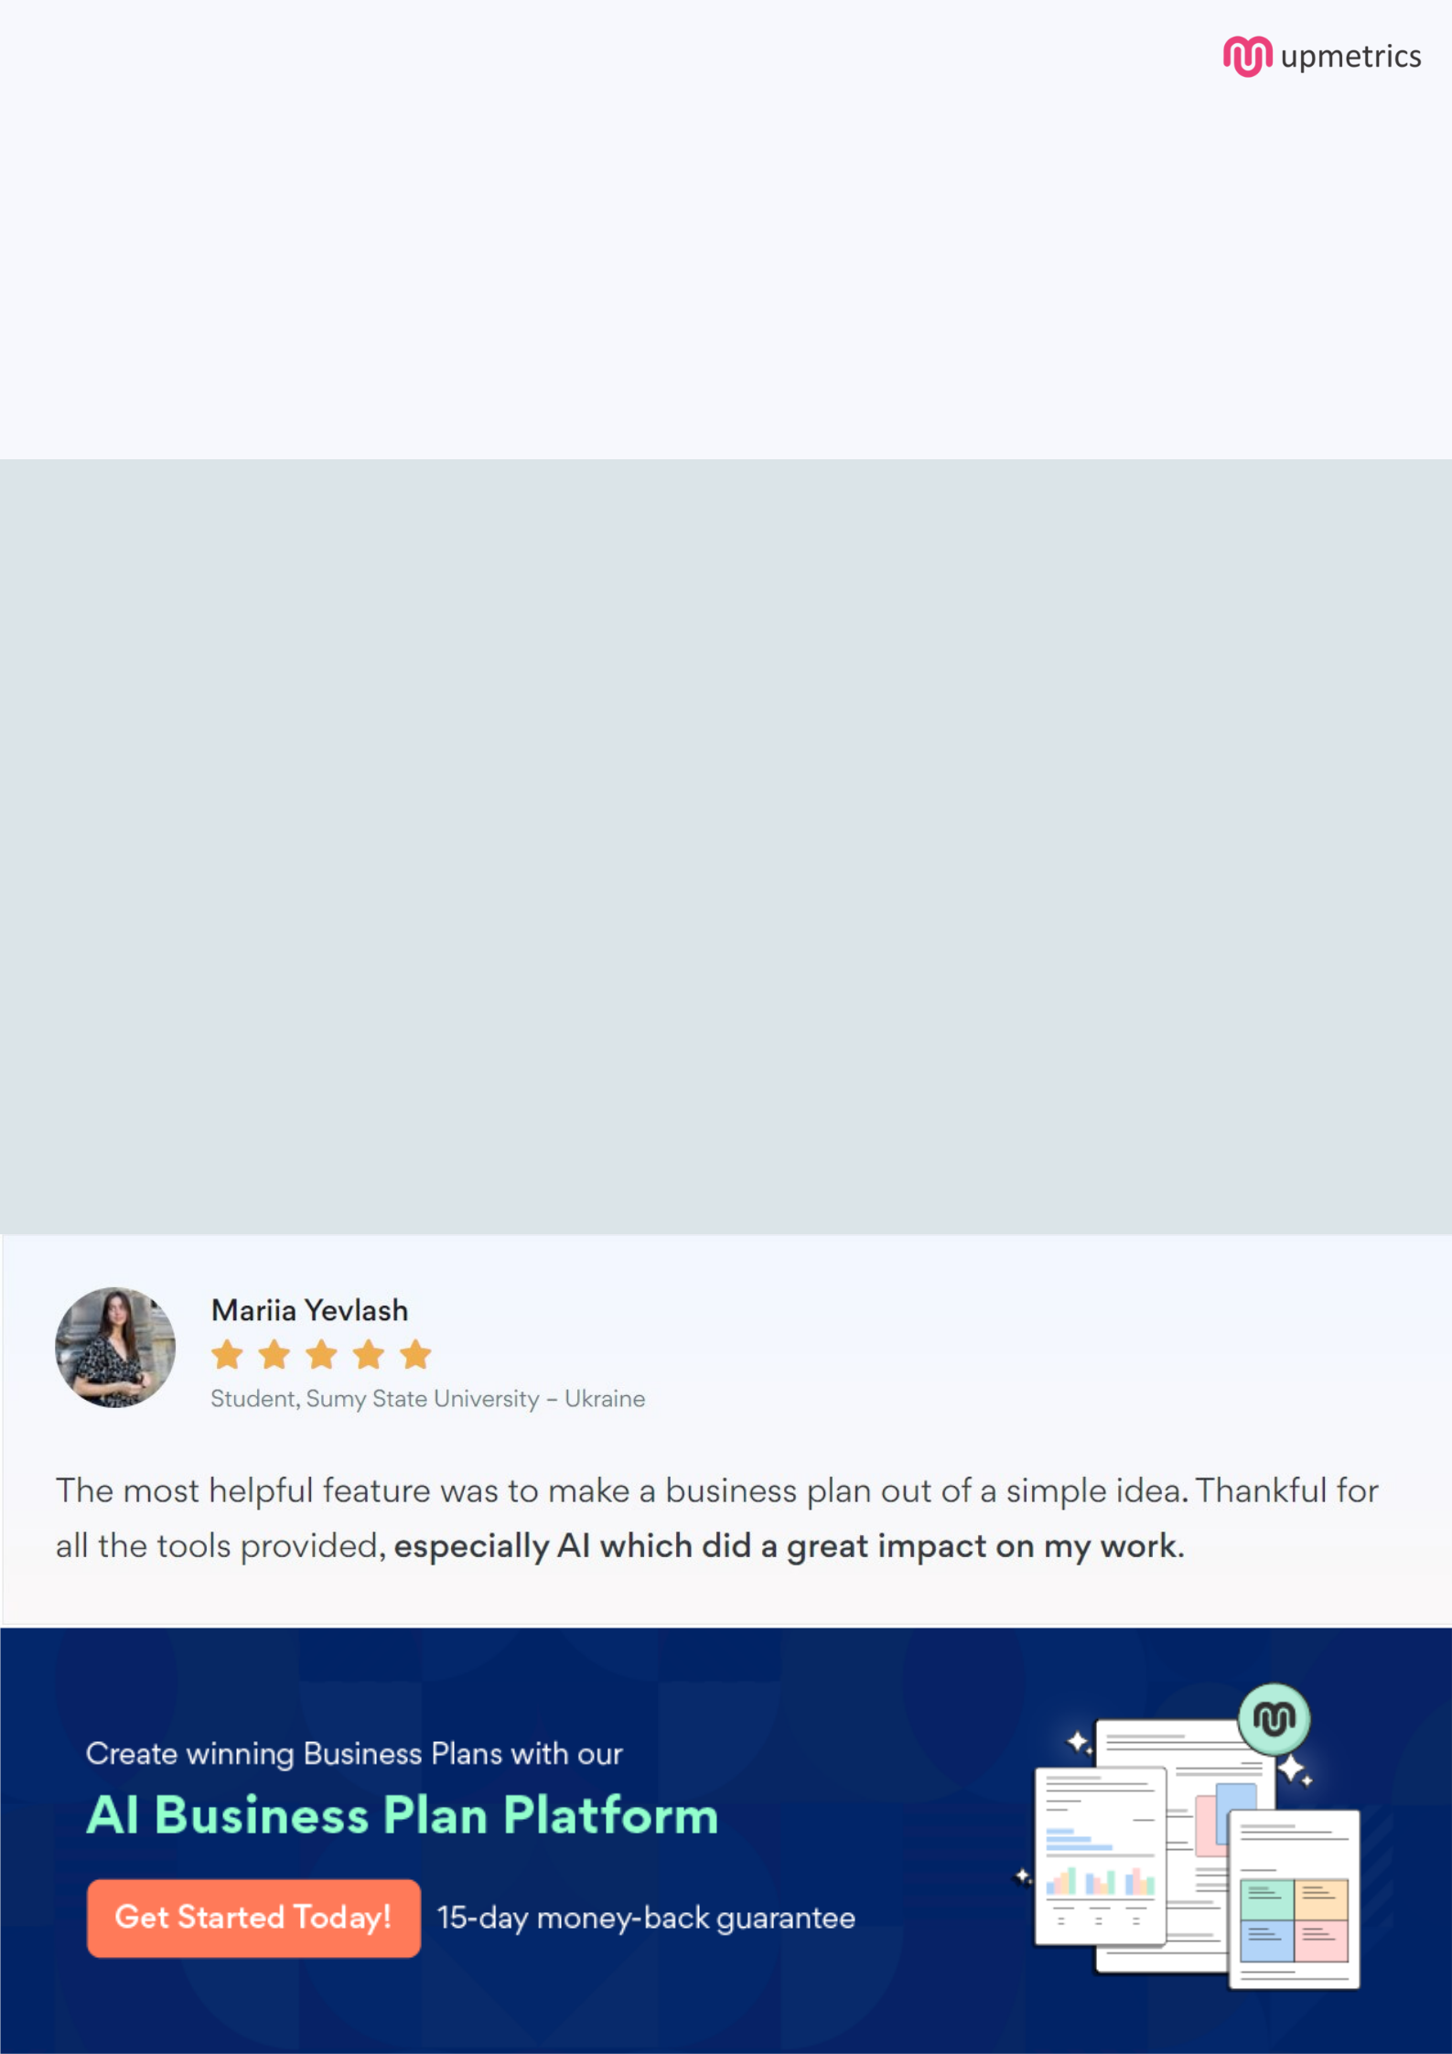
Create a winning business plan that gets you funded

Creating a stunning and investment-ready plan requires no writing, graphic designing, or financial planning expertise.

Upmetrics has all the features required to help you create a comprehensive business plan—from start to finish. Make no mistakes, it’s the modern way of planning to structure ideas, make plans, and create stunning pitch decks to awe investors.

Pitch decks that impress investors

Create pitch decks that provide a visual representation of your business, engage investors, and make them want to invest in your business idea.

Interactive plans in no time

Import business plan sections like—SWOT analysis, comparison tables, and others to create an interactive business plan. No designing skills are required.

Stunning cover page designs

With Upmetrics, you have the liberty to choose from multiple stunning cover page designs. Choose a creative design and make your plan stand out.

Online sharing made simple

Upmetrics makes online sharing quick and easier for users. Easily share your business plans with a link while tracking reader activity.

500+ sample business plans

Simply import a template from our library of sample plans into the editor and start customizing it to make it yours. It takes only a few clicks to get started.

Collaborate with team in real-time

Invite team members, initiate conversations, discuss ideas & strategies, share feedback, and work on a business plan in real-time.

