
BUSINESS PLAN

2023


Bookkeeping Business Plan

Turning Figures into Financial Insights

John Doe

10200 Bolsa Ave, Westminster, CA, 92683

- 359-3153 info@example.com http://www.example.com

Information provided in this business plan is unique to this business and confidential; therefore, anyone reading this plan agrees not to disclose any of the information in this business plan without prior written permission of the company.
Table of Contents

Executive Summary | 6
Market opportunity | 6
Services Offered | 6
Management team | 7
John Doe | 7
Jane Doe | 7
Alice Brown | 7
Robert Brown | 7
Financial Highlights | 8
Units Sold v/s Revenue | 8

Company Overview | 9
Ownership | 9
Mission statement | 9
Business history | 10
Future goals | 10

Market Analysis | 11
Target Market | 11
Market size and growth potential | 11
Market Size | 12
Competitive analysis | 12
AccountMasters | 12
LedgerLink | 13
NumeralNest | 13
Market trends | 13
Regulatory environment | 14

Products and Services | 15
Products and Services | 15

Accounting 15

Payroll | 16
Tax Preparation | 16
Financial Statement Production | 17
Additional services | 17
Tax Planning | 17
Business Advising | 18

Sales And Marketing Strategies | 19
Unique Selling Proposition (USP) | 19
Pricing Strategy | 19
Marketing strategies | 20
Online | 20
Offline | 20
Sales strategies | 21
Customer retention | 21

Operations Plan | 22
Rules and Regulations | 22
Operational Process | 22
Workplace | 23

Management Team | 24
Key managers | 24
John Doe | 25
Jane Doe | 26
Robert White | 26
Organizational structure | 26
Organization chart | 27
Compensation plan | 27
Board of advisors | 28
Robert Brown | 28
Alice Brown | 28
[ADVISOR NAME] | 28
Financial Plan | 29
Profit & loss statement | 29
Cash flow statement | 31
Balance sheet | 32
Break-even Point | 34
Financing needs | 35
Appendix
Appendix | 36
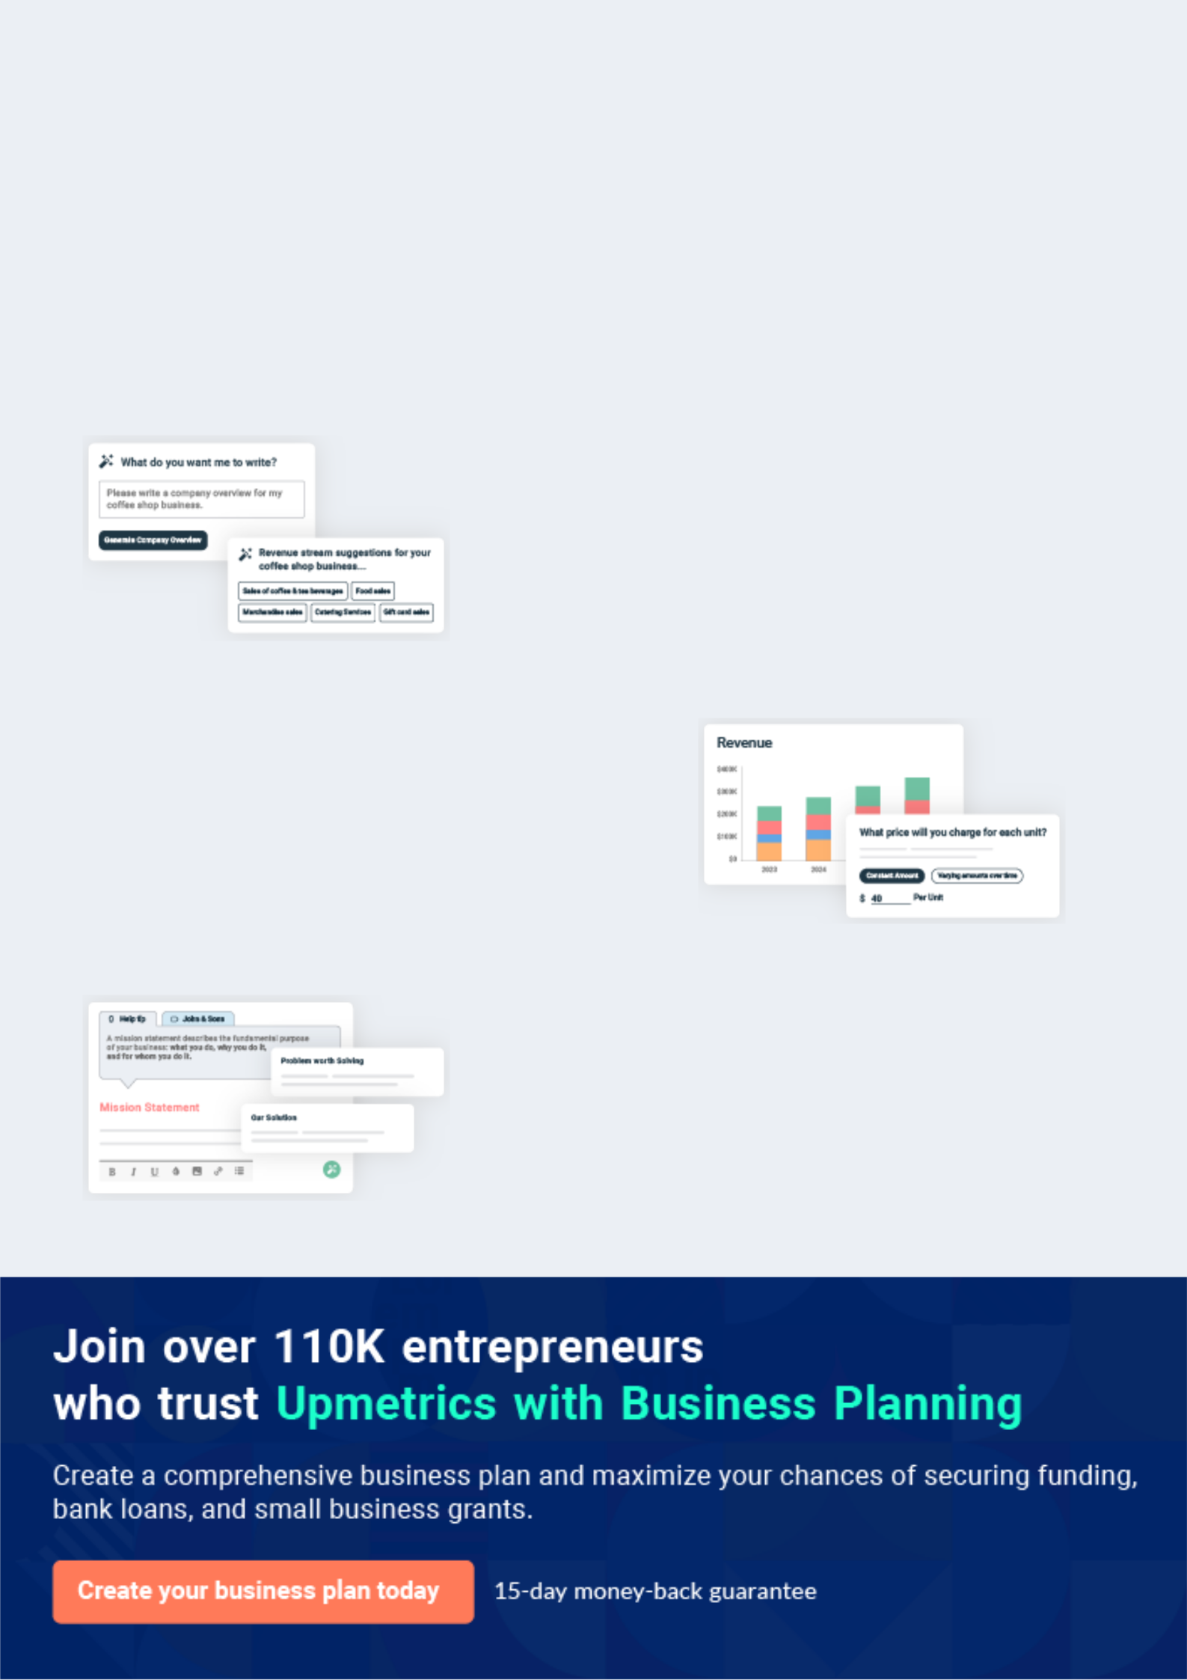
Business planning that’s simpler and faster than you think

Creating a business plan using Upmetrics to start and grow a business is literally the easiest thing in the World. Simply read the instructions and fill in the blanks. It’s as simple as that.

❛ | Upmetrics has everything you need to create a | ❜
❛ | comprehensive business plan. | ❜

AI-powered Upmetrics Assistant

AI-powered insights to streamline your plan

Not sure where to start? Upmetrics’ AI Assistant will automatically generate ideas for each section of your plan and offer improved versions of your writing, adjusting for tone, voice, and grammar or spelling errors.

Financial Forecasting Tool

All the financials are calculated for you

Forget the complex formulas and clumsy spreadsheets — with automatic financials and drag-and-drop forecasting, you can finish your plan faster and be confident that your numbers are accurate.

Business Plan Builder

Guides you like a business mentor

Upmetrics’ step-by-step instructions, prompts, and the library of 400+ sample business plans will guide you through each section of your plan as a business mentor.
Executive Summary


An executive summary is the first section of the business plan intended to provide an overview of the whole business plan.
To unlock help try Upmetrics! 

 Help tip  Bookkeeping Business Plan


Start your executive summary by introducing your idea behind starting a bookkeeping business and explaining what it does.
To unlock help try Upmetrics! 

Start writing here..

Market opportunity

 Help tip  Bookkeeping Business Plan

Describe the target market in brief, and explain the demographics, geographic location, and psychographic attributes of your customer.
To unlock help try Upmetrics! 

Start writing here..

Services Offered

 Help tip  Bookkeeping Business Plan

Describe in detail what all services your bookkeeping firm will provide as tax returns, payroll services, audit preparation, or others.
To unlock help try Upmetrics! 

Start writing here..

 Help tip


Name all the key members of your management team with their duties, responsibilities, and qualifications.
To unlock help try Upmetrics! 

Management team


JOHN DOE

Founder and CEO - john.doe@example.com

A veteran in the accounting world with [specific qualifications e.g., CPA] and over [X years] of experience.


JANE DOE

Chief Financial Strategist - jane.doe@example.com

An expert with [specific qualifications] and a proven track record of optimizing business financials.


ALICE BROWN

Client Relations Manager - alice.brown@example.com

With her prowess in [specific skills], she ensures every client interaction is seamless and productive.


ROBERT BROWN

Operations Head - robert.brown@example.com

Bringing in operational efficiencies with his [specific qualifications] and [X years] experience.

Financial Highlights
To unlock help try Upmetrics!

 Help tip  Bookkeeping Business Plan

Provide a summary of your financial projections for the company’s initial years of operation.

Include any capital or investment requirements, startup costs, projected revenues, and profits.
To unlock help try Upmetrics! 

Start writing here..

Units Sold v/s Revenue

 |  | Units Sold | Revenue
15.00k
10.00k
5.00k
0
Year 1 | Year 2 | Year 3


Financial Year |  |  | Units Sold | Revenue
Year 1 | 1,550 |  |  | $10,000
Year 2 | 1,800 |  |  | $12,000
Year 3 | 2,050 |  |  | $14,000
 Help tip |  |  Bookkeeping Business Plan


After giving a brief about your business plan, end your summary with a call to action, for example; inviting potential investors or readers to the next meeting if they are interested in your business.



Write a call to action for your business plan.

Company Overview

Depending on what details of your business are essential, you’ll need different elements in your business overview.
To unlock help try Upmetrics! 

 Help tip  Bookkeeping Business Plan

Provide all the basic information about your business in this section like:

• The name of your bookkeeping firm and what type of firm it is: a simple bookkeeping firm,
audit firm, virtual bookkeeping firm, tax firm, forensic accounting firm, or some other.
To unlock help try Upmetrics! 

Start writing here..

Ownership

 Help tip  Bookkeeping Business Plan

Describe the owners of your bookkeeping business and mention their roles in running it. Whose shares in the corporation are they, and how each owner helps in the business?
To unlock help try Upmetrics! 

Start writing here..

Mission statement

 Help tip  Bookkeeping Business Plan

Add a mission statement that sums up the objectives and core principles of your firm. This statement needs to be memorable, clear, and brief.
To unlock help try Upmetrics! 
❛ At [Business Name], our mission is to [clear and concise mission, e.g., 'empower businesses with precise, timely, and strategic financial insights, upholding the highest standards of integrity and professionalism in every ledger, report, and interaction.']
To unlock help try Upmetrics!

❜

Business history

 Help tip  Bookkeeping Business Plan

Include an outline of the accounting firm’s history and how it came to be in its current position.

If you can, add some personality and intriguing details, especially if you got any achievements
To unlock help try Upmetrics! 

Start writing here..

Future goals

 Help tip  Bookkeeping Business Plan

It’s crucial to convey your aspirations and your vision. Include the vision of where you see your business in the near future and if you have any plans of opening a new franchise of your business in the same city in the future.



Start writing here..
Market Analysis
To unlock help try Upmetrics!


 |  | Market analysis provides a clear understanding of the market in which your
 |  | printing business will run along with the target market, competitors, and
 |  | growth opportunities.
 |  |  |  | To unlock help try Upmetrics! 
 Help tip |  |  Bookkeeping Business Plan

To write the introduction section of your market analysis, start by clearly identifying your primary target market.
To unlock help try Upmetrics! 

Start writing here..

Target Market

 Help tip  Bookkeeping Business Plan

Identify your target market and define your ideal customer. Know more about your customers and which services they prefer: bookkeeping, auditing, accounting, tax calculation, payroll, or something else.



Start writing here..

Market size and growth potential

 Help tip  Bookkeeping Business Plan

Provide an overview of the bookkeeping industry. It will include market size, trends, growth potential, and regulatory considerations.
To unlock help try Upmetrics! 

Start writing here..

Market Size

Available Market

Total businesses requiring bookkeeping 10M services in the country.

Served Market
Businesses actively using professional 2M bookkeeping services.

Target Market
Small to mid-sized businesses in urban 500k areas seeking digital bookkeeping.

 Help tip  Bookkeeping Business Plan

Identify and analyze all other printing businesses in the local market, including direct and indirect competitors.
To unlock help try Upmetrics! 

Competitive analysis

AccountMasters

AccountMasters has established itself as a reliable cloud-based bookkeeping service. The blend of a real-time financial dashboard and bespoke tax consultations sets them apart, albeit with a premium price tag.

Features

Comprehensive cloud-based bookkeeping solutions

Real-time financial dashboard

Tailored tax consultation and filing services

Automated payroll processing

Strengths | Weaknesses
Strong online presence with | Higher pricing brackets
user-friendly interface | compared to market averages
A diversified client portfolio | Limited personalization in their
showcasing their experience | software solutions
across sectors | Occasional reported delays in
Round-the-clock customer | payroll processing during peak
support | seasons

LedgerLink

With a balance of traditional and digital offerings, LedgerLink has retained its relevance over the years. Their sterling reputation in audit preparation stands out, but they show signs of lagging in the tech race.

Features | Strengths | Weaknesses
Traditional and digital | Renowned for thorough and | Slower adaptation to new
bookkeeping services | meticulous audit preparation | technology trends
Audit preparation and support | On-ground support teams for | Limited digital tools for clients to
Business financial consultancy | businesses preferring | access their financial data
Business financial consultancy | traditional bookkeeping
 | traditional bookkeeping | Relatively restricted online
 | Long-standing market | customer support hours
 | presence and brand trust

NumeralNest

NumeralNest is a fresh face in the industry, driving innovation through AI and a commendable focus on sustainability. While their tech-driven approach is a hit, they’re still laying down their market roots.

Features

AI-powered financial analytics

Virtual bookkeeping consultations

Environmentally-friendly paperless solutions

Strengths

Cutting-edge tech integration, offering predictive financial insights

Strong focus on sustainability and eco-friendly practices

Flexible pricing models catering to startups and established businesses

Weaknesses

Newer entrant in the market, thus less historical data for trust-building

Dependence on third-party software for certain solutions, leading to occasional system hitches

Limited services in the audit and compliance segment

Market trends

 Help tip  Bookkeeping Business Plan

Analyze current and emerging trends in your industry, such as changes in customer preference or tax regime. Explain how your business will cope with all the changes.
To unlock help try Upmetrics! 

Start writing here..

Regulatory environment

 Help tip  Bookkeeping Business Plan

Describe any regulations or licensing requirements that affect the bookkeeping business, such as storing data for 5 years, privacy policy for clients’ data, and others.
To unlock help try Upmetrics! 

Start writing here..
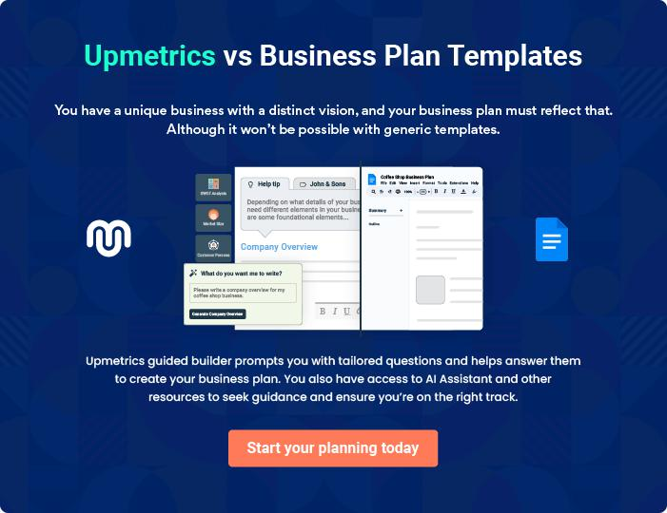
Products and Services
To unlock help try Upmetrics!

The product and services section of a bookkeeping business plan should describe the specific services and products that will be offered to customers. To write this section should include the following:



 Help tip  Bookkeeping Business Plan

To craft the introduction for your "Products and Services" chapter, begin by positioning your business within its industry, emphasizing its unique strengths or value proposition.
To unlock help try Upmetrics! 

Start writing here..

 Help tip

Create a list of the services:

The primary services you provide, such as accounting, payroll, tax preparation, and financial
To unlock help try Upmetrics! 

Products and Services

Accounting


Price: [$150 per hour] or [Monthly retainer fee: $2,500]

Our accounting solutions cover everything from maintaining ledgers to end-of-year reconciliations.

We ensure that all financial transactions are recorded accurately, assets and liabilities are balanced, and financial records are maintained systematically.

Qualifications of Professionals

The service is provided by a team of Certified Public Accountants (CPAs) with extensive experience in managing business finances.

Payroll

Price: [Fixed fee: $30 per employee] or [Monthly package starting at $500]

Our payroll services ensure that employee compensation is processed timely and accurately.

This includes calculating wages, managing deductions, ensuring tax compliance, and disbursing salaries to employees' accounts.

Additionally, year-end processes like generating W-2 and 1099 forms are also managed.

Qualifications of Professionals

Managed by payroll specialists who are well-versed in employment law and tax regulations.

Tax Preparation

Price: [Starting at $300 per return] or [Yearly package:

$1,000]

This service ensures that businesses are tax-compliant.

From income to expenditure, we meticulously evaluate all financial aspects, ensuring businesses benefit from available deductions and credits, leading to optimized tax returns.

Qualifications of Professionals

Chartered Accountants with specializations in tax management oversee this segment, ensuring compliance and optimal returns.
Financial Statement Production

Price: [Starting at $500 per statement]

We craft detailed financial statements, including income statements, balance sheets, and cash flow statements.

These documents offer businesses a clear view of their financial health, enabling informed decision-making.

Qualifications of Professionals

Financial analysts and CPAs collaborate to produce these statements, ensuring accuracy and relevance.

 Help tip

Make sure to list these in your product and services section if you provide any services beyond basic bookkeeping, such as tax planning or business advising.
To unlock help try Upmetrics! 

Additional services

Tax Planning

Price: [Annual fee: $1,200] or [Per consultation: $200]

Beyond immediate tax obligations, we strategize for the future.

This involves understanding a business's projected financial movements, leveraging tax benefits, and planning investments and expenditures to minimize tax liabilities.

Qualifications of Professionals

Chartered Accountants with expertise in tax strategy are at the helm of this service.
Business Advising

Price: [Per session: $250] or [Quarterly package: $900]

Based on financial data and market insights, we offer strategic counsel to businesses. This could encompass expansion strategies, cost optimization, or investment opportunities.

Qualifications of Professionals

Business consultants with financial backgrounds, often holding MBA degrees or equivalent qualifications, provide these insights.
Sales And Marketing Strategies

Writing the sales and marketing strategies section means a list of strategies you will use to attract and retain your clients.
To unlock help try Upmetrics! 

 Help tip  Bookkeeping Business Plan

To create an effective introduction for your "Sales and Marketing Strategies" chapter, start by setting the stage within your specific industry or market.
To unlock help try Upmetrics! 

Unique Selling Proposition (USP)

 Help tip  Bookkeeping Business Plan

Determine what makes your bookkeeping services stand out from the crowd – competitive pricing, expert knowledge, or customized service.
To unlock help try Upmetrics! 

Start writing here..

Pricing Strategy

 Help tip  Bookkeeping Business Plan

Develop a pricing strategy that is competitive and affordable, yet profitable.

Consider offering promotions, discounts, or packages for your bookkeeping services to attract
To unlock help try Upmetrics! 

Start writing here..

 Help tip  Bookkeeping Business Plan

Develop a marketing strategy that includes a mix of online and offline marketing tactics.

Consider social media, email marketing, content marketing, brochures, print marketing, and
To unlock help try Upmetrics! 

Marketing strategies

Online


Social Media

Engaging content on platforms like [specific platforms, e.g., "LinkedIn, Facebook, and Twitter"], fostering community and awareness.

Content Marketing

Insightful articles and blogs on our website, positioning [Business Name] as a thought leader in the bookkeeping space.

Offline

Brochures

Detailed brochures available at our office and distributed during industry events.

Email Marketing

Regular newsletters with updates, tips, and promotions, ensuring we stay top-of-mind.

Print Marketing

Advertisements in [specific places, e.g., "local business magazines and newspapers"].

Events

Participation in and sponsorship of

local business events and trade

shows.

Sales strategies
To unlock help try Upmetrics!

 Help tip  Bookkeeping Business Plan

Create a sales plan that explains how you’ll turn leads into paying customers. Offering free consultations, providing references, or creating unique proposals are a few examples of what this could include.



Free Consultations Providing References

Allowing potential clients to Showcasing our track record with

experience our expertise firsthand. testimonials and case studies.

Unique Proposals

Tailoring proposals to address

each client's specific needs and

challenges.

 Help tip  Bookkeeping Business Plan

Describe how your business will retain customers and build loyalty, such as through loyalty programs, special events, or personalized service.
To unlock help try Upmetrics! 

Customer retention

Loyalty Programs Special Events

Rewarding consistent partnerships Hosting [specific events, e.g.,

with discounts and complimentary "financial literacy workshops and

services. annual client appreciation events"].

Personalized Service

Ensuring each client has a

dedicated representative, always

ready to assist and advise.

Operations Plan

 |  | When writing the operations plan section, it’s important to consider the
 |  | various aspects of your business operations.
 |  |  |  | To unlock help try Upmetrics! 
 Help tip |  |  Bookkeeping Business Plan


To create an effective introduction for your "Operational Plan" chapter, start by emphasizing the
pivotal role of efficient operations in the success of your business, underscoring how they
directly impact the quality of services delivered.
 |  |  |  | To unlock help try Upmetrics! 
Start writing here..
Rules and Regulations
 Help tip |  |  Bookkeeping Business Plan

Create policies and procedures for your bookkeeping services, including how you will handle
confidential client information, track billable hours, and respond to client questions and
complaints.
 |  |  |  | To unlock help try Upmetrics! 
Start writing here..
Operational Process
 Help tip |  |  Bookkeeping Business Plan

Outline the processes and procedures that you will use to run your bookkeeping business. It includes scheduling meetings with clients, filing tax returns, and other jobs.
To unlock help try Upmetrics! 

Start writing here..

Workplace
To unlock help try Upmetrics!

 Help tip  Bookkeeping Business Plan

Make a list of the equipment and physical space you’ll need for your bookkeeping firm. A dedicated workstation, accounting software, and communication tools are a few examples of what this may entail.



Start writing here..
Management Team

The management team section provides an overview of the individuals responsible for running your business plan.
To unlock help try Upmetrics! 

 Help tip  Bookkeeping Business Plan

To craft an introduction for your "Management Team" chapter, begin by emphasizing the crucial role of leadership in the success of any business.
To unlock help try Upmetrics! 

Start writing here..

Key managers

 Help tip  Bookkeeping Business Plan

Describe the key members of your management team, their roles, and their responsibilities.

It should include the owners, senior management, and any other accountants who will be
To unlock help try Upmetrics! 

Start writing here..
JOHN DOE

CEO and Founder - john.doe@example.com

As the CEO and Founder of [Business Name], John sets the strategic direction, oversees key partnerships, and ensures that the company continually evolves to meet the dynamic needs of its clientele.


- Educational Background: John graduated magna cum laude with a Bachelor's in Accounting from [Prestigious University Name] and later pursued his MBA with a specialization in Finance from [Another Prestigious University].

- Professional Background: John's journey in the financial world spans over two decades. He began his career with [Big Financial Firm], climbing the ranks to become a Senior Financial Strategist.

His entrepreneurial spirit led him to establish [Business Name], with a vision to revolutionize traditional bookkeeping practices.
JANE DOE

Chief Financial Officer (CFO) - jane.doe@example.com

Jane holds the financial reins at [Business Name], directing everything from daily operations to long-term financial planning, ensuring fiscal health and compliance.

- Educational Background: With a Bachelor's in Business Economics from [Esteemed University Name] and a CPA certification, Jane possesses both the academic and practical knowledge essential for her role.

- Professional Background: Jane's professional arc took her through roles such as Senior Auditor at [Notable Audit Firm] and Finance Manager at [Major Corporate Entity].

Her expertise in both audit and corporate finance makes her a linchpin in the [Business Name] ecosystem.


ROBERT WHITE

Director of Client Relations - robert.white@example.com

Robert spearheads the client relations department, ensuring that every interaction with [Business Name] is smooth, productive, and exceeds client expectations.

- Educational Background: A graduate in Communication Studies from [Top-tier University Name], Robert also holds a certification in Customer Relationship Management.

- Professional Background: Having worked with giants like [Major Service Company] as a Client Relations Manager and [Another Big Company] as a Customer Success Lead, Robert understands the nuances of client needs and tailors solutions accordingly

Organizational structure

 Help tip  Bookkeeping Business Plan

Describe the organizational structure of the management team, including reporting lines and how decisions will be made.
To unlock help try Upmetrics! 

Start writing here..

Organization chart


John Doe

CEO


Robert White
Director of Client | Jane Doe
Relations | Jane Doe
Relations | CFO




Bill Gray | Clara Green | Alex Ray
Client Relation | Client Relation | Senior | Amy Lee
Specialist | Specialist | Accountant | Senior
 |  |  | Accountant



Compensation plan

 Help tip  Bookkeeping Business Plan

Describe your compensation plan for the management team and staff, including salaries, bonuses, and other benefits.
To unlock help try Upmetrics! 

Start writing here..
 Help tip  Bookkeeping Business Plan

If you have a board of advisors for your business, then mention them along with their roles and experience.
To unlock help try Upmetrics! 

Board of advisors


ROBERT BROWN

With a rich history in [specific domain, e.g., "tech integrations for financial institutions"], Robert brings a wealth of knowledge on modernizing traditional bookkeeping practices.

ALICE BROWN

Stalwart

A stalwart in the financial industry with over [X years] of experience, Alice has been [specific accolades or roles, e.g., "the CFO of MajorCorp and an advisor to several Fortune 500 companies"].


[ADVISOR NAME]

[DESIGNATION]

[Description of this advisor's background and expertise]
Financial Plan
To unlock help try Upmetrics!

When writing the financial plan section of a business plan, it’s important to provide a comprehensive overview of your financial projections for the first few years of your business, You may provide the following:
To unlock help try Upmetrics! 

 Help tip  Bookkeeping Business Plan

To create an effective introduction for your "Financial Plan" chapter, begin by stressing the critical role of a well-structured financial plan in the success of your venture.
To unlock help try Upmetrics! 

Start writing here..

 Help tip

Create a projected profit & loss statement that describes the expected revenue, cost of products sold, and operational costs. Your firm’s anticipated net profit or loss should be computed and included.



Profit & loss statement

 | 2023-24 | 2024-25 | 2025-26 | 2026-27 | 2027-28
Revenue | $0 | $0 | $0 | $0 | $0

Cost Of Sales | $0 | $0 | $0 | $0 | $0
General Costs | $0 | $0 | $0 | $0 | $0
Revenue Specific Costs | $0 | $0 | $0 | $0 | $0
Personnel Costs (Direct | $0 | $0 | $0 | $0 | $0
Labor)

Gross Margin $0 $0 $0 $0 $0

Gross Margin (%)

Operating Expense

Payroll Expense

(Indirect Labor)

General Expense

Bad Debt

Amortization of Current Assets

EBITDA

Additional Expense

Long Term

Depreciation

Gain or loss from Sale of Assets

EBIT

Interest Expenses

EBT

Income Tax Expense

Total Expense

Net Income

Net Income (%)

2023-24 | 2024-25 | 2025-26 | 2026-27 | 2027-28
0% | 0% | 0% | 0% | 0%
$0 | $0 | $0 | $0 | $0
$0 | $0 | $0 | $0 | $0
$0 | $0 | $0 | $0 | $0
$0 | $0 | $0 | $0 | $0
$0 | $0 | $0 | $0 | $0
$0 | $0 | $0 | $0 | $0
$0 | $0 | $0 | $0 | $0
$0 | $0 | $0 | $0 | $0
$0 | $0 | $0 | $0 | $0
$0 | $0 | $0 | $0 | $0
$0 | $0 | $0 | $0 | $0
$0 | $0 | $0 | $0 | $0
$0 | $0 | $0 | $0 | $0
$0 | $0 | $0 | $0 | $0
$0 | $0 | $0 | $0 | $0
0% | 0% | 0% | 0% | 0%
To unlock help try Upmetrics!
 | 2023-24 | 2024-25 | 2025-26 | 2026-27 | 2027-28
Retained Earning | $0 | $0 | $0 | $0 | $0
Opening
Owner's Distribution | $0 | $0 | $0 | $0 | $0
Retained Earning | $0 | $0 | $0 | $0 | $0
Closing

 Help tip

Estimate your cash inflows and outflows for the first few years of operation. It should include cash receipts from clients, payments to vendors, loan payments, and any other cash inflows and outflows.



Cash flow statement

Cash Received

Cash Paid

COS & General Expenses

Salary & Wages

Interest

Sales Tax

Income Tax

Net Cash From

Operations

Assets Sell

Assets Purchase

Net Cash From

Investments

2023-24 | 2024-25 | 2025-26 | 2026-27 | 2027-28
$0 | $0 | $0 | $0 | $0
$0 | $0 | $0 | $0 | $0
$0 | $0 | $0 | $0 | $0
$0 | $0 | $0 | $0 | $0
$0 | $0 | $0 | $0 | $0
$0 | $0 | $0 | $0 | $0
$0 | $0 | $0 | $0 | $0
$0 | $0 | $0 | $0 | $0

$0 | $0 | $0 | $0 | $0
$0 | $0 | $0 | $0 | $0
$0 | $0 | $0 | $0 | $0

 | 2023-24 | 2024-25 | 2025-26 | 2026-27 | 2027-28
Amount Received | $0 | $0 | $0 | $0 | $0
Loan Received | $0 | $0 | $0 | $0 | $0
Common Stock
Preferred Stock | $0 | $0 | $0 | $0 | $0
Owner's Contribution | $0 | $0 | $0 | $0 | $0
Amount Paid | $0 | $0 | $0 | $0 | $0
Loan Capital | $0 | $0 | $0 | $0 | $0
Dividends & Distributions | $0 | $0 | $0 | $0 | $0
Net Cash From | $0 | $0 | $0 | $0 | $0
Financing

Summary
Starting Cash | $0 | $0 | $0 | $0 | $0
Cash In | $0 | $0 | $0 | $0 | $0
Cash Out | $0 | $0 | $0 | $0 | $0
Change in Cash | $0 | $0 | $0 | $0 | $0
Ending Cash | $0 | $0 | $0 | $0 | $0

 Help tip

Prepare a projected balance sheet, which shows the accounting firm’s assets, liabilities, and equity.
To unlock help try Upmetrics! 

Balance sheet

 | 2023-24 | 2024-25 | 2025-26 | 2026-27 | 2027-28
Assets | $0 | $0 | $0 | $0 | $0
 | 2023-24 | 2024-25 | 2025-26 | 2026-27 | 2027-28
Current Assets | $0 | $0 | $0 | $0 | $0
Cash | $0 | $0 | $0 | $0 | $0
Accounts Receivable | $0 | $0 | $0 | $0 | $0
Inventory | $0 | $0 | $0 | $0 | $0
Other Current Assets | $0 | $0 | $0 | $0 | $0
Long Term Assets | $0 | $0 | $0 | $0 | $0
Gross Long Term Assets | $0 | $0 | $0 | $0 | $0
Accumulated Depreciation | $0 | $0 | $0 | $0 | $0

Liabilities & Equity | $0 | $0 | $0 | $0 | $0
Liabilities | $0 | $0 | $0 | $0 | $0
Current Liabilities | $0 | $0 | $0 | $0 | $0
Accounts Payable | $0 | $0 | $0 | $0 | $0
Income Tax Payable | $0 | $0 | $0 | $0 | $0
Sales Tax Payable | $0 | $0 | $0 | $0 | $0
Short Term Debt | $0 | $0 | $0 | $0 | $0
Long Term Liabilities | $0 | $0 | $0 | $0 | $0
Long Term Debt | $0 | $0 | $0 | $0 | $0
Equity | $0 | $0 | $0 | $0 | $0
Paid-in Capital | $0 | $0 | $0 | $0 | $0
Common Stock | $0 | $0 | $0 | $0 | $0
Preferred Stock | $0 | $0 | $0 | $0 | $0
Owner's Contribution | $0 | $0 | $0 | $0 | $0
Retained Earnings | $0 | $0 | $0 | $0 | $0
 | 2023-24 |  |  | 2024-25 | 2025-26 | 2026-27 | 2027-28
Check | $0 |  |  | $0 | $0 | $0 | $0
 Help tip |  |  Bookkeeping Business Plan

Determine the point at which your bookkeeping company will break even, or generate enough revenue to cover its operating costs.
To unlock help try Upmetrics! 

Break-even Point

 | 2023-24 | 2024-25 | 2025-26 | 2026-27 | 2027-28
Starting Revenue | $0 | $0 | $0 | $0 | $0
Net Revenue | $0 | $0 | $0 | $0 | $0
Closing Revenue | $0 | $0 | $0 | $0 | $0

Starting Expense | $0 | $0 | $0 | $0 | $0
Net Expense | $0 | $0 | $0 | $0 | $0
Closing Expense | $0 | $0 | $0 | $0 | $0

Is Break Even? | 0 | 0 | 0 | 0 | 0
Break Even Month | 0 | 0 | 0 | 0 | 0
Days Required | 0 | 0 | 0 | 0 | 0
Break Even Revenue | $0 | $0 | $0 | $0 | $0
Break Even Units
Financing needs
To unlock help try Upmetrics!

 Help tip  Bookkeeping Business Plan

Estimate how much financing you will need to start and operate your bookkeeping business. It should include both short-term and long-term financing needs, such as loans or investment capital.



Start writing here..
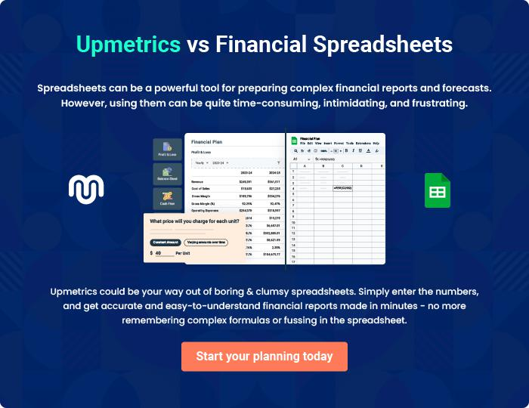
Appendix

When writing the appendix section, you should include any additional information that supports the main content of your plan. This may include financial statements, market research data, legal documents, and other
To unlock help try Upmetrics! 

Create a winning business plan that gets you funded

Creating a stunning and investment-ready plan requires no writing, graphic designing, or financial planning expertise.

Upmetrics has all the features required to help you create a comprehensive business plan—from start to finish. Make no mistakes, it’s the modern way of planning to structure ideas, make plans, and create stunning pitch decks to awe investors.

Pitch decks that impress investors

Create pitch decks that provide a visual representation of your business, engage investors, and make them want to invest in your business idea.

Interactive plans in no time

Import business plan sections like—SWOT analysis, comparison tables, and others to create an interactive business plan. No designing skills are required.

Stunning cover page designs

With Upmetrics, you have the liberty to choose from multiple stunning cover page designs. Choose a creative design and make your plan stand out.

Online sharing made simple

Upmetrics makes online sharing quick and easier for users. Easily share your business plans with a link while tracking reader activity.

500+ sample business plans

Simply import a template from our library of sample plans into the editor and start customizing it to make it yours. It takes only a few clicks to get started.

Collaborate with team in real-time

Invite team members, initiate conversations, discuss ideas & strategies, share feedback, and work on a business plan in real-time.

