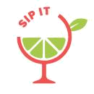
Beverage Business Plan


Business
Plan

2023
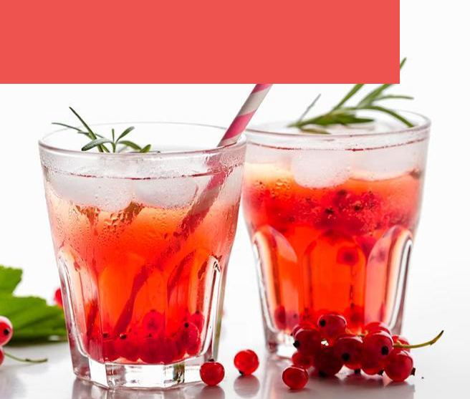

Refreshing Moments, Always

Information provided in this business plan is unique to this business and confidential; therefore, anyone reading this plan agrees not to disclose any of the information in this business plan without prior written permission of the company.

 | Prepared By | 10200 Bolsa Ave, Westminster, CA, 92683
 | John Doe | info@example.com
 | (650) 359-3153 | http://www.example.com

Table of Contents

Executive Summary | 6
Market opportunity | 6
Beverage Servings | 6
Marketing and Sales Strategies | 7
Financial Highlights | 7
Units Sold v/s Revenue | 8

Company Overview | 9
Ownership | 9
Mission statement | 10
Business history | 10
Future goals | 10

Market Analysis | 11
Target Market | 11
Market size and growth potential | 11
Market Size | 12
Competitive analysis | 12
Cafe Aromas | 12
GreenLeaf Juicery | 13
Tea Traditions | 13
Market trends | 13
Regulatory environment | 14

Products and Services | 15
Products and Services | 15
Espresso | 15
Caramel Latte | 16
Jasmine Green Tea | 16
Berry Burst Smoothie | 16
Ham & Cheese Croissant | 17
Beverage Bliss Membership Card | 17
Quality Standards | 17
Additional Services | 18

Sales And Marketing Strategies | 19
Unique Selling Proposition (USP) | 19
Pricing Strategy | 19
Marketing strategies | 20
Online | 20
Offline | 20
Sales strategies | 21
Customer retention | 22

Operations Plan | 23
Staffing and Training | 23
Operational Process | 23
Equipment & Machinery | 24

Management Team | 25
Key managers | 25
John Doe | 25
Jane Doe | 26
Alice Brown | 26
Robert Brown | 26
Lucas White | 27
Organizational structure | 27
Organization chart | 28
Compensation plan | 28
Board of advisors | 29
Mr. David Blue | 29
Dr. Emily Green | 29
Financial Plan | 30
Profit & loss statement | 30
Cash flow statement | 32
Balance sheet | 33
Break-even Point | 35
Financing needs | 36
Appendix
Appendix | 37
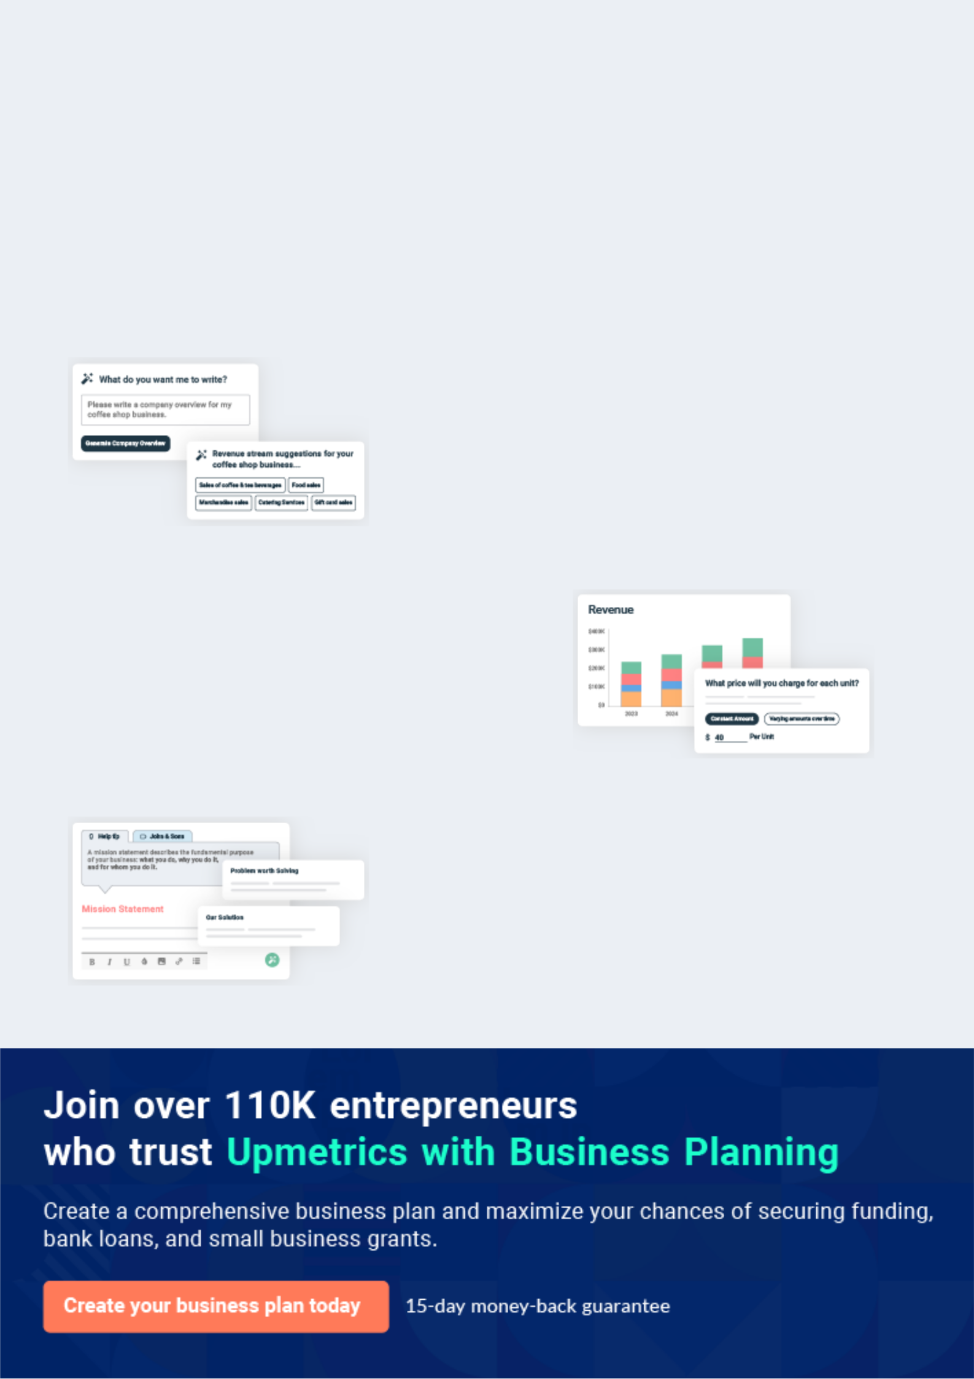
Business planning that’s simpler and faster than you think

Creating a business plan using Upmetrics to start and grow a business is literally the easiest thing in the World. Simply read the instructions and fill in the blanks. It’s as simple as that.

❛ | Upmetrics has everything you need to create a | ❜
❛ | comprehensive business plan. | ❜

AI-powered Upmetrics Assistant

AI-powered insights to streamline your plan

Not sure where to start? Upmetrics’ AI Assistant will automatically generate ideas for each section of your plan and offer improved versions of your writing, adjusting for tone, voice, and grammar or spelling errors.

Financial Forecasting Tool

All the financials are calculated for you

Forget the complex formulas and clumsy spreadsheets — with automatic financials and drag-and-drop forecasting, you can finish your plan faster and be confident that your numbers are accurate.

Business Plan Builder

Guides you like a business mentor

Upmetrics’ step-by-step instructions, prompts, and the library of 400+ sample business plans will guide you through each section of your plan as a business mentor.
Executive Summary


An executive summary is the first section of the business plan intended to provide an overview of the whole business plan.
To unlock help try Upmetrics! 

 Help tip  Beverage Business Plan


Start your executive summary by briefly introducing your business to your readers.

This section may include the name of your beverage business, its location, when it was
To unlock help try Upmetrics! 

Start writing here..

Market opportunity

 Help tip  Beverage Business Plan

Summarize your market research, including market size, growth potential, and marketing trends.
To unlock help try Upmetrics! 

Start writing here..

Beverage Servings

 Help tip  Beverage Business Plan

Highlight the beverages you offer your clients. The USPs and differentiators you offer are always a plus.
To unlock help try Upmetrics! 

Start writing here..

Marketing and Sales Strategies
To unlock help try Upmetrics!

 Help tip  Beverage Business Plan

Outline your sales and marketing strategies—what marketing platforms you use, how you plan on acquiring customers, etc.
To unlock help try Upmetrics! 

Start writing here..

Financial Highlights

 Help tip  Beverage Business Plan

Briefly summarize your financial projections for the initial years of business operations. Include capital or investment requirements, associated startup costs, projected revenues, and profit forecasts.



Start writing here..
Units Sold v/s Revenue

 |  | Units Sold | Revenue
15.00k
10.00k
5.00k
0
Year 1 | Year 2 | Year 3
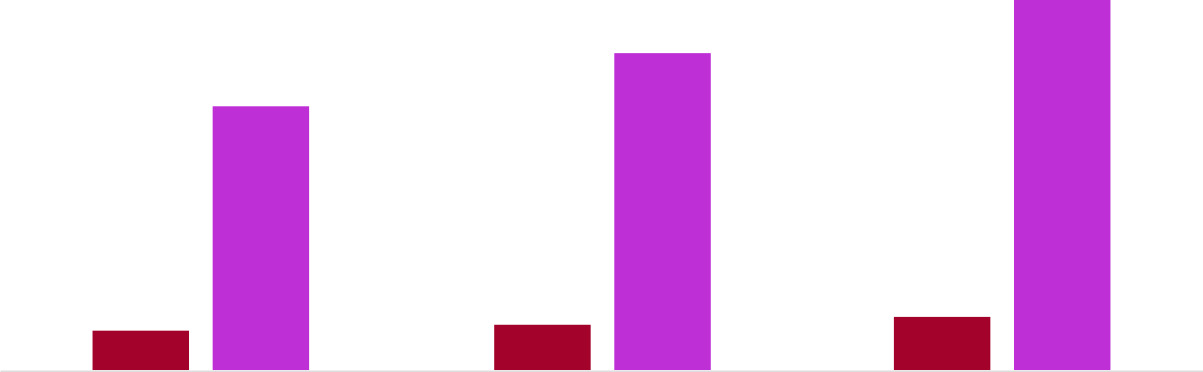

Financial Year |  |  | Units Sold | Revenue
Year 1 | 1,550 |  |  | $10,000
Year 2 | 1,800 |  |  | $12,000
Year 3 | 2,050 |  |  | $14,000
 Help tip |  |  Beverage Business Plan
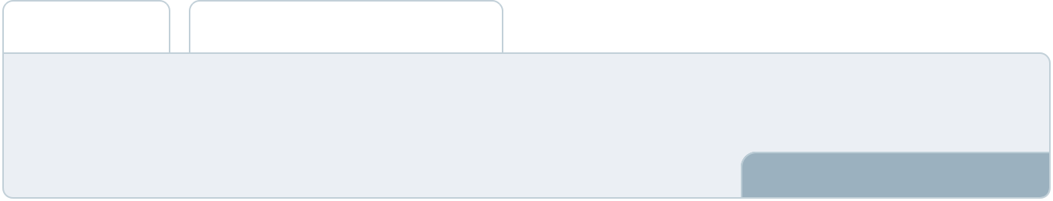

Summarize your executive summary section with a clear CTA, for example, inviting angel investors to discuss the potential business investment
To unlock help try Upmetrics! 

Write a call to action for your business plan.
Company Overview

Depending on what details of your business are essential, you’ll need different elements in your business overview.
To unlock help try Upmetrics! 

 Help tip  Beverage Business Plan

Describe your business in this section by providing all the basic information:

Describe what kind of beverage company you run and the name of it. You may specialize in one
To unlock help try Upmetrics! 

Start writing here..

Ownership

 Help tip  Beverage Business Plan

List the names of your beverage business’s founders or owners. Describe what shares they own and their responsibilities for efficiently managing the business.
To unlock help try Upmetrics! 

Start writing here..
Mission statement

 Help tip  Beverage Business Plan

Summarize your business’ objective, core principles, and values in your mission statement. This statement needs to be memorable, clear, and brief.
To unlock help try Upmetrics! 

❛ At "[Beverage Bliss]", our mission is succinct yet profound: "[Memorable mission statement, e.g., 'To infuse every sip with a story, merging age-old traditions with modern flavours, all while creating a community bound by the love for exquisite beverages.']" This encapsulates our commitment to quality, community, and innovation.

❜

Business history

 Help tip  Beverage Business Plan

If you’re an established beverage business, briefly describe your business history, like—when it was founded, how it evolved over time, etc.
To unlock help try Upmetrics! 

Start writing here..

Future goals

 Help tip  Beverage Business Plan

It’s crucial to convey your aspirations and vision. Mention your short-term and long-term goals; they can be specific targets for revenue, market share, or expanding your services.
To unlock help try Upmetrics! 

Start writing here..

Market Analysis
To unlock help try Upmetrics!


 |  | Market analysis provides a clear understanding of the market in which your
 |  | printing business will run along with the target market, competitors, and
 |  | growth opportunities.
 |  |  |  | To unlock help try Upmetrics! 
 Help tip |  |  Beverage Business Plan

To write the introduction section of your market analysis, start by clearly identifying your primary target market.
To unlock help try Upmetrics! 

Start writing here..

Target Market

 Help tip  Beverage Business Plan

Start this section by describing your target market. Define your ideal customer and explain what types of services they prefer. Creating a buyer persona will help you easily define your target market to your readers.



Start writing here..

Market size and growth potential

 Help tip  Beverage Business Plan

Describe your market size and growth potential and whether you will target a niche or a much broader market.
To unlock help try Upmetrics! 

Start writing here..

Market Size

Available Market

Total potential coffee and beverage 5M consumers in the region.

Served Market
Consumers within our delivery and 1M physical reach.

Target Market
Working professionals aged 25-45 in 250k urban areas.

 Help tip  Beverage Business Plan

Identify and analyze your direct and indirect competitors. Identify their strengths and weaknesses, and describe what differentiates your beverage business from them.
To unlock help try Upmetrics! 

Competitive analysis

Cafe Aromas

Location: Main Street, Downtown

Features | Strengths | Weaknesses
Wide range of espresso-based | Prime location with high foot | Limited non-coffee beverage
drinks | traffic | options
In-house baked pastries | Strong brand presence on | The ambience lacks a personal
Subscription-based loyalty | social media | touch and feels more
Subscription-based loyalty |  | commercial
program | Efficient and rapid service | commercial
Mobile app for pre-orders |  | No options for dietary
Mobile app for pre-orders |  | restrictions, such as vegan or
 |  | gluten-free

GreenLeaf Juicery

Location: Bay Avenue, Near City Park

Features | Strengths | Weaknesses
Extensive menu of fresh fruit | Sourced from organic, local | Higher pricing due to organic
and vegetable juices | farms | sourcing
Detox and health-centric | Strong loyalty among health- | Limited seating space
beverage programs | conscious customers | Does not offer any hot beverages
Eco-friendly packaging | Regularly introduces seasonal
 | specials

Tea Traditions

Location: Elm Street, Shopping District

Features

Wide variety of traditional and herbal teas

Monthly tea tasting events

Online store selling tea blends and accessories

Strengths

Authentic experience with staff knowledgeable about tea origins and brew methods

Strong online presence with an active e-commerce platform

Offers tea classes and workshops

Weaknesses

Limited food/snack options

No options for coffee or other beverages

Peak hours often result in long wait times

Market trends

 Help tip  Beverage Business Plan

Analyze emerging trends in the industry, such as technology disruptions, changes in customer behavior or preferences, etc. Explain how your business will cope with all the trends.
To unlock help try Upmetrics! 

Start writing here..

Regulatory environment
To unlock help try Upmetrics!

 Help tip  Beverage Business Plan

List regulations and licensing requirements that may affect your beverage company, such as licensing & permits, food safety & quality standards, alcohol regulations, labeling & packaging regulations, etc.



Start writing here..
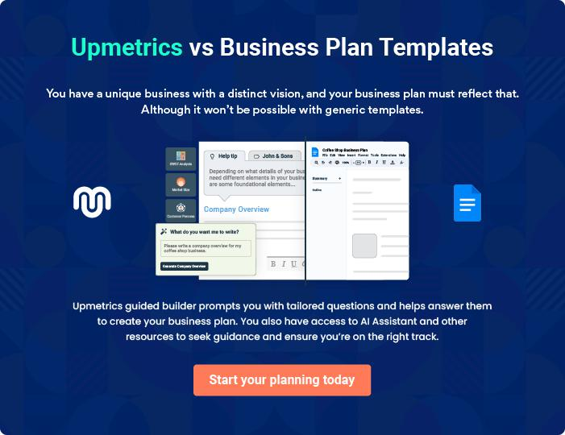
Products and Services
To unlock help try Upmetrics!

The product and services section of a beverage business plan should describe the specific services and products that will be offered to customers. To write this section should include the following:



 Help tip  Beverage Business Plan

To craft the introduction for your "Products and Services" chapter, begin by positioning your business within its industry, emphasizing its unique strengths or value proposition.
To unlock help try Upmetrics! 

Start writing here..

 Help tip


Mention the beverage menu your business will offer. This list may include:

• All types of beverages, with flavors
• Snacks & food | To unlock help try Upmetrics! 

Products and Services

Espresso


Price: [$3.50]

A rich, full-bodied shot of coffee that forms the foundation of many of our beverages.

Specifications

- Size: Single (1 oz.) or Double (2 oz.)

- Origin: Colombian Arabica Beans

- Brewing Temperature: 195°F - 205°F
Caramel Latte

Price: [$5.00]

Smooth espresso blended with steamed milk and a dash of caramel syrup.

Specifications

- Size: 12 oz. standard (Options available for 16 oz. and 20 oz.)

- Milk Options: Whole, Skim, Soy, Almond

- Caramel: House-made syrup, gluten-free

Jasmine Green Tea

Price: [$4.00]

Delicate green tea infused with the floral notes of jasmine.

Specifications

- Size: 10 oz. standard cup

- Origin: Darjeeling, India

- Brewing Temperature: 175°F - 180°F

Berry Burst Smoothie

Price: [$6.50]

A refreshing blend of seasonal berries with a hint of natural sweetness.

Specifications

- Size: 16 oz. standard (Options available for 20 oz.)

- Ingredients: Strawberries, Blueberries, Raspberries, Banana, Honey

- Add-on Options: Protein powder, Chia seeds, Flaxseeds
Ham & Cheese Croissant

Price: [$5.50]

Flaky croissant filled with thinly sliced ham and melted cheese.

Specifications

- Size: 5-inch length

- Ingredients: Butter croissant, Smoked ham, Swiss cheese

- Serving Temperature: Warm

Beverage Bliss Membership Card

Price: [$25.00]/month

A loyalty program offering members exclusive discounts, early access to events, and a free drink on joining.

Specifications

- Validity: One month from the date of purchase

- Discounts: 10% off on all beverages

- Events: Priority seating and early bird offers

Quality Standards

 Help tip  Beverage Business Plan

This section should explain how you maintain quality standards and consistently provide the highest quality service.
To unlock help try Upmetrics! 

Start writing here..

Additional Services

 Help tip  Beverage Business Plan

Mention if your beverage company offers any additional services. You may include services like catering, events, online ordering, etc.
To unlock help try Upmetrics! 

Start writing here..
Sales And Marketing Strategies

Writing the sales and marketing strategies section means a list of strategies you will use to attract and retain your clients.
To unlock help try Upmetrics! 

 Help tip  Beverage Business Plan

To create an effective introduction for your "Sales and Marketing Strategies" chapter, start by setting the stage within your specific industry or market.
To unlock help try Upmetrics! 

Unique Selling Proposition (USP)

 Help tip  Beverage Business Plan

Define your business’s USPs depending on the market you serve, the equipment you use, and the unique services you provide. Identifying USPs will help you plan your marketing strategies.
To unlock help try Upmetrics! 

Start writing here..

Pricing Strategy

 Help tip  Beverage Business Plan

Describe your pricing strategy—how you plan to price your products and stay competitive in the local market.
To unlock help try Upmetrics! 

Start writing here..

 Help tip  Beverage Business Plan
To unlock help try Upmetrics!

Discuss your marketing strategies to market your services. You may include some of these marketing strategies in your business plan—social media marketing, brochures, content marketing, and print marketing.



Marketing strategies

Online


Social Media Marketing

Leveraging platforms like Instagram and Facebook, we aim to create a vibrant community, share our story, and showcase our beverage artistry.

Content Marketing

Our blog updated bi-weekly, will dive into the world of beverages— sharing brewing techniques, exploring the origins of drinks, and announcing upcoming events at "[Beverage Bliss]."

Offline

Brochures

Strategically placed at [location, e.g., "local gyms and offices"], our brochures will detail our offerings, highlight our USPs, and offer exclusive coupons.

Print Marketing

Collaborations with local newspapers and magazines will see us running both ads and feature stories, reaching a broader demographic.

 Help tip
To unlock help try Upmetrics!

Outline the strategies you’ll implement to maximize your sales. Your sales strategies may include partnering with other businesses, influencer collaboration, offering referral programs, etc.



Sales strategies

Partner with Businesses

Partnering with local [business type, e.g., "bookstores and co-working spaces"] will introduce exclusive offers for their patrons at our outlet.

Influencer Collaborations: Engagements with local influencers will amplify our reach, with curated events and promotions.

Referral Programs

Patrons can enjoy [specific benefits, e.g., "a free drink"] for every friend they introduce to "[Beverage Bliss.]"

 Help tip

Describe your customer retention strategies and how you plan to execute them. For instance, introducing loyalty programs, discounts & offers, personalized service, etc.
To unlock help try Upmetrics! 

Customer retention

Loyalty Programs

Regular customers can benefit from our [program details, e.g., "points-based rewards system"], which offers them exclusive discounts and early access to events.

Personalized Service

Using data analytics, we'll tailor recommendations based on a patron's purchase history, enhancing their experience.

Exclusive Offers

Regular customers will receive tailored discounts, early bird access to events, and sneak peeks at new menu additions.

Operations Plan
To unlock help try Upmetrics!

 |  | When writing the operations plan section, it’s important to consider the
 |  | various aspects of your business operations.
 |  |  |  | To unlock help try Upmetrics! 
 Help tip |  |  Beverage Business Plan
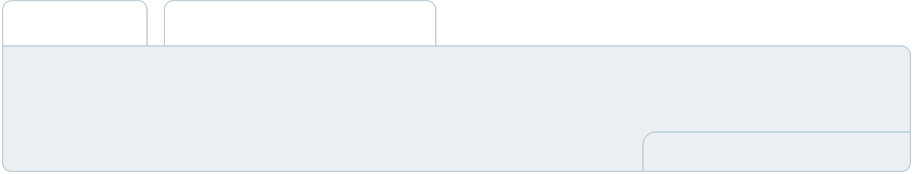

To create an effective introduction for your "Operational Plan" chapter, start by emphasizing the
pivotal role of efficient operations in the success of your business, underscoring how they
directly impact the quality of services delivered.
 |  |  |  | To unlock help try Upmetrics! 
Start writing here..
Staffing and Training
 Help tip |  |  Beverage Business Plan

Mention your business’s staffing requirements, including the number of employees or kitchen staff needed.
To unlock help try Upmetrics! 

Start writing here..

Operational Process

 Help tip  Beverage Business Plan

Outline the processes and procedures you will use to run your beverage business. Your operational processes may include beverage preparation & production, ordering & procurement, sanitation & hygiene, workflow & staffing, etc.



Start writing here..

Equipment & Machinery

 Help tip  Beverage Business Plan

Include the list of equipment and machinery required for beverages, such as beverage blenders & mixers, refrigerators, walk-in coolers, beverage dispensers, bottling machines, etc.
To unlock help try Upmetrics! 

Start writing here..
Management Team

The management team section provides an overview of the individuals responsible for running your business plan.
To unlock help try Upmetrics! 

 Help tip  Beverage Business Plan

To craft an introduction for your "Management Team" chapter, begin by emphasizing the crucial role of leadership in the success of any business.
To unlock help try Upmetrics! 

Start writing here..

Key managers

 Help tip  Beverage Business Plan

Introduce your management and key members of your team, and explain their roles and responsibilities.
To unlock help try Upmetrics! 

Start writing here..


JOHN DOE

CEO & Co-founder - john.doe@example.com

John's journey began [XX years ago] with [a brief about his background, e.g., "a single coffee cart in downtown"].

Today, his leadership and strategic vision are the driving forces behind the brand.


His responsibilities include overall strategy, financial planning, and fostering business relationships.

JANE DOE

Co-founder - jane.doe@example.com

Jane's flair for [specific skill, e.g., "creating unique beverage blends"] has been instrumental in setting "Beverage Bliss" apart.

She spearheads menu innovation and quality control, ensuring every offering is a symphony of taste.



ALICE BROWN

Operations Manager - alice.brown@example.com

Alice holds a Master's degree in Hospitality Management from the esteemed University of Culinary Arts.

With over 12 years of experience in the beverage industry, she has honed her skills at renowned establishments such as "Café Luxe" and "Brewed Awakenings."


As the Operations Manager at "Beverage Bliss," Alice seamlessly integrates diverse aspects of the business, ensuring top-notch service delivery and optimal operational efficiency.


ROBERT BROWN

Production Manager - robert.brown@example.com

A certified barista and mixologist, Robert graduated from the International Beverage Academy.

With a career spanning 10 years, he previously played pivotal roles at "Mocha Moments" and "Twilight Teas," developing unique beverage blends and training budding baristas.

At "Beverage Bliss," Robert's expertise ensures consistency, quality, and innovation in every cup served.

LUCAS WHITE

Customer Services Manager - lucas.white@example.com

Lucas's flair for customer relations began with his Bachelor's in Public Relations from Riverside University. He further enriched his skills with a stint at "Harmony Hotels," managing guest relations.

With over 8 years in the service industry, Lucas ensures that "Beverage Bliss" remains synonymous with customer satisfaction.

His initiatives, ranging from feedback mechanisms to loyalty programs, enhance the overall customer experience.

Organizational structure

 Help tip  Beverage Business Plan

Explain the organizational structure of your management team. Include the reporting line and decision-making hierarchy.
To unlock help try Upmetrics! 

Start writing here..
Organization chart


John Doe

CEO


Jane Doe

COO
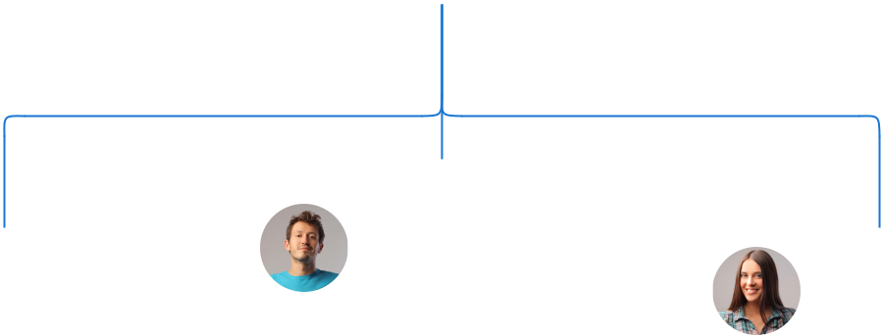

 | Lucas White
Robert Brown | Customer Service | Alice Brown
Production Manager | Manager | Operations Manager


Compensation plan

 Help tip  Beverage Business Plan

Describe your compensation plan for the management and staff. Include their salaries, incentives, and other benefits.
To unlock help try Upmetrics! 

Start writing here..
 Help tip

Mentioning advisors or consultants in your business plans adds credibility to your business idea.
To unlock help try Upmetrics! 

Board of advisors

MR. DAVID BLUE

Veteran

A veteran in [specific area, e.g., "supply chain management"], David's insights ensure our procurement and sourcing are both cost-effective and of the highest quality.


DR. EMILY GREEN

Consultant

With over [XX years] in the beverage industry and a specialization in [specific field, e.g., "herbal and health drinks"], Dr. Green's consultancy has been pivotal in our product development.
Financial Plan

When writing the financial plan section of a business plan, it’s important to provide a comprehensive overview of your financial projections for the first few years of your business, You may provide the following:
To unlock help try Upmetrics! 

 Help tip  Beverage Business Plan

To create an effective introduction for your "Financial Plan" chapter, begin by stressing the critical role of a well-structured financial plan in the success of your venture.
To unlock help try Upmetrics! 

Start writing here..

 Help tip

Describe details such as projected revenue, operational costs, and service costs in your projected profit and loss statement.
To unlock help try Upmetrics! 

Profit & loss statement

 | 2023-24 | 2024-25 | 2025-26 | 2026-27 | 2027-28
Revenue | $0 | $0 | $0 | $0 | $0

Cost Of Sales | $0 | $0 | $0 | $0 | $0
General Costs | $0 | $0 | $0 | $0 | $0
Revenue Specific Costs | $0 | $0 | $0 | $0 | $0
Personnel Costs (Direct | $0 | $0 | $0 | $0 | $0
Labor)

Gross Margin $0 $0 $0 $0 $0

Gross Margin (%)

Operating Expense

Payroll Expense

(Indirect Labor)

General Expense

Bad Debt

Amortization of Current Assets

EBITDA

Additional Expense

Long Term

Depreciation

Gain or loss from Sale of Assets

EBIT

Interest Expenses

EBT

Income Tax Expense

Total Expense

Net Income

Net Income (%)

2023-24 | 2024-25 | 2025-26 | 2026-27 | 2027-28
0% | 0% | 0% | 0% | 0%
$0 | $0 | $0 | $0 | $0
$0 | $0 | $0 | $0 | $0
$0 | $0 | $0 | $0 | $0
$0 | $0 | $0 | $0 | $0
$0 | $0 | $0 | $0 | $0
$0 | $0 | $0 | $0 | $0
$0 | $0 | $0 | $0 | $0
$0 | $0 | $0 | $0 | $0
$0 | $0 | $0 | $0 | $0
$0 | $0 | $0 | $0 | $0
$0 | $0 | $0 | $0 | $0
$0 | $0 | $0 | $0 | $0
$0 | $0 | $0 | $0 | $0
$0 | $0 | $0 | $0 | $0
$0 | $0 | $0 | $0 | $0
0% | 0% | 0% | 0% | 0%
 | 2023-24 | 2024-25 | 2025-26 | 2026-27 | 2027-28
Retained Earning | $0 | $0 | $0 | $0 | $0
Opening
Owner's Distribution | $0 | $0 | $0 | $0 | $0
Retained Earning | $0 | $0 | $0 | $0 | $0
Closing

 Help tip

The cash flow for the first few years of your operation should be estimated and described in this section.
To unlock help try Upmetrics! 

Cash flow statement

Cash Received

Cash Paid

COS & General Expenses

Salary & Wages

Interest

Sales Tax

Income Tax

Net Cash From

Operations

Assets Sell

Assets Purchase

Net Cash From

Investments

2023-24 | 2024-25 | 2025-26 | 2026-27 | 2027-28
$0 | $0 | $0 | $0 | $0
$0 | $0 | $0 | $0 | $0
$0 | $0 | $0 | $0 | $0
$0 | $0 | $0 | $0 | $0
$0 | $0 | $0 | $0 | $0
$0 | $0 | $0 | $0 | $0
$0 | $0 | $0 | $0 | $0
$0 | $0 | $0 | $0 | $0

$0 | $0 | $0 | $0 | $0
$0 | $0 | $0 | $0 | $0
$0 | $0 | $0 | $0 | $0

 | 2023-24 | 2024-25 | 2025-26 | 2026-27 | 2027-28
Amount Received | $0 | $0 | $0 | $0 | $0
Loan Received | $0 | $0 | $0 | $0 | $0
Common Stock
Preferred Stock | $0 | $0 | $0 | $0 | $0
Owner's Contribution | $0 | $0 | $0 | $0 | $0
Amount Paid | $0 | $0 | $0 | $0 | $0
Loan Capital | $0 | $0 | $0 | $0 | $0
Dividends & Distributions | $0 | $0 | $0 | $0 | $0
Net Cash From | $0 | $0 | $0 | $0 | $0
Financing

Summary
Starting Cash | $0 | $0 | $0 | $0 | $0
Cash In | $0 | $0 | $0 | $0 | $0
Cash Out | $0 | $0 | $0 | $0 | $0
Change in Cash | $0 | $0 | $0 | $0 | $0
Ending Cash | $0 | $0 | $0 | $0 | $0

 Help tip

Create a projected balance sheet documenting your beverage business’s assets, liabilities, and equity.
To unlock help try Upmetrics! 

Balance sheet

 | 2023-24 | 2024-25 | 2025-26 | 2026-27 | 2027-28
Assets | $0 | $0 | $0 | $0 | $0
 | 2023-24 | 2024-25 | 2025-26 | 2026-27 | 2027-28
Current Assets | $0 | $0 | $0 | $0 | $0
Cash | $0 | $0 | $0 | $0 | $0
Accounts Receivable | $0 | $0 | $0 | $0 | $0
Inventory | $0 | $0 | $0 | $0 | $0
Other Current Assets | $0 | $0 | $0 | $0 | $0
Long Term Assets | $0 | $0 | $0 | $0 | $0
Gross Long Term Assets | $0 | $0 | $0 | $0 | $0
Accumulated Depreciation | $0 | $0 | $0 | $0 | $0

Liabilities & Equity | $0 | $0 | $0 | $0 | $0
Liabilities | $0 | $0 | $0 | $0 | $0
Current Liabilities | $0 | $0 | $0 | $0 | $0
Accounts Payable | $0 | $0 | $0 | $0 | $0
Income Tax Payable | $0 | $0 | $0 | $0 | $0
Sales Tax Payable | $0 | $0 | $0 | $0 | $0
Short Term Debt | $0 | $0 | $0 | $0 | $0
Long Term Liabilities | $0 | $0 | $0 | $0 | $0
Long Term Debt | $0 | $0 | $0 | $0 | $0
Equity | $0 | $0 | $0 | $0 | $0
Paid-in Capital | $0 | $0 | $0 | $0 | $0
Common Stock | $0 | $0 | $0 | $0 | $0
Preferred Stock | $0 | $0 | $0 | $0 | $0
Owner's Contribution | $0 | $0 | $0 | $0 | $0
Retained Earnings | $0 | $0 | $0 | $0 | $0
 | 2023-24 |  |  | 2024-25 | 2025-26 | 2026-27 | 2027-28
Check | $0 |  |  | $0 | $0 | $0 | $0
 Help tip |  |  Beverage Business Plan

Determine and mention your business’s break-even point—the point at which your business costs and revenue will be equal.
To unlock help try Upmetrics! 

Break-even Point

 | 2023-24 | 2024-25 | 2025-26 | 2026-27 | 2027-28
Starting Revenue | $0 | $0 | $0 | $0 | $0
Net Revenue | $0 | $0 | $0 | $0 | $0
Closing Revenue | $0 | $0 | $0 | $0 | $0

Starting Expense | $0 | $0 | $0 | $0 | $0
Net Expense | $0 | $0 | $0 | $0 | $0
Closing Expense | $0 | $0 | $0 | $0 | $0

Is Break Even? | 0 | 0 | 0 | 0 | 0
Break Even Month | 0 | 0 | 0 | 0 | 0
Days Required | 0 | 0 | 0 | 0 | 0
Break Even Revenue | $0 | $0 | $0 | $0 | $0
Break Even Units
Financing needs

 Help tip  Beverage Business Plan

Calculate costs associated with starting a beverage business, and estimate your financing needs and how much capital you need to raise to operate your business.
To unlock help try Upmetrics! 

Start writing here..
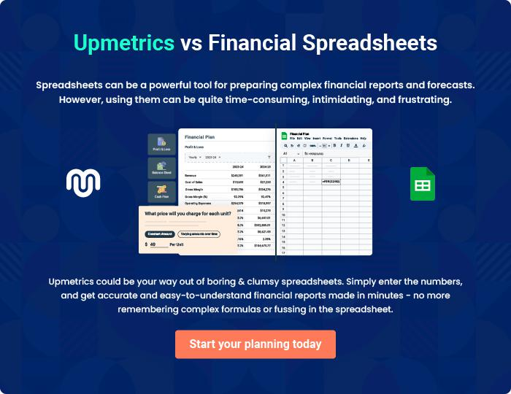
Appendix

When writing the appendix section, you should include any additional information that supports the main content of your plan. This may include financial statements, market research data, legal documents, and other
To unlock help try Upmetrics! 
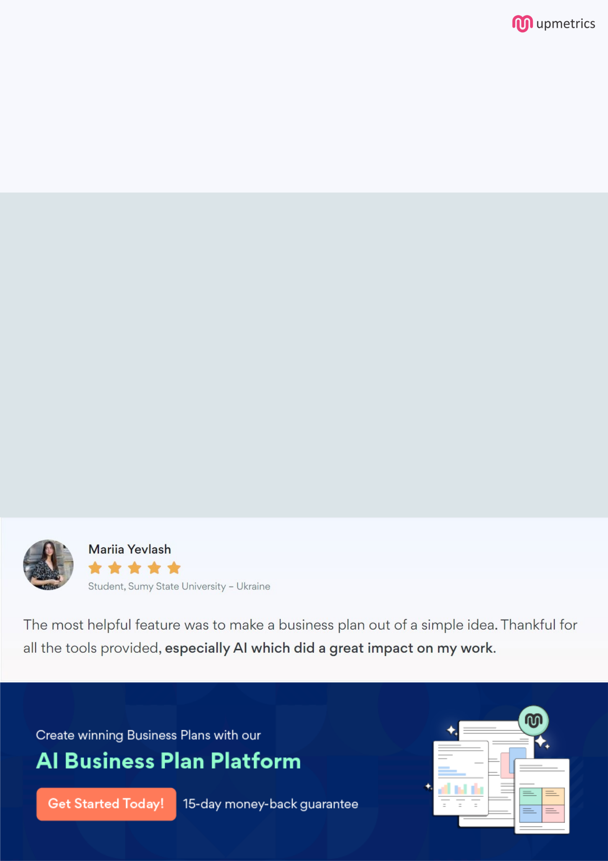
Create a winning business plan that gets you funded

Creating a stunning and investment-ready plan requires no writing, graphic designing, or financial planning expertise.

Upmetrics has all the features required to help you create a comprehensive business plan—from start to finish. Make no mistakes, it’s the modern way of planning to structure ideas, make plans, and create stunning pitch decks to awe investors.

Pitch decks that impress investors

Create pitch decks that provide a visual representation of your business, engage investors, and make them want to invest in your business idea.

Interactive plans in no time

Import business plan sections like—SWOT analysis, comparison tables, and others to create an interactive business plan. No designing skills are required.

Stunning cover page designs

With Upmetrics, you have the liberty to choose from multiple stunning cover page designs. Choose a creative design and make your plan stand out.

Online sharing made simple

Upmetrics makes online sharing quick and easier for users. Easily share your business plans with a link while tracking reader activity.

500+ sample business plans

Simply import a template from our library of sample plans into the editor and start customizing it to make it yours. It takes only a few clicks to get started.

Collaborate with team in real-time

Invite team members, initiate conversations, discuss ideas & strategies, share feedback, and work on a business plan in real-time.

