
Beekeeping Business Plan


Business
Plan

2023
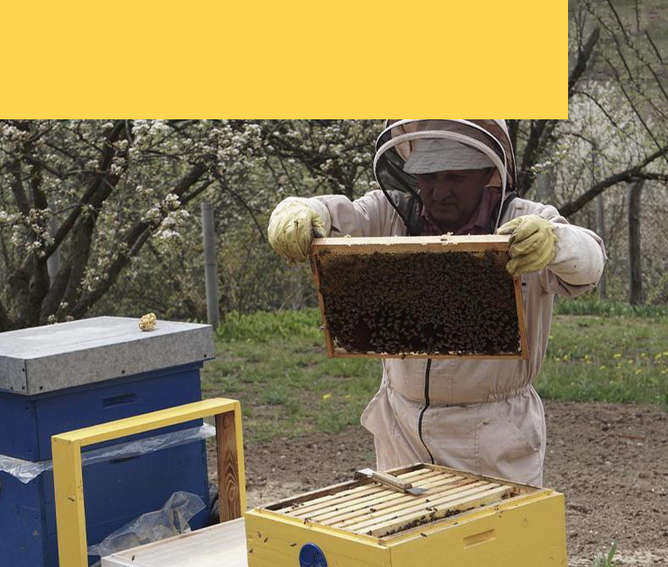

Harvesting Honey, Cultivating Nature

Information provided in this business plan is unique to this business and confidential; therefore, anyone reading this plan agrees not to disclose any of the information in this business plan without prior written permission of the company.

 | Prepared By | 10200 Bolsa Ave, Westminster, CA, 92683
 | John Doe | info@example.com
 | (650) 359-3153 | http://www.example.com

Table of Contents

Executive Summary | 6
Market opportunity | 6
Services Offered | 6
Marketing & Sales Strategies | 7
Financial Highlights | 7
Units Sold v/s Revenue | 8

Company Overview | 9
Ownership | 9
Mission statement | 10
Business history | 10
Future goals | 11

Market Analysis | 12
Target Market | 12
Market size and growth potential | 12
Market Size | 13
Competitive analysis | 13
Honey Haven | 13
Buzz Beekeeping Supplies | 14
The Beekeepers’ Hub | 14
Market trends | 14
Regulatory environment | 15

Products and Services | 16
Beekeeping services | 16
Basic Hive Management | 17
Deluxe Bee Package | 17
Seasonal Hive Rental | 18
Queen Bee Breeding | 18
Beekeeping Starter Kit | 19
Professional Beekeeping Consultation | 19
Quality Measures | 20
Additional Services | 20

Sales And Marketing Strategies | 21
Unique Selling Proposition (USP) | 21
Pricing Strategy | 21
Marketing strategies | 22
Online | 22
Offline | 22
Sales strategies | 23
Customer retention | 24

Operations Plan | 25
Staffing & Training | 25
Operational Process | 25
Equipment & Machinery | 26

Management Team | 27
Key managers | 27
John Doe | 28
Jane Doe | 29
Alice Brown | 29
Robert Brown | 29
Organizational structure | 30
Organization chart | 30
Compensation plan | 31
Advisors/Consultants | 31
[ADVISOR NAME] | 31

Financial Plan | 32
Profit & loss statement | 32
Cash flow statement | 35
Balance sheet | 37
Break-even Analysis | 39
Financing needs | 41
Appendix
Appendix | 43
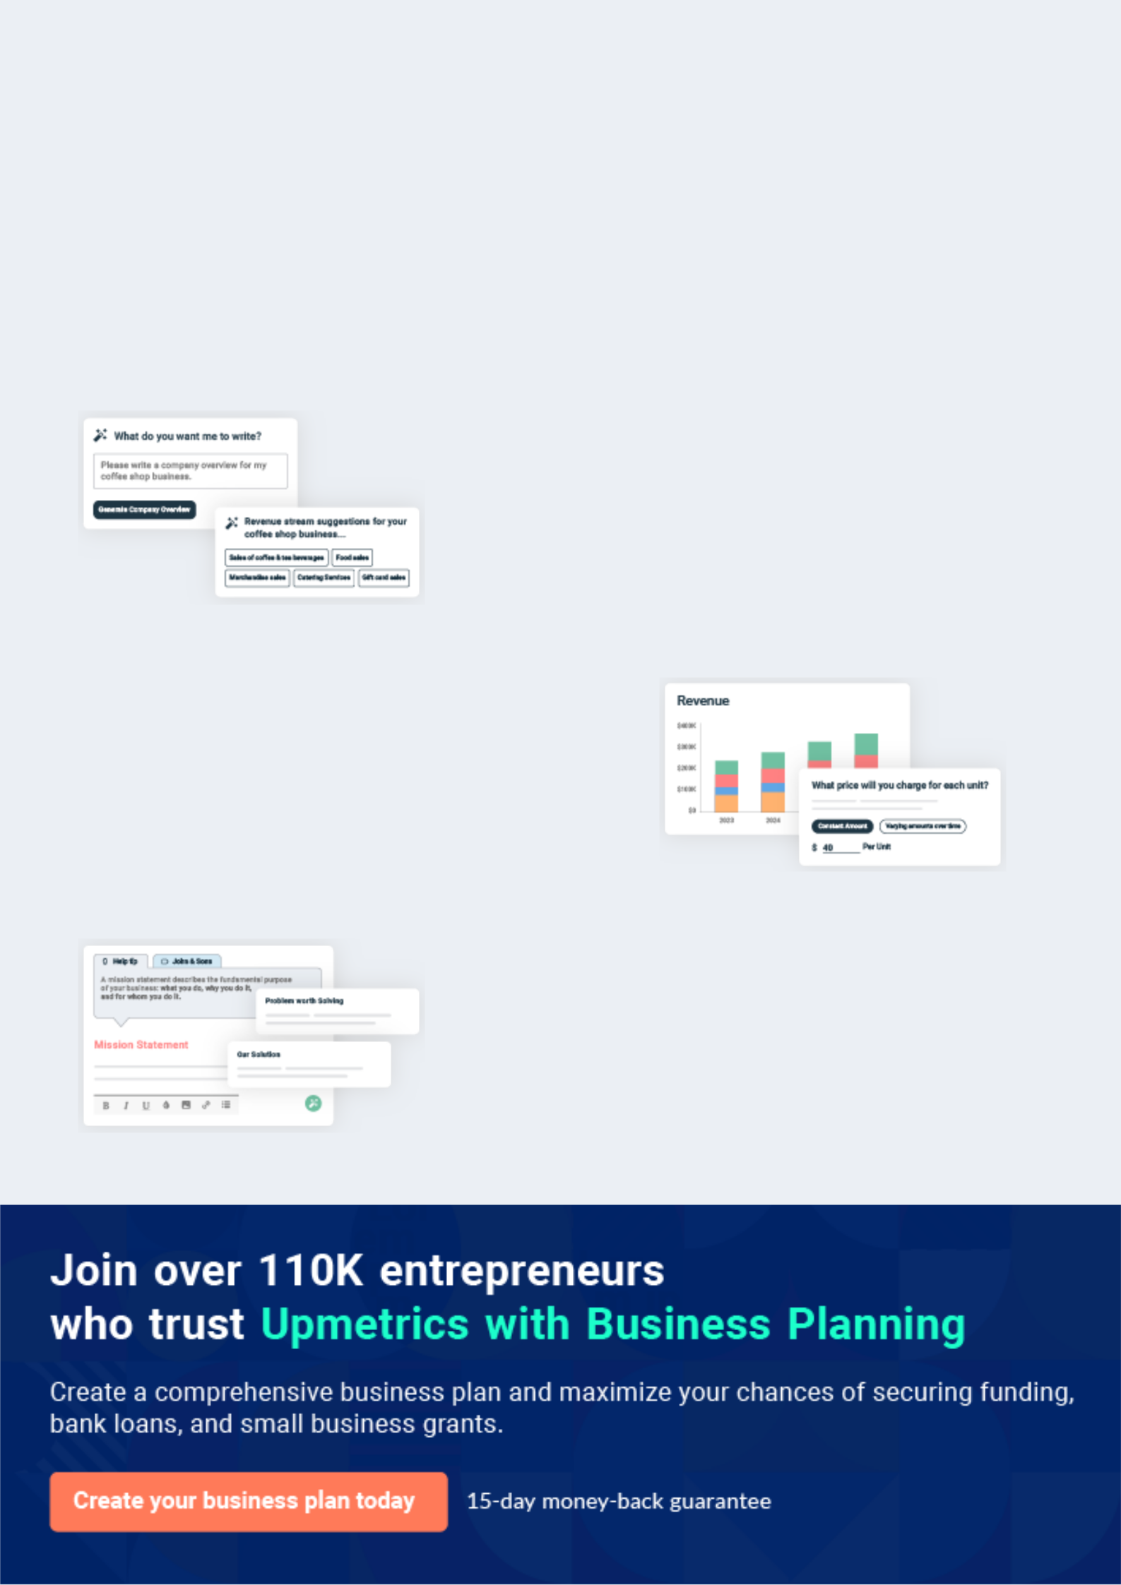
Business planning that’s simpler and faster than you think

Creating a business plan using Upmetrics to start and grow a business is literally the easiest thing in the World. Simply read the instructions and fill in the blanks. It’s as simple as that.

❛ | Upmetrics has everything you need to create a | ❜
❛ | comprehensive business plan. | ❜

AI-powered Upmetrics Assistant

AI-powered insights to streamline your plan

Not sure where to start? Upmetrics’ AI Assistant will automatically generate ideas for each section of your plan and offer improved versions of your writing, adjusting for tone, voice, and grammar or spelling errors.

Financial Forecasting Tool

All the financials are calculated for you

Forget the complex formulas and clumsy spreadsheets — with automatic financials and drag-and-drop forecasting, you can finish your plan faster and be confident that your numbers are accurate.

Business Plan Builder

Guides you like a business mentor

Upmetrics’ step-by-step instructions, prompts, and the library of 400+ sample business plans will guide you through each section of your plan as a business mentor.
Executive Summary


An executive summary is the first section of the business plan intended to provide an overview of the whole business plan.
To unlock help try Upmetrics! 

 Help tip  Beekeeping Business Plan


Start your executive summary by briefly introducing your business to your readers.

This section may include the name of your beekeeping business, its location, when it was
To unlock help try Upmetrics! 

Start writing here..

Market opportunity

 Help tip  Beekeeping Business Plan

Summarize your market research, including market size, growth potential, and marketing trends. Highlight the opportunities in the market and how your business will fit in to fill the gap.
To unlock help try Upmetrics! 

Start writing here..

Services Offered

 Help tip  Beekeeping Business Plan

Highlight the beekeeping services you offer your clients. The USPs and differentiators you offer are always a plus.
To unlock help try Upmetrics! 

Start writing here..

Marketing & Sales Strategies
To unlock help try Upmetrics!

 Help tip  Beekeeping Business Plan

Outline your sales and marketing strategies—what marketing platforms you use, how you plan on acquiring customers, etc.
To unlock help try Upmetrics! 

Start writing here..

Financial Highlights

 Help tip  Beekeeping Business Plan

Briefly summarize your financial projections for the initial years of business operations. Include any capital or investment requirements, associated startup costs, projected revenues, and profit forecasts.



Start writing here..
Units Sold v/s Revenue

 |  | Units Sold | Revenue
15.00k
10.00k
5.00k
0
Year 1 | Year 2 | Year 3


Financial Year |  |  | Units Sold | Revenue
Year 1 | 1,550 |  |  | $10,000
Year 2 | 1,800 |  |  | $12,000
Year 3 | 2,050 |  |  | $14,000
 Help tip |  |  Beekeeping Business Plan


Summarize your executive summary section with a clear CTA, for example, inviting angel investors to discuss the potential business investment.
To unlock help try Upmetrics! 

Write a call to action for your business plan.
Company Overview

Depending on what details of your business are essential, you’ll need different elements in your business overview.
To unlock help try Upmetrics! 

 Help tip  Beekeeping Business Plan

Describe your business in this section by providing all the basic information:

Describe what kind of beekeeping company you run and the name of it. You may specialize in
To unlock help try Upmetrics! 

Start writing here..

Ownership

 Help tip  Beekeeping Business Plan

List the names of your beekeeping company’s founders or owners. Describe what shares they own and their responsibilities for efficiently managing the business.
To unlock help try Upmetrics! 

Start writing here..
Mission statement

 Help tip  Beekeeping Business Plan

Summarize your business’ objective, core principles, and values in your mission statement. This statement needs to be memorable, clear, and brief.
To unlock help try Upmetrics! 

❛ At [Beekeepers’ Eden], we are committed to the sustainable stewardship of bees, fostering an environment of growth, education, and excellence.

We endeavor to produce the finest bee-related products, educate the community on the importance of bees, and contribute to the global effort of pollinator preservation. Our operations are rooted in integrity, quality, and a deep respect for nature.

❜

Business history

 Help tip  Beekeeping Business Plan

If you’re an established beekeeping business, briefly describe your business history, like—when it was founded, how it evolved over time, etc.
To unlock help try Upmetrics! 

Start writing here..
Future goals

 Help tip  Beekeeping Business Plan

It’s crucial to convey your aspirations and vision. Mention your short-term and long-term goals; they can be specific targets for revenue, market share, or expanding your services.
To unlock help try Upmetrics! 

Start writing here..
Market Analysis
To unlock help try Upmetrics!


 |  | Market analysis provides a clear understanding of the market in which your
 |  | printing business will run along with the target market, competitors, and
 |  | growth opportunities.
 |  |  |  | To unlock help try Upmetrics! 
 Help tip |  |  Beekeeping Business Plan

To write the introduction section of your market analysis, start by clearly identifying your primary target market.
To unlock help try Upmetrics! 

Start writing here..

Target Market

 Help tip  Beekeeping Business Plan

Start this section by describing your target market. Define your ideal customer and explain what types of services they prefer. Creating a buyer persona will help you easily define your target market to your readers.



Start writing here..

Market size and growth potential

 Help tip  Beekeeping Business Plan

Describe your market size and growth potential and whether you will target a niche or a much broader market.
To unlock help try Upmetrics! 

Start writing here..

Market Size


Available Market | 1B
Global honey and beekeeping market. | 1B

Served Market | 500M
North American beekeeping sector. | 500M

Target Market
Organic honey and sustainable 100M beekeeping

 Help tip  Beekeeping Business Plan

Identify and analyze your direct and indirect competitors. Identify their strengths and weaknesses, and describe what differentiates your beekeeping services from them.
To unlock help try Upmetrics! 

Competitive analysis

Honey Haven

Honey Haven is an established player in the beekeeping industry, with over 20 years of experience. They offer a wide range of products and services, including honey production, beekeeping equipment sales, and educational workshops.

Features | Strengths | Weaknesses
Extensive range of high-quality | A strong brand reputation built | Higher pricing compared to
beekeeping equipment | over two decades | competitors
Variety of honey products, | Diverse product and service | Limited innovation in product
including organic and flavored | offerings catering to different | offerings
options | customer needs | Dependence on traditional
Comprehensive beekeeping | Extensive knowledge and | marketing channels, with limited
workshops and training | expertise in beekeeping | online presence
sessions
Bee colony removal services

Buzz Beekeeping Supplies

Buzz Beekeeping Supplies is a newer entrant in the market, known for its innovative beekeeping equipment and competitive pricing.

Features | Strengths | Weaknesses
Innovative and ergonomic | Strong focus on innovation and | Limited experience and brand
beekeeping tools | product development | recognition in the market
Affordable pricing with | Competitive pricing strategy | Smaller product range compared
discounts for bulk purchases | Robust online presence with an | to established competitors
User-friendly online purchasing | efficient e-commerce platform | Limited offline presence and
platform |  | physical stores
Hive rental services for
pollination

The Beekeepers’ Hub

The Beekeepers’ Hub is a community-oriented business focusing on sustainable beekeeping practices and local honey production.

Features

Locally produced, sustainable honey products

Community workshops and educational programs

Hive management and consultation services

Strong focus on sustainable and ethical beekeeping

Strengths

Strong community engagement and loyal customer base

Commitment to sustainability and ethical beekeeping practices

Established a presence in local farmers' markets and community events

Weaknesses

Limited product range focused mainly on local honey

Less focus on technological innovation and modern beekeeping practices

Reliance on local markets may limit growth potential

Market trends

 Help tip  Beekeeping Business Plan

Analyze emerging trends in the industry, such as technology disruptions, changes in customer behavior or preferences, etc. Explain how your business will cope with all the trends.
To unlock help try Upmetrics! 

Start writing here..

Regulatory environment
To unlock help try Upmetrics!

 Help tip  Beekeeping Business Plan

List regulations and licensing requirements that may affect your beekeeping company, such as registration & licensing, hive placement & zoning, pest control & pesticide regulations, pollination services, occupational health & safety, etc.



Start writing here..
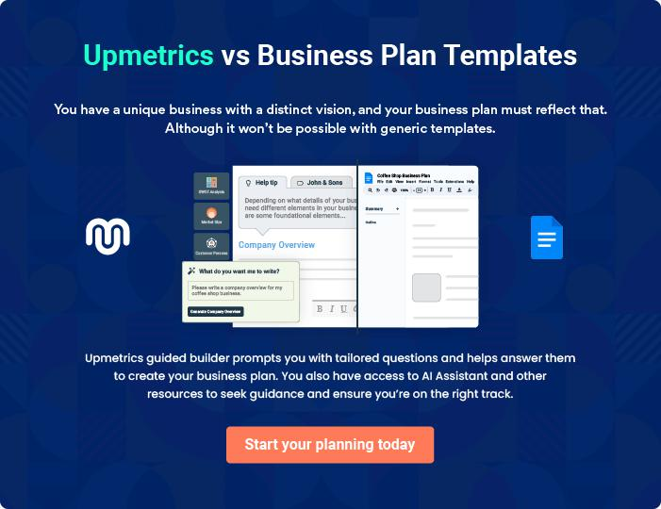
Products and Services
To unlock help try Upmetrics!

The product and services section of the beekeeping business plan should describe the specific services and products that will be offered to customers. To write this section should include the following:



 Help tip  Beekeeping Business Plan

To craft the introduction for your "Products and Services" chapter, begin by positioning your business within its industry, emphasizing its unique strengths or value proposition.
To unlock help try Upmetrics! 

Start writing here..

 Help tip


Mention the beekeeping services your business will offer. This list may include services like,

• Hive management
To unlock help try Upmetrics! 

Beekeeping services
Basic Hive Management


Price: [$120] per hive per month

Comprehensive hive management service to ensure the health and productivity of your bee colonies. Suitable for hobbyist beekeepers and small-scale operations.

Specifications

- Monthly hive inspections

- Pest and disease management

- Nutritional support and supplemental feeding when necessary

- Hive productivity assessment

- Recommendations for improvements and interventions

Deluxe Bee Package

Price: [$150] per package

A premium starter kit for new colonies, featuring a vigorous queen bee and healthy worker bees.

Specifications

- 1 mated queen bee

- Approximately 3 lbs of worker bees

- Installation guide and support

- First-month health check-up included
Seasonal Hive Rental

Price: [$250] per hive for a 3-month rental period

Hive rental service for pollination purposes or honey production, ideal for farmers and orchard owners.

Specifications

- Strong, healthy bee colony

- Hive transportation and setup

- 3-month rental period

- Optional hive maintenance service available

Queen Bee Breeding

Price: [$30] per queen bee

High-quality, selectively bred queen bees, available for purchase to enhance your colony’s productivity.

Specifications

- Mated and ready to lay

- Bred for disease resistance and productivity

- Comprehensive introduction guide

- Follow-up support available
Beekeeping Starter Kit

Price: [$200] per kit

A complete set of beekeeping equipment for beginners, including all necessary tools and protective gear.

Specifications

- Bee suit and gloves

- Hive tool and smoker

- Bee brush and uncapping fork

- Beginner’s guide to beekeeping

- 10% discount on first bee package purchase

Professional Beekeeping Consultation

Price: [$100] per hour

Expert advice and guidance on all aspects of beekeeping, from hive management to honey production.

Specifications

- One-on-one consultation with a beekeeping expert

- Customized advice based on your specific needs and goals

- Follow-up resources and recommendations

- Available in-person or via video call
Quality Measures
- To unlock help try Upmetrics!

 Help tip  Beekeeping Business Plan

This section should explain how you maintain quality standards and consistently provide the highest quality service.
To unlock help try Upmetrics! 

Start writing here..

Additional Services

 Help tip  Beekeeping Business Plan

Mention if your beekeeping company offers any additional services. You may include beekeeping workshops & training, hive installation & consultation, hive rental & maintenance, honey extraction & processing, beekeeping equipment sales, etc.



Start writing here..
Sales And Marketing Strategies

Writing the sales and marketing strategies section means a list of strategies you will use to attract and retain your clients.
To unlock help try Upmetrics! 

 Help Tip  Beekeeping Business Plan


To create an effective introduction for your "Sales and Marketing Strategies" chapter, start by setting the stage within your specific industry or market.
To unlock help try Upmetrics! 

Start writing here..

Unique Selling Proposition (USP)

 Help tip  Beekeeping Business Plan

Define your business’s USPs depending on the market you serve, the equipment you use, and the unique services you provide. Identifying USPs will help you plan your marketing strategies.
To unlock help try Upmetrics! 

Start writing here..

Pricing Strategy

 Help tip  Beekeeping Business Plan

Describe your pricing strategy—how you plan to price your services and stay competitive in the local market. You can mention any discounts you plan on offering to attract new customers.
To unlock help try Upmetrics! 

Start writing here..

 Help tip  Beekeeping Business Plan
To unlock help try Upmetrics!

Discuss your marketing strategies to market your services. You may include some of these marketing strategies in your business plan—social media marketing, local networking, content marketing, and print marketing.



Marketing strategies

Online


Social Media

Utilizing platforms like Instagram, Facebook, and Twitter, we aim to create a vibrant community of bee enthusiasts, share insightful content, and promote our products and services.

Content Marketing

Our blog serves as a resource for beekeeping tips, honey recipes, and updates on our services, helping to establish our authority in the field.

Offline

Local Networking

We actively participate in local farmers' markets, beekeeping workshops, and community events to build relationships and increase brand visibility.

Print Marketing

Brochures, flyers, and local newspaper ads are utilized to reach a wider audience, especially in areas with limited online engagement.

 Help tip  Beekeeping Business Plan
To unlock help try Upmetrics!

Outline the strategies you’ll implement to maximize your sales. Your sales strategies may include direct sales calls, sampling, partnering with other businesses, offering referral programs, etc.



Sales strategies

Partner with Businesses

Establishing mutually beneficial partnerships with local stores and eateries to stock our products.

Referral Programs

Encouraging word-of-mouth promotion through a referral program that rewards existing customers for bringing in new clients.

Sampling

Offering samples of our honey varieties at markets and events, allowing customers to taste the quality of our products firsthand.

 Help tip  Beekeeping Business Plan

Describe your customer retention strategies and how you plan to execute them. For instance, introducing loyalty programs, discounts on bulk purchases, personalized service, etc.
To unlock help try Upmetrics! 

Customer retention

Loyalty Programs

Introducing a loyalty program to reward repeat customers and encourage consistent purchases.

Personalized Service

Offering tailored beekeeping advice and support, ensuring that our customers feel valued and well-cared-for.

Regular Follow-ups

Checking in with our customers to gather feedback, provide assistance, and inform them of new products or services.

Operations Plan
To unlock help try Upmetrics!

 |  | When writing the operations plan section, it’s important to consider the
 |  | various aspects of your business operations.
 |  |  |  | To unlock help try Upmetrics! 
 Help tip |  |  Beekeeping Business Plan


To create an effective introduction for your "Operational Plan" chapter, start by emphasizing the
pivotal role of efficient operations in the success of your business, underscoring how they
directly impact the quality of services delivered.
 |  |  |  | To unlock help try Upmetrics! 
Start writing here..
Staffing & Training
 Help tip |  |  Beekeeping Business Plan

Mention your business’s staffing requirements, including the number of employees or
beekeepers needed. Include their qualifications, the training required, and the duties they will
perform.
 |  |  |  | To unlock help try Upmetrics! 
Start writing here..
Operational Process
 Help tip |  |  Beekeeping Business Plan

Outline the processes and procedures you will use to run your beekeeping business. Your operational processes may include hive setup & placement, bee feeding, hive inspection & maintenance, swarm prevention & management, etc.



Start writing here..

Equipment & Machinery
To unlock help try Upmetrics!

 Help tip  Beekeeping Business Plan

Include the list of equipment and machinery required for beekeeping, such as hive components, beekeeping tools, protective gear, honey extraction equipment, bee feeding equipment, transportation & hive management, etc.



Start writing here..
Management Team

The management team section provides an overview of the individuals responsible for running your business plan.
To unlock help try Upmetrics! 

 Help tip  Beekeeping Business Plan

To craft an introduction for your "Management Team" chapter, begin by emphasizing the crucial role of leadership in the success of any business.
To unlock help try Upmetrics! 

Start writing here..

Key managers

 Help tip  Beekeeping Business Plan

Introduce your management and key members of your team, and explain their roles and responsibilities.
To unlock help try Upmetrics! 

Start writing here..

JOHN DOE

CEO - john.doe@example.com

As the founder and CEO of [Beekeepers’ Eden], John is the visionary behind the business, driving strategic growth and ensuring operational excellence.

He brings over 15 years of extensive experience in apiculture and agribusiness management.


- Education: John holds a Master’s Degree in Agribusiness Management from the University of California, and a Bachelor’s Degree in Biology, with a specialization in entomology, from Stanford University.

- Professional Background: Prior to founding [Beekeepers’ Eden], John worked with leading agricultural firms and played a pivotal role in sustainable farming initiatives and bee conservation programs.

JANE DOE

Chief Operating Officer (COO) - jane.doe@example.com

As the COO, Jane oversees the day-to-day operations, ensuring that our beekeeping practices are sustainable, efficient, and productive. She is deeply passionate about sustainable agriculture and biodiversity.

- Education: Jane has a Bachelor’s Degree in Environmental Science from the University of California and has completed various courses and certifications in sustainable farming and beekeeping.

- Professional Background: Jane has over 10 years of experience in agricultural operations and sustainability, having worked with several non-profit organizations focused on environmental conservation and sustainable agriculture.


ALICE BROWN

CMO - alice.brown@example.com

Alice leads our marketing and branding initiatives, working tirelessly to promote [Beekeepers’ Eden] and drive market share. She is innovative, results-oriented, and has a keen eye for market trends.

- Education: Alice holds a Master’s Degree in Marketing from the University of Southern California, and a Bachelor’s Degree in Communication from UCLA.

- Professional Background: With over 12 years of experience in marketing, particularly in the agricultural and food industries, Alice has a proven track record of successful campaigns and brand development.


ROBERT BROWN

Operations Manager - robert.brown@example.com

Robert is responsible for the smooth operation of our beekeeping facilities. He ensures that our hives are healthy, our production processes are efficient, and our products are of the highest quality.

- Education: Robert has a Bachelor’s Degree in Agriculture from Texas A&M University, with a focus on sustainable farming practices.

- Professional Background: With over 10 years of experience in agricultural operations and hive management, Robert brings a wealth of knowledge and expertise to [Beekeepers’ Eden].
Organizational structure

 Help tip  Beekeeping Business Plan

Explain the organizational structure of your management team. Include the reporting line and decision-making hierarchy.
To unlock help try Upmetrics! 

Start writing here..

Organization chart


John Doe

CEO


Robert Brown |  |  | David Green
Robert Brown | Jane Doe | Alice Brown | Sales Manager
Operations | Jane Doe | Alice Brown | Sales Manager
Operations | COO | CMO
Manager | COO | CMO




Emily White

Beekeeping

Specialist
Compensation plan

 Help tip  Beekeeping Business Plan

Describe your compensation plan for the management and staff. Include their salaries, incentives, and other benefits.
To unlock help try Upmetrics! 

Start writing here..

 Help tip

Mentioning advisors or consultants in your business plans adds credibility to your business idea.
To unlock help try Upmetrics! 

Advisors/Consultants


[ADVISOR NAME]

Advisor

With expertise in [Field of Expertise], [Advisor Name] provides invaluable advice and guidance, helping us navigate challenges and capitalize on opportunities in the beekeeping industry.
Financial Plan

When writing the financial plan section of a business plan, it’s important to provide a comprehensive overview of your financial projections for the first few years of your business, You may provide the following:
To unlock help try Upmetrics! 

 Help tip  Beekeeping Business Plan


To create an effective introduction for your "Financial Plan" chapter, begin by stressing the critical role of a well-structured financial plan in the success of your venture.
To unlock help try Upmetrics! 

Start writing here..

 Help tip  Beekeeping Business Plan

Describe details such as projected revenue, operational costs, and service costs in your projected profit and loss statement. Make sure to include your business’s expected net profit or loss.
To unlock help try Upmetrics! 

Profit & loss statement

Revenue

Cost Of Sales

General Costs

Revenue Specific Costs

Personnel Costs (Direct

Labor)

Gross Margin

Gross Margin (%)

Operating Expense

Payroll Expense

(Indirect Labor)

General Expense

Bad Debt

Amortization of Current

Assets

2023-24 | 2024-25 | 2025-26 | 2026-27 | 2027-28
$0 | $0 | $0 | $0 | $0

$0 | $0 | $0 | $0 | $0
$0 | $0 | $0 | $0 | $0
$0 | $0 | $0 | $0 | $0
$0 | $0 | $0 | $0 | $0

$0 | $0 | $0 | $0 | $0
0% | 0% | 0% | 0% | 0%

$0 | $0 | $0 | $0 | $0
$0 | $0 | $0 | $0 | $0
$0 | $0 | $0 | $0 | $0
$0 | $0 | $0 | $0 | $0
$0 | $0 | $0 | $0 | $0

EBITDA

Additional Expense

Long Term

Depreciation

Gain or loss from Sale

of Assets

EBIT

Interest Expenses

EBT

Income Tax Expense

Total Expense

Net Income

Net Income (%)

2023-24 | 2024-25 | 2025-26 | 2026-27 | 2027-28
$0 | $0 | $0 | $0 | $0
$0 | $0 | $0 | $0 | $0
$0 | $0 | $0 | $0 | $0
$0 | $0 | $0 | $0 | $0
$0 | $0 | $0 | $0 | $0
$0 | $0 | $0 | $0 | $0
$0 | $0 | $0 | $0 | $0
$0 | $0 | $0 | $0 | $0
$0 | $0 | $0 | $0 | $0
$0 | $0 | $0 | $0 | $0
0% | 0% | 0% | 0% | 0%

 |  |  | 2023-24 |  | 2024-25 | 2025-26
Retained Earning |  |  | $0 |  | $0 | $0
Opening |  |  |  |  | $0 | $0
Owner's Distribution |  |  | $0 |  | $0 | $0
Retained Earning |  |  | $0 |  | $0 | $0
Closing |  |  |  |  | $0 | $0
 Help tip |  |  |  Beekeeping Business Plan


The cash flow for the first few years of your operation should be estimated and described in this section. This may include billing invoices, payment receipts, loan payments, and any other cash flow statements
2026-27 2027-28

$0 $0

$0 $0

$0 $0

To unlock help try Upmetrics! 

Cash flow statement

 | 2023-24 | 2024-25 | 2025-26 | 2026-27 | 2027-28
Cash Received | $0 | $0 | $0 | $0 | $0
Cash Paid | $0 | $0 | $0 | $0 | $0
COS & General Expenses | $0 | $0 | $0 | $0 | $0
Salary & Wages | $0 | $0 | $0 | $0 | $0
Interest | $0 | $0 | $0 | $0 | $0

Sales Tax

Income Tax

Net Cash From

Operations

Assets Sell

Assets Purchase

Net Cash From

Investments

Amount Received

Loan Received

Common Stock

Preferred Stock

Owner's Contribution

Amount Paid

2023-24 | 2024-25 | 2025-26 | 2026-27 | 2027-28
$0 | $0 | $0 | $0 | $0
$0 | $0 | $0 | $0 | $0
$0 | $0 | $0 | $0 | $0

$0 | $0 | $0 | $0 | $0
$0 | $0 | $0 | $0 | $0
$0 | $0 | $0 | $0 | $0

$0 | $0 | $0 | $0 | $0
$0 | $0 | $0 | $0 | $0

$0 | $0 | $0 | $0 | $0
$0 | $0 | $0 | $0 | $0
$0 | $0 | $0 | $0 | $0

Loan Capital $0 $0 $0 $0 $0

 |  |  | 2023-24 | 2024-25 | 2025-26 | 2026-27 | 2027-28
Dividends & Distributions |  |  | $0 | $0 | $0 | $0 | $0
Net Cash From |  |  | $0 | $0 | $0 | $0 | $0
Financing
Summary
Starting Cash |  |  | $0 | $0 | $0 | $0 | $0
Cash In |  |  | $0 | $0 | $0 | $0 | $0
Cash Out |  |  | $0 | $0 | $0 | $0 | $0
Change in Cash |  |  | $0 | $0 | $0 | $0 | $0
Ending Cash |  |  | $0 | $0 | $0 | $0 | $0
 Help tip |  |  Beekeeping Business Plan

Create a projected balance sheet documenting your beekeeping business’s assets, liabilities, and equity.

To unlock help try Upmetrics! 

Balance sheet

 | 2023-24 | 2024-25 | 2025-26 | 2026-27 | 2027-28
Assets | $0 | $0 | $0 | $0 | $0
Current Assets | $0 | $0 | $0 | $0 | $0
Cash | $0 | $0 | $0 | $0 | $0
Accounts Receivable | $0 | $0 | $0 | $0 | $0
Inventory | $0 | $0 | $0 | $0 | $0
Other Current Assets | $0 | $0 | $0 | $0 | $0
Long Term Assets | $0 | $0 | $0 | $0 | $0
Gross Long Term Assets | $0 | $0 | $0 | $0 | $0
Accumulated Depreciation | $0 | $0 | $0 | $0 | $0

Liabilities & Equity | $0 | $0 | $0 | $0 | $0
Liabilities | $0 | $0 | $0 | $0 | $0
Current Liabilities | $0 | $0 | $0 | $0 | $0
Accounts Payable | $0 | $0 | $0 | $0 | $0
Income Tax Payable | $0 | $0 | $0 | $0 | $0
Sales Tax Payable | $0 | $0 | $0 | $0 | $0
Short Term Debt | $0 | $0 | $0 | $0 | $0
 | 2023-24 | 2024-25 | 2025-26 | 2026-27 | 2027-28
Long Term Liabilities | $0 | $0 | $0 | $0 | $0
Long Term Debt | $0 | $0 | $0 | $0 | $0
Equity | $0 | $0 | $0 | $0 | $0
Paid-in Capital | $0 | $0 | $0 | $0 | $0
Common Stock | $0 | $0 | $0 | $0 | $0
Preferred Stock | $0 | $0 | $0 | $0 | $0
Owner's Contribution | $0 | $0 | $0 | $0 | $0
Retained Earnings | $0 | $0 | $0 | $0 | $0

Check | $0 |  |  | $0 | $0 | $0 | $0
 Help tip |  |  Beekeeping Business Plan

Determine and mention your business’s break-even point—the point at which your business costs and revenue will be equal.

This exercise will help you understand how much revenue you need to generate to sustain or be profitable.
To unlock help try Upmetrics! 

Break-even Analysis

 | 2023-24 | 2024-25 | 2025-26 | 2026-27 | 2027-28
Starting Revenue | $0 | $0 | $0 | $0 | $0
Net Revenue | $0 | $0 | $0 | $0 | $0
Closing Revenue | $0 | $0 | $0 | $0 | $0

Starting Expense | $0 | $0 | $0 | $0 | $0
Net Expense | $0 | $0 | $0 | $0 | $0
Closing Expense | $0 | $0 | $0 | $0 | $0

Is Break Even? | 0 | 0 | 0 | 0 | 0
Break Even Month | 0 | 0 | 0 | 0 | 0
Days Required | 0 | 0 | 0 | 0 | 0
Break Even Revenue | $0 | $0 | $0 | $0 | $0
Break Even Units
Financing needs

 Help tip  Beekeeping Business Plan

Calculate costs associated with starting a beekeeping business, and estimate your financing needs and how much capital you need to raise to operate your business.
To unlock help try Upmetrics! 

Start writing here..
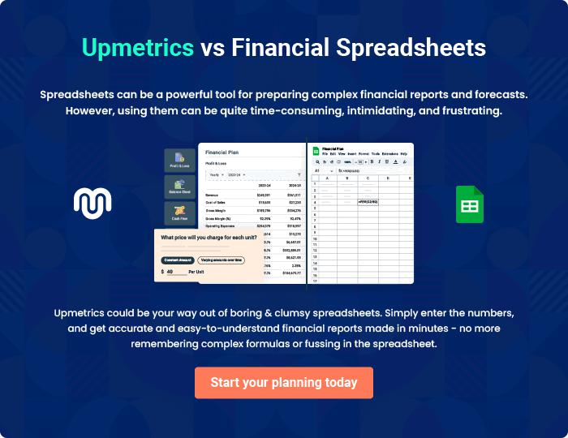
Appendix

When writing the appendix section, you should include any additional information that supports the main content of your plan. This may include financial statements, market research data, legal documents, and other
To unlock help try Upmetrics! 

Create a winning business plan that gets you funded

Creating a stunning and investment-ready plan requires no writing, graphic designing, or financial planning expertise.

Upmetrics has all the features required to help you create a comprehensive business plan—from start to finish. Make no mistakes, it’s the modern way of planning to structure ideas, make plans, and create stunning pitch decks to awe investors.

Pitch decks that impress investors

Create pitch decks that provide a visual representation of your business, engage investors, and make them want to invest in your business idea.

Interactive plans in no time

Import business plan sections like—SWOT analysis, comparison tables, and others to create an interactive business plan. No designing skills are required.

Stunning cover page designs

With Upmetrics, you have the liberty to choose from multiple stunning cover page designs. Choose a creative design and make your plan stand out.

Online sharing made simple

Upmetrics makes online sharing quick and easier for users. Easily share your business plans with a link while tracking reader activity.

500+ sample business plans

Simply import a template from our library of sample plans into the editor and start customizing it to make it yours. It takes only a few clicks to get started.

Collaborate with team in real-time

Invite team members, initiate conversations, discuss ideas & strategies, share feedback, and work on a business plan in real-time.

