
BBQ Business Plan

BUSINESS PLAN

Savoring Smokehouse Traditions

Prepared By

John Doe

10200 Bolsa Ave, Westminster, CA, 92683

info@example.com

(650) 359-3153 http://www.example.com

Table of Contents

Executive Summary | 6
Market opportunity | 6
BBQ Menu | 6
Marketing and Sales Strategies | 7
Financial Highlights | 7
Units Sold v/s Revenue | 8

Company Overview | 9
Ownership | 9
Business Owners | 9
Mission statement | 10
Business history | 10
Future goals | 10

Market Analysis | 11
Target Market | 11
Market size and growth potential | 11
Market Size | 12
Competitive analysis | 12
Grill Master's Delight | 12
The BBQ Boulevard | 13
Sizzle & Smoke BBQ Hub | 13
Market trends | 13
Regulatory environment | 14

Products and Services | 15
Products | 15
Beef Brisket | 15
Smoked Chicken Thighs | 16
Apple Cider Vinegar-Based Sauce | 16
Bourbon-Infused BBQ Sauce | 16
Brisket Delight Sandwich | 17
The Smokey Combo | 17
Emphasize quality | 17
Sourcing and Quality | 18
Additional Services | 18

Sales And Marketing Strategies | 19
Unique Selling Proposition (USP) | 19
Pricing Strategy | 19
Marketing strategies | 20
Online | 20
Offline | 20
Sales strategies | 21
Customer retention | 21

Operations Plan | 22
Staffing & Training | 22
Operational Process | 22
Equipment & Machinery | 23

Management Team | 24
Key managers | 24
John Doe | 24
Jane Doe | 25
Alice Brown | 25
Organizational structure | 25
Organization chart | 26
Compensation plan | 26
Board of advisors | 27
Robert Brown | 27
Financial Plan
Financial Plan | 28

Profit & loss statement 28

Cash flow statement | 30
Balance sheet | 31
Break-even Point | 33
Financing needs | 34
Appendix
Appendix | 35
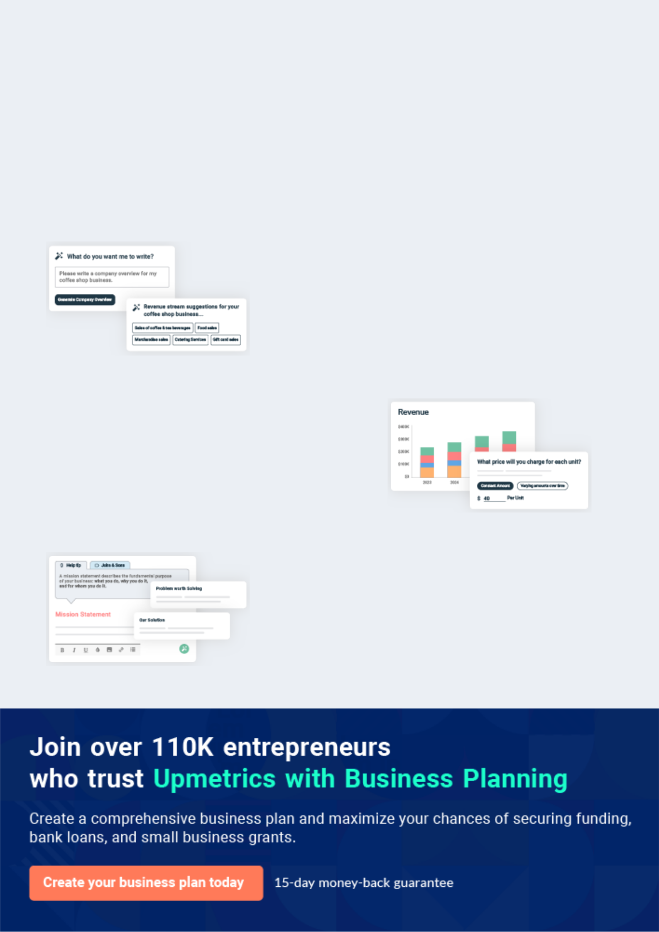
Business planning that’s simpler and faster than you think

Creating a business plan using Upmetrics to start and grow a business is literally the easiest thing in the World. Simply read the instructions and fill in the blanks. It’s as simple as that.

❛ | Upmetrics has everything you need to create a | ❜
❛ | comprehensive business plan. | ❜

AI-powered Upmetrics Assistant

AI-powered insights to streamline your plan

Not sure where to start? Upmetrics’ AI Assistant will automatically generate ideas for each section of your plan and offer improved versions of your writing, adjusting for tone, voice, and grammar or spelling errors.

Financial Forecasting Tool

All the financials are calculated for you

Forget the complex formulas and clumsy spreadsheets — with automatic financials and drag-and-drop forecasting, you can finish your plan faster and be confident that your numbers are accurate.

Business Plan Builder

Guides you like a business mentor

Upmetrics’ step-by-step instructions, prompts, and the library of 400+ sample business plans will guide you through each section of your plan as a business mentor.
Executive Summary


An executive summary is the first section of the business plan intended to provide an overview of the whole business plan.
To unlock help try Upmetrics! 

 Help tip  BBQ Business Plan


Start your executive summary by briefly introducing your business to your readers.

This section may include the name of your BBQ business, its location, when it was founded, the
To unlock help try Upmetrics! 

Start writing here..

Market opportunity

 Help tip  BBQ Business Plan

Summarize your market research, including market size, growth potential, and marketing trends.
To unlock help try Upmetrics! 

Start writing here..

BBQ Menu

 Help tip  BBQ Business Plan

Highlight the BBQ you offer your clients. The USPs and differentiators you offer are always a plus.
To unlock help try Upmetrics! 

Start writing here..

Marketing and Sales Strategies
To unlock help try Upmetrics!

 Help tip  BBQ Business Plan

Outline your sales and marketing strategies—what marketing platforms you use, how you plan on acquiring customers, etc.
To unlock help try Upmetrics! 

Start writing here..

Financial Highlights

 Help tip  BBQ Business Plan

Briefly summarize your financial projections for the initial years of business operations. Include any capital or investment requirements, associated startup costs, projected revenues, and profit forecasts.



Start writing here..
Units Sold v/s Revenue

 |  | Units Sold | Revenue
15.00k
10.00k
5.00k
0
Year 1 | Year 2 | Year 3


Financial Year |  |  | Units Sold | Revenue
Year 1 | 1,550 |  |  | $10,000
Year 2 | 1,800 |  |  | $12,000
Year 3 | 2,050 |  |  | $14,000
 Help tip |  |  BBQ Business Plan


Summarize your executive summary section with a clear CTA, for example, inviting angel investors to discuss the potential business investment.
To unlock help try Upmetrics! 

Write a call to action for your business plan.
Company Overview

Depending on what details of your business are essential, you’ll need different elements in your business overview.
To unlock help try Upmetrics! 

 Help tip  BBQ Business Plan

Describe your business in this section by providing all the basic information:

Describe what kind of BBQ business you run and the name of it. You may specialize in one of
To unlock help try Upmetrics! 

Start writing here..

Ownership

 Help tip  BBQ Business Plan

List the names of your BBQ business’s founders or owners. Describe what shares they own and their responsibilities for efficiently managing the business.
To unlock help try Upmetrics! 

Start writing here..

Business Owners



70% John Doe



30% Jane Doe
Mission statement

 Help tip  BBQ Business Plan

Summarize your business’ objective, core principles, and values in your mission statement. This statement needs to be memorable, clear, and brief.
To unlock help try Upmetrics! 

❛ At [Smokey Haven BBQ], we are more than just food; we are an experience. Our mission is to transcend the boundaries of taste, serving not just BBQ but memories, crafted with passion,

tradition, and an unwavering commitment to quality.
❜

Business history

 Help tip  BBQ Business Plan

If you’re an established BBQ business, briefly describe your business history, like—when it was founded, how it evolved over time, etc.
To unlock help try Upmetrics! 

Start writing here..

Future goals

 Help tip  BBQ Business Plan

It’s crucial to convey your aspirations and vision. Mention your short-term and long-term goals; they can be specific targets for revenue, market share, or expanding your services.
To unlock help try Upmetrics! 

Start writing here..

Market Analysis
To unlock help try Upmetrics!
To unlock help try Upmetrics!

Market analysis provides a clear understanding of the market in which your printing business will run along with the target market, competitors, and growth opportunities.



 Help tip  BBQ Business Plan

To write the introduction section of your market analysis, start by clearly identifying your primary target market.
To unlock help try Upmetrics! 

Start writing here..

Target Market

 Help tip  BBQ Business Plan

Start this section by describing your target market. Define your ideal customer and explain what types of services they prefer. Creating a buyer persona will help you easily define your target market to your readers.



Start writing here..

Market size and growth potential

 Help tip  BBQ Business Plan

Describe your market size and growth potential and whether you will target a niche or a much broader market.
To unlock help try Upmetrics! 

Start writing here..

Market Size

Available Market

Total individuals consuming BBQ in 5M California.

Served Market
Total BBQ consumers in Westminster 500k and neighboring regions.

Target Market
Families and tourists in Westminster 100k seeking authentic BBQ experience

 Help tip  BBQ Business Plan

Identify and analyze your direct and indirect competitors. Identify their strengths and weaknesses, and describe what differentiates your BBQ business from them.
To unlock help try Upmetrics! 

Competitive analysis

Grill Master's Delight

- Location: [Address]

- Years in Business: 10

- Type: BBQ restaurant and catering service

Features Strengths Weaknesses

Extensive meat selection including beef, chicken, and pork

Vegan and vegetarian BBQ options

Specialty sauces available for purchase

Customizable catering menus

Established brand name with a Limited online presence affecting

loyal customer base potential online sales

Diverse menu catering to Lacks a robust loyalty or rewards

various dietary preferences program

Availability of specialty

products for purchase

The BBQ Boulevard

- Location: [Address]

- Years in Business: 5

- Type: Food truck and online BBQ retailer

Features

Quick serve BBQ dishes for on-the-go customers

Online ordering with home delivery options

Monthly subscription boxes featuring BBQ sauces and spices

Strengths

Mobility of the food truck allows tapping into various events and locations

Strong online presence with a user-friendly ordering system

Unique offerings like subscription boxes

Weaknesses

Limited seating capacity due to the food truck model

Relatively new in the market, leading to lesser brand recognition

Sizzle & Smoke BBQ Hub

• Location: [Address]

• Years in Business: 8

• Type: BBQ franchise

Features | Strengths | Weaknesses
Consistent menu across all | Standardized operations | Less flexibility in menu due to
franchise locations | across all franchises ensuring | franchise model
Loyalty program for regular | consistency | Quality discrepancies observed
customers | Effective loyalty program | across different franchise
Interactive BBQ workshops and | driving repeat business | locations
classes | Educational workshops
 | positioning them as industry
 | experts

Market trends

 Help tip  BBQ Business Plan

Analyze emerging trends in the industry, such as changes in customer behavior or preferences, etc.
To unlock help try Upmetrics! 

Start writing here..
To unlock help try Upmetrics!

Regulatory environment

 Help tip  BBQ Business Plan

List regulations and licensing requirements that may affect your BBQ company, such as business licensing, zoning & land use regulations, employment & labor laws, food safety & handling laws, etc.



Start writing here..
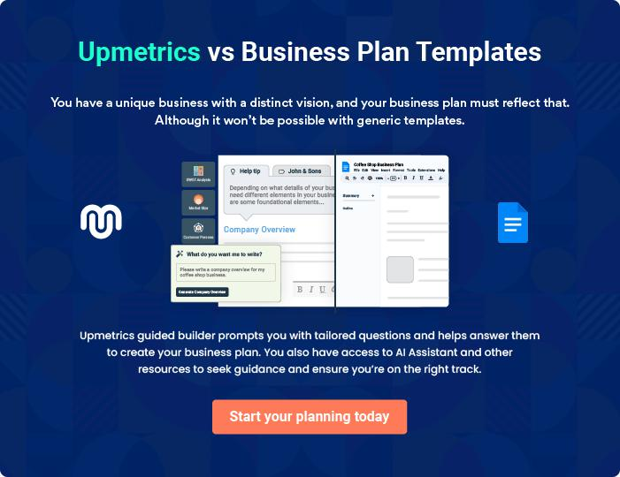
Products and Services
To unlock help try Upmetrics!

The product and services section of a BBQ business plan should describe the specific services and products that will be offered to customers. To write this section should include the following:



 Help tip  BBQ Business Plan

To craft the introduction for your "Products and Services" chapter, begin by positioning your business within its industry, emphasizing its unique strengths or value proposition.
To unlock help try Upmetrics! 

Start writing here..

 Help tip


Mention the BBQ cuisines your business will offer. This list may include

• Smoked meats
To unlock help try Upmetrics! 

Products

Beef Brisket


Price: [$24.99] per pound

Tender beef brisket, slow-smoked for over 12 hours, ensuring melt-in-the-mouth goodness.

Product Specifications

- Source: Organic, grass-fed beef

- Weight: Approx. 1lb per serving

- Marination: 24 hours in our special spice blend

Smoked Chicken Thighs

Price: [$18.99] per pound

Succulent chicken thighs smoked to perfection, ensuring juicy interiors with a crispy skin

Product Specifications

- Source: Free-range chicken

- Weight: Approx. 0.75lb per serving

- Smoke Time: 4-6 hours

Apple Cider Vinegar-Based Sauce

Price: [$6.99] per bottle

A zesty sauce with a tangy kick, perfect for drizzling over smoked meats or dipping.

Product Specifications

- Base: Apple cider vinegar

- Size: 12oz bottle

- Shelf Life: 6 months

Bourbon-Infused BBQ Sauce

Price: [$7.99] per bottle

A rich and smoky sauce with a hint of bourbon, elevating the flavors of any dish.

Product Specifications

- Infusion: Premium bourbon

- Size: 12oz bottle

- Shelf Life: 6 months
Brisket Delight Sandwich

Price: [$14.99] each

Our signature smoked beef brisket served between artisan buns with pickles, onions, and our special sauce.

Product Specifications

- Meat: Approx. 0.5lb beef brisket

- Bread: Artisan sourdough buns

- Served with: House coleslaw and chips

The Smokey Combo

Price: [$29.99]

A comprehensive BBQ experience featuring a selection of our smoked meats, sides, and a drink

Product Specifications

- Meats: Beef brisket (0.5lb), smoked chicken thighs (2 pieces)

- Sides: Coleslaw, baked beans, and cornbread

- Drink: Choice of soda or iced tea

Emphasize quality

 Help tip  BBQ Business Plan

Accentuate your signature dish that differentiates your BBQ from the rest. This uniqueness can be the use of flavors, a creative combination of two plates, or any secret ingredient, etc.
To unlock help try Upmetrics! 

Start writing here..

Sourcing and Quality

 Help tip  BBQ Business Plan

Describe how you find the ingredients for your dishes, paying special attention to the meats, spices, and other essential items.
To unlock help try Upmetrics! 

Start writing here..

Additional Services

 Help tip  BBQ Business Plan

Mention if your BBQ business offers any additional services. You may include services like catering, event services, etc.
To unlock help try Upmetrics! 

Start writing here..
Sales And Marketing Strategies

Writing the sales and marketing strategies section means a list of strategies you will use to attract and retain your clients.
To unlock help try Upmetrics! 

 Help tip  BBQ Business Plan

To create an effective introduction for your "Sales and Marketing Strategies" chapter, start by setting the stage within your specific industry or market.
To unlock help try Upmetrics! 

Unique Selling Proposition (USP)

 Help tip  BBQ Business Plan

Define your business’s USPs depending on the market you serve, the equipment you use, and the unique services you provide. Identifying USPs will help you plan your marketing strategies.
To unlock help try Upmetrics! 

Start writing here..

Pricing Strategy

 Help tip  BBQ Business Plan

Describe your pricing strategy—how you plan to price your products and stay competitive in the local market.
To unlock help try Upmetrics! 

Start writing here..

 Help tip  BBQ Business Plan

Discuss your marketing strategies to market your services.

You may include some of these marketing strategies in your business plan—social media
To unlock help try Upmetrics! 

Marketing strategies

Online


Social Media Marketing

Engaging posts, contests, and promotions on platforms like Facebook, Instagram, and Twitter.

Local Advertising

Collaborating with local businesses and event organizers to promote our services.

Content Marketing

Sharing blog posts and articles about BBQ techniques, recipes, and more to engage BBQ enthusiasts.

Offline

Brochures

Distributed in strategic locations, providing potential customers with a glance at our offerings

Print Marketing

Regular ads in local newspapers, magazines, and community bulletins.

 Help tip
To unlock help try Upmetrics!

Outline the strategies you’ll implement to maximize your sales. Your sales strategies may include upselling – cross-selling, group packages, corporate accounts & business partnerships, etc.



Sales strategies

Upselling & Cross-Selling

Group Packages

Suggesting complementary dishes or larger portion sizes.

Special menus and discounts for larger groups or parties.

Corporate Accounts & Business

Partnerships

Collaborating with local

businesses for events, meetings, or

regular meal options.

 Help tip  BBQ Business Plan

Describe your customer retention strategies and how you plan to execute them. For instance, gift cards & vouchers, discounts on bulk orders, personalized service, etc.
To unlock help try Upmetrics! 

Customer retention

Gift Cards & Vouchers

Bulk Order Discounts

Encouraging repeat visits and word-of-mouth promotion.

Offering discounts for larger orders, especially for events.

Personalized Service

Remembering regular patrons'

preferences, celebrating special

occasions, and ensuring each

customer feels valued.

Operations Plan
To unlock help try Upmetrics!


 |  | When writing the operations plan section, it’s important to consider the
 |  | various aspects of your business operations.
 |  |  |  | To unlock help try Upmetrics! 
 Help tip |  |  BBQ Business Plan


To create an effective introduction for your "Operational Plan" chapter, start by emphasizing the
pivotal role of efficient operations in the success of your business, underscoring how they
directly impact the quality of services delivered.
 |  |  |  | To unlock help try Upmetrics! 
Start writing here..
Staffing & Training
 Help tip |  |  BBQ Business Plan

Mention your business’s staffing requirements, including the number of employees, kitchen staff, or chefs needed.
To unlock help try Upmetrics! 

Start writing here..

Operational Process

 Help tip  BBQ Business Plan

Outline the processes and procedures you will use to run your BBQ business. Your operational processes may include menu planning, ingredient sourcing, food preparation, smoking & grilling, etc.



Start writing here..

Equipment & Machinery

 Help tip  BBQ Business Plan

Include the list of equipment and machinery required for BBQ, such as smokers & grills, barbecue utensils & tools, food service equipment, etc.
To unlock help try Upmetrics! 

Start writing here..
Management Team

The management team section provides an overview of the individuals responsible for running your business plan.
To unlock help try Upmetrics! 

 Help tip  BBQ Business Plan

To craft an introduction for your "Management Team" chapter, begin by emphasizing the crucial role of leadership in the success of any business.
To unlock help try Upmetrics! 

Start writing here..

Key managers

 Help tip  BBQ Business Plan

Introduce your management and key members of your team, and explain their roles and responsibilities.
To unlock help try Upmetrics! 

Start writing here..


JOHN DOE

CEO & Co-founder - john.doe@example.com

John oversees the strategic direction of Smokey Haven BBQ. From vendor relations to business expansion plans, he is actively involved in every major decision, ensuring the brand's vision remains consistent.


Background: With over [10] years in the food and hospitality industry, John's experience, combined with his passion for BBQ, led to the creation of Smokey Haven.

JANE DOE

Operations Manager - jane.doe@example.com

Jane is the backbone of Smokey Haven BBQ's day-to-day operations. With an astute understanding of the restaurant business, she ensures that everything from procurement to service meets the brand's standard of excellence.


- Educational Background: Jane holds a Bachelor's degree in Hospitality Management from [XYZ University].

- Professional Background: With over 8 years of experience in the restaurant industry, she has previously held managerial roles in [ABC Restaurant Group] and [DEF Fine Dining].

Her knack for operations management and dedication to quality has been a significant asset to our brand.


ALICE BROWN

Hotel manager - robert.brown@example.com

Alice brings her hospitality prowess to ensure every guest has an exceptional stay experience at Smokey Haven.

Her meticulous attention to detail and unwavering commitment to guest satisfaction set the benchmark for our accommodation services.

- Educational Background: Alice graduated with a Master's degree in Hotel Management from [UVW University].

- Professional Background: Before joining Smokey Haven BBQ, Alice worked with leading hotel chains like [GHI Hotels] and [JKL Resorts], accumulating a vast knowledge of the hotel industry over her 7-year career.

Her expertise in guest relations and property management makes her an invaluable member of our team.

Organizational structure

 Help tip  BBQ Business Plan

Explain the organizational structure of your management team. Include the reporting line and decision-making hierarchy.
To unlock help try Upmetrics! 
Start writing here..

Organization chart


John Doe

CEO


Alice White


Marketing Manager Jane Doe

Operations Manager


David Green

Robert Brown Digital Marketing Specialist

Kitchen Supervisor



Emily Johnson Lucy Black

Front-of-House Manager Events & Promotions Coordinator

Compensation plan

 Help tip  BBQ Business Plan

Describe your compensation plan for the management and staff. Include their salaries, incentives, and other benefits.
To unlock help try Upmetrics! 

Start writing here..

 Help tip

Mentioning advisors or consultants in your business plans adds credibility to your business idea.
To unlock help try Upmetrics! 

Board of advisors


ROBERT BROWN

Culinary Consultant

With over [20] years in the culinary world, specializing in BBQ cuisines, Robert provides invaluable insights into menu planning and food innovations.
Financial Plan

When writing the financial plan section of a business plan, it’s important to provide a comprehensive overview of your financial projections for the first few years of your business, You may provide the following:
To unlock help try Upmetrics! 

 Help tip  BBQ Business Plan

To create an effective introduction for your "Financial Plan" chapter, begin by stressing the critical role of a well-structured financial plan in the success of your venture.
To unlock help try Upmetrics! 

Start writing here..

 Help tip

Describe details such as projected revenue, operational costs, and service costs in your projected profit and loss statement.
To unlock help try Upmetrics! 

Profit & loss statement

 | 2023-24 | 2024-25 | 2025-26 | 2026-27 | 2027-28
Revenue | $0 | $0 | $0 | $0 | $0

Cost Of Sales | $0 | $0 | $0 | $0 | $0
General Costs | $0 | $0 | $0 | $0 | $0
Revenue Specific Costs | $0 | $0 | $0 | $0 | $0
Personnel Costs (Direct | $0 | $0 | $0 | $0 | $0
Labor)

Gross Margin $0 $0 $0 $0 $0

Gross Margin (%)

Operating Expense

Payroll Expense

(Indirect Labor)

General Expense

Bad Debt

Amortization of Current Assets

EBITDA

Additional Expense

Long Term

Depreciation

Gain or loss from Sale of Assets

EBIT

Interest Expenses

EBT

Income Tax Expense

Total Expense

Net Income

Net Income (%)

2023-24 | 2024-25 | 2025-26 | 2026-27 | 2027-28
0% | 0% | 0% | 0% | 0%
$0 | $0 | $0 | $0 | $0
$0 | $0 | $0 | $0 | $0
$0 | $0 | $0 | $0 | $0
$0 | $0 | $0 | $0 | $0
$0 | $0 | $0 | $0 | $0
$0 | $0 | $0 | $0 | $0
$0 | $0 | $0 | $0 | $0
$0 | $0 | $0 | $0 | $0
$0 | $0 | $0 | $0 | $0
$0 | $0 | $0 | $0 | $0
$0 | $0 | $0 | $0 | $0
$0 | $0 | $0 | $0 | $0
$0 | $0 | $0 | $0 | $0
$0 | $0 | $0 | $0 | $0
$0 | $0 | $0 | $0 | $0
0% | 0% | 0% | 0% | 0%
To unlock help try Upmetrics!
 | 2023-24 | 2024-25 | 2025-26 | 2026-27 | 2027-28
Retained Earning | $0 | $0 | $0 | $0 | $0
Opening
Owner's Distribution | $0 | $0 | $0 | $0 | $0
Retained Earning | $0 | $0 | $0 | $0 | $0
Closing

 Help tip

The cash flow for the first few years of your operation should be estimated and described in this section. This may include billing invoices, payment receipts, loan payments, and any other cash flow statements.



Cash flow statement

Cash Received

Cash Paid

COS & General Expenses

Salary & Wages

Interest

Sales Tax

Income Tax

Net Cash From

Operations

Assets Sell

Assets Purchase

Net Cash From

Investments

2023-24 | 2024-25 | 2025-26 | 2026-27 | 2027-28
$0 | $0 | $0 | $0 | $0
$0 | $0 | $0 | $0 | $0
$0 | $0 | $0 | $0 | $0
$0 | $0 | $0 | $0 | $0
$0 | $0 | $0 | $0 | $0
$0 | $0 | $0 | $0 | $0
$0 | $0 | $0 | $0 | $0
$0 | $0 | $0 | $0 | $0

$0 | $0 | $0 | $0 | $0
$0 | $0 | $0 | $0 | $0
$0 | $0 | $0 | $0 | $0

 | 2023-24 | 2024-25 | 2025-26 | 2026-27 | 2027-28
Amount Received | $0 | $0 | $0 | $0 | $0
Loan Received | $0 | $0 | $0 | $0 | $0
Common Stock
Preferred Stock | $0 | $0 | $0 | $0 | $0
Owner's Contribution | $0 | $0 | $0 | $0 | $0
Amount Paid | $0 | $0 | $0 | $0 | $0
Loan Capital | $0 | $0 | $0 | $0 | $0
Dividends & Distributions | $0 | $0 | $0 | $0 | $0
Net Cash From | $0 | $0 | $0 | $0 | $0
Financing

Summary
Starting Cash | $0 | $0 | $0 | $0 | $0
Cash In | $0 | $0 | $0 | $0 | $0
Cash Out | $0 | $0 | $0 | $0 | $0
Change in Cash | $0 | $0 | $0 | $0 | $0
Ending Cash | $0 | $0 | $0 | $0 | $0

 Help tip

Create a projected balance sheet documenting your BBQ business’s assets, liabilities, and equity.
To unlock help try Upmetrics! 

Balance sheet

 | 2023-24 | 2024-25 | 2025-26 | 2026-27 | 2027-28
Assets | $0 | $0 | $0 | $0 | $0
 | 2023-24 | 2024-25 | 2025-26 | 2026-27 | 2027-28
Current Assets | $0 | $0 | $0 | $0 | $0
Cash | $0 | $0 | $0 | $0 | $0
Accounts Receivable | $0 | $0 | $0 | $0 | $0
Inventory | $0 | $0 | $0 | $0 | $0
Other Current Assets | $0 | $0 | $0 | $0 | $0
Long Term Assets | $0 | $0 | $0 | $0 | $0
Gross Long Term Assets | $0 | $0 | $0 | $0 | $0
Accumulated Depreciation | $0 | $0 | $0 | $0 | $0

Liabilities & Equity | $0 | $0 | $0 | $0 | $0
Liabilities | $0 | $0 | $0 | $0 | $0
Current Liabilities | $0 | $0 | $0 | $0 | $0
Accounts Payable | $0 | $0 | $0 | $0 | $0
Income Tax Payable | $0 | $0 | $0 | $0 | $0
Sales Tax Payable | $0 | $0 | $0 | $0 | $0
Short Term Debt | $0 | $0 | $0 | $0 | $0
Long Term Liabilities | $0 | $0 | $0 | $0 | $0
Long Term Debt | $0 | $0 | $0 | $0 | $0
Equity | $0 | $0 | $0 | $0 | $0
Paid-in Capital | $0 | $0 | $0 | $0 | $0
Common Stock | $0 | $0 | $0 | $0 | $0
Preferred Stock | $0 | $0 | $0 | $0 | $0
Owner's Contribution | $0 | $0 | $0 | $0 | $0
Retained Earnings | $0 | $0 | $0 | $0 | $0
 | 2023-24 |  |  | 2024-25 | 2025-26 | 2026-27 | 2027-28
Check | $0 |  |  | $0 | $0 | $0 | $0
 Help tip |  |  BBQ Business Plan

Determine and mention your business’s break-even point—the point at which your business costs and revenue will be equal.
To unlock help try Upmetrics! 

Break-even Point

 | 2023-24 | 2024-25 | 2025-26 | 2026-27 | 2027-28
Starting Revenue | $0 | $0 | $0 | $0 | $0
Net Revenue | $0 | $0 | $0 | $0 | $0
Closing Revenue | $0 | $0 | $0 | $0 | $0

Starting Expense | $0 | $0 | $0 | $0 | $0
Net Expense | $0 | $0 | $0 | $0 | $0
Closing Expense | $0 | $0 | $0 | $0 | $0

Is Break Even? | 0 | 0 | 0 | 0 | 0
Break Even Month | 0 | 0 | 0 | 0 | 0
Days Required | 0 | 0 | 0 | 0 | 0
Break Even Revenue | $0 | $0 | $0 | $0 | $0
Break Even Units
Financing needs

 Help tip  BBQ Business Plan

Calculate costs associated with starting a BBQ business, and estimate your financing needs and how much capital you need to raise to operate your business.
To unlock help try Upmetrics! 

Start writing here..
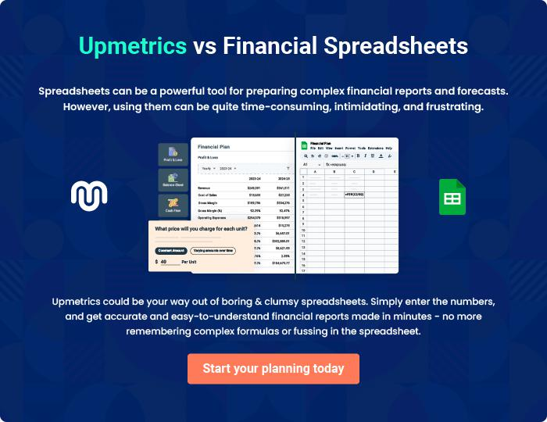
Appendix

When writing the appendix section, you should include any additional information that supports the main content of your plan. This may include financial statements, market research data, legal documents, and other
To unlock help try Upmetrics! 
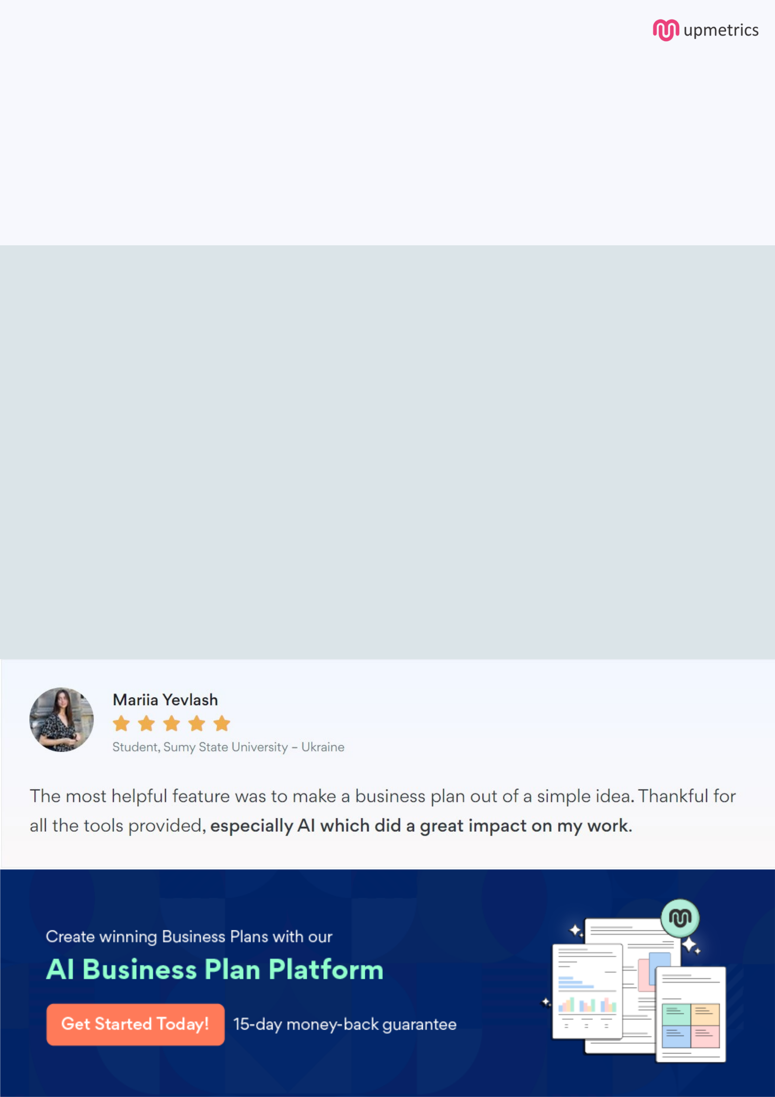
Create a winning business plan that gets you funded

Creating a stunning and investment-ready plan requires no writing, graphic designing, or financial planning expertise.

Upmetrics has all the features required to help you create a comprehensive business plan—from start to finish. Make no mistakes, it’s the modern way of planning to structure ideas, make plans, and create stunning pitch decks to awe investors.

Pitch decks that impress investors

Create pitch decks that provide a visual representation of your business, engage investors, and make them want to invest in your business idea.

Interactive plans in no time

Import business plan sections like—SWOT analysis, comparison tables, and others to create an interactive business plan. No designing skills are required.

Stunning cover page designs

With Upmetrics, you have the liberty to choose from multiple stunning cover page designs. Choose a creative design and make your plan stand out.

Online sharing made simple

Upmetrics makes online sharing quick and easier for users. Easily share your business plans with a link while tracking reader activity.

500+ sample business plans

Simply import a template from our library of sample plans into the editor and start customizing it to make it yours. It takes only a few clicks to get started.

Collaborate with team in real-time

Invite team members, initiate conversations, discuss ideas & strategies, share feedback, and work on a business plan in real-time.

