
BUSINESS PLAN

2023

Axe Throwing

Business Plan

Bullseye Moments, Axe-citing Memories

John Doe

10200 Bolsa Ave, Westminster, CA, 92683

- 359-3153 info@example.com http://www.example.com

Information provided in this business plan is unique to this business and confidential; therefore, anyone reading this plan agrees not to disclose any of the information in this business plan without prior written permission of the company.
Table of Contents

Executive Summary | 6
Market opportunity | 6
Services Offered | 6
Financial Highlights | 7
Units Sold v/s Revenue | 7

Company Overview | 8
Ownership | 8
Mission statement | 8
Business history | 9
Future goals | 9

Market Analysis | 10
Target Market | 10
Market size and growth potential | 10
Market Size | 11
Competitive analysis | 11
AxeElite Hub | 11
Throw & Thrill | 12
Bullseye Axe Masters | 12
Market trends | 12
Regulatory environment | 13

Products and Services | 14
Products and Services | 14
Beginner's Coaching Session | 14
Standard Axe-Throwing Session | 15
Private Lane Booking | 15
Themed Night Entry Pass | 15
AxeVenture Merchandise - Custom Axe | 16
Refreshment Package | 16
Facilities | 16
Additional Services | 17

Sales And Marketing Strategies | 18
Unique Selling Proposition (USP) | 18
Pricing Strategy | 18
Marketing strategies | 19
Online | 19
Offline | 19
Sales strategies | 20
Customer retention | 20

Operations Plan | 21
Hiring Plan | 21
Booking & Scheduling | 21
Facility and Equipment | 22

Management Team | 23
Key managers | 23
John Doe | 23
Jane Doe | 24
Robert Brown | 24
Alice Brown | 24
Organizational structure | 25
Organization chart | 25
Compensation plan | 25
Board of advisors | 26
Mr. James Smith | 26
Ms. Lucy White | 26

Financial Plan | 27
Profit & loss statement | 27
Cash flow statement | 29
Balance sheet | 30
Break-even Point | 32
Financing needs | 33
Appendix
Appendix | 34
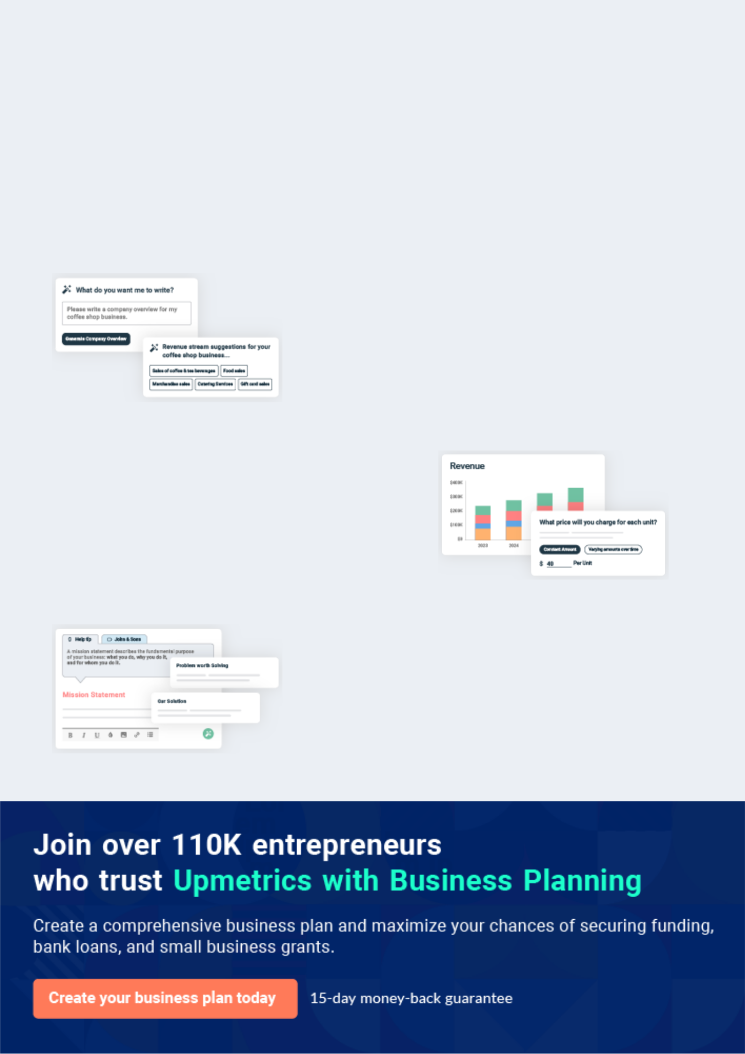
Business planning that’s simpler and faster than you think

Creating a business plan using Upmetrics to start and grow a business is literally the easiest thing in the World. Simply read the instructions and fill in the blanks. It’s as simple as that.

❛ | Upmetrics has everything you need to create a | ❜
❛ | comprehensive business plan. | ❜

AI-powered Upmetrics Assistant

AI-powered insights to streamline your plan

Not sure where to start? Upmetrics’ AI Assistant will automatically generate ideas for each section of your plan and offer improved versions of your writing, adjusting for tone, voice, and grammar or spelling errors.

Financial Forecasting Tool

All the financials are calculated for you

Forget the complex formulas and clumsy spreadsheets — with automatic financials and drag-and-drop forecasting, you can finish your plan faster and be confident that your numbers are accurate.

Business Plan Builder

Guides you like a business mentor

Upmetrics’ step-by-step instructions, prompts, and the library of 400+ sample business plans will guide you through each section of your plan as a business mentor.
Executive Summary


An executive summary is the first section of the business plan intended to provide an overview of the whole business plan.
To unlock help try Upmetrics! 

 Help tip  Axe Throwing Business Plan


Start your executive summary by introducing your idea behind starting an axe-throwing business and explaining what it does.
To unlock help try Upmetrics! 

Start writing here..

Market opportunity

 Help tip  Axe Throwing Business Plan

Describe the target market in brief, and explain the demographics, geographic location, and psychographic attributes of your target customer.
To unlock help try Upmetrics! 

Start writing here..

Services Offered

 Help tip  Axe Throwing Business Plan

Describe the axe-throwing service. Also, include how really axe throwing works.

To unlock help try Upmetrics! 

Start writing here..

Financial Highlights
To unlock help try Upmetrics!

 Help tip  Axe Throwing Business Plan

Provide a summary of your financial projections for the company’s initial years of operation.

Include any capital or investment requirements, startup costs, projected revenues, and profits.
To unlock help try Upmetrics! 

Start writing here..

Units Sold v/s Revenue

 |  | Units Sold | Revenue
15.00k
10.00k
5.00k
0
Year 1 | Year 2 | Year 3


Financial Year |  |  | Units Sold | Revenue
Year 1 | 1,550 |  |  | $10,000
Year 2 | 1,800 |  |  | $12,000
Year 3 | 2,050 |  |  | $14,000
 Help tip |  |  Axe Throwing Business Plan


After giving a brief about your business plan, end your summary with a call to action, for example; inviting potential investors or readers to the next meeting if they are interested in your business.



Write a call to action for your business plan.

Company Overview

Depending on what details of your business are essential, you’ll need different elements in your business overview.
To unlock help try Upmetrics! 

 Help tip  Axe Throwing Business Plan

Provide all the basic information about your business in this section like:

• The name of the axe-throwing business and a summary of your business that it will run
To unlock help try Upmetrics! 

Start writing here..

Ownership

 Help tip  Axe Throwing Business Plan

Describe the owners of your axe-throwing business and mention their roles in running it. Also, describe how each owner helps in the business.
To unlock help try Upmetrics! 

Start writing here..

Mission statement

 Help tip  Axe Throwing Business Plan

Add a mission statement that sums up the objectives and core principles of your business. This statement needs to be memorable, clear, and brief.
To unlock help try Upmetrics! 
❛ At [AxeVenture Throwing Lounge], our mission is to redefine recreation by merging tradition with innovation. We aim to provide a safe, exhilarating, and unique axe-throwing experience,
To unlock help try Upmetrics!

fostering community, competition, and skill.
❜

Business history

 Help tip  Axe Throwing Business Plan

If you have established a business, including an outline of the axe-throwing business’s history and how it came to be in its current position.
To unlock help try Upmetrics! 

Start writing here..

Future goals

 Help tip  Axe Throwing Business Plan

It’s crucial to convey your aspirations and your vision. Include the vision of where you see your business in the near future and if you have any plans of opening a new franchise of your business in the same city in the future.



Start writing here..
Market Analysis
To unlock help try Upmetrics!


 |  | Market analysis provides a clear understanding of the market in which your
 |  | printing business will run along with the target market, competitors, and
 |  | growth opportunities.
 |  |  |  | To unlock help try Upmetrics! 
 Help tip |  |  Axe Throwing Business Plan

To write the introduction section of your market analysis, start by clearly identifying your primary target market.
To unlock help try Upmetrics! 

Start writing here..

Target Market

 Help tip  Axe Throwing Business Plan

Identify your target market and define your ideal customer. Know more about your customers and which services they prefer. For example, your target market can be young adults or corporate employees.



Start writing here..

Market size and growth potential

 Help tip  Axe Throwing Business Plan

Describe your market size and growth potential, as well as what is industry’s growth forecast.

To unlock help try Upmetrics! 

Start writing here..

Market Size

Available Market

Total individuals aged 18-45 in [City/ 5M Region].

Served Market
Those in [City/Region] who've tried axe- 1M throwing at least once.

Target Market
Urban professionals & students aged 500k 21-35 in [City's] downtown area.

 Help tip


Identify and analyze all other axe-throwing businesses in the local market, including direct and indirect competitors.
To unlock help try Upmetrics! 

Competitive analysis

AxeElite Hub

Location: Downtown [City]

Operating Since: 2019

Target Audience: Corporate events and bachelor parties

Features

Integrated bar and dining area

Dedicated lanes for corporate events

Advanced online booking system with corporate discounts

Strengths

Catering specifically to corporate events provides them with consistent bookings

Integrated dining ensures longer stays and increased spend per customer

Prime downtown location attracts higher-end clientele

Weaknesses

Exclusivity might deter casual throwers or younger audiences

Higher prices due to premium location and offerings

Lacks themed events or promotions for broader appeal

Throw & Thrill

Location: [City] Suburbs

Operating Since: 2017

Target Audience: Young adults and casual throwers

Features | Strengths
Nightly themed events | Themed events create buzz
(Medieval Mondays, | and attract a steady stream of
Lumberjack Weekends) | patrons
Basic refreshment counters | Located in the suburbs, it's
Walk-in options without prior | more accessible to residents
booking | Flexible walk-in options cater to
 | impromptu plans

Weaknesses

Lacks advanced booking benefits, making group events harder to schedule

Absence of a dining area might result in shorter customer stays

Fewer safety instructors, raising concerns over patron safety

Bullseye Axe Masters

Location: Near [City] University

Operating Since: 2018

Target Audience: Students and competitive leagues

Features

Monthly tournaments with cash prizes

Special student discounts

Membership options for regular throwers

Strengths

Proximity to the university ensures a regular influx of students

Competitive tournaments position them as a hub for serious axe throwers

Membership options build a dedicated customer base

Weaknesses

Over-reliance on student demographics, which can be seasonal

Lack of a comprehensive refreshment area

Lacks mobile or off-site services for events or parties

Market trends

 Help tip  Axe Throwing Business Plan

Analyze current and emerging trends in your industry, such as changes in technology or customer preference. Explain how your business will cope with all the trends.
To unlock help try Upmetrics! 

Start writing here..
To unlock help try Upmetrics!

Regulatory environment

 Help tip  Axe Throwing Business Plan

Describe any regulations or licensing requirements that affect the axe-throwing business, such as safety codes, age criteria, business registration and licensing, zoning regulations, alcohol regulations, etc.



Start writing here..
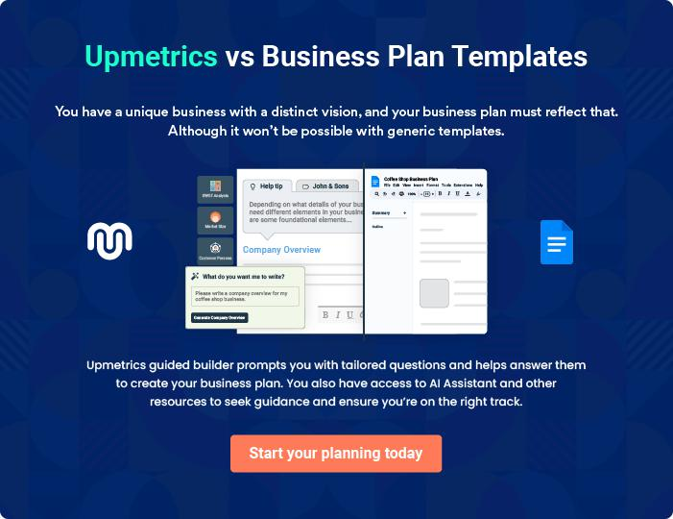
Products and Services
To unlock help try Upmetrics!
To unlock help try Upmetrics!

The product and services section of an axe throwing business plan should describe the specific services and products that will be offered to customers. To write this section should include the following:



 Help tip  Axe Throwing Business Plan

To craft the introduction for your "Products and Services" chapter, begin by positioning your business within its industry, emphasizing its unique strengths or value proposition.
To unlock help try Upmetrics! 

Start writing here..

 Help tip

Explain the qualities and advantages of the service you provide in more depth. You might, for instance, mention that beginners will receive coaching and teaching and that axe-throwing sessions would be available for 30 minutes.



Products and Services

Beginner's Coaching Session


Price: $25 per session

A comprehensive introduction to the art of axe throwing tailored for beginners. This session ensures newcomers understand the technique, safety measures, and basic scoring methods.

Specifications

- Duration: 30 minutes

- Includes safety gear (gloves, protective eyewear)

- 1:1 coaching with a certified instructor
Standard Axe-Throwing Session

Price: $40 per session

Ideal for those familiar with axe throwing, this session offers participants the chance to practice, compete, or simply enjoy the thrill of the throw.

Specifications

- Duration: 60 minutes

- Lane reservation option available

- Up to 4 participants per lane

Private Lane Booking

Price: $150 for 2 hours

Perfect for groups or those seeking a more private experience, this booking ensures a dedicated lane for the duration of the session.

Specifications

- Duration: 120 minutes

- Dedicated instructor

- Complimentary refreshments

Themed Night Entry Pass

Price: $50 per person

Join our special themed nights, from Medieval Mondays to Lumberjack Weekends. An immersive experience with themed music, decor, and games.

Specifications

- Duration: 3 hours (7 PM to 10 PM)

- Includes entry to competitions with prizes

- Discounts on food and beverages
AxeVenture Merchandise - Custom Axe

Price: $120

Take home a piece of AxeVenture with a custom-designed axe, perfect for enthusiasts and collectors

Specifications

- Material: High-carbon steel with wooden handle

- Length: 15 inches

- Engraved AxeVenture logo

Refreshment Package

Price: $15

Stay refreshed during your session with our specially curated package, including a drink and a snack.

Specifications

- Choice of craft beer, soda, or water

- Snack options: Pretzel, nachos, or sandwich

Facilities

 Help tip  Axe Throwing Business Plan

Describe the amenities you will offer to your clients, including the quantity of throwing lanes, the style of the targets, and the safety precautions that will be implemented.
To unlock help try Upmetrics! 

Start writing here..

Additional Services
To unlock help try Upmetrics!

 Help tip  Axe Throwing Business Plan

Clarify the additional services you plan to provide and how they will enhance the overall client experience, such as selling food and drinks or products, organizing special parties and events, or if there are any retail items.



Start writing here..
Sales And Marketing Strategies

Writing the sales and marketing strategies section means a list of strategies you will use to attract and retain your clients.
To unlock help try Upmetrics! 

 Help tip  Axe Throwing Business Plan

To create an effective introduction for your "Sales and Marketing Strategies" chapter, start by setting the stage within your specific industry or market.
To unlock help try Upmetrics! 

Unique Selling Proposition (USP)

 Help tip  Axe Throwing Business Plan

Clearly define your unique selling proposition, such as your services, safety equipment, prior training from a coach, etc.
To unlock help try Upmetrics! 

Start writing here..

Pricing Strategy

 Help tip  Axe Throwing Business Plan

Develop a pricing strategy that is competitive and affordable, yet profitable. Consider offering promotions, discounts, and packages to attract new customers.
To unlock help try Upmetrics! 

Start writing here..

 Help tip  Axe Throwing Business Plan

Develop a marketing strategy that includes a mix of online and offline marketing tactics.

Consider social media, hosting special events or girl’s night out, content marketing, brochures,
To unlock help try Upmetrics! 

Marketing strategies

Online


Online Presence

Leveraging platforms like Instagram and Facebook, we regularly update our community about events, offers, and tips on axe throwing.

Content Marketing

Through blogs and videos, we aim to educate our audience about the sport, safety measures, and benefits of axe throwing.

Offline

Print Marketing

Brochures, posters, and flyers are distributed in strategic locations, like universities and corporate hubs, to increase visibility.

Special Events

From 'Girls’ Night Out' to 'Medieval Mondays', we host themed events to attract varied audience segments.

 Help tip  Axe Throwing Business Plan

Explain your sales strategy, including the channels you’ll utilize, the sales team, and the steps you’ll take to close deals.
To unlock help try Upmetrics! 

Sales strategies

Direct Customers

Our front desk, helmed by trained sales personnel, is equipped to handle walk-ins, providing them with package details and benefits, and ensuring conversions.

Community Outreach

Participating in community events, fairs, and university events to directly engage with potential customers.

Referral Programs

A reward-based system where

existing customers get [e.g., a 15%

discount] for every new customer

they refer.

 Help tip  Axe Throwing Business Plan

Encourage your happy consumers to recommend your business to others. Provide customers rewards for their referrals, such as discounts or free sessions.
To unlock help try Upmetrics! 

Customer retention

Loyalty Programs

A points-based system where regular patrons can accumulate points with each visit, redeemable against sessions or merchandise.

Referral Discounts

As part of our referral program, both the referrer and referee receive [e.g., a 10% discount] on their next booking.

Operations Plan

 |  | When writing the operations plan section, it’s important to consider the
 |  | various aspects of your business operations.
 |  |  |  | To unlock help try Upmetrics! 
 Help tip |  |  Axe Throwing Business Plan


To create an effective introduction for your "Operational Plan" chapter, start by emphasizing the
pivotal role of efficient operations in the success of your business, underscoring how they
directly impact the quality of services delivered.
 |  |  |  | To unlock help try Upmetrics! 
Start writing here..
Hiring Plan
 Help tip |  |  Axe Throwing Business Plan

Tell the staffing requirements of your axe-throwing business, including the number of employees needed, their qualifications, and the duties they will perform.
To unlock help try Upmetrics! 

Start writing here..

Booking & Scheduling

 Help tip  Axe Throwing Business Plan

Describe the procedure for session reservations and payment. Indicate whether you’ll accept walk-ins or reservations and whether you’ll accept phone or online reservations.
To unlock help try Upmetrics! 

Start writing here..

Facility and Equipment

 Help tip  Axe Throwing Business Plan

Explain your facility’s layout and any necessary tools, such as axes and targets.

Specify the equipment maintenance schedule, also how you’ll stick to keep the building tidy and
To unlock help try Upmetrics! 

Start writing here..
Management Team

The management team section provides an overview of the individuals responsible for running your business plan.
To unlock help try Upmetrics! 

 Help tip  Axe Throwing Business Plan

To craft an introduction for your "Management Team" chapter, begin by emphasizing the crucial role of leadership in the success of any business.
To unlock help try Upmetrics! 

Start writing here..

Key managers

 Help tip  Axe Throwing Business Plan

Describe your management team’s key members, roles, and responsibilities.

It should include the owners, and senior management of the axe-throwing business, including
To unlock help try Upmetrics! 

Start writing here..


JOHN DOE

Founder/CEO - john.doe@example.com

Roles & Responsibilities: John oversees the overall strategic direction of AxeVenture. He is instrumental in decision-making, forging strategic partnerships, and maintaining the brand's ethos.


Background: With a Bachelor's in Business Administration from [University Name] and over [e.g., 10] years in the recreational industry, John identified the potential of axe-throwing as a mainstream entertainment option and founded AxeVenture.

JANE DOE

Chief Operating Officer (COO) - jane.doe@example.com

As the COO, Jane ensures the smooth daily operations of Accenture. From staff scheduling to customer experience optimization, Jane's role is pivotal in ensuring a seamless interface between the brand and its patrons.


Educational Background: Jane holds a Master's in Business Administration from Prestige University, majoring in Operations Management.

Professional Background: With over 8 years of experience managing operations in the entertainment sector, Jane previously served as the Operations Head for FunZone, a leading recreational centre in the state.


ROBERT BROWN

Chief Marketing Officer (CMO) - robert.brown@example.com

Robert is the driving force behind AxeVenture's brand identity and market presence. He crafts and oversees marketing strategies, digital campaigns, and customer engagement initiatives that have positioned AxeVenture as a top choice for axe-throwing enthusiasts.

Educational Background: Robert graduated Magna Cum Laude with a Bachelor's in Marketing from Elite Business School.

Professional Background: Before joining AxeVenture, Robert was the Director of Marketing at PlayArena, a nationwide chain of amusement parks, where he executed multiple successful campaigns


ALICE BROWN

Chief Financial Officer (CFO) - alice.brown@example.com

Alice's astute financial acumen and strategic planning have been instrumental in steering AxeVenture towards profitability and fiscal responsibility. She oversees budgets, financial forecasting, and ensures optimal allocation of resources.

Educational Background: Alice is a Chartered Accountant and also holds a Master's in Finance from Global Finance Institute.

Professional Background: With over 9 years in the entertainment industry, Alice served as the Vice President of Finance for ThrillWorld before joining AxeVenture.
Organizational structure

 Help tip  Axe Throwing Business Plan

Describe the organizational structure of the management team, including reporting lines and how decisions will be made.
To unlock help try Upmetrics! 

Start writing here..

Organization chart


John Doe

CEO
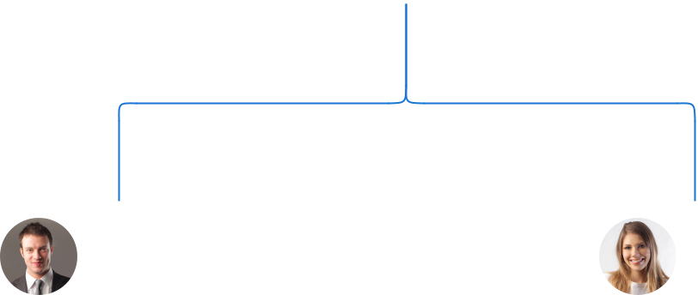

Robert Brown Jane Doe

CMO COO


Alice White

Mark Green Operations Assistant

Marketing Specialist

Compensation plan

 Help tip  Axe Throwing Business Plan

Describe your compensation plan for the management team and staff, including salaries, bonuses, and other benefits.
To unlock help try Upmetrics! 

Start writing here..

 Help tip  Axe Throwing Business Plan

If you have a board of advisors for your business, then mention them along with their roles and experience.
To unlock help try Upmetrics! 

Board of advisors


MR. JAMES SMITH

Former CEO of [Famous Entertainment Chain]

Former CEO of [Famous Entertainment Chain]. James provides insights into scaling operations and brand positioning.


MS. LUCY WHITE

Safety Consultant

Renowned safety consultant. Lucy guides us on maintaining and enhancing safety protocols.
Financial Plan
To unlock help try Upmetrics!

When writing the financial plan section of a business plan, it’s important to provide a comprehensive overview of your financial projections for the first few years of your business, You may provide the following:
To unlock help try Upmetrics! 

 Help tip  Axe Throwing Business Plan

To create an effective introduction for your "Financial Plan" chapter, begin by stressing the critical role of a well-structured financial plan in the success of your venture.
To unlock help try Upmetrics! 

Start writing here..

 Help tip

Create a projected profit & loss statement that describes the expected revenue, cost of products sold, and operational costs. Your business’s anticipated net profit or loss should be computed and included.



Profit & loss statement

 | 2023-24 | 2024-25 | 2025-26 | 2026-27 | 2027-28
Revenue | $0 | $0 | $0 | $0 | $0

Cost Of Sales | $0 | $0 | $0 | $0 | $0
General Costs | $0 | $0 | $0 | $0 | $0
Revenue Specific Costs | $0 | $0 | $0 | $0 | $0
Personnel Costs (Direct | $0 | $0 | $0 | $0 | $0
Labor)

Gross Margin $0 $0 $0 $0 $0

Gross Margin (%)

Operating Expense

Payroll Expense

(Indirect Labor)

General Expense

Bad Debt

Amortization of Current Assets

EBITDA

Additional Expense

Long Term

Depreciation

Gain or loss from Sale of Assets

EBIT

Interest Expenses

EBT

Income Tax Expense

Total Expense

Net Income

Net Income (%)

2023-24 | 2024-25 | 2025-26 | 2026-27 | 2027-28
0% | 0% | 0% | 0% | 0%
$0 | $0 | $0 | $0 | $0
$0 | $0 | $0 | $0 | $0
$0 | $0 | $0 | $0 | $0
$0 | $0 | $0 | $0 | $0
$0 | $0 | $0 | $0 | $0
$0 | $0 | $0 | $0 | $0
$0 | $0 | $0 | $0 | $0
$0 | $0 | $0 | $0 | $0
$0 | $0 | $0 | $0 | $0
$0 | $0 | $0 | $0 | $0
$0 | $0 | $0 | $0 | $0
$0 | $0 | $0 | $0 | $0
$0 | $0 | $0 | $0 | $0
$0 | $0 | $0 | $0 | $0
$0 | $0 | $0 | $0 | $0
0% | 0% | 0% | 0% | 0%
To unlock help try Upmetrics!
 | 2023-24 | 2024-25 | 2025-26 | 2026-27 | 2027-28
Retained Earning | $0 | $0 | $0 | $0 | $0
Opening
Owner's Distribution | $0 | $0 | $0 | $0 | $0
Retained Earning | $0 | $0 | $0 | $0 | $0
Closing

 Help tip

Estimate your cash inflows and outflows for the first few years of operation. It should include cash receipts from clients, payments to vendors, loan payments, and any other cash inflows and outflows.



Cash flow statement

Cash Received

Cash Paid

COS & General Expenses

Salary & Wages

Interest

Sales Tax

Income Tax

Net Cash From

Operations

Assets Sell

Assets Purchase

Net Cash From

Investments

2023-24 | 2024-25 | 2025-26 | 2026-27 | 2027-28
$0 | $0 | $0 | $0 | $0
$0 | $0 | $0 | $0 | $0
$0 | $0 | $0 | $0 | $0
$0 | $0 | $0 | $0 | $0
$0 | $0 | $0 | $0 | $0
$0 | $0 | $0 | $0 | $0
$0 | $0 | $0 | $0 | $0
$0 | $0 | $0 | $0 | $0

$0 | $0 | $0 | $0 | $0
$0 | $0 | $0 | $0 | $0
$0 | $0 | $0 | $0 | $0

 | 2023-24 | 2024-25 | 2025-26 | 2026-27 | 2027-28
Amount Received | $0 | $0 | $0 | $0 | $0
Loan Received | $0 | $0 | $0 | $0 | $0
Common Stock
Preferred Stock | $0 | $0 | $0 | $0 | $0
Owner's Contribution | $0 | $0 | $0 | $0 | $0
Amount Paid | $0 | $0 | $0 | $0 | $0
Loan Capital | $0 | $0 | $0 | $0 | $0
Dividends & Distributions | $0 | $0 | $0 | $0 | $0
Net Cash From | $0 | $0 | $0 | $0 | $0
Financing

Summary
Starting Cash | $0 | $0 | $0 | $0 | $0
Cash In | $0 | $0 | $0 | $0 | $0
Cash Out | $0 | $0 | $0 | $0 | $0
Change in Cash | $0 | $0 | $0 | $0 | $0
Ending Cash | $0 | $0 | $0 | $0 | $0

 Help tip

Prepare a projected balance sheet, which shows the assets, liabilities, and equity.

To unlock help try Upmetrics! 

Balance sheet

 | 2023-24 | 2024-25 | 2025-26 | 2026-27 | 2027-28
Assets | $0 | $0 | $0 | $0 | $0
 | 2023-24 | 2024-25 | 2025-26 | 2026-27 | 2027-28
Current Assets | $0 | $0 | $0 | $0 | $0
Cash | $0 | $0 | $0 | $0 | $0
Accounts Receivable | $0 | $0 | $0 | $0 | $0
Inventory | $0 | $0 | $0 | $0 | $0
Other Current Assets | $0 | $0 | $0 | $0 | $0
Long Term Assets | $0 | $0 | $0 | $0 | $0
Gross Long Term Assets | $0 | $0 | $0 | $0 | $0
Accumulated Depreciation | $0 | $0 | $0 | $0 | $0

Liabilities & Equity | $0 | $0 | $0 | $0 | $0
Liabilities | $0 | $0 | $0 | $0 | $0
Current Liabilities | $0 | $0 | $0 | $0 | $0
Accounts Payable | $0 | $0 | $0 | $0 | $0
Income Tax Payable | $0 | $0 | $0 | $0 | $0
Sales Tax Payable | $0 | $0 | $0 | $0 | $0
Short Term Debt | $0 | $0 | $0 | $0 | $0
Long Term Liabilities | $0 | $0 | $0 | $0 | $0
Long Term Debt | $0 | $0 | $0 | $0 | $0
Equity | $0 | $0 | $0 | $0 | $0
Paid-in Capital | $0 | $0 | $0 | $0 | $0
Common Stock | $0 | $0 | $0 | $0 | $0
Preferred Stock | $0 | $0 | $0 | $0 | $0
Owner's Contribution | $0 | $0 | $0 | $0 | $0
Retained Earnings | $0 | $0 | $0 | $0 | $0
 | 2023-24 | 2024-25 | 2025-26 | 2026-27 | 2027-28
Check | $0 | $0 | $0 | $0 | $0

 Help tip

Determine the point at which your axe-throwing business will break even, or generate enough revenue to cover its operating costs.
To unlock help try Upmetrics! 

Break-even Point

 | 2023-24 | 2024-25 | 2025-26 | 2026-27 | 2027-28
Starting Revenue | $0 | $0 | $0 | $0 | $0
Net Revenue | $0 | $0 | $0 | $0 | $0
Closing Revenue | $0 | $0 | $0 | $0 | $0

Starting Expense | $0 | $0 | $0 | $0 | $0
Net Expense | $0 | $0 | $0 | $0 | $0
Closing Expense | $0 | $0 | $0 | $0 | $0

Is Break Even? | 0 | 0 | 0 | 0 | 0
Break Even Month | 0 | 0 | 0 | 0 | 0
Days Required | 0 | 0 | 0 | 0 | 0
Break Even Revenue | $0 | $0 | $0 | $0 | $0
Break Even Units
Financing needs
To unlock help try Upmetrics!

 Help tip  Axe Throwing Business Plan

Estimate how much financing you will need to start and operate your axe-throwing business. It should include both short-term and long-term financing needs, such as loans or investment capital.



Start writing here..
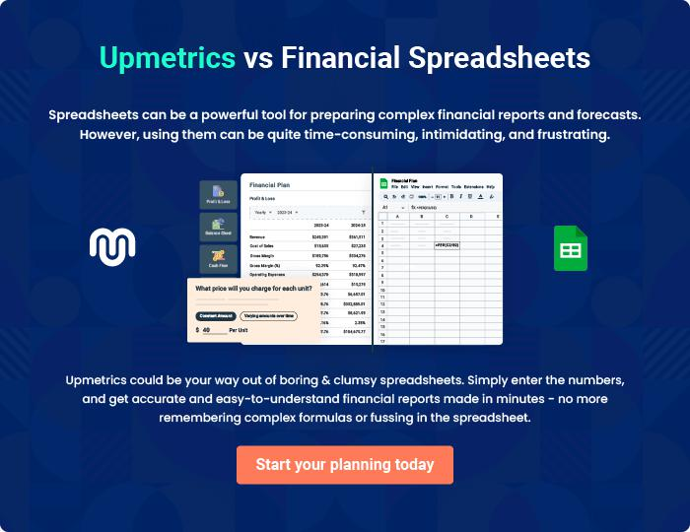
Appendix

When writing the appendix section, you should include any additional information that supports the main content of your plan. This may include financial statements, market research data, legal documents, and other
To unlock help try Upmetrics! 
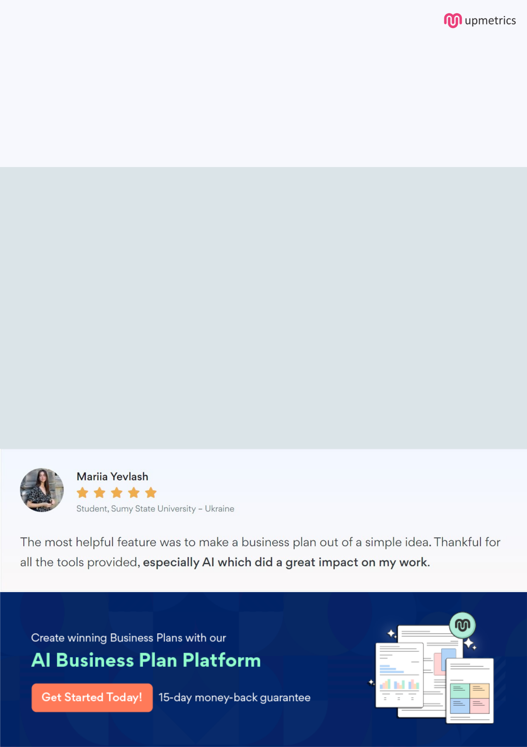
Create a winning business plan that gets you funded

Creating a stunning and investment-ready plan requires no writing, graphic designing, or financial planning expertise.

Upmetrics has all the features required to help you create a comprehensive business plan—from start to finish. Make no mistakes, it’s the modern way of planning to structure ideas, make plans, and create stunning pitch decks to awe investors.

Pitch decks that impress investors

Create pitch decks that provide a visual representation of your business, engage investors, and make them want to invest in your business idea.

Interactive plans in no time

Import business plan sections like—SWOT analysis, comparison tables, and others to create an interactive business plan. No designing skills are required.

Stunning cover page designs

With Upmetrics, you have the liberty to choose from multiple stunning cover page designs. Choose a creative design and make your plan stand out.

Online sharing made simple

Upmetrics makes online sharing quick and easier for users. Easily share your business plans with a link while tracking reader activity.

500+ sample business plans

Simply import a template from our library of sample plans into the editor and start customizing it to make it yours. It takes only a few clicks to get started.

Collaborate with team in real-time

Invite team members, initiate conversations, discuss ideas & strategies, share feedback, and work on a business plan in real-time.

