
 Artist Business Plan

ADDRESS CONTACT

10200 Bolsa Ave, Westminster, CA, 92683 (650) 359-3153

http://www.example.com info@example.com


Business Plan

2023

Prepared By

John Doe


Creating Art, Inspiring Souls

Information provided in this business plan is unique to this business and confidential; therefore, anyone reading this plan agrees not to disclose any of the information in this business plan without prior written permission of the company.

Table of Contents

Executive Summary | 6
Market opportunity | 6
Services Offered | 6
Management team | 7
John Doe | 7
Jane Smith | 7
Alice Brown | 7
Robert Green | 7
Financial Highlights | 8
Units Sold v/s Revenue | 8

Company Overview | 9
Ownership | 9
Business Owners | 9
Mission statement | 10
Business history | 10
Future goals | 10

Market Analysis | 11
Target Market | 11
Market size and growth potential | 11
Market Size | 12
Competitive analysis | 12
Artistic Verve Studio | 12
Modern Muse Creations | 13
Timeless Brushworks | 13
Market trends | 13
Regulatory environment | 14
Products and Services | 15
Services | 15
Original Works | 15
Limited Edition Prints | 16
Commissioned Creations | 16
Emphasize safety and quality | 17

Sales And Marketing Strategies | 18
Unique Selling Proposition (USP) | 18
Pricing Strategy | 18
Marketing strategies | 19
Online | 19
Offline | 19
Sales strategies | 20
Customer retention | 20

Operations Plan | 21
Operational Process | 21
Inventory Management | 21
Management Team
Management Team | 22
Key managers | 22
John Doe | 22
Alice Brown | 23
Robert Brown | 23
Jane Smith | 23
Charlie Green | 24
Diane White | 24
Organizational structure | 24
Organization chart | 25
Compensation plan | 25
Board of advisors | 26
Liam Black | 26
Sophia Gray | 26
Financial Plan | 27
Profit & loss statement | 27
Cash flow statement | 30
Balance sheet | 32
Break-even Point | 34
Financing needs | 36
Appendix
Appendix | 38
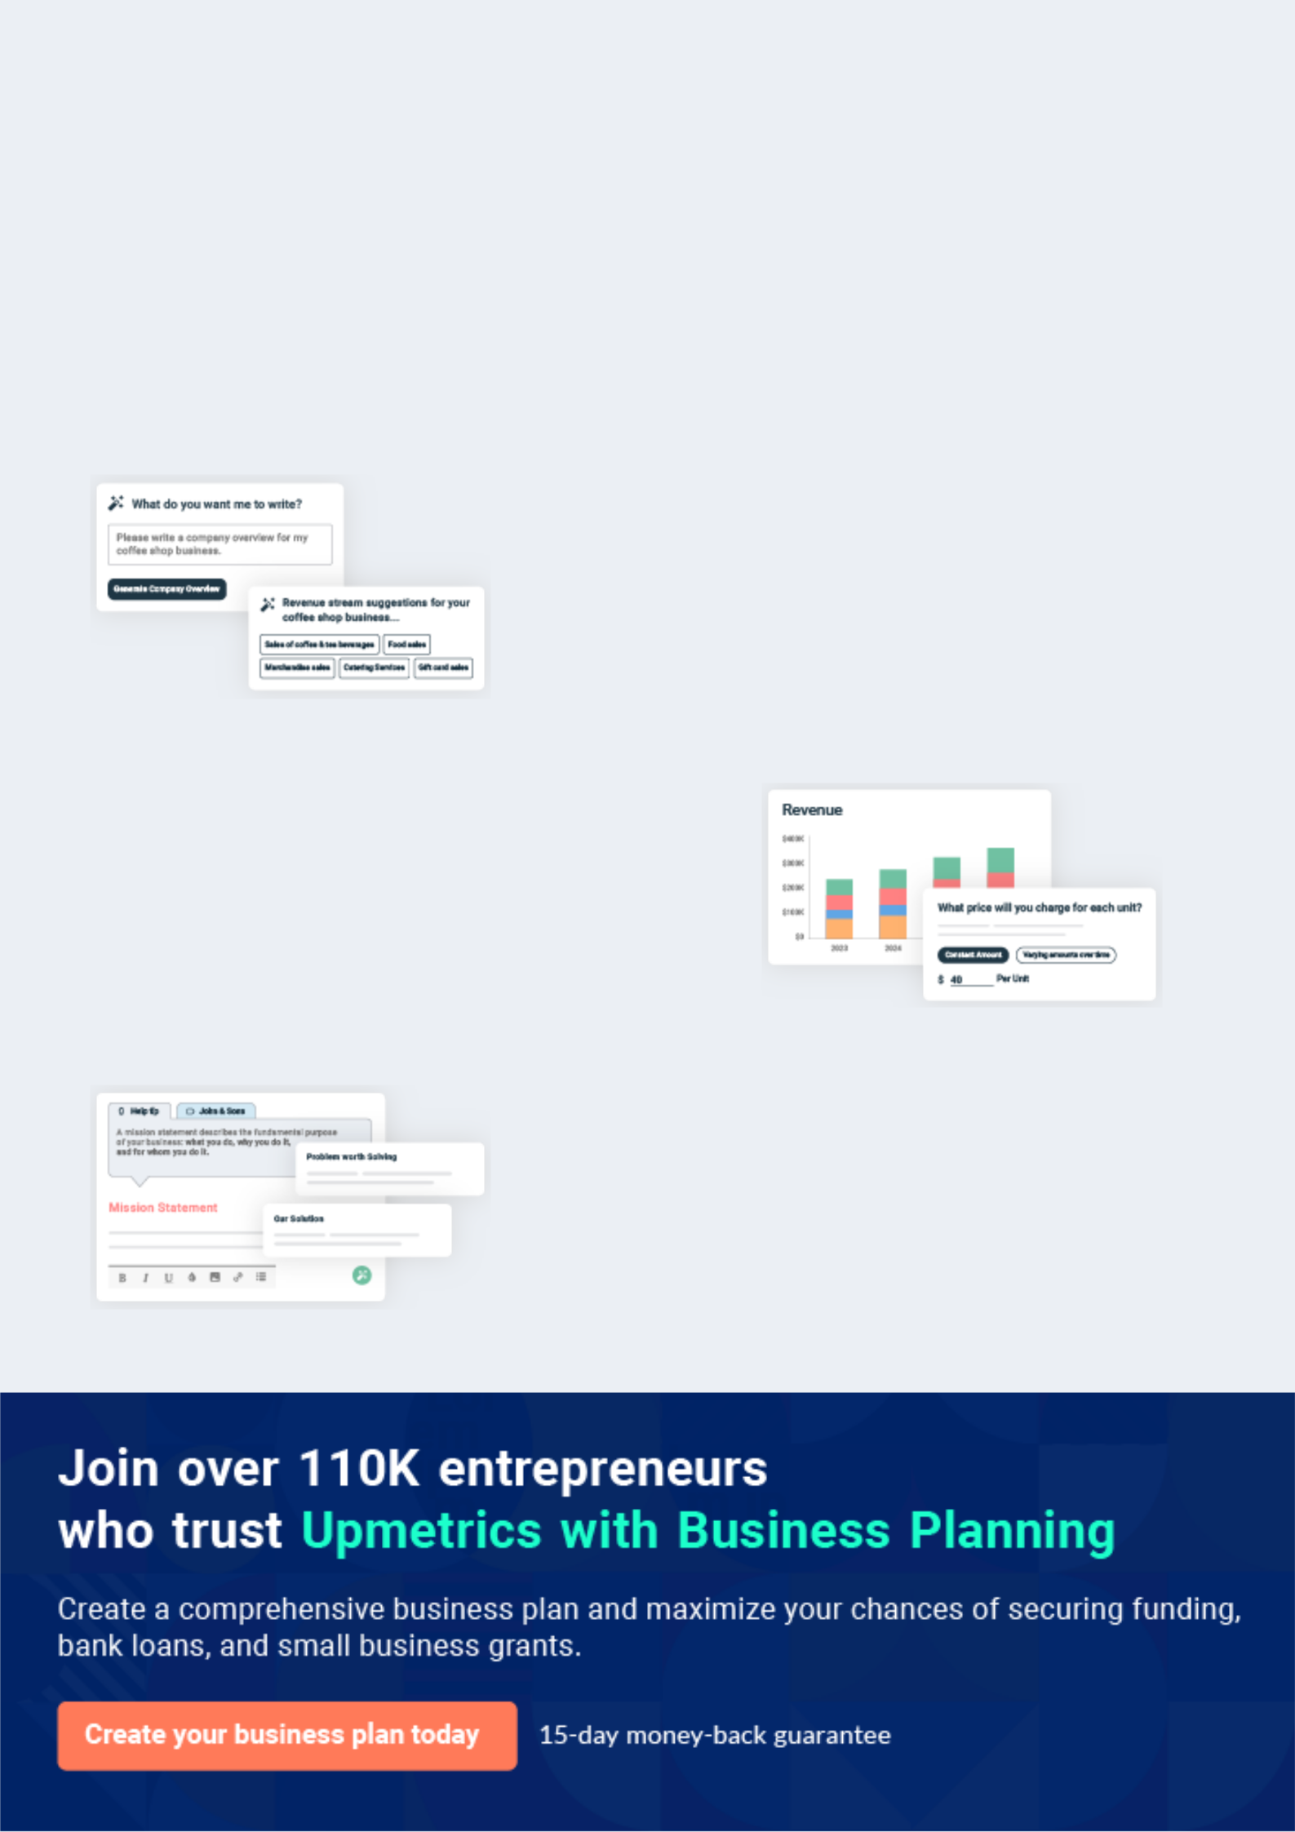
Business planning that’s simpler and faster than you think

Creating a business plan using Upmetrics to start and grow a business is literally the easiest thing in the World. Simply read the instructions and fill in the blanks. It’s as simple as that.

❛ | Upmetrics has everything you need to create a | ❜
❛ | comprehensive business plan. | ❜

AI-powered Upmetrics Assistant

AI-powered insights to streamline your plan

Not sure where to start? Upmetrics’ AI Assistant will automatically generate ideas for each section of your plan and offer improved versions of your writing, adjusting for tone, voice, and grammar or spelling errors.

Financial Forecasting Tool

All the financials are calculated for you

Forget the complex formulas and clumsy spreadsheets — with automatic financials and drag-and-drop forecasting, you can finish your plan faster and be confident that your numbers are accurate.

Business Plan Builder

Guides you like a business mentor

Upmetrics’ step-by-step instructions, prompts, and the library of 400+ sample business plans will guide you through each section of your plan as a business mentor.
Executive Summary
To unlock help try Upmetrics!


An executive summary is the first section of the business plan intended to provide an overview of the whole business plan.
To unlock help try Upmetrics! 

 Help tip  Artist Business Plan


Start your executive summary by introducing your idea behind starting an art business and explaining what it does.
To unlock help try Upmetrics! 

Start writing here..

Market opportunity

 Help tip  Artist Business Plan

Describe the target market in brief, and explain the demographics, geographic location, and psychographic attributes of your customer.
To unlock help try Upmetrics! 

Start writing here..

Services Offered

 Help tip  Artist Business Plan

Describe in detail the products or services you will provide, for example, paintings, sketches, customized services, greeting cards, or something else. Also, incorporate all the details about the raw material you will use keeping quality in your mind.



Start writing here..

 Help tip


Name all the key members of your management team with their duties, responsibilities, and qualifications.
To unlock help try Upmetrics! 

Management team


JOHN DOE

Founder & CEO - john.doe@example.com

A renowned artist with a passion for innovation, John steers the strategic direction of the studio.
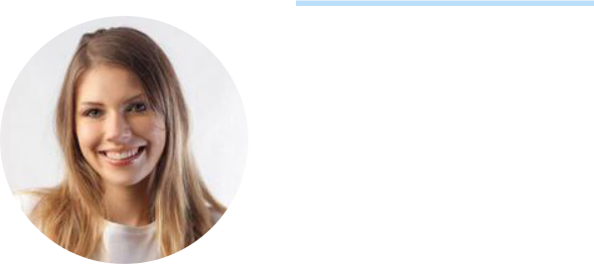

JANE SMITH

Operations Manager - jane.smith@example.com

With her impeccable organizational skills and a background in art curation, Jane ensures smooth day-to-day operations.


ALICE BROWN

Lead Artist - alice.brown@example.com

A maestro in contemporary art, Alice brings her expertise and creative touch to our portfolio.


ROBERT GREEN

Marketing & Outreach - robert.green@example.com

Leveraging his extensive network and expertise, Robert drives the studio's brand and outreach initiatives.

Financial Highlights
To unlock help try Upmetrics!

 Help tip  Artist Business Plan

Provide a summary of your financial projections for the company’s initial years of operation.

Include any capital or investment requirements, startup costs, projected revenues, and profits.
To unlock help try Upmetrics! 

Start writing here..

Units Sold v/s Revenue

 |  | Units Sold | Revenue
15.00k
10.00k
5.00k
0
Year 1 | Year 2 | Year 3


Financial Year |  |  | Units Sold | Revenue
Year 1 | 1,550 |  |  | $10,000
Year 2 | 1,800 |  |  | $12,000
Year 3 | 2,050 |  |  | $14,000
 Help tip |  |  Artist Business Plan


After giving a brief about your business plan, end your summary with a call to action, for example; inviting potential investors or readers to the next meeting if they are interested in your business.



Write a call to action for your business plan.

Company Overview

Depending on what details of your business are essential, you’ll need different elements in your business overview.
To unlock help try Upmetrics! 

 Help tip  Artist Business Plan

Provide all the basic information about your business in this section like:

• The name of your art business and the concept behind it, for example: do you need a
To unlock help try Upmetrics! 

Start writing here..

Ownership

 Help tip  Artist Business Plan

Describe the owners of your business and mention their roles in running it. Whose shares in the firm are they, and how each owner helps in the business?
To unlock help try Upmetrics! 

Start writing here..

Business Owners



70% John Doe



30% Jane Doe
Mission statement
To unlock help try Upmetrics!

 Help tip  Artist Business Plan

Add a mission statement that sums up the objectives and core principles of your art studio.

This statement needs to be memorable, clear, and brief.
To unlock help try Upmetrics! 

❛ To inspire and evoke, to connect hearts and minds through the transcendent power of art, and to cultivate a community where
every brushstroke tells a story.
❜

Business history

 Help tip  Artist Business Plan

Include an outline of the art business’s history and how it came to be in its current position.

If you can, add some personality and intriguing details, especially if you got any achievements
To unlock help try Upmetrics! 

Start writing here..

Future goals

 Help tip  Artist Business Plan

It’s crucial to convey your aspirations and your vision. Include the vision of where you see your business in the near future and if you have any plans of opening an art studio or hosting an art gallery opening.



Start writing here..

Market Analysis
To unlock help try Upmetrics!
To unlock help try Upmetrics!

Market analysis provides a clear understanding of the market in which your printing business will run along with the target market, competitors, and growth opportunities.



 Help tip  Artist Business Plan

To write the introduction section of your market analysis, start by clearly identifying your primary target market.
To unlock help try Upmetrics! 

Start writing here..

Target Market

 Help tip  Artist Business Plan

Identify your target market and define your ideal customer. Know more about your customers and which services they prefer: customized painting, greetings, invitation card, poetries, songs, or anything else.



Start writing here..

Market size and growth potential

 Help tip  Artist Business Plan

Provide an overview of the art industry. It will include market size, trends, growth potential, and regulatory considerations.
To unlock help try Upmetrics! 

Start writing here..

Market Size
To unlock help try Upmetrics!

Available Market

All art enthusiasts in the U.S. seeking art 10M pieces and experiences.

Served Market
Enthusiasts purchasing from 3M established art studios & galleries.

Target Market
Affluent, aged 30-50, seeking 750k personalized & sustainable art.

 Help tip  Artist Business Plan

Identify and analyze all other artists in the local market, including direct and indirect competitors. Evaluate their strengths and weaknesses, and explain how you can offer qualitative services.



Competitive analysis

Artistic Verve Studio

A renowned studio, known for its eclectic mix of traditional and modern artworks.

Features

Large-scale art installations

Artwork leasing for corporate spaces

Digital art workshops and webinars

E-commerce platform for global sales

Strengths

Established brand with a vast portfolio

Strong online presence and digital sales channels.

Comprehensive art workshops targeting diverse age groups.

Weaknesses

Limited customization options, focusing mainly on ready-made art.

Higher price points, making it less accessible to budget-conscious clients.

Less emphasis on sustainable art production.

Modern Muse Creations

Emerging as a leader in the digital art space, they are blending technology with creativity

Features | Strengths | Weaknesses
Digital art commissions. | Pioneers in integrating tech | Limited to digital art; lacks
Online gallery for artists to | solutions in art, like AR and VR. | traditional artwork touch.
showcase and sell their digital | Quick turnaround for digital | Newer in the market, so less
pieces. | commissions | brand recognition compared to
AR (Augmented Reality) art | A growing community platform | established studios.
experiences. | for artists. | Potential tech barriers for less
VR (Virtual Reality) art |  | tech-savvy clients.
workshops

Timeless Brushworks

Specializing in age-old art techniques, they provide a gateway to the past with their creations.

Features

Traditional paintings using ancient techniques.

Art restoration services.

Workshops on historical art forms.

Travelling exhibitions showcasing historical art evolution.

Strengths | Weaknesses
Unique niche focusing on | Limited appeal to younger,
historical art methods. | modern art enthusiasts.
Expertise in art restoration, | Absence of digital integration in
attracting clientele with vintage | their business model.
pieces. | Slower production due to
Educational angle with in-depth | traditional methods.
workshops.

Market trends

 Help tip  Artist Business Plan

Analyze current and emerging trends in your industry, such as changes in customer preferences. Explain how your business will cope with all the trends.
To unlock help try Upmetrics! 

Start writing here..

Regulatory environment

 Help tip  Artist Business Plan

Describe any regulations or licensing requirements that affect your art business, such as safety codes, contracts, taxes, or something else.
To unlock help try Upmetrics! 

Start writing here..
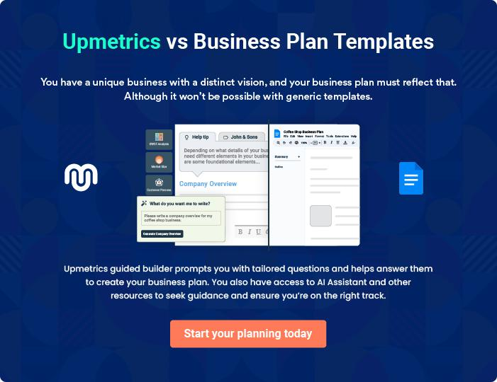
Products and Services
To unlock help try Upmetrics!

The product and services section of an artist business plan should describe the specific services and products that will be offered to customers. To write this section should include the following:



 Help tip  Artist Business Plan

To craft the introduction for your "Products and Services" chapter, begin by positioning your business within its industry, emphasizing its unique strengths or value proposition.
To unlock help try Upmetrics! 

Start writing here..

 Help tip

Introduce the artist first, along with the art form they will be using, such as painting, sculpture, or photography.
To unlock help try Upmetrics! 

Services

Original Works


Price: [$5,000 to $50,000]

These are unique, one-of-a-kind pieces created by John Doe, ranging from vast canvases capturing landscapes to intricate portraits.

Specifications

- John starts with a concept sketch, refining it multiple times. Once finalized, he selects the canvas size and type.

- Layer by layer, the painting comes to life, with drying time between each.

- If it's a sculpture, John chooses the material (marble, wood, etc.) and begins sculpting after the initial sketch.
Limited Edition Prints

Price: Small Prints (e.g., 12" x 16"): [$200 - $300]

Medium Prints (e.g., 24" x 36"): [$400 - $600] Large

Prints (e.g., 48" x 60"): [$700 - $1,000] Frame (Optional):

Additional [$50 - $300], depending on size and material

These are high-quality reproductions of John's masterpieces, ensuring more art enthusiasts can own a piece of his work without compromising on quality.

Specifications

- Using state-of-the-art digital scanners, the original artwork is scanned in high resolution. It's then printed using fine art printers on premium paper or canvas.

- Each print is hand-signed by John, numbered, and accompanied by a certificate of authenticity.

Commissioned Creations

Price: Paintings: Starts at [$7,000 and can go up to $100,000] or more based on complexity, size, and materials Sculptures: Starts at [$10,000 and can go up to $150,000] or more, depending on size, detail, and material chosen

These are bespoke art pieces, created on request, tailored to a client's vision, and specifications

Specifications

- It begins with a detailed consultation with the client to understand their vision. John then sketches preliminary designs. Once approved, the final work commences.

- For paintings, the client can choose the type of canvas, style, and size. For sculptures, material options like bronze, marble, or wood are provided.
Emphasize safety and quality
- To unlock help try Upmetrics!

 Help tip  Artist Business Plan

In all descriptions of services and products, emphasize the importance of quality. Explain how your business will ensure that all services and products are delivered with the highest standards of efficacy.



Start writing here..
Sales And Marketing Strategies

Writing the sales and marketing strategies section means a list of strategies you will use to attract and retain your clients.
To unlock help try Upmetrics! 

 Help tip  Artist Business Plan

To create an effective introduction for your "Sales and Marketing Strategies" chapter, start by setting the stage within your specific industry or market.
To unlock help try Upmetrics! 

Unique Selling Proposition (USP)

 Help tip  Artist Business Plan


Clearly state the artist’s unique selling point, which should cover their taste, aesthetic, and the
advantages of their products and services. Something needs to be said in a way that appeals to
the intended audience.
 |  |  |  | To unlock help try Upmetrics! 
Start writing here..
Pricing Strategy
 Help tip |  |  Artist Business Plan

Develop a pricing strategy that is competitive and affordable, yet profitable. Consider offering promotions, discounts, or packages for your products & services to attract new customers.
To unlock help try Upmetrics! 

Start writing here..

 Help tip  Artist Business Plan
To unlock help try Upmetrics!

Develop a marketing strategy that includes a mix of online and offline marketing tactics. Consider social media, email marketing, content marketing, brochures, print marketing, and events.



Marketing strategies

Online


Social Media

Platforms like Instagram and Pinterest to showcase our pieces, behind-the-scenes processes, and studio events.

Content Marketing

Blog posts and articles exploring the world of art, artist interviews, and art appreciation

Offline

Print Marketing

Elegant brochures, catalogues, and postcards for direct mail and distribution at events.

Email Marketing

Curated newsletters, providing subscribers with exclusive insights, early access to new collections, and special offers.

Events

Hosting and participating in art galas, exhibitions, and workshops].

 Help tip

Mention your sales strategy as – an approach to turn potential buyers into clients by providing limited edition prints, discounts, and referral scheme discounts.
To unlock help try Upmetrics! 

Sales strategies

Limited Edition Prints Personalized Consultations

Offering exclusivity to entice One-on-one sessions with

collectors. interested buyers to discuss

commissioned works.

Referral Schemes

Discounts to patrons who refer

potential buyers.

 Help tip

Describe how your art business will retain customers and build loyalty, such as through loyalty programs, special events, or personalized service.
To unlock help try Upmetrics! 

Customer retention

Loyalty Programs

Earn points with every purchase, redeemable against future buys.

Special Events

Exclusive studio visits, artist meet-and-greets, and early access to new collections for returning customers.

Personalized services

Tailored recommendations, art

care tips, and framing services for

patrons.

Operations Plan
To unlock help try Upmetrics!


 |  | When writing the operations plan section, it’s important to consider the
 |  | various aspects of your business operations.
 |  |  |  | To unlock help try Upmetrics! 
 Help tip |  |  Artist Business Plan


To create an effective introduction for your "Operational Plan" chapter, start by emphasizing the
pivotal role of efficient operations in the success of your business, underscoring how they
directly impact the quality of services delivered.
 |  |  |  | To unlock help try Upmetrics! 
Start writing here..
Operational Process
 Help tip |  |  Artist Business Plan

Explain how you go about creating your art, what tools and materials you need, and how long it takes to finish each piece.
To unlock help try Upmetrics! 

Start writing here..

Inventory Management

 Help tip  Artist Business Plan

Describe your inventory management strategy, including your shipping, tracking, and storage methods. Describe how you’ll maintain track of your artwork and make sure it’s transported and stored correctly.



Start writing here..

Management Team

The management team section provides an overview of the individuals responsible for running your business plan.
To unlock help try Upmetrics! 

 Help tip  Artist Business Plan

To craft an introduction for your "Management Team" chapter, begin by emphasizing the crucial role of leadership in the success of any business.
To unlock help try Upmetrics! 

Start writing here..

Key managers

 Help tip  Artist Business Plan

Introduce the important members of the management team and the artist, the artist manager, booking agent, publicist, accountant, and lawyer.
To unlock help try Upmetrics! 

Start writing here..

JOHN DOE

Founder and Chief Artist - john.doe@example.com

The heart and soul of [Whimsical Canvas Art Studio], John’s artistic journey spans over two decades.

With a Bachelor's in Fine Arts from the prestigious Artistic University and a Master’s in Modern Art Techniques from Creative Institute, John has honed his skills through both formal education and extensive international art residencies.


His style, an eclectic mix of abstract and realism, has garnered acclaim in various exhibitions.
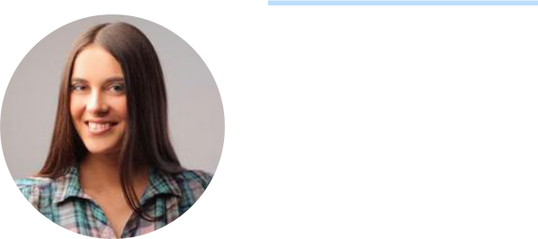
ALICE BROWN

Artist Manager - alice.brown@example.com

With a deep passion for art management, [Alice] has dedicated over a decade to nurturing artists and their creations.

She holds an MBA in Arts Management from Elite Business School and has previously managed renowned artists on global stages, ensuring their work gets the spotlight it deserves.


Her meticulous nature and vast network make her an invaluable asset to the studio.


ROBERT BROWN

Booking Agent - robert.brown@example.com

Robert's forte lies in his extensive network within the art world.

After graduating with a degree in Event Management from Eventful University, Robert swiftly rose through the ranks in renowned art galleries, coordinating exhibitions and art shows.

His knack for spotting the perfect venues for showcasing art ensures Whimsical Canvas Art Studio's masterpieces always find their ideal audience.

JANE SMITH

Publicist - jane.smith@example.com

Jane's experience in curating narratives for brands, especially in the art domain, is unparalleled.

With a Bachelor's in Communication from Media Tech University and a stint with top art galleries handling public relations, Jane crafts compelling stories around John's masterpieces, amplifying their reach and resonance.

CHARLIE GREEN

Accountant - charlie.green@example.com

Charlie's meticulous nature and keen financial acumen are the safeguards of the studio's fiscal health.

An alumnus of Finance First University with a major in Art Business Accounting, Charlie's previous tenure at top art institutions has equipped him with a unique perspective on financial planning tailored for the art business.

DIANE WHITE

Legal Counsel - diane.white@example.com

With a law degree from Legal Masters University and a specialization in Intellectual Property Rights, Diane is adept at navigating the intricate legal landscape of the art world.

Her previous engagements with art houses and individual artists equip her with a deep understanding of contracts, rights, and the nuances of art law.

Organizational structure

 Help tip  Artist Business Plan

Describe the organizational structure of the management team, including reporting lines and how decisions will be made.
To unlock help try Upmetrics! 

Start writing here..
Organization chart
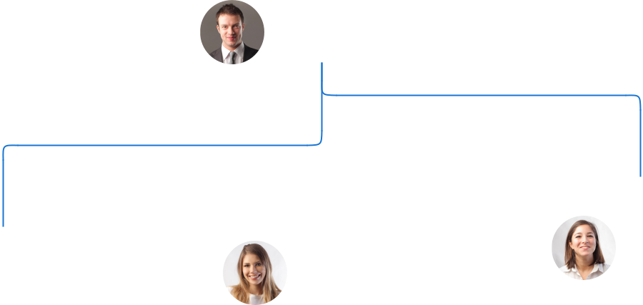

John Doe

CEO and Chief Artist

 |  |  | Jane Smith
Robert Brown | Alice Brown |  | Jane Smith
Robert Brown |  |  | Publicist
Booking Agent | Artist Manager

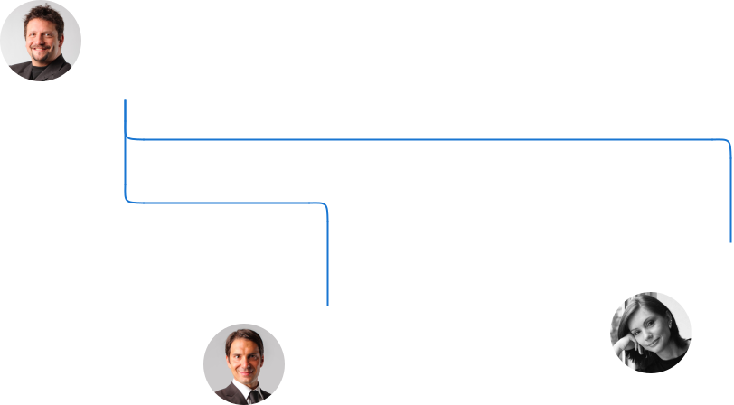

Diane White

Charlie Green Legal Counsel

Accoutant

Compensation plan

 Help tip  Artist Business Plan

Describe your compensation plan for the management team and staff, including salaries, bonuses, and other benefits.
To unlock help try Upmetrics! 

Start writing here..
 Help tip  Artist Business Plan

If you have a board of advisors for your business, then mention them along with their roles and experience.
To unlock help try Upmetrics! 

Board of advisors

LIAM BLACK

Advisor

A veteran in the art industry, Liam provides strategic advice on expanding the studio's reach.

SOPHIA GRAY

Digital Marketer

With her background in digital marketing, Sophia offers insights into online branding and digital engagements for the studio.
Financial Plan

When writing the financial plan section of a business plan, it’s important to provide a comprehensive overview of your financial projections for the first few years of your business, You may provide the following:
To unlock help try Upmetrics! 

 Help tip  Artist Business Plan


To create an effective introduction for your "Financial Plan" chapter, begin by stressing the critical role of a well-structured financial plan in the success of your venture.
To unlock help try Upmetrics! 

Start writing here..

 Help tip


Create a projected profit & loss statement that describes the expected revenue, cost of products sold, and operational costs. Your business’s anticipated net profit or loss should be computed and included.
To unlock help try Upmetrics! 

Profit & loss statement

Revenue

Cost Of Sales

General Costs

Revenue Specific Costs

Personnel Costs (Direct

Labor)

Gross Margin

Gross Margin (%)

Operating Expense

Payroll Expense

(Indirect Labor)

General Expense

Bad Debt

Amortization of Current

Assets

2023-24 | 2024-25 | 2025-26 | 2026-27 | 2027-28
$0 | $0 | $0 | $0 | $0

$0 | $0 | $0 | $0 | $0
$0 | $0 | $0 | $0 | $0
$0 | $0 | $0 | $0 | $0
$0 | $0 | $0 | $0 | $0

$0 | $0 | $0 | $0 | $0
0% | 0% | 0% | 0% | 0%

$0 | $0 | $0 | $0 | $0
$0 | $0 | $0 | $0 | $0
$0 | $0 | $0 | $0 | $0
$0 | $0 | $0 | $0 | $0
$0 | $0 | $0 | $0 | $0

EBITDA

Additional Expense

Long Term

Depreciation

Gain or loss from Sale

of Assets

EBIT

Interest Expenses

EBT

Income Tax Expense

Total Expense

Net Income

Net Income (%)

2023-24 | 2024-25 | 2025-26 | 2026-27 | 2027-28
$0 | $0 | $0 | $0 | $0
$0 | $0 | $0 | $0 | $0
$0 | $0 | $0 | $0 | $0
$0 | $0 | $0 | $0 | $0
$0 | $0 | $0 | $0 | $0
$0 | $0 | $0 | $0 | $0
$0 | $0 | $0 | $0 | $0
$0 | $0 | $0 | $0 | $0
$0 | $0 | $0 | $0 | $0
$0 | $0 | $0 | $0 | $0
0% | 0% | 0% | 0% | 0%
 | 2023-24 | 2024-25 | 2025-26 | 2026-27 | 2027-28
Retained Earning | $0 | $0 | $0 | $0 | $0
Opening
Owner's Distribution | $0 | $0 | $0 | $0 | $0
Retained Earning | $0 | $0 | $0 | $0 | $0
Closing

 Help tip

Estimate your cash inflows and outflows for the first few years of operation. It should include cash receipts from clients, payments to vendors, loan payments, and any other cash inflows and outflows.
To unlock help try Upmetrics! 

Cash flow statement

 | 2023-24 | 2024-25 | 2025-26 | 2026-27 | 2027-28
Cash Received | $0 | $0 | $0 | $0 | $0
Cash Paid | $0 | $0 | $0 | $0 | $0
COS & General Expenses | $0 | $0 | $0 | $0 | $0
Salary & Wages | $0 | $0 | $0 | $0 | $0
Interest | $0 | $0 | $0 | $0 | $0

Sales Tax

Income Tax

Net Cash From

Operations

Assets Sell

Assets Purchase

Net Cash From

Investments

Amount Received

Loan Received

Common Stock

Preferred Stock

Owner's Contribution

Amount Paid

2023-24 | 2024-25 | 2025-26 | 2026-27 | 2027-28
$0 | $0 | $0 | $0 | $0
$0 | $0 | $0 | $0 | $0
$0 | $0 | $0 | $0 | $0

$0 | $0 | $0 | $0 | $0
$0 | $0 | $0 | $0 | $0
$0 | $0 | $0 | $0 | $0

$0 | $0 | $0 | $0 | $0
$0 | $0 | $0 | $0 | $0

$0 | $0 | $0 | $0 | $0
$0 | $0 | $0 | $0 | $0
$0 | $0 | $0 | $0 | $0

Loan Capital $0 $0 $0 $0 $0

 | 2023-24 | 2024-25 | 2025-26 | 2026-27 | 2027-28
Dividends & Distributions | $0 | $0 | $0 | $0 | $0
Net Cash From | $0 | $0 | $0 | $0 | $0
Financing

Summary
Starting Cash | $0 | $0 | $0 | $0 | $0
Cash In | $0 | $0 | $0 | $0 | $0
Cash Out | $0 | $0 | $0 | $0 | $0
Change in Cash | $0 | $0 | $0 | $0 | $0
Ending Cash | $0 | $0 | $0 | $0 | $0

 Help tip

Prepare a projected balance sheet, which shows the artist’s assets, liabilities, and equity.

To unlock help try Upmetrics! 

Balance sheet

 | 2023-24 | 2024-25 | 2025-26 | 2026-27 | 2027-28
Assets | $0 | $0 | $0 | $0 | $0
Current Assets | $0 | $0 | $0 | $0 | $0
Cash | $0 | $0 | $0 | $0 | $0
Accounts Receivable | $0 | $0 | $0 | $0 | $0
Inventory | $0 | $0 | $0 | $0 | $0
Other Current Assets | $0 | $0 | $0 | $0 | $0
Long Term Assets | $0 | $0 | $0 | $0 | $0
Gross Long Term Assets | $0 | $0 | $0 | $0 | $0
Accumulated Depreciation | $0 | $0 | $0 | $0 | $0

Liabilities & Equity | $0 | $0 | $0 | $0 | $0
Liabilities | $0 | $0 | $0 | $0 | $0
Current Liabilities | $0 | $0 | $0 | $0 | $0
Accounts Payable | $0 | $0 | $0 | $0 | $0
Income Tax Payable | $0 | $0 | $0 | $0 | $0
Sales Tax Payable | $0 | $0 | $0 | $0 | $0
Short Term Debt | $0 | $0 | $0 | $0 | $0
 | 2023-24 | 2024-25 | 2025-26 | 2026-27 | 2027-28
Long Term Liabilities | $0 | $0 | $0 | $0 | $0
Long Term Debt | $0 | $0 | $0 | $0 | $0
Equity | $0 | $0 | $0 | $0 | $0
Paid-in Capital | $0 | $0 | $0 | $0 | $0
Common Stock | $0 | $0 | $0 | $0 | $0
Preferred Stock | $0 | $0 | $0 | $0 | $0
Owner's Contribution | $0 | $0 | $0 | $0 | $0
Retained Earnings | $0 | $0 | $0 | $0 | $0

Check | $0 | $0 | $0 | $0 | $0

 Help tip

Determine the point at which your art studio will break even, or generate enough revenue to cover its operating costs. This will help you understand how much revenue you need to generate to make a profit.
To unlock help try Upmetrics! 

Break-even Point

 | 2023-24 | 2024-25 | 2025-26 | 2026-27 | 2027-28
Starting Revenue | $0 | $0 | $0 | $0 | $0
Net Revenue | $0 | $0 | $0 | $0 | $0
Closing Revenue | $0 | $0 | $0 | $0 | $0

Starting Expense | $0 | $0 | $0 | $0 | $0
Net Expense | $0 | $0 | $0 | $0 | $0
Closing Expense | $0 | $0 | $0 | $0 | $0

Is Break Even? | 0 | 0 | 0 | 0 | 0
Break Even Month | 0 | 0 | 0 | 0 | 0
Days Required | 0 | 0 | 0 | 0 | 0
Break Even Revenue | $0 | $0 | $0 | $0 | $0
Break Even Units
Financing needs

 Help tip  Artist Business Plan

Estimate how much financing you will need to start and operate your art business. It should include both short-term and long-term financing needs, such as loans or investment capital.
To unlock help try Upmetrics! 

Start writing here..
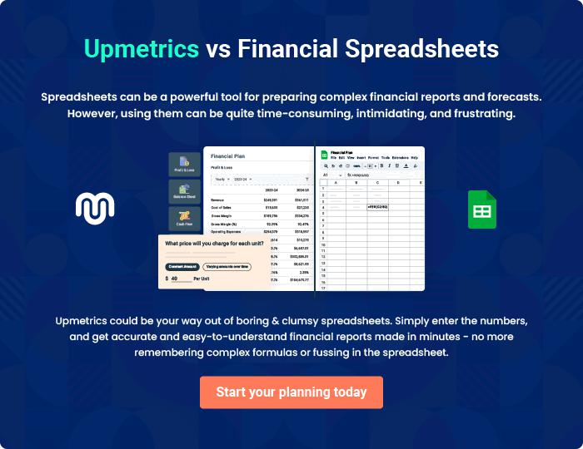
Appendix

When writing the appendix section, you should include any additional information that supports the main content of your plan. This may include financial statements, market research data, legal documents, and other
To unlock help try Upmetrics! 
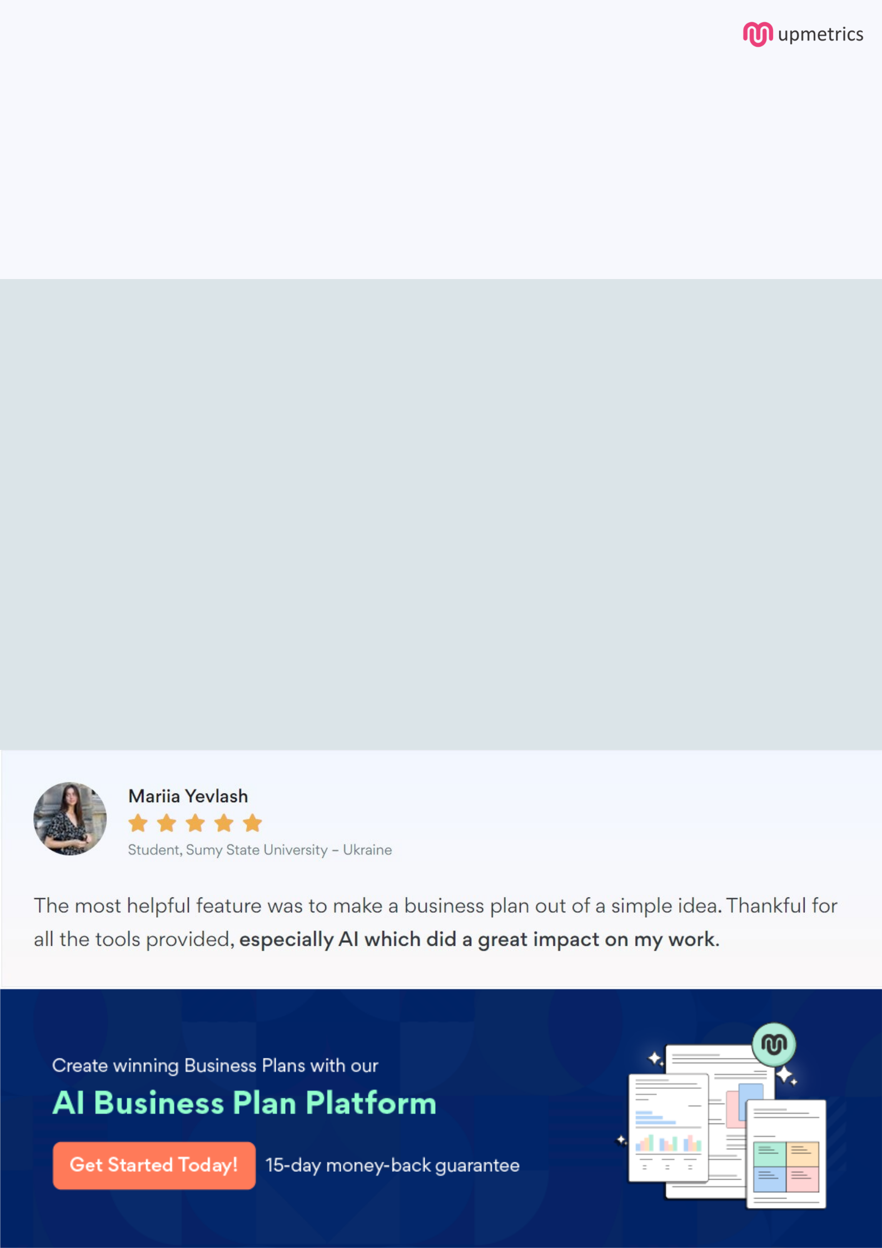
Create a winning business plan that gets you funded

Creating a stunning and investment-ready plan requires no writing, graphic designing, or financial planning expertise.

Upmetrics has all the features required to help you create a comprehensive business plan—from start to finish. Make no mistakes, it’s the modern way of planning to structure ideas, make plans, and create stunning pitch decks to awe investors.

Pitch decks that impress investors

Create pitch decks that provide a visual representation of your business, engage investors, and make them want to invest in your business idea.

Interactive plans in no time

Import business plan sections like—SWOT analysis, comparison tables, and others to create an interactive business plan. No designing skills are required.

Stunning cover page designs

With Upmetrics, you have the liberty to choose from multiple stunning cover page designs. Choose a creative design and make your plan stand out.

Online sharing made simple

Upmetrics makes online sharing quick and easier for users. Easily share your business plans with a link while tracking reader activity.

500+ sample business plans

Simply import a template from our library of sample plans into the editor and start customizing it to make it yours. It takes only a few clicks to get started.

Collaborate with team in real-time

Invite team members, initiate conversations, discuss ideas & strategies, share feedback, and work on a business plan in real-time.

