
Architecture Business Plan

Blueprinting Visions, Building Realities

BUSINESS PLAN

2023

Upmetrics Admin |  | 10200 Bolsa Ave, Westminster, CA, 92683 | (650) 359-3153
info@example.com | http://www.example.com

Information provided in this business plan is unique to this business and confidential; therefore, anyone reading this plan agrees not to disclose any of the information in this business plan without prior written permission of the company.
Table of Contents

Executive Summary | 6
Market opportunity | 6
Services Offered | 6
Marketing & Sales Strategies | 7
Financial Highlights | 7
Units Sold v/s Revenue | 8

Company Overview | 9
Owners | 9
Mission statement | 10
Business history | 10
Future goals | 10

Market Analysis | 11
Target Market | 11
Market size and growth potential | 11
Market Size | 12
Competitive analysis | 12
BluePrint Creations | 12
UrbanScape Architects | 13
NatureNest Design Studios | 13
Market trends | 14
Regulatory environment | 14

Products and Services | 16
Services | 16
Architectural Design | 16
Site Analysis and Planning | 17
Construction Documentation | 17
Interior Design | 19
Sustainable Design and Green Building | 20
Renovation | 20
Urban Design | 21
Quality Measures | 21
Additional Services | 21

Sales And Marketing Strategies | 22
Unique Selling Proposition (USP) | 22
Pricing Strategy | 22
Marketing strategies | 23
Online | 23
Sales strategies | 24
Customer retention | 25

Operations Plan | 26
Staffing & Training | 26
Operational Process | 26
Equipment & Machinery | 27

Management Team | 28
Key managers | 28
John Doe | 28
Jane Doe | 29
Alice Brown | 29
Robert Brown | 30
Organizational structure | 30
Organization chart | 31
Compensation plan | 31
Board of advisors | 32
Dr. Emily White | 32
Mr. David Johnson | 32
Financial Plan
Financial Plan | 33

Profit & loss statement 33

Cash flow statement | 35
Balance sheet | 36
Break-even Point | 38
Financing needs | 39
Appendix
Appendix | 40
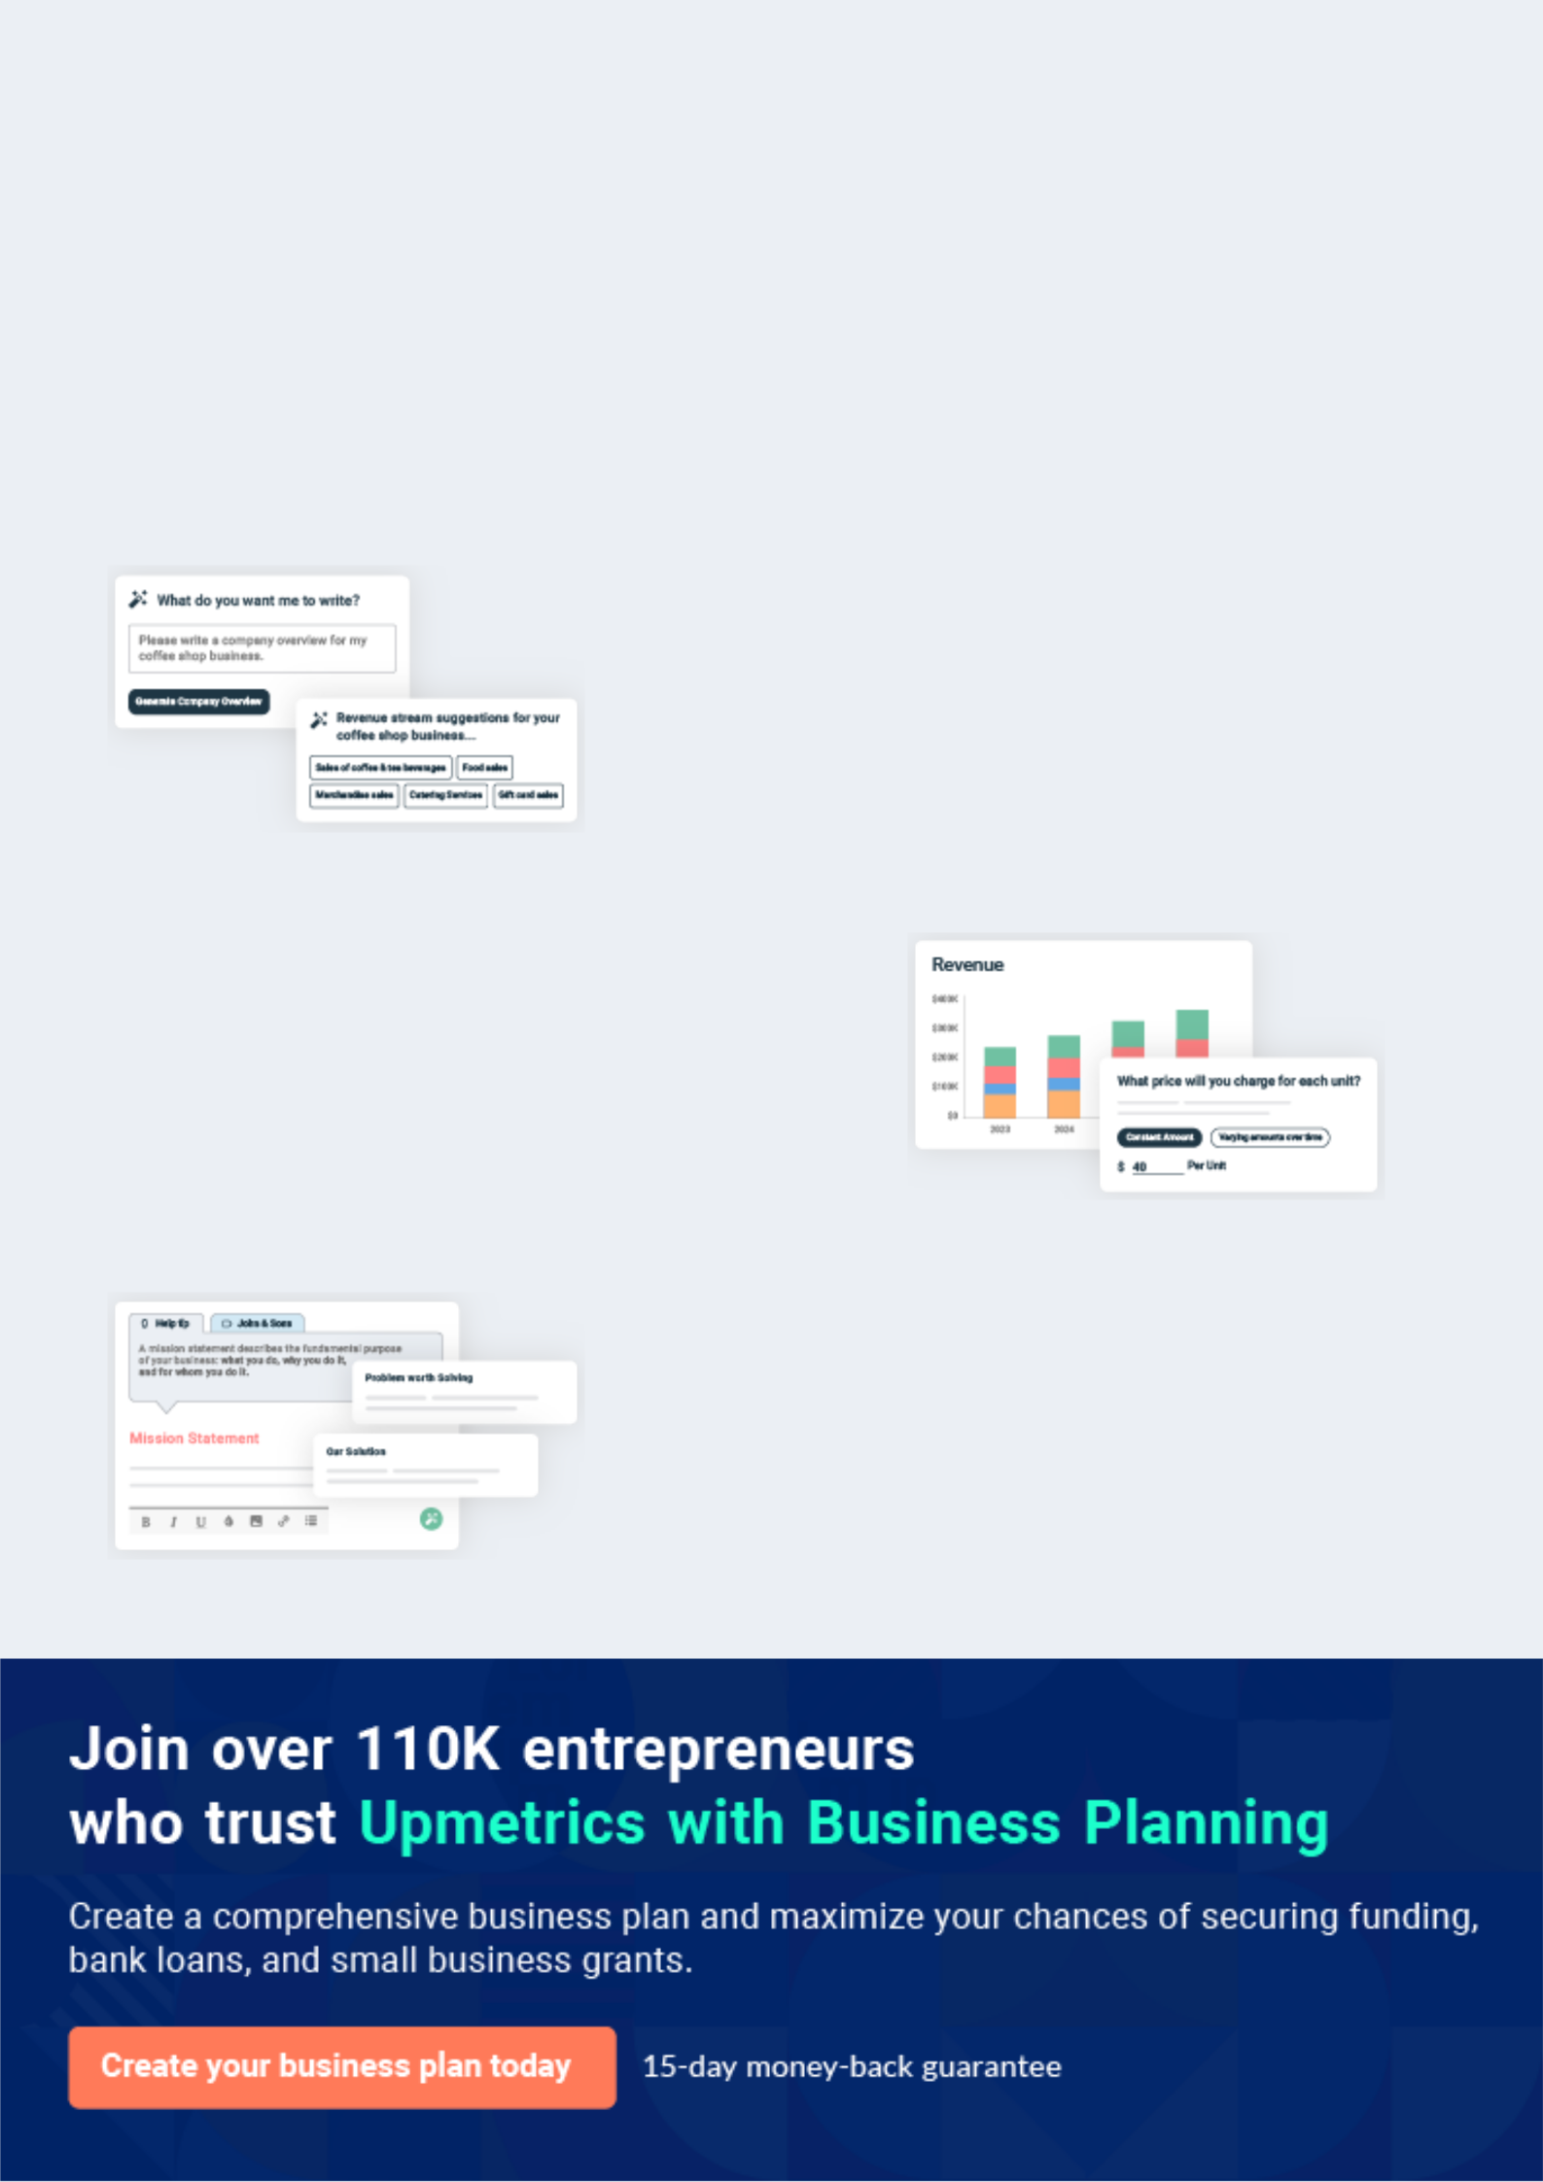
Business planning that’s simpler and faster than you think

Creating a business plan using Upmetrics to start and grow a business is literally the easiest thing in the World. Simply read the instructions and fill in the blanks. It’s as simple as that.

❛ | Upmetrics has everything you need to create a | ❜
❛ | comprehensive business plan. | ❜

AI-powered Upmetrics Assistant

AI-powered insights to streamline your plan

Not sure where to start? Upmetrics’ AI Assistant will automatically generate ideas for each section of your plan and offer improved versions of your writing, adjusting for tone, voice, and grammar or spelling errors.

Financial Forecasting Tool

All the financials are calculated for you

Forget the complex formulas and clumsy spreadsheets — with automatic financials and drag-and-drop forecasting, you can finish your plan faster and be confident that your numbers are accurate.

Business Plan Builder

Guides you like a business mentor

Upmetrics’ step-by-step instructions, prompts, and the library of 400+ sample business plans will guide you through each section of your plan as a business mentor.
Executive Summary


An executive summary is the first section of the business plan intended to provide an overview of the whole business plan.
To unlock help try Upmetrics! 

 Help tip  Architecture Business Plan


Start your executive summary by briefly introducing your business to your readers.

This section may include the name of your architecture business, its location, when it was
To unlock help try Upmetrics! 

Start writing here..

Market opportunity

 Help tip  Architecture Business Plan

Summarize your market research, including market size, growth potential, and marketing trends.
To unlock help try Upmetrics! 

Start writing here..

Services Offered

 Help tip  Architecture Business Plan

Highlight the architecture services you offer your clients. The USPs and differentiators you offer are always a plus.
To unlock help try Upmetrics! 

Start writing here..

Marketing & Sales Strategies

 Help tip  Architecture Business Plan

Outline your sales and marketing strategies—what marketing platforms you use, how you plan on acquiring customers, etc.
To unlock help try Upmetrics! 

Start writing here..

Financial Highlights

 Help tip  Architecture Business Plan

Briefly summarize your financial projections for the initial years of business operations.

Include any capital or investment requirements, associated startup costs, projected revenues,
To unlock help try Upmetrics! 

Start writing here..
Units Sold v/s Revenue

 |  | Units Sold | Revenue
15.00k
10.00k
5.00k
0
Year 1 | Year 2 | Year 3


Financial Year |  |  | Units Sold | Revenue
Year 1 | 1,550 |  |  | $10,000
Year 2 | 1,800 |  |  | $12,000
Year 3 | 2,050 |  |  | $14,000
 Help tip |  |  Architecture Business Plan


Summarize your executive summary section with a clear CTA, for example, inviting angel investors to discuss the potential business investment.
To unlock help try Upmetrics! 

Write a call to action for your business plan.
Company Overview

Depending on what details of your business are essential, you’ll need different elements in your business overview.
To unlock help try Upmetrics! 

 Help tip  Architecture Business Plan

Describe your business in this section by providing all the basic information:

Describe what kind of architecture company you run and the name of it. You may specialize in
To unlock help try Upmetrics! 

Start writing here..

Owners

 Help tip  Architecture Business Plan

List the names of your architecture company’s founders or owners. Describe what shares they own and their responsibilities for efficiently managing the business.
To unlock help try Upmetrics! 

Start writing here..
Mission statement

 Help tip  Architecture Business Plan

Summarize your business’ objective, core principles, and values in your mission statement. This statement needs to be memorable, clear, and brief.
To unlock help try Upmetrics! 

❛ At [Golden Arch Studios], our mission is to create architectural masterpieces that stand the test of time, merging form with function and design with sustainability.

We strive to exceed client expectations, fostering spaces that resonate with their vision while making a positive impact on communities and the environment.

❜

Business history

 Help tip  Architecture Business Plan

If you’re an established architecture service provider, briefly describe your business history, like —when it was founded, how it evolved over time, etc.
To unlock help try Upmetrics! 

Start writing here..

Future goals

 Help tip  Architecture Business Plan

It’s crucial to convey your aspirations and vision. Mention your short-term and long-term goals; they can be specific targets for revenue, market share, or expanding your services.
To unlock help try Upmetrics! 

Start writing here..

Market Analysis
To unlock help try Upmetrics!


 |  | Market analysis provides a clear understanding of the market in which your
 |  | printing business will run along with the target market, competitors, and
 |  | growth opportunities.
 |  |  |  | To unlock help try Upmetrics! 
 Help tip |  |  Architecture Business Plan

To write the introduction section of your market analysis, start by clearly identifying your primary target market.
To unlock help try Upmetrics! 

Start writing here..

Target Market

 Help tip  Architecture Business Plan

Start this section by describing your target market. Define your ideal customer and explain what types of services they prefer. Creating a buyer persona will help you easily define your target market to your readers.



Start writing here..

Market size and growth potential

 Help tip  Architecture Business Plan

Describe your market size and growth potential and whether you will target a niche or a much broader market.
To unlock help try Upmetrics! 

Start writing here..

Market Size

Available Market | 8B
Total annual spend on architectural services in | 8B
the U.S.
Served Market | 3B
Expenditure on specialized architectural | 3B
solutions, including eco-friendly and digital | 3B

design servic

Target Market | 1B
Spending on eco-friendly commercial | 1B
architecture solutions in urban U.S. areas. | 1B

 Help tip  Architecture Business Plan

Identify and analyze your direct and indirect competitors. Identify their strengths and weaknesses, and describe what differentiates your architecture services from them.
To unlock help try Upmetrics! 

Competitive analysis

BluePrint Creations

BluePrint Creations stands out as a premier architecture firm with a focus on residential designs. Through their advanced digital tools, they offer clients an immersive experience, allowing them to visualize their dream homes even before the first brick is laid.

Their commitment to using eco-friendly building materials further accentuates their brand, appealing to a segment of the market that values sustainability.

Features

Strengths Weaknesses

Comprehensive residential design solutions.

Digital visualization tools for clients

Eco-friendly building material sourcing

Strong presence in the residential architecture segment.

Advanced digital tools that provide clients with immersive design experiences.

A commitment to eco-sustainability, attracting eco-conscious clients

Limited experience in commercial and industrial projects

Longer project turnaround times Higher pricing structure.

UrbanScape Architects

UrbanScape Architects have carved out a niche for themselves in the urban commercial sector. Their modular designs enable rapid construction, making them an ideal choice for clients seeking swift project completions.

Their collaborative approach, partnering with top construction firms, ensures seamless execution but also means they rely heavily on these partnerships.

Features | Strengths | Weaknesses
Specialization in commercial | Dominance in the urban | Limited design customization
and urban projects. | commercial project sector. | due to modular emphasis.
Modular design offerings for | Rapid project completion due | Relatively less focus on
rapid construction. | to modular designs. | sustainable design solutions.
Partnerships with leading | Strong industry collaborations | Dependence on partner firms for
construction firms. | ensuring smoother project | project execution.
 | executions.

NatureNest Design Studios

NatureNest Design Studios epitomizes the integration of natural aesthetics into modern architecture. They offer a holistic design approach, catering to both interiors and exteriors with a distinctive emphasis on incorporating natural elements.

Their prowess in landscape architecture sets them apart, though this unique approach may also limit their project scope.

Features | Strengths | Weaknesses
Emphasis on integrating | Unique niche in nature-centric | Limited to projects that demand
natural elements in designs. | designs. | a natural aesthetic.
Landscape architecture and | Broad service range, including | Less experience in large-scale
garden designs. | interiors and landscape | commercial projects.
Holistic designs encompassing | architecture. | Premium pricing might alienate
both interiors and exteriors. | Excellent client feedback and a | budget-conscious clients.
 | strong portfolio.

Market trends
To unlock help try Upmetrics!

 Help tip  Architecture Business Plan

Analyze emerging trends in the industry, such as technology disruptions, changes in customer behavior or preferences, etc. Explain how your business will cope with all the trends.
To unlock help try Upmetrics! 

Start writing here..

Regulatory environment

 Help tip  Architecture Business Plan

List regulations and licensing requirements that may affect your architecture company, such as business registration, insurance, building codes, contractual agreements, intellectual property protection, etc.



Start writing here..
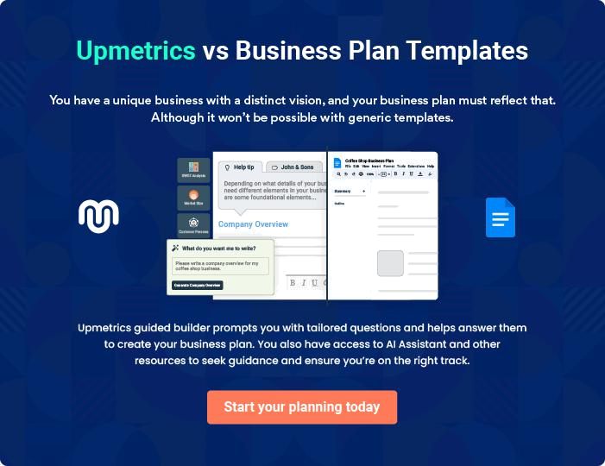
Products and Services
To unlock help try Upmetrics!

The product and services section of an architecture business plan should describe the specific services and products that will be offered to customers. To write this section should include the following:



 Help tip  Architecture Business Plan

To craft the introduction for your "Products and Services" chapter, begin by positioning your business within its industry, emphasizing its unique strengths or value proposition.
To unlock help try Upmetrics! 

Start writing here..

 Help tip


Mention the architecture services your business will offer. This list may include services like,

• Architectural design
To unlock help try Upmetrics! 

Services

Architectural Design


Price: $6,000 - $20,000 (depends on project scale and complexity)

Our architectural design service is the heart of what we offer. We transform client ideas into tangible blueprints.

Process begins with a client consultation to understand their vision, needs, and the project's constraints.

We then create preliminary sketches, followed by detailed drafts, before producing the final architectural blueprint.
Specifications

- Client consultation

- Preliminary sketches

- Detailed drafts & Blueprint creation

- Final design approval

Site Analysis and Planning

Price: $3,500 - $8,000 (varies based on site size and location)

Every architectural project begins with the site. We analyze its topography, soil, climate, surrounding environment, and other crucial factors.

This data helps us create designs that optimize space and integrate seamlessly with the environment.

Specifications

- Site visit and data collection

- Topographical and environmental analysis

- Site opportunity and constraint mapping

- Initial site plan draft

- Client feedback and final planning

Construction Documentation

Price: $4,500 - $12,000 (depends on project intricacy)

After finalizing the design, we create comprehensive documentation essential for the construction phase.

These documents include detailed drawings, specifications, and other pertinent information to guide construction teams, ensuring the design is realized accurately.

Specifications

- Finalized design review

- Creation of detailed construction drawings

- Specification documentation

- Client and contractor walkthrough of documents

- Final documentation set release
Interior Design

Price: $5,000 - $30,000+ (varies based on room count, space size, and level of customization)

We craft interiors that resonate with the building's architecture and the occupants' preferences.

From space planning to selecting materials, finishes, and fixtures, our team curates spaces that are both functional and aesthetically pleasing.

Specifications

Process:

- Client consultation to understand preferences

- Space planning and layout design

- Material, finish, and fixture selection

- 3D visualization of interiors

- Client approval and final design

Time Required: 4-10 weeks, depending on project size and customization.
Sustainable Design and Green Building

Price: $7,000 - $25,000+ (addition to architectural design cost, dependent on green technologies and materials used)

In today's world, sustainability is paramount. We design buildings that reduce environmental impact, incorporating energy-efficient technologies, sustainable materials, and green construction practices.

Specifications

- Client consultation to understand sustainability goals

- Integration of energy-efficient systems (e.g., solar, rainwater harvesting)

- Material sourcing and selection

- Design review and finalization

Renovation

Price: $10,000 - $50,000+ (dependent on renovation scale and challenges)

Revamping existing structures is both an art and science. We meticulously assess the current structure, understanding its strengths and constraints, and then infuse new life into it with our designs.

Specifications

- Site visit and structural assessment

- Client consultation for renovation objectives

- Preliminary design sketches

- Detailed design and client approval
Urban Design

Price: $15,000 - $100,000+ (varies based on area size, community involvement, and scope)

Urban design is about crafting cohesive, sustainable urban spaces.

We focus on designing urban areas, streetscapes, and public spaces to enhance community living and environmental sustainability.

Specifications

- Community consultation and stakeholder meetings

- Site analysis and planning

- Preliminary urban design concepts

- Detailed planning and design

Quality Measures

 Help tip  Architecture Business Plan

This section should explain how you maintain quality standards and consistently provide the highest quality service.
To unlock help try Upmetrics! 

Start writing here..

Additional Services

 Help tip  Architecture Business Plan

Mention if your architecture company offers any additional services. You may include services like master planning, space planning, landscape design, and building performance analysis.
To unlock help try Upmetrics! 

Start writing here..

Sales And Marketing Strategies
To unlock help try Upmetrics!

Writing the sales and marketing strategies section means a list of strategies you will use to attract and retain your clients.
To unlock help try Upmetrics! 

 Help tip  Architecture Business Plan

To create an effective introduction for your "Sales and Marketing Strategies" chapter, start by setting the stage within your specific industry or market.
To unlock help try Upmetrics! 

Unique Selling Proposition (USP)

 Help tip  Architecture Business Plan

Define your business’s USPs depending on the market you serve, the equipment you use, and the unique services you provide. Identifying USPs will help you plan your marketing strategies.
To unlock help try Upmetrics! 

Start writing here..

Pricing Strategy

 Help tip  Architecture Business Plan

Describe your pricing strategy—how you plan to price your services and stay competitive in the local market. You can mention any discounts you plan on offering to attract new customers to your service.



Start writing here..

 Help tip  Architecture Business Plan

Discuss your marketing strategies to market your services.

You may include some of these marketing strategies in your business plan—social media
To unlock help try Upmetrics! 

Marketing strategies

Online


Social Media Marketing

Harnessing platforms like Instagram, LinkedIn, and Pinterest to showcase our projects and engage with a broader audience.

Brochures

Elegant, comprehensive brochures detailing our services and past projects, perfect for distribution at industry events..

Content Marketing

Regular blog posts and articles that establish our thought leadership in the architectural domain.

Google Ads

Utilizing paid search campaigns to increase our visibility for individuals seeking architectural services.

Email Marketing

Regular newsletters and project updates to keep our clientele informed and engaged.

Print Marketing

Leveraging newspapers, magazines, and other print media to reach a diverse audience.

 Help tip
To unlock help try Upmetrics!

Outline the strategies you’ll implement to maximize your sales. Your sales strategies may include offering consultations, fostering referral partnerships, and offering incentives or special promotions.



Sales strategies

Consultations

Offering potential clients free initial consultations, allowing them to gauge our expertise firsthand.

Special Promotions

[Placeholder for promotional offers], designed to incentivize both new project acquisitions and repeat business.

Referral Partnerships

Collaborating with real estate agents, builders, and interior designers to create a referral network.

 Help tip

Describe your customer retention strategies and how you plan to execute them.

For instance, maintaining excellent communication, exceeding client communication, and
To unlock help try Upmetrics! 

Customer retention

Excellent Communication

Ensuring our clients are kept in the loop at every project phase, from conceptualization to completion.

Value-Added Services

Offering services such as post-completion check-ins or free minor modifications within the first year of project completion to enhance client loyalty.

Exceeding Expectations:

Delivering results that not only meet but often exceed client expectations.

.

Operations Plan

 |  | When writing the operations plan section, it’s important to consider the
 |  | various aspects of your business operations.
 |  |  |  | To unlock help try Upmetrics! 
 Help tip |  |  Architecture Business Plan


To create an effective introduction for your "Operational Plan" chapter, start by emphasizing the
pivotal role of efficient operations in the success of your business, underscoring how they
directly impact the quality of services delivered.
 |  |  |  | To unlock help try Upmetrics! 
Start writing here..
Staffing & Training
 Help tip |  |  Architecture Business Plan

Mention your business’s staffing requirements, including the number of employees or
architects needed. Include their qualifications, the training required, and the duties they will
perform.
 |  |  |  | To unlock help try Upmetrics! 
Start writing here..
Operational Process
 Help tip |  |  Architecture Business Plan

Outline the processes and procedures you will use to run your architecture business.

Your operational processes may include project management, client communication, design
To unlock help try Upmetrics! 

Start writing here..

Equipment & Machinery
To unlock help try Upmetrics!

 Help tip  Architecture Business Plan

Include the list of equipment and machinery required for architecture, such as computer hardware and CAD/BIM software, large format printers, presentation equipment, measuring tools, etc.



Start writing here..
Management Team

The management team section provides an overview of the individuals responsible for running your business plan.
To unlock help try Upmetrics! 

 Help tip  Architecture Business Plan

To craft an introduction for your "Management Team" chapter, begin by emphasizing the crucial role of leadership in the success of any business.
To unlock help try Upmetrics! 

Start writing here..

 Help tip

Introduce your management and key members of your team, and explain their roles and responsibilities.
To unlock help try Upmetrics! 

Key managers


JOHN DOE

CEO & Co-founder - john.doe@example.com

John's passion for architecture led to the inception of [Golden Arch Studios].

With a Master's degree in Architecture from [University Name] and over [20] years of industry experience, he oversees the company's strategic direction and business development.


His vision is to merge timeless design with sustainability, ensuring each project stands out while harmonizing with its environment.

JANE DOE

Chief Operating Officer (COO) - jane.smith@example.com

Role: As the Chief Operations Officer, Jane supervises the day-to-day functions of [Golden Arch Studios], ensuring that all projects are executed seamlessly and to the highest standards.


She plays a pivotal role in resource allocation, timeline management, and client coordination.

Educational Background: Jane graduated with a Bachelor's in Architecture from the prestigious [University Name]. She later pursued advanced architectural management courses at [Another University Name], honing her leadership skills and operational proficiency.

Professional Experience: Jane has an illustrious career spanning over [15] years in the architectural realm. She has managed diverse projects, ranging from residential estates to corporate skyscrapers, bringing them to fruition with precision and flair.


ALICE BROWN

Chief Financial Officer (CFO) - alice.brown@example.com

Role: Alice is responsible for steering the financial direction of [Golden Arch Studios].

She handles budgeting, financial forecasting, and exploring investment avenues to ensure the firm's fiscal health and sustainable growth.

Educational Background: Alice earned her Master's in Finance from [University Name]. She furthered her financial acumen with a certification in Architectural Finance from [Another University Name].

Professional Experience: Alice boasts a rich [12]-year career, specializing in financial planning within the architectural sector. Her insights have transformed startups into industry stalwarts, and she brings that transformative vision to [Golden Arch Studios].

ROBERT BROWN

Project Manager - robert.brown@example.com

Role: Robert is the linchpin that holds projects together. He directs project teams, liaises with clients, and manages every facet of the project's timeline, ensuring deliverables are met and clients are satisfied.

Educational Background: Robert completed his Bachelor's in Civil Engineering from [University Name]. He further solidified his project management prowess by becoming a certified Project Management Professional (PMP).

Professional Experience: With over [10] years at the helm of numerous architectural projects, Robert has a keen eye for detail, unmatched organizational skills, and a dedication to perfection that ensures every project under his leadership stands out.

Organizational structure

 Help tip  Architecture Business Plan

Explain the organizational structure of your management team. Include the reporting line and decision-making hierarchy.
To unlock help try Upmetrics! 

Start writing here..
Organization chart


John Doe

CEO


Robert Brown


Jane Doe

Alice Smith

CTO

Ethan White

COO

CFO


CMO

David Black | Lisa Grey
Lead Architect | Lisa Grey
Lead Architect | Financial
 | Analyst

Compensation plan

 Help tip  Architecture Business Plan

Describe your compensation plan for the management and staff. Include their salaries, incentives, and other benefits.
To unlock help try Upmetrics! 

Start writing here..

 Help tip  Architecture Business Plan

Mentioning advisors or consultants in your business plans adds credibility to your business idea.
To unlock help try Upmetrics! 

Board of advisors


DR. EMILY WHITE

Urban Planner

A renowned urban planner with [30] years of experience. She provides invaluable insights into sustainable urban architectural practices.


MR. DAVID JOHNSON

Architectural Historian

An architectural historian, he advises on integrating classical design elements with modern architectural trends.
Financial Plan
To unlock help try Upmetrics!

When writing the financial plan section of a business plan, it’s important to provide a comprehensive overview of your financial projections for the first few years of your business, You may provide the following:
To unlock help try Upmetrics! 

 Help tip  Architecture Business Plan

To create an effective introduction for your "Financial Plan" chapter, begin by stressing the critical role of a well-structured financial plan in the success of your venture.
To unlock help try Upmetrics! 

Start writing here..

 Help tip

Describe details such as projected revenue, operational costs, and service costs in your projected profit and loss statement. Make sure to include your business’s expected net profit or loss.



Profit & loss statement

 | 2023-24 | 2024-25 | 2025-26 | 2026-27 | 2027-28
Revenue | $0 | $0 | $0 | $0 | $0

Cost Of Sales | $0 | $0 | $0 | $0 | $0
General Costs | $0 | $0 | $0 | $0 | $0
Revenue Specific Costs | $0 | $0 | $0 | $0 | $0
Personnel Costs (Direct | $0 | $0 | $0 | $0 | $0
Labor)

Gross Margin $0 $0 $0 $0 $0

Gross Margin (%)

Operating Expense

Payroll Expense

(Indirect Labor)

General Expense

Bad Debt

Amortization of Current Assets

EBITDA

Additional Expense

Long Term

Depreciation

Gain or loss from Sale of Assets

EBIT

Interest Expenses

EBT

Income Tax Expense

Total Expense

Net Income

Net Income (%)

2023-24 | 2024-25 | 2025-26 | 2026-27 | 2027-28
0% | 0% | 0% | 0% | 0%
$0 | $0 | $0 | $0 | $0
$0 | $0 | $0 | $0 | $0
$0 | $0 | $0 | $0 | $0
$0 | $0 | $0 | $0 | $0
$0 | $0 | $0 | $0 | $0
$0 | $0 | $0 | $0 | $0
$0 | $0 | $0 | $0 | $0
$0 | $0 | $0 | $0 | $0
$0 | $0 | $0 | $0 | $0
$0 | $0 | $0 | $0 | $0
$0 | $0 | $0 | $0 | $0
$0 | $0 | $0 | $0 | $0
$0 | $0 | $0 | $0 | $0
$0 | $0 | $0 | $0 | $0
$0 | $0 | $0 | $0 | $0
0% | 0% | 0% | 0% | 0%
To unlock help try Upmetrics!
 | 2023-24 | 2024-25 | 2025-26 | 2026-27 | 2027-28
Retained Earning | $0 | $0 | $0 | $0 | $0
Opening
Owner's Distribution | $0 | $0 | $0 | $0 | $0
Retained Earning | $0 | $0 | $0 | $0 | $0
Closing

 Help tip

The cash flow for the first few years of your operation should be estimated and described in this section. This may include billing invoices, payment receipts, loan payments, and any other cash flow statements.



Cash flow statement

Cash Received

Cash Paid

COS & General Expenses

Salary & Wages

Interest

Sales Tax

Income Tax

Net Cash From

Operations

Assets Sell

Assets Purchase

Net Cash From

Investments

2023-24 | 2024-25 | 2025-26 | 2026-27 | 2027-28
$0 | $0 | $0 | $0 | $0
$0 | $0 | $0 | $0 | $0
$0 | $0 | $0 | $0 | $0
$0 | $0 | $0 | $0 | $0
$0 | $0 | $0 | $0 | $0
$0 | $0 | $0 | $0 | $0
$0 | $0 | $0 | $0 | $0
$0 | $0 | $0 | $0 | $0

$0 | $0 | $0 | $0 | $0
$0 | $0 | $0 | $0 | $0
$0 | $0 | $0 | $0 | $0

 | 2023-24 | 2024-25 | 2025-26 | 2026-27 | 2027-28
Amount Received | $0 | $0 | $0 | $0 | $0
Loan Received | $0 | $0 | $0 | $0 | $0
Common Stock
Preferred Stock | $0 | $0 | $0 | $0 | $0
Owner's Contribution | $0 | $0 | $0 | $0 | $0
Amount Paid | $0 | $0 | $0 | $0 | $0
Loan Capital | $0 | $0 | $0 | $0 | $0
Dividends & Distributions | $0 | $0 | $0 | $0 | $0
Net Cash From | $0 | $0 | $0 | $0 | $0
Financing

Summary
Starting Cash | $0 | $0 | $0 | $0 | $0
Cash In | $0 | $0 | $0 | $0 | $0
Cash Out | $0 | $0 | $0 | $0 | $0
Change in Cash | $0 | $0 | $0 | $0 | $0
Ending Cash | $0 | $0 | $0 | $0 | $0

 Help tip

Create a projected balance sheet documenting your architecture business’s assets, liabilities, and equity.
To unlock help try Upmetrics! 

Balance sheet

 | 2023-24 | 2024-25 | 2025-26 | 2026-27 | 2027-28
Assets | $0 | $0 | $0 | $0 | $0
 | 2023-24 | 2024-25 | 2025-26 | 2026-27 | 2027-28
Current Assets | $0 | $0 | $0 | $0 | $0
Cash | $0 | $0 | $0 | $0 | $0
Accounts Receivable | $0 | $0 | $0 | $0 | $0
Inventory | $0 | $0 | $0 | $0 | $0
Other Current Assets | $0 | $0 | $0 | $0 | $0
Long Term Assets | $0 | $0 | $0 | $0 | $0
Gross Long Term Assets | $0 | $0 | $0 | $0 | $0
Accumulated Depreciation | $0 | $0 | $0 | $0 | $0

Liabilities & Equity | $0 | $0 | $0 | $0 | $0
Liabilities | $0 | $0 | $0 | $0 | $0
Current Liabilities | $0 | $0 | $0 | $0 | $0
Accounts Payable | $0 | $0 | $0 | $0 | $0
Income Tax Payable | $0 | $0 | $0 | $0 | $0
Sales Tax Payable | $0 | $0 | $0 | $0 | $0
Short Term Debt | $0 | $0 | $0 | $0 | $0
Long Term Liabilities | $0 | $0 | $0 | $0 | $0
Long Term Debt | $0 | $0 | $0 | $0 | $0
Equity | $0 | $0 | $0 | $0 | $0
Paid-in Capital | $0 | $0 | $0 | $0 | $0
Common Stock | $0 | $0 | $0 | $0 | $0
Preferred Stock | $0 | $0 | $0 | $0 | $0
Owner's Contribution | $0 | $0 | $0 | $0 | $0
Retained Earnings | $0 | $0 | $0 | $0 | $0
 | 2023-24 | 2024-25 | 2025-26 | 2026-27 | 2027-28
Check | $0 | $0 | $0 | $0 | $0

 Help tip

Determine and mention your business’s break-even point—the point at which your business costs and revenue will be equal.
To unlock help try Upmetrics! 

Break-even Point

 | 2023-24 | 2024-25 | 2025-26 | 2026-27 | 2027-28
Starting Revenue | $0 | $0 | $0 | $0 | $0
Net Revenue | $0 | $0 | $0 | $0 | $0
Closing Revenue | $0 | $0 | $0 | $0 | $0

Starting Expense | $0 | $0 | $0 | $0 | $0
Net Expense | $0 | $0 | $0 | $0 | $0
Closing Expense | $0 | $0 | $0 | $0 | $0

Is Break Even? | 0 | 0 | 0 | 0 | 0
Break Even Month | 0 | 0 | 0 | 0 | 0
Days Required | 0 | 0 | 0 | 0 | 0
Break Even Revenue | $0 | $0 | $0 | $0 | $0
Break Even Units
Financing needs

 Help tip  Architecture Business Plan

Calculate costs associated with starting an architecture business, and estimate your financing needs and how much capital you need to raise to operate your business.
To unlock help try Upmetrics! 

Start writing here..
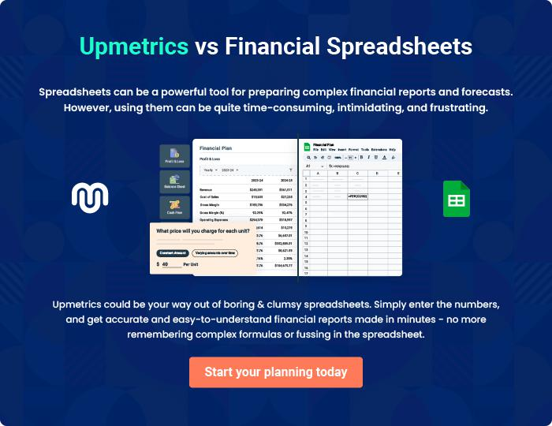
Appendix

When writing the appendix section, you should include any additional information that supports the main content of your plan. This may include financial statements, market research data, legal documents, and other
To unlock help try Upmetrics! 
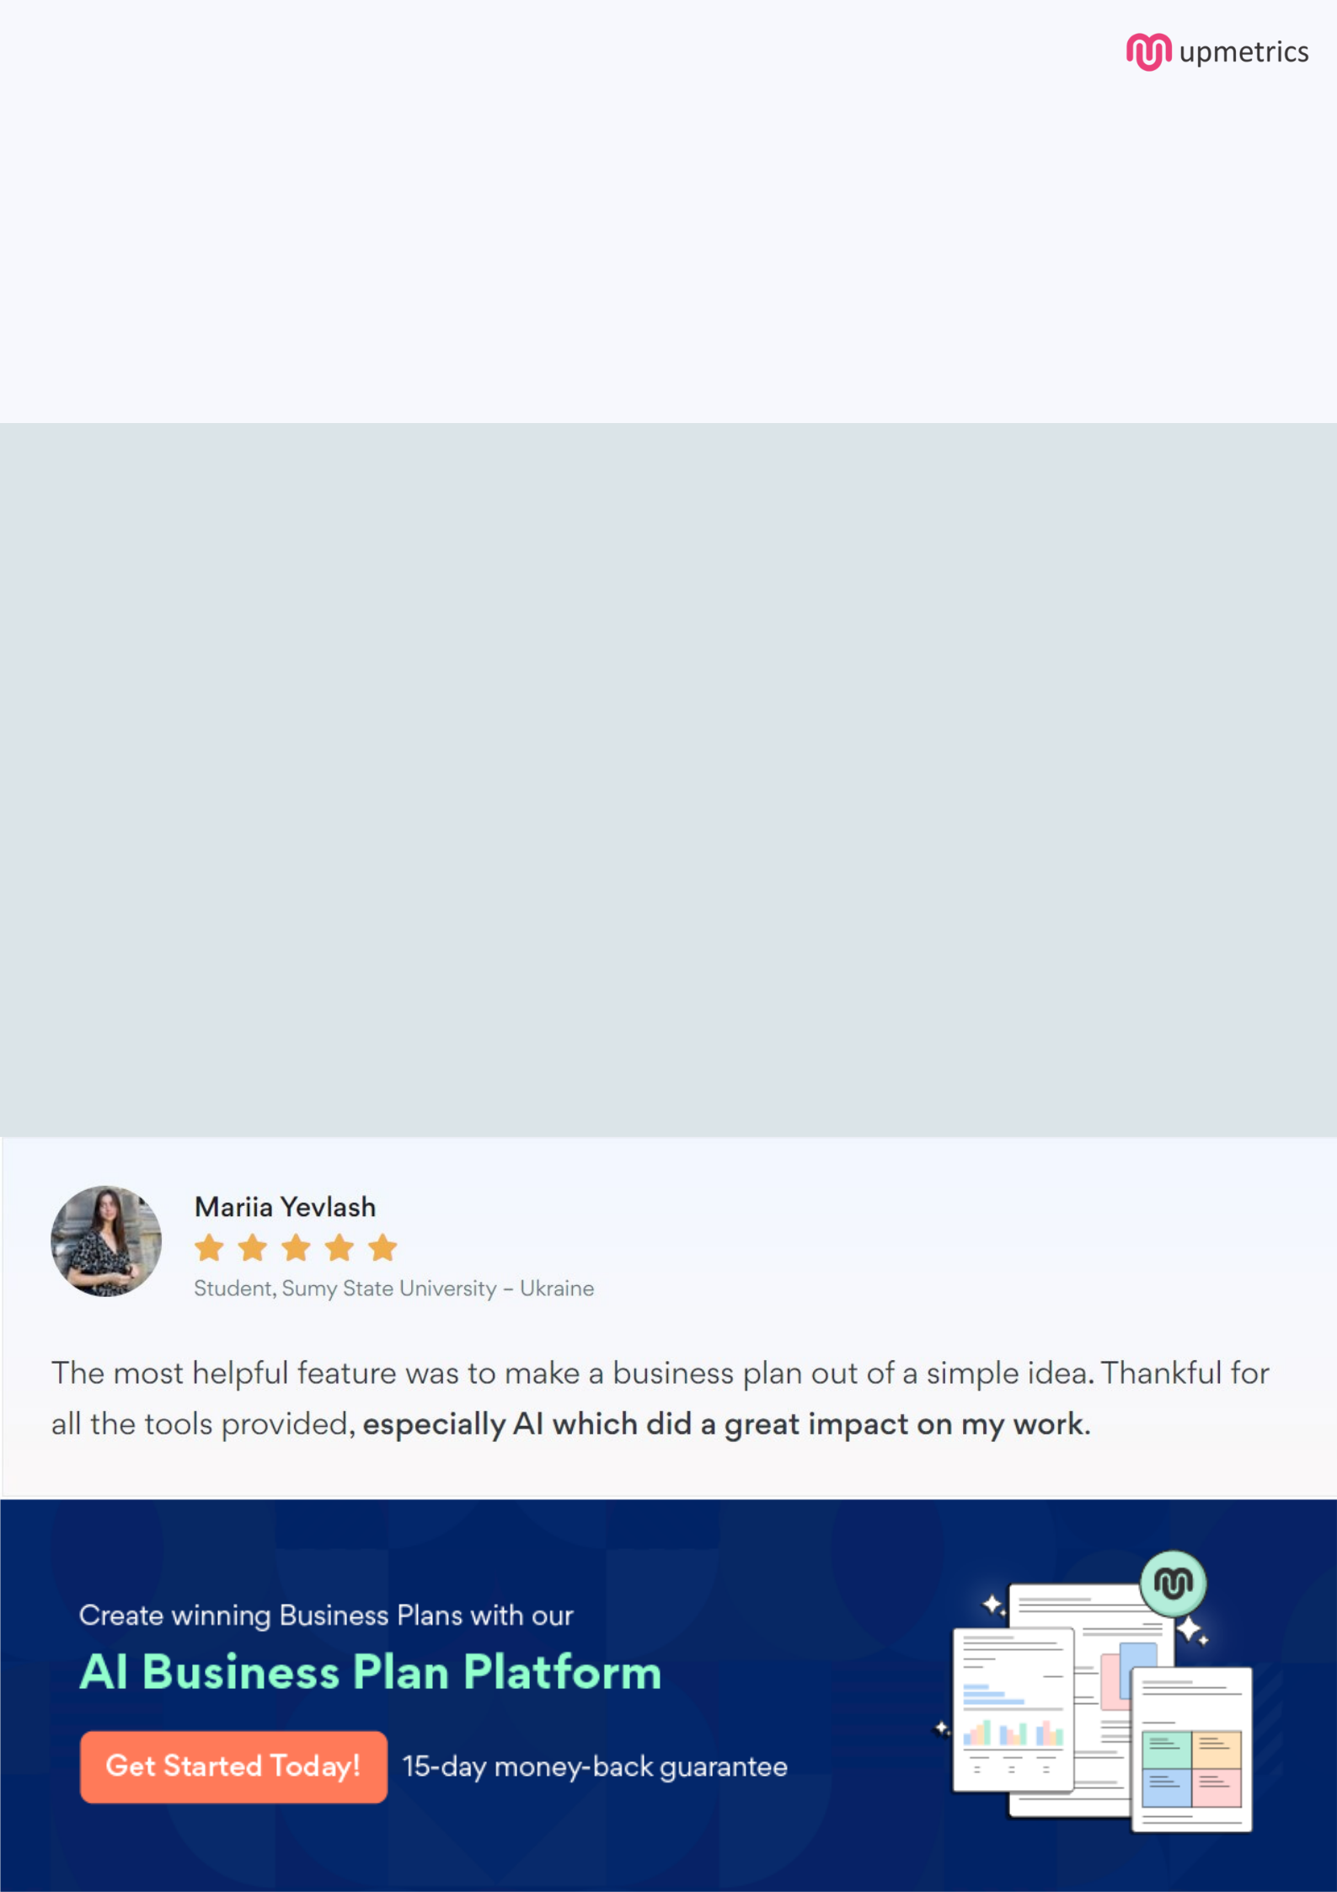
Create a winning business plan that gets you funded

Creating a stunning and investment-ready plan requires no writing, graphic designing, or financial planning expertise.

Upmetrics has all the features required to help you create a comprehensive business plan—from start to finish. Make no mistakes, it’s the modern way of planning to structure ideas, make plans, and create stunning pitch decks to awe investors.

Pitch decks that impress investors

Create pitch decks that provide a visual representation of your business, engage investors, and make them want to invest in your business idea.

Interactive plans in no time

Import business plan sections like—SWOT analysis, comparison tables, and others to create an interactive business plan. No designing skills are required.

Stunning cover page designs

With Upmetrics, you have the liberty to choose from multiple stunning cover page designs. Choose a creative design and make your plan stand out.

Online sharing made simple

Upmetrics makes online sharing quick and easier for users. Easily share your business plans with a link while tracking reader activity.

500+ sample business plans

Simply import a template from our library of sample plans into the editor and start customizing it to make it yours. It takes only a few clicks to get started.

Collaborate with team in real-time

Invite team members, initiate conversations, discuss ideas & strategies, share feedback, and work on a business plan in real-time.

