

Arcade Business Plan

Games, Fun, Memories

Business

Plan

2023

John Doe

10200 Bolsa Ave, Westminster, CA, 92683

- 359-3153 info@example.com http://www.example.com

CONFIDENTIAL

Table of Contents

Executive Summary | 6
Market opportunity | 6
Services Offered | 6
Marketing & Sales Strategies | 7
Financial Highlights | 7
Units Sold v/s Revenue | 8

Company Overview | 9
Ownership | 9
Mission statement | 10
Business history | 10
Future goals | 10

Market Analysis | 11
Target Market | 11
Market size and growth potential | 11
Market Size | 12
Competitive analysis | 12
Game Galaxy | 12
NextGen Playroom | 13
Market trends | 13
Regulatory environment | 13

Products and Services | 15
Services | 15
Virtual Reality Experience | 15
eSports Tournaments | 16
Prize Redemption | 16
Arcade Games Sales and Rental | 17
Hosting Corporate Events | 17
Classic Arcade Games | 18
Modern Arcade Games | 18
Advanced Tech and Graphics Games | 19
Party and Event Rentals | 19
Snack Bar | 20
Arcade games | 20
Quality measures | 20
Additional Services | 21

Sales And Marketing Strategies | 22
Unique Selling Proposition (USP) | 22
Pricing Strategy | 22
Marketing strategies | 23
Online | 23
Offline | 23
Sales strategies | 24
Customer retention | 25

Operations Plan | 26
Staffing & Training | 26
Operational Processes | 26
Equipment | 27

Management Team | 28
Key managers | 28
John Doe | 29
Jane Doe | 29
Alice Brown | 30
Robert Brown | 30
Organizational structure | 31
Organization chart | 31
Compensation plan | 32
Advisors/Consultants | 32

[ADVISOR NAME] 32

Financial Plan | 33
Profit & loss statement | 33
Cash flow statement | 36
Balance sheet | 38
Break-even Analysis | 40
Financing needs | 42
Appendix
Appendix | 44
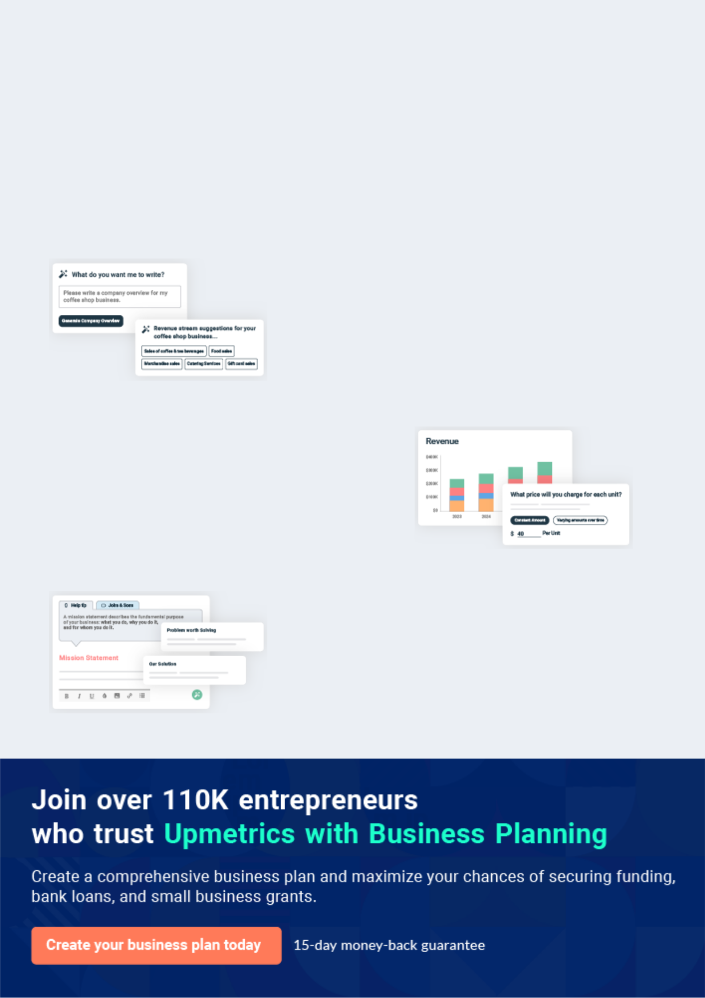
Business planning that’s simpler and faster than you think

Creating a business plan using Upmetrics to start and grow a business is literally the easiest thing in the World. Simply read the instructions and fill in the blanks. It’s as simple as that.

❛ | Upmetrics has everything you need to create a | ❜
❛ | comprehensive business plan. | ❜

AI-powered Upmetrics Assistant

AI-powered insights to streamline your plan

Not sure where to start? Upmetrics’ AI Assistant will automatically generate ideas for each section of your plan and offer improved versions of your writing, adjusting for tone, voice, and grammar or spelling errors.

Financial Forecasting Tool

All the financials are calculated for you

Forget the complex formulas and clumsy spreadsheets — with automatic financials and drag-and-drop forecasting, you can finish your plan faster and be confident that your numbers are accurate.

Business Plan Builder

Guides you like a business mentor

Upmetrics’ step-by-step instructions, prompts, and the library of 400+ sample business plans will guide you through each section of your plan as a business mentor.
Executive Summary


An executive summary is the first section of the business plan intended to provide an overview of the whole business plan.
To unlock help try Upmetrics! 

 Help tip  Arcade Business Plan


Start your executive summary by briefly introducing your business to your readers.

This section may include the name of your arcade business, its location, when it was founded,
To unlock help try Upmetrics! 

Start writing here..

Market opportunity

 Help tip  Arcade Business Plan

Summarize your market research, including market size, growth potential, and marketing trends. Highlight the opportunities in the market and how your business will fit in to fill the gap.
To unlock help try Upmetrics! 

Start writing here..

Services Offered

 Help tip  Arcade Business Plan

Highlight the services your arcade business will offer your clients. The USPs and differentiators you offer are always a plus.
To unlock help try Upmetrics! 

Start writing here..

Marketing & Sales Strategies
To unlock help try Upmetrics!

 Help tip  Arcade Business Plan

Outline your sales and marketing strategies—what marketing platforms you use, how you plan on acquiring customers, etc.
To unlock help try Upmetrics! 

Start writing here..

Financial Highlights

 Help tip  Arcade Business Plan

Briefly summarize your financial projections for the initial years of business operations. Include any capital or investment requirements, associated startup costs, projected revenues, and profit forecasts.



Start writing here..
Units Sold v/s Revenue

 |  | Units Sold | Revenue
15.00k
10.00k
5.00k
0
Year 1 | Year 2 | Year 3


Financial Year |  |  | Units Sold | Revenue
Year 1 | 1,550 |  |  | $10,000
Year 2 | 1,800 |  |  | $12,000
Year 3 | 2,050 |  |  | $14,000
 Help tip |  |  Arcade Business Plan
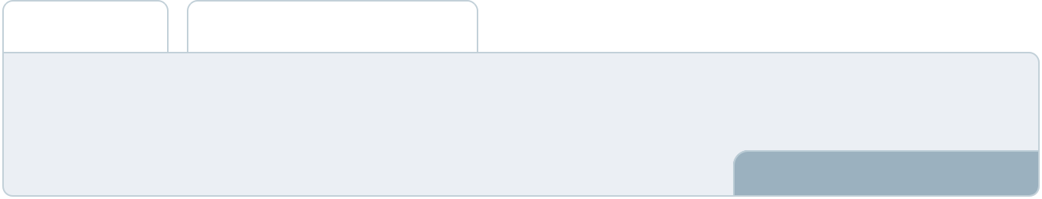

Summarize your executive summary section with a clear CTA, for example, inviting angel investors to discuss the potential business investment.
To unlock help try Upmetrics! 

Write a call to action for your business plan.
Company Overview

Depending on what details of your business are essential, you’ll need different elements in your business overview.
To unlock help try Upmetrics! 

 Help tip  Arcade Business Plan

Describe your business in this section by providing all the basic information:

Describe what kind of arcade business you run and the name of it. Here are some of the
To unlock help try Upmetrics! 

Start writing here..

Ownership

 Help tip  Arcade Business Plan

List the founders of your gaming arcade. Describe what shares they own and their responsibilities for efficiently managing the business.
To unlock help try Upmetrics! 

Start writing here..
Mission statement

 Help tip  Arcade Business Plan

Summarize your business’ objective, core principles, and values in your mission statement. This statement needs to be memorable, clear, and brief.
To unlock help try Upmetrics! 

- At [Victory Vault Arcade], our mission is to provide an unparalleled gaming experience, bridging the gap between nostalgic classics and innovative interactive entertainment.

We are dedicated to creating a vibrant, inclusive community of gamers, fostering a culture of fun, connection, and continuous improvement.

Business history

 Help tip  Arcade Business Plan

❜

If you’re an established gaming service provider, briefly describe your business history, like— when it was founded, how it evolved over time, etc.
To unlock help try Upmetrics! 

Start writing here..

Future goals

 Help tip  Arcade Business Plan

It’s crucial to convey your aspirations and vision. Mention your short-term and long-term goals; they can be specific targets for revenue, market share, or expanding your services.
To unlock help try Upmetrics! 

Start writing here..

Market Analysis
To unlock help try Upmetrics!


 |  | Market analysis provides a clear understanding of the market in which your
 |  | printing business will run along with the target market, competitors, and
 |  | growth opportunities.
 |  |  |  | To unlock help try Upmetrics! 
 Help tip |  |  Arcade Business Plan

To write the introduction section of your market analysis, start by clearly identifying your primary target market.
To unlock help try Upmetrics! 

Start writing here..

Target Market

 Help tip  Arcade Business Plan

Start this section by describing your target market. Define your ideal customer and explain what types of services they prefer. Creating a buyer persona will help you easily define your target market to your readers.



Start writing here..

Market size and growth potential

 Help tip  Arcade Business Plan

Describe your market size and growth potential and whether you will target a niche or a much broader market.
To unlock help try Upmetrics! 

Start writing here..

Market Size

Available Market

Total pool of arcade and gaming 5M enthusiasts in the region.

Served Market
Individuals seeking diverse gaming 2M experiences.

Target Market
Teens and families interested in mixed 500k gaming.

 Help tip  Arcade Business Plan

Identify and analyze your direct and indirect competitors. Identify their strengths and weaknesses, and describe what differentiates your gaming services from them.
To unlock help try Upmetrics! 

Competitive analysis

Game Galaxy

Game Galaxy is a well-established arcade located in the bustling downtown area of [City]. With over a decade in the business, they have created a strong brand presence and have a loyal customer base.

Features | Strengths | Weaknesses
Wide range of classic arcade | Strong brand recognition in the | Limited variety in modern and
games | local community | interactive gaming options
Membership plans with | Extensive collection of retro | Facilities and gaming equipment
benefits like discounts and | games appealing to nostalgic | are somewhat outdated
exclusive access | gamers | Lack of engagement in
Birthday party and event | Strategic location with high | community and eSports events
hosting services | foot traffic
In-house snack bar

NextGen Playroom
To unlock help try Upmetrics!

NextGen Playroom is a modern arcade and gaming lounge that caters to a younger demographic, situated in the [City] shopping mall. They focus on providing the latest in gaming technology and interactive experiences.

Features | Strengths | Weaknesses
Virtual Reality (VR) gaming | Offering cutting-edge gaming | Higher pricing due to advanced
stations | technology | gaming options
Contemporary arcade games | A contemporary and | Less appeal to fans of classic
and consoles | welcoming ambiance | arcade games
Loyalty rewards program | Strong online presence and | Dependent on the shopping
Online reservation system for | social media engagement | mall’s foot traffic for customer
Online reservation system for |  | inflow
gaming stations |  | inflow

Market trends

 Help tip  Arcade Business Plan

Analyse emerging trends in the industry, such as technology disruptions, changes in customer behavior or preferences, etc. Explain how your business will cope with all the trends.
To unlock help try Upmetrics! 

Start writing here..

Regulatory environment

 Help tip  Arcade Business Plan

List regulations and licensing requirements that may affect your arcade business, such as business registration, zoning regulations, employment laws, gaming laws, health and safety regulations, etc.



Start writing here..

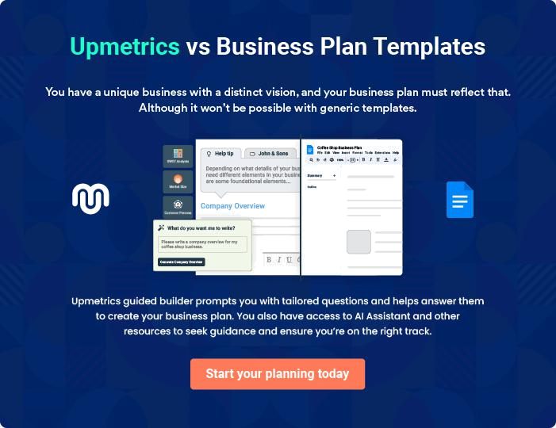
Products and Services

 |  | The product and services section of arcade business plan should describe
 |  | the specific services and products offered to customers. To write this section
 |  | should include the following:
 |  |  |  | To unlock help try Upmetrics! 
 Help tip |  |  Arcade Business Plan

To craft the introduction for your "Products and Services" chapter, begin by positioning your business within its industry, emphasizing its unique strengths or value proposition.
To unlock help try Upmetrics! 

Start writing here..

 Help tip


Mention the arcade services your business will offer. This list may include services like,

• Virtual Reality experience
To unlock help try Upmetrics! 

Services

Virtual Reality Experience


Price: [$20] for 30 minutes

Immerse yourself in an alternate reality with our state-of-the-art VR stations, featuring a wide variety of immersive games and experiences suitable for all ages

Specifications

- High-resolution VR headsets

- Wide selection of games and experiences

- Comfortable, sanitized play area

- Suitable for individuals and groups
eSports Tournaments

Price: Entry Fee [$10] per participant

Compete with the best gamers in town at our thrilling eSports tournaments, showcasing popular games across various genres

Specifications

- High-performance gaming PCs and consoles

- Large projection screens for audience viewing

- Professional grade headsets and peripherals

- Prizes for top finishers

Prize Redemption

Price: Points-based system

Redeem your game winnings at our prize center, featuring an extensive range of toys, gadgets, and exclusive merchandise.

Specifications

- Wide variety of prizes

- Easy-to-use redemption kiosks

- Transparent points system

- Friendly staff assistance
Arcade Games Sales and Rental

Price: Varies based on game title and rental duration

Bring the arcade fun to your space with our game sales and rental services, offering a selection of popular arcade titles for purchase or rent.

Specifications

- Both classic and modern game titles available

- Flexible rental terms

- Delivery and setup services available

- Maintenance support included for rentals

Hosting Corporate Events

Price: Custom packages starting at [$500]

Transform your corporate events with a unique gaming experience, with tailored packages to suit your team’s needs and preferences

Specifications

- Private venue access

- Customizable gaming packages

- Catering and beverage options

- Professional event coordination
Classic Arcade Games

Price: [$1] per play

Relive the golden age of gaming with our collection of classic arcade games, featuring all-time favorites and timeless hits.

Specifications

- Well-maintained vintage cabinets

- Authentic gameplay experience

- Variety of genres and titles

- Easy token-based system

Modern Arcade Games

Price: [$2] per play

Experience the latest in arcade gaming with our modern game selection, boasting impressive graphics, engaging gameplay, and innovative features

Specifications

- Cutting-edge gaming technology

- Diverse game genres

- High-definition displays

- User-friendly interfaces
Advanced Tech and Graphics Games

Price: [$3] per play

Step into the future of arcade gaming with our premium selection of advanced tech games, delivering unparalleled graphics and immersive experiences

Specifications

- State-of-the-art gaming hardware

- Ultra-high-definition graphics

- Immersive sound and visuals

- Wide variety of gameplay styles

Party and Event Rentals

Price: Custom packages starting at [$300]

Host unforgettable parties and events at [Victory Vault Arcade], with tailored packages to cater to all your entertainment needs

Specifications

- Private venue rental

- Access to all arcade games

- Customizable gaming experiences

- Catering and decoration options
Snack Bar

Price: Items starting at [$2]

Satisfy your cravings with a visit to our snack bar, serving a variety of snacks, beverages, and quick bites to keep you energized

Specifications

- Wide selection of snacks and drinks

- Quality ingredients

- Convenient location within the arcade

- Fast and friendly service

Arcade games

 Help tip  Arcade Business Plan

Describe the types of arcade games your facility will offer to game enthusiasts, including classing games, modern games, and games with advanced tech and graphics.
To unlock help try Upmetrics! 

Start writing here..

Quality measures

 Help tip  Arcade Business Plan

This section should explain how you maintain quality standards and consistently provide the highest quality service.
To unlock help try Upmetrics! 

Start writing here..

Additional Services
To unlock help try Upmetrics!

 Help tip  Arcade Business Plan

Mention if your arcade offers any additional services. You may include services like party and event rentals, game sales and rental, serving food and beverages, and if there are any additional services.



Start writing here..
Sales And Marketing Strategies
To unlock help try Upmetrics!

Writing the sales and marketing strategies section means a list of strategies you will use to attract and retain your clients.
To unlock help try Upmetrics! 

 Help Tip  Arcade Business Plan


To create an effective introduction for your "Sales and Marketing Strategies" chapter, start by setting the stage within your specific industry or market.
To unlock help try Upmetrics! 

Start writing here..

Unique Selling Proposition (USP)

 Help tip  Arcade Business Plan

Define your business’s USPs depending on the market you serve, the equipment you use, and the unique services you provide. Identifying USPs will help you plan your marketing strategies.
To unlock help try Upmetrics! 

Start writing here..

Pricing Strategy

 Help tip  Arcade Business Plan

Describe your pricing strategy—how you plan to price your gaming services and stay competitive in the local market. You can mention any discounts you plan on offering to attract new customers to your facility.



Start writing here..

 Help tip  Arcade Business Plan
To unlock help try Upmetrics!

Discuss your marketing strategies to market your services. You may include some of these marketing strategies in your business plan—social media marketing, Google ads, brochures, email marketing, content marketing, and print marketing.



Marketing strategies

Online


Social Media

Utilizing platforms like Facebook, Instagram, and Twitter to engage with our community, promote events, and showcase new games.

Content Marketing

Maintaining an active blog and YouTube channel showcasing game reviews, event highlights, and arcade-related content.

Email Marketing

Sending out regular newsletters to our mailing list with promotions, event announcements, and updates.

Google Ads

Running targeted ads to capture the attention of potential customers searching for arcade-related activities in our area.

Offline

Brochures & Print Marketing

Distributing brochures and posters in local businesses, schools, and community centers.

 Help tip  Arcade Business Plan
To unlock help try Upmetrics!

Outline the strategies you’ll implement to maximize your sales. Your sales strategies may include cross-business promotions, providing group discounts, hosting local gaming events, and providing referral discounts.



Sales strategies

Partner with Businesses

Partnering with local businesses for mutual promotion and discounts.

Group Discounts

Offering discounted rates for large groups and party bookings.

Referral Programs

Implementing a referral program where existing customers can refer friends and receive discounts on their next visit.

Hosting Gaming Events

Organizing regular gaming tournaments and events to attract competitive and casual gamers alike.

 Help tip  Arcade Business Plan

Describe your customer retention strategies and how you plan to execute them. For instance, introducing loyalty programs, discounts on annual membership, personalized service, etc.
To unlock help try Upmetrics! 

Customer retention

Loyalty Programs

Annual Membership Discounts

Implementing a loyalty program where customers can earn points for every visit and redeem them for discounts or free play.

Offering discounted annual memberships for frequent visitors.

Personalized Service

Feedback and Improvement

Training our staff to provide personalized recommendations and assistance, ensuring every customer feels valued.

Actively seeking customer feedback and making improvements based on their suggestions.

Operations Plan
To unlock help try Upmetrics!

 |  | When writing the operations plan section, it’s important to consider the
 |  | various aspects of your business operations.
 |  |  |  | To unlock help try Upmetrics! 
 Help tip |  |  Arcade Business Plan
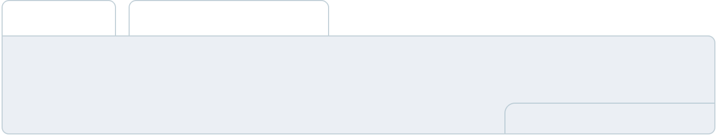

To create an effective introduction for your "Operational Plan" chapter, start by emphasizing the
pivotal role of efficient operations in the success of your business, underscoring how they
directly impact the quality of services delivered.
 |  |  |  | To unlock help try Upmetrics! 
Start writing here..
Staffing & Training
 Help tip |  |  Arcade Business Plan

Mention your arcade business’s staffing requirements, including the number of employees, game technicians, or support staff needed. Include their qualifications, the training required, and the duties they will perform.



Start writing here..

Operational Processes

 Help tip  Arcade Business Plan

Include the processes and procedures you will use to run your arcade business. Your operational processes may include game maintenance, cash management, inventory management, cleaning and maintenance, customer service, marketing, and sales.
To unlock help try Upmetrics! 

Start writing here..

Equipment
To unlock help try Upmetrics!

 Help tip  Arcade Business Plan

Include the list of equipment and machinery required for the arcade, such as arcade games, cash registers, ticket dispensers, security cameras, maintenance tools, game tokens or cards, and other equipment.



Start writing here..
Management Team

The management team section provides an overview of the individuals responsible for running your business plan.
To unlock help try Upmetrics! 

 Help tip  Arcade Business Plan

To craft an introduction for your "Management Team" chapter, begin by emphasizing the crucial role of leadership in the success of any business.
To unlock help try Upmetrics! 

Start writing here..

Key managers

 Help tip  Arcade Business Plan

Introduce your management and key team members, and explain their roles and responsibilities.
To unlock help try Upmetrics! 

Start writing here..

JOHN DOE

CEO & Co-founder - john.doe@example.com

As the Founder and CEO of [Victory Vault Arcade], [John Doe] plays a pivotal role in strategic planning, business development, and overall company leadership.


With a passion for gaming and sharp business acumen, [he/she] is committed to establishing [Victory Vault Arcade] as a premier destination for gaming enthusiasts.

[His/Her] responsibilities also include overseeing marketing strategies, financial planning, and maintaining strong relationships with suppliers and stakeholders.

- Education: [Degree] in [Field], [University]

- Professional Background: [X] years of experience in the gaming industry, with prior roles in [Previous Job Roles].

- Relevant Experience: A lifelong gamer with a knack for business, [John Doe] has successfully led previous ventures in the entertainment sector, demonstrating exceptional leadership and a deep understanding of the gaming industry.


JANE DOE

Arcade Manager - jane.doe@example.com

As the Arcade Manager, Jane Doe is instrumental in overseeing the daily operations at [Victory Vault Arcade].

She ensures that all games are in peak condition, the staff is well-trained, and customers leave with a memorable gaming experience.


- Educational Background: Bachelor's Degree in Business Administration from the University of Example.

- Professional Background: Jane has over seven years of experience managing entertainment venues, with a particular focus on arcades and gaming centers.

She has a proven track record of increasing customer satisfaction, streamlining operations, and boosting overall revenue.

ALICE BROWN

Game Technician Manager - alice.brown@example.com

Alice is responsible for maintaining and repairing all gaming equipment at [Victory Vault Arcade], ensuring everything runs smoothly and minimizing downtime.

She leads a team of skilled technicians to achieve these goals efficiently.

- Educational Background: Associate Degree in Electronics from Tech Example College.

- Professional Background: With over eight years of experience in game maintenance and electronics repair, Alice has developed a keen eye for detail and a deep understanding of arcade game mechanics.

Her expertise is crucial for maintaining the high standard of gaming experiences at [Victory Vault Arcade].


ROBERT BROWN

Marketing Manager - robert.brown@example.com

Robert is at the helm of all marketing and promotional activities for [Victory Vault Arcade].

He creates and implements innovative marketing strategies to boost brand awareness and attract more gamers to the arcade.

- Educational Background: Bachelor's Degree in Marketing from Example State University.

- Professional Background: With a decade of experience in marketing, particularly in the entertainment and gaming industries, Robert has a flair for creating campaigns that resonate with our target audience.

He has significantly contributed to increasing the arcade's visibility and customer base.
Organizational structure

 Help tip  Arcade Business Plan

Explain the organizational structure of your management team. Include the reporting line and decision-making hierarchy.
To unlock help try Upmetrics! 

Start writing here..

Organization chart


Sarah

Johnson

Social Media Manager

Robert Brown



Marketing Manager



Emily White

Event Manager

John Doe

CEO
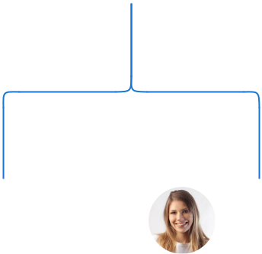

Jane Doe

Arcade

Manager




Alice Brown Michael Smith

Game Technician Customer Service

Coordinator Manager

Compensation plan

 Help tip  Arcade Business Plan

Describe your compensation plan for the management and staff. Include their salaries, incentives, and other benefits.
To unlock help try Upmetrics! 

Start writing here..

 Help tip

Mentioning advisors or consultants in your business plans adds credibility to your business idea.
To unlock help try Upmetrics! 

Advisors/Consultants


[ADVISOR NAME]

Business Strategy Consultant

Providing strategic advice, and industry insights, and helping in decision-making processes.

- years of experience in business consultancy, with a focus on the gaming and entertainment industry.
Financial Plan

When writing the financial plan section of a business plan, it’s important to provide a comprehensive overview of your financial projections for the first few years of your business, You may provide the following:
To unlock help try Upmetrics! 

 Help tip  Arcade Business Plan


To create an effective introduction for your "Financial Plan" chapter, begin by stressing the critical role of a well-structured financial plan in the success of your venture.
To unlock help try Upmetrics! 

Start writing here..

 Help tip  Arcade Business Plan

Describe your projected revenue, operational, and service costs in your projected profit and loss statement. Make sure to include your business’s expected net profit or loss.
To unlock help try Upmetrics! 

Profit & loss statement

Revenue

Cost Of Sales

General Costs

Revenue Specific Costs

Personnel Costs (Direct

Labor)

Gross Margin

Gross Margin (%)

Operating Expense

Payroll Expense

(Indirect Labor)

General Expense

Bad Debt

Amortization of Current

Assets

2023-24 | 2024-25 | 2025-26 | 2026-27 | 2027-28
$0 | $0 | $0 | $0 | $0

$0 | $0 | $0 | $0 | $0
$0 | $0 | $0 | $0 | $0
$0 | $0 | $0 | $0 | $0
$0 | $0 | $0 | $0 | $0

$0 | $0 | $0 | $0 | $0
0% | 0% | 0% | 0% | 0%

$0 | $0 | $0 | $0 | $0
$0 | $0 | $0 | $0 | $0
$0 | $0 | $0 | $0 | $0
$0 | $0 | $0 | $0 | $0
$0 | $0 | $0 | $0 | $0

EBITDA

Additional Expense

Long Term

Depreciation

Gain or loss from Sale

of Assets

EBIT

Interest Expenses

EBT

Income Tax Expense

Total Expense

Net Income

Net Income (%)

2023-24 | 2024-25 | 2025-26 | 2026-27 | 2027-28
$0 | $0 | $0 | $0 | $0
$0 | $0 | $0 | $0 | $0
$0 | $0 | $0 | $0 | $0
$0 | $0 | $0 | $0 | $0
$0 | $0 | $0 | $0 | $0
$0 | $0 | $0 | $0 | $0
$0 | $0 | $0 | $0 | $0
$0 | $0 | $0 | $0 | $0
$0 | $0 | $0 | $0 | $0
$0 | $0 | $0 | $0 | $0
0% | 0% | 0% | 0% | 0%

 |  |  | 2023-24 |  | 2024-25 | 2025-26
Retained Earning |  |  | $0 |  | $0 | $0
Opening |  |  |  |  | $0 | $0
Owner's Distribution |  |  | $0 |  | $0 | $0
Retained Earning |  |  | $0 |  | $0 | $0
Closing |  |  |  |  | $0 | $0
 Help tip |  |  |  Arcade Business Plan
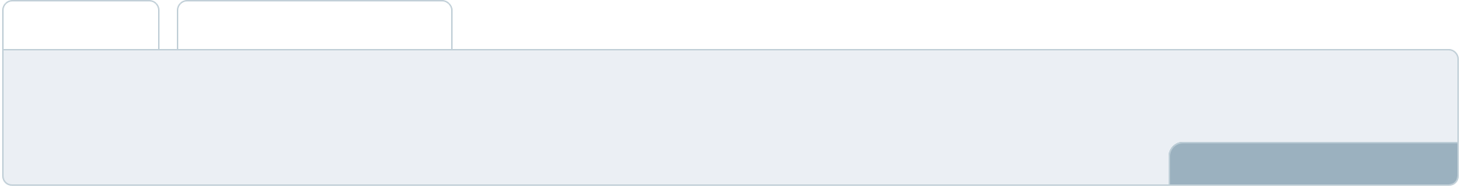

This section should estimate and describe the cash flow for the first few years of your operation.

This may include billing invoices, payment receipts, loan payments, and any other cash flow statements.
2026-27 2027-28

$0 $0

$0 $0

$0 $0

To unlock help try Upmetrics! 

Cash flow statement

 | 2023-24 | 2024-25 | 2025-26 | 2026-27 | 2027-28
Cash Received | $0 | $0 | $0 | $0 | $0
Cash Paid | $0 | $0 | $0 | $0 | $0
COS & General Expenses | $0 | $0 | $0 | $0 | $0
Salary & Wages | $0 | $0 | $0 | $0 | $0
Interest | $0 | $0 | $0 | $0 | $0

Sales Tax

Income Tax

Net Cash From

Operations

Assets Sell

Assets Purchase

Net Cash From

Investments

Amount Received

Loan Received

Common Stock

Preferred Stock

Owner's Contribution

Amount Paid

2023-24 | 2024-25 | 2025-26 | 2026-27 | 2027-28
$0 | $0 | $0 | $0 | $0
$0 | $0 | $0 | $0 | $0
$0 | $0 | $0 | $0 | $0

$0 | $0 | $0 | $0 | $0
$0 | $0 | $0 | $0 | $0
$0 | $0 | $0 | $0 | $0

$0 | $0 | $0 | $0 | $0
$0 | $0 | $0 | $0 | $0

$0 | $0 | $0 | $0 | $0
$0 | $0 | $0 | $0 | $0
$0 | $0 | $0 | $0 | $0

Loan Capital $0 $0 $0 $0 $0

 |  |  | 2023-24 | 2024-25 | 2025-26 | 2026-27 | 2027-28
Dividends & Distributions |  |  | $0 | $0 | $0 | $0 | $0
Net Cash From |  |  | $0 | $0 | $0 | $0 | $0
Financing
Summary
Starting Cash |  |  | $0 | $0 | $0 | $0 | $0
Cash In |  |  | $0 | $0 | $0 | $0 | $0
Cash Out |  |  | $0 | $0 | $0 | $0 | $0
Change in Cash |  |  | $0 | $0 | $0 | $0 | $0
Ending Cash |  |  | $0 | $0 | $0 | $0 | $0
 Help tip |  |  Arcade Business Plan

Create a projected balance sheet documenting your arcade business’s assets, liabilities, and equity.

To unlock help try Upmetrics! 

Balance sheet

 | 2023-24 | 2024-25 | 2025-26 | 2026-27 | 2027-28
Assets | $0 | $0 | $0 | $0 | $0
Current Assets | $0 | $0 | $0 | $0 | $0
Cash | $0 | $0 | $0 | $0 | $0
Accounts Receivable | $0 | $0 | $0 | $0 | $0
Inventory | $0 | $0 | $0 | $0 | $0
Other Current Assets | $0 | $0 | $0 | $0 | $0
Long Term Assets | $0 | $0 | $0 | $0 | $0
Gross Long Term Assets | $0 | $0 | $0 | $0 | $0
Accumulated Depreciation | $0 | $0 | $0 | $0 | $0

Liabilities & Equity | $0 | $0 | $0 | $0 | $0
Liabilities | $0 | $0 | $0 | $0 | $0
Current Liabilities | $0 | $0 | $0 | $0 | $0
Accounts Payable | $0 | $0 | $0 | $0 | $0
Income Tax Payable | $0 | $0 | $0 | $0 | $0
Sales Tax Payable | $0 | $0 | $0 | $0 | $0
Short Term Debt | $0 | $0 | $0 | $0 | $0
 | 2023-24 | 2024-25 | 2025-26 | 2026-27 | 2027-28
Long Term Liabilities | $0 | $0 | $0 | $0 | $0
Long Term Debt | $0 | $0 | $0 | $0 | $0
Equity | $0 | $0 | $0 | $0 | $0
Paid-in Capital | $0 | $0 | $0 | $0 | $0
Common Stock | $0 | $0 | $0 | $0 | $0
Preferred Stock | $0 | $0 | $0 | $0 | $0
Owner's Contribution | $0 | $0 | $0 | $0 | $0
Retained Earnings | $0 | $0 | $0 | $0 | $0

Check | $0 |  |  | $0 | $0 | $0 | $0
 Help tip |  |  Arcade Business Plan

Determine and mention your business’s break-even point—the point at which your business costs and revenue will be equal.

This exercise will help you understand how much revenue you need to generate to sustain or be profitable.
To unlock help try Upmetrics! 

Break-even Analysis

 | 2023-24 | 2024-25 | 2025-26 | 2026-27 | 2027-28
Starting Revenue | $0 | $0 | $0 | $0 | $0
Net Revenue | $0 | $0 | $0 | $0 | $0
Closing Revenue | $0 | $0 | $0 | $0 | $0

Starting Expense | $0 | $0 | $0 | $0 | $0
Net Expense | $0 | $0 | $0 | $0 | $0
Closing Expense | $0 | $0 | $0 | $0 | $0

Is Break Even? | 0 | 0 | 0 | 0 | 0
Break Even Month | 0 | 0 | 0 | 0 | 0
Days Required | 0 | 0 | 0 | 0 | 0
Break Even Revenue | $0 | $0 | $0 | $0 | $0
Break Even Units
Financing needs

 Help tip  Arcade Business Plan

Calculate costs associated with starting an arcade business, and estimate your financing needs and how much capital you need to raise to operate your business.
To unlock help try Upmetrics! 

Start writing here..
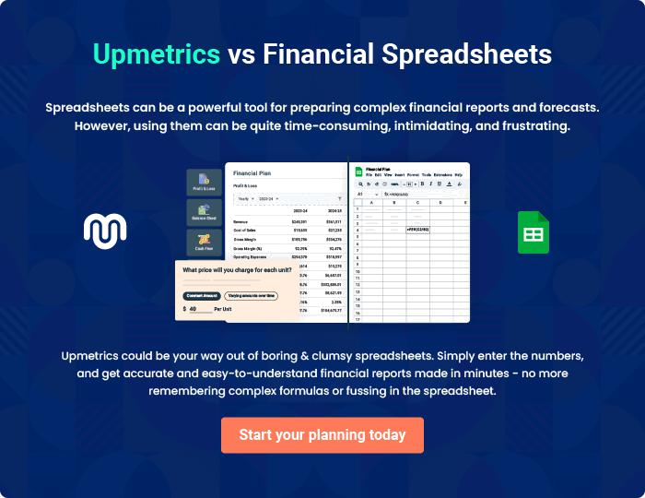
Appendix

When writing the appendix section, you should include any additional information that supports the main content of your plan. This may include financial statements, market research data, legal documents, and other
To unlock help try Upmetrics! 
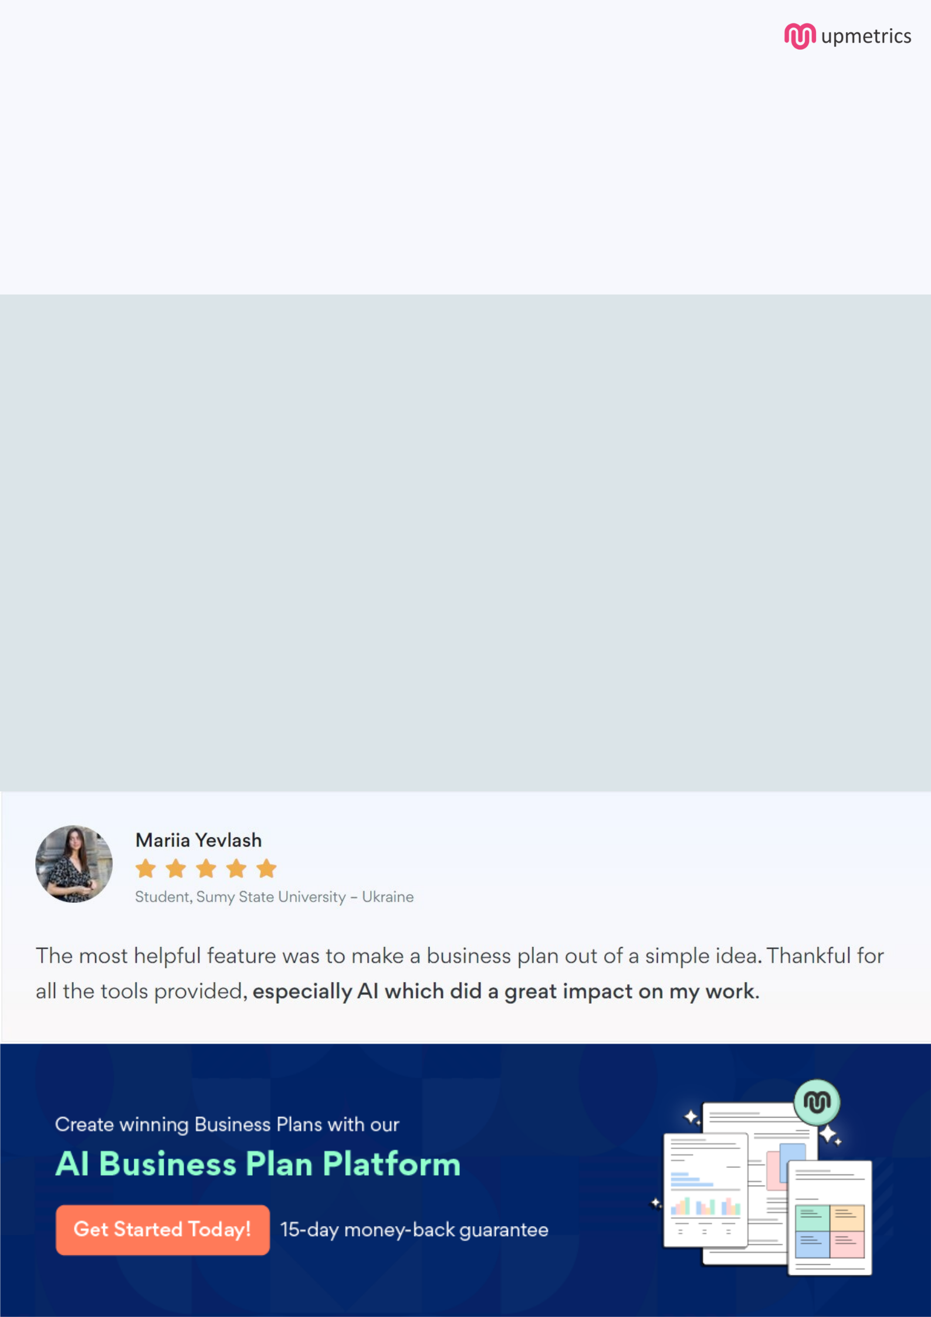
Create a winning business plan that gets you funded

Creating a stunning and investment-ready plan requires no writing, graphic designing, or financial planning expertise.

Upmetrics has all the features required to help you create a comprehensive business plan—from start to finish. Make no mistakes, it’s the modern way of planning to structure ideas, make plans, and create stunning pitch decks to awe investors.

Pitch decks that impress investors

Create pitch decks that provide a visual representation of your business, engage investors, and make them want to invest in your business idea.

Interactive plans in no time

Import business plan sections like—SWOT analysis, comparison tables, and others to create an interactive business plan. No designing skills are required.

Stunning cover page designs

With Upmetrics, you have the liberty to choose from multiple stunning cover page designs. Choose a creative design and make your plan stand out.

Online sharing made simple

Upmetrics makes online sharing quick and easier for users. Easily share your business plans with a link while tracking reader activity.

500+ sample business plans

Simply import a template from our library of sample plans into the editor and start customizing it to make it yours. It takes only a few clicks to get started.

Collaborate with team in real-time

Invite team members, initiate conversations, discuss ideas & strategies, share feedback, and work on a business plan in real-time.

