
Amusement Park Business Plan

Thrills, Laughter, Memories

BUSINESS PLAN

2023

John Doe | 10200 Bolsa Ave, Westminster, CA, 92683 | (650) 359-3153 | info@example.com
http://www.example.com

Information provided in this business plan is unique to this business and confidential; therefore, anyone reading this plan agrees not to disclose any of the information in this business plan without prior written permission of the company.
Table of Contents

Executive Summary | 6
Market opportunity | 6
Services Offered | 6
Marketing & Sales Strategies | 7
Financial Highlights | 7
Units Sold v/s Revenue | 8

Company Overview | 9
Ownership | 9
Business Owners | 9
Mission statement | 10
Business history | 10
Future goals | 10

Market Analysis | 11
Target Market | 11
Market size and growth potential | 11
Market Size | 12
Competitive analysis | 12
AdventureLand | 12
TechnoWorld | 13
AquaRealm | 13
Market trends | 13
Regulatory environment | 14

Products and Services | 15
Main Attractions | 15
Roller Coaster Thrills | 15
Family Carousel | 17
Water Ride Adventures | 17
Kiddie Land | 18
VIP Passes | 18
Emphasize safety and quality | 18
Additional Facilities | 19

Sales And Marketing Strategies | 20
Unique Selling Proposition (USP) | 20
Pricing Strategy | 20
Marketing strategies | 21
Strategies | 21
Sales strategies | 22
Customer retention | 22

Operations Plan | 23
Staffing & Training | 23
Operational Process | 23
Equipment & Machinery | 24

Management Team | 25
Key managers | 25
John Doe | 25
Jane Smith | 26
Alice Johnson | 26
Robert Lee | 27
Sophia Martinez | 27
Organizational structure | 27
Organization chart | 28
Compensation plan | 28
Board of advisors | 29
Dr. Mark Stewart | 29
Ms. Lucy Reynolds | 29
Financial Plan
Financial Plan | 30

Profit & loss statement 30

Cash flow statement | 32
Balance sheet | 33
Break-even Point | 35
Financing needs | 36
Appendix
Appendix | 37
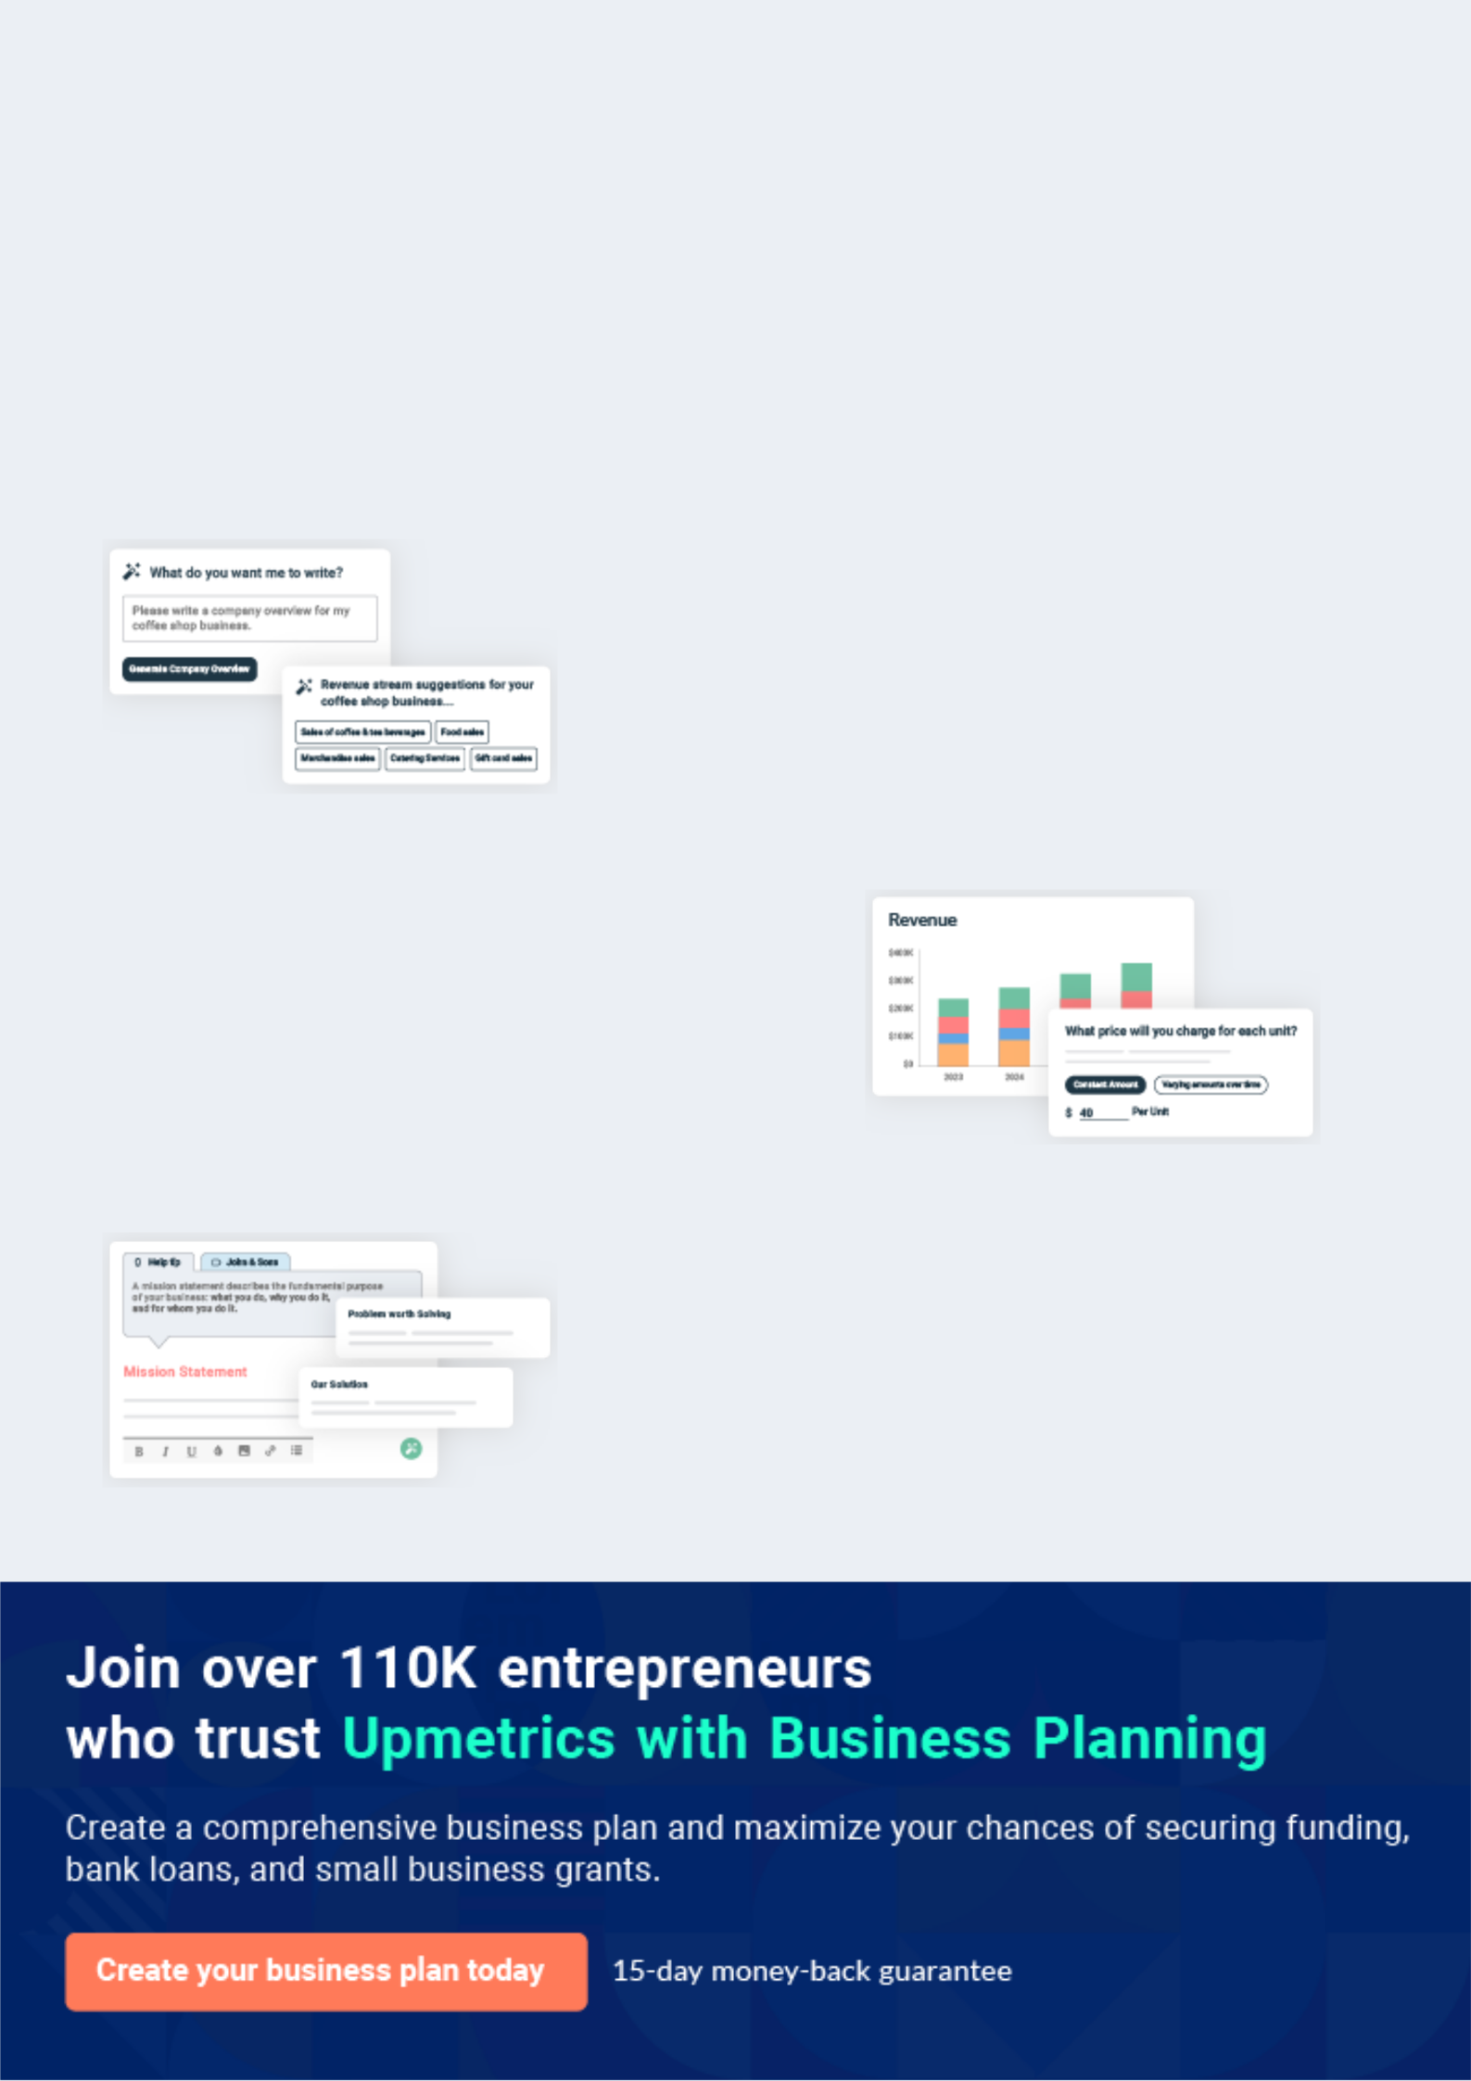
Business planning that’s simpler and faster than you think

Creating a business plan using Upmetrics to start and grow a business is literally the easiest thing in the World. Simply read the instructions and fill in the blanks. It’s as simple as that.

❛ | Upmetrics has everything you need to create a | ❜
❛ | comprehensive business plan. | ❜

AI-powered Upmetrics Assistant

AI-powered insights to streamline your plan

Not sure where to start? Upmetrics’ AI Assistant will automatically generate ideas for each section of your plan and offer improved versions of your writing, adjusting for tone, voice, and grammar or spelling errors.

Financial Forecasting Tool

All the financials are calculated for you

Forget the complex formulas and clumsy spreadsheets — with automatic financials and drag-and-drop forecasting, you can finish your plan faster and be confident that your numbers are accurate.

Business Plan Builder

Guides you like a business mentor

Upmetrics’ step-by-step instructions, prompts, and the library of 400+ sample business plans will guide you through each section of your plan as a business mentor.
Executive Summary


An executive summary is the first section of the business plan intended to provide an overview of the whole business plan.
To unlock help try Upmetrics! 

 Help tip  Amusement Park Business Plan


Start your executive summary by briefly introducing your business to your readers.

This section may include the name of your amusement park business, its location, when it was
To unlock help try Upmetrics! 

Start writing here..

Market opportunity

 Help tip  Amusement Park Business Plan

Summarize your market research, including market size, growth potential, and marketing trends.
To unlock help try Upmetrics! 

Start writing here..

Services Offered

 Help tip  Amusement Park Business Plan

Highlight the amusement park facilities or attractions you offer your clients. The USPs and differentiators you offer are always a plus.
To unlock help try Upmetrics! 

Start writing here..

Marketing & Sales Strategies

 Help tip  Amusement Park Business Plan

Outline your sales and marketing strategies—what marketing platforms you use, how you plan on acquiring customers, etc.
To unlock help try Upmetrics! 

Start writing here..

Financial Highlights

 Help tip  Amusement Park Business Plan

Briefly summarize your financial projections for the initial years of business operations.

Include any capital or investment requirements, associated startup costs, projected revenues,
To unlock help try Upmetrics! 

Start writing here..
Units Sold v/s Revenue

 |  | Units Sold | Revenue
15.00k
10.00k
5.00k
0
Year 1 | Year 2 | Year 3
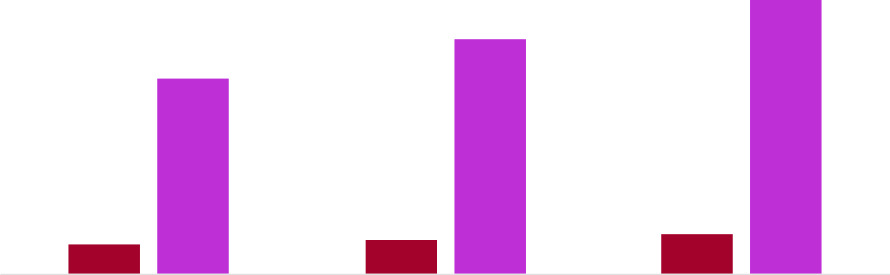

Financial Year |  |  | Units Sold | Revenue
Year 1 | 1,550 |  |  | $10,000
Year 2 | 1,800 |  |  | $12,000
Year 3 | 2,050 |  |  | $14,000
 Help tip |  |  Amusement Park Business Plan


Summarize your executive summary section with a clear CTA, for example, inviting angel investors to discuss the potential business investment.
To unlock help try Upmetrics! 

Write a call to action for your business plan.
Company Overview

Depending on what details of your business are essential, you’ll need different elements in your business overview.
To unlock help try Upmetrics! 

 Help tip  Amusement Park Business Plan

Describe your business in this section by providing all the basic information:

Describe what kind of amusement park you run and the name of it. You may specialize in one
To unlock help try Upmetrics! 

Start writing here..

Ownership

 Help tip  Amusement Park Business Plan

List the names of your amusement park’s founders or owners. Describe what shares they own and their responsibilities for efficiently managing the business.
To unlock help try Upmetrics! 

Start writing here..

Business Owners



40% John Doe



40% Jane Smith



20% Alice Johnson

Mission statement

 Help tip  Amusement Park Business Plan

Summarize your business’ objective, core principles, and values in your mission statement. This statement needs to be memorable, clear, and brief.
To unlock help try Upmetrics! 

❛ At [Park Name], we aim to inspire joy, foster learning, and craft unforgettable memories. Committed to safety, inclusivity, and innovation, we strive to be the leading destination for

entertainment and wonder.
❜

Business history

 Help tip  Amusement Park Business Plan

If you’re an established amusement park, briefly describe your business history, like—when it was founded, how it evolved over time, etc.
To unlock help try Upmetrics! 

Start writing here..

Future goals

 Help tip  Amusement Park Business Plan

It’s crucial to convey your aspirations and vision. Mention your short-term and long-term goals; they can be specific targets for revenue, market share, or expanding your services.
To unlock help try Upmetrics! 

Start writing here..

Market Analysis
To unlock help try Upmetrics!


 |  | Market analysis provides a clear understanding of the market in which your
 |  | printing business will run along with the target market, competitors, and
 |  | growth opportunities.
 |  |  |  | To unlock help try Upmetrics! 
 Help tip |  |  Amusement Park Business Plan

To write the introduction section of your market analysis, start by clearly identifying your primary target market.
To unlock help try Upmetrics! 

Start writing here..

Target Market

 Help tip  Amusement Park Business Plan

Start this section by describing your target market. Define your ideal customer and explain what types of services they prefer. Creating a buyer persona will help you easily define your target market to your readers.



Start writing here..

Market size and growth potential

 Help tip  Amusement Park Business Plan

Describe your market size and growth potential and whether you will target a niche or a much broader market.
To unlock help try Upmetrics! 

Start writing here..

Market Size

Available Market | 100M
Total individuals who visit amusement | 100M
parks globally.


Served Market | 50M
Visitors in regions where we have | 50M
parks operational. | 50M
Target Market | 10M
Families & tech-savvy youth in urban | 10M
areas.

 Help tip  Amusement Park Business Plan

Identify and analyze your direct and indirect competitors. Identify their strengths and weaknesses, and describe what differentiates your amusement park from them.
To unlock help try Upmetrics! 

Competitive analysis

AdventureLand

[AdventureLand], established in [Year], is one of the oldest and most renowned amusement parks in the region. With a rich history and expansive grounds, it has become synonymous with classic amusement experiences.

Features

Historic Carousel: A century-old ride, attracting nostalgia-seekers.

Rollercoaster Kingdom: A zone dedicated exclusively to different rollercoasters.

Live Shows: Daily performances showcasing local talent.

Strengths

Strong brand recognition owing to its long-standing history.

Loyalty programs that encourage repeat visits.

Strategic location in the heart of the city, making it easily accessible

Weaknesses

Limited technological integration, offering a more traditional experience.

Infrequent updates or additions to park attractions, leading to potential stagnation.

Aging infrastructure in certain sections of the park.

TechnoWorld

[TechnoWorld], launched in [Year], is a cutting-edge amusement park that integrates the latest technology into every aspect of its offerings. It appeals to a younger and tech-savvy demographic.

Features

Virtual Reality Zone: An immersive VR experience, transporting visitors to fantastical realms.

App-based Ride Booking: Allows guests to book rides and minimizes wait times.

Interactive Exhibits: Engaging, tech-driven installations that respond to visitor interactions.

Strengths

State-of-the-art technological integrations, providing a unique park experience.

Strong online presence and engagement, with active social media channels

Regular updates and additions to park features, ensuring repeat visits.

Weaknesses

Potentially alienating older demographics or less tech-savvy individuals.

Dependency on technology can lead to operational issues during tech malfunctions.

Higher ticket pricing due to the costs associated with maintaining advanced technology.

AquaRealm

[AquaRealm], inaugurated in [Year], positions itself as the ultimate water-based amusement destination. With a plethora of water slides, rides, and aquatic experiences, it's the go-to destination during warmer months.

Features

Wave Pools: Simulating beach-like waves, offering an authentic sea experience.

Lazy River: A tranquil water ride, allowing guests to leisurely float and relax.

Adrenaline Slides: High-speed water slides for thrill-seekers.

Strengths

Unique specialization in water-based attractions, carving a niche for itself.

On-site accommodations, promoting extended stays.

Safety measures and trained lifeguards ensuring a safe experience for guests.

Weaknesses

Seasonal operations, often witness downtimes during cooler months.

Limited attractions for guests not interested in water activities.

Maintenance challenges due to continuous water usage and treatment.

Market trends

 Help tip  Amusement Park Business Plan

Analyze emerging trends in the industry, such as technology disruptions, changes in customer behavior or preferences, etc. Explain how your business will cope with all the trends.
To unlock help try Upmetrics! 

Start writing here..

Regulatory environment
To unlock help try Upmetrics!

 Help tip  Amusement Park Business Plan

List regulations and licensing requirements that may affect your amusement park, such as ride safety regulations, accessibility requirements, employment & labor laws, health & sanitation regulations, etc.



Start writing here..
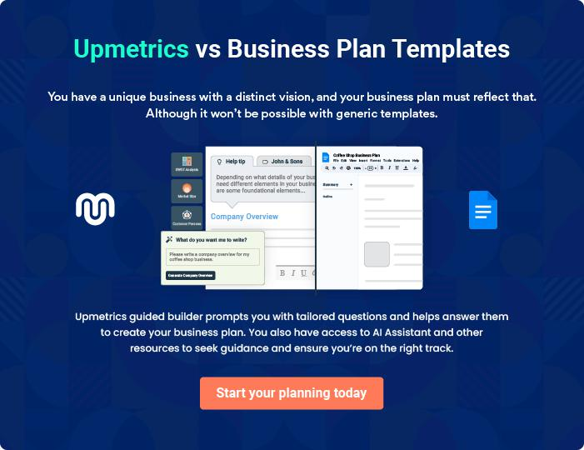
Products and Services

The product and services section of an amusement park business plan should describe the specific services and products that will be offered to customers. To write this section should include the following:
To unlock help try Upmetrics! 

 Help tip  Amusement Park Business Plan

To craft the introduction for your "Products and Services" chapter, begin by positioning your business within its industry, emphasizing its unique strengths or value proposition.
To unlock help try Upmetrics! 

Start writing here..

 Help tip


Mention the amusement park attractions your business will offer. This list may include,

• Roller coasters
• High-height water slides | To unlock help try Upmetrics! 

Main Attractions

Roller Coaster Thrills


Price: [$XX per ride OR included in general admission ticket]

Experience the ultimate adrenaline rush as you twist, turn, and dive through our cutting-edge roller coasters designed for thrill-seekers.
Product Specifications

- Maximum ride time: [XX minutes]

- Height restrictions: Minimum [XX ft] and Maximum [XX ft]

- Weight restrictions: Up to [XXX lbs]

- Health restrictions: Not suitable for those with heart conditions, vertigo, etc.
Family Carousel

Price: [$XX per ride OR included in general admission ticket]

A timeless amusement ride, our carousel is perfect for families and children, offering a gentle, nostalgic experience.

Product / Service Specifications

- Ride duration: [XX minutes]

- Height restrictions: Children under [XX ft] must be accompanied by an adult

- Weight restrictions: Up to [XXX lbs per seat]

- Number of seats: [XX seats]

Water Ride Adventures

Price: [$XX per ride OR included in general admission ticket]

Beat the heat and get splashed! Enjoy our water rides that range from calm boat rides to thrilling water slides.

Product Specifications

•

- Maximum ride time: [XX minutes per ride]

- Height restrictions: Minimum [XX ft] for slides

- Health restrictions: Not suitable for those who cannot swim or with specific health concerns

- Guests are advised to bring a change of clothe
Kiddie Land
- To unlock help try Upmetrics!

Price: [$XX per area OR included in general admission ticket]

Specially designed for our youngest guests, this area boasts a range of safe, fun rides, and attractions for children.

Product Specifications

- Suitable for ages: [2-8] years

- Constant supervision by trained staff

- Height and weight restrictions vary by ride

- Parents can accompany children on certain rides

VIP Passes

Price: [$XXX per person]

Elevate your park experience with our VIP passes. Enjoy priority access to rides, reserved seating at shows, free merchandise, and more.

Product / Service Specifications

- Priority access to all major rides

- Reserved seating for all shows and events

- Complimentary [merchandise item, e.g., "t-shirt"]

- Access to VIP lounges

Emphasize safety and quality

 Help tip  Amusement Park Business Plan

Discuss the park’s dedication to security and safety in brief. Describe the steps taken to assure visitor safety, including ride inspections, employee training, emergency response methods, and security measures.



Start writing here..

Additional Facilities

 Help tip  Amusement Park Business Plan

Mention if your amusement park business offers any additional facilities.

You may include facilities like dining & food service, retail merchandise, event spaces & venues,
To unlock help try Upmetrics! 

Start writing here..
Sales And Marketing Strategies

Writing the sales and marketing strategies section means a list of strategies you will use to attract and retain your clients.
To unlock help try Upmetrics! 

 Help tip  Amusement Park Business Plan

To create an effective introduction for your "Sales and Marketing Strategies" chapter, start by setting the stage within your specific industry or market.
To unlock help try Upmetrics! 

Unique Selling Proposition (USP)

 Help tip  Amusement Park Business Plan

Define your business’s USPs depending on the market you serve, the equipment you use, and the unique services you provide. Identifying USPs will help you plan your marketing strategies.
To unlock help try Upmetrics! 

Start writing here..

Pricing Strategy

 Help tip  Amusement Park Business Plan

Describe your pricing strategy—how you plan to price your services and stay competitive in the local market.
To unlock help try Upmetrics! 

Start writing here..

 Help tip  Amusement Park Business Plan

Discuss your marketing strategies to market your services.

You may include some of these marketing strategies in your business plan—social media
To unlock help try Upmetrics! 

Marketing strategies

Strategies


Social Media Marketing

Engaging campaigns on platforms like Instagram and Facebook, showcasing our attractions and events.

Brochures

Distributed at strategic locations, such as hotels and tourist information centers.

Google Ads

Targeted advertisements to reach potential visitors searching for amusement park experiences.

Content Marketing

Regular blog posts and articles highlighting visitor experiences, upcoming events, and park news.

Print Marketing

Advertisements in local

newspapers and magazines,

especially during peak seasons.

 Help tip  Amusement Park Business Plan

Outline the strategies you’ll implement to maximize your sales. Your sales strategies may include partnering with other local businesses, offering referral programs, etc.
To unlock help try Upmetrics! 

Sales strategies

 | Local Business Partnerships |  |  | Referral Programs
 | Collaborating with nearby |  |  | Encouraging visitors to refer
 | businesses, like hotels or |  |  | friends and family with incentives
 | restaurants, offering package |  |  | like discounted future visits.
 | deals.
 Help tip |  |  |  Amusement Park Business Plan

Describe your customer retention strategies and how you plan to execute them. For instance, introducing loyalty programs, group discounts, personalized service, etc.
To unlock help try Upmetrics! 

Customer retention

Loyalty Programs

Group Discounts

Frequent visitors accumulate points, which can be redeemed for free rides, merchandise, or even free entry.

Encouraging repeat group outings, be it with family or colleagues.

Personalized Service

Using data analytics, we tailor

suggestions for visitors based on

their past preferences and

interests.

Operations Plan

 |  | When writing the operations plan section, it’s important to consider the
 |  | various aspects of your business operations.
 |  |  |  | To unlock help try Upmetrics! 
 Help tip |  |  Amusement Park Business Plan


To create an effective introduction for your "Operational Plan" chapter, start by emphasizing the
pivotal role of efficient operations in the success of your business, underscoring how they
directly impact the quality of services delivered.
 |  |  |  | To unlock help try Upmetrics! 
Start writing here..
Staffing & Training
 Help tip |  |  Amusement Park Business Plan

Mention your business’s staffing requirements, including the number of employees or staff needed. Include their qualifications, the training required, and the duties they will perform.
To unlock help try Upmetrics! 

Start writing here..

Operational Process

 Help tip  Amusement Park Business Plan

Outline the processes and procedures you will use to run your amusement park business.

Your operational processes may include park opening & closing procedures, ticketing &
To unlock help try Upmetrics! 

Start writing here..

Equipment & Machinery
To unlock help try Upmetrics!

 Help tip  Amusement Park Business Plan

Include the list of equipment and machinery required for the amusement park, such as rides & attractions, safety equipment, audio & visual equipment, maintenance & repair tools, lighting & electrical system, etc.



Start writing here..
Management Team

The management team section provides an overview of the individuals responsible for running your business plan.
To unlock help try Upmetrics! 

 Help tip  Amusement Park Business Plan

To craft an introduction for your "Management Team" chapter, begin by emphasizing the crucial role of leadership in the success of any business.
To unlock help try Upmetrics! 

Start writing here..

Key managers

 Help tip  Amusement Park Business Plan

Introduce your management and key members of your team, and explain their roles and responsibilities.
To unlock help try Upmetrics! 

Start writing here..


JOHN DOE

CEO - john.doe@example.com

Role & Responsibilities: As the CEO, [John Doe] oversees the strategic direction of the park, ensuring its alignment with our long-term vision.

With over [X years, e.g., "15 years"] in the amusement park industry, he brings a wealth of knowledge, driving both operational excellence and innovation.


His leadership has been instrumental in [specific achievement, e.g., "securing key partnerships and spearheading our most popular attractions."]

JANE SMITH

Chief Operating Officer (COO) - jane.smith@example.com

[Jane]'s keen analytical skills, combined with her passion for operational efficiency, make her indispensable as our COO.

Tasked with overseeing the day-to-day administrative and operational functions, [Jane] ensures the myriad components of [WonderWorld] come together seamlessly, delivering a consistent and enjoyable visitor experience.


Educational Background: [Jane] holds an MBA in Operations Management from [University Name, e.g., "Stanford University"] and a Bachelor's in Business Administration from [University Name, e.g., "University of California"].

Professional Background: With over [X years, e.g., "12 years"] in the amusement park industry, she has previously served as the Operations Director for [Previous Company, e.g., "Funland Amusements"], where she spearheaded significant efficiency drives.


ALICE JOHNSON

Chief Marketing Officer (CMO) - alice.johnson@example.com

[Alice] brings a mix of creativity and strategic acumen to her role as CMO.

Heading our marketing division, she crafts compelling campaigns and outreach strategies, ensuring [WonderWorld] resonates with both local residents and tourists.

Educational Background: [Alice] graduated with a Master's in Marketing from [University Name, e.g., "Harvard Business School"] and a Bachelor's in Communications from [University Name, e.g., "Boston University"].

Professional Background:[Alice]'s [X years, e.g., "15 years"] of industry experience includes a stint as Marketing Head for [Previous Company, e.g., "Adventure World"], where her innovative campaigns significantly boosted annual footfall.

ROBERT LEE

Operations Manager - robert.lee@example.com

Tasked with the daily operations, from ride maintenance to guest services, [Robert]'s keen eye for detail and commitment to safety ensures the park's smooth functioning, day in and day out.

Educational Background: [Robert] has a Bachelor's degree in Operations Management from [University Name, e.g., "Michigan State University"].

Professional Background: Before joining [WonderWorld], [Robert] worked for [X years, e.g., "10 years"] as an Assistant Operations Manager at [Previous Company, e.g., "Thrill Zone Park"], honing his skills and gaining invaluable industry insights.


SOPHIA MARTINEZ

Customer Services Manager - sophia.martinez@example.com

The linchpin of our guest relations, [Sophia] and her team are often the first point of contact for visitors. Her impeccable interpersonal skills and commitment to excellence ensure every visitor feels valued.

Educational Background: [Sophia] holds a Bachelor's in Public Relations from [University Name, e.g., "New York University"].

Professional Background: With [X years, e.g., "8 years"] of experience in hospitality and customer relations, she has previously served esteemed roles at [Previous Company, e.g., "Sunshine Resorts"], enhancing guest experiences.

Organizational structure

 Help tip  Amusement Park Business Plan

Explain the organizational structure of your management team. Include the reporting line and decision-making hierarchy.
To unlock help try Upmetrics! 

Start writing here..

Organization chart


John Doe

CEO


Alice Johnson Jane Smith

CMO COO



Sophia Martinez Robert Lee

Customer Services Manager Operations Manager


Emily Adams

Digital Marketing Specialist Chris Green

Maintenance Head

Compensation plan

 Help tip  Amusement Park Business Plan

Describe your compensation plan for the management and staff. Include their salaries, incentives, and other benefits.
To unlock help try Upmetrics! 

Start writing here..

Board of advisors


DR. MARK STEWART

Consultant

A consultant with over [X years, e.g., "25 years"] in the amusement park industry, his insights have been invaluable in [specific aspect, e.g., "designing our most popular rides."]

MS. LUCY REYNOLDS

Advisor

With a career spanning [X years, e.g., "18 years"], Lucy has consulted for tech giants and innovative startups alike, giving her a broad perspective on tech trends.
Financial Plan
To unlock help try Upmetrics!

When writing the financial plan section of a business plan, it’s important to provide a comprehensive overview of your financial projections for the first few years of your business, You may provide the following:
To unlock help try Upmetrics! 

 Help tip  Amusement Park Business Plan

To create an effective introduction for your "Financial Plan" chapter, begin by stressing the critical role of a well-structured financial plan in the success of your venture.
To unlock help try Upmetrics! 

Start writing here..

 Help tip

Describe details such as projected revenue, operational costs, and service costs in your projected profit and loss statement. Make sure to include your business’s expected net profit or loss.



Profit & loss statement

 | 2023-24 | 2024-25 | 2025-26 | 2026-27 | 2027-28
Revenue | $0 | $0 | $0 | $0 | $0

Cost Of Sales | $0 | $0 | $0 | $0 | $0
General Costs | $0 | $0 | $0 | $0 | $0
Revenue Specific Costs | $0 | $0 | $0 | $0 | $0
Personnel Costs (Direct | $0 | $0 | $0 | $0 | $0
Labor)

Gross Margin $0 $0 $0 $0 $0

Gross Margin (%)

Operating Expense

Payroll Expense

(Indirect Labor)

General Expense

Bad Debt

Amortization of Current Assets

EBITDA

Additional Expense

Long Term

Depreciation

Gain or loss from Sale of Assets

EBIT

Interest Expenses

EBT

Income Tax Expense

Total Expense

Net Income

Net Income (%)

2023-24 | 2024-25 | 2025-26 | 2026-27 | 2027-28
0% | 0% | 0% | 0% | 0%
$0 | $0 | $0 | $0 | $0
$0 | $0 | $0 | $0 | $0
$0 | $0 | $0 | $0 | $0
$0 | $0 | $0 | $0 | $0
$0 | $0 | $0 | $0 | $0
$0 | $0 | $0 | $0 | $0
$0 | $0 | $0 | $0 | $0
$0 | $0 | $0 | $0 | $0
$0 | $0 | $0 | $0 | $0
$0 | $0 | $0 | $0 | $0
$0 | $0 | $0 | $0 | $0
$0 | $0 | $0 | $0 | $0
$0 | $0 | $0 | $0 | $0
$0 | $0 | $0 | $0 | $0
$0 | $0 | $0 | $0 | $0
0% | 0% | 0% | 0% | 0%
To unlock help try Upmetrics!
 | 2023-24 | 2024-25 | 2025-26 | 2026-27 | 2027-28
Retained Earning | $0 | $0 | $0 | $0 | $0
Opening
Owner's Distribution | $0 | $0 | $0 | $0 | $0
Retained Earning | $0 | $0 | $0 | $0 | $0
Closing

 Help tip

The cash flow for the first few years of your operation should be estimated and described in this section. This may include billing invoices, payment receipts, loan payments, and any other cash flow statements.



Cash flow statement

Cash Received

Cash Paid

COS & General Expenses

Salary & Wages

Interest

Sales Tax

Income Tax

Net Cash From

Operations

Assets Sell

Assets Purchase

Net Cash From

Investments

2023-24 | 2024-25 | 2025-26 | 2026-27 | 2027-28
$0 | $0 | $0 | $0 | $0
$0 | $0 | $0 | $0 | $0
$0 | $0 | $0 | $0 | $0
$0 | $0 | $0 | $0 | $0
$0 | $0 | $0 | $0 | $0
$0 | $0 | $0 | $0 | $0
$0 | $0 | $0 | $0 | $0
$0 | $0 | $0 | $0 | $0

$0 | $0 | $0 | $0 | $0
$0 | $0 | $0 | $0 | $0
$0 | $0 | $0 | $0 | $0

 | 2023-24 | 2024-25 | 2025-26 | 2026-27 | 2027-28
Amount Received | $0 | $0 | $0 | $0 | $0
Loan Received | $0 | $0 | $0 | $0 | $0
Common Stock
Preferred Stock | $0 | $0 | $0 | $0 | $0
Owner's Contribution | $0 | $0 | $0 | $0 | $0
Amount Paid | $0 | $0 | $0 | $0 | $0
Loan Capital | $0 | $0 | $0 | $0 | $0
Dividends & Distributions | $0 | $0 | $0 | $0 | $0
Net Cash From | $0 | $0 | $0 | $0 | $0
Financing

Summary
Starting Cash | $0 | $0 | $0 | $0 | $0
Cash In | $0 | $0 | $0 | $0 | $0
Cash Out | $0 | $0 | $0 | $0 | $0
Change in Cash | $0 | $0 | $0 | $0 | $0
Ending Cash | $0 | $0 | $0 | $0 | $0

 Help tip

Create a projected balance sheet documenting your amusement park business’s assets, liabilities, and equity.
To unlock help try Upmetrics! 

Balance sheet

 | 2023-24 | 2024-25 | 2025-26 | 2026-27 | 2027-28
Assets | $0 | $0 | $0 | $0 | $0
 | 2023-24 | 2024-25 | 2025-26 | 2026-27 | 2027-28
Current Assets | $0 | $0 | $0 | $0 | $0
Cash | $0 | $0 | $0 | $0 | $0
Accounts Receivable | $0 | $0 | $0 | $0 | $0
Inventory | $0 | $0 | $0 | $0 | $0
Other Current Assets | $0 | $0 | $0 | $0 | $0
Long Term Assets | $0 | $0 | $0 | $0 | $0
Gross Long Term Assets | $0 | $0 | $0 | $0 | $0
Accumulated Depreciation | $0 | $0 | $0 | $0 | $0

Liabilities & Equity | $0 | $0 | $0 | $0 | $0
Liabilities | $0 | $0 | $0 | $0 | $0
Current Liabilities | $0 | $0 | $0 | $0 | $0
Accounts Payable | $0 | $0 | $0 | $0 | $0
Income Tax Payable | $0 | $0 | $0 | $0 | $0
Sales Tax Payable | $0 | $0 | $0 | $0 | $0
Short Term Debt | $0 | $0 | $0 | $0 | $0
Long Term Liabilities | $0 | $0 | $0 | $0 | $0
Long Term Debt | $0 | $0 | $0 | $0 | $0
Equity | $0 | $0 | $0 | $0 | $0
Paid-in Capital | $0 | $0 | $0 | $0 | $0
Common Stock | $0 | $0 | $0 | $0 | $0
Preferred Stock | $0 | $0 | $0 | $0 | $0
Owner's Contribution | $0 | $0 | $0 | $0 | $0
Retained Earnings | $0 | $0 | $0 | $0 | $0
 | 2023-24 | 2024-25 | 2025-26 | 2026-27 | 2027-28
Check | $0 | $0 | $0 | $0 | $0

 Help tip

Determine and mention your business’s break-even point—the point at which your business costs and revenue will be equal.
To unlock help try Upmetrics! 

Break-even Point

 | 2023-24 | 2024-25 | 2025-26 | 2026-27 | 2027-28
Starting Revenue | $0 | $0 | $0 | $0 | $0
Net Revenue | $0 | $0 | $0 | $0 | $0
Closing Revenue | $0 | $0 | $0 | $0 | $0

Starting Expense | $0 | $0 | $0 | $0 | $0
Net Expense | $0 | $0 | $0 | $0 | $0
Closing Expense | $0 | $0 | $0 | $0 | $0

Is Break Even? | 0 | 0 | 0 | 0 | 0
Break Even Month | 0 | 0 | 0 | 0 | 0
Days Required | 0 | 0 | 0 | 0 | 0
Break Even Revenue | $0 | $0 | $0 | $0 | $0
Break Even Units
Financing needs

 Help tip  Amusement Park Business Plan

Calculate costs associated with starting an amusement park business, and estimate your financing needs and how much capital you need to raise to operate your business.
To unlock help try Upmetrics! 

Start writing here..
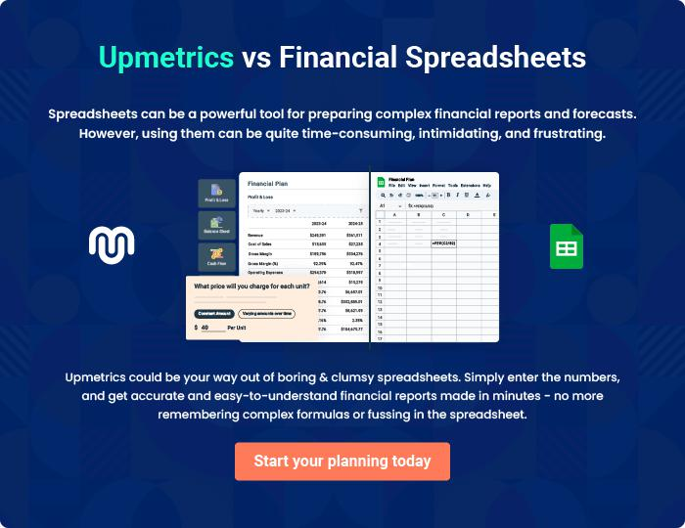
Appendix

When writing the appendix section, you should include any additional information that supports the main content of your plan. This may include financial statements, market research data, legal documents, and other
To unlock help try Upmetrics! 
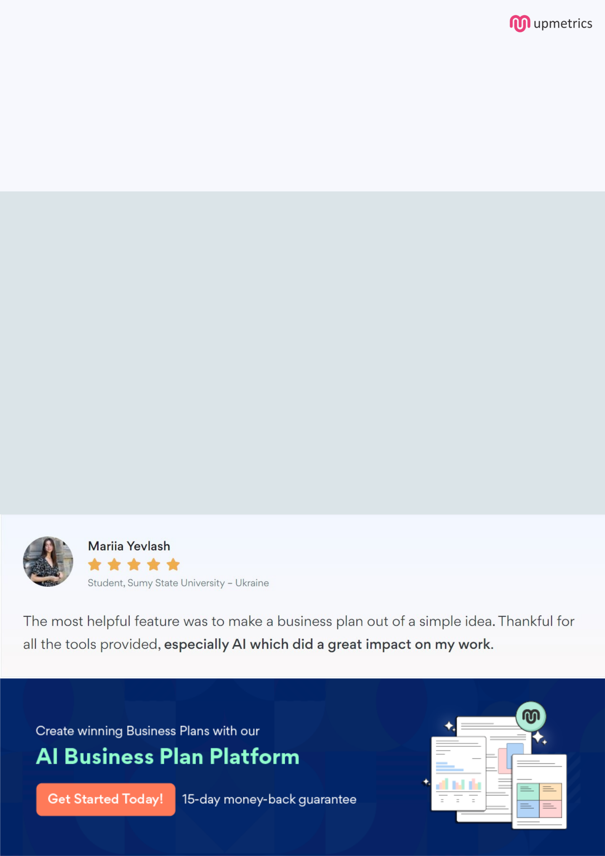
Create a winning business plan that gets you funded

Creating a stunning and investment-ready plan requires no writing, graphic designing, or financial planning expertise.

Upmetrics has all the features required to help you create a comprehensive business plan—from start to finish. Make no mistakes, it’s the modern way of planning to structure ideas, make plans, and create stunning pitch decks to awe investors.

Pitch decks that impress investors

Create pitch decks that provide a visual representation of your business, engage investors, and make them want to invest in your business idea.

Interactive plans in no time

Import business plan sections like—SWOT analysis, comparison tables, and others to create an interactive business plan. No designing skills are required.

Stunning cover page designs

With Upmetrics, you have the liberty to choose from multiple stunning cover page designs. Choose a creative design and make your plan stand out.

Online sharing made simple

Upmetrics makes online sharing quick and easier for users. Easily share your business plans with a link while tracking reader activity.

500+ sample business plans

Simply import a template from our library of sample plans into the editor and start customizing it to make it yours. It takes only a few clicks to get started.

Collaborate with team in real-time

Invite team members, initiate conversations, discuss ideas & strategies, share feedback, and work on a business plan in real-time.

