
BUSINESS PLAN

2023


Amazon Fba Business Plan

Amazon FBA, Your Storefront

John Doe

10200 Bolsa Ave, Westminster, CA, 92683

- 359-3153 info@example.com http://www.example.com

Information provided in this business plan is unique to this business and confidential; therefore, anyone reading this plan agrees not to disclose any of the information in this business plan without prior written permission of the company.
Table of Contents

Executive Summary | 6
Market opportunity | 6
Products and Services | 6
Marketing & Sales Strategies | 7
Financial Highlights | 7
Units Sold v/s Revenue | 8

Company Overview | 9
Ownership | 9
Business Owners | 9
Mission statement | 10
Business history | 10
Future goals | 10

Market Analysis | 11
Target Market | 11
Market size and growth potential | 11
Market Size | 12
Competitive analysis | 12
Dyson Inc. | 12
Instant Brands Inc. | 13
Breville Group | 13
Market trends | 13
Regulatory environment | 14

Products and Services | 15
Products & Services | 15
Premium Stainless Steel Blender | 15
Energy-Efficient Refrigerator | 16
Expert Installation Service | 16
Bi-Yearly Maintenance Check-Up | 17
Product Development | 17
Emphasize Customer Services | 17
Additional Services | 18

Sales And Marketing Strategies | 19
Unique Selling Proposition (USP) | 19
Pricing Strategy | 19
Marketing strategies | 20
Online | 20
Sales strategies | 21
Customer retention | 22

Operations Plan | 23
Staffing & Training | 23
Operational Process | 23
Quality Control | 24
Shipping & Logistics | 24
Technology & System | 24

Management Team | 25
Key managers | 25
John Doe | 25
Jane Doe | 26
Alice Brown | 26
Robert Brown | 26
Organizational structure | 27
Organization chart | 27
Compensation plan | 28
Board of advisors | 28
Mr. William Green | 28
Dr. Emily White | 28
Financial Plan | 29
Profit & loss statement | 29
Cash flow statement | 32
Balance sheet | 34
Break-even Analysis | 36
Financing needs | 38
Appendix
Appendix | 40
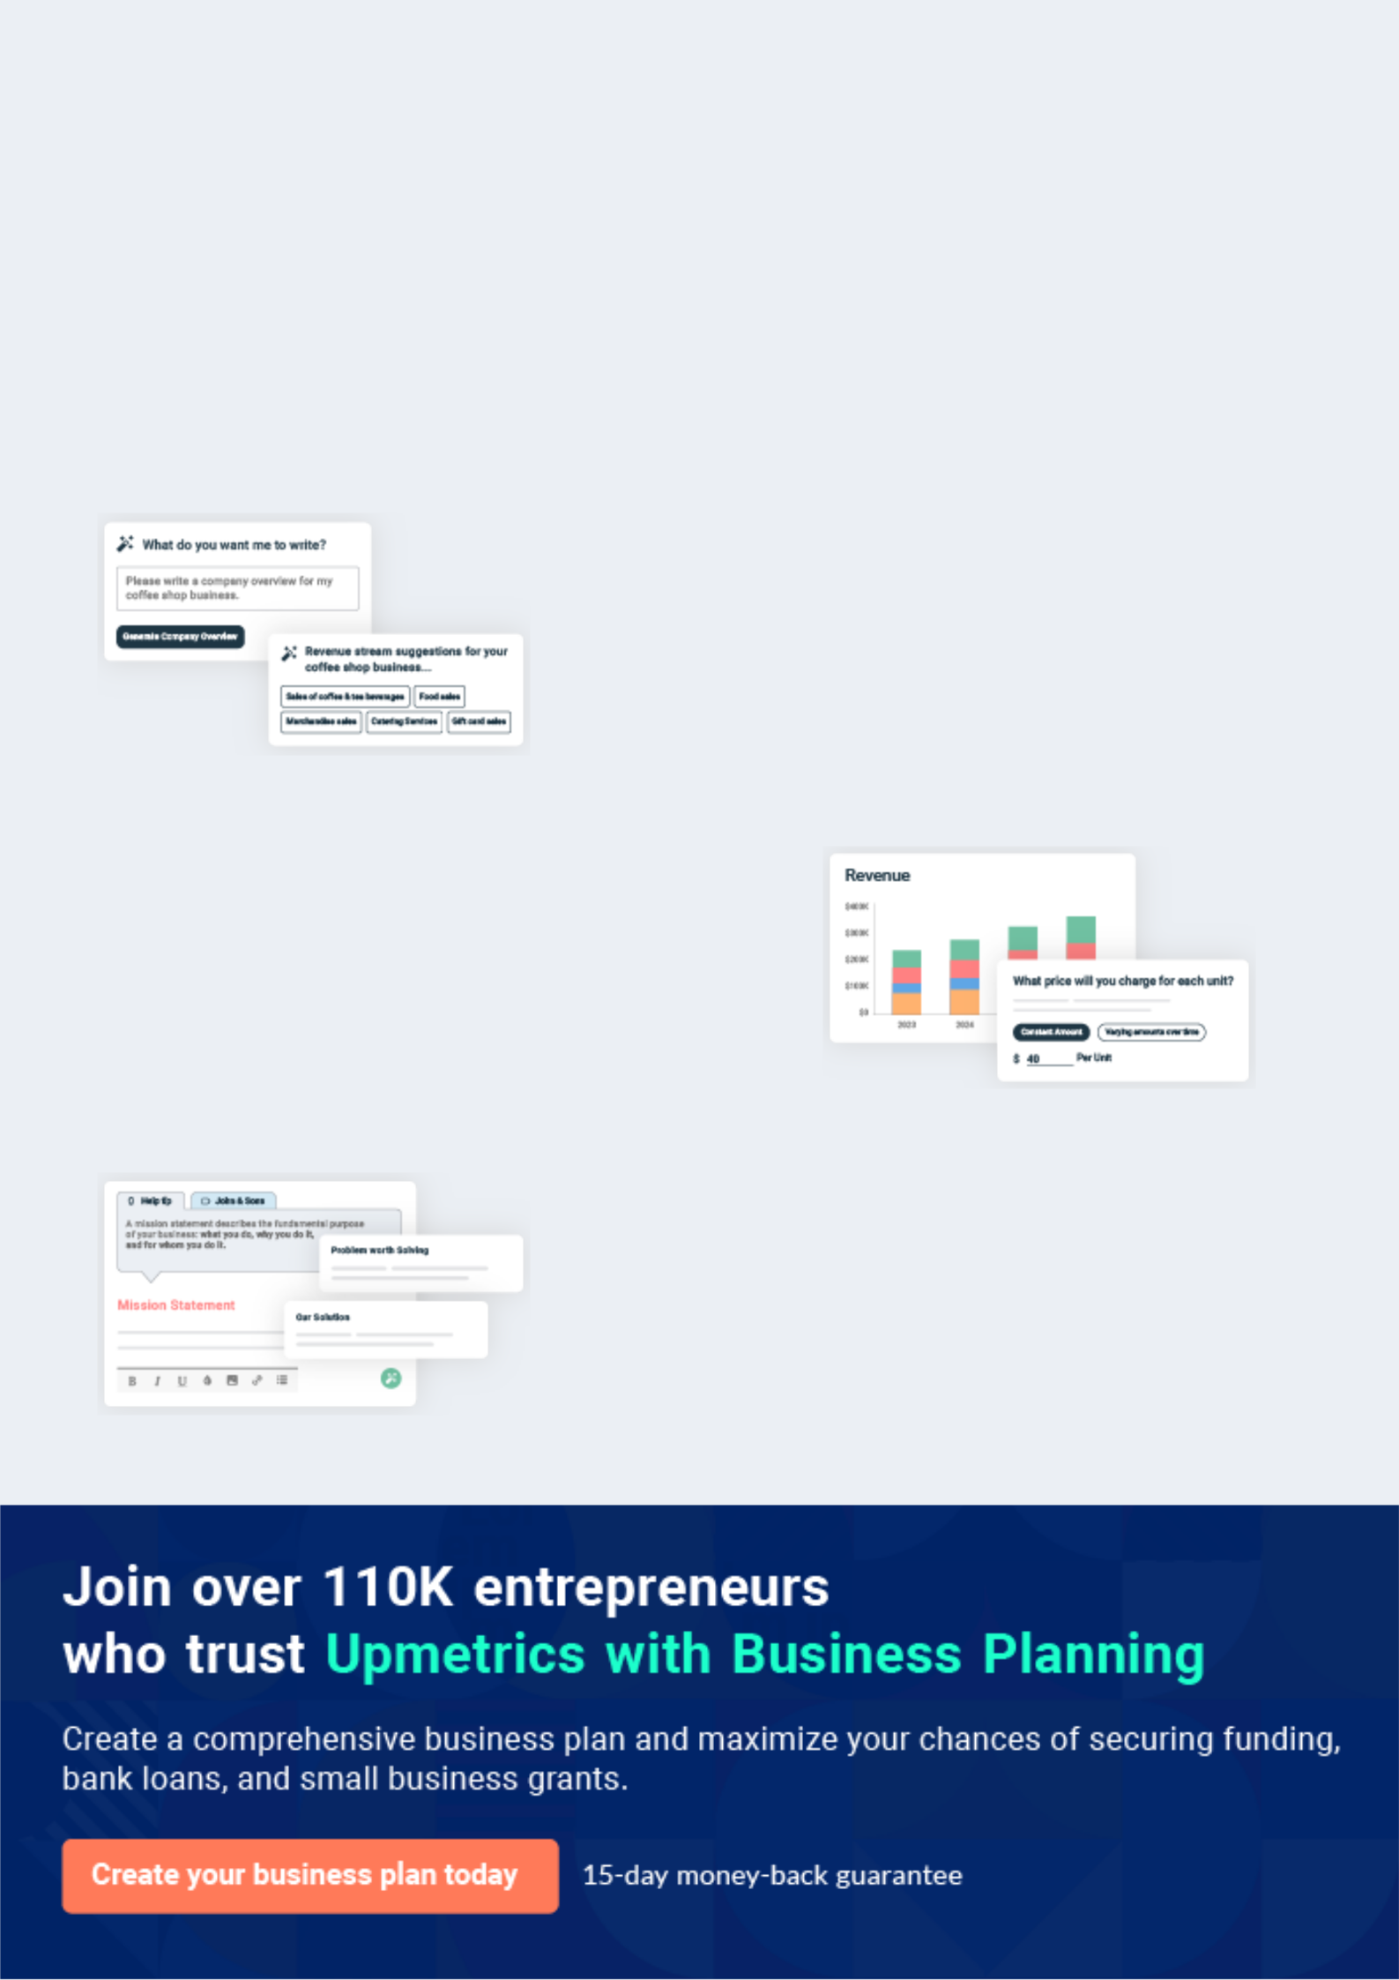
Business planning that’s simpler and faster than you think

Creating a business plan using Upmetrics to start and grow a business is literally the easiest thing in the World. Simply read the instructions and fill in the blanks. It’s as simple as that.

❛ | Upmetrics has everything you need to create a | ❜
❛ | comprehensive business plan. | ❜

AI-powered Upmetrics Assistant

AI-powered insights to streamline your plan

Not sure where to start? Upmetrics’ AI Assistant will automatically generate ideas for each section of your plan and offer improved versions of your writing, adjusting for tone, voice, and grammar or spelling errors.

Financial Forecasting Tool

All the financials are calculated for you

Forget the complex formulas and clumsy spreadsheets — with automatic financials and drag-and-drop forecasting, you can finish your plan faster and be confident that your numbers are accurate.

Business Plan Builder

Guides you like a business mentor

Upmetrics’ step-by-step instructions, prompts, and the library of 400+ sample business plans will guide you through each section of your plan as a business mentor.
Executive Summary


An executive summary is the first section of the business plan intended to provide an overview of the whole business plan.
To unlock help try Upmetrics! 

 Help tip  Amazon Fba Business Plan


Start your executive summary by introducing your business to investors or stakeholders.

Offer a high-level overview of your Amazon FBA business, including name, location, legal
To unlock help try Upmetrics! 

Start writing here..

Market opportunity

 Help tip  Amazon Fba Business Plan

Briefly describe your target market and discuss user demographics, preferences, and buying habits. Clearly describe the market and how your business will fit in to fill the gap.
To unlock help try Upmetrics! 

Start writing here..

Products and Services

 Help tip  Amazon Fba Business Plan

Highlight the products or services your Amazon FBA business offers and mention USPs or differentiator elements, if any.
To unlock help try Upmetrics! 

Start writing here..

Marketing & Sales Strategies

 Help tip  Amazon Fba Business Plan

Offer a brief outline of the marketing and sales strategies you plan on implementing to reach your audience and maximize your ROI.
To unlock help try Upmetrics! 

Start writing here..

Financial Highlights

 Help tip  Amazon Fba Business Plan

Provide a summary of your financial projections for the company’s initial years of operation.

Include any capital or investment requirements, startup costs, projected revenues, and profits.
To unlock help try Upmetrics! 

Start writing here..
Units Sold v/s Revenue
To unlock help try Upmetrics!

 |  | Units Sold | Revenue
15.00k
10.00k
5.00k
0
Year 1 | Year 2 | Year 3


Financial Year |  |  | Units Sold | Revenue
Year 1 | 1,550 |  |  | $10,000
Year 2 | 1,800 |  |  | $12,000
Year 3 | 2,050 |  |  | $14,000
 Help tip |  |  Amazon Fba Business Plan


After giving a brief about your business plan, end your summary with a call to action, for example; inviting potential investors or readers to the next meeting if they are interested in your business.



Write a call to action for your business plan.
Company Overview
To unlock help try Upmetrics!

Depending on what details of your business are essential, you’ll need different elements in your business overview.
To unlock help try Upmetrics! 

 Help tip  Amazon Fba Business Plan

Provide all the basic information about your business in this section like:

• Business name and model: Describe what your FBA business does and what business
To unlock help try Upmetrics! 

Start writing here..

Ownership

 Help tip  Amazon Fba Business Plan

Describe the owners or founders of your Amazon FBA business and mention their roles in running it. Who owns what shares in the business, and how each founder helps in the business?



Start writing here..

Business Owners



60% John Doe



40% Jane Doe
Mission statement

 Help tip  Amazon Fba Business Plan

Add a mission statement that sums up the objectives and core principles of your Amazon FBA business. This statement needs to be memorable, clear, and brief.
To unlock help try Upmetrics! 

❛ At [XYZ Ventures], our mission is to provide customers with top-quality, sustainable home appliances that not only meet their needs but also contribute to a greener planet.

We strive to redefine the online shopping experience, delivering excellence through our products and customer service.

❜

Business history

 Help tip  Amazon Fba Business Plan


This one is optional for newly established startups. If you’re an established business owner, you
can provide information about the history of your business, like when it was founded and how it
evolved.
 |  |  |  |  | To unlock help try Upmetrics! 
Start writing here..
Future goals
 Help tip |  |  |  Amazon Fba Business Plan

It’s crucial to convey your aspirations and your vision. Mention your short-term and long-term goals; they can be specific targets for revenue, market share, or expanding your services.
To unlock help try Upmetrics! 

Start writing here..

Market Analysis
To unlock help try Upmetrics!


 |  | Market analysis provides a clear understanding of the market in which your
 |  | printing business will run along with the target market, competitors, and
 |  | growth opportunities.
 |  |  |  | To unlock help try Upmetrics! 
 Help tip |  |  Amazon Fba Business Plan

To write the introduction section of your market analysis, start by clearly identifying your primary target market.
To unlock help try Upmetrics! 

Start writing here..

Target Market

 Help tip  Amazon Fba Business Plan

Identify and describe your target market. Include user demographics, location, preferences, buying habits, and more. A buyer persona will help you and your readers better understand your target audience.



Start writing here..

Market size and growth potential

 Help tip  Amazon Fba Business Plan

Provide an overview of the industry you operate in. It will include market size, trends, growth potential, and regulatory considerations.
To unlock help try Upmetrics! 

Start writing here..

Market Size
To unlock help try Upmetrics!

Available Market

Total market for home appliances 200M worldwide

Served Market
Customers accessible via Amazon's 75M platform.

Target Market
Urban homeowners aged 25-45 30M seeking energy-efficient appliances.

 Help tip  Amazon Fba Business Plan

Identify and analyze all other sellers on Amazon, including your direct and indirect competitors. Evaluate their strengths and weaknesses, and explain how your business has a competitive edge over the other competitors.



Competitive analysis

Dyson Inc.

Dyson Inc. is renowned for its innovative home and electronics products, notably their vacuum cleaners, air purifiers, and hair care products. Their products are widely recognized and are available on Amazon as well as their own direct-to-consumer platform.

Features | Strengths | Weaknesses
Cyclone vacuum technology | Strong brand recognition and | Premium pricing can alienate
Bladeless fans | reputation | budget-conscious customers

High-quality and innovative
Supersonic hair dryers
products
Air purifiers with real-time
Extensive research and
pollution metrics
development capabilities

Limited product range compared to more generalized home appliance sellers

Instant Brands Inc.

Instant Brands Inc. rose to fame with the Instant Pot, a multifunctional electric cooker. They have since expanded their product line and have established themselves as a major player in the kitchen appliance sector on Amazon.

Features | Strengths | Weaknesses
Multi-functional electric | Strong community and loyal | Primarily known for a singular
cookers | customer base | product (Instant Pot)
Air fryers | Diverse product range within | Faces competition from other
Blenders | the kitchen appliance niche | multifunctional cooker brands
 | Highly reviewed and rated
 | products on Amazon

Breville Group

Breville is a global brand known for its high-end kitchen appliances. They offer everything from espresso machines to ovens, ensuring quality and innovation in every product.

Features | Strengths | Weaknesses
Espresso machines with | Reputable brand with a long- | Higher price points than many
proprietary heating technology | standing history | competitors
Smart ovens with preset | High-quality products built to | Some products have a steeper
cooking modes | last | learning curve for customers
Juicers with cold extraction | Strong emphasis on customer
technology | service and warranty

Market trends

 Help tip  Amazon Fba Business Plan

Analyze current and emerging trends in your industry, such as technological changes or customer preferences. Explain how your business will cope with all the trends.
To unlock help try Upmetrics! 

Start writing here..

Regulatory environment
To unlock help try Upmetrics!

 Help tip  Amazon Fba Business Plan

Describe any regulations or licensing requirements that affect your Amazon FBA business, business license, product safety regulations, import/export regulations, sales tax registration, etc.



Start writing here..
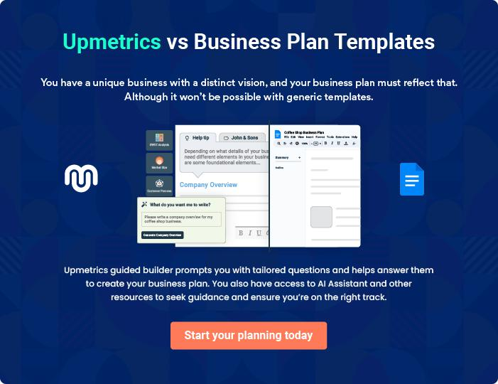
Products and Services
To unlock help try Upmetrics!
To unlock help try Upmetrics!

The product and services section of an amazon FBA business plan should describe the specific services and products that will be offered to customers. To write this section should include the following:



 Help tip  Amazon Fba Business Plan

To craft the introduction for your "Products and Services" chapter, begin by positioning your business within its industry, emphasizing its unique strengths or value proposition.
To unlock help try Upmetrics! 

Start writing here..

 Help tip


Start this section by describing products your business will sell on Amazon. Your product and services section must include details about product quality, design, and benefits, as well as their benefits and features.



Products & Services

Premium Stainless Steel Blender


Price: [$79.99]

Our Premium Stainless Steel Blender is perfect for smoothies, soups, and more. Its sleek design and powerful motor make it a kitchen must-have.

Specifications

- Motor: 600W

- Capacity: 1.5 Liters

- Speed Settings: 3

- Material: Stainless Steel

- Warranty: 2 Years
Energy-Efficient Refrigerator

Price: [$499.99]

This Energy-Efficient Refrigerator keeps your food fresh and your energy bills low. Its modern design and adjustable shelves offer both style and convenience.

Specifications

- Capacity: 20 Cubic Feet

- Energy Rating: A++

- Shelves: 5 Adjustable Glass Shelves

- Color Options: Stainless Steel, Black, White

- Warranty: 5 Years

Expert Installation Service

Price: [$99.99]

Our expert technicians will install your new appliance and ensure everything is set up perfectly. Sit back and relax while we take care of the hard work.

Specifications

- Availability: 7 Days a Week

- Coverage Area: Nationwide

- Warranty: 1 Year on Installation Workmanship
Bi-Yearly Maintenance Check-Up
- To unlock help try Upmetrics!

Price: [$49.99] per Visit

Keep your appliances running smoothly with our bi-yearly maintenance check-up. Our technicians will inspect, clean, and tune-up your appliance to ensure optimal performance.

Specifications

- Availability: Monday to Friday

- Coverage Area: Nationwide

- Included: Inspection, Cleaning, and Tune-Up

Product Development

 Help tip  Amazon Fba Business Plan

Describe how you are planning on developing and sourcing your products. Mention if you have any partnerships or relationships you have with any manufacturers, distributors, or suppliers.
To unlock help try Upmetrics! 

Start writing here..

Emphasize Customer Services

 Help tip  Amazon Fba Business Plan

In all descriptions of services and products, emphasize the importance of customer service. Explain the customer services your business will offer to consumers such as return policies, guarantees, warranties, etc.



Start writing here..

Additional Services

 Help tip  Amazon Fba Business Plan

Mention if your business offers any additional services depending on the products you sell, such as maintenance, installation, or support.
To unlock help try Upmetrics! 

Start writing here..
Sales And Marketing Strategies

Writing the sales and marketing strategies section means a list of strategies you will use to attract and retain your clients.
To unlock help try Upmetrics! 

 Help Tip  Amazon Fba Business Plan


To create an effective introduction for your "Sales and Marketing Strategies" chapter, start by setting the stage within your specific industry or market.
To unlock help try Upmetrics! 

Start writing here..

Unique Selling Proposition (USP)

 Help tip  Amazon Fba Business Plan

Define your business’s USPs depending on the product you sell and the market you serve.

For example, Natural ingredients, cruelty-free and vegan products, and sustainable packaging
To unlock help try Upmetrics! 

Start writing here..

Pricing Strategy

 Help tip  Amazon Fba Business Plan

Develop the product pricing strategy—how you plan on pricing your products and staying competitive on the Amazon seller’s market.
To unlock help try Upmetrics! 

Start writing here..

 Help tip

Discuss the marketing strategies you’ll implement to market your products. You may include some of these marketing strategies in your business plan—Amazon SEO, Amazon advertising, social media marketing, affiliate marketing, content marketing, and paid advertising.
To unlock help try Upmetrics! 

Marketing strategies

Online


Amazon SEO

By optimizing product titles, descriptions, and backend keywords, we ensure our products rank higher in Amazon searches, driving organic traffic to our listings.

Social Media Marketing

Engaging content on platforms like Facebook, Instagram, and Pinterest will not only drive traffic but also foster community building.

Content Marketing

Regular blog posts, e-books, and guides related to our product niche will establish [XYZ Ventures] as a thought leader in the industry.

Amazon Advertising

Leveraging Amazon's in-built advertising solutions, we will run targeted Pay-Per-Click (PPC) campaigns to enhance product visibility.

Affiliate Marketing

Collaborating with bloggers and influencers, we'll spread the word about our products, driving both awareness and sales.

Paid Advertising

Utilizing platforms like Google Ads, we'll target potential customers based on their online behavior, search patterns, and interests.

 Help tip

Describe your sales strategies—offering seasonal and festival sale discounts, collaborating with other brands, offering package deals, etc.
To unlock help try Upmetrics! 

Sales strategies

Seasonal Discounts

Catering to the festive spirit, we'll roll out discounts during peak seasons to boost sales volume.

Package Deals

Bundle offers will provide value to the customer while increasing our average order value.

Brand Collaborations

By partnering with complementary brands, we can offer package deals, broadening our customer base.

 Help tip  Amazon Fba Business Plan

Describe how your business will retain customers and build loyalty, by running loyalty programs, requesting feedback, providing incentives for reviews, etc.
To unlock help try Upmetrics! 

Customer retention

Loyalty Programs

Rewarding our repeat customers with points for every purchase, which can be redeemed for discounts or free products.

Incentives for Reviews

Encouraging product reviews with incentives will not only improve our product ranking but also provide social proof to potential buyers.

Feedback Solicitation

By proactively seeking customer feedback, we can continuously refine our offerings.

Operations Plan

 |  | When writing the operations plan section, it’s important to consider the
 |  | various aspects of your business operations.
 |  |  |  | To unlock help try Upmetrics! 
 Help tip |  |  Amazon Fba Business Plan


To create an effective introduction for your "Operational Plan" chapter, start by emphasizing the
pivotal role of efficient operations in the success of your business, underscoring how they
directly impact the quality of services delivered.
 |  |  |  | To unlock help try Upmetrics! 
Start writing here..
Staffing & Training
 Help tip |  |  Amazon Fba Business Plan

Tell the staffing requirements of your Amazon FBA business, including the number of employees needed, their qualifications, and the duties they will perform.
To unlock help try Upmetrics! 

Start writing here..

Operational Process

 Help tip  Amazon Fba Business Plan

Explain the tasks and business procedures involved in your day-to-day business operations.

You may include business processes like managing, tracking, and restocking inventory, fulfilling
To unlock help try Upmetrics! 

Start writing here..

Quality Control
To unlock help try Upmetrics!

 Help tip  Amazon Fba Business Plan

Describe your Amazon FBA business’s QC process, how your team ensures the best product quality, and how you handle customer complaints and feedback.
To unlock help try Upmetrics! 

Start writing here..

Shipping & Logistics

 Help tip  Amazon Fba Business Plan

Describe how Amazon’s FBA business program will be used to handle shipping and logistics for your business.
To unlock help try Upmetrics! 

Start writing here..

Technology & System

 Help tip  Amazon Fba Business Plan

Explain the technology and systems that will be used in your business operations such as inventory management software, CRM software, Amazon Seller Center, accounting and financial software, etc.



Start writing here..
Management Team

The management team section provides an overview of the individuals responsible for running your business plan.
To unlock help try Upmetrics! 

 Help tip  Amazon Fba Business Plan

To craft an introduction for your "Management Team" chapter, begin by emphasizing the crucial role of leadership in the success of any business.
To unlock help try Upmetrics! 

Start writing here..

Key managers

 Help tip  Amazon Fba Business Plan

Describe the key members of your management team, their roles, and their responsibilities.

It should include the owners, senior management, other department managers, and people who
To unlock help try Upmetrics! 

Start writing here..


JOHN DOE

Founder & CEO - john.doe@example.com

John is the visionary founder of [XYZ Ventures], having established the business with a clear vision and mission.

With a Master's in Business Administration from [University], he has over 10 years of experience in e-commerce, particularly within the Amazon FBA ecosystem.


His strategic insights and leadership skills are instrumental in guiding [XYZ Ventures] on a path of success and growth.

JANE DOE

Chief Operating Officer (COO) - jane.doe@example.com

Jane brings a wealth of experience in operations management to [XYZ Ventures].

With a Bachelor's Degree in Operations Management from [University] and 8 years of experience in e-commerce logistics, she ensures that our business processes are seamless and efficient.


Jane's meticulous approach to order fulfillment and inventory management is a valuable asset to our team.


ALICE BROWN

Chief Marketing Officer (CMO) - alice.brown@example.com

Alice specializes in crafting compelling branding and marketing strategies that resonate with our target audience.

With a Master's in Marketing from [University] and 7 years of experience in digital marketing, Alice's creative insights and strategic planning drive our brand's visibility and customer engagement on Amazon's competitive marketplace.


ROBERT BROWN

Chief Financial Officer (CFO) - robert.brown@example.com

Robert oversees the financial health of [XYZ Ventures], managing our budgeting, financial projections, and overall fiscal responsibilities.

With a Master's in Finance from [University] and over 9 years of experience in e-commerce, his financial acumen ensures that our business remains profitable and fiscally responsible.
Organizational structure

 Help tip  Amazon Fba Business Plan

Describe the organizational structure of the management team, including reporting lines and how decisions will be made.
To unlock help try Upmetrics! 

Start writing here..

Organization chart


John Doe

CEO
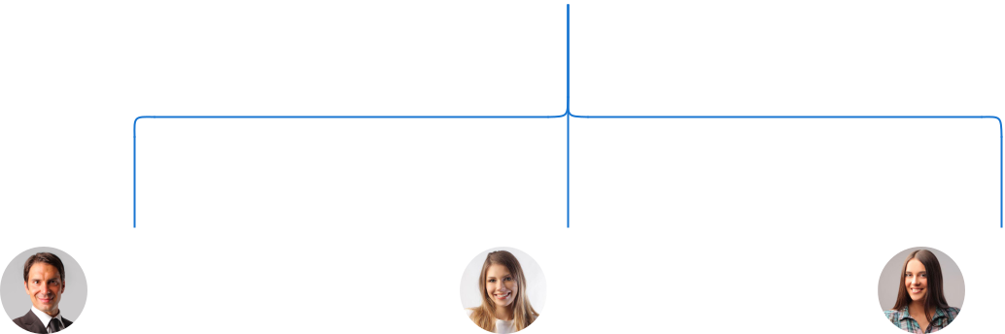

Robert Brown

Jane Doe

Alice Brown

CFO


COO



CMO

Lucy Gray

Tom Green

HR Manager

IT Manager

Compensation plan

 Help tip  Amazon Fba Business Plan

Describe your compensation plan for the management team and staff, including salaries, bonuses, and other benefits.
To unlock help try Upmetrics! 

Start writing here..

 Help tip

If you have a board of advisors for your business, then mention them along with their roles and experience.
To unlock help try Upmetrics! 

Board of advisors


MR. WILLIAM GREEN

Advisor 1

An e-commerce mogul with multiple successful ventures under his belt, Mr.

Green advises on strategic partnerships and growth opportunities.


DR. EMILY WHITE

Advisor 2

With a Ph.D. in Retail Management and over [15] years of advisory experience, Dr. White provides invaluable insights into industry trends and consumer behavior.
Financial Plan

When writing the financial plan section of a business plan, it’s important to provide a comprehensive overview of your financial projections for the first few years of your business, You may provide the following:
To unlock help try Upmetrics! 

 Help tip  Amazon Fba Business Plan


To create an effective introduction for your "Financial Plan" chapter, begin by stressing the critical role of a well-structured financial plan in the success of your venture.
To unlock help try Upmetrics! 

Start writing here..

 Help tip  Amazon Fba Business Plan

Create a projected profit & loss statement that describes the expected revenue, cost of products sold, and operational costs. Your business’s anticipated net profit or loss should be computed and included.
To unlock help try Upmetrics! 

Profit & loss statement

Revenue

Cost Of Sales

General Costs

Revenue Specific Costs

Personnel Costs (Direct

Labor)

Gross Margin

Gross Margin (%)

Operating Expense

Payroll Expense

(Indirect Labor)

General Expense

Bad Debt

Amortization of Current

Assets

2023-24 | 2024-25 | 2025-26 | 2026-27 | 2027-28
$0 | $0 | $0 | $0 | $0

$0 | $0 | $0 | $0 | $0
$0 | $0 | $0 | $0 | $0
$0 | $0 | $0 | $0 | $0
$0 | $0 | $0 | $0 | $0

$0 | $0 | $0 | $0 | $0
0% | 0% | 0% | 0% | 0%

$0 | $0 | $0 | $0 | $0
$0 | $0 | $0 | $0 | $0
$0 | $0 | $0 | $0 | $0
$0 | $0 | $0 | $0 | $0
$0 | $0 | $0 | $0 | $0

EBITDA

Additional Expense

Long Term

Depreciation

Gain or loss from Sale

of Assets

EBIT

Interest Expenses

EBT

Income Tax Expense

Total Expense

Net Income

Net Income (%)

2023-24 | 2024-25 | 2025-26 | 2026-27 | 2027-28
$0 | $0 | $0 | $0 | $0
$0 | $0 | $0 | $0 | $0
$0 | $0 | $0 | $0 | $0
$0 | $0 | $0 | $0 | $0
$0 | $0 | $0 | $0 | $0
$0 | $0 | $0 | $0 | $0
$0 | $0 | $0 | $0 | $0
$0 | $0 | $0 | $0 | $0
$0 | $0 | $0 | $0 | $0
$0 | $0 | $0 | $0 | $0
0% | 0% | 0% | 0% | 0%
 |  |  | 2023-24 |  | 2024-25 | 2025-26 | 2026-27 | 2027-28
Retained Earning |  |  | $0 |  | $0 | $0 | $0 | $0
Opening
Owner's Distribution |  |  | $0 |  | $0 | $0 | $0 | $0
Retained Earning |  |  | $0 |  | $0 | $0 | $0 | $0
Closing
 Help tip |  |  |  Amazon Fba Business Plan


Estimate your cash inflows and outflows for the first few years of operation. It should include cash receipts from clients, vendor payments, loan payments, and any other cash inflows and outflows.
To unlock help try Upmetrics! 

Cash flow statement

 | 2023-24 | 2024-25 | 2025-26 | 2026-27 | 2027-28
Cash Received | $0 | $0 | $0 | $0 | $0
Cash Paid | $0 | $0 | $0 | $0 | $0
COS & General Expenses | $0 | $0 | $0 | $0 | $0
Salary & Wages | $0 | $0 | $0 | $0 | $0
Interest | $0 | $0 | $0 | $0 | $0

Sales Tax

Income Tax

Net Cash From

Operations

Assets Sell

Assets Purchase

Net Cash From

Investments

Amount Received

Loan Received

Common Stock

Preferred Stock

Owner's Contribution

Amount Paid

2023-24 | 2024-25 | 2025-26 | 2026-27 | 2027-28
$0 | $0 | $0 | $0 | $0
$0 | $0 | $0 | $0 | $0
$0 | $0 | $0 | $0 | $0

$0 | $0 | $0 | $0 | $0
$0 | $0 | $0 | $0 | $0
$0 | $0 | $0 | $0 | $0

$0 | $0 | $0 | $0 | $0
$0 | $0 | $0 | $0 | $0

$0 | $0 | $0 | $0 | $0
$0 | $0 | $0 | $0 | $0
$0 | $0 | $0 | $0 | $0

Loan Capital $0 $0 $0 $0 $0

 |  |  | 2023-24 | 2024-25 | 2025-26 | 2026-27 | 2027-28
Dividends & Distributions |  |  | $0 | $0 | $0 | $0 | $0
Net Cash From |  |  | $0 | $0 | $0 | $0 | $0
Financing
Summary
Starting Cash |  |  | $0 | $0 | $0 | $0 | $0
Cash In |  |  | $0 | $0 | $0 | $0 | $0
Cash Out |  |  | $0 | $0 | $0 | $0 | $0
Change in Cash |  |  | $0 | $0 | $0 | $0 | $0
Ending Cash |  |  | $0 | $0 | $0 | $0 | $0
 Help tip |  |  Amazon Fba Business Plan

Prepare a projected balance sheet, which shows the business’s assets, liabilities, and equity.

To unlock help try Upmetrics! 

Balance sheet

 | 2023-24 | 2024-25 | 2025-26 | 2026-27 | 2027-28
Assets | $0 | $0 | $0 | $0 | $0
Current Assets | $0 | $0 | $0 | $0 | $0
Cash | $0 | $0 | $0 | $0 | $0
Accounts Receivable | $0 | $0 | $0 | $0 | $0
Inventory | $0 | $0 | $0 | $0 | $0
Other Current Assets | $0 | $0 | $0 | $0 | $0
Long Term Assets | $0 | $0 | $0 | $0 | $0
Gross Long Term Assets | $0 | $0 | $0 | $0 | $0
Accumulated Depreciation | $0 | $0 | $0 | $0 | $0

Liabilities & Equity | $0 | $0 | $0 | $0 | $0
Liabilities | $0 | $0 | $0 | $0 | $0
Current Liabilities | $0 | $0 | $0 | $0 | $0
Accounts Payable | $0 | $0 | $0 | $0 | $0
Income Tax Payable | $0 | $0 | $0 | $0 | $0
Sales Tax Payable | $0 | $0 | $0 | $0 | $0
Short Term Debt | $0 | $0 | $0 | $0 | $0
 | 2023-24 | 2024-25 | 2025-26 | 2026-27 | 2027-28
Long Term Liabilities | $0 | $0 | $0 | $0 | $0
Long Term Debt | $0 | $0 | $0 | $0 | $0
Equity | $0 | $0 | $0 | $0 | $0
Paid-in Capital | $0 | $0 | $0 | $0 | $0
Common Stock | $0 | $0 | $0 | $0 | $0
Preferred Stock | $0 | $0 | $0 | $0 | $0
Owner's Contribution | $0 | $0 | $0 | $0 | $0
Retained Earnings | $0 | $0 | $0 | $0 | $0

Check | $0 |  |  | $0 | $0 | $0 | $0
 Help tip |  |  Amazon Fba Business Plan

Determine the point at which your Amazon FBA business will break even or generate enough revenue to cover its operating costs.

This will help you understand how much revenue you need to generate to make a profit.
To unlock help try Upmetrics! 

Break-even Analysis

 | 2023-24 | 2024-25 | 2025-26 | 2026-27 | 2027-28
Starting Revenue | $0 | $0 | $0 | $0 | $0
Net Revenue | $0 | $0 | $0 | $0 | $0
Closing Revenue | $0 | $0 | $0 | $0 | $0

Starting Expense | $0 | $0 | $0 | $0 | $0
Net Expense | $0 | $0 | $0 | $0 | $0
Closing Expense | $0 | $0 | $0 | $0 | $0

Is Break Even? | 0 | 0 | 0 | 0 | 0
Break Even Month | 0 | 0 | 0 | 0 | 0
Days Required | 0 | 0 | 0 | 0 | 0
Break Even Revenue | $0 | $0 | $0 | $0 | $0
Break Even Units
Financing needs

 Help tip  Amazon Fba Business Plan

Estimate how much financing you will need to start and operate your Amazon FBA business. It should include short-term and long-term financing needs, such as loans or investment capital.
To unlock help try Upmetrics! 

Start writing here..
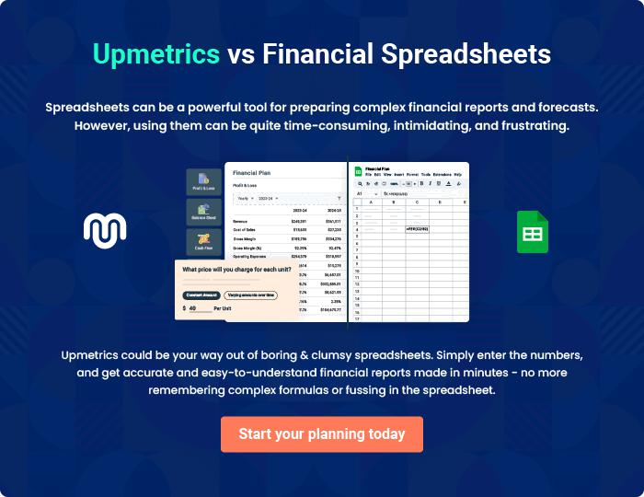
Appendix

When writing the appendix section, you should include any additional information that supports the main content of your plan. This may include financial statements, market research data, legal documents, and other
To unlock help try Upmetrics! 
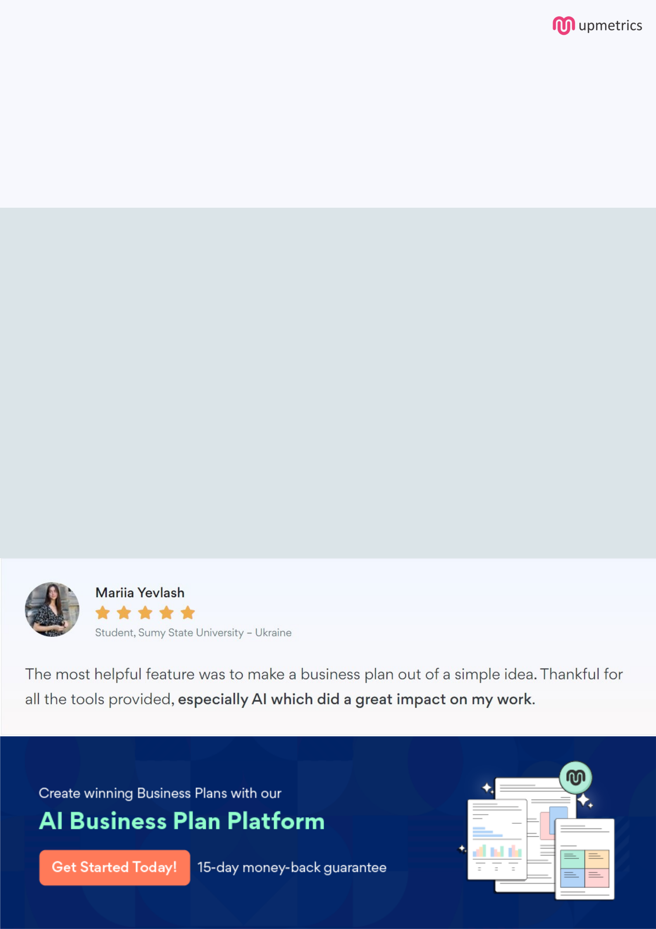
Create a winning business plan that gets you funded

Creating a stunning and investment-ready plan requires no writing, graphic designing, or financial planning expertise.

Upmetrics has all the features required to help you create a comprehensive business plan—from start to finish. Make no mistakes, it’s the modern way of planning to structure ideas, make plans, and create stunning pitch decks to awe investors.

Pitch decks that impress investors

Create pitch decks that provide a visual representation of your business, engage investors, and make them want to invest in your business idea.

Interactive plans in no time

Import business plan sections like—SWOT analysis, comparison tables, and others to create an interactive business plan. No designing skills are required.

Stunning cover page designs

With Upmetrics, you have the liberty to choose from multiple stunning cover page designs. Choose a creative design and make your plan stand out.

Online sharing made simple

Upmetrics makes online sharing quick and easier for users. Easily share your business plans with a link while tracking reader activity.

500+ sample business plans

Simply import a template from our library of sample plans into the editor and start customizing it to make it yours. It takes only a few clicks to get started.

Collaborate with team in real-time

Invite team members, initiate conversations, discuss ideas & strategies, share feedback, and work on a business plan in real-time.

