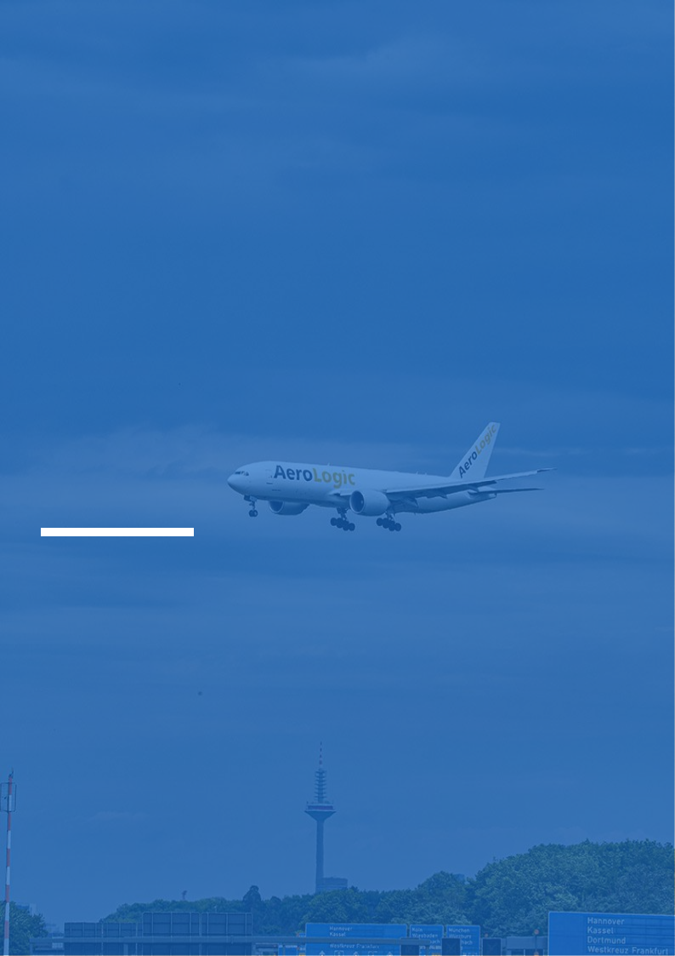
Airline Business Plan

Flying Dreams, Connecting Worlds

BUSINESS PLAN

2023

John Doe | 10200 Bolsa Ave, Westminster, CA, 92683 | (650) 359-3153 | info@example.com
http://www.example.com

Information provided in this business plan is unique to this business and confidential; therefore, anyone reading this plan agrees not to disclose any of the information in this business plan without prior written permission of the company.
Table of Contents

Executive Summary | 6
Market opportunity | 6
Services Offered | 6
Marketing & Sales Strategies | 7
Financial Highlights | 7
Units Sold v/s Revenue | 8

Company Overview | 9
Ownership | 9
Mission statement | 10
Business history | 10
Future goals | 10

Market Analysis | 11
Target Market | 11
Market size and growth potential | 11
Market Size | 12
Competitive analysis | 12
SkyHigh Airlines | 12
JetStream Express | 13
RegionalWings | 13
Market trends | 13
Regulatory environment | 14

Products and Services | 15
Airline Services | 15
Economy Class Seating | 15
Business Class Seating | 16
In-Flight Wi-Fi | 16
Extra Baggage Allowance | 17
Pre-Booked Meals | 17
Priority Boarding | 17
Loyalty Program Membership | 18
Quality Measures | 18
Additional Services | 18

Sales And Marketing Strategies | 19
Unique Selling Proposition (USP) | 19
Pricing Strategy | 19
Marketing strategies | 20
Online | 20
Offline | 20
Sales strategies | 21
Customer retention | 22

Operations Plan | 23
Staffing & Training | 23
Operational Process | 23
Equipment & Software | 24

Management Team | 25
Key managers | 25
John Doe | 25
Jane Doe | 26
Alice Brown | 26
Robert Brown | 26
Organizational structure | 27
Organization chart | 27
Compensation plan | 27
Advisors/Consultants | 28
Dr. Michael Johnson | 28
Samantha Taylor | 28
Financial Plan | 29
Profit & loss statement | 29
Cash flow statement | 32
Balance sheet | 34
Break-even Analysis | 36
Financing needs | 38
Appendix
Appendix | 40
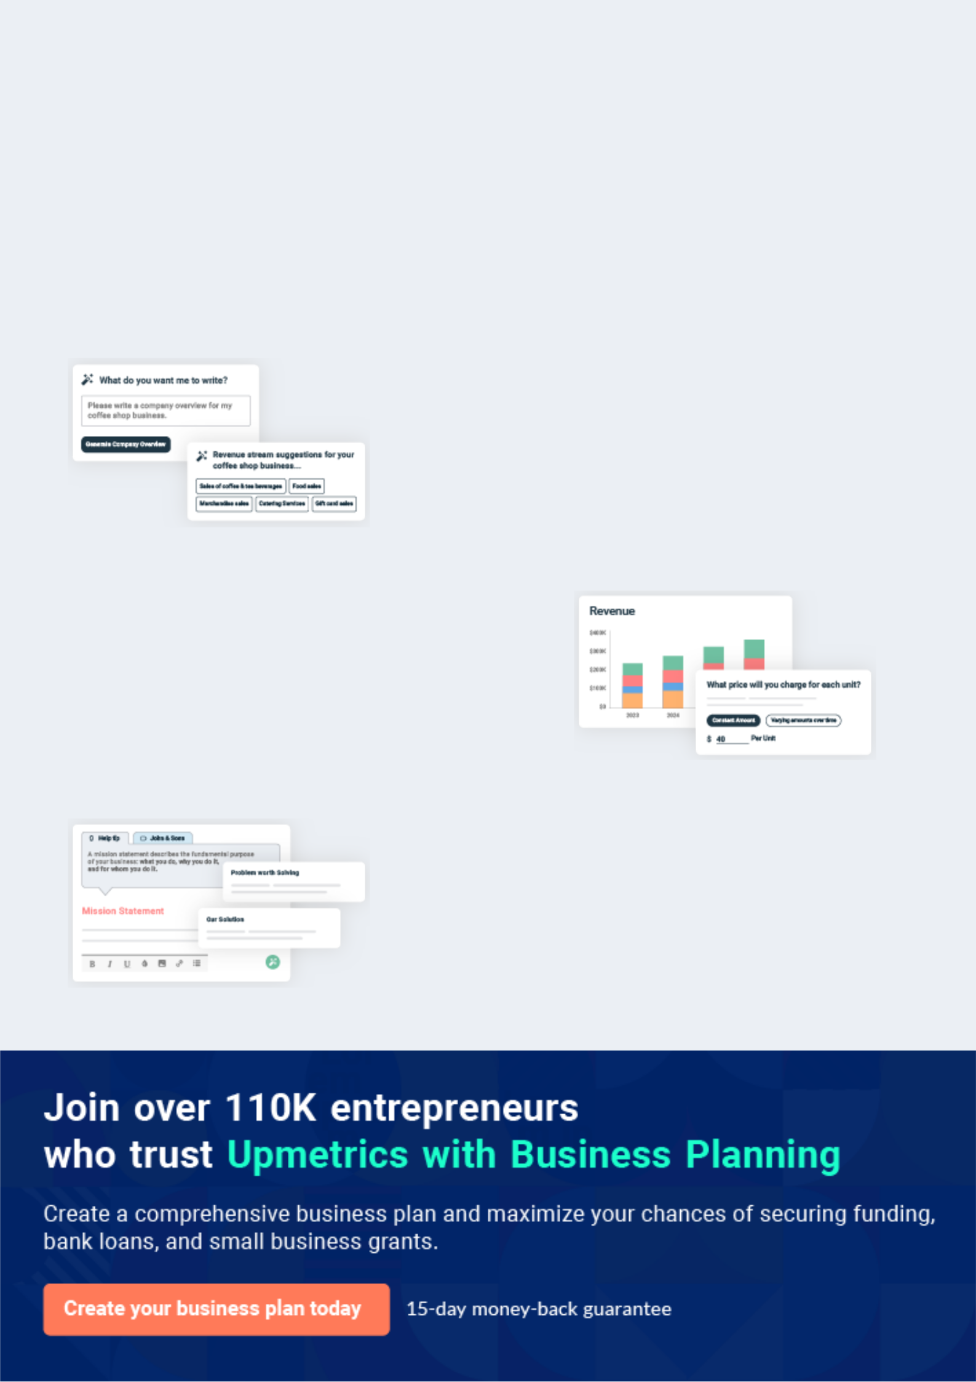
Business planning that’s simpler and faster than you think

Creating a business plan using Upmetrics to start and grow a business is literally the easiest thing in the World. Simply read the instructions and fill in the blanks. It’s as simple as that.

❛ | Upmetrics has everything you need to create a | ❜
❛ | comprehensive business plan. | ❜

AI-powered Upmetrics Assistant

AI-powered insights to streamline your plan

Not sure where to start? Upmetrics’ AI Assistant will automatically generate ideas for each section of your plan and offer improved versions of your writing, adjusting for tone, voice, and grammar or spelling errors.

Financial Forecasting Tool

All the financials are calculated for you

Forget the complex formulas and clumsy spreadsheets — with automatic financials and drag-and-drop forecasting, you can finish your plan faster and be confident that your numbers are accurate.

Business Plan Builder

Guides you like a business mentor

Upmetrics’ step-by-step instructions, prompts, and the library of 400+ sample business plans will guide you through each section of your plan as a business mentor.
Executive Summary


An executive summary is the first section of the business plan intended to provide an overview of the whole business plan.
To unlock help try Upmetrics! 

 Help tip  Airline Business Plan


Start your executive summary by briefly introducing your business to your readers.

This section may include the name of your airline business, its location, when it was founded,
To unlock help try Upmetrics! 

Start writing here..

Market opportunity

 Help tip  Airline Business Plan

Summarize your market research, including market size, growth potential, and marketing trends. Highlight the opportunities in the market and how your business will fit in to fill the gap.
To unlock help try Upmetrics! 

Start writing here..

Services Offered

 Help tip  Airline Business Plan

Highlight the airline services you offer your clients. The USPs and differentiators you offer are always a plus.
To unlock help try Upmetrics! 

Start writing here..

Marketing & Sales Strategies
To unlock help try Upmetrics!

 Help tip  Airline Business Plan

Outline your sales and marketing strategies—what marketing platforms you use, how you plan on acquiring customers, etc.
To unlock help try Upmetrics! 

Start writing here..

Financial Highlights

 Help tip  Airline Business Plan

Briefly summarize your financial projections for the initial years of business operations. Include any capital or investment requirements, associated startup costs, projected revenues, and profit forecasts.



Start writing here..
Units Sold v/s Revenue

 |  | Units Sold | Revenue
15.00k
10.00k
5.00k
0
Year 1 | Year 2 | Year 3


Financial Year |  |  | Units Sold | Revenue
Year 1 | 1,550 |  |  | $10,000
Year 2 | 1,800 |  |  | $12,000
Year 3 | 2,050 |  |  | $14,000
 Help tip |  |  Airline Business Plan


Summarize your executive summary section with a clear CTA, for example, inviting angel investors to discuss the potential business investment.
To unlock help try Upmetrics! 

Write a call to action for your business plan.
Company Overview

Depending on what details of your business are essential, you’ll need different elements in your business overview.
To unlock help try Upmetrics! 

 Help tip  Airline Business Plan

Describe your business in this section by providing all the basic information:

Describe what kind of airline company you run and the name of it. You may specialize in one of
To unlock help try Upmetrics! 

Start writing here..

Ownership

 Help tip  Airline Business Plan

List the names of your airline company’s founders or owners. Describe what shares they own and their responsibilities for efficiently managing the business.
To unlock help try Upmetrics! 

Start writing here..
Mission statement

 Help tip  Airline Business Plan

Summarize your business’ objective, core principles, and values in your mission statement. This statement needs to be memorable, clear, and brief.
To unlock help try Upmetrics! 

❛ At [BreezeBird Airlines], we are committed to connecting lives and creating memorable journeys. Our mission is to offer affordable, reliable, and enjoyable air travel experiences, grounded in safety, efficiency, and unparalleled customer service.

We uphold the values of integrity, innovation, and inclusivity, as we soar to new heights together.

❜

Business history

 Help tip  Airline Business Plan

If you’re an established airline service provider, briefly describe your business history, like— when it was founded, how it evolved over time, etc.
To unlock help try Upmetrics! 

Start writing here..

Future goals

 Help tip  Airline Business Plan

It’s crucial to convey your aspirations and vision. Mention your short-term and long-term goals; they can be specific targets for revenue, market share, or expanding your services.
To unlock help try Upmetrics! 

Start writing here..

Market Analysis
To unlock help try Upmetrics!


 |  | Market analysis provides a clear understanding of the market in which your
 |  | printing business will run along with the target market, competitors, and
 |  | growth opportunities.
 |  |  |  | To unlock help try Upmetrics! 
 Help tip |  |  Airline Business Plan

To write the introduction section of your market analysis, start by clearly identifying your primary target market.
To unlock help try Upmetrics! 

Start writing here..

Target Market

 Help tip  Airline Business Plan

Start this section by describing your target market. Define your ideal customer and explain what types of services they prefer. Creating a buyer persona will help you easily define your target market to your readers.



Start writing here..

Market size and growth potential

 Help tip  Airline Business Plan

Describe your market size and growth potential and whether you will target a niche or a much broader market.
To unlock help try Upmetrics! 

Start writing here..

Market Size

Available Market

Total global revenue potential for 3D 150M printing.

Served Market
Air travelers that prefer routes 75M
BreezeBird operates.

Target Market
Budget-conscious leisure and 30M business travelers.

 Help tip  Airline Business Plan

Identify and analyze your direct and indirect competitors. Identify their strengths and weaknesses, and describe what differentiates your airline services from them.
To unlock help try Upmetrics! 

Competitive analysis

SkyHigh Airlines

Established in [Year], SkyHigh Airlines is a full-service carrier known for its extensive route network and premium in-flight services. With a strong brand presence and a loyal customer base, SkyHigh has been a dominant player in the market.

Features | Strengths
Extensive domestic and | Well-established brand with
international routes | strong market recognition
Premium in-flight amenities | Wide network of destinations
Loyalty rewards program | Strong partnerships with other
Business and first-class | airlines and travel agencies
seating options

Weaknesses

Higher ticket prices compared to low-cost carriers

Operational costs associated with maintaining a large fleet and premium services

Limited flexibility in pricing and packages

JetStream Express

JetStream Express is a low-cost carrier that entered the market in [Year], quickly gaining popularity for its affordable travel options and efficient services. Targeting budget-conscious travelers, JetStream has carved out a significant market share in the budget travel segment.

Features | Strengths | Weaknesses
Competitive pricing and | Strong appeal to price-sensitive | Limited in-flight services and
affordable ticket options | customers | amenities
Streamlined services for | Lean operations leading to | Smaller route network compared
operational efficiency | lower operational costs | to full-service carriers
Frequent promotions and | Agile and able to quickly | Perception of lower quality due
discounts | respond to market changes | to budget pricing
User-friendly online booking
system

RegionalWings

A regional carrier specializing in short-haul flights, RegionalWings has been serving smaller communities and airports since [Year]. Known for their community engagement and reliable services, they have become a preferred choice for travelers in specific regions.

Features | Strengths | Weaknesses
Extensive network of short-haul | Strong reputation in regional | Limited international and long-
flights | markets | haul flight options
Community engagement and | Ability to serve smaller airports | Smaller fleet size
personalized services | and communities | Dependency on specific regional
Flexible ticketing and travel | Personalized customer service | markets
options
Focus on underserved markets
and airports

Market trends

 Help tip  Airline Business Plan

Analyze emerging trends in the industry, such as technology disruptions, changes in customer behavior or preferences, etc. Explain how your business will cope with all the trends.
To unlock help try Upmetrics! 

Start writing here..

Regulatory environment

 Help tip  Airline Business Plan

List regulations and licensing requirements that may affect your airline company, such as airline deregulation, aviation security, consumer protection, competition regulation, etc.
To unlock help try Upmetrics! 

Start writing here..
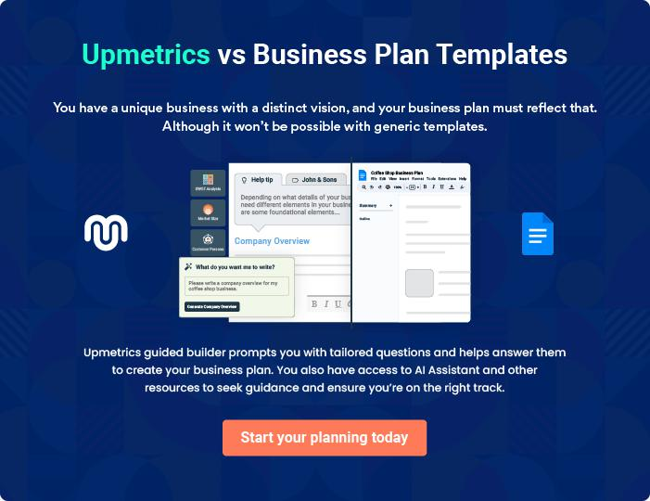
Products and Services

 |  | The product and services section of an airline business plan should describe
 |  | the specific services and products that will be offered to customers. To write
 |  | this section should include the following:
 |  |  |  | To unlock help try Upmetrics! 
 Help tip |  |  Airline Business Plan

To craft the introduction for your "Products and Services" chapter, begin by positioning your business within its industry, emphasizing its unique strengths or value proposition.
To unlock help try Upmetrics! 

Start writing here..

 Help tip


Mention the airline services your business will offer. This list may include services like,

• Passenger flight
To unlock help try Upmetrics! 

Airline Services

Economy Class Seating


Price: Starting at $[XXX] per ticket

Our economy class offers an affordable yet comfortable travel option, perfect for budget-conscious travelers

Specifications

- Seat Pitch: 31 inches

- Seat Width: 17 inches

- In-flight Entertainment: Over 100 hours of movies and TV shows

- Meal Service: Complimentary snacks and beverages
Business Class Seating

Price: Starting at $[XXX] per ticket

For those seeking a more luxurious experience, our business class provides spacious seating, premium amenities, and personalized service.

Specifications

- Lie-flat Seats

- Seat Pitch: 76 inches

- Access to VIP Lounges

- Premium In-flight Entertainment

- Gourmet Meal Service

In-Flight Wi-Fi

Price: $[XX] for the duration of the flight

Stay connected even while cruising at 35,000 feet with our in-flight Wi-Fi service.

Specifications

- Available on select flights

- High-speed internet connectivity

- Purchase through the in-flight entertainment system or pre-flight
Extra Baggage Allowance

Price: $[XX] per additional bag

For those needing to travel with extra luggage, our additional baggage allowance option provides the flexibility you need.

Specifications

- Maximum Weight: 23kg per bag

- Additional bags can be purchased up to 24 hours before the flight

Pre-Booked Meals

Price: Starting at $[XX] per meal

Ensure you have the meal of your choice by pre-booking from our gourmet selection, available on flights longer than [X] hours.

Specifications

- Options include vegetarian, vegan, gluten-free, and kosher

- Must be booked at least 48 hours before departure

Priority Boarding

Price: $[XX]

Skip the queues and board at your convenience with our priority boarding service.

Specifications

- Available to pre-purchase during booking or at check-in

- Includes priority security screening at select airports
Loyalty Program Membership

Price: Complimentary enrollment

Join our loyalty program and earn points with every flight, enjoying a range of exclusive benefits and rewards.

Specifications

- Earn points on flights, partner hotels, and car rentals

- Redeem points for flights, upgrades, and more

- Access to member-only promotions and offers

Quality Measures

 Help tip  Airline Business Plan

This section should explain how you maintain quality standards and consistently provide the highest quality service.
To unlock help try Upmetrics! 

Start writing here..

Additional Services

 Help tip  Airline Business Plan

Mention if your airline company offers any additional services. You may include services like pre-booking seats, extra baggage allowance, in-flight entertainment options, onboard Wi-Fi, duty-free shopping, special assistance for passengers with disabilities, etc.
To unlock help try Upmetrics! 

Start writing here..
Sales And Marketing Strategies

Writing the sales and marketing strategies section means a list of strategies you will use to attract and retain your clients.
To unlock help try Upmetrics! 

 Help Tip  Airline Business Plan


To create an effective introduction for your "Sales and Marketing Strategies" chapter, start by setting the stage within your specific industry or market.
To unlock help try Upmetrics! 

Start writing here..

Unique Selling Proposition (USP)

 Help tip  Airline Business Plan

Define your business’s USPs depending on the market you serve, the equipment you use, and your unique services. Identifying USPs will help you plan your marketing strategies.
To unlock help try Upmetrics! 

Start writing here..

Pricing Strategy

 Help tip  Airline Business Plan

Describe your pricing strategy—how you plan to price your services and stay competitive in the local market. You can mention any discounts you plan on offering to attract new customers.
To unlock help try Upmetrics! 

Start writing here..

 Help tip
To unlock help try Upmetrics!

Discuss your marketing strategies to market your services. You may include some of these marketing strategies in your business plan—social media marketing, Google ads, targeted advertising, content marketing, etc.



Marketing strategies

Online


Digital Advertising

Utilizing platforms like Google Ads and social media, we aim to reach our target audience through targeted advertising and strategic content marketing.

Content Marketing

Our content strategy includes [Insert Types of Content, e.g., travel blogs, in-flight magazines, video content], designed to engage customers and highlight our services.

Offline

Partnerships

We will establish partnerships with [Insert Types of Businesses, e.g., travel agencies, hotels] to increase our visibility and reach a broader audience.

 Help tip
To unlock help try Upmetrics!

Outline the strategies you’ll implement to maximize your sales. Your sales strategies may include partnering with other businesses, influencer collaboration, offering referral programs, etc.



Sales strategies

Partner with Businesses

Collaborating with other businesses in the travel industry will allow us to offer package deals and promotions, driving sales and increasing customer value.

Referral Programs

Implementing a referral program will encourage word-of-mouth recommendations, leveraging our existing customer base to attract new clients.

Direct Sales

Through our website and mobile app, customers will have direct access to our services, promotions, and customer support.

 Help tip

Describe your customer retention strategies and how you plan to execute them. For instance, introducing loyalty programs, discounts & offers, personalized service, etc.
To unlock help try Upmetrics! 

Customer retention

Loyalty Programs

Our loyalty program is designed to reward frequent flyers, encouraging repeat business and fostering a strong customer relationship.

Personalized Service

By utilizing customer data, we aim to personalize our services, providing recommendations, and offers that cater to individual preferences and travel patterns.

After-Sales Support

Providing exceptional customer service post-booking and post-flight is crucial. Our customer support team will be readily available to address inquiries, provide assistance, and gather feedback to continually improve our services

Operations Plan
To unlock help try Upmetrics!

 |  | When writing the operations plan section, it’s important to consider the
 |  | various aspects of your business operations.
 |  |  |  | To unlock help try Upmetrics! 
 Help tip |  |  Airline Business Plan


To create an effective introduction for your "Operational Plan" chapter, start by emphasizing the
pivotal role of efficient operations in the success of your business, underscoring how they
directly impact the quality of services delivered.
 |  |  |  | To unlock help try Upmetrics! 
Start writing here..
Staffing & Training
 Help tip |  |  Airline Business Plan

Mention your business’s staffing requirements, including the number of employees or cabin crew needed. Include their qualifications, the training required, and the duties they will perform.
To unlock help try Upmetrics! 

Start writing here..

Operational Process

 Help tip  Airline Business Plan

Outline the processes and procedures you will use to run your airline business. Your operational processes may include flight planning & scheduling, ground operations, aircraft operations, safety & security, customer service, etc.



Start writing here..

Equipment & Software

 Help tip  Airline Business Plan

Include the list of equipment and software required for the airline, such as aircraft, baggage handling systems, flight operations systems, revenue management systems, etc.
To unlock help try Upmetrics! 

Start writing here..
Management Team

The management team section provides an overview of the individuals responsible for running your business plan.
To unlock help try Upmetrics! 

 Help tip  Airline Business Plan

To craft an introduction for your "Management Team" chapter, begin by emphasizing the crucial role of leadership in the success of any business.
To unlock help try Upmetrics! 

Start writing here..

Key managers

 Help tip  Airline Business Plan

Introduce your management and key members of your team, and explain their roles and responsibilities.
To unlock help try Upmetrics! 

Start writing here..


JOHN DOE

CEO & Co-founder - john.doe@example.com

John Doe is a seasoned professional in the aviation industry with over 25 years of experience.

He holds a Master’s degree in Aeronautical Engineering from the prestigious MIT and an MBA from Harvard Business School.


Prior to founding [BreezeBird Airlines], John worked in various leadership positions at major airlines, where he honed his skills in strategic planning, operations, and customer service.

He is known for his visionary leadership and commitment to excellence.

JANE DOE

Chief Operating Officer (COO) - jane.doe@example.com

Jane Doe brings over 20 years of experience in airline operations to [BreezeBird Airlines]. She has a Bachelor’s degree in Aviation Management and an MBA from Stanford University.


Before joining BreezeBird, Jane was the Director of Operations at a major international airline, overseeing all aspects of flight operations and ground services.

Her expertise in operational efficiency and safety management is a valuable asset to our team.


ALICE BROWN

CMO - robert.brown@example.com

Alice Brown has a vibrant background in marketing and brand development, with over 18 years of experience specifically in the travel and aviation sector.

She holds a Bachelor's degree in Marketing from UCLA and an MBA from Columbia Business School.

Alice has successfully led marketing campaigns for airlines, increasing brand visibility and customer engagement.

Her innovative approach to digital marketing and customer relations sets her apart in the industry.


ROBERT BROWN

CFO - robert.brown@example.com

Robert Brown is a financial expert with a deep understanding of the aviation industry.

He has a Bachelor’s degree in Finance from the University of Chicago and is a Certified Public Accountant (CPA).

With over 22 years of experience in financial management and strategic planning, Robert has played a pivotal role in ensuring the financial stability and growth of several airlines.

His acumen in risk management, budgeting, and financial analysis is integral to the success of [BreezeBird Airlines].
Organizational structure

 Help tip  Airline Business Plan

Explain the organizational structure of your management team. Include the reporting line and decision-making hierarchy.
To unlock help try Upmetrics! 

Start writing here..

Organization chart


John Doe

CEO


Alice Brown Jane Doe Robert Brown

CMO COO CFO




William Smith Emily Johnson

Head of Customer Head of Human

Service Resources

Compensation plan

 Help tip  Airline Business Plan

Describe your compensation plan for the management and staff. Include their salaries, incentives, and other benefits.
To unlock help try Upmetrics! 

Start writing here..

 Help tip  Airline Business Plan

Mentioning advisors or consultants in your business plans adds credibility to your business idea.
To unlock help try Upmetrics! 

Advisors/Consultants


DR. MICHAEL JOHNSON

Aviation Safety Advisor

Dr. Johnson advises us on all matters related to aviation safety, ensuring that our operations meet and exceed industry safety standards. He conducts regular safety audits and provides recommendations for continuous improvement.

Dr. Johnson is a former National Transportation Safety Board (NTSB) investigator with over 30 years of experience in aviation safety. He holds a Ph.D. in Aerospace Safety and is widely recognized as an expert in his field.


SAMANTHA TAYLOR

Financial Consultant

Samantha assists us with financial planning, budgeting, and financial analysis. She ensures that our financial models are robust and that we are making sound financial decisions.

Samantha is a Certified Public Accountant with 15 years of experience in financial consulting, specifically in the aviation sector. She has helped numerous airlines optimize their financial performance.
Financial Plan

When writing the financial plan section of a business plan, it’s important to provide a comprehensive overview of your financial projections for the first few years of your business, You may provide the following:
To unlock help try Upmetrics! 

 Help tip  Airline Business Plan


To create an effective introduction for your "Financial Plan" chapter, begin by stressing the critical role of a well-structured financial plan in the success of your venture.
To unlock help try Upmetrics! 

Start writing here..

 Help tip  Airline Business Plan

Describe details such as projected revenue, operational costs, and service costs in your projected profit and loss statement. Make sure to include your business’s expected net profit or loss.
To unlock help try Upmetrics! 

Profit & loss statement

Revenue

Cost Of Sales

General Costs

Revenue Specific Costs

Personnel Costs (Direct

Labor)

Gross Margin

Gross Margin (%)

Operating Expense

Payroll Expense

(Indirect Labor)

General Expense

Bad Debt

Amortization of Current

Assets

2023-24 | 2024-25 | 2025-26 | 2026-27 | 2027-28
$0 | $0 | $0 | $0 | $0

$0 | $0 | $0 | $0 | $0
$0 | $0 | $0 | $0 | $0
$0 | $0 | $0 | $0 | $0
$0 | $0 | $0 | $0 | $0

$0 | $0 | $0 | $0 | $0
0% | 0% | 0% | 0% | 0%

$0 | $0 | $0 | $0 | $0
$0 | $0 | $0 | $0 | $0
$0 | $0 | $0 | $0 | $0
$0 | $0 | $0 | $0 | $0
$0 | $0 | $0 | $0 | $0

EBITDA

Additional Expense

Long Term

Depreciation

Gain or loss from Sale

of Assets

EBIT

Interest Expenses

EBT

Income Tax Expense

Total Expense

Net Income

Net Income (%)

2023-24 | 2024-25 | 2025-26 | 2026-27 | 2027-28
$0 | $0 | $0 | $0 | $0
$0 | $0 | $0 | $0 | $0
$0 | $0 | $0 | $0 | $0
$0 | $0 | $0 | $0 | $0
$0 | $0 | $0 | $0 | $0
$0 | $0 | $0 | $0 | $0
$0 | $0 | $0 | $0 | $0
$0 | $0 | $0 | $0 | $0
$0 | $0 | $0 | $0 | $0
$0 | $0 | $0 | $0 | $0
0% | 0% | 0% | 0% | 0%

 |  |  | 2023-24 |  | 2024-25 | 2025-26
Retained Earning |  |  | $0 |  | $0 | $0
Opening |  |  |  |  | $0 | $0
Owner's Distribution |  |  | $0 |  | $0 | $0
Retained Earning |  |  | $0 |  | $0 | $0
Closing |  |  |  |  | $0 | $0
 Help tip |  |  |  Airline Business Plan


The cash flow for the first few years of your operation should be estimated and described in this section.

This may include billing invoices, payment receipts, loan payments, and any other cash flow statements.
2026-27 2027-28

$0 $0

$0 $0

$0 $0

To unlock help try Upmetrics! 

Cash flow statement

 | 2023-24 | 2024-25 | 2025-26 | 2026-27 | 2027-28
Cash Received | $0 | $0 | $0 | $0 | $0
Cash Paid | $0 | $0 | $0 | $0 | $0
COS & General Expenses | $0 | $0 | $0 | $0 | $0
Salary & Wages | $0 | $0 | $0 | $0 | $0
Interest | $0 | $0 | $0 | $0 | $0

Sales Tax

Income Tax

Net Cash From

Operations

Assets Sell

Assets Purchase

Net Cash From

Investments

Amount Received

Loan Received

Common Stock

Preferred Stock

Owner's Contribution

Amount Paid

2023-24 | 2024-25 | 2025-26 | 2026-27 | 2027-28
$0 | $0 | $0 | $0 | $0
$0 | $0 | $0 | $0 | $0
$0 | $0 | $0 | $0 | $0

$0 | $0 | $0 | $0 | $0
$0 | $0 | $0 | $0 | $0
$0 | $0 | $0 | $0 | $0

$0 | $0 | $0 | $0 | $0
$0 | $0 | $0 | $0 | $0

$0 | $0 | $0 | $0 | $0
$0 | $0 | $0 | $0 | $0
$0 | $0 | $0 | $0 | $0

Loan Capital $0 $0 $0 $0 $0

 |  |  | 2023-24 | 2024-25 | 2025-26 | 2026-27 | 2027-28
Dividends & Distributions |  |  | $0 | $0 | $0 | $0 | $0
Net Cash From |  |  | $0 | $0 | $0 | $0 | $0
Financing
Summary
Starting Cash |  |  | $0 | $0 | $0 | $0 | $0
Cash In |  |  | $0 | $0 | $0 | $0 | $0
Cash Out |  |  | $0 | $0 | $0 | $0 | $0
Change in Cash |  |  | $0 | $0 | $0 | $0 | $0
Ending Cash |  |  | $0 | $0 | $0 | $0 | $0
 Help tip |  |  Airline Business Plan

Create a projected balance sheet documenting your airline business’s assets, liabilities, and equity.

To unlock help try Upmetrics! 

Balance sheet

 | 2023-24 | 2024-25 | 2025-26 | 2026-27 | 2027-28
Assets | $0 | $0 | $0 | $0 | $0
Current Assets | $0 | $0 | $0 | $0 | $0
Cash | $0 | $0 | $0 | $0 | $0
Accounts Receivable | $0 | $0 | $0 | $0 | $0
Inventory | $0 | $0 | $0 | $0 | $0
Other Current Assets | $0 | $0 | $0 | $0 | $0
Long Term Assets | $0 | $0 | $0 | $0 | $0
Gross Long Term Assets | $0 | $0 | $0 | $0 | $0
Accumulated Depreciation | $0 | $0 | $0 | $0 | $0

Liabilities & Equity | $0 | $0 | $0 | $0 | $0
Liabilities | $0 | $0 | $0 | $0 | $0
Current Liabilities | $0 | $0 | $0 | $0 | $0
Accounts Payable | $0 | $0 | $0 | $0 | $0
Income Tax Payable | $0 | $0 | $0 | $0 | $0
Sales Tax Payable | $0 | $0 | $0 | $0 | $0
Short Term Debt | $0 | $0 | $0 | $0 | $0
 | 2023-24 | 2024-25 | 2025-26 | 2026-27 | 2027-28
Long Term Liabilities | $0 | $0 | $0 | $0 | $0
Long Term Debt | $0 | $0 | $0 | $0 | $0
Equity | $0 | $0 | $0 | $0 | $0
Paid-in Capital | $0 | $0 | $0 | $0 | $0
Common Stock | $0 | $0 | $0 | $0 | $0
Preferred Stock | $0 | $0 | $0 | $0 | $0
Owner's Contribution | $0 | $0 | $0 | $0 | $0
Retained Earnings | $0 | $0 | $0 | $0 | $0

Check | $0 |  |  | $0 | $0 | $0 | $0
 Help tip |  |  Airline Business Plan

Determine and mention your business’s break-even point—the point at which your business costs and revenue will be equal.

This exercise will help you understand how much revenue you need to generate to sustain or be profitable.
To unlock help try Upmetrics! 

Break-even Analysis

 | 2023-24 | 2024-25 | 2025-26 | 2026-27 | 2027-28
Starting Revenue | $0 | $0 | $0 | $0 | $0
Net Revenue | $0 | $0 | $0 | $0 | $0
Closing Revenue | $0 | $0 | $0 | $0 | $0

Starting Expense | $0 | $0 | $0 | $0 | $0
Net Expense | $0 | $0 | $0 | $0 | $0
Closing Expense | $0 | $0 | $0 | $0 | $0

Is Break Even? | 0 | 0 | 0 | 0 | 0
Break Even Month | 0 | 0 | 0 | 0 | 0
Days Required | 0 | 0 | 0 | 0 | 0
Break Even Revenue | $0 | $0 | $0 | $0 | $0
Break Even Units
Financing needs

 Help tip  Airline Business Plan

Calculate costs associated with starting an airline business, and estimate your financing needs and how much capital you need to raise to operate your business.
To unlock help try Upmetrics! 

Start writing here..
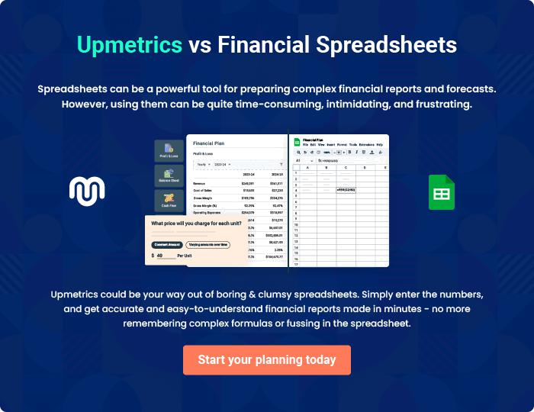
Appendix

When writing the appendix section, you should include any additional information that supports the main content of your plan. This may include financial statements, market research data, legal documents, and other
To unlock help try Upmetrics! 
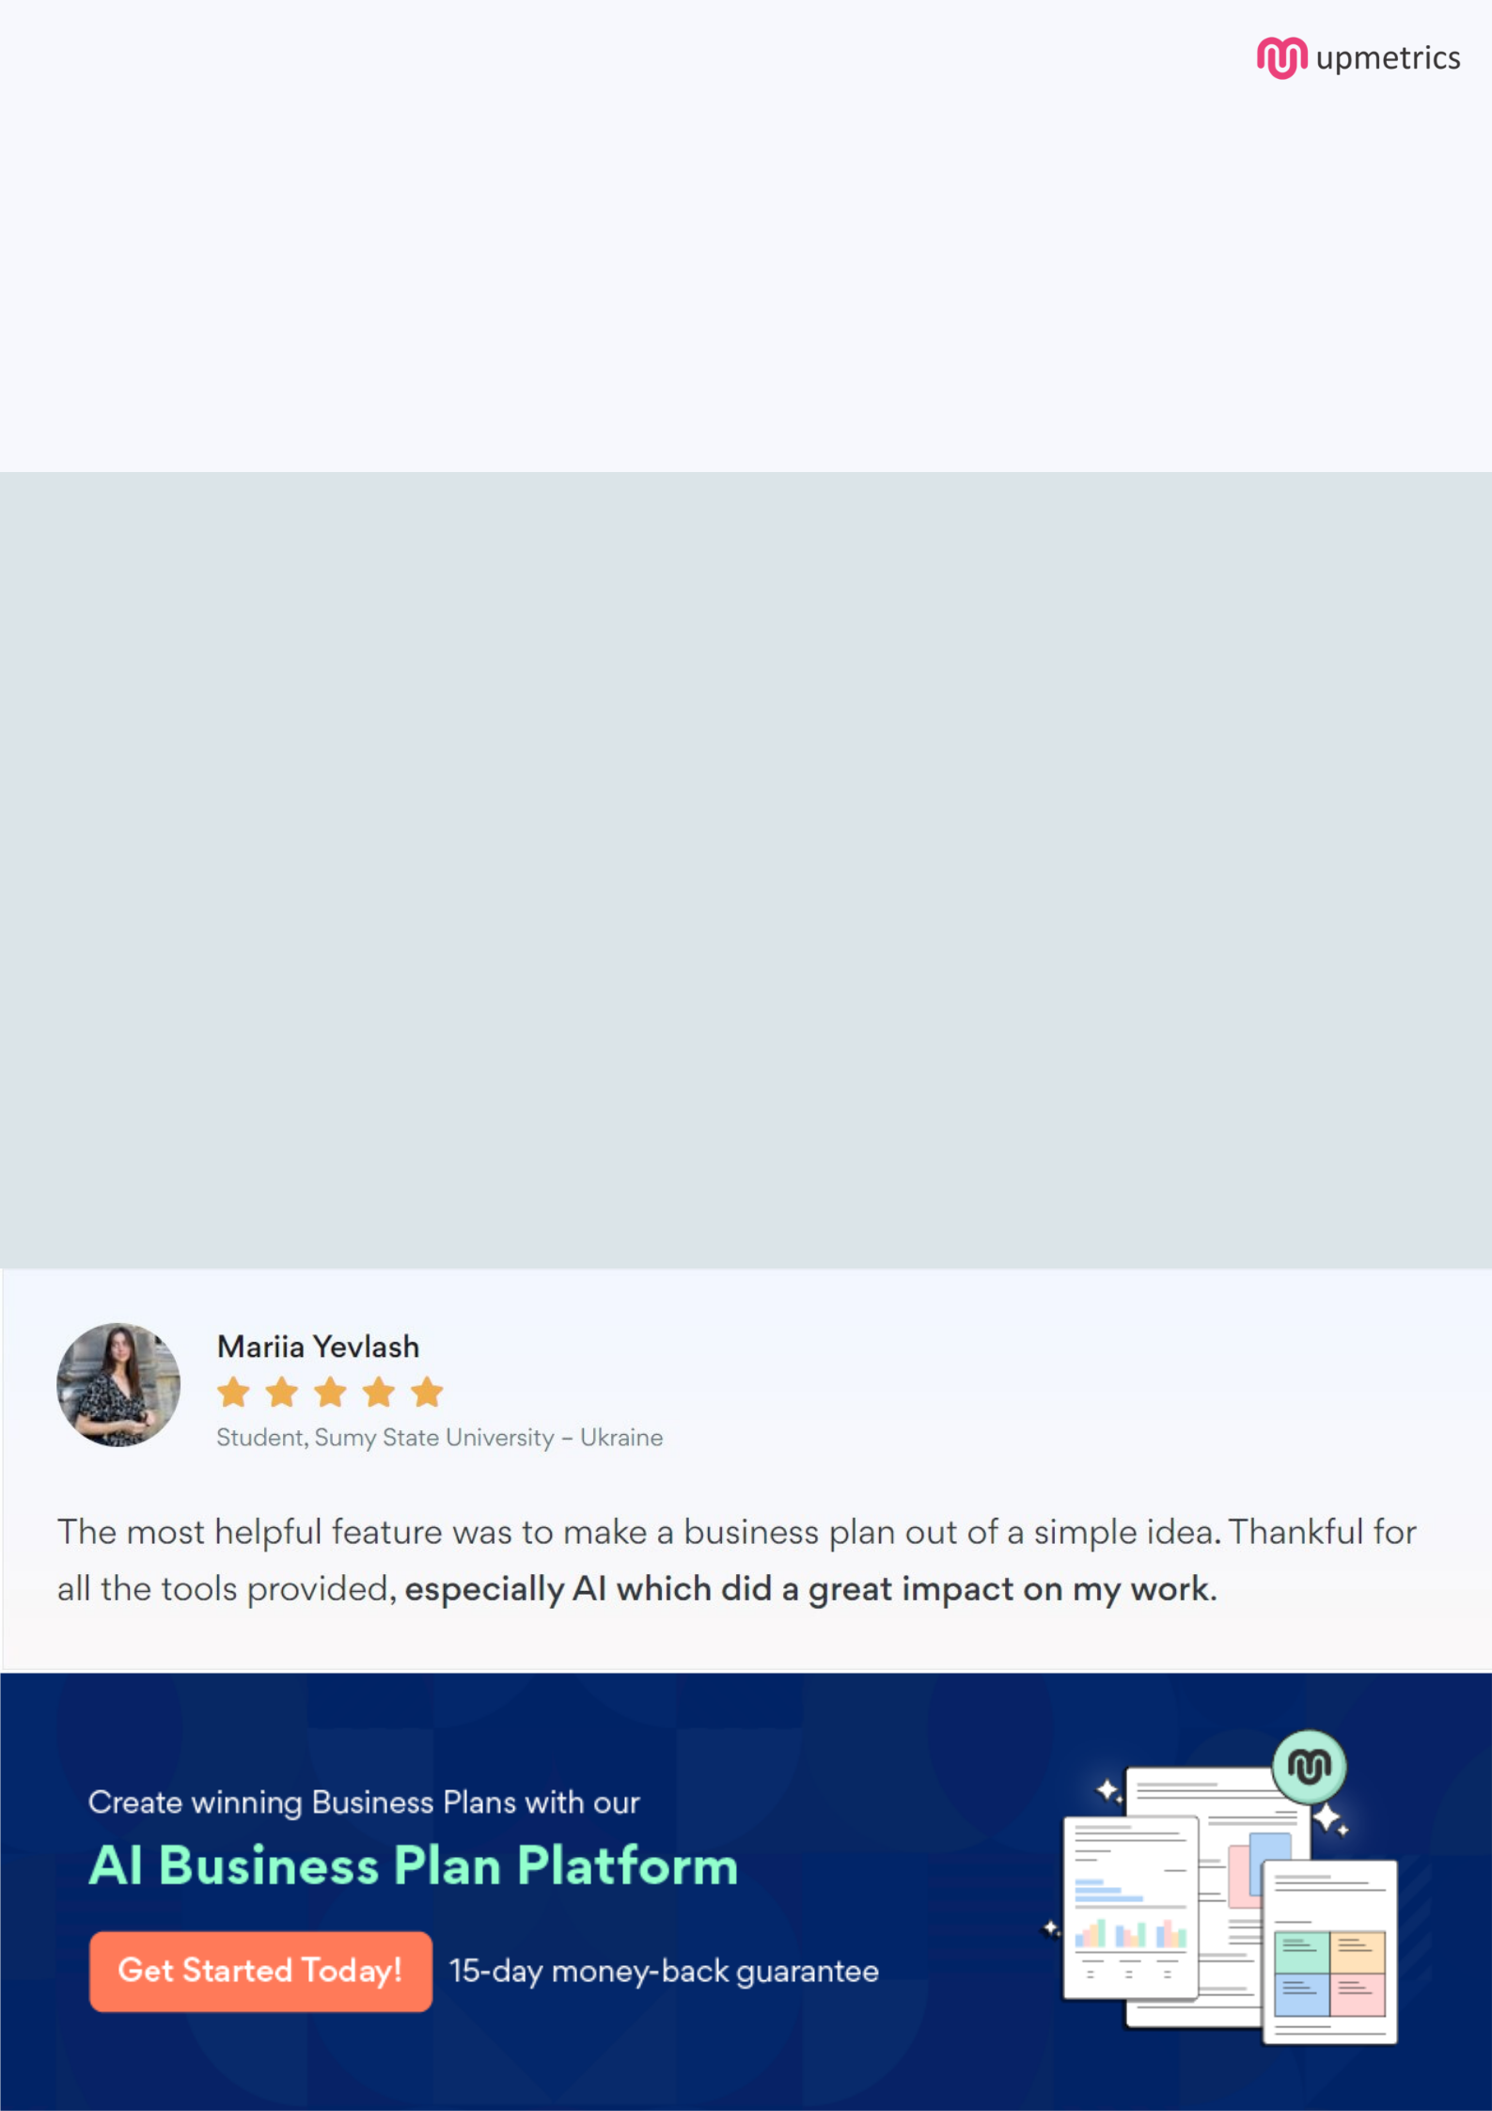
Create a winning business plan that gets you funded

Creating a stunning and investment-ready plan requires no writing, graphic designing, or financial planning expertise.

Upmetrics has all the features required to help you create a comprehensive business plan—from start to finish. Make no mistakes, it’s the modern way of planning to structure ideas, make plans, and create stunning pitch decks to awe investors.

Pitch decks that impress investors

Create pitch decks that provide a visual representation of your business, engage investors, and make them want to invest in your business idea.

Interactive plans in no time

Import business plan sections like—SWOT analysis, comparison tables, and others to create an interactive business plan. No designing skills are required.

Stunning cover page designs

With Upmetrics, you have the liberty to choose from multiple stunning cover page designs. Choose a creative design and make your plan stand out.

Online sharing made simple

Upmetrics makes online sharing quick and easier for users. Easily share your business plans with a link while tracking reader activity.

500+ sample business plans

Simply import a template from our library of sample plans into the editor and start customizing it to make it yours. It takes only a few clicks to get started.

Collaborate with team in real-time

Invite team members, initiate conversations, discuss ideas & strategies, share feedback, and work on a business plan in real-time.

