
BUSINESS PLAN

2023
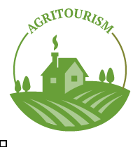

Agritourism Business Plan

Discover the Heart of Farm Life

John Doe

10200 Bolsa Ave, Westminster, CA, 92683

- 359-3153 info@example.com http://www.example.com

Information provided in this business plan is unique to this business and confidential; therefore, anyone reading this plan agrees not to disclose any of the information in this business plan without prior written permission of the company.
Table of Contents

Executive Summary | 6
Market opportunity | 6
Services Offered | 6
Marketing and Sales Strategies | 7
Financial Highlights | 7
Units Sold v/s Revenue | 8

Company Overview | 9
Ownership | 9
Mission statement | 10
Business history | 10
Future goals | 11

Market Analysis | 12
Target Market | 12
Market size and growth potential | 12
Market Size | 13
Competitive analysis | 13
Green Acres Farm Adventures | 14
Eco Adventure Farms | 14
GammaTech 3D | 15
Market trends | 15
Regulatory environment | 15

Products and Services | 17
Agritourism products & services | 17
Farm Adventure Tour | 17
Cheese-Making Workshop | 18
Farm-to-Table Dining Experience | 18
Country Cottage Stay | 18
Harvest Festival Ticket | 19
Organic Vegetable Box | 19
Additional Services | 19

Sales And Marketing Strategies | 20
Unique Selling Proposition (USP) | 20
Pricing Strategy | 20
Marketing strategies | 21
Online | 21
Offline | 21
Sales strategies | 22
Customer retention | 23

Operations Plan | 24
Staffing & Training | 24
Operational Processes | 24
Equipment & Machinery | 25

Management Team | 26
Key managers | 26
John Doe | 26
Jane Doe | 27
Alice Brown | 27
Robert Brown | 27
Organizational structure | 28
Organization chart | 28
Compensation plan | 29
Advisors/Consultants | 29
Dr. Jane Appleseed | 29
Ms. Alice Cash | 30

Financial Plan | 31
Profit & loss statement | 31
Cash flow statement | 34
Balance sheet | 36
Break-even Analysis | 38
Financing needs | 40
Appendix
Appendix | 42
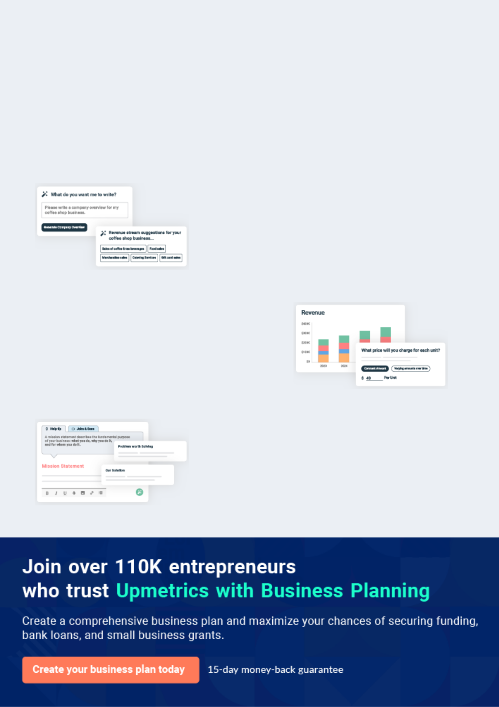
Business planning that’s simpler and faster than you think

Creating a business plan using Upmetrics to start and grow a business is literally the easiest thing in the World. Simply read the instructions and fill in the blanks. It’s as simple as that.

❛ | Upmetrics has everything you need to create a | ❜
❛ | comprehensive business plan. | ❜

AI-powered Upmetrics Assistant

AI-powered insights to streamline your plan

Not sure where to start? Upmetrics’ AI Assistant will automatically generate ideas for each section of your plan and offer improved versions of your writing, adjusting for tone, voice, and grammar or spelling errors.

Financial Forecasting Tool

All the financials are calculated for you

Forget the complex formulas and clumsy spreadsheets — with automatic financials and drag-and-drop forecasting, you can finish your plan faster and be confident that your numbers are accurate.

Business Plan Builder

Guides you like a business mentor

Upmetrics’ step-by-step instructions, prompts, and the library of 400+ sample business plans will guide you through each section of your plan as a business mentor.
Executive Summary


An executive summary is the first section of the business plan intended to provide an overview of the whole business plan.
To unlock help try Upmetrics! 

 Help tip  Agritourism Business Plan


Start your executive summary by briefly introducing your business to your readers.

This section may include the name of your agritourism business, its location, when it was
To unlock help try Upmetrics! 

Start writing here..

Market opportunity

 Help tip  Agritourism Business Plan

Summarize your market research, including market size, growth potential, and marketing trends. Highlight the opportunities in the market and how your business will fit in to fill the gap.
To unlock help try Upmetrics! 

Start writing here..

Services Offered

 Help tip  Agritourism Business Plan

Highlight the agritourism products & services you offer your clients. The USPs and differentiators you offer are always a plus.
To unlock help try Upmetrics! 

Start writing here..

Marketing and Sales Strategies
To unlock help try Upmetrics!

 Help tip  Agritourism Business Plan

Outline your sales and marketing strategies—what marketing platforms you use, how you plan on acquiring customers, etc.
To unlock help try Upmetrics! 

Start writing here..

Financial Highlights

 Help tip  Agritourism Business Plan

Briefly summarize your financial projections for the initial years of business operations. Include any capital or investment requirements, associated startup costs, projected revenues, and profit forecasts.



Start writing here..
Units Sold v/s Revenue

 |  | Units Sold | Revenue
15.00k
10.00k
5.00k
0
Year 1 | Year 2 | Year 3


Financial Year |  |  | Units Sold | Revenue
Year 1 | 1,550 |  |  | $10,000
Year 2 | 1,800 |  |  | $12,000
Year 3 | 2,050 |  |  | $14,000
 Help tip |  |  Agritourism Business Plan


Summarize your executive summary section with a clear CTA, for example, inviting angel investors to discuss the potential business investment.
To unlock help try Upmetrics! 

Write a call to action for your business plan.
Company Overview

Depending on what details of your business are essential, you’ll need different elements in your business overview.
To unlock help try Upmetrics! 

 Help tip  Agritourism Business Plan

Describe your business in this section by providing all the basic information:

Describe what kind of agritourism business you run and the name of it. You may specialize in
To unlock help try Upmetrics! 

Start writing here..

Ownership

 Help tip  Agritourism Business Plan

List the names of your agritourism business’s founders or owners. Describe what shares they own and their responsibilities for efficiently managing the business.
To unlock help try Upmetrics! 

Start writing here..
Mission statement

 Help tip  Agritourism Business Plan

Summarize your business’ objective, core principles, and values in your mission statement. This statement needs to be memorable, clear, and brief.
To unlock help try Upmetrics! 

❛ At [Agri-Adventure Land], our mission is to connect people with the land, fostering a deep appreciation for agriculture and the natural world.

We strive to educate, entertain, and inspire, providing a safe and welcoming space for learning and adventure. Our core values are rooted in sustainability, community, and education, guiding every aspect of our business.

❜

Business history

 Help tip  Agritourism Business Plan

If you’re an established agritourism service provider, briefly describe your business history, like —when it was founded, how it evolved over time, etc.
To unlock help try Upmetrics! 

Start writing here..
Future goals

 Help tip  Agritourism Business Plan

It’s crucial to convey your aspirations and vision. Mention your short-term and long-term goals; they can be specific targets for revenue, market share, or expanding your services.
To unlock help try Upmetrics! 

Start writing here..
Market Analysis
To unlock help try Upmetrics!


 |  | Market analysis provides a clear understanding of the market in which your
 |  | printing business will run along with the target market, competitors, and
 |  | growth opportunities.
 |  |  |  | To unlock help try Upmetrics! 
 Help tip |  |  Agritourism Business Plan

To write the introduction section of your market analysis, start by clearly identifying your primary target market.
To unlock help try Upmetrics! 

Start writing here..

Target Market

 Help tip  Agritourism Business Plan

Start this section by describing your target market. Define your ideal customer and explain what types of services they prefer. Creating a buyer persona will help you easily define your target market to your readers.



Start writing here..

Market size and growth potential

 Help tip  Agritourism Business Plan

Describe your market size and growth potential and whether you will target a niche or a much broader market.
To unlock help try Upmetrics! 

Start writing here..

Market Size

Available Market

All individuals interested in agritourism 2M nationwide.

Served Market
Agritourism enthusiasts within a 300- 500k mile radius.

Target Market
Families and schools within a 150-mile 150k radius.

 Help tip  Agritourism Business Plan

Identify and analyze your direct and indirect competitors. Identify their strengths and weaknesses, and describe what differentiates your agritourism services from them.
To unlock help try Upmetrics! 

Competitive analysis
Green Acres Farm Adventures

Green Acres Farm Adventures is an established agritourism destination located [Location]. Operating for over a decade, they have garnered a solid reputation for providing authentic farm experiences to families and individuals seeking a rural getaway.

Features

Interactive activities such as fruit picking, animal petting, and tractor rides.

Educational sessions on sustainable farming and cooking classes.

A restaurant serving meals prepared with fresh produce from their farm.

Rustic cabins available for overnight stays.

Seasonal festivals and private event hosting.

Eco Adventure Farms

Strengths

Over ten years in the industry, building trust and a loyal customer base.

A wide range of activities and amenities catering to different age groups and interests.

Partnerships with local schools for educational programs and events.

Weaknesses

Few changes or additions to their offerings over the years, risking staleness.

Heavy reliance on peak seasons for the majority of their revenue.

An outdated website and minimal social media engagement.

Eco Adventure Farms is a relatively new player located [Location], focusing on providing eco-friendly and sustainable farm experiences.

Features

Sustainable Farm Tours: Guided tours emphasizing eco-friendly farming practices.

Zip-lining and hiking trails within the farm premises. Organic Produce Market: Selling organic fruits, vegetables, and homemade products.

Classes on composting, permaculture, and sustainable living.

Designated areas for visitors to camp on the farm.

Strengths

Strong appeal to environmentally conscious visitors.

Attracts a younger, adventure-seeking demographic.

Effective use of social media and a user-friendly website.

Weaknesses

Limited traditional farm activities.

Being newer in the market, they have lesser brand recognition.

Heavy reliance on the eco-tourism market could be a risk if trends change.

GammaTech 3D
To unlock help try Upmetrics!

Heritage Homestead offers a deep-dive into traditional farming life and is located [Location]. It stands out for its emphasis on history and educational experiences.

Features Strengths Weaknesses

Guided tours showcasing farming practices from different eras.

School group tours and educational materials.

Workshops teaching traditional crafts like pottery and weaving.

Opportunities to interact with a variety of farm animals.

A quaint bed and breakfast setup for overnight stays.

Strong appeal to schools and educational groups.

Differentiates them from other agritourism farms.

Their bed & breakfast is highly rated and popular.

Less focus on adventure or interactive activities.

Primarily operates during the school year, limiting revenue in summer.

Less engaged in digital marketing compared to competitors.

Market trends

 Help tip  Agritourism Business Plan

Analyze emerging trends in the industry, such as technology disruptions, changes in customer behavior or preferences, etc. Explain how your business will cope with all the trends.
To unlock help try Upmetrics! 

Start writing here..

Regulatory environment

 Help tip  Agritourism Business Plan

List regulations and licensing requirements that may affect your agritourism business, such as zoning & land use regulations, business licenses & permits, health & food safety regulations, liability & insurance, etc.



Start writing here..

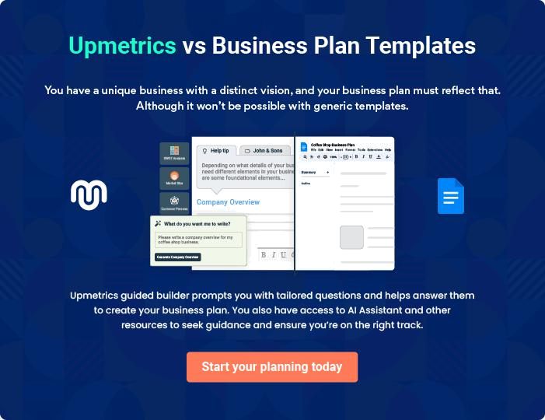
Products and Services
To unlock help try Upmetrics!

The product and services section of the agritourism business plan should describe the specific services and products that will be offered to customers. To write this section should include the following:



 Help tip  Agritourism Business Plan

To craft the introduction for your "Products and Services" chapter, begin by positioning your business within its industry, emphasizing its unique strengths or value proposition.
To unlock help try Upmetrics! 

Start writing here..

 Help tip


Mention the agritourism products & services your business will offer. This list may include

• Farm activities
To unlock help try Upmetrics! 

Agritourism products & services

Farm Adventure Tour


Price: [$25] per person

A guided tour that takes visitors through our fields, orchards, and barns, showcasing the various aspects of farm life and sustainable agriculture.

Specifications

2-hour tour, available daily from 9 AM to 4 PM, includes a complimentary basket of fresh produce.
Cheese-Making Workshop

Price: [$40] per person

A hands-on workshop where participants learn the art of cheese-making, from milk to finished product, and get to take home their own creation.

Specifications

3-hour workshop, available on weekends, all materials provided, suitable for ages 12 and up.

Farm-to-Table Dining Experience

Price: [$60] per person

A gourmet 3-course meal prepared using the freshest ingredients directly from our farm, served in a rustic outdoor setting.

Specifications

Includes starter, main course, and dessert, vegetarian options available, reservations required.

Country Cottage Stay

Price: [$150] per night

Enjoy a night in one of our cozy country cottages, surrounded by nature and the tranquil sounds of the farm.

Specifications

Accommodates up to 4 guests, includes a kitchenette and private bathroom, breakfast included.
Harvest Festival Ticket

Price: [$20] per person

Celebrate the bounty of the harvest with us at our annual Harvest Festival, featuring live music, food stalls, and plenty of farm fun.

Specifications

Event lasts from 10 AM to 10 PM, children under 5 enter free, includes access to all festival activities.

Organic Vegetable Box

Price: [$30] per box

A selection of our freshest organic vegetables, picked straight from the field and packaged for your convenience.

Specifications

Seasonal selection, approximately 10 lbs of produce per box, available for pick-up or local delivery.

Additional Services

 Help tip  Agritourism Business Plan

Mention if your agritourism business offers any additional services. You may include services like farm markets, nature trails or outdoor recreational activities, community engagement, etc.
To unlock help try Upmetrics! 

Start writing here..

Sales And Marketing Strategies
To unlock help try Upmetrics!

Writing the sales and marketing strategies section means a list of strategies you will use to attract and retain your clients.
To unlock help try Upmetrics! 

 Help Tip  Agritourism Business Plan


To create an effective introduction for your "Sales and Marketing Strategies" chapter, start by setting the stage within your specific industry or market.
To unlock help try Upmetrics! 

Start writing here..

Unique Selling Proposition (USP)

 Help tip  Agritourism Business Plan

Define your business’s USPs depending on the market you serve, the equipment you use, and the unique services you provide. Identifying USPs will help you plan your marketing strategies.
To unlock help try Upmetrics! 

Start writing here..

Pricing Strategy

 Help tip  Agritourism Business Plan

Describe your pricing strategy—how you plan to price your products & services and stay competitive in the local market. You can mention any discounts you plan on offering to attract new customers.



Start writing here..

 Help tip  Agritourism Business Plan
To unlock help try Upmetrics!

Discuss your marketing strategies to market your services. You may include some of these marketing strategies in your business plan—social media marketing, Google ads, brochures, content marketing, and print marketing.



Marketing strategies

Online


Social Media

Leveraging platforms like Instagram, Facebook, and Twitter to showcase our farm activities, events, and customer experiences.

Content Marketing

Creating engaging blog posts, articles, and videos that highlight our expertise, share agritourism tips, and tell our farm’s story.

Offline

Local Partnerships

Collaborating with local businesses and tourism boards to cross-promote our services.

Email Marketing

Keeping our audience engaged and informed through regular newsletters, updates, and exclusive offers.

Events

Participating in local fairs, markets, and expos to increase visibility and connect directly with our community.

 Help tip  Agritourism Business Plan

Outline the strategies you’ll implement to maximize your sales. Your sales strategies may include partnering with other businesses, offering referral programs, etc.
To unlock help try Upmetrics! 

Sales strategies

Partner with Businesses

Establishing partnerships with travel agencies, hotels, and other businesses to drive referrals.

Group Packages

Offering tailored packages for schools, corporate teams, and large groups

On-Site Sales

Promoting and selling our farm

products, merchandise, and

additional experiences during

visits.

 Help tip  Agritourism Business Plan

Describe your customer retention strategies and how you plan to execute them. For instance, introducing loyalty programs, discounts & offers, personalized service, etc.
To unlock help try Upmetrics! 

Customer retention

Loyalty Programs

Introducing loyalty programs that reward frequent visits and purchases.

Follow-Up Surveys

Conducting post-visit surveys to gather feedback and identify areas for improvement.

Personalized Service Exclusive Offers

Using customer data to Providing past visitors with

personalize experiences and exclusive offers and early access

communications. to events and new experiences.

Operations Plan
To unlock help try Upmetrics!

 |  | When writing the operations plan section, it’s important to consider the
 |  | various aspects of your business operations.
 |  |  |  | To unlock help try Upmetrics! 
 Help tip |  |  Agritourism Business Plan


To create an effective introduction for your "Operational Plan" chapter, start by emphasizing the
pivotal role of efficient operations in the success of your business, underscoring how they
directly impact the quality of services delivered.
 |  |  |  | To unlock help try Upmetrics! 
Start writing here..
Staffing & Training
 Help tip |  |  Agritourism Business Plan

Mention your business’s staffing requirements, including the number of employees, chefs, or
other staff needed. Include their qualifications, the training required, and the duties they will
perform.
 |  |  |  | To unlock help try Upmetrics! 
Start writing here..
Operational Processes
 Help tip |  |  Agritourism Business Plan

Outline the processes and procedures you will use to run your agritourism business. Your operational processes may include visitor reservations & bookings, farm activity management, hospitality management, food service & retail management, etc.



Start writing here..

Equipment & Machinery
To unlock help try Upmetrics!

 Help tip  Agritourism Business Plan

Include the list of equipment and machinery required for agritourism, such as farm vehicles, farm implements, livestock equipment, kitchen equipment, workshop equipment, safety equipment, etc.



Start writing here..
Management Team

The management team section provides an overview of the individuals responsible for running your business plan.
To unlock help try Upmetrics! 

 Help tip  Agritourism Business Plan

To craft an introduction for your "Management Team" chapter, begin by emphasizing the crucial role of leadership in the success of any business.
To unlock help try Upmetrics! 

Start writing here..

Key managers

 Help tip  Agritourism Business Plan

Introduce your management and key members of your team, and explain their roles and responsibilities.
To unlock help try Upmetrics! 

Start writing here..


JOHN DOE

CEO & Co-founder - john.doe@example.com

John is an innovative and strategic leader with over 15 years of experience in the agritourism industry. He holds a Master’s degree in Business Administration and a Bachelor’s degree in Agriculture Science.


Before joining [Agri-Adventure Land], John worked with leading agritourism ventures where he played a crucial role in operations management and business development.

His exceptional leadership skills and deep understanding of agritourism operations make him a vital asset to our team.

JANE DOE

CFO - jane.doe@example.com

Jane is a seasoned financial strategist with a CPA certification and a Master’s degree in Finance. She has accumulated over 12 years of experience in financial planning, risk management, and accounting within the agritourism sector.


Jane has a proven track record of optimizing financial performance and driving profitability. At [Agri-Adventure Land], she oversees all financial operations, ensuring fiscal responsibility and transparency.


ALICE BROWN

Operations Manager - alice.brown@example.com

Alice brings over 10 years of experience in agricultural management and operations to the [Agri-Adventure Land] team. She holds a Bachelor’s degree in Agricultural Management and has undergone extensive training in sustainable farming practices.

Alice’s expertise lies in optimizing farm operations, ensuring safety standards, and enhancing the overall guest experience.

Her hands-on approach and commitment to excellence significantly contribute to the smooth running of our agritourism activities.


ROBERT BROWN

Hospitality Manager - robert.brown@example.com

Robert is a hospitality enthusiast with a Bachelor’s degree in Hotel Management and over 8 years of experience in guest relations and accommodation services.

Prior to joining [Agri-Adventure Land], he worked with renowned resorts and hotels, where he mastered the art of delivering exceptional guest experiences.

At [Agri-Adventure Land], Robert is responsible for managing accommodations, ensuring guest comfort, and maintaining the highest standards of hospitality.
Organizational structure

 Help tip  Agritourism Business Plan

Explain the organizational structure of your management team. Include the reporting line and decision-making hierarchy.
To unlock help try Upmetrics! 

Start writing here..

Organization chart


John Doe

CEO


Alice Brown

Jane Doe

Operations Manager


CFO



Emily White


Mike Johnson

Robert Brown

Marketing Manager

Accountant

Hospitality Manager

Compensation plan

 Help tip  Agritourism Business Plan

Describe your compensation plan for the management and staff. Include their salaries, incentives, and other benefits.
To unlock help try Upmetrics! 

Start writing here..

 Help tip

Mentioning advisors or consultants in your business plans adds credibility to your business idea.
To unlock help try Upmetrics! 

Advisors/Consultants


DR. JANE APPLESEED

Agricultural Consultant

- Expertise: Sustainable farming practices and organic certification.

- Background: PhD in Sustainable Agriculture, over 20 years of experience advising farms across [Country].

- Role: To guide the implementation of sustainable and organic farming methods and oversee the process of obtaining organic certifications.

MS. ALICE CASH

Financial Advisor

- Expertise: Financial planning, investment strategies, and fund management.

- Background: Chartered Financial Analyst with 15 years in financial advisory roles, particularly in hospitality and leisure industries.

- Role: To oversee the financial structuring of the business, ensuring optimal investment strategies, cost management, and the establishment of a robust financial plan.
Financial Plan

When writing the financial plan section of a business plan, it’s important to provide a comprehensive overview of your financial projections for the first few years of your business, You may provide the following:
To unlock help try Upmetrics! 

 Help tip  Agritourism Business Plan


To create an effective introduction for your "Financial Plan" chapter, begin by stressing the critical role of a well-structured financial plan in the success of your venture.
To unlock help try Upmetrics! 

Start writing here..

 Help tip  Agritourism Business Plan

Describe details such as projected revenue, operational costs, and service costs in your projected profit and loss statement. Make sure to include your business’s expected net profit or loss.
To unlock help try Upmetrics! 

Profit & loss statement

Revenue

Cost Of Sales

General Costs

Revenue Specific Costs

Personnel Costs (Direct

Labor)

Gross Margin

Gross Margin (%)

Operating Expense

Payroll Expense

(Indirect Labor)

General Expense

Bad Debt

Amortization of Current

Assets

2023-24 | 2024-25 | 2025-26 | 2026-27 | 2027-28
$0 | $0 | $0 | $0 | $0

$0 | $0 | $0 | $0 | $0
$0 | $0 | $0 | $0 | $0
$0 | $0 | $0 | $0 | $0
$0 | $0 | $0 | $0 | $0

$0 | $0 | $0 | $0 | $0
0% | 0% | 0% | 0% | 0%

$0 | $0 | $0 | $0 | $0
$0 | $0 | $0 | $0 | $0
$0 | $0 | $0 | $0 | $0
$0 | $0 | $0 | $0 | $0
$0 | $0 | $0 | $0 | $0

EBITDA

Additional Expense

Long Term

Depreciation

Gain or loss from Sale

of Assets

EBIT

Interest Expenses

EBT

Income Tax Expense

Total Expense

Net Income

Net Income (%)

2023-24 | 2024-25 | 2025-26 | 2026-27 | 2027-28
$0 | $0 | $0 | $0 | $0
$0 | $0 | $0 | $0 | $0
$0 | $0 | $0 | $0 | $0
$0 | $0 | $0 | $0 | $0
$0 | $0 | $0 | $0 | $0
$0 | $0 | $0 | $0 | $0
$0 | $0 | $0 | $0 | $0
$0 | $0 | $0 | $0 | $0
$0 | $0 | $0 | $0 | $0
$0 | $0 | $0 | $0 | $0
0% | 0% | 0% | 0% | 0%

 |  |  | 2023-24 |  | 2024-25 | 2025-26
Retained Earning |  |  | $0 |  | $0 | $0
Opening |  |  |  |  | $0 | $0
Owner's Distribution |  |  | $0 |  | $0 | $0
Retained Earning |  |  | $0 |  | $0 | $0
Closing |  |  |  |  | $0 | $0
 Help tip |  |  |  Agritourism Business Plan


The cash flow for the first few years of your operation should be estimated and described in this section.

This may include billing invoices, payment receipts, loan payments, and any other cash flow statements.
2026-27 2027-28

$0 $0

$0 $0

$0 $0

To unlock help try Upmetrics! 

Cash flow statement

 | 2023-24 | 2024-25 | 2025-26 | 2026-27 | 2027-28
Cash Received | $0 | $0 | $0 | $0 | $0
Cash Paid | $0 | $0 | $0 | $0 | $0
COS & General Expenses | $0 | $0 | $0 | $0 | $0
Salary & Wages | $0 | $0 | $0 | $0 | $0
Interest | $0 | $0 | $0 | $0 | $0

Sales Tax

Income Tax

Net Cash From

Operations

Assets Sell

Assets Purchase

Net Cash From

Investments

Amount Received

Loan Received

Common Stock

Preferred Stock

Owner's Contribution

Amount Paid

2023-24 | 2024-25 | 2025-26 | 2026-27 | 2027-28
$0 | $0 | $0 | $0 | $0
$0 | $0 | $0 | $0 | $0
$0 | $0 | $0 | $0 | $0

$0 | $0 | $0 | $0 | $0
$0 | $0 | $0 | $0 | $0
$0 | $0 | $0 | $0 | $0

$0 | $0 | $0 | $0 | $0
$0 | $0 | $0 | $0 | $0

$0 | $0 | $0 | $0 | $0
$0 | $0 | $0 | $0 | $0
$0 | $0 | $0 | $0 | $0

Loan Capital $0 $0 $0 $0 $0

 |  |  | 2023-24 | 2024-25 | 2025-26 | 2026-27 | 2027-28
Dividends & Distributions |  |  | $0 | $0 | $0 | $0 | $0
Net Cash From |  |  | $0 | $0 | $0 | $0 | $0
Financing
Summary
Starting Cash |  |  | $0 | $0 | $0 | $0 | $0
Cash In |  |  | $0 | $0 | $0 | $0 | $0
Cash Out |  |  | $0 | $0 | $0 | $0 | $0
Change in Cash |  |  | $0 | $0 | $0 | $0 | $0
Ending Cash |  |  | $0 | $0 | $0 | $0 | $0
 Help tip |  |  Agritourism Business Plan

Create a projected balance sheet documenting your agritourism business’s assets, liabilities, and equity.

To unlock help try Upmetrics! 

Balance sheet

 | 2023-24 | 2024-25 | 2025-26 | 2026-27 | 2027-28
Assets | $0 | $0 | $0 | $0 | $0
Current Assets | $0 | $0 | $0 | $0 | $0
Cash | $0 | $0 | $0 | $0 | $0
Accounts Receivable | $0 | $0 | $0 | $0 | $0
Inventory | $0 | $0 | $0 | $0 | $0
Other Current Assets | $0 | $0 | $0 | $0 | $0
Long Term Assets | $0 | $0 | $0 | $0 | $0
Gross Long Term Assets | $0 | $0 | $0 | $0 | $0
Accumulated Depreciation | $0 | $0 | $0 | $0 | $0

Liabilities & Equity | $0 | $0 | $0 | $0 | $0
Liabilities | $0 | $0 | $0 | $0 | $0
Current Liabilities | $0 | $0 | $0 | $0 | $0
Accounts Payable | $0 | $0 | $0 | $0 | $0
Income Tax Payable | $0 | $0 | $0 | $0 | $0
Sales Tax Payable | $0 | $0 | $0 | $0 | $0
Short Term Debt | $0 | $0 | $0 | $0 | $0
 | 2023-24 | 2024-25 | 2025-26 | 2026-27 | 2027-28
Long Term Liabilities | $0 | $0 | $0 | $0 | $0
Long Term Debt | $0 | $0 | $0 | $0 | $0
Equity | $0 | $0 | $0 | $0 | $0
Paid-in Capital | $0 | $0 | $0 | $0 | $0
Common Stock | $0 | $0 | $0 | $0 | $0
Preferred Stock | $0 | $0 | $0 | $0 | $0
Owner's Contribution | $0 | $0 | $0 | $0 | $0
Retained Earnings | $0 | $0 | $0 | $0 | $0

Check | $0 |  |  | $0 | $0 | $0 | $0
 Help tip |  |  Agritourism Business Plan

Determine and mention your business’s break-even point—the point at which your business costs and revenue will be equal.

This exercise will help you understand how much revenue you need to generate to sustain or be profitable.
To unlock help try Upmetrics! 

Break-even Analysis

 | 2023-24 | 2024-25 | 2025-26 | 2026-27 | 2027-28
Starting Revenue | $0 | $0 | $0 | $0 | $0
Net Revenue | $0 | $0 | $0 | $0 | $0
Closing Revenue | $0 | $0 | $0 | $0 | $0

Starting Expense | $0 | $0 | $0 | $0 | $0
Net Expense | $0 | $0 | $0 | $0 | $0
Closing Expense | $0 | $0 | $0 | $0 | $0

Is Break Even? | 0 | 0 | 0 | 0 | 0
Break Even Month | 0 | 0 | 0 | 0 | 0
Days Required | 0 | 0 | 0 | 0 | 0
Break Even Revenue | $0 | $0 | $0 | $0 | $0
Break Even Units
Financing needs

 Help tip  Agritourism Business Plan

Calculate costs associated with starting an agritourism business, and estimate your financing needs and how much capital you need to raise to operate your business.
To unlock help try Upmetrics! 

Start writing here..
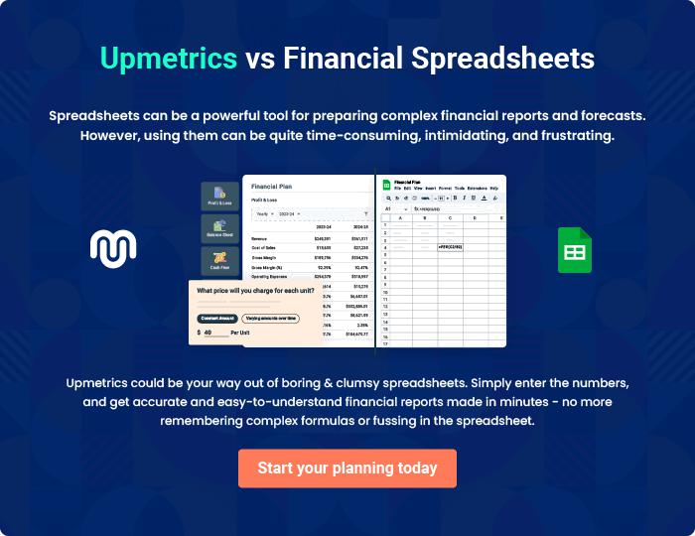
Appendix

When writing the appendix section, you should include any additional information that supports the main content of your plan. This may include financial statements, market research data, legal documents, and other
To unlock help try Upmetrics! 

Create a winning business plan that gets you funded

Creating a stunning and investment-ready plan requires no writing, graphic designing, or financial planning expertise.

Upmetrics has all the features required to help you create a comprehensive business plan—from start to finish. Make no mistakes, it’s the modern way of planning to structure ideas, make plans, and create stunning pitch decks to awe investors.

Pitch decks that impress investors

Create pitch decks that provide a visual representation of your business, engage investors, and make them want to invest in your business idea.

Interactive plans in no time

Import business plan sections like—SWOT analysis, comparison tables, and others to create an interactive business plan. No designing skills are required.

Stunning cover page designs

With Upmetrics, you have the liberty to choose from multiple stunning cover page designs. Choose a creative design and make your plan stand out.

Online sharing made simple

Upmetrics makes online sharing quick and easier for users. Easily share your business plans with a link while tracking reader activity.

500+ sample business plans

Simply import a template from our library of sample plans into the editor and start customizing it to make it yours. It takes only a few clicks to get started.

Collaborate with team in real-time

Invite team members, initiate conversations, discuss ideas & strategies, share feedback, and work on a business plan in real-time.

