
After-School Program Business Plan

BUSINESS PLAN

Inspiring Minds, Beyond the Bell

Prepared By

John Doe

10200 Bolsa Ave, Westminster, CA, 92683

info@example.com

(650) 359-3153 http://www.example.com

Table of Contents

Executive Summary | 6
Market opportunity | 6
Services Offered | 6
Management team | 7
John Doe | 7
Jane Doe | 7
Alice Brown | 7
Robert Brown | 7
Financial Highlights | 8
Units Sold v/s Revenue | 8

Company Overview | 9
Ownership | 9
Business Owners | 9
Mission statement | 10
Business history | 10
Future goals | 10

Market Analysis | 11
Target Market | 11
Market size and growth potential | 11
Market Size | 12
Competitive analysis | 12
Academic Excellence Hub | 12
WhizKidz Clubhouse | 13
Learn & Play Sanctum | 13
Market trends | 13
Regulatory environment | 14
Products and Services | 15
Services | 15
Help with Homework | 15
Tutoring | 16
Extracurricular Activities | 17
Enrichment Activities | 17
Social & Emotional Support | 18
Other Potential Programs | 18
Staff and Facilities | 20

Sales And Marketing Strategies | 21
Unique Selling Proposition (USP) | 21
Pricing Strategy | 21
Marketing strategies | 22
Online | 22
Offline | 22
Sales strategies | 23
Customer retention | 23

Operations Plan | 24
Hiring Plan | 24
Operational Process | 24
Curriculum | 25

Management Team | 26
Key managers | 26
John Doe | 27
Jane Doe | 27
Alice Brown | 28
Organizational structure | 28
Organization chart | 28
Compensation plan | 29
Board of advisors | 30

Robert Brown 30

Ms. Clara Mitchell | 30

Financial Plan | 31
Profit & loss statement | 31
Cash flow statement | 34
Balance sheet | 36
Break-even Analysis | 38
Financing needs | 40
Appendix
Appendix | 42
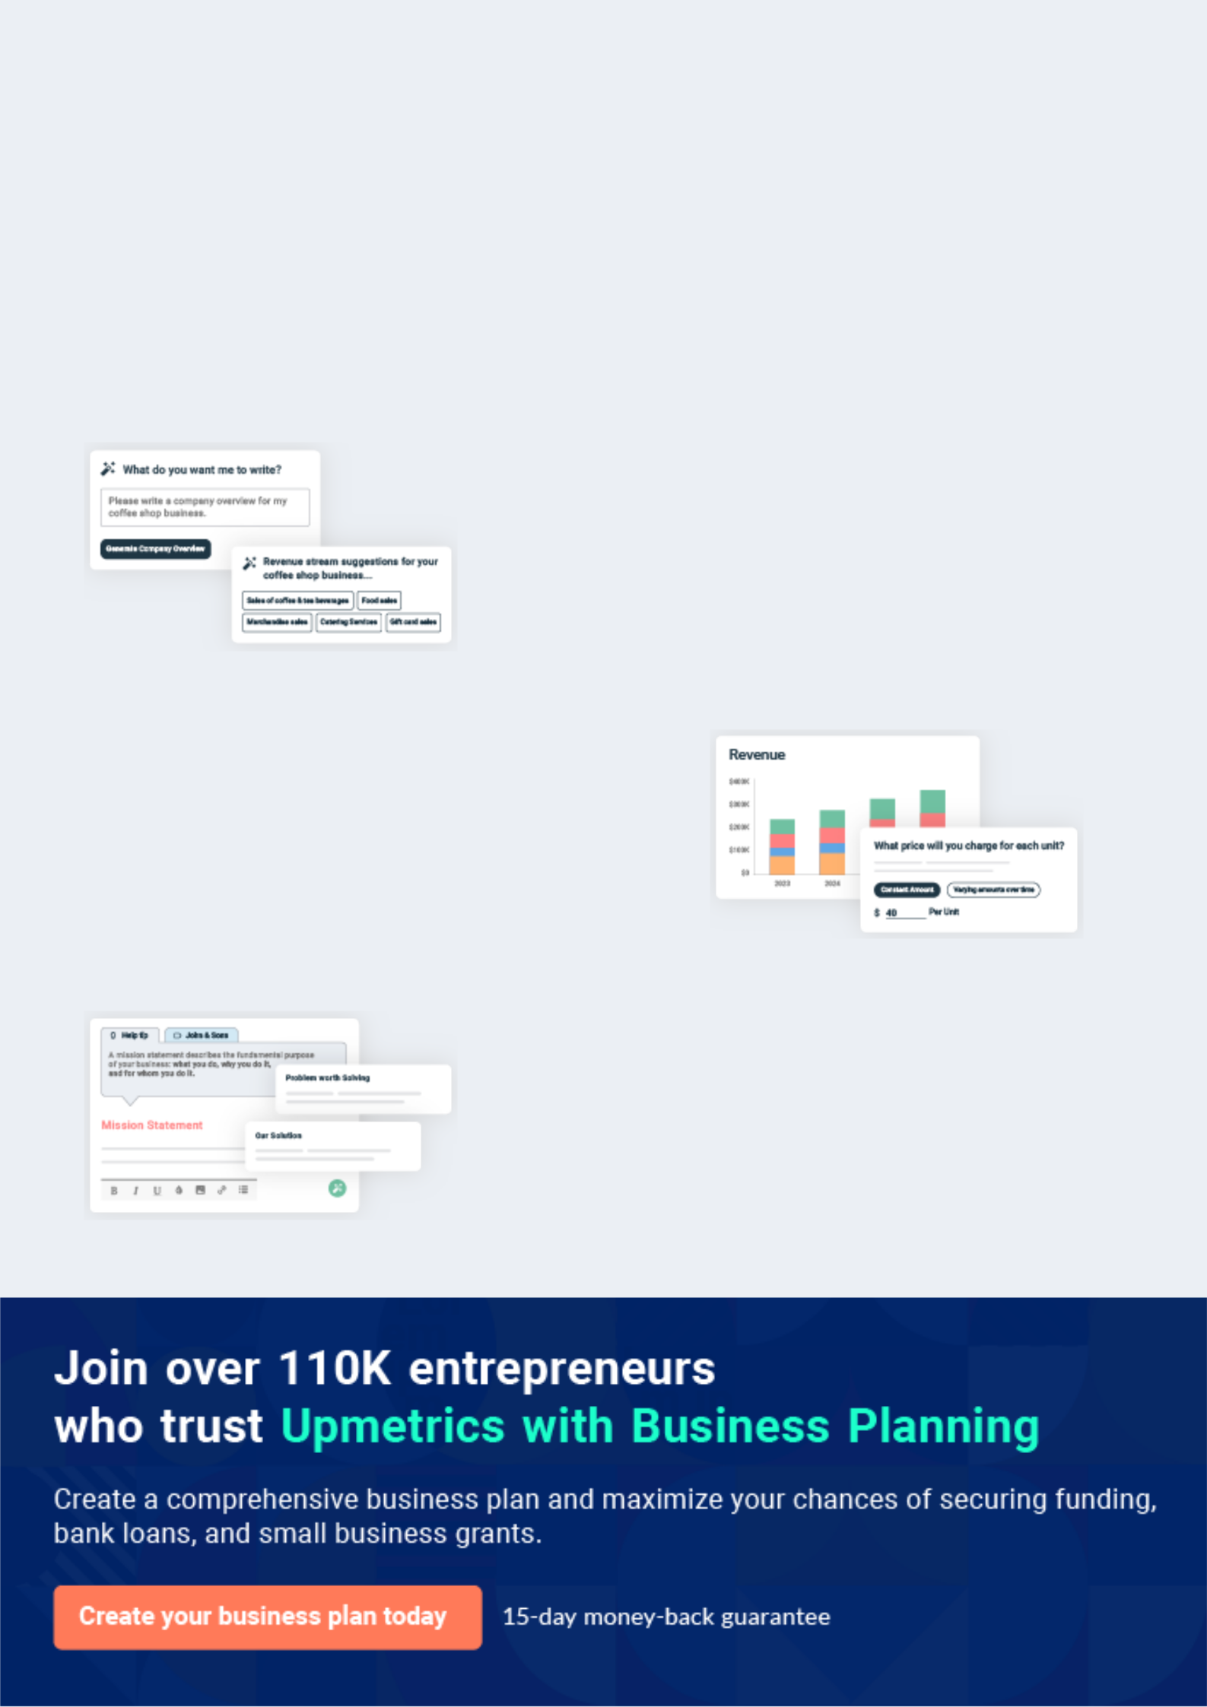
Business planning that’s simpler and faster than you think

Creating a business plan using Upmetrics to start and grow a business is literally the easiest thing in the World. Simply read the instructions and fill in the blanks. It’s as simple as that.

❛ | Upmetrics has everything you need to create a | ❜
❛ | comprehensive business plan. | ❜

AI-powered Upmetrics Assistant

AI-powered insights to streamline your plan

Not sure where to start? Upmetrics’ AI Assistant will automatically generate ideas for each section of your plan and offer improved versions of your writing, adjusting for tone, voice, and grammar or spelling errors.

Financial Forecasting Tool

All the financials are calculated for you

Forget the complex formulas and clumsy spreadsheets — with automatic financials and drag-and-drop forecasting, you can finish your plan faster and be confident that your numbers are accurate.

Business Plan Builder

Guides you like a business mentor

Upmetrics’ step-by-step instructions, prompts, and the library of 400+ sample business plans will guide you through each section of your plan as a business mentor.
Executive Summary


 |  | An executive summary is the first section of the business plan intended to
 |  | provide an overview of the whole business plan.
 |  |  |  | To unlock help try Upmetrics! 
 Help tip |  |  After-school program business plan


Start your executive summary by introducing your idea behind starting an after-school program
and explaining what it does. Mention the name and location of your after-school program
business.
 |  |  |  | To unlock help try Upmetrics! 
Start writing here..
Market opportunity
 Help tip |  |  After-school program business plan


Describe the target market in brief, and explain the demographics, geographic location, and psychographic attributes of your customer. Explain how your after-school program business meets its needs. Clearly describe the market that your business will serve.
To unlock help try Upmetrics! 

Start writing here..

Services Offered

 Help tip  After-school program business plan


List the services your after-school program will provide in brief, such as homework assistance, enrichment activities, and snacks.
To unlock help try Upmetrics! 

Start writing here..

 Help tip


Name all the key members of your management team with their duties, responsibilities, and qualifications.
To unlock help try Upmetrics! 

Management team


JOHN DOE

Founder & CEO - john.doe@example.com

With a background in [Educational Leadership], John provides vision and strategic direction.


JANE DOE

Program Director - jane.doe@example.com

Leveraging her [Masters in Child Psychology], Jane curates the program's content ensuring it's both engaging and educational.


ALICE BROWN

Operations Manager - alice.brown@example.com

With her [degree in Business Management], Alice ensures seamless day-to-day operations and parent-student coordination.


ROBERT BROWN

Community Outreach Coordinator

Drawing from his experience in [Public Relations], Robert connects with schools and communities to increase our program's outreach.

Financial Highlights
To unlock help try Upmetrics!

 Help tip  After-school program business plan

Provide a summary of your financial projections for the company’s initial years of operation.

Include any capital or investment requirements, startup costs, projected revenues, and profits.
To unlock help try Upmetrics! 

Start writing here..

Units Sold v/s Revenue

 |  | Units Sold | Revenue
15.00k
10.00k
5.00k
0
Year 1 | Year 2 | Year 3


Financial Year |  |  | Units Sold | Revenue
Year 1 | 1,550 |  |  | $10,000
Year 2 | 1,800 |  |  | $12,000
Year 3 | 2,050 |  |  | $14,000
 Help tip |  |  After-school program business plan

After giving a brief about your business plan, end your summary with a call to action, for example; inviting potential investors or readers to the next meeting if they are interested in your business.



Write a call to action for your business plan.

Company Overview


Depending on what details of your business are essential, you’ll need different elements in your business overview.
To unlock help try Upmetrics! 

 Help tip  After-school program business plan

Provide all the basic information about your business in this section like:

• The name of the after-school program and the type of program you will be operating. For
To unlock help try Upmetrics! 

Start writing here..

Ownership

 Help tip  After-school program business plan

Describe the owners of your after-school program business and mention their roles in running it. Whose shares in the corporation are they, and how each owner helps in the business?
To unlock help try Upmetrics! 

Start writing here..

Business Owners



60% John Doe



30% Jane Doe



10% Alice Brown

Mission statement
To unlock help try Upmetrics!

 Help tip  After-school program business plan

Add a mission statement that sums up the objectives and core principles of your business. This statement needs to be memorable, clear, and brief.
To unlock help try Upmetrics! 

❛ Our mission at [Bright Futures] is to provide a nurturing, educational environment that ensures holistic development for school-age children. We believe that every child, given the right resources and guidance, can shine bright, and our goal is to be that guiding light.

❜

Business history

 Help tip  After-school program business plan

Include an outline of the after-school program’s history and how it came to be in its current position.
To unlock help try Upmetrics! 

Start writing here..

Future goals

 Help tip  After-school program business plan

It’s crucial to convey your aspirations and your vision. Include the vision of where you see your business in the near future and if you have any plans of opening a new franchise of your business in the same city in the future.



Start writing here..

Market Analysis

 |  | Market analysis provides a clear understanding of the market in which your
 |  | printing business will run along with the target market, competitors, and
 |  | growth opportunities.
 |  |  |  | To unlock help try Upmetrics! 
 Help tip |  |  After-school program business plan

To write the introduction section of your market analysis, start by clearly identifying your primary target market.
To unlock help try Upmetrics! 

Start writing here..

Target Market

 Help Tip  After-school program business plan


Identify your target market and define your ideal customer. Know more about your customers and which services they prefer: enrichment activities, parental involvement, or homework help.
To unlock help try Upmetrics! 

Start writing here..

Market size and growth potential

 Help tip  After-school program business plan

Provide an overview of the after-school program providers industry. It will include market size, trends, growth potential, and regulatory considerations.
To unlock help try Upmetrics! 

Start writing here..

Market Size
To unlock help try Upmetrics!


Available Market | 5M
Total children aged 5-14 in the state. | 5M

Served Market
Children in the city using after-school 500k programs.

Target Market
School-age children near our facility 50k seeking holistic development.

 Help tip  After-school program business plan

Identify and analyze all other after-school programs in the local market, including direct and indirect competitors. Evaluate their strengths and weaknesses, and explain how your business can offer qualitative services.



Competitive analysis

Academic Excellence Hub

With over [five] years in operation, the [Academic Excellence Hub] primarily focuses on academic guidance and curriculum support. They have three centers across the city and have catered to over [500] students.

Features

Curriculum-aligned tutorials.

Homework assistance.

Monthly parent-teacher meetings.

Summer boot camps for intensive learning.

Strengths

Strong brand reputation.

High success rate in improving academic scores.

Experienced staff with teaching backgrounds.

Weaknesses

Limited to only academic offerings with minimal enrichment activities.

Priced on the higher side, making it less accessible for many.

Restricted flexibility in timings.

WhizKidz Clubhouse

Launched two years ago, [WhizKidz Clubhouse] positions itself as a holistic development center for children, blending academics with extracurricular activities.

Features

Academic support for major subjects.

Weekly workshops on arts, crafts, and music.

A mini-library for reading and literature activities.

Tech labs for introductory coding lessons.

Strengths

Diverse offerings catering to both academic and personal development.

Modern infrastructure with tech integration.

Regular updates and communication with parents.

Weaknesses

Newer in the market, thus less brand recognition.

Limited capacity due to space constraints.

Occasional complaints about staff turnover.

Learn & Play Sanctum

Operational for over a decade, [Learn & Play Sanctum] is more of a fusion between daycare and an after-school program, catering to a broader age group.

Features

Basic academic guidance.

Play areas with toys and games.

Occasional guest lectures and activity days.

Daycare facilities for younger kids.

Strengths

Long-standing reputation in the community.

Extended hours catering to parents with unconventional work timings.

Caters to a broader age group, from toddlers to pre-teens.

Weaknesses

Diluted focus due to the vast age group they cater to.

Infrequent curriculum updates.

The staff-student ratio not ideal for personalized attention.

Market trends

 Help tip  After-school program business plan

Analyze current and emerging trends in your industry, such as changes in technology or customer preference like STEM education, online learning, or anything else.
To unlock help try Upmetrics! 

Start writing here..

Regulatory environment

 Help tip  After-school program business plan

Describe any regulations or licensing requirements that affect the after-school program, such as safety codes, state regulations, zoning requirements, or anything else.
To unlock help try Upmetrics! 

Start writing here..
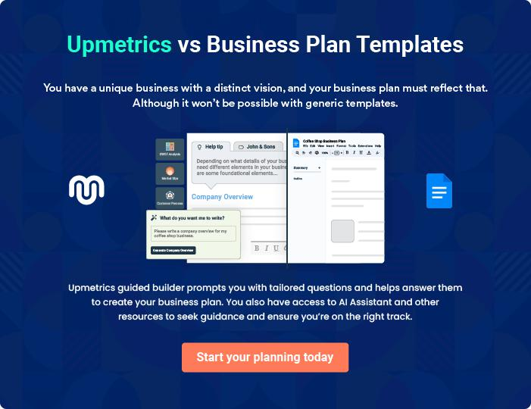
Products and Services

The product and services section of an after-school program business plan should describe the specific services and products that will be offered to customers. To write this section should include the following:
To unlock help try Upmetrics! 

 Help tip  After-school program business plan

To craft the introduction for your "Products and Services" chapter, begin by positioning your business within its industry, emphasizing its unique strengths or value proposition.
To unlock help try Upmetrics! 

Start writing here..

 Help tip

Give a thorough explanation of the after-school program services provided in this section. The particular activities that will be offered, such as:
To unlock help try Upmetrics! 

Services

Help with Homework


Price: [$25 - $35] per session.

Our homework assistance program is tailored to help students understand and complete their daily school assignments.

Each child receives personalized attention, ensuring that they not only finish their homework but also comprehend the underlying concepts.
Specifications

Time Required:

Each session lasts [1-1.5 hours], depending on the volume and complexity of the assignments.

Qualifications of Professionals:

The professionals assisting with homework have a minimum of a Bachelor's degree in education or related fields, with [3-5 years] of teaching experience. They are adept at handling queries across subjects and are trained to offer constructive feedback.

Tutoring

Price: [$40 - $60] per session

Tutoring sessions are designed to provide individualized instruction to students who need additional help in specific subjects. These sessions aim to clarify doubts, reinforce concepts, and boost the child's confidence in the subject.

Specifications

Time Required:

Each tutoring session spans [1-1.5 hours]. The frequency can vary based on the student's needs, ranging from daily to weekly sessions.

Qualifications of Professionals:

Our tutors typically have a Master's degree in their specific subject area, coupled with [5-7 years] of tutoring or teaching experience. They are skilled in adaptive teaching methodologies to cater to each student's unique learning style.
Extracurricular Activities

Price: [$20 - $40] per session (varies based on activity; for example, specialized music lessons may be priced higher)

Beyond academics, our program offers activities like [sports, arts & crafts, music, and drama]. These activities are designed to foster creativity, teamwork, and physical well-being.

Specifications

Time Required:

Each activity session lasts [1-2 hours], generally held once or twice a week.

Qualifications of Professionals:

These sessions are helmed by professionals who hold certifications in their respective fields, whether it's a certified art teacher, a sports coach with credentials, or a music instructor with formal training.

Enrichment Activities

Price: [$30 - $50] per session

These sessions, including [robotics workshops, creative writing, and STEM projects], are designed to provide students with additional skills and knowledge beyond their regular curriculum, ensuring a holistic educational experience.
Specifications

Time Required:

Sessions typically last [1.5-2 hours] and are

conducted once a week.

Qualifications of Professionals:

Professionals leading these activities have

specialized degrees and certifications in their

respective domains, along with [3-5 years] of

experience in facilitating such workshops.

Social & Emotional Support

Price: [$40 - $80] per session

Recognizing the myriad challenges children face, we offer counseling sessions that cater to their emotional and social well-being, ensuring that they can navigate challenges confidently.

Specifications

Time Required:

Individual sessions last [30 minutes to 1 hour], with the frequency tailored to the child's needs.

Qualifications of Professionals:

Our counselors hold advanced degrees in [Child Psychology or Counseling] and are licensed practitioners. They possess [5-7 years] of experience working with children and adolescents.

Other Potential Programs

Price: [$25 - $50] per session (varies based on program type)

With a keen eye on emerging trends, we're poised to introduce new modules like [language classes, culinary workshops, and coding bootcamps], ensuring our students receive a well-rounded education.

Specifications

Time Required:

These sessions would typically span [1-2 hours], held once a week.

Qualifications of Professionals:

All professionals for these modules will have specialized qualifications in their respective domains, backed by a substantial track record of successful teaching or facilitation experience.
Staff and Facilities
To unlock help try Upmetrics!

 Help tip  After-school program business plan

Give a succinct description of your staff’s credentials, mentioning both their training and pertinent work experience. Additionally, give details about the program’s facilities, along with any tools or materials that will be required.



Start writing here..
Sales And Marketing Strategies

Writing the sales and marketing strategies section means a list of strategies you will use to attract and retain your clients.
To unlock help try Upmetrics! 

 Help Tip  After-school program business plan

To create an effective introduction for your "Sales and Marketing Strategies" chapter, start by setting the stage within your specific industry or market.
To unlock help try Upmetrics! 

Start writing here..

Unique Selling Proposition (USP)

 Help tip  After-school program business plan

Clearly define your after-school program’s unique selling proposition, such as your services, trained staff, flexible timing, safety regulations, an ideal setting, and reasonable costs.
To unlock help try Upmetrics! 

Start writing here..

Pricing Strategy

 Help tip  After-school program business plan

Develop a pricing strategy that is competitive and affordable, yet profitable. Consider offering promotions, discounts, or packages for your services and facilities to attract new customers.
To unlock help try Upmetrics! 

Start writing here..

 Help tip  After-school program business plan
To unlock help try Upmetrics!

Develop a marketing strategy that includes a mix of online and offline marketing tactics. Consider social media, email marketing, content marketing, brochures, print marketing, and events.



Marketing strategies

Online


Social Media

Regular updates, success stories, and engagement activities on platforms like [Facebook, Instagram, and Twitter].

Content Marketing

Blog posts, articles, and videos that highlight our methodologies, success stories, and tips for parents.

Offline

Brochures

Detailed printed material available at our center and distributed at local community events.

Email Marketing

Monthly newsletters to parents, providing insights, updates, and useful resources.

Print Marketing

Local newspaper ads, especially during peak enrollment seasons.

Events

Open houses, parent-teacher

meetings, and student showcases

to engage with the community

directly.

 Help tip

Explain your sales strategy, including giving prospective clients a free trial or discount, giving them a tour of your facility, or providing them with extra services.
To unlock help try Upmetrics! 

Sales strategies

Free Trials

Prospective students can attend a week's sessions to experience our offerings firsthand.

Facility Tours

Parents can tour our facility, meeting staff and understanding our methodologies.

Value-Added Services

Enrollments for a year get [1-month

free summer boot camp] or similar

incentives.

 Help tip

Describe how your after-school business will retain customers and build loyalty, such as through loyalty programs, special events, or personalized service.
To unlock help try Upmetrics! 

Customer retention

Loyalty Programs Special Events

Discounts on renewals, referral Regular workshops, guest lectures,

benefits, and milestone rewards. and celebrations.

Personalized Service

Regular feedback sessions,

personalized learning plans, and

direct communication channels

with educators.

Operations Plan

 |  | When writing the operations plan section, it’s important to consider the
 |  | various aspects of your business operations.
 |  |  |  | To unlock help try Upmetrics! 
 Help tip |  |  After-school program business plan

To create an effective introduction for your "Operational Plan" chapter, start by emphasizing the
pivotal role of efficient operations in the success of your business, underscoring how they
directly impact the quality of services delivered.
 |  |  |  | To unlock help try Upmetrics! 
Start writing here..
Hiring Plan
 Help tip |  |  After-school program business plan

Tell the staffing requirements of your after-school program business, including the number of
employees needed as a tutor, cooks, or customer service representative along with their
qualifications, and the duties they will perform.
 |  |  |  | To unlock help try Upmetrics! 
Start writing here..
Operational Process
 Help tip |  |  After-school program business plan

Outline the processes and procedures that you will use to run your after-school program business.
To unlock help try Upmetrics! 

Start writing here..

Curriculum

 Help tip  After-school program business plan

Outline the activities like; the class timetable, and any special events or field trips that will be provided for the after-school program.
To unlock help try Upmetrics! 

Start writing here..
Management Team

The management team section provides an overview of the individuals responsible for running your business plan.
To unlock help try Upmetrics! 

 Help tip  After-school program business plan

To craft an introduction for your "Management Team" chapter, begin by emphasizing the crucial role of leadership in the success of any business.
To unlock help try Upmetrics! 

Start writing here..

Key managers

 Help tip  After-school program business plan

Describe the key members of your management team, their roles, and their responsibilities.

It should include the owners, senior management, and people who will be involved in the
To unlock help try Upmetrics! 

Start writing here..
JOHN DOE

CEO & Co-founder - john.doe@example.com

As the Founder & CEO, John steers the ship, setting the overarching vision, strategy, and direction for [Bright Futures After-School Program].

A hands-on leader, he actively liaises with partners, oversees curriculum development, and ensures the organization's financial health.


- Educational Background: John pursued his Bachelor's degree in Education from [Prestigious University] and later completed his Master’s in Education Management from [Top-tier University].

- Professional Background: Bringing over a decade of rich experience, John previously held senior leadership roles at renowned educational institutions like [Elite Academy] and [Pioneer Learning Center], driving both to significant successes during his tenure.

JANE DOE

Chief Operating Officer (COO) - jane.doe@example.com

Jane stands as the backbone of operations at [Bright Futures After-School Program].

As the COO, she ensures that day-to-day operations run seamlessly, from staffing to compliance, always with an eye for innovation and efficiency.

- Educational Background: Jane graduated with honors in Business Administration from [Reputed University] and later procured an MBA from [Ivy League College], specializing in Operations Management.

- Professional Background: Jane's dynamic career spans over 8 years, during which she managed operations for institutions like [Educare Institute] and [Futuristic Learning Systems], gaining a reputation for her meticulousness and strategic acumen.

ALICE BROWN

Director of Curriculum Development - alice.brown@example.com

Alice leads the charge in ensuring that the curriculum at [Bright Futures After-School Program] is both comprehensive and adaptive.

Her role entails constant research, design, revision, and implementation, ensuring the curriculum meets and exceeds industry standards.

- Educational Background: Alice's academic journey began with a Bachelor's in Early Childhood Education from [Well-known University]. Her thirst for knowledge led her to pursue a PhD in Child Psychology from [Elite Research University].

- Professional Background: Over the past 7 years, Alice has been instrumental in designing and refining curricula for prestigious schools such as [Innovative Minds School] and [NextGen Academy]. Her methodologies and approaches are considered benchmarks in contemporary education.

Organizational structure

 Help tip  After-school program business plan

Describe the organizational structure of the management team, including reporting lines and how decisions will be made.
To unlock help try Upmetrics! 

Start writing here..

Organization chart

John Doe

CEO


 |  |  | Alice Brown
Robert Smith | Jane Doe |  | Director of Curriculum
CFO | COO |  | Development





Mary Gray

Paul White

Marketing Head

HR Manager

Compensation plan

 Help tip  After-school program business plan

Describe your compensation plan for the management team and staff, including salaries, bonuses, and other benefits.
To unlock help try Upmetrics! 

Start writing here..

 Help tip

If you have a board of advisors for your business, then mention them along with their roles and experience.
To unlock help try Upmetrics! 

Board of advisors

ROBERT BROWN

Advisor 1

A luminary in the education sector, Robert has [20 years] of experience and has served on the boards of [notable educational institutions]. He advises on strategy and partnerships.

MS. CLARA MITCHELL

Advisor 2

With expertise in [specific domain, e.g., ed-tech], [Name] provides guidance on [specific areas, e.g., technology integration].
Financial Plan

When writing the financial plan section of a business plan, it’s important to provide a comprehensive overview of your financial projections for the first few years of your business, You may provide the following:
To unlock help try Upmetrics! 

 Help tip  After-school program business plan


To create an effective introduction for your "Financial Plan" chapter, begin by stressing the critical role of a well-structured financial plan in the success of your venture.
To unlock help try Upmetrics! 

Start writing here..

 Help tip


Create a projected profit & loss statement that describes the expected revenue, cost of products sold, and operational costs. Your business’s anticipated net profit or loss should be computed and included.
To unlock help try Upmetrics! 

Profit & loss statement

Revenue

Cost Of Sales

General Costs

Revenue Specific Costs

Personnel Costs (Direct

Labor)

Gross Margin

Gross Margin (%)

Operating Expense

Payroll Expense

(Indirect Labor)

General Expense

Bad Debt

Amortization of Current

Assets

2023-24 | 2024-25 | 2025-26 | 2026-27 | 2027-28
$0 | $0 | $0 | $0 | $0

$0 | $0 | $0 | $0 | $0
$0 | $0 | $0 | $0 | $0
$0 | $0 | $0 | $0 | $0
$0 | $0 | $0 | $0 | $0

$0 | $0 | $0 | $0 | $0
0% | 0% | 0% | 0% | 0%

$0 | $0 | $0 | $0 | $0
$0 | $0 | $0 | $0 | $0
$0 | $0 | $0 | $0 | $0
$0 | $0 | $0 | $0 | $0
$0 | $0 | $0 | $0 | $0

EBITDA

Additional Expense

Long Term

Depreciation

Gain or loss from Sale

of Assets

EBIT

Interest Expenses

EBT

Income Tax Expense

Total Expense

Net Income

Net Income (%)

2023-24 | 2024-25 | 2025-26 | 2026-27 | 2027-28
$0 | $0 | $0 | $0 | $0
$0 | $0 | $0 | $0 | $0
$0 | $0 | $0 | $0 | $0
$0 | $0 | $0 | $0 | $0
$0 | $0 | $0 | $0 | $0
$0 | $0 | $0 | $0 | $0
$0 | $0 | $0 | $0 | $0
$0 | $0 | $0 | $0 | $0
$0 | $0 | $0 | $0 | $0
$0 | $0 | $0 | $0 | $0
0% | 0% | 0% | 0% | 0%
 | 2023-24 | 2024-25 | 2025-26 | 2026-27 | 2027-28
Retained Earning | $0 | $0 | $0 | $0 | $0
Opening
Owner's Distribution | $0 | $0 | $0 | $0 | $0
Retained Earning | $0 | $0 | $0 | $0 | $0
Closing

 Help tip

Estimate your cash inflows and outflows for the first few years of operation. It should include cash receipts from clients, payments to vendors, loan payments, and any other cash inflows and outflows.
To unlock help try Upmetrics! 

Cash flow statement

 | 2023-24 | 2024-25 | 2025-26 | 2026-27 | 2027-28
Cash Received | $0 | $0 | $0 | $0 | $0
Cash Paid | $0 | $0 | $0 | $0 | $0
COS & General Expenses | $0 | $0 | $0 | $0 | $0
Salary & Wages | $0 | $0 | $0 | $0 | $0
Interest | $0 | $0 | $0 | $0 | $0

Sales Tax

Income Tax

Net Cash From

Operations

Assets Sell

Assets Purchase

Net Cash From

Investments

Amount Received

Loan Received

Common Stock

Preferred Stock

Owner's Contribution

Amount Paid

2023-24 | 2024-25 | 2025-26 | 2026-27 | 2027-28
$0 | $0 | $0 | $0 | $0
$0 | $0 | $0 | $0 | $0
$0 | $0 | $0 | $0 | $0

$0 | $0 | $0 | $0 | $0
$0 | $0 | $0 | $0 | $0
$0 | $0 | $0 | $0 | $0

$0 | $0 | $0 | $0 | $0
$0 | $0 | $0 | $0 | $0

$0 | $0 | $0 | $0 | $0
$0 | $0 | $0 | $0 | $0
$0 | $0 | $0 | $0 | $0

Loan Capital $0 $0 $0 $0 $0

 | 2023-24 | 2024-25 | 2025-26 | 2026-27 | 2027-28
Dividends & Distributions | $0 | $0 | $0 | $0 | $0
Net Cash From | $0 | $0 | $0 | $0 | $0
Financing

Summary
Starting Cash | $0 | $0 | $0 | $0 | $0
Cash In | $0 | $0 | $0 | $0 | $0
Cash Out | $0 | $0 | $0 | $0 | $0
Change in Cash | $0 | $0 | $0 | $0 | $0
Ending Cash | $0 | $0 | $0 | $0 | $0

 Help tip

Prepare a projected balance sheet, which shows the assets, liabilities, and equity of the business.

To unlock help try Upmetrics! 

Balance sheet

 | 2023-24 | 2024-25 | 2025-26 | 2026-27 | 2027-28
Assets | $0 | $0 | $0 | $0 | $0
Current Assets | $0 | $0 | $0 | $0 | $0
Cash | $0 | $0 | $0 | $0 | $0
Accounts Receivable | $0 | $0 | $0 | $0 | $0
Inventory | $0 | $0 | $0 | $0 | $0
Other Current Assets | $0 | $0 | $0 | $0 | $0
Long Term Assets | $0 | $0 | $0 | $0 | $0
Gross Long Term Assets | $0 | $0 | $0 | $0 | $0
Accumulated Depreciation | $0 | $0 | $0 | $0 | $0

Liabilities & Equity | $0 | $0 | $0 | $0 | $0
Liabilities | $0 | $0 | $0 | $0 | $0
Current Liabilities | $0 | $0 | $0 | $0 | $0
Accounts Payable | $0 | $0 | $0 | $0 | $0
Income Tax Payable | $0 | $0 | $0 | $0 | $0
Sales Tax Payable | $0 | $0 | $0 | $0 | $0
Short Term Debt | $0 | $0 | $0 | $0 | $0
 | 2023-24 | 2024-25 | 2025-26 | 2026-27 | 2027-28
Long Term Liabilities | $0 | $0 | $0 | $0 | $0
Long Term Debt | $0 | $0 | $0 | $0 | $0
Equity | $0 | $0 | $0 | $0 | $0
Paid-in Capital | $0 | $0 | $0 | $0 | $0
Common Stock | $0 | $0 | $0 | $0 | $0
Preferred Stock | $0 | $0 | $0 | $0 | $0
Owner's Contribution | $0 | $0 | $0 | $0 | $0
Retained Earnings | $0 | $0 | $0 | $0 | $0

Check | $0 |  |  | $0 | $0 | $0 | $0
 Help tip |  |  After-school program business plan


Determine the point at which your after-school program will break even, or generate enough revenue to cover its operating costs. This will help you understand how much revenue you need to generate to make a profit.
To unlock help try Upmetrics! 

Break-even Analysis

 | 2023-24 | 2024-25 | 2025-26 | 2026-27 | 2027-28
Starting Revenue | $0 | $0 | $0 | $0 | $0
Net Revenue | $0 | $0 | $0 | $0 | $0
Closing Revenue | $0 | $0 | $0 | $0 | $0

Starting Expense | $0 | $0 | $0 | $0 | $0
Net Expense | $0 | $0 | $0 | $0 | $0
Closing Expense | $0 | $0 | $0 | $0 | $0

Is Break Even? | 0 | 0 | 0 | 0 | 0
Break Even Month | 0 | 0 | 0 | 0 | 0
Days Required | 0 | 0 | 0 | 0 | 0
Break Even Revenue | $0 | $0 | $0 | $0 | $0
Break Even Units
Financing needs

 Help tip  After-school program business plan

Estimate how much financing you will need to start and operate your after-school program business. It should include both short-term and long-term financing needs, such as loans or investment capital.
To unlock help try Upmetrics! 

Start writing here..
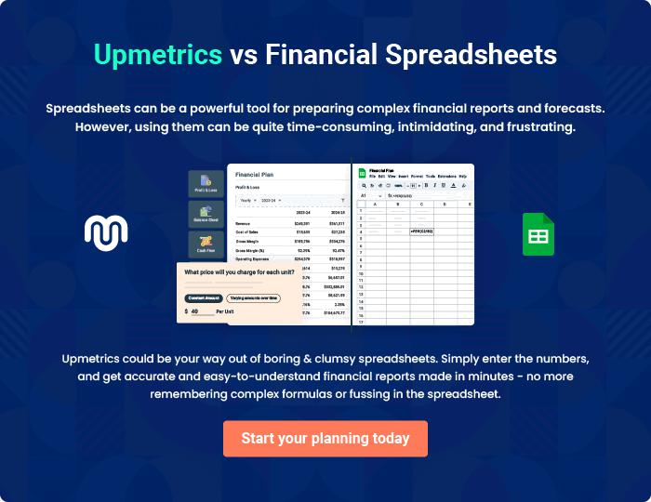
Appendix

When writing the appendix section, you should include any additional information that supports the main content of your plan. This may include financial statements, market research data, legal documents, and other
To unlock help try Upmetrics! 
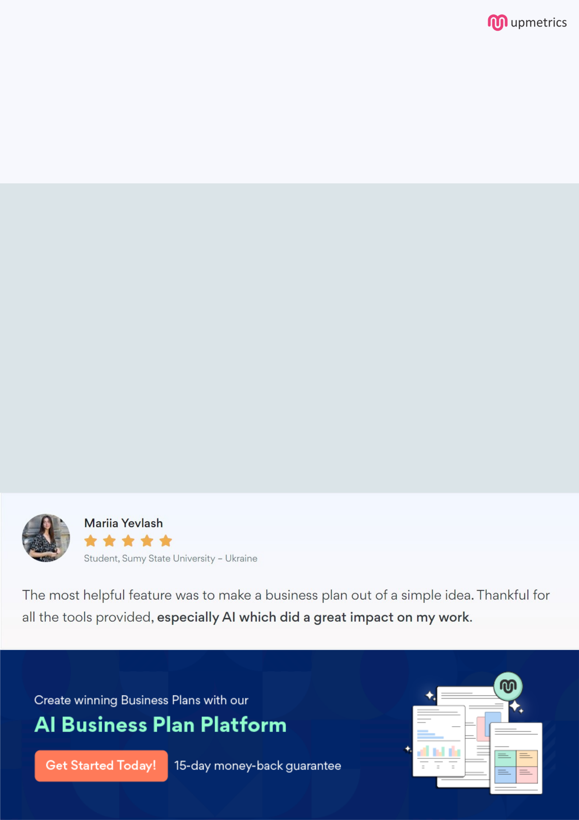
Create a winning business plan that gets you funded

Creating a stunning and investment-ready plan requires no writing, graphic designing, or financial planning expertise.

Upmetrics has all the features required to help you create a comprehensive business plan—from start to finish. Make no mistakes, it’s the modern way of planning to structure ideas, make plans, and create stunning pitch decks to awe investors.

Pitch decks that impress investors

Create pitch decks that provide a visual representation of your business, engage investors, and make them want to invest in your business idea.

Interactive plans in no time

Import business plan sections like—SWOT analysis, comparison tables, and others to create an interactive business plan. No designing skills are required.

Stunning cover page designs

With Upmetrics, you have the liberty to choose from multiple stunning cover page designs. Choose a creative design and make your plan stand out.

Online sharing made simple

Upmetrics makes online sharing quick and easier for users. Easily share your business plans with a link while tracking reader activity.

500+ sample business plans

Simply import a template from our library of sample plans into the editor and start customizing it to make it yours. It takes only a few clicks to get started.

Collaborate with team in real-time

Invite team members, initiate conversations, discuss ideas & strategies, share feedback, and work on a business plan in real-time.

