
Woodworking Shop


Business
Plan

[YEAR]


Carving out excellence.

Information provided in this business plan is unique to this business and confidential; therefore, anyone reading this plan agrees not to disclose any of the information in this business plan without prior written permission of the Company

 | Prepared By | 10200 Bolsa Ave, Westminster, CA, 92683
 | John Doe | info@example.com
 | (650) 359-3153 | http://www.example.com

Table of Contents

Executive Summary | 5
Business Overview | 6
Objectives | 6
Mission | 6
Products And Services | 7
Management | 7
Customers | 7
Operating Summary | 8
3 Year profit forecast | 8

Business Description | 9
Company Owner | 10
Purpose of starting a business | 10
Legal Structure | 10
Start-up Summary | 11
Startup Cost | 11
Startup Requirements | 11

Products and Services | 14
Products and services | 15
Market Analysis
Market Analysis | 18
Market Trends | 19
Target Market | 19
Marketing Segmentation | 20
Marketing Share | 20
Product Pricing | 20
Strategy and Implementation Summary
Strategy and Implementation Summary | 21
Competitive Analysis | 22

Woodworking Shop | Business Plan [YEAR] 2/39

Sales Strategy | 22
Sales Yearly | 22
Sales Forecast | 23
Detailed Sales Forecast | 24

Management Summary | 26
Personnel Plan | 27
Average Salary | 28
Financial Plan
Financial Plan | 29
Important Assumptions | 30
Brake-even Analysis | 30
Projected Profit and Loss | 30
Projected Cash Flow | 33
Projected Balance Sheet | 35
Business Ratios | 36

Woodworking Shop | Business Plan [YEAR] 3/39

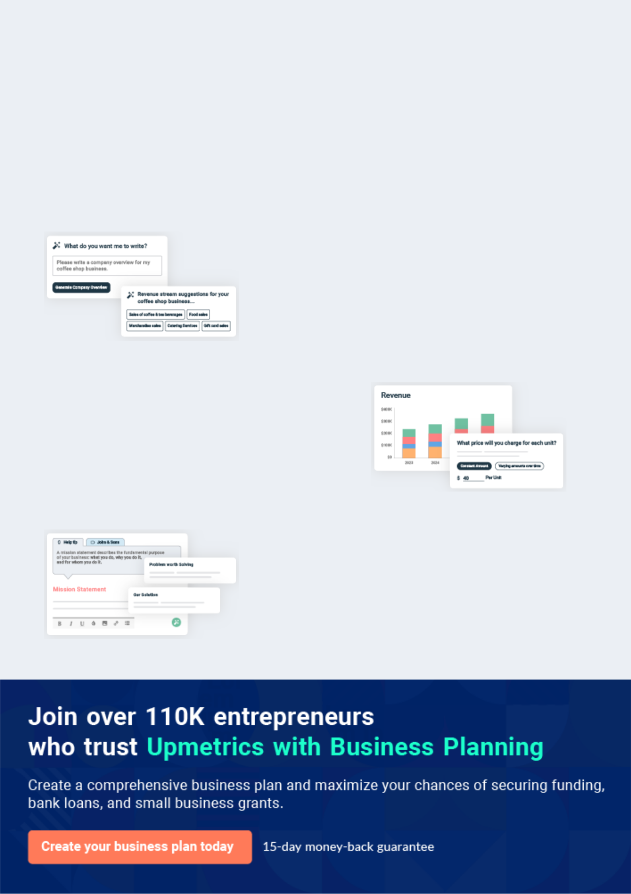
Business planning that’s simpler and faster than you think

Creating a business plan using Upmetrics to start and grow a business is literally the easiest thing in the World. Simply read the instructions and fill in the blanks. It’s as simple as that.

❛ | Upmetrics has everything you need to create a | ❜
❛ | comprehensive business plan. | ❜

AI-powered Upmetrics Assistant

AI-powered insights to streamline your plan

Not sure where to start? Upmetrics’ AI Assistant will automatically generate ideas for each section of your plan and offer improved versions of your writing, adjusting for tone, voice, and grammar or spelling errors.

Financial Forecasting Tool

All the financials are calculated for you

Forget the complex formulas and clumsy spreadsheets — with automatic financials and drag-and-drop forecasting, you can finish your plan faster and be confident that your numbers are accurate.

Business Plan Builder

Guides you like a business mentor

Upmetrics’ step-by-step instructions, prompts, and the library of 400+ sample business plans will guide you through each section of your plan as a business mentor.

1.


Executive Summary

Business Overview

Objectives

Mission

Products And Services

Management

Customers

Operating Summary

Woodworking Shop | Business Plan [YEAR] 5/39

Before you think about how to start Woodworking services, you must create a detailed Woodworking business plan. It will not only guide you in the initial phases of your startup but will also help you later on.
To unlock help try Upmetrics!

Business Overview

 Ex :: Jacobs Woodworking




Jacobs Woodworking Shop, Inc. is a registered woodworking company that will be located in Reno – Nevada; in an ideal location highly suitable for the kind of business we want to establish. We have been able to lease a facility that is big enough (a 10 thousand square foot
To unlock help try Upmetrics! 

Start writing here..

Objectives

 Ex :: Jacobs Woodworking

The objectives of the Jacobs Woodworking Shop are:

• Capture the majority of the garden carpentry business in the Old Town area.
To unlock help try Upmetrics! 

Start writing here..

Mission

 Ex :: Jacobs Woodworking

The mission of Jacobs Woodworking Shop is to become the primary resource for residential garden carpentry in the Old Town area.
To unlock help try Upmetrics! 

Start writing here..

Woodworking Shop | Business Plan [YEAR] 6/39

Products And Services

 Ex :: Jacobs Woodworking

Jacobs Woodworking Shop will be involved in the carving of woods, cabins, and also a wide range of household furniture (living room, dining room, and bedroom furniture, upholstered,
coffee tables, sofa tables, end tables, sofas, love seats, chairs, bookshelves, ottomans, display
To unlock help try Upmetrics! 

Start writing here..

Management

 Ex :: Jacobs Woodworking

Jacobs Woodworking Shop, Inc. is a family business that is owned by Nathaniel Jacobs and his immediate family members. Nathaniel Jacobs holds a Bachelor of Arts degree from Western College in Art that she obtained while working full-time in the construction field, working for
To unlock help try Upmetrics! 

Start writing here..

Customers

 Ex :: Jacobs Woodworking

The majority of the people decorate their property like decks, terrace, staircases, lawns, balcony, and kitchens, etc. with wooden adornments. Many just buy beautiful wooden pieces and decorations for placing inside their houses. As the Strip is the center of entertainment
To unlock help try Upmetrics! 

Start writing here..

Woodworking Shop | Business Plan [YEAR] 7/39

Operating Summary

Our 3 year financial profit forecast is as follow:

3 Year profit forecast
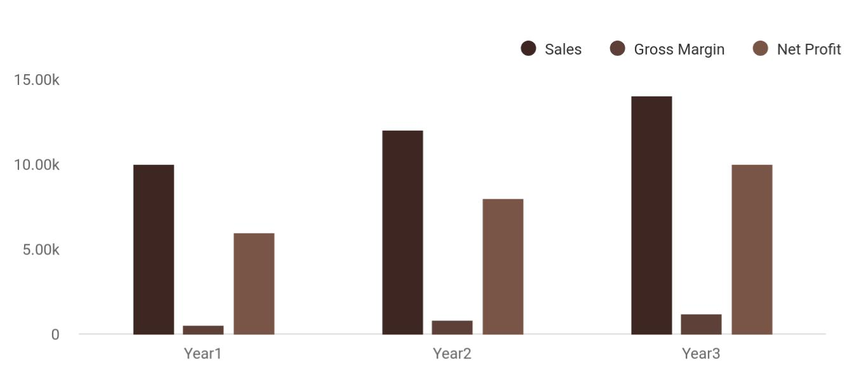

Financial Year | Sales | Gross Margin | Net Profit
Year1 | 10,000 | 500 | 6,000
Year2 | 12,000 | 800 | 8,000
Year3 | 14,000 | 1,200 | 10,000

Woodworking Shop | Business Plan [YEAR] 8/39

2.

Business Description

Company Owner

Purpose of starting a business

Legal Structure

Start-up Summary

Woodworking Shop | Business Plan [YEAR] 9/39

Company Owner
To unlock help try Upmetrics!

 Ex :: Jacobs Woodworking

Nathaniel Jacobs will be the owner of the company. Jacobs is a famous interior designer, crafting unique items of wood is Jacobs’s hobby, even some of his handmade wooden sculptures were kept in the International Woodworking Fair last year.



Start writing here..

Purpose of starting a business

 Ex :: Jacobs Woodworking

Jacobs has been related to making designs, and artifacts since his childhood. He is called by various shows and programs to give interior design ideas. By starting a woodwork business, Jacobs wants to use his experience, skill, and passion on a larger scale to earn a profit.
To unlock help try Upmetrics! 

Start writing here..

Legal Structure

 Ex :: Jacobs Woodworking

Jacobs Woodworking Shop is a sole proprietorship.

To unlock help try Upmetrics! 

Start writing here..

Woodworking Shop | Business Plan [YEAR] 10/39

Start-up Summary
To unlock help try Upmetrics!

 Ex :: Jacobs Woodworking

Jacobs will provide the major investment in starting Jacobs Woodworking Shop. Jacobs will also secure an SBA loan. The following table and chart show the projected initial start-up costs for Jacobs Woodworking Shop.



Start writing here..

Startup Cost
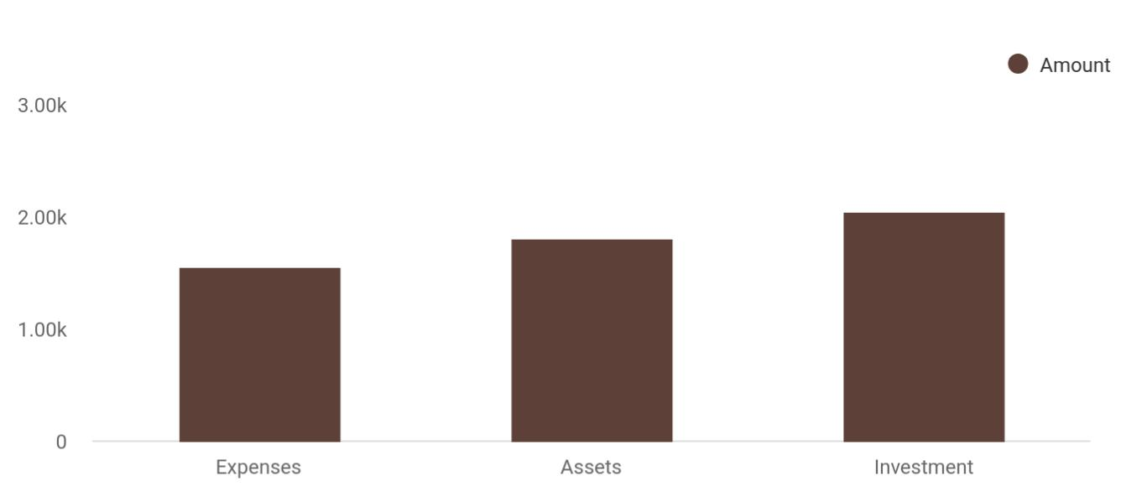

Cost distribution | Amount
Expenses | 1,550
Assets | 1,800
Investment | 2,050

Startup Requirements

The detailed start-up requirements and liabilities as forecast by experts is given below:


Start-up Expenses

Legal

Consultants

Insurance

Amount

$55,300

$0

$32,750

Woodworking Shop | Business Plan [YEAR] 11/39

Start-up Expenses | Amount
Rent | $32,500
Research and Development | $32,750
Expense Equipment | $32,750
Signs | $1,250
TOTAL START-UP EXPENSES | $187,300
Start-up Assets | $0
Cash Required | $332,500
Start-up Inventory | $32,625
Other Current Assets | $232,500
Long-term Assets | $235,000
TOTAL ASSETS | $121,875
Total Requirements | $245,000
START-UP FUNDING | $0
START-UP FUNDING | $273,125
Start-up Expenses to Fund | $11,875
Start-up Assets to Fund | $15,000
TOTAL FUNDING REQUIRED | $0
Assets | $23,125
Non-cash Assets from Start-up | $18,750
Cash Requirements from Start-up | $0
Additional Cash Raised | $18,750
Cash Balance on Starting Date | $21,875
TOTAL ASSETS | $0
Liabilities and Capital | $0
Liabilities | $0
Current Borrowing | $0
Long-term Liabilities | $0
Accounts Payable (Outstanding Bills) | $0

Woodworking Shop | Business Plan [YEAR] 12/39

Start-up Expenses | Amount
Other Current Liabilities (interest-free) | $0
TOTAL LIABILITIES | $0
Capital | $0
Planned Investment | $0
Investor 1 | $332,500
Investor 2 | $0
Other | $0
Additional Investment Requirement | $0
TOTAL PLANNED INVESTMENT | $695,000
Loss at Start-up (Start-up Expenses) | $313,125
TOTAL CAPITAL | $251,875
TOTAL CAPITAL AND LIABILITIES | $251,875
Total Funding | $255,000

Woodworking Shop | Business Plan [YEAR] 13/39

3.

Products and Services

Products and services

Woodworking Shop | Business Plan [YEAR] 14/39

Before starting a woodworking business, you must take many things into consideration such as you must consider what types of wood services will you be providing to your customers. Deciding your services is extremely
To unlock help try Upmetrics! 

 Ex :: Jacobs Woodworking

Jacobs Woodworking Shop, Inc. is in the woodworking industry to service a wide range of clients and of course to make profits, which is why we will ensure we go all the way to give our clients and potential clients options. The products and services that Jacobs Woodcraft will
To unlock help try Upmetrics! 

Start writing here..

Products and services


Beautifully carved

wooden decoration Designated wooden

pieces and chests

sculptures

Designated wooden
Wooden toys
cradles

Wall to wall

woodworking

Woodworking Shop | Business Plan [YEAR] 15/39

 Ex :: Jacobs Woodworking
To unlock help try Upmetrics!

Jacobs Woodcraft’s major serving will be adorning the stage and sets with beautiful woodwork in events and programs. The company will also take orders on doing interior wood designing in residential or commercial buildings.



Start writing here..

Woodworking Shop | Business Plan [YEAR] 16/39

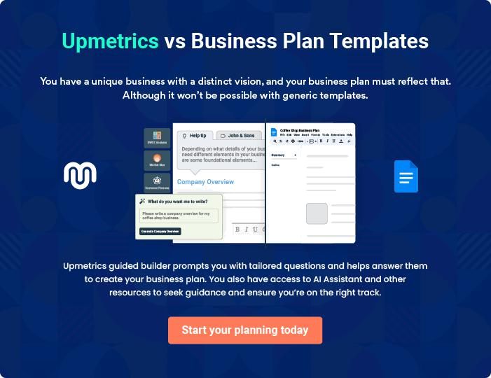

Woodworking Shop | Business Plan [YEAR] | 17/39

4.

Market Analysis

Market Trends

Target Market

Marketing Segmentation

Product Pricing

Woodworking Shop | Business Plan [YEAR] 18/39

The most significant part of developing a woodworking business plan is its accurate market analysis. Knowing the customers’ demand before you start your own woodworking business is really helpful in deciding your services
To unlock help try Upmetrics!
To unlock help try Upmetrics! 

Market Trends

 Ex :: Jacobs Woodworking

If you are conversant with the trends in the Woodworking Industry, you will quite agree that the changes in disposable income, consumer sentiment, ever-changing trends, and of course the rate of homeownership are major growth drivers for this industry.



Start writing here..

Target Market

 Ex :: Jacobs Woodworking

We are fully aware that there is indeed a large national and international market for products made from wood hence we have positioned our woodworking company to service wood-related construction companies, households, and other manufacturing companies all around Reno –
To unlock help try Upmetrics! 

Start writing here..

Woodworking Shop | Business Plan [YEAR] 19/39

Marketing Segmentation

Jacobs Woodworking Shop will focus on two significant customer groups:

Marketing Share
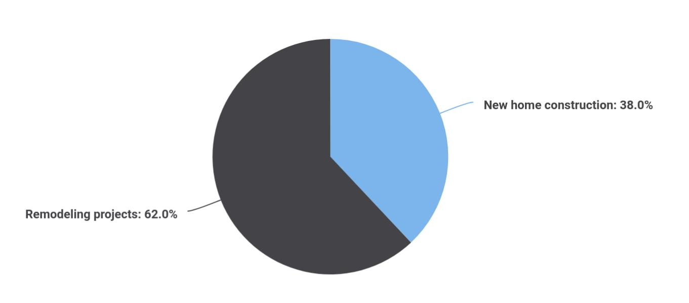

Segments | Market share
New home construction | 38
Remodeling projects | 62

Potential Customers | Growth | Year 1 | Year 2 | Year 3 | Year 4 | Year 5 | CAGR
New Home Construction | 7% | 2,000 | 2,140 | 2,290 | 2,450 | 2,622 | 7.00%
Remodeling Projects | 5% | 3,000 | 3,150 | 3,308 | 3,473 | 3,647 | 5.00%
Total | 5.82% | 5,000 | 5,290 | 5,598 | 5,923 | 6,269 | 5.82%

Product Pricing

 Ex :: Jacobs Woodworking

Setting the prices of products and services is undoubtedly the most challenging part while starting a new business, as it is difficult in the initial stages to earn a profit while keeping low prices. You can have an idea of the wooden product prices by going through any woodworking
To unlock help try Upmetrics! 

Start writing here..

Woodworking Shop | Business Plan [YEAR] 20/39

5.

Strategy and

Implementation Summary

Competitive Analysis

Sales Strategy

Woodworking Shop | Business Plan [YEAR] 21/39

The most important part after starting a small woodworking business is to advertise your services to let your target customers know about you. In fact, there are more chances of a startup to end as a failure if its owner failed to
To unlock help try Upmetrics!
To unlock help try Upmetrics! 

Competitive Analysis

 Ex :: Jacobs Woodworking

Nathaniel Jacobs' reputation for quality work and excellent customer skills has been a hallmark of his work history in construction. Starting his own company is just another step in his quest to deliver services to customers that were second to none. As a woman in the male-dominated
To unlock help try Upmetrics! 

Start writing here..

Sales Strategy

 Ex :: Jacobs Woodworking

Considering the market demand and the beauty of our products, our sales pattern is expected to increase with years. Our experts have forecasted the following sales on a yearly basis which are summarised in the column charts.



Start writing here..

Sales Yearly
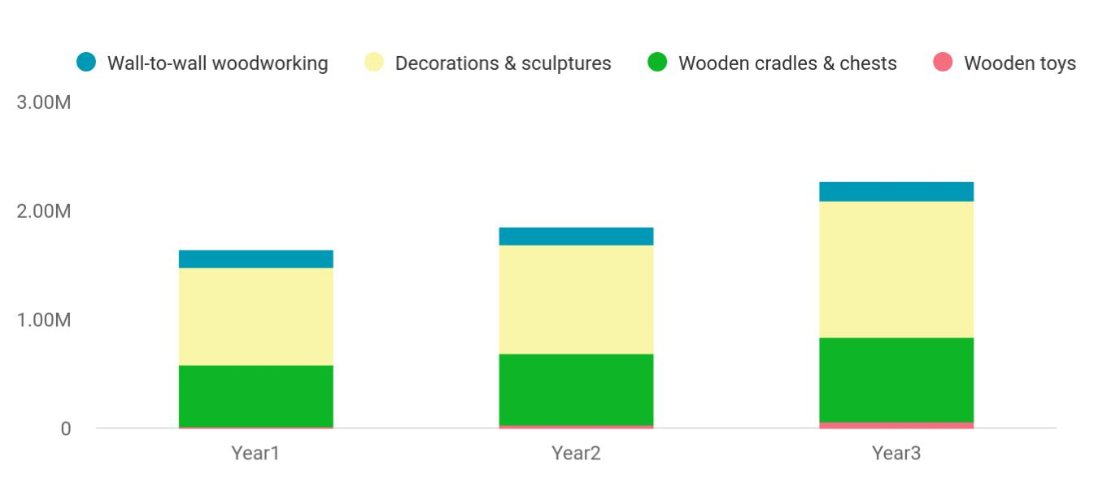

Woodworking Shop | Business Plan [YEAR] 22/39

Financial Year | Wall-to-wall woodworking | Decorations & sculworking | Wooden cradles & working | Wooden toys
Year1 | 158,745 | 895,665 | 568,654 | 12,451
Year2 | 164,548 | 1,004,512 | 658,457 | 24,578
Year3 | 186,541 | 1,245,587 | 784,512 | 56,452

Sales Forecast
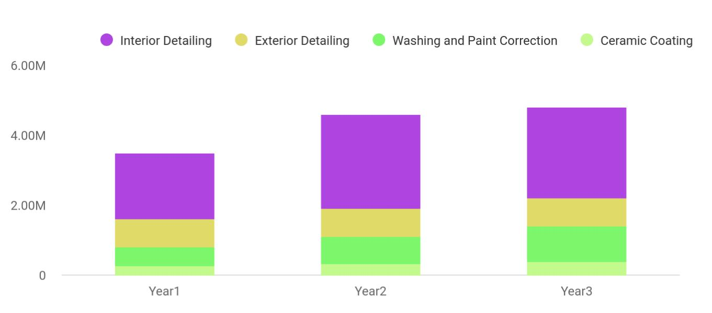

Financial Year | Interior Detailing | Exterior Detailing | Washing and Painworking | Ceramic Coating
Year1 | 1,887,030 | 802,370 | 539,320 | 265,450
Year2 | 2,680,320 | 815,430 | 770,230 | 322,390
Year3 | 2,588,240 | 823,540 | 1,002,310 | 393,320

Woodworking Shop | Business Plan [YEAR] 23/39

Detailed Sales Forecast

Start writing here..

 | Year 1 | Year 2 | Year 3
Unit Sales
Wall-to-wall woodworking | 1,887,030 | 2,680,320 | 2,588,240
Decorations & sculptures | 802,370 | 815,430 | 823,540
Wooden cradles & chests | 539,320 | 770230 | 1,002,310
Wooden toys | 265,450 | 322,390 | 393,320
TOTAL UNIT SALES | 3,494,170 | 4,588,370 | 4,807,410
Unit Prices
Wall-to-wall woodworking | $140.00 | $150.00 | $160.00
Decorations & sculptures | $600.00 | $800.00 | $1,000.00
Wooden cradles & chests | $700.00 | $800.00 | $900.00
Wooden toys | $650.00 | $750.00 | $850.00
Sales
Wall-to-wall woodworking | $2,149,800 | $2,784,000 | $3,383,200
Decorations & sculptures | $120,050 | $194,500 | $268,500
Wooden cradles & chests | $50,110 | $71,600 | $93,000
Wooden toys | $139,350 | $194,600 | $249,850
Direct Unit Costs
Wall-to-wall woodworking | $0.70 | $0.80 | $0.90
Decorations & sculptures | $0.40 | $0.45 | $0.50
Wooden cradles & chests | $0.30 | $0.35 | $0.40
Wooden toys | $3.00 | $3.50 | $4.00
Direct Cost of Sales
Wall-to-wall woodworking | $989,300 | $1,839,000 | $2,679,700
Decorations & sculptures | $66,600 | $119,900 | $173,200
Wooden cradles & chests | $17,900 | $35,000 | $52,100
Wooden toys | $19,400 | $67,600 | $115,800

Woodworking Shop | Business Plan [YEAR] 24/39

 | Year 1 | Year 2 | Year 3
Subtotal Direct Cost of Sales | $1,294,100 | $1,699,400 | $2,104,700

Woodworking Shop | Business Plan [YEAR] 25/39

6.

Management Summary

Personnel Plan

Average Salary

Woodworking Shop | Business Plan [YEAR] 26/39

The management plan is also an important component of a woodworking business plan since it gives you an estimate of the staff required for your startup as well as the costs incurred on their salaries. So, make sure to duly
To unlock help try Upmetrics! 

 Ex :: Jacobs Woodworking

Jacobs Woodworking Shop will be managed by Nathaniel Jacobs. Jacobs is a talented professional who holds a Bachelor of Arts degree from Western College in Art that she obtained while working full-time in the construction field. Jacobs entered the world of
To unlock help try Upmetrics! 

Start writing here..

Personnel Plan

Jacobs is all-in-all in carving wooden products and making unique designs, he needs staff for working on his ideas, so he has decided to be in the production center and not be the manager himself. He’ll hire the following persons:

- 1 General Manager to manage the operations

- 2 Accountants to maintain financial records

- 3 Artists/Designers for presenting and drawing new designs

- 8 Carpenters for woodworking

- 4 Salespersons to operate display centers

- 3 Sales and Marketing Executives responsible for delivering products to retailers and discover new ventures

- 2 Technicians for maintaining machines

- 2 Drivers for transporting wood and other material

- 1 Front Desk Officer to act as a receptionist for receiving interior design orders

- 2 General Workers for routine tasks

Woodworking Shop | Business Plan [YEAR] 27/39

Average Salary

 | Year 1 | Year 2 | Year 3
Accountants | $85,000 | $95,000 | $105,000
General Manager | $45,000 | $50,000 | $55,000
Carpenters | $550,000 | $650,000 | $750,000
Artists/ Designers | $410,000 | $440,000 | $480,000
Salespersons | $152,000 | $159,000 | $166,000
Sales Executives | $145,000 | $152,000 | $159,000
Technicians | $50,000 | $55,000 | $60,000
Drivers & Workers | $187,000 | $194,000 | $201,000
Front Desk Officer | $42,000 | $45,000 | $48,000
Total Salaries | $562,000 | $599,000 | $646,000

Woodworking Shop | Business Plan [YEAR] 28/39

7.

Financial Plan

Important Assumptions

Brake-even Analysis

Projected Profit and Loss

Projected Cash Flow

Projected Balance Sheet

Business Ratios

Woodworking Shop | Business Plan [YEAR] 29/39

The last component of a woodworking business plan is an in-depth financial plan. The financial plan crafts a detailed map of all the expenses needed for the startup and how these expenses will be met by the earned profits. It is
To unlock help try Upmetrics! 

Important Assumptions

The financial projections of the company are forecast on the basis of the following assumptions. These assumptions are quite conservative and are expected to show deviation but to a limited level such that the company’s major financial strategy will not be affected.

 | Year 1 | Year 2 | Year 3
Plan Month | 1 | 2 | 3
Current Interest Rate | 10,00% | 11,00% | 12,00%
Long-term Interest Rate | 10,00% | 10,00% | 10,00%
Tax Rate | 26,42% | 27,76% | 28,12%
Other | 0 | 0 | 0

Brake-even Analysis

Monthly Units Break-even | 5530
Monthly Revenue Break-even | $159 740
Assumptions:
Average Per-Unit Revenue | $260,87
Average Per-Unit Variable Cost | $0,89
Estimated Monthly Fixed Cost | $196 410

Projected Profit and Loss

 | 2024 | 2025 | 2026
Revenue | $454,323 | $607,138 | $957,367
Custom Furniture | $160,936 | $204,104 | $258,680

Woodworking Shop | Business Plan [YEAR] 30/39

 | 2024 | 2025 | 2026
Unit Sales | 201 | 255 | 323
Unit Price | $800 | $800 | $800
Woodworking Classes | $78,795 | $130,770 | $353,439
Unit Sales | 263 | 436 | 1,178
Unit Price | $300 | $300 | $300
Customized Projects | $214,592 | $272,264 | $345,248
Unit Sales | 268 | 340 | 432
Unit Price | $800 | $800 | $800

Cost Of Sales | $40,800.52 | $48,504.46 | $62,846.55
General Costs | $40,800.52 | $48,504.46 | $62,846.55
Raw Materials for Custom | $23,364.79 | $26,391.91 | $34,802.41
Furniture | $23,364.79 | $26,391.91 | $34,802.41
Wood | $18,000 | $19,587.97 | $26,173.04
Wood Glue | $5,364.79 | $6,803.94 | $8,629.37
Supplies for Woodworking | $17,435.73 | $22,112.55 | $28,044.14
Classes | $17,435.73 | $22,112.55 | $28,044.14
Sandpaper Packs | $6,705.97 | $8,504.74 | $10,786.13
Wood (Pine) | $10,729.76 | $13,607.81 | $17,258.01
Revenue Specific Costs | $0 | $0 | $0
Personnel Costs (Direct | $0 | $0 | $0
Labor) | $0 | $0 | $0

Gross Margin | $413,522.48 | $558,633.54 | $894,520.45
Gross Margin (%) | 91.02% | 92.01% | 93.44%

Operating Expense | $409,023.38 | $419,183.25 | $430,513.15

Woodworking Shop | Business Plan [YEAR] 31/39

 | 2024 | 2025 | 2026
Payroll Expense (Indirect | $379,800 | $384,498 | $389,261.04
Labor) | $379,800 | $384,498 | $389,261.04
Management Team | $162,000 | $164,520 | $167,083.20
General Manager | $90,000 | $91,800 | $93,636
Operations Manager | $72,000 | $72,720 | $73,447.20
Production Team | $117,000 | $118,170 | $119,351.76
Lead Carpenter | $72,000 | $72,720 | $73,447.20
Carpenter Assistant | $45,000 | $45,450 | $45,904.56
Sales and Marketing Team | $100,800 | $101,808 | $102,826.08
Sales Associate | $43,200 | $43,632 | $44,068.32
Marketing Specialist | $57,600 | $58,176 | $58,757.76
General Expense | $29,223.38 | $34,685.25 | $41,252.11
Workshop Utilities | $11,922.40 | $14,741.46 | $18,242.96
Electricity | $6,705.97 | $8,504.74 | $10,786.13
Water | $5,216.43 | $6,236.72 | $7,456.83
Marketing and Advertising | $10,959.55 | $12,798.11 | $14,957.46
Online Ads | $6,520.58 | $7,796.13 | $9,321.21
Print Ads | $4,438.97 | $5,001.98 | $5,636.25
Shop Maintenance and | $6,341.43 | $7,145.68 | $8,051.69
Supplies | $6,341.43 | $7,145.68 | $8,051.69
Maintenance | $4,438.97 | $5,001.98 | $5,636.25
Cleaning Supplies | $1,902.46 | $2,143.70 | $2,415.44
Bad Debt | $0 | $0 | $0
Amortization of Current | $0 | $0 | $0
Assets | $0 | $0 | $0

EBITDA | $4,499.10 | $139,450.29 | $464,007.30

Woodworking Shop | Business Plan [YEAR] 32/39

Additional Expense

Long Term Depreciation

Gain or loss from Sale of Assets

EBIT

Interest Expense

EBT

Income Tax Expense / Benefit
2024 2025 2026

$22,649.71 | $20,855.53 | $18,989.99
$17,951.76 | $17,951.76 | $17,951.76
$0 | $0 | $0
($13,452.66) | $121,498.53 | $446,055.54
$4,697.95 | $2,903.79 | $1,038.24
($18,150.61) | $118,594.76 | $445,017.31
$0 | $0 | $0

Total Expense | $472,473.61 | $488,543.24 | $512,349.69
Net Income | ($18,150.61) | $118,594.76 | $445,017.31
Net Income (%) | (4%) | 19.53% | 46.48%
Retained Earning Opening | $0 | ($93,150.61) | $25,444.15
Owner's Distribution | $75,000 | $0 | $0
Retained Earning Closing | ($93,150.61) | $25,444.15 | $470,461.46
Projected Cash Flow
 | 2024 | 2025 | 2026
Cash Received | $454,323 | $607,138 | $957,367
Cash Paid | $454,521.85 | $470,591.48 | $494,397.93
COS & General Expenses | $70,023.90 | $83,189.71 | $104,098.66
Salary & Wages | $379,800 | $384,498 | $389,261.04

Woodworking Shop | Business Plan [YEAR] 33/39

2024 2025 2026

Interest

Sales Tax

Income Tax

Net Cash From

Operations

Assets Sell

Assets Purchase

Net Cash From

Investments

Amount Received

Loan Received

Common Stock

Preferred Stock

Owner's Contribution

Amount Paid

Loan Capital

Dividends & Distributions

Net Cash From

Financing

Summary

$4,697.95 | $2,903.79 | $1,038.24
$0 | $0 | $0
$0 | $0 | $0
($198.85) | $136,546.52 | $462,969.07

$0 | $0 | $0
$119,999 | $0 | $0
($119,999) | $0 | $0

$150,000 | $0 | $0
$150,000 | $0 | $0
$0 | $0 | $0
$0 | $0 | $0
$0 | $0 | $0
$123,181.97 | $49,976.15 | $51,841.92
$48,181.97 | $49,976.13 | $51,841.91
$75,000 | $0 | $0
$26,818.03 | ($49,976.15) | ($51,841.92)

Starting Cash | $0 | ($93,379.82) | ($6,809.45)
Cash In | $604,323 | $607,138 | $957,367
Cash Out | $697,702.82 | $520,567.63 | $546,239.85
Change in Cash | ($93,379.82) | $86,570.37 | $411,127.15

Woodworking Shop | Business Plan [YEAR] 34/39

 | 2024 | 2025 | 2026
Ending Cash | ($93,379.82) | ($6,809.45) | $404,317.70

Projected Balance Sheet

 | 2024 | 2025 | 2026
Assets | $8,667.37 | $77,285.93 | $470,461.27
Current Assets | ($93,379.82) | ($6,809.45) | $404,317.70
Cash | ($93,379.82) | ($6,809.45) | $404,317.70
Accounts Receivable | $0 | $0 | $0
Inventory | $0 | $0 | $0
Other Current Assets | $0 | $0 | $0
Long Term Assets | $102,047.19 | $84,095.38 | $66,143.57
Gross Long Term Assets | $119,999 | $119,999 | $119,999
Accumulated Depreciation | ($17,951.81) | ($35,903.62) | ($53,855.43)
Liabilities & Equity | $8,667.43 | $77,286.06 | $470,461.46
Liabilities | $101,818.04 | $51,841.91 | $0
Current Liabilities | $49,976.13 | $51,841.91 | $0
Accounts Payable | $0 | $0 | $0
Income Tax Payable | $0 | $0 | $0
Sales Tax Payable | $0 | $0 | $0
Short Term Debt | $49,976.13 | $51,841.91 | $0
Long Term Liabilities | $51,841.91 | $0 | $0
Long Term Debt | $51,841.91 | $0 | $0
Equity | ($93,150.61) | $25,444.15 | $470,461.46
Paid-in Capital | $0 | $0 | $0
Woodworking Shop | Business Plan [YEAR] |  |  | 35/39
 | 2024 |  |  | 2025 | 2026
Common Stock | $0 |  |  | $0 | $0
Preferred Stock | $0 |  |  | $0 | $0
Owner's Contribution | $0 |  |  | $0 | $0
Retained Earnings | ($93,150.61) |  | $25,444.15 |  | $470,461.46
Check | $0 |  |  | $0 | $0
Business Ratios
 |  | Year 1 | Year 2 | Year 3 | Industry Profile
Sales Growth |  | 4,35% | 30,82% | 63,29% | 4,00%
Percent of Total Assets
Accounts Receivable |  | 5,61% | 4,71% | 3,81% | 9,70%
Inventory |  | 1,85% | 1,82% | 1,79% | 9,80%
Other Current Assets |  | 1,75% | 2,02% | 2,29% | 27,40%
Total Current Assets |  | 138,53% | 150,99% | 163,45% | 54,60%
Long-term Assets |  | -9,47% | -21,01% | -32,55% | 58,40%
TOTAL ASSETS |  | 100,00% | 100,00% | 100,00% | 100,00%
Current Liabilities |  | 4,68% | 3,04% | 2,76% | 27,30%
Long-term Liabilities |  | 0,00% | 0,00% | 0,00% | 25,80%
Total Liabilities |  | 4,68% | 3,04% | 2,76% | 54,10%
NET WORTH |  | 99,32% | 101,04% | 102,76% | 44,90%
Percent of Sales
Sales |  | 100,00% | 100,00% | 100,00% | 100,00%
Gross Margin |  | 94,18% | 93,85% | 93,52% | 0,00%
Selling, General & Administrative Expenses |  | 74,29% | 71,83% | 69,37% | 65,20%
Advertising Expenses |  | 2,06% | 1,11% | 0,28% | 1,40%
Profit Before Interest and Taxes |  | 26,47% | 29,30% | 32,13% | 2,86%

Woodworking Shop | Business Plan [YEAR] 36/39

 | Year 1 | Year 2 | Year 3 | Industry Profile
Main Ratios
Current | 25,86 | 29,39 | 32,92 | 1,63
Quick | 25,4 | 28,88 | 32,36 | 0,84
Total Debt to Total Assets | 2,68% | 1,04% | 0,76% | 67,10%
Pre-tax Return on Net Worth | 66,83% | 71,26% | 75,69% | 4,40%
Pre-tax Return on Assets | 64,88% | 69,75% | 74,62% | 9,00%
Additional Ratios | Year 1 | Year 2 | Year 3
Net Profit Margin | 19,20% | 21,16% | 23,12% | N.A.
Return on Equity | 47,79% | 50,53% | 53,27% | N.A.
Activity Ratios
Accounts Receivable Turnover | 4,56 | 4,56 | 4,56 | N.A.
Collection Days | 92 | 99 | 106 | N.A.
Inventory Turnover | 19,7 | 22,55 | 25,4 | N.A.
Accounts Payable Turnover | 14,17 | 14,67 | 15,17 | N.A.
Payment Days | 27 | 27 | 27 | N.A.
Total Asset Turnover | 1,84 | 1,55 | 1,26 | N.A.
Debt Ratios
Debt to Net Worth | 0 | -0,02 | -0,04 | N.A.
Current Liab. to Liab. | 1 | 1 | 1 | N.A.
Liquidity Ratios
Net Working Capital | $120 943 | $140 664 | $160 385 | N.A.
Interest Coverage | 0 | 0 | 0 | N.A.
Additional Ratios
Assets to Sales | 0,45 | 0,48 | 0,51 | N.A.
Current Debt/Total Assets | 4% | 3% | 2% | N.A.
Acid Test | 23,66 | 27,01 | 30,36 | N.A.
Sales/Net Worth | 1,68 | 1,29 | 0,9 | N.A.
Dividend Payout | 0 | 0 | 0 | N.A.

Woodworking Shop | Business Plan [YEAR] 37/39

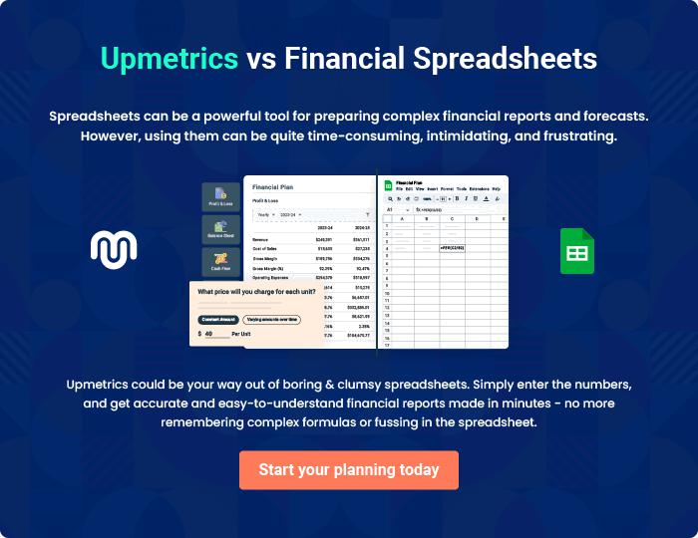

Woodworking Shop | Business Plan [YEAR] | 38/39


Create a winning business plan that gets you funded

Creating a stunning and investment-ready plan requires no writing, graphic designing, or financial planning expertise.

Upmetrics has all the features required to help you create a comprehensive business plan—from start to finish. Make no mistakes, it’s the modern way of planning to structure ideas, make plans, and create stunning pitch decks to awe investors.

Pitch decks that impress investors

Create pitch decks that provide a visual representation of your business, engage investors, and make them want to invest in your business idea.

Interactive plans in no time

Import business plan sections like—SWOT analysis, comparison tables, and others to create an interactive business plan. No designing skills are required.

Stunning cover page designs

With Upmetrics, you have the liberty to choose from multiple stunning cover page designs. Choose a creative design and make your plan stand out.

Online sharing made simple

Upmetrics makes online sharing quick and easier for users. Easily share your business plans with a link while tracking reader activity.

500+ sample business plans

Simply import a template from our library of sample plans into the editor and start customizing it to make it yours. It takes only a few clicks to get started.

Collaborate with team in real-time

Invite team members, initiate conversations, discuss ideas & strategies, share feedback, and work on a business plan in real-time.

