
BUSINESS PLAN

[YEAR]

Maxwell Winery

Good Wine for Good Moments

John Doe

10200 Bolsa Ave, Westminster, CA, 92683

- 359-3153 info@example.com http://www.example.com

Information provided in this business plan is unique to this business and confidential; therefore, anyone reading this plan agrees not to disclose any of the information in this business plan without prior written permission of the company.
Table of Contents

Executive Summary | 5
Mission Statement | 6
Vision Statement | 6
Customer Focus | 7
Financial Summary | 7
3 Year profit forecast | 7

Company Summary | 9
History | 10
Business Structure | 10
Startup summary | 11
Startup cost | 11
Products and services
Products and services | 14
Market Analysis
Market Analysis | 17
Industry Analysis | 18
Market Trends | 18
Target Market | 18
SWOT Analysis
SWOT Analysis | 19
Strategy & Implementations
Strategy & Implementations | 21
Sales Forecast | 22
Advertising Strategy | 22
Direct Mail | 22
Public Relations | 23
Advertising | 23
Sampling | 23
Ongoing Customer Communications | 23
Pre-Opening Events | 24

Maxwell Winery | Business Plan [YEAR] 2/38

Pricing Strategy | 24

Management Summary | 25
Functional Roles | 26
Service Functions | 26
Administrative Functions | 26
Milestones | 27

Financial Plan | 28
Important Assumptions | 29
Brake-even Analysis | 29
Projected Profit and Loss | 30
Projected Cash Flow | 33
Projected Balance Sheet | 34
Business Ratios | 35

Maxwell Winery | Business Plan [YEAR] 3/38

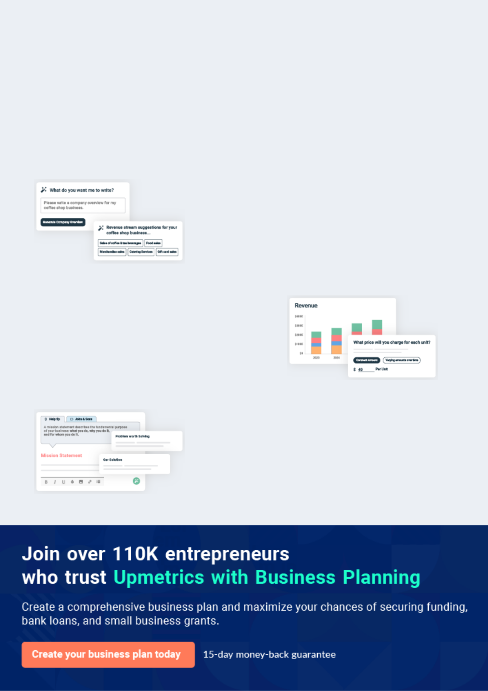
Business planning that’s simpler and faster than you think

Creating a business plan using Upmetrics to start and grow a business is literally the easiest thing in the World. Simply read the instructions and fill in the blanks. It’s as simple as that.

❛ | Upmetrics has everything you need to create a | ❜
❛ | comprehensive business plan. | ❜

AI-powered Upmetrics Assistant

AI-powered insights to streamline your plan

Not sure where to start? Upmetrics’ AI Assistant will automatically generate ideas for each section of your plan and offer improved versions of your writing, adjusting for tone, voice, and grammar or spelling errors.

Financial Forecasting Tool

All the financials are calculated for you

Forget the complex formulas and clumsy spreadsheets — with automatic financials and drag-and-drop forecasting, you can finish your plan faster and be confident that your numbers are accurate.

Business Plan Builder

Guides you like a business mentor

Upmetrics’ step-by-step instructions, prompts, and the library of 400+ sample business plans will guide you through each section of your plan as a business mentor.

1.


Executive Summary

Mission Statement

Vision Statement

Customer Focus

Financial Summary

Maxwell Winery | Business Plan [YEAR] 5/38

Before you think about how to start a Winery business, you must create a detailed Winery business plan. It will not only guide you in the initial phases of your startup but will also help you later on.
To unlock help try Upmetrics!



 Maxwell Wine


Maxwell Wine, Inc. is a standard and licensed winery business that will be located in an industrial area in Detroit – Michigan. We have been able to secure a long-term lease for a
standard facility and 2 acres of farmland in a strategic location with an option of a long-term
To unlock help try Upmetrics! 

Start writing here..

Mission Statement

 Maxwell Wine

- Our mission is to establish a standard winery business that will produce a wide range of wines for both low-income earners and for luxury consumption.
To unlock help try Upmetrics! 

Start writing here..

Vision Statement

 Maxwell Wine

Our vision is to establish a standard winery whose products will not only be sold in the United States of America and Canada but also in other parts of the world.
To unlock help try Upmetrics! 

Start writing here..

Maxwell Winery | Business Plan [YEAR] 6/38

Customer Focus

 Maxwell Wine

Maxwell Wine will primarily serve the residents who live within a 20-mile radius of our winery and workers within a quarter-mile radius. The demographics of these customers are as follows:
To unlock help try Upmetrics! 

Start writing here..

Financial Summary

 Maxwell Wine

Maxwell Wine is seeking total funding of $520,000 to launch its winery. The capital will be used for funding capital expenditures, manpower costs, marketing expenses, and working capital.
To unlock help try Upmetrics! 

Start writing here..

3 Year profit forecast
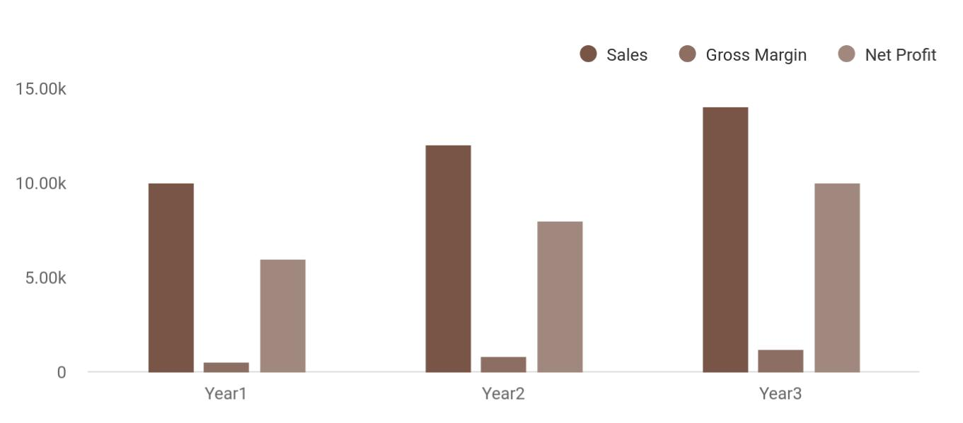

Maxwell Winery | Business Plan [YEAR] 7/38

 Maxwell Wine


Financial Summary | Year 1 | Year 2 |  | Year 3
 |  |  | To unlock help try Upmetrics! |  | 

Start writing here..

Maxwell Winery | Business Plan [YEAR] 8/38

2.

Company Summary

History

Business Structure

Startup summary

Maxwell Winery | Business Plan [YEAR] 9/38

 Maxwell Wine

Maxwell Wine, Inc. is a family business that will be owned by John Moore and their Family. John Moore who is the Chief Executive Officer of the Company is a Graduate of MicroBiology (B.Sc.) and he holds a Master’s Degree in Business Management (MBA)._{To unlock help try Upmetrics!} 

Start writing here..

History

 Maxwell Wine

In 2015, John Moore acquired land and decided to plant a Maxwell Wine with the vision to be a leading wine supplier in the Detroit area. He spent years developing his land and producing the
best harvest of grapes to turn into wine. With the help of his three sons and daughter, they were
To unlock help try Upmetrics! 

Start writing here..

Business Structure

 Maxwell Wine

Maxwell Wine, Inc. is a business that is established with the aim of competing favorably with other leading winery brands in the industry. This is why we will ensure that we put the right structure in place that will support the kind of growth that we have in mind while setting up the
To unlock help try Upmetrics! 

Start writing here..

Maxwell Winery | Business Plan [YEAR] 10/38

Startup summary

Startup cost
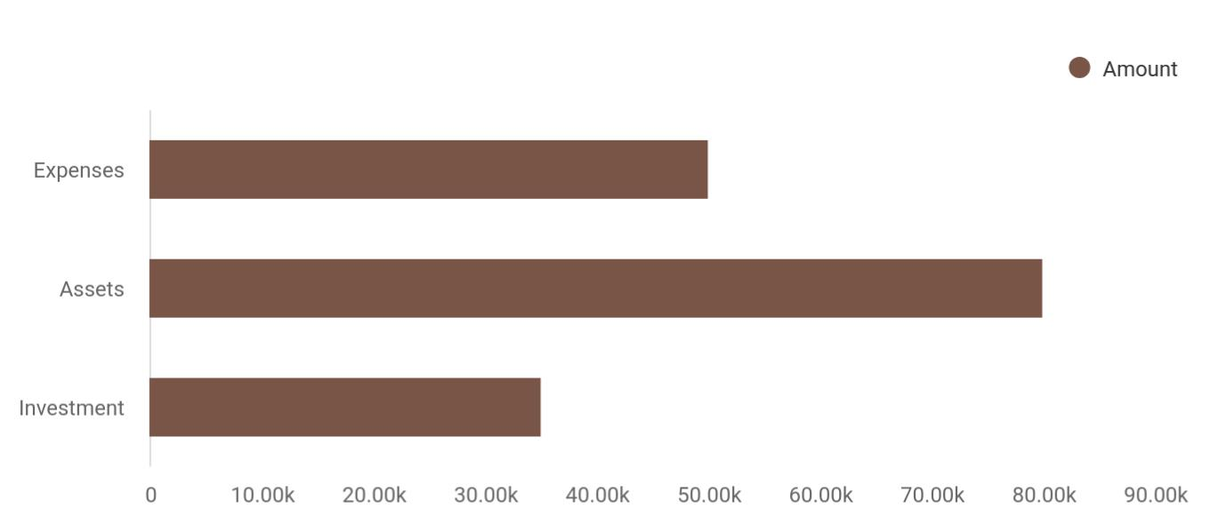

Cost distribution | Amount
Expenses | 50,000
Assets | 80,000
Investment | 35,000

Start-up Expenses | Amount
Legal | $75,500
Consultants | $0
Insurance | $62,750
Rent | $22,500
Research and Development | $42,750
Expensed Equipment | $42,750
Signs | $1,250
TOTAL START-UP EXPENSES | $247,500
Start-up Assets | $0
Cash Required | $322,500
Start-up Inventory | $52,625
Other Current Assets | $222,500

Maxwell Winery | Business Plan [YEAR] 11/38

Start-up Expenses | Amount
Long-term Assets | $125,000
TOTAL ASSETS | $121,875
Total Requirements | $245,000
START-UP FUNDING | $0
START-UP FUNDING | $273,125
Start-up Expenses to Fund | $121,875
Start-up Assets to Fund | $195,000
TOTAL FUNDING REQUIRED | $0
Assets | $203,125
Non-cash Assets from Start-up | $118,750
Cash Requirements from Start-up | $0
Additional Cash Raised | $118,750
Cash Balance on Starting Date | $121,875
TOTAL ASSETS | $0
Liabilities and Capital | $0
Liabilities | $0
Current Borrowing | $0
Long-term Liabilities | $0
Accounts Payable (Outstanding Bills) | $0
Other Current Liabilities (interest-free) | $0
TOTAL LIABILITIES | $0
Capital | $0
Planned Investment | $0
Investor 1 | $312,500
Investor 2 | $0
Other | $0
Additional Investment Requirement | $0
TOTAL PLANNED INVESTMENT | $695,000

Maxwell Winery | Business Plan [YEAR] 12/38

Start-up Expenses | Amount
Loss at Start-up (Start-up Expenses) | $313,125
TOTAL CAPITAL | $221,875
TOTAL CAPITAL AND LIABILITIES | $221,875
Total Funding | $265,000

Maxwell Winery | Business Plan [YEAR] 13/38

3.

Products and services

Maxwell Winery | Business Plan [YEAR] 14/38

 Maxwell Wine

Maxwell Wine, Inc. is going to operate a standard and licensed winery whose products will not only be sold in the United States and Canada but also in other parts of the world. We are in the winery business to make profits and also to give our customers value for their money.
To unlock help try Upmetrics! 

Start writing here..


Growing wine grapes Blending wines

Marketing and
Bottling wines
retailing wines

Manufacturing

brandy, vermouth and Chardonnay cider

Cabernet Sauvignon Merlot

Maxwell Winery | Business Plan [YEAR] 15/38



Pinot Grigio Pinot Noir

Zinfandel, Riesling
Sauvignon Blanc
and other blends
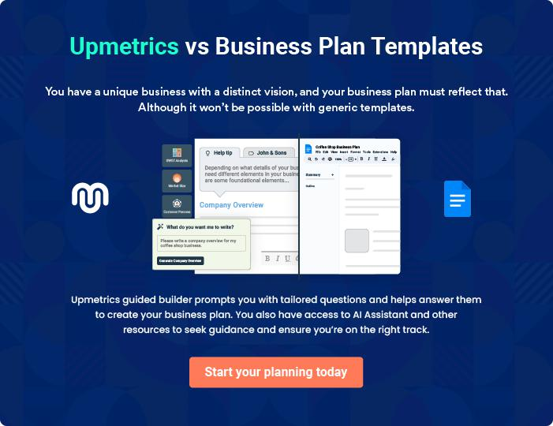

Maxwell Winery | Business Plan [YEAR] 16/38

4.

Market Analysis

Industry Analysis

Market Trends

Target Market

Maxwell Winery | Business Plan [YEAR] 17/38

The most important component of an effective Winery business plan is its accurate marketing analysis. If you are starting on a smaller scale, you can
do marketing analysis yourself by taking help from this Winery business plan
To unlock help try Upmetrics! 

Industry Analysis

 Maxwell Wine

The Winery industry has experienced fairly consistent growth over the past years. As the United States has become an increasingly prominent producer and exporter of quality wines, the industry has established itself as a key player in the global wine market. Additionally, consumer
To unlock help try Upmetrics! 

Start writing here..

Market Trends

 Maxwell Wine

One common trend in the wineries industry is that, over the last five years, it has become obvious that consumer drinking preferences have moved away from standard light beers, and loads of consumers have discovered wine for its perceived health benefits and increasingly
To unlock help try Upmetrics! 

Start writing here..

Target Market

 Maxwell Wine

When it comes to selling wines, there is indeed a wide range of available customers. In essence, our target market can’t be restricted to just a group of people, but all those who drink alcoholic drinks and non – alcoholic drinks. One thing is certain; the target market for wines,
To unlock help try Upmetrics! 

Start writing here..

Maxwell Winery | Business Plan [YEAR] 18/38

5.

SWOT Analysis

Maxwell Winery | Business Plan [YEAR] 19/38

 Maxwell Wine
To unlock help try Upmetrics!

We are quite aware that there are several wineries in the United States of America and Canada which is why we are following the due process of establishing a business so as to compete favorably with them.



Start writing here..


Strength

Part of what is going to count as positives for Maxwell Wine, Inc. is the vast experience of our management team, we have people on board who are highly experienced and understand how to grow business from scratch to becoming a national phenomenon.

So also, we grow our own grapes and the wide varieties of wine et al that we produce our large national distribution network and of course our excellent customer service culture will definitely count as a strong strength for the business.


Weakness

A major weakness that may count against us is the fact that we are a new winery and we don’t have the financial capacity to engage in the kind of publicity that we intend to give the business especially when big names like The Wine Group, Gallo, and Constellation Brand Inc. are already determining the direction of the market.


Opportunity

The opportunities for mega wineries with a wide range of products are enormous. This due to the fact that the average Americans and Canadians consume distilled products.

As a result of that, we were able to conduct a thorough market survey and feasibility studies so as to position our business to take advantage of the existing market for wine products and also to create our own new market. We know that it is going to requires hard work, and we are determined to achieve it.

Threat

We are quite aware that just like any other business, one of the major threats that we are likely going to face is an economic downturn and unfavorable government policies.

It is a fact that the economic downturn affects purchasing power. Another threat that may likely confront us is the arrival of a new winery or distillery plant in the same location where ours is located.

Maxwell Winery | Business Plan [YEAR] 20/38

6.

Strategy &

Implementations

Sales Forecast

Advertising Strategy

Pricing Strategy

Maxwell Winery | Business Plan [YEAR] 21/38

After identifying the market demand, market trends, and the potential customers of the startup, the next step is to define an effective strategy for attracting those customers. Like marketing analysis, sales strategy is also an
To unlock help try Upmetrics!
To unlock help try Upmetrics! 

Sales Forecast

 Maxwell Wine

It is important to state that our sales forecast is based on the data gathered during our feasibility studies, market survey, and also some of the assumptions readily available in the
field. Below are the sales projections that we were able to come up with for the first three years
To unlock help try Upmetrics! 

Start writing here..

Advertising Strategy

 Maxwell Wine

Maxwell Wine expects its target market to be residents and individuals working within the

Detroit area. The Company’s promotions strategy to reach these individuals includes:
To unlock help try Upmetrics! 

Start writing here..

 Maxwell Wine

Maxwell Wine will blanket neighborhoods surrounding its locations with direct mail pieces. These pieces will provide general information on Maxwell Wine, offer discounts, and/or provide other promotions for people to experience our wine offerings.



Direct Mail

Start writing here..

Maxwell Winery | Business Plan [YEAR] 22/38

 Maxwell Wine

We will contact all local and area newspapers and television stations and send them a press release describing the opening and unique value proposition of Maxwell Wine.
To unlock help try Upmetrics! 

Public Relations

Start writing here..

 Maxwell Wine

Maxwell Wine will initially advertise in local newspapers and sponsor community events in order to gain awareness.
To unlock help try Upmetrics! 

Advertising

Start writing here..

 Maxwell Wine

Maxwell Wine employees will initially give free wine samples to enable customers to taste the quality of our wines and learn about us.
To unlock help try Upmetrics! 

Sampling

Start writing here..

 Maxwell Wine

Maxwell Wine will maintain a website and publish a monthly email newsletter to tell customers about new events, products, and more.
To unlock help try Upmetrics! 

Ongoing Customer Communications

Start writing here..

Maxwell Winery | Business Plan [YEAR] 23/38

 Maxwell Wine
To unlock help try Upmetrics!

Before opening the winery, Maxwell Wine will organize pre-opening events designed for prospective customers, local merchants, and press contacts. These events will create buzz and awareness for Maxwell Wine in the area.



Pre-Opening Events

Start writing here..

Pricing Strategy

 Maxwell Wine

When it comes to pricing for products such as alcoholic and non – alcoholic wines, there are two sides to the coin. We are aware of the pricing trend in the winery industry which is why we have decided to produce products for both high–end customers and regular consumers of
To unlock help try Upmetrics! 

Start writing here..

Maxwell Winery | Business Plan [YEAR] 24/38

7.

Management Summary

Functional Roles

Milestones

Maxwell Winery | Business Plan [YEAR] 25/38

 Maxwell Wine
To unlock help try Upmetrics!

Maxwell Liquor Store will be managed by John Moore and James Moore. After the launch of the business, as sales volumes increase, an associate manager may be hired to help with day-to-day store operations.



Start writing here..

Functional Roles

 Maxwell Wine

In order to execute on Maxwell Wine’s business model, the Company needs to perform many functions including the following:
To unlock help try Upmetrics! 

Start writing here..

 Maxwell Wine


• Grape harvesting

• Grapes pressing and wine making To unlock help try Upmetrics! 

Service Functions

Start writing here..

 Maxwell Wine

• General & administrative functions including legal, marketing, bookkeeping, etc.

• ^{Hiring and training staff} To unlock help try Upmetrics! 

Administrative Functions

Start writing here..

Maxwell Winery | Business Plan [YEAR] 26/38

Milestones

 Maxwell Wine

Maxwell Wine’s long-term goal is to become the dominant provider of quality wines in the Detroit area. We seek to be the standard by which other providers are judged.
To unlock help try Upmetrics! 

Start writing here..

Maxwell Winery | Business Plan [YEAR] 27/38

8.

Financial Plan

Important Assumptions

Brake-even Analysis

Projected Profit and Loss

Projected Cash Flow

Projected Balance Sheet

Business Ratios

Maxwell Winery | Business Plan [YEAR] 28/38

The last component of the Winery business plan is an in-depth financial plan.

The financial plan crafts a detailed map of all the expenses needed for the
startup and how these expenses will be met by the earned profits. It is
To unlock help try Upmetrics! 

 Maxwell Wine

The company will be financed by John himself and he will control the direction of the business to make sure that it is expanding at the forecasted rate. As for the Winery business start-up, no equity funding or outside loans will be required. With the help of financial experts, John has
To unlock help try Upmetrics! 

Start writing here..

Important Assumptions

The financial projections of the company are forecast on the basis of the following assumptions. These assumptions are quite conservative and are expected to show deviation but to a limited level such that the company’s major financial strategy will not be affected.

 | Year 1 | Year 2 | Year 3
Plan Month | 1 | 2 | 3
Current Interest Rate | 10,00% | 11,00% | 12,00%
Long-term Interest Rate | 10,00% | 10,00% | 10,00%
Tax Rate | 26,42% | 27,76% | 28,12%
Other | 0 | 0 | 0

Brake-even Analysis

Monthly Units Break-even | 5530
Monthly Revenue Break-even | $159 740
Assumptions:
Average Per-Unit Revenue | $260,87
Average Per-Unit Variable Cost | $0,89
Estimated Monthly Fixed Cost | $196 410

Maxwell Winery | Business Plan [YEAR] 29/38

Projected Profit and Loss

 | 2024 | 2025 | 2026
Revenue | $1,200,669 | $2,653,351.60 | $4,003,606.15
Wine Sales | $240,000 | $283,841.60 | $404,692
Unit Sales | 12,000 | 14,192 | 20,235
Unit Price | $20 | $20 | $20
Tasting Room Charges | $90,000 | $92,700 | $98,106.15
Unit Sales | 6,000 | 6,180 | 6,540
Unit Price | $15 | $15 | $15
Wine Club Subscriptions | $870,669 | $2,276,810 | $3,500,808
Users | 1,292 | 2,370 | 3,350
Recurring Charges | $100 | $100 | $100
Cost Of Sales | $191,118.13 | $302,043.86 | $406,797.68
General Costs | $191,118.13 | $302,043.86 | $406,797.68
Wine Production Costs | $134,046.83 | $237,734.60 | $334,332.44
Grape Purchase | $50,000 | $52,000 | $54,080
Bottle and Packaging | $84,046.83 | $185,734.60 | $280,252.44
Labor and Processing Costs | $57,071.30 | $64,309.26 | $72,465.24
Winemaking Labor | $38,047.52 | $42,872.83 | $48,310.14
Fermentation and Storage | $19,023.78 | $21,436.43 | $24,155.10
Revenue Specific Costs | $0 | $0 | $0
Personnel Costs (Direct | $0 | $0 | $0
Labor) | $0 | $0 | $0
Gross Margin | $1,009,550.87 | $2,351,307.74 | $3,596,808.47

Maxwell Winery | Business Plan [YEAR] 30/38

 | 2024 | 2025 | 2026
Gross Margin (%) | 84.08% | 88.62% | 89.84%

Operating Expense | $1,073,469.78 | $1,108,688.69 | $1,156,387.91
Payroll Expense (Indirect | $986,640 | $1,008,397.20 | $1,030,650.36
Labor) | $986,640 | $1,008,397.20 | $1,030,650.36
Winemaking Team | $439,440 | $449,383.20 | $459,559.92
Head Winemaker | $115,440 | $118,903.20 | $122,470.32
Winery Workers | $324,000 | $330,480 | $337,089.60
Sales and Marketing Team | $339,000 | $346,650 | $354,479.16
Sales Manager | $87,000 | $89,610 | $92,298.36
Marketing Specialists | $252,000 | $257,040 | $262,180.80
Administrative Staff | $208,200 | $212,364 | $216,611.28
Office Manager | $73,200 | $74,664 | $76,157.28
Administrative Assistants | $135,000 | $137,700 | $140,454
General Expense | $86,829.78 | $100,291.49 | $125,737.55
Marketing and Advertising | $40,274.29 | $47,935.25 | $61,885.24
Digital Marketing | $23,474.29 | $28,066.35 | $33,556.80
Print Advertising | $16,800 | $19,868.90 | $28,328.44
Operational Costs | $29,482.53 | $34,160 | $44,431.88
Utilities | $12,682.53 | $14,291.10 | $16,103.44
Equipment Maintenance | $16,800 | $19,868.90 | $28,328.44
Administrative Costs | $17,072.96 | $18,196.24 | $19,420.43
Office Supplies | $5,072.96 | $5,716.24 | $6,441.23
Legal and Professional | $12,000 | $12,480 | $12,979.20
Fees | $12,000 | $12,480 | $12,979.20
Bad Debt | $0 | $0 | $0

Maxwell Winery | Business Plan [YEAR] 31/38

Amortization of Current Assets

EBITDA

Additional Expense

Long Term Depreciation

Gain or loss from Sale of Assets

EBIT

Interest Expense

EBT

Income Tax Expense / Benefit

Total Expense

Net Income

Net Income (%)

Retained Earning Opening

Owner's Distribution

Retained Earning Closing

2024 | 2025 | 2026
$0 | $0 | $0

($63,918.91) $1,242,619.06 $2,440,420.56

$31,096.80 | $28,853.24 | $26,447.49
$25,080 | $25,080 | $25,080
$0 | $0 | $0
($88,998.91) | $1,217,539.06 | $2,415,340.56
$6,016.82 | $3,773.25 | $1,367.48
($95,015.71) | $1,213,765.82 | $2,413,973.07
$0 | $0 | $0

$1,295,684.71 | $1,439,585.78 | $1,589,633.08
($95,015.71) | $1,213,765.82 | $2,413,973.07
(7.91%) | 45.74% | 60.29%

$0 ($122,015.71) $1,064,750.11

$27,000 $27,000 $27,000

($122,015.71) $1,064,750.11 $3,451,723.18

Maxwell Winery | Business Plan [YEAR] 32/38

Projected Cash Flow

 | 2024 | 2025 | 2026
Cash Received | $1,200,669 | $2,653,351.60 | $4,003,606.15
Cash Paid | $1,270,604.72 | $1,414,505.79 | $1,564,553.07
COS & General Expenses | $277,947.92 | $402,335.35 | $532,535.22
Salary & Wages | $986,640 | $1,008,397.20 | $1,030,650.36
Interest | $6,016.82 | $3,773.25 | $1,367.48
Sales Tax | $0 | $0 | $0
Income Tax | $0 | $0 | $0
Net Cash From | ($69,935.72) | $1,238,845.81 | $2,439,053.08
Operations | ($69,935.72) | $1,238,845.81 | $2,439,053.08
Assets Sell | $0 | $0 | $0
Assets Purchase | $250,000 | $0 | $0
Net Cash From | ($250,000) | $0 | $0
Investments | ($250,000) | $0 | $0
Amount Received | $150,000 | $0 | $0
Loan Received | $100,000 | $0 | $0
Common Stock | $0 | $0 | $0
Preferred Stock | $0 | $0 | $0
Owner's Contribution | $50,000 | $0 | $0
Amount Paid | $58,035.72 | $60,279.28 | $62,685.02
Loan Capital | $31,035.70 | $33,279.27 | $35,685.03
Dividends & Distributions | $27,000 | $27,000 | $27,000
Net Cash From | $91,964.28 | ($60,279.28) | ($62,685.02)
Financing | $91,964.28 | ($60,279.28) | ($62,685.02)

Maxwell Winery | Business Plan [YEAR] 33/38

2024 2025 2026

Summary

Starting Cash | $0 | ($227,971.44) | $950,595.09
Cash In | $1,350,669 | $2,653,351.60 | $4,003,606.15
Cash Out | $1,578,640.44 | $1,474,785.07 | $1,627,238.09
Change in Cash | ($227,971.44) | $1,178,566.53 | $2,376,368.06
Ending Cash | ($227,971.44) | $950,595.09 | $3,326,963.15

Projected Balance Sheet

 | 2024 | 2025 | 2026
Assets | ($3,051.44) | $1,150,435.09 | $3,501,723.15
Current Assets | ($227,971.44) | $950,595.09 | $3,326,963.15
Cash | ($227,971.44) | $950,595.09 | $3,326,963.15
Accounts Receivable | $0 | $0 | $0
Inventory | $0 | $0 | $0
Other Current Assets | $0 | $0 | $0
Long Term Assets | $224,920 | $199,840 | $174,760
Gross Long Term Assets | $250,000 | $250,000 | $250,000
Accumulated Depreciation | ($25,080) | ($50,160) | ($75,240)

Liabilities & Equity | ($3,051.42) | $1,150,435.13 | $3,501,723.18
Liabilities | $68,964.29 | $35,685.02 | $0
Current Liabilities | $33,279.27 | $35,685.02 | $0
Accounts Payable | $0 | $0 | $0
Income Tax Payable | $0 | $0 | $0

Maxwell Winery | Business Plan [YEAR] 34/38

 | 2024 |  |  | 2025 |  | 2026
Sales Tax Payable | $0 |  |  | $0 |  | $0
Short Term Debt | $33,279.27 |  | $35,685.02 |  |  | $0
Long Term Liabilities | $35,685.02 |  |  | $0 |  | $0
Long Term Debt | $35,685.02 |  |  | $0 |  | $0
Equity | ($72,015.71) |  | $1,114,750.11 |  |  | $3,501,723.18
Paid-in Capital | $0 |  |  | $0 |  | $0
Common Stock | $0 |  |  | $0 |  | $0
Preferred Stock | $0 |  |  | $0 |  | $0
Owner's Contribution | $50,000 |  |  | $50,000 |  | $50,000
Retained Earnings | ($122,015.71) |  | $1,064,750.11 |  |  | $3,451,723.18
Check | $0 |  |  | $0 |  | $0
Business Ratios
 |  | Year 1 | Year 2 |  | Year 3 | Industry Profile
Sales Growth |  | 4,35% | 30,82% |  | 63,29% | 4,00%
Percent of Total Assets
Accounts Receivable |  | 5,61% | 4,71% |  | 3,81% | 9,70%
Inventory |  | 1,85% | 1,82% |  | 1,79% | 9,80%
Other Current Assets |  | 1,75% | 2,02% |  | 2,29% | 27,40%
Total Current Assets |  | 138,53% | 150,99% |  | 163,45% | 54,60%
Long-term Assets |  | -9,47% | -21,01% |  | -32,55% | 58,40%
TOTAL ASSETS |  | 100,00% | 100,00% |  | 100,00% | 100,00%
Current Liabilities |  | 4,68% | 3,04% |  | 2,76% | 27,30%
Long-term Liabilities |  | 0,00% | 0,00% |  | 0,00% | 25,80%
Total Liabilities |  | 4,68% | 3,04% |  | 2,76% | 54,10%

Maxwell Winery | Business Plan [YEAR] 35/38

 | Year 1 | Year 2 | Year 3 | Industry Profile
NET WORTH | 99,32% | 101,04% | 102,76% | 44,90%
Percent of Sales
Sales | 100,00% | 100,00% | 100,00% | 100,00%
Gross Margin | 94,18% | 93,85% | 93,52% | 0,00%
Selling, General & Administrative Expenses | 74,29% | 71,83% | 69,37% | 65,20%
Advertising Expenses | 2,06% | 1,11% | 0,28% | 1,40%
Profit Before Interest and Taxes | 26,47% | 29,30% | 32,13% | 2,86%
Main Ratios
Current | 25,86 | 29,39 | 32,92 | 1,63
Quick | 25,4 | 28,88 | 32,36 | 0,84
Total Debt to Total Assets | 2,68% | 1,04% | 0,76% | 67,10%
Pre-tax Return on Net Worth | 66,83% | 71,26% | 75,69% | 4,40%
Pre-tax Return on Assets | 64,88% | 69,75% | 74,62% | 9,00%
Additional Ratios
Net Profit Margin | 19,20% | 21,16% | 23,12% | N.A.
Return on Equity | 47,79% | 50,53% | 53,27% | N.A.
Activity Ratios
Accounts Receivable Turnover | 4,56 | 4,56 | 4,56 | N.A.
Collection Days | 92 | 99 | 106 | N.A.
Inventory Turnover | 19,7 | 22,55 | 25,4 | N.A.
Accounts Payable Turnover | 14,17 | 14,67 | 15,17 | N.A.
Payment Days | 27 | 27 | 27 | N.A.
Total Asset Turnover | 1,84 | 1,55 | 1,26 | N.A.
Debt Ratios
Debt to Net Worth | 0 | -0,02 | -0,04 | N.A.
Current Liab. to Liab. | 1 | 1 | 1 | N.A.
Liquidity Ratios
Net Working Capital | $120 943 | $140 664 | $160 385 | N.A.

Maxwell Winery | Business Plan [YEAR] 36/38

 | Year 1 | Year 2 | Year 3 | Industry Profile
Interest Coverage | 0 | 0 | 0 | N.A.
Additional Ratios
Assets to Sales | 0,45 | 0,48 | 0,51 | N.A.
Current Debt/Total Assets | 4% | 3% | 2% | N.A.
Acid Test | 23,66 | 27,01 | 30,36 | N.A.
Sales/Net Worth | 1,68 | 1,29 | 0,9 | N.A.
Dividend Payout | 0 | 0 | 0 | N.A.
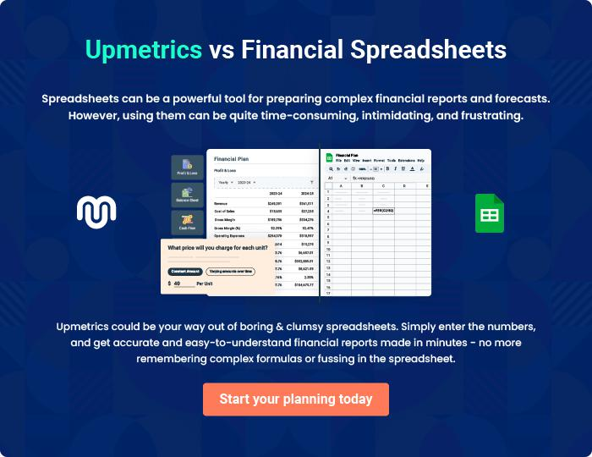

Maxwell Winery | Business Plan [YEAR] 37/38


Create a winning business plan that gets you funded

Creating a stunning and investment-ready plan requires no writing, graphic designing, or financial planning expertise.

Upmetrics has all the features required to help you create a comprehensive business plan—from start to finish. Make no mistakes, it’s the modern way of planning to structure ideas, make plans, and create stunning pitch decks to awe investors.

Pitch decks that impress investors

Create pitch decks that provide a visual representation of your business, engage investors, and make them want to invest in your business idea.

Interactive plans in no time

Import business plan sections like—SWOT analysis, comparison tables, and others to create an interactive business plan. No designing skills are required.

Stunning cover page designs

With Upmetrics, you have the liberty to choose from multiple stunning cover page designs. Choose a creative design and make your plan stand out.

Online sharing made simple

Upmetrics makes online sharing quick and easier for users. Easily share your business plans with a link while tracking reader activity.

500+ sample business plans

Simply import a template from our library of sample plans into the editor and start customizing it to make it yours. It takes only a few clicks to get started.

Collaborate with team in real-time

Invite team members, initiate conversations, discuss ideas & strategies, share feedback, and work on a business plan in real-time.

