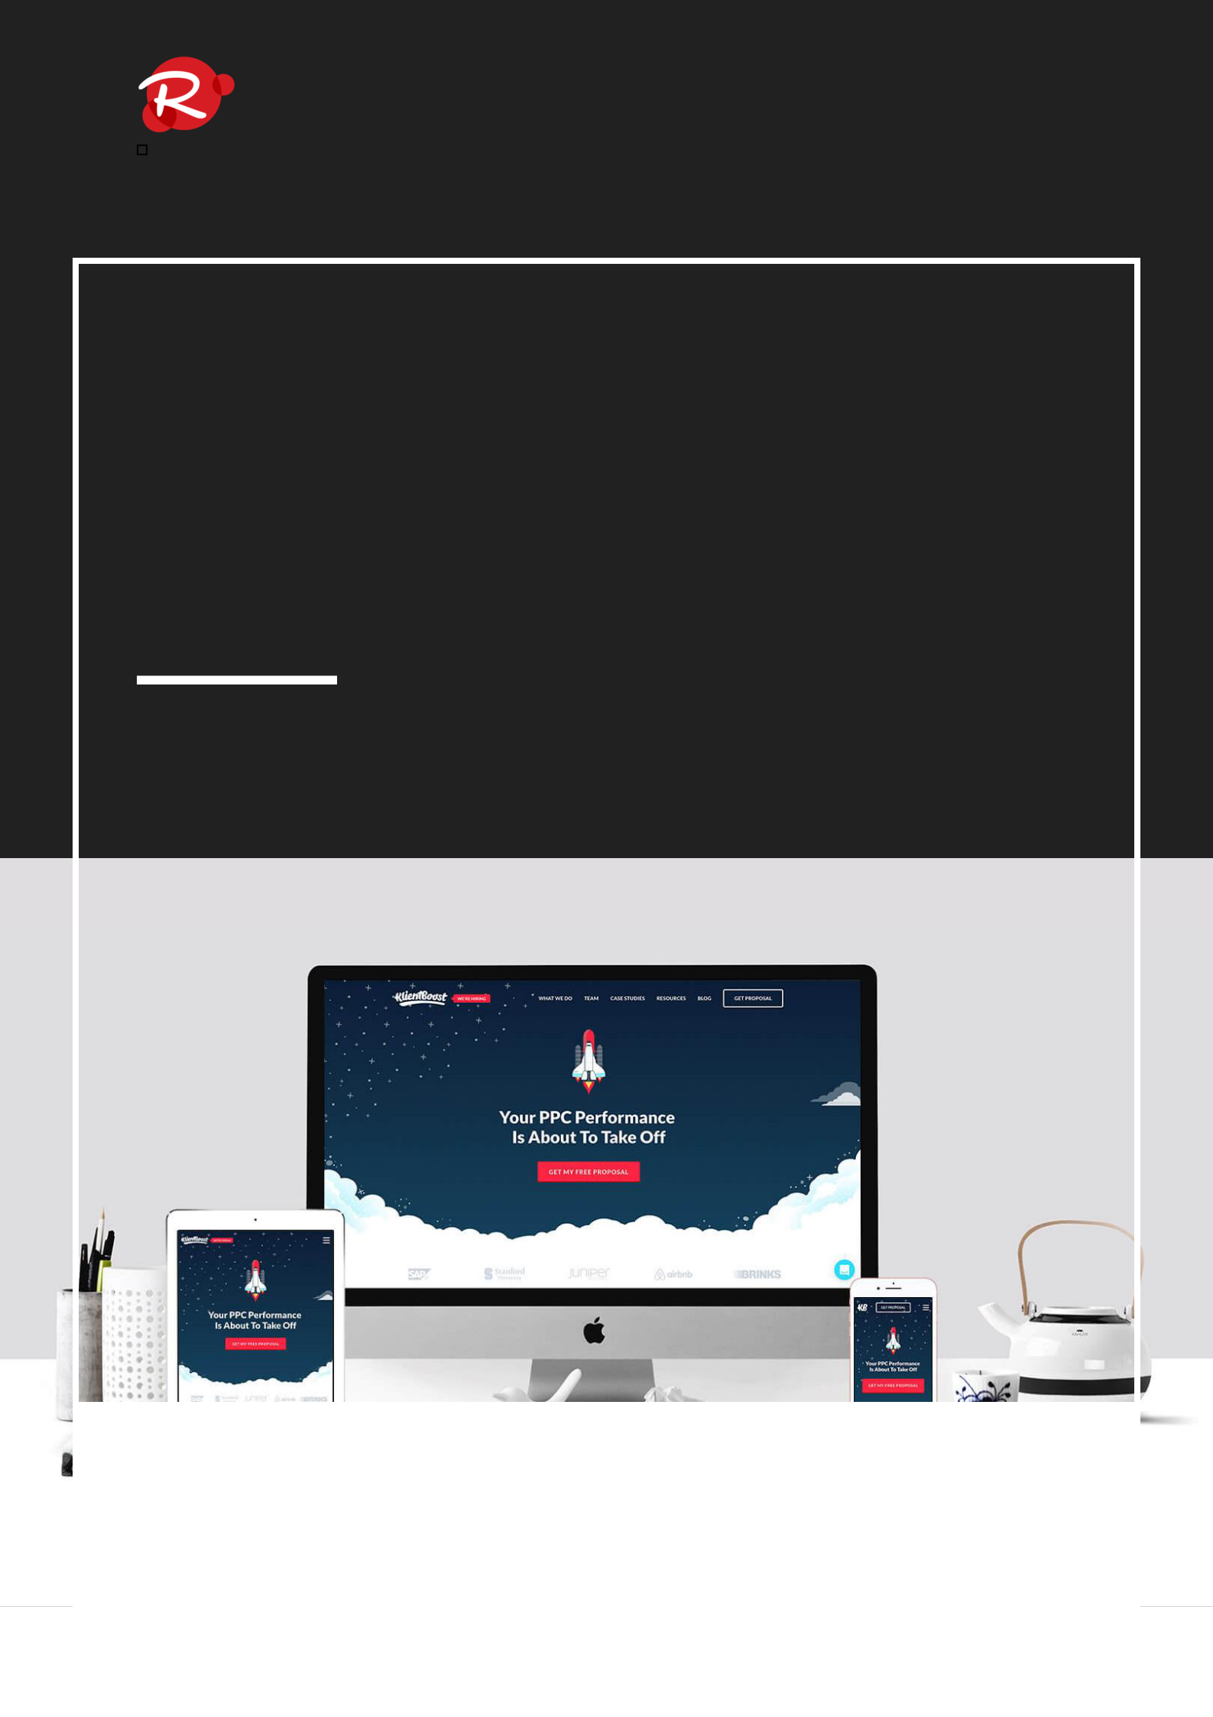
Web Design

BUSINESS PLAN

Experience digital innovation

Prepared By

John Doe

10200 Bolsa Ave, Westminster, CA, 92683

info@example.com

(650) 359-3153 http://www.example.com

Table of Contents

Executive Summary | 5
Business Overview | 6
Objectives | 6
Keys to Success | 6
Mission statement | 7
Business Target | 7
3 Year profit forecast | 8

Company Summary | 9
Company Ownership | 10
Start-up Summary | 10
Company Location and Facilities | 11
Startup cost | 11
Funding Required | 11

Products and Services | 14
Services | 15
Existing services | 15
Service Description | 17
Sales Literature | 17
Fulfillment | 17
Technology | 18
Future Services | 18

Market Analysis | 20
Target Market Segment Strategy | 21
Market Trends | 21
Market Growth | 22
Service Business Analysis | 22

Web Design | Business Plan [YEAR] 2/43

Main Competitors | 23
Features | 23
Business Participants | 24
Market Segmentation | 25

Strategy and Implementation | 26
Competitive Advantage | 27
Marketing Strategy | 27
Marketing Programs | 28
Pricing Strategy | 28
Promotion Strategy | 28
Sales Strategy | 29
Strategic Alliances | 29

Management Summary | 30
Organizational Structure | 31
Management Team Gaps | 31
Personnel Plan | 32

Financial Plan | 33
Important Assumptions | 34
Brake-even Analysis | 34
Projected Profit and Loss | 34
Projected Cash Flow | 37
Projected Balance Sheet | 38
Business Ratios | 40

Web Design | Business Plan [YEAR] 3/43

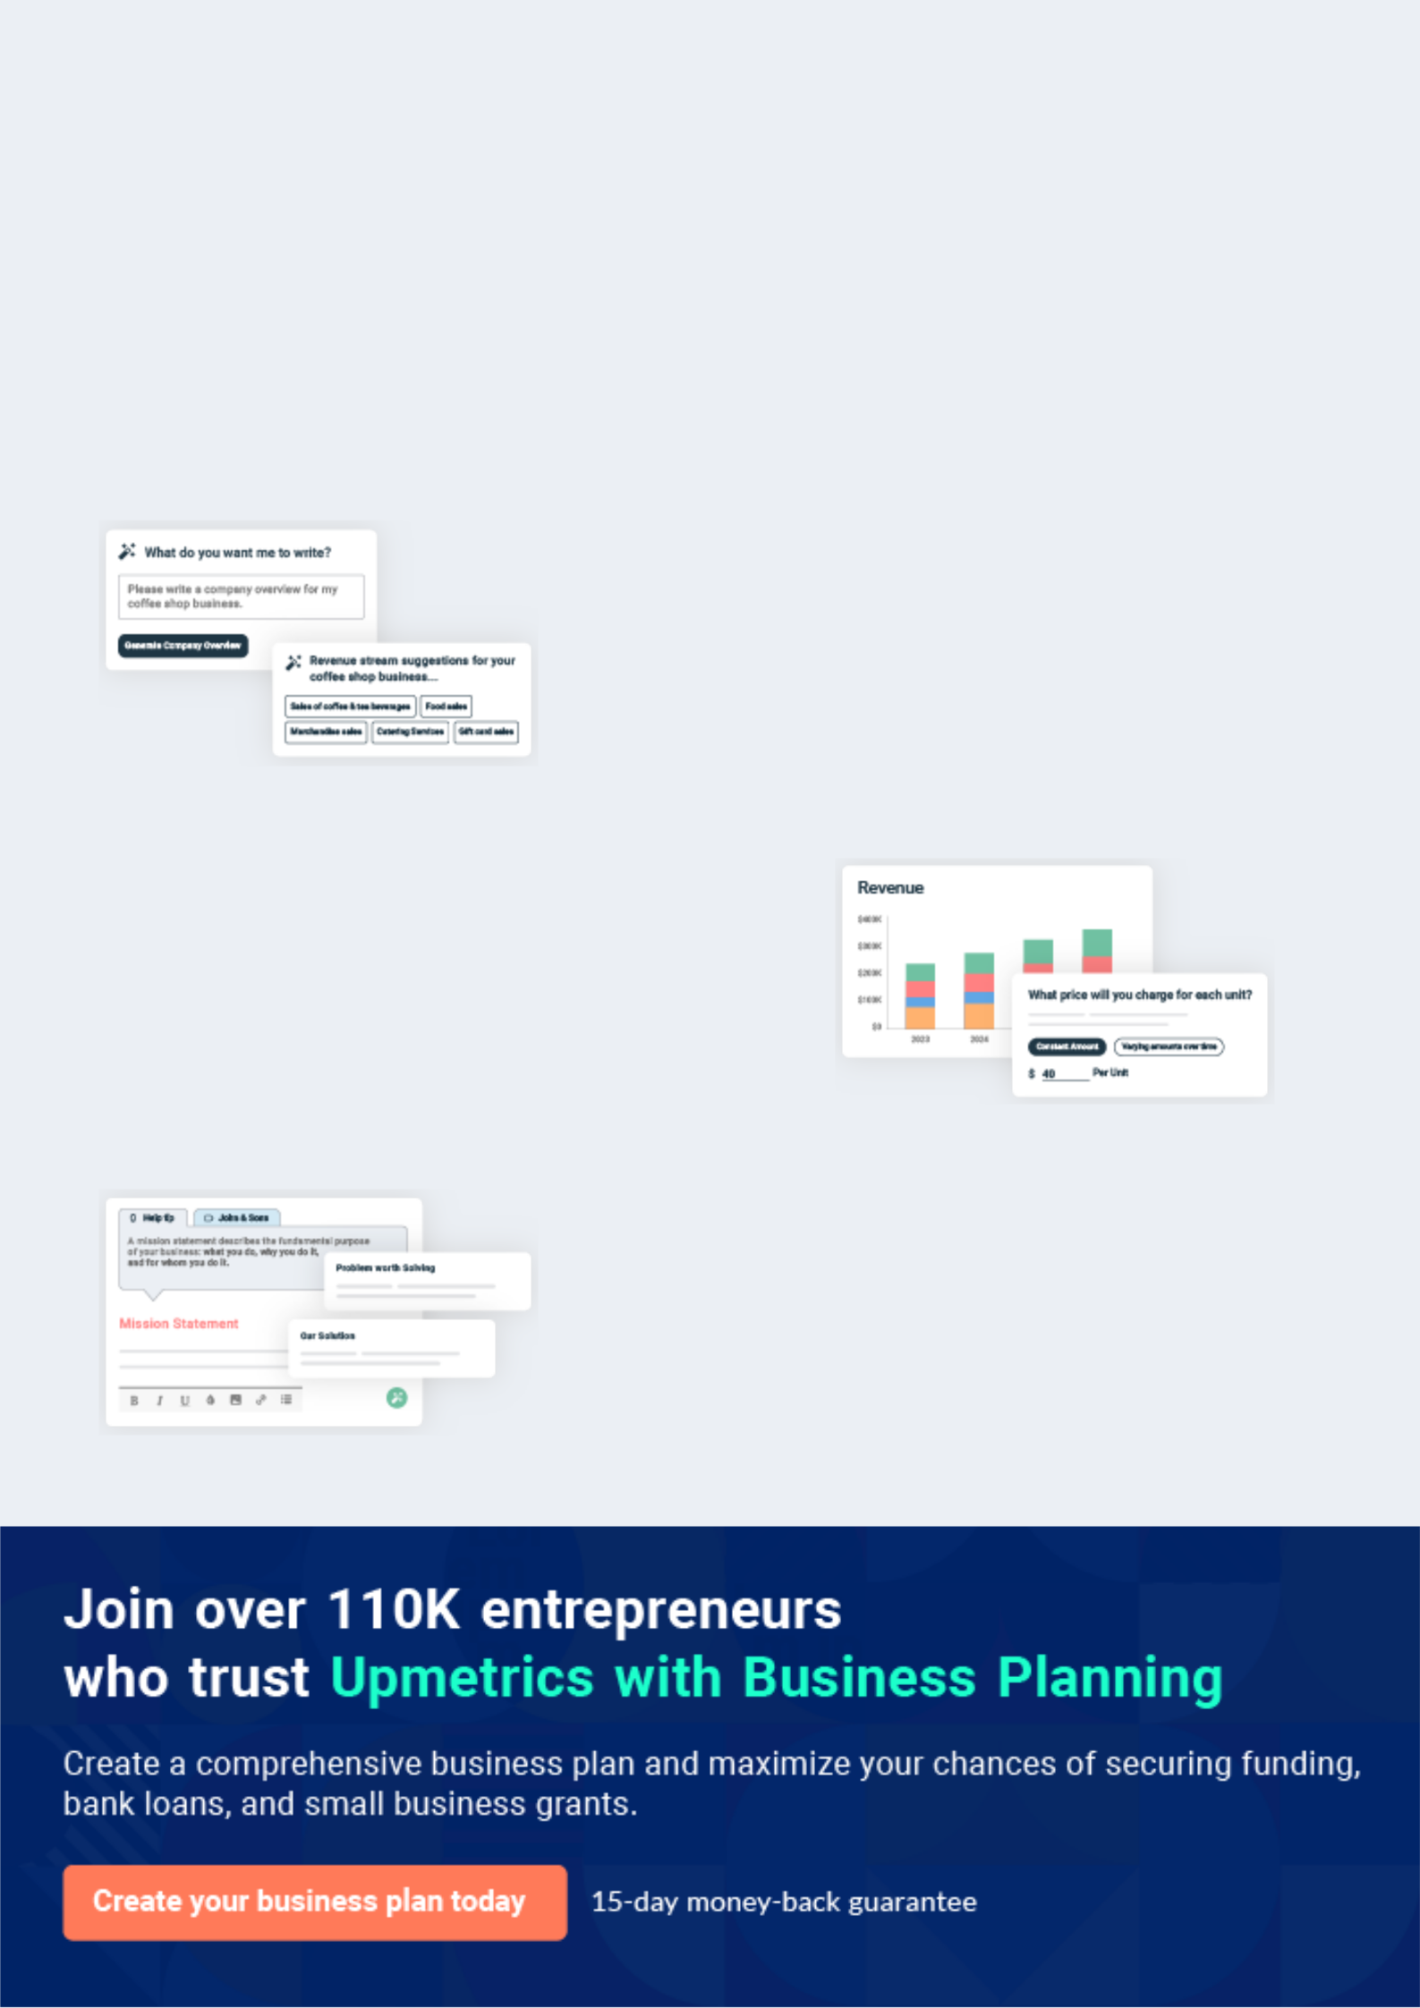
Business planning that’s simpler and faster than you think

Creating a business plan using Upmetrics to start and grow a business is literally the easiest thing in the World. Simply read the instructions and fill in the blanks. It’s as simple as that.

❛ | Upmetrics has everything you need to create a | ❜
❛ | comprehensive business plan. | ❜

AI-powered Upmetrics Assistant

AI-powered insights to streamline your plan

Not sure where to start? Upmetrics’ AI Assistant will automatically generate ideas for each section of your plan and offer improved versions of your writing, adjusting for tone, voice, and grammar or spelling errors.

Financial Forecasting Tool

All the financials are calculated for you

Forget the complex formulas and clumsy spreadsheets — with automatic financials and drag-and-drop forecasting, you can finish your plan faster and be confident that your numbers are accurate.

Business Plan Builder

Guides you like a business mentor

Upmetrics’ step-by-step instructions, prompts, and the library of 400+ sample business plans will guide you through each section of your plan as a business mentor.

1.


Executive Summary

Business Overview

Objectives

Keys to Success

Mission statement

Business Target

Web Design | Business Plan [YEAR] 5/43


Before you think about how to start Web Design services, you must create a detailed Web Design Company business plan. It will not only guide you in the initial phases of your startup but will also help you later on.
To unlock help try Upmetrics! 

Business Overview

 Robid Inc.


Robid Inc. is a small firm located in Kapolei, Hawaii. We are a start-up company offering we band internet services to small businesses and institutions in Kapolei City. We offer services in website design, development, hosting, marketing, maintenance, and analysis.
To unlock help try Upmetrics! 

Start writing here..

Objectives

 Ex :: Robid


- To generate revenues of $300,000 by the end of our first year of operations.

- To attain a net profit of 30% in the first year and 40% in the second year.

• To have a 70% gross margin by the end of the first year.
To unlock help try Upmetrics! 

Start writing here..

Keys to Success

 Ex :: Robid

- We will offer quality web services to small businesses and institutions at affordable prices.

• To build and tailor our services to small businesses.
To unlock help try Upmetrics! 

Start writing here..

Web Design | Business Plan [YEAR] 6/43

Mission statement
To unlock help try Upmetrics!

 Ex :: Robid

Our mission is to provide accessibly, and streamlined web and Internet services to small businesses and institutions. Using our system, we will offer various types of web solutions that will be tailored to serve the changing needs of our clients.



Start writing here..

Business Target

 Ex :: Robid

Our main business targets are summarized in the following column chart.

To unlock help try Upmetrics! 

Start writing here..

Web Design | Business Plan [YEAR] 7/43

3 Year profit forecast
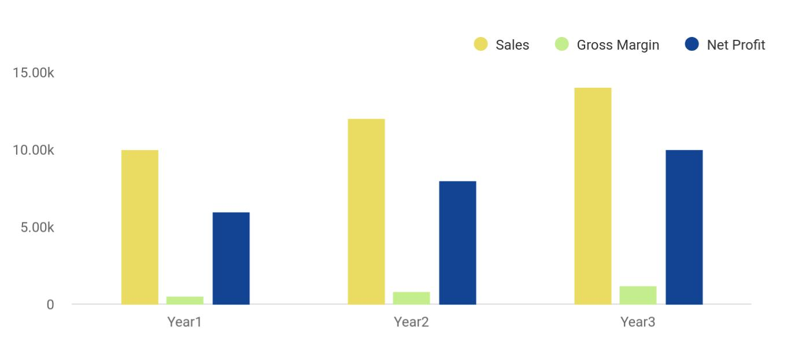

Financial Year | Sales | Gross Margin | Net Profit
Year1 | 10,000 | 500 | 6,000
Year2 | 12,000 | 800 | 8,000
Year3 | 14,000 | 1,200 | 10,000

Web Design | Business Plan [YEAR] 8/43

2.

Company Summary

Company Ownership

Start-up Summary

Company Location and Facilities

Funding Required

Web Design | Business Plan [YEAR] 9/43

 Ex :: Robid
To unlock help try Upmetrics!

Robid Inc. is a company still at the start-up stage. We will provide quality, affordable, and high-end web services to small businesses and institutions. We will also help our clients improve their existing marketing and web services. We have established a system that will help us in
To unlock help try Upmetrics! 

Start writing here..

Company Ownership

 Ex :: Robid

Robid Inc. has been incorporated and has its offices and facilities in Kapolei County, Hawaii as of September 30, 2013. The company is co-owned by Richard Walker, the chief executive officer, and David Hart, the Information Technology Director.



Start writing here..

Start-up Summary

 Ex :: Robid

We have a well-thought-out start-up plan that will help us move forward with proper marketing tools, equipment and personnel get us started. The owners have an initial cash investment of $50,000 each to acquire office furniture, software, and computers. To make the kick-off of our
To unlock help try Upmetrics! 

Start writing here..

Web Design | Business Plan [YEAR] 10/43

Company Location and Facilities
To unlock help try Upmetrics!

 Ex :: Robid

Robid Inc. has leased commercial office space at the Kapolei business center for three years with an option of renewal within sixty days. Space can accommodate fifteen workstations for all our employees.



Start writing here..

Startup cost
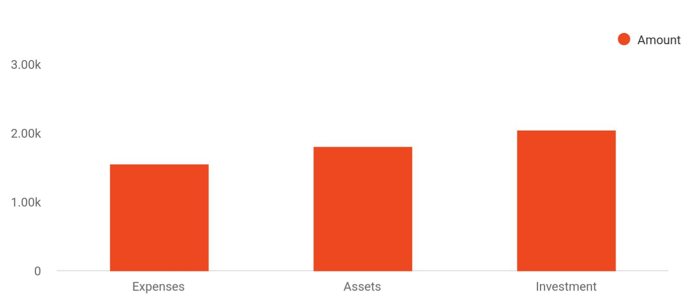

Cost distribution | Amount
Expenses | 1,550
Assets | 1,800
Investment | 2,050

Funding Required

The detailed startup requirements and expenses are given in the table below.


Start-up Expenses

Legal

Consultants

Insurance

Amount

$75,500

$0

$62,750

Web Design | Business Plan [YEAR] 11/43

Start-up Expenses | Amount
Rent | $22,500
Research and Development | $42,750
Expensed Equipment | $42,750
Signs | $1,250
TOTAL START-UP EXPENSES | $247,500
Start-up Assets | $0
Cash Required | $322,500
Start-up Inventory | $52,625
Other Current Assets | $222,500
Long-term Assets | $125,000
TOTAL ASSETS | $121,875
Total Requirements | $245,000
START-UP FUNDING | $0
START-UP FUNDING | $273,125
Start-up Expenses to Fund | $121,875
Start-up Assets to Fund | $195,000
TOTAL FUNDING REQUIRED | $0
Assets | $203,125
Non-cash Assets from Start-up | $118,750
Cash Requirements from Start-up | $0
Additional Cash Raised | $118,750
Cash Balance on Starting Date | $121,875
TOTAL ASSETS | $0
Liabilities and Capital | $0
Liabilities | $0
Current Borrowing | $0
Long-term Liabilities | $0
Accounts Payable (Outstanding Bills) | $0

Web Design | Business Plan [YEAR] 12/43

Start-up Expenses | Amount
Other Current Liabilities (interest-free) | $0
TOTAL LIABILITIES | $0
Capital | $0
Planned Investment | $0
Investor 1 | $312,500
Investor 2 | $0
Other | $0
Additional Investment Requirement | $0
TOTAL PLANNED INVESTMENT | $695,000
Loss at Start-up (Start-up Expenses) | $313,125
TOTAL CAPITAL | $221,875
TOTAL CAPITAL AND LIABILITIES | $221,875
Total Funding | $265,000

Web Design | Business Plan [YEAR] 13/43

3.

Products and Services

Service Description

Sales Literature

Fulfillment

Technology

Future Services

Web Design | Business Plan [YEAR] 14/43

Before starting a Web Design business, you must take many things into consideration such as you must consider what types of web services will you be providing to your customers. Deciding your services is extremely
To unlock help try Upmetrics! 

 Robid


Robid Inc. will be a provider of internet service solutions for small businesses and institutions within Kapolei. Our focus will be on website services. We will offer the following services:
To unlock help try Upmetrics! 

Start writing here..

Services


Web development
Web marketing
and design

Web hosting and
Analysis
maintenance

The new services will be additional to our range of existing services which include:

Existing services

Developing e- Renovation and

commerce for upgrading of

businesses websites

Web Design | Business Plan [YEAR] 15/43


Website training and
Maintaining websites
seminars


Constructing

databases

Once we are established, we will also offer services in the following areas within the first three years of operations:

Installing Local Area

Network for small Website marketing businesses

Intranet set-up and

installation

Web Design | Business Plan [YEAR] 16/43

Service Description
To unlock help try Upmetrics!

 Robid

Web development and design: Robid Inc. will offer a unique and customized web experience to each client's needs. We will model our designs to the caliber the large organization gets.
To unlock help try Upmetrics! 

Start writing here..

Sales Literature

 Robid

Robid Inc. currently has a sales brochure containing all the pertinent information about the company and its services. We have included our company's strong history, pictorials, and pricing



Start writing here..

Fulfillment

 Robid

Besides our existing team of experts in web-hosting and maintenance, we will hire professionals in web development and design to ensure proper handling of clients' needs. Our experts will be divided into teams of three to work better on different client requirements and
To unlock help try Upmetrics! 

Start writing here..

Web Design | Business Plan [YEAR] 17/43

Technology

 Robid

Technological innovations influence most of our operations. We use the latest software and hardware components in all our office equipment and machinery. We intend to invest in additional tools to help us meet the customers' requirements more efficiently. We will acquire
To unlock help try Upmetrics! 

Start writing here..

Future Services

 Robid

Installation of Local Area Network (LAN) services: With the increasing number of small businesses using computers and the Internet as necessary office tools, there is an urgent need to meet their new demands. We will help the businesses from purchasing to configuring the
To unlock help try Upmetrics! 

Start writing here..

Web Design | Business Plan [YEAR] 18/43

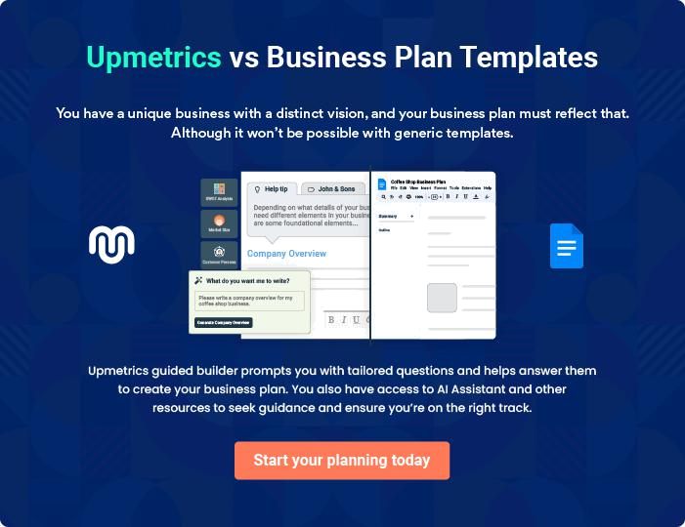

Web Design | Business Plan [YEAR] | 19/43

4.

Market Analysis

Target Market Segment Strategy

Market Trends

Market Growth

Service Business Analysis

Main Competitors

Business Participants

Market Segmentation

Web Design | Business Plan [YEAR] 20/43

The most important component of an effective Web Design company business plan is its accurate marketing analysis. If you are starting on a
To unlock help try Upmetrics!
To unlock help try Upmetrics!
smaller scale, you can do marketing analysis yourself by taking help from this
To unlock help try Upmetrics! 

 Robid

Robid Inc. will focus on small businesses and institutions that are looking to develop or upgrade their web presence. Our approach will be step-by-step; starting with a simple, basic website and improving it to meet their changing needs.



Start writing here..

Target Market Segment Strategy

 Robid

We will focus our marketing efforts on attracting institutions and small businesses. We reached this decision after careful market analysis and identifying the needs of this market segment. The high demand for web services by this market is an opportunity that will not necessitate
To unlock help try Upmetrics! 

Start writing here..

Market Trends

 Robid

The most notable trend in the industry currently is mass migration online. Small businesses are either waiting to migrate or are looking to upgrade their already existing sites to suit the rapidly changing industry.



Start writing here..

Web Design | Business Plan [YEAR] 21/43

Market Growth

 Robid

Our target market has expanded and grown at a rapid rate to cope up with the changing technologies. We have put together some evidence to support this exponential growth:
To unlock help try Upmetrics! 

Start writing here..

Service Business Analysis

 Robid

Companies in the web development and service industry vary with the size and nature of services. Robid Inc. will provide a unique alternative that the existing providers do not have. The bigger web development firms ignore our target market making it unique. We will start with this
To unlock help try Upmetrics! 

Start writing here..

Web Design | Business Plan [YEAR] 22/43

Main Competitors

Features

Peetle Graphics

It is located 5 miles from Kapolei and provide graphic and web development services. They have a loyal and established customer base. However, the company has only two employees; Mr. John Peetle and his son Peter. They work from home and are unable to meet all the needs of the market.

Wackyweb Inc

It is located

approximately 30 miles

from our offices and

offer services in

marketing and web

development. They

have been in existence

for over seven years

and have a talented

team of programmers

and developers. Their

pricing is, however, too

high for the small and

medium-sized

businesses that they

are now trying to

attract.

Create Innovations

They are located 10 miles from Kapolei and offer web development and design services to small businesses in Kawai and neighboring towns. They have a fairly wide customer base due to their large area of operation. They offer services to small businesses but charge highly, which does not go well with most of their clients.

Web Design | Business Plan [YEAR] 23/43

Business Participants

 Robid

Three types of firms make up the web services industry:

• Large companies: They generate high revenue and serve top companies. There are a few
To unlock help try Upmetrics! 

Start writing here..

Web Design | Business Plan [YEAR] 24/43

Market Segmentation

 Robid

The nature of our services and our location enables us to serve small businesses and institutions no matter their location. We plan to expand to other cities but will in the meantime use our communication technologies to get in touch with customers in other parts of the
To unlock help try Upmetrics! 

Start writing here..

Web Design | Business Plan [YEAR] 25/43

5.

Strategy and

Implementation

Competitive Advantage

Marketing Strategy

Marketing Programs

Pricing Strategy

Promotion Strategy

Sales Strategy

Strategic Alliances

Web Design | Business Plan [YEAR] 26/43

After identifying the market demand, market trends, and the potential customers of the startup, the next step is to define an effective strategy for attracting those customers. Like marketing analysis, sales strategy is also an
To unlock help try Upmetrics!
To unlock help try Upmetrics! 

 Ex :: Robid

At start-up, Robid Inc. will focus all the sales and marketing efforts on the city of Kapolei and its environs.
To unlock help try Upmetrics! 

Start writing here..

Competitive Advantage

 Ex :: Robid

The fact that our services target small businesses gives us an edge over our competitors. By setting up strategic alliances with some of the web and Internet-related companies, we will offer our customers efficient and affordable web services that will meet their demands.
To unlock help try Upmetrics! 

Start writing here..

Marketing Strategy

 Ex :: AutoCar


We will approach and follow up with all the prospective clients with a clear and thorough marketing strategy. We will give them all the details about the web and the Internet so that they do not get confused and intimidated along the way.



Start writing here..

Web Design | Business Plan [YEAR] 27/43

Marketing Programs

 Ex :: Robid

We intend to join the following organizations as part of our initial marketing programs:

• Hawaii Chamber of Commerce.
To unlock help try Upmetrics! 

Start writing here..

Pricing Strategy

 Ex :: Robid

Robid Inc. will establish a pricing system to guide our clients on the nature of the services and the corresponding prices. Since we will be dealing with a market segment that tries to reduce costs, we will charge our services on an hourly basis. It will make the clients understand the
To unlock help try Upmetrics! 

Start writing here..

Promotion Strategy

 Ex :: Robid

Since our target market is distinguishable, we will use a direct approach to marketing our services. We will use yellow pages directories to place our adverts. Robid Inc. will also put
feature adverts in business publications with a wide audience like the Hawaii Business Journal.
To unlock help try Upmetrics! 

Start writing here..

Web Design | Business Plan [YEAR] 28/43

Sales Strategy
To unlock help try Upmetrics!

 Ex :: Robid

We will sell service, value, and quality to our prospective clients. We will need to convince them that having an online presence is a worthy course for their businesses. We have a database that has proven useful in getting new business contacts and establishing relationships.
To unlock help try Upmetrics! 

Start writing here..

Strategic Alliances

 Ex :: Robid

We have established four strategic partnerships with two Internet service providing companies and another two with computer consultancy firms. We intend to use alliances to attract more businesses and referrals from our competitors.



Start writing here..

Web Design | Business Plan [YEAR] 29/43

6.

Management Summary

Organizational Structure

Management Team Gaps

Personnel Plan

Web Design | Business Plan [YEAR] 30/43

 Ex :: Robid

Robid Inc. is a partnership between two individuals who have equal shares in the company. They will all serve as directors. Richard Walker attended Gareth college and earned his Associates Degree in Management. He has completed various courses in business and
To unlock help try Upmetrics! 

Start writing here..

Organizational Structure

 Ex :: Robid

Robid Inc. will be managed by the co-owners. They will conduct recruitment for important positions like office managers, accountants, marketing, customer care, and human resource.
To unlock help try Upmetrics! 

Start writing here..

Management Team Gaps

 Ex :: Robid

The two directors will need management support in the marketing and business development departments. They feel that their prior experience did not need many of these departments. The company will contact accounting and a public relations firm to assist in setting up the two
To unlock help try Upmetrics! 

Start writing here..

Web Design | Business Plan [YEAR] 31/43

Personnel Plan

 Ex :: Robid

We will implement a system that will focus on developing a team and will consist of three web developers and two salespeople. The web development team will have one highly-qualified staff while the other two may be lesser-qualified. The team will work on different projects as
To unlock help try Upmetrics! 

Start writing here..

Web Design | Business Plan [YEAR] 32/43

7.

Financial Plan

Important Assumptions

Brake-even Analysis

Projected Profit and Loss

Projected Cash Flow

Projected Balance Sheet

Business Ratios

Web Design | Business Plan [YEAR] 33/43

The last component of a web design business plan is an in-depth financial plan. The financial plan crafts a detailed map of all the expenses needed for the startup and how these expenses will be met by the earned profits. It is
To unlock help try Upmetrics! 

Important Assumptions

We have prepared this plan with the assumption that the economy will remain steady with the standard number of players in the industry. We also hope that there will be less interference from the government and the industry regulators.

Brake-even Analysis

Monthly Units Break-even | 5530
Monthly Revenue Break-even | $159 740
Assumptions:
Average Per-Unit Revenue | $260,87
Average Per-Unit Variable Cost | $0,89
Estimated Monthly Fixed Cost | $196 410

Projected Profit and Loss

 | 2024 | 2025 | 2026
Revenue | $709,965.37 | $1,508,149.26 | $2,724,533.04
Web Design Projects | $477,740 | $858,280 | $1,541,540
Unit Sales | 239 | 429 | 771
Unit Price | $2,000 | $2,000 | $2,000
Website Maintenance | $187,148 | $577,699 | $1,067,446
Services | $187,148 | $577,699 | $1,067,446
Users | 295 | 652 | 1,110
Recurring Charges | $100 | $100 | $100
Web Hosting Services | $45,077.37 | $72,170.26 | $115,547.04

Web Design | Business Plan [YEAR] 34/43

2024 2025 2026

Cost Of Sales | $223,396.55 | $310,486.66 | $440,160.63
General Costs | $223,396.55 | $310,486.66 | $440,160.63
Web Development Costs | $138,000 | $144,551.75 | $151,831.32
Developer Salaries | $84,000 | $88,931.75 | $94,542.72
Software Licenses | $54,000 | $55,620 | $57,288.60
Hosting and Maintenance | $85,396.55 | $165,934.91 | $288,329.31
Costs | $85,396.55 | $165,934.91 | $288,329.31
Server Hosting Fees | $14,400 | $15,120 | $15,876
Website Maintenance | $70,996.55 | $150,814.91 | $272,453.31
Revenue Specific Costs | $0 | $0 | $0
Personnel Costs (Direct | $0 | $0 | $0
Labor) | $0 | $0 | $0

Gross Margin | $486,568.82 | $1,197,662.60 | $2,284,372.41
Gross Margin (%) | 68.53% | 79.41% | 83.84%

Operating Expense | $1,063,982.29 | $1,126,908.30 | $1,211,150.20
Payroll Expense (Indirect | $982,284 | $1,004,089.32 | $1,026,431.88
Labor) | $982,284 | $1,004,089.32 | $1,026,431.88
Web Development Team | $477,900 | $489,933 | $502,281.24
Senior Web Developers | $247,500 | $254,925 | $262,572.84
Junior Web Developers | $230,400 | $235,008 | $239,708.40
Design Team | $212,064 | $217,921.92 | $223,943.04
Graphic Designers | $111,264 | $114,601.92 | $118,039.92
UI/UX Designers | $100,800 | $103,320 | $105,903.12
Support and Administration | $292,320 | $296,234.40 | $300,207.60

Web Design | Business Plan [YEAR] 35/43

 | 2024 | 2025 | 2026
Customer Support | $193,200 | $195,132 | $197,083.20
Representatives | $193,200 | $195,132 | $197,083.20
Administrative Staff | $99,120 | $101,102.40 | $103,124.40
General Expense | $81,698.29 | $122,818.98 | $184,718.30
Office and Administration | $30,000 | $30,660 | $31,335
Office Rent | $24,000 | $24,480 | $24,969.60
Utilities | $6,000 | $6,180 | $6,365.40
Marketing and Advertising | $45,098.29 | $85,378.98 | $146,414.30
Digital Marketing | $35,498.29 | $75,407.46 | $136,226.66
Print Advertising | $9,600 | $9,971.52 | $10,187.64
Technology and Equipment | $6,600 | $6,780 | $6,969
Software Subscriptions | $3,600 | $3,780 | $3,969
Computer Hardware | $3,000 | $3,000 | $3,000
Bad Debt | $0 | $0 | $0
Amortization of Current | $0 | $0 | $0
Assets | $0 | $0 | $0

EBITDA | ($577,413.47) | $70,754.30 | $1,073,222.21

Additional Expense | $7,999.02 | $6,724.40 | $5,344.01

Long Term Depreciation

Gain or loss from Sale of Assets

EBIT

Interest Expense

EBT

$4,554 | $4,554 | $4,554
$0 | $0 | $0
($581,967.47) | $66,200.30 | $1,068,668.21
$3,445.02 | $2,170.41 | $790.01
($585,412.49) | $64,029.90 | $1,067,878.20

Web Design | Business Plan [YEAR] 36/43

 | 2024 | 2025 | 2026
Income Tax Expense / | $0 | $0 | $0
Benefit | $0 | $0 | $0
Total Expense | $1,295,377.86 | $1,444,119.36 | $1,656,654.84
Net Income | ($585,412.49) | $64,029.90 | $1,067,878.20
Net Income (%) | (82.46%) | 4.25% | 39.19%
Retained Earning Opening | $0 | ($603,412.49) | ($547,382.59)
Owner's Distribution | $18,000 | $8,000 | $8,000
Retained Earning Closing | ($603,412.49) | ($547,382.59) | $512,495.61
Projected Cash Flow
 | 2024 | 2025 | 2026
Cash Received | $709,965.37 | $1,508,149.26 | $2,724,533.04
Cash Paid | $1,290,823.86 | $1,439,565.36 | $1,652,100.84
COS & General Expenses | $305,094.84 | $433,305.64 | $624,878.95
Salary & Wages | $982,284 | $1,004,089.32 | $1,026,431.88
Interest | $3,445.02 | $2,170.41 | $790.01
Sales Tax | $0 | $0 | $0
Income Tax | $0 | $0 | $0
Net Cash From | ($580,858.49) | $68,583.90 | $1,072,432.20
Operations | ($580,858.49) | $68,583.90 | $1,072,432.20
Assets Sell | $0 | $0 | $0
Assets Purchase | $45,000 | $0 | $0

Web Design | Business Plan [YEAR] 37/43

Net Cash From

Investments

Amount Received

Loan Received

Common Stock

Preferred Stock

Owner's Contribution

Amount Paid

Loan Capital

Dividends & Distributions

Net Cash From

Financing

Summary

2024 | 2025 | 2026
($45,000) | $0 | $0

$150,000 | $0 | $0
$50,000 | $0 | $0
$0 | $0 | $0
$0 | $0 | $0
$100,000 | $0 | $0
$33,356.82 | $24,631.44 | $26,011.76
$15,356.82 | $16,631.43 | $18,011.76
$18,000 | $8,000 | $8,000
$116,643.18 | ($24,631.44) | ($26,011.76)

Starting Cash | $0 | ($509,215.31) | ($465,262.85)
Cash In | $859,965.37 | $1,508,149.26 | $2,724,533.04
Cash Out | $1,369,180.68 | $1,464,196.80 | $1,678,112.60
Change in Cash | ($509,215.31) | $43,952.46 | $1,046,420.44
Ending Cash | ($509,215.31) | ($465,262.85) | $581,157.59

Projected Balance Sheet

 | 2024 | 2025 | 2026
Assets | ($468,769.31) | ($429,370.85) | $612,495.59
Current Assets | ($509,215.31) | ($465,262.85) | $581,157.59
Cash | ($509,215.31) | ($465,262.85) | $581,157.59

Web Design | Business Plan [YEAR] 38/43

 | 2024 | 2025 | 2026
Accounts Receivable | $0 | $0 | $0
Inventory | $0 | $0 | $0
Other Current Assets | $0 | $0 | $0
Long Term Assets | $40,446 | $35,892 | $31,338
Gross Long Term Assets | $45,000 | $45,000 | $45,000
Accumulated Depreciation | ($4,554) | ($9,108) | ($13,662)

Liabilities & Equity | ($468,769.30) | ($429,370.83) | $612,495.61
Liabilities | $34,643.19 | $18,011.76 | $0
Current Liabilities | $16,631.43 | $18,011.76 | $0
Accounts Payable | $0 | $0 | $0
Income Tax Payable | $0 | $0 | $0
Sales Tax Payable | $0 | $0 | $0
Short Term Debt | $16,631.43 | $18,011.76 | $0
Long Term Liabilities | $18,011.76 | $0 | $0
Long Term Debt | $18,011.76 | $0 | $0
Equity | ($503,412.49) | ($447,382.59) | $612,495.61
Paid-in Capital | $0 | $0 | $0
Common Stock | $0 | $0 | $0
Preferred Stock | $0 | $0 | $0
Owner's Contribution | $100,000 | $100,000 | $100,000
Retained Earnings | ($603,412.49) | ($547,382.59) | $512,495.61

Check | $0 | $0 | $0

Web Design | Business Plan [YEAR] 39/43

Business Ratios

 | Year 1 | Year 2 | Year 3 | Industry Profile
Sales Growth | 4,35% | 30,82% | 63,29% | 4,00%
Percent of Total Assets
Accounts Receivable | 5,61% | 4,71% | 3,81% | 9,70%
Inventory | 1,85% | 1,82% | 1,79% | 9,80%
Other Current Assets | 1,75% | 2,02% | 2,29% | 27,40%
Total Current Assets | 138,53% | 150,99% | 163,45% | 54,60%
Long-term Assets | -9,47% | -21,01% | -32,55% | 58,40%
TOTAL ASSETS | 100,00% | 100,00% | 100,00% | 100,00%
Current Liabilities | 4,68% | 3,04% | 2,76% | 27,30%
Long-term Liabilities | 0,00% | 0,00% | 0,00% | 25,80%
Total Liabilities | 4,68% | 3,04% | 2,76% | 54,10%
NET WORTH | 99,32% | 101,04% | 102,76% | 44,90%
Percent of Sales
Sales | 100,00% | 100,00% | 100,00% | 100,00%
Gross Margin | 94,18% | 93,85% | 93,52% | 0,00%
Selling, General & Administrative Expenses | 74,29% | 71,83% | 69,37% | 65,20%
Advertising Expenses | 2,06% | 1,11% | 0,28% | 1,40%
Profit Before Interest and Taxes | 26,47% | 29,30% | 32,13% | 2,86%
Main Ratios
Current | 25,86 | 29,39 | 32,92 | 1,63
Quick | 25,4 | 28,88 | 32,36 | 0,84
Total Debt to Total Assets | 2,68% | 1,04% | 0,76% | 67,10%
Pre-tax Return on Net Worth | 66,83% | 71,26% | 75,69% | 4,40%
Pre-tax Return on Assets | 64,88% | 69,75% | 74,62% | 9,00%
Additional Ratios | Year 1 | Year 2 | Year 3
Net Profit Margin | 19,20% | 21,16% | 23,12% | N.A.

Web Design | Business Plan [YEAR] 40/43

 | Year 1 | Year 2 | Year 3 | Industry Profile
Return on Equity | 47,79% | 50,53% | 53,27% | N.A.
Activity Ratios
Accounts Receivable Turnover | 4,56 | 4,56 | 4,56 | N.A.
Collection Days | 92 | 99 | 106 | N.A.
Inventory Turnover | 19,7 | 22,55 | 25,4 | N.A.
Accounts Payable Turnover | 14,17 | 14,67 | 15,17 | N.A.
Payment Days | 27 | 27 | 27 | N.A.
Total Asset Turnover | 1,84 | 1,55 | 1,26 | N.A.
Debt Ratios
Debt to Net Worth | 0 | -0,02 | -0,04 | N.A.
Current Liab. to Liab. | 1 | 1 | 1 | N.A.
Liquidity Ratios
Net Working Capital | $120 943 | $140 664 | $160 385 | N.A.
Interest Coverage | 0 | 0 | 0 | N.A.
Additional Ratios
Assets to Sales | 0,45 | 0,48 | 0,51 | N.A.
Current Debt/Total Assets | 4% | 3% | 2% | N.A.
Acid Test | 23,66 | 27,01 | 30,36 | N.A.
Sales/Net Worth | 1,68 | 1,29 | 0,9 | N.A.
Dividend Payout | 0 | 0 | 0 | N.A.

Web Design | Business Plan [YEAR] 41/43

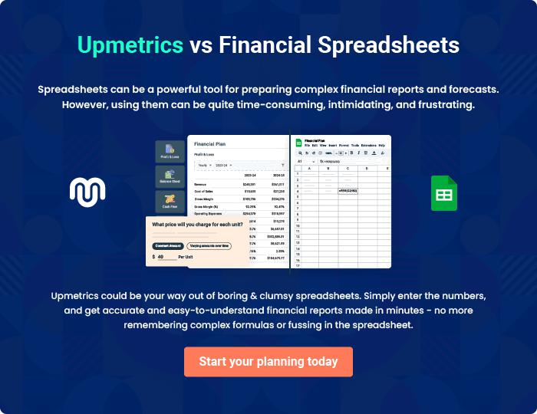

Web Design | Business Plan [YEAR] | 42/43


Create a winning business plan that gets you funded

Creating a stunning and investment-ready plan requires no writing, graphic designing, or financial planning expertise.

Upmetrics has all the features required to help you create a comprehensive business plan—from start to finish. Make no mistakes, it’s the modern way of planning to structure ideas, make plans, and create stunning pitch decks to awe investors.

Pitch decks that impress investors

Create pitch decks that provide a visual representation of your business, engage investors, and make them want to invest in your business idea.

Interactive plans in no time

Import business plan sections like—SWOT analysis, comparison tables, and others to create an interactive business plan. No designing skills are required.

Stunning cover page designs

With Upmetrics, you have the liberty to choose from multiple stunning cover page designs. Choose a creative design and make your plan stand out.

Online sharing made simple

Upmetrics makes online sharing quick and easier for users. Easily share your business plans with a link while tracking reader activity.

500+ sample business plans

Simply import a template from our library of sample plans into the editor and start customizing it to make it yours. It takes only a few clicks to get started.

Collaborate with team in real-time

Invite team members, initiate conversations, discuss ideas & strategies, share feedback, and work on a business plan in real-time.

