
Vocational School

BUSINESS PLAN

Your perfect partner in training

Prepared By

John Doe

10200 Bolsa Ave, Westminster, CA, 92683

info@example.com

(650) 359-3153 http://www.example.com

Table of Contents

Executive Summary | 5
Services and Amenities | 6
Vision Statement | 6
Mission Statement | 7

Business Overview | 8
Roles and Responsibilities | 9
Head of the School / School Coordinator: | 9
School Administrator | 9
Instructors | 9
Marketing and Sales Executive | 10
Accountant | 10
Client Service Executive | 10
SWOT Analysis
SWOT Analysis | 11
Market Analysis
Market Analysis | 14
Market Trends | 15
Target Market | 15
Competitive Advantage | 15
Sales And Marketing Strategy
Sales And Marketing Strategy | 16
Marketing Strategy and Sales Strategy | 17
Sources of Income | 17
Sales Forecast | 17
No. of students v/s Revenue Chart | 18
Pricing Strategy | 18
Payment Options | 18
Publicity and Advertising Strategy | 19

Vocational School | Business Plan [YEAR] 2/25

Financial Plan | 20
Startup Expenditure (Budget) | 21
Generating Funds/Startup | 21
Sustainability and Expansion Strategy
Sustainability and Expansion Strategy | 23

Vocational School | Business Plan [YEAR] 3/25

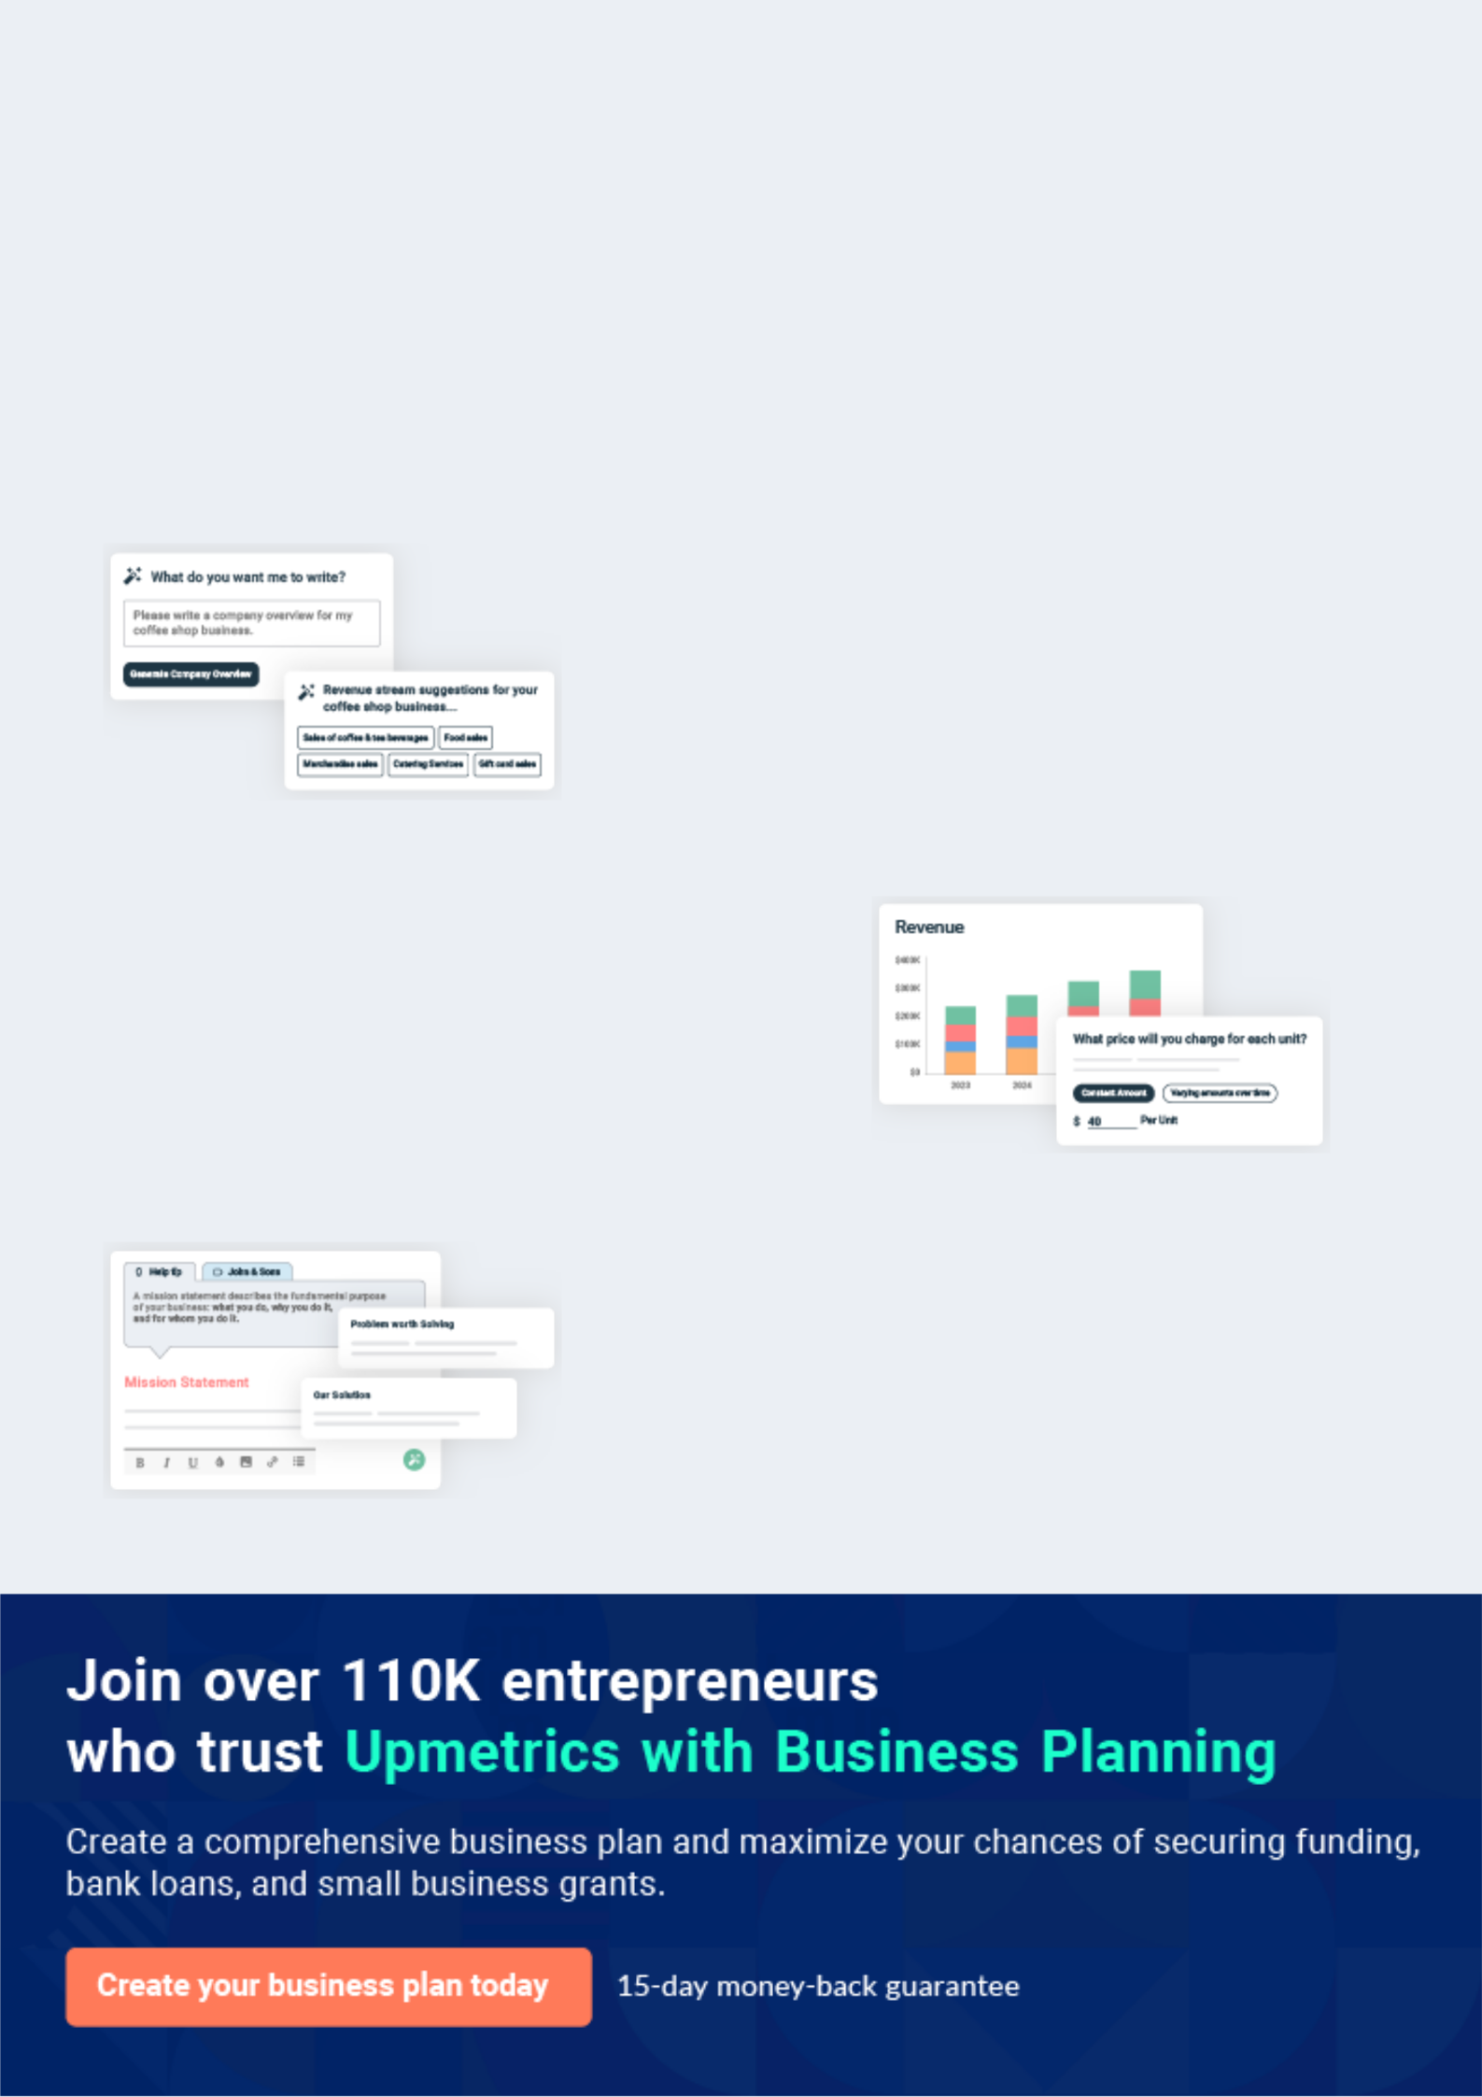
Business planning that’s simpler and faster than you think

Creating a business plan using Upmetrics to start and grow a business is literally the easiest thing in the World. Simply read the instructions and fill in the blanks. It’s as simple as that.

❛ | Upmetrics has everything you need to create a | ❜
❛ | comprehensive business plan. | ❜

AI-powered Upmetrics Assistant

AI-powered insights to streamline your plan

Not sure where to start? Upmetrics’ AI Assistant will automatically generate ideas for each section of your plan and offer improved versions of your writing, adjusting for tone, voice, and grammar or spelling errors.

Financial Forecasting Tool

All the financials are calculated for you

Forget the complex formulas and clumsy spreadsheets — with automatic financials and drag-and-drop forecasting, you can finish your plan faster and be confident that your numbers are accurate.

Business Plan Builder

Guides you like a business mentor

Upmetrics’ step-by-step instructions, prompts, and the library of 400+ sample business plans will guide you through each section of your plan as a business mentor.

1.


Executive Summary

Services and Amenities

Vision Statement

Mission Statement

Vocational School | Business Plan [YEAR] 5/25

 Radiant


Radiant Vocational Training Center, LLC is a registered and accredited trade and technical school that will be located in Orange County – California. We are registered under the United States’ Government. We are well equipped to train people on various technical and vocational
To unlock help try Upmetrics! 

Start writing here..

Services and Amenities

 Radiant

Radiant Vocational Training Center, LLC is an accredited vocational school & training center that offers a wide range of services that revolves around the Trade and Technical Schools industry. These are the services we will offer as a vocational school & training center;
To unlock help try Upmetrics! 

Start writing here..

Vision Statement

 Radiant

Our Vision is to become the number one government-approved vocational school & training center in the whole of Orange County – California, United States of America.
To unlock help try Upmetrics! 

Start writing here..

Vocational School | Business Plan [YEAR] 6/25

Mission Statement

 Radiant

Our mission as a government-approved vocational school & training center is to develop a highly successful, and profitable vocational school & training center that provides quality
training in our community and to become a standard for an ideal vocational school & training
To unlock help try Upmetrics! 

Start writing here..

Vocational School | Business Plan [YEAR] 7/25

2.

Business Overview

Roles and Responsibilities

Vocational School | Business Plan [YEAR] 8/25

 Radiant
To unlock help try Upmetrics!

Radiant Vocational Training Center, LLC is aware that the success of any business lies in the foundation on which the business is built on, which is why we have decided to build our vocational school & training center on the right foundation.



Start writing here..

Roles and Responsibilities

 Radiant

• Increases management’s effectiveness by recruiting, selecting, orienting, training, coaching, counselings, and disciplining managers; communicating values, strategies, and
objectives; assigning accountability; planning, monitoring, and appraising job results
To unlock help try Upmetrics! 

Head of the School / School Coordinator:

Start writing here..

 Radiant

• Responsible for overseeing the smooth running of HR and administrative tasks for the school
• Regularly hold meetings with key stakeholders (students and member of the school
To unlock help try Upmetrics! 

School Administrator

Start writing here..

 Radiant

- Responsible for teaching students based on the vocation they enrolled for.

- Accesses the progress of students under their care
- Ensures that students abide by the rules and regulations of the regulating_{Tounlock} bodies_{helptry Upmetrics!}inthe 

Instructors

Start writing here..

Vocational School | Business Plan [YEAR] 9/25

 Radiant

- Identifies, priorities, and reach out to new students, and business opportunities et al

- Identifies development opportunities; follows up on development leads and contacts
- Develops, executes, and evaluates new plans for expanding increase_{To unlock}sales_{help try Upmetrics!} 

Marketing and Sales Executive

Start writing here..

 Radiant

• Responsible for preparing financial reports, budgets, and financial statements for the organization
• Provides management with financial analyses, development budgets, and accounting
To unlock help try Upmetrics! 

Accountant

Start writing here..

 Radiant

• Welcomes students and visitors by greeting them in person or on the telephone; answering or directing inquiries.
• Ensures that all contacts with clients (e-mail, walk-In center, SMS, or phone) provide the
To unlock help try Upmetrics! 

Client Service Executive

Start writing here..

Vocational School | Business Plan [YEAR] 10/25

3.

SWOT Analysis

Vocational School | Business Plan [YEAR] 11/25

 Radiant

In the United States, vocational school & training centers are one of the many businesses that can easily generate business deals with little stress as long as they are well-positioned. We are building a standard vocational school & training center with various training areas which is why
To unlock help try Upmetrics! 

Start writing here..


Strength

Radiant Vocational Training Center, LLC is centrally located in an area with the right climatic conditions and demographic composition for the kind of business we want to run. Another strength that counts for us is the power of our team; our workforce and management. We have a team that is considered experts in the vocational school line of business, a team of hardworking and dedicated individuals.


Weakness

Radiant Vocational Training Center, LLC is a new business and we may not have the financial muscle to acquire the latest equipment needed to train students, to attract and retain the best hands in the industry, and also to sustain the kind of publicity we want to give our business.


Opportunity

We are centrally located in one of the busiest areas in Orange County – California and we are open to all the available opportunities that the city has to offer. Our business concept and staff strength also positioned us to accommodate over 100 students per time.

The truth is that there are no standard vocational school & training centers within our area; the closest to our proposed location is about 10 miles away. In a nutshell, we do not have any direct competition within our target market area.

Threat

Some of the threats that are likely going to confront Radiant Vocational Training Center, LLC are unfavorable government policies, seasonal fluctuations, demographic/social factors, the downturn in the economy which is likely going to affect consumers spending, and of course the emergence of new competitors within the same location where our vocational school & training center is located.

Vocational School | Business Plan [YEAR] 12/25

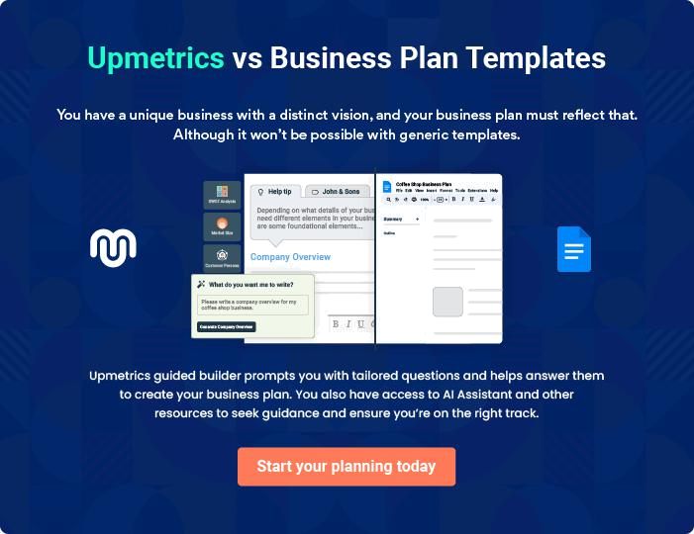

Vocational School | Business Plan [YEAR] | 13/25

4.

Market Analysis

Market Trends

Target Market

Competitive Advantage

Vocational School | Business Plan [YEAR] 14/25

Market Trends
To unlock help try Upmetrics!

 Radiant

The truth is that any vocational school & training center that has good records and loads of positive testimonials from students who have passed through the school will always thrive.
To unlock help try Upmetrics! 

Start writing here..

Target Market

 Radiant

Prior to choosing a location for our vocational school & training center, we conducted thorough feasibility studies and market surveys and we were able to identify those who will benefit greatly from our service offerings.



Start writing here..

Competitive Advantage

 Radiant

In spite of the fact that vocational schools scale through hurdles before they are established does not mean that there are no real competitions in the industry. The truth is that no matter the line of business that you are involved in, as long as it is called business, you will definitely
To unlock help try Upmetrics! 

Start writing here..

Vocational School | Business Plan [YEAR] 15/25

5.

Sales And Marketing Strategy

Marketing Strategy and Sales Strategy

Sources of Income

Sales Forecast

Pricing Strategy

Publicity and Advertising Strategy

Vocational School | Business Plan [YEAR] 16/25

Marketing Strategy and Sales Strategy
To unlock help try Upmetrics!
To unlock help try Upmetrics!

 Radiant

The marketing strategy adopted by Radiant Vocational Training Center, LLC is going to be driven basically by excellent customer service and quality training delivery. We will ensure that we build a loyal customer base.



Start writing here..

Sources of Income

 Radiant

Radiant Vocational Training Center, LLC is established with the aim of maximizing profits in the Trade and Technical Schools industry and we are going to ensure that we do all it takes to attract both individual clients and corporate clients on a regular basis.

Start writing here..

Sales Forecast

 Radiant



We are well-positioned to take on the available market in and around Orange County – California and we are quite optimistic that we will meet our set target of generating enough
income/profits from the first six months of operation and grow our vocational school & training
To unlock help try Upmetrics! 

Start writing here..

Vocational School | Business Plan [YEAR] 17/25

No. of students v/s Revenue Chart
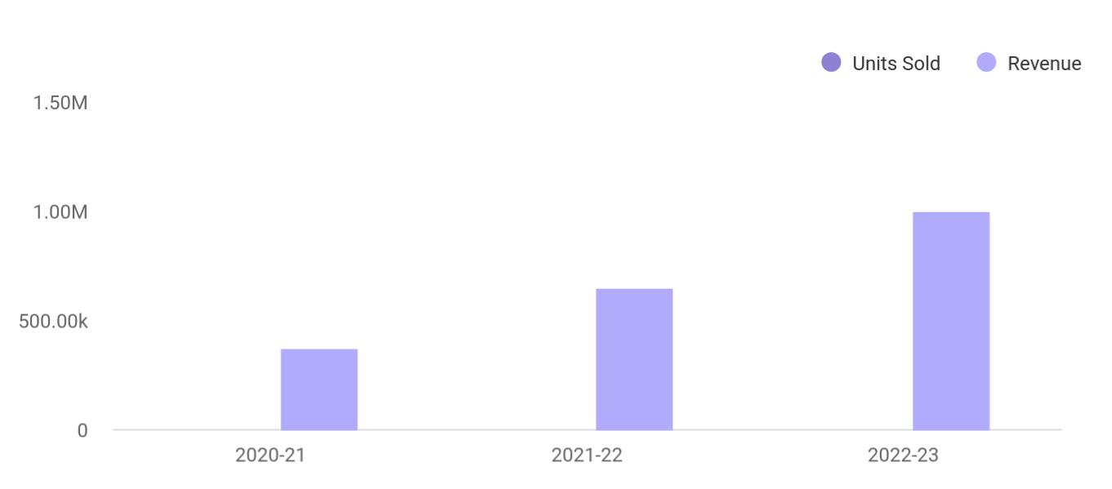

Financial Year | Units Sold | Revenue
2020-21 | 1,550 | 375,000
2021-22 | 1,800 | 650,000
2022-23 | 2,050 | 1,000,000

Pricing Strategy

 Radiant

At Radiant Vocational Training Center, LLC we will keep our fees below the average market rate by keeping our overhead low and by collecting payment in advance.
To unlock help try Upmetrics! 

Start writing here..

 Radiant

The payment policy adopted by Radiant Vocational Training Center, LLC is all-inclusive because we are quite aware that different customers prefer different payment options as it suits them but at the same time, we will ensure that we abide by the financial rules and regulation in the
To unlock help try Upmetrics! 

Payment Options

Start writing here..

Vocational School | Business Plan [YEAR] 18/25

Publicity and Advertising Strategy

 Radiant

Radiant Vocational Training Center, LLC is set to create a standard for the vocational school & training center business not only in Orange County – California but throughout the United States of America which is why we will go all the way to adopt and apply best practices to
To unlock help try Upmetrics! 

Start writing here..

Vocational School | Business Plan [YEAR] 19/25

6.

Financial Plan

Startup Expenditure (Budget)

Generating Funds/Startup

Vocational School | Business Plan [YEAR] 20/25

Startup Expenditure (Budget)

 Radiant

If you are looking towards starting a vocational school & training center, then you should be ready to raise enough capital to cover some of the basic expenditures that you are going to incur. You will need money to secure a standard facility, acquire different types of training
To unlock help try Upmetrics! 

Start writing here..

Generating Funds/Startup

 Radiant

Radiant Vocational Training Center, LLC is owned and managed by Richmond Jones and other members of the faculty. They are the financiers of the business which is why they decided to restrict the sourcing of the startup capital for the business to just three major sources.
To unlock help try Upmetrics! 

Start writing here..

Vocational School | Business Plan [YEAR] 21/25

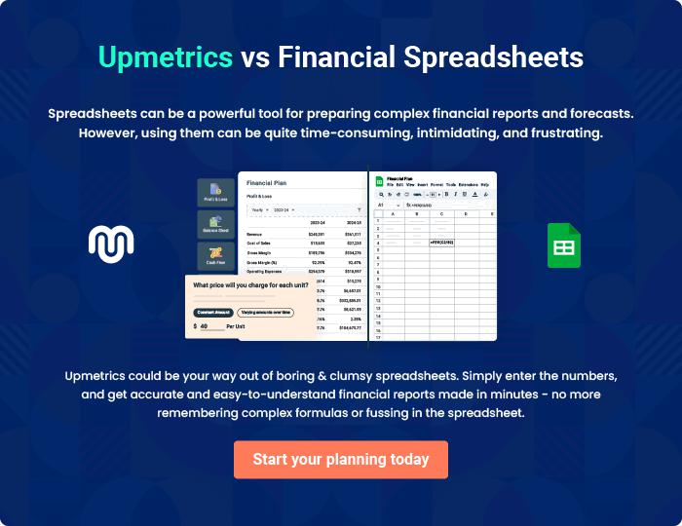

Vocational School | Business Plan [YEAR] | 22/25

7.

Sustainability and

Expansion Strategy

Vocational School | Business Plan [YEAR] 23/25

 Radiant

The future of a business lies in the number of loyal customers that they have, the capacity and competence of their employees, their investment strategy, and the business structure. If all of these factors are missing from a business, then it won’t be too long before the business closes
To unlock help try Upmetrics! 

Start writing here..

Vocational School | Business Plan [YEAR] 24/25


Create a winning business plan that gets you funded

Creating a stunning and investment-ready plan requires no writing, graphic designing, or financial planning expertise.

Upmetrics has all the features required to help you create a comprehensive business plan—from start to finish. Make no mistakes, it’s the modern way of planning to structure ideas, make plans, and create stunning pitch decks to awe investors.

Pitch decks that impress investors

Create pitch decks that provide a visual representation of your business, engage investors, and make them want to invest in your business idea.

Interactive plans in no time

Import business plan sections like—SWOT analysis, comparison tables, and others to create an interactive business plan. No designing skills are required.

Stunning cover page designs

With Upmetrics, you have the liberty to choose from multiple stunning cover page designs. Choose a creative design and make your plan stand out.

Online sharing made simple

Upmetrics makes online sharing quick and easier for users. Easily share your business plans with a link while tracking reader activity.

500+ sample business plans

Simply import a template from our library of sample plans into the editor and start customizing it to make it yours. It takes only a few clicks to get started.

Collaborate with team in real-time

Invite team members, initiate conversations, discuss ideas & strategies, share feedback, and work on a business plan in real-time.

