
Tutoring

ADDRESS

CONTACT

10200 Bolsa Ave, Westminster, CA, 92683

(650) 359-3153

http://www.example.com

info@example.com


Business Plan

[YEAR]

Prepared By

John Doe


Math – Reading – Success

Information provided in this business plan is unique to this business and confidential; therefore, anyone reading this plan agrees not to disclose any of the information in this business plan without prior written permission of the Company

Table of Contents

Executive Summary | 5
Business Summary | 6
Market Research Summary | 6
Marketing Summary | 6
Finance Summary | 7
Net Income | 7

Business Profile | 8
Business Overview | 9
Business Description | 9
Compelling Value | 9
Product/Service Description | 10
Company History | 10
Management | 10
Location | 11
Legal Structure | 11
Vision & Mission | 11
Professional Advisors(optional) | 12
Goals & Objectives | 12

Market Research | 13
Industry Profile & Outlook | 14
Local Market | 14
Key Competitors/ S.W.O.T. Analysis | 14
TOP Tutors | 15
ABC Tutoring | 16
Target Market | 16
Keys to Success | 17
Customer Survey Summary | 17

Tutoring | Business Plan [YEAR] 2/37

Sales & Marketing | 19
Pricing Strategy | 20
Marketing | 20
Marketing Strategy | 20
Marketing Activities | 20
Marketing Objectives | 21
Positioning Statement | 21
Sales Process | 21
Strategic Alliances | 22

Operations | 23
Physical Location | 24
Virtual Location | 24
Legal Issues | 24
Insurance Issues | 25
Human Resources | 25
Process/Production | 25
Risk Assessment | 26

Financials | 27
Past Purchases | 28
Start-up Costs Sheet | 28
Sales Forecast Assumptions | 28
Cash Flow | 29
Projected Profit and Loss | 30
Projected Balance Sheet | 33
Appendix
Appendix | 35

Tutoring | Business Plan [YEAR] 3/37

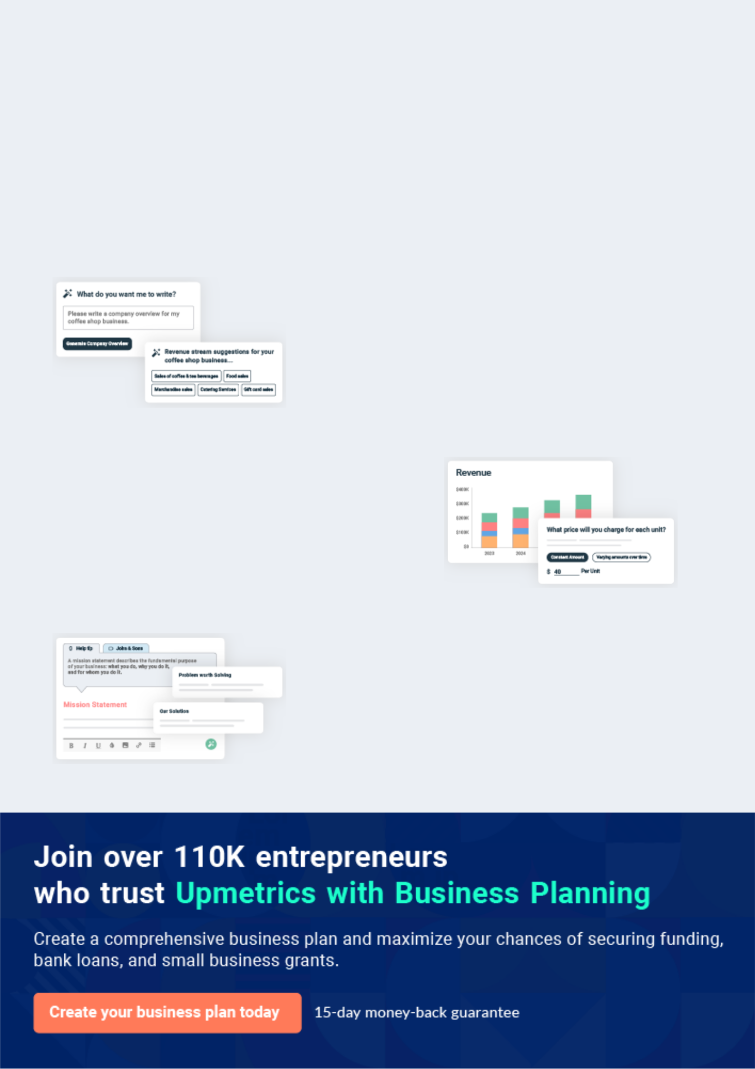
Business planning that’s simpler and faster than you think

Creating a business plan using Upmetrics to start and grow a business is literally the easiest thing in the World. Simply read the instructions and fill in the blanks. It’s as simple as that.

❛ | Upmetrics has everything you need to create a | ❜
❛ | comprehensive business plan. | ❜

AI-powered Upmetrics Assistant

AI-powered insights to streamline your plan

Not sure where to start? Upmetrics’ AI Assistant will automatically generate ideas for each section of your plan and offer improved versions of your writing, adjusting for tone, voice, and grammar or spelling errors.

Financial Forecasting Tool

All the financials are calculated for you

Forget the complex formulas and clumsy spreadsheets — with automatic financials and drag-and-drop forecasting, you can finish your plan faster and be confident that your numbers are accurate.

Business Plan Builder

Guides you like a business mentor

Upmetrics’ step-by-step instructions, prompts, and the library of 400+ sample business plans will guide you through each section of your plan as a business mentor.

1.


Executive Summary

Business Summary

Market Research Summary

Marketing Summary

Finance Summary

Tutoring | Business Plan [YEAR] 5/37


This section is placed first but done last. Write short, concise paragraphs summarizing each of the main sections of the business plan. The Executive Summary should ideally be a page in length and no longer than a page and a
To unlock help try Upmetrics! 

Business Summary

 Help Tip  ABC Tutoring


What are you selling and who is the person behind this?

Start writing here..

Market Research Summary

 Help Tip  ABC Tutoring

- What is a brief overview of the market?

- Who are the key competitors?

- Who is the target market?

Start writing here..

To unlock help try Upmetrics! 

To unlock help try Upmetrics! 

Marketing Summary

 Help Tip  ABC Tutoring

- How will you gain clients?

- What specific strategies make sense to do?
- What are the basic necessities you will need to get off the ground and_{Tounlock}how_{help}will_{try}you_{Upmetrics!}create 

Start writing here..

Tutoring | Business Plan [YEAR] 6/37

Finance Summary

 Help Tip  ABC Tutoring

- How much money do you need to start?

- Where will you get the money?
- How many sales do you plan on generating in the first then second_{To}years?_{unlock help try Upmetrics!} 

Start writing here..

Net Income
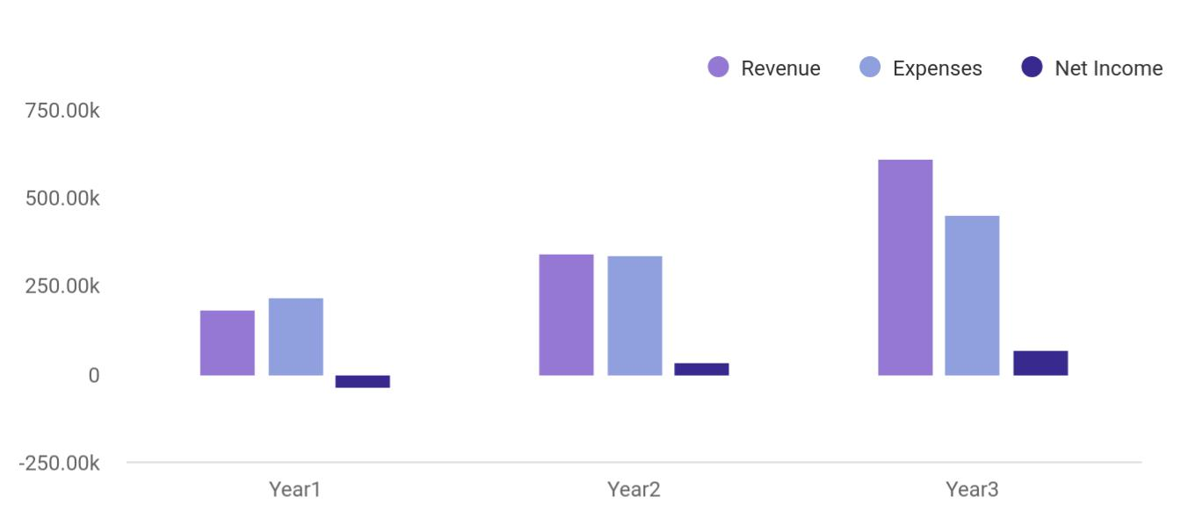

Financial Year | Revenue | Expenses | Net Income
Year1 | 184,074 | 219,452 | -35,378
Year2 | 341,645 | 338,451 | 35,000
Year3 | 612,545 | 451,125 | 70,000

Tutoring | Business Plan [YEAR] 7/37

2.

Business Profile

Business Overview

Company History

Management

Location

Legal Structure

Vision & Mission

Professional Advisors(optional)

Goals & Objectives

Tutoring | Business Plan [YEAR] 8/37

The Business Profile chapter addresses your offering, what your company is about, and who is/are the person(s) behind the company.
To unlock help try Upmetrics! 

Business Overview

 Help Tip


- What is the status of your company as of today?

- What is your company about?
To unlock help try Upmetrics! 

Start writing here..

 Help Tip  ABC Tutoring

If you were to meet someone and they asked you what is your company about and you had one minute to talk, what would you say?
To unlock help try Upmetrics! 

Business Description

Start writing here..

 Help Tip  ABC Tutoring

What is the key benefit to the customer? Select one overriding key benefit for the customer - sometimes this is referred to as the Competitive Advantage, Unique Selling Point, or Distinguishing Feature. What key promise are you making to the customer? You can’t be all
To unlock help try Upmetrics! 

Compelling Value

Start writing here..

Tutoring | Business Plan [YEAR] 9/37

 Help Tip  ABC Tutoring
To unlock help try Upmetrics!

Briefly describe the products and/or services that you are offering. It may be apparent to you what products or services you’re offering but you need to state the obvious by listing the services/products offered.



Product/Service Description

Start writing here..

Company History

 Help Tip  ABC Tutoring

What have you done up until now on your business (idea)? Discuss any sales you’ve made to date (whether part-time or not), potential and actual customer contacts, business
developments such as established suppliers, areas of the businesses that have been set up like
To unlock help try Upmetrics! 

Start writing here..

Management

 Help Tip  ABC Tutoring

Describe the team or individual who will make things happen and is crucial to the success of the business. This section outlines what you (and your team) bring to the table, what you have to offer to make the business a success. Don’t be afraid to draw upon all your life experiences.
To unlock help try Upmetrics! 

Start writing here..

Tutoring | Business Plan [YEAR] 10/37

Location

 Help Tip  ABC Tutoring


What location will you run your business from? Why does this make sense? If you are renting
office space a good case needs to be made as to why you need to rent office/studio space in
the early start-up phase of your business.
 |  |  |  | To unlock help try Upmetrics! 
Start writing here..
Legal Structure
 Help Tip |  |  ABC Tutoring


What is your company structure? Sole proprietorship, partnership, or corporation? If in doubt start with a sole proprietorship – you can always upgrade and incorporate later. When you start you are building a reputation and that takes time to develop, but at a later date, it may be
To unlock help try Upmetrics! 

Start writing here..

Vision & Mission

 Help Tip  ABC Tutoring

Vision:

How do you see your business 5-10 years from now? A vision is very personal and should motivate you at a deeper level. Think big. This is the end result - how do you want to be seen?
To unlock help try Upmetrics! 

Start writing here..

Tutoring | Business Plan [YEAR] 11/37

Professional Advisors(optional)

 Help Tip  ABC Tutoring

Who are the people who you will rely upon to give you expert advice? Examples include accountants, legal advice, experts in your industry etc. You may not have any at this point.
To unlock help try Upmetrics! 

Start writing here..

Goals & Objectives

 Help Tip  ABC Tutoring

What are the business milestones that you want to set? This may include sales target per month, number of clients, website launch date, new product/service launches, etc. These need to be measurable and have a time frame: ‘Conducting extensive marketing’ for example is not a
To unlock help try Upmetrics! 

Start writing here..

Tutoring | Business Plan [YEAR] 12/37

3.

Market Research

Industry Profile & Outlook

Local Market

Key Competitors/ S.W.O.T. Analysis

Target Market

Keys to Success

Customer Survey Summary

Tutoring | Business Plan [YEAR] 13/37

From the viewpoint of the customer, what options they have? Is the marketplace dominated by a few key players or many small ‘shops’?What are the keys to success? What are the key challenges in the market place? What
To unlock help try Upmetrics! 

Industry Profile & Outlook

 Help Tip  ABC Tutoring

Explain what changes have occurred in the industry and how this will affect your business. Based on past analysis what are the predictions for the future in the industry? How will any of the following trends have an effect on your business: socio-cultural; technological; political;
To unlock help try Upmetrics! 

Start writing here..

Local Market

 Help Tip  ABC Tutoring

What immediate market will you serve? What’s the catchment area? It is important to know the scope (the geographical area) of your initial marketing reach. Describe the make-up of this local market – who are the competitors? Even if you are running a web-based business you
To unlock help try Upmetrics! 

Start writing here..

Key Competitors/ S.W.O.T. Analysis

 Help Tip  ABC Tutoring

Who are your 4-5 closest competitors and what are their Strengths, Weaknesses, Opportunities, and Threats? Fill in the S.W.O.T. chart. Please select 4-5 of your closest competitors and do a S.W.O.T. Analysis including doing one on your own business (see example).
To unlock help try Upmetrics! 

Start writing here..

Tutoring | Business Plan [YEAR] 14/37

TOP Tutors

Start writing here..

Strength | Weakness
• Good reputation | • $145 diagnostic test required
• Well established | • $390 for 8 session
• Online presence
Opportunity | Threat
• No fee diagnostics | • May decide to waive diagnostic fee
 | • Offer online tutoring

Tutoring | Business Plan [YEAR] 15/37

ABC Tutoring

Start writing here..

Strength | Weakness
• Familiar with local community | • Limited physical teaching space in home
 | office
Opportunity | Threat
• Make learning exciting for students | • High schools may begin to offer in-school
 | tutoring

Target Market

 Help Tip  ABC Tutoring

Who is your best customer? Determine who your best-paying customer is – not necessarily who needs it the most, but who values it the most and is willing to pay for it. Identifying a target market will help you develop a much more effective marketing strategy. You should not plan to
To unlock help try Upmetrics! 

Start writing here..

Tutoring | Business Plan [YEAR] 16/37

Keys to Success
To unlock help try Upmetrics!

 Help Tip  ABC Tutoring

What are the few key drivers that will ensure success? In other words, the key priorities to keep in mind day-in, day-out. Marketing addresses how you will gain clients and Operations on how you will maintain your reputation.



Start writing here..

Customer Survey Summary

 Help Tip  ABC Tutoring

What have you learned from your customer survey to move your business forward? It is important to get feedback from your potential customers and to determine whether you are
targeting the right audience and what is important to your customer. For business-to-consumer
To unlock help try Upmetrics! 

Start writing here..

Tutoring | Business Plan [YEAR] 17/37

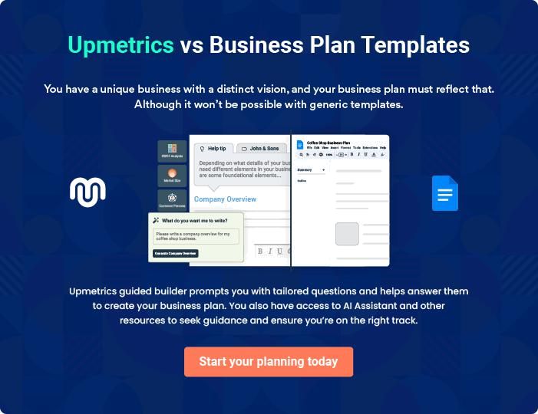

Tutoring | Business Plan [YEAR] | 18/37

4.

Sales & Marketing

Pricing Strategy

Marketing

Positioning Statement

Sales Process

Strategic Alliances

Tutoring | Business Plan [YEAR] 19/37

The Sales & Marketing section addresses how you will gain customers with specific marketing activities identified to accomplish this.
To unlock help try Upmetrics!
To unlock help try Upmetrics! 

Pricing Strategy

 Help Tip  ABC Tutoring

What do your key competitors charge for the same or similar services/products? How do you compare (list your prices)? Why do you charge what you charge? Your price(s) needs to be consistent with your key messaging – if you are promoting your business as providing top
To unlock help try Upmetrics! 

Start writing here..

Marketing

 Help Tip  ABC Tutoring

There is a tendency to have a long shopping list of all the marketing activities you can do. It’s more effective to focus on 3-5 marketing activities to start as this will inform your marketing strategy and keep you on target. Marketing takes time and a smart business plan includes the
To unlock help try Upmetrics! 

Marketing Strategy

Start writing here..

 Help Tip  ABC Tutoring

What are the top 3-5 marketing activities based on your Marketing Strategy and the detailed implementation plan for each? Prioritize each marketing activity starting with the most effective method.



Marketing Activities

Start writing here..

Tutoring | Business Plan [YEAR] 20/37

 Help Tip  ABC Tutoring

What marketing goals have you set for the company in the next year or two? You should have specific, measurable goals for your marketing activities. These goals may be expressed in terms of monthly, quarterly or annual sales, clients, website hits, networking events attended,
To unlock help try Upmetrics! 

Marketing Objectives

Start writing here..

Positioning Statement

 Help Tip  ABC Tutoring

How do you want your product/service to be perceived? What one key message do you want your customers to hear? Your messaging will need to be consistent. Your positioning statement needs to reflect your Compelling Value. For example, a positioning statement for a
To unlock help try Upmetrics! 

Start writing here..

Sales Process

 Help Tip  ABC Tutoring

What is the typical sales cycle from initial client contact to making a sale? Every business has a typical sales process - generally, the costlier the product/service the longer the sales process. Included in this process can be the initial inquiry or contact, clarifying questions to see what
To unlock help try Upmetrics! 

Start writing here..

Tutoring | Business Plan [YEAR] 21/37

Strategic Alliances

 Help Tip  ABC Tutoring

These are people or businesses that may be able to refer business to you or complement your business i.e. if you tutor English you may have a strategic alliance with a math tutor as you can both refer business to each other. You can include influencers – individuals who have solid
To unlock help try Upmetrics! 

Start writing here..

Tutoring | Business Plan [YEAR] 22/37

5.

Operations

Physical Location

Virtual Location

Legal Issues

Insurance Issues

Human Resources

Process/Production

Risk Assessment

Tutoring | Business Plan [YEAR] 23/37

Physical Location

 Help Tip  ABC Tutoring

Why have you chosen to locate where you have? Are you opening a storefront or office space?

Are you planning on leasing? What is your rationale? What will your hours of operation be?
To unlock help try Upmetrics! 

Start writing here..

Virtual Location

 Help Tip  ABC Tutoring

Describe how you envisage the website. What are the key features of the website? What is your
timeline? Provide details about your website such as ease of navigation and design issues.
How long will it take to have the website up and running?
 |  |  |  |  | To unlock help try Upmetrics! 
Start writing here..
Legal Issues
 Help Tip |  |  |  ABC Tutoring

Will you need to protect your intellectual property? Patent, Trademark, Copyright?

This takes time and money to secure. It is advised that you do not rush into these without
To unlock help try Upmetrics! 

Start writing here..

Tutoring | Business Plan [YEAR] 24/37

Insurance Issues

 Help Tip

All businesses take some form of risk. Many businesses start off by having liability insurance to protect their business from being sued. One way to determine whether you should take insurance or not if necessary the type of insurance is to see what the norm is in the industry.
To unlock help try Upmetrics! 

Start writing here..

Human Resources

 Help Tip  ABC Tutoring

How many full-time staff will you have?

How many part-time staff will you have?

For each staff member indicated above, list their title and role.

Start writing here..

Process/Production

 Help Tip  ABC Tutoring

To unlock help try Upmetrics! 

Outline the process from order to customer delivery. Discuss capacity issues i.e. how many orders can you physically fulfill each day/month? Provide a supplier analysis if your key selling point is your suppliers. What are your lead times from suppliers? What would happen if your
To unlock help try Upmetrics! 

Start writing here..

Tutoring | Business Plan [YEAR] 25/37

Risk Assessment

 Help Tip  ABC Tutoring

What could cause your marketing efforts to be ineffective and how would you plan to minimize those risks? What are the potential risks in operations and how do you plan on mitigating those risks? Consider the worst-case scenario. At what point would you need to close your doors?
To unlock help try Upmetrics! 

Start writing here..

Tutoring | Business Plan [YEAR] 26/37

6.

Financials

Past Purchases

Start-up Costs Sheet

Sales Forecast Assumptions

Cash Flow

Projected Profit and Loss

Projected Balance Sheet

Tutoring | Business Plan [YEAR] 27/37

Past Purchases
To unlock help try Upmetrics!

 Help Tip

List any items you have already bought for the business. These are not included in the Start-up Costs Sheet and should be mentioned in either Company Profile/Company History or within the Operations section accordingly.



Start writing here..

Start-up Costs Sheet

 Help Tip

How much money will you need to get your business off the ground?

You will need to list all the items required to start your business and the cost associated with
To unlock help try Upmetrics! 

Start writing here..

Sales Forecast Assumptions

 Help Tip  ABC Tutoring

What overall assumptions are you making for your products/services sold?

Sales forecasting may seem like a guessing game. However, an effective sales forecast looks
To unlock help try Upmetrics! 

Start writing here..

Tutoring | Business Plan [YEAR] 28/37

Cash Flow

 | 2024 | 2025 | 2026
Cash Received | $307,210.20 | $637,208.70 | $883,506.60
Cash Paid | $459,126.62 | $505,542.55 | $543,062.22
COS & General Expenses | $105,193.14 | $144,288.97 | $174,345.99
Salary & Wages | $351,360 | $359,647.20 | $368,136.60
Interest | $2,573.47 | $1,606.38 | $579.64
Sales Tax | $0 | $0 | $0
Income Tax | $0 | $0 | $0
Net Cash From | ($151,916.42) | $131,666.15 | $340,444.38
Operations | ($151,916.42) | $131,666.15 | $340,444.38
Assets Sell | $0 | $0 | $0
Assets Purchase | $60,000 | $0 | $0
Net Cash From | ($60,000) | $0 | $0
Investments | ($60,000) | $0 | $0
Amount Received | $80,000 | $0 | $0
Loan Received | $50,000 | $0 | $0
Common Stock | $0 | $0 | $0
Preferred Stock | $0 | $0 | $0
Owner's Contribution | $30,000 | $0 | $0
Amount Paid | $41,679.72 | $22,646.82 | $23,673.45
Loan Capital | $15,679.73 | $16,646.82 | $17,673.44
Dividends & Distributions | $26,000 | $6,000 | $6,000
Net Cash From | $38,320.28 | ($22,646.82) | ($23,673.45)
Financing | $38,320.28 | ($22,646.82) | ($23,673.45)

Tutoring | Business Plan [YEAR] 29/37

 | 2024 | 2025 | 2026
Summary
Starting Cash | $0 | ($173,596.14) | ($64,576.81)
Cash In | $387,210.20 | $637,208.70 | $883,506.60
Cash Out | $560,806.34 | $528,189.37 | $566,735.67
Change in Cash | ($173,596.14) | $109,019.33 | $316,770.93
Ending Cash | ($173,596.14) | ($64,576.81) | $252,194.12
Projected Profit and Loss
 | 2024 | 2025 | 2026
Revenue | $307,210.20 | $637,208.70 | $883,506.60
One-on-One Tutoring | $30,000 | $31,500 | $33,078
Unit Sales | 600 | 630 | 662
Unit Price | $50 | $50 | $50
Group Tutoring Sessions | $42,000 | $46,200 | $50,820
Unit Sales | 420 | 462 | 508
Unit Price | $100 | $100 | $100
Online Course | $235,210.20 | $559,508.70 | $799,608.60
Subscriptions | $235,210.20 | $559,508.70 | $799,608.60
Users | 1,103 | 1,865 | 2,467
Recurring Charges | $30 | $30 | $30
Cost Of Sales | $58,032.61 | $79,668.49 | $96,372.77
General Costs | $58,032.61 | $79,668.49 | $96,372.77
Direct Tutoring Costs | $42,144.20 | $50,544.16 | $57,360.15

Tutoring | Business Plan [YEAR] 30/37

 | 2024 | 2025 | 2026
Tutor Salaries | $36,000 | $37,800 | $39,690
Educational Materials | $6,144.20 | $12,744.16 | $17,670.15
Classroom supplies | $15,888.41 | $29,124.33 | $39,012.62
Stationery and Printing | $3,600 | $3,636 | $3,672.36
CLassroom Utilities | $12,288.41 | $25,488.33 | $35,340.26
Revenue Specific Costs | $0 | $0 | $0
Personnel Costs (Direct | $0 | $0 | $0
Labor) | $0 | $0 | $0

Gross Margin | $249,177.59 | $557,540.21 | $787,133.83
Gross Margin (%) | 81.11% | 87.50% | 89.09%

Operating Expense | $398,520.53 | $424,267.68 | $446,109.82
Payroll Expense (Indirect | $351,360 | $359,647.20 | $368,136.60
Labor) | $351,360 | $359,647.20 | $368,136.60
Tutoring Staff | $165,600 | $169,488 | $173,471.04
Lead Tutor | $57,600 | $59,328 | $61,107.84
Junior Tutor | $108,000 | $110,160 | $112,363.20
Administrative Staff | $90,720 | $92,786.40 | $94,900.44
Office Manager | $50,400 | $51,660 | $52,951.56
Administrative Assistant | $40,320 | $41,126.40 | $41,948.88
Support Staff | $95,040 | $97,372.80 | $99,765.12
IT Support Specialist | $43,200 | $44,496 | $45,830.88
Cleaning Staff | $51,840 | $52,876.80 | $53,934.24
General Expense | $47,160.53 | $64,620.48 | $77,973.22
Facility Expenses | $24,000 | $24,780 | $25,633.54

Tutoring | Business Plan [YEAR] 31/37

Facility Expenses

Utilities

Marketing and Advertising

Digital Advertising

Promotional Material

Operational and

Administrative

Insurance

Office Supplies

Bad Debt

Amortization of Current Assets

EBITDA

Additional Expense

Long Term Depreciation

Gain or loss from Sale of Assets

EBIT

Interest Expense

EBT

Income Tax Expense / Benefit

Total Expense

Net Income

2024 | 2025 | 2026
$18,000 | $18,540 | $19,143.94
$6,000 | $6,240 | $6,489.60
$18,960.53 | $35,532.48 | $47,920.80
$15,360.53 | $31,860.48 | $44,175.36
$3,600 | $3,672 | $3,745.44
$4,200 | $4,308 | $4,418.88
$2,400 | $2,472 | $2,546.16
$1,800 | $1,836 | $1,872.72
$0 | $0 | $0
$0 | $0 | $0

($149,342.94) $133,272.53 $341,024.01

$10,589.48 | $9,622.38 | $8,595.63
$8,016 | $8,016 | $8,016
$0 | $0 | $0
($157,358.94) | $125,256.53 | $333,008.01
$2,573.47 | $1,606.38 | $579.64
($159,932.42) | $123,650.15 | $332,428.38
$0 | $0 | $0

$467,142.62 | $513,558.55 | $551,078.22
($159,932.42) | $123,650.15 | $332,428.38

Tutoring | Business Plan [YEAR] 32/37

 | 2024 | 2025 | 2026
Net Income (%) | (52.06%) | 19.40% | 37.63%
Retained Earning Opening | $0 | ($185,932.42) | ($68,282.27)
Owner's Distribution | $26,000 | $6,000 | $6,000
Retained Earning Closing | ($185,932.42) | ($68,282.27) | $258,146.11
Projected Balance Sheet
 | 2024 | 2025 | 2026
Assets | ($121,612.14) | ($20,608.81) | $288,146.12
Current Assets | ($173,596.14) | ($64,576.81) | $252,194.12
Cash | ($173,596.14) | ($64,576.81) | $252,194.12
Accounts Receivable | $0 | $0 | $0
Inventory | $0 | $0 | $0
Other Current Assets | $0 | $0 | $0
Long Term Assets | $51,984 | $43,968 | $35,952
Gross Long Term Assets | $60,000 | $60,000 | $60,000
Accumulated Depreciation | ($8,016) | ($16,032) | ($24,048)
Liabilities & Equity | ($121,612.16) | ($20,608.83) | $288,146.11
Liabilities | $34,320.26 | $17,673.44 | $0
Current Liabilities | $16,646.82 | $17,673.44 | $0
Accounts Payable | $0 | $0 | $0
Income Tax Payable | $0 | $0 | $0
Sales Tax Payable | $0 | $0 | $0
Short Term Debt | $16,646.82 | $17,673.44 | $0

Tutoring | Business Plan [YEAR] 33/37

 | 2024 | 2025 | 2026
Long Term Liabilities | $17,673.44 | $0 | $0
Long Term Debt | $17,673.44 | $0 | $0
Equity | ($155,932.42) | ($38,282.27) | $288,146.11
Paid-in Capital | $0 | $0 | $0
Common Stock | $0 | $0 | $0
Preferred Stock | $0 | $0 | $0
Owner's Contribution | $30,000 | $30,000 | $30,000
Retained Earnings | ($185,932.42) | ($68,282.27) | $258,146.11

Check | $0 | $0 | $0
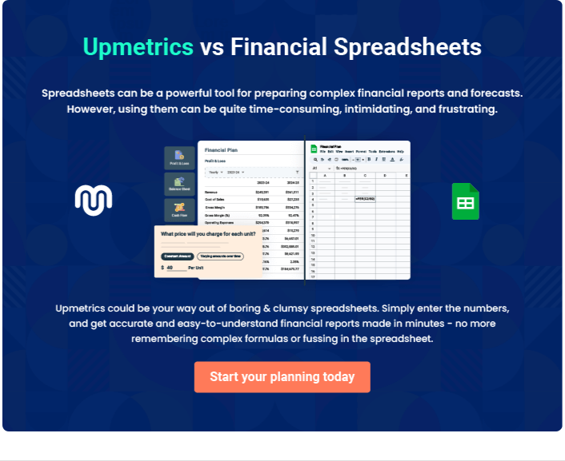

Tutoring | Business Plan [YEAR] 34/37

7.

Appendix

Tutoring | Business Plan [YEAR] 35/37

Include in here pictures of your product, store layout, design, resume, survey details, and any other extensive information or documents.
To unlock help try Upmetrics! 

Tutoring | Business Plan [YEAR] 36/37

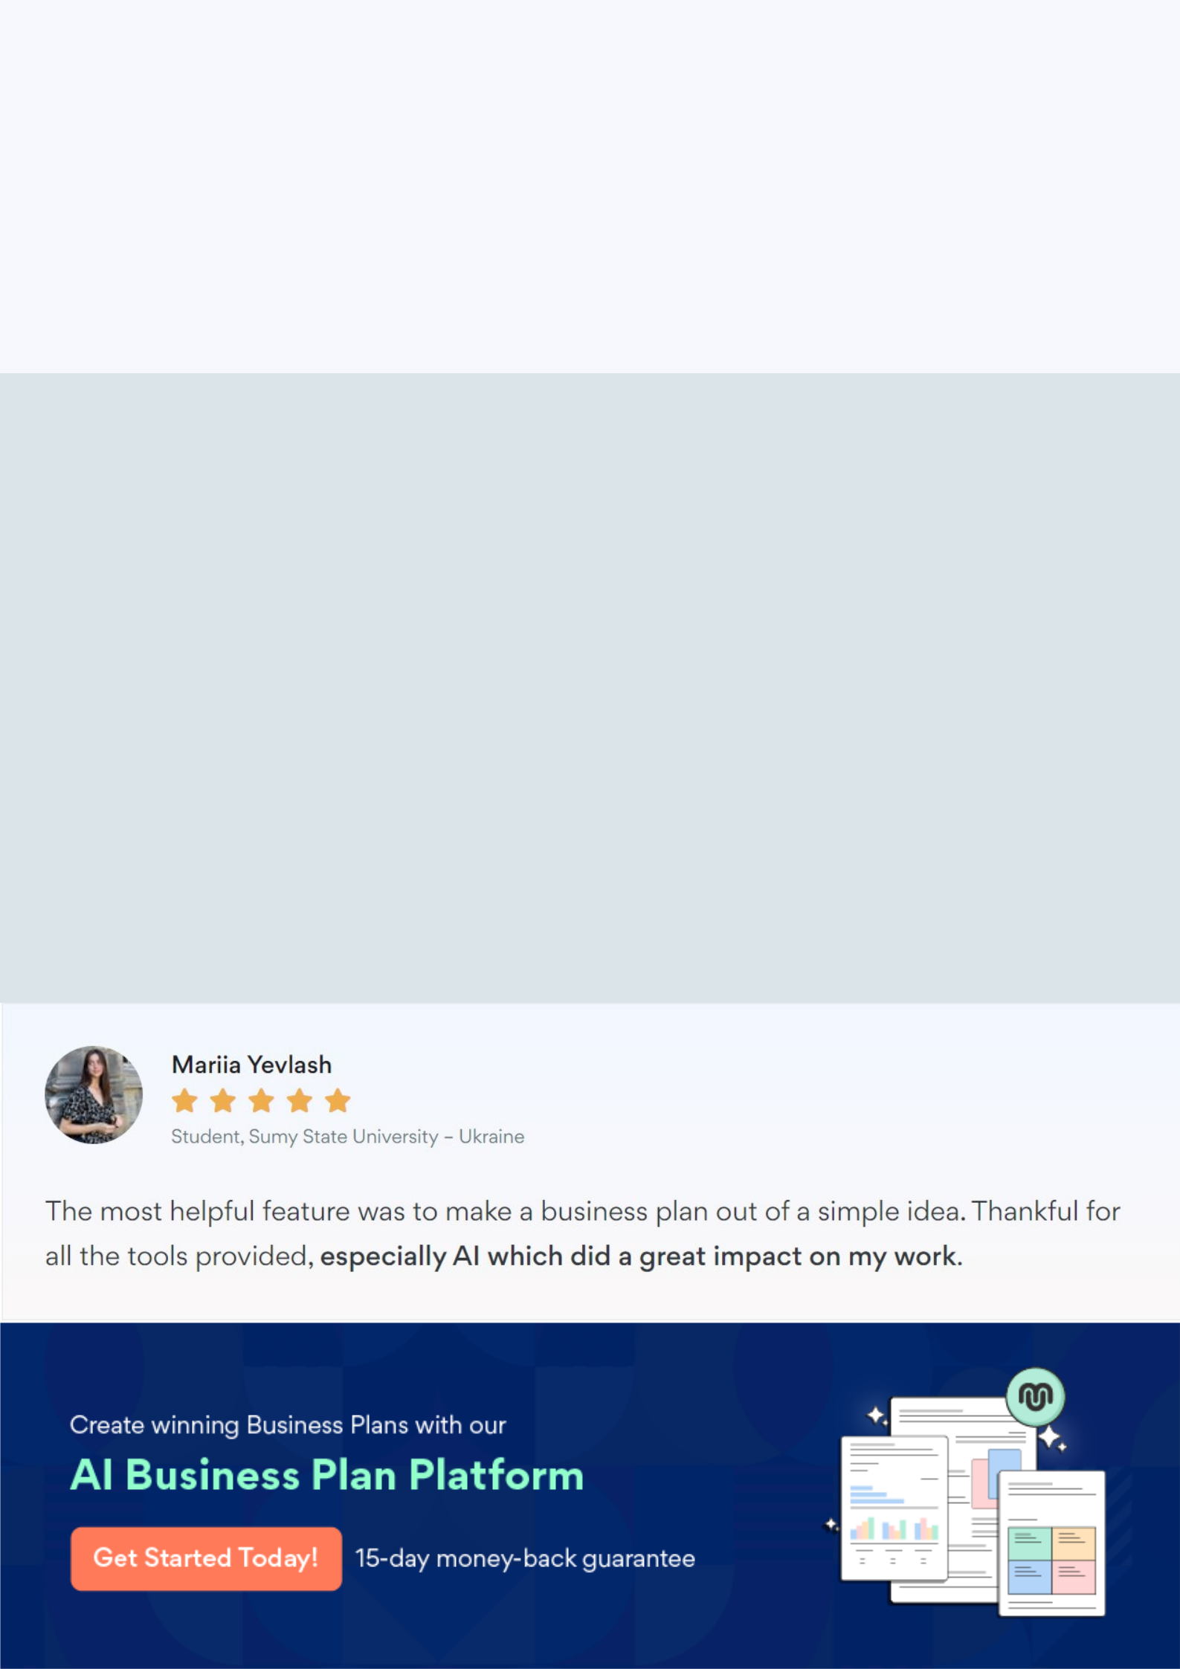
Create a winning business plan that gets you funded

Creating a stunning and investment-ready plan requires no writing, graphic designing, or financial planning expertise.

Upmetrics has all the features required to help you create a comprehensive business plan—from start to finish. Make no mistakes, it’s the modern way of planning to structure ideas, make plans, and create stunning pitch decks to awe investors.

Pitch decks that impress investors

Create pitch decks that provide a visual representation of your business, engage investors, and make them want to invest in your business idea.

Interactive plans in no time

Import business plan sections like—SWOT analysis, comparison tables, and others to create an interactive business plan. No designing skills are required.

Stunning cover page designs

With Upmetrics, you have the liberty to choose from multiple stunning cover page designs. Choose a creative design and make your plan stand out.

Online sharing made simple

Upmetrics makes online sharing quick and easier for users. Easily share your business plans with a link while tracking reader activity.

500+ sample business plans

Simply import a template from our library of sample plans into the editor and start customizing it to make it yours. It takes only a few clicks to get started.

Collaborate with team in real-time

Invite team members, initiate conversations, discuss ideas & strategies, share feedback, and work on a business plan in real-time.

