
BUSINESS PLAN

[YEAR]


Thrift Store

The store preferred by millions.

John Doe

10200 Bolsa Ave, Westminster, CA, 92683

- 359-3153 info@example.com http://www.example.com

Information provided in this business plan is unique to this business and confidential; therefore, anyone reading this plan agrees not to disclose any of the information in this business plan without prior written permission of the company.
Table of Contents

Executive Summary | 5
Mission Statement | 6
Vision Statement | 6
Sales Forecasts | 7
3 Year profit forecast | 7
Expansion Plan | 8

Company Summary | 9
Business Structure | 10
Startup summary | 11
Startup cost | 11
Products and services
Products and services | 14
Market Analysis
Market Analysis | 17
Market Trends | 18
Target Market | 18
Marketing Segmentation | 18
Moneyless Senior Citizens | 19
Underprivileged Children, Teens & Adults | 19
Tourists & Students | 20
SWOT Analysis
SWOT Analysis | 21
Strategy & Implementations
Strategy & Implementations | 23
Sales Strategy | 24
Marketing Objectives | 24
Advertising Strategy | 24
Pricing Strategy | 25

Thrift Store | Business Plan [YEAR] 2/38

Personnel plan | 26
Average Salary of Employees | 27
Financial Plan
Financial Plan | 28
Important Assumptions | 29
Brake-even Analysis | 29
Projected Profit and Loss | 30
Projected Cash Flow | 32
Projected Balance Sheet | 34
Business Ratios | 35

Thrift Store | Business Plan [YEAR] 3/38

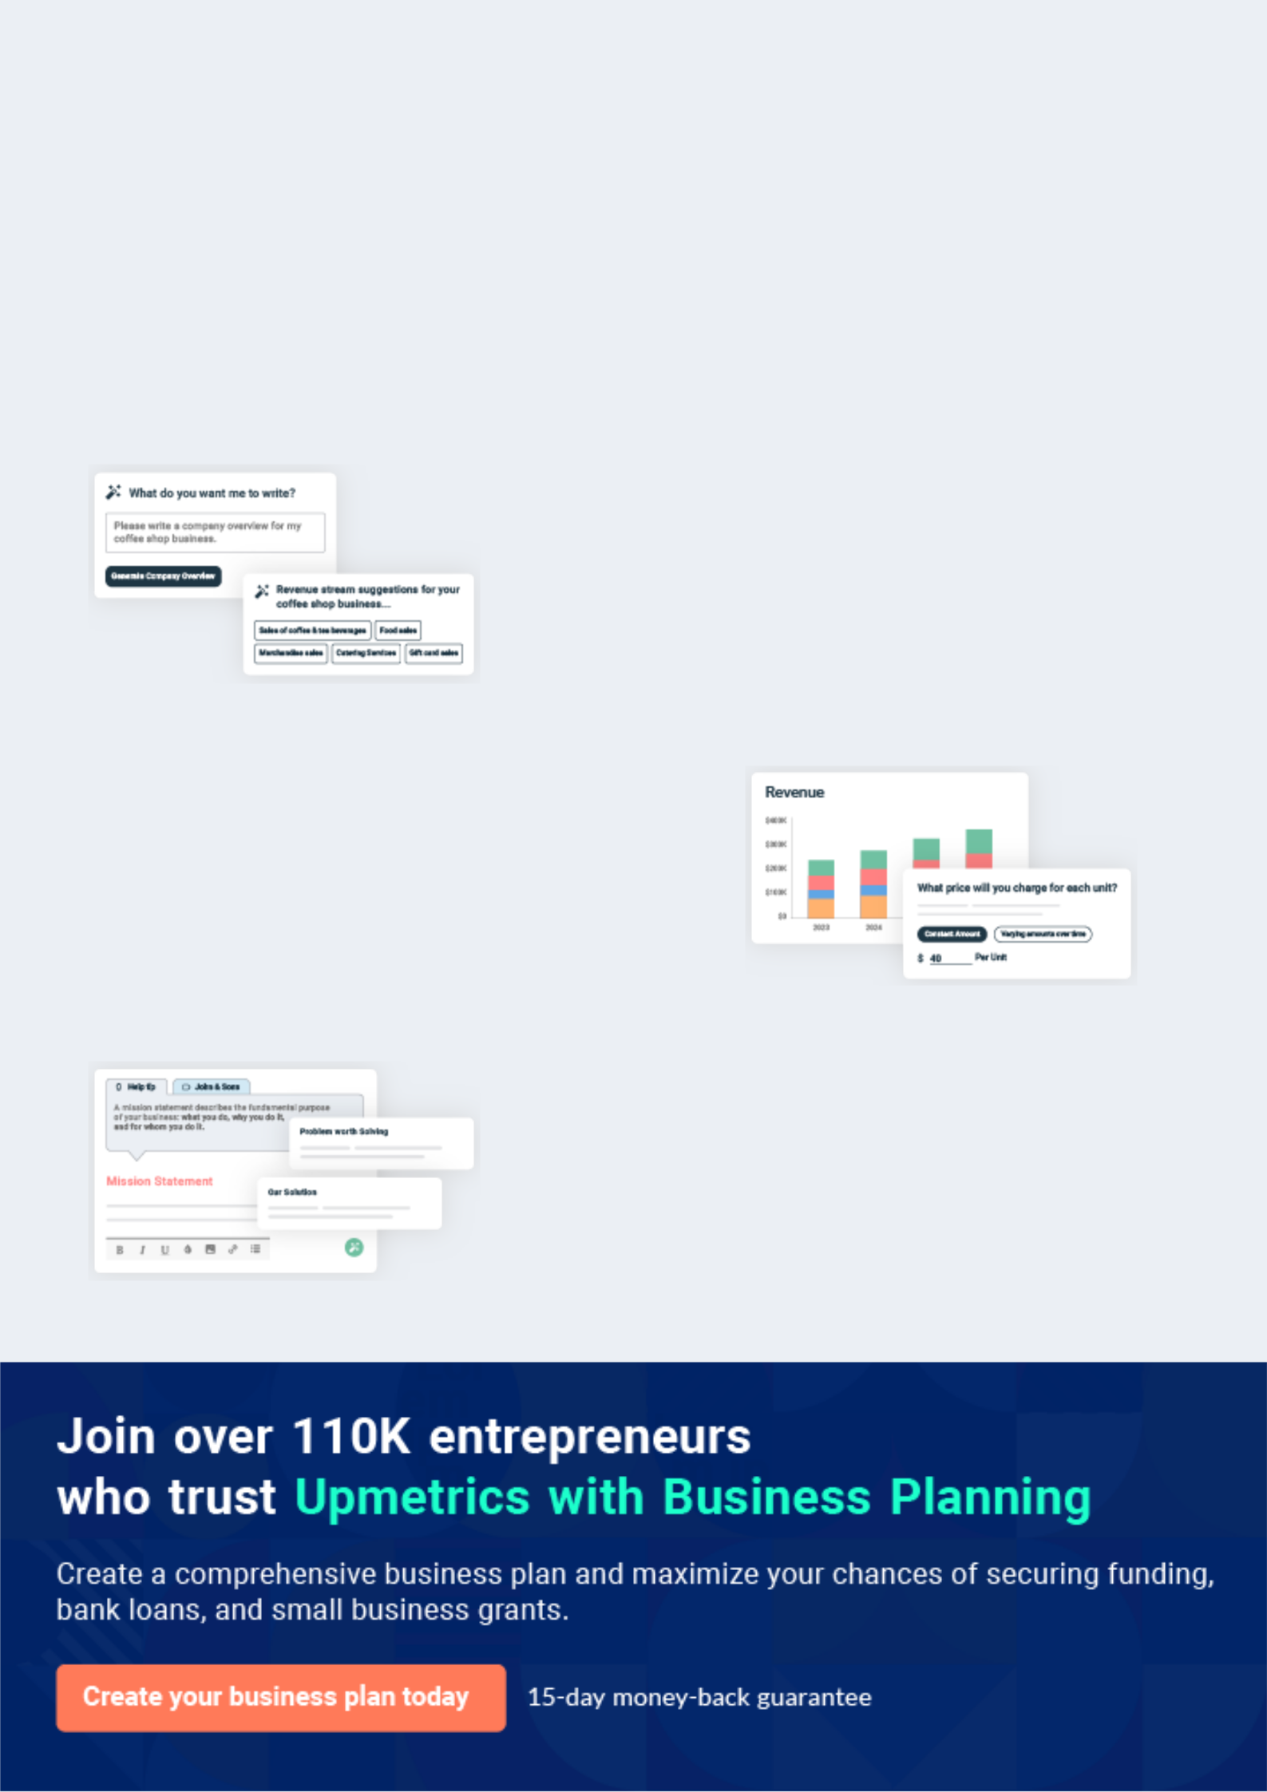
Business planning that’s simpler and faster than you think

Creating a business plan using Upmetrics to start and grow a business is literally the easiest thing in the World. Simply read the instructions and fill in the blanks. It’s as simple as that.

❛ | Upmetrics has everything you need to create a | ❜
❛ | comprehensive business plan. | ❜

AI-powered Upmetrics Assistant

AI-powered insights to streamline your plan

Not sure where to start? Upmetrics’ AI Assistant will automatically generate ideas for each section of your plan and offer improved versions of your writing, adjusting for tone, voice, and grammar or spelling errors.

Financial Forecasting Tool

All the financials are calculated for you

Forget the complex formulas and clumsy spreadsheets — with automatic financials and drag-and-drop forecasting, you can finish your plan faster and be confident that your numbers are accurate.

Business Plan Builder

Guides you like a business mentor

Upmetrics’ step-by-step instructions, prompts, and the library of 400+ sample business plans will guide you through each section of your plan as a business mentor.

1.


Executive Summary

Mission Statement

Vision Statement

Sales Forecasts

Expansion Plan

Thrift Store | Business Plan [YEAR] 5/38

Before you think about how to start a Thrift Store business, you must create a detailed Thrift Store business plan. It will not only guide you in the initial phases of your startup but will also help you later on.
To unlock help try Upmetrics!

 Maxwell Thrift Store




Maxwell Thrift Store, Inc. is a standard and registered charitable organization that operates a thrift store business in one of the busiest streets in Detroit, Michigan. We have been able to lease a facility that is big enough (a 5 thousand square foot facility) to fit into the design of the
To unlock help try Upmetrics! 

Start writing here..

Mission Statement

 Maxwell Thrift Store

Our mission is to establish a thrift store business that will make available a wide range of secondhand goods and products at affordable prices to the residents of Detroit, Michigan, and other cities in Michigan where we intend opening of chains of thrift stores. We want to generate
To unlock help try Upmetrics! 

Start writing here..

Vision Statement

 Maxwell Thrift Store

Our vision is to become one of the leading brands in the thrifts cum used goods stores industry in Michigan and to establish a one-stop thrift store in Detroit and in other cities in Michigan.
To unlock help try Upmetrics! 

Start writing here..

Thrift Store | Business Plan [YEAR] 6/38

Sales Forecasts

 Maxwell Thrift Store

Mr. Moore expects a strong rate of growth at the start of operations. Below are the expected financials over the next three years.
To unlock help try Upmetrics! 

Start writing here..

3 Year profit forecast
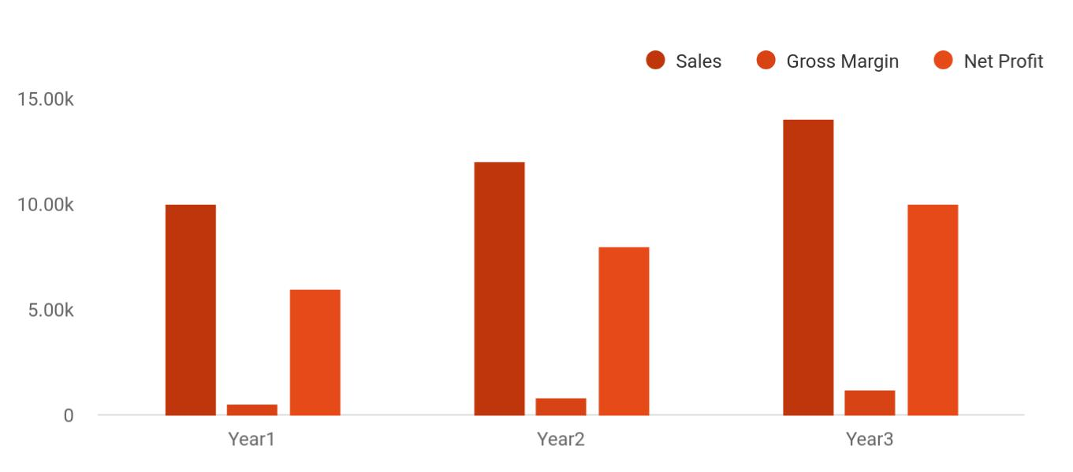

 Maxwell Thrift Store


Financial Summary | Year 1 | Year 2 |  | Year 3
 |  |  | To unlock help try Upmetrics! |  | 

Start writing here..

Thrift Store | Business Plan [YEAR] 7/38

Expansion Plan
To unlock help try Upmetrics!

 Maxwell Thrift Store

John Moore expects that the business will aggressively expand during the first three years of operation. Mr. Moore intends to implement marketing campaigns that will effectively target individuals that enjoy vintage clothing within the target market.



Start writing here..

Thrift Store | Business Plan [YEAR] 8/38

2.

Company Summary

Business Structure

Startup summary

Thrift Store | Business Plan [YEAR] 9/38

 Maxwell Thrift Store
To unlock help try Upmetrics!

Maxwell Thrift Store, Inc. is a charitable business that is owned by John Moore and their Family. John Moore has a B.Sc. in Business Administration, with well over 15 years of experience in the charity cum not for profits organizations, working for some of the leading brands in the United
To unlock help try Upmetrics! 

Start writing here..

Business Structure

 Maxwell Thrift Store

Maxwell Thrift Store, Inc. does not intend to start a thrift store business like the usual mom-and-pop business around the street corner; our intention of starting a thrift store business is to build a standard and one-stop thrift store outlet in Detroit, Michigan.



Start writing here..

Thrift Store | Business Plan [YEAR] 10/38

Startup summary

Startup cost
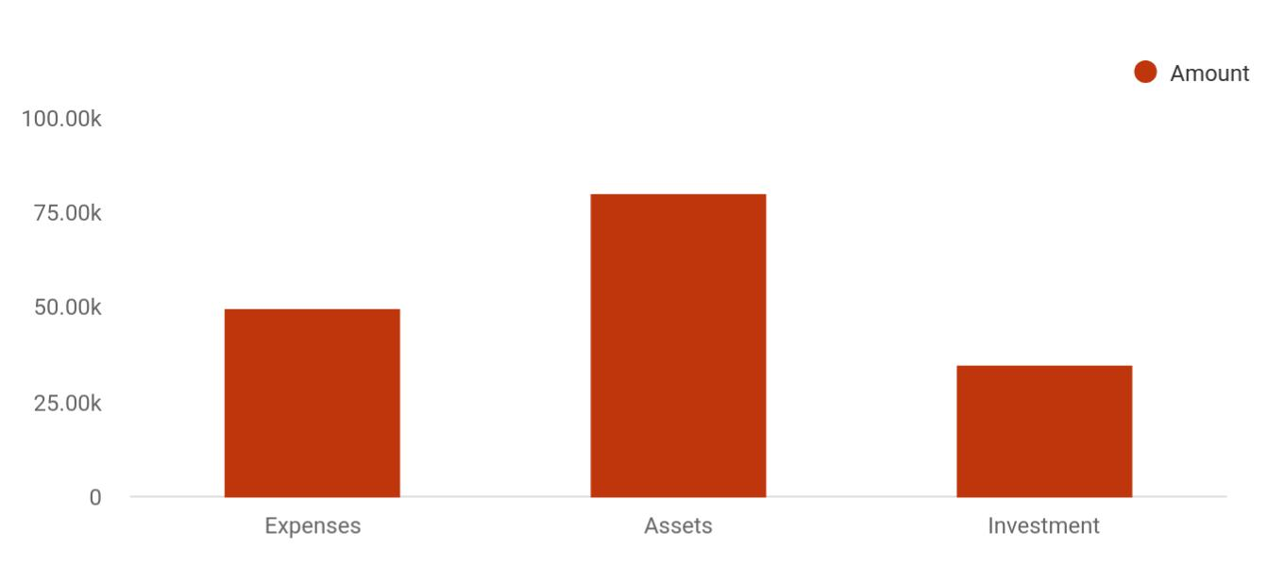

Cost distribution | Amount
Expenses | 50,000
Assets | 80,000
Investment | 35,000

Start-up Expenses | Amount
Legal | $75,500
Consultants | $0
Insurance | $62,750
Rent | $22,500
Research and Development | $42,750
Expensed Equipment | $42,750
Signs | $1,250
TOTAL START-UP EXPENSES | $247,500
Start-up Assets | $0
Cash Required | $322,500
Start-up Inventory | $52,625
Other Current Assets | $222,500

Thrift Store | Business Plan [YEAR] 11/38

Start-up Expenses | Amount
Long-term Assets | $125,000
TOTAL ASSETS | $121,875
Total Requirements | $245,000
START-UP FUNDING | $0
START-UP FUNDING | $273,125
Start-up Expenses to Fund | $121,875
Start-up Assets to Fund | $195,000
TOTAL FUNDING REQUIRED | $0
Assets | $203,125
Non-cash Assets from Start-up | $118,750
Cash Requirements from Start-up | $0
Additional Cash Raised | $118,750
Cash Balance on Starting Date | $121,875
TOTAL ASSETS | $0
Liabilities and Capital | $0
Liabilities | $0
Current Borrowing | $0
Long-term Liabilities | $0
Accounts Payable (Outstanding Bills) | $0
Other Current Liabilities (interest-free) | $0
TOTAL LIABILITIES | $0
Capital | $0
Planned Investment | $0
Investor 1 | $312,500
Investor 2 | $0
Other | $0
Additional Investment Requirement | $0
TOTAL PLANNED INVESTMENT | $695,000

Thrift Store | Business Plan [YEAR] 12/38

Start-up Expenses | Amount
Loss at Start-up (Start-up Expenses) | $313,125
TOTAL CAPITAL | $221,875
TOTAL CAPITAL AND LIABILITIES | $221,875
Total Funding | $265,000

Thrift Store | Business Plan [YEAR] 13/38

3.

Products and services

Thrift Store | Business Plan [YEAR] 14/38

 Maxwell Thrift Store
Clothes, Shoes & Books
The reusable books, shoes, fashion accessories, and clothes like dress shirts, sweaters, jackets etc. will also be kept at the store to be purchased by the low-incomes.
Sports Equipment &
Musical Instruments
This type of inventory is often found in the solely new condition as people after getting bored put their guitars, pianos, rackets, footballs and the things like that outside their house to be taken by someone, so we have decided to keep such reusable things in our shop.
To unlock help try Upmetrics!

Maxwell Thrift Store, Inc. is in the thrift cum used goods stores industry and we will ensure we go all the way to make available a wide range of used goods and products from households in the United States and other countries of the world.



Start writing here..


Furniture

We’ll clean and polish the furniture items such as wooden tables, chairs, cradles, old rugs and carpets, cupboards, etc. which are in a reusable condition and sell them to at very low and economical prices.

Small Electronic Devices

We will also sell the technology products and small electronics such as cell phones, microwaves, printers, mobile and computer accessories, storage devices and much more than that.

Thrift Store | Business Plan [YEAR] 15/38


Miscellaneous

Besides the above-

mentioned necessities

of living, we will also

keep the miscellaneous

items like crockery,

decoration pieces,

baskets, plastic

products etc.
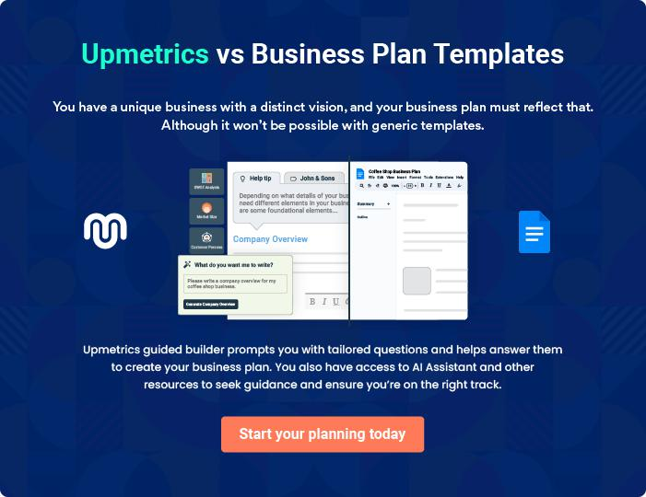

Thrift Store | Business Plan [YEAR] 16/38

4.

Market Analysis

Market Trends

Target Market

Marketing Segmentation

Thrift Store | Business Plan [YEAR] 17/38

The most important component of an effective Thrift Store business plan is its accurate marketing analysis. If you are starting on a smaller scale, you can do marketing analysis yourself by taking help from this Thrift Store
To unlock help try Upmetrics! 

Market Trends

 Maxwell Thrift Store

Generally, thrift stores/resale shopping attracts consumers from all economic levels. There is no distinctive resale shopper, just as there is no distinctive resale shop. The truth is that everybody irrespective of their financial status would usually look towards saving money and it
To unlock help try Upmetrics! 

Start writing here..

Target Market

 Maxwell Thrift Store

Perhaps the thrift store industry has the widest range of customers; everybody on planet earth, especially low-income earners, has one or more things that they would need in a thrift store. It is difficult to find people who are trying to cut costs who don’t patronize thrift stores.
To unlock help try Upmetrics! 

Start writing here..

Marketing Segmentation

 Maxwell Thrift Store

Our customers will be people with average financial backgrounds. Most people living in Detroit do not have enough income to meet their expenses in a rich city. These people lust for the items like clothes, furniture, etc., and are convenient in buying used items. It is also a
To unlock help try Upmetrics! 

Start writing here..

Thrift Store | Business Plan [YEAR] 18/38

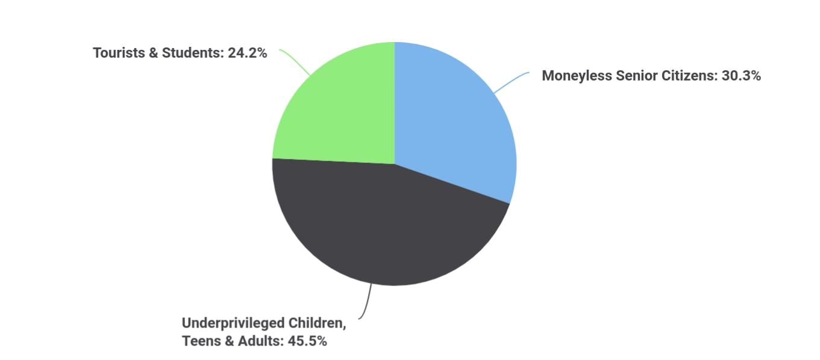To unlock help try Upmetrics!
To unlock help try Upmetrics!

 Maxwell Thrift Store

According to a report by City Performance Scorecards, more than 15 thousand senior citizens are living below the poverty level in San Francisco. The health and age of such people don’t allow them to meet their needs by hard work.



Moneyless Senior Citizens

Start writing here..

 Maxwell Thrift Store

There are many children and teens in the city who desire to buy good clothes, tech-based things, or sports equipment and musical instruments, but the reality is that most of their
desires remain unfulfilled due to the costs of such items. Moreover, about 61 thousand young
To unlock help try Upmetrics! 

Underprivileged Children, Teens & Adults

Start writing here..

 Maxwell Thrift Store

There are often situations when you are roaming in another country, but due to wrong estimates, become out of budget. So, the tourists or students who have to cut their discretionary needs, temporarily, will also be one of our target groups.



Thrift Store | Business Plan [YEAR] 19/38

Tourists & Students

Start writing here..

 Maxwell Thrift Store


The detailed market analysis of our potential customers is given in the following table:

To unlock help try Upmetrics! 

Start writing here..

Thrift Store | Business Plan [YEAR] 20/38

5.

SWOT Analysis

Thrift Store | Business Plan [YEAR] 21/38

 Maxwell Thrift Store
To unlock help try Upmetrics!

Our intention of starting just one outlet of our thrift store in Detroit, Michigan is to first test run the business for a period of 2 to 5 years to know if we will invest more money, expand the business and then open other outlets all over Michigan.



Start writing here..


Strength

Our location, the business model we will be operating on (a physical store and online store), varieties of payment options, a wide range of products, and our charity cause, and of course our excellent customer service culture will definitely count as a strong strength for Maxwell Thrift Store, Inc.


Weakness

A major weakness that may count against us is the fact that we are a new thrift store outlet and we don’t have the popularity like leading thrift store outlets like Goodwill Industries International Inc., Savers, and The Salvation Army and co when it comes to receiving goods from households and retailing at a rock bottom prices for all their goods.


Opportunity

The fact that we are going to be operating our thrift store in one of the busiest streets in Detroit, Michigan provides us with unlimited opportunities to sell our secondhand goods to a large number of people. We have been able to conduct thorough feasibility studies and market surveys and we know what our potential clients will be looking for when they visit our thrift store; we are well-positioned to take on the opportunities that will come our way.

Threat

Just like any other business, one of the major threats that we are likely going to face is an economic downturn. It is a fact that the economic downturn affects purchasing/ spending power. Another threat that may likely confront us is the arrival of a new thrift store or consignment store in the same location where ours is located.

Thrift Store | Business Plan [YEAR] 22/38

6.

Strategy &

Implementations

Sales Strategy

Marketing Objectives

Advertising Strategy

Pricing Strategy

Thrift Store | Business Plan [YEAR] 23/38

After identifying the market demand, market trends, and the potential customers of the startup, the next step is to define an effective strategy for attracting those customers. Like marketing analysis, sales strategy is also an
To unlock help try Upmetrics!
To unlock help try Upmetrics!
To unlock help try Upmetrics! 

Sales Strategy

 Maxwell Thrift Store

For promoting our sales, we will advertise our store in local magazines, newspapers and social media. We will also distribute our flyers in nearby schools and colleges. We’ll post our banners in well-off residential communities.



Start writing here..

Marketing Objectives

 Maxwell Thrift Store

- Maintain a committed program for divesting the Thrift Shop’s inventories through online distribution channels.
To unlock help try Upmetrics! 

Start writing here..

Advertising Strategy

 Maxwell Thrift Store

Even though our thrift store is well located and our charity cause is worthy of pursuit, we will still go ahead to intensify publicity for the business. We are going to explore all available means to promote our thrift store.



Start writing here..

Thrift Store | Business Plan [YEAR] 24/38

Pricing Strategy

 Maxwell Thrift Store

Pricing is one of the key factors that gives leverage to thrift stores, it is normal for consumers to go to places (retail outlets) where they can get goods at cheaper price which is why a big player in the thrift stores industry like Goodwill Industries International Inc., Savers, and The
To unlock help try Upmetrics! 

Start writing here..

Thrift Store | Business Plan [YEAR] 25/38

7.

Personnel plan

Average Salary of Employees

Thrift Store | Business Plan [YEAR] 26/38

 Maxwell Thrift Store

Mr. Moore will manage the overall operations and will hire the following people for his assistance.
To unlock help try Upmetrics! 

Start writing here..

Average Salary of Employees

 Maxwell Thrift Store


The following table shows the forecasted data about employees and their salaries for the next three years.
To unlock help try Upmetrics! 

Start writing here..

Thrift Store | Business Plan [YEAR] 27/38

8.

Financial Plan

Important Assumptions

Brake-even Analysis

Projected Profit and Loss

Projected Cash Flow

Projected Balance Sheet

Business Ratios

Thrift Store | Business Plan [YEAR] 28/38

The last component of the Thrift Store business plan is an in-depth financial plan. The financial plan crafts a detailed map of all the expenses needed for the startup and how these expenses will be met by the earned profits. It is
To unlock help try Upmetrics! 

 Maxwell Thrift Store

The company will be financed by John himself and he will control the direction of the business to make sure that it is expanding at the forecasted rate. As for the Thrift Store business start-up, no equity funding or outside loans will be required. With the help of financial experts, John
To unlock help try Upmetrics! 

Start writing here..

Important Assumptions

The financial projections of the company are forecast on the basis of the following assumptions. These assumptions are quite conservative and are expected to show deviation but to a limited level such that the company’s major financial strategy will not be affected.

 | Year 1 | Year 2 | Year 3
Plan Month | 1 | 2 | 3
Current Interest Rate | 10,00% | 11,00% | 12,00%
Long-term Interest Rate | 10,00% | 10,00% | 10,00%
Tax Rate | 26,42% | 27,76% | 28,12%
Other | 0 | 0 | 0

Brake-even Analysis

Monthly Units Break-even | 5530
Monthly Revenue Break-even | $159 740
Assumptions:
Average Per-Unit Revenue | $260,87
Average Per-Unit Variable Cost | $0,89
Estimated Monthly Fixed Cost | $196 410

Thrift Store | Business Plan [YEAR] 29/38

Projected Profit and Loss

 | 2024 | 2025 | 2026
Revenue | $447,959.60 | $780,523.20 | $1,427,448.20
Retail Sales | $159,171.40 | $285,849.20 | $513,343.20
Unit Sales | 7,959 | 14,292 | 25,667
Unit Price | $20 | $20 | $20
Online Sales | $75,909.20 | $191,154 | $481,362
Unit Sales | 3,795 | 9,558 | 24,068
Unit Price | $20 | $20 | $20
Custom Orders | $212,879 | $303,520 | $432,743
Unit Sales | 2,129 | 3,035 | 4,327
Unit Price | $100 | $100 | $100

Cost Of Sales | $55,563.48 | $80,191.25 | $122,569.28
General Costs | $55,563.48 | $80,191.25 | $122,569.28
Product Acquisition Costs | $26,824.26 | $34,019.75 | $43,145.35
Product Purchase Cost | $26,824.26 | $34,019.75 | $43,145.35
Operational Costs | $28,739.22 | $46,171.50 | $79,423.93
Utility Costs | $22,397.98 | $39,026.16 | $71,372.41
Maintenance Costs | $6,341.24 | $7,145.34 | $8,051.52
Revenue Specific Costs | $0 | $0 | $0
Personnel Costs (Direct | $0 | $0 | $0
Labor) | $0 | $0 | $0

Gross Margin | $392,396.12 | $700,331.95 | $1,304,878.92
Gross Margin (%) | 87.60% | 89.73% | 91.41%

Thrift Store | Business Plan [YEAR] 30/38

2024 2025 2026

Operating Expense | $433,134.01 | $460,200.34 | $500,690.41
Payroll Expense (Indirect | $369,900 | $378,378 | $387,057.96
Labor) | $369,900 | $378,378 | $387,057.96
Sales Team | $161,100 | $164,898 | $168,789.24
Sales Manager | $57,600 | $59,328 | $61,107.84
Sales Associate | $103,500 | $105,570 | $107,681.40
Store Operations | $111,120 | $113,846.40 | $116,642.40
Store Manager | $50,400 | $51,912 | $53,469.36
Inventory Specialist | $60,720 | $61,934.40 | $63,173.04
Administrative Staff | $97,680 | $99,633.60 | $101,626.32
Individual employee | $42,480 | $43,329.60 | $44,196.24
Customer Service | $55,200 | $56,304 | $57,430.08
Representative | $55,200 | $56,304 | $57,430.08
General Expense | $63,234.01 | $81,822.34 | $113,632.45
Store Operating Expenses | $43,283.37 | $59,802.74 | $89,304.47
Rent | $25,364.99 | $28,581.81 | $32,206.53
Utilities | $17,918.38 | $31,220.93 | $57,097.94
Marketing and Advertising | $10,145.94 | $11,432.47 | $12,882.25
Social Media Ads | $6,341.24 | $7,145.34 | $8,051.52
Promotional Materials | $3,804.70 | $4,287.13 | $4,830.73
Administrative Expenses | $9,804.70 | $10,587.13 | $11,445.73
Office Supplies | $3,804.70 | $4,287.13 | $4,830.73
Insurance | $6,000 | $6,300 | $6,615
Bad Debt | $0 | $0 | $0
Amortization of Current | $0 | $0 | $0
Assets | $0 | $0 | $0

Thrift Store | Business Plan [YEAR] 31/38

EBITDA

Additional Expense

Long Term Depreciation

Gain or loss from Sale of Assets

EBIT

Interest Expense

EBT

Income Tax Expense / Benefit
2024 2025 2026

($40,737.89) $240,131.61 $804,188.51

$8,024.42 | $6,902.62 | $5,699.75
$5,016 | $5,016 | $5,016
$0 | $0 | $0
($45,753.89) | $235,115.61 | $799,172.51
$3,008.41 | $1,886.63 | $683.75
($48,762.31) | $233,228.99 | $798,488.76
$0 | $0 | $0

Total Expense | $496,721.91 | $547,294.21 | $628,959.44
Net Income | ($48,762.31) | $233,228.99 | $798,488.76
Net Income (%) | (10.89%) | 29.88% | 55.94%
Retained Earning Opening | $0 | ($66,762.31) | $148,466.68
Owner's Distribution | $18,000 | $18,000 | $8,000
Retained Earning Closing | ($66,762.31) | $148,466.68 | $938,955.44
Projected Cash Flow
 | 2024 | 2025 | 2026
Cash Received | $447,959.60 | $780,523.20 | $1,427,448.20
Cash Paid | $491,705.91 | $542,278.21 | $623,943.44

Thrift Store | Business Plan [YEAR] 32/38

 | 2024 | 2025 | 2026
COS & General Expenses | $118,797.49 | $162,013.59 | $236,201.73
Salary & Wages | $369,900 | $378,378 | $387,057.96
Interest | $3,008.41 | $1,886.63 | $683.75
Sales Tax | $0 | $0 | $0
Income Tax | $0 | $0 | $0
Net Cash From | ($43,746.31) | $238,244.99 | $803,504.76
Operations | ($43,746.31) | $238,244.99 | $803,504.76

Assets Sell | $0 | $0 | $0
Assets Purchase | $25,000 | $0 | $0
Net Cash From | ($25,000) | $0 | $0
Investments | ($25,000) | $0 | $0

Amount Received | $80,000 | $0 | $0
Loan Received | $50,000 | $0 | $0
Common Stock | $0 | $0 | $0
Preferred Stock | $0 | $0 | $0
Owner's Contribution | $30,000 | $0 | $0
Amount Paid | $33,517.78 | $34,639.58 | $25,842.64
Loan Capital | $15,517.79 | $16,639.57 | $17,842.64
Dividends & Distributions | $18,000 | $18,000 | $8,000
Net Cash From | $46,482.22 | ($34,639.58) | ($25,842.64)
Financing | $46,482.22 | ($34,639.58) | ($25,842.64)

Summary

Starting Cash | $0 | ($22,264.09) | $181,341.32
Cash In | $527,959.60 | $780,523.20 | $1,427,448.20

Thrift Store | Business Plan [YEAR] 33/38

 | 2024 | 2025 | 2026
Cash Out | $550,223.69 | $576,917.79 | $649,786.08
Change in Cash | ($22,264.09) | $203,605.41 | $777,662.12
Ending Cash | ($22,264.09) | $181,341.32 | $959,003.44

Projected Balance Sheet

 | 2024 | 2025 | 2026
Assets | ($2,280.09) | $196,309.32 | $968,955.44
Current Assets | ($22,264.09) | $181,341.32 | $959,003.44
Cash | ($22,264.09) | $181,341.32 | $959,003.44
Accounts Receivable | $0 | $0 | $0
Inventory | $0 | $0 | $0
Other Current Assets | $0 | $0 | $0
Long Term Assets | $19,984 | $14,968 | $9,952
Gross Long Term Assets | $25,000 | $25,000 | $25,000
Accumulated Depreciation | ($5,016) | ($10,032) | ($15,048)
Liabilities & Equity | ($2,280.10) | $196,309.32 | $968,955.44
Liabilities | $34,482.21 | $17,842.64 | $0
Current Liabilities | $16,639.57 | $17,842.64 | $0
Accounts Payable | $0 | $0 | $0
Income Tax Payable | $0 | $0 | $0
Sales Tax Payable | $0 | $0 | $0
Short Term Debt | $16,639.57 | $17,842.64 | $0
Long Term Liabilities | $17,842.64 | $0 | $0
Long Term Debt | $17,842.64 | $0 | $0

Thrift Store | Business Plan [YEAR] 34/38

 | 2024 |  |  | 2025 |  | 2026
Equity | ($36,762.31) |  | $178,466.68 |  |  | $968,955.44
Paid-in Capital | $0 |  |  | $0 |  | $0
Common Stock | $0 |  |  | $0 |  | $0
Preferred Stock | $0 |  |  | $0 |  | $0
Owner's Contribution | $30,000 |  |  | $30,000 |  | $30,000
Retained Earnings | ($66,762.31) |  | $148,466.68 |  |  | $938,955.44
Check | $0 |  |  | $0 |  | $0
Business Ratios
 |  | Year 1 | Year 2 |  | Year 3 | Industry Profile
Sales Growth |  | 4,35% | 30,82% |  | 63,29% | 4,00%
Percent of Total Assets
Accounts Receivable |  | 5,61% | 4,71% |  | 3,81% | 9,70%
Inventory |  | 1,85% | 1,82% |  | 1,79% | 9,80%
Other Current Assets |  | 1,75% | 2,02% |  | 2,29% | 27,40%
Total Current Assets |  | 138,53% | 150,99% |  | 163,45% | 54,60%
Long-term Assets |  | -9,47% | -21,01% |  | -32,55% | 58,40%
TOTAL ASSETS |  | 100,00% | 100,00% |  | 100,00% | 100,00%
Current Liabilities |  | 4,68% | 3,04% |  | 2,76% | 27,30%
Long-term Liabilities |  | 0,00% | 0,00% |  | 0,00% | 25,80%
Total Liabilities |  | 4,68% | 3,04% |  | 2,76% | 54,10%
NET WORTH |  | 99,32% | 101,04% |  | 102,76% | 44,90%
Percent of Sales
Sales |  | 100,00% | 100,00% |  | 100,00% | 100,00%
Gross Margin |  | 94,18% | 93,85% |  | 93,52% | 0,00%

Thrift Store | Business Plan [YEAR] 35/38

 | Year 1 | Year 2 | Year 3 | Industry Profile
Selling, General & Administrative Expenses | 74,29% | 71,83% | 69,37% | 65,20%
Advertising Expenses | 2,06% | 1,11% | 0,28% | 1,40%
Profit Before Interest and Taxes | 26,47% | 29,30% | 32,13% | 2,86%
Main Ratios
Current | 25,86 | 29,39 | 32,92 | 1,63
Quick | 25,4 | 28,88 | 32,36 | 0,84
Total Debt to Total Assets | 2,68% | 1,04% | 0,76% | 67,10%
Pre-tax Return on Net Worth | 66,83% | 71,26% | 75,69% | 4,40%
Pre-tax Return on Assets | 64,88% | 69,75% | 74,62% | 9,00%
Additional Ratios
Net Profit Margin | 19,20% | 21,16% | 23,12% | N.A.
Return on Equity | 47,79% | 50,53% | 53,27% | N.A.
Activity Ratios
Accounts Receivable Turnover | 4,56 | 4,56 | 4,56 | N.A.
Collection Days | 92 | 99 | 106 | N.A.
Inventory Turnover | 19,7 | 22,55 | 25,4 | N.A.
Accounts Payable Turnover | 14,17 | 14,67 | 15,17 | N.A.
Payment Days | 27 | 27 | 27 | N.A.
Total Asset Turnover | 1,84 | 1,55 | 1,26 | N.A.
Debt Ratios
Debt to Net Worth | 0 | -0,02 | -0,04 | N.A.
Current Liab. to Liab. | 1 | 1 | 1 | N.A.
Liquidity Ratios
Net Working Capital | $120 943 | $140 664 | $160 385 | N.A.
Interest Coverage | 0 | 0 | 0 | N.A.
Additional Ratios
Assets to Sales | 0,45 | 0,48 | 0,51 | N.A.
Current Debt/Total Assets | 4% | 3% | 2% | N.A.

Thrift Store | Business Plan [YEAR] 36/38

 | Year 1 | Year 2 | Year 3 | Industry Profile
Acid Test | 23,66 | 27,01 | 30,36 | N.A.
Sales/Net Worth | 1,68 | 1,29 | 0,9 | N.A.
Dividend Payout | 0 | 0 | 0 | N.A.

Thrift Store | Business Plan [YEAR] 37/38


Create a winning business plan that gets you funded

Creating a stunning and investment-ready plan requires no writing, graphic designing, or financial planning expertise.

Upmetrics has all the features required to help you create a comprehensive business plan—from start to finish. Make no mistakes, it’s the modern way of planning to structure ideas, make plans, and create stunning pitch decks to awe investors.

Pitch decks that impress investors

Create pitch decks that provide a visual representation of your business, engage investors, and make them want to invest in your business idea.

Interactive plans in no time

Import business plan sections like—SWOT analysis, comparison tables, and others to create an interactive business plan. No designing skills are required.

Stunning cover page designs

With Upmetrics, you have the liberty to choose from multiple stunning cover page designs. Choose a creative design and make your plan stand out.

Online sharing made simple

Upmetrics makes online sharing quick and easier for users. Easily share your business plans with a link while tracking reader activity.

500+ sample business plans

Simply import a template from our library of sample plans into the editor and start customizing it to make it yours. It takes only a few clicks to get started.

Collaborate with team in real-time

Invite team members, initiate conversations, discuss ideas & strategies, share feedback, and work on a business plan in real-time.

