

Taxi Company

Travel securely with us

Business

Plan

[YEAR]

John Doe

10200 Bolsa Ave, Westminster, CA, 92683

- 359-3153 info@example.com http://www.example.com

CONFIDENTIAL

Table of Contents

Executive Summary | 5
Introduction | 6
Mission Statement | 6
Vision Statement | 6
Objectives | 7
Financial Highlights | 7
3 Year profit forecast | 7
Highlights | 8

Business Summary | 9
Company Strategy | 10
Startup - Summary | 10
Past Performance | 11
Risks | 12
Value Proposition | 13

Products and Services | 14
Service Description | 15
Taxi Cab Services | 15
Maintenance/Repair Services | 15
Technology | 16
Future Services | 16

Market Analysis | 18
Market Segmentation | 19
Customers and Target Markets | 19
Customer Buying Criteria | 19
Market Analysis | 20
Service Business Analysis | 20
Competition and Buying Patterns | 21

Taxi Company | Business Plan [YEAR] 2/38

Strategy | 22
Sales Strategy | 23
Sales Yearly | 23
Detailed Sales Forecast | 23
Marketing Strategy | 24
Marketing Programs | 24
Strategic Alliances | 25

Management Plan | 26
Organization | 27
Officers and Key Employees | 27
Financial Plan
Financial Plan | 28
Important Assumptions | 29
Brake-even Analysis | 29
Projected Profit and Loss | 30
Projected Cash Flow | 32
Projected Balance Sheet | 34
Business Ratios | 35

Taxi Company | Business Plan [YEAR] 3/38

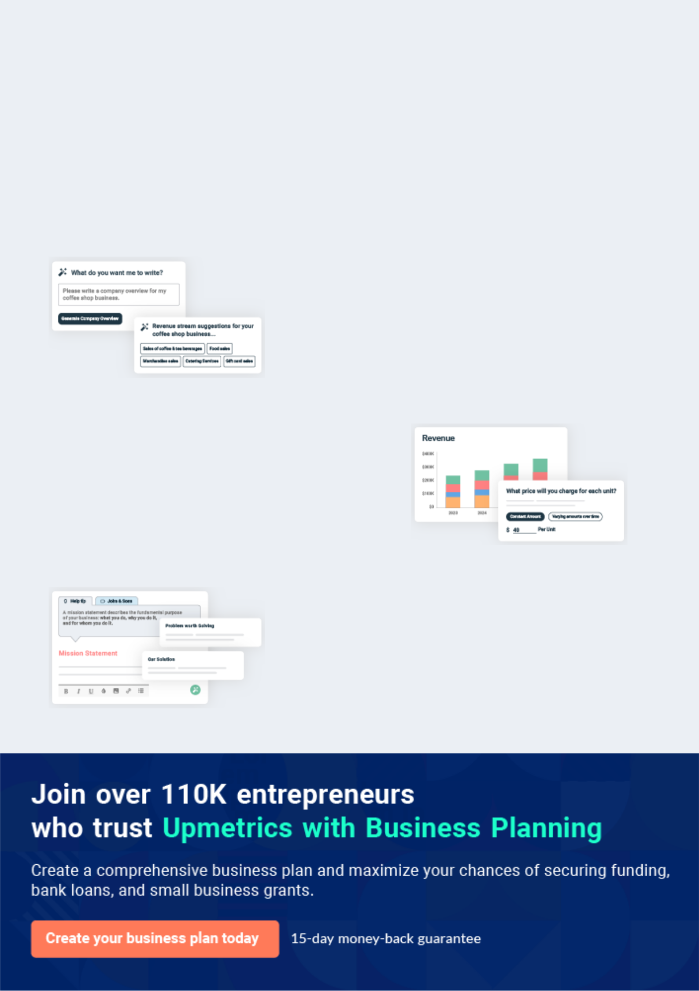
Business planning that’s simpler and faster than you think

Creating a business plan using Upmetrics to start and grow a business is literally the easiest thing in the World. Simply read the instructions and fill in the blanks. It’s as simple as that.

❛ | Upmetrics has everything you need to create a | ❜
❛ | comprehensive business plan. | ❜

AI-powered Upmetrics Assistant

AI-powered insights to streamline your plan

Not sure where to start? Upmetrics’ AI Assistant will automatically generate ideas for each section of your plan and offer improved versions of your writing, adjusting for tone, voice, and grammar or spelling errors.

Financial Forecasting Tool

All the financials are calculated for you

Forget the complex formulas and clumsy spreadsheets — with automatic financials and drag-and-drop forecasting, you can finish your plan faster and be confident that your numbers are accurate.

Business Plan Builder

Guides you like a business mentor

Upmetrics’ step-by-step instructions, prompts, and the library of 400+ sample business plans will guide you through each section of your plan as a business mentor.

1.


Executive Summary

Introduction

Mission Statement

Vision Statement

Objectives

Financial Highlights

Highlights

Taxi Company | Business Plan [YEAR] 5/38

Before you think about how to start a Taxi business, you must create a detailed Taxi business plan. It will not only guide you in the initial phases of your startup but will also help you later on.
To unlock help try Upmetrics!



Introduction

 Metro Cabs


Metro Cabs specializes in providing customers with chauffeuring/taxi services within 50 miles of its office location. The Company is registered as a corporation and located in the State of New York. The Company charges its customers on a per-mile basis, or for longer trips on a flat
To unlock help try Upmetrics! 

Start writing here..

Mission Statement

 Metro Cabs

Our mission as a cab services company is to develop a highly successful, profitable business which provides quality automobile transportation services in our city and to become a standard for an ideal taxi services business not only in the State of New York but also throughout the
To unlock help try Upmetrics! 

Start writing here..

Vision Statement

 Metro Cabs

Our vision is to become the number one taxi cab services company in the whole of New York with an active presence in key cities all around the State of New York.
To unlock help try Upmetrics! 

Start writing here..

Taxi Company | Business Plan [YEAR] 6/38

Objectives

 Metro Cabs

The company's goal in the next year is to pursue an aggressive marketing campaign and from that, penetrate at least 65% of the market share. The company's goal in the next two to five years is to be the top-rated ground transportation company in the New York Metro Area by
To unlock help try Upmetrics! 

Start writing here..

Financial Highlights

 Metro Cabs

The company is seeking $2.5 million of financing to fund the acquisition of the Mighty Cab Association and its initial operations. This funding will cover the purchase of Mighty Cab,
marketing, purchase of extra vehicles, software, and hardware. Projected revenues for 2020 to
To unlock help try Upmetrics! 

Start writing here..

3 Year profit forecast
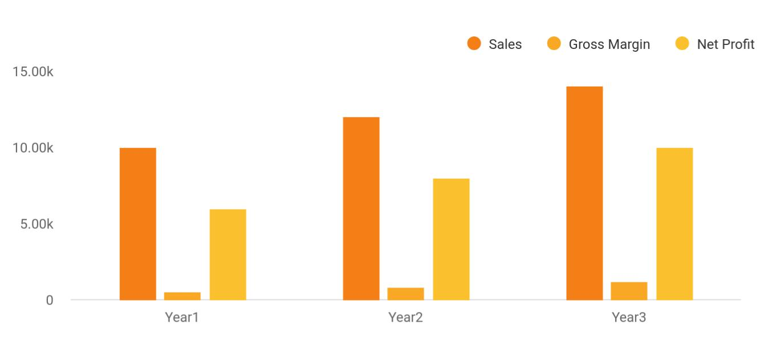

Financial Year | Sales | Gross Margin | Net Profit
Year1 | 10,000 | 500 | 6,000
Year2 | 12,000 | 800 | 8,000

Taxi Company | Business Plan [YEAR] 7/38

Financial Year Sales Gross Margin Net Profit

Year3 14,000 1,200 10,000

Highlights

 Metro Cabs

Highlights of Metro Cabs

Technology. Metro Cabs has a unique Global Positioning System (GPS) that pinpoints the
To unlock help try Upmetrics! 

Start writing here..

Taxi Company | Business Plan [YEAR] 8/38

2.

Business Summary

Company Strategy

Startup - Summary

Risks

Value Proposition

Taxi Company | Business Plan [YEAR] 9/38

 Metro Cabs

Metro Cabs is a standard, licensed and registered Taxi cab Services Company that will be based in New York – United States of America and we will have an active presence in other
cities such as Green acres City, Miami, Jacksonville, Clearwater, Tampa, Fort Lauderdale, North
To unlock help try Upmetrics! 

Start writing here..

Company Strategy

 Metro Cabs

Metro Cabs' strategy is to saturate the market with television ads depicting the company as a premier taxi service. The company will leverage the newest in-car technology to dominate the credit card segment of the market. Metro Cabs will dominate the market because no other
To unlock help try Upmetrics! 

Start writing here..

Startup - Summary

 Metro Cabs

As can be seen in the chart and table below, the company performed well in its first year, but sales have not been fully actualized. That is the intent of this plan: to increase sales by utilizing our competitive advantages and by the acquisition of a rival taxi company.
To unlock help try Upmetrics! 

Start writing here..

Taxi Company | Business Plan [YEAR] 10/38

Past Performance
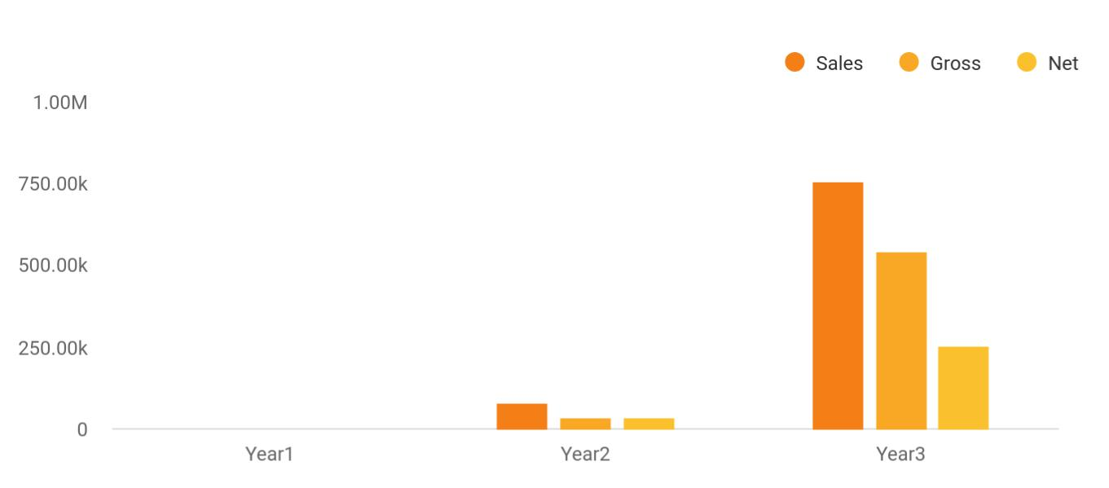

Financial Year | Sales | Gross | Net
Year1 | 0 | 0 | 0
Year2 | 78,451 | 35,452 | 35,468
Year3 | 754,121 | 542,151 | 254,785

PAST PERFORMANCE | 2017 | 2018 | 2019
Sales | $0 | $0 | $100,000
Gross Margin | $0 | $0 | $60,000
Gross Margin % | 0.00% | 0.00% | 60.00%
Operating Expenses | $0 | $0 | $20,000
BALANCE SHEET
Current Assets
Cash | $0 | $0 | $45,000
Other Current Assets | $0 | $0 | $13,400
TOTAL CURRENT ASSETS | $0 | $0 | $58,400
Long-term Assets
Long-term Assets | $0 | $0 | $75,000
Accumulated Depreciation | $0 | $0 | $10,000
TOTAL LONG-TERM ASSETS | $0 | $0 | $65,000

Taxi Company | Business Plan [YEAR] 11/38

PAST PERFORMANCE | 2017 | 2018 | 2019
Total Assets | $0 | $0 | $123,400
Current Liabilities
Accounts Payable | $0 | $0 | $23,600
Current Borrowing | $0 | $0 | $10,000
Other Current Liabilities (interest free) | $0 | $0 | $25,400
TOTAL CURRENT LIABILITIES | $0 | $0 | $59,000
Long-term Liabilities | $0 | $0 | $25,000
TOTAL LIABILITIES | $0 | $0 | $84,000
Paid-in Capital | $0 | $0 | $37,000
Retained Earnings | $0 | $0 | $2,400
Earnings | $0 | $0 | $0
TOTAL CAPITAL | $0 | $0 | $39,400
Total Capital and Liabilities | $0 | $0 | $123,400
Other Inputs
Payment Days | 0 | 0 | 30

Risks

 Metro Cabs

The company recognizes that it is subject to both market and technological risks. The company's view of its risks, as well as how each is being addressed, is as follows:
To unlock help try Upmetrics! 

Start writing here..

Taxi Company | Business Plan [YEAR] 12/38

Value Proposition

 Metro Cabs

Metro Cabs' products and services offer the following advantages to customers:

Convenience. Metro Cabs' products and services provide the driver and the customer with the
To unlock help try Upmetrics! 

Start writing here..

Taxi Company | Business Plan [YEAR] 13/38

3.

Products and Services

Service Description

Technology

Future Services

Taxi Company | Business Plan [YEAR] 14/38

Before starting a Taxi company, you must take many things into consideration such as you must consider what types of taxi services will you be providing to your passengers. Deciding your services is extremely
To unlock help try Upmetrics! 

 Metro Cabs

Metro Cabs provides taxi services utilizing computer dispatch to help with timely pickup and quality customer care. The software and hardware systems used by Metro Cabs give customers convenience by allowing them to use credit and debit cards in the taxi.
To unlock help try Upmetrics! 

Start writing here..

Service Description

 Metro Cabs

The taxi driver is often the first contact that a visitor has with New York and as such, Metro Cabs realizes the importance of first impressions and customer care. The company's customer-oriented philosophy and its commitment to service are reflected in the careful selection of
To unlock help try Upmetrics! 

Taxi Cab Services

Start writing here..

 Metro Cabs

This division of Metro Cabs deals with the pure maintenance of vehicles. Drivers will be charged at discounted rates for tune-ups, wheel alignments, and other repairs.
To unlock help try Upmetrics! 

Maintenance/Repair Services

Start writing here..

Taxi Company | Business Plan [YEAR] 15/38

Technology
To unlock help try Upmetrics!

 Metro Cabs

Global Positioning System. Metro Cabs has a unique Global Positioning System (GPS) that pinpoints the nearing driver thus allowing the driver to give an accurate estimated time of arrival.



Start writing here..

Future Services

 Metro Cabs

Metro Cabs plans to respond to market needs by following up with taxi plus (wheelchair accessible taxi vans with credit card access inside) with the next 5 years. Metro Cabs believes it can capture this niche and again in overall market share. Additional plans for next-generation
To unlock help try Upmetrics! 

Start writing here..

Taxi Company | Business Plan [YEAR] 16/38

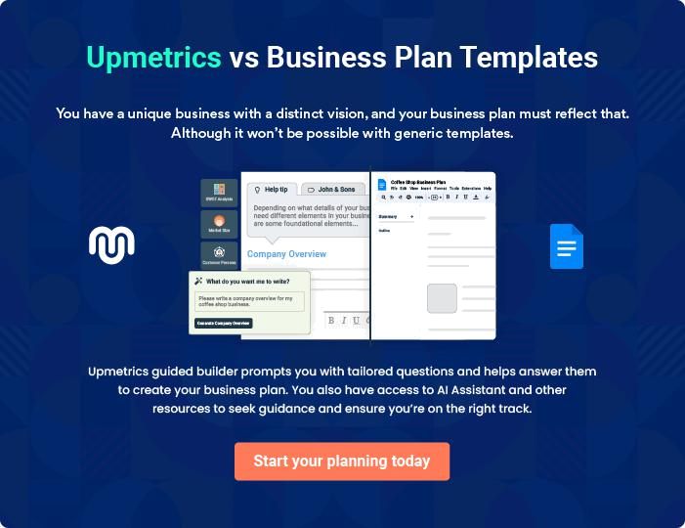

Taxi Company | Business Plan [YEAR] | 17/38

4.

Market Analysis

Market Segmentation

Service Business Analysis

Taxi Company | Business Plan [YEAR] 18/38

The most important component of an effective Taxi business plan is its accurate market analysis. If you are starting on a smaller scale, you can do the market analysis yourself by taking help from this Taxi business plan
To unlock help try Upmetrics! 

 Metro Cabs

The company's emphasis is on the dispatch, mobile data, and credit/debit card markets of the taxi industry. In aggregate, these markets are believed to represent potential sales in excess of $119 million as of March 2020. Within these markets, Metro Cabs will focus on the more
To unlock help try Upmetrics! 

Start writing here..

Market Segmentation

 Metro Cabs

Metro Cabs' focus will be on the credit card market with target customers in the low to mid-income range in the Metropolitan New York area. The target customers are motivated to use our services over that of competitors because of the convenience and quality associated with
To unlock help try Upmetrics! 

Customers and Target Markets

Start writing here..

 Metro Cabs

We believe our customers choose our cab service based on the following criteria:

Performance. We work with one goal in mind: to get customers where they want to go, when
To unlock help try Upmetrics! 

Customer Buying Criteria

Start writing here..

Taxi Company | Business Plan [YEAR] 19/38

Market Analysis
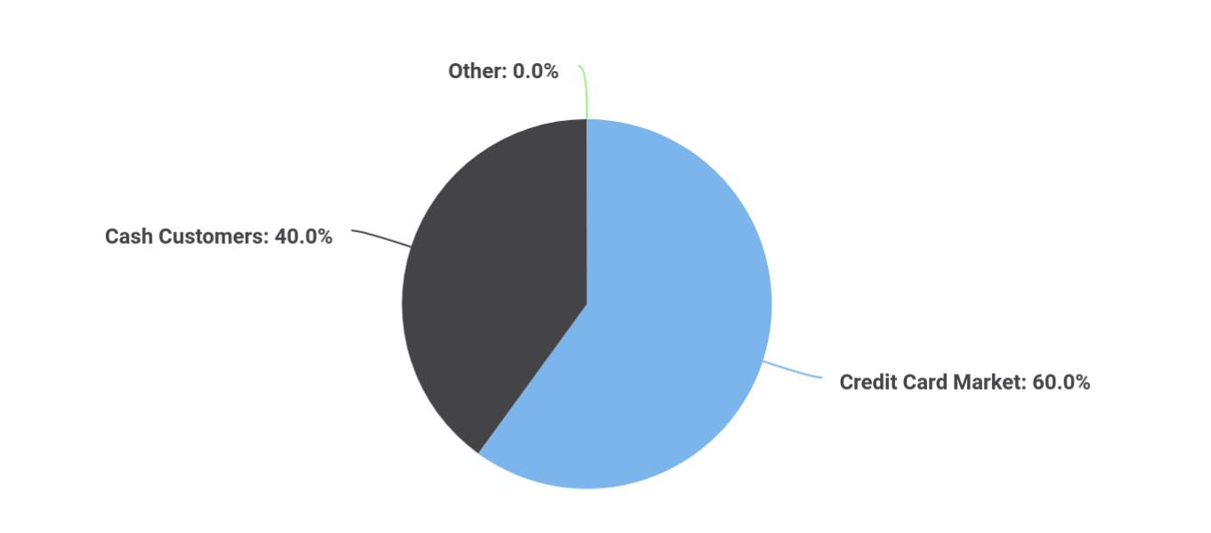

Financial Year | Units Sold
Credit Card Market | 60
Cash Customers | 40
Other | 0

Potential | Growth | Year 1 | Year 2 | Year 3 | Year 4 | Year 5 | CAGR
Customers
Credit Card Market | 25% | 200,000 | 250,000 | 312,500 | 390,625 | 488,281 | 25.00%
Cash Customers | 10% | 100,000 | 110,000 | 121,000 | 133,100 | 146,410 | 10.00%
Other | 0% | 0 | 0 | 0 | 0 | 0 | 0.00%
Total | 20.60% | 300,000 | 360,000 | 433,500 | 523,725 | 634,691 | 20.60%

Service Business Analysis

 Metro Cabs

Market 1-Taxi Cabs

This category covers establishments engaged primarily in furnishing passenger transportation
To unlock help try Upmetrics! 

Start writing here..

Taxi Company | Business Plan [YEAR] 20/38

 Metro Cabs

Competitive threats come from existing taxi cab companies in the New York area. Their weaknesses are, however, that they do not have the credit/debit card payment option, and
some still use the radio dispatch system. Transportation, Inc. has computer-aided dispatch but
To unlock help try Upmetrics! 

Competition and Buying Patterns

Start writing here..

Taxi Company | Business Plan [YEAR] 21/38

5.

Strategy

Sales Strategy

Marketing Strategy

Strategic Alliances

Taxi Company | Business Plan [YEAR] 22/38

After identifying the market demand, market trends, and the potential customers of the startup, the next step is to define an effective strategy for attracting those clients. Like marketing analysis, sales strategy is also an
To unlock help try Upmetrics! 

Sales Strategy

 Metro Cabs

At Metro Cabs, the sales process is the same for each of Metro Cabs' two areas: taxi cab services and maintenance and repair services. The company intends to establish its presence online by developing a website from which sales will be generated. The District of Columbia
To unlock help try Upmetrics! 

Start writing here..

Sales Yearly
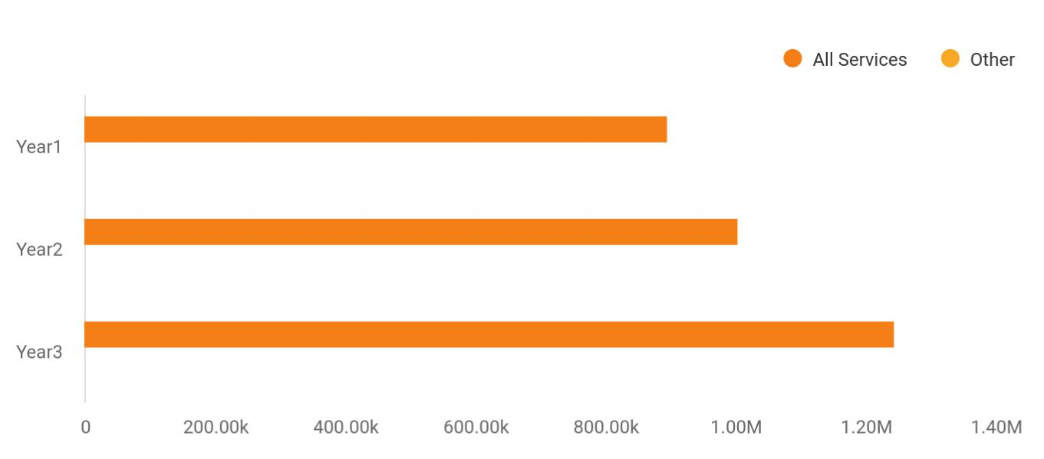

Financial Year | All Services | Other
Year1 | 895,665 | 0
Year2 | 1,004,512 | 0
Year3 | 1,245,587 | 0

Detailed Sales Forecast

Detailed sales forecast data is provided in below table:

Taxi Company | Business Plan [YEAR] 23/38

Sales | Year 1 | Year 2 | Year 3
All services | $200,000 | $1,500,000 | $2,200,000
Other | $0 | $0 | $0
TOTAL SALES | $200,000 | $1,500,000 | $2,200,000
Direct Cost of Sales
All services | $65,000 | $125,000 | $100,000
Other | $0 | $0 | $0
Subtotal Direct Cost of Sales | $65,000 | $125,000 | $100,000

Marketing Strategy

 Metro Cabs

Marketing Strategy

Metro Cabs markets its products and services as solutions to transportation needs in the city
To unlock help try Upmetrics! 

Start writing here..

 Metro Cabs

Metro Cabs plans to communicate through direct mail and television advertising to generate sales. TCI MEDIA Services and Val-Pak Direct Marketing will spearhead the marketing campaign. The key message associated with our products and services is cleaner, efficient,
To unlock help try Upmetrics! 

Marketing Programs

Start writing here..

Taxi Company | Business Plan [YEAR] 24/38

Strategic Alliances

 Metro Cabs

The company has strategic alliances with King Communications, Surfside Systems, and Commercial Electronic Services. These alliances are valuable to Metro Cabs because they
allow the company to get updates on technology and added tech support, and they are valuable
To unlock help try Upmetrics! 

Start writing here..

Taxi Company | Business Plan [YEAR] 25/38

6.

Management Plan

Organization

Officers and Key Employees

Taxi Company | Business Plan [YEAR] 26/38

The management plan is also an important component of a Taxi business plan since it gives you an estimate of the staff required for your startup as
To unlock help try Upmetrics!
well as the costs incurred on their salaries. So, make sure to duly consider it
To unlock help try Upmetrics! 

Organization

 Metro Cabs

The company's management philosophy is based on responsibility and mutual respect. Metro Cabs has an environment and structure that encourages productivity and respect for customers and fellow employees.



Start writing here..

Officers and Key Employees

Metro Cabs' management is highly experienced and qualified. Key members of Metro Cabs' management teams, their backgrounds, and responsibilities are as follows.

- Mr. Kennedy Williams, President, and CEO.

- Mr. Peter Jackson, Senior Vice President - Operations.

- Ms. Glenda Jones, Call Center Supervisor.

PERSONNEL PLAN | YEAR 1 | YEAR 2 | YEAR 3
Taxi Cabs & Administrative | $108,696 | $365,217 | $395,652
Maintenance & Repair | $108,695 | $156,522 | $169,565
Total People | 8 | 17 | 20
Total Payroll | $217,391 | $521,739 | $565,217

Taxi Company | Business Plan [YEAR] 27/38

7.

Financial Plan

Important Assumptions

Brake-even Analysis

Projected Profit and Loss

Projected Cash Flow

Projected Balance Sheet

Business Ratios

Taxi Company | Business Plan [YEAR] 28/38

The last component of a Taxi Business plan is an in-depth financial plan. The financial plan crafts a detailed map of all the expenses needed for the startup and how these expenses will be met by the earned profits. It is recommended
To unlock help try Upmetrics!
To unlock help try Upmetrics! 

 Metro Cabs

The company is seeking $2.5 million of financing to fund the acquisition of the Mighty Cab Association and its initial operations. This funding will cover the purchase of Mighty Cab, marketing, purchase of extra vehicles, software, and hardware.



Start writing here..

Important Assumptions

The financial projections of the company are forecast on the basis of the following assumptions. These assumptions are quite conservative and are expected to show deviation but to a limited level such that the company’s major financial strategy will not be affected.

 | Year 1 | Year 2 | Year 3
Plan Month | 1 | 2 | 3
Current Interest Rate | 10,00% | 11,00% | 12,00%
Long-term Interest Rate | 10,00% | 10,00% | 10,00%
Tax Rate | 26,42% | 27,76% | 28,12%
Other | 0 | 0 | 0

Brake-even Analysis

Monthly Units Break-even | 5530
Monthly Revenue Break-even | $159 740
Assumptions:
Average Per-Unit Revenue | $260,87
Average Per-Unit Variable Cost | $0,89
Estimated Monthly Fixed Cost | $196 410

Taxi Company | Business Plan [YEAR] 29/38

Projected Profit and Loss

 | 2024 | 2025 | 2026
Revenue | $404,742.25 | $797,500.25 | $1,232,739
City Taxi Service | $192,000 | $201,600 | $220,500
Unit Sales | 9,600 | 10,080 | 11,025
Unit Price | $20 | $20 | $20
Airport Transfers | $17,742.25 | $25,300.25 | $36,069
Unit Sales | 710 | 1,012 | 1,443
Unit Price | $25 | $25 | $25
Corporate Accounts | $195,000 | $570,600 | $976,170
Users | 60 | 125 | 195
Recurring Charges | $500 | $500 | $500

Cost Of Sales | $19,094.88 | $27,264.03 | $36,292.36
General Costs | $19,094.88 | $27,264.03 | $36,292.36
Vehicle Maintenance and | $9,000 | $9,234 | $9,474.36
Fuel Costs | $9,000 | $9,234 | $9,474.36
Vehicle Maintenance | $3,600 | $3,672 | $3,745.44
Fuel Costs | $5,400 | $5,562 | $5,728.92
Licensing and Insurance | $10,094.88 | $18,030.03 | $26,818
Vehicle Insurance | $2,000 | $2,080 | $2,163.20
Licensing Fees | $8,094.88 | $15,950.03 | $24,654.80
Revenue Specific Costs | $0 | $0 | $0
Personnel Costs (Direct | $0 | $0 | $0
Labor) | $0 | $0 | $0

Gross Margin | $385,647.37 | $770,236.22 | $1,196,446.64

Taxi Company | Business Plan [YEAR] 30/38

 | 2024 | 2025 | 2026
Gross Margin (%) | 95.28% | 96.58% | 97.06%

Operating Expense | $437,931 | $451,992.80 | $466,602.32
Payroll Expense (Indirect | $386,700 | $399,700.80 | $413,191.32
Labor) | $386,700 | $399,700.80 | $413,191.32
General Manager | $131,040 | $135,432 | $140,000.40
General Manager | $72,000 | $73,440 | $74,908.80
Operations Manager | $59,040 | $61,992 | $65,091.60
Drivers | $160,080 | $164,440.80 | $168,923.76
Full-Time Driver | $115,920 | $119,397.60 | $122,979.60
Part-Time Driver | $44,160 | $45,043.20 | $45,944.16
Support Staff | $95,580 | $99,828 | $104,267.16
Customer Service | $42,480 | $44,604 | $46,834.20
Representative | $42,480 | $44,604 | $46,834.20
Maintenance Technician | $53,100 | $55,224 | $57,432.96
General Expense | $51,231 | $52,292 | $53,411
Facility Costs | $30,015 | $30,660 | $31,335
Rent | $24,000 | $24,480 | $24,969.60
Utilities | $6,015 | $6,180 | $6,365.40
Operational Costs | $14,416 | $14,640 | $14,884.32
Dog Food and Supplies | $9,616 | $9,792 | $9,987.84
Cleaning Services | $4,800 | $4,848 | $4,896.48
Marketing and Advertising | $6,800 | $6,992 | $7,191.68
Online Advertising | $4,800 | $4,992 | $5,191.68
Promotional Events | $2,000 | $2,000 | $2,000
Bad Debt | $0 | $0 | $0

Taxi Company | Business Plan [YEAR] 31/38

Amortization of Current Assets

EBITDA

Additional Expense

Long Term Depreciation

Gain or loss from Sale of Assets

EBIT

Interest Expense

EBT

Income Tax Expense / Benefit

Total Expense

Net Income

Net Income (%)

Retained Earning Opening

Owner's Distribution

Retained Earning Closing

2024 | 2025 | 2026
$0 | $0 | $0

($52,283.63) $318,243.42 $729,844.31

$9,284.97 | $8,823.11 | $8,337.59
$6,990 | $6,990 | $6,990
$0 | $0 | $0
($59,273.63) | $311,253.42 | $722,854.31
$2,294.98 | $1,833.10 | $1,347.59
($61,568.60) | $309,420.31 | $721,506.72
$0 | $0 | $0

$466,310.85 | $488,079.94 | $511,232.28
($61,568.60) | $309,420.31 | $721,506.72
(15.21%) | 38.80% | 58.53%

$0 | ($71,368.60) | $233,251.71
$9,800 | $4,800 | $4,800
($71,368.60) | $233,251.71 | $949,958.43

Projected Cash Flow

 | 2024 | 2025 | 2026
Cash Received | $404,742.25 | $797,500.25 | $1,232,739

Taxi Company | Business Plan [YEAR] 32/38

 | 2024 | 2025 | 2026
Cash Paid | $459,320.85 | $481,089.94 | $504,242.28
COS & General Expenses | $70,325.88 | $79,556.03 | $89,703.37
Salary & Wages | $386,700 | $399,700.80 | $413,191.32
Interest | $2,294.98 | $1,833.10 | $1,347.59
Sales Tax | $0 | $0 | $0
Income Tax | $0 | $0 | $0
Net Cash From | ($54,578.60) | $316,410.31 | $728,496.72
Operations | ($54,578.60) | $316,410.31 | $728,496.72

Assets Sell | $0 | $0 | $0
Assets Purchase | $35,000 | $0 | $0
Net Cash From | ($35,000) | $0 | $0
Investments | ($35,000) | $0 | $0

Amount Received | $150,000 | $0 | $0
Loan Received | $50,000 | $0 | $0
Common Stock | $100,000 | $0 | $0
Preferred Stock | $0 | $0 | $0
Owner's Contribution | $0 | $0 | $0
Amount Paid | $18,827.75 | $14,289.61 | $14,775.13
Loan Capital | $9,027.74 | $9,489.62 | $9,975.13
Dividends & Distributions | $9,800 | $4,800 | $4,800
Net Cash From | $131,172.25 | ($14,289.61) | ($14,775.13)
Financing | $131,172.25 | ($14,289.61) | ($14,775.13)

Summary

Starting Cash | $0 | $41,593.65 | $343,714.35

Taxi Company | Business Plan [YEAR] 33/38

 | 2024 | 2025 | 2026
Cash In | $554,742.25 | $797,500.25 | $1,232,739
Cash Out | $513,148.60 | $495,379.55 | $519,017.41
Change in Cash | $41,593.65 | $302,120.70 | $713,721.59
Ending Cash | $41,593.65 | $343,714.35 | $1,057,435.94

Projected Balance Sheet

 | 2024 | 2025 | 2026
Assets | $69,603.65 | $364,734.35 | $1,071,465.94
Current Assets | $41,593.65 | $343,714.35 | $1,057,435.94
Cash | $41,593.65 | $343,714.35 | $1,057,435.94
Accounts Receivable | $0 | $0 | $0
Inventory | $0 | $0 | $0
Other Current Assets | $0 | $0 | $0
Long Term Assets | $28,010 | $21,020 | $14,030
Gross Long Term Assets | $35,000 | $35,000 | $35,000
Accumulated Depreciation | ($6,990) | ($13,980) | ($20,970)
Liabilities & Equity | $69,603.66 | $364,734.35 | $1,071,465.94
Liabilities | $40,972.26 | $31,482.64 | $21,507.51
Current Liabilities | $9,489.62 | $9,975.13 | $0
Accounts Payable | $0 | $0 | $0
Income Tax Payable | $0 | $0 | $0
Sales Tax Payable | $0 | $0 | $0
Short Term Debt | $9,489.62 | $9,975.13 | $0
Long Term Liabilities | $31,482.64 | $21,507.51 | $21,507.51

Taxi Company | Business Plan [YEAR] 34/38

 | 2024 |  |  | 2025 |  | 2026
Long Term Debt | $31,482.64 |  | $21,507.51 |  |  | $21,507.51
Equity | $28,631.40 |  | $333,251.71 |  |  | $1,049,958.43
Paid-in Capital | $0 |  |  | $0 |  | $0
Common Stock | $100,000 |  | $100,000 |  |  | $100,000
Preferred Stock | $0 |  |  | $0 |  | $0
Owner's Contribution | $0 |  |  | $0 |  | $0
Retained Earnings | ($71,368.60) |  | $233,251.71 |  |  | $949,958.43
Check | $0 |  |  | $0 |  | $0
Business Ratios
 |  | Year 1 | Year 2 |  | Year 3 | Industry Profile
Sales Growth |  | 4,35% | 30,82% |  | 63,29% | 4,00%
Percent of Total Assets
Accounts Receivable |  | 5,61% | 4,71% |  | 3,81% | 9,70%
Inventory |  | 1,85% | 1,82% |  | 1,79% | 9,80%
Other Current Assets |  | 1,75% | 2,02% |  | 2,29% | 27,40%
Total Current Assets |  | 138,53% | 150,99% |  | 163,45% | 54,60%
Long-term Assets |  | -9,47% | -21,01% |  | -32,55% | 58,40%
TOTAL ASSETS |  | 100,00% | 100,00% |  | 100,00% | 100,00%
Current Liabilities |  | 4,68% | 3,04% |  | 2,76% | 27,30%
Long-term Liabilities |  | 0,00% | 0,00% |  | 0,00% | 25,80%
Total Liabilities |  | 4,68% | 3,04% |  | 2,76% | 54,10%
NET WORTH |  | 99,32% | 101,04% |  | 102,76% | 44,90%
Percent of Sales
Sales |  | 100,00% | 100,00% |  | 100,00% | 100,00%

Taxi Company | Business Plan [YEAR] 35/38

 | Year 1 | Year 2 | Year 3 | Industry Profile
Gross Margin | 94,18% | 93,85% | 93,52% | 0,00%
Selling, General & Administrative Expenses | 74,29% | 71,83% | 69,37% | 65,20%
Advertising Expenses | 2,06% | 1,11% | 0,28% | 1,40%
Profit Before Interest and Taxes | 26,47% | 29,30% | 32,13% | 2,86%
Main Ratios
Current | 25,86 | 29,39 | 32,92 | 1,63
Quick | 25,4 | 28,88 | 32,36 | 0,84
Total Debt to Total Assets | 2,68% | 1,04% | 0,76% | 67,10%
Pre-tax Return on Net Worth | 66,83% | 71,26% | 75,69% | 4,40%
Pre-tax Return on Assets | 64,88% | 69,75% | 74,62% | 9,00%
Additional Ratios
Net Profit Margin | 19,20% | 21,16% | 23,12% | N.A.
Return on Equity | 47,79% | 50,53% | 53,27% | N.A.
Activity Ratios
Accounts Receivable Turnover | 4,56 | 4,56 | 4,56 | N.A.
Collection Days | 92 | 99 | 106 | N.A.
Inventory Turnover | 19,7 | 22,55 | 25,4 | N.A.
Accounts Payable Turnover | 14,17 | 14,67 | 15,17 | N.A.
Payment Days | 27 | 27 | 27 | N.A.
Total Asset Turnover | 1,84 | 1,55 | 1,26 | N.A.
Debt Ratios
Debt to Net Worth | 0 | -0,02 | -0,04 | N.A.
Current Liab. to Liab. | 1 | 1 | 1 | N.A.
Liquidity Ratios
Net Working Capital | $120 943 | $140 664 | $160 385 | N.A.
Interest Coverage | 0 | 0 | 0 | N.A.
Additional Ratios
Assets to Sales | 0,45 | 0,48 | 0,51 | N.A.

Taxi Company | Business Plan [YEAR] 36/38

 | Year 1 | Year 2 | Year 3 | Industry Profile
Current Debt/Total Assets | 4% | 3% | 2% | N.A.
Acid Test | 23,66 | 27,01 | 30,36 | N.A.
Sales/Net Worth | 1,68 | 1,29 | 0,9 | N.A.
Dividend Payout | 0 | 0 | 0 | N.A.
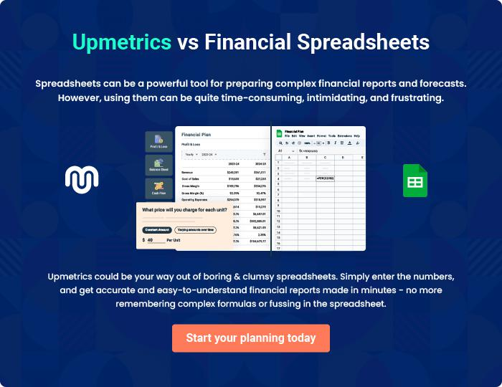

Taxi Company | Business Plan [YEAR] 37/38


Create a winning business plan that gets you funded

Creating a stunning and investment-ready plan requires no writing, graphic designing, or financial planning expertise.

Upmetrics has all the features required to help you create a comprehensive business plan—from start to finish. Make no mistakes, it’s the modern way of planning to structure ideas, make plans, and create stunning pitch decks to awe investors.

Pitch decks that impress investors

Create pitch decks that provide a visual representation of your business, engage investors, and make them want to invest in your business idea.

Interactive plans in no time

Import business plan sections like—SWOT analysis, comparison tables, and others to create an interactive business plan. No designing skills are required.

Stunning cover page designs

With Upmetrics, you have the liberty to choose from multiple stunning cover page designs. Choose a creative design and make your plan stand out.

Online sharing made simple

Upmetrics makes online sharing quick and easier for users. Easily share your business plans with a link while tracking reader activity.

500+ sample business plans

Simply import a template from our library of sample plans into the editor and start customizing it to make it yours. It takes only a few clicks to get started.

Collaborate with team in real-time

Invite team members, initiate conversations, discuss ideas & strategies, share feedback, and work on a business plan in real-time.

