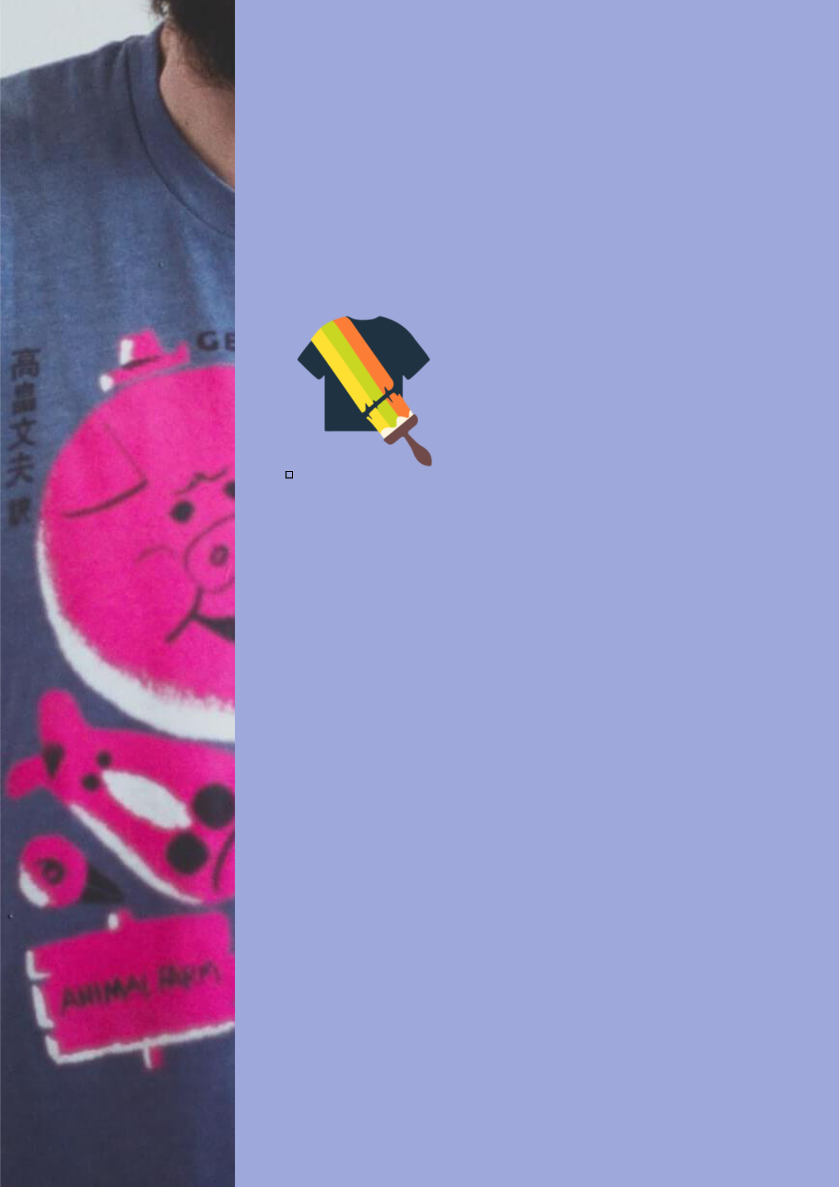
BUSINESS PLAN

[YEAR]

T-Shirt Printing

Creative arts on your t-shirt

John Doe

10200 Bolsa Ave, Westminster, CA, 92683

- 359-3153 info@example.com http://www.example.com

Information provided in this business plan is unique to this business and confidential; therefore, anyone reading this plan agrees not to disclose any of the information in this business plan without prior written permission of the company.
Table of Contents

Executive Summary | 5
Problem Definition & Validation | 6
Solution | 6
Objectives | 7
Short Term (1 -3 Years) | 7
Long Term (3-5 years) | 7
Mission Statement | 7
Keys to Success | 8
Financial Highlights | 8
3 Year profit forecast | 9

Business Overview | 10
Company Ownership/Legal Entity | 11
Location | 11
Interior Operating Facilities & Equipment | 12
Hours of Operation | 12
Start-up Summary | 12

Products and Services | 13
Suppliers | 14
Range of Products | 14
Market Analysis
Market Analysis | 16
Market Segmentation | 17
Women | 17
Men | 18
Businesses | 18
Market Analysis | 18
Business Target | 19
Product Pricing | 19
Competitive Advantage | 19

T-Shirt Printing | Business Plan [YEAR] 2/40

SWOT analysis | 20
Strategy & implementation
Strategy & implementation | 22
Distribution Strategy | 23
Marketing and Promotions Strategy | 23
Positioning Statement | 24
Pricing Strategy | 24
Sales Strategy | 24
Online Channels | 25
Offline Channels | 25
Operational Plan
Operational Plan | 26
Organization chart | 27
Management Team | 27
Personnel Plan | 28
Hiring plan | 28
Print Your Tee | 29
Financial Plan
Financial Plan | 30
Important Assumptions | 31
Brake-even Analysis | 31
Projected Profit and Loss | 32
Projected Cash Flow | 34
Projected Balance Sheet | 36
Business Ratios | 37

T-Shirt Printing | Business Plan [YEAR] 3/40

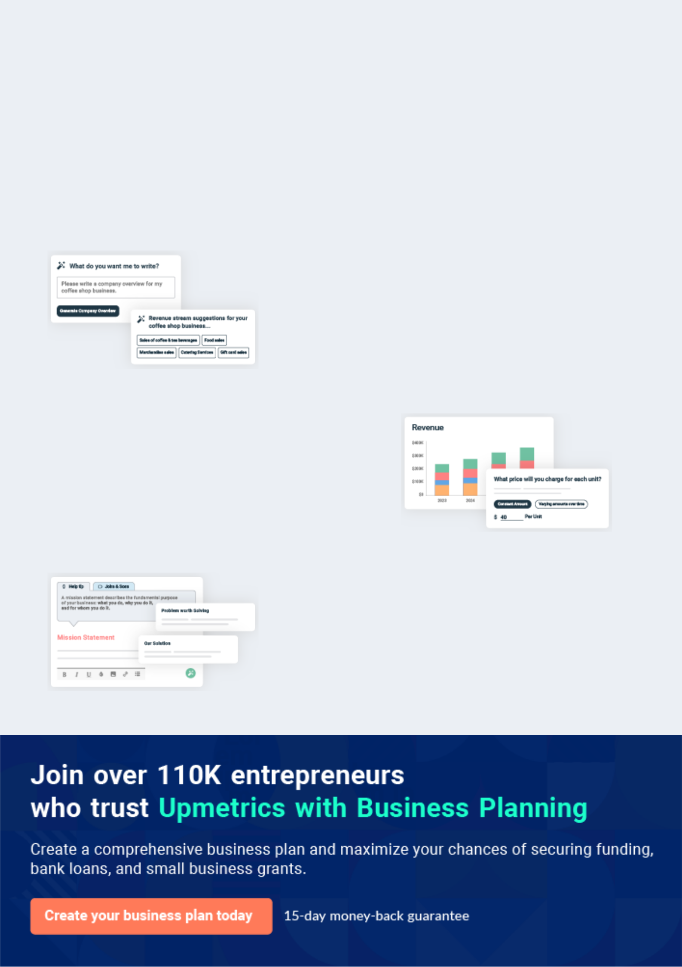
Business planning that’s simpler and faster than you think

Creating a business plan using Upmetrics to start and grow a business is literally the easiest thing in the World. Simply read the instructions and fill in the blanks. It’s as simple as that.

❛ | Upmetrics has everything you need to create a | ❜
❛ | comprehensive business plan. | ❜

AI-powered Upmetrics Assistant

AI-powered insights to streamline your plan

Not sure where to start? Upmetrics’ AI Assistant will automatically generate ideas for each section of your plan and offer improved versions of your writing, adjusting for tone, voice, and grammar or spelling errors.

Financial Forecasting Tool

All the financials are calculated for you

Forget the complex formulas and clumsy spreadsheets — with automatic financials and drag-and-drop forecasting, you can finish your plan faster and be confident that your numbers are accurate.

Business Plan Builder

Guides you like a business mentor

Upmetrics’ step-by-step instructions, prompts, and the library of 400+ sample business plans will guide you through each section of your plan as a business mentor.

1.


Executive Summary

Problem Definition & Validation

Solution

Objectives

Mission Statement

Keys to Success

Financial Highlights

T-Shirt Printing | Business Plan [YEAR] 5/40

Before you think about how to start a T-Shirt service, you must create a detailed Drop Shipping business plan. It will not only guide you in the initial phases of your startup but will also help you later on.
To unlock help try Upmetrics!

 PYT




Print Your Tee (PYT) offers customized t-shirt printing services that allow customers to personalize t-shirts with their print choices. Operating out of Jacksonville, Florida, the business will offer a plethora of t-shirt colors available in various sizes that can be personalized with a
To unlock help try Upmetrics! 

Start writing here..

Problem Definition & Validation

 PYT

A T-shirt is a single piece of clothing that is universal and has remained timeless. It will never go out of style, whether it is a graphic tee, a plain oversized throw or even a body-hugging jersey. The ubiquity of the t-shirt may be apparent, the prints and designs available in the
To unlock help try Upmetrics! 

Start writing here..

Solution

 PYT

Offer customized t-shirts where consumers are free to choose the size, color, and even the print they want on their t-shirt. Operating from an office base in the heart of Jacksonville, the company will cater to online and walk-in customers. Prospects can either choose from a range
To unlock help try Upmetrics! 

Start writing here..

T-Shirt Printing | Business Plan [YEAR] 6/40

Objectives

 PYT

- To set up an attractive, user-friendly website prior to the inception of the business in Florida
- To build marketing material targeting both B2B and B2C markets _{To unlock help try Upmetrics!} 

Short Term (1 -3 Years)

Start writing here..

 PYT

- To expand operations beyond Jacksonville to include nearby regions

- To begin the development of a mobile application allowing consumers to design their
own t-shirt | To unlock help try Upmetrics! 

Long Term (3-5 years)

Start writing here..

Mission Statement

 PYT

We aim to bring the excitement of shopping, the luxury of variety, the privilege of choice, and the advantage of cost, all at the convenience of one’s home. We envision becoming the first choice for t-shirt customization both for the corporate and consumer world.
To unlock help try Upmetrics! 

Start writing here..

T-Shirt Printing | Business Plan [YEAR] 7/40

Keys to Success

 PYT

- PYT will be a one-of-a-kind personalized t-shirt printing service in Florida

- The healthy combination of creativity and technical expertise brought in by the
company’s Founders will benefit the sustainability of the company_{To unlock help try Upmetrics!} 

Start writing here..

Financial Highlights

 PYT

The founder will invest a capital sum of $400,000 in launching and growing the business in Florida. The company expects sales to kickstart from its maiden year, albeit with a low net
profit margin. The company’s strategic investments in marketing and networking activities are
To unlock help try Upmetrics! 

Start writing here..

T-Shirt Printing | Business Plan [YEAR] 8/40

3 Year profit forecast
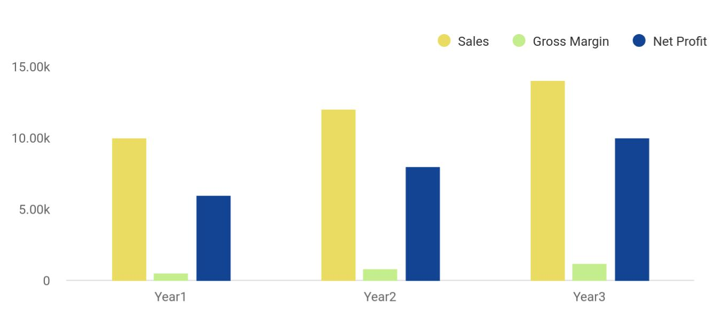

Financial Year | Sales | Gross Margin | Net Profit
Year1 | 10,000 | 500 | 6,000
Year2 | 12,000 | 800 | 8,000
Year3 | 14,000 | 1,200 | 10,000

T-Shirt Printing | Business Plan [YEAR] 9/40

2.

Business Overview

Company Ownership/Legal Entity

Location

Interior Operating Facilities & Equipment

Hours of Operation

Start-up Summary

T-Shirt Printing | Business Plan [YEAR] 10/40

 PYT

PYT is a t-shirt printing service company driven by a passion for innovation and aims to provide a cost-effective and easy way to personalize clothing. The company specializes in all types of t-shirt printing, from screen printing, digital printing to plot printing. On setting up the business in
To unlock help try Upmetrics! 

Start writing here..

Company Ownership/Legal Entity

 PYT

The company will be registered as a limited liability entity with the Department of State. Further, since the company envisions setting up operations in Florida, it will also register with the local county. The business will be wholly owned and Managed by Founder Mr X, who will also be the
To unlock help try Upmetrics! 

Start writing here..

Location

 PYT

Location is vital for PYT as it plans to cater to walk-in customers and service online prospects. The convenience of transportation, skilled workers and regional traffic will primary factors that will drive the Founder’s decision of an ideal location. Thanks to its pro-business state tax
To unlock help try Upmetrics! 

Start writing here..

T-Shirt Printing | Business Plan [YEAR] 11/40

Interior Operating Facilities & Equipment
To unlock help try Upmetrics!

 PYT

The company will begin operations from a rented showroom space at the heart of Jacksonville’s commercial hub. Initial investments in setting up the interior facilities, printing equipment, consumables and client entertainment space will be set up. Additions to space will
To unlock help try Upmetrics! 

Start writing here..

Hours of Operation

 PYT

PYT will cater to walk-in as well as online customers, as such it will be required to stay open during the business hours. The company envisions opening shop at 10 am and remain open till 7pm to entertain walk-in prospects as well as fulfil online orders.



Start writing here..

Start-up Summary

 PYT

The schedule below elucidates the company’s anticipated expenses on launch in Florida. Of the total capital investment of $400,000, the company will spend $81,500 on a range of pre-launch expenses. Accordingly, a sum of $3,000 will be paid for company set-up and incorporation
To unlock help try Upmetrics! 

Start writing here..

T-Shirt Printing | Business Plan [YEAR] 12/40

3.

Products and Services

Suppliers

T-Shirt Printing | Business Plan [YEAR] 13/40

If you are starting a Drop Shipping Business, you must focus on the services, you will provide to your customers. This sample business plan of Drop Shipping will guide you on how to start your own dog daycare business.
To unlock help try Upmetrics! 

 PYT

At PYT, the next favorite t-shirt is just a print away. More than just custom printed t-shirts, the company seeks to celebrate life’s favorite moments with its customers. Be it a child’s first
soccer game, a milestone birthday, or even a company’s fundraiser event, the company direct to
To unlock help try Upmetrics! 

Start writing here..

Suppliers

 PYT

While all the printing will be done in-house, the company will outsource its t-shirt manufacturing services. PYT will maintain a stock of high-quality t-shirts of all sizes and colors to enhance its service delivery capabilities. The company’s range of t-shirts will include:_{To unlock help try Upmetrics!} 

Start writing here..

Range of Products


Dress Shirts Fleece

Toddler and Infant Knits and Layered T-

Wear shirts

T-Shirt Printing | Business Plan [YEAR] 14/40



Polos Outerwear

Sweats Tank Tops
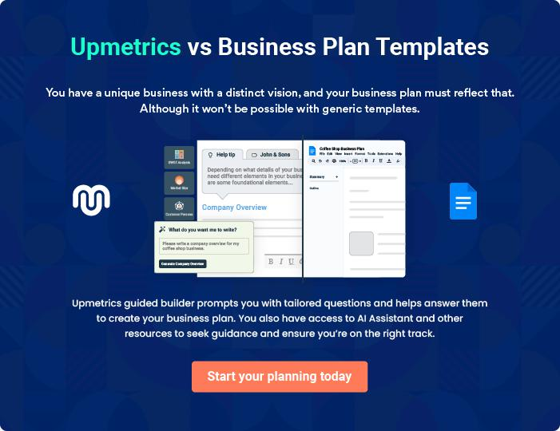

T-Shirt Printing | Business Plan [YEAR] 15/40

4.

Market Analysis

Market Segmentation

Market Analysis

Business Target

Product Pricing

Competitive Advantage

T-Shirt Printing | Business Plan [YEAR] 16/40

The most important component of an effective drop shipping business plan is its accurate marketing analysis. If you are starting this venture on small scale, you can take help from this drop shipping business plan template and
To unlock help try Upmetrics! 

 PYT

The global custom t-shirt printing industry was valued at $3.64 billion in 2020. The industry is expected to grow at a compounded annual growth rate of 9.7% over the next eight years from 2021 to 2028[1]. The growth in the industry can be attributed to the customized t-shirt being
To unlock help try Upmetrics! 

Start writing here..

Market Segmentation

 PYT


The global industry is segmented by type of print (screen, digital and plot printing), design and region.
To unlock help try Upmetrics! 

Start writing here..

 PYT

The biggest consumer of our services will be women in the United States. It has been established by various surveys and studies that women are more likely to make online
purchases than men. That’s why American women will be the biggest contributor to our
To unlock help try Upmetrics! 

Women

Start writing here..

T-Shirt Printing | Business Plan [YEAR] 17/40

 PYT

The second-biggest consumer of our products will be men. Although their contribution to our revenue will be less than women still it will be of significant value.
To unlock help try Upmetrics! 

Men

Start writing here..

 PYT

We also hope to target the corporate sector for buying the products from our first category, computers, and accessories.
To unlock help try Upmetrics! 

Businesses

Start writing here..

Market Analysis

The detailed market analysis of our potential customers is given in the following table:

Potential | Growth | Year 1 | Year 2 | Year 3 | Year 4 | Year 5 | CAGR
Customers
Women | 48% | 22,334 | 32,344 | 43,665 | 52,544 | 66,432 | 10.00%
Businesses | 18% | 11,433 | 13,344 | 16,553 | 18,745 | 20,545 | 13.43%
Men | 34% | 18,322 | 19,455 | 20,655 | 22,867 | 24,433 | 15.32%
Total | 100% | 52,089 | 65,143 | 80,873 | 94,156 | 111,410 | 9.54%

T-Shirt Printing | Business Plan [YEAR] 18/40

Business Target
Quick Turnaround
PYT will ensure delivery of the customized t-shirts within 24 hours of placing the order. In-house printing and on-hand t-shirt inventory will make this possible.
Range of T-Shirts
The company will make sure to keep a stock of all types of t-shirts and sizes made available in a range of colours
To unlock help try Upmetrics!

 PYT

• To achieve the net profit margin of $10k/month by the first year, $15k by the second year, and $25k by the third year
• To add 3 more categories of electronic appliances, sports products, and furniture by the
To unlock help try Upmetrics! 

Start writing here..

Product Pricing

 PYT

Considering the competition in the E-commerce industry, we have priced all our products in similar ranges as of our competitors. However, the delivery charges are kept slightly less as compared to our competitors.



Start writing here..

Competitive Advantage


Free Design Help

PYT’s expert graphic designers will help customers to bring their vision to life with graphic designs of their choice.

No Minimums

A range of printing capabilities will allow the company to cater to small orders of a single t-shirt as well as bulk order for the corporate sector

T-Shirt Printing | Business Plan [YEAR] 19/40

5.

SWOT analysis

T-Shirt Printing | Business Plan [YEAR] 20/40

 PYT

A SWOT (Strength, Weakness, Opportunity, and Threat) analysis is a useful tool for businesses to evaluate their position in the market against the potential internal and external factors that could assist or jeopardize their operations and existence. A SWOT has been conducted for PYT
To unlock help try Upmetrics! 

Start writing here..


Strength Weakness

- Unique personalized designs

- Scalable pricing strategy and business model

- Design is aligned to market preferences

- PYT’s founding team comprises members who have a combined experience of three decades across service innovation and strategic planning, digital banking service, and investment.


- Fragmented industry

- Highly competitive market

- Limited market understanding


Opportunity Threat

- Collaboration with marketing firms

- Increased technology adoption among consumers

- High growth potential market in the US Cloud-based capabilities

- Technology redundancy

- Low barriers to entry

- Competitors poaching corporate clients

T-Shirt Printing | Business Plan [YEAR] 21/40

6.

Strategy & implementation

Distribution Strategy

Marketing and Promotions Strategy

Positioning Statement

Pricing Strategy

Sales Strategy

T-Shirt Printing | Business Plan [YEAR] 22/40

Like marketing analysis, sales strategy is also an important component of a drop shipping business plan so it must be planned before you think about how to start a drop-shipping business.
To unlock help try Upmetrics!



 PYT

Building awareness of the company’s services will be PYT’s focus during the initial years of operations. As such, the company's marketing and promotional strategy will revolve around this goal. PYT targets corporates and individuals in Florida predominantly within the Jacksonville
To unlock help try Upmetrics! 

Start writing here..

Distribution Strategy

 PYT

The company will reach its customer through both online and offline channels. PYT’s comprehensive website will accept orders online and deliver them to the customer’s doorstep. Customers will also have an option to physically visit the company’s showroom to browse and
To unlock help try Upmetrics! 

Start writing here..

Marketing and Promotions Strategy

 PYT

- Launch an engaging and attractive website that is a source of promotional materials

- Create a healthy feedback loop to gauge shifting trends and align services to meet
demand | To unlock help try Upmetrics! 

Start writing here..

T-Shirt Printing | Business Plan [YEAR] 23/40

Positioning Statement
To unlock help try Upmetrics!

 PYT

PYT offers high-quality custom printed t-shirts designed to hold sentimental value for its B2C consumers and promote a brand for its B2B market. Offering personalized services with no minimums will allow the company to differentiate from commercially available casual wear.
To unlock help try Upmetrics! 

Start writing here..

Pricing Strategy

 PYT

T-shirts will be priced at market competitive prices. On average, a custom printed t-shirt will be priced at $20 per shirt for the B2C market. For corporates, the company will reduce the price of the t-shirt to an average of $7.5 for a quantity of 50 pieces.



Start writing here..

Sales Strategy

 PYT

Professional service providers form the company’s primary target market. However, the company’s marketing efforts will also include end-users, clients of the professional service providers. While push marketing efforts will be deployed to reach service providers, pull
To unlock help try Upmetrics! 

Start writing here..

T-Shirt Printing | Business Plan [YEAR] 24/40

Online Channels



Electronic Direct Mail | Social Media
Marketing | Millennials and
Corporate looking to | consumers in general
grow their brand image | spend a considerable
and create awareness | time browsing social
stand out prominently | media platforms.
as viable marketing | Reaching to them
targets for this channel. | through this channel
PYT will mail | will be and effective
professionally designed | way to capture
materials with its value | attention and position
proposition to these | its services.
companies and provide
quotes for promotion
merchandise printing
services.

Offline Channels


Networking | Pop-Up Store | Walk-in
Participate in leading | The company will also hold | The showroom will be
consumers exhibitions and | pop-up stalls at consumer | designed with attractive
corporate events. Display a | exhibitions. Digital printing | display of sample t-shirts.
range of samples, print types, t- | machines that are portable will | Visually attractive hoardings
shirts and distribute flyers at | be carried for on-the-spot | and a high street presence will
these events. The company will | printing services. | further attract prospects to
also keep a record of visitors to |  | walk-in and buy one of their
their stalls as leads for its |  | ready designs or place an order
email marketing campaigns. |  | for custom prints.

T-Shirt Printing | Business Plan [YEAR] 25/40

7.

Operational Plan

Management Team

Personnel Plan

T-Shirt Printing | Business Plan [YEAR] 26/40

 PYT

The team will be headed by Managing Director Mr. Xavier who will also oversee production operations. Joining Mr. Xavier in the Management Team, the company will onboard a creative director to oversee all creative aspects of the business as well as Sales and Marketing matters.
To unlock help try Upmetrics! 

Start writing here..

Organization chart


John Doe

CEO


Jane Doe


Customer Engagement Manager Amanda Doe

Marketing Specialist

Management Team

 PYT

PYT will be spearheaded by Mr. Xavier at its helm. Counting 10+ years on entrepreneurial experience, Mr. Xavier holds a master’s degree in investment banking and finance and is richly experienced in the fields of copywriting, lobby management, clothes-design planning, and
To unlock help try Upmetrics! 

Start writing here..

T-Shirt Printing | Business Plan [YEAR] 27/40

Personnel Plan
To unlock help try Upmetrics!

 PYT

The company plans to create six full-time equivalent jobs in addition to the management team within the first three years of operations. Salaries for each employee are in line with the industry’s benchmark.



Start writing here..

Hiring plan

20 |  |  |  | 5 |  |  |  |  | 25
Filled |  |  |  | Hired |  |  |  |  | Open
Group By | Position Filled |  |  |  |  | Time of Hire |  |  | Time of Start |  | Filled On Time
Department |  |  |  |  |  |  |  |  |  |  | Filled On Time
Customer |  | 1 of 20 |  |  |  | 10 days |  |  | 121 days |  | 100%
Engagement |  |  |  |  |  |  |  |  |  |  | 100%
Customer Service |  | 3 of 23 |  |  |  | 30 days |  |  | 21 days |  | 80%
Reps |  |  |  |  |  |  |  |  |  |  | 80%
Marketing |  | 4 of 15 |  |  |  | 158 days |  |  | 127 days |  | 0%
Specialists |  |  |  |  |  |  |  |  |  |  | 0%

T-Shirt Printing | Business Plan [YEAR] 28/40

Print Your Tee


Year 2

>Year 3

Establishment

PYT will rent a showroom space at the

heart of Jacksonville Florida’s commercial

hub alongside developing a fully optimized

and informative website. During this period,
the company will also acquire printing ^{Year 1} machinery and build an inventory of t-shirts and printed samples. Marketing activities

will also begin during this stage to build

awareness and launch the brand into the

market.



Expand

The company will begin expanding its

services beyond Jacksonville to cover other

regions around Florida


Diversify

Having externally established the business,
the company will begin internally advancing ^{Year 3} the modules and adding additional print materials and t-shirt options


Grow

- Begin developing mobile application

- Consider market expansion beyond Florida


T-Shirt Printing | Business Plan [YEAR] 29/40

8.

Financial Plan

Important Assumptions

Brake-even Analysis

Projected Profit and Loss

Projected Cash Flow

Projected Balance Sheet

Business Ratios

T-Shirt Printing | Business Plan [YEAR] 30/40

If you are going to start your own t-shirt printing business, then make sure you will pay special attention to your financial plan. Your financial plan should include the details about how well you manage your incomes and expenses,
To unlock help try Upmetrics! 

Important Assumptions

The company’s financial projections are forecasted on the basis of the following assumptions. These assumptions are quite conservative and are also expected to show deviation but to a limited level such that the company’s major financial strategy will not be affected.

 | Year 1 | Year 2 | Year 3
Plan Month | 1 | 2 | 3
Current Interest Rate | 10,00% | 11,00% | 12,00%
Long-term Interest Rate | 10,00% | 10,00% | 10,00%
Tax Rate | 26,42% | 27,76% | 28,12%
Other | 0 | 0 | 0

Brake-even Analysis

Monthly Units Break-even | 5530
Monthly Revenue Break-even | $159 740
Assumptions:
Average Per-Unit Revenue | $260,87
Average Per-Unit Variable Cost | $0,89
Estimated Monthly Fixed Cost | $196 410

T-Shirt Printing | Business Plan [YEAR] 31/40

Projected Profit and Loss

 | 2024 | 2025 | 2026
Revenue | $461,047.45 | $645,501.95 | $949,534.80
Online T-shirt Sales | $159,171.40 | $285,849.20 | $513,343.20
Unit Sales | 7,959 | 14,292 | 25,667
Unit Price | $20 | $20 | $20
Customized T-shirt Orders | $95,795.55 | $136,584 | $194,734.35
Unit Sales | 2,129 | 3,035 | 4,327
Unit Price | $45 | $45 | $45
Bulk Sales to Retailers | $206,080.50 | $223,068.75 | $241,457.25
Unit Sales | 8,243 | 8,923 | 9,658
Unit Price | $25 | $25 | $25
Cost Of Sales | $29,221.31 | $40,581.12 | $59,178.31
General Costs | $29,221.31 | $40,581.12 | $59,178.31
Production Costs | $28,333.44 | $39,580.63 | $58,050.99
T-shirt Material Cost | $670.58 | $850.51 | $1,078.88
Printing Cost | $27,662.86 | $38,730.12 | $56,972.11
Shipping and Handling | $887.87 | $1,000.49 | $1,127.32
Domestic Shipping Cost | $253.62 | $285.78 | $321.97
Domestic Shipping Cost | $634.25 | $714.71 | $805.35
Revenue Specific Costs | $0 | $0 | $0
Personnel Costs (Direct | $0 | $0 | $0
Labor) | $0 | $0 | $0
Gross Margin | $431,826.14 | $604,920.83 | $890,356.49

T-Shirt Printing | Business Plan [YEAR] 32/40

 | 2024 | 2025 | 2026
Gross Margin (%) | 93.66% | 93.71% | 93.77%

Operating Expense | $475,284.66 | $487,946.71 | $502,586.61
Payroll Expense (Indirect | $449,280 | $460,512 | $472,036.32
Labor) | $449,280 | $460,512 | $472,036.32
Sales Team | $115,200 | $118,022.40 | $120,916.92
Sales Manager | $51,840 | $53,395.20 | $54,997.08
Sales Representatives | $63,360 | $64,627.20 | $65,919.84
Production Team | $207,360 | $211,968 | $216,682.20
Production Manager | $46,080 | $47,462.40 | $48,886.32
Production Workers | $161,280 | $164,505.60 | $167,795.88
Administrative Staff | $126,720 | $130,521.60 | $134,437.20
Office Manager | $40,320 | $41,529.60 | $42,775.44
Administrative Assistants | $86,400 | $88,992 | $91,661.76
General Expense | $26,004.66 | $27,434.71 | $30,550.29
Marketing and Advertising | $9,600 | $9,941.63 | $11,165.65
Online Advertising | $6,000 | $6,231.10 | $7,004.58
Print Media Advertising | $3,600 | $3,710.53 | $4,161.07
Operational Costs | $12,136.46 | $13,004.11 | $14,653.27
Office Rent | $9,600 | $10,145.95 | $11,432.68
Utilities | $2,536.46 | $2,858.16 | $3,220.59
Miscellaneous | $4,268.20 | $4,488.97 | $4,731.37
Website Maintenance | $1,268.20 | $1,428.97 | $1,610.17
Business Insurance | $3,000 | $3,060 | $3,121.20
Bad Debt | $0 | $0 | $0

T-Shirt Printing | Business Plan [YEAR] 33/40

Amortization of Current Assets

EBITDA

Additional Expense

Long Term Depreciation

Gain or loss from Sale of Assets

EBIT

Interest Expense

EBT

Income Tax Expense / Benefit

Total Expense

Net Income

Net Income (%)

Retained Earning Opening

Owner's Distribution

Retained Earning Closing

2024 | 2025 | 2026
$0 | $0 | $0

($43,458.52) $116,974.12 $387,769.88

$6,851.48 | $5,884.38 | $4,857.63
$4,278 | $4,278 | $4,278
$0 | $0 | $0
($47,736.52) | $112,696.12 | $383,491.88
$2,573.47 | $1,606.38 | $579.64
($50,310) | $111,089.74 | $382,912.25
$0 | $0 | $0

$511,357.45 | $534,412.21 | $566,622.55
($50,310) | $111,089.74 | $382,912.25
(10.91%) | 17.21% | 40.33%

$0 | ($68,310) | $24,779.74
$18,000 | $18,000 | $18,000
($68,310) | $24,779.74 | $389,691.99

Projected Cash Flow

 | 2024 | 2025 | 2026
Cash Received | $461,047.45 | $645,501.95 | $949,534.80

T-Shirt Printing | Business Plan [YEAR] 34/40

 | 2024 | 2025 | 2026
Cash Paid | $507,079.45 | $530,134.21 | $562,344.55
COS & General Expenses | $55,225.97 | $68,015.83 | $89,728.60
Salary & Wages | $449,280 | $460,512 | $472,036.32
Interest | $2,573.47 | $1,606.38 | $579.64
Sales Tax | $0 | $0 | $0
Income Tax | $0 | $0 | $0
Net Cash From | ($46,032) | $115,367.74 | $387,190.25
Operations | ($46,032) | $115,367.74 | $387,190.25

Assets Sell | $0 | $0 | $0
Assets Purchase | $25,000 | $0 | $0
Net Cash From | ($25,000) | $0 | $0
Investments | ($25,000) | $0 | $0

Amount Received | $150,000 | $0 | $0
Loan Received | $50,000 | $0 | $0
Common Stock | $0 | $0 | $0
Preferred Stock | $0 | $0 | $0
Owner's Contribution | $100,000 | $0 | $0
Amount Paid | $33,679.72 | $34,646.82 | $35,673.45
Loan Capital | $15,679.73 | $16,646.82 | $17,673.44
Dividends & Distributions | $18,000 | $18,000 | $18,000
Net Cash From | $116,320.28 | ($34,646.82) | ($35,673.45)
Financing | $116,320.28 | ($34,646.82) | ($35,673.45)

Summary

Starting Cash | $0 | $45,288.28 | $126,009.20

T-Shirt Printing | Business Plan [YEAR] 35/40

 | 2024 | 2025 | 2026
Cash In | $611,047.45 | $645,501.95 | $949,534.80
Cash Out | $565,759.17 | $564,781.03 | $598,018
Change in Cash | $45,288.28 | $80,720.92 | $351,516.80
Ending Cash | $45,288.28 | $126,009.20 | $477,526

Projected Balance Sheet

 | 2024 | 2025 | 2026
Assets | $66,010.28 | $142,453.20 | $489,692
Current Assets | $45,288.28 | $126,009.20 | $477,526
Cash | $45,288.28 | $126,009.20 | $477,526
Accounts Receivable | $0 | $0 | $0
Inventory | $0 | $0 | $0
Other Current Assets | $0 | $0 | $0
Long Term Assets | $20,722 | $16,444 | $12,166
Gross Long Term Assets | $25,000 | $25,000 | $25,000
Accumulated Depreciation | ($4,278) | ($8,556) | ($12,834)
Liabilities & Equity | $66,010.26 | $142,453.18 | $489,691.99
Liabilities | $34,320.26 | $17,673.44 | $0
Current Liabilities | $16,646.82 | $17,673.44 | $0
Accounts Payable | $0 | $0 | $0
Income Tax Payable | $0 | $0 | $0
Sales Tax Payable | $0 | $0 | $0
Short Term Debt | $16,646.82 | $17,673.44 | $0
Long Term Liabilities | $17,673.44 | $0 | $0

T-Shirt Printing | Business Plan [YEAR] 36/40

 | 2024 |  |  | 2025 | 2026
Long Term Debt | $17,673.44 |  |  | $0 | $0
Equity | $31,690 |  | $124,779.74 |  | $489,691.99
Paid-in Capital | $0 |  |  | $0 | $0
Common Stock | $0 |  |  | $0 | $0
Preferred Stock | $0 |  |  | $0 | $0
Owner's Contribution | $100,000 |  | $100,000 |  | $100,000
Retained Earnings | ($68,310) |  | $24,779.74 |  | $389,691.99
Check | $0 |  |  | $0 | $0
Business Ratios
 |  | Year 1 | Year 2 | Year 3 | Industry profile
Sales Growth |  | 4,35% | 30,82% | 63,29% | 4,00%
Percent of Total Assets
Accounts Receivable |  | 5,61% | 4,71% | 3,81% | 9,70%
Inventory |  | 1,85% | 1,82% | 1,79% | 9,80%
Other Current Assets |  | 1,75% | 2,02% | 2,29% | 27,40%
Total Current Assets |  | 138,53% | 150,99% | 163,45% | 54,60%
Long-term Assets |  | -9,47% | -21,01% | -32,55% | 58,40%
TOTAL ASSETS |  | 100,00% | 100,00% | 100,00% | 100,00%
Current Liabilities |  | 4,68% | 3,04% | 2,76% | 27,30%
Long-term Liabilities |  | 0,00% | 0,00% | 0,00% | 25,80%
Total Liabilities |  | 4,68% | 3,04% | 2,76% | 54,10%
NET WORTH |  | 99,32% | 101,04% | 102,76% | 44,90%
Percent of Sales
Sales |  | 100,00% | 100,00% | 100,00% | 100,00%

T-Shirt Printing | Business Plan [YEAR] 37/40

 | Year 1 | Year 2 | Year 3 | Industry profile
Gross Margin | 94,18% | 93,85% | 93,52% | 0,00%
Selling, General & Administrative Expenses | 74,29% | 71,83% | 69,37% | 65,20%
Advertising Expenses | 2,06% | 1,11% | 0,28% | 1,40%
Profit Before Interest and Taxes | 26,47% | 29,30% | 32,13% | 2,86%
Main Ratios
Current | 25,86 | 29,39 | 32,92 | 1,63
Quick | 25,4 | 28,88 | 32,36 | 0,84
Total Debt to Total Assets | 2,68% | 1,04% | 0,76% | 67,10%
Pre-tax Return on Net Worth | 66,83% | 71,26% | 75,69% | 4,40%
Pre-tax Return on Assets | 64,88% | 69,75% | 74,62% | 9,00%
Additional Ratios
Net Profit Margin | 19,20% | 21,16% | 23,12% | N.A.
Return on Equity | 47,79% | 50,53% | 53,27% | N.A.
Activity Ratios
Accounts Receivable Turnover | 4,56 | 4,56 | 4,56 | N.A.
Collection Days | 92 | 99 | 106 | N.A.
Inventory Turnover | 19,7 | 22,55 | 25,4 | N.A.
Accounts Payable Turnover | 14,17 | 14,67 | 15,17 | N.A.
Payment Days | 27 | 27 | 27 | N.A.
Total Asset Turnover | 1,84 | 1,55 | 1,26 | N.A.
Debt Ratios
Debt to Net Worth | 0 | -0,02 | -0,04 | N.A.
Current Liab. to Liab. | 1 | 1 | 1 | N.A.
Liquidity Ratios
Net Working Capital | $120 943 | $140 664 | $160 385 | N.A.
Interest Coverage | 0 | 0 | 0 | N.A.
Additional Ratios
Assets to Sales | 0,45 | 0,48 | 0,51 | N.A.

T-Shirt Printing | Business Plan [YEAR] 38/40

 | Year 1 | Year 2 | Year 3 | Industry profile
Current Debt/Total Assets | 4% | 3% | 2% | N.A.
Acid Test | 23,66 | 27,01 | 30,36 | N.A.
Sales/Net Worth | 1,68 | 1,29 | 0,9 | N.A.
Dividend Payout | 0 | 0 | 0 | N.A.
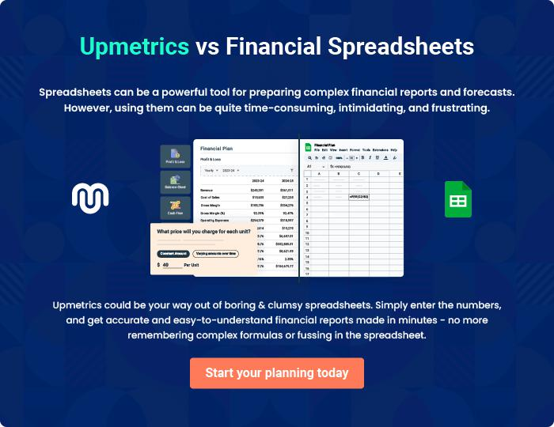

T-Shirt Printing | Business Plan [YEAR] 39/40


Create a winning business plan that gets you funded

Creating a stunning and investment-ready plan requires no writing, graphic designing, or financial planning expertise.

Upmetrics has all the features required to help you create a comprehensive business plan—from start to finish. Make no mistakes, it’s the modern way of planning to structure ideas, make plans, and create stunning pitch decks to awe investors.

Pitch decks that impress investors

Create pitch decks that provide a visual representation of your business, engage investors, and make them want to invest in your business idea.

Interactive plans in no time

Import business plan sections like—SWOT analysis, comparison tables, and others to create an interactive business plan. No designing skills are required.

Stunning cover page designs

With Upmetrics, you have the liberty to choose from multiple stunning cover page designs. Choose a creative design and make your plan stand out.

Online sharing made simple

Upmetrics makes online sharing quick and easier for users. Easily share your business plans with a link while tracking reader activity.

500+ sample business plans

Simply import a template from our library of sample plans into the editor and start customizing it to make it yours. It takes only a few clicks to get started.

Collaborate with team in real-time

Invite team members, initiate conversations, discuss ideas & strategies, share feedback, and work on a business plan in real-time.

