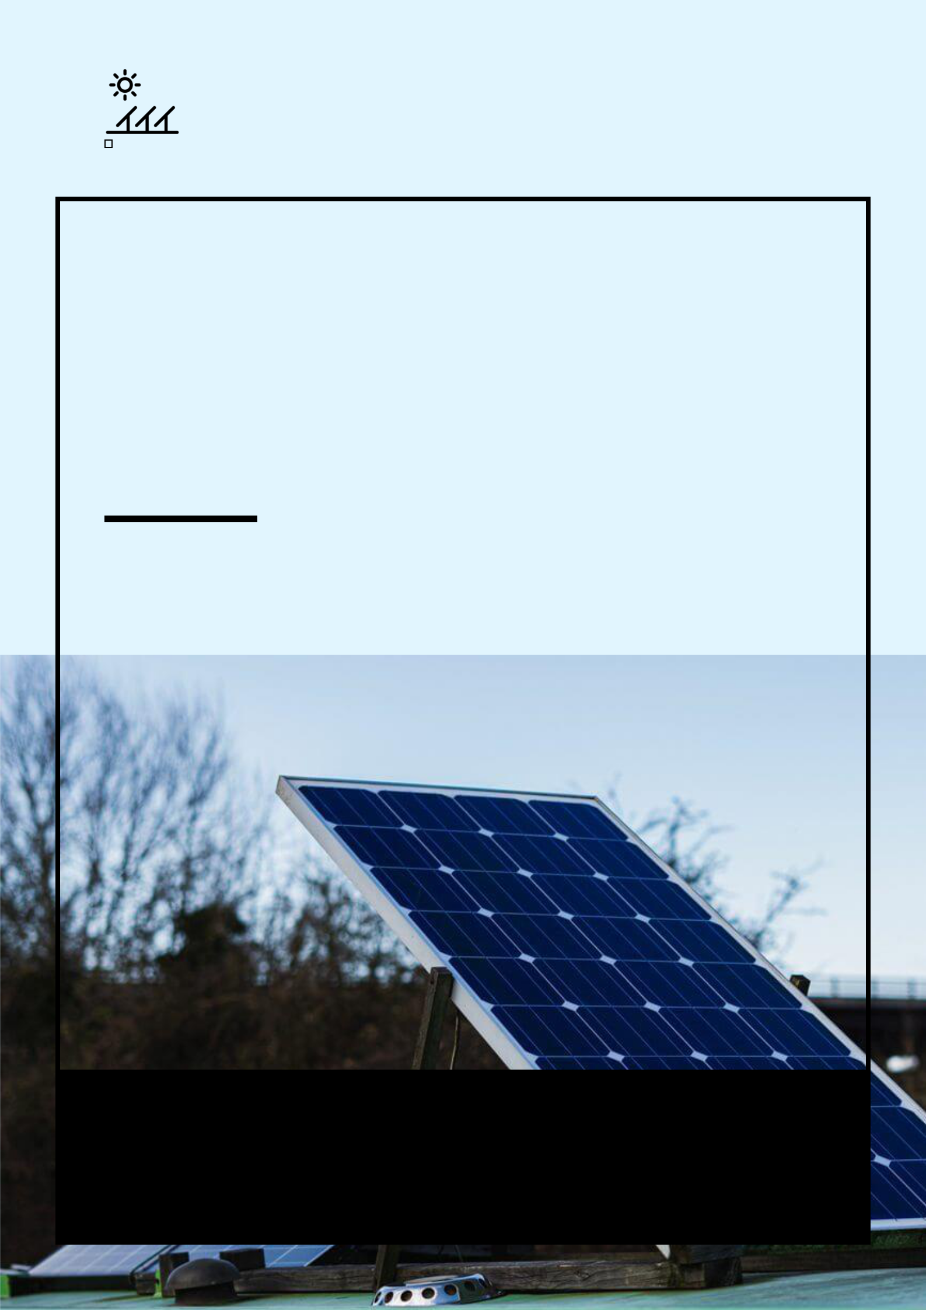
Solar Farm

BUSINESS PLAN

Clean energy for a pure world.

Prepared By

John Doe

10200 Bolsa Ave, Westminster, CA, 92683

info@example.com

(650) 359-3153 http://www.example.com

Table of Contents

Executive Summary | 5
Mission Statement | 6
Vision Statement | 6
Customer Focus | 7
Success Factors | 7
Financial Summary | 7
3 Year profit forecast | 8

Company Summary | 9
History | 10
Business Structure | 10
Startup summary | 11
Startup cost | 11
Products and services
Products and services | 14
Market Analysis
Market Analysis | 17
Market Trends | 18
Market Segmentation | 18
Individuals and Households | 19
Corporate Organizations and Manufacturers | 19
Real Estate Developers | 19
Schools | 19
SWOT Analysis
SWOT Analysis | 20
Strategy & Implementations
Strategy & Implementations | 22
Sales Strategy | 23
Advertising Strategy | 23
Local Publications | 23
Direct Mail | 24

Solar Farm | Business Plan [YEAR] 2/36

Public Relations | 24
Community Events/Organizations | 24
Pricing Strategy | 24
Milestones | 25

Financial Plan | 26
Important Assumptions | 27
Brake-even Analysis | 27
Projected Profit and Loss | 28
Projected Cash Flow | 31
Projected Balance Sheet | 32
Business Ratios | 33

Solar Farm | Business Plan [YEAR] 3/36

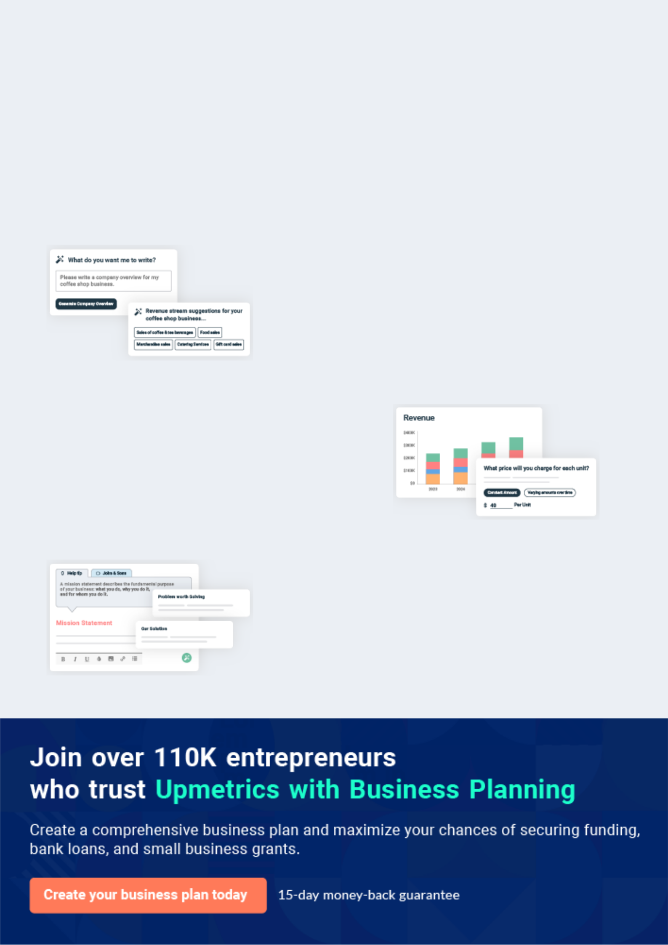
Business planning that’s simpler and faster than you think

Creating a business plan using Upmetrics to start and grow a business is literally the easiest thing in the World. Simply read the instructions and fill in the blanks. It’s as simple as that.

❛ | Upmetrics has everything you need to create a | ❜
❛ | comprehensive business plan. | ❜

AI-powered Upmetrics Assistant

AI-powered insights to streamline your plan

Not sure where to start? Upmetrics’ AI Assistant will automatically generate ideas for each section of your plan and offer improved versions of your writing, adjusting for tone, voice, and grammar or spelling errors.

Financial Forecasting Tool

All the financials are calculated for you

Forget the complex formulas and clumsy spreadsheets — with automatic financials and drag-and-drop forecasting, you can finish your plan faster and be confident that your numbers are accurate.

Business Plan Builder

Guides you like a business mentor

Upmetrics’ step-by-step instructions, prompts, and the library of 400+ sample business plans will guide you through each section of your plan as a business mentor.

1.


Executive Summary

Mission Statement

Vision Statement

Customer Focus

Success Factors

Financial Summary

Solar Farm | Business Plan [YEAR] 5/36

Before you think about how to start a solar farm business, you must create a detailed Solar farm business plan. It will not only guide you in the initial phases of your startup but will also help you later on.
To unlock help try Upmetrics!
To unlock help try Upmetrics!



 Maxwell Technologies


Maxwell Technologies, LLC is a U.S based and standard solar farm company. We have been able to secure standard and well-positioned vast acres of land in the outskirt of Detroit - Michigan.



Start writing here..

Mission Statement

 Maxwell Technologies

Our mission is to provide solar energy and professional solar panel installation, maintenance and repair services, and other related services that will assist businesses, individuals, households, and non-profit organizations in ensuring that their solar panels are always in good
To unlock help try Upmetrics! 

Start writing here..

Vision Statement

 Maxwell Technologies

Our vision is to establish a standard and world-class solar farm and solar panel installation, maintenance, and repair company whose services and brand will not only be accepted in Detroit - Michigan but also in other cities in the United States of America.
To unlock help try Upmetrics! 

Start writing here..

Solar Farm | Business Plan [YEAR] 6/36

Customer Focus
To unlock help try Upmetrics!

 Maxwell Technologies

Maxwell Technologies will primarily serve the residents and businesses within a 10-mile radius of our location. The demographics of these customers are as follows:
To unlock help try Upmetrics! 

Start writing here..

Success Factors

 Maxwell Technologies

Maxwell Technologies is uniquely qualified to succeed due to the following reasons:

• Maxwell Technologies provides customized residential and business energy solutions. In
To unlock help try Upmetrics! 

Start writing here..

Financial Summary

 Maxwell Technologies

Maxwell Technologies is seeking total funding of $470,000 of debt capital to open its solar farm business. The capital will be used for funding capital expenditures, location build-out, hiring initial employees, marketing expenses, and working capital.



Start writing here..

Solar Farm | Business Plan [YEAR] 7/36

3 Year profit forecast
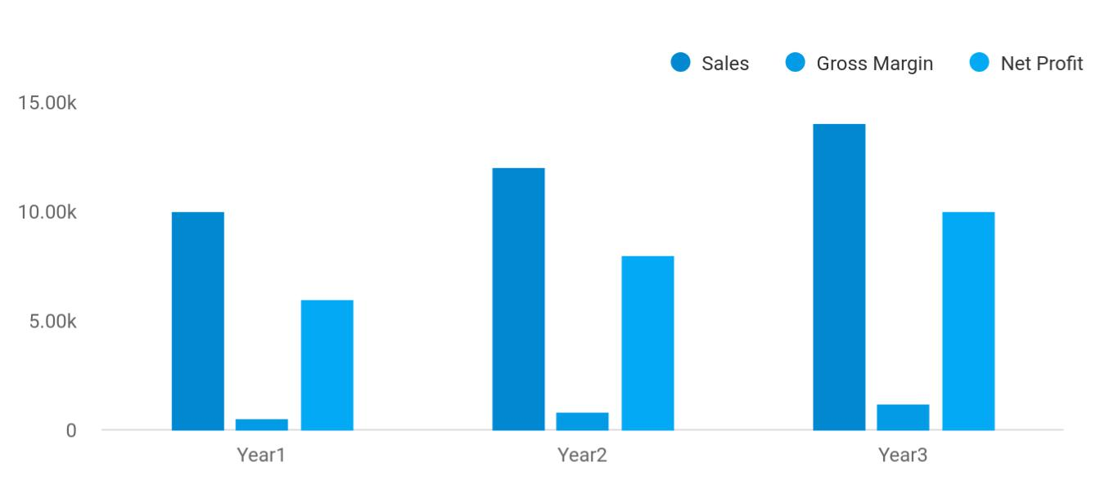

 Maxwell Technologies


Financial Summary | Year 1 | Year 2 |  | Year 3
 |  |  | To unlock help try Upmetrics! |  | 

Start writing here..

Solar Farm | Business Plan [YEAR] 8/36

2.

Company Summary

History

Business Structure

Startup summary

Solar Farm | Business Plan [YEAR] 9/36

 Maxwell Technologies

Maxwell Technologies, LLC is founded by Engr. John Moore a solar energy engineer per excellence who graduated from Illinois Institute of Technology (B.Engr.) and his friend and business partner for many years James Moore (B.Sc. Business Management). They have a
To unlock help try Upmetrics! 

Start writing here..

History

 Maxwell Technologies

Established in 2015, Maxwell Technologies is making a name for itself in the photovoltaic industry. The company was founded by John Moore, who at the young age of 20, earned a
Master’s degree in Materials Science and Engineering at the University of Michigan. He has
To unlock help try Upmetrics! 

Start writing here..

Business Structure

 Maxwell Technologies

Maxwell Technologies, LLC, is a solar farm and solar panel installation, maintenance, and repair company that intends to start small in Detroit - Michigan, but hope to grow big in order to compete favorably with leading solar energy companies and solar panel installation,
To unlock help try Upmetrics! 

Start writing here..

Solar Farm | Business Plan [YEAR] 10/36

Startup summary

Startup cost
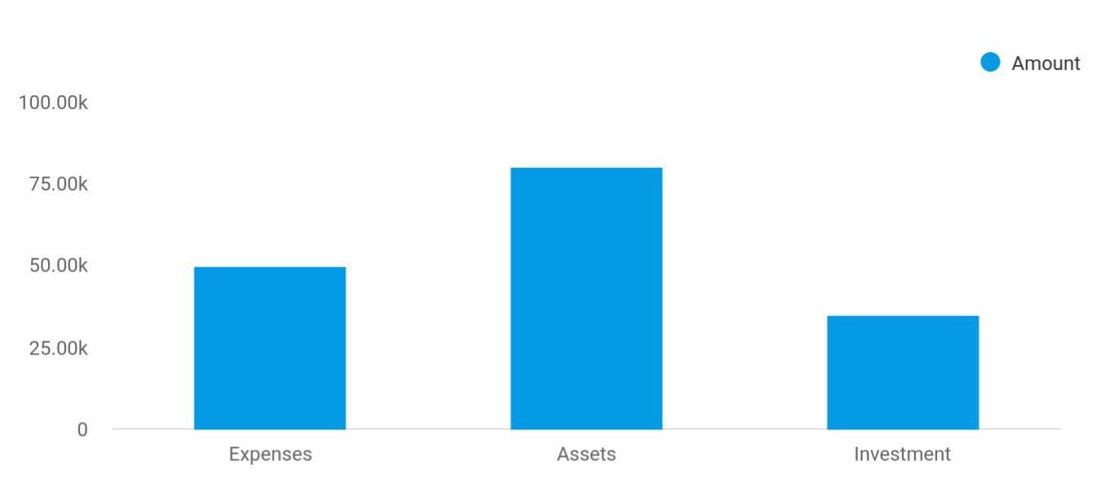

Cost distribution | Amount
Expenses | 50,000
Assets | 80,000
Investment | 35,000

Start-up Expenses | Amount
Legal | $75,500
Consultants | $0
Insurance | $62,750
Rent | $22,500
Research and Development | $42,750
Expensed Equipment | $42,750
Signs | $1,250
TOTAL START-UP EXPENSES | $247,500
Start-up Assets | $0
Cash Required | $322,500
Start-up Inventory | $52,625
Other Current Assets | $222,500

Solar Farm | Business Plan [YEAR] 11/36

Start-up Expenses | Amount
Long-term Assets | $125,000
TOTAL ASSETS | $121,875
Total Requirements | $245,000
START-UP FUNDING | $0
START-UP FUNDING | $273,125
Start-up Expenses to Fund | $121,875
Start-up Assets to Fund | $195,000
TOTAL FUNDING REQUIRED | $0
Assets | $203,125
Non-cash Assets from Start-up | $118,750
Cash Requirements from Start-up | $0
Additional Cash Raised | $118,750
Cash Balance on Starting Date | $121,875
TOTAL ASSETS | $0
Liabilities and Capital | $0
Liabilities | $0
Current Borrowing | $0
Long-term Liabilities | $0
Accounts Payable (Outstanding Bills) | $0
Other Current Liabilities (interest-free) | $0
TOTAL LIABILITIES | $0
Capital | $0
Planned Investment | $0
Investor 1 | $312,500
Investor 2 | $0
Other | $0
Additional Investment Requirement | $0
TOTAL PLANNED INVESTMENT | $695,000

Solar Farm | Business Plan [YEAR] 12/36

Start-up Expenses | Amount
Loss at Start-up (Start-up Expenses) | $313,125
TOTAL CAPITAL | $221,875
TOTAL CAPITAL AND LIABILITIES | $221,875
Total Funding | $265,000

Solar Farm | Business Plan [YEAR] 13/36

3.

Products and services

Solar Farm | Business Plan [YEAR] 14/36

 Maxwell Technologies

Maxwell Dance Studio is going to offer varieties of dance-related services within the scope of the dance studio industry in the United States of America. Our intention of starting our dance studio business is to help individuals and organizations learn various dance steps and also
To unlock help try Upmetrics! 

Start writing here..


Energy Supply Panel Installations

Supply solar energy to Installation of solar

domestic, commercial panels, repair and

and industrial maintenance services

enterprises in need of thanks to a qualified

clean, efficient and and reputable

reliable solar energy installation and quality

assurance team

Plant Constructions Consultation

Construction of CSP Consultation, energy

power plants, CSP analysis studies and

tower power plants and designing of integrated

CSP trough power solar system plans.

plants using the latest This involves holding

environmentally friendly discussions with

technologies potential customers to

determine their solar

needs and recommend

an appropriate solution.

Solar Farm | Business Plan [YEAR] 15/36

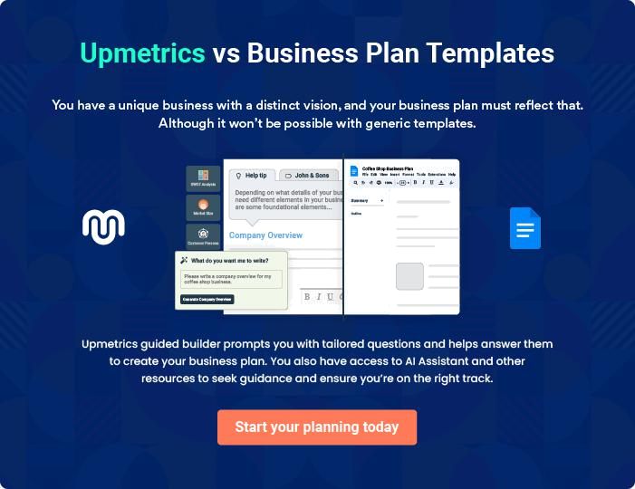

Solar Farm | Business Plan [YEAR] | 16/36

4.

Market Analysis

Market Trends

Market Segmentation

Solar Farm | Business Plan [YEAR] 17/36

The most important component of an effective solar farm business plan is its accurate marketing analysis. If you are starting on a smaller scale, you can do marketing analysis yourself by taking help from this solar farm
To unlock help try Upmetrics! 

Market Trends

 Maxwell Technologies

If you are keeping tabs on happenings in the Solar Farm Developers industry, you will agree that the demand for construction of utility-scale solar power projects has skyrocketed many thanks to substantial government support. So also, technological advancements in solar panel
To unlock help try Upmetrics! 

Start writing here..

Market Segmentation

 Maxwell Technologies

In order to ensure business goals are met, Maxwell Technologies intends to offer a wide range of services in order to cater to different types of customers. The focus will be placed on offering quality services and deployment of the latest infrastructure and technologies to ensure
To unlock help try Upmetrics! 

Start writing here..
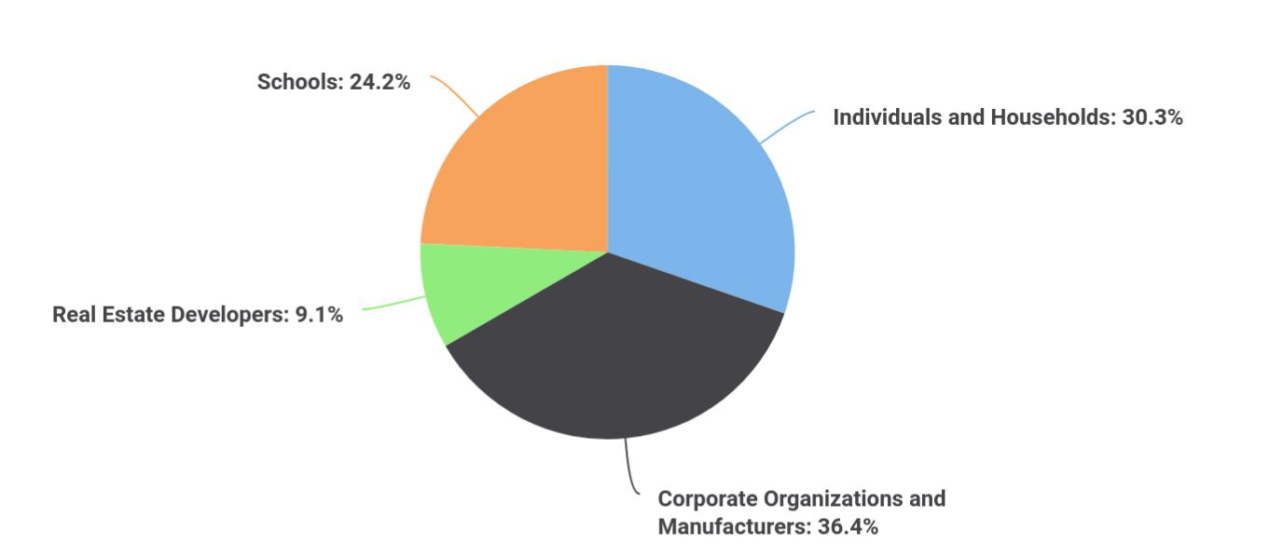

Solar Farm | Business Plan [YEAR] 18/36

 Maxwell Technologies

Statistics have indicated that the biggest consumers of solar energy are domestic consumers who account for a larger percentage of the total consumption. With the high cost of electricity, many households and individual users are opting for solar energy which is considered to be
To unlock help try Upmetrics! 

Individuals and Households

Start writing here..

 Maxwell Technologies

In a bid to reduce electricity costs, many companies are opting to embrace solar energy to lower business expenses with a view of increasing profits. Numerous government incentives including tax reliefs on solar energy have encouraged the uptake of commercial use of solar
To unlock help try Upmetrics! 

Corporate Organizations and Manufacturers

Start writing here..

 Maxwell Technologies

A lot of real estate developments are increasingly opting for solar energy since it’s a cost-effective and environmentally friendly option. To avoid depending on traditional electricity,
many developers are investing heavily in solar infrastructure with the intention of using solar as
To unlock help try Upmetrics! 

Real Estate Developers

Start writing here..

 Maxwell Technologies

This solar farm business model incorporates educational institutions as one of the key customer segments that Maxwell Technologies needs to reach out to. There are numerous educational institutions in Forney, and the solar farm has a good opportunity to market to the
To unlock help try Upmetrics! 

Schools

Start writing here..

Solar Farm | Business Plan [YEAR] 19/36

5.

SWOT Analysis

Solar Farm | Business Plan [YEAR] 20/36

 Maxwell Technologies

Maxwell Technologies, LLC engaged the services of a core professional in the area of business consulting and structuring to assist our organization in building a well-structured solar farm and solar panel installation, maintenance, and repair business that can favorably compete in
To unlock help try Upmetrics! 

Start writing here..


Strength

Aside from the fact that we have a vast acre of land in a strategic location in the outskirts of Detroit for our solar farm, Our core strength lies in the power of our team; our workforce.

We have a team of certified and highly trained and experienced solar panel installation, maintenance, and repair engineers and technicians, a team with excellent qualifications and experience in various niche areas in The Solar Farm Developers industry. Aside from the synergy that exists in our carefully selected workforce, our services will be guided by best practices in the industry.


Weakness

As a new solar farm and solar panel installation, maintenance, and repair company in Detroit - Michigan, it might take some time for our organization to break into the market and gain acceptance especially from top profile clients in the already saturated and highly competitive Solar Farm Developers industry; that is perhaps our major weakness. Another weakness is that we may not have the required cash to pump into promoting our business the way we would want to.


Opportunity

No doubt, the opportunities in the Solar Farm Developers industry are massive considering the support from the government and of course the number of individuals and corporate organizations who are now switching over to alternative energy such as solar energy. As a solar farm cum solar panel installation, maintenance, and Repair Company, we are ready to take advantage of any opportunity that is available in the industry.

Threat

Just like any other business, one of the major threats that we are likely going to face is an economic downturn. It is a fact that the economic downturn affects purchasing/ spending power. Another threat that may likely confront us is the arrival of a new solar farm or solar panel installation, maintenance and repair company in the same location where our target market exists and who may want to adopt the same Business model as us.

Solar Farm | Business Plan [YEAR] 21/36

6.

Strategy &

Implementations

Sales Strategy

Advertising Strategy

Pricing Strategy

Milestones

Solar Farm | Business Plan [YEAR] 22/36

After identifying the market demand, market trends, and the potential customers of the startup, the next step is to define an effective strategy for attracting those customers. Like marketing analysis, sales strategy is also an
To unlock help try Upmetrics!
To unlock help try Upmetrics!
To unlock help try Upmetrics! 

Sales Strategy

 Maxwell Technologies

For Maxwell Technologies to achieve its goals, the following strategies have been identified to help the solar farm reach out to its customers. If you plan to start a solar farm business, the following strategies will be of great help.



Start writing here..

Advertising Strategy

 Maxwell Technologies

Maxwell Technologies’s target markets is residents and businesses in Detroit. The Company’s promotions strategy to reach these individuals includes:
To unlock help try Upmetrics! 

Start writing here..

 Maxwell Technologies

Maxwell Technologies will create brand awareness through features in multiple local newspapers and publications. Regular advertisements will run to maintain exposure and build brand awareness to relevant markets.



Local Publications

Start writing here..

Solar Farm | Business Plan [YEAR] 23/36

 Maxwell Technologies
To unlock help try Upmetrics!

Maxwell Technologies will blanket neighborhoods surrounding its locations with direct mail pieces. These pieces will provide general information on Maxwell Technologies, offer discounts, and/or provide other enticements for people to avail of our services.
To unlock help try Upmetrics! 

Direct Mail

Start writing here..

 Maxwell Technologies

We will contact all local and area newspapers and television stations and send them a press release describing the benefits of renewable energy and solar farms and the unique value proposition of Maxwell Technologies.



Public Relations

Start writing here..

 Maxwell Technologies

Maxwell Technologies will conduct informative community discussions and seminars regarding the advantages of using sustainable energy. This seeks to educate people on the negative effects of nonrenewable resources on the environment, while simultaneously promoting our
To unlock help try Upmetrics! 

Community Events/Organizations

Start writing here..

Pricing Strategy

 Maxwell Technologies

At Maxwell Technologies, LLC we will keep the prices of our products and services below the average market rate for all of our customers by keeping our overhead low and by collecting payment in advance from corporate organizations who would hire our services. In addition, we
To unlock help try Upmetrics! 

Start writing here..

Solar Farm | Business Plan [YEAR] 24/36

Milestones

 Maxwell Technologies

Maxwell Technologies’s long-term goal is to become the dominant solar farmer and renewable energy provider in Detroit. We seek to the standard by which other providers are judged.
To unlock help try Upmetrics! 

Start writing here..

Solar Farm | Business Plan [YEAR] 25/36

7.

Financial Plan

Important Assumptions

Brake-even Analysis

Projected Profit and Loss

Projected Cash Flow

Projected Balance Sheet

Business Ratios

Solar Farm | Business Plan [YEAR] 26/36

The last component of the solar farm business plan is an in-depth financial plan. The financial plan crafts a detailed map of all the expenses needed for the startup and how these expenses will be met by the earned profits. It is
To unlock help try Upmetrics! 

 Maxwell Technologies

The company will be financed by John himself and he will control the direction of the business to make sure that it is expanding at the forecasted rate. As for the solar farm business start-up, no equity funding or outside loans will be required. With the help of financial experts, John has
To unlock help try Upmetrics! 

Start writing here..

Important Assumptions

The financial projections of the company are forecast on the basis of the following assumptions. These assumptions are quite conservative and are expected to show deviation but to a limited level such that the company’s major financial strategy will not be affected.

 | Year 1 | Year 2 | Year 3
Plan Month | 1 | 2 | 3
Current Interest Rate | 10,00% | 11,00% | 12,00%
Long-term Interest Rate | 10,00% | 10,00% | 10,00%
Tax Rate | 26,42% | 27,76% | 28,12%
Other | 0 | 0 | 0

Brake-even Analysis

Monthly Units Break-even | 5530
Monthly Revenue Break-even | $159 740
Assumptions:
Average Per-Unit Revenue | $260,87
Average Per-Unit Variable Cost | $0,89
Estimated Monthly Fixed Cost | $196 410

Solar Farm | Business Plan [YEAR] 27/36

Projected Profit and Loss

 | 2024 | 2025 | 2026
Revenue | $1,284,400 | $1,737,576 | $2,385,706
Sale of Solar Energy | $1,064,400 | $1,517,576 | $2,163,706
Unit Sales | 21,288 | 30,352 | 43,274
Unit Price | $50 | $50 | $50
Government Subsidies | $100,000 | $100,000 | $102,000
Carbon Credits Sales | $120,000 | $120,000 | $120,000
Unit Sales | 240 | 240 | 240
Unit Price | $500 | $500 | $500
Cost Of Sales | $250,483.21 | $138,205.15 | $182,523.06
General Costs | $250,483.21 | $138,205.15 | $182,523.06
Operational Costs | $219,017.07 | $101,464.21 | $135,926.62
Maintenance and Repairs | $39,067.17 | $62,547.79 | $100,141.01
Equipment Wear and Tear | $179,949.90 | $38,916.42 | $35,785.61
Energy Production Costs | $31,466.14 | $36,740.94 | $46,596.44
Panel Cleaning Services | $24,141.70 | $30,617.45 | $38,830.35
Inverter Maintenance | $7,324.44 | $6,123.49 | $7,766.09
Revenue Specific Costs | $0 | $0 | $0
Personnel Costs (Direct | $0 | $0 | $0
Labor) | $0 | $0 | $0
Gross Margin | $1,033,916.79 | $1,599,370.85 | $2,203,182.94
Gross Margin (%) | 80.50% | 92.05% | 92.35%

Solar Farm | Business Plan [YEAR] 28/36

 | 2024 | 2025 | 2026
Operating Expense | $843,592.42 | $947,606.19 | $1,086,976.42
Payroll Expense (Indirect | $707,645.83 | $774,089.10 | $861,776.04
Labor) | $707,645.83 | $774,089.10 | $861,776.04
Management | $183,245.83 | $233,957.10 | $305,440.08
Project Manager | $114,245.83 | $162,887.10 | $232,237.92
Financial Analyst | $69,000 | $71,070 | $73,202.16
Technical Staff | $420,900 | $433,527 | $446,532.72
Solar Panel Technician | $276,000 | $284,280 | $292,808.40
Maintenance Worker | $144,900 | $149,247 | $153,724.32
Administrative Staff | $103,500 | $106,605 | $109,803.24
Office Administrator | $41,400 | $42,642 | $43,921.32
HR Coordinator | $62,100 | $63,963 | $65,881.92
General Expense | $135,946.60 | $173,517.09 | $225,200.39
Store Operations | $41,094.83 | $47,634.39 | $55,359.37
Rent | $31,706.31 | $35,727.40 | $40,258.40
Utilities | $9,388.52 | $11,906.99 | $15,100.97
Marketing and Advertising | $81,250.46 | $111,160.19 | $153,904.88
Online Advertising | $64,220.02 | $86,878.83 | $119,285.32
Local Events Sponsorship | $17,030.44 | $24,281.36 | $34,619.56
Shop Maintenance | $13,601.31 | $14,722.51 | $15,936.14
Equipment Maintenance | $9,891.86 | $10,707.30 | $11,589.95
Technical Maintenance | $3,709.45 | $4,015.21 | $4,346.19
Bad Debt | $0 | $0 | $0
Amortization of Current | $0 | $0 | $0
Assets | $0 | $0 | $0

Solar Farm | Business Plan [YEAR] 29/36

EBITDA

Additional Expense

Long Term Depreciation

Gain or loss from Sale of Assets

EBIT

Interest Expense

EBT

Income Tax Expense / Benefit

2024 | 2025 | 2026
$190,324.37 | $651,764.65 | $1,116,206.52

$167,380.91 | $145,571.25 | $122,416.41
$57,000 | $57,000 | $57,000
$0 | $0 | $0
$133,324.37 | $594,764.65 | $1,059,206.52
$110,380.90 | $88,571.24 | $65,416.41
$22,943.46 | $506,193.40 | $993,790.11
$0 | $0 | $0

Total Expense | $1,261,456.54 | $1,231,382.60 | $1,391,915.89
Net Income | $22,943.46 | $506,193.40 | $993,790.11
Net Income (%) | 1.79% | 29.13% | 41.66%

Retained Earning Opening | $0 | ($87,056.54) | $309,136.86
Owner's Distribution | $110,000 | $110,000 | $110,000
Retained Earning Closing | ($87,056.54) | $309,136.86 | $1,192,926.97

Solar Farm | Business Plan [YEAR] 30/36

Projected Cash Flow

 | 2024 | 2025 | 2026
Cash Received | $1,284,400 | $1,737,576 | $2,385,706
Cash Paid | $1,204,456.54 | $1,174,382.60 | $1,334,915.89
COS & General Expenses | $386,429.80 | $311,722.25 | $407,723.44
Salary & Wages | $707,645.83 | $774,089.10 | $861,776.04
Interest | $110,380.90 | $88,571.24 | $65,416.41
Sales Tax | $0 | $0 | $0
Income Tax | $0 | $0 | $0
Net Cash From | $79,943.46 | $563,193.40 | $1,050,790.11
Operations | $79,943.46 | $563,193.40 | $1,050,790.11
Assets Sell | $0 | $0 | $0
Assets Purchase | $1,500,000 | $0 | $0
Net Cash From | ($1,500,000) | $0 | $0
Investments | ($1,500,000) | $0 | $0
Amount Received | $3,000,000 | $0 | $0
Loan Received | $2,000,000 | $0 | $0
Common Stock | $1,000,000 | $0 | $0
Preferred Stock | $0 | $0 | $0
Owner's Contribution | $0 | $0 | $0
Amount Paid | $463,606.29 | $485,415.95 | $508,570.79
Loan Capital | $353,606.30 | $375,415.96 | $398,570.79
Dividends & Distributions | $110,000 | $110,000 | $110,000
Net Cash From | $2,536,393.71 | ($485,415.95) | ($508,570.79)
Financing | $2,536,393.71 | ($485,415.95) | ($508,570.79)

Solar Farm | Business Plan [YEAR] 31/36

2024 2025 2026

Summary

Starting Cash | $0 | $1,116,337.17 | $1,194,114.62
Cash In | $4,284,400 | $1,737,576 | $2,385,706
Cash Out | $3,168,062.83 | $1,659,798.55 | $1,843,486.68
Change in Cash | $1,116,337.17 | $77,777.45 | $542,219.32
Ending Cash | $1,116,337.17 | $1,194,114.62 | $1,736,333.94

Projected Balance Sheet

 | 2024 | 2025 | 2026
Assets | $2,559,337.17 | $2,580,114.62 | $3,065,333.94
Current Assets | $1,116,337.17 | $1,194,114.62 | $1,736,333.94
Cash | $1,116,337.17 | $1,194,114.62 | $1,736,333.94
Accounts Receivable | $0 | $0 | $0
Inventory | $0 | $0 | $0
Other Current Assets | $0 | $0 | $0
Long Term Assets | $1,443,000 | $1,386,000 | $1,329,000
Gross Long Term Assets | $1,500,000 | $1,500,000 | $1,500,000
Accumulated Depreciation | ($57,000) | ($114,000) | ($171,000)

Liabilities & Equity | $2,559,337.16 | $2,580,114.60 | $3,065,333.92
Liabilities | $1,646,393.70 | $1,270,977.74 | $872,406.95
Current Liabilities | $375,415.96 | $398,570.79 | $0
Accounts Payable | $0 | $0 | $0
Income Tax Payable | $0 | $0 | $0

Solar Farm | Business Plan [YEAR] 32/36

 | 2024 |  |  | 2025 | 2026
Sales Tax Payable | $0 |  |  | $0 | $0
Short Term Debt | $375,415.96 |  | $398,570.79 |  | $0
Long Term Liabilities | $1,270,977.74 |  | $872,406.95 |  | $872,406.95
Long Term Debt | $1,270,977.74 |  | $872,406.95 |  | $872,406.95
Equity | $912,943.46 |  | $1,309,136.86 |  | $2,192,926.97
Paid-in Capital | $0 |  |  | $0 | $0
Common Stock | $1,000,000 |  | $1,000,000 |  | $1,000,000
Preferred Stock | $0 |  |  | $0 | $0
Owner's Contribution | $0 |  |  | $0 | $0
Retained Earnings | ($87,056.54) |  | $309,136.86 |  | $1,192,926.97
Check | $0 |  |  | $0 | $0
Business Ratios
 |  | Year 1 | Year 2 | Year 3 | Industry Profile
Sales Growth |  | 4,35% | 30,82% | 63,29% | 4,00%
Percent of Total Assets
Accounts Receivable |  | 5,61% | 4,71% | 3,81% | 9,70%
Inventory |  | 1,85% | 1,82% | 1,79% | 9,80%
Other Current Assets |  | 1,75% | 2,02% | 2,29% | 27,40%
Total Current Assets |  | 138,53% | 150,99% | 163,45% | 54,60%
Long-term Assets |  | -9,47% | -21,01% | -32,55% | 58,40%
TOTAL ASSETS |  | 100,00% | 100,00% | 100,00% | 100,00%
Current Liabilities |  | 4,68% | 3,04% | 2,76% | 27,30%
Long-term Liabilities |  | 0,00% | 0,00% | 0,00% | 25,80%
Total Liabilities |  | 4,68% | 3,04% | 2,76% | 54,10%

Solar Farm | Business Plan [YEAR] 33/36

 | Year 1 | Year 2 | Year 3 | Industry Profile
NET WORTH | 99,32% | 101,04% | 102,76% | 44,90%
Percent of Sales
Sales | 100,00% | 100,00% | 100,00% | 100,00%
Gross Margin | 94,18% | 93,85% | 93,52% | 0,00%
Selling, General & Administrative Expenses | 74,29% | 71,83% | 69,37% | 65,20%
Advertising Expenses | 2,06% | 1,11% | 0,28% | 1,40%
Profit Before Interest and Taxes | 26,47% | 29,30% | 32,13% | 2,86%
Main Ratios
Current | 25,86 | 29,39 | 32,92 | 1,63
Quick | 25,4 | 28,88 | 32,36 | 0,84
Total Debt to Total Assets | 2,68% | 1,04% | 0,76% | 67,10%
Pre-tax Return on Net Worth | 66,83% | 71,26% | 75,69% | 4,40%
Pre-tax Return on Assets | 64,88% | 69,75% | 74,62% | 9,00%
Additional Ratios
Net Profit Margin | 19,20% | 21,16% | 23,12% | N.A.
Return on Equity | 47,79% | 50,53% | 53,27% | N.A.
Activity Ratios
Accounts Receivable Turnover | 4,56 | 4,56 | 4,56 | N.A.
Collection Days | 92 | 99 | 106 | N.A.
Inventory Turnover | 19,7 | 22,55 | 25,4 | N.A.
Accounts Payable Turnover | 14,17 | 14,67 | 15,17 | N.A.
Payment Days | 27 | 27 | 27 | N.A.
Total Asset Turnover | 1,84 | 1,55 | 1,26 | N.A.
Debt Ratios
Debt to Net Worth | 0 | -0,02 | -0,04 | N.A.
Current Liab. to Liab. | 1 | 1 | 1 | N.A.
Liquidity Ratios
Net Working Capital | $120 943 | $140 664 | $160 385 | N.A.

Solar Farm | Business Plan [YEAR] 34/36

 | Year 1 | Year 2 | Year 3 | Industry Profile
Interest Coverage | 0 | 0 | 0 | N.A.
Additional Ratios
Assets to Sales | 0,45 | 0,48 | 0,51 | N.A.
Current Debt/Total Assets | 4% | 3% | 2% | N.A.
Acid Test | 23,66 | 27,01 | 30,36 | N.A.
Sales/Net Worth | 1,68 | 1,29 | 0,9 | N.A.
Dividend Payout | 0 | 0 | 0 | N.A.
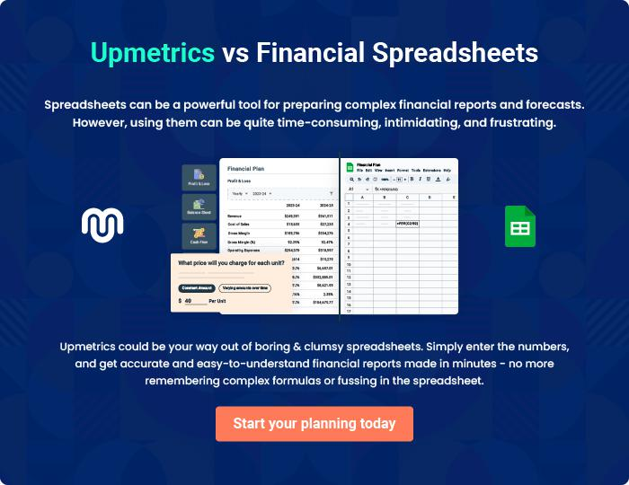

Solar Farm | Business Plan [YEAR] 35/36


Create a winning business plan that gets you funded

Creating a stunning and investment-ready plan requires no writing, graphic designing, or financial planning expertise.

Upmetrics has all the features required to help you create a comprehensive business plan—from start to finish. Make no mistakes, it’s the modern way of planning to structure ideas, make plans, and create stunning pitch decks to awe investors.

Pitch decks that impress investors

Create pitch decks that provide a visual representation of your business, engage investors, and make them want to invest in your business idea.

Interactive plans in no time

Import business plan sections like—SWOT analysis, comparison tables, and others to create an interactive business plan. No designing skills are required.

Stunning cover page designs

With Upmetrics, you have the liberty to choose from multiple stunning cover page designs. Choose a creative design and make your plan stand out.

Online sharing made simple

Upmetrics makes online sharing quick and easier for users. Easily share your business plans with a link while tracking reader activity.

500+ sample business plans

Simply import a template from our library of sample plans into the editor and start customizing it to make it yours. It takes only a few clicks to get started.

Collaborate with team in real-time

Invite team members, initiate conversations, discuss ideas & strategies, share feedback, and work on a business plan in real-time.

