

Social Media

Marketing

Grow with your audience

Business

Plan

[YEAR]

John Doe

10200 Bolsa Ave, Westminster, CA, 92683

- 359-3153 info@example.com https://example.com

CONFIDENTIAL

Table of Contents

Executive Summary | 5
The Business | 6
Management | 6
Customers | 7
Business Target | 7
3 Year profit forecast | 8

Company Summary | 9
Company Owner | 10
Why the business is being started? | 10
How the business will be started? | 10
Startup cost | 11
Startup Requirements | 11

Products | 14
Products and services | 15
Marketing Analysis
Marketing Analysis | 17
Market Trends | 18
Marketing Segmentation | 18
Marketing share | 18
Businesses | 19
Institutions & Organizations | 19
Media & Celebrities | 19
Business Target | 20
Product Pricing | 20
Strategy
Strategy | 21
Competitive Analysis | 22
Sales Strategy | 22
Sales Monthly | 22

Social Media Marketing | Business Plan [YEAR] 2/37

Sales Yearly | 23
Sales Forecast | 24

Personnel plan | 25
Company Staff | 26
Average Salary of Employees | 26
Financial Plan
Financial Plan | 27
Important Assumptions | 28
Brake-even Analysis | 28
Projected Profit and Loss | 28
Projected Cash Flow | 31
Projected Balance Sheet | 33
Business Ratios | 34

Social Media Marketing | Business Plan [YEAR] 3/37

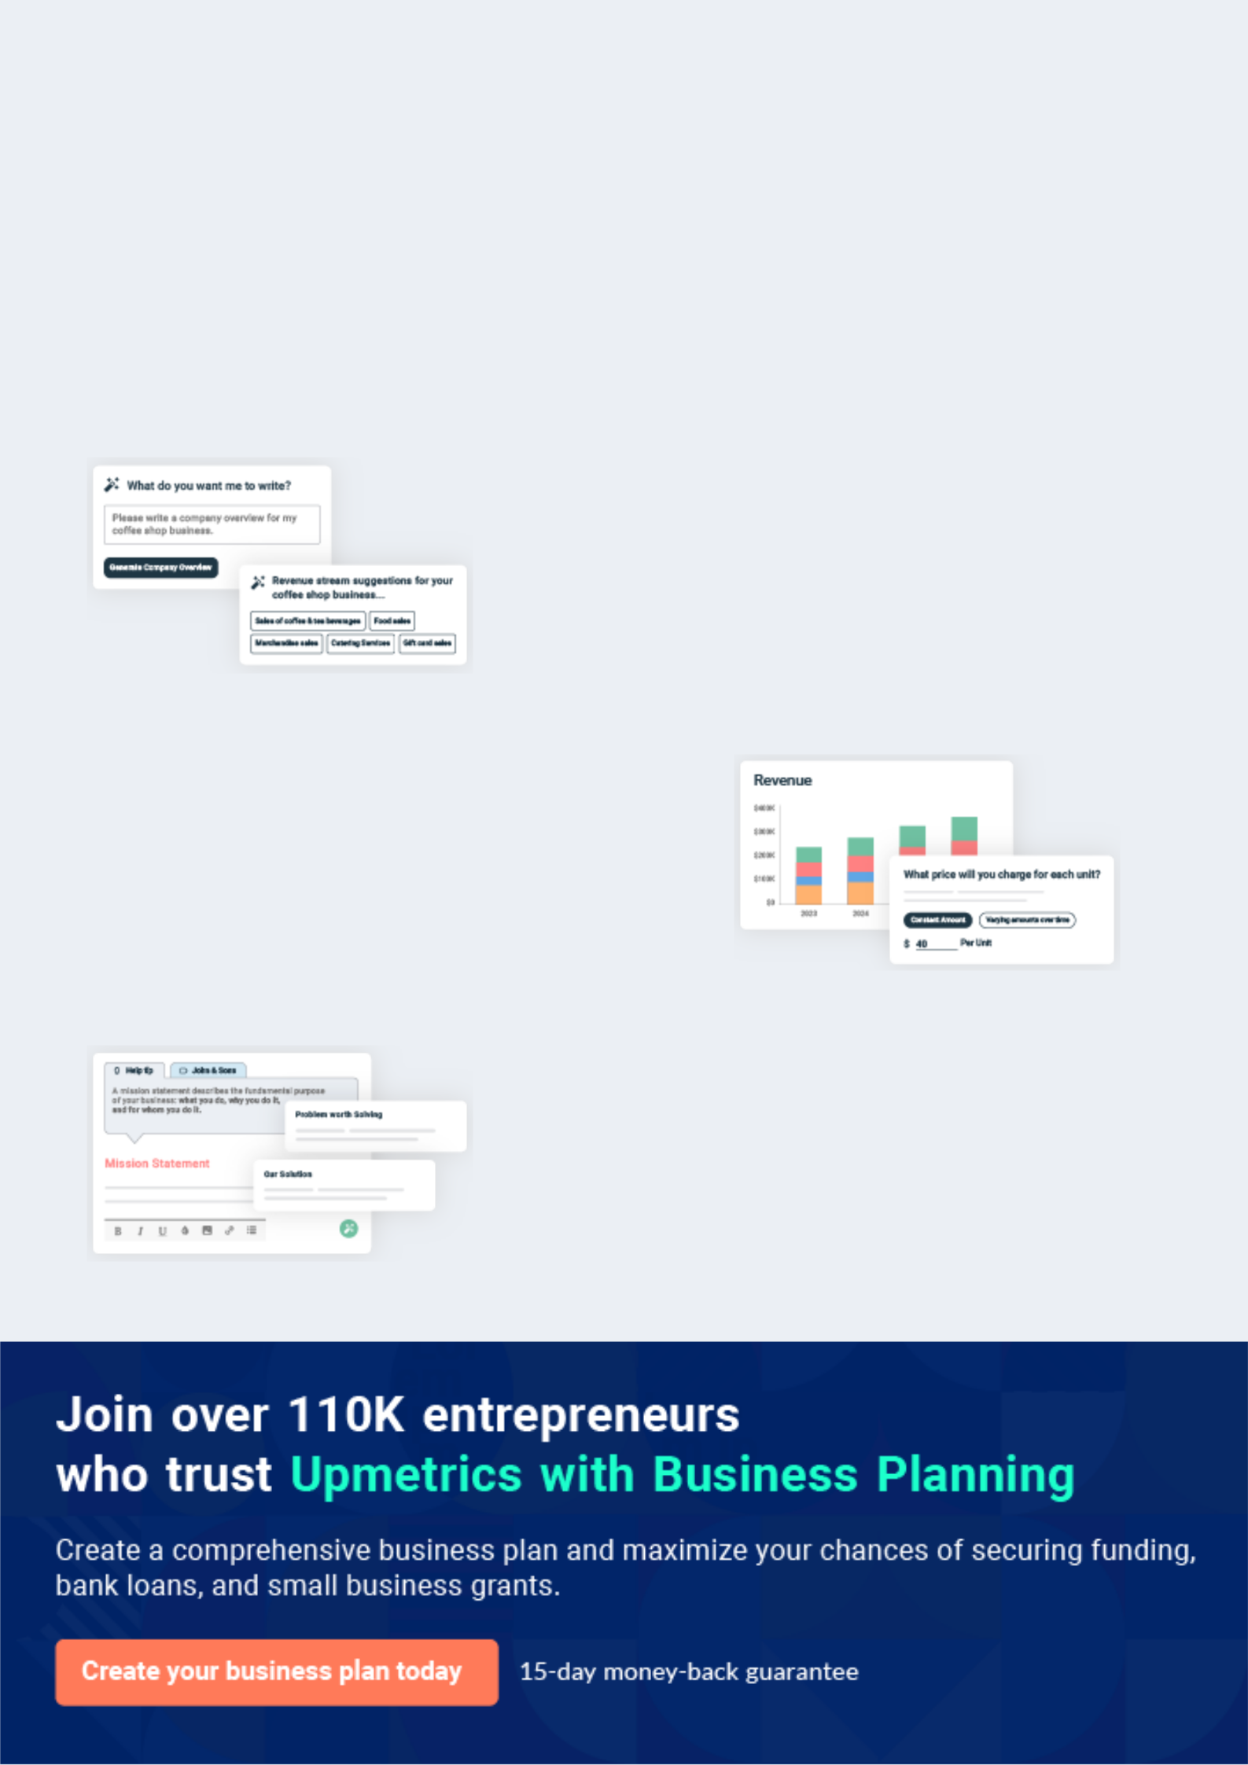
Business planning that’s simpler and faster than you think

Creating a business plan using Upmetrics to start and grow a business is literally the easiest thing in the World. Simply read the instructions and fill in the blanks. It’s as simple as that.

❛ | Upmetrics has everything you need to create a | ❜
❛ | comprehensive business plan. | ❜

AI-powered Upmetrics Assistant

AI-powered insights to streamline your plan

Not sure where to start? Upmetrics’ AI Assistant will automatically generate ideas for each section of your plan and offer improved versions of your writing, adjusting for tone, voice, and grammar or spelling errors.

Financial Forecasting Tool

All the financials are calculated for you

Forget the complex formulas and clumsy spreadsheets — with automatic financials and drag-and-drop forecasting, you can finish your plan faster and be confident that your numbers are accurate.

Business Plan Builder

Guides you like a business mentor

Upmetrics’ step-by-step instructions, prompts, and the library of 400+ sample business plans will guide you through each section of your plan as a business mentor.

1.


Executive Summary

The Business

Management

Customers

Business Target

Social Media Marketing | Business Plan [YEAR] 5/37

Before you think about how to start a social media management business, you must create a detailed social media management business plan. It will not only guide you in the initial phases of your startup but will also help you
To unlock help try Upmetrics!
To unlock help try Upmetrics!
To unlock help try Upmetrics! 

 Ex :: Rebox


Rebox Consultants is a U.S based and world-class social media marketing company. We have been able to secure a standard and well – positioned office facility in a central business district in Austin, Texas.



Start writing here..

The Business

 Ex :: Rebox

Rebox Consultants is a social media management company based in Austin, Texas. The company will provide wide-ranging services for all major platforms including but not limited to Facebook, Instagram, Twitter, Pinterest, and YouTube.



Start writing here..

Management

 Ex :: Rebox

Rebox Consultants is owned by Natalie Gordon, a digital marketing guru. Natalie will hire an experienced social media team of graphic designers, SEO specialists, and content writers. She will also work with freelance service providers located around the world._{To unlock help try Upmetrics!} 

Start writing here..

Social Media Marketing | Business Plan [YEAR] 6/37

Customers
To unlock help try Upmetrics!

 Ex :: Rebox

Rebox Consultants will provide social media management services to businesses located around the world, ranging from small startups to multinational corporations.
To unlock help try Upmetrics! 

Start writing here..

Business Target

 Ex :: Rebox

Our target is to become one of the top social media management group with the next 2-3 years. We also aim to achieve a net profit margin of $10k per month by the end of the first year, $15k per month by the end of the second year, and so on every year.



Start writing here..

Social Media Marketing | Business Plan [YEAR] 7/37

3 Year profit forecast
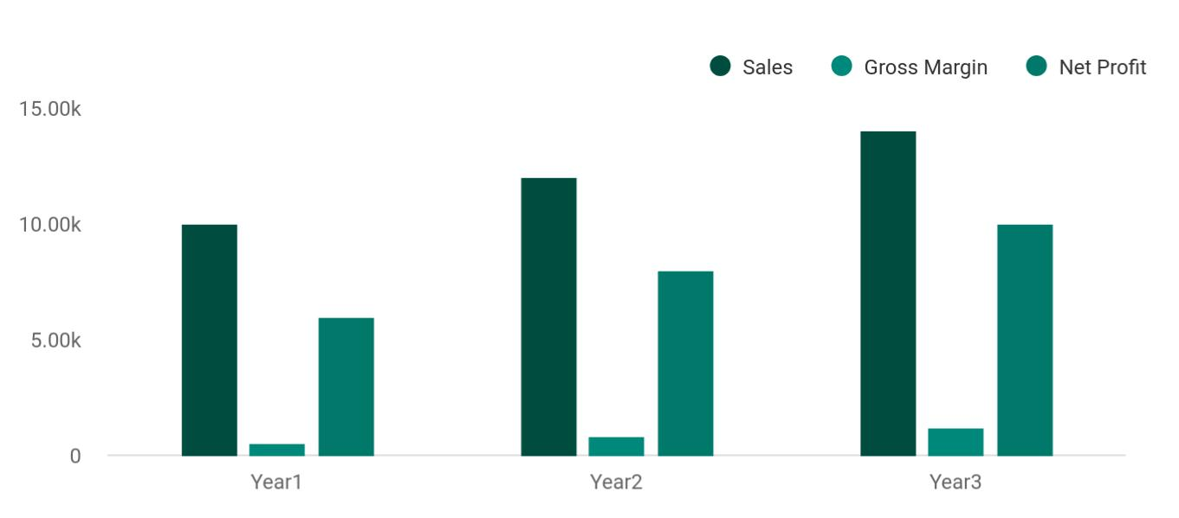

Financial Year | Sales | Gross Margin | Net Profit
Year1 | 10,000 | 500 | 6,000
Year2 | 12,000 | 800 | 8,000
Year3 | 14,000 | 1,200 | 10,000

Social Media Marketing | Business Plan [YEAR] 8/37

2.

Company Summary

Company Owner

Why the business is being started?

How the business will be started?

Social Media Marketing | Business Plan [YEAR] 9/37

Company Owner

 Ex :: Rebox

Rebox Consultants is owned by Natalie Gordon, a digital marketing guru. After completing her bachelor in Digital Advertising, Natalie worked with several marketing giants for more than 10 years. She served in a variety of positions ranging from technical to managerial.
To unlock help try Upmetrics! 

Start writing here..

Why the business is being started?

 Ex :: Rebox

Natalie is a well-known figure in the world of marketing and is famous for designing innovative social media marketing strategies. Her passion for digital marketing is what led her to start her own business. Being highly experienced in this field, she knows how to start a social media
To unlock help try Upmetrics! 

Start writing here..

How the business will be started?

 Ex :: Rebox

Rebox Consultants will be located in Austin, Texas. A working space that was previously in use by a Web Hosting firm will be acquired on lease. It will serve as our company headquarter, though our team will also be working remotely. Natalie will hire an experienced social media
To unlock help try Upmetrics! 

Start writing here..

Social Media Marketing | Business Plan [YEAR] 10/37

Startup cost
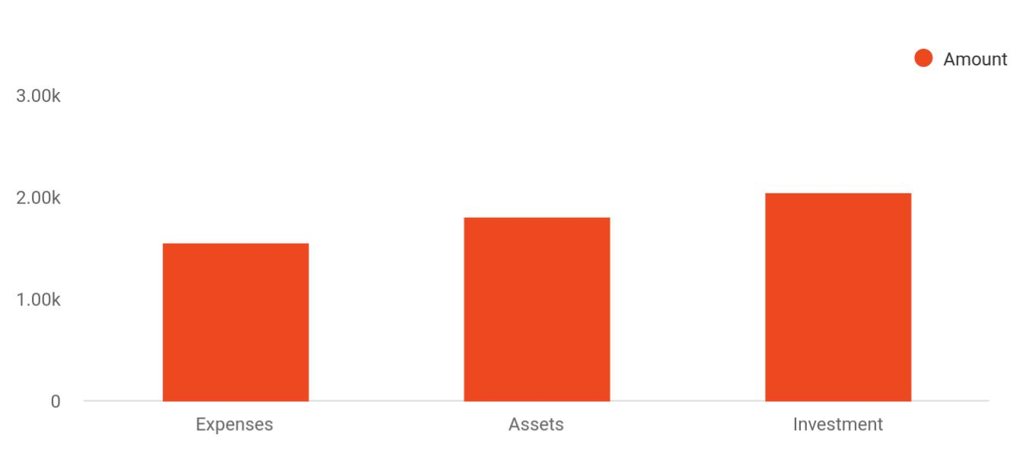

Cost distribution | Amount
Expenses | 1,550
Assets | 1,800
Investment | 2,050

Startup Requirements

The detailed startup requirements are given below:

Start-up Expenses | Amount
Legal | $55300
Consultants | $0
Insurance | $32750
Rent | $32500
Research and Development | $32750
Equipment Expense | $32750
Signs | $1250
TOTAL START-UP EXPENSES | $187300
Start-up Assets | $220875
Cash Required | $332500
Start-up Inventory | $32625

Social Media Marketing | Business Plan [YEAR] 11/37

Start-up Expenses | Amount
Other Current Assets | $232500
Long-term Assets | $235000
TOTAL ASSETS | $121875
Total Requirements | $245000
START-UP FUNDING
START-UP FUNDING | $273125
Start-up Expenses to Fund | $151875
Start-up Assets to Fund | $123000
TOTAL FUNDING REQUIRED | $0
Assets | $23125
Non-cash Assets from Start-up | $18750
Cash Requirements from Start-up | $0
Additional Cash Raised | $18750
Cash Balance on Starting Date | $21875
TOTAL ASSETS | $373125
Liabilities and Capital | $0
Liabilities | $0
Current Borrowing | $0
Long-term Liabilities | $0
Accounts Payable (Outstanding Bills) | $0
Other Current Liabilities (interest-free) | $0
TOTAL LIABILITIES | $0
Capital | $620125
Planned Investment | $620125
Investor 1 | $0
Investor 2 | $0
Other | $0
Additional Investment Requirement | $0

Social Media Marketing | Business Plan [YEAR] 12/37

Start-up Expenses | Amount
TOTAL PLANNED INVESTMENT | $620125
The loss at Start-up (Start-up Expenses) | $313125
TOTAL CAPITAL | $251875
TOTAL CAPITAL AND LIABILITIES | $251875
Total Funding | $255000

Social Media Marketing | Business Plan [YEAR] 13/37

3.

Products

Products and services

Social Media Marketing | Business Plan [YEAR] 14/37

 Ex :: Rebox

Rebox Consultants will provide wide-ranging social media management services for all major platforms including but not limited to Facebook, Instagram, Twitter, Pinterest, and YouTube. Our primary services, as highlighted by our social media consulting business plan, are as follows:
To unlock help try Upmetrics! 

Start writing here..

Products and services



Marketing
Advertising and
consultation and
branding services
advisory services



Social media profile
Blogging and
management
specialty services
services

Social Media Marketing | Business Plan [YEAR] 15/37

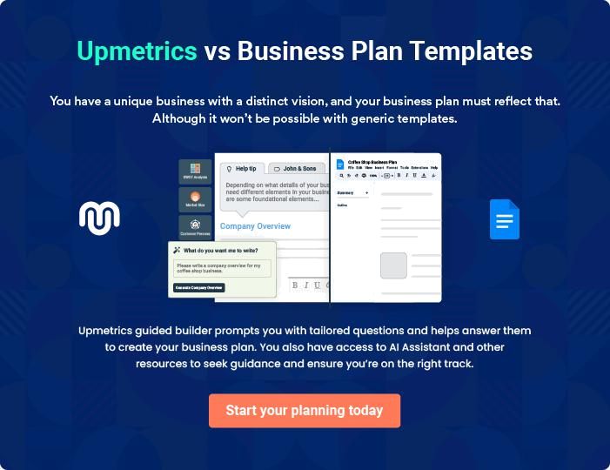

Social Media Marketing | Business Plan [YEAR] | 16/37

4.

Marketing Analysis

Market Trends

Marketing Segmentation

Business Target

Product Pricing

Social Media Marketing | Business Plan [YEAR] 17/37

Marketing analysis of your startup is an important part of your business plan as it indicates who your future customers will be and how you can attract them toward you. Owing to its nature, marketing analysis should be done well
To unlock help try Upmetrics! 

Market Trends

 Ex :: Rebox

According to IBIS World, the US advertising industry generates revenue of more than $54.5 billion annually. A major part of this astronomical amount is contributed by the social media advertising industry. That’s why any business in this niche can prove extremely beneficial for
To unlock help try Upmetrics! 

Start writing here..

Marketing Segmentation

 Ex :: Rebox

Rebox Consultants will provide social media management services to businesses located around the world. We will be serving companies ranging from small startups to multinational corporations. Our potential customers are divided into the following target groups.
To unlock help try Upmetrics! 

Start writing here..

Marketing share
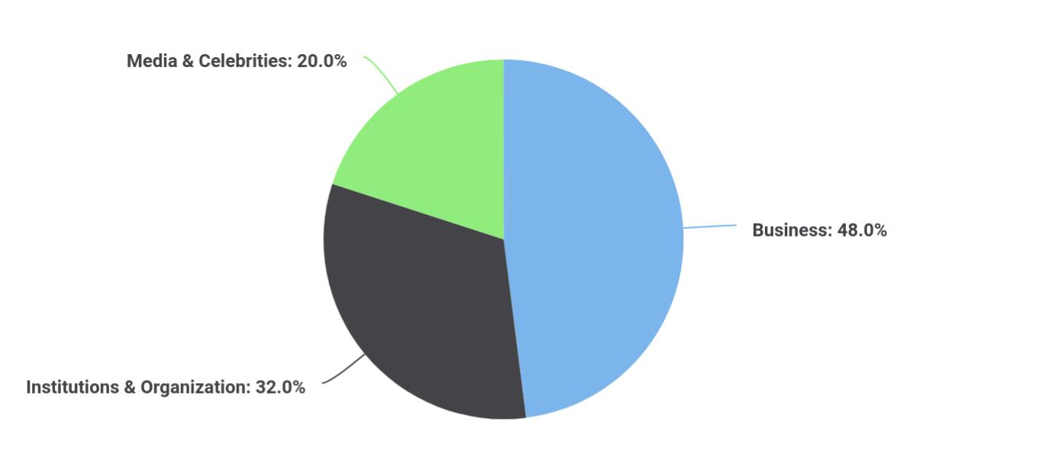

Social Media Marketing | Business Plan [YEAR] 18/37

To unlock help try Upmetrics!
Segments | Market share
Business | 48
Institutions & Organization | 32
Media & Celebrities | 20

 Ex :: Rebox

The primary category of our customers will be the owners of both small and large businesses located across the globe. We will manage their social media profiles across all platforms such as their Facebook, Instagram, Twitter, Pinterest, and YouTube accounts. Our aim will be to
To unlock help try Upmetrics! 

Businesses

Start writing here..

 Ex :: Rebox

Our second target group will comprise of various institutions and organizations located around the world. We will provide social media management services to both public and private sector organizations such as schools, colleges and universities, political parties, sports organizations,
To unlock help try Upmetrics! 

Institutions & Organizations

Start writing here..

 Ex :: Rebox

Our third target group will be media groups such as magazines, newspapers, and digital media outlets. We will also manage the social media accounts of all kinds of celebrities including but not limited to actors, sportsperson, and politicians.



Media & Celebrities

Start writing here..


Market Analysis

Potential Customers

Growth

Year 1

Year 2

Year 3

Year 4

Year 5

CAGR

Social Media Marketing | Business Plan [YEAR] 19/37


Market Analysis

Businesses | 48% | 22 334 | 32 344 | 43 665 | 52 544 | 66 432 | 10,00%
Institutions & Organisations | 32% | 12 867 | 14 433 | 15 999 | 17 565 | 19 131 | 15,32%
Media & Celebrities | 20% | 11 433 | 13 344 | 16 553 | 18 745 | 20 545 | 13,43%
Total | 100% | 46 634 | 60 121 | 76 217 | 88 854 | 106 108 | 9,54%

Business Target

 Ex :: Rebox

We aim to become one of the top social media management group with the next 2-3 years. Our other business targets are as follows:
To unlock help try Upmetrics! 

Start writing here..

Product Pricing

 Ex :: Rebox

After considering the market demands, we will be charging almost the same prices as charged by our leading competitors. But we will be offering several discounts to introduce our services.
To unlock help try Upmetrics! 

Start writing here..

Social Media Marketing | Business Plan [YEAR] 20/37

5.

Strategy

Competitive Analysis

Sales Strategy

Social Media Marketing | Business Plan [YEAR] 21/37

After you have identified your target audience, the next step is to attract them towards you and convert them into loyal customers. It can only be achieved using a brilliant sales strategy.
To unlock help try Upmetrics!



Competitive Analysis

 Ex :: Rebox

Social media is undoubtedly the face of any business. No matter how good a business is, customers judge it from its social media content as well as the number of its social media followers. Moreover, it is also very important for all businesses, irrespective of their size and
To unlock help try Upmetrics! 

Start writing here..

Sales Strategy

 Ex :: Rebox

Here is how we will be converting our target audience into our customers.

• We will advertise our services through all platforms, especially by social media
To unlock help try Upmetrics! 

Start writing here..

Sales Monthly
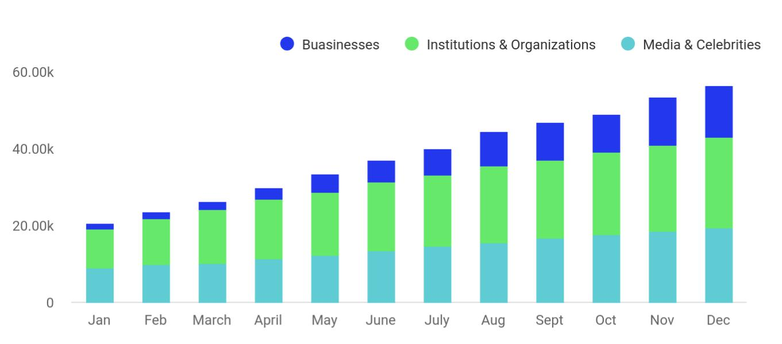

Social Media Marketing | Business Plan [YEAR] 22/37

Month | Buasinesses | Institutions & Organizations | Media & Celebrities
Jan | 1,550 | 10,000 | 8,956
Feb | 1,800 | 12,000 | 9,845
March | 2,050 | 14,000 | 10,245
April | 3,050 | 15,457 | 11,452
May | 4,500 | 16,457 | 12,345
June | 5,740 | 17,845 | 13,457
July | 6,874 | 18,652 | 14,569
Aug | 8,956 | 19,874 | 15,654
Sept | 9,854 | 20,145 | 16,784
Oct | 10,000 | 21,457 | 17,564
Nov | 12,457 | 22,356 | 18,654
Dec | 13,547 | 23,458 | 19,541

Sales Yearly
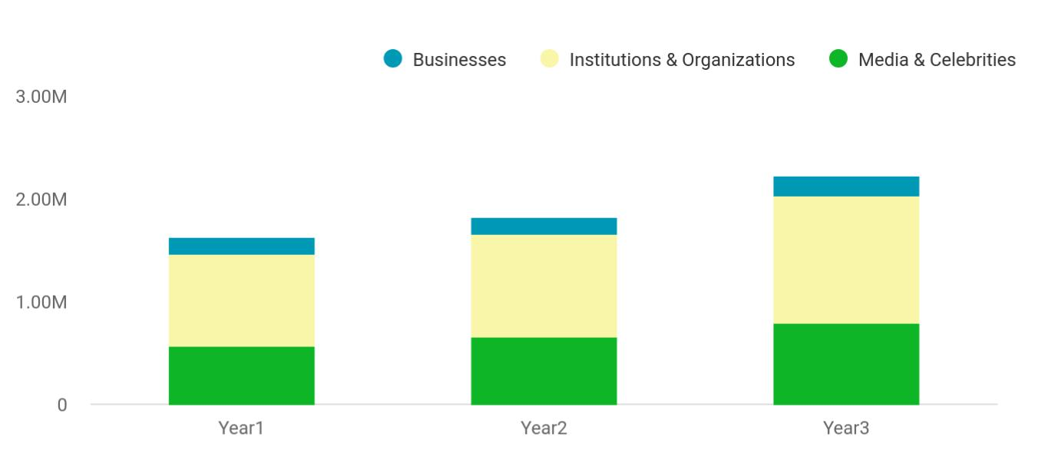

Financial Year | Businesses | Institutions & Organizations | Media & Celebrities
Year1 | 158,745 | 895,665 | 568,654
Year2 | 164,548 | 1,004,512 | 658,457
Year3 | 186,541 | 1,245,587 | 784,512

Social Media Marketing | Business Plan [YEAR] 23/37

Sales Forecast
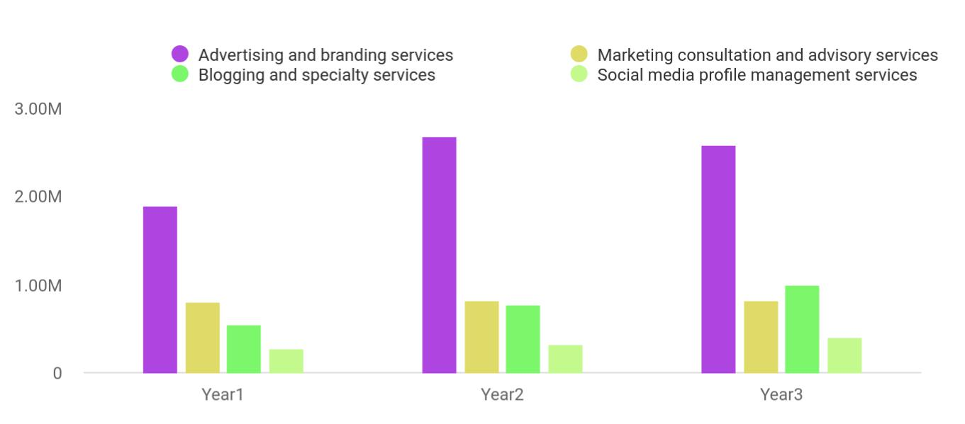

Financial Year | Advertising and bons | Marketing consultons | Blogging and speons | Social media profions
Year1 | 1,887,030 | 802,370 | 539,320 | 265,450
Year2 | 2,680,320 | 815,430 | 770,230 | 322,390
Year3 | 2,588,240 | 823,540 | 1,002,310 | 393,320

Social Media Marketing | Business Plan [YEAR] 24/37

6.

Personnel plan

Company Staff

Average Salary of Employees

Social Media Marketing | Business Plan [YEAR] 25/37

You will need to hire a highly trained staff for starting a social media management business due to the intensity of competition in this niche. It
must be done before you think about other aspects of how to set up a social
To unlock help try Upmetrics! 

Company Staff

 Ex :: Rebox

Natalie will manage the business herself and will be hiring the following people on a contract basis.
To unlock help try Upmetrics! 

Start writing here..

Average Salary of Employees

Personnel Plan | Year 1 | Year 2 | Year 3
Accountant | $85 000 | $95 000 | $105 000
Receptionist | $50 000 | $55 000 | $60 000
Graphic Artists | $187 000 | $194 000 | $201 000
SEO Specialists | $150 000 | $155 000 | $165 000
Content Writers | $145 000 | $152 000 | $159 000
Assistants | $85 000 | $95 000 | $105 000
Total Salaries | $295 000 | $307 000 | $324 000

Social Media Marketing | Business Plan [YEAR] 26/37

7.

Financial Plan

Important Assumptions

Brake-even Analysis

Projected Profit and Loss

Projected Cash Flow

Projected Balance Sheet

Business Ratios

Social Media Marketing | Business Plan [YEAR] 27/37

The success of a business heavily depends on its financial plan because it helps you take all major decisions about your startup. A good financial plan must include all expenses of your startup as well as the forecasted profits so
To unlock help try Upmetrics! 

Important Assumptions

 | Year 1 | Year 2 | Year 3
Plan Month | 1 | 2 | 3
Current Interest Rate | 10,00% | 11,00% | 12,00%
Long-term Interest Rate | 10,00% | 10,00% | 10,00%
Tax Rate | 26,42% | 27,76% | 28,12%
Other | 0 | 0 | 0

Brake-even Analysis

Monthly Units Break-even | 5530
Monthly Revenue Break-even | $159 740
Assumptions:
Average Per-Unit Revenue | $260,87
Average Per-Unit Variable Cost | $0,89
Estimated Monthly Fixed Cost | $196 410

Projected Profit and Loss

 | 2024 | 2025 | 2026
Revenue | $704,851.22 | $1,086,924.22 | $1,700,037.45
Social Media Management | $238,875 | $429,135 | $770,340
Services | $238,875 | $429,135 | $770,340
Unit Sales | 159 | 286 | 514
Unit Price | $1,500 | $1,500 | $1,500

Social Media Marketing | Business Plan [YEAR] 28/37

Content Creation and Strategy

Unit Sales

Unit Price

Training and Workshops

Cost Of Sales

General Costs

Content Creation Costs

Graphic Design Services

Video Production Services

Platform and Tooling Costs

Social Media Management Tools

Website Hosting and

Maintenance

Revenue Specific Costs

Personnel Costs (Direct Labor)

Gross Margin

Gross Margin (%)

Operating Expense

Payroll Expense (Indirect Labor)

Management Team

General Manager

2024 | 2025 | 2026
$425,740 | $606,760 | $864,980
213 | 303 | 432
$2,000 | $2,000 | $2,000
$40,236.22 | $51,029.22 | $64,717.45

$73,642.55 | $94,063.22 | $126,209.02
$73,642.55 | $94,063.22 | $126,209.02
$59,242.55 | $79,375.22 | $111,227.26
$24,000 | $25,029 | $26,225.40
$35,242.55 | $54,346.22 | $85,001.86
$14,400 | $14,688 | $14,981.76
$9,600 | $9,792 | $9,987.84
$4,800 | $4,896 | $4,993.92
$0 | $0 | $0
$0 | $0 | $0

$631,208.67 | $992,861 | $1,573,828.43
89.55% | 91.35% | 92.58%

$648,350.27 | $715,959.26 | $815,064.76
$498,120 | $515,234.40 | $533,009.40
$230,400 | $241,056 | $252,210.24
$144,000 | $151,200 | $158,760

Social Media Marketing | Business Plan [YEAR] 29/37

Marketing Manager

Creative Team

Graphic Designer

Content Writer

Support Staff

Administrative Assistant

Customer Support

Representative

General Expense

Marketing and Advertising Costs

Online Advertising

Print Media Advertising

Office and Administration

Office Rent

Utilities

Technology and

Communication

Software Subscriptions

Communication Expenses

Bad Debt

Amortization of Current Assets

EBITDA

Additional Expense

Long Term Depreciation

2024 | 2025 | 2026
$86,400 | $89,856 | $93,450.24
$110,400 | $113,712 | $117,123.36
$62,100 | $63,963 | $65,881.92
$48,300 | $49,749 | $51,241.44
$157,320 | $160,466.40 | $163,675.80
$41,400 | $42,228 | $43,072.56
$115,920 | $118,238.40 | $120,603.24
$149,230.67 | $200,724.87 | $282,055.36
$82,485.13 | $120,932.41 | $182,488.56
$70,485.13 | $108,692.41 | $170,003.76
$12,000 | $12,240 | $12,484.80
$39,600 | $40,596 | $41,619.96
$30,000 | $30,900 | $31,827
$9,600 | $9,696 | $9,792.96
$27,145.54 | $39,196.46 | $57,946.84
$6,000 | $6,588.75 | $6,945.72
$21,145.54 | $32,607.71 | $51,001.12
$0 | $0 | $0
$999.60 | $0 | $0

($17,141.60) $276,901.74 $758,763.67

$9,616.80 | $7,373.24 | $4,967.49
$3,600 | $3,600 | $3,600

Social Media Marketing | Business Plan [YEAR] 30/37

Gain or loss from Sale of Assets

EBIT

Interest Expense

EBT

Income Tax Expense / Benefit

Total Expense

Net Income

Net Income (%)

Retained Earning Opening

Owner's Distribution

Retained Earning Closing

2024 | 2025 | 2026
$0 | $0 | $0
($20,741.60) | $273,301.74 | $755,163.67
$6,016.82 | $3,773.25 | $1,367.48
($26,758.40) | $269,528.50 | $753,796.18
$0 | $0 | $0

$731,609.62 | $817,395.72 | $946,241.27
($26,758.40) | $269,528.50 | $753,796.18
(3.80%) | 24.80% | 44.34%

$0 | ($44,758.40) | $216,770.10
$18,000 | $8,000 | $8,000
($44,758.40) | $216,770.10 | $962,566.28

Projected Cash Flow

 | 2024 | 2025 | 2026
Cash Received | $704,851.22 | $1,086,924.22 | $1,700,037.45
Cash Paid | $727,010.02 | $813,795.72 | $942,641.27
COS & General Expenses | $222,873.22 | $294,788.08 | $408,264.38
Salary & Wages | $498,120 | $515,234.40 | $533,009.40
Interest | $6,016.82 | $3,773.25 | $1,367.48
Sales Tax | $0 | $0 | $0
Income Tax | $0 | $0 | $0

Social Media Marketing | Business Plan [YEAR] 31/37

 | 2024 | 2025 | 2026
Net Cash From | ($22,158.80) | $273,128.50 | $757,396.18
Operations | ($22,158.80) | $273,128.50 | $757,396.18

Assets Sell | $0 | $0 | $0
Assets Purchase | $21,000 | $0 | $0
Net Cash From | ($21,000) | $0 | $0
Investments | ($21,000) | $0 | $0

Amount Received | $150,000 | $0 | $0
Loan Received | $100,000 | $0 | $0
Common Stock | $0 | $0 | $0
Preferred Stock | $0 | $0 | $0
Owner's Contribution | $50,000 | $0 | $0
Amount Paid | $49,035.72 | $41,279.28 | $43,685.02
Loan Capital | $31,035.70 | $33,279.27 | $35,685.03
Dividends & Distributions | $18,000 | $8,000 | $8,000
Net Cash From | $100,964.28 | ($41,279.28) | ($43,685.02)
Financing | $100,964.28 | ($41,279.28) | ($43,685.02)

Summary

Starting Cash | $0 | $57,805.48 | $289,654.70
Cash In | $854,851.22 | $1,086,924.22 | $1,700,037.45
Cash Out | $797,045.74 | $855,075 | $986,326.29
Change in Cash | $57,805.48 | $231,849.22 | $713,711.16
Ending Cash | $57,805.48 | $289,654.70 | $1,003,365.86

Social Media Marketing | Business Plan [YEAR] 32/37

Projected Balance Sheet

 | 2024 | 2025 | 2026
Assets | $74,205.88 | $302,455.10 | $1,012,566.26
Current Assets | $57,805.88 | $289,655.10 | $1,003,366.26
Cash | $57,805.48 | $289,654.70 | $1,003,365.86
Accounts Receivable | $0 | $0 | $0
Inventory | $0 | $0 | $0
Other Current Assets | $0.40 | $0.40 | $0.40
Long Term Assets | $16,400 | $12,800 | $9,200
Gross Long Term Assets | $20,000 | $20,000 | $20,000
Accumulated Depreciation | ($3,600) | ($7,200) | ($10,800)
Liabilities & Equity | $74,205.89 | $302,455.12 | $1,012,566.28
Liabilities | $68,964.29 | $35,685.02 | $0
Current Liabilities | $33,279.27 | $35,685.02 | $0
Accounts Payable | $0 | $0 | $0
Income Tax Payable | $0 | $0 | $0
Sales Tax Payable | $0 | $0 | $0
Short Term Debt | $33,279.27 | $35,685.02 | $0
Long Term Liabilities | $35,685.02 | $0 | $0
Long Term Debt | $35,685.02 | $0 | $0
Equity | $5,241.60 | $266,770.10 | $1,012,566.28
Paid-in Capital | $0 | $0 | $0
Common Stock | $0 | $0 | $0
Preferred Stock | $0 | $0 | $0
Owner's Contribution | $50,000 | $50,000 | $50,000

Social Media Marketing | Business Plan [YEAR] 33/37

 | 2024 |  |  | 2025 |  | 2026
Retained Earnings | ($44,758.40) |  | $216,770.10 |  |  | $962,566.28
Check | $0 |  |  | $0 |  | $0
Business Ratios
 |  | Year 1 | Year 2 |  | Year 3 | Industry Profile
Sales Growth |  | 4,35% | 30,82% |  | 63,29% | 4,00%
Percent of Total Assets
Accounts Receivable |  | 5,61% | 4,71% |  | 3,81% | 9,70%
Inventory |  | 1,85% | 1,82% |  | 1,79% | 9,80%
Other Current Assets |  | 1,75% | 2,02% |  | 2,29% | 27,40%
Total Current Assets |  | 138,53% | 150,99% |  | 163,45% | 54,60%
Long-term Assets |  | -9,47% | -21,01% |  | -32,55% | 58,40%
TOTAL ASSETS |  | 100,00% | 100,00% |  | 100,00% | 100,00%
Current Liabilities |  | 4,68% | 3,04% |  | 2,76% | 27,30%
Long-term Liabilities |  | 0,00% | 0,00% |  | 0,00% | 25,80%
Total Liabilities |  | 4,68% | 3,04% |  | 2,76% | 54,10%
NET WORTH |  | 99,32% | 101,04% |  | 102,76% | 44,90%
Percent of Sales
Sales |  | 100,00% | 100,00% |  | 100,00% | 100,00%
Gross Margin |  | 94,18% | 93,85% |  | 93,52% | 0,00%
Selling, General & Administrative Expenses |  | 74,29% | 71,83% |  | 69,37% | 65,20%
Advertising Expenses |  | 2,06% | 1,11% |  | 0,28% | 1,40%
Profit Before Interest and Taxes |  | 26,47% | 29,30% |  | 32,13% | 2,86%
Main Ratios
Current |  | 25,86 | 29,39 |  | 32,92 | 1,63
Quick |  | 25,4 | 28,88 |  | 32,36 | 0,84

Social Media Marketing | Business Plan [YEAR] 34/37

 | Year 1 | Year 2 | Year 3 | Industry Profile
Total Debt to Total Assets | 2,68% | 1,04% | 0,76% | 67,10%
Pre-tax Return on Net Worth | 66,83% | 71,26% | 75,69% | 4,40%
Pre-tax Return on Assets | 64,88% | 69,75% | 74,62% | 9,00%
Additional Ratios | Year 1 | Year 2 | Year 3
Net Profit Margin | 19,20% | 21,16% | 23,12% | N.A.
Return on Equity | 47,79% | 50,53% | 53,27% | N.A.
Activity Ratios
Accounts Receivable Turnover | 4,56 | 4,56 | 4,56 | N.A.
Collection Days | 92 | 99 | 106 | N.A.
Inventory Turnover | 19,7 | 22,55 | 25,4 | N.A.
Accounts Payable Turnover | 14,17 | 14,67 | 15,17 | N.A.
Payment Days | 27 | 27 | 27 | N.A.
Total Asset Turnover | 1,84 | 1,55 | 1,26 | N.A.
Debt Ratios
Debt to Net Worth | 0 | -0,02 | -0,04 | N.A.
Current Liab. to Liab. | 1 | 1 | 1 | N.A.
Liquidity Ratios
Net Working Capital | $120 943 | $140 664 | $160 385 | N.A.
Interest Coverage | 0 | 0 | 0 | N.A.
Additional Ratios
Assets to Sales | 0,45 | 0,48 | 0,51 | N.A.
Current Debt/Total Assets | 4% | 3% | 2% | N.A.
Acid Test | 23,66 | 27,01 | 30,36 | N.A.
Sales/Net Worth | 1,68 | 1,29 | 0,9 | N.A.
Dividend Payout | 0 | 0 | 0 | N.A.

Social Media Marketing | Business Plan [YEAR] 35/37

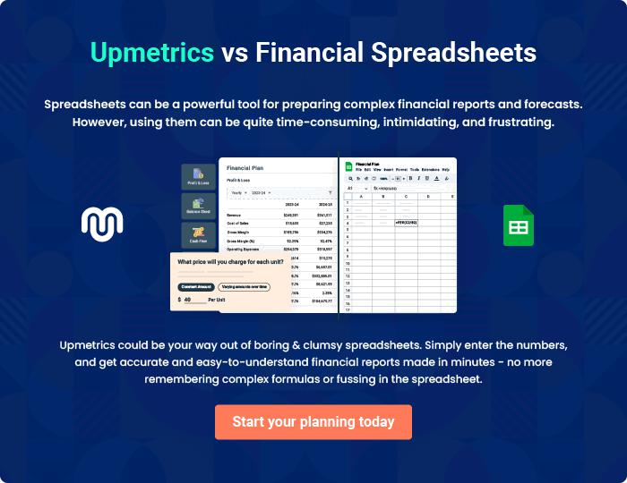

Social Media Marketing | Business Plan [YEAR] | 36/37


Create a winning business plan that gets you funded

Creating a stunning and investment-ready plan requires no writing, graphic designing, or financial planning expertise.

Upmetrics has all the features required to help you create a comprehensive business plan—from start to finish. Make no mistakes, it’s the modern way of planning to structure ideas, make plans, and create stunning pitch decks to awe investors.

Pitch decks that impress investors

Create pitch decks that provide a visual representation of your business, engage investors, and make them want to invest in your business idea.

Interactive plans in no time

Import business plan sections like—SWOT analysis, comparison tables, and others to create an interactive business plan. No designing skills are required.

Stunning cover page designs

With Upmetrics, you have the liberty to choose from multiple stunning cover page designs. Choose a creative design and make your plan stand out.

Online sharing made simple

Upmetrics makes online sharing quick and easier for users. Easily share your business plans with a link while tracking reader activity.

500+ sample business plans

Simply import a template from our library of sample plans into the editor and start customizing it to make it yours. It takes only a few clicks to get started.

Collaborate with team in real-time

Invite team members, initiate conversations, discuss ideas & strategies, share feedback, and work on a business plan in real-time.

