


Small Business

BUSINESS PLAN

[Your Tagline]

Prepared By

John Doe

10200 Bolsa Ave, Westminster, CA, 92683

info@example.com

(650) 359-3153 https://example.com

Table of Contents

Executive Summary | 6
Business Description | 7
Mission Statement | 7
Goals | 7
Plan Summary | 8
Capital Request | 8

Business Description | 9
Business Overview | 10
Location | 10
Facilities | 10
Business History | 11
Ownership Structure | 11
Owners | 11

Operations | 12
Products | 13
Services | 13
Production System | 13
Customer Service | 14
Inventory Management | 14
Licenses, Permits & Regulations | 14
Patents and Trademarks | 15
Risk Management | 15
Environmental Issues | 15
Quality Control | 16
Implementation Timeline | 16

Market Analysis | 18
Industry analysis | 19

Small Business | Business Plan [YEAR] 2/37

Market Trends | 19
Customers | 19
Market Segments | 20
Target Market | 20
Market Size & Growth | 20

Marketing Plan | 22
Marketing Contracts | 23
Strategic Partners | 23
Pricing | 23
Promotion | 24
Distribution | 24
Competitive Advantage | 24
SWOT Analysis | 25

Management & Organization | 26
Management Team | 27
John Doe | 27
Board of Directors | 27
John Doe | 27
Advisory Board | 28
John Doe | 28
Personnel Plan | 28
Professional Services | 28

Financial Plan | 29
Financial Position | 30
Historical Performance | 30
Financial Projections | 30
Profit & Loss | 31
Cash Flow | 32
Balance Sheet | 33
Benchmarks | 35

Small Business | Business Plan [YEAR] 3/37

Capital Request | 35

Small Business | Business Plan [YEAR] 4/37

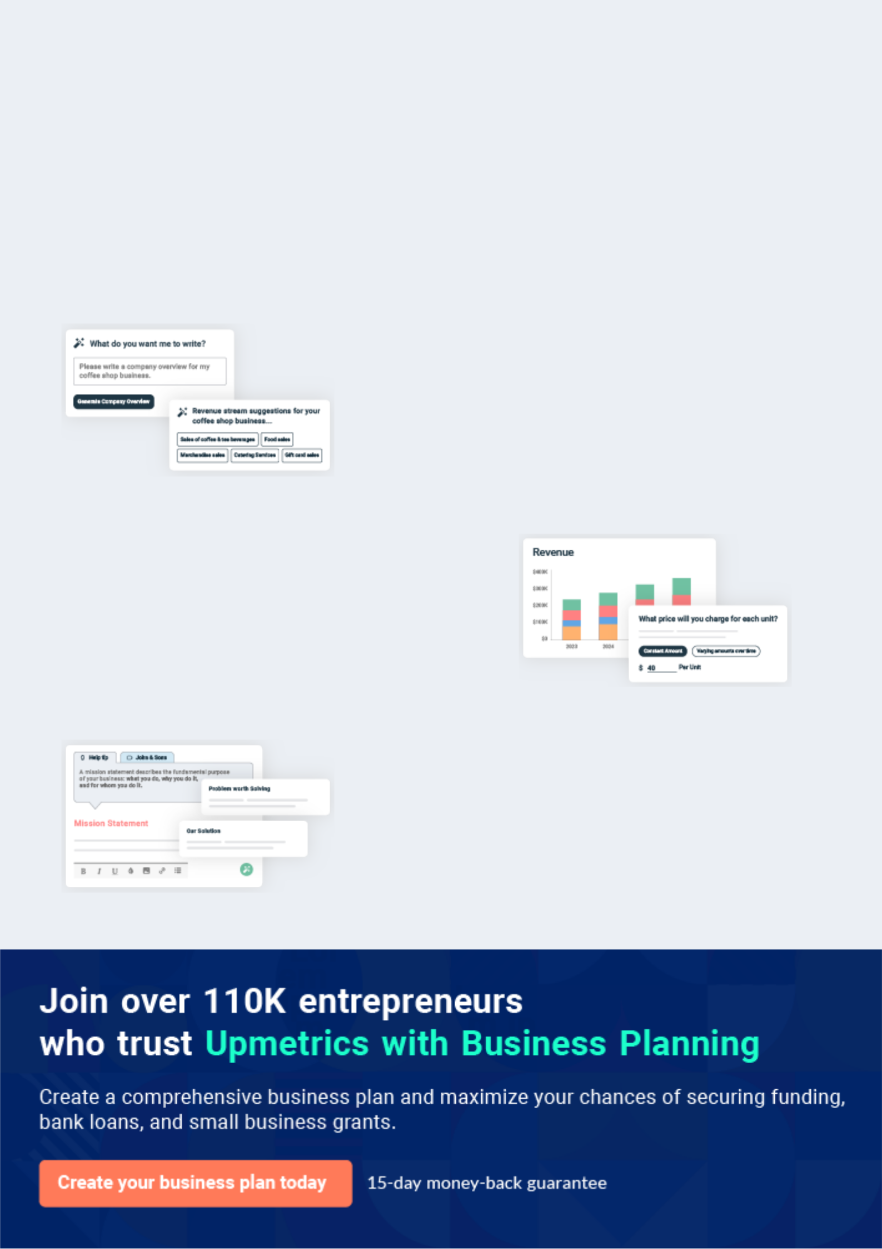
Business planning that’s simpler and faster than you think

Creating a business plan using Upmetrics to start and grow a business is literally the easiest thing in the World. Simply read the instructions and fill in the blanks. It’s as simple as that.

❛ | Upmetrics has everything you need to create a | ❜
❛ | comprehensive business plan. | ❜

AI-powered Upmetrics Assistant

AI-powered insights to streamline your plan

Not sure where to start? Upmetrics’ AI Assistant will automatically generate ideas for each section of your plan and offer improved versions of your writing, adjusting for tone, voice, and grammar or spelling errors.

Financial Forecasting Tool

All the financials are calculated for you

Forget the complex formulas and clumsy spreadsheets — with automatic financials and drag-and-drop forecasting, you can finish your plan faster and be confident that your numbers are accurate.

Business Plan Builder

Guides you like a business mentor

Upmetrics’ step-by-step instructions, prompts, and the library of 400+ sample business plans will guide you through each section of your plan as a business mentor.

1.


Executive Summary

Business Description

Mission Statement

Goals

Plan Summary

Capital Request

Small Business | Business Plan [YEAR] 6/37

The Executive Summary is the first page of your business plan(for Readers), but it should be the last chapter you write. It acts as both the introduction to, and the summary of, your entire idea. In other words, your Executive
To unlock help try Upmetrics!
To unlock help try Upmetrics! 

Business Description

 Help Tip  Riverbend Farm  Lakeshore Orchard


Provide a brief description of your operation. In a few sentences, help people who are unfamiliar with your business develop an understanding of what you produce, the size of your operation, and how you market your products.



Start writing here..

Mission Statement

 Help Tip


A mission statement describes the fundamental purpose of your business,
❛ To unlock help try Upmetrics! 

Start writing here..

Goals

 Help Tip


Goals help you communicate to others what you expect your business to accomplish. They should be specific, measurable, and attainable. You may want to include separate business and personal goals, as well as considering both short term and long term perspectives.
To unlock help try Upmetrics! 

Start writing here..

Small Business | Business Plan [YEAR] 7/37

Plan Summary

 Help Tip

Give a brief summary of your business plan. If you are starting a new business or making changes to your current business, describe what you intend to do, how you plan to do it, and the expected results. In particular, summarize your financial plan and your marketing plan. You may
To unlock help try Upmetrics! 

Start writing here..

Capital Request

 Help Tip

The most common reason for developing a business plan is to be able to present your ideas for a new or expanded business to investors or lenders. After you have described your plan, they will want to know how much money you need and the purpose for which you need it. Use this
To unlock help try Upmetrics! 

Start writing here..

Small Business | Business Plan [YEAR] 8/37

2.

Business Description

Business Overview

Location

Facilities

Business History

Ownership Structure

Small Business | Business Plan [YEAR] 9/37

Use this section and the following subsections to describe your business.

If you want a very brief business plan, write a full description in this main
To unlock help try Upmetrics! 

Start writing here..

Business Overview

 Help Tip

Briefly describe your business.

• What products do you produce, or what services do you provide?
To unlock help try Upmetrics! 

Start writing here..

Location

 Help Tip

- Where is your business located?

- Do you have multiple branches or locations?
To unlock help try Upmetrics! 

Start writing here..

Facilities

 Help Tip

Describe the size, type, and quality of your facilities and equipment. What about processing or marketing facilities? Describe the condition of your equipment and facilities.
To unlock help try Upmetrics! 

Start writing here..

Small Business | Business Plan [YEAR] 10/37

Business History

 Help Tip  Farming


Describe the history of your business and your value-added enterprise(s).

• When and how did it start?
To unlock help try Upmetrics! 

Start writing here..

Ownership Structure

 Help Tip  Farming

Describe the ownership and legal structure of the business.

• Is it a sole proprietorship, partnership, corporation, limited liability partnership, or
To unlock help try Upmetrics! 

Start writing here..

Owners

Small Business | Business Plan [YEAR] 11/37

3.

Operations

Products

Services

Production System

Customer Service

Inventory Management

Licenses, Permits & Regulations

Patents and Trademarks

Risk Management

Environmental Issues

Quality Control

Implementation Timeline

Small Business | Business Plan [YEAR] 12/37

Use this section and the following sub-sections to describe the operations of your business, including what you produce, how much you produce, and how you produce it.
To unlock help try Upmetrics!



Products

 Help Tip  Farming

If your business sells any products, provide a short description of each of the primary products you produce. You may want to describe the relative importance of each product to the overall profitability of your business. If you have more than a few products, you may want to describe
To unlock help try Upmetrics! 

Start writing here..

Services

 Help Tip

If your business sells services (i.e. custom work, hunting leases, tourism, consulting) provide a short description of each of the primary services you provide. Indicate the volume or quantity of each service. If you offer more than one service, describe the relative importance of each to
To unlock help try Upmetrics! 

Start writing here..

Production System

 Help Tip  Farming

In this section, discuss how it is that you do what you do. Describe your production or service delivery processes (manufacturing,etc.).
To unlock help try Upmetrics! 

Start writing here..

Small Business | Business Plan [YEAR] 13/37

Customer Service
To unlock help try Upmetrics!

 Help Tip

Good customer service is critical to maintaining and growing your customer base and is important whether you sell products or services. Describe what you do to provide good customer service.



Start writing here..

Inventory Management

 Help Tip


- How important is inventory management and storage for your business?

- Do you produce and distribute your product quickly or do you carry an inventory?
- Can you improve profits by turning your inventory more quickly? To unlock help try Upmetrics! 

Start writing here..

Licenses, Permits & Regulations

 Help Tip

Obtaining permits and understanding regulations are important factors when considering changes in any business. If your business requires licenses or permits (either now, or as a
result of any changes you are planning to make in connection with this business plan), list the
To unlock help try Upmetrics! 

Start writing here..

Small Business | Business Plan [YEAR] 14/37

Patents and Trademarks
To unlock help try Upmetrics!

 Help Tip

If you have patents, brands, or trademarks, or are in the process of obtaining them, document them and describe why they are important for your business.
To unlock help try Upmetrics! 

Start writing here..

Risk Management

 Help Tip  Farming

There are many risks associated with businesses, including production and weather risks, natural disasters, market and price risks, health and worker safety, legal liabilities, and financial risks. In this section, describe the methods and tools you use to manage risk.
To unlock help try Upmetrics! 

Start writing here..

Environmental Issues

 Help Tip  Farming

Environmental concerns and regulations are an important part of managing some business. Describe the environmental considerations associated with your enterprise(s) and how you address them.



Start writing here..

Small Business | Business Plan [YEAR] 15/37

Quality Control
To unlock help try Upmetrics!

 Help Tip  Farming

- What do you do in your business to deliver consistent, high-quality products or services?

- How do you build or maintain your reputation?
To unlock help try Upmetrics! 

Start writing here..

Implementation Timeline

 Help Tip

You have described your strategy. Now it is time to describe how you will get to where you want to be with your business. If you are going to be making major changes in the business, describe what will happen during the transition period.



Start writing here..

Small Business | Business Plan [YEAR] 16/37

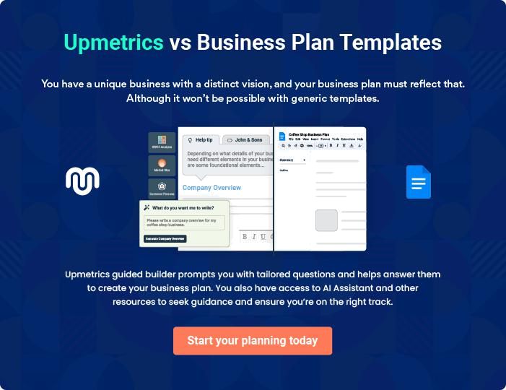

Small Business | Business Plan [YEAR] | 17/37

4.

Market Analysis

Industry analysis

Market Trends

Customers

Market Segments

Target Market

Small Business | Business Plan [YEAR] 18/37

Industry analysis

 Help Tip

Give a brief overview of the industry. Define the industry in terms of historical background, the geographic area it services, and the products it offers. Describe how your company will position itself within the industry. Focus on how your company can take advantage of opportunities
To unlock help try Upmetrics! 

Start writing here..

Market Trends

 Help Tip

Describe the market trends for your primary products or services and how they will impact your business.
To unlock help try Upmetrics! 

Start writing here..

Customers

 Help Tip

- Who are the customers for your primary products?

- Do you anticipate those customer changing? If so, what are the characteristics of these new customers that must be factored into your marketing plan? _{To unlock help try Upmetrics!} 

Start writing here..

Small Business | Business Plan [YEAR] 19/37

Market Segments
To unlock help try Upmetrics!

 Help Tip

Market segments are groups of customers that have similar needs or who will respond similarly to a marketing approach. You probably have different groups or types of customers to which you market your products.



Start writing here..

Target Market

 Help Tip

Who are your target markets? Identifying and understanding the market segments does not mean they will all be markets that you want to target.
To unlock help try Upmetrics! 

Start writing here..

 Help Tip

Indicating to your readers that your problem addresses a big enough market will play a huge role in how excited they’ll be about getting involved in helping your company. This is where you’ll want to put your research cap on and start uncovering some numbers that help your
To unlock help try Upmetrics! 

Market Size & Growth

Start writing here..

Small Business | Business Plan [YEAR] 20/37


Available Market

Served Market

Target Market
10k

7k

5k

Small Business | Business Plan [YEAR] 21/37

5.

Marketing Plan

Marketing Contracts

Strategic Partners

Pricing

Promotion

Distribution

Competitive Advantage

SWOT Analysis

Small Business | Business Plan [YEAR] 22/37

Use your marketing plan to describe what products you are marketing, how you will market the products when you will market the products, and to whom you will sell the products. A marketing plan includes an analysis of the
To unlock help try Upmetrics! 

Marketing Contracts

 Help Tip

Describe contracts that you have to produce and market products with processors, other producers, value-added ventures, or retail markets. If you provide services, describe the contracts that you have to deliver your services. Are there new contracts that you need to
To unlock help try Upmetrics! 

Start writing here..

Strategic Partners

 Help Tip

- Do you have strategic marketing, purchasing, distribution, promotion, or development alliances?

• How important are they to your business?
To unlock help try Upmetrics! 

Start writing here..

Pricing

 Help Tip

List the prices that you charge for your primary products or services. Why do you charge these prices? There are generally two major factors that determine prices: your cost to produce the product or provide the service, and the market price of comparable products or services.
To unlock help try Upmetrics! 

Start writing here..

Small Business | Business Plan [YEAR] 23/37

Promotion
To unlock help try Upmetrics!
To unlock help try Upmetrics!

 Help Tip

How will you promote your products or services? Your promotion plan will be different if you have an established market and name recognition compared to promoting new products or starting a new business.



Start writing here..

Distribution

 Help Tip

How do you distribute your products or services to your customers? Do you distribute to wholesale or retail markets? Do you distribute your products geographically; locally, regionally, nationally, or internationally?



Start writing here..

Competitive Advantage

 Help Tip

Who are your competitors? How well do you compete with them? Are your products different? Do you produce at a lower cost? Do you have better delivery or customer service? Do you have better market access? Do you have better brand recognition or customer loyalty?
To unlock help try Upmetrics! 

Start writing here..

Small Business | Business Plan [YEAR] 24/37

SWOT Analysis


Strength

Mention positive tangible and intangible attributes. Internal to your organization. which are within the organization's control.


Opportunity

External attractive factors that represent the reason for an organization to exist and develop. What opportunities exist in the environment which will propel the organization?

Weakness


Factors that are within an organization's control that detract from its ability to attain the core goal. In which areas might the organization improve?


Threat

External factors, beyond an organization‘s control, which could place the organization‘s mission or operation at risk. The organization may benefit by having contingency plans to address them should they occur.

Small Business | Business Plan [YEAR] 25/37

6.

Management &

Organization

Management Team

Board of Directors

Advisory Board

Personnel Plan

Professional Services

Small Business | Business Plan [YEAR] 26/37

Management Team
To unlock help try Upmetrics!

 Help Tip

List the members of your management team. Briefly describe their qualifications and their management roles. What major management functions need to be handled in your business? Are there gaps in your management team that need to be filled? How will management change
To unlock help try Upmetrics! 

Start writing here..


John Doe

CEO - johnd@example.com

Briefly describe his qualifications and his management/business roles.

Board of Directors

 Help Tip

If you are a corporation with a board of directors, list the board members, their affiliations, and the strengths they bring to your business. Describe how the board functions and how it participates in or oversees the management of the business.



Start writing here..


John Doe

Board Member - johnd@example.com

Small Business | Business Plan [YEAR] 27/37

Advisory Board
To unlock help try Upmetrics!

 Help Tip

Some businesses have an advisory board rather than a board of directors. If you have an advisory board, list the board members, their affiliations, and the strengths they bring to your business. Describe how the board functions and how it contributes to the business.
To unlock help try Upmetrics! 

Start writing here..


John Doe

Advisory Board Member - johnd@example.com

Personnel Plan

 Help Tip

List the major tasks, including operations, marketing, and financial, that must be accomplished in your business and describe who is responsible for each task or how many employees work in each area.



Start writing here..

Professional Services

 Help Tip

Many of today’s businesses hire professional services or consultants, like custom operators, accountants, tax prepares, and veterinarians. Professional services could include accounting, marketing, financial planning, crop scouting, nutrition, etc. If you use outside professional
To unlock help try Upmetrics! 

Start writing here..

Small Business | Business Plan [YEAR] 28/37

7.

Financial Plan

Financial Position

Historical Performance

Financial Projections

Benchmarks

Capital Request

Small Business | Business Plan [YEAR] 29/37

Financial Position
To unlock help try Upmetrics!
To unlock help try Upmetrics!

 Help Tip

The financial position of your business communicates the financial resources you have available and your ability to withstand future risks. Your financial position can be evaluated in terms of the solvency and liquidity position of your business.



Start writing here..

Historical Performance

 Help Tip

Historical performance is considered a good indicator of future performance. Document key financial and production measures from the past three to five years and show the trends for yields, production levels, net income, and other key measures.



Start writing here..

Financial Projections

 Help Tip

If you are starting or expanding a business, your financial projections may be the most important component of your business plan. How do you know if your plans will be financially feasible and how will you communicate your financial projections to others? Most lenders or
To unlock help try Upmetrics! 

Start writing here..

Small Business | Business Plan [YEAR] 30/37

Profit & Loss

Revenue

Cost Of Sales

General Costs

Revenue Specific Costs

Personnel Costs (Direct Labor)

Gross Margin

Gross Margin (%)

Operating Expense

Payroll Expense

(Indirect Labor)

General Expense

Bad Debt

Amortization of Current Assets

EBITDA

Additional Expense

Long Term

Depreciation

Gain or loss from Sale of Assets

EBIT

2024-25 | 2025-26 | 2026-27
$0 | $0 | $0
$0 | $0 | $0
$0 | $0 | $0
$0 | $0 | $0
$0 | $0 | $0
$0 | $0 | $0
0% | 0% | 0%
$0 | $0 | $0
$0 | $0 | $0
$0 | $0 | $0
$0 | $0 | $0
$0 | $0 | $0
$0 | $0 | $0
$0 | $0 | $0
$0 | $0 | $0
$0 | $0 | $0
$0 | $0 | $0

Small Business | Business Plan [YEAR] 31/37

Interest Expense

EBT

Income Tax Expense / Benefit

Total Expense

Net Income

Net Income (%)

Retained Earning

Opening

Owner's Distribution

Retained Earning

Closing

Cash Flow

Cash Received

Cash Paid

COS & General Expenses

Salary & Wages

Interest

Sales Tax

Income Tax

Net Cash From

Operations

Assets Sell

2024-25 | 2025-26 | 2026-27
$0 | $0 | $0
$0 | $0 | $0
$0 | $0 | $0

$0 | $0 | $0
$0 | $0 | $0
0% | 0% | 0%

$0 | $0 | $0
$0 | $0 | $0
$0 | $0 | $0

2024-25 | 2025-26 | 2026-27
$0 | $0 | $0
$0 | $0 | $0
$0 | $0 | $0
$0 | $0 | $0
$0 | $0 | $0
$0 | $0 | $0
$0 | $0 | $0
$0 | $0 | $0

$0 $0 $0

Small Business | Business Plan [YEAR] 32/37

 | 2024-25 | 2025-26 | 2026-27
Assets Purchase | $0 | $0 | $0
Net Cash From | $0 | $0 | $0
Investments | $0 | $0 | $0

Amount Received | $0 | $0 | $0
Loan Received | $0 | $0 | $0
Common Stock
Preferred Stock | $0 | $0 | $0
Owner's Contribution | $0 | $0 | $0
Amount Paid | $0 | $0 | $0
Loan Capital | $0 | $0 | $0
Dividends & Distributions | $0 | $0 | $0
Net Cash From | $0 | $0 | $0
Financing | $0 | $0 | $0

Summary
Starting Cash | $0 | $0 | $0
Cash In | $0 | $0 | $0
Cash Out | $0 | $0 | $0
Change in Cash | $0 | $0 | $0
Ending Cash | $0 | $0 | $0

Balance Sheet

 | 2024-25 | 2025-26 | 2026-27
Assets | $0 | $0 | $0
Current Assets | $0 | $0 | $0
Cash | $0 | $0 | $0

Small Business | Business Plan [YEAR] 33/37

 | 2024-25 | 2025-26 | 2026-27
Accounts Receivable | $0 | $0 | $0
Inventory | $0 | $0 | $0
Other Current Assets | $0 | $0 | $0
Long Term Assets | $0 | $0 | $0
Gross Long Term Assets | $0 | $0 | $0
Accumulated Depreciation | $0 | $0 | $0

Liabilities & Equity | $0 | $0 | $0
Liabilities | $0 | $0 | $0
Current Liabilities | $0 | $0 | $0
Accounts Payable | $0 | $0 | $0
Income Tax Payable | $0 | $0 | $0
Sales Tax Payable | $0 | $0 | $0
Short Term Debt | $0 | $0 | $0
Long Term Liabilities | $0 | $0 | $0
Long Term Debt | $0 | $0 | $0
Equity | $0 | $0 | $0
Paid-in Capital | $0 | $0 | $0
Common Stock | $0 | $0 | $0
Preferred Stock | $0 | $0 | $0
Owner's Contribution | $0 | $0 | $0
Retained Earnings | $0 | $0 | $0

Check | $0 | $0 | $0

Small Business | Business Plan [YEAR] 34/37

Benchmarks

 Help Tip

Benchmarking is increasingly important. Benchmarking lets you compare your business’ performance to similar businesses. It gives you and those reviewing your plan a perspective on how well your business is doing or is projected to do relative to similar businesses.
To unlock help try Upmetrics! 

Start writing here..

Capital Request

 Help Tip

The most common reason for developing a business plan is to present your ideas for a new or expanded business to investors or lenders. They want to know how much money you need and the purpose for which you need it. Use this section to communicate your capital requirements
To unlock help try Upmetrics! 

Start writing here..

Small Business | Business Plan [YEAR] 35/37

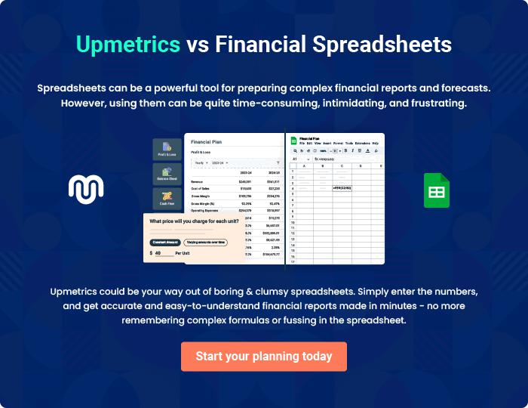

Small Business | Business Plan [YEAR] | 36/37


Create a winning business plan that gets you funded

Creating a stunning and investment-ready plan requires no writing, graphic designing, or financial planning expertise.

Upmetrics has all the features required to help you create a comprehensive business plan—from start to finish. Make no mistakes, it’s the modern way of planning to structure ideas, make plans, and create stunning pitch decks to awe investors.

Pitch decks that impress investors

Create pitch decks that provide a visual representation of your business, engage investors, and make them want to invest in your business idea.

Interactive plans in no time

Import business plan sections like—SWOT analysis, comparison tables, and others to create an interactive business plan. No designing skills are required.

Stunning cover page designs

With Upmetrics, you have the liberty to choose from multiple stunning cover page designs. Choose a creative design and make your plan stand out.

Online sharing made simple

Upmetrics makes online sharing quick and easier for users. Easily share your business plans with a link while tracking reader activity.

500+ sample business plans

Simply import a template from our library of sample plans into the editor and start customizing it to make it yours. It takes only a few clicks to get started.

Collaborate with team in real-time

Invite team members, initiate conversations, discuss ideas & strategies, share feedback, and work on a business plan in real-time.

