

Retail Store

Every day you get our best.

Business

Plan

[YEAR]

John Doe

10200 Bolsa Ave, Westminster, CA, 92683

- 359-3153 info@example.com http://www.example.com

CONFIDENTIAL

Table of Contents

Executive Summary | 5
Company Profile Summary | 6
Market Research Summary | 6
Marketing Summary | 6
Finance Summary | 7

Company Profile | 8
Business Overview | 9
Company History | 9
Management | 9
Location | 10
Legal Structure | 10
Vision & Mission | 10

Market Research | 11
Industry Profile & Market Size | 12
Local Market | 12
Target Market | 13
Competitor Analysis | 13
GT Pet Foods | 13
Smith Pet Boutique | 13
Keys to Success | 14
Customer Survey Summary | 14
SWOT Analysis | 14

Sales & Marketing | 17
Products and Services | 18
Pricing Strategy | 18
Marketing Strategy | 18

Retail Store | Business Plan [YEAR] 2/39

Primary Marketing Activities | 19
Marketing Objective | 19
Positioning Statement | 19
The Sales Process | 19
Strategic Alliances | 20

Operations | 21
Location(s) | 22
Legal Issues | 22
Insurance Issues | 22
Human Resources (Or Team) | 23
John doe | 23
John doe | 23
Jane Doe | 23
Process/Production | 23
Risk Assessment | 24

Financial Plan | 25
Startup Funding & Capital | 26
Funding | 26
Start-Up Costs | 27
Personnel Expenses | 27
Sales Forecast | 29
Projected Revenue | 29
Cash Flow | 30
Projected Profit & Loss | 32
Profit & Loss | 32
Balance Sheet | 35
Appendix
Appendix | 37

Retail Store | Business Plan [YEAR] 3/39

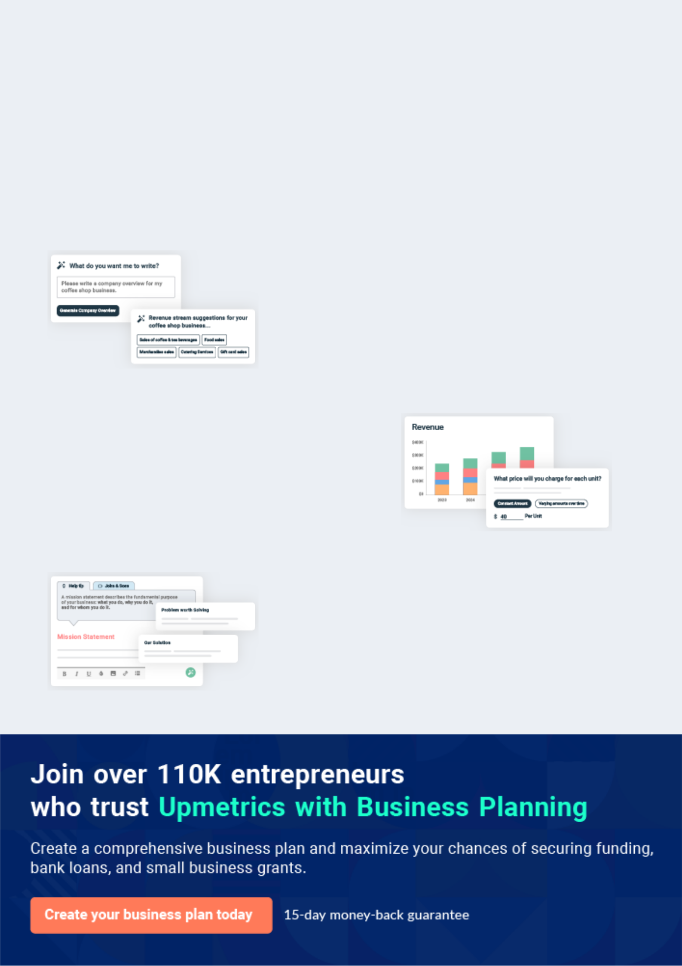
Business planning that’s simpler and faster than you think

Creating a business plan using Upmetrics to start and grow a business is literally the easiest thing in the World. Simply read the instructions and fill in the blanks. It’s as simple as that.

❛ | Upmetrics has everything you need to create a | ❜
❛ | comprehensive business plan. | ❜

AI-powered Upmetrics Assistant

AI-powered insights to streamline your plan

Not sure where to start? Upmetrics’ AI Assistant will automatically generate ideas for each section of your plan and offer improved versions of your writing, adjusting for tone, voice, and grammar or spelling errors.

Financial Forecasting Tool

All the financials are calculated for you

Forget the complex formulas and clumsy spreadsheets — with automatic financials and drag-and-drop forecasting, you can finish your plan faster and be confident that your numbers are accurate.

Business Plan Builder

Guides you like a business mentor

Upmetrics’ step-by-step instructions, prompts, and the library of 400+ sample business plans will guide you through each section of your plan as a business mentor.

1.


Executive Summary

Company Profile Summary

Market Research Summary

Marketing Summary

Finance Summary

Retail Store | Business Plan [YEAR] 5/39

An Executive Summary is the first and most basic piece of the accomplishment of the business plan. The Executive Summary offers an abstract of your business plan and features the key focuses you need to
To unlock help try Upmetrics!
To unlock help try Upmetrics!
To unlock help try Upmetrics! 

Company Profile Summary

 Help Tip


This section is an overview of your basic business. It describes what business you are in, what your business will do, what are your goals for your business. This section includes the following:



Start writing here..

Market Research Summary

 Help Tip

This section is a quantitative and qualitative assessment of a market. It looks into the size of the market both in volume and in value, the various customer segments and buying patterns, the competition, and the economic environment in terms of barriers to entry and regulation.
To unlock help try Upmetrics! 

Start writing here..

Marketing Summary

 Help Tip

This section should define the basics of your marketing plan. It should disclose who the customers are, where the business is conducted, and the products and services that will be sold. List a set of marketing strategies are you're going to apply.



Start writing here..

Retail Store | Business Plan [YEAR] 6/39

Finance Summary

 Help Tip

Your financial summary should provide your company’s current value as accurately as possible. In this section, you should consider adding charts, tables, and graphs to guide your investors
To unlock help try Upmetrics! 

Start writing here..

Retail Store | Business Plan [YEAR] 7/39

2.

Company Profile

Business Overview

Company History

Management

Location

Legal Structure

Vision & Mission

Retail Store | Business Plan [YEAR] 8/39

Note: Don't try to get creative when writing this section. Use easy-to-read, common terminology that people can relate to. You never want to assume that those reading your business plan have the same level of technical
To unlock help try Upmetrics! 

Business Overview

 Help Tip

It should include your business structure, Established year, legal name, location, and the goods or services offered.
To unlock help try Upmetrics! 

Start writing here..

Company History

 Help Tip

This section is not for startups, If it's already an established organization, let's say a few words about company history and achievements.
To unlock help try Upmetrics! 

Start writing here..

Management

 Help Tip

In the Management section, the information included should show that your retail business has the necessary human resources to be successful. This part answers questions about your key management personnel and their backgrounds, explains how the store will be staffed, and
To unlock help try Upmetrics! 

Start writing here..

Retail Store | Business Plan [YEAR] 9/39

Location

 Help Tip

Where does it locate? if you have multiple branches write down about them all.

To unlock help try Upmetrics! 

Start writing here..

Legal Structure

 Help Tip

Describe legal structure here

To unlock help try Upmetrics! 

Start writing here..

Vision & Mission

 Help Tip

This is when you really start getting into the core of why your business exists, what you hope to accomplish, and what you actually stand for.
To unlock help try Upmetrics! 

Start writing here..

Retail Store | Business Plan [YEAR] 10/39

3.

Market Research

Industry Profile & Market Size

Local Market

Target Market

Competitor Analysis

Keys to Success

Customer Survey Summary

SWOT Analysis

Retail Store | Business Plan [YEAR] 11/39

Industry Profile & Market Size
To unlock help try Upmetrics!

 Help Tip

The industry profile section describes data centered on an area of business that outlines and describes the major components of that area. Profiles often provide an overview of the industry and may make projections about future trends. Based on market research describe the size of
To unlock help try Upmetrics! 

Start writing here..


Available Market

Served Market

Target Market

10k

7k

5k

Local Market

 Help Tip

It is a retail industry, there should always include some data related to the local market. What is the location of the current market? where the potentials customers are located around the market?



Start writing here..

Retail Store | Business Plan [YEAR] 12/39

Target Market

 Help Tip

To define a target market for your business plan, you should research the potential buying audience for your product. This could range from a few thousand individuals if you are opening a retail store in a small town. If you are catering to the consumer market, narrow your potential
To unlock help try Upmetrics! 

Start writing here..

 Help Tip

It's important for new businesses to complete a competitive analysis during the business planning stage. Competitive intelligence can also be useful for marketing, pricing, managing, and other strategic planning for retailers at any stage of their business. Before you can know
To unlock help try Upmetrics! 

Competitor Analysis

GT Pet Foods




Features

Open to customer feedback on products to carry

Strengths

Canada's largest chain of pet food stores specializing in natural, holistic and organic foods and supplements!

Health food store for pets

Weaknesses

Limited selection of products and services

Each store does not have the same level of knowledge ability or service

Smith Pet Boutique

Retail Store | Business Plan [YEAR] 13/39



Features

Responsive to the local community in offering premium pet food products and pet care advice

Strengths



Locally responsive premium pet food store – owner is extremely knowledgeable and known in the community

High-quality products

Weaknesses

New store so will need time to establish credibility and build reputation

Keys to Success

 Help Tip

List keys to success your business, For retail business most effective keys to success if store location. How many possibilities of getting more customers based on location?
To unlock help try Upmetrics! 

Start writing here..

Customer Survey Summary

 Help Tip

The customer survey is an essential part of your business plan, By conducting a survey you know what are the market needs?
To unlock help try Upmetrics! 

Start writing here..

SWOT Analysis

Retail Store | Business Plan [YEAR] 14/39


Strength

- Experience and understanding of the fashion industry

- Unique shopping experience with exceptional customer service

- Great downtown location

- The large and growing consumer base

Weakness


- An untested market in Pleasantville

- While the market is large, it is a niche market (Baby Boomers)


Opportunity

- The outstanding shopping experience will lead to repeat business

- Growing online clothing store Booming Boutique

- Establish a Booming Boutique clothing line

Threat

- Cost and effectiveness of marketing to women “Baby Boomers”

- New retail shops that may or may not open in the future

Retail Store | Business Plan [YEAR] 15/39

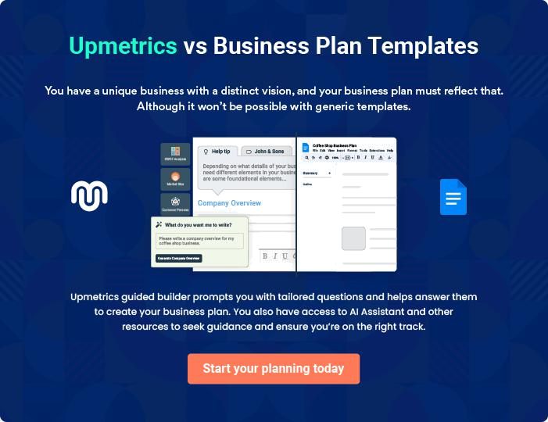

Retail Store | Business Plan [YEAR] | 16/39

4.

Sales & Marketing

Products and Services

Pricing Strategy

Marketing Strategy

Primary Marketing Activities

Positioning Statement

The Sales Process

Strategic Alliances

Retail Store | Business Plan [YEAR] 17/39

Products and Services
To unlock help try Upmetrics!

 Help Tip

This section of the business plan is most important to retailers in the midst of developing a business. The Products and Services section describes the goods and services offered, how they are provided, information about the vendors, and any plans for the future growth of your
To unlock help try Upmetrics! 

Start writing here..

Pricing Strategy

 Help Tip

Describe which pricing strategies you are going to use to acquire more and more customers? Before you can determine which retail pricing strategy to use in determining the right price for
your products, you must consider the product's direct costs and other related expenses. These
To unlock help try Upmetrics! 

Start writing here..

Marketing Strategy

 Help Tip

A retailer needs to decide as to what it wants to achieve for its customers. It has to decide the target market and then select the appropriate combination of product, price, place, and promotion to create his marketing strategies.



Start writing here..

Retail Store | Business Plan [YEAR] 18/39

Primary Marketing Activities
To unlock help try Upmetrics!

 Help Tip

List out the marketing activities or campaigns you are going to run as a part of your marketing strategy.
To unlock help try Upmetrics! 

Start writing here..

 Help Tip

The overall objective of retail marketing is creating and developing services and products that meet the specific needs of customers and offering these products at competitive, reasonable prices that will still yield profits.



Marketing Objective

Start writing here..

Positioning Statement

 Help Tip

The positioning statement is defined “as the design and implementation of a retail mix to create an image of the retailer in the customer's mind relative to its competitors.
To unlock help try Upmetrics! 

Start writing here..

The Sales Process

 Help Tip

This section describes how you are going to sell your products or services. Don't go into detail just define the process with a few steps.
To unlock help try Upmetrics! 

Retail Store | Business Plan [YEAR] 19/39

Start writing here..

Strategic Alliances

 Help Tip

List of strategic alliances with other retail outlets or service providers from where you can get leads.
To unlock help try Upmetrics! 

Start writing here..

Retail Store | Business Plan [YEAR] 20/39

5.

Operations

Location(s)

Legal Issues

Insurance Issues

Human Resources (Or Team)

Process/Production

Risk Assessment

Retail Store | Business Plan [YEAR] 21/39

This chapter describes the outlines for separate operations and development sections for your retail business plan. Under operations, divide your contents by typical business functions such as Locations, accounting, administration,
To unlock help try Upmetrics! 

Location(s)

 Help Tip

Detailed descriptions about store locations, Proper site selection for your business influences whether you succeed or fail in making money. Your business location analysis should take into account demographics, psychographics, census, and other data. Although a great location may
To unlock help try Upmetrics! 

Start writing here..

Legal Issues

 Help Tip

For the retailer, the Most common Legal issues are considered as Business License, Food safety license, Non-Disclosure Agreements, Zoning, partnership agreements, etc.
To unlock help try Upmetrics! 

Start writing here..

Insurance Issues

 Help Tip

Store insurance requirements to save it from physical disasters.

To unlock help try Upmetrics! 

Start writing here..

Retail Store | Business Plan [YEAR] 22/39

 Help Tip
To unlock help try Upmetrics!

So-called retail Staff, Includes Management Team, Salesman Team and Supplier Team, etc.

To unlock help try Upmetrics! 

Human Resources (Or Team)


John doe

Manager - john.doe@example.com

Describe his skills, Achievements and experience.


John doe

john.doe@example.com

Describe his skills, Achievements and experience.


Jane Doe

jane.doe@example.com

Describe her skills, Achievements and experience.

Process/Production

 Help Tip

For retail, Goods are coming from either self-manufacturing units or some third party suppliers, Define your inventory process and goods supply chain. Also, describe where the raw materials are coming from?



Retail Store | Business Plan [YEAR] 23/39

Start writing here..

Risk Assessment

 Help Tip

This section is for actions that has been undertaken for assessing risks.

To unlock help try Upmetrics! 

Start writing here..

Retail Store | Business Plan [YEAR] 24/39

6.

Financial Plan

Startup Funding & Capital

Start-Up Costs

Sales Forecast

Cash Flow

Projected Profit & Loss

Balance Sheet

Retail Store | Business Plan [YEAR] 25/39

One of the more difficult parts of the business plan, the Financial Plan, involves the company's revenue and profitability model. This part of your business plan assesses the amount of capital the retail business needs. It
To unlock help try Upmetrics! 

Startup Funding & Capital

 Help Tip

Enter the funding information, How much money you're going to borrow either from investors or bank loans?
To unlock help try Upmetrics! 

Start writing here..

Funding

 | 2024 | 2025 | 2026
Amount Received | $150,000 | $0 | $0
Business Loan | $100,000 | $0 | $0
Owner Contribution | $50,000 | $0 | $0

Amount Paid | $36,506.28 | $36,506.28 | $36,506.43
Business Loan | $36,506.28 | $36,506.28 | $36,506.43
Principal Paid | $31,359.34 | $33,293.52 | $35,347.14
Interest Paid | $5,146.94 | $3,212.76 | $1,159.29

Total Debt | $68,640.66 | $35,347.14 | $0
Short-Term Debt | $33,293.52 | $35,347.14 | $0
Business Loan | $33,293.52 | $35,347.14 | $0
Long-Term Debt | $35,347.14 | $0 | $0
Business Loan | $35,347.14 | $0 | $0

Retail Store | Business Plan [YEAR] 26/39

Start-Up Costs

 Help Tip

We have automated financial forecasts to calculate summary startup costs, Input numbers into financial modeling and it all calculate your summary costs and necessary metrics.
To unlock help try Upmetrics! 

Start writing here..

Personnel Expenses

Head Count

Average Salary

Revenue Per Employee

Net Income Per Employee

Store Staff

Indirect Labor

Store Manager

Salaries & Wages

Employee Related Expenses (20%)

Sales Associate

Salaries & Wages

Employee Related Expenses (20%)

Administrative Staff

Indirect Labor

Administrative Assistant

2024 | 2025 | 2026
8 | 8 | 8
$37,500 | $38,550 | $39,630
$85,243.16 | $217,978.03 | $414,877.01
($549.14) | $104,716 | $262,538.67

$168,480 | $173,534.40 | $178,740.48
$168,480 | $173,534.40 | $178,740.48
$60,480 | $62,294.40 | $64,163.28
$50,400 | $51,912 | $53,469.36
$10,080 | $10,382.40 | $10,693.92
$108,000 | $111,240 | $114,577.20
$90,000 | $92,700 | $95,481
$18,000 | $18,540 | $19,096.20

$119,520 | $123,105.60 | $126,798.72
$119,520 | $123,105.60 | $126,798.72
$47,520 | $48,945.60 | $50,413.92

Retail Store | Business Plan [YEAR] 27/39

Salaries & Wages

Employee Related Expenses (20%)

HR Manager

Salaries & Wages

Employee Related Expenses (20%)

Support Staff

Indirect Labor

Cleaner

Salaries & Wages

Employee Related Expenses (15%)

Maintenance Technician

Salaries & Wages

Employee Related Expenses (15%)

Summary

Total Personnel Expenses

Direct Labor (COS)

Salary & Wages

Employee Related Expenses

Indirect Labor

Salary & Wages

Employee Related Expenses

% Of Revenue

2024 | 2025 | 2026
$39,600 | $40,788 | $42,011.64
$7,920 | $8,157.60 | $8,402.28
$72,000 | $74,160 | $76,384.80
$60,000 | $61,800 | $63,654
$12,000 | $12,360 | $12,730.80

$69,000 | $70,380 | $71,787.60
$69,000 | $70,380 | $71,787.60
$27,600 | $28,152 | $28,715.04
$24,000 | $24,480 | $24,969.60
$3,600 | $3,672 | $3,745.44
$41,400 | $42,228 | $43,072.56
$36,000 | $36,720 | $37,454.40
$5,400 | $5,508 | $5,618.16

$357,000 | $367,020 | $377,326.80
$0 | $0 | $0
$0 | $0 | $0
$0 | $0 | $0
$357,000 | $367,020 | $377,326.80
$300,000 | $308,400 | $317,040
$57,000 | $58,620 | $60,286.80
52.35% | 21.05% | 11.37%

Retail Store | Business Plan [YEAR] 28/39

 Help Tip

Choose the product revenue stream in a financial modeling tool, enter the price, production volume, and inventory tracking information it will calculate revenue summaries.
To unlock help try Upmetrics! 

Sales Forecast

Projected Revenue

 | 2024 | 2025 | 2026
Product Sales | $159,171.40 | $285,849.20 | $513,343.20
Unit Sales | 7,959 | 14,292 | 25,667
Unit Price | $20 | $20 | $20
Gross Revenue | $159,171.40 | $285,849.20 | $513,343.20
Gross Margin | $159,171.40 | $285,849.20 | $513,343.20
Gross Margin (%) | 100% | 100% | 100%

Service Charges | $141,923 | $202,352 | $288,508.50
Unit Customers | 2,838 | 4,047 | 5,770
Charges Per Customer | $50 | $50 | $50
Gross Revenue | $141,923 | $202,352 | $288,508.50
Gross Margin | $141,923 | $202,352 | $288,508.50
Gross Margin (%) | 100% | 100% | 100%

Online Sales | $380,850.90 | $1,255,623 | $2,517,164.40
Ending Users | 2,041 | 4,869 | 9,052
Starting Users | 0 | 2,041 | 4,869
New Users | 2,254 | 3,609 | 5,778

Retail Store | Business Plan [YEAR] 29/39

 | 2024 | 2025 | 2026
Lost Users | 213 | 781 | 1,594
Recurring Charges | $30 | $30 | $30
Gross Revenue | $380,850.90 | $1,255,623 | $2,517,164.40
Gross Margin | $380,850.90 | $1,255,623 | $2,517,164.40
Gross Margin (%) | 100% | 100% | 100%

Summary

Total Revenue | $681,945.30 | $1,743,824.20 | $3,319,016.10
Total Refund | $0 | $0 | $0
Net Revenue | $681,945.30 | $1,743,824.20 | $3,319,016.10
Total Cost of Sales | $199,440.61 | $301,804.88 | $445,145.36
General Costs | $199,440.61 | $301,804.88 | $445,145.36
Revenue Specific Costs | $0 | $0 | $0
Personnel Costs (Direct | $0 | $0 | $0
Labor) | $0 | $0 | $0
Gross Margin | $482,504.69 | $1,442,019.32 | $2,873,870.74
Gross Margin (%) | 70.75% | 82.69% | 86.59%

 Help Tip


Under this section add a cash flow report to generate reports use our automated financial forecasting tool.

 |  |  |  | To unlock help try Upmetrics! 
Cash Flow
 | 2024 | 2025 |  | 2026
Cash Received | $681,945.30 | $1,743,824.20 |  | $3,319,016.10

Retail Store | Business Plan [YEAR] 30/39

 | 2024 | 2025 | 2026
Cash Paid | $681,805.64 | $901,502.93 | $1,214,053.04
COS & General Expenses | $319,658.71 | $531,270.16 | $835,566.93
Salary & Wages | $357,000 | $367,020 | $377,326.80
Interest | $5,146.94 | $3,212.76 | $1,159.29
Sales Tax | $0 | $0 | $0
Income Tax | $0 | $0 | $0
Net Cash From | $139.66 | $842,321.27 | $2,104,963.06
Operations | $139.66 | $842,321.27 | $2,104,963.06

Assets Sell | $0 | $0 | $0
Assets Purchase | $27,400 | $2,400 | $2,400
Net Cash From | ($27,400) | ($2,400) | ($2,400)
Investments | ($27,400) | ($2,400) | ($2,400)

Amount Received | $150,000 | $0 | $0
Loan Received | $100,000 | $0 | $0
Common Stock | $0 | $0 | $0
Preferred Stock | $0 | $0 | $0
Owner's Contribution | $50,000 | $0 | $0
Amount Paid | $49,359.35 | $41,293.51 | $43,347.12
Loan Capital | $31,359.34 | $33,293.52 | $35,347.14
Dividends & Distributions | $18,000 | $8,000 | $8,000
Net Cash From | $100,640.65 | ($41,293.51) | ($43,347.12)
Financing | $100,640.65 | ($41,293.51) | ($43,347.12)

Summary

Starting Cash | $0 | $73,380.31 | $872,008.07

Retail Store | Business Plan [YEAR] 31/39

 | 2024 | 2025 | 2026
Cash In | $831,945.30 | $1,743,824.20 | $3,319,016.10
Cash Out | $758,564.99 | $945,196.44 | $1,259,800.16
Change in Cash | $73,380.31 | $798,627.76 | $2,059,215.94
Ending Cash | $73,380.31 | $872,008.07 | $2,931,224.01

 Help Tip

Under this section add an income statement report to generate reports use our automated financial forecasting tool.
To unlock help try Upmetrics! 

Projected Profit & Loss

Profit & Loss

 | 2024 | 2025 | 2026
Revenue | $681,945.30 | $1,743,824.20 | $3,319,016.10
Product Sales | $159,171.40 | $285,849.20 | $513,343.20
Unit Sales | 7,959 | 14,292 | 25,667
Unit Price | $20 | $20 | $20
Service Charges | $141,923 | $202,352 | $288,508.50
Unit Sales | 2,838 | 4,047 | 5,770
Unit Price | $50 | $50 | $50
Online Sales | $380,850.90 | $1,255,623 | $2,517,164.40
Users | 2,041 | 4,869 | 9,052
Recurring Charges | $30 | $30 | $30

Cost Of Sales | $199,440.61 | $301,804.88 | $445,145.36
General Costs | $199,440.61 | $301,804.88 | $445,145.36

Retail Store | Business Plan [YEAR] 32/39

 | 2024 | 2025 | 2026
Product-Related Costs | $168,218.22 | $257,289.15 | $381,676.13
Purchase of Goods | $134,120.93 | $170,097.91 | $215,725.32
Packaging Material | $34,097.29 | $87,191.24 | $165,950.81
Service-Related Costs | $31,222.39 | $44,515.73 | $63,469.23
Service Equipment | $28,384 | $40,468.84 | $57,699.28
Maintenance | $28,384 | $40,468.84 | $57,699.28
Service Supplies | $2,838.39 | $4,046.89 | $5,769.95
Revenue Specific Costs | $0 | $0 | $0
Personnel Costs (Direct | $0 | $0 | $0
Labor) | $0 | $0 | $0

Gross Margin | $482,504.69 | $1,442,019.32 | $2,873,870.74
Gross Margin (%) | 70.75% | 82.69% | 86.59%

Operating Expense | $477,218.10 | $596,485.28 | $767,748.37
Payroll Expense (Indirect | $357,000 | $367,020 | $377,326.80
Labor) | $357,000 | $367,020 | $377,326.80
Store Staff | $168,480 | $173,534.40 | $178,740.48
Store Manager | $60,480 | $62,294.40 | $64,163.28
Sales Associate | $108,000 | $111,240 | $114,577.20
Administrative Staff | $119,520 | $123,105.60 | $126,798.72
Administrative Assistant | $47,520 | $48,945.60 | $50,413.92
HR Manager | $72,000 | $74,160 | $76,384.80
Support Staff | $69,000 | $70,380 | $71,787.60
Cleaner | $27,600 | $28,152 | $28,715.04
Maintenance Technician | $41,400 | $42,228 | $43,072.56
General Expense | $120,218.10 | $229,465.28 | $390,421.57

Retail Store | Business Plan [YEAR] 33/39

 | 2024 | 2025 | 2026
Facility Expenses | $39,600 | $41,388 | $43,259.64
Rent | $30,000 | $31,500 | $33,075
Utilities | $9,600 | $9,888 | $10,184.64
Operational Expenses | $72,218.10 | $179,485.28 | $338,373.37
Office Supplies | $4,023.57 | $5,102.86 | $6,471.76
Marketing | $68,194.53 | $174,382.42 | $331,901.61
Miscellaneous Expenses | $8,400 | $8,592 | $8,788.56
Cleaning Services | $6,000 | $6,120 | $6,242.40
Equipment Maintenance | $2,400 | $2,472 | $2,546.16
Bad Debt | $0 | $0 | $0
Amortization of Current | $0 | $0 | $0
Assets | $0 | $0 | $0

EBITDA

Additional Expense

Long Term Depreciation

Gain or loss from Sale of Assets

EBIT

Interest Expense

EBT

Income Tax Expense / Benefit

Total Expense

Net Income

$5,286.59 $845,534.04 $2,106,122.37

$9,679.69 | $7,806.01 | $5,813.03
$4,532.76 | $4,593.24 | $4,653.72
$0 | $0 | $0
$753.83 | $840,940.80 | $2,101,468.65
$5,146.94 | $3,212.76 | $1,159.29
($4,393.10) | $837,728.03 | $2,100,309.34
$0 | $0 | $0

$686,338.40 | $906,096.17 | $1,218,706.76
($4,393.10) | $837,728.03 | $2,100,309.34

Retail Store | Business Plan [YEAR] 34/39

 | 2024 | 2025 | 2026
Net Income (%) | (0.64%) | 48.04% | 63.28%
Retained Earning Opening | $0 | ($22,393.10) | $807,334.93
Owner's Distribution | $18,000 | $8,000 | $8,000
Retained Earning Closing | ($22,393.10) | $807,334.93 | $2,899,644.27
Balance Sheet
 | 2024 | 2025 | 2026
Assets | $96,247.55 | $892,682.07 | $2,949,644.29
Current Assets | $73,380.31 | $872,008.07 | $2,931,224.01
Cash | $73,380.31 | $872,008.07 | $2,931,224.01
Accounts Receivable | $0 | $0 | $0
Inventory | $0 | $0 | $0
Other Current Assets | $0 | $0 | $0
Long Term Assets | $22,867.24 | $20,674 | $18,420.28
Gross Long Term Assets | $27,400 | $29,800 | $32,200
Accumulated Depreciation | ($4,532.76) | ($9,126) | ($13,779.72)
Liabilities & Equity | $96,247.56 | $892,682.07 | $2,949,644.27
Liabilities | $68,640.66 | $35,347.14 | $0
Current Liabilities | $33,293.52 | $35,347.14 | $0
Accounts Payable | $0 | $0 | $0
Income Tax Payable | $0 | $0 | $0
Sales Tax Payable | $0 | $0 | $0
Short Term Debt | $33,293.52 | $35,347.14 | $0

Retail Store | Business Plan [YEAR] 35/39

 | 2024 | 2025 | 2026
Long Term Liabilities | $35,347.14 | $0 | $0
Long Term Debt | $35,347.14 | $0 | $0
Equity | $27,606.90 | $857,334.93 | $2,949,644.27
Paid-in Capital | $0 | $0 | $0
Common Stock | $0 | $0 | $0
Preferred Stock | $0 | $0 | $0
Owner's Contribution | $50,000 | $50,000 | $50,000
Retained Earnings | ($22,393.10) | $807,334.93 | $2,899,644.27

Check | $0 | $0 | $0
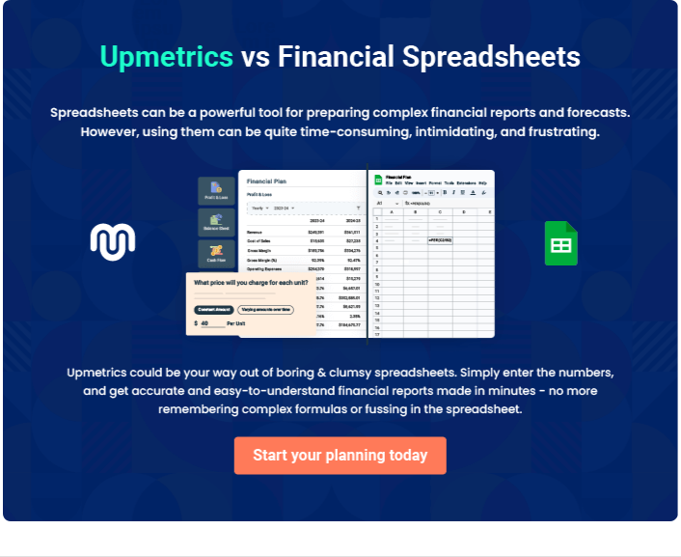

Retail Store | Business Plan [YEAR] 36/39

7.

Appendix

Retail Store | Business Plan [YEAR] 37/39

 Help Tip

A business plan’s appendix is like its own mini-library. It holds the entire plan's supporting documents in a clear, well-organized fashion. The appendix consists of an array of
documentation that ranges from receipts and bank statements to contracts and inventories. It
To unlock help try Upmetrics! 

Start writing here..

Retail Store | Business Plan [YEAR] 38/39

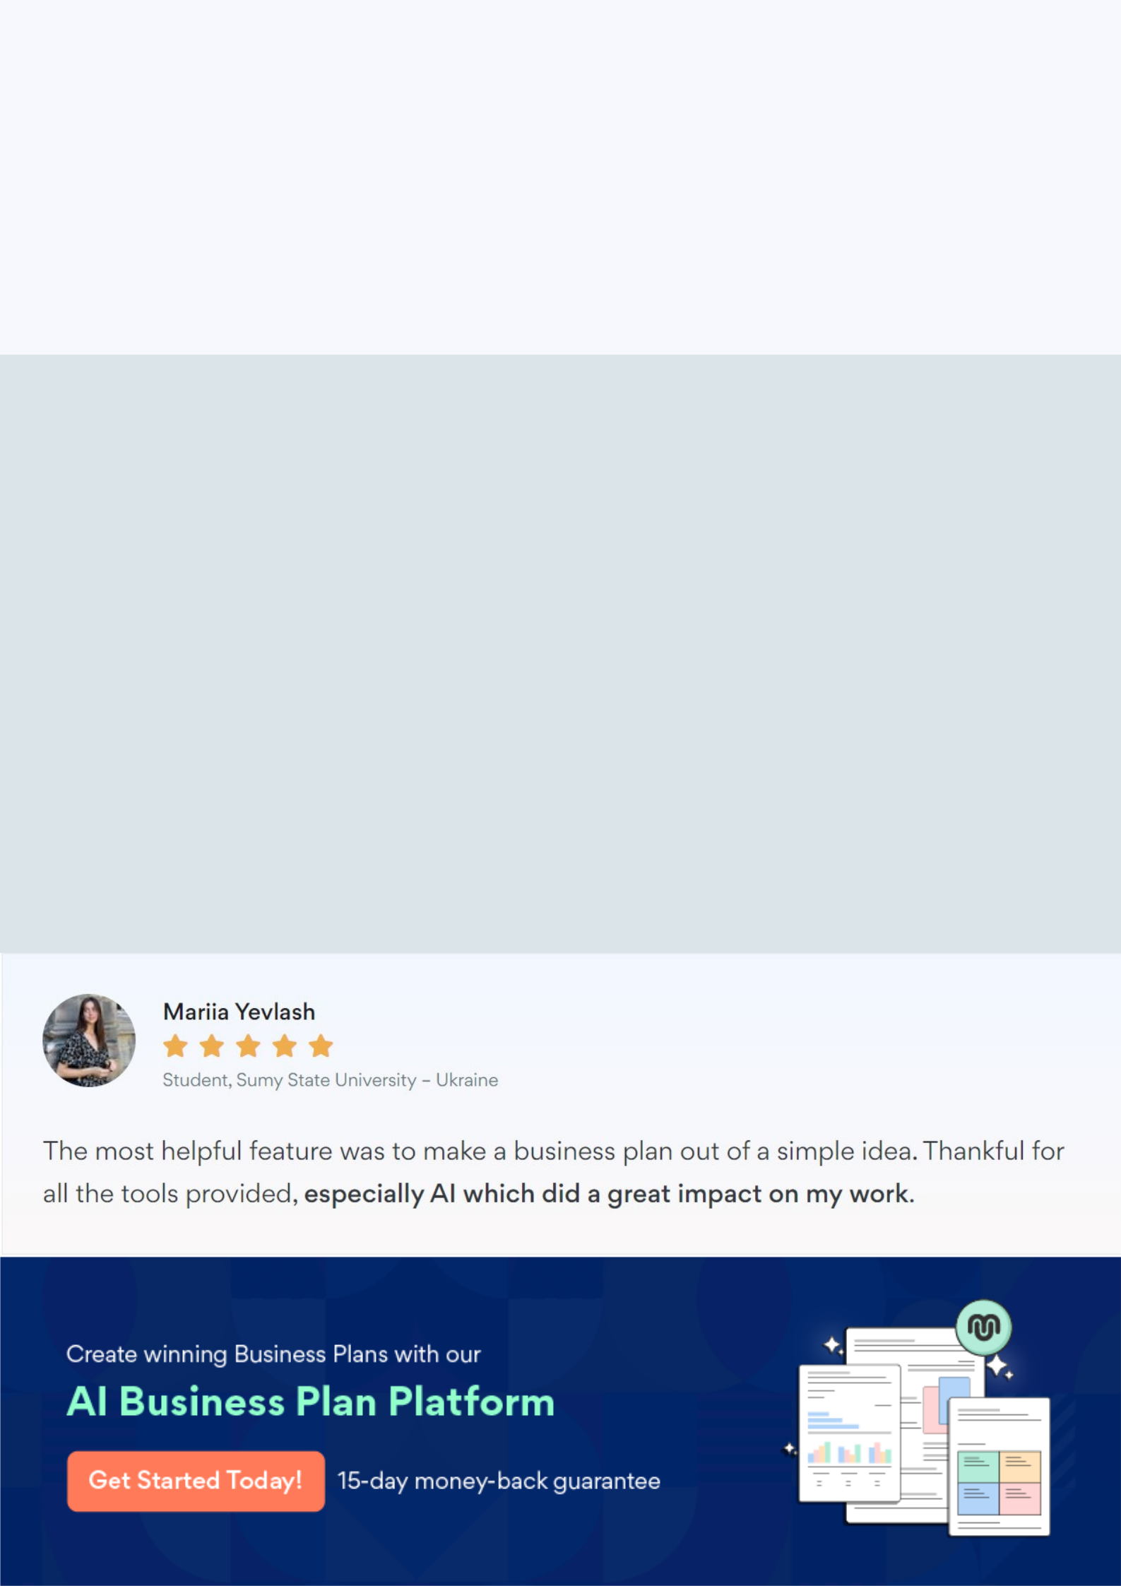
Create a winning business plan that gets you funded

Creating a stunning and investment-ready plan requires no writing, graphic designing, or financial planning expertise.

Upmetrics has all the features required to help you create a comprehensive business plan—from start to finish. Make no mistakes, it’s the modern way of planning to structure ideas, make plans, and create stunning pitch decks to awe investors.

Pitch decks that impress investors

Create pitch decks that provide a visual representation of your business, engage investors, and make them want to invest in your business idea.

Interactive plans in no time

Import business plan sections like—SWOT analysis, comparison tables, and others to create an interactive business plan. No designing skills are required.

Stunning cover page designs

With Upmetrics, you have the liberty to choose from multiple stunning cover page designs. Choose a creative design and make your plan stand out.

Online sharing made simple

Upmetrics makes online sharing quick and easier for users. Easily share your business plans with a link while tracking reader activity.

500+ sample business plans

Simply import a template from our library of sample plans into the editor and start customizing it to make it yours. It takes only a few clicks to get started.

Collaborate with team in real-time

Invite team members, initiate conversations, discuss ideas & strategies, share feedback, and work on a business plan in real-time.

