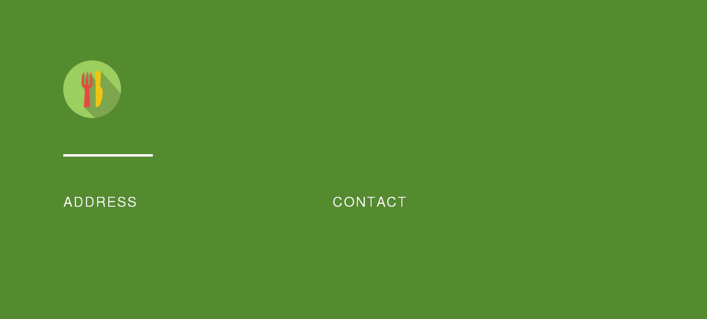
[Your Restaurant Name]

10200 Bolsa Ave, Westminster, CA, 92683

(650) 359-3153

https://upmetrics.co

info@upmetrics.co


Restaurant Business Plan

John Doe

[Your Tagline]

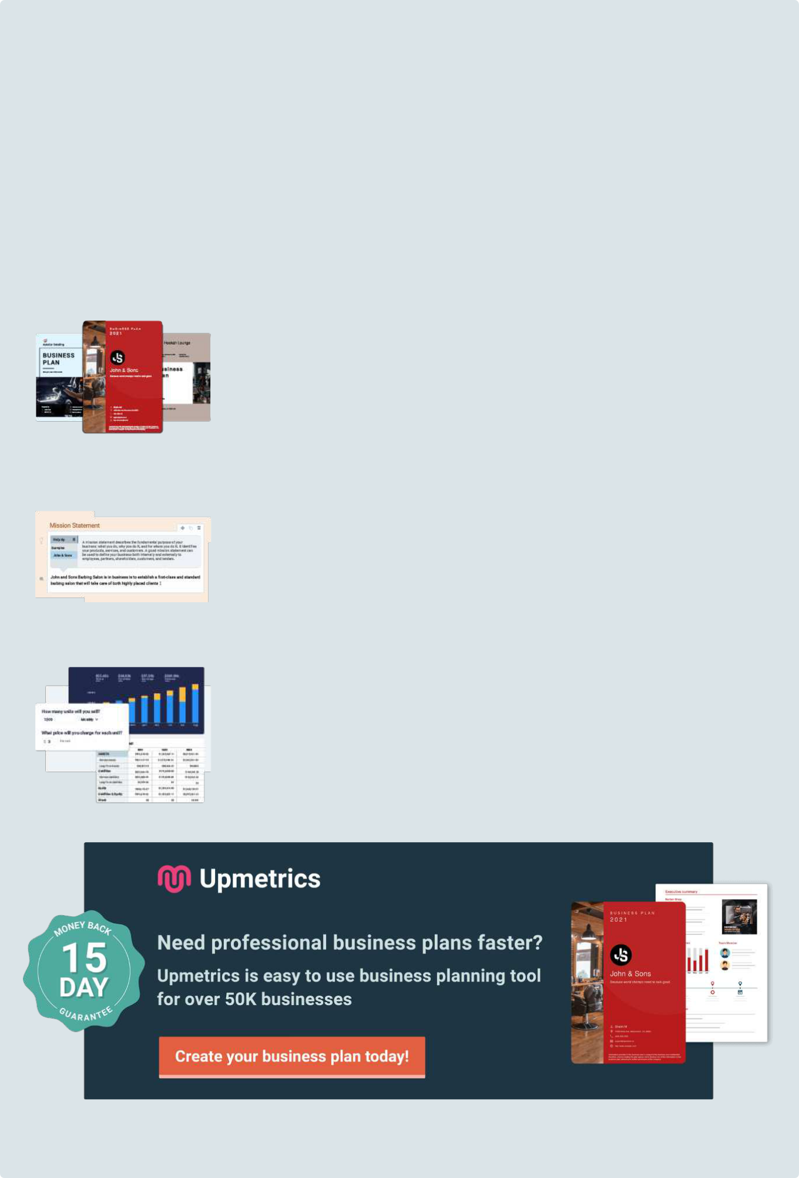
Easy to use Business Plan Software

Get started using a business plan template is always the fastest way to write your business plan, but as you know, you can't just fill in the blanks along with a template. You will need a collaborative tool that guides you on every step of your planning.

Upmetrics can help. With Upmetrics, you can easily bring your team to write a professional business plan with automated financial forecasts. You can also do:

200+ Sample business plans

Get access to hundreds of sample business plans covering almost all industries to kick start your business plan writing. This helps you to get an idea how the perfect business plan should look like.

View Sample Business Plans

Step-By-Step Guide

You'll receive step-by-step instruction as soon as you select any business plan template. We made business planning easy with prompt help and examples on every step of your business plan writing.

See How It Works

Conduct accurate financial projections

Do not worry about not having accounting skills. With Upmetrics, Simply enter your sales and costs figures, and we'll prepare all of your monthly/quarterly and yearly financial projections.

See How It Works

1.


Executive Summary

Business Description

Mission Statement

Goals

Plan Summary

Capital Request
Business Description

Start Writing here...

Mission Statement

Start Writing here...

Goals

Start Writing here...

Plan Summary

Start Writing here...

Capital Request

Start Writing here...

2.

Business

Description

Business Overview

Location

Facilities

Business History

Ownership Structure

Management Team
Start Writing here...

Business Overview

Start Writing here...

Location

Start Writing here...

Facilities

Start Writing here...

Design & Layouts

Start writing here...

Business History

Start Writing here...

Ownership Structure

Start Writing here...

Management Team

Start Writing here...


JOHN DOE

CEO - johnd@example.com

Briefly describe his qualifications and his management/business roles.

3.

Menu
Menu Items



Appetizers

Soups a Salads

Salt & Pepper Chicken Wings Chinese Lettuce Wraps Teriyaki Beef Skewers


Pho-Viet Nam Style Beef Noodle Soup Spicy Thai Coconut Soup Asian Calamari Salad


Rice Bowls

Main Dishes

Singapore Style Currie Lo Mein


Vindaloo Chicken Thai Fried Catfish & Chile Sauce Shrimp & Long Beans


Desserts

Beverages

Double Chocolate Cookie Lychee Fruit


Freshly Brewed Iced & Hot Tea Homemade Lemonade Bubble Tea

Wine & Beer

Bottled Beers from Asia Select

California Wines

4.

Industry Analysis

Target Market

Location Analysis

Competitive Analysis
Start Writing here...

Target Market

Start Writing here...

Location Analysis

Start Writing here...

Competitive Analysis

Start Writing here...

Competitor name

5.

Marketing Plan

Customer Database

Loyalty Program

Community / Charity Involvement

Public Relations

Advertising / Social Media

SWOT Analysis
Customer Database

Start Writing here...

Loyalty Program

Start Writing here...

Community / Charity Involvement

Start Writing here...

Public Relations

Start Writing here...

Advertising / Social Media

Start Writing here...

SWOT Analysis


Strengths

Mention positive tangible and intangible attributes. Internal to your organization. which are within the organization's control.

Weaknesses


Factors that are within an organization's control that detract from its ability to attain the core goal. In which areas might the organization improve?


Opportunities

External attractive factors that represent the reason for an organization to exist and develop. What opportunities exist in the environment which will propel the organization?

Threats

External factors, beyond an organization‘s control, which could place the organization‘s mission or operation at risk. The organization may benefit by having contingency plans to address them should they occur.

6.

Operations Plan

Staffing & Training

Customer Service Policies & Procedures

Suppliers
Staffing & Training

Start Writing here...

Customer Service Policies & Procedures

Start Writing here...

Suppliers

Start Writing here...

7.

Financial Analysis / Growth Plan

Investment Plan

Income statement

Cashflow

Balance Sheet

Break-Even Analysis

Expected Cash Flow
Investment Plan

Start Writing here...
Income statement

A projected income statement will document your income, expenses, and profitability when your plan is fully implemented. It is an important tool to help you determine if your plan is financially feasible.

 | Year1 | Year2 | Year3 | Year4 | Year5
Revenues
Product/Service-A | $151,200 | $333,396 | $367,569 | $405,245 | $446,783
Product/Service B | $100,800 | $222,264 | $245,046 | $270,163 | $297,855
Total Revenues | $252,000 | $555,660 | $612,615 | $675,408 | $744,638
Expenses & Costs
Cost of goods sold | $57,960 | $122,245 | $122,523 | $128,328 | $134,035
Lease | $60,000 | $61,500 | $63,038 | $64,613 | $66,229
Marketing | $20,000 | $25,000 | $25,000 | $25,000 | $25,000
Salaries | $133,890 | $204,030 | $224,943 | $236,190 | $248,000
Other Expenses | $3,500 | $4,000 | $4,500 | $5,000 | $5,500
Total Expenses & Costs | $271,850 | $412,775 | $435,504 | $454,131 | $473,263
EBITDA | ($19,850) | $142,885 | $177,112 | $221,277 | $271,374
Depreciation | $36,960 | $36,960 | $36,960 | $36,960 | $36,960
EBIT | ($56,810) | $105,925 | $140,152 | $184,317 | $234,414
Interest | $23,621 | $20,668 | $17,716 | $14,763 | $11,810
EBT | ($80,431) | $85,257 | $122,436 | $169,554 | $222,604
Net Operating Loss | ($80,431) | ($80,431) | $0 | $0 | $0
Income Tax Expense | $0 | $1,689 | $42,853 | $59,344 | $77,911
NET INCOME | ($80,431) | $83,568 | $79,583 | $110,210 | $144,693
Net Profit Margin (%) | - | 15.00% | 13.00% | 16.30% | 19.40%

Cashflow

Projected cash flow will help you determine if your plan can meet expenses, make debt payments, and make it through the transition period.

 | Year1 | Year2 | Year3 | Year4 | Year5
CASH FLOW FROM OPERATIONS
Net Income (Loss) | ($80,431) | $83,568 | $79,583 | $110,210 | $144,693
Change in working capital | ($11,340) | ($1,625) | ($2,350) | ($2,133) | ($2,409)
Depreciation | $36,960 | $36,960 | $36,960 | $36,960 | $36,960
Net Cash Flow from Operations | ($54,811) | $118,902 | $114,193 | $145,037 | $179,244
CASH FLOW FROM INVESTMENTS
Investment | ($246,450) | $0 | $0 | $0 | $0
Net Cash Flow from Investments | ($246,450) | $0 | $0 | $0 | $0
CASH FLOW FROM FINANCING
Cash from equity | $0 | $0 | $0 | $0 | $0
Cash from debt | $317,971 | ($45,424) | ($45,424) | ($45,424) | ($45,424)
Net Cash Flow from Financing | $317,971 | ($45,424) | ($45,424) | ($45,424) | ($45,424)
SUMMARY
Net Cash Flow | $16,710 | $73,478 | $68,769 | $99,613 | $133,819
Cash at Beginning of Period | $0 | $16,710 | $90,188 | $158,957 | $258,570
Cash at End of Period | $16,710 | $90,188 | $158,957 | $258,570 | $392,389

Balance Sheet

You may also want to develop a projected balance sheet to evaluate how your plan will impact your solvency or net worth.

 | Year1 | Year2 | Year3 | Year4 | Year5
ASSETS
Cash | $16,710 | $90,188 | $158,957 | $258,570 | $392,389
Accounts receivable | $0 | $0 | $0 | $0 | $0

 | Year1 | Year2 | Year3 | Year4 | Year5
Inventory | $21,000 | $23,153 | $25,526 | $28,142 | $31,027
Total Current Assets | $37,710 | $113,340 | $184,482 | $286,712 | $423,416
Fixed assets | $246,450 | $246,450 | $246,450 | $246,450 | $246,450
Depreciation | $36,960 | $73,920 | $110,880 | $147,840 | $184,800
Net fixed assets | $209,490 | $172,530 | $135,570 | $98,610 | $61,650
TOTAL ASSETS | $247,200 | $285,870 | $320,052 | $385,322 | $485,066
LIABILITIES & EQUITY
Debt | $317,971 | $272,546 | $227,122 | $181,698 | $136,273
Accounts payable | $9,660 | $10,187 | $10,210 | $10,694 | $11,170
Total Liabilities | $327,631 | $282,733 | $237,332 | $192,391 | $147,443
Share Capital | $0 | $0 | $0 | $0 | $0
Retained earnings | ($80,431) | $3,137 | $82,720 | $192,930 | $337,623
Total Equity | ($80,431) | $3,137 | $82,720 | $192,930 | $337,623
TOTAL LIABILITIES & EQUITY | $247,200 | $285,870 | $320,052 | $385,322 | $485,066

Break-Even Analysis

Start Writing here...

Expected Cash Flow

Start Writing here...


Want to make it more presentable?

Want help tips on each section?

You'll save time and can write your professional business plan effectively and faster with Upmetrics' business plan software.

Every feature you need to convert your great business idea into a reality.

Write your plan easily and faster without any hassles.

Structure your idea and create stunning pitches that awe your investors.

Get access to Upmetrics software, invite your team members and start writing your business plan.

1. Get tried and tested tips

Upmetrics business plan builder gives you everything you need to stay in sync and guides you on every step of your business plan writing.

2. Write an interactive plan

Use our business plan sections - competitive Analysis, comparison tables, SWOT Analysis, charts, timelines, milestones, etc to create a visually impactful business plan.

- Stunning business plan cover pages

Upmetrics business plan builder comes with beautifully designed cover pages. Choose professional, creative cover pages to make your business plan stand out.

4. Financial forecasting

With Upmetrics you don’t have to worry about navigating complex spreadsheets. Just input your numbers and we’ll provide you with well-structured financial reports that you and your investors understand.

5. Share easily with anyone

Upmetrics plans are easily shareable in pdf and word documents. And if either doesn’t work, you can share it with a quick link too and track the reader's activity!

6. Real-time and Collaborative

Invite your team members to initiate conversations, discuss ideas and strategies in real-time, share respective feedback, and write your business plan.

Join over 100k+ entrepreneurs who have used Upmetrics to create their business plans.

Start writing your business plan today

