
Avadh Restaurant

"Beyond the boundaries of taste"

BUSINESS PLAN

[YEAR]

John Doe | 10200 Bolsa Ave, Westminster, CA, 92683 | (650) 359-3153 | info@example.com
http://www.example.com

Information provided in this business plan is unique to this business and confidential; therefore, anyone reading this plan agrees not to disclose any of the information in this business plan without prior written permission of the Company
Table of Contents

Executive Summary | 6
Overview | 7
Market Opportunity | 7
Management | 7
Financial Projections & Funding | 8

Avadh | 9
The Restaurant Concept | 10
Technology | 10
Business Model | 10
Objectives | 11
Keys to Success | 11
Long Term Strategy | 11
Intellectual Property | 12
Sustainability | 12

Sample Menu | 13
Menu Items | 14
Restaurant Operations
Restaurant Operations | 16
Customer Service | 17
Operating Policies | 17
Strict Inventory Controls | 17
Purchasing Cost Controls | 18
Recipe a Portion Controls | 18
Menu Blending | 18
Sanitation a Food Handling | 18
Operating Standards | 19
Management's Role | 19
Software a Systems | 19
Money a Profit Management | 19

Avadh Restaurant | Business Plan [YEAR] 2/50

Training | 20
Hiring the Best | 20
Training for Excellence | 20
Retaining the Best | 20
Controlling Costs | 21
Food Costs | 21
Equipment Costs | 21
Staff Turnover /Training Costs | 21

Location | 22
Operating Details | 23
Industry Analysis
Industry Analysis | 24
Industry Overview | 25
Restaurant Demographics | 25
Millennials | 25
Fast Casual Ming | 26
Denning Fast Casual | 26
Fast Casual Asian Food | 26
Tempe Arizona | 27
Select Demographic Data | 27
Competition
Competition | 28
Competitive Landscape | 29
Direct Competitors | 29
Competitive Advantages | 29
Marketing
Marketing | 30
Target Market Overview | 31
Market Positioning & Brand | 31
Marketing Strategies | 31

Avadh Restaurant | Business Plan [YEAR] 3/50

Company & Management | 32
Company | 33
Management Team | 33
John Doe | 33
Jane Doe | 34
Staffing Plan | 35
External Issues | 35

Financial Plan | 36
Projected Revenue | 37
Personnel Expenses | 38
Startup Expenditures | 40
Revenue Assumptions | 42
Cost of Goods Sold | 42
Operating Expense Assumptions | 42
Balance Sheet Assumptions | 43
Bank Loan Assumptions | 43
Projected Balance Sheet | 43
Projected Profit and Loss | 44
Projected Cash Flow | 47

Avadh Restaurant | Business Plan [YEAR] 4/50

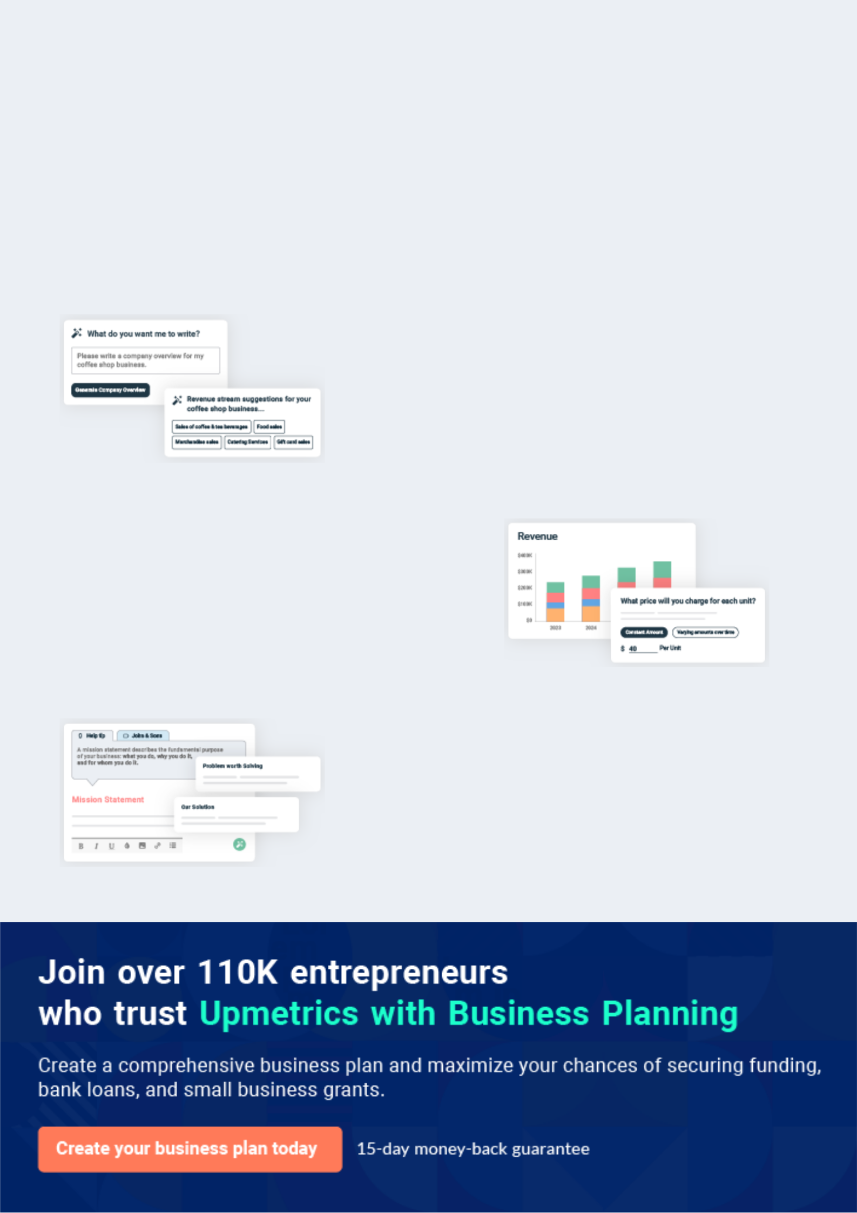
Business planning that’s simpler and faster than you think

Creating a business plan using Upmetrics to start and grow a business is literally the easiest thing in the World. Simply read the instructions and fill in the blanks. It’s as simple as that.

❛ | Upmetrics has everything you need to create a | ❜
❛ | comprehensive business plan. | ❜

AI-powered Upmetrics Assistant

AI-powered insights to streamline your plan

Not sure where to start? Upmetrics’ AI Assistant will automatically generate ideas for each section of your plan and offer improved versions of your writing, adjusting for tone, voice, and grammar or spelling errors.

Financial Forecasting Tool

All the financials are calculated for you

Forget the complex formulas and clumsy spreadsheets — with automatic financials and drag-and-drop forecasting, you can finish your plan faster and be confident that your numbers are accurate.

Business Plan Builder

Guides you like a business mentor

Upmetrics’ step-by-step instructions, prompts, and the library of 400+ sample business plans will guide you through each section of your plan as a business mentor.

1.


Executive Summary

Overview

Market Opportunity

Management

Financial Projections & Funding

Avadh Restaurant | Business Plan [YEAR] 6/50

Overview
To unlock help try Upmetrics!

 Avadh


Avadh will be a quick casual dining concept that's intended to appeal first and foremost to the millennial generation (15-35) along with the generations which follow it. Avadh will interest Millennials since the food is clean, healthy, economical, and portable. They'll have the ability to
To unlock help try Upmetrics! 

Start writing here..

Market Opportunity

 Avadh

Though a Smaller portion of the general market than the fast food and casual dining sections, fast-casual concepts are Exploding on the scene and gaining popularity every year. According to Techno inc, the market research company, the quick-casual segment increased sales by 12
To unlock help try Upmetrics! 

Start writing here..

Management

 Avadh

John Doe, the founder and visionary behind the Avadh notion has spent his whole career serving excellent meals to hungry customers. He possessed 6 restaurants at San Jose before going into the Phoenix region and producing the Avadh notion.



Start writing here..

Avadh Restaurant | Business Plan [YEAR] 7/50

Financial Projections & Funding

Avadh plans to start 4 company-owned restaurants. The first restaurant is Of this sum, $400,000 will be supplied in the shape of equity with the remainder, $400,000 coming out of a term loan given by a commercial lender.

Avadh plans to raise $2,000,000 in equity funding. The Restaurant Will divide this funding evenly between both business shops. It's considered that the second, third and fourth-largest shops will use duration centers from a commercial lender to complete the financing of those shops too. Please be aware that the financial details of the document pertain only to the very first shop.

Once proof of concept has been attained with These shops, Avadh will proceed to a master business plan with growth programs for other Nevada locations and Then moving to cities in other Sunbelt states.

 | Year1 | Year2 | Year3 | Year4 | Year5
Revenue | 812,451 | 999,871 | 1,455,145 | 1,985,895 | 2,457,878
Cost of Sales | 105,104 | 205,451 | 385,451 | 521,451 | 854,145
Employee | 312,451 | 351,458 | 452,451 | 482,451 | 492,451
Expense
Operating | 112,451 | 121,451 | 134,451 | 145,451 | 152,451
Expense
EBITDA | 116,451 | 216,451 | 516,451 | 641,451 | 895,452

Avadh Restaurant | Business Plan [YEAR] 8/50

2.

Avadh

The Restaurant Concept

Business Model

Objectives

Keys to Success

Long Term Strategy

Intellectual Property

Sustainability

Avadh Restaurant | Business Plan [YEAR] 9/50

The Restaurant Concept

 Avadh


Avadh ("the Restaurant") is a brand new quick-casual Asian inspired restaurant idea. It'll be perfectly positioned to benefit from the fastest-growing segment within the

Start writing here..

 Avadh

To unlock help try Upmetrics! 

In targeting the millennial era category, Avadh has discovered a "technological link" that needs to happen to attract and participate in this age category as customers. That is the reason why
the Restaurant will use the most recent technologies to promote the brand, join with customers,
To unlock help try Upmetrics! 

Technology

Start writing here..

Business Model

 Avadh

The Restaurant's business model is going to be dependent upon operational competence and a fantastic tasting, wholesome menu. The company model is persuasive for the easy reason that from the own large, nicely equipped kitchen Avadh will prepare dishes which are available in its
To unlock help try Upmetrics! 

Start writing here..

Avadh Restaurant | Business Plan [YEAR] 10/50

Objectives
To unlock help try Upmetrics!

 Avadh

Avadh has established the following Goals for the first twelve months of operation Following Launching the restaurant:
To unlock help try Upmetrics! 

Start writing here..

Keys to Success

 Avadh

The founder considers he has the ideal mixture of experience, vision, and skill to swiftly place the Restaurant on a quick track for profit and growth. These keys will contribute to its achievement:



Start writing here..

Long Term Strategy

 Avadh

Avadh plans to open 3 restaurants in metropolitan Phoenix in its first 2 decades of operation.

Those restaurants will be business owned. When the outlets are open and operating profitably,
Avadh will establish a franchise plan. The plan involves developing master franchisees which
To unlock help try Upmetrics! 

Start writing here..

Avadh Restaurant | Business Plan [YEAR] 11/50

Intellectual Property
To unlock help try Upmetrics!

 Avadh

The name, Avadh was registered with the Secretary of State of San Jose. Along with this name, a URL was registered. It's the proprietor's intention to trademark its packaged products. All recipes are owned and proprietary by the Restaurant.



Start writing here..

Sustainability

 Avadh

Avadh believes in getting a positive effect on the community. The founder will take the additional steps required to be useful, accountable neighbors by integrating sustainable practices at every opportunity. Avadh will attain environmental sustainability through:
To unlock help try Upmetrics! 

Start writing here..

Avadh Restaurant | Business Plan [YEAR] 12/50

3.

Sample Menu

Menu Items

Avadh Restaurant | Business Plan [YEAR] 13/50


Developing the abilities to produce and prepare an exciting menu of excellent Asian dishes comes from traveling, tasting and experiencing Asian meals in Asia. The end result is a combination of traditional Asian cuisine with a dab
To unlock help try Upmetrics! 

Menu Items
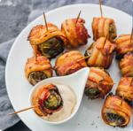
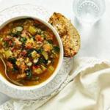

Appetizers Soups a Salads

Salt & Pepper Chicken Wings Pho-Viet Nam Style Beef Noodle

Chinese Lettuce Wraps Teriyaki Soup Spicy Thai Coconut Soup

Beef Skewers Asian Calamari Salad

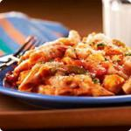

Rice Bowls Main Dishes

Singapore Style Currie Lo Mein Vindaloo Chicken Thai Fried

Catfish & Chile Sauce Shrimp & Long Beans



Desserts Beverages

Double Chocolate Cookie Lychee Freshly Brewed Iced & Hot Tea

Fruit Homemade Lemonade Bubble Tea


Wine & Beer

Bottled Beers from Asia Select

California Wines

Avadh Restaurant | Business Plan [YEAR] 14/50

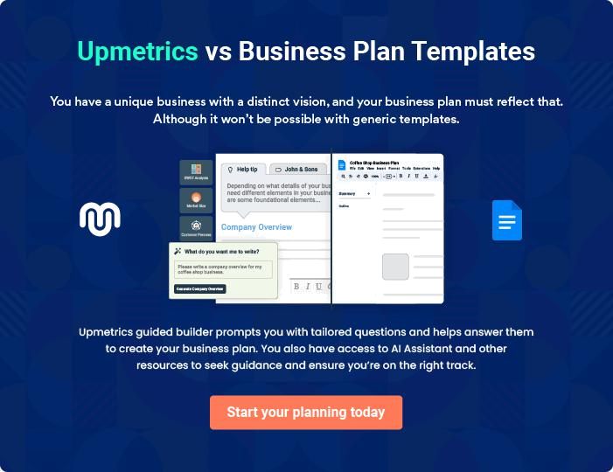

Avadh Restaurant | Business Plan [YEAR] | 15/50

4.

Restaurant Operations

Customer Service

Operating Policies

Operating Standards

Training

Controlling Costs

Avadh Restaurant | Business Plan [YEAR] 16/50

The effective implementation of the working standards and standards outlined in this business plan requires demonstrated support tools and
skilled direction. To attain these goals, the Restaurant will use the strategies
To unlock help try Upmetrics! 

Start writing here..

Customer Service

 Avadh

The hospitality business recognizes the client's support experience is the critical driver to replicate business. The direction will Offer a superior degree of Professionalism by hiring individuals who deliver the ideal attitude to work and teaching them the skills required to
To unlock help try Upmetrics! 

Start writing here..

Operating Policies

 Avadh

The managing of Avadh is going to be contingent upon operating policies and strategies which the founders and the staff have grown and successfully employed in other profitable restaurant projects such as Avadh. The founders have expertise in the food service company and an
To unlock help try Upmetrics! 

Start writing here..

 Avadh

Avadh will utilize the Most Recent technology available, Now the NEC Aloha Method to Closely monitor and handle food and beverage use, allowing management to correctly ascertain operating expenses and manage the loss. Manual inventories will be run on a weekly basis to
To unlock help try Upmetrics! 

Strict Inventory Controls

Start writing here..

Avadh Restaurant | Business Plan [YEAR] 17/50

 Avadh
To unlock help try Upmetrics!

Management will always monitor provider bids to gain the best Pricing for many foods along with other components. Market price changes will direct buying, menu composition, and menu pricing to guarantee the restaurant matches and exceed gain expectations.
To unlock help try Upmetrics! 

Purchasing Cost Controls

Start writing here..

 Avadh

Food preparation personnel will follow standardized recipes developed by the founders to control food costs and ensure consistency. The Restaurant will offer an innovative menu with nutritious food while achieving the greatest margin yield.



Recipe a Portion Controls

Start writing here..

 Avadh

Menu blending enables the Restaurant to maintain a perception of affordability. This is achieved by taking certain items and reducing the price in order to maintain interest in specific items, while delivering higher margins on others, therefore blending costs.
To unlock help try Upmetrics! 

Menu Blending

Start writing here..

 Avadh

Avadh will maintain a 100% compliance policy for sanitation and food handling to ensure the safety and health of all guests and employees. The Restaurant will always comply with all city, county, and state Department of Health sanitation and food handling standards. All employees
To unlock help try Upmetrics! 

Sanitation a Food Handling

Start writing here..

Avadh Restaurant | Business Plan [YEAR] 18/50

Operating Standards

 Avadh

The founder will be responsible for hiring and training managers who, in turn, will be responsible for ensuring that the day-to-day operations will comply with the standards set by Restaurant policy. Weekly management meetings will provide a forum to review and discuss
To unlock help try Upmetrics! 

Management's Role

Start writing here..

 Avadh

Avadh will utilize an integrated information system to manage the flow of information within each of the future restaurants and the home office. This system will include a point-of-sale local area network that helps facilitate the operations of the restaurant by recording sales
To unlock help try Upmetrics! 

Software a Systems

Start writing here..

 Avadh

While the quality of the cuisine and dining experience contributes significantly to a restaurant's profitability, it is attention to business and financial details that can transform small changes into large returns. While all decisions are made with the customer and employee in mind, they
To unlock help try Upmetrics! 

Money a Profit Management

Start writing here..

Avadh Restaurant | Business Plan [YEAR] 19/50

 Avadh
To unlock help try Upmetrics!
To unlock help try Upmetrics!

The successful implementation of the culinary and dining concepts outlined within this business plan demands excellence from each and every employee. To achieve excellence, the Restaurant will focus on hiring, training, and retaining the very best employees.
To unlock help try Upmetrics! 

Training

 Avadh


Employees with a good attitude, a strong

work ethic, an eye for detail, and a passion for providing excellent service will be recruited. Front of house

Hiring the Best

Start writing here..

To unlock help try Upmetrics! 

 Avadh

An ongoing program of training and education will ensure that each staff member learns and implements Avadh's exacting standards for service and operational procedures. Staff meetings will reinforce service standards and principles.



Training for Excellence

Start writing here..

 Avadh

The Restaurant embraces the concept of promoting from within. Excellence in one function typically leads to excellence in another. There will be regular staff evaluations to ensure motivation and address key issues.



Retaining the Best

Start writing here..

Avadh Restaurant | Business Plan [YEAR] 20/50

 Avadh

Avadh s simple menu and service concept will enable Avadh to control the following key criteria:
To unlock help try Upmetrics! 

Controlling Costs

 Avadh

A menu that is easy to execute will minimize errors. Fewer menu items will mean reduced volumes of perishable foods and therefore less likelihood of waste. Ordering should be quick
and simple as there are relatively few items to order. Even with the use of high-quality all-natural
To unlock help try Upmetrics! 

Food Costs

Start writing here..

 Avadh

The Restaurant requires comparatively fewer items of equipment to run an efficient operation, resulting in lower startup costs. This will, in turn, result in lower ongoing maintenance costs.
To unlock help try Upmetrics! 

Equipment Costs

Start writing here..

 Avadh

Staff turnover rates in the restaurant industry run at over 70% p.a. and fast food is even higher. Maintaining quality standards with such high turnover rates is an ongoing challenge. Lower than normal staff turnover due to sound management philosophy and a rewarding working
To unlock help try Upmetrics! 

Staff Turnover /Training Costs

Start writing here..

Avadh Restaurant | Business Plan [YEAR] 21/50

5.

Location

Operating Details

Avadh Restaurant | Business Plan [YEAR] 22/50

Avadh will negotiate to lease a 1600
To unlock help try Upmetrics!

-1800 square feet space in San Pedro in close proximity to San Jose State

Start writing here..

To unlock help try Upmetrics! 

Operating Details

 Avadh

Avadh will be open from 11:00 am to 10:30 pm Sunday through Thursday and 11:00 am to 1:00 am Friday and Saturday. The store will be clean, safe, and well lit. Customers will be able to pay for their orders with cash, credit card, or through a mobile app.



Start writing here..

Avadh Restaurant | Business Plan [YEAR] 23/50

6.

Industry Analysis

Industry Overview

Fast Casual Ming

Fast Casual Asian Food

Tempe Arizona

Avadh Restaurant | Business Plan [YEAR] 24/50

Industry Overview

 Avadh

In 2014, restaurant industry sales reached $752.5 billion, a 4.8% increase over 2013 in current dollars reflecting a continuing recovery in the economy. The restaurant industry is predicted to continue to be one of the largest employers in the public sector generating approximately 12.6
To unlock help try Upmetrics! 

Start writing here..

 Avadh

According to IBIS World, the source from which this analysis has been prepared, "The extent to which a population dines out can be projected based on age and income level. Households that make less than $50,000 per year spend 36.6% of their food budget on dining out. Households
To unlock help try Upmetrics! 

Restaurant Demographics

Start writing here..

 Avadh

As will be discussed in section 8.1 of this document, Millennials will be the Restaurant's target customers. Researchers believe that the millennial generation is made up of people who were born from the early 1980s to the early 2000s. Industry experts project Millennials to become
To unlock help try Upmetrics! 

Millennials

Start writing here..

Avadh Restaurant | Business Plan [YEAR] 25/50

Fast Casual Ming
To unlock help try Upmetrics!
To unlock help try Upmetrics!

 Avadh

The restaurant industry has historically been measured in three categories; fast food, casual dining, and fine dining. This changed in the 1990s with the addition of the Fast Casual classification. Typically restaurants in this category do not offer full table service but offer a
To unlock help try Upmetrics! 

Denning Fast Casual

Start writing here..

Fast Casual Asian Food

 Avadh

"The broader palates of younger Americans are looking for bolder and spicier flavors, and something different," says Darren Tristano, executive vice president of Technomic, a Chicago-based restaurant-research firm.



Start writing here..

 Avadh

The Restaurant's first store and in all likelihood all of its company owned stores will be in or near Tempe, Arizona. Tempe is located in metropolitan Phoenix and is home to Arizona State University, the largest university in the United States by enrollment.



Avadh Restaurant | Business Plan [YEAR] 26/50

Tempe Arizona

 Avadh
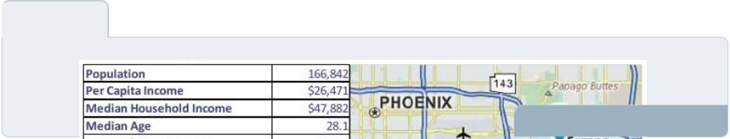

To unlock help try Upmetrics! 

Select Demographic Data

Start writing here..

Avadh Restaurant | Business Plan [YEAR] 27/50

7.

Competition

Competitive Landscape

Direct Competitors

Competitive Advantages

Avadh Restaurant | Business Plan [YEAR] 28/50

Competitive Landscape
To unlock help try Upmetrics!

 Avadh

The Restaurant recognizes that in the Phoenix metropolitan area there are many quick serves, fast-casual, and casual dining restaurants, and other retailers where consumers can purchase food at an affordable price and consume the food on the premises or take it away to consume
To unlock help try Upmetrics! 

Start writing here..

Direct Competitors

 Avadh


Pei Wei is a chain of quick-casual restaurants that serve freshly prepared, wok-seared, contemporary pan-Asian cuisine in a relaxed, warm environment
To unlock help try Upmetrics! 

Start writing here..

Competitive Advantages

 Avadh

Although there can be no clearly defined differentiators within such a fiercely competitive business environment, Avadh is focused on delivering an overall fresh, healthy competitive product. Key areas for focus include:



Start writing here..

Avadh Restaurant | Business Plan [YEAR] 29/50

8.

Marketing

Target Market Overview

Market Positioning & Brand

Marketing Strategies

Avadh Restaurant | Business Plan [YEAR] 30/50

Target Market Overview

 Avadh

The Restaurant's target customers are first and foremost most Millennials (ages 15-35) who live, study, or work in the neighborhood. According to Nicolas Jammet, Co-founder and Co-CEO of Sweetgreen, "they've embedded sustainability, charity, and healthy eating into their overall
To unlock help try Upmetrics! 

Start writing here..

Market Positioning & Brand

 Avadh

Each and every activity in which the Restaurant participates will establish or reinforce its brand. In doing so, every aspect of the Restaurant's communications with customers, employees, suppliers, and other partners will support the following branding marketing messages:
To unlock help try Upmetrics! 

Start writing here..

Marketing Strategies

 Avadh


Avadh will achieve its marketing objectives through a carefully conceived and aggressively implemented marketing program highlighted by the following strategies:

Start writing here..

To unlock help try Upmetrics! 

Avadh Restaurant | Business Plan [YEAR] 31/50

9.

Company & Management

Company

Management Team

Staffing Plan

External Issues

Avadh Restaurant | Business Plan [YEAR] 32/50

Company
To unlock help try Upmetrics!

 Avadh

The first Avadh and the two stores to follow will be owned by Mr. Chen and his investor group.

The legal entity is called Eat Great Enterprises LLC, an Arizona limited liability company. Mr.
Chen will be the Managing Member.


Start writing here..

Management Team

 Avadh

Avadh is the vision of a successful businessman who brings a number of important skills and experiences to the Company, including:
To unlock help try Upmetrics! 

Start writing here..


John Doe

Founder & CEO - john@example.com

Mr. John was born and raised in Arizona. After graduating from Arizona State University, he joined his family restaurant business and learned all aspect of the business from taking care of customers to managing a busy kitchen. After selling the five Inchon restaurants, Mr. John decided to join his wife's family who had earlier immigrated metropolitan Phoenix Arizona. After studying a number of restaurant concepts, Chen created Avadh. He is driven by how the fast-casual concept seems to fit the way Americans like to eat.

Avadh Restaurant | Business Plan [YEAR] 33/50


Jane Doe

Store Manager

Reporting to Mr. John, the Store Manager will be responsible for the entire store operation. In addition to enforcing all policies of the Restaurant as outlined, the Store Manager will oversee daily operations concentrating primarily on ensuring standards are adhered to during all times of the day. She will be responsible for hiring, training, disciplining and terminating service and bar staff, with assistance as needed from the founder.

She will be expected to have a complete understanding of the technology that will be an integral part of the operation from customer orders, payments, and delivery. During meal service, the Store Manager will be expected to control the flow of all activities overseeing, service staff and communicating with the kitchen to ensure a smooth flow to the Restaurant and will be expected to maintain clean and organized ordering and dining areas.

Avadh Restaurant | Business Plan [YEAR] 34/50

Staffing Plan
To unlock help try Upmetrics!

The Company aims to create a successful and rewarding work environment. It is Mr. Chen's firm belief that employee satisfaction represents a key contribution to customer satisfaction. The management team will consist of one General Store Manager and an Assistant Manager. They will be paid $50,000 and $35,000 respectively. The remaining employees will be hourly. For the first year of operation, there will be no employee benefits offered to employees. Down the road, this will be reviewed for it is the desire of ownership to offer a benefits program that will allow Avadh to be competitive in the workplace and take care of employees. Avadh will be staffed as follows:

Restaurant Front of House | Starting Month | Count | Annual Salary
Manager | 1st | 2 | 30,000
Serving Staff | 1st | 6 | 9,600
Bartender | 3rd | 1 | 16,000
Dish Washers | 3rd | 4 | 6,400

Restaurant Back of the House | Starting Month | Count | Annual Salary
Head Cook | 1st | 1 | 24,000
Cooks | 1st | 4 | 20,000
Servents | 1st | 4 | 16,000
Cleaners | 1st | 3 | 8,000

External Issues

 Avadh

There are no regulatory issues related to EPA, OSHA, IRS, or other governmental agencies. There are no unions represented at the Restaurant and there is no pending or anticipated litigation.



Start writing here..

Avadh Restaurant | Business Plan [YEAR] 35/50

10.

Financial Plan

Startup Expenditures

Revenue Assumptions

Cost of Goods Sold

Operating Expense Assumptions

Balance Sheet Assumptions

Bank Loan Assumptions

Projected Balance Sheet

Projected Profit and Loss

Projected Cash Flow

Avadh Restaurant | Business Plan [YEAR] 36/50

Projected Revenue

 | 2024 | 2025 | 2026
Dine in-sales | $35,814.30 | $64,317.60 | $115,506.60
Unit Sales | 2,388 | 4,288 | 7,700
Unit Price | $15 | $15 | $15
Gross Revenue | $35,814.30 | $64,317.60 | $115,506.60
Gross Margin | $35,814.30 | $64,317.60 | $115,506.60
Gross Margin (%) | 100% | 100% | 100%

Catering services | $142,005 | $202,520 | $288,760
Unit Customers | 284 | 405 | 578
Charges Per Customer | $500 | $500 | $500
Gross Revenue | $142,005 | $202,520 | $288,760
Gross Margin | $142,005 | $202,520 | $288,760
Gross Margin (%) | 100% | 100% | 100%

Online Food Delievery | $489,628.30 | $1,401,445.70 | $2,577,463.10
Ending Users | 2,357 | 5,047 | 8,769
Starting Users | 0 | 2,357 | 5,047
New Users | 3,005 | 4,811 | 7,703
Lost Users | 648 | 2,121 | 3,981
Setup Charges | $10 | $10 | $10
Recurring Charges | $30 | $30 | $30
Gross Revenue | $489,628.30 | $1,401,445.70 | $2,577,463.10
Gross Margin | $489,628.30 | $1,401,445.70 | $2,577,463.10
Gross Margin (%) | 100% | 100% | 100%

Avadh Restaurant | Business Plan [YEAR] 37/50

2024 2025 2026

Summary

Total Revenue | $667,447.60 | $1,668,283.30 | $2,981,729.70
Total Refund | $0 | $0 | $0
Net Revenue | $667,447.60 | $1,668,283.30 | $2,981,729.70
Total Cost of Sales | $130,381.21 | $287,189.75 | $492,500.92
General Costs | $130,381.21 | $287,189.75 | $492,500.92
Revenue Specific Costs | $0 | $0 | $0
Personnel Costs (Direct | $0 | $0 | $0
Labor) | $0 | $0 | $0
Gross Margin | $537,066.39 | $1,381,093.55 | $2,489,228.78
Gross Margin (%) | 80.47% | 82.79% | 83.48%

Personnel Expenses

 | 2024 | 2025 | 2026
Head Count | 16 | 16 | 16
Average Salary | $29,100 | $30,035.25 | $31,001.05
Revenue Per Employee | $41,715.48 | $104,267.71 | $186,358.11
Net Income Per Employee | ($7,245.89) | $39,164.49 | $100,889.36

Kitchen Staff | $186,300 | $191,889 | $197,645.52
Indirect Labor | $186,300 | $191,889 | $197,645.52
Chef | $48,300 | $49,749 | $51,241.44
Salaries & Wages | $42,000 | $43,260 | $44,557.80
Employee Related Expenses | $6,300 | $6,489 | $6,683.64
(15%) | $6,300 | $6,489 | $6,683.64
Sous Chef | $38,640 | $39,799.20 | $40,993.20

Avadh Restaurant | Business Plan [YEAR] 38/50

Salaries & Wages

Employee Related Expenses (15%)

Kitchen Helper

Salaries & Wages

Employee Related Expenses (15%)

Service Staff

Indirect Labor

Waiter

Salaries & Wages

Employee Related Expenses (15%)

Bartender

Salaries & Wages

Employee Related Expenses (15%)

Administrative Staff

Indirect Labor

Manager

Salaries & Wages

Employee Related Expenses (18%)

Accountant

Salaries & Wages

Employee Related Expenses (18%)

2024 | 2025 | 2026
$33,600 | $34,608 | $35,646.24
$5,040 | $5,191.20 | $5,346.96
$99,360 | $102,340.80 | $105,410.88
$86,400 | $88,992 | $91,661.76
$12,960 | $13,348.80 | $13,749.12

$234,600 | $241,638 | $248,887.20
$234,600 | $241,638 | $248,887.20
$165,600 | $170,568 | $175,685.04
$144,000 | $148,320 | $152,769.60
$21,600 | $22,248 | $22,915.44
$69,000 | $71,070 | $73,202.16
$60,000 | $61,800 | $63,654
$9,000 | $9,270 | $9,548.16

$117,528 | $122,229.12 | $127,118.28
$117,528 | $122,229.12 | $127,118.28
$63,720 | $66,268.80 | $68,919.60
$54,000 | $56,160 | $58,406.40
$9,720 | $10,108.80 | $10,513.20
$53,808 | $55,960.32 | $58,198.68
$45,600 | $47,424 | $49,320.96
$8,208 | $8,536.32 | $8,877.72

Avadh Restaurant | Business Plan [YEAR] 39/50

2024 2025 2026

Summary

Total Personnel Expenses | $538,428 | $555,756.12 | $573,651
Direct Labor (COS) | $0 | $0 | $0
Salary & Wages | $0 | $0 | $0
Employee Related Expenses | $0 | $0 | $0
Indirect Labor | $538,428 | $555,756.12 | $573,651
Salary & Wages | $465,600 | $480,564 | $496,016.76
Employee Related Expenses | $72,828 | $75,192.12 | $77,634.24
% Of Revenue | 80.67% | 33.31% | 19.24%

Startup Expenditures

 Avadh

The following table highlights how the startup capital will be utilized:

To unlock help try Upmetrics! 

Start writing here..


Pre-Opening Cash Outlays

Buildout/Tenant Improvements

Tenant Improvements

Total Buildout/Tenant Improvements

Fixed Assets

Furniture, Fixtures, and Equipment

Total Fixed Assets

Inventory

250,000

250,000

200,000

200,000

Avadh Restaurant | Business Plan [YEAR] 40/50

Pre-Opening Cash Outlays
Food | 10,000
Beer, Wine, and Liquor | 5,000
Total Inventory | 15,000
Capitalized Start-Up Expenses (Pre-Opening)
Employee Expenses | 20,000
Grand Opening | 5,000
Labor Recruitment | 1,000
Legal Fees | 5,000
Liquor License | 3,500
Menus/Imprinted Materials | 1,500
Miscellaneous | 2,500
Other | 1,500
Office Supplies | 1,000
Pre-opening Advertising | 15,000
Utilities | 1,500
Rent | 15,000
Supplies | 20,000
Training Dry Run COGS | 2,000
Training Materials | 2,000
Uniforms | 1,500
Working Capital | 20,000
Total Capitalized Start-Up Expenses (Pre-Opening) | 118,000
Total Start-Up Costs | 583,000

Avadh Restaurant | Business Plan [YEAR] 41/50

Revenue Assumptions
To unlock help try Upmetrics!
To unlock help try Upmetrics!

 Avadh

The financial forecast assumes that Avadh will process an average of 250 customer transactions per day, seven days a week. It further assumes that the average food purchase will be $7.00 and the average beverage purchase will be $4.50. Lastly, prices are forecast to grow
To unlock help try Upmetrics! 

Start writing here..

Cost of Goods Sold

 Avadh

The forecast assumes that food costs will run at 27% of the food sales price and beverage costs will be 20% of beverage cost. A 1% factor has been forecast for comps and promotions. COGS are forecast to increase by 3% per year.



Start writing here..

Operating Expense Assumptions

 Avadh

The operating expenses that appear in the income statement forecast that follows are assumed to grow by 3% per year with the exception of credit card fees which are based on gross revenue.



Start writing here..

Avadh Restaurant | Business Plan [YEAR] 42/50

Balance Sheet Assumptions

 Avadh

It is assumed that there are no accounts receivable as products are paid for at the time of purchase. Account payable are assumed to be paid for in the month in which they are incurred or in the month following the month they are incurred depending upon timing and supplier
To unlock help try Upmetrics! 

Start writing here..

Bank Loan Assumptions

 Avadh

A $300,000 commercial bank loan is assumed to fully amortize over a period of 72 months at an interest rate of 4.00%
To unlock help try Upmetrics! 

Start writing here..

Projected Balance Sheet

 | 2024 | 2025 | 2026
Assets | $16,756.06 | $604,826.72 | $2,189,153.57
Current Assets | ($24,243.94) | $572,826.72 | $2,166,153.57
Cash | ($35,249.14) | $561,821.52 | $2,155,148.37
Accounts Receivable | $0 | $0 | $0
Inventory | $0 | $0 | $0
Other Current Assets | $11,005.20 | $11,005.20 | $11,005.20
Long Term Assets | $41,000 | $32,000 | $23,000
Gross Long Term Assets | $50,000 | $50,000 | $50,000
Accumulated Depreciation | ($9,000) | ($18,000) | ($27,000)

Avadh Restaurant | Business Plan [YEAR] 43/50

2024 2025 2026

Liabilities & Equity | $16,756.04 | $604,826.71 | $2,189,153.56
Liabilities | $82,690.20 | $64,129.08 | $44,226.17
Current Liabilities | $18,561.12 | $19,902.91 | $0
Accounts Payable | $0 | $0 | $0
Income Tax Payable | $0 | $0 | $0
Sales Tax Payable | $0 | $0 | $0
Short Term Debt | $18,561.12 | $19,902.91 | $0
Long Term Liabilities | $64,129.08 | $44,226.17 | $44,226.17
Long Term Debt | $64,129.08 | $44,226.17 | $44,226.17
Equity | ($65,934.16) | $540,697.63 | $2,144,927.39
Paid-in Capital | $0 | $0 | $0
Common Stock | $0 | $0 | $0
Preferred Stock | $0 | $0 | $0
Owner's Contribution | $50,000 | $50,000 | $50,000
Retained Earnings | ($115,934.16) | $490,697.63 | $2,094,927.39

Check | $0 | $0 | $0

Projected Profit and Loss

 | 2024 | 2025 | 2026
Revenue | $667,447.60 | $1,668,283.30 | $2,981,729.70
Dine in-sales | $35,814.30 | $64,317.60 | $115,506.60
Unit Sales | 2,388 | 4,288 | 7,700
Unit Price | $15 | $15 | $15

Avadh Restaurant | Business Plan [YEAR] 44/50

 | 2024 | 2025 | 2026
Catering services | $142,005 | $202,520 | $288,760
Unit Sales | 284 | 405 | 578
Unit Price | $500 | $500 | $500
Online Food Delievery | $489,628.30 | $1,401,445.70 | $2,577,463.10
Users | 2,357 | 5,047 | 8,769
Recurring Charges | $30 | $30 | $30

Cost Of Sales | $130,381.21 | $287,189.75 | $492,500.92
General Costs | $130,381.21 | $287,189.75 | $492,500.92
Kitchen Supplies | $53,490.48 | $108,928.72 | $181,445.23
Fresh produce | $20,118.08 | $25,514.54 | $32,358.72
Meat Poultry | $33,372.40 | $83,414.18 | $149,086.51
Beverages | $76,890.73 | $178,261.03 | $311,055.69
Alcoholic Beverages | $66,744.78 | $166,828.35 | $298,173
Non-Alcoholic Beverages | $10,145.95 | $11,432.68 | $12,882.69
Revenue Specific Costs | $0 | $0 | $0
Personnel Costs (Direct | $0 | $0 | $0
Labor) | $0 | $0 | $0

Gross Margin | $537,066.39 | $1,381,093.55 | $2,489,228.78
Gross Margin (%) | 80.47% | 82.79% | 83.48%

Operating Expense | $637,548.89 | $740,261.45 | $862,140.49
Payroll Expense (Indirect | $538,428 | $555,756.12 | $573,651
Labor) | $538,428 | $555,756.12 | $573,651
Kitchen Staff | $186,300 | $191,889 | $197,645.52

Avadh Restaurant | Business Plan [YEAR] 45/50

 | 2024 | 2025 | 2026
Chef | $48,300 | $49,749 | $51,241.44
Sous Chef | $38,640 | $39,799.20 | $40,993.20
Kitchen Helper | $99,360 | $102,340.80 | $105,410.88
Service Staff | $234,600 | $241,638 | $248,887.20
Waiter | $165,600 | $170,568 | $175,685.04
Bartender | $69,000 | $71,070 | $73,202.16
Administrative Staff | $117,528 | $122,229.12 | $127,118.28
Manager | $63,720 | $66,268.80 | $68,919.60
Accountant | $53,808 | $55,960.32 | $58,198.68
General Expense | $86,126.09 | $160,505.33 | $264,489.49
Utilities | $20,741.98 | $28,094.19 | $38,180.67
Electricity | $11,353.62 | $16,187.39 | $23,079.54
Water Supply | $4,023.57 | $5,102.86 | $6,471.76
Gas Consumption | $5,364.79 | $6,803.94 | $8,629.37
Maintenance And Repairs | $16,094.49 | $20,411.73 | $25,887.10
Costs | $16,094.49 | $20,411.73 | $25,887.10
Kitchen Equipment | $6,705.97 | $8,504.74 | $10,786.13
Building Repairs | $9,388.52 | $11,906.99 | $15,100.97
Marketing and Advertising | $49,289.62 | $111,999.41 | $200,421.72
Social Media Ads | $20,023.44 | $50,048.52 | $89,451.90
Print Advertising | $13,348.96 | $33,365.66 | $59,634.60
Promotional Events | $15,917.22 | $28,585.23 | $51,335.22
Bad Debt | $0 | $0 | $0
Amortization of Current | $12,994.80 | $24,000 | $24,000
Assets | $12,994.80 | $24,000 | $24,000

Avadh Restaurant | Business Plan [YEAR] 46/50

EBITDA

Additional Expense

Long Term Depreciation

Gain or loss from Sale of Assets

EBIT

Interest Expense

EBT

Income Tax Expense / Benefit

2024 | 2025 | 2026
($100,482.50) | $640,832.10 | $1,627,088.29

$15,451.66 | $14,200.31 | $12,858.53
$9,000 | $9,000 | $9,000
$0 | $0 | $0
($109,482.50) | $631,832.10 | $1,618,088.29
$6,451.64 | $5,200.32 | $3,858.53
($115,934.16) | $626,631.79 | $1,614,229.76
$0 | $0 | $0

Total Expense | $783,381.76 | $1,041,651.51 | $1,367,499.94
Net Income | ($115,934.16) | $626,631.79 | $1,614,229.76
Net Income (%) | (17.37%) | 37.56% | 54.14%
Retained Earning Opening | $0 | ($115,934.16) | $490,697.63
Owner's Distribution | $0 | $20,000 | $10,000
Retained Earning Closing | ($115,934.16) | $490,697.63 | $2,094,927.39
Projected Cash Flow
 | 2024 | 2025 | 2026
Cash Received | $667,447.60 | $1,668,283.30 | $2,981,729.70
Cash Paid | $761,386.96 | $1,008,651.51 | $1,334,499.94
COS & General Expenses | $216,507.30 | $447,695.08 | $756,990.41

Avadh Restaurant | Business Plan [YEAR] 47/50

2024 2025 2026

Salary & Wages

Interest

Sales Tax

Income Tax

Net Cash From

Operations

Assets Sell

Assets Purchase

Net Cash From

Investments

Amount Received

Loan Received

Common Stock

Preferred Stock

Owner's Contribution

Amount Paid

Loan Capital

Dividends & Distributions

Net Cash From

Financing

Summary

$538,428 | $555,756.12 | $573,651
$6,451.64 | $5,200.32 | $3,858.53
$0 | $0 | $0
$0 | $0 | $0
($93,939.36) | $659,631.79 | $1,647,229.76

$0 | $0 | $0
$74,000 | $24,000 | $24,000
($74,000) | ($24,000) | ($24,000)

$150,000 | $0 | $0
$100,000 | $0 | $0
$0 | $0 | $0
$0 | $0 | $0
$50,000 | $0 | $0
$17,309.78 | $38,561.13 | $29,902.91
$17,309.80 | $18,561.12 | $19,902.91
$0 | $20,000 | $10,000
$132,690.22 | ($38,561.13) | ($29,902.91)

Starting Cash | $0 | ($35,249.14) | $561,821.52
Cash In | $817,447.60 | $1,668,283.30 | $2,981,729.70
Cash Out | $852,696.74 | $1,071,212.64 | $1,388,402.85

Avadh Restaurant | Business Plan [YEAR] 48/50

 | 2024 | 2025 | 2026
Change in Cash | ($35,249.14) | $597,070.66 | $1,593,326.85
Ending Cash | ($35,249.14) | $561,821.52 | $2,155,148.37
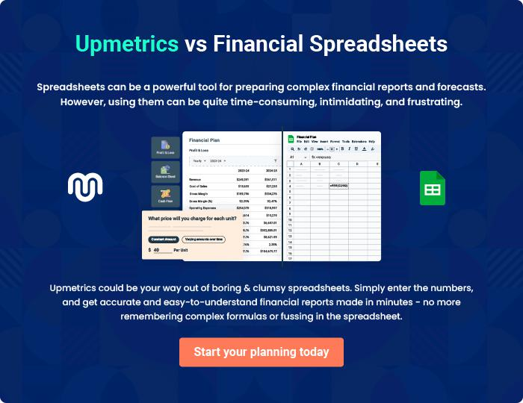

Avadh Restaurant | Business Plan [YEAR] 49/50

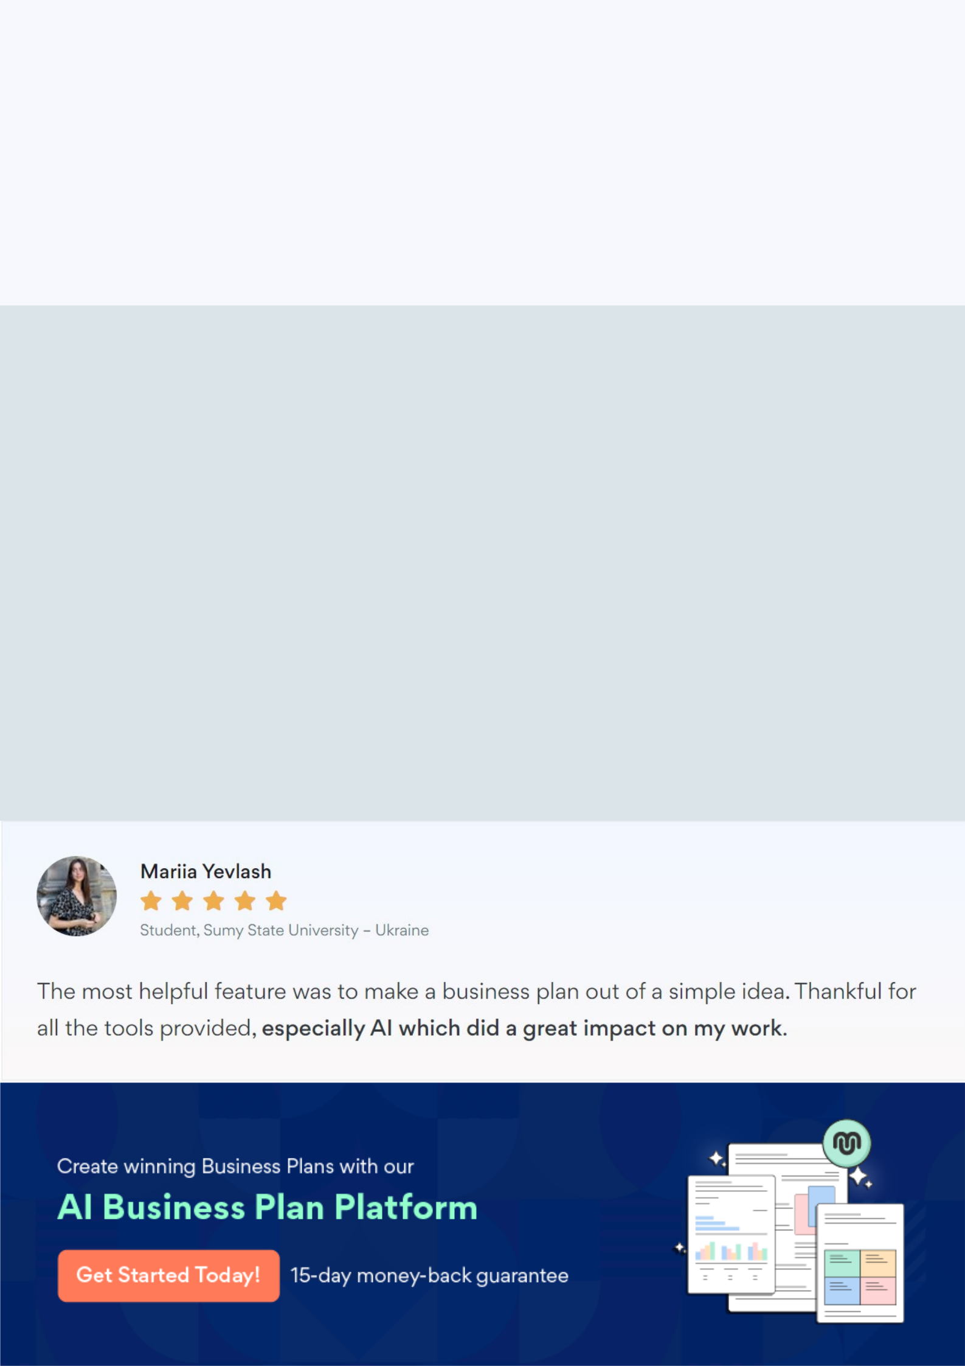
Create a winning business plan that gets you funded

Creating a stunning and investment-ready plan requires no writing, graphic designing, or financial planning expertise.

Upmetrics has all the features required to help you create a comprehensive business plan—from start to finish. Make no mistakes, it’s the modern way of planning to structure ideas, make plans, and create stunning pitch decks to awe investors.

Pitch decks that impress investors

Create pitch decks that provide a visual representation of your business, engage investors, and make them want to invest in your business idea.

Interactive plans in no time

Import business plan sections like—SWOT analysis, comparison tables, and others to create an interactive business plan. No designing skills are required.

Stunning cover page designs

With Upmetrics, you have the liberty to choose from multiple stunning cover page designs. Choose a creative design and make your plan stand out.

Online sharing made simple

Upmetrics makes online sharing quick and easier for users. Easily share your business plans with a link while tracking reader activity.

500+ sample business plans

Simply import a template from our library of sample plans into the editor and start customizing it to make it yours. It takes only a few clicks to get started.

Collaborate with team in real-time

Invite team members, initiate conversations, discuss ideas & strategies, share feedback, and work on a business plan in real-time.

