
BUSINESS PLAN

[YEAR]


Rental Property

Where Dreams Come Home

John Doe

10200 Bolsa Ave, Westminster, CA, 92683

- 359-3153 info@example.com http://www.example.com

Information provided in this business plan is unique to this business and confidential; therefore, anyone reading this plan agrees not to disclose any of the information in this business plan without prior written permission of the Company
Table of Contents

Executive Summary | 5
Business Objectives | 6
Mission Statement | 6
Guiding Principles | 7
Keys to Success | 7

Company Description | 8
Ownership | 9
Legal Form | 9
Start-Up Summary | 10
Location and Facilities | 10

Products | 11
Products/Services Descriptions | 12
Competitive Comparison | 12
Market Analysis
Market Analysis | 14
Industry Analysis | 15
Market Size | 15
Industry Participants | 15
Main Competitors | 16
Market Segments | 16
Market Tests | 16
Target Market Segment Strategy | 17
Market Needs | 17
Market Trends | 17
Market Growth | 17
Positioning | 18
Marketing Strategy and Implementation
Marketing Strategy and Implementation | 19
SWOT Analysis | 20

Rental Property | Business Plan [YEAR] 2/39

Strategy Pyramid | 22
Unique Selling Proposition (USP) | 22
Competitive Edge | 22
Marketing Strategy and Positioning | 23
Positioning Statement | 23
Pricing Strategy | 23
Promotion and Advertising Strategy | 23
Website | 24
Marketing Programs | 24
Sales Strategy | 24
Sales Forecast | 24
Sales Programs | 25
Legal | 25
Milestones | 25
Exit Strategy | 26

Organization and Management | 27
Organizational Structure | 28
Management Team | 28
Steve Rogers | 28
Linda Rogers | 28
Management Team Gaps | 29
Personnel Plan | 29

Financial Plan | 30
Important Assumptions | 31
Construction Budget | 31
Source of Funds | 31
Profit and Loss | 31
Start-Up Costs | 31
Source and Use of Funds | 32
Projected Profit and Loss | 32
Projected Cash Flow | 35
Projected Balance Sheet | 36

Rental Property | Business Plan [YEAR] 3/39


Business planning that’s simpler and faster than you think

Creating a business plan using Upmetrics to start and grow a business is literally the easiest thing in the World. Simply read the instructions and fill in the blanks. It’s as simple as that.

❛ | Upmetrics has everything you need to create a | ❜
❛ | comprehensive business plan. | ❜

AI-powered Upmetrics Assistant

AI-powered insights to streamline your plan

Not sure where to start? Upmetrics’ AI Assistant will automatically generate ideas for each section of your plan and offer improved versions of your writing, adjusting for tone, voice, and grammar or spelling errors.

Financial Forecasting Tool

All the financials are calculated for you

Forget the complex formulas and clumsy spreadsheets — with automatic financials and drag-and-drop forecasting, you can finish your plan faster and be confident that your numbers are accurate.

Business Plan Builder

Guides you like a business mentor

Upmetrics’ step-by-step instructions, prompts, and the library of 400+ sample business plans will guide you through each section of your plan as a business mentor.

1.


Executive Summary

Business Objectives

Mission Statement

Guiding Principles

Keys to Success

Rental Property | Business Plan [YEAR] 5/39

 REV


Real Estate Ventures (“REV”) is a newly formed S-Corporation wholly owned by Steve and Linda Rogers for purposes of purchasing and owning income-producing real estate. REV fills the void in the local Franklin, Tennessee rental housing market by providing clean, well cared for rental
To unlock help try Upmetrics! 

Start writing here..

Business Objectives

 REV


- Invest in quality well cared for properties that are priced within the local market range

- Locate only well-qualified tenants, desiring to lease long term
• ^{Generate passive income} To unlock help try Upmetrics! 

Start writing here..

Mission Statement

 REV

REV’s goal is to invest in quality – both in its properties and in its tenants. One of the largest mistakes made by new real estate investors is poor property selection. Even worse is their tenant selection process, often with little or no background and credit checks. At REV, the
To unlock help try Upmetrics! 

Start writing here..

Rental Property | Business Plan [YEAR] 6/39

Guiding Principles
To unlock help try Upmetrics!

 REV

REV holds the following as its Guiding Principles

- Treat the investment as a business first and foremost.
To unlock help try Upmetrics! 

Start writing here..

Keys to Success

 REV

REV is fully committed to make its rental property business a long term success with future plans for expansion. It is this dedication and drives which will set them apart from their local peers. The following are what REV believes are its keys to success:



Start writing here..

Rental Property | Business Plan [YEAR] 7/39

2.

Company Description

Ownership

Legal Form

Start-Up Summary

Location and Facilities

Rental Property | Business Plan [YEAR] 8/39

 REV

Real Estate Ventures, (“REV”), is a newly formed S-Corporation formed for purposes of managing the underlying real estate located in Franklin, Tennessee, a principal city in the Nashville Metropolitan Statistical Area (“MSA”). REV is jointly owned by Steve and Linda
To unlock help try Upmetrics! 

Start writing here..

Ownership

 REV

Steve and Linda Rogers are lifelong residents of Franklin, Tennessee. Steve has an established business and has owned his paint business known as ProStar Paint for 15+ years. Linda Rogers, a graduate of Middle Tennessee State University, is a math teacher at Franklin
To unlock help try Upmetrics! 

Start writing here..

Legal Form

 REV

Real Estate Ventures is an S-Corporation.

To unlock help try Upmetrics! 

Start writing here..

Rental Property | Business Plan [YEAR] 9/39

Start-Up Summary

 REV

Steve and Linda Rogers, the owners of REV have been interested in finding a means to supplement their income. When Linda’s mother passed away earlier this year, the couple received approximately $100,000 in inheritance and they decided to use this windfall to
To unlock help try Upmetrics! 

Start writing here..

Location and Facilities

 REV

REV extensively researched the local market and found it met their key criterion. The Red Mill Estates neighborhood has lush landscaping, larger than average lots, and is primarily owner-occupied. The surrounding neighborhoods are middle-class suburbs with five grocery stores
To unlock help try Upmetrics! 

Start writing here..

Rental Property | Business Plan [YEAR] 10/39

3.

Products

Products/Services Descriptions

Competitive Comparison

Rental Property | Business Plan [YEAR] 11/39

Products/Services Descriptions

 REV

REV provides clean, quality homes in growing markets to well-qualified tenants. The primary source of revenue is rental income. Supplemental income will include:
To unlock help try Upmetrics! 

Start writing here..

Competitive Comparison

 REV

There are seven rental income properties within a 1-mile radius of the subject along with several multifamily apartment units. For comparison purposes, the multifamily units have been excluded from this comparison. Rents per square foot range from a high of $1.11 to a low of
To unlock help try Upmetrics! 

Start writing here..

Rental Property | Business Plan [YEAR] 12/39

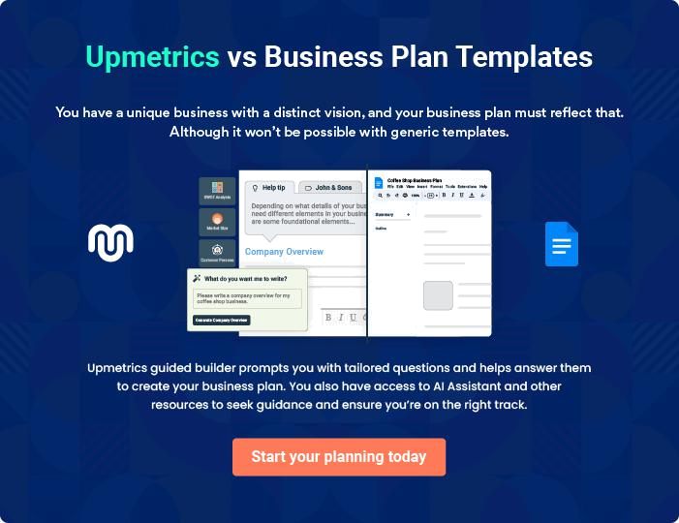

Rental Property | Business Plan [YEAR] | 13/39

4.

Market Analysis

Industry Analysis

Market Tests

Target Market Segment Strategy

Positioning

Rental Property | Business Plan [YEAR] 14/39

 REV

Franklin, Tennessee, located in Williamson County, is a Principal City in the Nashville Metropolitan Statistical Area (“MSA”) and is ranked 31 in the United States. According to the
University Of Tennessee’s 2012 Economic Outlook, Williamson County is one of the fastest-
To unlock help try Upmetrics! 

Start writing here..

Industry Analysis

 REV

The housing market recovery has remained true to the old real estate axiom of “location, location, location.” How your local market is faring today – and if it makes more sense to buy or rent, to sell now, or to hold off if possible – is largely determined by unique, local factors and
To unlock help try Upmetrics! 

Start writing here..

 REV

A recent survey of Franklin, Tennessee revealed there are currently 67 single-family residences available for rent. The average monthly rental charge ranges from $2,202 monthly to $1,058 monthly. The middle tier monthly rent is $1,283 or $1,031,532 annualized.
To unlock help try Upmetrics! 

Market Size

Start writing here..

 REV

The primary participants in the rental real estate market are other single-family residences and apartments. However, other indirect competitors include condos, mobile homes, trailers, garage apartments, and duplexes. Sellers of homes that offer rent to own options pose yet another
To unlock help try Upmetrics! 

Industry Participants

Start writing here..

Rental Property | Business Plan [YEAR] 15/39

 REV
To unlock help try Upmetrics!

Within a one mile radius of the subject are 10 apartment complexes and 7 single-family residences available for rent. For comparison, this analysis will focus only on the single-family residences available for rent.



Main Competitors

Start writing here..

 REV

The 1-mile radius surrounding the subject had a population of 7,199 at the 2010 Census and is expected to grow to 7,363 by the Year 2017. The majority of the homes are owner-occupied with 1,950 housing units and a reported 793 renter-occupied units from the 2010 Census.
To unlock help try Upmetrics! 

Market Segments

Start writing here..

Market Tests

 REV

Prior to selecting the rental unit, REV placed an advertisement for rent with the online classifieds at Linda’s place of employment, Franklin Elementary. The response was
overwhelming! REV had 14 candidates to choose from! The majority of these applicants were
To unlock help try Upmetrics! 

Start writing here..

Rental Property | Business Plan [YEAR] 16/39

Target Market Segment Strategy

 REV

REV is targeting families with children – single-family households or dual income households. The target tenant is young, under the age of 35 and is likely to have some additional financial obligations, such as student loan debt and car note debt that they want to pay off prior to
To unlock help try Upmetrics! 

Start writing here..

 REV

Given the option of raising a family in a traditional single-family home compared to an apartment complex, REV’s target tenant prefers the former. The Red Mill Estates neighborhood and surrounding neighborhoods are growing residential neighborhoods making the location
To unlock help try Upmetrics! 

Market Needs

Start writing here..

 REV

• Homeownership makes financial sense when the occupant is planning on staying 5+ years and has the cash flow cover the normal repair and maintenance costs. And as we leave the recession behind us over time tenants may vacate to pursue homeownership.
To unlock help try Upmetrics! 

Market Trends

Start writing here..

 REV

The local single family rental home market increased 1.4% over the prior year.

Source: Zillow Rent Index
To unlock help try Upmetrics! 

Market Growth

Start writing here..

Rental Property | Business Plan [YEAR] 17/39

Positioning

 REV

REV will position itself as the rental property of choice when it comes to quality properties in solid neighborhoods, by actively staying current on local market conditions.
To unlock help try Upmetrics! 

Start writing here..

Rental Property | Business Plan [YEAR] 18/39

5.

Marketing Strategy and Implementation

SWOT Analysis

Strategy Pyramid

Unique Selling Proposition (USP)

Competitive Edge

Marketing Strategy and Positioning

Sales Strategy

Legal

Milestones

Exit Strategy

Rental Property | Business Plan [YEAR] 19/39

 REV

REV will own, operate, and lease clean, well maintained single-family residences to well-qualified tenants. Others often miss the mark by investing in low-quality properties which will not provide sufficient ROI (return on investment). Additionally, other landlords often fall short in
To unlock help try Upmetrics! 

Start writing here..

SWOT Analysis

 REV

SWOT stands for strengths, weaknesses, opportunities, and threats. A SWOT analysis is a method for strategic planning that evaluates these four elements as they relate to REV’s business objectives. The following section helps demonstrate REV’s marketing strategy:
To unlock help try Upmetrics! 

Start writing here..

Rental Property | Business Plan [YEAR] 20/39


Strength

The rental property is well located in a growing neighborhood with easy access to neighborhood schools, shopping, and restaurants. Located less than 5 minutes from I-65, the commute to Nashville is less than 20 minutes.

REV has an approved tenant in place with a security deposit. The tenant has excellent credit and payment history. The tenant is known by REV and works as a teacher at the same school as Linda Rogers.

Upgrades to the property will be made by a reputable contractor with a 15-year history with the owners of REV. The owners of REV will paint the property themselves which will further reduce expenses.

REV will come out of pocket in excess of $67,000 toward the house purchase and capital improvements resulting in a low, loan to value (LTV) ratio of 50%.

The owners of REV have ‘day jobs’ and thus have additional income sources and savings to draw from to support business operations.

Weakness


New entrants into real estate property management, REV has limited

experience owning and managing investment income properties.


Opportunity

Franklin has low vacancy levels at 6% compared to the national average of 7.9%.

The property is located in a strong growing community and the fastest growing county in the state.

REV has an opportunity to participate in a $1 million local real estate rental market.

Threat

Investment real estate is economically tied – changes in unemployment, rent spikes, and changes in the economy could adversely impact demand for rental units.

Declination in the local neighborhood could impact the attractiveness of rents.

Cost overruns in the construction budget and failure to complete upgrades in time could impact REV’s cash flow.

Rental Property | Business Plan [YEAR] 21/39

Strategy Pyramid

 REV

REV will only lease solid, clean, well-maintained investment properties that generate positive cash flow.
To unlock help try Upmetrics! 

Start writing here..

Unique Selling Proposition (USP)

 REV

The owners of REV love what they do! And it shows in from the quality of the properties they invest into the caliber of tenants they lease to. They thoroughly review the property and analyze the real estate market. REV will continually monitor and evaluate the local market trends. They
To unlock help try Upmetrics! 

Start writing here..

Competitive Edge

 REV

REV utilizes a thorough due diligence process prior to purchasing and investing in any property.

By doing their homework, REV can competitively price their rents – often at or below market.
Thoroughly knowing their market gives REV a competitive edge over their competitors. Further,
To unlock help try Upmetrics! 

Start writing here..

Rental Property | Business Plan [YEAR] 22/39

Marketing Strategy and Positioning
To unlock help try Upmetrics!
To unlock help try Upmetrics!

 REV

REV’s marketing strategy incorporates a Focus Strategy – that is, it targets a specific target market. REV concentrates their marketing efforts on attracting solid, creditworthy tenants that are motivated to live in growing, thriving comminutes.



Start writing here..

 REV

REV is a high-quality real estate investment corporation. REV carefully and methodically selects its rental properties in growing neighborhoods, with low vacancy rates. The properties are clean, well maintained, and provide positive cash flow. In keeping with their high-quality
To unlock help try Upmetrics! 

Positioning Statement

Start writing here..

 REV

REV utilizes Competition-Based Pricing – in which prices are based on the market. The company’s thorough due diligence process assures that they never buy the highest-priced property or the lowest price for that matter.



Pricing Strategy

Start writing here..

 REV

REV will primarily rely on advertising in the Franklin Elementary School Online Classified Ads and Word of Mouth advertising.
To unlock help try Upmetrics! 

Promotion and Advertising Strategy

Start writing here..

Rental Property | Business Plan [YEAR] 23/39

 REV

REV’s website features properties available to rent, the business phone number to contact for information regarding renting or who to contact for repairs. Additionally, the website will have links to complete an online application and links to key articles for tenants such as the
To unlock help try Upmetrics! 

Website

Start writing here..

 REV

REV is uniquely sized to both personally own and manage its investment properties. Through their extensive contacts in the Franklin area, REV hopes to rely on Word of Mouth advertising and not be forced to allocate a large portion of their budget to advertising costs. However, in
To unlock help try Upmetrics! 

Marketing Programs

Start writing here..

Sales Strategy

 REV

REV will meet with prospects right on site. The prospects will be greeted and treated with the utmost professionalism in a relaxed and respectful environment. The first meeting is an opportunity for the owners of REV to decide on leasing to the prospective tenant. If the
To unlock help try Upmetrics! 

Start writing here..

 REV


The following table represents the estimated sales from the rental unit the initial three years of operations. The analysis assumes 100% leased and no escalations in rent the initial two years.
To unlock help try Upmetrics! 

Sales Forecast

Start writing here..

Rental Property | Business Plan [YEAR] 24/39

 REV
To unlock help try Upmetrics!

The owners of REV personally lease their properties and do not need to pay incentives to sales agents. However, just like sales agents, the owners of REV are motivated to lease properties quickly- after all vacant properties do not generate revenue! Although the owners of REV are
To unlock help try Upmetrics! 

Sales Programs

Start writing here..

Legal

 REV

Clean title and zoning, will be instrumental in purchasing investment real estate. The title search and tax record search must confirm this prior to REV purchasing any property. The title search must be free of liens.



Start writing here..

Milestones

Following are the Milestones REV believes will allow them to meet their objectives.
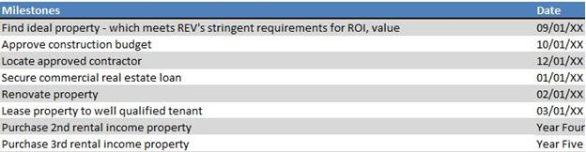

Rental Property | Business Plan [YEAR] 25/39

Exit Strategy

 REV

In the event, the rental unit remains vacant for an extended period of time or in the event that extreme repairs and depletes all cash reserves, the secondary recourse will be to the owners.
After the owners have depleted their personal reserves, the property will be sold. Proceeds will
To unlock help try Upmetrics! 

Start writing here..

Rental Property | Business Plan [YEAR] 26/39

6.

Organization and Management

Organizational Structure

Management Team

Management Team Gaps

Personnel Plan

Rental Property | Business Plan [YEAR] 27/39

The following section highlights ownership and future staffing expectations of REV:

Organizational Structure

 REV

Both Linda and Steve Rogers will own and manage the subject of real estate. Steve Rogers will perform routine maintenance requirements and repairs. Linda Rogers will manage the daily bookkeeping requirements. She will submit payments to vendors such as trash service and
To unlock help try Upmetrics! 

Start writing here..

Management Team


Steve Rogers

Owner - steve@example.com

Steve Rogers will oversee the day to day maintenance of the rental unit. On a monthly basis, he will replace air filters, inspect the grounds, and make notations of the overall physical condition of the property. The tenant will be put on notice for example if the yard needs to be mowed or weeds appear to be an issue. The tenant will have sufficient time to remedy the notice and will be fined daily until the issue has been resolved.

Steve has successfully owned and operated his painting business for 15+ years and is in the neighborhood on a daily basis. He will drive by the property frequently for visual inspections of the property. He is readily available in the event the tenant has any repair needs.


Linda Rogers

Assistant - linda@example.com

Linda Rogers will oversee the day to day bookkeeping needs for the rental property.

All tenants will be required to agree to EFT (electronic funds transfer) for monthly payments – which should minimize the need to collect rents.

Rental Property | Business Plan [YEAR] 28/39

Management Team Gaps
To unlock help try Upmetrics!

 REV

REV does not have an accountant or attorney on its staff. Income tax preparation and consulting services will be provided by the owner’s long term personal public accountant. REV will rely on their title company to verify a clear title.



Start writing here..

Personnel Plan

 REV

Steve and Linda Rogers will own and operate REV but draw no salary; both owners have outside incomes and will not draw salaries from the properties.
To unlock help try Upmetrics! 

Start writing here..

Rental Property | Business Plan [YEAR] 29/39

7.

Financial Plan

Important Assumptions

Start-Up Costs

Source and Use of Funds

Projected Profit and Loss

Projected Cash Flow

Projected Balance Sheet

Rental Property | Business Plan [YEAR] 30/39

Important Assumptions

Construction Budget

REV estimates a 1-month completion. Work will be performed by a contractor that is well known by the owners. The contractor is bonded, licensed, and in good standing with the state.

Source of Funds

The owners of REV received approximately $100,000 in inheritance and have access to liquidity to fund start-up costs and meet operating shortfalls. However, they plan to invest a portion of these proceeds into additional rental income properties. An additional source of funds comes from both owners 'day jobs' - Steve Rogers owns his own house painting business and Linda Rogers is a math teacher at Franklin Elementary.

Profit and Loss

Vacancy levels in Franklin are a low 6% and are substantially lower than the national average of 7.9%.

The analysis assumes 100% occupancy over the 3 years reviewed.

Start-Up Costs

The following table represents start-up costs.
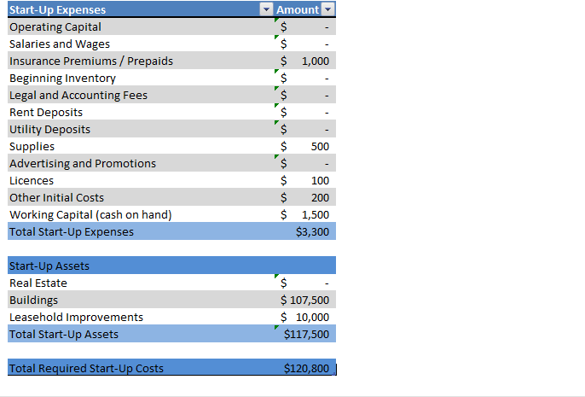

Rental Property | Business Plan [YEAR] 31/39

Source and Use of Funds

The owners of REV received approximately $100,000 in inheritance and have access to liquidity to fund start-up costs and meet operating shortfalls. However, they plan to invest a portion of these proceeds into additional rental income properties. An additional source of funds comes from both owners 'day jobs' - Steve Rogers owns his own house painting business and Linda Rogers is an elementary school math teacher at Franklin Elementary. The following table shows the proposed Source and Use of Funds:
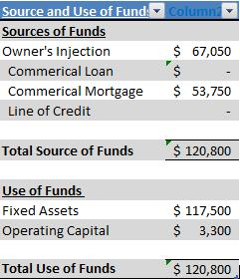

Projected Profit and Loss

 | 2024 | 2025 | 2026
Revenue | $1,456,018 | $2,952,737.50 | $3,844,598.50
Monthly Residential Rent | $1,176,018 | $2,644,542 | $3,478,254
Users | 276 | 430 | 519
Recurring Charges | $600 | $600 | $600
Annual Lease of | $100,000 | $103,000 | $106,090
Commercial Spaces | $100,000 | $103,000 | $106,090
Short-term Vacation | $180,000 | $205,195.50 | $260,254.50
Rentals | $180,000 | $205,195.50 | $260,254.50
Unit Sales | 1,200 | 1,368 | 1,735
Unit Price | $150 | $150 | $150

Rental Property | Business Plan [YEAR] 32/39

 | 2024 | 2025 | 2026
Cost Of Sales | $187,724.79 | $327,497.86 | $418,591.38
General Costs | $187,724.79 | $327,497.86 | $418,591.38
Property Maintenance | $101,927.33 | $163,424.09 | $209,595.87
Routine Maintenance | $12,134.25 | $15,787.20 | $17,365.92
Emergency Repairs | $89,793.08 | $147,636.89 | $192,229.95
Operational Costs | $85,797.46 | $164,073.77 | $208,995.51
Property Tax | $12,996.56 | $16,436.88 | $16,765.56
Insurance | $72,800.90 | $147,636.89 | $192,229.95
Revenue Specific Costs | $0 | $0 | $0
Personnel Costs (Direct | $0 | $0 | $0
Labor) | $0 | $0 | $0

Gross Margin | $1,268,293.21 | $2,625,239.64 | $3,426,007.12
Gross Margin (%) | 87.11% | 88.91% | 89.11%

Operating Expense | $1,030,055.18 | $1,228,429.47 | $1,372,022.45
Payroll Expense (Indirect | $795,720 | $821,578.80 | $848,319.24
Labor) | $795,720 | $821,578.80 | $848,319.24
Administrative Staff | $219,600 | $224,892 | $230,316.84
Office Manager | $90,000 | $92,700 | $95,481
Administrative Assistants | $129,600 | $132,192 | $134,835.84
Maintenance Staff | $576,120 | $596,686.80 | $618,002.40
Property Maintenance | $247,800 | $255,234 | $262,891.20
Workers | $247,800 | $255,234 | $262,891.20
Real Estate Agents | $328,320 | $341,452.80 | $355,111.20
General Expense | $234,335.18 | $406,850.68 | $523,703.23
Administrative Costs | $63,673.76 | $96,750.66 | $123,822.61

Rental Property | Business Plan [YEAR] 33/39

 | 2024 | 2025 | 2026
Office Supplies | $6,436.94 | $8,168.52 | $8,484.63
Utility Bills | $57,236.82 | $88,582.14 | $115,337.98
Marketing and Advertising | $79,122.90 | $155,121.29 | $200,088.63
Online Advertising | $6,322 | $7,484.40 | $7,858.68
Print Media Advertising | $72,800.90 | $147,636.89 | $192,229.95
Property Management | $91,538.52 | $154,978.73 | $199,791.99
Property Management Fees | $85,216.52 | $147,636.89 | $192,229.95
Landscaping Services | $6,322 | $7,341.84 | $7,562.04
Bad Debt | $0 | $0 | $0
Amortization of Current | $0 | $0 | $0
Assets | $0 | $0 | $0

EBITDA

Additional Expense

Long Term Depreciation

Gain or loss from Sale of Assets

EBIT

Interest Expense

EBT

Income Tax Expense / Benefit

$238,238.03 $1,396,810.17 $2,053,984.66

$23,680.40 | $20,779.13 | $17,698.91
$15,960 | $15,960 | $15,960
$0 | $0 | $0
$222,278.03 | $1,380,850.17 | $2,038,024.66
$7,720.40 | $4,819.14 | $1,738.92
$214,557.63 | $1,376,031.04 | $2,036,285.75
$0 | $0 | $0

Total Expense | $1,241,460.37 | $1,576,706.46 | $1,808,312.75
Net Income | $214,557.63 | $1,376,031.04 | $2,036,285.75
Net Income (%) | 14.74% | 46.60% | 52.96%

Rental Property | Business Plan [YEAR] 34/39

 | 2024 | 2025 | 2026
Retained Earning Opening | $0 | $196,557.63 | $1,572,588.67
Owner's Distribution | $18,000 | $0 | $0
Retained Earning Closing | $196,557.63 | $1,572,588.67 | $3,608,874.42
Projected Cash Flow
 | 2024 | 2025 | 2026
Cash Received | $1,456,018 | $2,952,737.50 | $3,844,598.50
Cash Paid | $1,225,500.37 | $1,560,746.47 | $1,792,352.75
COS & General Expenses | $422,059.97 | $734,348.54 | $942,294.60
Salary & Wages | $795,720 | $821,578.80 | $848,319.24
Interest | $7,720.40 | $4,819.14 | $1,738.92
Sales Tax | $0 | $0 | $0
Income Tax | $0 | $0 | $0
Net Cash From | $230,517.63 | $1,391,991.03 | $2,052,245.75
Operations | $230,517.63 | $1,391,991.03 | $2,052,245.75
Assets Sell | $0 | $0 | $0
Assets Purchase | $430,000 | $0 | $0
Net Cash From | ($430,000) | $0 | $0
Investments | ($430,000) | $0 | $0
Amount Received | $200,000 | $0 | $0
Loan Received | $150,000 | $0 | $0
Common Stock | $0 | $0 | $0
Preferred Stock | $0 | $0 | $0

Rental Property | Business Plan [YEAR] 35/39

 | 2024 | 2025 | 2026
Owner's Contribution | $50,000 | $0 | $0
Amount Paid | $65,039.08 | $49,940.35 | $53,020.59
Loan Capital | $47,039.08 | $49,940.34 | $53,020.58
Dividends & Distributions | $18,000 | $0 | $0
Net Cash From | $134,960.92 | ($49,940.35) | ($53,020.59)
Financing | $134,960.92 | ($49,940.35) | ($53,020.59)

Summary

Starting Cash | $0 | ($64,521.45) | $1,277,529.23
Cash In | $1,656,018 | $2,952,737.50 | $3,844,598.50
Cash Out | $1,720,539.45 | $1,610,686.82 | $1,845,373.34
Change in Cash | ($64,521.45) | $1,342,050.68 | $1,999,225.16
Ending Cash | ($64,521.45) | $1,277,529.23 | $3,276,754.39

Projected Balance Sheet

 | 2024 | 2025 | 2026
Assets | $349,518.55 | $1,675,609.23 | $3,658,874.39
Current Assets | ($64,521.45) | $1,277,529.23 | $3,276,754.39
Cash | ($64,521.45) | $1,277,529.23 | $3,276,754.39
Accounts Receivable | $0 | $0 | $0
Inventory | $0 | $0 | $0
Other Current Assets | $0 | $0 | $0
Long Term Assets | $414,040 | $398,080 | $382,120
Gross Long Term Assets | $430,000 | $430,000 | $430,000
Accumulated Depreciation | ($15,960) | ($31,920) | ($47,880)

Rental Property | Business Plan [YEAR] 36/39

2024 2025 2026

Liabilities & Equity | $349,518.55 | $1,675,609.25 | $3,658,874.42
Liabilities | $102,960.92 | $53,020.58 | $0
Current Liabilities | $49,940.34 | $53,020.58 | $0
Accounts Payable | $0 | $0 | $0
Income Tax Payable | $0 | $0 | $0
Sales Tax Payable | $0 | $0 | $0
Short Term Debt | $49,940.34 | $53,020.58 | $0
Long Term Liabilities | $53,020.58 | $0 | $0
Long Term Debt | $53,020.58 | $0 | $0
Equity | $246,557.63 | $1,622,588.67 | $3,658,874.42
Paid-in Capital | $0 | $0 | $0
Common Stock | $0 | $0 | $0
Preferred Stock | $0 | $0 | $0
Owner's Contribution | $50,000 | $50,000 | $50,000
Retained Earnings | $196,557.63 | $1,572,588.67 | $3,608,874.42

Check | $0 | $0 | $0

Rental Property | Business Plan [YEAR] 37/39

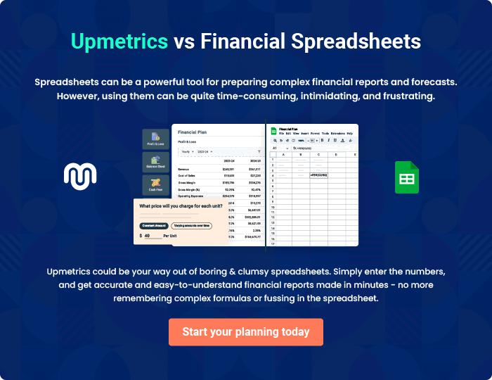

Rental Property | Business Plan [YEAR] | 38/39


Create a winning business plan that gets you funded

Creating a stunning and investment-ready plan requires no writing, graphic designing, or financial planning expertise.

Upmetrics has all the features required to help you create a comprehensive business plan—from start to finish. Make no mistakes, it’s the modern way of planning to structure ideas, make plans, and create stunning pitch decks to awe investors.

Pitch decks that impress investors

Create pitch decks that provide a visual representation of your business, engage investors, and make them want to invest in your business idea.

Interactive plans in no time

Import business plan sections like—SWOT analysis, comparison tables, and others to create an interactive business plan. No designing skills are required.

Stunning cover page designs

With Upmetrics, you have the liberty to choose from multiple stunning cover page designs. Choose a creative design and make your plan stand out.

Online sharing made simple

Upmetrics makes online sharing quick and easier for users. Easily share your business plans with a link while tracking reader activity.

500+ sample business plans

Simply import a template from our library of sample plans into the editor and start customizing it to make it yours. It takes only a few clicks to get started.

Collaborate with team in real-time

Invite team members, initiate conversations, discuss ideas & strategies, share feedback, and work on a business plan in real-time.

