
Real Estate Investments

A Premier Real Estate Professional

BUSINESS PLAN

[YEAR]

John Doe | 10200 Bolsa Ave, Westminster, CA, 92683 | (650) 359-3153 | info@example.com
http://www.example.com

Information provided in this business plan is unique to this business and confidential; therefore, anyone reading this plan agrees not to disclose any of the information in this business plan without prior written permission of the Company
Table of Contents

Executive Summary | 6
Purpose of the Plan | 7
Introduction | 7
The Problem | 7
The Solution | 8
Market Opportunity | 8
Fundamental change in US housing market | 8
All three legs of the apartment investment stool are in place | 8
Weak Housing Market | 9
Competitive Advantage | 9
Business Model | 9
Growth Opportunity | 10
Corporate Structure Overview | 10
Financial Projections | 10
Net Profit | 11
Financial Need and Use of Funds | 11
Source and Use of Funds | 11
Return on Investment | 12

Business Description | 14
Mission Statement | 15
Business Objectives | 15
Organization | 15
Legal Structure | 15
Company Ownerships | 16
Location and Premises | 16
Intellectual Property | 16

The Business Concept and Revenue Model | 17
The Business Concept | 18
CREI Business Model | 18

Real Estate Investments | Business Plan [YEAR] 2/56

Revenue Model | 18
Revenue Projections | 20
Investment Details | 20
The Amount of Investment Funds Requested | 20
Business Benefits | 21
Investment Repayments | 21

Market Analysis | 23
Apartment Rental - Industry Overview – Market Trends | 24
Good Investment Trends in Apartment Rentals | 24
Rent Spikes Coming For a Good Investment in Apartment Buildings | 24
Apartments Continue as Good Investment Through 2012 and Beyond | 24
Apartment Buildings Going From Good Investment to Great | 25
Filling Basic Needs Makes for a Good Investment | 25
More Americans renting by choice | 25
The Apartment Building Investment Triple Opportunity Is Right Now | 25
Internet Trends | 26
Internet Growth Allows Renters to Locate Good Apartments | 26
Industry Participants and Competitive Analysis | 26
Industry Participants | 26
Competitive Advantages | 26

Growth Strategy | 27
Strategic Initiatives | 28
Brand Strategy | 28
Marketing Strategy | 29
Provide Individuals, Families and Businesses Quality Rental Properties at an Affordable Price. | 29
Positioning Statement | 29
Pricing Strategy | 29
Sales Strategy | 30
Sales Forecast | 30
Sales Programs | 30
Strategic Alliances | 31
Milestones | 31

Real Estate Investments | Business Plan [YEAR] 3/56

Web Plan | 34
Web Marketing Strategy | 35
Social networking websites | 35
Email campaigns | 35
SEO (Search Engine Optimization) PPC | 36
Banner advertisements | 36
Search Engine Optimization | 36

Management Summary | 37
John Doe | 38
Jane Doe | 39
Thomas Doe | 40
Organizational Structure | 40
People | 40
SWOT Analysis
SWOT Analysis | 42
Financial Plan
Financial Plan | 46
Key Assumptions | 47
Key Financial Indicators | 47
Explanation of Break-even Analysis | 48
Business Ratios | 48
Long-term Plan and Financial Highlights | 49
Projected Income Statement | 49
Projected Cash Flow | 52
Projected Balance Sheet | 53

Real Estate Investments | Business Plan [YEAR] 4/56

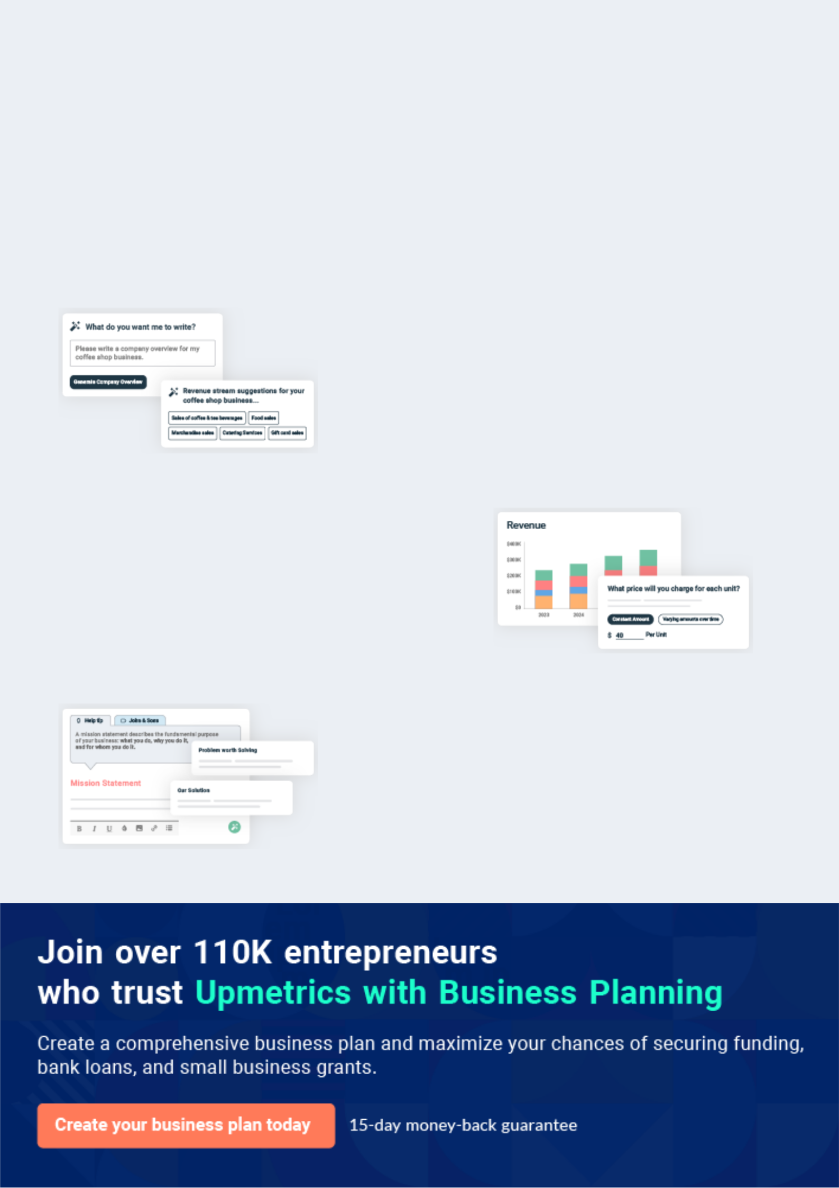
Business planning that’s simpler and faster than you think

Creating a business plan using Upmetrics to start and grow a business is literally the easiest thing in the World. Simply read the instructions and fill in the blanks. It’s as simple as that.

❛ | Upmetrics has everything you need to create a | ❜
❛ | comprehensive business plan. | ❜

AI-powered Upmetrics Assistant

AI-powered insights to streamline your plan

Not sure where to start? Upmetrics’ AI Assistant will automatically generate ideas for each section of your plan and offer improved versions of your writing, adjusting for tone, voice, and grammar or spelling errors.

Financial Forecasting Tool

All the financials are calculated for you

Forget the complex formulas and clumsy spreadsheets — with automatic financials and drag-and-drop forecasting, you can finish your plan faster and be confident that your numbers are accurate.

Business Plan Builder

Guides you like a business mentor

Upmetrics’ step-by-step instructions, prompts, and the library of 400+ sample business plans will guide you through each section of your plan as a business mentor.

1.


Executive Summary

Purpose of the Plan

Introduction

The Problem

The Solution

Market Opportunity

Competitive Advantage

Business Model

Growth Opportunity

Corporate Structure Overview

Financial Projections

Financial Need and Use of Funds

Real Estate Investments | Business Plan [YEAR] 6/56

Purpose of the Plan

 CREI


The purpose of this plan is to provide potential investors with the information necessary to evaluate the merits of the value proposition and growth strategy of Castilo Real Estate Investments LLC. Additionally, it will serve as a guide for management by establishing goals
To unlock help try Upmetrics! 

Start writing here..

Introduction

 CREI

Castilo Real Estate Investments (CREI) is a real estate investment company focused on purchasing multi-family housing facilities below current Fair Market Value (FMV), refurbishing them, and renting the units near market rates to provide a steady stream of long term income
To unlock help try Upmetrics! 

Start writing here..

The Problem

 CREI


The personal home mortgage market is weak and does not show any immediate signs of improvement. Strategic default in mortgages continues to be an

Start writing here..

To unlock help try Upmetrics! 

Real Estate Investments | Business Plan [YEAR] 7/56

The Solution

 CREI

There is an increasing demand for apartment rentals by individuals and families. CREI will be in the position, with a strong equity partner, to purchase multi-family housing facilities, at a discount, refurbish them into very attractive apartment locations and offer them at market
To unlock help try Upmetrics! 

Start writing here..

Market Opportunity

 CREI

“The U.S. is on the cusp of fundamental change in our housing dynamics changing demographics and changing housing preferences drive more people away from the typical suburban house and toward the type of housing that rental housing offers.” “Families with
To unlock help try Upmetrics! 

Fundamental change in US housing market

Start writing here..

 CREI

Leg one is that there should be a million or more new renters every year for the next decade. Leg two is that there has been hardly any new apartment construction in the last eight or nine years and practically none in the last three. In fact between design, approvals, and permitting
To unlock help try Upmetrics! 

All three legs of the apartment investment stool are in place

Start writing here..

Real Estate Investments | Business Plan [YEAR] 8/56

 CREI
To unlock help try Upmetrics!

There is still a significant amount of global economic instability, especially in the housing market. The market opportunity for CREI is very strong as more homeowners are faced with the reality that long-term apartment living is necessary and in many ways a desirable solution.
To unlock help try Upmetrics! 

Weak Housing Market

Start writing here..

Competitive Advantage

 CREI

CREI has an advantage over its competitors due to our focus on lower acquisition costs coupled with the ability to refurbish/rehabilitate these properties with our own partner
companies. Our goal is to purchase the properties at 15-25% below the current Fair Market
To unlock help try Upmetrics! 

Start writing here..

Business Model

 CREI

The founder of CREI, Bolaji Sofola, is a successful medical doctor and a longtime resident of Oklahoma. His family has been involved in real estate investments since his childhood and he has extensive knowledge of the industry.



Start writing here..

Real Estate Investments | Business Plan [YEAR] 9/56

Growth Opportunity

 CREI

The growth opportunities for CREI in the multi-family housing market are substantial and projected to grow for many years. National and local rent reports for the first quarter of 2011 are showing more good news for the multifamily real estate sector, with upticks in occupancy
To unlock help try Upmetrics! 

Start writing here..

Corporate Structure Overview

 CREI

Castilo Real Estate Investments LLC is a startup company based in Oklahoma with a founder who has many years of experience in the multi-family property investment market. Within this business plan, we are referring to CREI which includes separate company structures for:
To unlock help try Upmetrics! 

Start writing here..

Financial Projections

 CREI

CREI’s financial projections show that the Company will utilize the requested investor funding to refurbish/rehabilitate each of the properties purchased. The properties themselves will be purchased through conventional financing, an assumption of an existing mortgage owner
To unlock help try Upmetrics! 

Start writing here..

Real Estate Investments | Business Plan [YEAR] 10/56

Net Profit
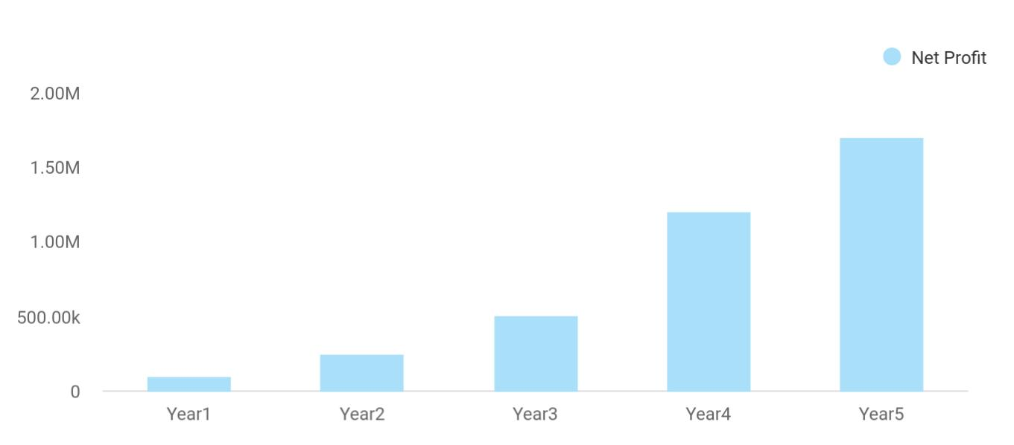

Financial Year | Net Profit
Year1 | 100,000
Year2 | 250,000
Year3 | 510,000
Year4 | 1,200,000
Year5 | 1,700,000

Financial Need and Use of Funds

Source and Use of Funds

CREI will execute this business plan based on the founder’s research, planning, and ability to purchase the desired properties. In addition, CREI is actively seeking private money equity investors’ to finance the refurbishment/rehabilitation of the properties through an open line of credit covering the five years of this business plan. Within this period of time CREI, we become self-funding and would be able to pay off the investors in years 4 and 5 with interest. The monies needed to fund property investments during this five year period will be $1 Million (USD). The funds will be drawn, as needed, to refurbish/ rehabilitate the class B & C properties that are purchased. Once the CREI project/process is in motion, the line of credit equity investment will be used to continue the perpetual motion of the company allowing it to purchase property on an on-going basis. The equity investment will assure that CREI has sufficient liquidity during the course of this business plan and long term into the future. The market for our business model is strong and growth is expected to continue for several years.


Sources of Funds - 12 Months

Cash Equity from Investors | $600,000 | 11.12%

Real Estate Investments | Business Plan [YEAR] 11/56

Sources of Funds - 12 Months
Loans for Apartment Complexes (Two in Year 1) | $4,000,000 | 74.14%
Recognized Revenue - Year 1 | $795,270 | 14.74%
TOTAL Sources | $5,395,270 | 100.00%

Return on Investment

CREI financial projections will allow investors to earn a 10% annual return on all monies invested, which will be paid out in year five. In addition to the interest earned, the investment group will be granted a 2nd lien position in each property purchased until their investment is paid in full. CREI anticipates the purchase of two properties in year one and expanding to 6 properties by the end of year 5. Based on the sophisticated financial model that we have constructed the 1st year source and use of funds are displayed below. The full five-year financial model is available upon request.

Uses of Funds - 12 Months
Remodeling/Rehabilitation | $600,000 | 11.26%
Boulder Plaza Apartments | $2,400,000 | 45.03%
Elm Street Apartments | $1,600,000 | 30.02%
Brighton Place Apartments |  | 0.00%
New Investment Year 3 |  | 0.00%
New Investment Year 4 |  | 0.00%
New Investment Year 5 |  | 0.00%
Computer/Technology/Office Furniture/Web Site | $10,000 | 0.19%
Repiars and Maintenance | $31,806 | 0.60%
Replacements - Appliances, Carpet, Blinds, Fixtures | $23,856 | 0.45%
Utilities - Company Paid | $79,530 | 1.49%
Carpet Cleaning | $3,978 | 0.07%
Pest Control | $3,978 | 0.07%
Personnel (12 Months Payroll) + taxes/benefits | $119,280 | 2.24%
Professional & Consulting Services | $35,784 | 0.67%
Advertising and Office Related Expenses | $27,828 | 0.52%
Insurance | $23,856 | 0.45%
Property Tax | $27,834 | 0.52%

Real Estate Investments | Business Plan [YEAR] 12/56

Uses of Funds - 12 Months
Interest on Apartment Loans | $157,120 | 2.95%
Principal Payments on Loan | $146,546 | 2.75%
Taxes - Corporate | $38,721 | 0.73%
Total Use of Funds | $5,330,117 | 100.00%

Real Estate Investments | Business Plan [YEAR] 13/56

2.

Business Description

Mission Statement

Business Objectives

Organization

Real Estate Investments | Business Plan [YEAR] 14/56

Mission Statement
To unlock help try Upmetrics!

 CREI


The Vision of CREI is to be a leading investment company in Oklahoma by “Creating Solid Investments Through Refurbishing Apartments.”

Start writing here..

Business Objectives

 CREI

To unlock help try Upmetrics! 

Provide Solid Investment and a good return for the Private Money Investor

• Allows the private money investor(s) to receive a solid ROI in a program and process that
To unlock help try Upmetrics! 

Start writing here..

Organization

 CREI

Castilo Real Estate Investments LLC (CREI) is a Limited Liability Company established in the State of Oklahoma CREI will be used as the parent Operating and Management Company for all the real estate investments



Legal Structure

Start writing here..

Real Estate Investments | Business Plan [YEAR] 15/56

 CREI
To unlock help try Upmetrics!

Castilo Real Estate Investments LLC(CREI) is a single-member company owned by Bolaji Sofola. Castilo Real Estate Holdings (I – VI) LLC will be single-member companies owned by Bolaji Sofola.



Company Ownerships

Start writing here..

 CREI

Castilo Real Estate Investments LLC (CREI) the exact location has not been established but will be in Oklahoma. Utilizing the advances of today’s technology CREI will function as a virtual company where the business will be transacted wherever the founder is located at that
To unlock help try Upmetrics! 

Location and Premises

Start writing here..

 CREI

Castilo Real Estate Investments LLC (CREI) will maintain copyright protection for its proprietary business model and concepts, its training programs, and its investment programs. CREI will also maintain a website at http://www.CastiloREI.com which is the web portal for all
To unlock help try Upmetrics! 

Intellectual Property

Start writing here..

Real Estate Investments | Business Plan [YEAR] 16/56

3.

The Business Concept and Revenue Model

The Business Concept

Revenue Model

Investment Details

Real Estate Investments | Business Plan [YEAR] 17/56

The Business Concept

 CREI

CREI business model is designed to buy Class B &C multi-family rental properties that need some refurbishment/rehabilitation. We will purchase these properties at 15-25% below the current Fair Market Value (FMV). Once these properties are purchased we will invest
To unlock help try Upmetrics! 

CREI Business Model

Start writing here..

Revenue Model

The line-of-credit funding vehicle that CREI is requesting will benefit the business by being able to refurbish/rehabilitate the purchased properties immediately upon acquisition of property. With the focus of obtaining several properties over the next five years, we will create a collaborative working relationship with lending institutions that have distressed properties and are willing to discount the financing. We will also work with current property owners who are willing to sell at a substantial discount, will allow us to assume their financing at a discount, or who will finance the properties themselves.

The following listing shows the individual categories for potential revenue:

Revenue Streams | Year 1 | Year 2 | Year 3 | Year 4 | Year 5
Boulder Plaza Apartments | $522,900 | $537,840 | $557,760 | $577,680 | $597,600
Elm Street Apartments | $242,250 | $499,800 | $510,000 | $530,400 | $550,800
Brighton Place Apartments | $252,265 | $1,11,259 | $1,345,200 | $1,390,800 | $1,436,400
New Investment | $30,120 | $76,320 | $121,920 | $179,040 | $247,440
Laundry and
Miscellaneous Income per | $795,270 | $1,995,960 | $3,434,880 | $5,641,680 | $8,727,720
Unit Total revenue

Our tentative target for a number of rental units for the next five years is:

Total Units Purchased Each Year | Cumulative | New This Year
Units PurchasedYear 1 | 176 | 176
Units Purchased Year 2 | 334 | 158

Real Estate Investments | Business Plan [YEAR] 18/56

Total Units Purchased Each Year | Cumulative | New This Year
Units PurchasedYear 3 | 534 | 200
Units Purchased Year 4 | 784 | 250
Units Purchased Year 5 | 1084 | 300

The financial model is a sophisticated business model that will allow us to run multiple projections based on the number of properties purchased, the purchase price of the property, and the projected monthly rent charged on each unit. The revenue forecast above reflects a conservative model.

Based on the projected sales levels and general assumptions above CREI should reach the following revenue goals. These goals are projected conservatively. This revenue will build on gradually as we prove the model using ever-increasing numbers of rental units. The Financial model is built to allow for gradual ramp up over 5 years.

Real Estate Investments | Business Plan [YEAR] 19/56

Revenue Projections
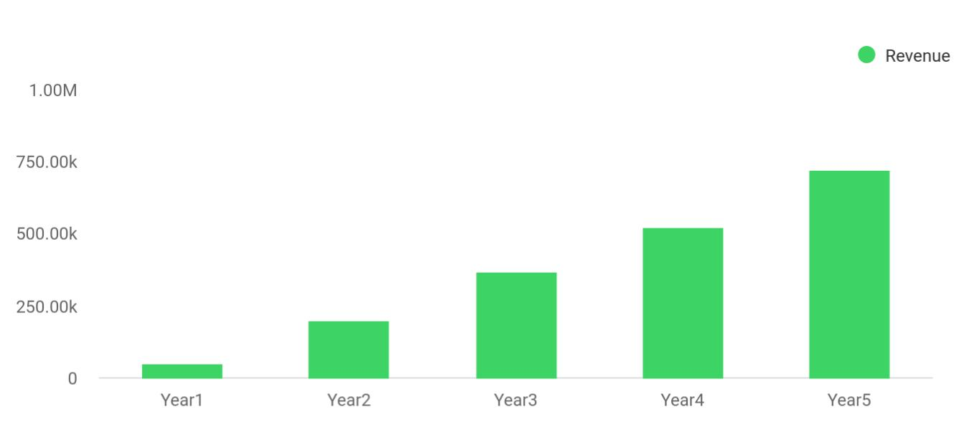

Financial Year | Revenue
Year1 | 50,000
Year2 | 200,000
Year3 | 370,000
Year4 | 520,000
Year5 | 720,000

Investment Details

 CREI

CREI has determined that $1 Million open lines of credit would be required during the 5 years covered in this business plan. It has been determined that the funds will primarily be utilized in Years1 and 2 in order to refurbish/remodel the first three properties. Internal cash flow will be
To unlock help try Upmetrics! 

The Amount of Investment Funds Requested

Start writing here..

Real Estate Investments | Business Plan [YEAR] 20/56

 CREI

The funds will benefit the business by providing the resources to refurbish/remodel the Class B & C properties purchased 15-25% below FMV. We will then be able to rent these properties at full occupancy at or above market rates. With the ability to form long-term collaborative
To unlock help try Upmetrics! 

Business Benefits

Start writing here..

 CREI

The investment partners will be 100% members of Castilo Real Estate Fund LLC. This company will be assigned the 2nd lien position on all properties purchased. Since the properties will be purchased at a discount of FMV the members will also have ‘built-in’ equity in these properties.
To unlock help try Upmetrics! 

Investment Repayments

Start writing here..

Real Estate Investments | Business Plan [YEAR] 21/56

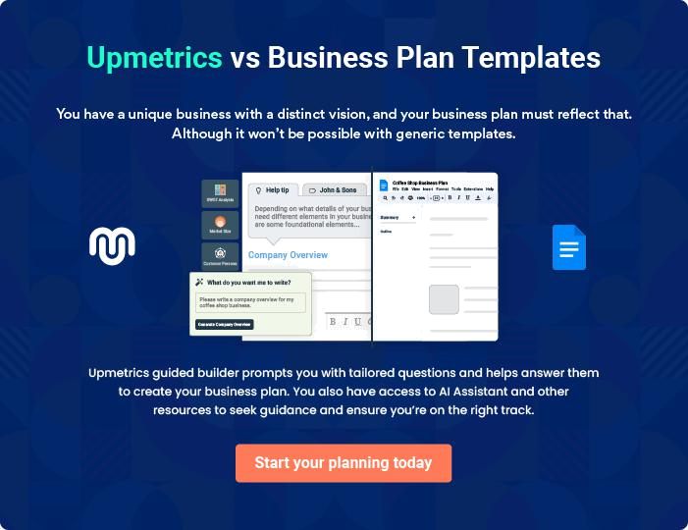

Real Estate Investments | Business Plan [YEAR] | 22/56

4.

Market Analysis

Apartment Rental - Industry Overview – Market Trends

Internet Trends

Industry Participants and Competitive Analysis

Real Estate Investments | Business Plan [YEAR] 23/56

Apartment Rental - Industry Overview – Market Trends

 CREI

If you are looking for proof that apartment rentals are a good investment, look no further than the national average showing vacancies declining and rents increasing across the board with
the very minor exception of a small vacancy increase for larger apartments. Here is where you
To unlock help try Upmetrics! 

Good Investment Trends in Apartment Rentals

Start writing here..

 CREI

With very little new construction of new apartments completing during 2011, there can be little doubt that rents will continue increasing. While 2010 saw a modest rise in rents of 2.5%, the expected increase in occupancy of 0.8% during 2011 is expected to easily drive up rents by
To unlock help try Upmetrics! 

Rent Spikes Coming For a Good Investment in Apartment Buildings

Start writing here..

 CREI

While we anticipate apartments to be a good investment for years to come, the rapid upswing of rents is likely to slow from 2013 through 2015. Rent increases are seen continuing to surge during 2012 although at a slightly slower pace than 2011 as new construction begins easing
To unlock help try Upmetrics! 

Apartments Continue as Good Investment Through 2012 and Beyond

Start writing here..

Real Estate Investments | Business Plan [YEAR] 24/56

 CREI

In a report released on January 6, REIS (a national commercial real estate data company) shows the apartment building sector continues to lead the commercial real estate to turn
around. Your chance to get in on a good investment that will soon turn into a great one may
To unlock help try Upmetrics! 

Apartment Buildings Going From Good Investment to Great

Start writing here..

 CREI

The facts go on and on to make the case that the apartment building owner is a good investment. Filling people’s basic needs is virtually always a good investment approach. The downside is almost nonexistent. When home foreclosures go up, apartment vacancies go
To unlock help try Upmetrics! 

Filling Basic Needs Makes for a Good Investment

Start writing here..

 CREI

Low prices and a maintenance-free lifestyle are just some of the reasons some Americans prefer renting cheap apartments instead of buying a home.
To unlock help try Upmetrics! 

More Americans renting by choice

Start writing here..

 CREI

For value investors, Demand, Supply, and the Cost of Acquisition are the three factors affecting the apartment building investment decision and all are saying the time to buy is now. There is a tidal wave of new renters coming into the market and there has been little apartment
To unlock help try Upmetrics! 

The Apartment Building Investment Triple Opportunity Is Right Now

Start writing here..

Real Estate Investments | Business Plan [YEAR] 25/56

Internet Trends
To unlock help try Upmetrics!

 CREI


Regardless of the industry, no one can ignore the internet as being an integral required part of their business strategy. Prospective renters use the internet
To unlock help try Upmetrics! 

Internet Growth Allows Renters to Locate Good Apartments

Start writing here..

Industry Participants and Competitive Analysis

 CREI

As we have completed our research, there are other companies with similar business models, but the market is so large and the demand is so strong that we do not feel that any competition will hinder our planned and steady growth.



Industry Participants

Start writing here..

 CREI

Ultimately our competitive advantage will be the ability for us to purchase the properties below market value, make the repairs/remodeling as needed and rent at a rate that is at or above the market rates for rental units. Our first-class personal services, desirable properties, available
To unlock help try Upmetrics! 

Competitive Advantages

Start writing here..

Real Estate Investments | Business Plan [YEAR] 26/56

5.

Growth Strategy

Strategic Initiatives

Brand Strategy

Marketing Strategy

Sales Programs

Strategic Alliances

Milestones

Real Estate Investments | Business Plan [YEAR] 27/56

 CREI
To unlock help try Upmetrics!


CREI centers its strategy on the premise that the company is in a market that has the potential for stronger growth during the next ten years. A survey

Start writing here..

Strategic Initiatives

 CREI

To unlock help try Upmetrics! 

Our overall strategy will encompass the following objectives:

• Seek and locate an equity funding partner(s) for $1 Million Line of Credit
To unlock help try Upmetrics! 

Start writing here..

Brand Strategy

 CREI

Building a strong business brand will require the coordination of many factors. As such, CREI will focus on several core elements that will help build and strengthen the backbone of the brand.



Start writing here..

Real Estate Investments | Business Plan [YEAR] 28/56

Marketing Strategy
To unlock help try Upmetrics!

 CREI

CREI is aware of all the choices we face in relation to our marketing strategy. With 15+ years of business and medical practice experience, the founder has planned systems for success which have been tested and tried. CREI will work diligently to improve and streamline all processes.
To unlock help try Upmetrics! 

Start writing here..

 CREI

• Provide for individuals looking for apartment rental units that are affordable, good quality and
secure/safe location.
To unlock help try Upmetrics! 

Provide Individuals, Families and Businesses Quality Rental Properties at an Affordable Price.

Start writing here..

 CREI

The founder positions the company in a profitable “niche” market segment purchasing apartment properties below FMV. His team repairs/remodel them as needed and quickly rents them to individuals and families. By focusing on areas of the city that are both safe and secure,
To unlock help try Upmetrics! 

Positioning Statement

Start writing here..

 CREI

Pricing for all rental units will be at, or slightly above, the current market price for rental units. This will be determined by using Zillow ‘rent Zestimate’ which estimates rental pricing for various apartments within a given region.



Pricing Strategy

Start writing here..

Real Estate Investments | Business Plan [YEAR] 29/56

 CREI

CREI will utilize ‘word of mouth’ marketing both in the traditional sense and more importantly, utilizing the social networking sites to carry on the name of excellent value in safe and secure properties. Utilization of Social Media/Networking will be used as well as Search Engine
To unlock help try Upmetrics! 

Sales Strategy

Start writing here..

 CREI

CREI has developed a projected sales forecastfor the next five years of operations. This market will grow quickly and using the financial model as a tool it will be updated and maintained even after the model is implemented. CREI knows that in order to make its businessplan succeed,
To unlock help try Upmetrics! 

Sales Forecast

Start writing here..

Sales Programs

 CREI

CREI sales program is centered on purchasing apartment properties at levels 15-25% below FMV. The properties will be purchased using conventional financing, assumption of existing
loans or through owner financing. This process allows for maximum ROI without tying up large
To unlock help try Upmetrics! 

Start writing here..

Real Estate Investments | Business Plan [YEAR] 30/56

Strategic Alliances

 CREI

CREI will work with a network of industry related companies, organizations, and associations in alliances to accomplish its major strategies. CREI is also committed to networking with rental associations, business groups and government agencies that may have a mutually favorable
To unlock help try Upmetrics! 

Start writing here..

Milestones

 CREI

No example added yet..

To unlock help try Upmetrics! 

CREI will strive to reach the following Milestones during the first 6 months of this plan

Timeline Business Expansion:

Register Castilo Real Estate Investments LLC | [Date]
Register Castilo Real Estate Holdings I LLC | [Date]
Register Castilo Investments LLC
Obtain Equity Investment operating line of credit
for the five-year plan
Partner with real estate, legal, and accounting
consultants
Partner with real estate, legal, and accounting
consultants
Execute the first purchase of properties
Ready the CREI team and begin to refurbish/
rehab of the first property
The contract for website development

Real Estate Investments | Business Plan [YEAR] 31/56


Create Marketing materials for the focus of

business

Establishing key relationships in Associations,

Business, and Gov.

Purchase of equipment for internal use as

needed

CREI is very pleased with the accomplishment of this business plan as the achievement of a significant company milestone. The next goal is to plan a meticulous launch of the business. After that, we will begin working to achieve our revenue and financial goals.

Initial Goals – High Level:

6 months (Octoberto April 2012):

- Secure Equity Line of Credit through Investors

- Secure financing for properties

- Ready CREIfor first refurbish/rehab

- Obtain first property purchase

- Purchase additional equipment if needed

- Launch Aggressive marketing campaign focusing on upgrades to the facility

One year:

- Purchase a total of two multi-family apartment properties (176 units) · Reach our projected revenue goal of $795k in rent

Two years:

- Purchase a total of three multi-family apartment properties (334 units)

- Reach our projected revenue goal of $2 Million in rent

- Be recognized in the industry as the company that is ‘‘Creating Solid Investments Through Refurbishing Apartments”

Three years:

- Purchase a total of four multi-family apartment properties (534 units)

- Reach our projected revenue goal of$3.4 Million in rent

- Expand to additional cities such as the Dallas marketplace

Four years:

- Purchase a total of five multi-family apartment properties (784 units)

- Reach our projected revenue goal of$5.6 Million in rent

- Analyze expansion into other Metropolitan Statistical Areas (MSAs) in the U.S.

Real Estate Investments | Business Plan [YEAR] 32/56

Five years:

- Purchase a total of six multi-family apartment properties (1,084 units) · Reach our projected revenue goal of $8.7 Million in rent

- Prepare to expand to other U.S. Cities

Real Estate Investments | Business Plan [YEAR] 33/56

6.

Web Plan

Web Marketing Strategy

Search Engine Optimization

Real Estate Investments | Business Plan [YEAR] 34/56

 CREI


CREI realizes that the web plan is crucial since nearly 80% of all Americans utilize the internet today. Since we will create information about each of our
To unlock help try Upmetrics! 

Start writing here..

Web Marketing Strategy

 CREI

The Internet is a crucial component of the CREI business model. The web site will be robust and capable of supporting large amounts of content, rental information, and data. It will also be scalable, created with an eye toward supporting new and improved technologies. Pictures and
To unlock help try Upmetrics! 

Start writing here..

 CREI

Social networking websites LinkedIn.com, Facebook.com Twitter.com and other similar sites will be used to promote and advance potential subscribers and allow them to be aware of the services that we offer. LinkedIn and Facebook.com traffic will be used to build client interest
To unlock help try Upmetrics! 

Social networking websites

Start writing here..

 CREI

As part of the registration process, CastiloREI.com will capture the renter or potential renter email address and will also give an opportunity to include the emails addresses of others that may be interested in rental properties. The email campaign feature will also serve as a great
To unlock help try Upmetrics! 

Email campaigns

Start writing here..

Real Estate Investments | Business Plan [YEAR] 35/56

 CREI

Search Engine Optimization campaigns that use strategically placed keywords that register in search engines. Pay per Click campaigns via Google.com and other similar sites will also be used to drive qualified potential subscribers to the CastiloREI.com website
To unlock help try Upmetrics! 

SEO (Search Engine Optimization) PPC

Start writing here..

 CREI

Banner advertisements will be placed on strategic real estate based websites throughout the Internet and Mobile Apps that cater to the CastiloREI.com target clients. Banner advertisements will be both static and rotating with banner type depending on the volume of
To unlock help try Upmetrics! 

Banner advertisements

Start writing here..

Search Engine Optimization

 CREI

• Strategize the use of the right words to ensure the website is created correctly so we can coordinate all marketing with tactical use of keywords.
• Be open to creatively envisioning new keywords for the ongoing SEO strategy, which is to
To unlock help try Upmetrics! 

Start writing here..

Real Estate Investments | Business Plan [YEAR] 36/56

7.

Management Summary

Organizational Structure

People

Real Estate Investments | Business Plan [YEAR] 37/56

 CREI

Management is the core of any organization. It is not just personnel and individuals’ resumes but vision, talent, and commitment that lead to success. CREI is led by John Doe medical doctor, real estate investor, and business person. John Doe is creating CREI based on his
To unlock help try Upmetrics! 

Start writing here..


John Doe

Owner - johnd@example.com

Mr. Doe has been a practicing Urologist in Ardmore, Oklahoma since 2003. Prior to practicing in Ardmore, he managed a successful solo urological practice in Port Arthur, Texas for six years.

In addition to running two successful medical practices, Mr. Doe has participated in the acquisition, rehabilitation, construction, leasing, and management of single and multi-family residential dwellings.

Mr. Doe sits on the board of project management and consulting firm, Doe and Associates, Inc., which specializes in construction, renovation, and facilities management of commercial properties. This company and its principals have over 27 years of engineering, construction, and facility management experience. Their clients have included: The City of Kansas City, Bristol-Myers Squibb, Master Card, Jones Lang LaSalle, Proctor & Gamble, and many others. He has used this firm in the past and will continue to use them as his primary commercial consultant.

Mr. Doe is originally from Oklahoma. He is familiar with the real estate markets in North Texas, Houston, Oklahoma City, Tulsa, and Lawton. His goal is to acquire, renovate, and lease distressed properties in these areas, and to bring them to profitability by working out reasonable financing and bringing in strong, experienced property managers.

Mr. Doe has the required skills and experience to be a successful owner of this apartment community and will oversee all management to ensure a continued high occupancy level and good Net Operating Income (NOI).

Real Estate Investments | Business Plan [YEAR] 38/56


Jane Doe

President and Sr. Project Manager - janed@example.com

With 25 years of experience as an Industrial Engineer in Construction and Facility Management, her breadth of knowledge encompasses every aspect of Program and Project Management. She brings a thorough knowledge of the design/construction process, regulatory issues governing bodies, and hands-on experience as a Facility Operations Executive with an in-depth understanding of means and best practices, building systems, building management methodologies/processes, corporate structures, and the human factors that influence them.

Her responsibilities include developing and implementing logistical strategies and reporting vehicles to meet project deliverables and evaluating or developing internal systems and mechanisms to facilitate consistent methodologies in strategic planning, project management, maintenance, utilities, and infrastructure management.

Ms. Doe worked as a Project Manager/Engineer (in both a consultant and/or employment capacity) for top Fortune 500 Companies Bristol-Myers Squibb Co. and Johnson & Johnson, Inc. Her background with the private sector gives her keen business execution acumen. She has developed frameworks for a variety of planning issues especially in the areas of infrastructure preventive and predictive maintenance, outsourcing specifications, vendor qualifications, and contract development. Her unique ability to create a project environment that fosters creativity, accountability, productivity, and team excellence coupled with her strong technical grounding guarantees clients that every attention is paid to finding discriminating solutions to complex problems.

As the President of Jane Doe and Associates, Project Management Consultants. She directed and oversaw the general management and direction of professional activities, and client accounts. She established the company in 1999 as a full-service Project Management provider and developed a network of associates and professional staff in New York, New Jersey, Connecticut, Missouri, Colorado, and Oklahoma. The company’s projects ranged from multi-million dollar redevelopment programs, out of the ground construction & interior renovations, building infrastructure and transportation, to establishing and implementing facility management programs.

Real Estate Investments | Business Plan [YEAR] 39/56


Thomas Doe

Vice President of Business & Systems Development - thomas@example.com

In this capacity he will be responsible for developing and improving internal business systems for the purpose of ensuring client satisfaction, internal efficiencies and effectiveness. He brings over 27 years hands on technical and management experience from military and private sector operations. His demonstrated leadership and proven track record to succeed have opened doors of increasing responsibility and have proven instrumental in gaining consensus among colleagues and stakeholders.

Organizational Structure

 CREI

CREI knows how important the organizational structure is to the success of a company. While CREI will remain small with a limited direct staff, each position within this company will have a detailed job description as well as a well-defined relationship to the whole. Additional crucial
To unlock help try Upmetrics! 

Start writing here..

People

The CREI team that will be handling the refurbish/rehab of the properties is included in that cost in our five-year business plan. The staff members listed below are the actual staff that will be running the daily operations of each property on an on-going basis. All aspects of the business have been sufficiently analyzed to determine every position required to run a fully functioning operation that can complete all of the strategies and programs to be undertaken. We emphasize a lean, low-overhead business model that outsources whenever possible.

Payroll | Year1 | Year 2 | Year 3 | Year 4 | Year 5
On-Site Manager(s) | $31,806 | $79,836 | $137,400 | $225,672 | $349,104
Maintenance Team | $31,806 | $79,836 | $137,400 | $225,672 | $349,104
Janitorial Team | $11,934 | $29,940 | $51,528 | $84,624 | $130,920
Landscaping& Grounds Team | $7,950 | $19,956 | $34,344 | $56,412 | $87,276
Administrator/Clerks | $7,950 | $19,956 | $34,344 | $56,412 | $87,276
Financial Team | $7,950 | $19,956 | $34,344 | $56,412 | $87,276

Real Estate Investments | Business Plan [YEAR] 40/56

Payroll | Year1 | Year 2 | Year 3 | Year 4 | Year 5
Annual Payroll | $99,396 | $249,480 | $429,360 | $705,204 | $1,090,956
MonthlyPayroll | $8,283 | $20,790 | $35,780 | $58,767 | $90,913

Real Estate Investments | Business Plan [YEAR] 41/56

8.

SWOT Analysis

Real Estate Investments | Business Plan [YEAR] 42/56

 CREI

What follows is a listing of the strengths and weaknesses of the CREI business model along with the opportunities and threats that exist within the marketplace.
To unlock help try Upmetrics! 

Start writing here..

Real Estate Investments | Business Plan [YEAR] 43/56


Strength

Concept and Knowledge: The founders’ passion and desire to take advantage of the opportunity in the multi-family residential estate markets helped to create the concepts based on his knowledge in the market. Expanding this dream is important. Being successful business persons and entrepreneurs he has the stamina, passion, and drives needed to succeed.

Renter/Investor Focused: CREI will ensure that each renter is provided a clean and safe living environment with many amenities and that the investor is able to achieve a good ROI

Timing: The timing for this business within this industry could not be any better. The need is great and the demand is growing stronger each day. The market has been hit hard and there is not much hope that it improves soon. The increase in demand for apartments is escalating and the monthly rent amounts are also increasing each year. There are many years of very strong demand forecasted.

The Internet is the foundation: The Internet is by far the most powerful communications tool ever created and will serve as the foundation and marketing presence for the CREI business model. At its core, CREI is ‘‘Creating Solid Investments Through Refurbishing Apartments” We will focus on our core values for the company that is found in the marketing strategy portion of the business plan.
Weakness


Lack of funding: In order to reach the desired levels of success and impact as projected, CREI must aggressively pursue a strong infusion of the working capital line of credit that will allow the refurb/rehab or the multi-family properties that are purchased. This will allow the company to grow exponentially to the next level.

Limited staff: Even though CREI has a talented person and team forging the company as it begins. The scope of the business mandates more in the way of collaborative partners and more staff members. Property management, realtors, and other team members may be added to the team to drive the project to success.

Real Estate Investments | Business Plan [YEAR] 44/56


Opportunity

It is a great time to invest in rental property: All of the market research and actual data delivers a very large opportunity in the multi-family real estate market. The housing industry is not expected to recover for years and there are many more individuals and families that either choose or are forced to live in apartments.

Technology: Technology is the only element of business that never regresses. As such, it is imperative for management to stay abreast of the latest cutting edge technologies that can be integrated into the CREI business model, giving the organization the capability to remain viable and effectively compete for market share.

Weakened Economy: When the economy is recessed or weak, potential homeowners may not be able to purchase houses and many others have lost their homes through foreclosure. This forces many more individuals and families to choose apartment living over homeownership. The renter and investors benefit by getting involved in the real estate market now.
Threat


Competition: As described previously, the demand for good quality, secure, and safe rental properties is at an all-time high.

Although there will be competition, CREI has abundant opportunities to expand on the market. We must serve our rental clients with excellence to ensure that we have a happy client base needed to maintain a competitive edge and be profitable.

Copy Cats: Copy cats are always a concern when dealing in any market especially with growing demand. Demand will far outstrip supply for the types of services we offer the rental market. Our top-quality customer services will not be easily duplicated. We will provide residential renters with delight in every transaction so that even when competition rises, our current and previous renters will tell others to use our properties.

Real Estate Investments | Business Plan [YEAR] 45/56

9.

Financial Plan

Key Assumptions

Key Financial Indicators

Explanation of Break-even Analysis

Business Ratios

Long-term Plan and Financial Highlights

Projected Income Statement

Projected Cash Flow

Projected Balance Sheet

Real Estate Investments | Business Plan [YEAR] 46/56

 CREI

CREI used the founders’ business savvy and experience to create a concept that is both tangible and profitable. In order to advance this concept to reality, a large investment is needed. CREI seeks a $1 Million open lines of credit in the form of an equity investment that will span
To unlock help try Upmetrics! 

Start writing here..

Key Assumptions

 CREI

US Corporate Income taxes – 30% (Pass through to the LLC Members) Tax minimization will always be at the forefront of our mind. Setting up a separate holding company apart from the
operating company will allow both entities to maximize income and expenses prior to passing
To unlock help try Upmetrics! 

Start writing here..

Key Financial Indicators

 CREI

CREI recognizes that the most important financial indicators are cash and bottom line. CREI will constantly monitor the flow of revenue to the company as well as the expense requirements that deplete the company of its cash. CREI will always try to improve the ratio of revenue and
To unlock help try Upmetrics! 

Start writing here..

Real Estate Investments | Business Plan [YEAR] 47/56

Explanation of Break-even Analysis

The break-even analysis for CREI calculates at what point the company becomes profitable and also at what point the company will be operating at a loss. The analysis takes into consideration forecasted revenues as well as regular running fixed costs and average per unit sales price also known as per-unit revenue. We surpass break-even in Year 1 as we achieve “take-off” and achieve the next level of business – full establishment and expansion.


Break-Even Analysis

Category | 1st Year | 2nd Year | 3rd Year | 4th Year | 5th Year
Sales
Net Projected Monthly Sales | $66,273 | $166,330 | $286,240 | $470,140 | $727,310
Monthly Cost of Sales | $11,929 | $29,940 | $51,523 | $84,626 | $130,916
Monthly Fixed Costs | $32,642 | $81,080 | $127,093 | $193,353 | $315,802
Break-Even MonthlySales | $44,571 | $111,020 | $178,616 | $277,979 | $446,718
Annual Breakeven Sales | $534,852 | $1,332,240 | $2,143,392 | $3,335,748 | $5,360,616

Business Ratios

At the very least, we will always subscribe to three ratios as quantitative measures of our financial health. These numbers derive from our five-year projections for Current Assets, Total Assets, Current Liabilities, Net Profit, and Gross Sales. Of course, we will be utilizing more and different statistics, but these ratios will always be at the core of our financial reports: [1] the Current Ratio, [2] the Net Profit Margin Ratio, and [3] the return on Investment Ratio.

Business Ratios

Ratios | 1st Year | 2nd Year | 3rd Year | 4th Year | 5th Year
Current Assets | $65,153 | $237,457 | $428,491 | $533,934 | $1,359,912
Current Liabilities | $0 | $0 | $0 | $0 | $0
Current Ratio | ∞ | ∞ | ∞ | ∞ | ∞
Net Profit | $129,066 | $371,364 | $878,131 | $1,751,577 | $2,651,745
Gross Sales | $795,270 | $1,995,960 | $3,434,880 | $3,434,880 | $3,434,880
Net Profit Margin Ratio | 16.2% | 18.6% | 25.6% | 51.0% | 77.2%
Net Profit | $129,066 | $371,364 | $878,131 | $1,751,577 | $2,651,745

Real Estate Investments | Business Plan [YEAR] 48/56

Total Assets | $4,543,800 | $8,828,748 | $11,911,431 | $15,317,524 | $19,833,146
Return on Asset Ratio | 2.8% | 4.2% | 7.4% | 11.4% | 13.4%

Long-term Plan and Financial Highlights

 CREI

CREI believes that its long-term prospects for continuing a successful business are excellent. We believe that this industry, and the strong foundation of experience that management and advisors bring to the company, lends itself to positive results over the long-term. With a market-
To unlock help try Upmetrics! 

Start writing here..

Projected Income Statement

 | 2024 | 2025 | 2026
Revenue | $2,947,225 | $7,703,337 | $11,666,834
Rental Income from Multi- | $1,088,250 | $2,846,055 | $4,325,340
family Housing | $1,088,250 | $2,846,055 | $4,325,340
Users | 108 | 197 | 274
Recurring Charges | $1,500 | $1,500 | $1,500
Rental Income | $1,633,365 | $4,243,770 | $6,373,650
Users | 162 | 293 | 401
Recurring Charges | $1,500 | $1,500 | $1,500
Property Management | $225,610 | $613,512 | $967,844
Fees | $225,610 | $613,512 | $967,844
Users | 170 | 325 | 468
Recurring Charges | $200 | $200 | $200

Cost Of Sales | $1,738,297.25 | $2,036,638.87 | $2,302,952.34
General Costs | $1,629,472.25 | $1,752,033.37 | $1,870,418.34

Real Estate Investments | Business Plan [YEAR] 49/56

Property Acquisition and Preparation Costs

Property Purchase Costs

Real Estate Agent Fees

Sales and Marketing Costs

Property Maintenance

Property Tax

Revenue Specific Costs

Rental Income from Multi-family Housing

Property Management Fees

Personnel Costs (Direct Labor)

Gross Margin

Gross Margin (%)

Operating Expense

Payroll Expense (Indirect Labor)

Management Team

Property Manager

Financial Manager

On-site Staff

Maintenance Workers

Cleaning Staff

Administrative Staff

2024 | 2025 | 2026
$1,500,000 | $1,575,000 | $1,653,750
$1,500,000 | $1,575,000 | $1,653,750
$0 | $0 | $0
$129,472.25 | $177,033.37 | $216,668.34
$100,000 | $100,000 | $100,000
$29,472.25 | $77,033.37 | $116,668.34
$108,825 | $284,605.50 | $432,534
$108,825 | $284,605.50 | $432,534
$108,825 | $284,605.50 | $432,534
$0 | $0 | $0

$1,208,927.75 $5,666,698.13 $9,363,881.66

41.02% 73.56% 80.26%

$1,219,467.48 | $1,605,372.08 | $2,234,605.23
$636,000 | $652,020 | $668,477.52
$165,000 | $170,850 | $176,911.56
$75,000 | $77,250 | $79,567.56
$90,000 | $93,600 | $97,344
$345,600 | $352,512 | $359,562.24
$216,000 | $220,320 | $224,726.40
$129,600 | $132,192 | $134,835.84
$125,400 | $128,658 | $132,003.72

Real Estate Investments | Business Plan [YEAR] 50/56

Office Administrator

Receptionist

General Expense

Property Maintenance and Renovation

Regular Maintenance

Property Renovation

Operational and Administrative Expenses

Utilities

Insurance

Marketing and Advertising Expenses

Online Advertising

Promotional Events

Bad Debt

Amortization of Current Assets

EBITDA

Additional Expense

Long Term Depreciation

Gain or loss from Sale of Assets

EBIT

Interest Expense

EBT

2024 | 2025 | 2026
$75,000 | $77,250 | $79,567.56
$50,400 | $51,408 | $52,436.16
$518,493.48 | $833,352.08 | $1,446,127.71
$112,754.41 | $122,630.66 | $133,575.41
$62,754.41 | $70,630.66 | $79,495.41
$50,000 | $52,000 | $54,080
$73,344.50 | $169,186.74 | $249,212.68
$58,944.50 | $154,066.74 | $233,336.68
$14,400 | $15,120 | $15,876
$332,394.57 | $541,534.68 | $1,063,339.62
$64,152.88 | $201,339.41 | $631,889.78
$268,241.69 | $340,195.27 | $431,449.84
$0 | $0 | $0
$64,974 | $120,000 | $120,000

($10,539.73) $4,061,326.05 $7,129,276.43

$44,395.23 | $38,942.82 | $33,154.08
$16,800 | $16,800 | $16,800
$0 | $0 | $0
($27,339.73) | $4,044,526.05 | $7,112,476.43
$27,595.23 | $22,142.81 | $16,354.10
($54,934.96) | $4,022,383.23 | $7,096,122.35

Real Estate Investments | Business Plan [YEAR] 51/56

 | 2024 | 2025 | 2026
Income Tax Expense / | $0 | $0 | $0
Benefit | $0 | $0 | $0
Total Expense | $3,002,159.96 | $3,680,953.77 | $4,570,711.65
Net Income | ($54,934.96) | $4,022,383.23 | $7,096,122.35
Net Income (%) | (1.86%) | 52.22% | 60.82%
Retained Earning Opening | $0 | ($104,934.96) | $3,767,448.27
Owner's Distribution | $50,000 | $150,000 | $50,000
Retained Earning Closing | ($104,934.96) | $3,767,448.27 | $10,813,570.62
Projected Cash Flow
 | 2024 | 2025 | 2026
Cash Received | $2,947,225 | $7,703,337 | $11,666,834
Cash Paid | $2,920,385.96 | $3,544,153.77 | $4,433,911.65
COS & General Expenses | $2,256,790.73 | $2,869,990.95 | $3,749,080.05
Salary & Wages | $636,000 | $652,020 | $668,477.52
Interest | $27,595.23 | $22,142.81 | $16,354.10
Sales Tax | $0 | $0 | $0
Income Tax | $0 | $0 | $0
Net Cash From | $26,839.04 | $4,159,183.23 | $7,232,922.35
Operations | $26,839.04 | $4,159,183.23 | $7,232,922.35
Assets Sell | $0 | $0 | $0
Assets Purchase | $1,120,000 | $120,000 | $120,000

Real Estate Investments | Business Plan [YEAR] 52/56

Net Cash From

Investments

Amount Received

Loan Received

Common Stock

Preferred Stock

Owner's Contribution

Amount Paid

Loan Capital

Dividends & Distributions

Net Cash From

Financing

Summary

2024 | 2025 | 2026
($1,120,000) | ($120,000) | ($120,000)

$800,000 | $0 | $0
$500,000 | $0 | $0
$0 | $0 | $0
$0 | $0 | $0
$300,000 | $0 | $0
$138,401.57 | $243,853.98 | $149,642.72
$88,401.57 | $93,853.99 | $99,642.70
$50,000 | $150,000 | $50,000
$661,598.43 | ($243,853.98) | ($149,642.72)

Starting Cash | $0 | ($431,562.53) | $3,363,766.72
Cash In | $3,747,225 | $7,703,337 | $11,666,834
Cash Out | $4,178,787.53 | $3,908,007.75 | $4,703,554.37
Change in Cash | ($431,562.53) | $3,795,329.25 | $6,963,279.63
Ending Cash | ($431,562.53) | $3,363,766.72 | $10,327,046.35

Projected Balance Sheet

 | 2024 | 2025 | 2026
Assets | $606,663.47 | $4,385,192.72 | $11,331,672.35
Current Assets | ($376,536.53) | $3,418,792.72 | $10,382,072.35
Cash | ($431,562.53) | $3,363,766.72 | $10,327,046.35

Real Estate Investments | Business Plan [YEAR] 53/56

 | 2024 | 2025 | 2026
Accounts Receivable | $0 | $0 | $0
Inventory | $0 | $0 | $0
Other Current Assets | $55,026 | $55,026 | $55,026
Long Term Assets | $983,200 | $966,400 | $949,600
Gross Long Term Assets | $1,000,000 | $1,000,000 | $1,000,000
Accumulated Depreciation | ($16,800) | ($33,600) | ($50,400)

Liabilities & Equity | $606,663.47 | $4,385,192.71 | $11,331,672.36
Liabilities | $411,598.43 | $317,744.44 | $218,101.74
Current Liabilities | $93,853.99 | $99,642.70 | $0
Accounts Payable | $0 | $0 | $0
Income Tax Payable | $0 | $0 | $0
Sales Tax Payable | $0 | $0 | $0
Short Term Debt | $93,853.99 | $99,642.70 | $0
Long Term Liabilities | $317,744.44 | $218,101.74 | $218,101.74
Long Term Debt | $317,744.44 | $218,101.74 | $218,101.74
Equity | $195,065.04 | $4,067,448.27 | $11,113,570.62
Paid-in Capital | $0 | $0 | $0
Common Stock | $0 | $0 | $0
Preferred Stock | $0 | $0 | $0
Owner's Contribution | $300,000 | $300,000 | $300,000
Retained Earnings | ($104,934.96) | $3,767,448.27 | $10,813,570.62

Check | $0 | $0 | $0

Real Estate Investments | Business Plan [YEAR] 54/56

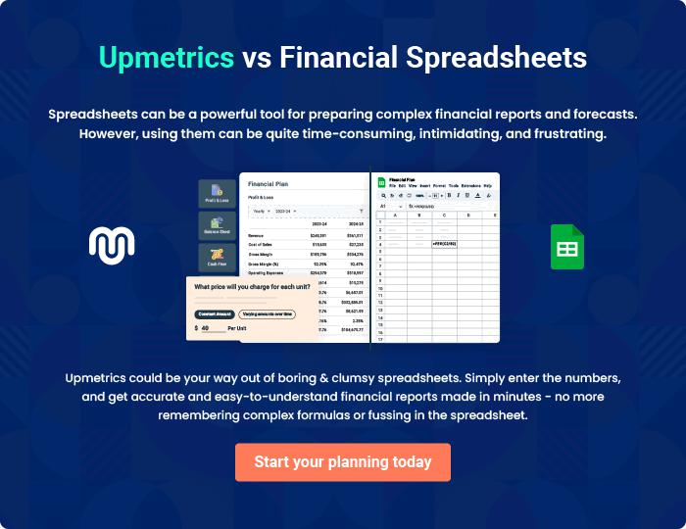

Real Estate Investments | Business Plan [YEAR] | 55/56


Create a winning business plan that gets you funded

Creating a stunning and investment-ready plan requires no writing, graphic designing, or financial planning expertise.

Upmetrics has all the features required to help you create a comprehensive business plan—from start to finish. Make no mistakes, it’s the modern way of planning to structure ideas, make plans, and create stunning pitch decks to awe investors.

Pitch decks that impress investors

Create pitch decks that provide a visual representation of your business, engage investors, and make them want to invest in your business idea.

Interactive plans in no time

Import business plan sections like—SWOT analysis, comparison tables, and others to create an interactive business plan. No designing skills are required.

Stunning cover page designs

With Upmetrics, you have the liberty to choose from multiple stunning cover page designs. Choose a creative design and make your plan stand out.

Online sharing made simple

Upmetrics makes online sharing quick and easier for users. Easily share your business plans with a link while tracking reader activity.

500+ sample business plans

Simply import a template from our library of sample plans into the editor and start customizing it to make it yours. It takes only a few clicks to get started.

Collaborate with team in real-time

Invite team members, initiate conversations, discuss ideas & strategies, share feedback, and work on a business plan in real-time.

