
Real Estate Agency

Your Dream Home Awaits

BUSINESS PLAN

[YEAR]

John Doe | 10200 Bolsa Ave, Westminster, CA, 92683 | (650) 359-3153 | info@example.com
http://www.example.com

Information provided in this business plan is unique to this business and confidential; therefore, anyone reading this plan agrees not to disclose any of the information in this business plan without prior written permission of the Company
Table of Contents

Executive Summary | 5
Objectives | 6
Products and Services | 6
Management Team | 7
Success Factors | 7
Financial Summary | 7
3 Year profit forecast | 8

Company Summary | 9
History | 10
Start-up Summary | 10
Startup cost | 11
Funding Required | 11

Products and Services | 14
Our business offering are listed below: | 15
Market Analysis
Market Analysis | 17
Industry Analysis | 18
Market Trends | 18
Target Market | 18
Strategy & Implementations
Strategy & Implementations | 19
Sales Strategy | 20
Advertising Strategy | 20
Targeted Cold Calls | 20
Referrals | 20
Internet | 21
Publications | 21
Seminars | 21
Pricing Strategy | 21

Real Estate Agency | Business Plan [YEAR] 2/36

Sales Forecast | 22
Sales | 22

Operations | 23
Management Summary | 24
Hiring Plan | 24
Milestones | 25

Financial Plan | 26
Important Assumptions | 27
Brake-even Analysis | 27
Projected Profit and Loss | 28
Projected Cash Flow | 31
Projected Balance Sheet | 32
Business Ratios | 33

Real Estate Agency | Business Plan [YEAR] 3/36

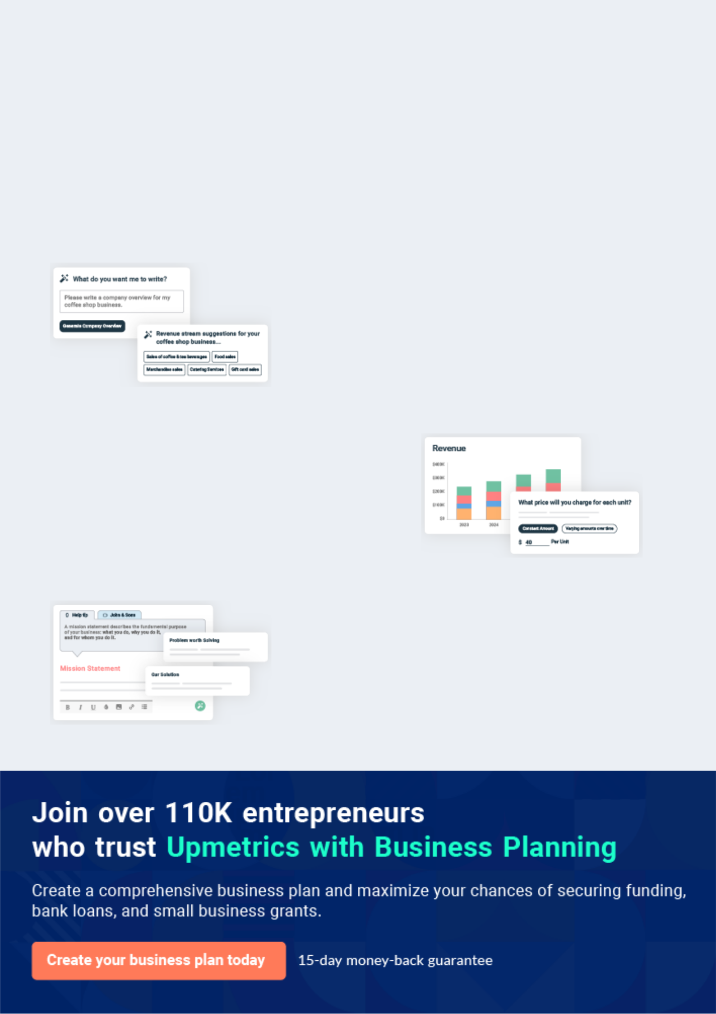
Business planning that’s simpler and faster than you think

Creating a business plan using Upmetrics to start and grow a business is literally the easiest thing in the World. Simply read the instructions and fill in the blanks. It’s as simple as that.

❛ | Upmetrics has everything you need to create a | ❜
❛ | comprehensive business plan. | ❜

AI-powered Upmetrics Assistant

AI-powered insights to streamline your plan

Not sure where to start? Upmetrics’ AI Assistant will automatically generate ideas for each section of your plan and offer improved versions of your writing, adjusting for tone, voice, and grammar or spelling errors.

Financial Forecasting Tool

All the financials are calculated for you

Forget the complex formulas and clumsy spreadsheets — with automatic financials and drag-and-drop forecasting, you can finish your plan faster and be confident that your numbers are accurate.

Business Plan Builder

Guides you like a business mentor

Upmetrics’ step-by-step instructions, prompts, and the library of 400+ sample business plans will guide you through each section of your plan as a business mentor.

1.


Executive Summary

Objectives

Products and Services

Management Team

Success Factors

Financial Summary

Real Estate Agency | Business Plan [YEAR] 5/36

Before you think about how to start a Real estate agency service, you must create a detailed real estate business plan. It will not only guide you in the initial phases of your startup but will also help you later on.
To unlock help try Upmetrics!
To unlock help try Upmetrics! 

 MT Moore & Associates


MT Moore & Associates Realty, Inc., is a real estate agency incorporated as an S corporation that will operate in all the states in the United States of America. but will be headquartered in
New York. We intend to become specialists in owning, developing, acquiring, managing, selling,
To unlock help try Upmetrics! 

Start writing here..

Objectives

 MT Moore & Associates

The primary objectives of our organization are to:

• Become a profitable organization allowing us the freedom of taking advantage of other
To unlock help try Upmetrics! 

Start writing here..

Products and Services

 MT Moore & Associates

MT Moore & Associates Realty will focus on superior service for its clients. It has a full-time assistant who, among other things, will manage the company website and listings, advertise listings elsewhere, and answer basic client questions.



Start writing here..

Real Estate Agency | Business Plan [YEAR] 6/36

Management Team
To unlock help try Upmetrics!

 MT Moore & Associates

MT Moore & Associates Realty’s most valuable asset is the expertise and experience of its founder, John Moore. John has been a licensed real estate broker for the past 20 years. He has spent much of his career working at Cold well Banker. There he specialized in rentals for 5
To unlock help try Upmetrics! 

Start writing here..

Success Factors

 MT Moore & Associates

MT Moore & Associates Realty is uniquely qualified to succeed due to the following reasons:

• MT Moore & Associates Realty will fill a specific market niche in the growing community
To unlock help try Upmetrics! 

Start writing here..

Financial Summary

 MT Moore & Associates

MT Moore & Associates Realty is seeking total funding of $78,000 of debt capital to open its office. The capital will be used for funding capital expenditures and location build-out, hiring initial employees, marketing expenses, and working capital.



Start writing here..

Real Estate Agency | Business Plan [YEAR] 7/36

3 Year profit forecast
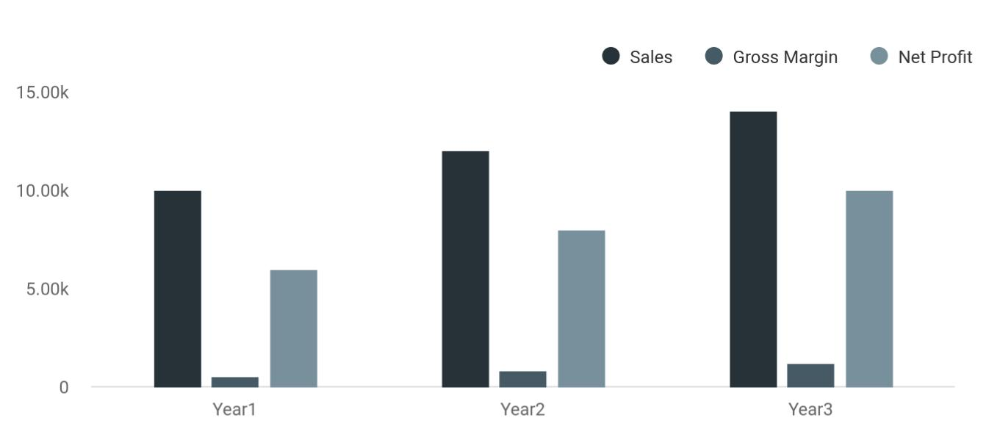

 MT Moore & Associates


Financial Summary | Year 1 | Year 2 |  | Year 3
 |  |  | To unlock help try Upmetrics! |  | 

Start writing here..

Real Estate Agency | Business Plan [YEAR] 8/36

2.

Company Summary

History

Start-up Summary

Funding Required

Real Estate Agency | Business Plan [YEAR] 9/36

 MT Moore & Associates
To unlock help try Upmetrics!

MT Moore & Associates Realty is founded by John Moore, Sarah Moore. They are the major financiers of the company. Mr. John is the company’s president and CEO. John has over 20
years of real estate experience including, significant senior management positions in the areas
To unlock help try Upmetrics! 

Start writing here..

History

 MT Moore & Associates

Upon returning from Cold well Banker, surveying the local customer base, and finding a potential retail office, John Moore incorporated MT Moore & Associates Realty as an S-Corporation in Jan 2021.



Start writing here..

Start-up Summary

 MT Moore & Associates

Our start-up costs are outlined in the following chart. Said start-up costs derive from website design, office equipment, main computer station (complete with all realtor information for agent usage), stationery, legal costs, furnishings, office advertising and services, and expenses
To unlock help try Upmetrics! 

Start writing here..

Real Estate Agency | Business Plan [YEAR] 10/36

Startup cost
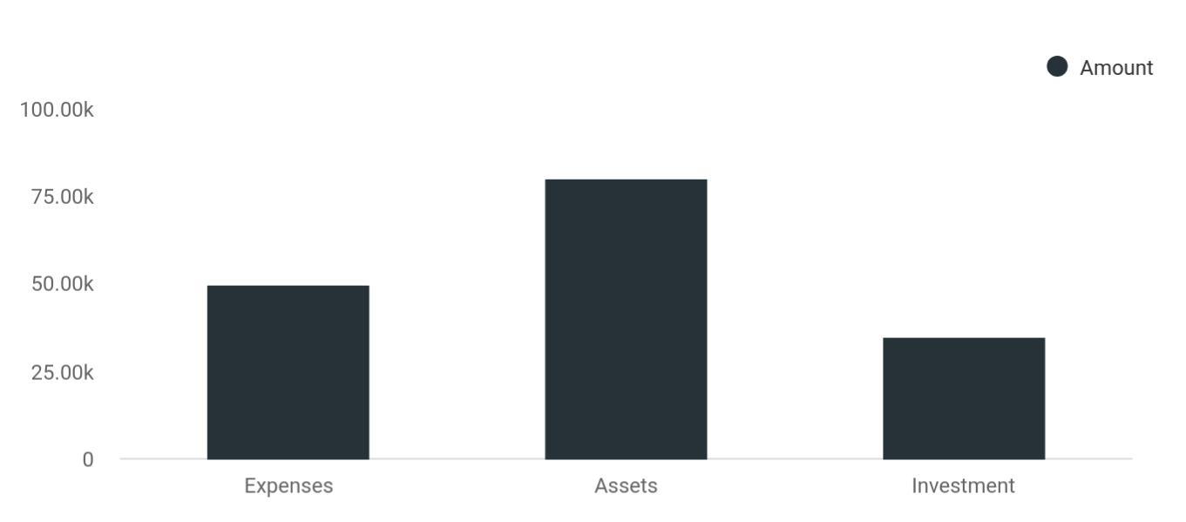

Cost distribution | Amount
Expenses | 50,000
Assets | 80,000
Investment | 35,000

Funding Required

The detailed startup requirements and expenses are given in the table below.

Start-up Expenses | Amount
Legal | $75,500
Consultants | $0
Insurance | $62,750
Rent | $22,500
Research and Development | $42,750
Expensed Equipment | $42,750
Signs | $1,250
TOTAL START-UP EXPENSES | $247,500
Start-up Assets | $0
Cash Required | $322,500

Real Estate Agency | Business Plan [YEAR] 11/36

Start-up Expenses | Amount
Start-up Inventory | $52,625
Other Current Assets | $222,500
Long-term Assets | $125,000
TOTAL ASSETS | $121,875
Total Requirements | $245,000
START-UP FUNDING | $0
START-UP FUNDING | $273,125
Start-up Expenses to Fund | $121,875
Start-up Assets to Fund | $195,000
TOTAL FUNDING REQUIRED | $0
Assets | $203,125
Non-cash Assets from Start-up | $118,750
Cash Requirements from Start-up | $0
Additional Cash Raised | $118,750
Cash Balance on Starting Date | $121,875
TOTAL ASSETS | $0
Liabilities and Capital | $0
Liabilities | $0
Current Borrowing | $0
Long-term Liabilities | $0
Accounts Payable (Outstanding Bills) | $0
Other Current Liabilities (interest-free) | $0
TOTAL LIABILITIES | $0
Capital | $0
Planned Investment | $0
Investor 1 | $312,500
Investor 2 | $0
Other | $0

Real Estate Agency | Business Plan [YEAR] 12/36

Start-up Expenses | Amount
Additional Investment Requirement | $0
TOTAL PLANNED INVESTMENT | $695,000
Loss at Start-up (Start-up Expenses) | $313,125
TOTAL CAPITAL | $221,875
TOTAL CAPITAL AND LIABILITIES | $221,875
Total Funding | $265,000

Real Estate Agency | Business Plan [YEAR] 13/36

3.

Products and Services

Our business offering are listed below:

Real Estate Agency | Business Plan [YEAR] 14/36

Before starting a real estate business, you must take many things into consideration such as you must consider what types of real estate services will you be providing to your customers. Deciding your services is extremely
To unlock help try Upmetrics!
To unlock help try Upmetrics! 

 MT Moore & Associates

MT Moore & Associates Realty is set to offer a variety of services within the scope of the real estate industry in the United States of America. Our intention of starting a real estate agency is to make profits from the industry and we will do all that is permitted by the law in the US to
To unlock help try Upmetrics! 

Start writing here..

 MT Moore & Associates

- Facilitating a Purchase — guiding a buyer through the process.

- Facilitating a Sale — guiding a seller through the selling process. _{To unlock help try Upmetrics!} 

Our business offering are listed below:

Start writing here..

 MT Moore & Associates

In addition, our customers will list their homes with our agency because of our aggressive and highly-skilled professionals. We will continuously have an above-average sales force to generate and close residential listings.



Start writing here..

Real Estate Agency | Business Plan [YEAR] 15/36

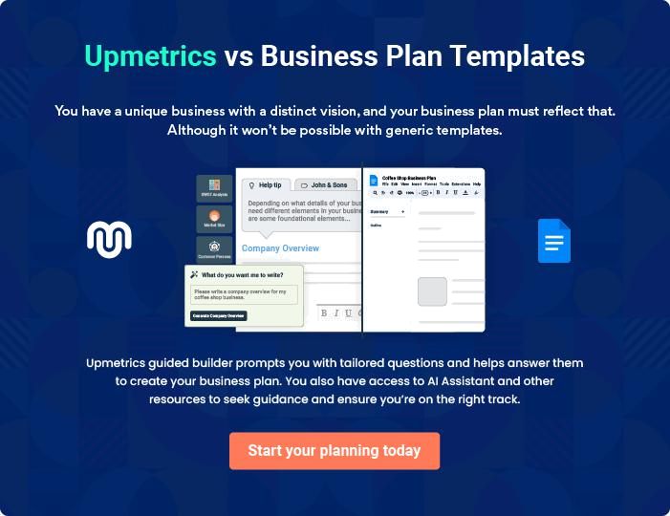

Real Estate Agency | Business Plan [YEAR] | 16/36

4.

Market Analysis

Industry Analysis

Market Trends

Target Market

Real Estate Agency | Business Plan [YEAR] 17/36

The most important component of an effective real estate business plan is its accurate marketing analysis. If you are starting on a smaller scale, you can do marketing analysis yourself by taking help from this real estate
To unlock help try Upmetrics! 

Industry Analysis

 Little Stars


Last year, according to IBISworld.com, U.S. real estate sales, and brokerage agencies brought in revenues of $137 billion and employed 1,085,000 people. There were 859,000 businesses in this market, for an average of $160,000 per business. Many agents work part-time, leading to
To unlock help try Upmetrics! 

Start writing here..

Market Trends

 Little Stars

The market trends in the real estate industry are such that, compensation is conventionally based on a percentage of the sales price, split between the buying and selling brokers, and then between the agent(s) and his/her real estate agency. While a split based on the percentage
To unlock help try Upmetrics! 

Start writing here..

Target Market

 Little Stars

Our target market cuts across people of different classes and people from all walks of life. We are coming into the industry with a business concept that will enable us to work with the highly placed people in the country and at the same with the lowly placed folks who are only
To unlock help try Upmetrics! 

Start writing here..

Real Estate Agency | Business Plan [YEAR] 18/36

5.

Strategy &

Implementations

Sales Strategy

Advertising Strategy

Pricing Strategy

Sales Forecast

Real Estate Agency | Business Plan [YEAR] 19/36

After identifying the market demand, market trends, and the potential customers of the startup, the next step is to define an effective strategy for attracting those customers. Like marketing analysis, sales strategy is also an
To unlock help try Upmetrics! 

Sales Strategy

 MT Moore & Associates

- Sales in our business are gaining property listings and utilizing a marketing plan that works best for the client.
To unlock help try Upmetrics! 

Start writing here..

Advertising Strategy

 MT Moore & Associates

MT Moore & Associates Realty will initially invest significant time and energy into contacting potential clients via telephone. In order to improve the effectiveness of this phase of the marketing strategy, a highly focused call list will be used, targeting landlords and sellers who
To unlock help try Upmetrics! 

Targeted Cold Calls

Start writing here..

 MT Moore & Associates

MT Moore & Associates Realty understands that the best promotion comes from satisfied customers. The Company will encourage its clients to refer other businesses by providing
economic or financial incentives for every new client produced. This strategy will increase in
To unlock help try Upmetrics! 

Referrals

Start writing here..

Real Estate Agency | Business Plan [YEAR] 20/36

 MT Moore & Associates

MT Moore & Associates Realty will invest resources in two forms of geographically-focused internet promotion—organic search engine optimization and pay-per-click advertising. The Company will develop its website in such a manner as to direct as much traffic from search
To unlock help try Upmetrics! 

Internet

Start writing here..

 MT Moore & Associates

MT Moore & Associates Realty will list its properties for rent and sale in key local publications, including newspapers, area magazines, and its own newsletter. Additionally, the Company will print brochures and place them in specific locations frequented by target individuals, such as
To unlock help try Upmetrics! 

Publications

Start writing here..

 MT Moore & Associates

By offering seminars on topics of interest in the office or other locations, Mr. Moore will encourage residents in the community to become comfortable with the expertise and character of MT Moore & Associates Realty. These seminars will generally be offered free of charge as
To unlock help try Upmetrics! 

Seminars

Start writing here..

Pricing Strategy

 MT Moore & Associates

Part of our business strategy is to ensure that we work within the budget of our clients to deliver excellent properties to them. The real estate industry is based on commission, and properties are valued by professionals based on the area the facility is located, the type of
To unlock help try Upmetrics! 

Start writing here..

Real Estate Agency | Business Plan [YEAR] 21/36

Sales Forecast
To unlock help try Upmetrics!

 MT Moore & Associates

The following table and chart give a run-down on forecasted sales. We expect sales to be slowest during September through December, building between January through March and the most growth during the months of March through August.



Start writing here..

Sales
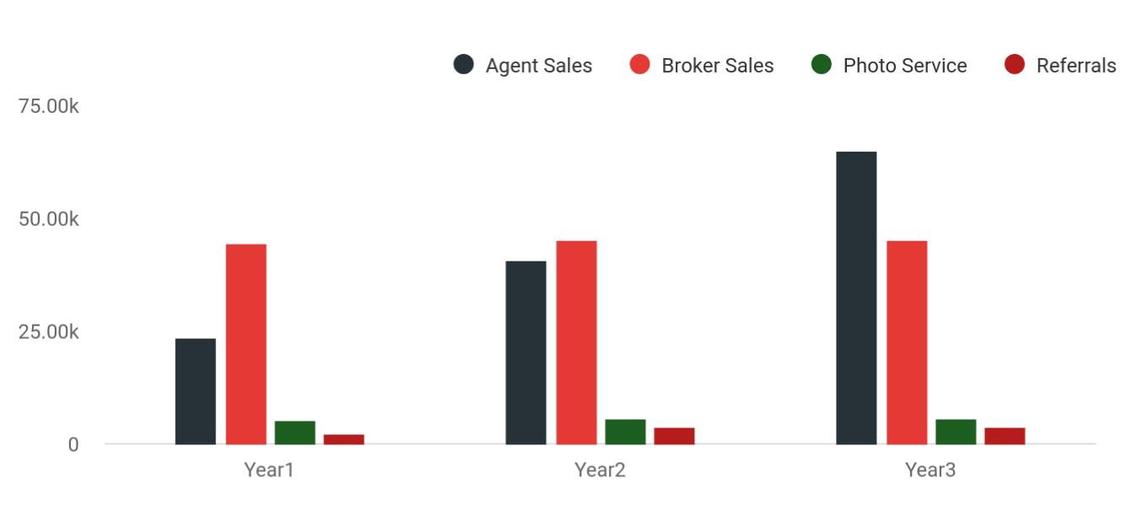

Financial Year | Agent Sales | Broker Sales | Photo Service | Referrals
Year1 | 23,625 | 44,245 | 5,280 | 2,244
Year2 | 40,500 | 45,000 | 5,760 | 3,750
Year3 | 65,000 | 45,000 | 5,760 | 3,750

Real Estate Agency | Business Plan [YEAR] 22/36

6.

Operations

Management Summary

Hiring Plan

Milestones

Real Estate Agency | Business Plan [YEAR] 23/36

 MT Moore & Associates
To unlock help try Upmetrics!

MT Moore & Associates Realty will carry out its day-to-day operations primarily on an appointment basis. Buying and renting clients will make appointments to view available
properties and to discuss their needs. Selling clients and landlords will make appointments to
To unlock help try Upmetrics! 

Start writing here..

Management Summary

 MT Moore & Associates

The initial management team is the owner/licensed broker. The broker of this firm has the only authority to sponsor oncoming licensed real estate agents under the corporate broker license. Upon joining this firm agents will receive a complete training program to include the broker’s
To unlock help try Upmetrics! 

Start writing here..

Hiring Plan

 MT Moore & Associates

John Moore will serve as the company CEO and president. In order to launch the business we do not need additional personnel beyond the assistant who has already been recruited, but will hire the following in the future:



Start writing here..

Real Estate Agency | Business Plan [YEAR] 24/36

Milestones

 MT Moore & Associates

MT Moore & Associates Realty's long-term goal is to become the number-one name in residential real estate brokerage in terms of the right balance of price and customer service quality. We seek to do this by ensuring customer satisfaction and developing a loyal and
To unlock help try Upmetrics! 

Start writing here..

Real Estate Agency | Business Plan [YEAR] 25/36

7.

Financial Plan

Important Assumptions

Brake-even Analysis

Projected Profit and Loss

Projected Cash Flow

Projected Balance Sheet

Business Ratios

Real Estate Agency | Business Plan [YEAR] 26/36

The last component of a real estate business plan is an in-depth financial plan. The financial plan crafts a detailed map of all the expenses needed for the startup and how these expenses will be met by the earned profits. It is
To unlock help try Upmetrics! 

 MT Moore & Associates

The company will be financed by John himself and he will control the direction of the business to make sure that it is expanding at the forecasted rate. As for the real estate business start-up, no equity funding or outside loans will be required. With the help of financial experts, John has
To unlock help try Upmetrics! 

Start writing here..

Important Assumptions

The financial projections of the company are forecast on the basis of the following assumptions. These assumptions are quite conservative and are expected to show deviation but to a limited level such that the company’s major financial strategy will not be affected.

 | Year 1 | Year 2 | Year 3
Plan Month | 1 | 2 | 3
Current Interest Rate | 10,00% | 11,00% | 12,00%
Long-term Interest Rate | 10,00% | 10,00% | 10,00%
Tax Rate | 26,42% | 27,76% | 28,12%
Other | 0 | 0 | 0

Brake-even Analysis

Monthly Units Break-even | 5530
Monthly Revenue Break-even | $159 740
Assumptions:
Average Per-Unit Revenue | $260,87
Average Per-Unit Variable Cost | $0,89
Estimated Monthly Fixed Cost | $196 410

Real Estate Agency | Business Plan [YEAR] 27/36

Projected Profit and Loss

 | 2024 | 2025 | 2026
Revenue | $1,809,424 | $3,006,756 | $4,458,623
Property Sales | $978,300 | $1,170,030 | $1,399,050
Commissions | $978,300 | $1,170,030 | $1,399,050
Unit Sales | 326 | 390 | 466
Unit Price | $3,000 | $3,000 | $3,000
Buyer Representation Fees | $425,740 | $606,760 | $864,980
Unit Sales | 213 | 303 | 432
Unit Price | $2,000 | $2,000 | $2,000
Agent Membership Fees | $405,384 | $1,229,966 | $2,194,593
Users | 636 | 1,371 | 2,239
Recurring Charges | $100 | $100 | $100
Cost Of Sales | $79,713.42 | $128,201.36 | $187,281.75
General Costs | $79,713.42 | $128,201.36 | $187,281.75
Property Listing Expenses | $40,988.48 | $65,208.08 | $94,888.70
Advertising Costs | $36,188.48 | $60,135.12 | $89,172.46
Inspection Fees | $4,800 | $5,072.96 | $5,716.24
Transaction Processing | $38,724.94 | $62,993.28 | $92,393.05
Legal and Closing Fees | $36,188.48 | $60,135.12 | $89,172.46
Escrow Charges | $2,536.46 | $2,858.16 | $3,220.59
Revenue Specific Costs | $0 | $0 | $0
Personnel Costs (Direct | $0 | $0 | $0
Labor) | $0 | $0 | $0
Gross Margin | $1,729,710.58 | $2,878,554.64 | $4,271,341.25

Real Estate Agency | Business Plan [YEAR] 28/36

 | 2024 | 2025 | 2026
Gross Margin (%) | 95.59% | 95.74% | 95.80%

Operating Expense | $1,798,354.12 | $1,881,111.70 | $1,973,987.80
Payroll Expense (Indirect | $1,683,840 | $1,721,164.80 | $1,759,345.44
Labor) | $1,683,840 | $1,721,164.80 | $1,759,345.44
Executive Team | $364,800 | $375,744 | $387,016.32
CEO Salary | $192,000 | $197,760 | $203,692.80
CFO Salary | $172,800 | $177,984 | $183,323.52
Sales Agents | $1,080,000 | $1,101,600 | $1,123,632
Senior Sales Agents | $432,000 | $440,640 | $449,452.80
Junior Sales Agents | $648,000 | $660,960 | $674,179.20
Administrative Staff | $239,040 | $243,820.80 | $248,697.12
Office Manager Salary | $74,880 | $76,377.60 | $77,905.20
Admin Assistant Salaries | $164,160 | $167,443.20 | $170,791.92
General Expense | $114,514.12 | $159,946.90 | $214,642.36
Office and Administrative | $38,944.17 | $46,125.99 | $54,657.50
Expenses | $38,944.17 | $46,125.99 | $54,657.50
Office Rent | $32,602.93 | $38,980.65 | $46,605.98
Utility Bills | $6,341.24 | $7,145.34 | $8,051.52
Marketing and Advertising | $66,965.25 | $104,493.78 | $149,862.13
Online Marketing | $54,282.72 | $90,202.68 | $133,758.69
Print Advertising | $12,682.53 | $14,291.10 | $16,103.44
Operational Expenses | $8,604.70 | $9,327.13 | $10,122.73
Office Supplies | $3,804.70 | $4,287.13 | $4,830.73
Insurance | $4,800 | $5,040 | $5,292
Bad Debt | $0 | $0 | $0

Real Estate Agency | Business Plan [YEAR] 29/36

Amortization of Current Assets

EBITDA

Additional Expense

Long Term Depreciation

Gain or loss from Sale of Assets

EBIT

Interest Expense

EBT

Income Tax Expense / Benefit

Total Expense

Net Income

Net Income (%)

Retained Earning Opening

Owner's Distribution

Retained Earning Closing

2024 | 2025 | 2026
$0 | $0 | $0

($68,643.54) $997,442.94 $2,297,353.45

$14,806.93 | $12,872.77 | $10,819.31
$9,660 | $9,660 | $9,660
$0 | $0 | $0
($78,303.54) | $987,782.94 | $2,287,693.45
$5,146.94 | $3,212.76 | $1,159.29
($83,450.47) | $984,570.17 | $2,286,534.14
$0 | $0 | $0

$1,892,874.47 | $2,022,185.83 | $2,172,088.86
($83,450.47) | $984,570.17 | $2,286,534.14
(4.61%) | 32.75% | 51.28%

$0 | ($101,450.47) | $865,119.70
$18,000 | $18,000 | $18,000
($101,450.47) | $865,119.70 | $3,133,653.84

Real Estate Agency | Business Plan [YEAR] 30/36

Projected Cash Flow

 | 2024 | 2025 | 2026
Cash Received | $1,809,424 | $3,006,756 | $4,458,623
Cash Paid | $1,883,214.47 | $2,012,525.83 | $2,162,428.86
COS & General Expenses | $194,227.54 | $288,148.26 | $401,924.11
Salary & Wages | $1,683,840 | $1,721,164.80 | $1,759,345.44
Interest | $5,146.94 | $3,212.76 | $1,159.29
Sales Tax | $0 | $0 | $0
Income Tax | $0 | $0 | $0
Net Cash From | ($73,790.47) | $994,230.17 | $2,296,194.14
Operations | ($73,790.47) | $994,230.17 | $2,296,194.14
Assets Sell | $0 | $0 | $0
Assets Purchase | $70,000 | $0 | $0
Net Cash From | ($70,000) | $0 | $0
Investments | ($70,000) | $0 | $0
Amount Received | $150,000 | $0 | $0
Loan Received | $100,000 | $0 | $0
Common Stock | $0 | $0 | $0
Preferred Stock | $0 | $0 | $0
Owner's Contribution | $50,000 | $0 | $0
Amount Paid | $49,359.35 | $51,293.51 | $53,347.12
Loan Capital | $31,359.34 | $33,293.52 | $35,347.14
Dividends & Distributions | $18,000 | $18,000 | $18,000
Net Cash From | $100,640.65 | ($51,293.51) | ($53,347.12)
Financing | $100,640.65 | ($51,293.51) | ($53,347.12)

Real Estate Agency | Business Plan [YEAR] 31/36

 | 2024 | 2025 | 2026
Summary
Starting Cash | $0 | ($43,149.82) | $899,786.84
Cash In | $1,959,424 | $3,006,756 | $4,458,623
Cash Out | $2,002,573.82 | $2,063,819.34 | $2,215,775.98
Change in Cash | ($43,149.82) | $942,936.66 | $2,242,847.02
Ending Cash | ($43,149.82) | $899,786.84 | $3,142,633.86
Projected Balance Sheet
 | 2024 | 2025 | 2026
Assets | $17,190.18 | $950,466.84 | $3,183,653.86
Current Assets | ($43,149.82) | $899,786.84 | $3,142,633.86
Cash | ($43,149.82) | $899,786.84 | $3,142,633.86
Accounts Receivable | $0 | $0 | $0
Inventory | $0 | $0 | $0
Other Current Assets | $0 | $0 | $0
Long Term Assets | $60,340 | $50,680 | $41,020
Gross Long Term Assets | $70,000 | $70,000 | $70,000
Accumulated Depreciation | ($9,660) | ($19,320) | ($28,980)
Liabilities & Equity | $17,190.19 | $950,466.84 | $3,183,653.84
Liabilities | $68,640.66 | $35,347.14 | $0
Current Liabilities | $33,293.52 | $35,347.14 | $0
Accounts Payable | $0 | $0 | $0
Income Tax Payable | $0 | $0 | $0

Real Estate Agency | Business Plan [YEAR] 32/36

 | 2024 |  |  | 2025 |  | 2026
Sales Tax Payable | $0 |  |  | $0 |  | $0
Short Term Debt | $33,293.52 |  | $35,347.14 |  |  | $0
Long Term Liabilities | $35,347.14 |  |  | $0 |  | $0
Long Term Debt | $35,347.14 |  |  | $0 |  | $0
Equity | ($51,450.47) |  | $915,119.70 |  |  | $3,183,653.84
Paid-in Capital | $0 |  |  | $0 |  | $0
Common Stock | $0 |  |  | $0 |  | $0
Preferred Stock | $0 |  |  | $0 |  | $0
Owner's Contribution | $50,000 |  |  | $50,000 |  | $50,000
Retained Earnings | ($101,450.47) |  | $865,119.70 |  |  | $3,133,653.84
Check | $0 |  |  | $0 |  | $0
Business Ratios
 |  | Year 1 | Year 2 |  | Year 3 | Industry Profile
Sales Growth |  | 4,35% | 30,82% |  | 63,29% | 4,00%
Percent of Total Assets
Accounts Receivable |  | 5,61% | 4,71% |  | 3,81% | 9,70%
Inventory |  | 1,85% | 1,82% |  | 1,79% | 9,80%
Other Current Assets |  | 1,75% | 2,02% |  | 2,29% | 27,40%
Total Current Assets |  | 138,53% | 150,99% |  | 163,45% | 54,60%
Long-term Assets |  | -9,47% | -21,01% |  | -32,55% | 58,40%
TOTAL ASSETS |  | 100,00% | 100,00% |  | 100,00% | 100,00%
Current Liabilities |  | 4,68% | 3,04% |  | 2,76% | 27,30%
Long-term Liabilities |  | 0,00% | 0,00% |  | 0,00% | 25,80%
Total Liabilities |  | 4,68% | 3,04% |  | 2,76% | 54,10%

Real Estate Agency | Business Plan [YEAR] 33/36

 | Year 1 | Year 2 | Year 3 | Industry Profile
NET WORTH | 99,32% | 101,04% | 102,76% | 44,90%
Percent of Sales
Sales | 100,00% | 100,00% | 100,00% | 100,00%
Gross Margin | 94,18% | 93,85% | 93,52% | 0,00%
Selling, General & Administrative Expenses | 74,29% | 71,83% | 69,37% | 65,20%
Advertising Expenses | 2,06% | 1,11% | 0,28% | 1,40%
Profit Before Interest and Taxes | 26,47% | 29,30% | 32,13% | 2,86%
Main Ratios
Current | 25,86 | 29,39 | 32,92 | 1,63
Quick | 25,4 | 28,88 | 32,36 | 0,84
Total Debt to Total Assets | 2,68% | 1,04% | 0,76% | 67,10%
Pre-tax Return on Net Worth | 66,83% | 71,26% | 75,69% | 4,40%
Pre-tax Return on Assets | 64,88% | 69,75% | 74,62% | 9,00%
Additional Ratios
Net Profit Margin | 19,20% | 21,16% | 23,12% | N.A.
Return on Equity | 47,79% | 50,53% | 53,27% | N.A.
Activity Ratios
Accounts Receivable Turnover | 4,56 | 4,56 | 4,56 | N.A.
Collection Days | 92 | 99 | 106 | N.A.
Inventory Turnover | 19,7 | 22,55 | 25,4 | N.A.
Accounts Payable Turnover | 14,17 | 14,67 | 15,17 | N.A.
Payment Days | 27 | 27 | 27 | N.A.
Total Asset Turnover | 1,84 | 1,55 | 1,26 | N.A.
Debt Ratios
Debt to Net Worth | 0 | -0,02 | -0,04 | N.A.
Current Liab. to Liab. | 1 | 1 | 1 | N.A.
Liquidity Ratios
Net Working Capital | $120 943 | $140 664 | $160 385 | N.A.

Real Estate Agency | Business Plan [YEAR] 34/36

 | Year 1 | Year 2 | Year 3 | Industry Profile
Interest Coverage | 0 | 0 | 0 | N.A.
Additional Ratios
Assets to Sales | 0,45 | 0,48 | 0,51 | N.A.
Current Debt/Total Assets | 4% | 3% | 2% | N.A.
Acid Test | 23,66 | 27,01 | 30,36 | N.A.
Sales/Net Worth | 1,68 | 1,29 | 0,9 | N.A.
Dividend Payout | 0 | 0 | 0 | N.A.
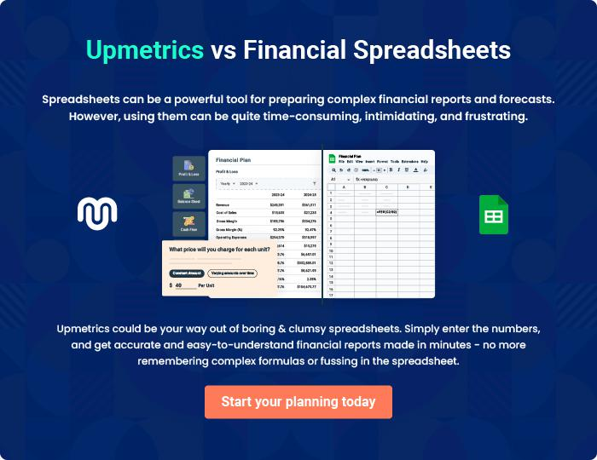

Real Estate Agency | Business Plan [YEAR] 35/36


Create a winning business plan that gets you funded

Creating a stunning and investment-ready plan requires no writing, graphic designing, or financial planning expertise.

Upmetrics has all the features required to help you create a comprehensive business plan—from start to finish. Make no mistakes, it’s the modern way of planning to structure ideas, make plans, and create stunning pitch decks to awe investors.

Pitch decks that impress investors

Create pitch decks that provide a visual representation of your business, engage investors, and make them want to invest in your business idea.

Interactive plans in no time

Import business plan sections like—SWOT analysis, comparison tables, and others to create an interactive business plan. No designing skills are required.

Stunning cover page designs

With Upmetrics, you have the liberty to choose from multiple stunning cover page designs. Choose a creative design and make your plan stand out.

Online sharing made simple

Upmetrics makes online sharing quick and easier for users. Easily share your business plans with a link while tracking reader activity.

500+ sample business plans

Simply import a template from our library of sample plans into the editor and start customizing it to make it yours. It takes only a few clicks to get started.

Collaborate with team in real-time

Invite team members, initiate conversations, discuss ideas & strategies, share feedback, and work on a business plan in real-time.

