
BUSINESS PLAN

[YEAR]

Property Management

Adding Care to your Property.

John Doe

10200 Bolsa Ave, Westminster, CA, 92683

- 359-3153 info@example.com http://www.example.com

Information provided in this business plan is unique to this business and confidential; therefore, anyone reading this plan agrees not to disclose any of the information in this business plan without prior written permission of the company.
Table of Contents

Executive Summary | 5
Mission statement | 6
Vision Statement | 6
Customer Focus | 7
Success Factors | 7
Financial Summary | 7
3 Year profit forecast | 8

Company Summary | 9
History | 10
Business Structure | 10
Startup Summary | 11
Startup cost | 11
Products and services
Products and services | 14
Market Analysis
Market Analysis | 17
Industry Analysis | 18
Market Trends | 18
Target Market | 18
SWOT Analysis
SWOT Analysis | 19
Strategy & Implementations
Strategy & Implementations | 21
Advertising Strategy | 22
Targeted Cold Calls | 22
Referrals | 22
Online Marketing | 23
Publications | 23
Community Events/Organizations | 23
Pricing Strategy | 23

Property Management | Business Plan [YEAR] 2/35

Financial Plan | 24
Important Assumptions | 25
Brake-even Analysis | 25
Units Sold v/s Revenue Chart | 26
Projected Profit and Loss | 26
Projected Cash Flow | 29
Projected Balance Sheet | 30
Business Ratios | 31

Property Management | Business Plan [YEAR] 3/35


Business planning that’s simpler and faster than you think

Creating a business plan using Upmetrics to start and grow a business is literally the easiest thing in the World. Simply read the instructions and fill in the blanks. It’s as simple as that.

❛ | Upmetrics has everything you need to create a | ❜
❛ | comprehensive business plan. | ❜

AI-powered Upmetrics Assistant

AI-powered insights to streamline your plan

Not sure where to start? Upmetrics’ AI Assistant will automatically generate ideas for each section of your plan and offer improved versions of your writing, adjusting for tone, voice, and grammar or spelling errors.

Financial Forecasting Tool

All the financials are calculated for you

Forget the complex formulas and clumsy spreadsheets — with automatic financials and drag-and-drop forecasting, you can finish your plan faster and be confident that your numbers are accurate.

Business Plan Builder

Guides you like a business mentor

Upmetrics’ step-by-step instructions, prompts, and the library of 400+ sample business plans will guide you through each section of your plan as a business mentor.

1.


Executive Summary

Mission statement

Vision Statement

Customer Focus

Success Factors

Financial Summary

Property Management | Business Plan [YEAR] 5/35


Before you think about how to start a property management service, you must create a detailed property management business plan. It will not only guide you in the initial phases of your startup but will also help you later on.
To unlock help try Upmetrics! 

 Maxwell Property Management


Maxwell Property Management Company is a Detroit-based property management firm specializing in commercial and residential properties. Its goal is to provide a solution to the real estate management problems that property owners struggle with. It helps its clients with
To unlock help try Upmetrics! 

Start writing here..

Mission statement

 Maxwell Property Management

We are a company that is established with the aim of helping tenants (people and businesses) get the properties of their choice and to helps property owners (landlords and group owners of properties et al) effectively manage and maximize their properties in the United States of
To unlock help try Upmetrics! 

Start writing here..

Vision Statement

 Maxwell Property Management

Our Vision is to become the preferred choice of landlords and tenants when it comes to property rentals in the whole of the United States of America.
To unlock help try Upmetrics! 

Start writing here..

Property Management | Business Plan [YEAR] 6/35

Customer Focus
To unlock help try Upmetrics!

 Maxwell Property Management

Maxwell Property Management Company will primarily serve the residents who live within the city. The demographics of these customers are as follows:
To unlock help try Upmetrics! 

Start writing here..

Success Factors

 Maxwell Property Management

Maxwell Property Management Company is uniquely qualified to succeed for the following reasons:
To unlock help try Upmetrics! 

Start writing here..

Financial Summary

 Maxwell Property Management

Maxwell Property Management Company is seeking total funding of $210,000 of debt capital to open its firm. The capital will be used for funding capital expenditures and location build-out, hiring initial employees, marketing expenses, and working capital.



Start writing here..

Property Management | Business Plan [YEAR] 7/35

3 Year profit forecast
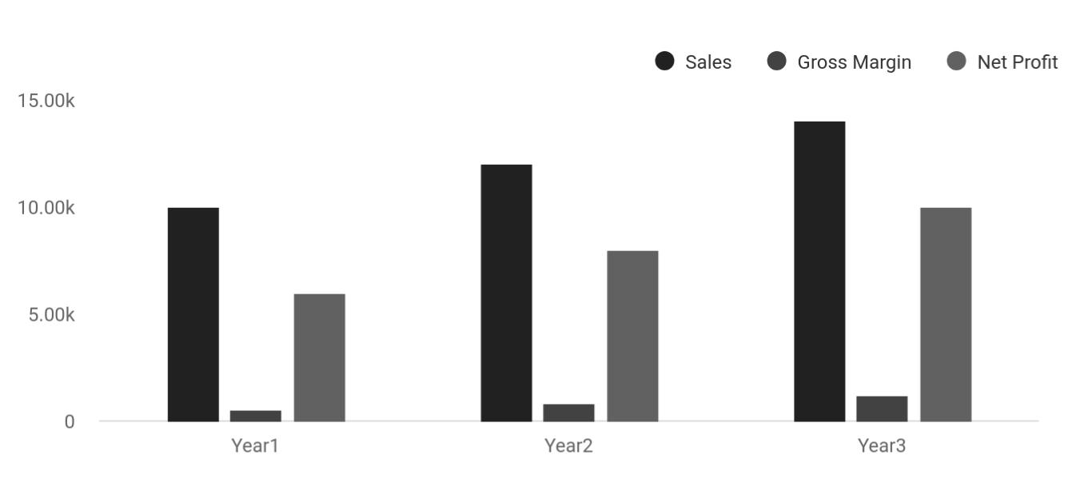

 Maxwell Property Management


Financial Summary | Year 1 | Year 2 |  | Year 3
 |  |  | To unlock help try Upmetrics! |  | 

Start writing here..

Property Management | Business Plan [YEAR] 8/35

2.

Company Summary

History

Business Structure

Startup Summary

Property Management | Business Plan [YEAR] 9/35

 Maxwell Property Management
To unlock help try Upmetrics!

Maxwell Property Management Company is owned by John Moore and his immediate family members (His Wife and Son). The company is fully financed by John Moore and his son James Moore is the chief operating officer of the company.



Start writing here..

History

 Maxwell Property Management

In 2000, John Moore, a licensed real estate broker started receiving an abundance of inquiries about marketing properties, landlord-tenant laws, and concerns about property rentals and their daily operations. Realizing that he cannot address every inquiry by himself and not wanting to
To unlock help try Upmetrics! 

Start writing here..

Business Structure

 Maxwell Property Management

Maxwell Property Management Company is going to be structured in a way that every employee will be actively involved in the growth of the organization and employees who have worked for a period of time for the company will become part owners of the company.
To unlock help try Upmetrics! 

Start writing here..

Property Management | Business Plan [YEAR] 10/35

Startup Summary

Startup cost
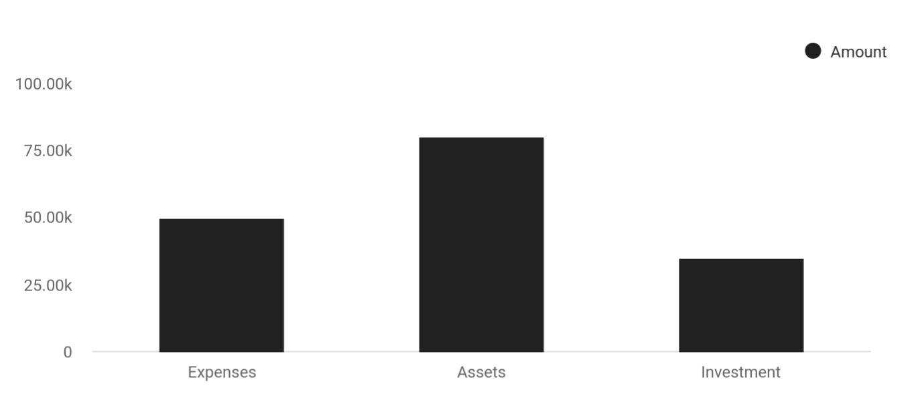

Cost distribution | Amount
Expenses | 50,000
Assets | 80,000
Investment | 35,000

Start-up Expenses | Amount
Legal | $75,500
Consultants | $0
Insurance | $62,750
Rent | $22,500
Research and Development | $42,750
Expensed Equipment | $42,750
Signs | $1,250
TOTAL START-UP EXPENSES | $247,500
Start-up Assets | $0
Cash Required | $322,500
Start-up Inventory | $52,625
Other Current Assets | $222,500

Property Management | Business Plan [YEAR] 11/35

Start-up Expenses | Amount
Long-term Assets | $125,000
TOTAL ASSETS | $121,875
Total Requirements | $245,000
START-UP FUNDING | $0
START-UP FUNDING | $273,125
Start-up Expenses to Fund | $121,875
Start-up Assets to Fund | $195,000
TOTAL FUNDING REQUIRED | $0
Assets | $203,125
Non-cash Assets from Start-up | $118,750
Cash Requirements from Start-up | $0
Additional Cash Raised | $118,750
Cash Balance on Starting Date | $121,875
TOTAL ASSETS | $0
Liabilities and Capital | $0
Liabilities | $0
Current Borrowing | $0
Long-term Liabilities | $0
Accounts Payable (Outstanding Bills) | $0
Other Current Liabilities (interest-free) | $0
TOTAL LIABILITIES | $0
Capital | $0
Planned Investment | $0
Investor 1 | $312,500
Investor 2 | $0
Other | $0
Additional Investment Requirement | $0
TOTAL PLANNED INVESTMENT | $695,000

Property Management | Business Plan [YEAR] 12/35

Start-up Expenses | Amount
Loss at Start-up (Start-up Expenses) | $313,125
TOTAL CAPITAL | $221,875
TOTAL CAPITAL AND LIABILITIES | $221,875
Total Funding | $265,000

Property Management | Business Plan [YEAR] 13/35

3.

Products and services

Property Management | Business Plan [YEAR] 14/35

 Maxwell Property Management

Maxwell Property Management Company is a company that looks forward to delivering excellent services in terms of helping landlords and property owners effectively manage their properties and also providing conducive apartments and facilities to tenants at an affordable
To unlock help try Upmetrics! 

Start writing here..


Facilitating a Purchase

Guiding a buyer through the process

FSBO document preparation

Preparing necessary paperwork for “For Sale by Owner” sellers.

Facilitating a Sale

Guiding a seller through the selling process.

Property Maintenance

Auctioning property
Exchanging property
for our clients.

Preparing contracts List the property for

and leases. sale to the public

Property Management | Business Plan [YEAR] 15/35


Selling of Fully Selling of Landed

Furnished Properties Properties

Property

Management Hold an open house

Consultancy and to show the property.

Advisory Services
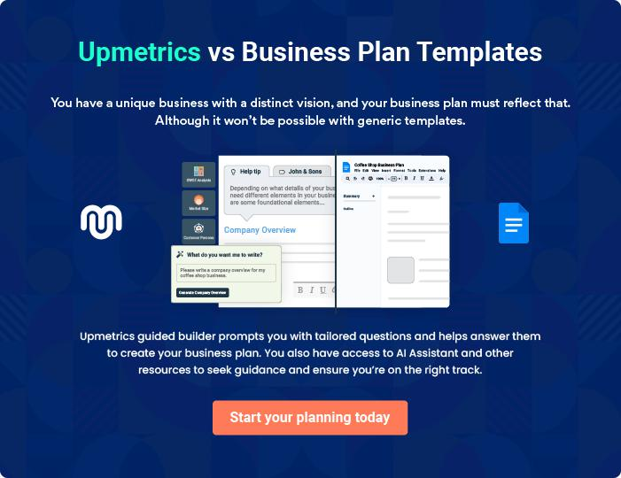

Property Management | Business Plan [YEAR] 16/35

4.

Market Analysis

Industry Analysis

Market Trends

Target Market

Property Management | Business Plan [YEAR] 17/35

The most important component of an effective property management services business plan is its accurate marketing analysis. If you are starting on a smaller scale, you can do marketing analysis yourself by taking help
To unlock help try Upmetrics! 

Industry Analysis

 Maxwell Property Management

The Property Management industry is structurally resistant to economic downturns, primarily as a result of countercyclical demand trends. When the national economy struggles, the homeownership rate tends to decline as consumers and lenders remain cautious, creating
To unlock help try Upmetrics! 

Start writing here..

Market Trends

 Maxwell Property Management

The market trends as it involves the property management business are indeed dynamic and at the same time, pretty much easier for a newbie to come in and still make money from the industry. All that is needed for any property management company to do well in the industry is
To unlock help try Upmetrics! 

Start writing here..

Target Market

 Maxwell Property Management

Our target market as a property management company cuts across people of different classes and people from all walks of life. We are coming into the industry with a business concept that will enable us to work with the highly placed people in the country and at the same with the
To unlock help try Upmetrics! 

Start writing here..

Property Management | Business Plan [YEAR] 18/35

5.

SWOT Analysis

Property Management | Business Plan [YEAR] 19/35

 Maxwell Property Management

No doubt, the property management business is perhaps one of the easiest and cheapest ways of entering the real estate business. As a matter of fact, all that is required to do pretty well in this line of business is a high school diploma, experience in property management, and the
To unlock help try Upmetrics! 

Start writing here..


Strength

Our strength as a property management company lies in the fact that we have a healthy relationship with loads of property owners (landlords) in the United States and we have some of the best hands in the industry working both as full-time employees and consultants for us. We can confidently boast that we have some of the qualities that are in high demand in the property management line of business which are trust, honesty, and relationship management.


Weakness

Our weakness could be that we are a new property management business in the United States and it may take us time and extra effort to convince landlords to give us their properties to manage for them.


Opportunity

The opportunities that are available in the real estate industry are massive and we are ready to take advantage of any opportunity that comes our way.

Threat

Some of the threats that we are likely going to face as a property management company in the United States of America are unfavorable government policies, global economic downturn, and unreasonable tenants. There is hardly anything we could do as regards these threats other than to be optimistic that things will continue to work for our good.

Property Management | Business Plan [YEAR] 20/35

6.

Strategy &

Implementations

Advertising Strategy

Pricing Strategy

Property Management | Business Plan [YEAR] 21/35

After identifying the market demand, market trends, and the potential customers of the startup, the next step is to define an effective strategy for attracting those customers. Like marketing analysis, sales strategy is also an
To unlock help try Upmetrics!
To unlock help try Upmetrics! 

Advertising Strategy

 Maxwell Property Management

Maxwell Property Management Company expects its target market to be individuals working and/or living within Michigan. The company’s promotions strategy to reach these individuals includes:



Start writing here..

 Maxwell Property Management

Maxwell Property Management Company will initially invest significant time and energy into contacting potential clients via telephone. In order to improve the effectiveness of this phase of the marketing strategy, a highly focused call list will be used, targeting landlords and sellers
To unlock help try Upmetrics! 

Targeted Cold Calls

Start writing here..

 Maxwell Property Management

Maxwell Property Management Company understands that the best promotion comes from satisfied customers. The Company will encourage its clients to refer other businesses by providing economic or financial incentives for every new client produced. This strategy will
To unlock help try Upmetrics! 

Referrals

Start writing here..

Property Management | Business Plan [YEAR] 22/35

 Maxwell Property Management
To unlock help try Upmetrics!

Maxwell Property Management Company will invest resources in two forms of geographically-focused internet promotion—organic search engine optimization and pay-per-click advertising.
The Company will develop its website in such a manner as to direct as much traffic from search
To unlock help try Upmetrics! 

Online Marketing

Start writing here..

 Maxwell Property Management

Maxwell Property Management Company will list its properties for rent and sale in key local publications, including newspapers, area magazines, and its own newsletter. Additionally, the company will print brochures and place them in specific locations frequented by target
To unlock help try Upmetrics! 

Publications

Start writing here..

 Maxwell Property Management

Maxwell Property Management Company will promote itself by distributing marketing materials and participating in local community events, such as local festivals, business networking, or sporting events.



Community Events/Organizations

Start writing here..

Pricing Strategy

 Maxwell Property Management

Part of business strategy is to ensure that we work within the budget of our clients to deliver excellent properties to them. The real estate industry is based on commissions and properties are valued by professionals based on the area the facility is located, the type of facility, and
To unlock help try Upmetrics! 

Start writing here..

Property Management | Business Plan [YEAR] 23/35

7.

Financial Plan

Important Assumptions

Brake-even Analysis

Projected Profit and Loss

Projected Cash Flow

Projected Balance Sheet

Business Ratios

Property Management | Business Plan [YEAR] 24/35

The last component of a property management service business plan is an in-depth financial plan. The financial plan crafts a detailed map of all the expenses needed for the startup and how these expenses will be met by the
To unlock help try Upmetrics! 

 Maxwell Property Management

The company will be financed by John himself and he will control the direction of the business to make sure that it is expanding at the forecasted rate. As for the property management service business start-up, no equity funding or outside loans will be required. With the help of
To unlock help try Upmetrics! 

Start writing here..

Important Assumptions

The financial projections of the company are forecast on the basis of the following assumptions. These assumptions are quite conservative and are expected to show deviation but to a limited level such that the company’s major financial strategy will not be affected.

 | Year 1 | Year 2 | Year 3
Plan Month | 1 | 2 | 3
Current Interest Rate | 10,00% | 11,00% | 12,00%
Long-term Interest Rate | 10,00% | 10,00% | 10,00%
Tax Rate | 26,42% | 27,76% | 28,12%
Other | 0 | 0 | 0

Brake-even Analysis

Monthly Units Break-even | 5530
Monthly Revenue Break-even | $159 740
Assumptions:
Average Per-Unit Revenue | $260,87
Average Per-Unit Variable Cost | $0,89
Estimated Monthly Fixed Cost | $196 410

Property Management | Business Plan [YEAR] 25/35

Units Sold v/s Revenue Chart
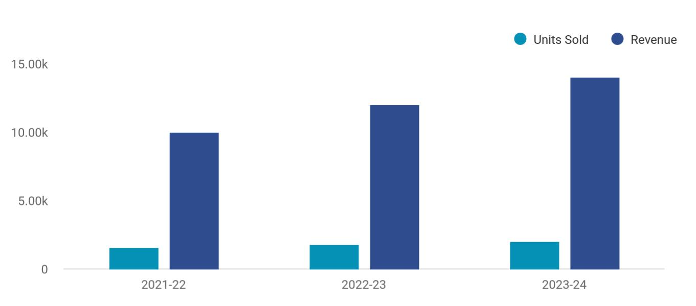

Financial Year | Units Sold | Revenue
2021-22 | 1,550 | 10,000
2022-23 | 1,800 | 12,000
2023-24 | 2,050 | 14,000

Projected Profit and Loss

 | 2024 | 2025 | 2026
Revenue | $662,083.50 | $885,106.50 | $1,231,861.50
Monthly Management | $144,000 | $158,400 | $174,240
Fees | $144,000 | $158,400 | $174,240
Unit Sales | 720 | 792 | 871
Unit Price | $200 | $200 | $200
Tenant Placement Fees | $180,000 | $185,400 | $190,962
Maintenance Services | $338,083.50 | $541,306.50 | $866,659.50
Unit Sales | 2,254 | 3,609 | 5,778
Unit Price | $150 | $150 | $150

Property Management | Business Plan [YEAR] 26/35

 | 2024 | 2025 | 2026
Cost Of Sales | $124,966.71 | $144,848.58 | $174,687.81
General Costs | $124,966.71 | $144,848.58 | $174,687.81
Property Maintenance | $93,104.19 | $106,055.36 | $125,247.12
Costs | $93,104.19 | $106,055.36 | $125,247.12
Property Repair Costs | $60,000 | $61,800 | $63,654
Cleaning Services | $33,104.19 | $44,255.36 | $61,593.12
Administrative Costs | $31,862.52 | $38,793.22 | $49,440.69
Office Supplies | $12,000 | $12,240 | $12,484.80
Software Subscriptions | $19,862.52 | $26,553.22 | $36,955.89
Revenue Specific Costs | $0 | $0 | $0
Personnel Costs (Direct | $0 | $0 | $0
Labor) | $0 | $0 | $0

Gross Margin | $537,116.79 | $740,257.92 | $1,057,173.69
Gross Margin (%) | 81.13% | 83.63% | 85.82%

Operating Expense | $642,563.34 | $665,616.66 | $693,959.22
Payroll Expense (Indirect | $545,280 | $557,840.40 | $570,704.64
Labor) | $545,280 | $557,840.40 | $570,704.64
Management Team | $264,000 | $270,480 | $277,125.60
Chief Operating Officer | $120,000 | $123,600 | $127,308
Property Manager | $144,000 | $146,880 | $149,817.60
Administrative Staff | $89,040 | $90,627.60 | $92,244
Office Administrator | $50,400 | $51,408 | $52,436.16
Receptionist | $38,640 | $39,219.60 | $39,807.84
Maintenance Staff | $192,240 | $196,732.80 | $201,335.04
Maintenance Supervisor | $64,800 | $66,744 | $68,746.32

Property Management | Business Plan [YEAR] 27/35

 | 2024 | 2025 | 2026
Maintenance Worker | $127,440 | $129,988.80 | $132,588.72
General Expense | $97,283.34 | $107,776.26 | $123,254.58
Office Expenses | $42,000 | $42,900 | $43,819.80
Office Rent | $36,000 | $36,720 | $37,454.40
Utilities | $6,000 | $6,180 | $6,365.40
Marketing and Advertising | $38,483.34 | $47,644.26 | $61,759.26
Digital Marketing | $26,483.34 | $35,404.26 | $49,274.46
Print Advertising | $12,000 | $12,240 | $12,484.80
Professional Services | $16,800 | $17,232 | $17,675.52
Legal Services | $9,600 | $9,888 | $10,184.64
Accounting Services | $7,200 | $7,344 | $7,490.88
Bad Debt | $0 | $0 | $0
Amortization of Current | $0 | $0 | $0
Assets | $0 | $0 | $0

EBITDA

Additional Expense

Long Term Depreciation

Gain or loss from Sale of Assets

EBIT

Interest Expense

EBT

Income Tax Expense / Benefit

($105,446.53) $74,641.25 $363,214.52

$9,995.53 | $9,450.30 | $8,871.41
$7,236 | $7,236 | $7,236
$0 | $0 | $0
($112,682.53) | $67,405.25 | $355,978.52
$2,759.52 | $2,214.28 | $1,635.41
($115,442.06) | $65,190.95 | $354,343.11
$0 | $0 | $0

Property Management | Business Plan [YEAR] 28/35

 | 2024 | 2025 | 2026
Total Expense | $777,525.56 | $819,915.55 | $877,518.39
Net Income | ($115,442.06) | $65,190.95 | $354,343.11
Net Income (%) | (17.44%) | 7.37% | 28.76%

Retained Earning Opening | $0 | ($150,442.06) | ($95,251.11)
Owner's Distribution | $35,000 | $10,000 | $10,000
Retained Earning Closing | ($150,442.06) | ($95,251.11) | $249,092

Projected Cash Flow

Cash Received

Cash Paid

COS & General Expenses

Salary & Wages

Interest

Sales Tax

Income Tax

Net Cash From

Operations

Assets Sell

Assets Purchase

Net Cash From

Investments

2024 | 2025 | 2026
$662,083.50 | $885,106.50 | $1,231,861.50
$770,289.58 | $812,679.53 | $870,282.42
$222,250.05 | $252,624.83 | $297,942.37
$545,280 | $557,840.40 | $570,704.64
$2,759.52 | $2,214.28 | $1,635.41
$0 | $0 | $0
$0 | $0 | $0
($108,206.08) | $72,426.97 | $361,579.08

$0 | $0 | $0
$50,000 | $0 | $0
($50,000) | $0 | $0

Amount Received | $150,000 | $0 | $0

Property Management | Business Plan [YEAR] 29/35

 | 2024 | 2025 | 2026
Loan Received | $50,000 | $0 | $0
Common Stock | $100,000 | $0 | $0
Preferred Stock | $0 | $0 | $0
Owner's Contribution | $0 | $0 | $0
Amount Paid | $43,840.15 | $19,385.38 | $19,964.27
Loan Capital | $8,840.16 | $9,385.40 | $9,964.27
Dividends & Distributions | $35,000 | $10,000 | $10,000
Net Cash From | $106,159.85 | ($19,385.38) | ($19,964.27)
Financing | $106,159.85 | ($19,385.38) | ($19,964.27)
Summary
Starting Cash | $0 | ($52,046.23) | $995.36
Cash In | $812,083.50 | $885,106.50 | $1,231,861.50
Cash Out | $864,129.73 | $832,064.91 | $890,246.69
Change in Cash | ($52,046.23) | $53,041.59 | $341,614.81
Ending Cash | ($52,046.23) | $995.36 | $342,610.17
Projected Balance Sheet
 | 2024 | 2025 | 2026
Assets | ($9,282.23) | $36,523.36 | $370,902.17
Current Assets | ($52,046.23) | $995.36 | $342,610.17
Cash | ($52,046.23) | $995.36 | $342,610.17
Accounts Receivable | $0 | $0 | $0
Inventory | $0 | $0 | $0
Other Current Assets | $0 | $0 | $0

Property Management | Business Plan [YEAR] 30/35

 | 2024 | 2025 | 2026
Long Term Assets | $42,764 | $35,528 | $28,292
Gross Long Term Assets | $50,000 | $50,000 | $50,000
Accumulated Depreciation | ($7,236) | ($14,472) | ($21,708)

Liabilities & Equity | ($9,282.22) | $36,523.33 | $370,902.17
Liabilities | $41,159.84 | $31,774.44 | $21,810.17
Current Liabilities | $9,385.40 | $9,964.27 | $0
Accounts Payable | $0 | $0 | $0
Income Tax Payable | $0 | $0 | $0
Sales Tax Payable | $0 | $0 | $0
Short Term Debt | $9,385.40 | $9,964.27 | $0
Long Term Liabilities | $31,774.44 | $21,810.17 | $21,810.17
Long Term Debt | $31,774.44 | $21,810.17 | $21,810.17
Equity | ($50,442.06) | $4,748.89 | $349,092
Paid-in Capital | $0 | $0 | $0
Common Stock | $100,000 | $100,000 | $100,000
Preferred Stock | $0 | $0 | $0
Owner's Contribution | $0 | $0 | $0
Retained Earnings | ($150,442.06) | ($95,251.11) | $249,092

Check | $0 | $0 | $0

Business Ratios

 | Year 1 | Year 2 | Year 3 | Industry Profile
Sales Growth | 4,35% | 30,82% | 63,29% | 4,00%

Property Management | Business Plan [YEAR] 31/35

 | Year 1 | Year 2 | Year 3 | Industry Profile
Percent of Total Assets
Accounts Receivable | 5,61% | 4,71% | 3,81% | 9,70%
Inventory | 1,85% | 1,82% | 1,79% | 9,80%
Other Current Assets | 1,75% | 2,02% | 2,29% | 27,40%
Total Current Assets | 138,53% | 150,99% | 163,45% | 54,60%
Long-term Assets | -9,47% | -21,01% | -32,55% | 58,40%
TOTAL ASSETS | 100,00% | 100,00% | 100,00% | 100,00%
Current Liabilities | 4,68% | 3,04% | 2,76% | 27,30%
Long-term Liabilities | 0,00% | 0,00% | 0,00% | 25,80%
Total Liabilities | 4,68% | 3,04% | 2,76% | 54,10%
NET WORTH | 99,32% | 101,04% | 102,76% | 44,90%
Percent of Sales
Sales | 100,00% | 100,00% | 100,00% | 100,00%
Gross Margin | 94,18% | 93,85% | 93,52% | 0,00%
Selling, General & Administrative Expenses | 74,29% | 71,83% | 69,37% | 65,20%
Advertising Expenses | 2,06% | 1,11% | 0,28% | 1,40%
Profit Before Interest and Taxes | 26,47% | 29,30% | 32,13% | 2,86%
Main Ratios
Current | 25,86 | 29,39 | 32,92 | 1,63
Quick | 25,4 | 28,88 | 32,36 | 0,84
Total Debt to Total Assets | 2,68% | 1,04% | 0,76% | 67,10%
Pre-tax Return on Net Worth | 66,83% | 71,26% | 75,69% | 4,40%
Pre-tax Return on Assets | 64,88% | 69,75% | 74,62% | 9,00%
Additional Ratios
Net Profit Margin | 19,20% | 21,16% | 23,12% | N.A.
Return on Equity | 47,79% | 50,53% | 53,27% | N.A.
Activity Ratios
Accounts Receivable Turnover | 4,56 | 4,56 | 4,56 | N.A.

Property Management | Business Plan [YEAR] 32/35

 | Year 1 | Year 2 | Year 3 | Industry Profile
Collection Days | 92 | 99 | 106 | N.A.
Inventory Turnover | 19,7 | 22,55 | 25,4 | N.A.
Accounts Payable Turnover | 14,17 | 14,67 | 15,17 | N.A.
Payment Days | 27 | 27 | 27 | N.A.
Total Asset Turnover | 1,84 | 1,55 | 1,26 | N.A.
Debt Ratios
Debt to Net Worth | 0 | -0,02 | -0,04 | N.A.
Current Liab. to Liab. | 1 | 1 | 1 | N.A.
Liquidity Ratios
Net Working Capital | $120 943 | $140 664 | $160 385 | N.A.
Interest Coverage | 0 | 0 | 0 | N.A.
Additional Ratios
Assets to Sales | 0,45 | 0,48 | 0,51 | N.A.
Current Debt/Total Assets | 4% | 3% | 2% | N.A.
Acid Test | 23,66 | 27,01 | 30,36 | N.A.
Sales/Net Worth | 1,68 | 1,29 | 0,9 | N.A.
Dividend Payout | 0 | 0 | 0 | N.A.

 Maxwell Property Management

The company will be financed by John himself and he will control the direction of the business to make sure that it is expanding at the forecasted rate. As for the property management service business start-up, no equity funding or outside loans will be required. With the help of
To unlock help try Upmetrics! 

Start writing here..

Property Management | Business Plan [YEAR] 33/35

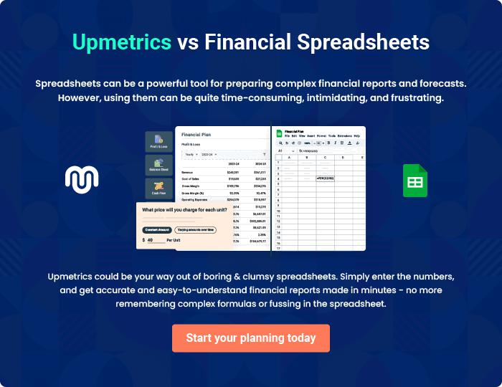

Property Management | Business Plan [YEAR] | 34/35


Create a winning business plan that gets you funded

Creating a stunning and investment-ready plan requires no writing, graphic designing, or financial planning expertise.

Upmetrics has all the features required to help you create a comprehensive business plan—from start to finish. Make no mistakes, it’s the modern way of planning to structure ideas, make plans, and create stunning pitch decks to awe investors.

Pitch decks that impress investors

Create pitch decks that provide a visual representation of your business, engage investors, and make them want to invest in your business idea.

Interactive plans in no time

Import business plan sections like—SWOT analysis, comparison tables, and others to create an interactive business plan. No designing skills are required.

Stunning cover page designs

With Upmetrics, you have the liberty to choose from multiple stunning cover page designs. Choose a creative design and make your plan stand out.

Online sharing made simple

Upmetrics makes online sharing quick and easier for users. Easily share your business plans with a link while tracking reader activity.

500+ sample business plans

Simply import a template from our library of sample plans into the editor and start customizing it to make it yours. It takes only a few clicks to get started.

Collaborate with team in real-time

Invite team members, initiate conversations, discuss ideas & strategies, share feedback, and work on a business plan in real-time.

