
[Your Company Name]

[Your Tagline]

PROJECT MANAGEMENT PLAN

[YEAR]

John Doe | 10200 Bolsa Ave, Westminster, CA, 92683 | (650) 359-3153 | info@example.com
http://www.example.com

Information provided in this business plan is unique to this business and confidential; therefore, anyone reading this plan agrees not to disclose any of the information in this business plan without prior written permission of the Company
Table of Contents

Overview | 5
Project Purpose, Objectives, and Success Criteria | 6
Project Deliverables | 6
Assumptions, Dependencies, and Constraints | 7
References | 7
Definitions and Acronyms | 7
Evolution of the Plan | 8

Project Organization | 9
External Interfaces | 10
Internal Structure | 10
Roles and Responsibilities | 10

Managerial Process Plans | 11
Start-Up Plans | 12
Estimation Plan | 12
Staffing Plan | 12
Staff Training Plan | 13
Resource Acquisition Plan | 13
Project Commitments | 13
Work Plan | 14
Control Plan | 14
Data Control Plan | 14
Requirements Control Plan | 14
Schedule Control Plan | 15
Budget Control Plan | 15
Communication, Tracking, and Reporting Plan | 15
Metrics Collection Plan | 16
Risk Management Plan | 16
Financial Management Plan (Cost/Budget Management) | 17
Issue Resolution Plan | 17

[Your Company Name] | Project Management Plan [YEAR] 2/22

Project Close-Out Plan | 17

Technical Process Plans | 19
Process Model | 20
Methods, Tools, and Techniques | 20
Configuration Management Plan | 20
Quality Assurance Plan | 21
Documentation Plan | 21
Process Improvement Plan | 21

[Your Company Name] | Project Management Plan [YEAR] 3/22

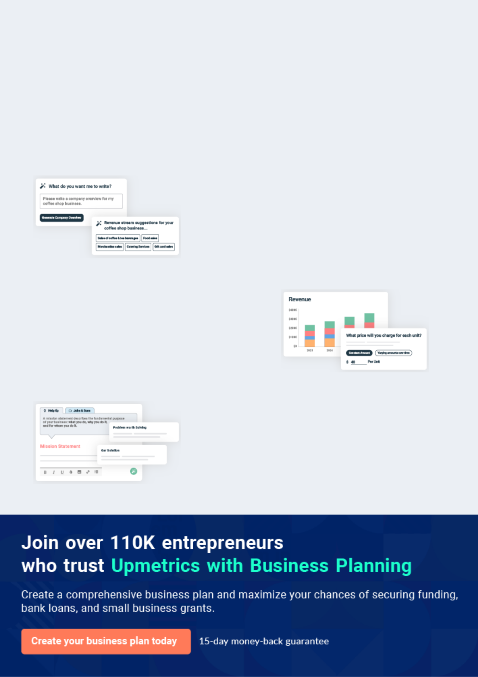
Business planning that’s simpler and faster than you think

Creating a business plan using Upmetrics to start and grow a business is literally the easiest thing in the World. Simply read the instructions and fill in the blanks. It’s as simple as that.

❛ | Upmetrics has everything you need to create a | ❜
❛ | comprehensive business plan. | ❜

AI-powered Upmetrics Assistant

AI-powered insights to streamline your plan

Not sure where to start? Upmetrics’ AI Assistant will automatically generate ideas for each section of your plan and offer improved versions of your writing, adjusting for tone, voice, and grammar or spelling errors.

Financial Forecasting Tool

All the financials are calculated for you

Forget the complex formulas and clumsy spreadsheets — with automatic financials and drag-and-drop forecasting, you can finish your plan faster and be confident that your numbers are accurate.

Business Plan Builder

Guides you like a business mentor

Upmetrics’ step-by-step instructions, prompts, and the library of 400+ sample business plans will guide you through each section of your plan as a business mentor.

1.


Overview

Project Purpose, Objectives, and Success Criteria

Project Deliverables

Assumptions, Dependencies, and Constraints

References

Definitions and Acronyms

Evolution of the Plan

[Your Company Name] | Project Management Plan [YEAR] 5/22


This chapter provides an overview of the project’s motivation, objectives, success criteria, major deliverables, and constraints. You might include a top-level summary of major milestones, contract type, start and end dates,
To unlock help try Upmetrics! 

Project Purpose, Objectives, and Success Criteria

 Help Tip


Define the purpose, scope, and objectives of the project and its delivered products. This information might already appear in the Vision and Scope Document. If so, avoid duplicating
information in both places. Briefly, state the business needs to be satisfied and the methods by
To unlock help try Upmetrics! 

Start writing here..

Project Deliverables

 Help Tip

List the major items to be delivered to the customers, subcontractors, integrators, or other parties. As appropriate, list the deliverable, their recipients, interim and final delivery dates, and delivery method. A table like the one below is a good way to show this information
To unlock help try Upmetrics! 


Deliverable

Recipients

Delivery Date

Delivery Method

Comments

[Your Company Name] | Project Management Plan [YEAR] 6/22

Assumptions, Dependencies, and Constraints

 Help Tip

This subsection describes known assumptions upon which the project is based (facts that are known to be true are not assumptions); any external events or externally-supplied items upon which the project depends; and the constraints under which the project will be conducted. Of
To unlock help try Upmetrics! 

Start writing here..

References

 Help Tip

List all documents and any other materials used as sources of information for this plan. For online documents, provide hyperlinks wherever possible.
To unlock help try Upmetrics! 

Start writing here..

Definitions and Acronyms

 Help Tip

Define any acronyms or project-specific terms. For each acronym, give both the meaning of the abbreviation and a definition of the item.
To unlock help try Upmetrics! 

Start writing here..

[Your Company Name] | Project Management Plan [YEAR] 7/22

Evolution of the Plan

 Help Tip

Describe the method for producing both scheduled and unscheduled updates to this plan and how the new information will be disseminated. For example, you could state that you will review the plan every time the product requirements specification or certain other major project
To unlock help try Upmetrics! 

Start writing here..

[Your Company Name] | Project Management Plan [YEAR] 8/22

2.

Project Organization

External Interfaces

Internal Structure

Roles and Responsibilities

[Your Company Name] | Project Management Plan [YEAR] 9/22

This section describes interfaces to entities outside of the project, identifies the internal project structure, and defines roles and responsibilities for the project.
To unlock help try Upmetrics!



External Interfaces

 Help Tip

Describe the organizational boundaries between the project and external entities. Define and describe communication with senior management, customers, subcontractors, purchasing,
sales, marketing, legal, finance, procurement, installation, and support organizations, standards
To unlock help try Upmetrics! 

Start writing here..

Internal Structure

 Help Tip

Describe the internal structure of the project organization, including interfaces between the units of the software team. It might be helpful to include organization charts or matrix diagrams to illustrate lines of authority, responsibility, and communication. Identify
To unlock help try Upmetrics! 

Start writing here..

Roles and Responsibilities

 Help Tip

List the major project team roles and the individuals who will fill these roles, along with the specific responsibilities those individuals will have. Identify the organizational units or project team roles that are responsible for all major work activities and supporting processes.
To unlock help try Upmetrics! 

Start writing here..

[Your Company Name] | Project Management Plan [YEAR] 10/22

3.

Managerial Process Plans

Start-Up Plans

Work Plan

Control Plan

Risk Management Plan

Financial Management Plan (Cost/Budget Management)

Issue Resolution Plan

Project Close-Out Plan

[Your Company Name] | Project Management Plan [YEAR] 11/22

This section defines the various project management plans and activities for the project.
To unlock help try Upmetrics! 

 Help Tip

This section specifies plans that will lay a solid foundation for a successful project. Depending on the size and scope of the project, you may incorporate these plans directly in this section, or each section may simply contain a reference or hyperlink to a separate document.
To unlock help try Upmetrics! 

Start-Up Plans

 Help Tip

This section describes how project estimates will be prepared, including:

• The methods, tools, and techniques that will be used to estimate project size, effort, cost,
To unlock help try Upmetrics! 

Estimation Plan

Start writing here..

 Help Tip

Specify the number of staff needed by skill area or project role (see section 2.3), along with required skill levels, and the duration for which each staff member is needed. Describe the anticipated staffing profile (the mix of skills and effort levels needed at various times in the
To unlock help try Upmetrics! 

Staffing Plan

Start writing here..

[Your Company Name] | Project Management Plan [YEAR] 12/22

 Help Tip

This section specifies any training that will be needed to ensure the necessary skill levels needed for the project. The types of training, number of people to be trained, and the training
methods should be specified. The Project Manager’s responsibilities include identifying training
To unlock help try Upmetrics! 

Staff Training Plan

Start writing here..

 Help Tip

This section specifies the plan for acquiring the resources other than personnel needed to successfully complete the project. Describe the resource acquisition process. Specify the
points in the project schedule when the various acquisition activities will be needed. List any
To unlock help try Upmetrics! 

Resource Acquisition Plan

Start writing here..

 Help Tip

Record commitments that the project as a whole is making to external parties, as well as major commitments that one individual or group within the project team is making to another. This gives those involved a clear, shared understanding of their commitments and allows project
To unlock help try Upmetrics! 

Project Commitments

Start writing here..

[Your Company Name] | Project Management Plan [YEAR] 13/22

Work Plan
To unlock help try Upmetrics!

 Help Tip

Specify the various work activities required to produce the project’s major deliverables, including the contents and timing of the activities. Use a work breakdown structure or a table to depict the work activities, corresponding deliverables, and the relationships among the
To unlock help try Upmetrics! 

Start writing here..

Control Plan

 Help Tip

This section describes how the project will control and report on project status and activities. Specify the frequency at which the various project status indicators are to be monitored and specific events that could trigger a status evaluation.



Start writing here..

 Help Tip

Describe how the project will manage its data, including deliverable and non-deliverable documents, project status metrics, reports, specifications, and so on. Address the following:
To unlock help try Upmetrics! 

Data Control Plan

Start writing here..

 Help Tip

Specify the mechanisms for measuring, reporting, and controlling changes to the product requirements. Describe how to assess the impact of requirement changes on product scope and quality, and on the project schedule, budget, resources, and risk factors. If a separate
To unlock help try Upmetrics! 

Requirements Control Plan

Start writing here..

[Your Company Name] | Project Management Plan [YEAR] 14/22

 Help Tip

Specify the control mechanisms used to measure the progress of the work completed at milestones. Specify the methods and tools used to compare actual schedule performance to planned performance and to implement corrective action when actual performance deviates
To unlock help try Upmetrics! 

Schedule Control Plan

Start writing here..

 Help Tip

Specify the control mechanisms used to measure the cost of work completed, compare actual to budgeted cost, and implement corrective actions when actual cost deviates excessively from budgeted cost. Specify the intervals or points at which cost reporting is needed and the
To unlock help try Upmetrics! 

Budget Control Plan

Start writing here..

 Help Tip

Identify the regular reports and communications expected of the project, such as weekly status reports, regular reviews, and as-needed communication. The exact types of communication vary between groups, but it is useful to identify the planned means at the start of the project.
To unlock help try Upmetrics! 

Communication, Tracking, and Reporting Plan

Type of | Communication | Typical | Who
Type of | Communication | Communication | Who | Recipient
Communication | Schedule | Communication | Initiates | Recipient
Communication | Schedule | Mechanism | Initiates
Status Report | every Friday | team meeting | Project | Project Team
Status Report | every Friday | team meeting | Manager | Project Team
Schedule and |  |  | Project | Program
Effort Tracking | weekly | email | Project | Program
Effort Tracking | weekly | email | Manager | Manager
Report |  |  | Manager | Manager
Project Review | monthly | face to face | Project | Project Team
Project Review | monthly | face to face | Manager | Project Team

[Your Company Name] | Project Management Plan [YEAR] 15/22

To unlock help try Upmetrics!
Type of | Communication | Typical | Who
Type of | Communication | Communication | Who | Recipient
Communication | Schedule | Communication | Initiates | Recipient
Communication | Schedule | Mechanism | Initiates
Risk Mitigation | as mitigation |  | responsible
Risk Mitigation | actions are | email | team | Project Manager
Status
Status | completed |  | member
Requirement | as changes are | email and change | CCB Chair | affected Project
Changes | approved | control tool | CCB Chair | Participants
 |  |  |  | Project Manager,
Supplier | at project life cycle |  | Program | Program
Management | at project life cycle | videoconference | Program | Manager,
Management | gates | videoconference | Manager | Manager,
Review | gates |  | Manager | Subcontract
 |  |  |  | Manager

 Help Tip

Specify the methods, tools, and techniques used to collect and retain project metrics. The metrics to be collected, the collection frequency, and how the metrics will be validated, analyzed, reported, stored, and used should all be addressed.



Metrics Collection Plan

Start writing here..

Risk Management Plan

 Help Tip

This section specifies the plan for identifying, analyzing, prioritizing, and controlling project risks. It should describe the procedures for contingency planning and the methods used in tracking risks, evaluating changes in individual risk exposures, and responding to those
To unlock help try Upmetrics! 

Start writing here..

[Your Company Name] | Project Management Plan [YEAR] 16/22

Financial Management Plan (Cost/Budget Management)

 Help Tip

Document the agreed to Financial Measurement Baseline (FMB) for the project and define how it will be tracked. Define the reviews that will be established for reporting on the financial health of the project. Also, define the invoicing requirements and timelines for the project. This section
To unlock help try Upmetrics! 

Start writing here..

Issue Resolution Plan

 Help Tip

Describe how problems, issues, and action items that arise on the project will be documented, resolved, and tracked to closure. Identify the project’s decision-makers for issues such as requirements baselining, requirements changes, resource contention, priority conflicts, etc.
To unlock help try Upmetrics! 

Start writing here..

Project Close-Out Plan

 Help Tip

This section describes the actions necessary to ensure an orderly closeout of the project. Address staff reassignment, archiving of project materials, recording of metrics, holding a
project retrospective, and preparation of a final report to include lessons learned and analysis
To unlock help try Upmetrics! 

Start writing here..

[Your Company Name] | Project Management Plan [YEAR] 17/22

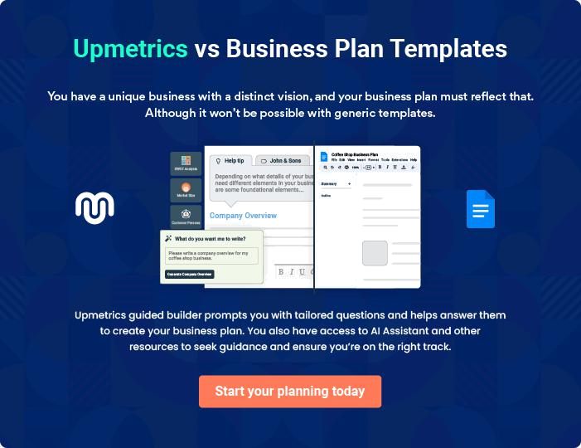

[Your Company Name] | Project Management Plan [YEAR] | 18/22

4.

Technical Process Plans

Process Model

Methods, Tools, and Techniques

Configuration Management Plan

Quality Assurance Plan

Documentation Plan

Process Improvement Plan

[Your Company Name] | Project Management Plan [YEAR] 19/22

This section describes the technical approaches to be used on the project.

Depending on the size and scope of the project, these plans may be
incorporated directly in this section, or each section may simply contain a
To unlock help try Upmetrics! 

Process Model

 Help Tip

Describe the product development life cycle that the project will use. Examples include a waterfall, iterative, and incremental (e.g., evolutionary, spiral, or agile). If an iterative or
incremental model is used, identify clear milestones, and provide the planned iteration number
To unlock help try Upmetrics! 

Start writing here..

Methods, Tools, and Techniques

 Help Tip

This section describes the design and development methodologies, programming languages, software and hardware tools, and operating environments to be used, as well as pertinent technical and management standards and procedures. Describe the following:
To unlock help try Upmetrics! 

Start writing here..

Configuration Management Plan

 Help Tip

This section could contain the configuration management plan for this project. For any but very small projects, this section should refer to a separate document. The CM plan should describe the activities and methods used for configuration identification, control, status accounting,
To unlock help try Upmetrics! 

Start writing here..

[Your Company Name] | Project Management Plan [YEAR] 20/22

Quality Assurance Plan

 Help Tip

This section could contain a quality assurance plan for this project. For any but very small projects, this section should refer to a separate document. The QA plan should describe the activities and methods used to build a high-quality product by the sensible application of an
To unlock help try Upmetrics! 

Start writing here..

Documentation Plan

 Help Tip

Describe the plans for creating system documentation deliverables, including installation and maintenance guides, user guides, reference manuals, on-line help systems, release notes, and so forth. List the documents to be created. For each type of documentation, describe any
To unlock help try Upmetrics! 


Document

Template or Standard

Created By

Reviewed By Target Date

Distribution

Process Improvement Plan

 Help Tip

This section describes plans for assessing the project and its processes, determining areas for process improvement, and implementing improvement plans without seriously disrupting an ongoing project. Each project should address at least one process improvement activity,
To unlock help try Upmetrics! 

Start writing here..

[Your Company Name] | Project Management Plan [YEAR] 21/22


Create a winning business plan that gets you funded

Creating a stunning and investment-ready plan requires no writing, graphic designing, or financial planning expertise.

Upmetrics has all the features required to help you create a comprehensive business plan—from start to finish. Make no mistakes, it’s the modern way of planning to structure ideas, make plans, and create stunning pitch decks to awe investors.

Pitch decks that impress investors

Create pitch decks that provide a visual representation of your business, engage investors, and make them want to invest in your business idea.

Interactive plans in no time

Import business plan sections like—SWOT analysis, comparison tables, and others to create an interactive business plan. No designing skills are required.

Stunning cover page designs

With Upmetrics, you have the liberty to choose from multiple stunning cover page designs. Choose a creative design and make your plan stand out.

Online sharing made simple

Upmetrics makes online sharing quick and easier for users. Easily share your business plans with a link while tracking reader activity.

500+ sample business plans

Simply import a template from our library of sample plans into the editor and start customizing it to make it yours. It takes only a few clicks to get started.

Collaborate with team in real-time

Invite team members, initiate conversations, discuss ideas & strategies, share feedback, and work on a business plan in real-time.

