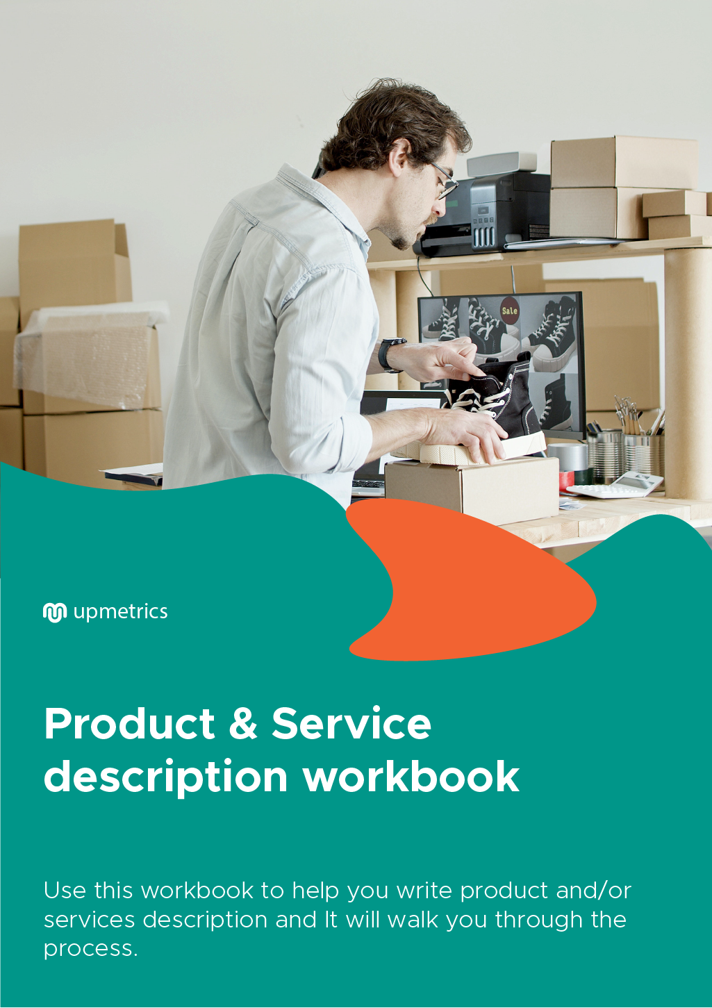

| Hi There!  Thanks for downloading this Worksheet.    You Can Edit This Version To Fit Your Needs. |
| --- |
| **How can this product and service worksheet help you?**  A product and service workbook helps you note down all the aspects of your product/service properly. It helps you take note of the major features of your product and the idea behind it.  Thus in explaining it better to your consumers.  This workbook will help you with the following:   1. It helps you put the main idea behind your product on paper. 2. It ensures that you have all your permits and property rights. 3. It also helps you describe the process of manufacturing and delivering the product and see if there are any loopholes in it.   Hence, it is a good practice to make a worksheet for your product or service before you develop it. |

| Do you want to plan your business faster?  Upmetrics can help you at every step of writing your business plan.  So, what are you waiting for! | Sample Business Plan |
| --- | --- |
| [**Start writing your business plan today**](https://upmetrics.co/call-to-download?utm_source=product-and-service-worksheet&utm_medium=create-business-plan&utm_campaign=download)**!** | |

Product & Service Description Worksheet

**Product and service worksheet**

|  |
| --- |
| Complete the following sections to create a product and/or services description. Review this thoroughly before using it for marketing and product development. |

|  |  |
| --- | --- |
| **Business Name** |  |
| **Product Idea/Service** |  |
| **Special Benefits** |  |
| **Unique Features** |  |
| **Limits and Liabilities** |  |
| **Production and Delivery** |  |
| **Suppliers** |  |
| **Intellectual Property/ Special Permits** |  |
| **Product/Service Description** |  |