

Pressure Washing

Your clean home is our business.

Business

Plan

[YEAR]

John Doe

10200 Bolsa Ave, Westminster, CA, 92683

- 359-3153 info@example.com http://www.example.com

CONFIDENTIAL

Table of Contents

Executive Summary | 5
Customer Focus | 6
Mission Statement | 6
Vision statement | 7
Business Target | 7
3 Year profit forecast | 7

Company Summary | 9
Business Structure | 10
Startup summary | 11
Startup cost | 11

Products and services | 14
Features | 15
Market Analysis
Market Analysis | 18
Market Trends | 19
Target Market | 19
Market Segmentation | 19
Corporate Sector | 20
Institutions & Organizations | 20
Residential Community | 21
SWOT Analysis
SWOT Analysis | 22
Strategy & Implementations
Strategy & Implementations | 25
Sales Strategy | 26
Advertising Strategy | 26
Pricing Strategy | 26

Pressure Washing | Business Plan [YEAR] 2/37

Financial Plan | 27
Important Assumptions | 28
Brake-even Analysis | 28
Projected Profit and Loss | 29
Projected Cash Flow | 32
Projected Balance Sheet | 33
Business Ratios | 34

Pressure Washing | Business Plan [YEAR] 3/37

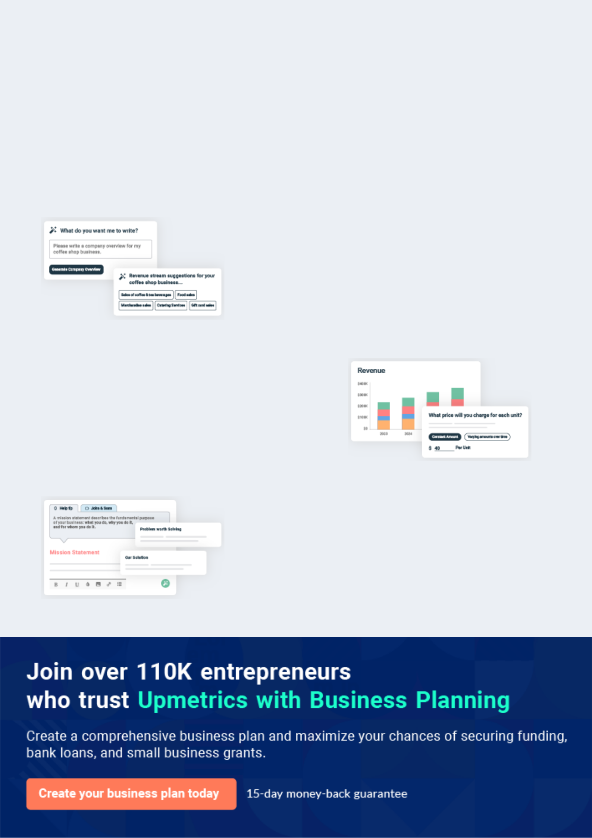
Business planning that’s simpler and faster than you think

Creating a business plan using Upmetrics to start and grow a business is literally the easiest thing in the World. Simply read the instructions and fill in the blanks. It’s as simple as that.

❛ | Upmetrics has everything you need to create a | ❜
❛ | comprehensive business plan. | ❜

AI-powered Upmetrics Assistant

AI-powered insights to streamline your plan

Not sure where to start? Upmetrics’ AI Assistant will automatically generate ideas for each section of your plan and offer improved versions of your writing, adjusting for tone, voice, and grammar or spelling errors.

Financial Forecasting Tool

All the financials are calculated for you

Forget the complex formulas and clumsy spreadsheets — with automatic financials and drag-and-drop forecasting, you can finish your plan faster and be confident that your numbers are accurate.

Business Plan Builder

Guides you like a business mentor

Upmetrics’ step-by-step instructions, prompts, and the library of 400+ sample business plans will guide you through each section of your plan as a business mentor.

1.


Executive Summary

Customer Focus

Mission Statement

Vision statement

Business Target

Pressure Washing | Business Plan [YEAR] 5/37


Before you think about how to start a Pressure Washing business, you must create a detailed Pressure Washing business plan. It will not only guide you in the initial phases of your startup but will also help you later on.
To unlock help try Upmetrics! 

 Maxwell Pressure Washing


The name of our company is Maxwell Pressure Washing Company. We are a standard pressure washing business that is incorporated under the law of the United States of America. Our head office will be located in a densely populated business district in the heart of Detroit - Michigan,
To unlock help try Upmetrics! 

Start writing here..

Customer Focus

 Maxwell Pressure Washing

We will offer both in-station and out-off station services. Our customers will have the options of choosing from our different packages – we have the plans to serve both individual clients (households) and corporate clients (industries and the government) as well which is why we
To unlock help try Upmetrics! 

Start writing here..

Mission Statement

 Maxwell Pressure Washing

Our mission as a pressure washing company is to develop a highly successful, profitable all-round pressure washing business that provides quality services in our community and to become a standard for an ideal pressure washing business not only in the State of Michigan
To unlock help try Upmetrics! 

Start writing here..

Pressure Washing | Business Plan [YEAR] 6/37

Vision statement

 Maxwell Pressure Washing

Our Vision is to become the number one pressure washing company in the whole of Detroit - Michigan with an active presence in major cities in the United States of America and Canada.
To unlock help try Upmetrics! 

Start writing here..

Business Target

 Maxwell Pressure Washing

Our business targets for the next three years are as follows:

To unlock help try Upmetrics! 

Start writing here..

3 Year profit forecast
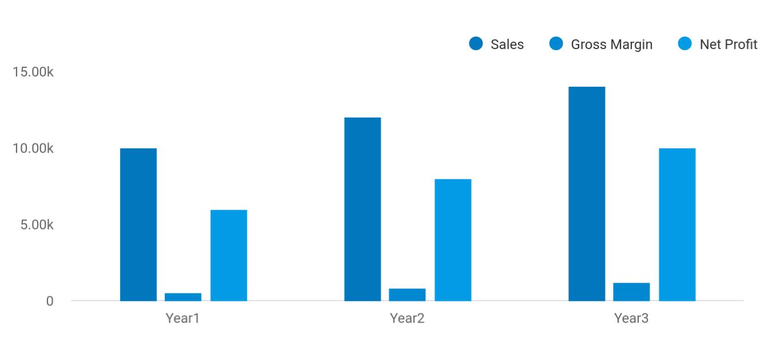

Pressure Washing | Business Plan [YEAR] 7/37

 Maxwell Pressure Washing


Financial Summary | Year 1 | Year 2 |  | Year 3
 |  |  | To unlock help try Upmetrics! |  | 

Start writing here..

Pressure Washing | Business Plan [YEAR] 8/37

2.

Company Summary

Business Structure

Startup summary

Pressure Washing | Business Plan [YEAR] 9/37

 Maxwell Pressure Washing
To unlock help try Upmetrics!

Maxwell Pressure Washing Company is owned and managed by Mr. John Moore and his family. John Moore has over 15 years of experience managing some of the leading pressure washing companies and industrial cleaning brands in different cities in the United States of America and
To unlock help try Upmetrics! 

Start writing here..

Business Structure

 Maxwell Pressure Washing

We are quite aware that the success of any business lies in the foundation on which the business is built, which is why we have decided to build our pressure washing company on the right business foundation.



Start writing here..

Pressure Washing | Business Plan [YEAR] 10/37

Startup summary

Startup cost
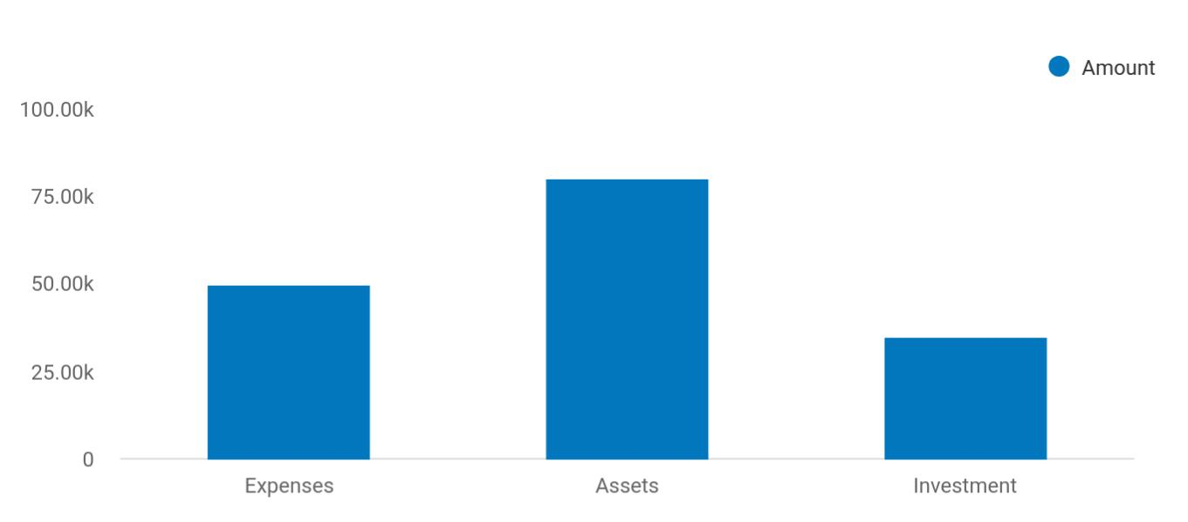

Cost distribution | Amount
Expenses | 50,000
Assets | 80,000
Investment | 35,000

Start-up Expenses | Amount
Legal | $75,500
Consultants | $0
Insurance | $62,750
Rent | $22,500
Research and Development | $42,750
Expensed Equipment | $42,750
Signs | $1,250
TOTAL START-UP EXPENSES | $247,500
Start-up Assets | $0
Cash Required | $322,500
Start-up Inventory | $52,625
Other Current Assets | $222,500

Pressure Washing | Business Plan [YEAR] 11/37

Start-up Expenses | Amount
Long-term Assets | $125,000
TOTAL ASSETS | $121,875
Total Requirements | $245,000
START-UP FUNDING | $0
START-UP FUNDING | $273,125
Start-up Expenses to Fund | $121,875
Start-up Assets to Fund | $195,000
TOTAL FUNDING REQUIRED | $0
Assets | $203,125
Non-cash Assets from Start-up | $118,750
Cash Requirements from Start-up | $0
Additional Cash Raised | $118,750
Cash Balance on Starting Date | $121,875
TOTAL ASSETS | $0
Liabilities and Capital | $0
Liabilities | $0
Current Borrowing | $0
Long-term Liabilities | $0
Accounts Payable (Outstanding Bills) | $0
Other Current Liabilities (interest-free) | $0
TOTAL LIABILITIES | $0
Capital | $0
Planned Investment | $0
Investor 1 | $312,500
Investor 2 | $0
Other | $0
Additional Investment Requirement | $0
TOTAL PLANNED INVESTMENT | $695,000

Pressure Washing | Business Plan [YEAR] 12/37

Start-up Expenses | Amount
Loss at Start-up (Start-up Expenses) | $313,125
TOTAL CAPITAL | $221,875
TOTAL CAPITAL AND LIABILITIES | $221,875
Total Funding | $265,000

Pressure Washing | Business Plan [YEAR] 13/37

3.

Products and services

Features

Pressure Washing | Business Plan [YEAR] 14/37

 Maxwell Pressure Washing
To unlock help try Upmetrics!

Maxwell Pressure Washing Company is a standard and well-equipped pressure washing company that offers a wide range of services that revolves around the pressure washing cum industrial cleaning industry and other complementary services.



Start writing here..

Features


Swimming pool

cleaning & Parking lot sweeping maintenance

Graffiti removal / Drain & gutter

washing cleaning

Ventilation duct
Snowplowing
cleaning

Chimney sweep
Window washing
services

Pressure Washing | Business Plan [YEAR] 15/37


Drain, duct and
Pool maintenance
gutter cleaning

Parking lot and Chimney sweep

driveway washing services

Providing other Other related

outdoor maintenance industrial cleaning

services services

Pressure Washing | Business Plan [YEAR] 16/37

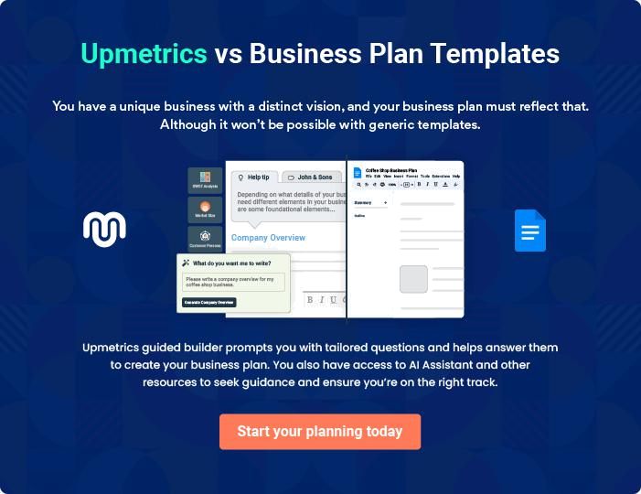

Pressure Washing | Business Plan [YEAR] | 17/37

4.

Market Analysis

Market Trends

Target Market

Market Segmentation

Pressure Washing | Business Plan [YEAR] 18/37

The most important component of an effective Pressure Washing business plan is its accurate marketing analysis. If you are starting on a smaller scale, you can do marketing analysis yourself by taking help from this Pressure
To unlock help try Upmetrics! 

Market Trends

 Maxwell Pressure Washing

The pressure washing and industrial cleaning market is a market that is dependent on loads of factors. The fact that it helps keep our environment clean and also helps in saving energy gives room for people to patronize the business. As a matter of fact, it is now common and trendy to
To unlock help try Upmetrics! 

Start writing here..

Target Market

 Maxwell Pressure Washing

Before choosing a location for our pressure washing and industrial cleaning business, we conducted our feasibility studies and market survey and we were able to identify those who will benefit greatly from our service offerings. Basically, those who will benefit from our service
To unlock help try Upmetrics! 

Start writing here..

Market Segmentation

 Maxwell Pressure Washing

We are strategically located midway between the residential and commercial zones of Michigan so that we may easily target the residential community as well as the corporate and industrial sectors. Our experts have identified the following type of target audience which can
To unlock help try Upmetrics! 

Start writing here..

Pressure Washing | Business Plan [YEAR] 19/37

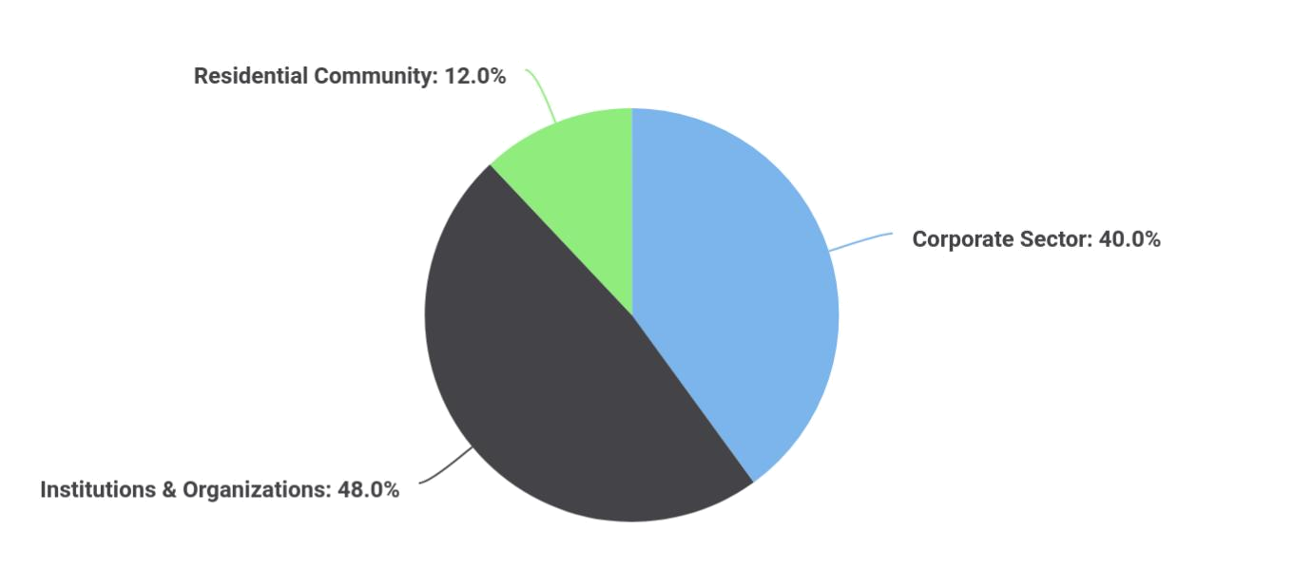To unlock help try Upmetrics!
To unlock help try Upmetrics!

 Maxwell Pressure Washing

This target group comprises factories, industries, and product manufacturers. These industries frequently need pressure washing services for cleaning and maintaining heavy industrial machines as well as industrial discharge outlets.



Corporate Sector

Start writing here..

 Maxwell Pressure Washing

Our second target group comprises various institutions and organizations located in Manhattan including government and public-sector organizations. This group seldom needs pressure washing services, such as occasional cleaning of parking and driveways, so it has a little
To unlock help try Upmetrics! 

Institutions & Organizations

Start writing here..

 Maxwell Pressure Washing

This will be our biggest target group as well as the biggest generator of our revenue. This target group will need our services for cleaning and maintaining their swimming pools, drains, gutters, etc.



Pressure Washing | Business Plan [YEAR] 20/37

Residential Community

Start writing here..

 Maxwell Pressure Washing


Growth

Year1

Year2

Year3

CAGR

To unlock help try Upmetrics! 

Start writing here..

Pressure Washing | Business Plan [YEAR] 21/37

5.

SWOT Analysis

Pressure Washing | Business Plan [YEAR] 22/37

 Maxwell Pressure Washing

The pressure washing business is one of the many businesses that can easily generate sales with little stress, as long as it is well-positioned and equipped to carry out the various services. We are building a standard pressure washing business with a variety of services which is why
To unlock help try Upmetrics! 

Start writing here..

Pressure Washing | Business Plan [YEAR] 23/37


Strength

Maxwell Pressure Washing Company is centrally located in a densely populated industrial and residential estate in Detroit - Michigan; our location is in fact one of our major strengths. We have a well-equipped state-of-the-art facility and we are also one of the very few pressure washing companies in the whole of Detroit - Michigan that offers a wide range of services for both households and industries.

Another strength that counts for us is the power of our team; our workforce and management. We have a team that is considered experts in the pressure washing cum industrial cleaning industry, a team of hardworking and dedicated individuals.

Weakness


Maxwell Pressure Washing Company is a new business which is owned by an individual (family), and we may not have the financial muscle to sustain the kind of publicity we want to give our business and also to attract some of the technocrats in the pressure washing and industrial cleaning industry.


Opportunity

We are centrally located in one of the busiest areas in Detroit - Michigan and are open to all the available opportunities that the city has to offer. Our business concept also positions us to be a one-stop-shop in the pressure washing and industrial cleaning industry.

The truth is that there are no standard and well–equipped pressure washing businesses within the area where ours is going to be located; the closest industrial cleaning facility to our proposed location is about 6 miles away. In a nutshell, we do not have any direct competition within our target market area.

Threat

Some of the threats that are likely going to confront Maxwell Pressure Washing Company are unfavorable government policies, seasonal fluctuations, demographic/ social factors, the downturn in the economy which is likely going to affect consumers spending, and of course the emergence of new competitors within the same location where ours is located.

Pressure Washing | Business Plan [YEAR] 24/37

6.

Strategy &

Implementations

Sales Strategy

Advertising Strategy

Pricing Strategy

Pressure Washing | Business Plan [YEAR] 25/37

After identifying the market demand, market trends, and the potential customers of the startup, the next step is to define an effective strategy for attracting those customers. Like marketing analysis, sales strategy is also an
To unlock help try Upmetrics!
To unlock help try Upmetrics! 

Sales Strategy

 Maxwell Pressure Washing

For encouraging sales during the initial months of our launch, we will offer a 10% discount on our services for the first three months. We will also give out cold calls and advertise our business in relevant newspapers, TV stations, and social media.



Start writing here..

Advertising Strategy

 Maxwell Pressure Washing

Maxwell Pressure Washing Company is set to create a standard for pressure washing and industrial cleaning business in Detroit - Michigan and throughout the United States which is why we will go all the way to adopt and apply best practices to promote our business.
To unlock help try Upmetrics! 

Start writing here..

Pricing Strategy

 Maxwell Pressure Washing

Our pricing system is going to be based on what is obtainable in the pressure washing and industrial cleaning industry, we don’t intend to charge more (except for premium and customized services) and we don’t intend to charge less than our competitors are offering in
To unlock help try Upmetrics! 

Start writing here..

Pressure Washing | Business Plan [YEAR] 26/37

7.

Financial Plan

Important Assumptions

Brake-even Analysis

Projected Profit and Loss

Projected Cash Flow

Projected Balance Sheet

Business Ratios

Pressure Washing | Business Plan [YEAR] 27/37

The last component of the Pressure Washing business plan is an in-depth financial plan. The financial plan crafts a detailed map of all the expenses needed for the startup and how these expenses will be met by the earned
To unlock help try Upmetrics! 

 Maxwell Pressure Washing

The company will be financed by John himself and he will control the direction of the business to make sure that it is expanding at the forecasted rate. As for the Pressure Washing business start-up, no equity funding or outside loans will be required. With the help of financial experts,
To unlock help try Upmetrics! 

Start writing here..

Important Assumptions

The financial projections of the company are forecast on the basis of the following assumptions. These assumptions are quite conservative and are expected to show deviation but to a limited level such that the company’s major financial strategy will not be affected.

 | Year 1 | Year 2 | Year 3
Plan Month | 1 | 2 | 3
Current Interest Rate | 10,00% | 11,00% | 12,00%
Long-term Interest Rate | 10,00% | 10,00% | 10,00%
Tax Rate | 26,42% | 27,76% | 28,12%
Other | 0 | 0 | 0

Brake-even Analysis

Monthly Units Break-even | 5530
Monthly Revenue Break-even | $159 740
Assumptions:
Average Per-Unit Revenue | $260,87
Average Per-Unit Variable Cost | $0,89
Estimated Monthly Fixed Cost | $196 410

Pressure Washing | Business Plan [YEAR] 28/37

Projected Profit and Loss

Revenue

Residential Pressure

Washing

Unit Sales

Unit Price

Commercial Pressure Washing

Unit Sales

Unit Price

Vehicle Pressure Washing

Unit Sales

Unit Price

Cost Of Sales

General Costs

Equipment and Supplies

Pressure Washing

Equipment Maintenance

Cleaning Chemicals

Transportation and Utilities

Fuel Costs for

Transportation

Water and Electricity

Utilities

Revenue Specific Costs

Personnel Costs (Direct Labor)

2024 | 2025 | 2026
$282,726.30 | $414,007.40 | $693,098.10
$90,150 | $144,334.50 | $231,100.50
601 | 962 | 1,541
$150 | $150 | $150
$150,000 | $208,970 | $375,450
300 | 418 | 751
$500 | $500 | $500
$42,576.30 | $60,702.90 | $86,547.60
1,419 | 2,023 | 2,885
$30 | $30 | $30

$19,452.77 | $24,834.25 | $31,998.08
$19,452.77 | $24,834.25 | $31,998.08
$9,096.53 | $10,819.10 | $12,912.99
$5,072.96 | $5,716.24 | $6,441.23
$4,023.57 | $5,102.86 | $6,471.76
$10,356.24 | $14,015.15 | $19,085.09
$7,095.96 | $10,117.14 | $14,424.58
$3,260.28 | $3,898.01 | $4,660.51
$0 | $0 | $0
$0 | $0 | $0

Pressure Washing | Business Plan [YEAR] 29/37

2024 2025 2026

Gross Margin | $263,273.53 | $389,173.15 | $661,100.02
Gross Margin (%) | 93.12% | 94% | 95.38%

Operating Expense | $292,754.76 | $313,990.66 | $337,899.47
Payroll Expense (Indirect | $245,455.20 | $257,644.20 | $270,440.40
Labor) | $245,455.20 | $257,644.20 | $270,440.40
Management | $112,500 | $118,125 | $124,031.28
Operations Manager | $60,000 | $63,000 | $66,150
Administrative Manager | $52,500 | $55,125 | $57,881.28
Field Staff | $93,600 | $98,280 | $103,194
Pressure Washing | $43,200 | $45,360 | $47,628
Technician | $43,200 | $45,360 | $47,628
Field Supervisor | $50,400 | $52,920 | $55,566
Support Staff | $39,355.20 | $41,239.20 | $43,215.12
Customer Service | $36,000 | $37,800 | $39,690
Representative | $36,000 | $37,800 | $39,690
Office Assistant | $3,355.20 | $3,439.20 | $3,525.12
General Expense | $47,299.56 | $56,346.46 | $67,459.07
Operational Expenses | $22,094.56 | $26,711.96 | $32,502.37
Office Rent | $16,094.56 | $20,411.96 | $25,887.37
Insurance | $6,000 | $6,300 | $6,615
Marketing and Advertising | $16,487.19 | $18,578.02 | $20,934.21
Online Advertising | $10,145.95 | $11,432.68 | $12,882.69
Print Media Advertising | $6,341.24 | $7,145.34 | $8,051.52
Miscellaneous | $8,717.81 | $11,056.48 | $14,022.49
Office Supplies | $5,364.79 | $6,803.94 | $8,629.37

Pressure Washing | Business Plan [YEAR] 30/37

 | 2024 | 2025 | 2026
Equipment Repairs | $3,353.02 | $4,252.54 | $5,393.12
Bad Debt | $0 | $0 | $0
Amortization of Current | $0 | $0 | $0
Assets | $0 | $0 | $0

EBITDA

Additional Expense

Long Term Depreciation

Gain or loss from Sale of Assets

EBIT

Interest Expense

EBT

Income Tax Expense / Benefit

($29,481.23) $75,182.49 $323,200.55

$7,884.72 | $7,014.79 | $5,760.25
$3,809 | $4,125 | $4,125
$0 | $0 | $0
($33,290.23) | $71,057.49 | $319,075.55
$4,075.71 | $2,889.79 | $1,635.26
($37,365.95) | $68,167.70 | $317,440.30
$0 | $0 | $0

Total Expense | $320,092.25 | $345,839.70 | $375,657.80
Net Income | ($37,365.95) | $68,167.70 | $317,440.30
Net Income (%) | (13.22%) | 16.47% | 45.80%

Retained Earning Opening | $0 | ($52,365.95) | $15,801.75
Owner's Distribution | $15,000 | $0 | $0
Retained Earning Closing | ($52,365.95) | $15,801.75 | $333,242.05

Pressure Washing | Business Plan [YEAR] 31/37

Projected Cash Flow

 | 2024 | 2025 | 2026
Cash Received | $282,726.30 | $414,007.40 | $693,098.10
Cash Paid | $316,283.25 | $341,714.70 | $371,532.80
COS & General Expenses | $66,752.33 | $81,180.71 | $99,457.15
Salary & Wages | $245,455.20 | $257,644.20 | $270,440.40
Interest | $4,075.71 | $2,889.79 | $1,635.26
Sales Tax | $0 | $0 | $0
Income Tax | $0 | $0 | $0
Net Cash From | ($33,556.95) | $72,292.70 | $321,565.30
Operations | ($33,556.95) | $72,292.70 | $321,565.30
Assets Sell | $0 | $0 | $0
Assets Purchase | $22,500 | $0 | $0
Net Cash From | ($22,500) | $0 | $0
Investments | ($22,500) | $0 | $0
Amount Received | $80,000 | $0 | $0
Loan Received | $80,000 | $0 | $0
Common Stock | $0 | $0 | $0
Preferred Stock | $0 | $0 | $0
Owner's Contribution | $0 | $0 | $0
Amount Paid | $36,035.24 | $22,221.17 | $23,475.90
Loan Capital | $21,035.25 | $22,221.17 | $23,475.89
Dividends & Distributions | $15,000 | $0 | $0
Net Cash From | $43,964.76 | ($22,221.17) | ($23,475.90)
Financing | $43,964.76 | ($22,221.17) | ($23,475.90)

Pressure Washing | Business Plan [YEAR] 32/37

 | 2024 | 2025 | 2026
Summary
Starting Cash | $0 | ($12,092.19) | $37,979.34
Cash In | $362,726.30 | $414,007.40 | $693,098.10
Cash Out | $374,818.49 | $363,935.87 | $395,008.70
Change in Cash | ($12,092.19) | $50,071.53 | $298,089.40
Ending Cash | ($12,092.19) | $37,979.34 | $336,068.74
Projected Balance Sheet
 | 2024 | 2025 | 2026
Assets | $6,598.81 | $52,545.34 | $346,509.74
Current Assets | ($12,092.19) | $37,979.34 | $336,068.74
Cash | ($12,092.19) | $37,979.34 | $336,068.74
Accounts Receivable | $0 | $0 | $0
Inventory | $0 | $0 | $0
Other Current Assets | $0 | $0 | $0
Long Term Assets | $18,691 | $14,566 | $10,441
Gross Long Term Assets | $22,500 | $22,500 | $22,500
Accumulated Depreciation | ($3,809) | ($7,934) | ($12,059)
Liabilities & Equity | $6,598.80 | $52,545.33 | $346,509.74
Liabilities | $58,964.75 | $36,743.58 | $13,267.69
Current Liabilities | $22,221.17 | $23,475.89 | $0
Accounts Payable | $0 | $0 | $0
Income Tax Payable | $0 | $0 | $0

Pressure Washing | Business Plan [YEAR] 33/37

 | 2024 |  |  | 2025 | 2026
Sales Tax Payable | $0 |  |  | $0 | $0
Short Term Debt | $22,221.17 |  | $23,475.89 |  | $0
Long Term Liabilities | $36,743.58 |  | $13,267.69 |  | $13,267.69
Long Term Debt | $36,743.58 |  | $13,267.69 |  | $13,267.69
Equity | ($52,365.95) |  | $15,801.75 |  | $333,242.05
Paid-in Capital | $0 |  |  | $0 | $0
Common Stock | $0 |  |  | $0 | $0
Preferred Stock | $0 |  |  | $0 | $0
Owner's Contribution | $0 |  |  | $0 | $0
Retained Earnings | ($52,365.95) |  | $15,801.75 |  | $333,242.05
Check | $0 |  |  | $0 | $0
Business Ratios
 |  | Year 1 | Year 2 | Year 3 | Industry Profile
Sales Growth |  | 4,35% | 30,82% | 63,29% | 4,00%
Percent of Total Assets
Accounts Receivable |  | 5,61% | 4,71% | 3,81% | 9,70%
Inventory |  | 1,85% | 1,82% | 1,79% | 9,80%
Other Current Assets |  | 1,75% | 2,02% | 2,29% | 27,40%
Total Current Assets |  | 138,53% | 150,99% | 163,45% | 54,60%
Long-term Assets |  | -9,47% | -21,01% | -32,55% | 58,40%
TOTAL ASSETS |  | 100,00% | 100,00% | 100,00% | 100,00%
Current Liabilities |  | 4,68% | 3,04% | 2,76% | 27,30%
Long-term Liabilities |  | 0,00% | 0,00% | 0,00% | 25,80%
Total Liabilities |  | 4,68% | 3,04% | 2,76% | 54,10%

Pressure Washing | Business Plan [YEAR] 34/37

 | Year 1 | Year 2 | Year 3 | Industry Profile
NET WORTH | 99,32% | 101,04% | 102,76% | 44,90%
Percent of Sales
Sales | 100,00% | 100,00% | 100,00% | 100,00%
Gross Margin | 94,18% | 93,85% | 93,52% | 0,00%
Selling, General & Administrative Expenses | 74,29% | 71,83% | 69,37% | 65,20%
Advertising Expenses | 2,06% | 1,11% | 0,28% | 1,40%
Profit Before Interest and Taxes | 26,47% | 29,30% | 32,13% | 2,86%
Main Ratios
Current | 25,86 | 29,39 | 32,92 | 1,63
Quick | 25,4 | 28,88 | 32,36 | 0,84
Total Debt to Total Assets | 2,68% | 1,04% | 0,76% | 67,10%
Pre-tax Return on Net Worth | 66,83% | 71,26% | 75,69% | 4,40%
Pre-tax Return on Assets | 64,88% | 69,75% | 74,62% | 9,00%
Additional Ratios
Net Profit Margin | 19,20% | 21,16% | 23,12% | N.A.
Return on Equity | 47,79% | 50,53% | 53,27% | N.A.
Activity Ratios
Accounts Receivable Turnover | 4,56 | 4,56 | 4,56 | N.A.
Collection Days | 92 | 99 | 106 | N.A.
Inventory Turnover | 19,7 | 22,55 | 25,4 | N.A.
Accounts Payable Turnover | 14,17 | 14,67 | 15,17 | N.A.
Payment Days | 27 | 27 | 27 | N.A.
Total Asset Turnover | 1,84 | 1,55 | 1,26 | N.A.
Debt Ratios
Debt to Net Worth | 0 | -0,02 | -0,04 | N.A.
Current Liab. to Liab. | 1 | 1 | 1 | N.A.
Liquidity Ratios
Net Working Capital | $120 943 | $140 664 | $160 385 | N.A.

Pressure Washing | Business Plan [YEAR] 35/37

 | Year 1 | Year 2 | Year 3 | Industry Profile
Interest Coverage | 0 | 0 | 0 | N.A.
Additional Ratios
Assets to Sales | 0,45 | 0,48 | 0,51 | N.A.
Current Debt/Total Assets | 4% | 3% | 2% | N.A.
Acid Test | 23,66 | 27,01 | 30,36 | N.A.
Sales/Net Worth | 1,68 | 1,29 | 0,9 | N.A.
Dividend Payout | 0 | 0 | 0 | N.A.
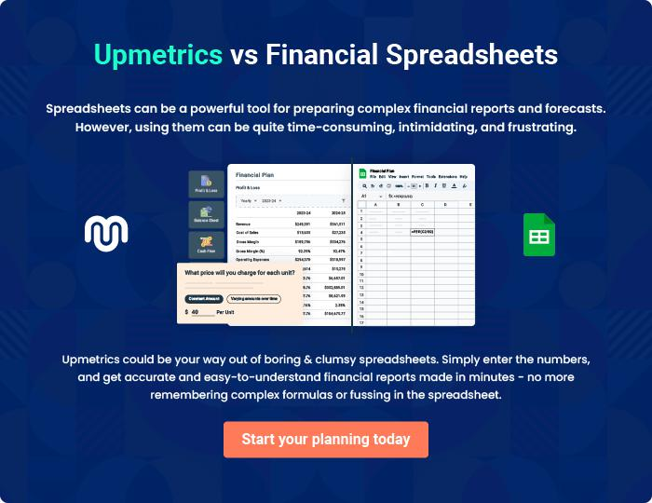

Pressure Washing | Business Plan [YEAR] 36/37


Create a winning business plan that gets you funded

Creating a stunning and investment-ready plan requires no writing, graphic designing, or financial planning expertise.

Upmetrics has all the features required to help you create a comprehensive business plan—from start to finish. Make no mistakes, it’s the modern way of planning to structure ideas, make plans, and create stunning pitch decks to awe investors.

Pitch decks that impress investors

Create pitch decks that provide a visual representation of your business, engage investors, and make them want to invest in your business idea.

Interactive plans in no time

Import business plan sections like—SWOT analysis, comparison tables, and others to create an interactive business plan. No designing skills are required.

Stunning cover page designs

With Upmetrics, you have the liberty to choose from multiple stunning cover page designs. Choose a creative design and make your plan stand out.

Online sharing made simple

Upmetrics makes online sharing quick and easier for users. Easily share your business plans with a link while tracking reader activity.

500+ sample business plans

Simply import a template from our library of sample plans into the editor and start customizing it to make it yours. It takes only a few clicks to get started.

Collaborate with team in real-time

Invite team members, initiate conversations, discuss ideas & strategies, share feedback, and work on a business plan in real-time.

