
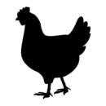 Poultry Farm

ADDRESS CONTACT

10200 Bolsa Ave, Westminster, CA, 92683 (650) 359-3153

http://www.example.com/ info@example.com
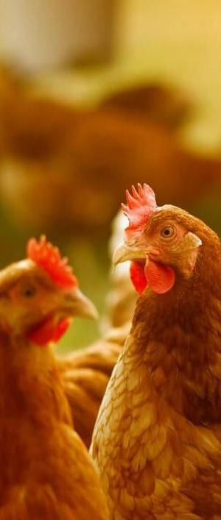

Business Plan

[YEAR]

Prepared By

John Doe


Information provided in this business plan is unique to this business and confidential; therefore, anyone reading this plan agrees not to disclose any of the information in this business plan without prior written permission of the Company

Table of Contents

Executive Summary | 6
Objectives | 7
Mission Statement | 7
keys to success | 8
Financial Summary | 8
Net Income | 8

Business Overview | 9
Company Ownership | 10
Owners | 10
Location and facilities | 11

Market Analysis | 12
Industry Analysis | 13
Challenges facing the poultry industry | 13
Market segmentation | 13
Target market segment strategy | 14
Market trends | 15

Startup Summary | 16
Startup costs | 17
Products & Services
Products & Services | 19
Product description | 20
Future products | 20
Service Description | 20
Future services | 21
Competitive Analysis
Competitive Analysis | 22
Competition | 23

Poultry Farm | Business Plan [YEAR] 2/41

Competitive edge | 23

Marketing Strategy and Implementation | 24
Marketing strategy | 25
Pricing and promotion strategy | 25
Web strategy | 25
Sales strategy | 26
SWOT analysis | 26
PEST analysis | 27
Socio-cultural | 27
Technological | 28
Economic | 28
Political | 28

Management and Organization Structure | 29
Management team | 30
Organizational structure | 30
Faustin Hategekimana | 30
Aisha Alimi | 30
Khadijah Khalid | 30
Asmau Abubakar | 31
Eric Hagenimana | 31
Lawal Nura Bada | 31
Hiring Plan | 31

Financial Plan | 32
Projected Profit and Loss | 33
Projected Cash Flow | 35
Projected Balance Sheet | 37

Risk Assesment | 39
Financial risks | 40
Health risks | 40

Poultry Farm | Business Plan [YEAR] 3/41

Technological risks | 40

Poultry Farm | Business Plan [YEAR] 4/41

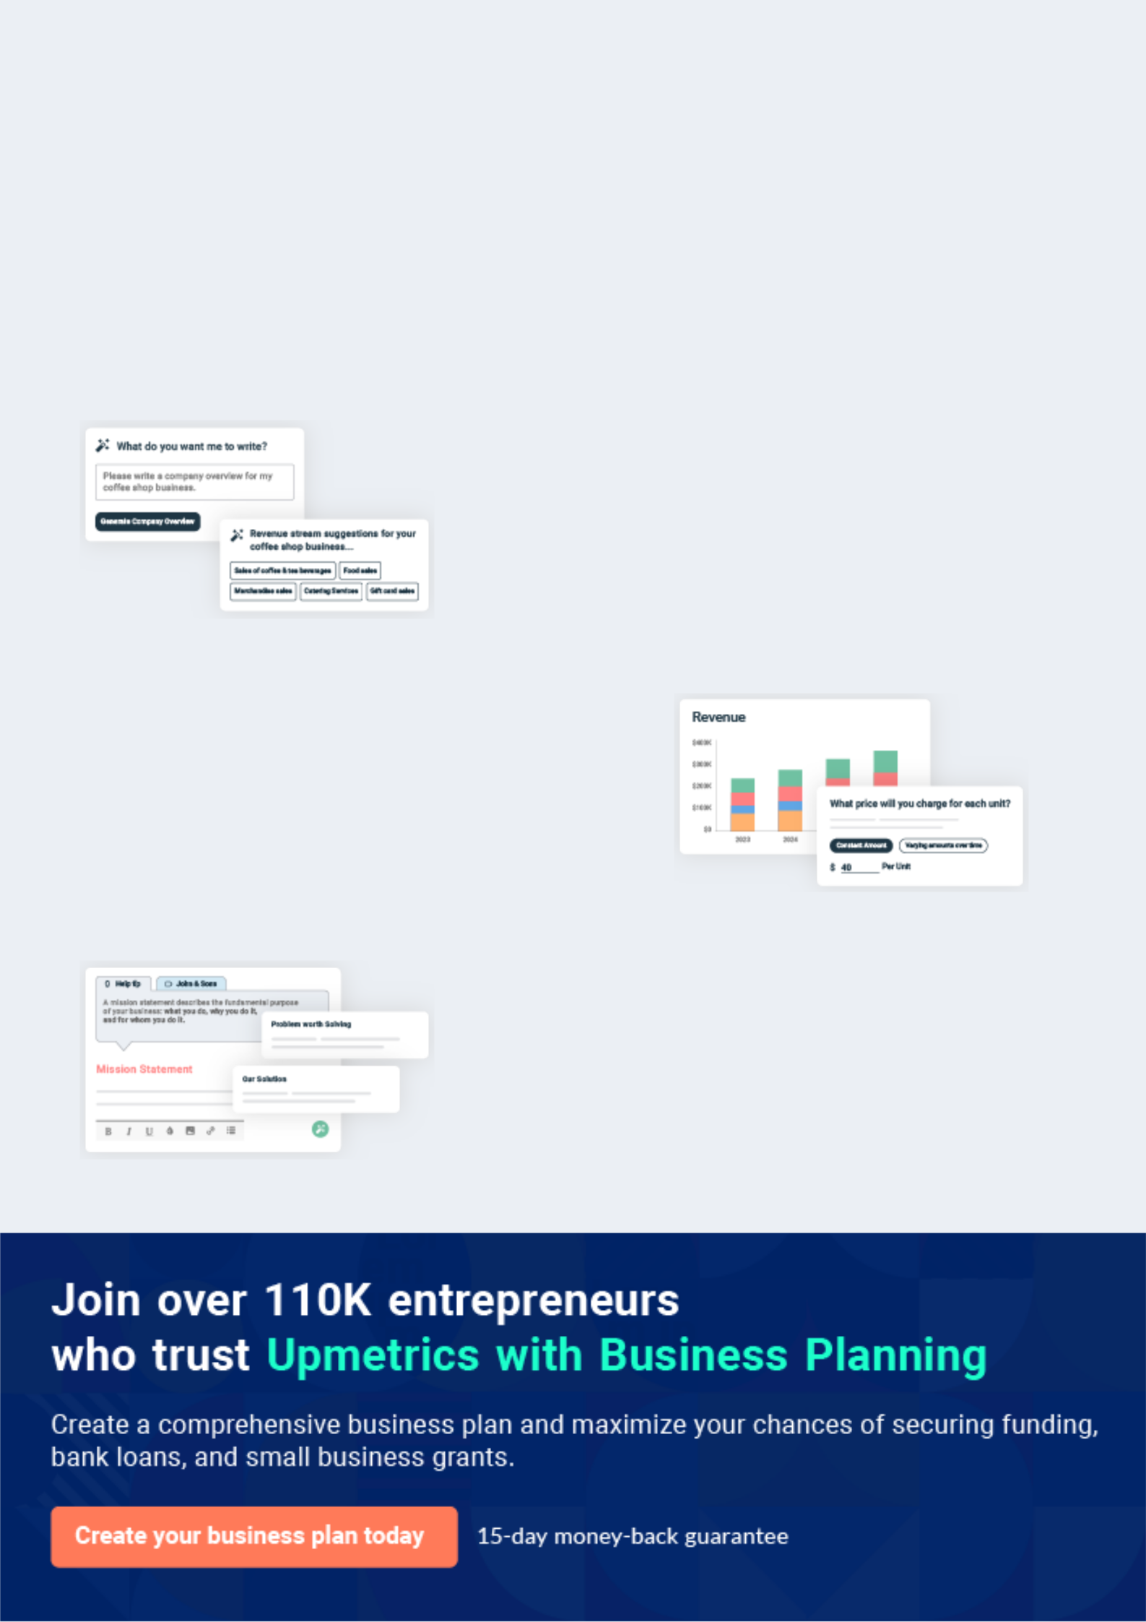
Business planning that’s simpler and faster than you think

Creating a business plan using Upmetrics to start and grow a business is literally the easiest thing in the World. Simply read the instructions and fill in the blanks. It’s as simple as that.

❛ | Upmetrics has everything you need to create a | ❜
❛ | comprehensive business plan. | ❜

AI-powered Upmetrics Assistant

AI-powered insights to streamline your plan

Not sure where to start? Upmetrics’ AI Assistant will automatically generate ideas for each section of your plan and offer improved versions of your writing, adjusting for tone, voice, and grammar or spelling errors.

Financial Forecasting Tool

All the financials are calculated for you

Forget the complex formulas and clumsy spreadsheets — with automatic financials and drag-and-drop forecasting, you can finish your plan faster and be confident that your numbers are accurate.

Business Plan Builder

Guides you like a business mentor

Upmetrics’ step-by-step instructions, prompts, and the library of 400+ sample business plans will guide you through each section of your plan as a business mentor.

1.


Executive Summary

Objectives

Mission Statement

keys to success

Financial Summary

Poultry Farm | Business Plan [YEAR] 6/41

 Hencube poultry


Hencube poultry is a farm focused on both egg and meat production that provides for a large market range. It also produces manure as a by-product. It is based in yola city, wuro Haussa. The founders have noticed the health implication of red meat and are creating a business to
To unlock help try Upmetrics! 

Start writing here..

Objectives

 Hencube poultry

Hencube poultry will measure its success by its ability to achieve the following objectives:

• Becoming the "Best and most hygienic poultry producer in the area" complying by the
To unlock help try Upmetrics! 

Start writing here..

Mission Statement

 Hencube poultry

Hencube poultry’s mission is to provide customers with quality, fresh, and valuable products. To respect all employees and enable everyone to have a say in company affairs. Quality and service are our number one priority. To provide investors with opportunities to receive a nice
To unlock help try Upmetrics! 

Start writing here..

Poultry Farm | Business Plan [YEAR] 7/41

keys to success

 Hencube poultry

Hencube poultry will follow these principles in order to achieve success in its market:

• State of art cage framework accommodating an optimum number of chickens with
To unlock help try Upmetrics! 

Start writing here..

Financial Summary

Net Income
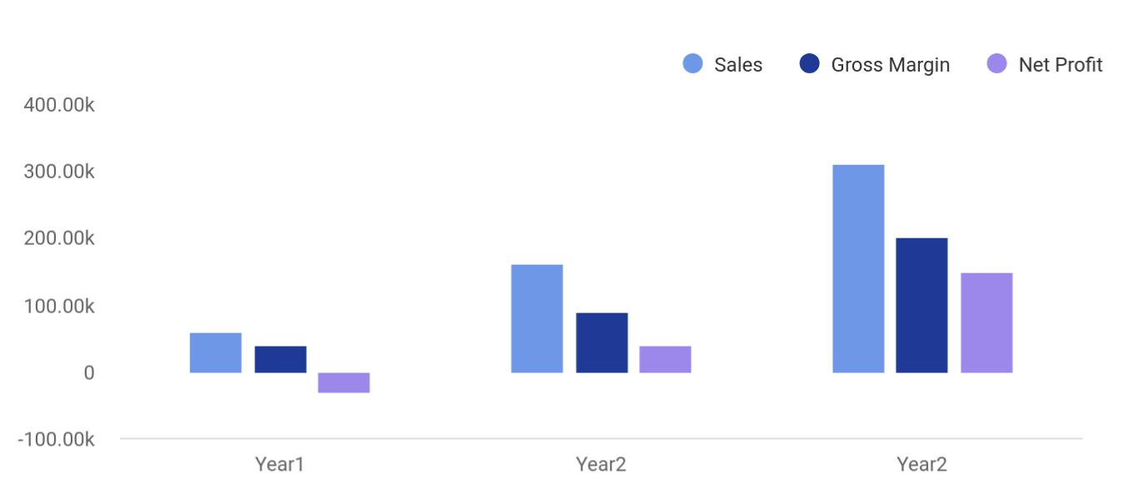

Financial Year | Sales | Gross Margin | Net Profit
Year1 | 60,000 | 40,000 | -30,000
Year2 | 160,000 | 90,000 | 40,000
Year2 | 310,000 | 200,000 | 150,000

Poultry Farm | Business Plan [YEAR] 8/41

2.

Business Overview

Company Ownership

Location and facilities

Poultry Farm | Business Plan [YEAR] 9/41

Company Ownership

 Hencube poultry

Hencube poultry is owned by six persons. They are namely Faustin Hategekimana, Aisha Alimi, Eric Hagenimana, Lawal Nura bada, Khadijah Ibrahim Khalid, and Asmau Abubakar Umar. It is a partnership and each person has an equal share in the business and is also equally liable for
To unlock help try Upmetrics! 

Start writing here..

Owners

 |  |  | Faustin Hategekimana
20% |  |  | Faustin Hategekimana
20% |  |  | 20 Shares
 |  |  | Aisha Alimi
20% |  |  | Aisha Alimi
20% |  |  | 20 Shares
 |  |  | Eric Hagenimana
20% |  |  | Eric Hagenimana
20% |  |  | 20 Shares
 |  |  | Lawal nura bada
10% |  |  | Lawal nura bada
10% |  |  | 10 Shares
 |  |  | Khadijah Ibrahim Khalid
10% |  |  | Khadijah Ibrahim Khalid
10% |  |  | 10 Shares
 |  |  | Asmau Abubakar Umar
20% |  |  | Asmau Abubakar Umar
20% |  |  | 20 Shares

Poultry Farm | Business Plan [YEAR] 10/41

Location and facilities

 Hencube poultry

At this point in the business, we don’t have an exact point yet but we have narrowed the location down to wuro Haussa, yola city. We are trading from this spot because is it a great
place to reach our target market. We think the population base is large enough for our business
To unlock help try Upmetrics! 

Start writing here..

Poultry Farm | Business Plan [YEAR] 11/41

3.

Market Analysis

Industry Analysis

Challenges facing the poultry industry

Market segmentation

Target market segment strategy

Market trends

Poultry Farm | Business Plan [YEAR] 12/41

Industry Analysis

 Hencube poultry

The poultry industry in the last 40 years has shown dramatic changes in both domestics and international environments. Those environmental forces include are classified into 2 categories: the internal forces and external forces. Internal and external forces include:
To unlock help try Upmetrics! 

Start writing here..

Challenges facing the poultry industry

 Hencube poultry

Poultry farming has some challenges that need to be attended to with vigor. Below are some of the common challenges that are faced by poultry farmers:
To unlock help try Upmetrics! 

Start writing here..

Market segmentation

 Hencube poultry

Although in the Nigerian populace, there are a few taboos, religious or cultural practices that will prevent the consumption of poultry products, during the market segmentation, we found out that nearly everybody eats eggs and meat, so we are targeting the whole market,
To unlock help try Upmetrics! 

Start writing here..

Poultry Farm | Business Plan [YEAR] 13/41

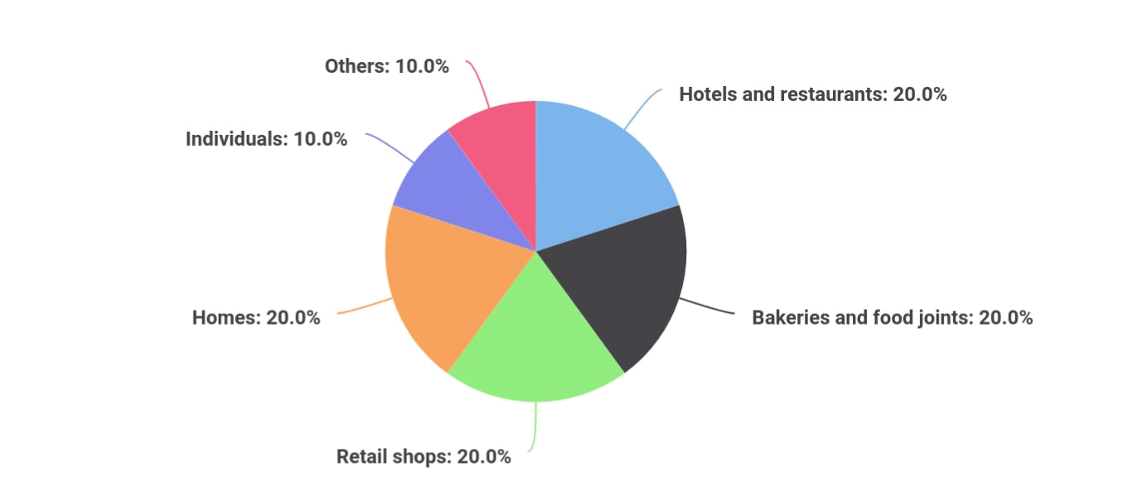

Market Segmentation | Market Share
Hotels and restaurants | 20
Bakeries and food joints | 20
Retail shops | 20
Homes | 20
Individuals | 10
Others | 10

Target market segment strategy

 Hencube poultry

Individuals are a small sector in the market segmentation. They are a pretty large group but they buy a relatively small amount of eggs.
To unlock help try Upmetrics! 

Start writing here..

Poultry Farm | Business Plan [YEAR] 14/41

Market trends

 Hencube poultry

While some countries are reputed to be important exporters of poultry products, Nigeria has a problem of meeting its local demand for poultry products. This problem started for the poultry market in 1984 when the federal government banned the importation of maize. This had quite
To unlock help try Upmetrics! 

Start writing here..
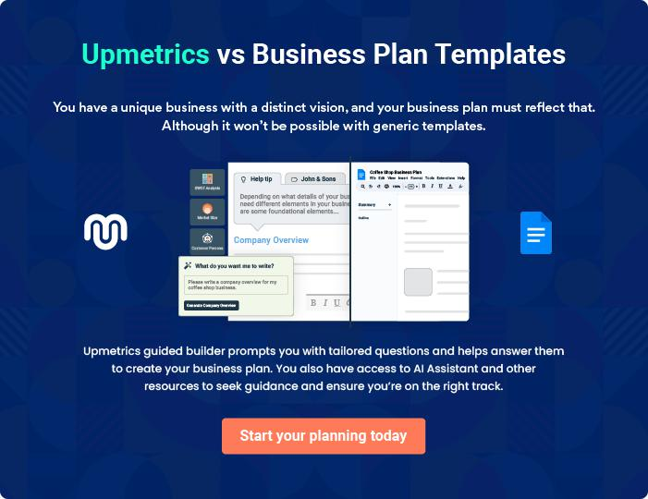

Poultry Farm | Business Plan [YEAR] 15/41

4.

Startup Summary

Startup costs

Poultry Farm | Business Plan [YEAR] 16/41

 Hencube poultry
To unlock help try Upmetrics!

Our business has start-up cost and we will need a bank account, we chose our bank to be GTBank because of its proximity in the area. This section of the plan shows projected startup costs prior to our opening.



Start writing here..

Startup costs

Items | Costs($)
Business cards | 20
Printer | 200
Leaflets | 10
Blank invoices | 20
Computers | 500
Internet | 500
Insurance | 500
Land | 8000
Building | 2000
Advertising/marketing | 100
Others | 500
Total | 12350

Equipment | Cost($)
Feeders and drinkers | 80
Crates | 150
Lighting system | 500
Egg tray | 50
Cages | 3000
Others | 1000

Poultry Farm | Business Plan [YEAR] 17/41

Equipment

Total equipment

Cost($)


4780

Poultry Farm | Business Plan [YEAR] 18/41

5.

Products & Services

Product description

Future products

Service Description

Future services

Poultry Farm | Business Plan [YEAR] 19/41

Product description

 Hencube poultry

We offer chicken eggs and chicken meat that will be gotten from layers and broilers to our target market. We plan to take pride in the uncompromising quality of our products. We also offer fertilizer in the form of chicken manure. This is mostly used in vegetable farming and as
To unlock help try Upmetrics! 

Start writing here..

Future products

 Hencube poultry

We have big plans for the future. We plan on supplying cracked eggshells for some detergent companies for use. These special detergents are used in washing basins and pots. Another thing we have planned for the future is the sale of processed chicken meat.
To unlock help try Upmetrics! 

Start writing here..

Service Description

 Hencube poultry

We plan on servicing our customers by providing home delivery for customers who are willing t buy at least a certain amount of our products.
To unlock help try Upmetrics! 

Start writing here..

Poultry Farm | Business Plan [YEAR] 20/41

Future services

 Hencube poultry

In the future, we plan on creating a restaurant that has eggs as its main menu. It will be like a breakfast restaurant. In the future, if this business gets large enough, we would also like to build our own bakery. A major ingredient in most baked goods is eggs and we will be funding
To unlock help try Upmetrics! 

Start writing here..

Poultry Farm | Business Plan [YEAR] 21/41

6.

Competitive Analysis

Competition

Competitive edge

Poultry Farm | Business Plan [YEAR] 22/41

Competition

 Hencube poultry

Competition is not so keen on the markets, however, it still exists. The reasons are;

• Poultry products are not branded products; hence what usually matters is effective
To unlock help try Upmetrics! 

Start writing here..

Competitive edge

 Hencube poultry

Our strength over its competitors is firstly based on the fact that we are not entering this business to make much money. We are entering this industry to solve the present problem that our population is facing. We are here to provide quality affordable chicken products. We saw
To unlock help try Upmetrics! 

Start writing here..

Poultry Farm | Business Plan [YEAR] 23/41

7.

Marketing Strategy and Implementation

Marketing strategy

Pricing and promotion strategy

Web strategy

Sales strategy

SWOT analysis

PEST analysis

Poultry Farm | Business Plan [YEAR] 24/41

Marketing strategy
To unlock help try Upmetrics!

 Hencube poultry

Hencube poultry will strive for the production of products with the highest quality and we plan on employing the following strategies. Our location puts us in the proximity of a major hotel, restaurant, schools with campuses and home deliver food centers we will be supplying to. We
To unlock help try Upmetrics! 

Start writing here..

Pricing and promotion strategy

 Hencube poultry

The price of the chicken would range from N1500 up to N1700 depending on the size and quality. Also, the price for a crate of eggs ranges from N600 to N1000. The price of a wheelbarrow of manure costs about N200. These prices would also vary depending on the
To unlock help try Upmetrics! 

Start writing here..

Web strategy

 Ex :: Industry


Hencube poultry also has a website where customers can interact with us and get a feel of what the business is about. We know a site or two where we can place online advertisements and we would also make mentions of our poultry in online newspapers.

Start writing here..



Poultry Farm | Business Plan [YEAR] 25/41

Sales strategy

 Hencube poultry


- Better farm management practices

- Regular visit by veterinary doctors
• Recycling wastes as fertilizer To unlock help try Upmetrics! 

Start writing here..

SWOT analysis

 Hencube poultry

SWOT stands for strength, weakness, opportunities, and threats and we have made an analysis in each case.
To unlock help try Upmetrics! 

Start writing here..

Poultry Farm | Business Plan [YEAR] 26/41


Strength

- Produce high-quality eggs enriched with protein

- Relatively good infrastructure systems

- Good marketing system

- Eggs and chicken are not seasonal products and can be eaten at any time of the year

- In this area, the poultry business hasn’t been over-exploited

- Poultry are environmentally friendly

Weakness


- Capital intensive. Starting a poultry business requires a large capital funding.

- Outbreak of disease can ruin entire business in a go

- The smell can be quite disturbing


Opportunity

- Expansion into large scale production of byproducts(fertilizer and detergent)

- Export to neighboring towns

- A large and successful poultry will ensure food security

Threat

- More competition

- Avian diseases

- High feed ingredients prices

- Threat of import of frozen chicken

PEST analysis

 Hencube poultry

Eating habits of our consumers will definitely affect our business. Also, the success of restaurants and other firms that order our products will indirectly affect our business.
To unlock help try Upmetrics! 

Socio-cultural

Start writing here..

Poultry Farm | Business Plan [YEAR] 27/41

 Hencube poultry
To unlock help try Upmetrics!

A good technical infrastructure would lead to better production and hence lower costs.

Technology will also mean more effective business marketing.
To unlock help try Upmetrics! 

Technological

Start writing here..

 Hencube poultry

Economic trends such as demand and supply will determine the sustenance and profitability of the business. Also, inflation rates will affect the way we pay our employees and the price of the product.



Economic

Start writing here..

 Hencube poultry

This will include government policies concerning inspection by the ministry of health and organizations like NAFDAC.
To unlock help try Upmetrics! 

Political

Start writing here..

Poultry Farm | Business Plan [YEAR] 28/41

8.

Management and Organization Structure

Management team

Organizational structure

Hiring Plan

Poultry Farm | Business Plan [YEAR] 29/41

Management team
To unlock help try Upmetrics!

 Hencube poultry

The management team is simply the partners in this business. They are Faustin Hategekimana, Aisha Alimi, Eric Hagenimana, Lawal nura bada, Khadijah Ibrahim Khalid and Asmau Abubakar Umar.



Start writing here..

Organizational structure


Faustin Hategekimana

fast@example.com

As the top manager, the CEO, he is typically responsible for the entire operations of the poultry. It is his responsibility to implement decisions and initiatives and to maintain the smooth operation of the poultry, with the assistance of the management team


Aisha Alimi

Chief Operational Officer - aisha@example.com

As the COO, she looks after issues related to marketing, sales, production, and personnel. More hands-on than the CEO, the COO looks after day-to-day activities while providing feedback to the CEO.


Khadijah Khalid

Chief Financial Officer - khad@example.com

Also reporting directly to the CEO, she is responsible for analyzing and reviewing financial data, reporting financial performance, preparing budgets and monitoring expenditures and costs. The CFO routinely checks the corporation's financial health and integrity.

Poultry Farm | Business Plan [YEAR] 30/41


Asmau Abubakar

Chief Information Officer - asmau@example.com

She reports directly to the CEO and is a more internally oriented person focused on technology needed for running the poultry. She is also in charge of the web designs of the poultry.


Eric Hagenimana

Chief Revenue Officer - eric@example.com

He is responsible for all revenue generation processes in an organization, and is ultimately accountable for driving better integration between all revenue-related areas.


Lawal Nura Bada

Chief Visionary Officer - lawal@example.com

As the CVO, he decides on the general direction of a company, and has a broad and comprehensive knowledge of all matters related to the business of the organization and the vision required to steer its course into the future. The CVO is generally in charge of defining corporate strategies, working plans, and often product ideas.

Hiring Plan

 Hencube poultry

Apart from the management team, other personnel include

1. Cleaners
To unlock help try Upmetrics! 

Start writing here..

Poultry Farm | Business Plan [YEAR] 31/41

9.

Financial Plan

Projected Profit and Loss

Projected Cash Flow

Projected Balance Sheet

Poultry Farm | Business Plan [YEAR] 32/41

Projected Profit and Loss

 | 2024 | 2025 | 2026
Revenue | $380,573.18 | $656,285.09 | $1,158,384.79
Sale of Eggs | $168,699.48 | $339,456.68 | $683,053.29
Unit Sales | 168,699 | 339,457 | 683,053
Unit Price | $1 | $1 | $1
Sale of Poultry Meat | $127,729.20 | $182,110.35 | $259,643.70
Unit Sales | 8,515 | 12,141 | 17,310
Unit Price | $15 | $15 | $15
Sale of Manure | $84,144.50 | $134,718.06 | $215,687.80
Unit Sales | 105,181 | 168,398 | 269,610
Unit Price | $0.80 | $0.80 | $0.80
Cost Of Sales | $69,101.33 | $105,800.54 | $168,356.95
General Costs | $69,101.33 | $105,800.54 | $168,356.95
Poultry Feed and | $20,898.05 | $28,739.34 | $39,635.78
Maintenance | $20,898.05 | $28,739.34 | $39,635.78
Poultry Feed | $14,192.08 | $20,234.60 | $28,849.65
Health and Veterinary Care | $6,705.97 | $8,504.74 | $10,786.13
Labor and Utilities | $48,203.28 | $77,061.20 | $128,721.17
Labor Costs | $38,057.33 | $65,628.52 | $115,838.48
Utilities | $10,145.95 | $11,432.68 | $12,882.69
Revenue Specific Costs | $0 | $0 | $0
Personnel Costs (Direct | $0 | $0 | $0
Labor) | $0 | $0 | $0
Gross Margin | $311,471.85 | $550,484.55 | $990,027.84

Poultry Farm | Business Plan [YEAR] 33/41

 | 2024 | 2025 | 2026
Gross Margin (%) | 81.84% | 83.88% | 85.47%

Operating Expense | $395,428.65 | $421,603.84 | $459,537.55
Payroll Expense (Indirect | $316,200 | $327,387.60 | $338,987.40
Labor) | $316,200 | $327,387.60 | $338,987.40
Administrative Staff | $86,760 | $89,900.40 | $93,156.60
Accountant | $53,760 | $55,910.40 | $58,146.84
Administrative Assistant | $33,000 | $33,990 | $35,009.76
Farm Management | $75,000 | $78,414 | $81,985.32
Farm Manager | $41,400 | $43,470 | $45,643.56
Assistant Manager | $33,600 | $34,944 | $36,341.76
Farm Workers | $154,440 | $159,073.20 | $163,845.48
Poultry Caretakers | $95,040 | $97,891.20 | $100,827.84
Maintenance Staff | $59,400 | $61,182 | $63,017.64
General Expense | $79,228.65 | $94,216.24 | $120,550.15
Facility Expenses | $33,600 | $34,176 | $34,762.56
Rent | $24,000 | $24,480 | $24,969.60
Utilities | $9,600 | $9,696 | $9,792.96
Operational Expenses | $21,600 | $22,176 | $22,767.84
Feed and Supplements | $14,400 | $14,832 | $15,276.96
Veterinary Services | $7,200 | $7,344 | $7,490.88
Marketing and | $24,028.65 | $37,864.24 | $63,019.75
Miscellaneous | $24,028.65 | $37,864.24 | $63,019.75
Marketing and Advertising | $19,028.65 | $32,814.24 | $57,919.25
Maintenance and Repairs | $5,000 | $5,050 | $5,100.50
Bad Debt | $0 | $0 | $0

Poultry Farm | Business Plan [YEAR] 34/41

Amortization of Current Assets

EBITDA

Additional Expense

Long Term Depreciation

Gain or loss from Sale of Assets

EBIT

Interest Expense

EBT

Income Tax Expense / Benefit

Total Expense

Net Income

Net Income (%)

Retained Earning Opening

Owner's Distribution

Retained Earning Closing

2024 | 2025 | 2026
$0 | $0 | $0

($83,956.80) $128,880.73 $530,490.30

$17,665.09 | $15,763.01 | $13,743.62
$12,504 | $12,504 | $12,504
$0 | $0 | $0
($96,460.80) | $116,376.73 | $517,986.30
$5,161.09 | $3,259.02 | $1,239.63
($101,621.89) | $113,117.72 | $516,746.68
$0 | $0 | $0

$482,195.07 | $543,167.38 | $641,638.12
($101,621.89) | $113,117.72 | $516,746.68
(26.70%) | 17.24% | 44.61%

$0 | ($117,621.89) | ($12,504.17)
$16,000 | $8,000 | $8,000
($117,621.89) | ($12,504.17) | $496,242.51

Projected Cash Flow

 | 2024 | 2025 | 2026
Cash Received | $380,573.18 | $656,285.10 | $1,158,384.80

Poultry Farm | Business Plan [YEAR] 35/41

 | 2024 | 2025 | 2026
Cash Paid | $469,691.07 | $530,663.38 | $629,134.12
COS & General Expenses | $148,329.98 | $200,016.77 | $288,907.10
Salary & Wages | $316,200 | $327,387.60 | $338,987.40
Interest | $5,161.09 | $3,259.02 | $1,239.63
Sales Tax | $0 | $0 | $0
Income Tax | $0 | $0 | $0
Net Cash From | ($89,117.89) | $125,621.72 | $529,250.68
Operations | ($89,117.89) | $125,621.72 | $529,250.68

Assets Sell | $0 | $0 | $0
Assets Purchase | $180,000 | $0 | $0
Net Cash From | ($180,000) | $0 | $0
Investments | ($180,000) | $0 | $0

Amount Received | $150,000 | $0 | $0
Loan Received | $100,000 | $0 | $0
Common Stock | $0 | $0 | $0
Preferred Stock | $0 | $0 | $0
Owner's Contribution | $50,000 | $0 | $0
Amount Paid | $46,838.91 | $40,740.99 | $44,420.12
Loan Capital | $30,838.91 | $32,740.98 | $36,420.11
Dividends & Distributions | $16,000 | $8,000 | $8,000
Net Cash From | $103,161.09 | ($40,740.99) | ($44,420.12)
Financing | $103,161.09 | ($40,740.99) | ($44,420.12)

Summary

Starting Cash | $0 | ($165,956.80) | ($81,076.07)

Poultry Farm | Business Plan [YEAR] 36/41

 | 2024 | 2025 | 2026
Cash In | $530,573.18 | $656,285.10 | $1,158,384.80
Cash Out | $696,529.98 | $571,404.37 | $673,554.24
Change in Cash | ($165,956.80) | $84,880.73 | $484,830.56
Ending Cash | ($165,956.80) | ($81,076.07) | $403,754.49

Projected Balance Sheet

 | 2024 | 2025 | 2026
Assets | $1,539.20 | $73,915.93 | $546,242.49
Current Assets | ($165,956.80) | ($81,076.07) | $403,754.49
Cash | ($165,956.80) | ($81,076.07) | $403,754.49
Accounts Receivable | $0 | $0 | $0
Inventory | $0 | $0 | $0
Other Current Assets | $0 | $0 | $0
Long Term Assets | $167,496 | $154,992 | $142,488
Gross Long Term Assets | $180,000 | $180,000 | $180,000
Accumulated Depreciation | ($12,504) | ($25,008) | ($37,512)
Liabilities & Equity | $1,539.20 | $73,915.94 | $546,242.51
Liabilities | $69,161.09 | $36,420.11 | $0
Current Liabilities | $32,740.98 | $36,420.11 | $0
Accounts Payable | $0 | $0 | $0
Income Tax Payable | $0 | $0 | $0
Sales Tax Payable | $0 | $0 | $0
Short Term Debt | $32,740.98 | $36,420.11 | $0
Long Term Liabilities | $36,420.11 | $0 | $0

Poultry Farm | Business Plan [YEAR] 37/41

 | 2024 | 2025 | 2026
Long Term Debt | $36,420.11 | $0 | $0
Equity | ($67,621.89) | $37,495.83 | $546,242.51
Paid-in Capital | $0 | $0 | $0
Common Stock | $0 | $0 | $0
Preferred Stock | $0 | $0 | $0
Owner's Contribution | $50,000 | $50,000 | $50,000
Retained Earnings | ($117,621.89) | ($12,504.17) | $496,242.51

Check | $0 | $0 | $0
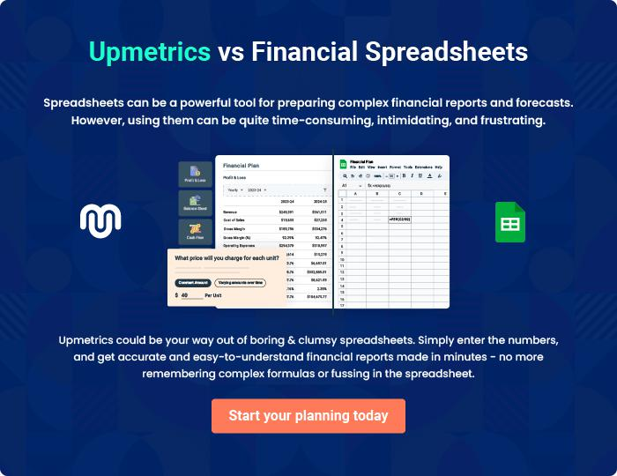

Poultry Farm | Business Plan [YEAR] 38/41

10.

Risk Assesment

Financial risks

Health risks

Technological risks

Poultry Farm | Business Plan [YEAR] 39/41

Financial risks

 Hencube poultry

- Changes in our pricing policies or that of our competitors

- Fluctuation in revenue from distributors and retailers
• Timing of costs related to acquisitions or payments To unlock help try Upmetrics! 

Start writing here..

Health risks

 Hencube poultry

Contagious disease and virus outbreak are very deadly; if one of the chickens should catch the disease, all of them will be affected and if it's not recognized and treated early it will lead to the death of all the chickens which is a great loss for the business. And also some of the diseases
To unlock help try Upmetrics! 

Start writing here..

Technological risks

 Hencube poultry

Technology is good but they also have their disadvantages. There are normally problems involved in using technology; the use of the machine that collects eggs may fail to work or
spoil, making the work slow and adding more cost to the business by repairing it. The cost of
To unlock help try Upmetrics! 

Start writing here..

Poultry Farm | Business Plan [YEAR] 40/41


Create a winning business plan that gets you funded

Creating a stunning and investment-ready plan requires no writing, graphic designing, or financial planning expertise.

Upmetrics has all the features required to help you create a comprehensive business plan—from start to finish. Make no mistakes, it’s the modern way of planning to structure ideas, make plans, and create stunning pitch decks to awe investors.

Pitch decks that impress investors

Create pitch decks that provide a visual representation of your business, engage investors, and make them want to invest in your business idea.

Interactive plans in no time

Import business plan sections like—SWOT analysis, comparison tables, and others to create an interactive business plan. No designing skills are required.

Stunning cover page designs

With Upmetrics, you have the liberty to choose from multiple stunning cover page designs. Choose a creative design and make your plan stand out.

Online sharing made simple

Upmetrics makes online sharing quick and easier for users. Easily share your business plans with a link while tracking reader activity.

500+ sample business plans

Simply import a template from our library of sample plans into the editor and start customizing it to make it yours. It takes only a few clicks to get started.

Collaborate with team in real-time

Invite team members, initiate conversations, discuss ideas & strategies, share feedback, and work on a business plan in real-time.

