
 Mindcast - Podcast

ADDRESS CONTACT

10200 Bolsa Ave, Westminster, CA, 92683 (650) 359-3153

http://www.example.com info@example.com


Business Plan

[YEAR]

Prepared By

John Doe


Let’s Level Up Your Mindset

Information provided in this business plan is unique to this business and confidential; therefore, anyone reading this plan agrees not to disclose any of the information in this business plan without prior written permission of the company.

Table of Contents

Executive summary | 6
Problem Definition & Validation | 7
Promotion of fixed mindsets at schools. | 7
Work-Place Related Mental Health Conditions | 8
Solution | 8
Strategically Devised Courses by Mindcast | 8
Solution Features | 9
Objectives | 9
Short Term (1 -3 Years) | 9
Long Term (3-5 years) | 9
Mission statement | 10
Unique Selling Proposition | 10
Financial Highlights | 10
Mindcast - 3 Year Financial Highlights | 11

Business overview | 12
Company Ownership/Legal Entity | 13
Location | 13
Interior Operating Facilities | 14
Hours of Operation | 14
Startup summary | 14

Products & Services | 15
Podcasts | 16
Learning How to Learn | 16
Coaching Educators | 17
Mental Health Development | 18
Emotional Well-Being at Workplace | 19
Overcoming Imposter Syndrome | 20
Understanding Anxiety, Depression and CBT | 21

Mindcast - Podcast | Business Plan [YEAR] 2/49

Market Analysis | 23
Market segmentation | 24
Market Trends | 24
Target market | 25
Target Market Segment | 25
Competitor Analysis | 26
Mindset Works | 26
Udemy | 26
Competitive Advantage | 27
SWOT analysis
SWOT analysis | 28
Strategy & implementation
Strategy & implementation | 30
Target Market Strategy | 31
Distribution Strategy | 31
Market Size | 31
Positioning Statement | 32
Sales strategy | 32
Online Marketing Channels | 32
Offline Marketing Channels | 33
Pricing strategy | 33
Operational Plan
Operational Plan | 34
Organization chart | 35
Management Team | 35
Personnel Plan | 36
Hiring plan | 36
Jane Doe | 36
Amanda Doe | 37
Jane Green | 37
Milestones | 38
MINDCAST | 38

Mindcast - Podcast | Business Plan [YEAR] 3/49

Financial plan | 39
Important Assumptions | 40
Break-even analysis | 40
Projected Profit and Loss | 41
Projected Cash Flow | 44
Projected Balance Sheet | 45
Business Ratios | 46

Mindcast - Podcast | Business Plan [YEAR] 4/49

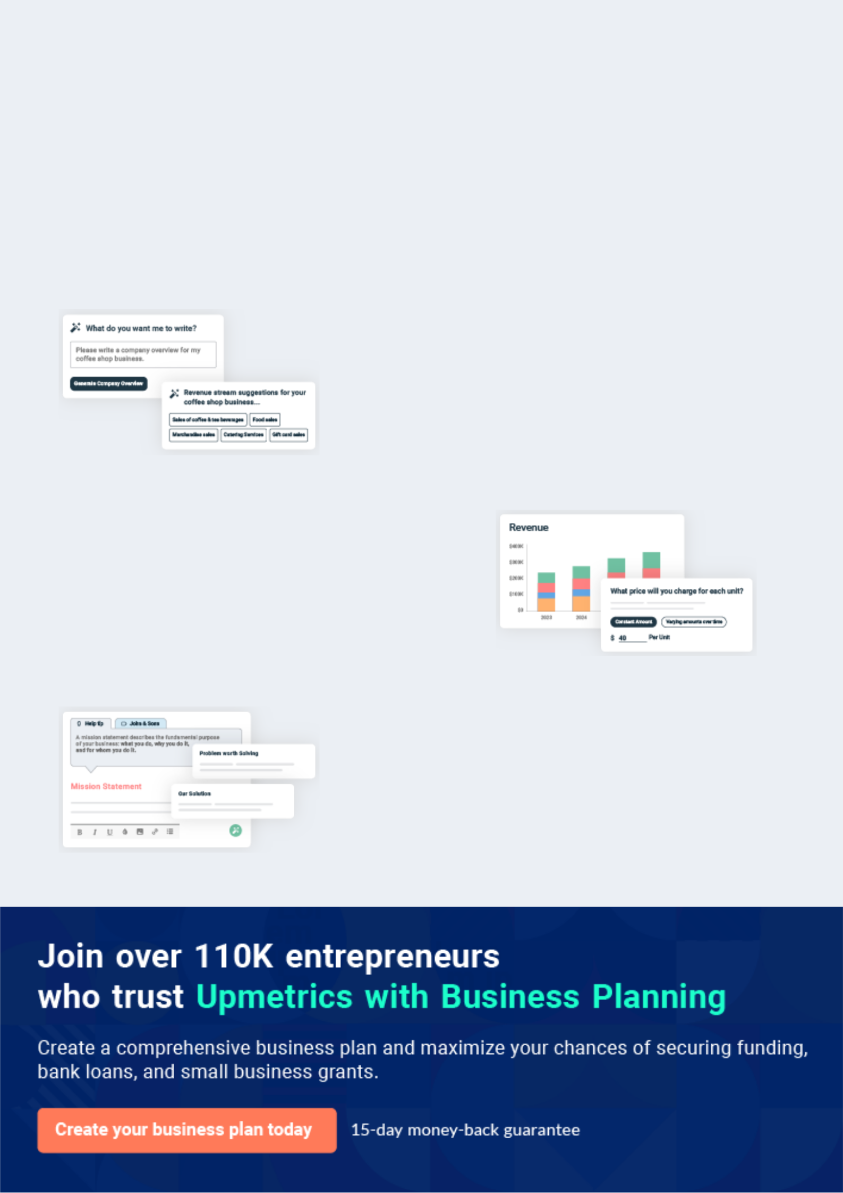
Business planning that’s simpler and faster than you think

Creating a business plan using Upmetrics to start and grow a business is literally the easiest thing in the World. Simply read the instructions and fill in the blanks. It’s as simple as that.

❛ | Upmetrics has everything you need to create a | ❜
❛ | comprehensive business plan. | ❜

AI-powered Upmetrics Assistant

AI-powered insights to streamline your plan

Not sure where to start? Upmetrics’ AI Assistant will automatically generate ideas for each section of your plan and offer improved versions of your writing, adjusting for tone, voice, and grammar or spelling errors.

Financial Forecasting Tool

All the financials are calculated for you

Forget the complex formulas and clumsy spreadsheets — with automatic financials and drag-and-drop forecasting, you can finish your plan faster and be confident that your numbers are accurate.

Business Plan Builder

Guides you like a business mentor

Upmetrics’ step-by-step instructions, prompts, and the library of 400+ sample business plans will guide you through each section of your plan as a business mentor.

1.


Executive summary

Problem Definition & Validation

Solution

Objectives

Mission statement

Unique Selling Proposition

Financial Highlights

Mindcast - Podcast | Business Plan [YEAR] 6/49

 Mindcast


Mindcast, as the name suggests, sets out to transform the human mind. Mindcast explores the science behind the idea "one can learn anything" through multimedia interventions that develop a 'growth mindset.' Mindcasts podcasts are designed to help students and adults develop
To unlock help try Upmetrics! 

Start writing here..

Problem Definition & Validation

Promotion of fixed mindsets at schools.


Whom?


Students

Causes

The traditional education system in schools is designed to promote a fixed mindset as the foundation for schooling is based on force. The proverbial “one-size-fits-all” approach to learning followed by schools does not leave room for the inspection of the learning process. In modern schools, children are corralled into classrooms and forced to learn concepts they are more likely to disdain. Even if a teacher attempts to cater to different learning styles, the bureaucracy of schooling stifles them. Standardized tests, standardized curriculums, and even standardized rules have pigeonholed students and teachers into conforming to the system.



Impact

A fixed mindset is a belief that one’s core abilities, such as talent and intelligence, are fixed traits. A fixed mindset leads an individual to treat failure as an indication of their capabilities. For instance, if a student is consistently failing at mathematics, his fixed mindset would lead him to believe that the subject is beyond his understanding is just not his forte. This conclusion would make him disinclined to try again.

Mindcast - Podcast | Business Plan [YEAR] 7/49

Work-Place Related Mental Health Conditions


Whom?


Employees and

Professionals

Causes

Mental illness, deemed globally to account for 32% of years lived with a disability, generates significant effects on workplaces. In particular, employees working in technology, finance, and healthcare fields experience high rates of mental ill-health such as burnout, stress, and depression due to workplace conditions including excessive workloads, workplace violence, and bullying.



Impact

These conditions impact workplaces significantly costing 1 trillion dollars in lost productivity. The prolific mental health conditions at the workplace have even overtaken physical safety as a critical risk. The World Health Organisation says anxiety and depression increased globally by 50% between 1990 and 2013. In May 2018, the American Psychiatric Association announced another 5% increase.

Solution

Strategically Devised Courses by Mindcast

My Mental Health Podcast: What Does Anxiety Look Like in Children? - My Mental Health

Mindcast challenges the notion of intelligence being something innate and fixed supplanting it by the contrarian concept of intelligence being malleable. The company seeks to empower students, educators, and corporate workers with a mindset that sets them free from being prisoners of immutable characteristics. With a range of specially designed courses, the company proves that with the right training, one can become authors of their cognitive abilities.

Mindcast - Podcast | Business Plan [YEAR] 8/49

Solution Features


Mental Health

Mental Health thus equates to

the mind being calm, alert, focused, agile and decisive.

Resilience | Mind Training
Mindcast proposes to | Training interventions deliver
condition an individual’s mind | an average 30% reduction in
to become resilient through | symptoms of depression and
structured training courses | an average of 32% average
targeted at a growth mindset. | reduction in anxiety symptoms.

Objectives

 Mindcast

• To begin commercial operations in LA by Q1 2021

• To build a market reputation for quality hygienic products and services during the
To unlock help try Upmetrics! 

Short Term (1 -3 Years)

Start writing here..

 Mindcast

- To expand by opening additional store locations across the country during the forecast period
To unlock help try Upmetrics! 

Long Term (3-5 years)

Start writing here..

Mindcast - Podcast | Business Plan [YEAR] 9/49

Mission statement

 Mindcast

Our mission is to empower individuals with lifelong learning capabilities by offering high-quality, accredited, accessible, innovative, and responsive education and training programs that are designed to cultivate a growth mindset leveraging the ground-breaking research of leading
To unlock help try Upmetrics! 

Start writing here..

Unique Selling Proposition

 Mindcast

The most significant advantage of the company is that all the courses are curated in-house by the Founder. A certified life coach with a master’s in business psychology, she

is highly equipped with the knowledge and insight into the internal Tomechanicsunlockhelp oftry Upmetrics!ahuman 

Start writing here..

Financial Highlights

 Mindcast

The company envisions raising an equity investment of $50,000 through long-term borrowings, which will be used for the setup and launch of the salon in the US. The company expects to steadily grow its revenues through active efforts in marketing, networking, excellent customer
To unlock help try Upmetrics! 

Start writing here..

Mindcast - Podcast | Business Plan [YEAR] 10/49

Mindcast - 3 Year Financial Highlights
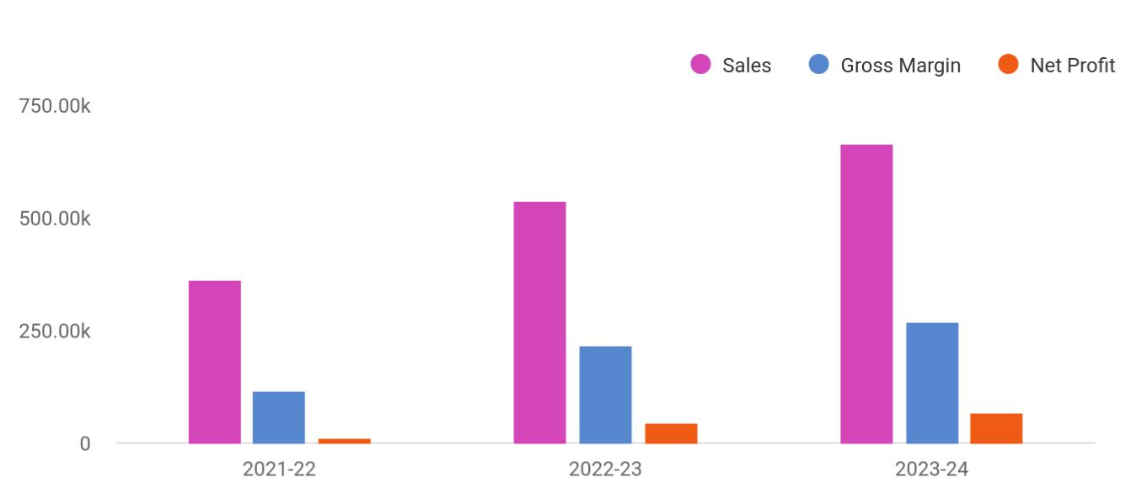

Financial Year | Sales | Gross Margin | Net Profit
2021-22 | 360,723 | 114,289 | 13,038
2022-23 | 538,041 | 216,784 | 44,360
2023-24 | 665,012 | 269,869 | 65,638

Mindcast - Podcast | Business Plan [YEAR] 11/49

2.

Business overview

Company Ownership/Legal Entity

Location

Interior Operating Facilities

Hours of Operation

Startup summary

Mindcast - Podcast | Business Plan [YEAR] 12/49

 Mindcast

Mindcast brings about innovation in its approach to online self-development courses that promise a growth mindset as an outcome. Soft skills such as communication, cognitive development, instilling a growth mindset, accountability, and problem-solving cannot be
To unlock help try Upmetrics! 

Start writing here..

Company Ownership/Legal Entity

 Mindcast

The company will be registered as a limited liability entity with the Department of State. Further, since the company envisions setting up operations in LA, it will also register with the local county. The business will be wholly owned and Managed by Founder Mr. Thomas Green, who
To unlock help try Upmetrics! 

Start writing here..

Location

 Mindcast

Los Angeles can be a tough city for entrepreneurs to establish and make a mark. Predominantly due to the thriving business landscape which has given rise to a competitive environment. LA has a great technology community scene. There are meetups, events, and conferences for
To unlock help try Upmetrics! 

Start writing here..

Mindcast - Podcast | Business Plan [YEAR] 13/49

Interior Operating Facilities
To unlock help try Upmetrics!

 Mindcast

The company will begin operations from a rented office space in a suburban region in LA. Being entirely online, the company does not have to be located in a high-traffic area and can reduce rental costs by having an office away from the commercial hub.



Start writing here..

Hours of Operation

 Mindcast

Mindcast's business is entirely online working on a subscription basis. Hence, the company does not have standard operating hours.
To unlock help try Upmetrics! 

Start writing here..

Startup summary

 Mindcast

The founding team will infuse a capital sum of $50,000 through long-term borrowings to meet the company’s start-up requirements. The start-up expenses are estimated at $18,500, primarily consisting of interior renovation, rent, and advertisement expenses. A further sum of $15,000
To unlock help try Upmetrics! 

Start writing here..

Mindcast - Podcast | Business Plan [YEAR] 14/49

3.

Products & Services

Podcasts

Mindcast - Podcast | Business Plan [YEAR] 15/49

 Mindcast

Mindcast provides an online educational platform offering multimedia interventions to develop a ‘growth mindset’ by developing an understanding of how the mind works and learn how to work the mind. Each of the courses is designed based on the scientific findings from
To unlock help try Upmetrics! 

Start writing here..

Podcasts

Learning How to Learn

Price: $150 USD


Targeted towards high school and university students, this course is designed with instructional coaching methods and interactive multimedia to develop an ‘infinite mindset’ in students across all ages through the understanding of how the mind works and learning how to work the mind. Students will learn methods to improve focus, study, memory, speed-reading, and thinking – learning a life skill that enables them to learn anything they want; as well as establishing an actionable behavioral plan to achieving their goals.

Targeted Towards

High school students, university students

Podcast Duration

5-6 hours

Learning Outcome

- Understand the mind and body connection

- Cultivate positive mindset

- Improve self-regulation of thoughts and emotions

- Improve focus, reading speed, note-taking, and memory

Mindcast - Podcast | Business Plan [YEAR] 16/49

Coaching Educators

Price: $150 USD


An intensive course designed to train and equip educators, parents, and coaches to develop ‘infinite mindset’ in children/adults through the proactive understanding of child development. The learners will comprehend the power and use of language in developing a growth mindset from a young age, as well as the methods for fostering better and effective learning habits.

Targeted Towards

Educators, parents, and coaches, schools

Podcast Duration

10 hours

Learning Outcome

- Understand and develop ‘connection before direction’

- Develop own positive mindset and in child

- Apply ‘Emotional Coaching’

- Effective appraisal

- Teaching self-discipline to children

Mindcast - Podcast | Business Plan [YEAR] 17/49

Mental Health Development

Price: $150 USD


Aligned with the development of soft skills, this course is designed to guide individuals to develop and discover their capabilities, interpersonal skills, help them to understand more about their challenges, and make informed choices about their future. It is typically done in approximately three to five coaching sessions – making coaching more accessible and affordable.

Targeted Towards

Students, working professionals, someone who wants to change something in their lives

Duration of Podcast

2-3 hours

Learning Outcome

- Establish clear, motivating goals

- Identify blocks to achieving the goals

- Explore and resolve mental barriers

- Enhance self-awareness

- Develop skills to manage decisions and actions effectively

Mindcast - Podcast | Business Plan [YEAR] 18/49

Emotional Well-Being at Workplace

Price: $150 USD


Understand the importance of team member wellbeing and consider different definitions of and theoretical approaches to wellbeing.

Targeted Towards

Students, working professionals, someone who wants to change something in their lives

Duration of Podcast

2-3 hours

Learning Outcome

- Establish clear, motivating goals

- Identify blocks to achieving the goals

- Explore and resolve mental barriers

- Enhance self-awareness

- Develop skills to manage decisions and actions effectively

Mindcast - Podcast | Business Plan [YEAR] 19/49

Overcoming Imposter Syndrome

Price: $150 USD


Identifying the Patterns Undermining Confidence - Explore what imposter syndrome is, what causes it, and the strategies that can be used to overcome it.

Targeted Towards

Students, working professionals, someone who wants to change something in their lives

Duration of Podcast

2-3 hours

Learning Outcome

- Establish clear, motivating goals

- Identify blocks to achieving the goals

- Explore and resolve mental barriers

- Enhance self-awareness

- Develop skills to manage decisions and actions effectively

Mindcast - Podcast | Business Plan [YEAR] 20/49

Understanding Anxiety, Depression and CBT

Price: $150 USD


Improve the understanding of depression and anxiety and find out about an effective and evidence-based treatment- CBT

Targeted Towards

Students, working professionals, someone who wants to change something in their lives

Duration of Podcast

2-3 hours

Learning Outcome

- Establish clear, motivating goals

- Identify blocks to achieving the goals

- Explore and resolve mental barriers

- Enhance self-awareness

- Develop skills to manage decisions and actions effectively

Mindcast - Podcast | Business Plan [YEAR] 21/49

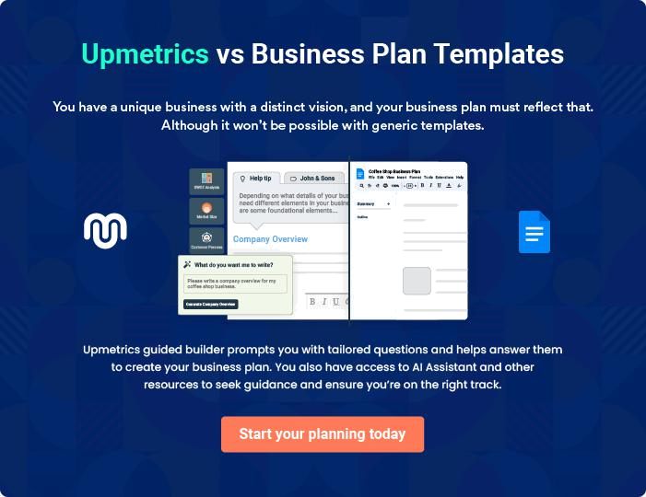

Mindcast - Podcast | Business Plan [YEAR] | 22/49

4.

Market Analysis

Market segmentation

Market Trends

Target market

Competitor Analysis

Competitive Advantage

Mindcast - Podcast | Business Plan [YEAR] 23/49

 Mindcast
To unlock help try Upmetrics!

The podcast industry is in a particular moment of creative and innovative renaissance, from content created by publishers and hosts to listener discovery. And while podcasts have been around for nearly two decades, the format has only just entered the mainstream.
To unlock help try Upmetrics! 

Start writing here..

Market segmentation

 Mindcast

Podcasts are growing outside of the US as well, and Latin America is a key region to watch given the rapid development of Spanish-language content. Additionally, tech companies are jockeying to become the No. 1 destination for podcast listeners, and the biggest players are
To unlock help try Upmetrics! 

Start writing here..

Market Trends

 Mindcast

Podcast listener numbers will see significant growth this year as demand for on-demand audio has increased. In 2021, the number of monthly US podcast listeners will increase by 10.1% year-over-year (YoY) to 117.8 million.



Start writing here..

Mindcast - Podcast | Business Plan [YEAR] 24/49

Target market

 Mindcast

Mindcast’s courses are designed by keeping three distinct market segments in mind. While the company’s “Learning how to Learn” and "coaching educators" is curated explicitly for higher education/university students and educators respectively, course like mental health programs
To unlock help try Upmetrics! 

Start writing here..

Target Market Segment
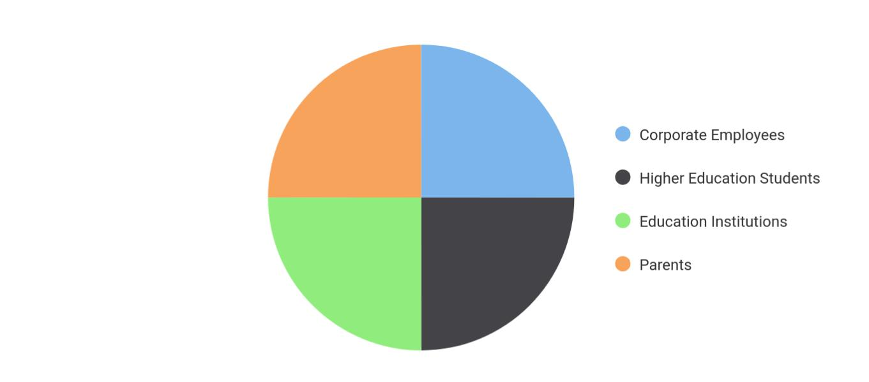

Mindcast - Podcast | Business Plan [YEAR] 25/49

Competitor Analysis

Mindset Works


Mindset Works is the global leader in growth mindset development leveraging the pioneering research of Carol Dweck and Lisa Blackwell. The company's mission is to enable a world in which all people realize continual learning and growth. The Mindset Works team includes practitioners, coaches, leaders, and researchers who collaborate to translate academic research into products and services that nurture positive learning beliefs, habits, and cultures.

Features Strengths Weaknesses

Mindset Courses Global Reach Standard Approach

Udemy


The leading global marketplace for learning and instruction. By connecting students all over the world to the best instructors, Udemy is helping individuals reach their goals and pursue their dreams.

Features Strengths Weaknesses

Mindset Courses Global Reach Standard Approach

Mindcast - Podcast | Business Plan [YEAR] 26/49

Competitive Advantage

 Mindcast

While most of the competitors listed above offer similar podcasts online, these competitors operate on a global scale, making their course content more generic and universal. Skills development and training courses that are designed to transform the current mindset are
To unlock help try Upmetrics! 

Start writing here..

Mindcast - Podcast | Business Plan [YEAR] 27/49

5.

SWOT analysis

Mindcast - Podcast | Business Plan [YEAR] 28/49

 Mindcast

A SWOT (Strength, Weakness, Opportunity, and Threat) analysis is a useful tool for businesses to evaluate their position in the market against the potential internal and external factors that could assist or jeopardize their operations and existence. A SWOT has been conducted for
To unlock help try Upmetrics! 

Start writing here..


Strength Weakness

• Personalized podcasts • Highly competitive market

• Thriving industry • Limited market understanding

- Lucrative business location

- Scalable pricing strategy and business model

Opportunity | Threat
• Collaboration with leading educators | • Competitors eroding the market
• Increased mental health consciousness | • Low barriers to entry
• High growth potential market in the US | • Competitors poaching B2B clients
• Export capabilities

Mindcast - Podcast | Business Plan [YEAR] 29/49

6.

Strategy & implementation

Target Market Strategy

Distribution Strategy

Positioning Statement

Sales strategy

Pricing strategy

Mindcast - Podcast | Business Plan [YEAR] 30/49

Target Market Strategy

 Mindcast

The online learning industry is a saturated market which makes course pricing a strategic challenge. As the Founder curates the courses, a significant cost of content creation is reduced. As no additional cost is incurred, the company will be in a position to transfer the
To unlock help try Upmetrics! 

Start writing here..

Distribution Strategy

 Mindcast

Intensive market competition and the face of rapidly evolving learning preferences will also make it imperative for Mindcast to not only focus on customer acquisition but also retention. To this end, Mindcast will provide freemium offerings such as collective webinars and talk
To unlock help try Upmetrics! 

Start writing here..

Market Size

Market in the US | 280k
Available Market

Market is LA | 120k
Served Market

5% of Served Market | 60k
Target Market

Mindcast - Podcast | Business Plan [YEAR] 31/49

Positioning Statement
To unlock help try Upmetrics!

 Mindcast

Mindcast will seek to target vulnerable groups within each market segment such as migrant workers and students from disadvantaged backgrounds as this market are more likely to require growth mindset courses offered by the company.



Start writing here..

Sales strategy

 Mindcast

Employees, educational institutions, students, and companies form the company’s primary target market. However, the company’s marketing efforts will also include end-users, clients of the professional service providers. While push marketing efforts will be deployed to reach its
To unlock help try Upmetrics! 

Start writing here..

Online Marketing Channels


Electronic Direct Mail

Marketing

Mindcast will mail

professionally designed materials with its value proposition to these companies and provide quotes for promotion merchandise printing services.

Social Media | Google Ad Campaigns
Millennials and consumers in | The advertising will target
general spend a considerable | specific keywords relevant to
time browsing social media | Mindcast's offering
platforms. Reaching to them
through this channel will be
and effective way to capture
attention and position its
services.

Mindcast - Podcast | Business Plan [YEAR] 32/49

Offline Marketing Channels



Networking | Pop-Up Store
Participate in leading health and lifestyle | The company will also hold pop-up stalls at
exhibitions. Offer sneak peak into the podcast. | consumer exhibitions.
The company will also keep a record of visitors
to their stalls as leads for its email marketing
campaigns.

Pricing strategy

 Mindcast

The company's mental health podcasts range between $149.99 and $249.99. The direct costs, which are primarily associated with instructors/subject matter experts and online processing fees, are estimated at 15%, resulting in 85% margins across all products and services.
To unlock help try Upmetrics! 

Start writing here..

Mindcast - Podcast | Business Plan [YEAR] 33/49

7.

Operational Plan

Management Team

Personnel Plan

Milestones

Mindcast - Podcast | Business Plan [YEAR] 34/49

 Mindcast

The team will be headed by Managing Director Mr. Thomas Green who will also oversee production operations. Joining Mr. Thomas in the Management Team, the company will onboard an office manager and a mental health advisor to help clients choose the best
To unlock help try Upmetrics! 

Start writing here..

Organization chart


Thomas Green

Managing Director


 | Amanda Doe | Jane Green
 | Sales & Marketing | Jane Green
Jane Doe | Sales & Marketing | Mental Health Advisor
Office Manager | Assistant


Management Team

 Mindcast

Mr. Thomas will serve as the Managing Director of Mindcast. A highly motivated and dynamic individual, Thomas boasts vast experience in the field of aesthetics having spent a career spanning 14 years essaying various white-collar roles for companies across America. His
To unlock help try Upmetrics! 

Start writing here..

Mindcast - Podcast | Business Plan [YEAR] 35/49

Personnel Plan
To unlock help try Upmetrics!

 Mindcast

The company plans to create six full-time equivalent jobs in addition to the management team within the first three years of operations. Salaries for each employee are in line with the industry’s benchmark.



Start writing here..

Hiring plan

20 |  |  | 5 |  |  |  |  | 25
Filled |  |  | Hired |  |  |  |  | Open
Group By Department |  |  | Position Filled |  | Time of Hire |  |  | Time of Start |  | Filled On Time
Office Manager |  |  | 3 of 23 |  | 30 days |  |  | 21 days |  | 80%
Sales Representative |  |  | 4 of 15 |  | 158 days |  |  | 127 days |  | 0%
Mental Health Advisor |  |  | 5 of 20 |  | 149 days |  |  | 136 days |  | 100%


Jane Doe

Office Manager - Jane@mindcast.com

Ability to cope with fast-paced and pressured work, accuracy, strong attention to detail and a strong analytical mind, ability to notice patterns within statistics, an interest in psychology and behavior, good organizational skills, excellent (spoken and written) communication skills.

Mindcast - Podcast | Business Plan [YEAR] 36/49


Amanda Doe

Sales Representatives - Amanda@mindcast.com

Preferably bilingual with ability to speak English and French fluently, problem-solving, ability to convert leads into sales, active listener, patience, and understanding of the company’s products and services. Additionally, skills in social media marketing, search engine optimization, newsletter marketing, other forms of digital marketing will also be required


Jane Green

Mental Health Advisor - Jane@mindcast.com

Excellent verbal skills and a knack for cosmetic products, strong written and verbal communication skills, skilled in customer interaction, and a qualified psychologist

Mindcast - Podcast | Business Plan [YEAR] 37/49

Milestones

MINDCAST


Year 2

>Year3

Establish

Mindcast will rent a office space in

suburban LA alongside developing a fully

optimized and informative website. During
this period, the company will also develop _{YEAR 1} initial podcasts to give as samples and fill

up the showroom shelves. Marketing

activities will also begin during this stage to

build awareness and launch the brand into

the market.



Gain Market Traction

The company will begin expanding its

services beyond LA to cover other regions

around California.


Diversify
Having externally established the business, | Year 3
the company will begin internally expanding | Year 3
its range of products


Grow

- Begin expanding across the US

- Consider market expansion beyond US


Mindcast - Podcast | Business Plan [YEAR] 38/49

8.

Financial plan

Important Assumptions

Break-even analysis

Projected Profit and Loss

Projected Cash Flow

Projected Balance Sheet

Business Ratios

Mindcast - Podcast | Business Plan [YEAR] 39/49


If you are going to start your own Podcast business, then make sure you will pay special attention to your financial plan. Your financial plan should include the details about how well you manage your incomes and expenses, and how
To unlock help try Upmetrics! 

Important Assumptions

The company’s financial projections are forecasted on the basis of the following assumptions. These assumptions are quite conservative and are also expected to show deviation but to a limited level such that the company’s major financial strategy will not be affected.

 | Year 1 | Year 2 | Year 3
Plan Month | 1 | 2 | 3
Current Interest Rate | 10,00% | 11,00% | 12,00%
Long-term Interest Rate | 10,00% | 10,00% | 10,00%
Tax Rate | 26,42% | 27,76% | 28,12%
Other | 0 | 0 | 0

Break-even analysis

Monthly Units Break-even | 5530
Monthly Revenue Break-even | $159 740
Assumptions:
Average Per-Unit Revenue | $260,87
Average Per-Unit Variable Cost | $0,89
Estimated Monthly Fixed Cost | $196 410

Mindcast - Podcast | Business Plan [YEAR] 40/49

Projected Profit and Loss

 | 2024 | 2025 | 2026
Revenue | $160,412.50 | $348,812.55 | $893,753.60
Listener Donations | $74,847.50 | $234,914.05 | $737,264.15
Unit Sales | 2,139 | 6,712 | 21,065
Unit Price | $35 | $35 | $35
Merchandise Sales | $37,565 | $60,138.50 | $96,278.25
Unit Sales | 1,503 | 2,406 | 3,851
Unit Price | $25 | $25 | $25
Episode Sponsorships | $48,000 | $53,760 | $60,211.20
Cost Of Sales | $11,212.36 | $17,026.38 | $33,540.87
General Costs | $11,212.36 | $17,026.38 | $33,540.87
Production Costs | $4,200 | $4,296 | $4,394.28
Audio Editing Services | $3,000 | $3,060 | $3,121.20
Music Licensing Fees | $1,200 | $1,236 | $1,273.08
Hosting and Distribution | $7,012.36 | $12,730.38 | $29,146.59
Podcast Hosting Fees | $4,812.36 | $10,464.38 | $26,812.61
Distribution & Promotion | $2,200 | $2,266 | $2,333.98
Costs | $2,200 | $2,266 | $2,333.98
Revenue Specific Costs | $0 | $0 | $0
Personnel Costs (Direct | $0 | $0 | $0
Labor) | $0 | $0 | $0
Gross Margin | $149,200.14 | $331,786.17 | $860,212.73
Gross Margin (%) | 93.01% | 95.12% | 96.25%

Mindcast - Podcast | Business Plan [YEAR] 41/49

 | 2024 | 2025 | 2026
Operating Expense | $282,208.13 | $312,936.31 | $369,023.63

Payroll Expense (Indirect Labor)

Production Team

Audio Producer

Sound Technician

Content Creation Team

Content Writer

Social Media Manager

Guest Relations

Guest Coordinator

Booking Agent

General Expense

Studio and Equipment

Maintenance

Studio Rent

Equipment Maintenance

Technology and Software

Audio Editing Software

Web Hosting and Domain

Marketing and Advertising

Social Media Advertising

Promotional Events and

Merchandise

Bad Debt

Amortization of Current Assets

$230,460 | $235,855.80 | $241,383.12
$80,040 | $82,054.80 | $84,122.40
$41,400 | $42,642 | $43,921.32
$38,640 | $39,412.80 | $40,201.08
$82,800 | $84,456 | $86,145.12
$44,160 | $45,043.20 | $45,944.04
$38,640 | $39,412.80 | $40,201.08
$67,620 | $69,345 | $71,115.60
$37,260 | $38,377.80 | $39,529.08
$30,360 | $30,967.20 | $31,586.52
$51,748.13 | $77,080.51 | $127,640.51
$36,743.24 | $51,964.16 | $73,552.28
$2,682.36 | $3,401.73 | $4,314.02
$34,060.88 | $48,562.43 | $69,238.26
$934.25 | $1,020.71 | $1,117.47
$634.25 | $714.71 | $805.35
$300 | $306 | $312.12
$14,070.64 | $24,095.64 | $52,970.76
$8,020.64 | $17,440.64 | $44,687.70
$6,050 | $6,655 | $8,283.06
$0 | $0 | $0
$0 | $0 | $0

Mindcast - Podcast | Business Plan [YEAR] 42/49

EBITDA

Additional Expense

Long Term Depreciation

Gain or loss from Sale of Assets

EBIT

Interest Expense

EBT

Income Tax Expense / Benefit
2024 2025 2026

($133,007.99) $18,849.86 $491,189.10

$4,092 | $4,092 | $4,092
$4,092 | $4,092 | $4,092
$0 | $0 | $0
($137,099.99) | $14,757.86 | $487,097.10
$0 | $0 | $0
($137,099.99) | $14,757.86 | $487,097.10
$0 | $0 | $0

Total Expense | $297,512.49 | $334,054.69 | $406,656.50
Net Income | ($137,099.99) | $14,757.86 | $487,097.10
Net Income (%) | (85.47%) | 4.23% | 54.50%

Retained Earning Opening | $0 | ($155,099.99) | ($148,342.13)
Owner's Distribution | $18,000 | $8,000 | $8,000
Retained Earning Closing | ($155,099.99) | ($148,342.13) | $330,754.97

Mindcast - Podcast | Business Plan [YEAR] 43/49

Projected Cash Flow

 | 2024 | 2025 | 2026
Cash Received | $160,412.50 | $348,812.55 | $893,753.60
Cash Paid | $293,420.49 | $329,962.69 | $402,564.50
COS & General Expenses | $62,960.49 | $94,106.89 | $161,181.38
Salary & Wages | $230,460 | $235,855.80 | $241,383.12
Interest | $0 | $0 | $0
Sales Tax | $0 | $0 | $0
Income Tax | $0 | $0 | $0
Net Cash From | ($133,007.99) | $18,849.86 | $491,189.10
Operations | ($133,007.99) | $18,849.86 | $491,189.10
Assets Sell | $0 | $0 | $0
Assets Purchase | $25,000 | $0 | $0
Net Cash From | ($25,000) | $0 | $0
Investments | ($25,000) | $0 | $0
Amount Received | $105,000 | $0 | $0
Loan Received | $0 | $0 | $0
Common Stock | $0 | $0 | $0
Preferred Stock | $0 | $0 | $0
Owner's Contribution | $105,000 | $0 | $0
Amount Paid | $18,000 | $8,000 | $8,000
Loan Capital | $0 | $0 | $0
Dividends & Distributions | $18,000 | $8,000 | $8,000
Net Cash From | $87,000 | ($8,000) | ($8,000)
Financing | $87,000 | ($8,000) | ($8,000)

Mindcast - Podcast | Business Plan [YEAR] 44/49

 | 2024 | 2025 | 2026
Summary
Starting Cash | $0 | ($71,007.99) | ($60,158.13)
Cash In | $265,412.50 | $348,812.55 | $893,753.60
Cash Out | $336,420.49 | $337,962.69 | $410,564.50
Change in Cash | ($71,007.99) | $10,849.86 | $483,189.10
Ending Cash | ($71,007.99) | ($60,158.13) | $423,030.97
Projected Balance Sheet
 | 2024 | 2025 | 2026
Assets | ($50,099.99) | ($43,342.13) | $435,754.97
Current Assets | ($71,007.99) | ($60,158.13) | $423,030.97
Cash | ($71,007.99) | ($60,158.13) | $423,030.97
Accounts Receivable | $0 | $0 | $0
Inventory | $0 | $0 | $0
Other Current Assets | $0 | $0 | $0
Long Term Assets | $20,908 | $16,816 | $12,724
Gross Long Term Assets | $25,000 | $25,000 | $25,000
Accumulated Depreciation | ($4,092) | ($8,184) | ($12,276)
Liabilities & Equity | ($50,099.99) | ($43,342.13) | $435,754.97
Liabilities | $0 | $0 | $0
Current Liabilities | $0 | $0 | $0
Accounts Payable | $0 | $0 | $0
Income Tax Payable | $0 | $0 | $0

Mindcast - Podcast | Business Plan [YEAR] 45/49

 | 2024 |  |  | 2025 |  | 2026
Sales Tax Payable | $0 |  |  | $0 |  | $0
Short Term Debt | $0 |  |  | $0 |  | $0
Long Term Liabilities | $0 |  |  | $0 |  | $0
Long Term Debt | $0 |  |  | $0 |  | $0
Equity | ($50,099.99) |  | ($43,342.13) |  |  | $435,754.97
Paid-in Capital | $0 |  |  | $0 |  | $0
Common Stock | $0 |  |  | $0 |  | $0
Preferred Stock | $0 |  |  | $0 |  | $0
Owner's Contribution | $105,000 |  |  | $105,000 |  | $105,000
Retained Earnings | ($155,099.99) |  | ($148,342.13) |  |  | $330,754.97
Check | $0 |  |  | $0 |  | $0
Business Ratios
 |  | Year 1 | Year 2 |  | Year 3 | Industry profile
Sales Growth |  | 4,35% | 30,82% |  | 63,29% | 4,00%
Percent of Total Assets
Accounts Receivable |  | 5,61% | 4,71% |  | 3,81% | 9,70%
Inventory |  | 1,85% | 1,82% |  | 1,79% | 9,80%
Other Current Assets |  | 1,75% | 2,02% |  | 2,29% | 27,40%
Total Current Assets |  | 138,53% | 150,99% |  | 163,45% | 54,60%
Long-term Assets |  | -9,47% | -21,01% |  | -32,55% | 58,40%
TOTAL ASSETS |  | 100,00% | 100,00% |  | 100,00% | 100,00%
Current Liabilities |  | 4,68% | 3,04% |  | 2,76% | 27,30%
Long-term Liabilities |  | 0,00% | 0,00% |  | 0,00% | 25,80%
Total Liabilities |  | 4,68% | 3,04% |  | 2,76% | 54,10%

Mindcast - Podcast | Business Plan [YEAR] 46/49

 | Year 1 | Year 2 | Year 3 | Industry profile
NET WORTH | 99,32% | 101,04% | 102,76% | 44,90%
Percent of Sales
Sales | 100,00% | 100,00% | 100,00% | 100,00%
Gross Margin | 94,18% | 93,85% | 93,52% | 0,00%
Selling, General & Administrative Expenses | 74,29% | 71,83% | 69,37% | 65,20%
Advertising Expenses | 2,06% | 1,11% | 0,28% | 1,40%
Profit Before Interest and Taxes | 26,47% | 29,30% | 32,13% | 2,86%
Main Ratios
Current | 25,86 | 29,39 | 32,92 | 1,63
Quick | 25,4 | 28,88 | 32,36 | 0,84
Total Debt to Total Assets | 2,68% | 1,04% | 0,76% | 67,10%
Pre-tax Return on Net Worth | 66,83% | 71,26% | 75,69% | 4,40%
Pre-tax Return on Assets | 64,88% | 69,75% | 74,62% | 9,00%
Additional Ratios
Net Profit Margin | 19,20% | 21,16% | 23,12% | N.A.
Return on Equity | 47,79% | 50,53% | 53,27% | N.A.
Activity Ratios
Accounts Receivable Turnover | 4,56 | 4,56 | 4,56 | N.A.
Collection Days | 92 | 99 | 106 | N.A.
Inventory Turnover | 19,7 | 22,55 | 25,4 | N.A.
Accounts Payable Turnover | 14,17 | 14,67 | 15,17 | N.A.
Payment Days | 27 | 27 | 27 | N.A.
Total Asset Turnover | 1,84 | 1,55 | 1,26 | N.A.
Debt Ratios
Debt to Net Worth | 0 | -0,02 | -0,04 | N.A.
Current Liab. to Liab. | 1 | 1 | 1 | N.A.
Liquidity Ratios
Net Working Capital | $120 943 | $140 664 | $160 385 | N.A.

Mindcast - Podcast | Business Plan [YEAR] 47/49

 | Year 1 | Year 2 | Year 3 | Industry profile
Interest Coverage | 0 | 0 | 0 | N.A.
Additional Ratios
Assets to Sales | 0,45 | 0,48 | 0,51 | N.A.
Current Debt/Total Assets | 4% | 3% | 2% | N.A.
Acid Test | 23,66 | 27,01 | 30,36 | N.A.
Sales/Net Worth | 1,68 | 1,29 | 0,9 | N.A.
Dividend Payout | 0 | 0 | 0 | N.A.
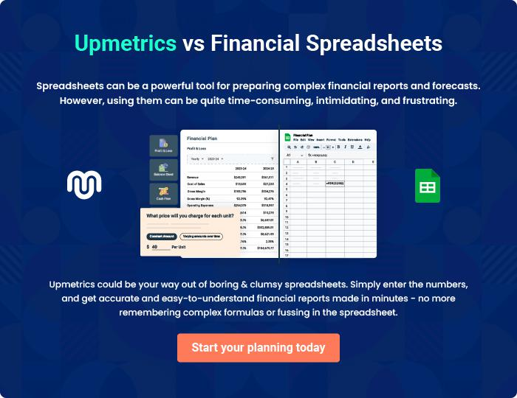

Mindcast - Podcast | Business Plan [YEAR] 48/49

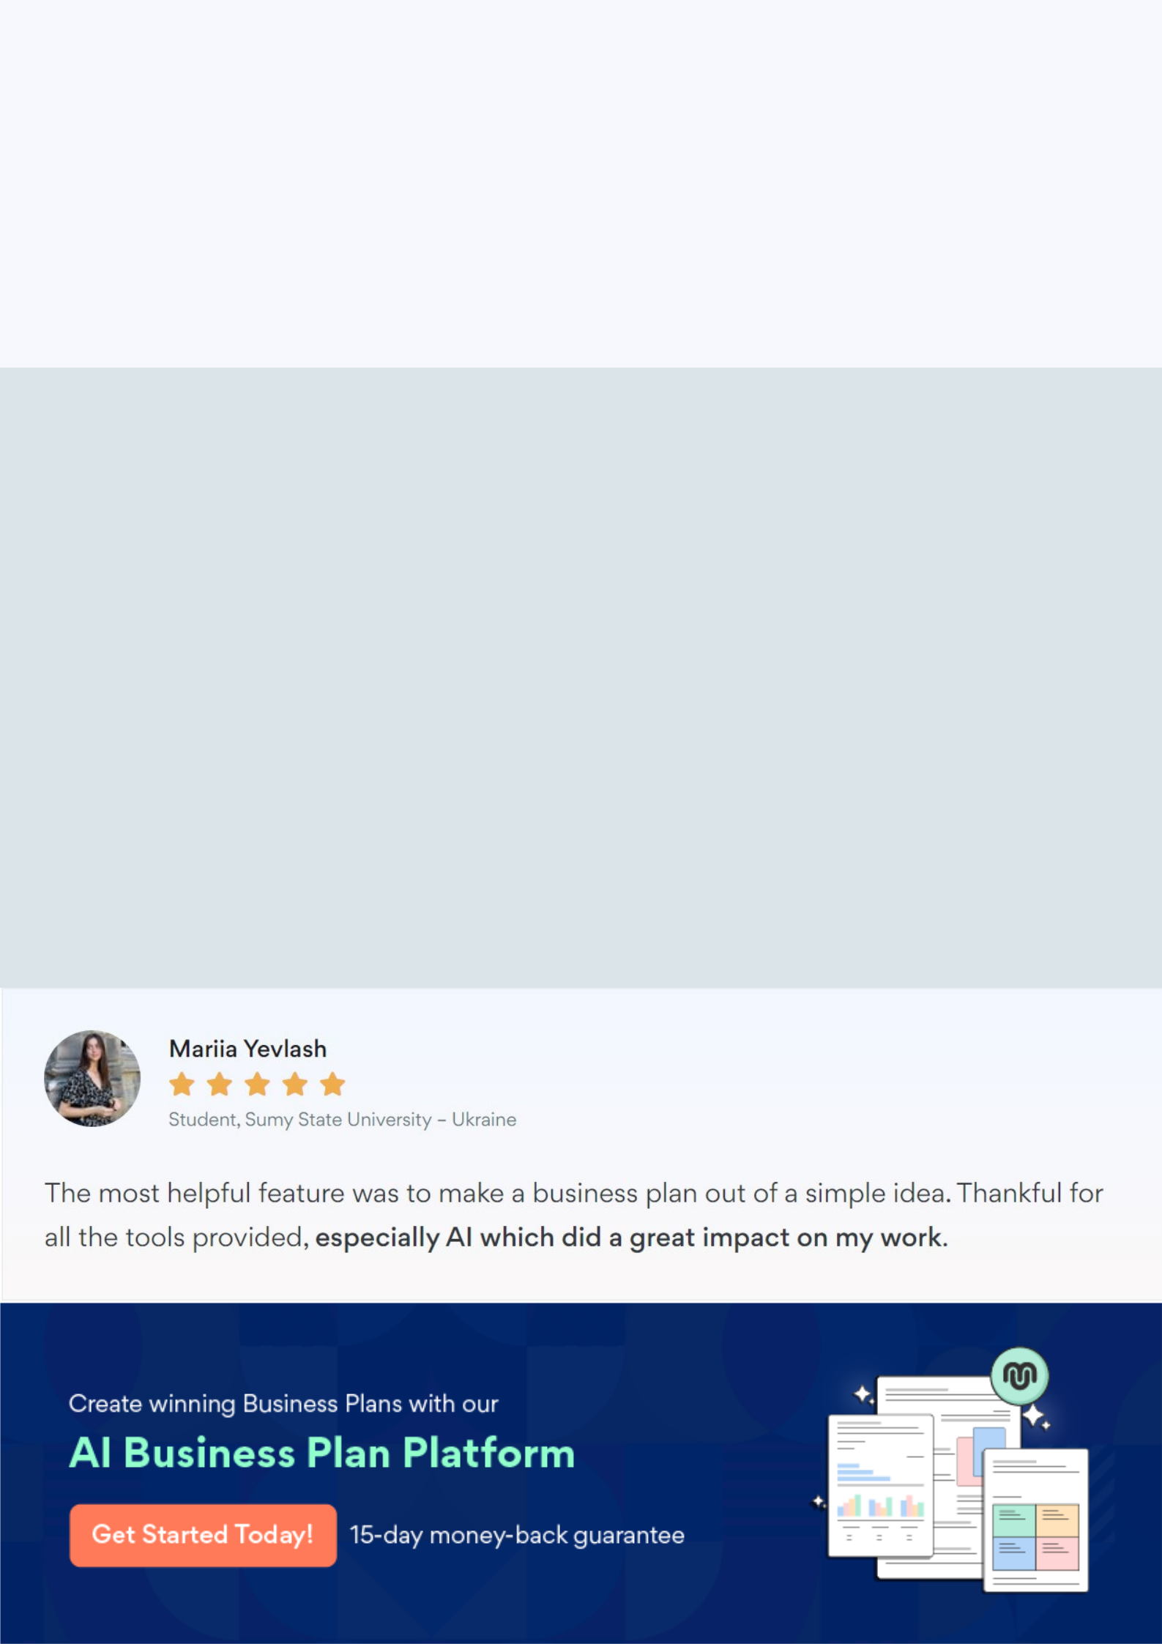
Create a winning business plan that gets you funded

Creating a stunning and investment-ready plan requires no writing, graphic designing, or financial planning expertise.

Upmetrics has all the features required to help you create a comprehensive business plan—from start to finish. Make no mistakes, it’s the modern way of planning to structure ideas, make plans, and create stunning pitch decks to awe investors.

Pitch decks that impress investors

Create pitch decks that provide a visual representation of your business, engage investors, and make them want to invest in your business idea.

Interactive plans in no time

Import business plan sections like—SWOT analysis, comparison tables, and others to create an interactive business plan. No designing skills are required.

Stunning cover page designs

With Upmetrics, you have the liberty to choose from multiple stunning cover page designs. Choose a creative design and make your plan stand out.

Online sharing made simple

Upmetrics makes online sharing quick and easier for users. Easily share your business plans with a link while tracking reader activity.

500+ sample business plans

Simply import a template from our library of sample plans into the editor and start customizing it to make it yours. It takes only a few clicks to get started.

Collaborate with team in real-time

Invite team members, initiate conversations, discuss ideas & strategies, share feedback, and work on a business plan in real-time.

