
BUSINESS PLAN

[YEAR]


Plant Nursery

Go the green way

John Doe

10200 Bolsa Ave, Westminster, CA, 92683

- 359-3153 info@example.com http://www.example.com

Information provided in this business plan is unique to this business and confidential; therefore, anyone reading this plan agrees not to disclose any of the information in this business plan without prior written permission of the company.
Table of Contents

Executive summary | 5
Problem Definition & Validation | 6
Solution | 6
Objectives | 7
Short Term (1 -3 Years) | 7
Long Term (3-5 years) | 7
Mission statement | 7
Keys to success | 8
Financial Highlights | 9
Nature Box - 5 Year Highlights | 9

Business overview | 10
Company Ownership/Legal Entity | 11
Location | 11
Interior Operating Facilities | 12
Hours of Operation | 12
Startup summary | 12

Products & Services | 13
Product classification | 14
Hardy Nursery Stock | 14
Protected Ornamentals | 15
Bulbs and Outdoor Flowers | 15

Market Analysis | 17
Market segmentation | 18
Wholesalers | 18
Retailors | 18
Flower and Plant Growers | 19
Market Trends | 19

Plant Nursery | Business Plan [YEAR] 2/42

Target market | 19
Competitive Advantage | 20
SWOT analysis
SWOT analysis | 21
Strategy & implementation
Strategy & implementation | 23
Marketing and Promotion Programs | 24
Direct Sales | 24
Trade Publications | 24
Trade shows | 24
Website | 25
Targeted Online Advertising | 25
Positioning Statement | 25
Sales strategy | 25
Online Marketing Channels | 26
Offline Marketing Channels | 27
Pricing strategy | 27
Operational Plan
Operational Plan | 28
Organization chart | 29
Management Team | 29
Personnel Plan | 30
Hiring plan | 30
Milestones | 31
Nature Box | 31
Financial plan
Financial plan | 32
Important Assumptions | 33
Brake-even Analysis | 33
Projected Profit and Loss | 34
Projected Cash Flow | 37
Projected Balance Sheet | 38
Business Ratios | 39

Plant Nursery | Business Plan [YEAR] 3/42

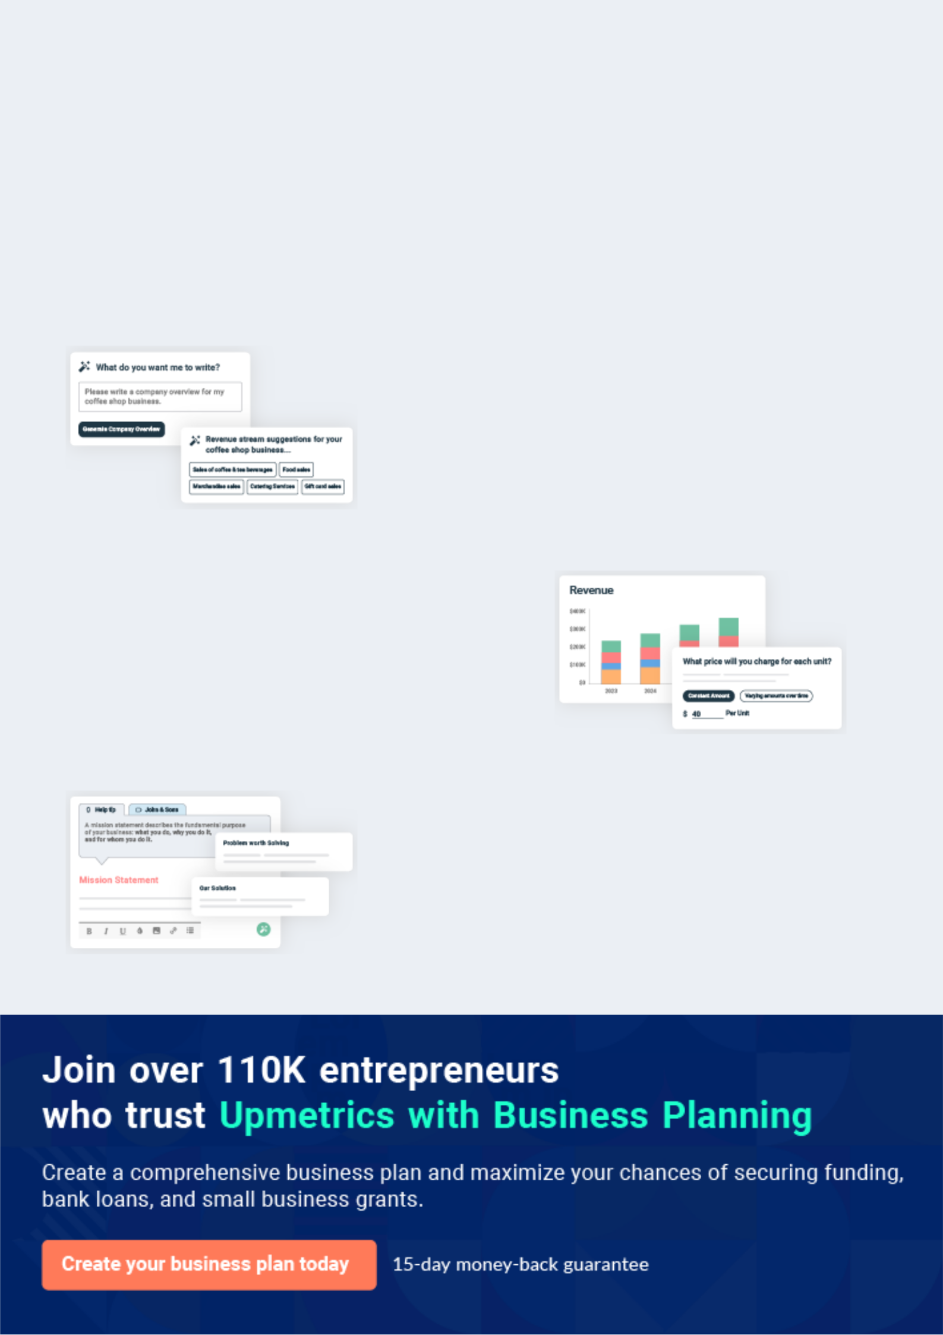
Business planning that’s simpler and faster than you think

Creating a business plan using Upmetrics to start and grow a business is literally the easiest thing in the World. Simply read the instructions and fill in the blanks. It’s as simple as that.

❛ | Upmetrics has everything you need to create a | ❜
❛ | comprehensive business plan. | ❜

AI-powered Upmetrics Assistant

AI-powered insights to streamline your plan

Not sure where to start? Upmetrics’ AI Assistant will automatically generate ideas for each section of your plan and offer improved versions of your writing, adjusting for tone, voice, and grammar or spelling errors.

Financial Forecasting Tool

All the financials are calculated for you

Forget the complex formulas and clumsy spreadsheets — with automatic financials and drag-and-drop forecasting, you can finish your plan faster and be confident that your numbers are accurate.

Business Plan Builder

Guides you like a business mentor

Upmetrics’ step-by-step instructions, prompts, and the library of 400+ sample business plans will guide you through each section of your plan as a business mentor.

1.


Executive summary

Problem Definition & Validation

Solution

Objectives

Mission statement

Keys to success

Financial Highlights

Plant Nursery | Business Plan [YEAR] 5/42

 Nature Box


Nature Box proposes to launch and expand a nursery business that grows and propagates plants and bulbs. The company will supply retail and wholesale businesses, landscapers,
councils, and other horticulture businesses, such as fruit and vegetable growers with pre-grown
To unlock help try Upmetrics! 

Start writing here..

Problem Definition & Validation

 Nature Box

Domestic growers often face price challenges brought forth from international markets. Many retailers continue to source cheap cut flowers from Kenya and the Netherlands, the largest sources of flowers in the United States. As flower and plant growth is fairly labor-intensive,
To unlock help try Upmetrics! 

Start writing here..

Solution

 Nature Box

A focus on organic flower growing will allow Nature Box to create a niche. Domestic consumers are placing more value on quality fresh-cut flowers cultivated without harmful pesticides or herbicides. The company will leverage this momentum by planting strong roots to spearhead
To unlock help try Upmetrics! 

Start writing here..

Plant Nursery | Business Plan [YEAR] 6/42

Objectives

 Nature Box

- To begin commercial operations in Jacksonville by Q1 2021

- To build a wide range of plants, bulbs, and flowers to meet the increasing market
requirement for organic produce | To unlock help try Upmetrics! 

Short Term (1 -3 Years)

Start writing here..

 Nature Box

• To gain a competitive edge within the country’s plant growing industry marketplace by establishing a brand that is synonym with locally grown and organic
• To explore GM of plants and how a variety of customization in crops can be achieved
To unlock help try Upmetrics! 

Long Term (3-5 years)

Start writing here..

Mission statement

 Nature Box

Our mission is to become a synonym with words like domestic, organic, custom grown, environmentally friendly, and sustainable. We are dedicated to providing a wide variety of plants, flowers, shrubs, fresh cuts, and trees for commercial and aesthetic purposes.
To unlock help try Upmetrics! 

Start writing here..

Plant Nursery | Business Plan [YEAR] 7/42

Keys to success

Automation



Minimising labour and employment costs through automation can boost productivity and efficiency. This enables Nature Box to deal with fierce foreign competition.


Aligned with market Trends


The ability to alter the balance between the industry’s crops and other agricultural products in response to changes in market conditions is important for a farm’s viability. Ensuring domestic produce helps make this possible for Nature Box



Access to Latest Technology

The latest technology can help profit margins and productivity, such as by maximizing water efficiency.

Appropriate climatic conditions

Climatic conditions can dictate the quality and type of plant or flower produced. Being based in Florida, where its warm all year round will significantly benefit the company.

Prompt delivery to market

The perishability of flowers and plants makes timely delivery imperative for all growers in the market. Nature Box' local operations will allow the company to ensure prompt delivery to market.

Premium goods/services

Through investments in GM, Nature Box can reach various niche markets by producing premium flowers and plants, for which customers are willing to pay a higher price. This can boost revenue and help the company mitigate growing import competition.

Plant Nursery | Business Plan [YEAR] 8/42

Financial Highlights

 Nature Box

The company envisions raising an equity investment of $50,000 through long-term borrowings, which will be used to set up and launch the business in the US. The company expects to maintain a gross margin of over 50% throughout the forecast period and steadily grow its
To unlock help try Upmetrics! 

Start writing here..

Nature Box - 5 Year Highlights
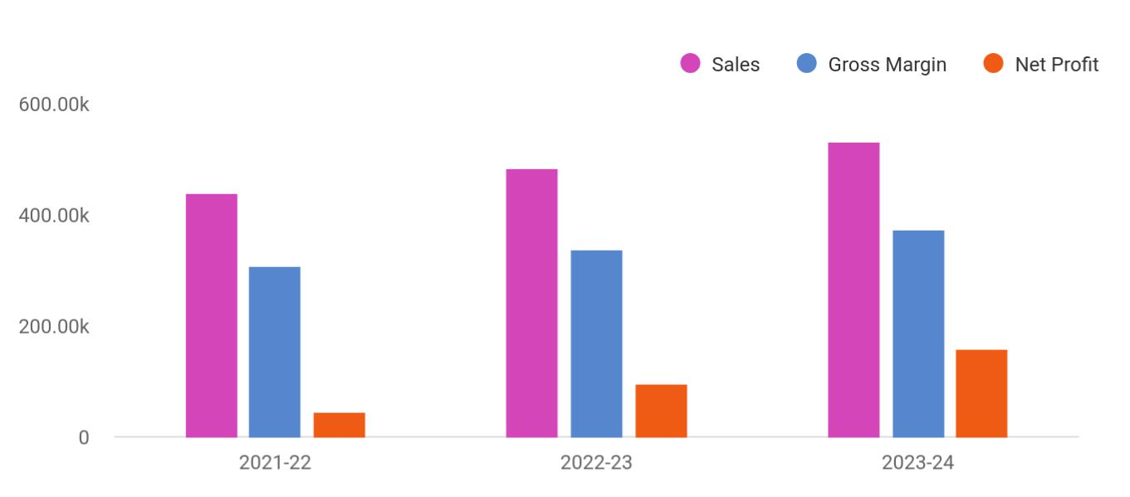

Financial Year | Sales | Gross Margin | Net Profit
2021-22 | 438,937 | 307,255.90 | 43,893.70
2022-23 | 482,830.70 | 337,981.49 | 96,566.14
2023-24 | 531,113.77 | 371,779.64 | 159,334.13

Plant Nursery | Business Plan [YEAR] 9/42

2.

Business overview

Company Ownership/Legal Entity

Location

Interior Operating Facilities

Hours of Operation

Startup summary

Plant Nursery | Business Plan [YEAR] 10/42

 Nature Box

Nature Box is a new plant nursery that is dedicated to providing quality, organic, locally grown, choices for individuals looking for plants as well as designers and landscapers looking for a reliable source for products. Nature Box will grow and propagate a variety of plants, trees,
To unlock help try Upmetrics! 

Start writing here..

Company Ownership/Legal Entity

 Nature Box

The company will be registered as a limited liability entity with the Department of State. Further, since the company envisions setting up operations in Florida, it will also register with the local county. The business will be wholly owned and managed by the Founder Mr. Grant, who will
To unlock help try Upmetrics! 

Start writing here..

Location

 Nature Box

Location is vital for the successful operation of Nature Box. Ideal weather conditions and connectivity are key to ensure the quality and cost-efficiency of products.
To unlock help try Upmetrics! 

Start writing here..

Plant Nursery | Business Plan [YEAR] 11/42

Interior Operating Facilities
To unlock help try Upmetrics!

 Nature Box

Nature Box will be required to purchase automated potting equipment with the intention of reducing labor costs and increasing production. Also required is the construction of heated
greenhouses to safely out weather crops. The greenhouses must be large enough to allow the
To unlock help try Upmetrics! 

Start writing here..

Hours of Operation

 Nature Box

Nature Box will operate an 8-hour workday from 9 am to 5 pm. However, since the company will be required to manage the crops and ensure their safety, a security detail will be added to make sure there is a watch at all times.



Start writing here..

Startup summary

 Nature Box

The Founder will infuse a capital sum of $1,200,000 into the company. Approximately £92,350 will be spent on a range of start-up expenses such as marketing, advertising, and professional fees. At the same time, another £602,000 will be earmarked for sales tax payment and the
To unlock help try Upmetrics! 

Start writing here..

Plant Nursery | Business Plan [YEAR] 12/42

3.

Products & Services

Product classification

Plant Nursery | Business Plan [YEAR] 13/42

 Nature Box

Nature Box plans to offer a wide variety of bedding plants, shrubs, trees, vegetable plants, and garden plants. The company will carry a number of seasonal and year-round (perennial) species. Nature Box will sell to both individual customers and landscape contractors. The
To unlock help try Upmetrics! 

Start writing here..

Product classification

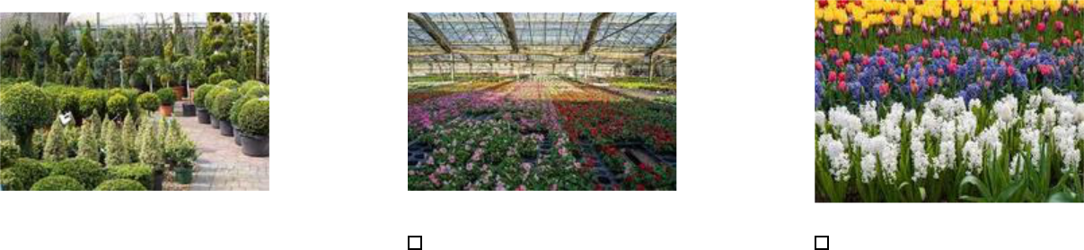

Hardy Nursery Stock | Protected Ornamentals | Bulbs and Outdoor Flowers
This segment includes shrubs | pot plants, pack bedding and | daffodil bulb, forced bulbs and
and climbers, ornamental trees | indoor cut flowers. | other bulb crops like tulips and
and hedging. |  | gladioli. Narcissi, or daffodils,

 Nature Box

Hardy nursery stock is the largest product segment in the industry by a considerable margin, accounting for an estimated 65.8% of the company's revenue. This segment includes shrubs
and climbers, ornamental trees, and hedging. Plants in this segment are grown using a range of
To unlock help try Upmetrics! 

Hardy Nursery Stock

Start writing here..

Plant Nursery | Business Plan [YEAR] 14/42

 Nature Box

Protected ornamentals comprise the second-largest product segment, generating an estimated 30.4% of the company's revenue mix. This segment encompasses the production of protected pot plants, pack bedding, and indoor cut flowers. The share of revenue generated from this
To unlock help try Upmetrics! 

Protected Ornamentals

Start writing here..

 Nature Box

Bulbs and outdoor flowers are the smallest product segment in the industry, generating an estimated 3.8% of the company's revenue. This segment includes daffodil bulbs, forced bulbs, and other bulb crops like tulips and gladioli. Narcissi, or daffodils, represent approximately half
To unlock help try Upmetrics! 

Bulbs and Outdoor Flowers

Start writing here..

Plant Nursery | Business Plan [YEAR] 15/42

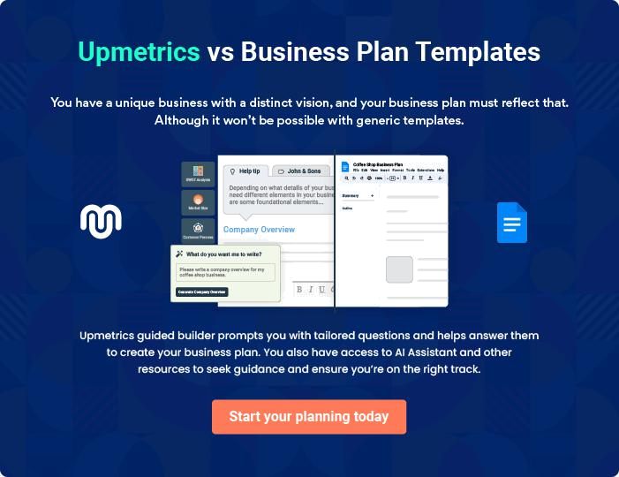

Plant Nursery | Business Plan [YEAR] | 16/42

4.

Market Analysis

Market segmentation

Market Trends

Target market

Plant Nursery | Business Plan [YEAR] 17/42

 Nature Box

The market size of the plant and flower growing sector in the United States reached 15.34 billion U.S. dollars in 2020, reflecting an increase over the previous year's size of 15.29 billion U.S. dollars. The sector was forecast to increase by 1.8 percent in 2021 (Source: Statista).
To unlock help try Upmetrics! 

Start writing here..

Market segmentation

 Nature Box

Although the market for flowers and plants is highly variegated, with a number of niches, there are four distinct major downstream markets. Wholesalers, including specialized packing companies, comprise the first, while retailers, exports, and trade with other flower and plant
To unlock help try Upmetrics! 

Start writing here..

 Nature Box

Wholesalers are the largest downstream market for the industry, accounting for an estimated 56.8% of industry revenue. This segment includes specialized packing companies that facilitate packing, grading, and sales between growers and supermarkets. Most florists purchase flowers
To unlock help try Upmetrics! 

Wholesalers

Start writing here..

 Nature Box

Retailers are the second-largest downstream market for flower and plant growers. Retailers contribute approximately 34.7% of industry revenue making them an important outlet. The retail market has three main subdivisions: independent florists, supermarkets, and garden centers or
To unlock help try Upmetrics! 

Retailors

Start writing here..

Plant Nursery | Business Plan [YEAR] 18/42

 Nature Box

It is fairly common for nurseries to sell to other growers for propagation or reseeding. This involves expanding flower and plant ranges between growers. This trade is estimated to account for 8.5% of industry revenue and has remained steady over the past five years. This
To unlock help try Upmetrics! 

Flower and Plant Growers

Start writing here..

Market Trends

 Nature Box

Flowers and plants are discretionary purchases, demand for which is broadly affected by levels of disposable income. A significant number of households have gardens and living spaces, which supports rising demand during periods of rising disposable income as people plant in
To unlock help try Upmetrics! 

Start writing here..

Target market

 Nature Box

Nature Box will strive to become an active choice of homeowners, wholesalers, and landscapers across the United States. Residential property owners will find the range of options available with the company attractive. Furthermore, a one-stop shop for all gardening
To unlock help try Upmetrics! 

Start writing here..

Plant Nursery | Business Plan [YEAR] 19/42

Competitive Advantage


Price

Automation in planting will help the company reduce its input costs which will reflect in its competitive pricing strategy

Organic

All of the company's offering are free of pesticides and other harmful chemical making them 100% organic

Genetic Mutation

Innovation in plants through genetic mutation will allow the company to offer a wider variety of plants

Range of Plants

The company will ensure stocking a wide selections of plants from shrubs and bulbs to flowering plants and trees

Plant Nursery | Business Plan [YEAR] 20/42

5.

SWOT analysis

Plant Nursery | Business Plan [YEAR] 21/42

 Nature Box

A SWOT (Strength, Weakness, Opportunity, and Threat) analysis is a useful tool for businesses to evaluate their position in the market against the potential internal and external factors that could assist or jeopardize their operations and existence. A SWOT has been conducted for PYT
To unlock help try Upmetrics! 

Start writing here..


Strength

- The company benefits from extensive insight and market expertise.

- The flexible and robust range of products ensures the company's capabilities to cater to a more significant market share.

- The company is based in Florida, which contains the right weather conditions to support year-round growth

- Strategic collaborations with agriculture and horticulturists enrich the products of the company with leading industry experts and technology experts to support genetic mutation


Weakness

- An increasing number of competitors within the industry leads to market share erosion.

- The company is relatively new to the US market, in which seasoned players dominate.

- The high rate of competition within the industry and the fragmented nature of the market makes the sector price sensitive.


Opportunity

- Partnering with leading horticulturist providers to extend their market offering

- Mr. Grant’s skill in tactfully combining customer relationship management and supply networks to achieve an organizational goal opens up opportunities within challenging and risk intensive markets

- The company possess the capabilities to extend its offerings globally

Threat

- Competitors eroding the market

- Low barriers to entry

- Competitors poaching B2B clients

- Any change in the trading regulations of the country will impact the operations of the company

Plant Nursery | Business Plan [YEAR] 22/42

6.

Strategy & implementation

Marketing and Promotion Programs

Positioning Statement

Sales strategy

Pricing strategy

Plant Nursery | Business Plan [YEAR] 23/42

 Nature Box
To unlock help try Upmetrics!

The company will predominantly rely on online advertising and lead generation strategies as many seeking logistic services first search online for information. As such, a full-fledged online marketing campaign will be launched inclusive of paid, social media, and website campaigns.
To unlock help try Upmetrics! 

Start writing here..

Marketing and Promotion Programs

 Nature Box

Nature Box will approach potential commercial clients directly, either through cold-calling or e-mail to arrange pitch meetings. The company’s sales representatives will use these opportunities to display the product catalog directly.



Direct Sales

Start writing here..

 Nature Box

The Company will advertise in specific trade publications that are targeted towards the appropriate target markets.
To unlock help try Upmetrics! 

Trade Publications

Start writing here..

 Nature Box

Euro Trucks will establish a presence at various trade shows that are relevant to the target market. For example, the Multimodal event (www.multimodal.org) is an annual exhibition that is considered the US’s premier freight transport, logistics, and supply chain management event.
To unlock help try Upmetrics! 

Trade shows

Start writing here..

Plant Nursery | Business Plan [YEAR] 24/42

 Nature Box

The Company will operate a professional and compelling website dedicated to landscape artists, contractors, and residential property owners
To unlock help try Upmetrics! 

Website

Start writing here..

 Nature Box

The focus will be on Google Ads, which are more likely to drive commercial leads than other online advertising platforms (such as Facebook). The advertising will target specific keywords relevant to Nature Box’s offering (e.g. “organic garden plants”, "landscape plants” etc.).
To unlock help try Upmetrics! 

Targeted Online Advertising

Start writing here..

Positioning Statement

 Nature Box

The company seeks to carve a niche for its products in the US market by capitalizing on its homegrown, organic plant grower brand. Consumers are embracing more natural, locally sourced flowers with fewer air miles. Leveraging this trend, the company will continue to
To unlock help try Upmetrics! 

Start writing here..

Sales strategy

 Nature Box

Residential property owners, landscape artists, wholesalers, and building contractors form the company’s primary target market. While push marketing efforts will be deployed to reach these companies and make them aware of the range of services provided, pull marketing efforts will
To unlock help try Upmetrics! 

Plant Nursery | Business Plan [YEAR] 25/42

Start writing here..

Online Marketing Channels


Electronic Direct Mail

Marketing

Landscape artists and contractors looking for a variety of plants will stand out prominently as viable marketing targets for this channel. Nature Box will mail professionally designed materials with its value proposition to these companies and provide quotes for its range of plants and flowers

Social Media

Millennials and consumers in general spend a considerable time browsing social media platforms. Reaching to them through this channel will be and effective way to capture

attention and position its services.

Google Ad Campaigns

The advertising will target

specific keywords relevant to

Nature Box's offering (e.g. “organic garden plants”, "landscape plants” etc.).

Plant Nursery | Business Plan [YEAR] 26/42

Offline Marketing Channels


Networking | Referral | Conferences
Participate in leading | The company will offer referral | The company will participate in
consumers exhibitions and | discounts and packaged | leading conferences and make
beauty events. Display a range | services to valued, regular | their presence known through
of samples and distribute | clients | marketing materials and
flyers at these events. The |  | presentations
company will also keep a
record of visitors to their stalls
as leads for its email
marketing campaigns.

Pricing strategy

 Nature Box


Products | Cost | Selling Price |  | Gross margin
Hardy Nursery Stock | $1.85 | $3.50 |  | $1.65
 |  |  |  | To unlock help try Upmetrics! 

Start writing here..

Plant Nursery | Business Plan [YEAR] 27/42

7.

Operational Plan

Management Team

Personnel Plan

Milestones

Plant Nursery | Business Plan [YEAR] 28/42

 Nature Box
To unlock help try Upmetrics!

The team will be headed by Managing Director Mr. Grant who will also oversee the company's operations. Joining Mr. Grant in the Management Team, the company will onboard an office, sales, potting, and shipping staff.



Start writing here..

Organization chart


Mr Grant

Managing

Director


Jane Doe  John Doe  John Doe  Jane Doe
Sales Staff Office Staff Potting Staff Shipping Staff

Management Team

 Nature Box

Mr. Grant counts 20 years of administrative and management experience, taking on various business development activities during the period. His ability to attract key players and build strong and lasting business relationships enabled her to grow in capacity and responsibility.
To unlock help try Upmetrics! 

Start writing here..

Plant Nursery | Business Plan [YEAR] 29/42

Personnel Plan

 Nature Box

The company plans to create two full-time equivalent jobs within the first five years of operations.
To unlock help try Upmetrics! 

Start writing here..

Hiring plan

20 |  |  | 5 |  |  |  |  | 25
Filled |  |  | Hired |  |  |  |  | Open
Group By | Position Filled |  |  |  | Time of Hire |  |  | Time of Start |  | Filled On Time
Department |  |  |  |  |  |  |  |  |  | Filled On Time
Sales Staff |  | 1 of 20 |  |  | 10 days |  |  | 121 days |  | 100%
Office Staff |  | 3 of 23 |  |  | 30 days |  |  | 21 days |  | 80%
Potting Staff |  | 4 of 15 |  |  | 158 days |  |  | 127 days |  | 0%
Shipping Staff |  | 5 of 20 |  |  | 149 days |  |  | 136 days |  | 100%

Plant Nursery | Business Plan [YEAR] 30/42

Milestones

Nature Box


Establish

Nature Box will rent a property to set up its

office, greenhouse facility and retail outlet.

Additionally the company will engage in

aggressive marketing activities to ensure

its organic brand is well known at the onset



 | Gain Market Traction
Year 2 | The company will begin expanding its
Year 2 | services beyond Florida to cover other
 | regions around the US.


Diversify

Having externally established the business,

the company will begin internally expanding

its products by exploring genetic mutation

of plants


YEAR 1

Year 3

Grow

>Year3 • Begin expanding across the US

• Consider market expansion beyond US


Plant Nursery | Business Plan [YEAR] 31/42

8.

Financial plan

Important Assumptions

Brake-even Analysis

Projected Profit and Loss

Projected Cash Flow

Projected Balance Sheet

Business Ratios

Plant Nursery | Business Plan [YEAR] 32/42


If you are going to start your own plant nursery business, then make sure you will pay special attention to your financial plan. Your financial plan should include the details about how well you manage your incomes and expenses,
To unlock help try Upmetrics! 

Important Assumptions

The company’s financial projections are forecasted on the basis of the following assumptions. These assumptions are quite conservative and are also expected to show deviation but to a limited level such that the company’s major financial strategy will not be affected.

 | Year 1 | Year 2 | Year 3
Plan Month | 1 | 2 | 3
Current Interest Rate | 10,00% | 11,00% | 12,00%
Long-term Interest Rate | 10,00% | 10,00% | 10,00%
Tax Rate | 26,42% | 27,76% | 28,12%
Other | 0 | 0 | 0

Brake-even Analysis

Monthly Units Break-even | 5530
Monthly Revenue Break-even | $159 740
Assumptions:
Average Per-Unit Revenue | $260,87
Average Per-Unit Variable Cost | $0,89
Estimated Monthly Fixed Cost | $196 410

Plant Nursery | Business Plan [YEAR] 33/42

Projected Profit and Loss

 | 2024 | 2025 | 2026
Revenue | $389,976.37 | $700,342.86 | $1,257,708.06
Plant Sales | $159,171.40 | $285,849.20 | $513,343.20
Unit Sales | 7,959 | 14,292 | 25,667
Unit Price | $20 | $20 | $20
Gardening Services | $222,846.40 | $400,201.20 | $718,697.70
Unit Sales | 3,184 | 5,717 | 10,267
Unit Price | $70 | $70 | $70
Gardening Workshops | $7,958.57 | $14,292.46 | $25,667.16
Cost Of Sales | $33,544.52 | $53,453.05 | $88,344.73
General Costs | $33,544.52 | $53,453.05 | $88,344.73
Plant Growing Costs | $18,040.53 | $28,155.63 | $45,782.76
Seed Purchase | $6,341.24 | $7,145.34 | $8,051.52
Soil and Fertilizer | $11,699.29 | $21,010.29 | $37,731.24
Gardening Supply Costs | $15,503.99 | $25,297.42 | $42,561.97
Gardening Tools | $3,804.70 | $4,287.13 | $4,830.73
Plant Pots | $11,699.29 | $21,010.29 | $37,731.24
Revenue Specific Costs | $0 | $0 | $0
Personnel Costs (Direct | $0 | $0 | $0
Labor) | $0 | $0 | $0
Gross Margin | $356,431.85 | $646,889.81 | $1,169,363.33
Gross Margin (%) | 91.40% | 92.37% | 92.98%

Plant Nursery | Business Plan [YEAR] 34/42

 | 2024 | 2025 | 2026
Operating Expense | $450,316.16 | $487,597.29 | $522,705.63
Payroll Expense (Indirect | $377,064 | $386,922.48 | $397,047.72
Labor) | $377,064 | $386,922.48 | $397,047.72
Sales Team | $126,600 | $130,398 | $134,310
Sales Manager | $57,600 | $59,328 | $61,107.84
Sales Representatives | $69,000 | $71,070 | $73,202.16
Nursery Staff | $139,104 | $142,390.08 | $145,757.16
Gardeners | $88,704 | $90,478.08 | $92,287.80
Nursery Manager | $50,400 | $51,912 | $53,469.36
Administrative Staff | $111,360 | $114,134.40 | $116,980.56
Accountant | $54,720 | $56,361.60 | $58,052.40
Administrative Assistants | $56,640 | $57,772.80 | $58,928.16
General Expense | $60,257.36 | $76,674.81 | $101,657.91
Facility Expenses | $37,064.28 | $49,592.10 | $69,937.77
Rent | $25,364.99 | $28,581.81 | $32,206.53
Utilities | $11,699.29 | $21,010.29 | $37,731.24
Marketing and Advertising | $10,510.67 | $12,791.87 | $15,616.86
Online Advertising | $6,705.97 | $8,504.74 | $10,786.13
Print Advertising | $3,804.70 | $4,287.13 | $4,830.73
Operational Costs | $12,682.41 | $14,290.84 | $16,103.28
Transportation | $10,145.95 | $11,432.68 | $12,882.69
Office Supplies | $2,536.46 | $2,858.16 | $3,220.59
Bad Debt | $0 | $0 | $0
Amortization of Current | $12,994.80 | $24,000 | $24,000
Assets | $12,994.80 | $24,000 | $24,000

Plant Nursery | Business Plan [YEAR] 35/42

EBITDA

Additional Expense

Long Term Depreciation

Gain or loss from Sale of Assets

EBIT

Interest Expense

EBT

Income Tax Expense / Benefit

2024 | 2025 | 2026
($93,884.31) | $159,292.52 | $646,657.70

$8,284.80 | $6,041.24 | $3,635.49
$2,268 | $2,268 | $2,268
$0 | $0 | $0
($96,152.31) | $157,024.52 | $644,389.70
$6,016.82 | $3,773.25 | $1,367.48
($102,169.11) | $153,251.28 | $643,022.21
$0 | $0 | $0

Total Expense | $492,145.48 | $547,091.58 | $614,685.85
Net Income | ($102,169.11) | $153,251.28 | $643,022.21
Net Income (%) | (26.20%) | 21.88% | 51.13%

Retained Earning Opening | $0 | ($122,169.11) | $11,082.17
Owner's Distribution | $20,000 | $20,000 | $20,000
Retained Earning Closing | ($122,169.11) | $11,082.17 | $634,104.38

Plant Nursery | Business Plan [YEAR] 36/42

Projected Cash Flow

 | 2024 | 2025 | 2026
Cash Received | $389,976.37 | $700,342.86 | $1,257,708.06
Cash Paid | $476,882.68 | $520,823.58 | $588,417.85
COS & General Expenses | $93,801.88 | $130,127.86 | $190,002.64
Salary & Wages | $377,064 | $386,922.48 | $397,047.72
Interest | $6,016.82 | $3,773.25 | $1,367.48
Sales Tax | $0 | $0 | $0
Income Tax | $0 | $0 | $0
Net Cash From | ($86,906.31) | $179,519.28 | $669,290.21
Operations | ($86,906.31) | $179,519.28 | $669,290.21
Assets Sell | $0 | $0 | $0
Assets Purchase | $54,000 | $24,000 | $24,000
Net Cash From | ($54,000) | ($24,000) | ($24,000)
Investments | ($54,000) | ($24,000) | ($24,000)
Amount Received | $150,000 | $0 | $0
Loan Received | $100,000 | $0 | $0
Common Stock | $0 | $0 | $0
Preferred Stock | $0 | $0 | $0
Owner's Contribution | $50,000 | $0 | $0
Amount Paid | $51,035.72 | $53,279.28 | $55,685.02
Loan Capital | $31,035.70 | $33,279.27 | $35,685.03
Dividends & Distributions | $20,000 | $20,000 | $20,000
Net Cash From | $98,964.28 | ($53,279.28) | ($55,685.02)
Financing | $98,964.28 | ($53,279.28) | ($55,685.02)

Plant Nursery | Business Plan [YEAR] 37/42

 | 2024 | 2025 | 2026
Summary
Starting Cash | $0 | ($41,942.03) | $60,297.97
Cash In | $539,976.37 | $700,342.86 | $1,257,708.06
Cash Out | $581,918.40 | $598,102.86 | $668,102.87
Change in Cash | ($41,942.03) | $102,240 | $589,605.19
Ending Cash | ($41,942.03) | $60,297.97 | $649,903.16
Projected Balance Sheet
 | 2024 | 2025 | 2026
Assets | ($3,204.83) | $96,767.17 | $684,104.36
Current Assets | ($30,936.83) | $71,303.17 | $660,908.36
Cash | ($41,942.03) | $60,297.97 | $649,903.16
Accounts Receivable | $0 | $0 | $0
Inventory | $0 | $0 | $0
Other Current Assets | $11,005.20 | $11,005.20 | $11,005.20
Long Term Assets | $27,732 | $25,464 | $23,196
Gross Long Term Assets | $30,000 | $30,000 | $30,000
Accumulated Depreciation | ($2,268) | ($4,536) | ($6,804)
Liabilities & Equity | ($3,204.82) | $96,767.19 | $684,104.38
Liabilities | $68,964.29 | $35,685.02 | $0
Current Liabilities | $33,279.27 | $35,685.02 | $0
Accounts Payable | $0 | $0 | $0
Income Tax Payable | $0 | $0 | $0

Plant Nursery | Business Plan [YEAR] 38/42

 | 2024 |  |  | 2025 |  | 2026
Sales Tax Payable | $0 |  |  | $0 |  | $0
Short Term Debt | $33,279.27 |  | $35,685.02 |  |  | $0
Long Term Liabilities | $35,685.02 |  |  | $0 |  | $0
Long Term Debt | $35,685.02 |  |  | $0 |  | $0
Equity | ($72,169.11) |  | $61,082.17 |  |  | $684,104.38
Paid-in Capital | $0 |  |  | $0 |  | $0
Common Stock | $0 |  |  | $0 |  | $0
Preferred Stock | $0 |  |  | $0 |  | $0
Owner's Contribution | $50,000 |  |  | $50,000 |  | $50,000
Retained Earnings | ($122,169.11) |  | $11,082.17 |  |  | $634,104.38
Check | $0 |  |  | $0 |  | $0
Business Ratios
 |  | Year 1 | Year 2 |  | Year 3 | Industry profile
Sales Growth |  | 4,35% | 30,82% |  | 63,29% | 4,00%
Percent of Total Assets
Accounts Receivable |  | 5,61% | 4,71% |  | 3,81% | 9,70%
Inventory |  | 1,85% | 1,82% |  | 1,79% | 9,80%
Other Current Assets |  | 1,75% | 2,02% |  | 2,29% | 27,40%
Total Current Assets |  | 138,53% | 150,99% |  | 163,45% | 54,60%
Long-term Assets |  | -9,47% | -21,01% |  | -32,55% | 58,40%
TOTAL ASSETS |  | 100,00% | 100,00% |  | 100,00% | 100,00%
Current Liabilities |  | 4,68% | 3,04% |  | 2,76% | 27,30%
Long-term Liabilities |  | 0,00% | 0,00% |  | 0,00% | 25,80%
Total Liabilities |  | 4,68% | 3,04% |  | 2,76% | 54,10%

Plant Nursery | Business Plan [YEAR] 39/42

 | Year 1 | Year 2 | Year 3 | Industry profile
NET WORTH | 99,32% | 101,04% | 102,76% | 44,90%
Percent of Sales
Sales | 100,00% | 100,00% | 100,00% | 100,00%
Gross Margin | 94,18% | 93,85% | 93,52% | 0,00%
Selling, General & Administrative Expenses | 74,29% | 71,83% | 69,37% | 65,20%
Advertising Expenses | 2,06% | 1,11% | 0,28% | 1,40%
Profit Before Interest and Taxes | 26,47% | 29,30% | 32,13% | 2,86%
Main Ratios
Current | 25,86 | 29,39 | 32,92 | 1,63
Quick | 25,4 | 28,88 | 32,36 | 0,84
Total Debt to Total Assets | 2,68% | 1,04% | 0,76% | 67,10%
Pre-tax Return on Net Worth | 66,83% | 71,26% | 75,69% | 4,40%
Pre-tax Return on Assets | 64,88% | 69,75% | 74,62% | 9,00%
Additional Ratios
Net Profit Margin | 19,20% | 21,16% | 23,12% | N.A.
Return on Equity | 47,79% | 50,53% | 53,27% | N.A.
Activity Ratios
Accounts Receivable Turnover | 4,56 | 4,56 | 4,56 | N.A.
Collection Days | 92 | 99 | 106 | N.A.
Inventory Turnover | 19,7 | 22,55 | 25,4 | N.A.
Accounts Payable Turnover | 14,17 | 14,67 | 15,17 | N.A.
Payment Days | 27 | 27 | 27 | N.A.
Total Asset Turnover | 1,84 | 1,55 | 1,26 | N.A.
Debt Ratios
Debt to Net Worth | 0 | -0,02 | -0,04 | N.A.
Current Liab. to Liab. | 1 | 1 | 1 | N.A.
Liquidity Ratios
Net Working Capital | $120 943 | $140 664 | $160 385 | N.A.

Plant Nursery | Business Plan [YEAR] 40/42

 | Year 1 | Year 2 | Year 3 | Industry profile
Interest Coverage | 0 | 0 | 0 | N.A.
Additional Ratios
Assets to Sales | 0,45 | 0,48 | 0,51 | N.A.
Current Debt/Total Assets | 4% | 3% | 2% | N.A.
Acid Test | 23,66 | 27,01 | 30,36 | N.A.
Sales/Net Worth | 1,68 | 1,29 | 0,9 | N.A.
Dividend Payout | 0 | 0 | 0 | N.A.
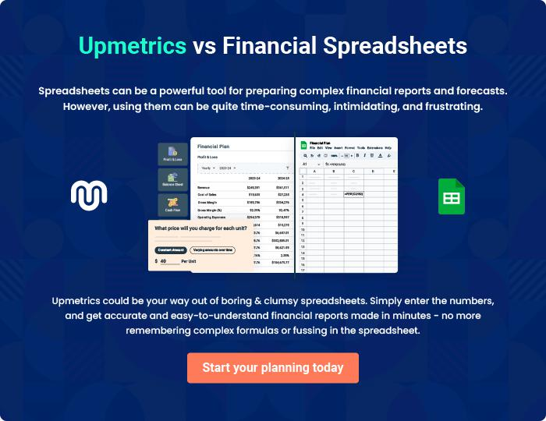

Plant Nursery | Business Plan [YEAR] 41/42


Create a winning business plan that gets you funded

Creating a stunning and investment-ready plan requires no writing, graphic designing, or financial planning expertise.

Upmetrics has all the features required to help you create a comprehensive business plan—from start to finish. Make no mistakes, it’s the modern way of planning to structure ideas, make plans, and create stunning pitch decks to awe investors.

Pitch decks that impress investors

Create pitch decks that provide a visual representation of your business, engage investors, and make them want to invest in your business idea.

Interactive plans in no time

Import business plan sections like—SWOT analysis, comparison tables, and others to create an interactive business plan. No designing skills are required.

Stunning cover page designs

With Upmetrics, you have the liberty to choose from multiple stunning cover page designs. Choose a creative design and make your plan stand out.

Online sharing made simple

Upmetrics makes online sharing quick and easier for users. Easily share your business plans with a link while tracking reader activity.

500+ sample business plans

Simply import a template from our library of sample plans into the editor and start customizing it to make it yours. It takes only a few clicks to get started.

Collaborate with team in real-time

Invite team members, initiate conversations, discuss ideas & strategies, share feedback, and work on a business plan in real-time.

