
BUSINESS PLAN

[YEAR]

Pharmacy Store

Bringing the medicine at your door

John Doe

10200 Bolsa Ave, Westminster, CA, 92683

- 359-3153 info@example.com http://www.example.com

Information provided in this business plan is unique to this business and confidential; therefore, anyone reading this plan agrees not to disclose any of the information in this business plan without prior written permission of the Company
Table of Contents

Executive Summary | 5
Objectives | 6
Mission | 6
Keys to Success | 7
Financial Summary | 7
Net Profit | 7

Company Summary | 8
Business Ownership | 9
Start-up Summary | 9
Summary Chart | 11

Products & Services | 12
Business Model Description | 13
Market Analysis
Market Analysis | 15
Market Segmentation | 16
Mail order customers | 16
Walk-in customers | 16
Target Market Analysis | 17
Target Market Segment Strategy | 17
Strategy and Implementation
Strategy and Implementation | 18
Competitive Edge | 19
Marketing Strategy | 19
Sales Strategy | 19
Sales Forecast | 20
Milestones | 21

Pharmacy Store | Business Plan [YEAR] 2/35

Web Plan | 22
Development Requirements | 23
Management
Management | 24
Personnel Plan | 25
Financial Plan
Financial Plan | 26
Important Assumptions | 27
Break-even Analysis | 27
Projected Profit and Loss | 28
Projected Cash Flow | 31
Balance Sheet | 32

Pharmacy Store | Business Plan [YEAR] 3/35

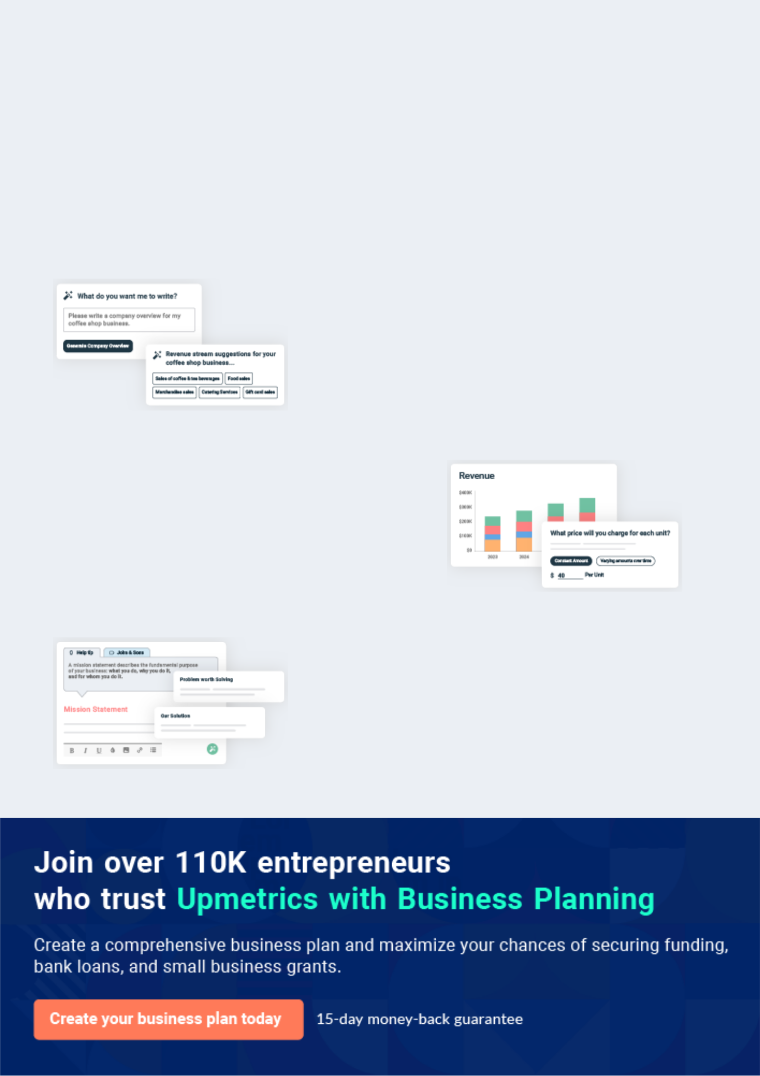
Business planning that’s simpler and faster than you think

Creating a business plan using Upmetrics to start and grow a business is literally the easiest thing in the World. Simply read the instructions and fill in the blanks. It’s as simple as that.

❛ | Upmetrics has everything you need to create a | ❜
❛ | comprehensive business plan. | ❜

AI-powered Upmetrics Assistant

AI-powered insights to streamline your plan

Not sure where to start? Upmetrics’ AI Assistant will automatically generate ideas for each section of your plan and offer improved versions of your writing, adjusting for tone, voice, and grammar or spelling errors.

Financial Forecasting Tool

All the financials are calculated for you

Forget the complex formulas and clumsy spreadsheets — with automatic financials and drag-and-drop forecasting, you can finish your plan faster and be confident that your numbers are accurate.

Business Plan Builder

Guides you like a business mentor

Upmetrics’ step-by-step instructions, prompts, and the library of 400+ sample business plans will guide you through each section of your plan as a business mentor.

1.


Executive Summary

Objectives

Mission

Keys to Success

Financial Summary

Pharmacy Store | Business Plan [YEAR] 5/35

 GoodRx
To unlock help try Upmetrics!


GoodRx Pharmacy's main goal is to provide prescription medications for our customers at the lowest prices on the market. We will be able to sell prescriptions at reduced prices by carefully maintaining efficiencies in our operations and by targeting a specific segment of the market -
To unlock help try Upmetrics! 

Start writing here..

Objectives

 GoodRx

The objectives for the first three years include:

1. Exceed customer expectations with superior pricing
To unlock help try Upmetrics! 

Start writing here..

Mission

 GoodRx

GoodRx Pharmacy's mission is to provide our customers with the best prices for their prescription medications. Our convenience and services will exceed the expectations of our customers.



Start writing here..

Pharmacy Store | Business Plan [YEAR] 6/35

Keys to Success

 GoodRx

The keys to success are:

• Satisfy our customers so they will return again and again
To unlock help try Upmetrics! 

Start writing here..

Financial Summary

Net Profit
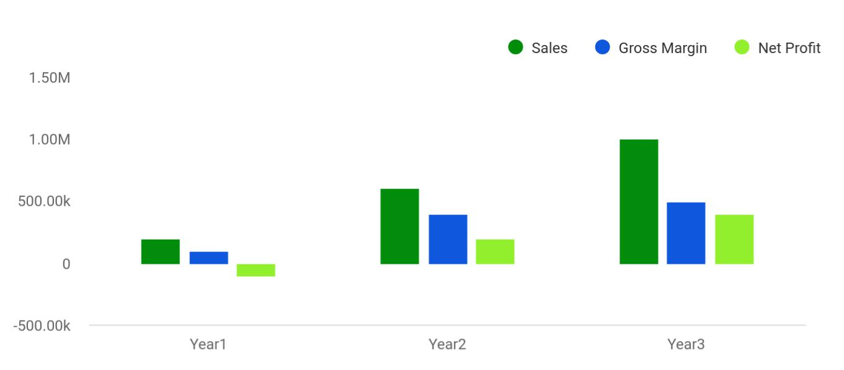

Financial Year | Sales | Gross Margin | Net Profit
Year1 | 200,000 | 100,000 | -100,000
Year2 | 600,000 | 400,000 | 200,000
Year3 | 1,000,000 | 500,000 | 400,000

Pharmacy Store | Business Plan [YEAR] 7/35

2.

Company Summary

Business Ownership

Start-up Summary

Pharmacy Store | Business Plan [YEAR] 8/35

 GoodRx

The GoodRx Pharmacy is located in Portland and offers prescription medications at discount prices to our customers by mail order or at the storefront.
To unlock help try Upmetrics! 

Start writing here..

Business Ownership

 GoodRx

The GoodRx Pharmacy is an Oregon limited liability corporation. The majority of the stockholder is John Redleaf.
To unlock help try Upmetrics! 

Start writing here..

Start-up Summary

The GoodRx Pharmacy will incur the following start-up equipment costs:

- Office equipment including chairs, file cabinets, and desks.

- Front counter, storage bins, cash register.

- Three computer terminals.

- Main computer server with a laser printer, and back-up system.

- Software: Microsoft Office, QuickBooks Pro, drug interaction software, Physician Desk Reference software detailing side effects, and other information pertinent to the customer.

- Assorted boxes for shipment.

- Scales for shipping.

Please note that these items will be used for more than one year and will, therefore, be labeled long-term assets, depreciated using G.A.A.P. approved straight-line depreciation.
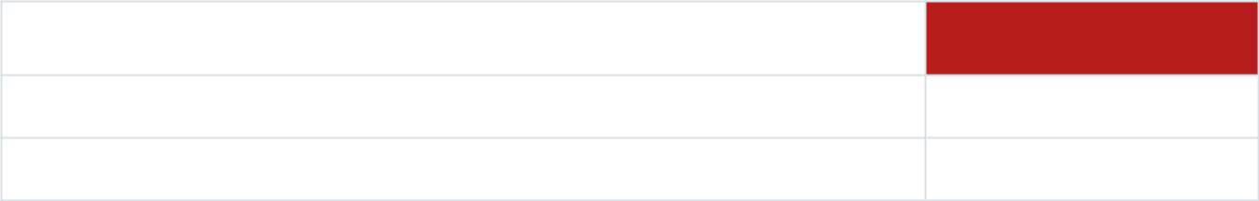

Start-up Expenses

Legal

Website development

Amount

$1,000

$1,000

Pharmacy Store | Business Plan [YEAR] 9/35

Start-up Expenses | Amount
Total Start-up Expenses | $2,000
Start-up Assets Needed
Cash Balance on Starting Date | $140,500
Other Current Assets | $0
Total Current Assets | $140,500
Long-term Assets | $8,500
Total Assets | $149,000
Total Requirements | $151,000
Funding
Investment
Seed Funding | $50,000
John | $51,000
Friends and Family | $50,000
Total Investment | $151,000
Current Liabilities
Accounts Payable | $0
Current Borrowing | $0
Other Current Liabilities | $0
Current Liabilities | $0
Long-term Liabilities | $0
Total Liabilities | $0
Loss at Start-up | ($2,000)
Total Capital | $149,000
Total Capital and Liabilities | $149,000

Pharmacy Store | Business Plan [YEAR] 10/35

Summary Chart
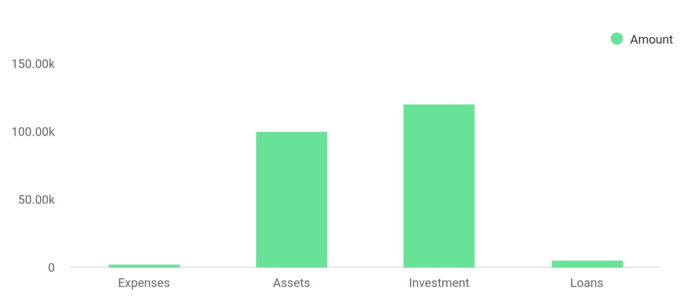

Summary | Amount
Expenses | 2,000
Assets | 100,000
Investment | 120,000
Loans | 5,000

Pharmacy Store | Business Plan [YEAR] 11/35

3.

Products & Services

Business Model Description

Pharmacy Store | Business Plan [YEAR] 12/35

 GoodRx

The GoodRx Pharmacy offers a wide range of prescription drugs to patients based in Oregon or nationally. Both generics and name brands are offered.
To unlock help try Upmetrics! 

Start writing here..

Business Model Description

 GoodRx

In order for a customer to purchase medications mail order, they must first contact The GoodRx Pharmacy over the phone. The customer then needs to either mail in the prescription, fax it, or email it. Once it is received and payment arrangements are complete, the meds will be sent out
To unlock help try Upmetrics! 

Start writing here..

Pharmacy Store | Business Plan [YEAR] 13/35

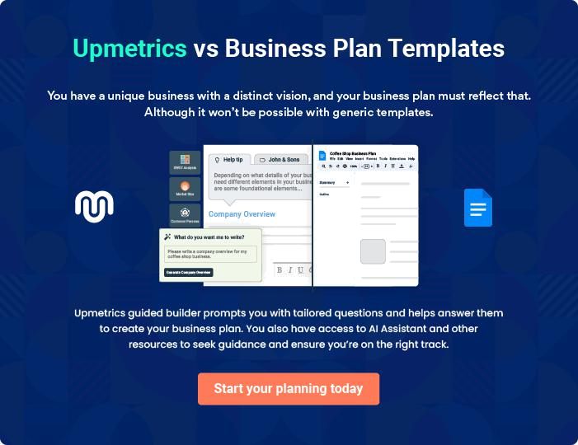

Pharmacy Store | Business Plan [YEAR] | 14/35

4.

Market Analysis

Market Segmentation

Target Market Analysis

Target Market Segment Strategy

Pharmacy Store | Business Plan [YEAR] 15/35

 GoodRx

The GoodRx Pharmacy's target market consists of two different groups, local customers or walk-ins, and mail-order customers.
To unlock help try Upmetrics! 

Start writing here..

Market Segmentation

The GoodRx Pharmacy's customers can be broken down into two different groups, mail order customers and walk-in customers:

 GoodRx

This group of customers orders their medication through the mail in an effort to save money. Generally, the mail order customers are older in age, typically over 50. In general, elderly customers consume more medication relative to younger people. The mail order customer will
To unlock help try Upmetrics! 

Mail order customers

Start writing here..

 GoodRx

This group of customers are also looking for the lowest prices for their medication. However, they tend to purchase medications monthly at their local pharmacy, often at a higher price. There is not a common demographic for this group of people, other than living in the Portland
To unlock help try Upmetrics! 

Walk-in customers

Start writing here..

Pharmacy Store | Business Plan [YEAR] 16/35

Target Market Analysis

Potential | Growth | Year1 | Year2 | Year3 | Year4 | Year5 | CAGR
Customers
Walk-in | 8% | 345,887 | 373,558 | 403,443 | 435,718 | 470,575 | 8.00%
customers
Mail order | 9% | 54,876,345 | 59,815,216 | 65,198,585 | 71,066,458 | 77,462,439 | 9.00%
customers
Total | 8.99% | 55,222,232 | 60,188,774 | 65,602,028 | 71,502,176 | 77,933,014 | 8.99%

Target Market Segment Strategy

 GoodRx

The GoodRx Pharmacy will seek to attract two different groups of customers and will thus have two strategies to attract them.
To unlock help try Upmetrics! 

Start writing here..

Pharmacy Store | Business Plan [YEAR] 17/35

5.

Strategy and

Implementation

Competitive Edge

Marketing Strategy

Sales Strategy

Milestones

Pharmacy Store | Business Plan [YEAR] 18/35

The GoodRx Pharmacy will use their website to develop visibility and disseminate information.
To unlock help try Upmetrics!
To unlock help try Upmetrics!

Competitive Edge

 GoodRx

GoodRx Pharmacy's competitive edge is superior pricing. To do that we must maintain our position as the low-cost provider by painstakingly ensuring that costs are kept low through operating efficiencies.



Start writing here..

Marketing Strategy

 GoodRx

The marketing strategy will be based on targeted advertisements, appealing to the customer's sense of value. The marketing campaign's goal will to be increase awareness of The GoodRx Pharmacy with their target market.



Start writing here..

Sales Strategy

 GoodRx

The sales strategy will be based on generating long-term relationships with customers. To facilitate that, we will provide medications at superior prices, have meds in stock for both quick shipment and storefront pick up, and provide superior customer service. All sales agents will be
To unlock help try Upmetrics! 

Start writing here..

Pharmacy Store | Business Plan [YEAR] 19/35

 GoodRx

During the first two months, we will focus on setting up the storefront and generating both local and national visibility. Sales activity will begin in month three. Sales during months three through five there will mainly consist of local business through the storefront. In month six we
To unlock help try Upmetrics! 

Sales Forecast

Start writing here..
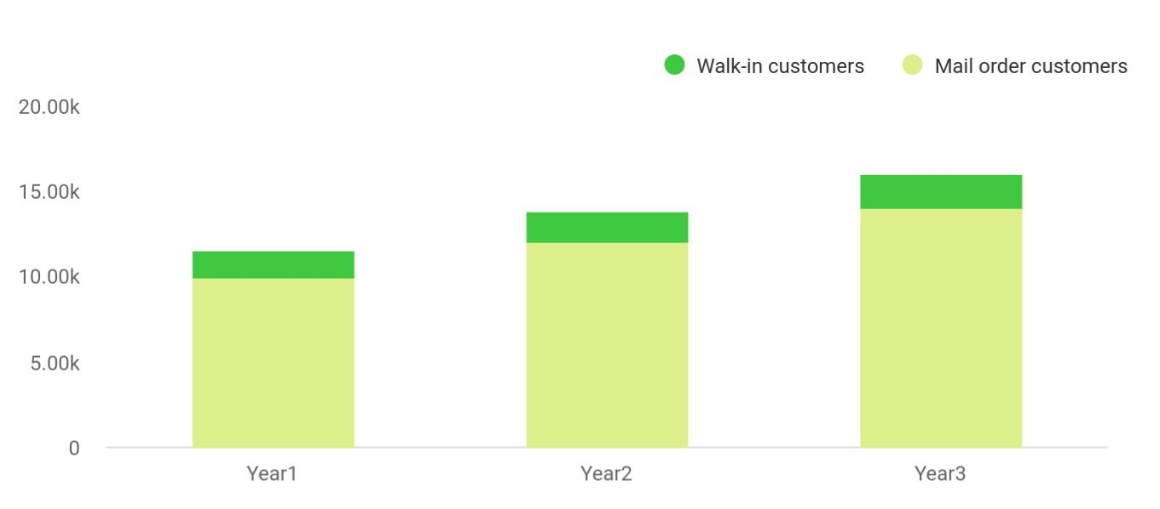

Financial Year | Walk-in customers | Mail order customers
Year1 | 1,550 | 10,000
Year2 | 1,800 | 12,000
Year3 | 2,050 | 14,000

Pharmacy Store | Business Plan [YEAR] 20/35

Milestones

The Discount Drug Dealer will have several milestones early on:

- Office/business set up.

- Establishment of the first strategic relationship.

- Profitability.

Milestone | Start Date | End Date | Budget | Manager | Department
Office/business set | 1/1/2001 | 5/1/2001 |  | John | Executive
up | 1/1/2001 | 5/1/2001 |  | John | Executive
Establishment of the |  |  |  |  | Business
first strategic | 1/1/2001 | 7/1/2001 |  | John | Business
first strategic | 1/1/2001 | 7/1/2001 |  | John | Development
relationship |  |  |  |  | Development
Profitability | 1/1/2001 | 11/1/2002 |  | Everyone | Finance
Totals |  |  | $0

Pharmacy Store | Business Plan [YEAR] 21/35

6.

Web Plan

Development Requirements

Pharmacy Store | Business Plan [YEAR] 22/35

 GoodRx
To unlock help try Upmetrics!

The website will be used for the dissemination of information as well as a mechanism for email communication. Initially, there will be no ordering through our website since we do not expect that method to be widely used and trusted by our target customers.



Start writing here..

Development Requirements

Start writing here..

Pharmacy Store | Business Plan [YEAR] 23/35

7.

Management

Personnel Plan

Pharmacy Store | Business Plan [YEAR] 24/35

 GoodRx

John Reeleaf has experience working with a major drug manufacturer, Eli Lilly, as a drug representative. He was able to see first hand the profitability associated with the prescription drug industry, as well as the inefficiencies with which most companies are plagued.
To unlock help try Upmetrics! 

Start writing here..

Personnel Plan

The Discount Drug Dealer will employ the following people:

- Sales agents/phone representatives: two at month three, an additional person at month sixth.

- Pharmaceutical technicians: two at month two, a third at month six.

- Pharmacists: month two.

- Order fulfillment agents: two for month five, a third for month eight.

- Counter person/phone representative: one at month three.

Personnel Plan | Year1 | Year2 | Year3
CEO (John) | $48,000 | $52,000 | $60,000
Pharmacist | $55,000 | $60,000 | $60,000
Pharmacist technician | $27,500 | $30,000 | $30,000
Pharmacist technician | $27,500 | $30,000 | $30,000
Pharmacist technician | $17,500 | $30,000 | $30,000
Sales agent | $19,200 | $23,040 | $23,040
Sales agent | $19,200 | $23,040 | $23,040
Sales agent | $11,520 | $23,040 | $23,040
Counter person/phone rep. | $14,400 | $17,280 | $17,280
Counter person/phone rep. | $14,400 | $17,280 | $17,280
Order fulfillment | $14,400 | $17,280 | $17,280
Total People | 11 | 11 | 11
Total Payroll | $268,620 | $322,960 | $330,960

Pharmacy Store | Business Plan [YEAR] 25/35

8.

Financial Plan

Important Assumptions

Break-even Analysis

Projected Profit and Loss

Projected Cash Flow

Balance Sheet

Pharmacy Store | Business Plan [YEAR] 26/35

The following sections will outline important financial information.

Important Assumptions

The following table details important financial assumptions.

General Assumptions | Year1 | Year2 | Year3
Plan Month | 1 | 2 | 3
Current Interest Rate | 10.00% | 10.00% | 10.00%
Long-term Interest Rate | 10.00% | 10.00% | 10.00%
Tax Rate | 30.00% | 30.00% | 30.00%
Other | 0.00% | 0.00% | 0.00%
Calculated Totals
Payroll Expense | $268,620 | $322,960 | $330,960
New Accounts Payable | $524,386 | $872,053 | $939,847

Break-even Analysis

The Break-even Analysis indicates that $72,494 will be needed in monthly revenue to reach the break-even point.

Break-even Analysis
Monthly Units Break-even | 725
Monthly Revenue Break-even | $72,494
Assumptions:
Average Per-Unit Revenue | $100.00
Average Per-Unit Variable Cost | $53.00
Estimated Monthly Fixed Cost | $34,072

Pharmacy Store | Business Plan [YEAR] 27/35

Projected Profit and Loss

Revenue

Prescription Medication Sales

Unit Sales

Unit Price

Over-The-Counter Product Sales

Unit Sales

Unit Price

Health and Wellness Consultation Services

Total Hours

Hourly Price

Cost Of Sales

General Costs

Medication Purchase Costs

Prescription Medication

Pharmacy Operational

Costs

Supply and Equipment

Healthcare Products

Revenue Specific Costs

Over-The-Counter Product Sales

Over-The-Counter

Medication

2024 | 2025 | 2026
$700,018.50 | $1,158,247.60 | $1,921,880.80
$437,728.50 | $786,107.50 | $1,411,736.50
8,755 | 15,722 | 28,235
$50 | $50 | $50
$214,290 | $324,140.10 | $462,144.30
7,143 | 10,805 | 15,405
$30 | $30 | $30
$48,000 | $48,000 | $48,000
480 | 480 | 480
$100 | $100 | $100

$174,314.60 | $234,114.65 | $318,777.27
$152,885.60 | $201,700.64 | $272,562.84
$93,884.65 | $119,068.23 | $151,007.18
$93,884.65 | $119,068.23 | $151,007.18
$59,000.95 | $82,632.41 | $121,555.66
$24,000 | $24,720 | $25,461.60
$35,000.95 | $57,912.41 | $96,094.06
$21,429 | $32,414.01 | $46,214.43
$21,429 | $32,414.01 | $46,214.43
$21,429 | $32,414.01 | $46,214.43

Pharmacy Store | Business Plan [YEAR] 28/35

 | 2024 | 2025 | 2026
Personnel Costs (Direct | $0 | $0 | $0
Labor) | $0 | $0 | $0

Gross Margin | $525,703.90 | $924,132.95 | $1,603,103.53
Gross Margin (%) | 75.10% | 79.79% | 83.41%

Operating Expense | $807,748.98 | $852,500.05 | $913,484.67
Payroll Expense (Indirect | $710,136 | $726,958.32 | $744,210.48
Labor) | $710,136 | $726,958.32 | $744,210.48
Pharmacists Staff | $428,160 | $439,795.20 | $451,755.36
Pharmacists | $307,200 | $316,416 | $325,908.48
Pharmacy Technicians | $120,960 | $123,379.20 | $125,846.88
Administrative Staff | $176,976 | $180,933.12 | $184,980
Store Manager | $83,520 | $85,608 | $87,748.32
Administrative Assistants | $93,456 | $95,325.12 | $97,231.68
Support Staff | $105,000 | $106,230 | $107,475.12
Cleaners | $69,000 | $69,690 | $70,386.96
Security Personnel | $36,000 | $36,540 | $37,088.16
General Expense | $97,612.98 | $125,541.73 | $169,274.19
Store and Equipment | $36,000 | $37,251.75 | $38,069.40
Maintenance | $36,000 | $37,251.75 | $38,069.40
Store Rent | $30,000 | $31,131.75 | $31,827
Equipment Maintenance | $6,000 | $6,120 | $6,242.40
Marketing and Advertising | $48,412.98 | $74,921.98 | $117,666.39
Online Advertising | $35,000.95 | $57,912.41 | $96,094.06
Promotional Events | $13,412.03 | $17,009.57 | $21,572.33
Utilities and Services | $13,200 | $13,368 | $13,538.40

Pharmacy Store | Business Plan [YEAR] 29/35

Utilities and Services

Cleaning Services

Bad Debt

Amortization of Current Assets

EBITDA

Additional Expense

Long Term Depreciation

Gain or loss from Sale of Assets

EBIT

Interest Expense

EBT

Income Tax Expense / Benefit

Total Expense

Net Income

Net Income (%)

2024 | 2025 | 2026
$9,600 | $9,696 | $9,792.96
$3,600 | $3,672 | $3,745.44
$0 | $0 | $0
$0 | $0 | $0

($282,045.07) $71,632.90 $689,618.86

$26,022.04 | $20,413.12 | $14,398.73
$10,980 | $10,980 | $10,980
$0 | $0 | $0
($293,025.07) | $60,652.90 | $678,638.86
$15,042.05 | $9,433.12 | $3,418.72
($308,067.11) | $51,219.78 | $675,220.13
$0 | $0 | $0

$1,008,085.61 | $1,107,027.82 | $1,246,660.67
($308,067.11) | $51,219.78 | $675,220.13
(44.01%) | 4.42% | 35.13%

Retained Earning Opening | $0 | ($348,067.11) | ($316,847.33)
Owner's Distribution | $40,000 | $20,000 | $20,000
Retained Earning Closing | ($348,067.11) | ($316,847.33) | $338,372.80

Pharmacy Store | Business Plan [YEAR] 30/35

Projected Cash Flow

 | 2024 | 2025 | 2026
Cash Received | $700,018.50 | $1,158,247.60 | $1,921,880.80
Cash Paid | $997,105.62 | $1,096,047.83 | $1,235,680.68
COS & General Expenses | $271,927.58 | $359,656.39 | $488,051.47
Salary & Wages | $710,136 | $726,958.32 | $744,210.48
Interest | $15,042.05 | $9,433.12 | $3,418.72
Sales Tax | $0 | $0 | $0
Income Tax | $0 | $0 | $0
Net Cash From | ($297,087.12) | $62,199.77 | $686,200.12
Operations | ($297,087.12) | $62,199.77 | $686,200.12
Assets Sell | $0 | $0 | $0
Assets Purchase | $60,000 | $0 | $0
Net Cash From | ($60,000) | $0 | $0
Investments | ($60,000) | $0 | $0
Amount Received | $300,000 | $0 | $0
Loan Received | $250,000 | $0 | $0
Common Stock | $0 | $0 | $0
Preferred Stock | $0 | $0 | $0
Owner's Contribution | $50,000 | $0 | $0
Amount Paid | $117,589.20 | $103,198.12 | $109,212.68
Loan Capital | $77,589.19 | $83,198.12 | $89,212.69
Dividends & Distributions | $40,000 | $20,000 | $20,000
Net Cash From | $182,410.80 | ($103,198.12) | ($109,212.68)
Financing | $182,410.80 | ($103,198.12) | ($109,212.68)

Pharmacy Store | Business Plan [YEAR] 31/35

 | 2024 | 2025 | 2026
Summary
Starting Cash | $0 | ($174,676.32) | ($215,674.67)
Cash In | $1,000,018.50 | $1,158,247.60 | $1,921,880.80
Cash Out | $1,174,694.82 | $1,199,245.95 | $1,344,893.36
Change in Cash | ($174,676.32) | ($40,998.35) | $576,987.44
Ending Cash | ($174,676.32) | ($215,674.67) | $361,312.77
Balance Sheet
 | 2024 | 2025 | 2026
Assets | ($125,656.32) | ($177,634.67) | $388,372.77
Current Assets | ($174,676.32) | ($215,674.67) | $361,312.77
Cash | ($174,676.32) | ($215,674.67) | $361,312.77
Accounts Receivable | $0 | $0 | $0
Inventory | $0 | $0 | $0
Other Current Assets | $0 | $0 | $0
Long Term Assets | $49,020 | $38,040 | $27,060
Gross Long Term Assets | $60,000 | $60,000 | $60,000
Accumulated Depreciation | ($10,980) | ($21,960) | ($32,940)
Liabilities & Equity | ($125,656.30) | ($177,634.64) | $388,372.80
Liabilities | $172,410.81 | $89,212.69 | $0
Current Liabilities | $83,198.12 | $89,212.69 | $0
Accounts Payable | $0 | $0 | $0
Income Tax Payable | $0 | $0 | $0

Pharmacy Store | Business Plan [YEAR] 32/35

 | 2024 | 2025 | 2026
Sales Tax Payable | $0 | $0 | $0
Short Term Debt | $83,198.12 | $89,212.69 | $0
Long Term Liabilities | $89,212.69 | $0 | $0
Long Term Debt | $89,212.69 | $0 | $0
Equity | ($298,067.11) | ($266,847.33) | $388,372.80
Paid-in Capital | $0 | $0 | $0
Common Stock | $0 | $0 | $0
Preferred Stock | $0 | $0 | $0
Owner's Contribution | $50,000 | $50,000 | $50,000
Retained Earnings | ($348,067.11) | ($316,847.33) | $338,372.80

Check | $0 | $0 | $0

Pharmacy Store | Business Plan [YEAR] 33/35

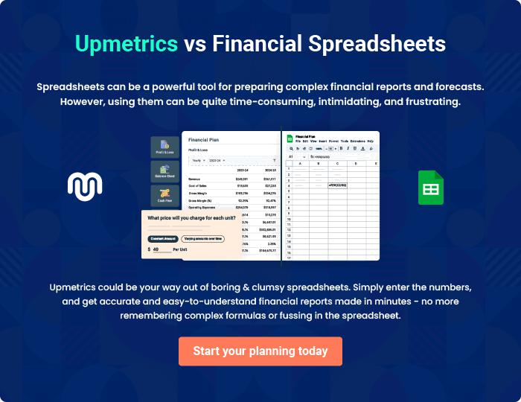

Pharmacy Store | Business Plan [YEAR] | 34/35


Create a winning business plan that gets you funded

Creating a stunning and investment-ready plan requires no writing, graphic designing, or financial planning expertise.

Upmetrics has all the features required to help you create a comprehensive business plan—from start to finish. Make no mistakes, it’s the modern way of planning to structure ideas, make plans, and create stunning pitch decks to awe investors.

Pitch decks that impress investors

Create pitch decks that provide a visual representation of your business, engage investors, and make them want to invest in your business idea.

Interactive plans in no time

Import business plan sections like—SWOT analysis, comparison tables, and others to create an interactive business plan. No designing skills are required.

Stunning cover page designs

With Upmetrics, you have the liberty to choose from multiple stunning cover page designs. Choose a creative design and make your plan stand out.

Online sharing made simple

Upmetrics makes online sharing quick and easier for users. Easily share your business plans with a link while tracking reader activity.

500+ sample business plans

Simply import a template from our library of sample plans into the editor and start customizing it to make it yours. It takes only a few clicks to get started.

Collaborate with team in real-time

Invite team members, initiate conversations, discuss ideas & strategies, share feedback, and work on a business plan in real-time.

