


The Educare Learning Center


BUSINESS PLAN

Education a Birth Right, Not a Privilege

Prepared By

John Doe

10200 Bolsa Ave, Westminster, CA, 92683

info@example.com

(650) 359-3153 http://www.example.com

Table of Contents

Executive Summary | 5
Business Overview | 6
Market Summary | 6
Marketing Summary | 6
Financial Summary | 7

Business Description | 8
Business Overview | 9
Educare's History | 9
Management | 9
Location | 10
Legal Structure | 10
Vision & Mission | 10
Goals & Objectives | 11
Professional Advisors | 11

Market Analysis | 12
Industry Analysis | 13
Local Market | 13
Target Market | 13
Target Market profile for The Educare Learning Centre consumers: | 13
Target Market profile for The Educare Learning Centre businesses: | 14
Keys to Success | 14
Customer Survey Summary | 14

Competitive Analysis | 16
Key Competitors / SWOT Analysis | 17
A+ Tutors for Less | 17
The Educare Learning Centre | 18

The Educare Learning Center | Business Plan [YEAR] 2/35

Sales & Marketing | 19
Pricing Strategy | 20
Marketing Strategy | 20
Networking | 20
Conferences | 20
Social Media: Twitter | 21
Marketing Activities | 21
Marketing Objectives | 21
Positioning Statement | 22
The Sales Process | 22
Strategic Alliances | 22

Operations | 23
Location(s) | 24
Website | 24
Website Development | 24
Legal Issues | 24
Insurance Issues | 25
Human Resources | 25
Process/Production | 25
The Educare Learning Centre Process – Student Tutoring | 25
The Educare Learning Centre Process – Educator Workshops | 26
Risk Assessment | 26

Financial Plan | 27
Start-Up Costs | 28
Sales Forecast | 28
Capital Requirements and Use of Funds | 29
Income Statement Projections | 29
Balance Sheet Projections | 31
Cashflow Projections | 32

The Educare Learning Center | Business Plan [YEAR] 3/35

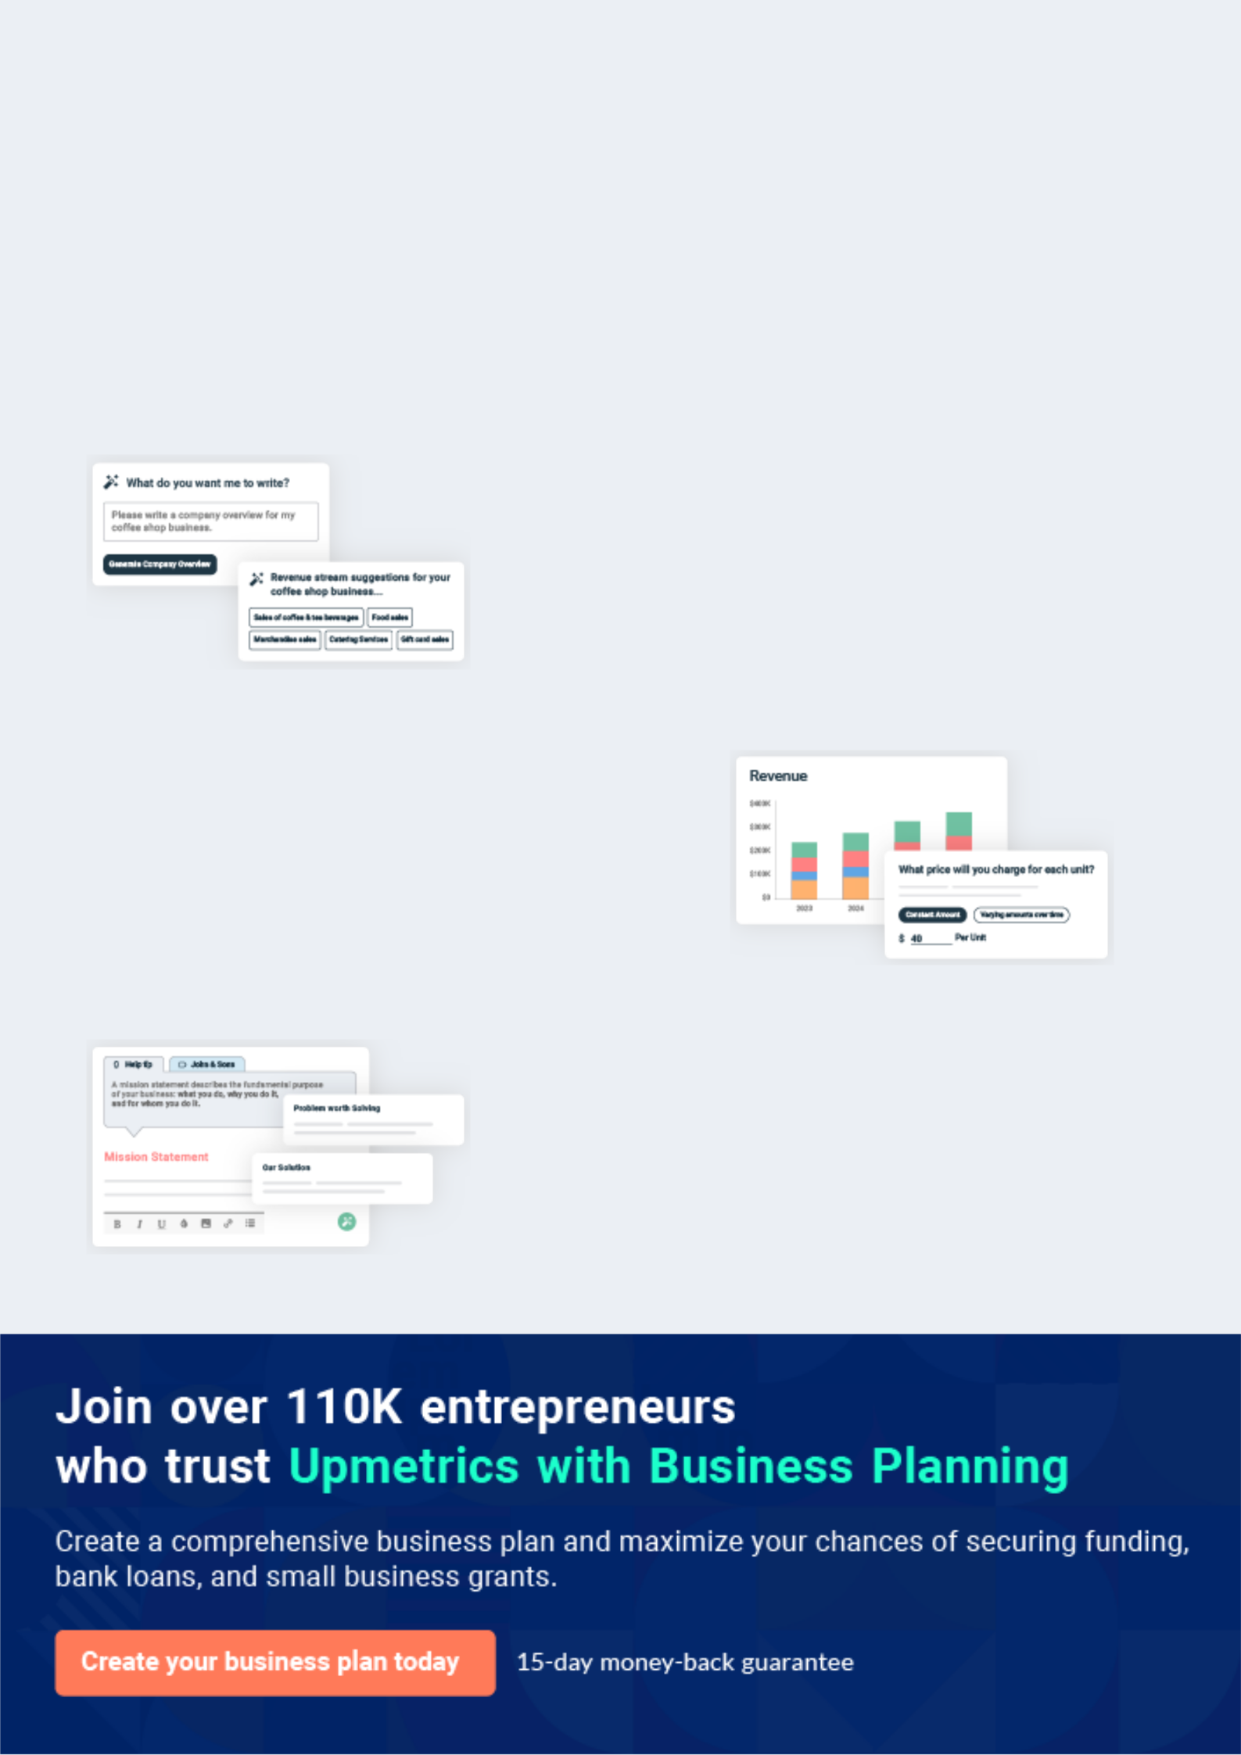
Business planning that’s simpler and faster than you think

Creating a business plan using Upmetrics to start and grow a business is literally the easiest thing in the World. Simply read the instructions and fill in the blanks. It’s as simple as that.

❛ | Upmetrics has everything you need to create a | ❜
❛ | comprehensive business plan. | ❜

AI-powered Upmetrics Assistant

AI-powered insights to streamline your plan

Not sure where to start? Upmetrics’ AI Assistant will automatically generate ideas for each section of your plan and offer improved versions of your writing, adjusting for tone, voice, and grammar or spelling errors.

Financial Forecasting Tool

All the financials are calculated for you

Forget the complex formulas and clumsy spreadsheets — with automatic financials and drag-and-drop forecasting, you can finish your plan faster and be confident that your numbers are accurate.

Business Plan Builder

Guides you like a business mentor

Upmetrics’ step-by-step instructions, prompts, and the library of 400+ sample business plans will guide you through each section of your plan as a business mentor.

1.


Executive Summary

Business Overview

Market Summary

Marketing Summary

Financial Summary

The Educare Learning Center | Business Plan [YEAR] 5/35

Business Overview

 The Educare


Many high school students and parents see a university/college degree as a requirement for success in the job market, making preparation for university/college success critical. The Educare Learning Centre is a non-profit focused on improving high school student
To unlock help try Upmetrics! 

Start writing here..

Market Summary

 The Educare

Public education has seen a significant change since 2010 when the curriculum was overhauled to cover more content within each school year. The effect of this change and the increased desire of parents wanting their child to attend university/college are having a direct
To unlock help try Upmetrics! 

Start writing here..

Marketing Summary

 The Educare

The Educare Learning Centre’s key strategy is to be actively engaged in the Ottawa community and to be seen as an expert in preparing high school students for university/college reading and writing. The Educare Learning Centre will achieve this by attending community events to
To unlock help try Upmetrics! 

Start writing here..

The Educare Learning Center | Business Plan [YEAR] 6/35

Financial Summary

 The Educare

$24,350 will be needed to start the business with $15,000 in funding coming from Futurpreneur Canada and $10,000 from a Trudeau Foundation grant. In the first year of business, The Educare Learning Centre plans on generating just over $160,000 in sales and securing $25,000
To unlock help try Upmetrics! 

Start writing here..

The Educare Learning Center | Business Plan [YEAR] 7/35

2.

Business Description

Business Overview

Educare's History

Management

Location

Legal Structure

Vision & Mission

Goals & Objectives

Professional Advisors

The Educare Learning Center | Business Plan [YEAR] 8/35

Business Overview
To unlock help try Upmetrics!
To unlock help try Upmetrics!

 The Educare

The Educare Learning Centre is a tutoring company dedicated to helping launch high school students on a successful journey at university and/or college by improving their literacy skills. The Educare Learning Centre was established on 01/01/2014.



Start writing here..

Educare's History

 The Educare

Jerry Yarrick conceived the launch of The Educare Learning Centre three years ago prompted by the struggles she faced in her first few months at the University of Ottawa.
To unlock help try Upmetrics! 

Start writing here..

Management

 The Educare

The Educare Learning Centre is a federally incorporated non-profit with a four-member board of directors. Ms. Yarrick will be the managing director on the board responsible for running educator workshops and volunteer recruitment.



Start writing here..

The Educare Learning Center | Business Plan [YEAR] 9/35

Location
To unlock help try Upmetrics!

 The Educare

The Educare Learning Centre will be a home office. The Educare Learning Centre will be located at 2898 Baycrest Dr., Ottawa, ON K1V 6P4. This location will be the non-profit’s headquarters, however, one-on-one tutoring sessions will take place at donated venues. The venues secured
To unlock help try Upmetrics! 

Start writing here..

Legal Structure

 The Educare

The Educare Learning Centre is a corporation. The Educare Learning Centre will operate as a federally incorporated non-profit that is also registered in Ontario.
To unlock help try Upmetrics! 

Start writing here..

Vision & Mission

 The Educare

To be an advocate for improving high school students’ reading/writing skills for post-secondary education, helping all students achieve success regardless of academic or financial circumstances.



Start writing here..

The Educare Learning Center | Business Plan [YEAR] 10/35

Goals & Objectives

 The Educare

• Enrolment of two school boards in ongoing educator workshops by September 2014 with monthly revenues of $15,000.
• The steady base of 20 students partaking in pay-what-you-can tutoring services each
To unlock help try Upmetrics! 

Start writing here..

Professional Advisors

 The Educare

In addition to Mr. Zao and Ms. Yarrick, The Educare Learning Centre will have two other board members. The Educare Learning Centre will rely on Bridgette Kohl both as a parent advocate in the community and lawyer for matters surrounding the start-up of the business. In addition,
To unlock help try Upmetrics! 

Start writing here..

The Educare Learning Center | Business Plan [YEAR] 11/35

3.

Market Analysis

Industry Analysis

Local Market

Target Market

Keys to Success

Customer Survey Summary

The Educare Learning Center | Business Plan [YEAR] 12/35

Industry Analysis

 The Educare

The Educare Learning Centre operates primarily in the service industry.

The Canadian tutoring industry is divided amongst national franchises such as Sylvan, Oxford,
To unlock help try Upmetrics! 

Start writing here..

Local Market

 The Educare

Ottawa has a variety of tutoring services available, from single tutor operations to national franchises. There are 78 services listed for the Ottawa area on moretutors.ca. This excludes the large franchises like Oxford Learning Centre and Kumon that also have locations in Ottawa.
To unlock help try Upmetrics! 

Start writing here..

Target Market

The Educare Learning Centre is focused on selling both to consumers (B2C) and businesses (B2B).

 The Educare


- Single or married households with children in high school (demographics)

- Students planning on attending university/college (lifestyle
3. Family income: $50,000 (demographics) To unlock help try Upmetrics! 

Target Market profile for The Educare Learning Centre consumers:

Start writing here..

The Educare Learning Center | Business Plan [YEAR] 13/35

 The Educare

- English and French secondary school boards (industry)

- School principals looking for Professional Development (PD) workshops (decision-
makers) | To unlock help try Upmetrics! 

Target Market profile for The Educare Learning Centre businesses:

Start writing here..

Keys to Success

 The Educare

A consistent visibility program will be essential to gain students for one-on-one tutoring and to gain traction with educators that students are seeking out ways to better prepare for post-secondary reading and writing requirements. The Educare Learning Centre will be focused on
To unlock help try Upmetrics! 

Start writing here..

Customer Survey Summary

 The Educare

During the initial business planning stages of The Educare Learning Centre, Ms. Yarrick interviewed a series of university students, professors, and parents of university students throughout the downtown Ottawa core. Using a tablet to track responses, she surveyed 50
To unlock help try Upmetrics! 

Start writing here..

The Educare Learning Center | Business Plan [YEAR] 14/35

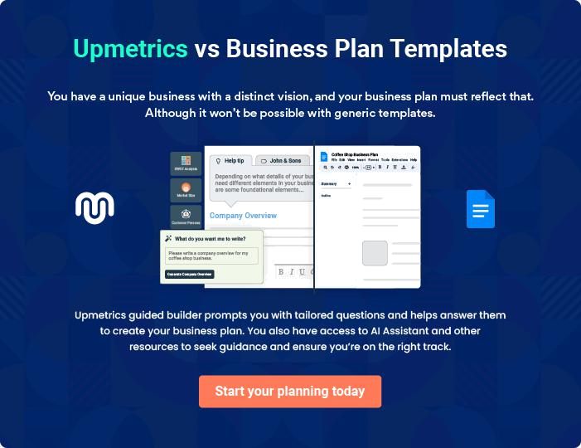

The Educare Learning Center | Business Plan [YEAR] | 15/35

4.

Competitive Analysis

Key Competitors / SWOT Analysis

The Educare Learning Center | Business Plan [YEAR] 16/35

Key Competitors / SWOT Analysis
To unlock help try Upmetrics!

 The Educare

The Educare Learning Centre has two lines of business both working to achieve its mission-vision. As such, we’ve included a separate SWOT analysis for each line of business. For direct one-on-one tutoring services:



Start writing here..

A+ Tutors for Less

Start writing here..

Strength | Weakness
• Well established | • Tutoring only provided “In Home”
• Marketed as low cost tutoring option | • Student reviews of tutors are poor
• Online presence


Opportunity

- Engaging peer tutors

- Low cost destination tutoring service

Threat

- May decide to start tutoring from offsite locations

The Educare Learning Center | Business Plan [YEAR] 17/35

The Educare Learning Centre

Start writing here..

Strength | Weakness
• Familiar with local community | • Not an established brand in Ottawa
• Network of university/college aged tutors

Opportunity

- Decrease anxiety about post-secondary success

- Provide peer aged tutors to engage students

Threat

- High schools/libraries may start charging for space usage

The Educare Learning Center | Business Plan [YEAR] 18/35

5.

Sales & Marketing

Pricing Strategy

Marketing Strategy

Positioning Statement

The Sales Process

Strategic Alliances

The Educare Learning Center | Business Plan [YEAR] 19/35

Pricing Strategy
To unlock help try Upmetrics!

 The Educare

Fees range from the low end of $20/hour to $55/hour for established tutoring companies like Oxford Tutoring for one-on-one tutoring. Fees for full-day educator workshops range from $600 - $1000 depending on the area of expertise.



Start writing here..

Marketing Strategy

 The Educare

Networking in the Ledbury, Heron Gate, Ridgemont Elmwood community

Becoming part of the local community fabric will be critical for the success of the business.
To unlock help try Upmetrics! 

Networking

Start writing here..

 The Educare

A secondary strategy will be for Mr. Zao to attend education conferences and secure speaking engagements to promote the need to help high school students succeed in post-secondary education. Appearing on the conference agenda will increase the visibility of The Educare
To unlock help try Upmetrics! 

Conferences

Start writing here..

The Educare Learning Center | Business Plan [YEAR] 20/35

 The Educare

In social media, The Educare Learning Centre will focus on announcing tutor availability, tutor insights, tutor biographies, and re-tweeting excerpts from Mr. Zao’s talks to students and educators. This will be an effective way to communicate directly with the student market and
To unlock help try Upmetrics! 

Social Media: Twitter

Start writing here..

 The Educare

Primary marketing activity

The Educare Learning Centre’s primary marketing activity will be networking throughout the
To unlock help try Upmetrics! 

Marketing Activities

Start writing here..

 The Educare

Goal #1: Workshops running in three of four school boards by October 2014

Goal #2: Eight reoccurring students seeking tutoring twice a week by March 2013.
To unlock help try Upmetrics! 

Marketing Objectives

Start writing here..

The Educare Learning Center | Business Plan [YEAR] 21/35

Positioning Statement

 The Educare

The Educare Learning Centre is a non-profit focused on achieving high school student’s success at university/college through tutoring and educator workshops.
To unlock help try Upmetrics! 

Start writing here..

The Sales Process

 The Educare

The Educare Learning Centre's sales cycle is one-two months.

The Educare Learning Centre’s sales process is focused on securing educator workshops, as
To unlock help try Upmetrics! 

Start writing here..

Strategic Alliances

 The Educare

The Educare Learning Centre has a strategic alliance with Hub Ottawa to help promote the non-profit through its social innovation center, helping to establish The Educare Learning Centre as part of the local community. The Educare Learning Centre has also developed a strategic
To unlock help try Upmetrics! 

Start writing here..

The Educare Learning Center | Business Plan [YEAR] 22/35

6.

Operations

Location(s)

Legal Issues

Insurance Issues

Human Resources

Process/Production

Risk Assessment

The Educare Learning Center | Business Plan [YEAR] 23/35

Location(s)

 The Educare

The Educare Learning Centre’s head office will be the residence of its managing director, Ms. Yarrick at 2898 Baycrest Dr., Ottawa, ON K1V 6P4. The Educare Learning Centre will not own or lease a physical location for their operations. Instead, they have negotiated the donation of
To unlock help try Upmetrics! 

Start writing here..

 The Educare

The Educare Learning Centre website will launch/launch on 01/03/2014.

The Educare Learning Centre has entered an agreement to set up and host their website on
To unlock help try Upmetrics! 

Website

Start writing here..

 The Educare

The Educare Learning Centre hired a freelance web developer to install WordPress onto their GoDaddy account. In November The Educare Learning Agency purchased “The Brand Identity
Pack” from 99designs.ca, which provided print collateral, a logo, and a Facebook cover image.
To unlock help try Upmetrics! 

Website Development

Start writing here..

Legal Issues

 The Educare

The Educare Learning Centre anticipates the following legal issues:

• Business licenses
To unlock help try Upmetrics! 

Start writing here..

The Educare Learning Center | Business Plan [YEAR] 24/35

Insurance Issues

 The Educare

The Educare Learning Centre requires liability insurance.

To unlock help try Upmetrics! 

Start writing here..

Human Resources

 The Educare

The Educare Learning Centre will have 1 – 10 full-time staff.

The Educare Learning Centre will have 0 part-time staff.
To unlock help try Upmetrics! 

Start writing here..

Process/Production

 The Educare

The Educare Learning Centre Process – Student Tutoring

Parent registers their child for tutoring via the website and selects a primary and secondary
To unlock help try Upmetrics! 

The Educare Learning Centre Process – Student Tutoring

Start writing here..

The Educare Learning Center | Business Plan [YEAR] 25/35

 The Educare

Teachers, principals, literacy advisors, or parents would contact The Educare Learning Centre to inquire about booking one or both of their workshops:
To unlock help try Upmetrics! 

The Educare Learning Centre Process – Educator Workshops

Start writing here..

Risk Assessment

 The Educare

The Educare Learning Centre will be spending the majority of its marketing efforts attending community events and networking within the educator community to build credibility and exposure with both parents and educators. However, if these efforts prove ineffective at
To unlock help try Upmetrics! 

Start writing here..

The Educare Learning Center | Business Plan [YEAR] 26/35

7.

Financial Plan

Start-Up Costs

Capital Requirements and Use of Funds

Income Statement Projections

Balance Sheet Projections

Cashflow Projections

The Educare Learning Center | Business Plan [YEAR] 27/35

Start-Up Costs

Sales Forecast

Key Assumptions for The Educare Learning Centre

- No sales in the first month due to extensive networking

- Slowest months: July/Aug – summer vacations

- Average hourly rate: $20 or pay-what-you-can tutoring

- Each student, on average, will attend two tutoring sessions per week

- Each student, on average, will have two months of tutoring

- Workshop cost: $795

Year One Sales Forecast (Including Assumptions)

January - $10,000

- Launched the business

- $10,000 – Trudeau Foundation grant

- Personalized emails from Mr. Zao to priority network contacts introducing educator workshops, approximately 25/week.

- Ten follow up meetings with Mr. Zao’s contacts interested in more information on educator workshops.

- Attended the “Brown Bag Lunch: Learning is for Life” event at Hub Ottawa

- Attended Canadian Public Education Society monthly meeting

- Attended Community Hub meeting for Conseil des écoles publiques de l'Est de l'Ontario (CEPEO)

- Published four to five tweets/week to a @LLcentreCAN Twitter account.

- Submitted grant to The W. Garfield Weston Foundation.

February - $4,615

- $640 – pay-what-you-can tutoring for four students for four weeks

- $3,975 – Five Workshop Pilot program with Notre Dame High School

- Attended a conference on Literacy Development

- Ten follow up meetings with Mr. Zao’s contacts interested in more information on educator workshops

- Visited the local YMCA and add tutoring service to the online community bulletin board

- Hosted Q&A at a student information session at the University of Ottawa

- Attended Education Innovation Reception with Carleton University at Ottawa Hub

- Published four to five tweets/week to @LLcentreCAN Twitter account.

- Submitted grants to Birks Family Foundation and Roaster Foundation.

The Educare Learning Center | Business Plan [YEAR] 28/35

March - $6,525

- $960 – pay-what-you-can tutoring for eight students for four weeks

- $4770 – Six trial workshops with Ottawa-Carleton District School board through Canterbury High

school and Glebe Collegiate Institute

- $795 - Workshop hosted at Redeemer Christian High School

- Negotiations with Ottawa-Carlton Catholic School board for additional workshops

- Five follow up meetings with Mr. Zao’s contacts interested in more information on educator workshops

- Hosted a Panel Discussion at the University of Ottawa on “The Skills Gap: high school to

university writing”

• Published four to five tweets/week to @LLcentreCAN Twitter account.

April - $20, 680

- $1,600 – pay-what-you-can tutoring for 10 students for 4 weeks

- $15,900 – Contract signed for 20 workshops with the Ottawa-Carleton Catholic School board as

part of their Student Success initiative

- $1,590 – Two Workshops with Ridgemont High School via the Ottawa-Carleton District School board

- $1,590 – Two Workshops with Ottawa Learner

- Five follow up meetings with Mr. Zao’s contacts interested in more information on educator workshops

- Attended Wine and Cheese Ottawa-Carleton District School board “Meet Your Trustees” event

- Joined “Impact Academy” springs session at Hub Ottawa

- Published four to five tweets/week to @LLcentreCAN Twitter account.

Capital Requirements and Use of Funds

The Educare Learning Centre’s “revenues” come from donations and the solicitation of donations from both individuals and corporations.

Capital Requirements and Use of Funds

The Educare Learning Centre is currently seeking donations totally $300,000 in order to hire new staff and expand its program offerings.

Specifically, these funds will be used as follows:

- Salaries: $X,000

- Administrative Expenses: $X,000 to pay for lease costs and ongoing operational expenses

Income Statement Projections

The Educare Learning Center | Business Plan [YEAR] 29/35

Revenue

Cost Of Sales

General Costs

Revenue Specific Costs

Personnel Costs (Direct Labor)

Gross Margin

Gross Margin (%)

Operating Expense

Payroll Expense

(Indirect Labor)

General Expense

Bad Debt

Amortization of Current Assets

EBITDA

Additional Expense

Long Term

Depreciation

Gain or loss from Sale of Assets

EBIT

2024-25 | 2025-26 | 2026-27
$0 | $0 | $0
$0 | $0 | $0
$0 | $0 | $0
$0 | $0 | $0
$0 | $0 | $0
$0 | $0 | $0
0% | 0% | 0%
$0 | $0 | $0
$0 | $0 | $0
$0 | $0 | $0
$0 | $0 | $0
$0 | $0 | $0
$0 | $0 | $0
$0 | $0 | $0
$0 | $0 | $0
$0 | $0 | $0
$0 | $0 | $0

The Educare Learning Center | Business Plan [YEAR] 30/35

 | 2024-25 | 2025-26 | 2026-27
Interest Expense | $0 | $0 | $0
EBT | $0 | $0 | $0
Income Tax Expense / | $0 | $0 | $0
Benefit | $0 | $0 | $0
Total Expense | $0 | $0 | $0
Net Income | $0 | $0 | $0
Net Income (%) | 0% | 0% | 0%
Retained Earning | $0 | $0 | $0
Opening | $0 | $0 | $0
Owner's Distribution | $0 | $0 | $0
Retained Earning | $0 | $0 | $0
Closing | $0 | $0 | $0
Balance Sheet Projections
 | 2024-25 | 2025-26 | 2026-27
Assets | $0 | $0 | $0
Current Assets | $0 | $0 | $0
Cash | $0 | $0 | $0
Accounts Receivable | $0 | $0 | $0
Inventory | $0 | $0 | $0
Other Current Assets | $0 | $0 | $0
Long Term Assets | $0 | $0 | $0
Gross Long Term Assets | $0 | $0 | $0
Accumulated Depreciation | $0 | $0 | $0

The Educare Learning Center | Business Plan [YEAR] 31/35

 | 2024-25 | 2025-26 | 2026-27
Liabilities & Equity | $0 | $0 | $0
Liabilities | $0 | $0 | $0
Current Liabilities | $0 | $0 | $0
Accounts Payable | $0 | $0 | $0
Income Tax Payable | $0 | $0 | $0
Sales Tax Payable | $0 | $0 | $0
Short Term Debt | $0 | $0 | $0
Long Term Liabilities | $0 | $0 | $0
Long Term Debt | $0 | $0 | $0
Equity | $0 | $0 | $0
Paid-in Capital | $0 | $0 | $0
Common Stock | $0 | $0 | $0
Preferred Stock | $0 | $0 | $0
Owner's Contribution | $0 | $0 | $0
Retained Earnings | $0 | $0 | $0
Check | $0 | $0 | $0
Cashflow Projections
 | 2024-25 | 2025-26 | 2026-27
Cash Received | $0 | $0 | $0
Cash Paid | $0 | $0 | $0
COS & General Expenses | $0 | $0 | $0
Salary & Wages | $0 | $0 | $0

The Educare Learning Center | Business Plan [YEAR] 32/35

 | 2024-25 | 2025-26 | 2026-27
Interest | $0 | $0 | $0
Sales Tax | $0 | $0 | $0
Income Tax | $0 | $0 | $0
Net Cash From | $0 | $0 | $0
Operations | $0 | $0 | $0

Assets Sell | $0 | $0 | $0
Assets Purchase | $0 | $0 | $0
Net Cash From | $0 | $0 | $0
Investments | $0 | $0 | $0

Amount Received | $0 | $0 | $0
Loan Received | $0 | $0 | $0
Common Stock
Preferred Stock | $0 | $0 | $0
Owner's Contribution | $0 | $0 | $0
Amount Paid | $0 | $0 | $0
Loan Capital | $0 | $0 | $0
Dividends & Distributions | $0 | $0 | $0
Net Cash From | $0 | $0 | $0
Financing | $0 | $0 | $0

Summary
Starting Cash | $0 | $0 | $0
Cash In | $0 | $0 | $0
Cash Out | $0 | $0 | $0
Change in Cash | $0 | $0 | $0

The Educare Learning Center | Business Plan [YEAR] 33/35

 | 2024-25 | 2025-26 | 2026-27
Ending Cash | $0 | $0 | $0
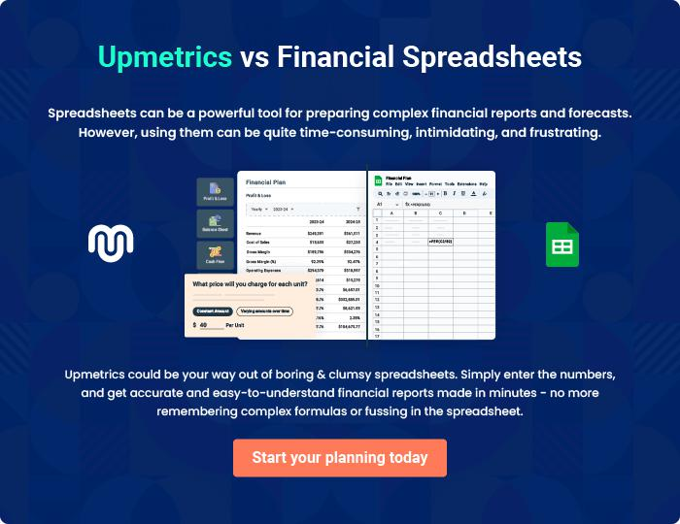

The Educare Learning Center | Business Plan [YEAR] 34/35

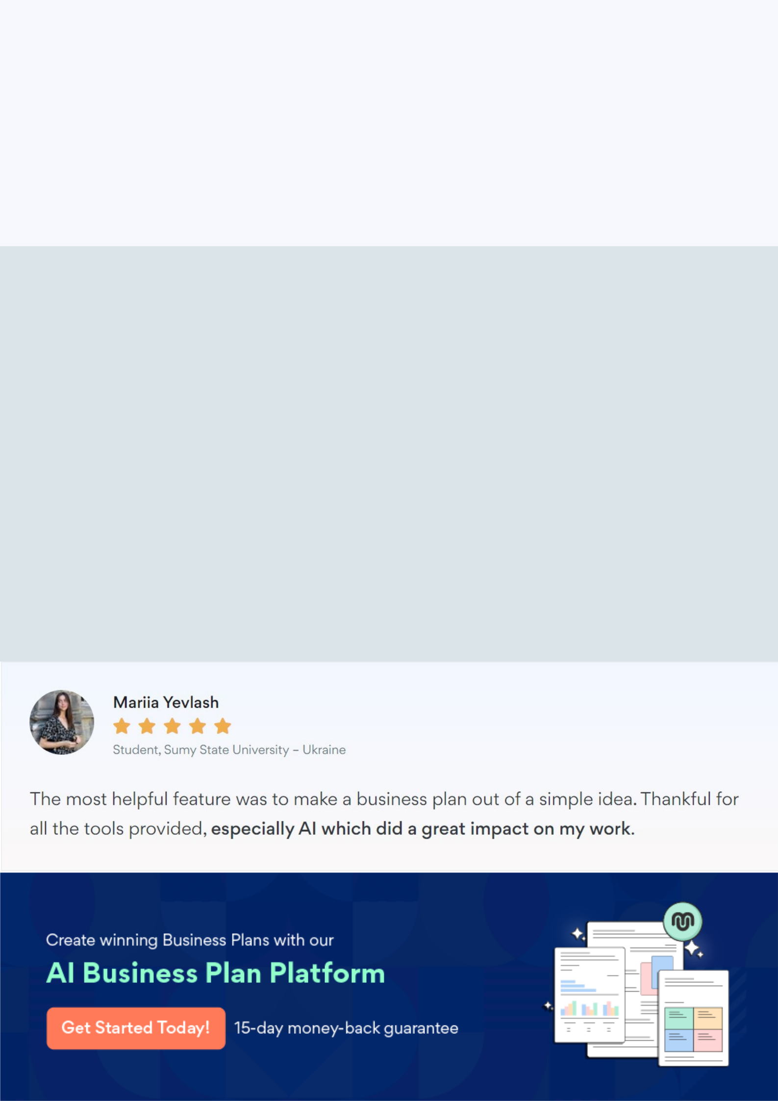
Create a winning business plan that gets you funded

Creating a stunning and investment-ready plan requires no writing, graphic designing, or financial planning expertise.

Upmetrics has all the features required to help you create a comprehensive business plan—from start to finish. Make no mistakes, it’s the modern way of planning to structure ideas, make plans, and create stunning pitch decks to awe investors.

Pitch decks that impress investors

Create pitch decks that provide a visual representation of your business, engage investors, and make them want to invest in your business idea.

Interactive plans in no time

Import business plan sections like—SWOT analysis, comparison tables, and others to create an interactive business plan. No designing skills are required.

Stunning cover page designs

With Upmetrics, you have the liberty to choose from multiple stunning cover page designs. Choose a creative design and make your plan stand out.

Online sharing made simple

Upmetrics makes online sharing quick and easier for users. Easily share your business plans with a link while tracking reader activity.

500+ sample business plans

Simply import a template from our library of sample plans into the editor and start customizing it to make it yours. It takes only a few clicks to get started.

Collaborate with team in real-time

Invite team members, initiate conversations, discuss ideas & strategies, share feedback, and work on a business plan in real-time.

