
Tom's Nightclub

BUSINESS PLAN

A night out worth remembering

Prepared By

John Doe

10200 Bolsa Ave, Westminster, CA, 92683

info@example.com

(650) 359-3153 http://www.example.com

Table of Contents

Executive Summary | 5
Mission Statement | 6
Vision Statement | 6
Keys to Success | 7
Financial Summary | 7
3 Year profit forecast | 7
Financing Needed | 8

Company Summary | 9
Business Structure | 10
Startup summary | 11
Startup cost | 11

Products and services | 14
Features | 15
Market Analysis
Market Analysis | 18
Market Trends | 19
Target Market | 19
Market Size & Segments | 19
SWOT Analysis
SWOT Analysis | 20
Strategy & Implementations
Strategy & Implementations | 22
Promotion Strategy | 23
Sales Plan | 23
Pricing Strategy | 23
Financial Plan
Financial Plan | 24
Important Assumptions | 25

Tom's Nightclub | Business Plan [YEAR] 2/34

Brake-even Analysis | 25
Projected Profit and Loss | 26
Projected Cash Flow | 29
Projected Balance Sheet | 30
Business Ratios | 31

Tom's Nightclub | Business Plan [YEAR] 3/34

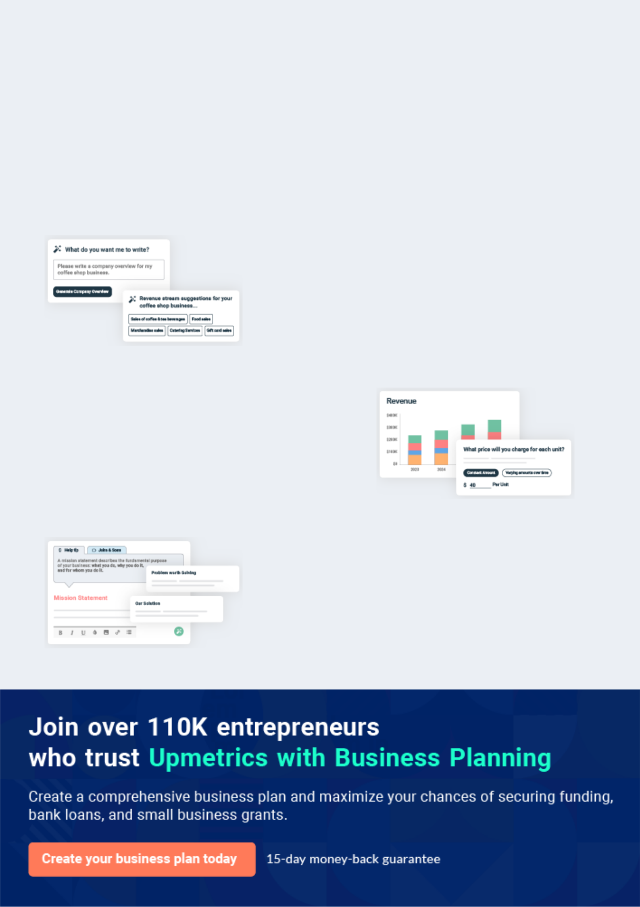
Business planning that’s simpler and faster than you think

Creating a business plan using Upmetrics to start and grow a business is literally the easiest thing in the World. Simply read the instructions and fill in the blanks. It’s as simple as that.

❛ | Upmetrics has everything you need to create a | ❜
❛ | comprehensive business plan. | ❜

AI-powered Upmetrics Assistant

AI-powered insights to streamline your plan

Not sure where to start? Upmetrics’ AI Assistant will automatically generate ideas for each section of your plan and offer improved versions of your writing, adjusting for tone, voice, and grammar or spelling errors.

Financial Forecasting Tool

All the financials are calculated for you

Forget the complex formulas and clumsy spreadsheets — with automatic financials and drag-and-drop forecasting, you can finish your plan faster and be confident that your numbers are accurate.

Business Plan Builder

Guides you like a business mentor

Upmetrics’ step-by-step instructions, prompts, and the library of 400+ sample business plans will guide you through each section of your plan as a business mentor.

1.


Executive Summary

Mission Statement

Vision Statement

Keys to Success

Financial Summary

Financing Needed

Tom's Nightclub | Business Plan [YEAR] 5/34

Before you think about how to start a Nightclub business, you must create a detailed Nightclub business plan. It will not only guide you in the initial phases of your startup but will also help you later on.
To unlock help try Upmetrics!
To unlock help try Upmetrics!



 Tom's Nightclub
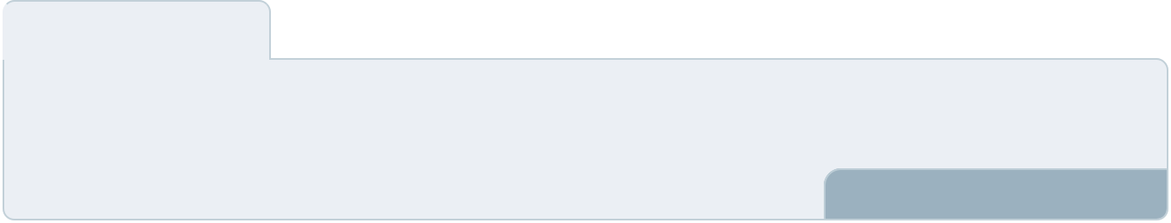

Tom's Nightclub is a standard nightclub and bar that will be located in the heart of Detroit - Michigan. We are conveniently located in the world’s headquarters for casinos and games; a commercial center that never goes to bed.



Start writing here..

Mission Statement

 Tom's Nightclub

- Our mission is to establish a nightclub and bar business that will create a standard of excellence in the industry.
To unlock help try Upmetrics! 

Start writing here..

Vision Statement

 Tom's Nightclub

Our vision is to establish a standard and secured nightclub and bar in Detroit - Michigan that will be the melting pot of all lovers of nightlife, social life, alcoholic and non-alcoholic drinks.
To unlock help try Upmetrics! 

Start writing here..

Tom's Nightclub | Business Plan [YEAR] 6/34

Keys to Success

 Tom's Nightclub

Our keys to success are:

• Having a place where college-age women feel comfortable
To unlock help try Upmetrics! 

Start writing here..

Financial Summary

 Tom's Nightclub

Our forecast is clearly too profitable, for now. We will be doing annual reviews and we expect to have to revise expense budgets upward over time.
To unlock help try Upmetrics! 

Start writing here..

3 Year profit forecast
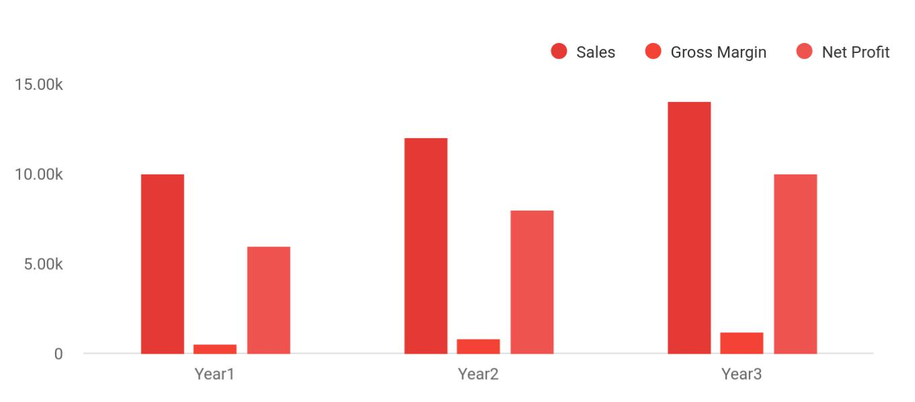

Tom's Nightclub | Business Plan [YEAR] 7/34

 Tom's Nightclub
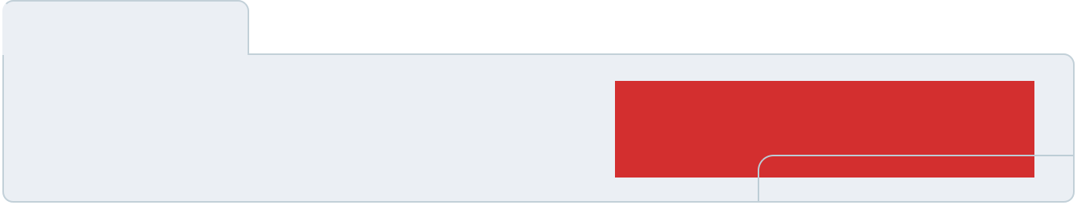

Financial Summary | Year 1 | Year 2 |  | Year 3
 |  |  | To unlock help try Upmetrics! |  | 

Start writing here..

Financing Needed

 Tom's Nightclub

Each of the three principals will invest $70K, making a total of $210K owner investment.

• Robert Shaw: $70,000
To unlock help try Upmetrics! 

Start writing here..

Tom's Nightclub | Business Plan [YEAR] 8/34

2.

Company Summary

Business Structure

Startup summary

Tom's Nightclub | Business Plan [YEAR] 9/34

 Tom's Nightclub

Tom's Nightclub is owned by John Moore who has successfully managed several bars and nightclubs in Los Angeles and Detroit prior to opening his own. He has the magic wand to
attract people who go to bars and nightclubs on a regular basis. John Moore has good working
To unlock help try Upmetrics! 

Start writing here..

Business Structure

 Tom's Nightclub

Tom's Nightclub is a business that is established to be a pacesetter when it comes to how standard nightclubs and bars should be run in Detroit and even in the United States of America.
To unlock help try Upmetrics! 

Start writing here..

Tom's Nightclub | Business Plan [YEAR] 10/34

Startup summary

Startup cost
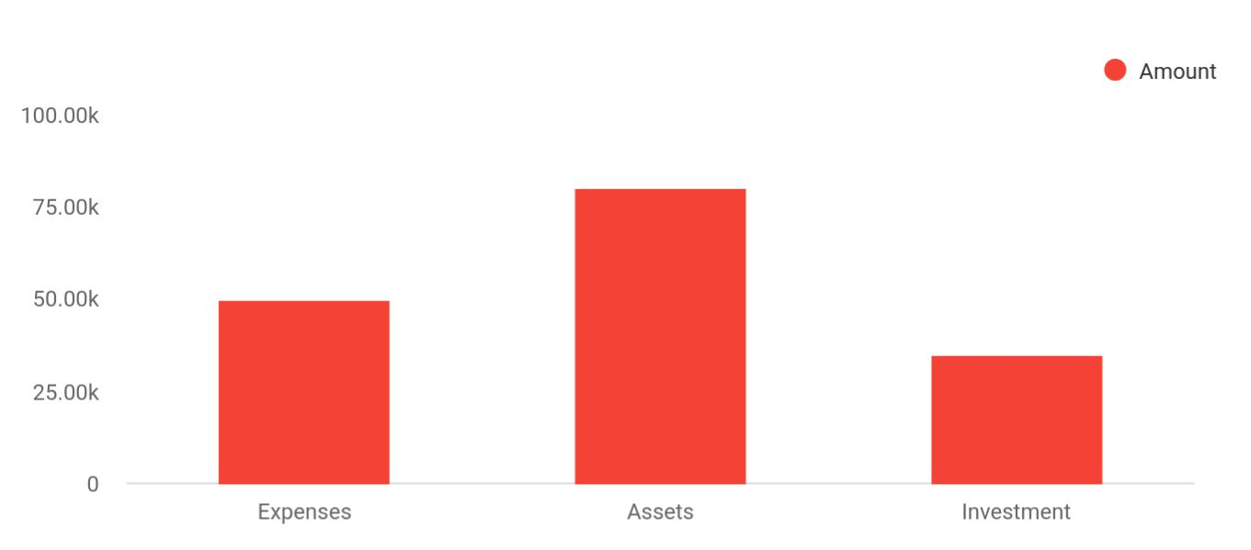

Cost distribution | Amount
Expenses | 50,000
Assets | 80,000
Investment | 35,000

Start-up Expenses | Amount
Legal | $75,500
Consultants | $0
Insurance | $62,750
Rent | $22,500
Research and Development | $42,750
Expensed Equipment | $42,750
Signs | $1,250
TOTAL START-UP EXPENSES | $247,500
Start-up Assets | $0
Cash Required | $322,500
Start-up Inventory | $52,625
Other Current Assets | $222,500

Tom's Nightclub | Business Plan [YEAR] 11/34

Start-up Expenses | Amount
Long-term Assets | $125,000
TOTAL ASSETS | $121,875
Total Requirements | $245,000
START-UP FUNDING | $0
START-UP FUNDING | $273,125
Start-up Expenses to Fund | $121,875
Start-up Assets to Fund | $195,000
TOTAL FUNDING REQUIRED | $0
Assets | $203,125
Non-cash Assets from Start-up | $118,750
Cash Requirements from Start-up | $0
Additional Cash Raised | $118,750
Cash Balance on Starting Date | $121,875
TOTAL ASSETS | $0
Liabilities and Capital | $0
Liabilities | $0
Current Borrowing | $0
Long-term Liabilities | $0
Accounts Payable (Outstanding Bills) | $0
Other Current Liabilities (interest-free) | $0
TOTAL LIABILITIES | $0
Capital | $0
Planned Investment | $0
Investor 1 | $312,500
Investor 2 | $0
Other | $0
Additional Investment Requirement | $0
TOTAL PLANNED INVESTMENT | $695,000

Tom's Nightclub | Business Plan [YEAR] 12/34

Start-up Expenses | Amount
Loss at Start-up (Start-up Expenses) | $313,125
TOTAL CAPITAL | $221,875
TOTAL CAPITAL AND LIABILITIES | $221,875
Total Funding | $265,000

Tom's Nightclub | Business Plan [YEAR] 13/34

3.

Products and services

Features

Tom's Nightclub | Business Plan [YEAR] 14/34

 Tom's Nightclub
Standup Comedy
Beers
Bud Light, Coors Light,
Miller Lite, Budweiser,
Michelob Ultra-Light,
Natural Light, Busch
Light, Bush, Redd's Apple Ale, Sierra Nevada Pale Ale, Keystone Light, Pabst Blue Ribbon, Bud Light Lime, Bud Light Platinum Lager etc.
Wines
To unlock help try Upmetrics!

Tom's Nightclub is going to operate a standard nightclub and bar that will make available every activity, service, and product that can be found in standard nightclubs and bars in the United States and in any part of the world.



Start writing here..

Features


Music and Dance

live band, karaoke, R & B, country side music and jazz etc.

Hall Rental Services for Parties

Locally Crafted Beers

Pale Beers, Amber Beers, Dark Beers, Hebrew Beers, Gluten Free, Organic Brews, Cider etc

Tom's Nightclub | Business Plan [YEAR] 15/34



Distilled spirits Liquor

Martinis Small Chops

Non – alcoholic
Tobacco
beverages

Tom's Nightclub | Business Plan [YEAR] 16/34

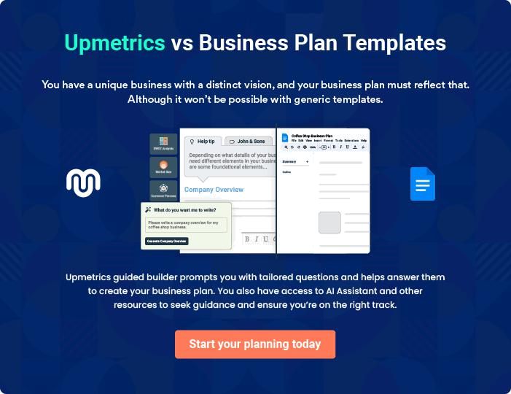

Tom's Nightclub | Business Plan [YEAR] | 17/34

4.

Market Analysis

Market Trends

Target Market

Market Size & Segments

Tom's Nightclub | Business Plan [YEAR] 18/34

The most important component of an effective Nightclub business plan is its accurate marketing analysis. If you are starting on a smaller scale, you can do marketing analysis yourself by taking help from this Nightclub business
To unlock help try Upmetrics! 

Market Trends

 Tom's Nightclub

In recent times, the societal shift away from alcoholic drinks toward healthier lifestyles is to a larger extent contributing to a steady decline in the amount of individual spending allocated to trips to bars and nightclubs plus the fact that nobody wants to be caught driving while drunk.
To unlock help try Upmetrics! 

Start writing here..

Target Market

 Tom's Nightclub

As a standard nightclub and bar, Tom's Nightclub will offer a wide range of services and products hence we are well trained and equipped to services a wide range of clientele base.
The target market for our nightclub and bar cuts across people of different classes and people
To unlock help try Upmetrics! 

Start writing here..

Market Size & Segments

 Tom's Nightclub

The Spot will focus on college-age women who are looking for a high-energy, fun nightclub environment to socialize and dance. Of course, we are also focused on college-age men but it has been our observation that the club scene is driven by where women choose to spend their
To unlock help try Upmetrics! 

Start writing here..

Tom's Nightclub | Business Plan [YEAR] 19/34

5.

SWOT Analysis

Tom's Nightclub | Business Plan [YEAR] 20/34

 Tom's Nightclub

Tom's Nightclub is established with the aim of becoming the melting pot of all lovers of nightlife, social life, alcoholic and non-alcoholic drinks in Detroit - Michigan and to become a pacesetter when it comes to how standard nightclubs and bars should be run in Detroit and
To unlock help try Upmetrics! 

Start writing here..


Strength

Our strength as a nightclub and bar business is excellent and detailed customer service, highly secured and safe facility, Availability of a wide range of assorted drinks, beverages, tobaccos, and food. We can boast of having some of the best hands in the industry, excellent facility, excellent ambiance, and perfect location for a nightclub and bar in a metropolitan and bubbling city like Detroit.


Weakness

Our perceived weakness could be that we are a new nightclub and bar in a highly competitive city like Detroit, and we may not have the financial muscle to sustain the kind of publicity we want to give our business.
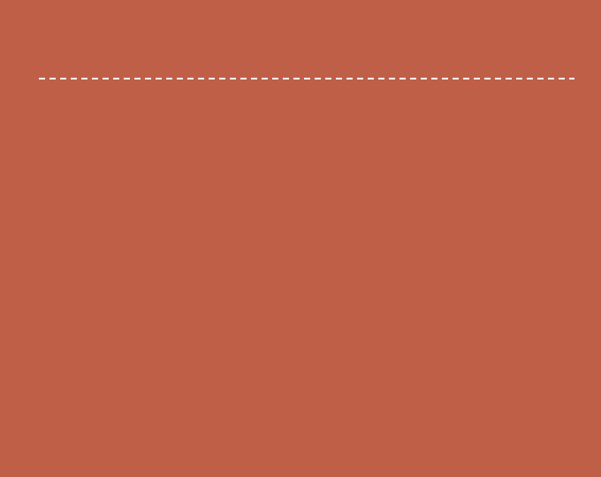

Opportunity

There are unlimited business opportunities available to nightclub and bar businesses in busy cities like Detroit. No doubt, Detroit happens to be one of the cities in the world where social life is at its peak. Another opportunity that we stand to leverage is the fact that we can easily order any brand or beer and drinks directly from the manufacturer with little or no stress.

Threat

One of the threats that are likely going to confront us is unfavorable government policies, security threats, the downturn in the economy which is likely going to affect sales, and perhaps the emergence of new nightclubs and bars (competitors) within the same location where our bar is located.

Tom's Nightclub | Business Plan [YEAR] 21/34

6.

Strategy &

Implementations

Promotion Strategy

Sales Plan

Pricing Strategy

Tom's Nightclub | Business Plan [YEAR] 22/34

After identifying the market demand, market trends, and the potential customers of the startup, the next step is to define an effective strategy for attracting those customers. Like marketing analysis, sales strategy is also an
To unlock help try Upmetrics! 

Promotion Strategy

 Tom's Nightclub

We know that being in the faces of our potentials is one of the keys to really breaking even. That is exactly what we plan to do. Regardless of the fact that our nightclub and bar are well located in Detroit, Michigan, we will still go ahead to intensify publicity for the business.
To unlock help try Upmetrics! 

Start writing here..

Sales Plan

 Tom's Nightclub

We will have a grand opening weekend where the cover charge will be waived for all women customers. We will then establish a traditional Ladies Night, every Wednesday.
To unlock help try Upmetrics! 

Start writing here..

Pricing Strategy

 Tom's Nightclub

The prices of our Beers, Locally Crafted Beers, Wines, Distilled spirits, Liquor, Martinis, Small chops, Non-alcoholic beverages, and Tobacco will be what is obtainable in the market. In fact, we will try as much as we can to sell below the industry’s average so as to attract loads of
To unlock help try Upmetrics! 

Start writing here..

Tom's Nightclub | Business Plan [YEAR] 23/34

7.

Financial Plan

Important Assumptions

Brake-even Analysis

Projected Profit and Loss

Projected Cash Flow

Projected Balance Sheet

Business Ratios

Tom's Nightclub | Business Plan [YEAR] 24/34

The last component of the Nightclub business plan is an in-depth financial plan. The financial plan crafts a detailed map of all the expenses needed for the startup and how these expenses will be met by the earned profits. It is
To unlock help try Upmetrics! 

 Tom's Nightclub

The company will be financed by John himself and he will control the direction of the business to make sure that it is expanding at the forecasted rate. As for the Nightclub business start-up, no equity funding or outside loans will be required. With the help of financial experts, John has
To unlock help try Upmetrics! 

Start writing here..

Important Assumptions

The financial projections of the company are forecast on the basis of the following assumptions. These assumptions are quite conservative and are expected to show deviation but to a limited level such that the company’s major financial strategy will not be affected.

 | Year 1 | Year 2 | Year 3
Plan Month | 1 | 2 | 3
Current Interest Rate | 10,00% | 11,00% | 12,00%
Long-term Interest Rate | 10,00% | 10,00% | 10,00%
Tax Rate | 26,42% | 27,76% | 28,12%
Other | 0 | 0 | 0

Brake-even Analysis

Monthly Units Break-even | 5530
Monthly Revenue Break-even | $159 740
Assumptions:
Average Per-Unit Revenue | $260,87
Average Per-Unit Variable Cost | $0,89
Estimated Monthly Fixed Cost | $196 410

Tom's Nightclub | Business Plan [YEAR] 25/34

Projected Profit and Loss

 | 2024 | 2025 | 2026
Revenue | $676,213.15 | $1,603,522.99 | $4,010,550.52
Entrance Fees | $223,612 | $503,614 | $1,134,227
Unit Sales | 4,472 | 10,072 | 22,685
Unit Price | $50 | $50 | $50
Bar Sales | $238,758.30 | $428,778.45 | $770,028.30
Unit Sales | 15,917 | 28,585 | 51,335
Unit Price | $15 | $15 | $15
Event Hosting | $213,842.85 | $671,130.54 | $2,106,295.22

Cost Of Sales | $206,023.50 | $446,333.19 | $1,058,665.70
General Costs | $206,023.50 | $446,333.19 | $1,058,665.70
Beverage Costs | $111,577.91 | $251,961.14 | $614,465.28
Alcoholic Beverages | $101,431.96 | $240,528.46 | $601,582.59
Non-Alcoholic Beverages | $10,145.95 | $11,432.68 | $12,882.69
Entertainment Costs | $94,445.59 | $194,372.05 | $444,200.42
DJ Services | $26,824.26 | $34,019.75 | $43,145.35
Live Band Fees | $67,621.33 | $160,352.30 | $401,055.07
Revenue Specific Costs | $0 | $0 | $0
Personnel Costs (Direct | $0 | $0 | $0
Labor) | $0 | $0 | $0

Gross Margin | $470,189.65 | $1,157,189.80 | $2,951,884.82
Gross Margin (%) | 69.53% | 72.17% | 73.60%

Tom's Nightclub | Business Plan [YEAR] 26/34

 | 2024 | 2025 | 2026
Operating Expense | $741,028.07 | $770,200.55 | $801,353.47
Payroll Expense (Indirect | $649,080 | $666,591.60 | $684,604.32
Labor) | $649,080 | $666,591.60 | $684,604.32
Management Team | $162,000 | $167,610 | $173,418.36
General Manager | $87,000 | $89,610 | $92,298.36
Marketing Manager | $75,000 | $78,000 | $81,120
Service Staff | $352,800 | $361,584 | $370,595.52
Bartenders | $180,000 | $183,600 | $187,272
Security Staff | $172,800 | $177,984 | $183,323.52
Support Staff | $134,280 | $137,397.60 | $140,590.44
Cleaning Staff | $91,080 | $92,901.60 | $94,759.56
Administrative Assistant | $43,200 | $44,496 | $45,830.88
General Expense | $91,948.07 | $103,608.95 | $116,749.15
Facility Expenses | $46,925.29 | $52,876.49 | $59,582.50
Rent | $31,706.31 | $35,727.40 | $40,258.40
Utilities | $15,218.98 | $17,149.09 | $19,324.10
Marketing Expenses | $28,535.59 | $32,154.44 | $36,232.44
Advertising | $19,023.72 | $21,436.34 | $24,155.06
Promotional Events | $9,511.87 | $10,718.10 | $12,077.38
Operational Expenses | $16,487.19 | $18,578.02 | $20,934.21
Maintenance | $10,145.95 | $11,432.68 | $12,882.69
Licensing Fees | $6,341.24 | $7,145.34 | $8,051.52
Bad Debt | $0 | $0 | $0
Amortization of Current | $0 | $0 | $0
Assets | $0 | $0 | $0

Tom's Nightclub | Business Plan [YEAR] 27/34

EBITDA

Additional Expense

Long Term Depreciation

Gain or loss from Sale of Assets

EBIT

Interest Expense

EBT

Income Tax Expense / Benefit

2024 | 2025 | 2026
($270,838.42) | $386,989.25 | $2,150,531.35

$13,447.93 | $11,513.77 | $9,460.31
$8,301 | $8,301 | $8,301
$0 | $0 | $0
($279,139.42) | $378,688.25 | $2,142,230.35
$5,146.94 | $3,212.76 | $1,159.29
($284,286.35) | $375,475.48 | $2,141,071.04
$0 | $0 | $0

Total Expense | $960,499.50 | $1,228,047.51 | $1,869,479.48
Net Income | ($284,286.35) | $375,475.48 | $2,141,071.04
Net Income (%) | (42.04%) | 23.42% | 53.39%

Retained Earning Opening | $0 | ($302,286.35) | $65,189.13
Owner's Distribution | $18,000 | $8,000 | $8,000
Retained Earning Closing | ($302,286.35) | $65,189.13 | $2,198,260.17

Tom's Nightclub | Business Plan [YEAR] 28/34

Projected Cash Flow

 | 2024 | 2025 | 2026
Cash Received | $676,213.15 | $1,603,522.99 | $4,010,550.52
Cash Paid | $952,198.50 | $1,219,746.51 | $1,861,178.48
COS & General Expenses | $297,971.57 | $549,942.14 | $1,175,414.85
Salary & Wages | $649,080 | $666,591.60 | $684,604.32
Interest | $5,146.94 | $3,212.76 | $1,159.29
Sales Tax | $0 | $0 | $0
Income Tax | $0 | $0 | $0
Net Cash From | ($275,985.35) | $383,776.48 | $2,149,372.04
Operations | ($275,985.35) | $383,776.48 | $2,149,372.04
Assets Sell | $0 | $0 | $0
Assets Purchase | $52,500 | $0 | $0
Net Cash From | ($52,500) | $0 | $0
Investments | ($52,500) | $0 | $0
Amount Received | $150,000 | $0 | $0
Loan Received | $100,000 | $0 | $0
Common Stock | $0 | $0 | $0
Preferred Stock | $0 | $0 | $0
Owner's Contribution | $50,000 | $0 | $0
Amount Paid | $49,359.35 | $41,293.51 | $43,347.12
Loan Capital | $31,359.34 | $33,293.52 | $35,347.14
Dividends & Distributions | $18,000 | $8,000 | $8,000
Net Cash From | $100,640.65 | ($41,293.51) | ($43,347.12)
Financing | $100,640.65 | ($41,293.51) | ($43,347.12)

Tom's Nightclub | Business Plan [YEAR] 29/34

 | 2024 | 2025 | 2026
Summary
Starting Cash | $0 | ($227,844.70) | $114,638.27
Cash In | $826,213.15 | $1,603,522.99 | $4,010,550.52
Cash Out | $1,054,057.85 | $1,261,040.02 | $1,904,525.60
Change in Cash | ($227,844.70) | $342,482.97 | $2,106,024.92
Ending Cash | ($227,844.70) | $114,638.27 | $2,220,663.19
Projected Balance Sheet
 | 2024 | 2025 | 2026
Assets | ($183,645.70) | $150,536.27 | $2,248,260.19
Current Assets | ($227,844.70) | $114,638.27 | $2,220,663.19
Cash | ($227,844.70) | $114,638.27 | $2,220,663.19
Accounts Receivable | $0 | $0 | $0
Inventory | $0 | $0 | $0
Other Current Assets | $0 | $0 | $0
Long Term Assets | $44,199 | $35,898 | $27,597
Gross Long Term Assets | $52,500 | $52,500 | $52,500
Accumulated Depreciation | ($8,301) | ($16,602) | ($24,903)
Liabilities & Equity | ($183,645.69) | $150,536.27 | $2,248,260.17
Liabilities | $68,640.66 | $35,347.14 | $0
Current Liabilities | $33,293.52 | $35,347.14 | $0
Accounts Payable | $0 | $0 | $0
Income Tax Payable | $0 | $0 | $0

Tom's Nightclub | Business Plan [YEAR] 30/34

 | 2024 |  |  | 2025 |  | 2026
Sales Tax Payable | $0 |  |  | $0 |  | $0
Short Term Debt | $33,293.52 |  | $35,347.14 |  |  | $0
Long Term Liabilities | $35,347.14 |  |  | $0 |  | $0
Long Term Debt | $35,347.14 |  |  | $0 |  | $0
Equity | ($252,286.35) |  | $115,189.13 |  |  | $2,248,260.17
Paid-in Capital | $0 |  |  | $0 |  | $0
Common Stock | $0 |  |  | $0 |  | $0
Preferred Stock | $0 |  |  | $0 |  | $0
Owner's Contribution | $50,000 |  |  | $50,000 |  | $50,000
Retained Earnings | ($302,286.35) |  | $65,189.13 |  |  | $2,198,260.17
Check | $0 |  |  | $0 |  | $0
Business Ratios
 |  | Year 1 | Year 2 |  | Year 3 | Industry Profile
Sales Growth |  | 4,35% | 30,82% |  | 63,29% | 4,00%
Percent of Total Assets
Accounts Receivable |  | 5,61% | 4,71% |  | 3,81% | 9,70%
Inventory |  | 1,85% | 1,82% |  | 1,79% | 9,80%
Other Current Assets |  | 1,75% | 2,02% |  | 2,29% | 27,40%
Total Current Assets |  | 138,53% | 150,99% |  | 163,45% | 54,60%
Long-term Assets |  | -9,47% | -21,01% |  | -32,55% | 58,40%
TOTAL ASSETS |  | 100,00% | 100,00% |  | 100,00% | 100,00%
Current Liabilities |  | 4,68% | 3,04% |  | 2,76% | 27,30%
Long-term Liabilities |  | 0,00% | 0,00% |  | 0,00% | 25,80%
Total Liabilities |  | 4,68% | 3,04% |  | 2,76% | 54,10%

Tom's Nightclub | Business Plan [YEAR] 31/34

 | Year 1 | Year 2 | Year 3 | Industry Profile
NET WORTH | 99,32% | 101,04% | 102,76% | 44,90%
Percent of Sales
Sales | 100,00% | 100,00% | 100,00% | 100,00%
Gross Margin | 94,18% | 93,85% | 93,52% | 0,00%
Selling, General & Administrative Expenses | 74,29% | 71,83% | 69,37% | 65,20%
Advertising Expenses | 2,06% | 1,11% | 0,28% | 1,40%
Profit Before Interest and Taxes | 26,47% | 29,30% | 32,13% | 2,86%
Main Ratios
Current | 25,86 | 29,39 | 32,92 | 1,63
Quick | 25,4 | 28,88 | 32,36 | 0,84
Total Debt to Total Assets | 2,68% | 1,04% | 0,76% | 67,10%
Pre-tax Return on Net Worth | 66,83% | 71,26% | 75,69% | 4,40%
Pre-tax Return on Assets | 64,88% | 69,75% | 74,62% | 9,00%
Additional Ratios
Net Profit Margin | 19,20% | 21,16% | 23,12% | N.A.
Return on Equity | 47,79% | 50,53% | 53,27% | N.A.
Activity Ratios
Accounts Receivable Turnover | 4,56 | 4,56 | 4,56 | N.A.
Collection Days | 92 | 99 | 106 | N.A.
Inventory Turnover | 19,7 | 22,55 | 25,4 | N.A.
Accounts Payable Turnover | 14,17 | 14,67 | 15,17 | N.A.
Payment Days | 27 | 27 | 27 | N.A.
Total Asset Turnover | 1,84 | 1,55 | 1,26 | N.A.
Debt Ratios
Debt to Net Worth | 0 | -0,02 | -0,04 | N.A.
Current Liab. to Liab. | 1 | 1 | 1 | N.A.
Liquidity Ratios
Net Working Capital | $120 943 | $140 664 | $160 385 | N.A.

Tom's Nightclub | Business Plan [YEAR] 32/34

 | Year 1 | Year 2 | Year 3 | Industry Profile
Interest Coverage | 0 | 0 | 0 | N.A.
Additional Ratios
Assets to Sales | 0,45 | 0,48 | 0,51 | N.A.
Current Debt/Total Assets | 4% | 3% | 2% | N.A.
Acid Test | 23,66 | 27,01 | 30,36 | N.A.
Sales/Net Worth | 1,68 | 1,29 | 0,9 | N.A.
Dividend Payout | 0 | 0 | 0 | N.A.
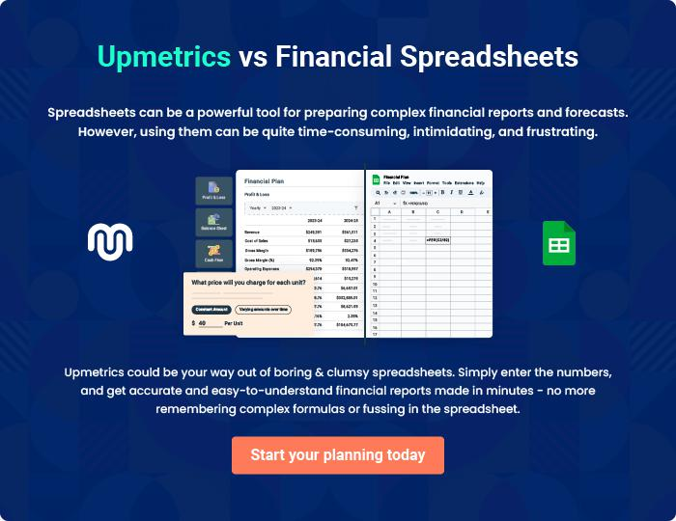

Tom's Nightclub | Business Plan [YEAR] 33/34


Create a winning business plan that gets you funded

Creating a stunning and investment-ready plan requires no writing, graphic designing, or financial planning expertise.

Upmetrics has all the features required to help you create a comprehensive business plan—from start to finish. Make no mistakes, it’s the modern way of planning to structure ideas, make plans, and create stunning pitch decks to awe investors.

Pitch decks that impress investors

Create pitch decks that provide a visual representation of your business, engage investors, and make them want to invest in your business idea.

Interactive plans in no time

Import business plan sections like—SWOT analysis, comparison tables, and others to create an interactive business plan. No designing skills are required.

Stunning cover page designs

With Upmetrics, you have the liberty to choose from multiple stunning cover page designs. Choose a creative design and make your plan stand out.

Online sharing made simple

Upmetrics makes online sharing quick and easier for users. Easily share your business plans with a link while tracking reader activity.

500+ sample business plans

Simply import a template from our library of sample plans into the editor and start customizing it to make it yours. It takes only a few clicks to get started.

Collaborate with team in real-time

Invite team members, initiate conversations, discuss ideas & strategies, share feedback, and work on a business plan in real-time.

