
 Nail Salon Studio

ADDRESS CONTACT

10200 Bolsa Ave, Westminster, CA, 92683 (650) 359-3153

https://example.com info@example.com

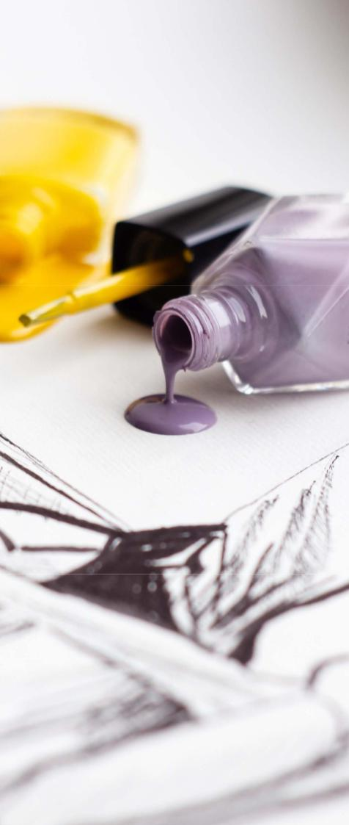

Business Plan

[YEAR]

Prepared By

John Doe


Fall in Love with the Art of Nails

Information provided in this business plan is unique to this business and confidential; therefore, anyone reading this plan agrees not to disclose any of the information in this business plan without prior written permission of the Company

Table of Contents

Executive Summary | 5
Mission statement | 6
Vision statement | 6
Customer Focus | 7
Management Team | 7
Success Factors | 7
Financial Summary | 8
3 Year profit forecast | 8

Company Summary | 9
History | 10
Products and Services | 10
Salon Design | 11

Market Analysis | 12
Market Trends | 13
Target Market | 13
Strategy & Implementations
Strategy & Implementations | 15
Advertising Strategy | 16
Local Publications | 16
Major Publications | 17
Community Events/Organizations | 17
Commute Advertising | 17
Direct Mail | 17
Ongoing Customer Communications | 18
Customer Loyalty Programs | 18
Pre-Opening Events | 18
Pricing Strategy | 18

Nail Salon Studio | Business Plan [YEAR] 2/34

Management Summary | 19
Management Team Members | 20
Hiring Plan | 20
Operations Plan
Operations Plan | 21
Functional Roles | 22
Service Functions | 22
Administrative Functions | 22
Milestones | 23
Financial Plan
Financial Plan | 24
Important Assumptions | 25
Brake-even Analysis | 25
Projected Profit and Loss | 26
Projected Cash Flow | 29
Projected Balance Sheet | 30
Business Ratios | 31

Nail Salon Studio | Business Plan [YEAR] 3/34


Business planning that’s simpler and faster than you think

Creating a business plan using Upmetrics to start and grow a business is literally the easiest thing in the World. Simply read the instructions and fill in the blanks. It’s as simple as that.

❛ | Upmetrics has everything you need to create a | ❜
❛ | comprehensive business plan. | ❜

AI-powered Upmetrics Assistant

AI-powered insights to streamline your plan

Not sure where to start? Upmetrics’ AI Assistant will automatically generate ideas for each section of your plan and offer improved versions of your writing, adjusting for tone, voice, and grammar or spelling errors.

Financial Forecasting Tool

All the financials are calculated for you

Forget the complex formulas and clumsy spreadsheets — with automatic financials and drag-and-drop forecasting, you can finish your plan faster and be confident that your numbers are accurate.

Business Plan Builder

Guides you like a business mentor

Upmetrics’ step-by-step instructions, prompts, and the library of 400+ sample business plans will guide you through each section of your plan as a business mentor.

1.


Executive Summary

Mission statement

Vision statement

Customer Focus

Management Team

Success Factors

Financial Summary

Nail Salon Studio | Business Plan [YEAR] 5/34

Before you think about how to start a Nail salon service, you must create a detailed Nail salon business plan. It will not only guide you in the initial phases of your startup but will also help you later on.
To unlock help try Upmetrics!
To unlock help try Upmetrics!
To unlock help try Upmetrics!



 Finger Art


Finger Art Nail Studio is a classy nail salon that will be opened in New York City, United States. We have chosen New York because we think that it would be an amazing opportunity to have the crème de la crème in society and in showbiz visit our nail hub.



Start writing here..

Mission statement

 Finger Art

Our mission is to provide professional and creative service to our clients- thereby meeting their beauty needs at all times.
To unlock help try Upmetrics! 

Start writing here..

Vision statement

 Finger Art

Our vision is to provide our teeming clients with the best of nail services, such that is hard to experience in New York. We strive to achieve this with our overly trained nail attendants and the ambiance which our salon has to offer.



Start writing here..

Nail Salon Studio | Business Plan [YEAR] 6/34

Customer Focus

 Finger Art

Finger Art will primarily serve the residents within a 5-mile radius of our location. The demographics of these customers are as follows:
To unlock help try Upmetrics! 

Start writing here..

Management Team

 Finger Art

Finger Art is led by John Moore who has been in the nail care business for 20 years. While Mr. Moore has never run a nail salon himself, he has been doing nails since age 15 and spent most of his adult life working at several major salons. As such Mr. Moore has an in-depth knowledge
To unlock help try Upmetrics! 

Start writing here..

Success Factors

 Finger Art

Finger Art is uniquely qualified to succeed due to the following reasons:

• The Company will fill a specific market niche in the growing community we are entering.
To unlock help try Upmetrics! 

Start writing here..

Nail Salon Studio | Business Plan [YEAR] 7/34

Financial Summary

 Finger Art

Finger Art is currently seeking $260,000 to launch. Specifically, these funds will be used as follows:
To unlock help try Upmetrics! 

Start writing here..

3 Year profit forecast
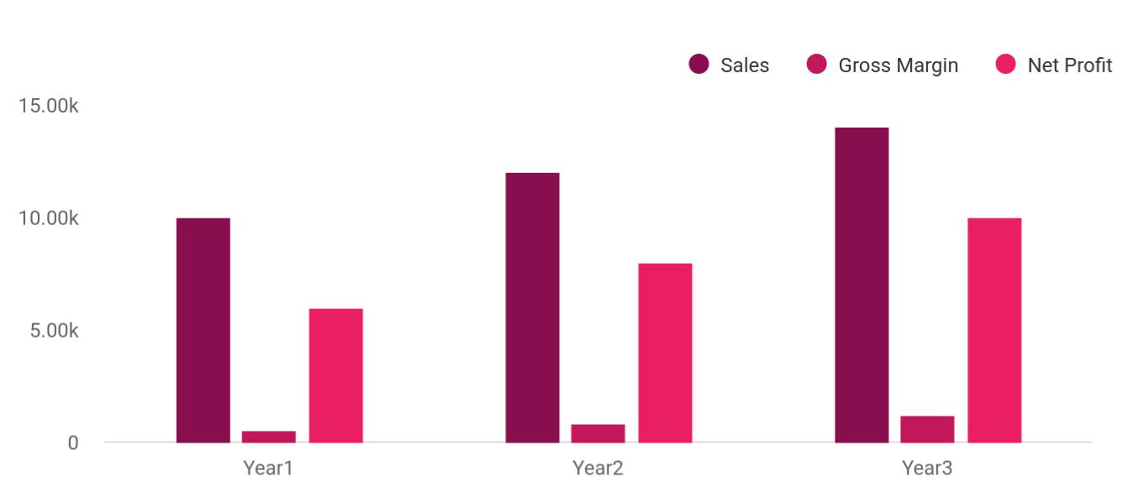

Financial Year | Sales | Gross Margin | Net Profit
Year1 | 10,000 | 500 | 6,000
Year2 | 12,000 | 800 | 8,000
Year3 | 14,000 | 1,200 | 10,000

 Finger Art

In addition to providing these services, Finger Art will also be a retailer of exclusive nail care products. Customers will find products at Finger Art that they won’t find in grocery stores. Our prices would also be very affordable; we do not want to scare our new clients away with our
To unlock help try Upmetrics! 

Start writing here..

Nail Salon Studio | Business Plan [YEAR] 8/34

2.

Company Summary

History

Products and Services

Salon Design

Nail Salon Studio | Business Plan [YEAR] 9/34

 Finger Art

Finger Art, located at the heart of New York is a new, upscale nail salon focusing on providing professional nail services in an enjoyable environment. It will showcase a well-designed interior as well as a full-featured waiting area equipped with television screens and at-request
To unlock help try Upmetrics! 

Start writing here..

History

 Finger Art

Upon returning from Fort Lauderdale, surveying the local customer base, and finding a potential retail location, John incorporated Finger Art as an S-Corporation in 2021.
To unlock help try Upmetrics! 

Start writing here..

Products and Services

 Finger Art

Below are Finger Art’s initial service offerings and in-store products sold.

Nail Technicians will be asked to perform the following services:
To unlock help try Upmetrics! 

Start writing here..

Nail Salon Studio | Business Plan [YEAR] 10/34

Salon Design

 Finger Art

Finger Art will develop a 2,500 square foot store whose key elements will include the following:

• Stylist Booths
To unlock help try Upmetrics! 

Start writing here..

Nail Salon Studio | Business Plan [YEAR] 11/34

3.

Market Analysis

Market Trends

Target Market

Nail Salon Studio | Business Plan [YEAR] 12/34

The most important component of an effective Nail Salon business plan is its accurate marketing analysis. If you are starting on a smaller scale, you can do marketing analysis yourself by taking help from this Nail Salon business
To unlock help try Upmetrics! 

Market Trends

 Finger Art

Quite a number of distinct trends have emerged in recent times in the nail beauty industry which is why nail salons are positioning their organizations to attract all and sundry. As a
matter of fact, this is one of the things that makes most nail studios spruce up their creativity
To unlock help try Upmetrics! 

Start writing here..

Target Market

 Finger Art

The target market which we are all out to serve is primarily the female folks. This is because of the fact that they are the ones who will leave no stone unturned in seeing that they look their best. Whilst some may do this to continue to be attractive to their partners, yet others cannot
To unlock help try Upmetrics! 

Start writing here..

Nail Salon Studio | Business Plan [YEAR] 13/34



Nail Salon Studio | Business Plan [YEAR] | 14/34

4.

Strategy &

Implementations

Advertising Strategy

Pricing Strategy

Nail Salon Studio | Business Plan [YEAR] 15/34

After identifying the market demand, market trends, and the potential customers of the startup, the next step is to define an effective strategy for attracting those customers. Like marketing analysis, sales strategy is also an
To unlock help try Upmetrics! 

 Finger Art

We are mindful of the fact that there is stiff competition amongst nail salons in the United States of America; hence we have been able to hire some of the best business developers to handle our sales and marketing. Our sales and marketing team will be recruited based on their
To unlock help try Upmetrics! 

Start writing here..

Advertising Strategy

 Finger Art

Finger Art expects its target market to be individuals working and/or living within a 5-mile radius of its location. Our promotions strategy to reach these individuals includes:
To unlock help try Upmetrics! 

Start writing here..

 Finger Art

Finger Art will announce its opening several weeks in advance through publicity pieces in multiple local newspapers and publications. Regular advertisements will run to maintain
exposure to relevant markets. Community newspapers, school publications, youth sports
To unlock help try Upmetrics! 

Local Publications

Start writing here..

Nail Salon Studio | Business Plan [YEAR] 16/34

 Finger Art
To unlock help try Upmetrics!

We will make careful use of advertising in selected larger publications. [Publication or newspaper name] has a circulation of XYZ and we can expect to reach a wider geographic region of customers on a limited basis. Advertisements with major publications will be used
To unlock help try Upmetrics! 

Major Publications

Start writing here..

 Finger Art

Finger Art will promote itself by distributing marketing materials and participating in local community events, such as school fairs, local festivals, homeowner associations, or sporting events. Since mothers are often heavily involved in such things, we will not only reach the
To unlock help try Upmetrics! 

Community Events/Organizations

Start writing here..

 Finger Art

We will drive attention toward Finger Art by hiring workers to hold signs alongside [route or highway]. Advertising on heavily traveled commute routes is an opportunity to alert large numbers of working individuals with disposable income of our opening.

Commute Advertising

Start writing here..

 Finger Art



Finger Art will maintain a website and publish a monthly email newsletter to tell customers about new events, products, and more.
To unlock help try Upmetrics! 

Direct Mail

Start writing here..

Nail Salon Studio | Business Plan [YEAR] 17/34

 Finger Art
To unlock help try Upmetrics!
To unlock help try Upmetrics!

Before opening the store, Finger Art will organize pre-opening events designed for prospective customers, local merchants, and press contacts. These events will create buzz and awareness for Finger Art in the area.



Ongoing Customer Communications

Start writing here..

 Finger Art

Finger Art will blanket neighborhoods surrounding its locations with direct mail pieces. These pieces will provide general information on Finger Art, offer discounts, and/or provide other inducements for people to visit the salon.



Customer Loyalty Programs

Start writing here..

 Finger Art

Finger Art will create a winning customer loyalty program to keep its best clients coming back again and again. When not actively providing services to customers in the store, our professionals and other employees will make periodic, regular phone calls to customers. These
To unlock help try Upmetrics! 

Pre-Opening Events

Start writing here..

Pricing Strategy

 Finger Art

One of the ways through which we know that we will be able to get more clients within a short period of time is when our pricing is on a moderate level. Being on the moderate level means that we are able to maximize profit in a way that doesn’t put holes in the pocket of our clients.
To unlock help try Upmetrics! 

Start writing here..

Nail Salon Studio | Business Plan [YEAR] 18/34

5.

Management Summary

Management Team Members

Hiring Plan

Nail Salon Studio | Business Plan [YEAR] 19/34

The management plan is also an important component of a nail salon business plan since it gives you an estimate of the staff required for your
startup as well as the costs incurred on their salaries. So, make sure to duly
To unlock help try Upmetrics! 

Management Team Members

 Finger Art

Finger Art is led by John Moore who has been in the nail salon business for 20 years.

While Mr. has never run a nail salon himself, he has extensive at major salons for the past 20
To unlock help try Upmetrics! 

Start writing here..

Hiring Plan

 Finger Art

John Moore will serve as the store manager. In order to launch our salon, we need to hire the following personnel:
To unlock help try Upmetrics! 

Start writing here..

Nail Salon Studio | Business Plan [YEAR] 20/34

6.

Operations Plan

Functional Roles

Service Functions

Administrative Functions

Milestones

Nail Salon Studio | Business Plan [YEAR] 21/34

Functional Roles

 Finger Art

Finger Art will carry out its day-to-day operations primarily on an appointment basis. Walk-in clients will be served by the earliest available technicians, but priority will be given to clients
who called ahead. In the meantime, waiting for customers can divert themselves to the lounge,
To unlock help try Upmetrics! 

Start writing here..

Service Functions

 Finger Art


- Manicures

- Pedicures
^{3.} ^{Massages} To unlock help try Upmetrics! 

Start writing here..

Administrative Functions

 Finger Art

• General & administrative functions including legal, marketing, bookkeeping, etc.

• ^{Sourcing and storing products} To unlock help try Upmetrics! 

Start writing here..

Nail Salon Studio | Business Plan [YEAR] 22/34

Milestones

 Finger Art

Finger Art’s long-term goal is to become the dominant provider of nail care and related services and products in the area. We seek to the standard by which other providers are judged.
To unlock help try Upmetrics! 

Start writing here..

Nail Salon Studio | Business Plan [YEAR] 23/34

7.

Financial Plan

Important Assumptions

Brake-even Analysis

Projected Profit and Loss

Projected Cash Flow

Projected Balance Sheet

Business Ratios

Nail Salon Studio | Business Plan [YEAR] 24/34

The last component of a nail salon business plan is an in-depth financial plan. The financial plan crafts a detailed map of all the expenses needed for the startup and how these expenses will be met by the earned profits. It is
To unlock help try Upmetrics! 

 Little Stars


The company will be financed by John himself and he will control the direction of the business to make sure that it is expanding at the forecasted rate. As for the nail salon business start-up, no equity funding or outside loans will be required. With the help of financial experts, John has
To unlock help try Upmetrics! 

Start writing here..

Important Assumptions

The financial projections of the company are forecast on the basis of the following assumptions. These assumptions are quite conservative and are expected to show deviation but to a limited level such that the company’s major financial strategy will not be affected.

 | Year 1 | Year 2 | Year 3
Plan Month | 1 | 2 | 3
Current Interest Rate | 10,00% | 11,00% | 12,00%
Long-term Interest Rate | 10,00% | 10,00% | 10,00%
Tax Rate | 26,42% | 27,76% | 28,12%
Other | 0 | 0 | 0

Brake-even Analysis

Monthly Units Break-even | 5530
Monthly Revenue Break-even | $159 740
Assumptions:
Average Per-Unit Revenue | $260,87
Average Per-Unit Variable Cost | $0,89
Estimated Monthly Fixed Cost | $196 410

Nail Salon Studio | Business Plan [YEAR] 25/34

Projected Profit and Loss

 | 2024 | 2025 | 2026
Revenue | $251,355.70 | $406,646.90 | $664,580.40
Hair and Scalp Treatment | $79,587.50 | $142,939.50 | $256,700
Unit Sales | 1,592 | 2,859 | 5,134
Unit Price | $50 | $50 | $50
Manicure and Pedicure | $102,183.20 | $145,696.40 | $207,738.40
Unit Sales | 2,555 | 3,642 | 5,193
Unit Price | $40 | $40 | $40
Nail Art and Design | $69,585 | $118,011 | $200,142
Unit Sales | 1,392 | 2,360 | 4,003
Unit Price | $50 | $50 | $50
Cost Of Sales | $34,082.11 | $47,043.31 | $67,454.83
General Costs | $34,082.11 | $47,043.31 | $67,454.83
Nail Products | $12,625.15 | $17,311.52 | $24,666.04
Nail Polish | $6,341.24 | $7,145.34 | $8,051.52
Nail Art Supplies | $6,283.91 | $10,166.18 | $16,614.52
Salon Equipment | $21,456.96 | $29,731.79 | $42,788.79
Manicure Stations | $10,145.95 | $11,432.68 | $12,882.69
Pedicure Chairs | $11,311.01 | $18,299.11 | $29,906.10
Revenue Specific Costs | $0 | $0 | $0
Personnel Costs (Direct | $0 | $0 | $0
Labor) | $0 | $0 | $0
Gross Margin | $217,273.59 | $359,603.59 | $597,125.57

Nail Salon Studio | Business Plan [YEAR] 26/34

 | 2024 | 2025 | 2026
Gross Margin (%) | 86.44% | 88.43% | 89.85%

Operating Expense | $234,275.61 | $343,352.42 | $377,174.89
Payroll Expense (Indirect | $209,364 | $309,641.55 | $330,051.72
Labor) | $209,364 | $309,641.55 | $330,051.72
Salon Staff | $67,524 | $164,122.35 | $180,754.44
Hairstylists | $33,924 | $121,702.35 | $112,203.72
Nail Technicians | $33,600 | $42,420 | $68,550.72
Administrative Staff | $84,240 | $86,767.20 | $89,370.24
Salon Manager | $55,200 | $56,856 | $58,561.68
Receptionist | $29,040 | $29,911.20 | $30,808.56
Support Staff | $57,600 | $58,752 | $59,927.04
Cleaners | $36,000 | $36,720 | $37,454.40
Maintenance Staff | $21,600 | $22,032 | $22,472.64
General Expense | $24,911.62 | $33,710.87 | $47,123.17
Utilities | $5,050.02 | $6,924.61 | $9,866.40
Electricity | $2,536.46 | $2,858.16 | $3,220.59
Water | $2,513.56 | $4,066.45 | $6,645.81
Salon Maintenance | $5,979.69 | $7,441.50 | $9,267.83
Equipment Maintenance | $1,956.12 | $2,338.64 | $2,796.07
Cleaning Services | $4,023.57 | $5,102.86 | $6,471.76
Marketing and Advertising | $13,881.91 | $19,344.76 | $27,988.94
Online Advertising | $7,540.67 | $12,199.42 | $19,937.42
Local Media Advertising | $6,341.24 | $7,145.34 | $8,051.52
Bad Debt | $0 | $0 | $0

Nail Salon Studio | Business Plan [YEAR] 27/34

Amortization of Current Assets

EBITDA

Additional Expense

Long Term Depreciation

Gain or loss from Sale of Assets

EBIT

Interest Expense

EBT

Income Tax Expense / Benefit

Total Expense

Net Income

Net Income (%)

Retained Earning Opening

Owner's Distribution

Retained Earning Closing

2024 | 2025 | 2026
$0 | $0 | $0

($17,002.01) $16,251.16 $219,950.68

$8,467.02 | $7,192.40 | $5,812.01
$5,022 | $5,022 | $5,022
$0 | $0 | $0
($22,024.01) | $11,229.16 | $214,928.68
$3,445.02 | $2,170.41 | $790.01
($25,469.03) | $9,058.76 | $214,138.67
$0 | $0 | $0

$276,824.73 | $397,588.14 | $450,441.73
($25,469.03) | $9,058.76 | $214,138.67
(10.13%) | 2.23% | 32.22%

$0 | ($115,469.03) | ($196,410.27)
$90,000 | $90,000 | $90,000
($115,469.03) | ($196,410.27) | ($72,271.60)

Nail Salon Studio | Business Plan [YEAR] 28/34

Projected Cash Flow

 | 2024 | 2025 | 2026
Cash Received | $251,355.70 | $406,646.90 | $664,580.40
Cash Paid | $271,802.74 | $392,566.15 | $445,419.73
COS & General Expenses | $58,993.72 | $80,754.20 | $114,578
Salary & Wages | $209,364 | $309,641.55 | $330,051.72
Interest | $3,445.02 | $2,170.41 | $790.01
Sales Tax | $0 | $0 | $0
Income Tax | $0 | $0 | $0
Net Cash From | ($20,447.04) | $14,080.75 | $219,160.67
Operations | ($20,447.04) | $14,080.75 | $219,160.67
Assets Sell | $0 | $0 | $0
Assets Purchase | $35,000 | $0 | $0
Net Cash From | ($35,000) | $0 | $0
Investments | ($35,000) | $0 | $0
Amount Received | $80,000 | $0 | $0
Loan Received | $50,000 | $0 | $0
Common Stock | $0 | $0 | $0
Preferred Stock | $0 | $0 | $0
Owner's Contribution | $30,000 | $0 | $0
Amount Paid | $105,356.82 | $106,631.44 | $108,011.76
Loan Capital | $15,356.82 | $16,631.43 | $18,011.76
Dividends & Distributions | $90,000 | $90,000 | $90,000
Net Cash From | ($25,356.82) | ($106,631.44) | ($108,011.76)
Financing | ($25,356.82) | ($106,631.44) | ($108,011.76)

Nail Salon Studio | Business Plan [YEAR] 29/34

 | 2024 | 2025 | 2026
Summary
Starting Cash | $0 | ($80,803.86) | ($173,354.55)
Cash In | $331,355.70 | $406,646.90 | $664,580.40
Cash Out | $412,159.56 | $499,197.59 | $553,431.49
Change in Cash | ($80,803.86) | ($92,550.69) | $111,148.91
Ending Cash | ($80,803.86) | ($173,354.55) | ($62,205.64)
Projected Balance Sheet
 | 2024 | 2025 | 2026
Assets | ($50,825.86) | ($148,398.55) | ($42,271.64)
Current Assets | ($80,803.86) | ($173,354.55) | ($62,205.64)
Cash | ($80,803.86) | ($173,354.55) | ($62,205.64)
Accounts Receivable | $0 | $0 | $0
Inventory | $0 | $0 | $0
Other Current Assets | $0 | $0 | $0
Long Term Assets | $29,978 | $24,956 | $19,934
Gross Long Term Assets | $35,000 | $35,000 | $35,000
Accumulated Depreciation | ($5,022) | ($10,044) | ($15,066)
Liabilities & Equity | ($50,825.84) | ($148,398.51) | ($42,271.60)
Liabilities | $34,643.19 | $18,011.76 | $0
Current Liabilities | $16,631.43 | $18,011.76 | $0
Accounts Payable | $0 | $0 | $0
Income Tax Payable | $0 | $0 | $0

Nail Salon Studio | Business Plan [YEAR] 30/34

 | 2024 |  |  | 2025 | 2026
Sales Tax Payable | $0 |  |  | $0 | $0
Short Term Debt | $16,631.43 |  | $18,011.76 |  | $0
Long Term Liabilities | $18,011.76 |  |  | $0 | $0
Long Term Debt | $18,011.76 |  |  | $0 | $0
Equity | ($85,469.03) |  | ($166,410.27) |  | ($42,271.60)
Paid-in Capital | $0 |  |  | $0 | $0
Common Stock | $0 |  |  | $0 | $0
Preferred Stock | $0 |  |  | $0 | $0
Owner's Contribution | $30,000 |  |  | $30,000 | $30,000
Retained Earnings | ($115,469.03) |  | ($196,410.27) |  | ($72,271.60)
Check | $0 |  |  | $0 | $0
Business Ratios
 |  | Year 1 | Year 2 | Year 3 | Industry Profile
Sales Growth |  | 4,35% | 30,82% | 63,29% | 4,00%
Percent of Total Assets
Accounts Receivable |  | 5,61% | 4,71% | 3,81% | 9,70%
Inventory |  | 1,85% | 1,82% | 1,79% | 9,80%
Other Current Assets |  | 1,75% | 2,02% | 2,29% | 27,40%
Total Current Assets |  | 138,53% | 150,99% | 163,45% | 54,60%
Long-term Assets |  | -9,47% | -21,01% | -32,55% | 58,40%
TOTAL ASSETS |  | 100,00% | 100,00% | 100,00% | 100,00%
Current Liabilities |  | 4,68% | 3,04% | 2,76% | 27,30%
Long-term Liabilities |  | 0,00% | 0,00% | 0,00% | 25,80%
Total Liabilities |  | 4,68% | 3,04% | 2,76% | 54,10%

Nail Salon Studio | Business Plan [YEAR] 31/34

 | Year 1 | Year 2 | Year 3 | Industry Profile
NET WORTH | 99,32% | 101,04% | 102,76% | 44,90%
Percent of Sales
Sales | 100,00% | 100,00% | 100,00% | 100,00%
Gross Margin | 94,18% | 93,85% | 93,52% | 0,00%
Selling, General & Administrative Expenses | 74,29% | 71,83% | 69,37% | 65,20%
Advertising Expenses | 2,06% | 1,11% | 0,28% | 1,40%
Profit Before Interest and Taxes | 26,47% | 29,30% | 32,13% | 2,86%
Main Ratios
Current | 25,86 | 29,39 | 32,92 | 1,63
Quick | 25,4 | 28,88 | 32,36 | 0,84
Total Debt to Total Assets | 2,68% | 1,04% | 0,76% | 67,10%
Pre-tax Return on Net Worth | 66,83% | 71,26% | 75,69% | 4,40%
Pre-tax Return on Assets | 64,88% | 69,75% | 74,62% | 9,00%
Additional Ratios
Net Profit Margin | 19,20% | 21,16% | 23,12% | N.A.
Return on Equity | 47,79% | 50,53% | 53,27% | N.A.
Activity Ratios
Accounts Receivable Turnover | 4,56 | 4,56 | 4,56 | N.A.
Collection Days | 92 | 99 | 106 | N.A.
Inventory Turnover | 19,7 | 22,55 | 25,4 | N.A.
Accounts Payable Turnover | 14,17 | 14,67 | 15,17 | N.A.
Payment Days | 27 | 27 | 27 | N.A.
Total Asset Turnover | 1,84 | 1,55 | 1,26 | N.A.
Debt Ratios
Debt to Net Worth | 0 | -0,02 | -0,04 | N.A.
Current Liab. to Liab. | 1 | 1 | 1 | N.A.
Liquidity Ratios
Net Working Capital | $120 943 | $140 664 | $160 385 | N.A.

Nail Salon Studio | Business Plan [YEAR] 32/34

 | Year 1 | Year 2 | Year 3 | Industry Profile
Interest Coverage | 0 | 0 | 0 | N.A.
Additional Ratios
Assets to Sales | 0,45 | 0,48 | 0,51 | N.A.
Current Debt/Total Assets | 4% | 3% | 2% | N.A.
Acid Test | 23,66 | 27,01 | 30,36 | N.A.
Sales/Net Worth | 1,68 | 1,29 | 0,9 | N.A.
Dividend Payout | 0 | 0 | 0 | N.A.
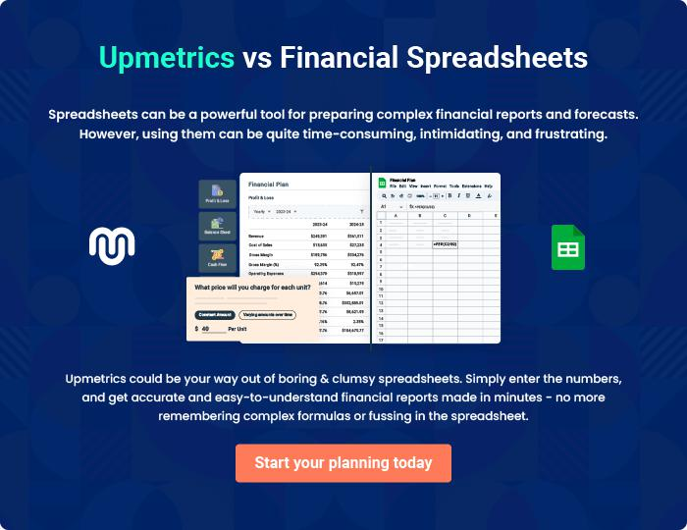

Nail Salon Studio | Business Plan [YEAR] 33/34


Create a winning business plan that gets you funded

Creating a stunning and investment-ready plan requires no writing, graphic designing, or financial planning expertise.

Upmetrics has all the features required to help you create a comprehensive business plan—from start to finish. Make no mistakes, it’s the modern way of planning to structure ideas, make plans, and create stunning pitch decks to awe investors.

Pitch decks that impress investors

Create pitch decks that provide a visual representation of your business, engage investors, and make them want to invest in your business idea.

Interactive plans in no time

Import business plan sections like—SWOT analysis, comparison tables, and others to create an interactive business plan. No designing skills are required.

Stunning cover page designs

With Upmetrics, you have the liberty to choose from multiple stunning cover page designs. Choose a creative design and make your plan stand out.

Online sharing made simple

Upmetrics makes online sharing quick and easier for users. Easily share your business plans with a link while tracking reader activity.

500+ sample business plans

Simply import a template from our library of sample plans into the editor and start customizing it to make it yours. It takes only a few clicks to get started.

Collaborate with team in real-time

Invite team members, initiate conversations, discuss ideas & strategies, share feedback, and work on a business plan in real-time.

