

Moving Company

Your friend with a truck.


Business
Plan

[YEAR]

Prepared By

John Doe

10200 Bolsa Ave, Westminster, CA, 92683

info@example.com

(650) 359-3153 http://www.example.com

Table of Contents

Executive Summary | 5
Objectives | 6
Mission Statement | 6
Vision Statement | 7
Financial Summary | 7
3 Year profit forecast | 7

Company Summary | 9
History | 10
Business Structure | 10
Startup Summary | 10
Startup cost | 11
Products and services
Products and services | 14
Market Analysis
Market Analysis | 17
Market Trends | 18
Target Market | 18
Market Segmentation | 18
SWOT Analysis
SWOT Analysis | 20
Strategy & Implementations
Strategy & Implementations | 23
Advertising Strategy | 24
Pricing Strategy | 24
Sales Forecast | 24
Milestones | 25
Financial Plan
Financial Plan | 26
Important Assumptions | 27

Moving Company | Business Plan [YEAR] 2/36

Brake-even Analysis | 27
Projected Profit and Loss | 28
Projected Cash Flow | 30
Projected Balance Sheet | 32
Business Ratios | 33

Moving Company | Business Plan [YEAR] 3/36

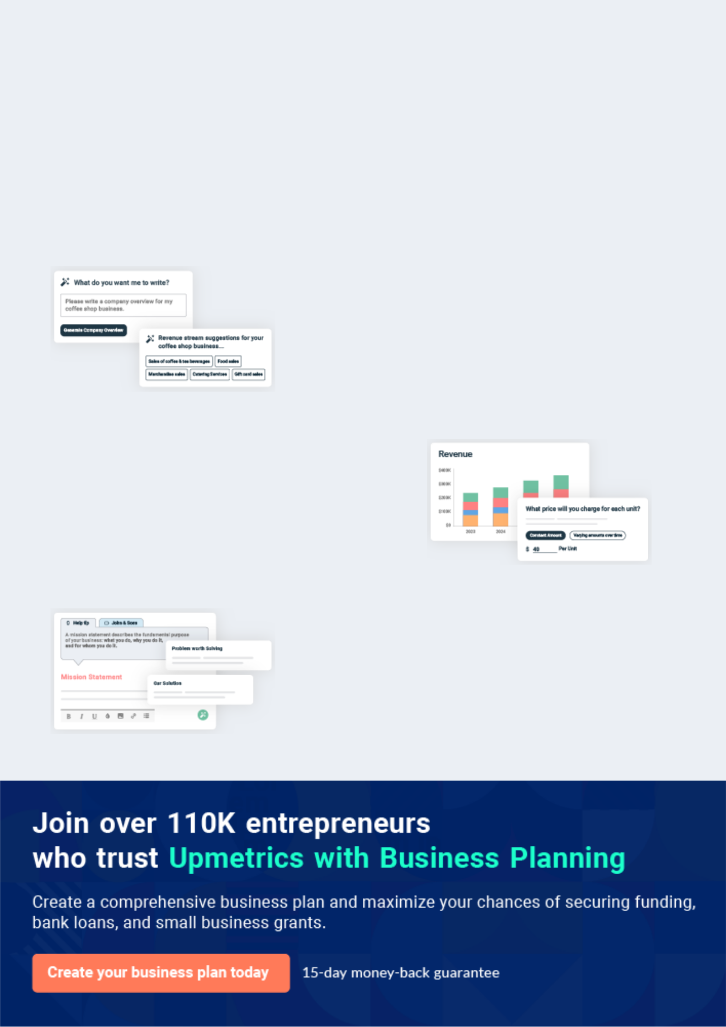
Business planning that’s simpler and faster than you think

Creating a business plan using Upmetrics to start and grow a business is literally the easiest thing in the World. Simply read the instructions and fill in the blanks. It’s as simple as that.

❛ | Upmetrics has everything you need to create a | ❜
❛ | comprehensive business plan. | ❜

AI-powered Upmetrics Assistant

AI-powered insights to streamline your plan

Not sure where to start? Upmetrics’ AI Assistant will automatically generate ideas for each section of your plan and offer improved versions of your writing, adjusting for tone, voice, and grammar or spelling errors.

Financial Forecasting Tool

All the financials are calculated for you

Forget the complex formulas and clumsy spreadsheets — with automatic financials and drag-and-drop forecasting, you can finish your plan faster and be confident that your numbers are accurate.

Business Plan Builder

Guides you like a business mentor

Upmetrics’ step-by-step instructions, prompts, and the library of 400+ sample business plans will guide you through each section of your plan as a business mentor.

1.


Executive Summary

Objectives

Mission Statement

Vision Statement

Financial Summary

Moving Company | Business Plan [YEAR] 5/36


Before you think about how to start a Moving company service, you must create a detailed Moving company business plan. It will not only guide you in the initial phases of your startup but will also help you later on.
To unlock help try Upmetrics! 

 Maxwell Moving


Maxwell Moving Services Company is a registered and licensed Moving and Storage Company that will be based in Detroit. We are in business to provide local and long-distance transportation of household and office goods; warehousing and storage services; packing and
To unlock help try Upmetrics! 

Start writing here..

Objectives

 Maxwell Moving

Maxwell Moving's objective for this business plan is to provide funding for the following:

• Purchasing new vehicles to replace older trucks with modern fuel-efficient models.
To unlock help try Upmetrics! 

Start writing here..

Mission Statement

 Maxwell Moving

Our mission is to ensure that we build a successful moving and storage company that will operate in the whole of the United States of America and Canada; a company that will boast of having some of the best and reliable material handlers and transporters (truck/van drivers) in
To unlock help try Upmetrics! 

Start writing here..

Moving Company | Business Plan [YEAR] 6/36

Vision Statement
To unlock help try Upmetrics!
To unlock help try Upmetrics!

 Maxwell Moving

Our Vision is to become one of the preferred choices of individuals and organizations when it comes to the demand for moving and storage services in the whole of the United States of America and Canada.



Start writing here..

Financial Summary

 Maxwell Moving

Maxwell Moving Services is seeking total funding of $400,000 to launch its Moving services. The capital will be used for funding capital expenditures, manpower costs, marketing expenses, and working capital.



Start writing here..

3 Year profit forecast
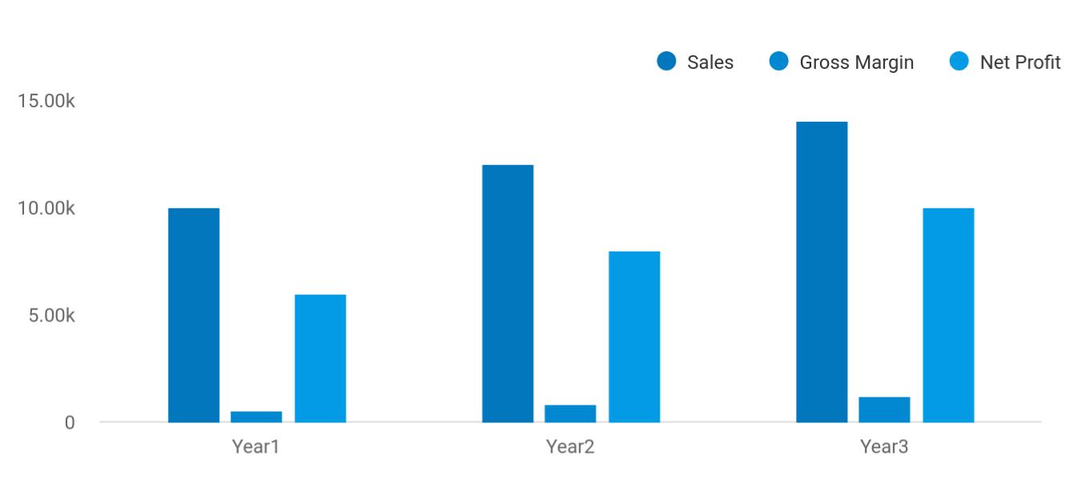

Moving Company | Business Plan [YEAR] 7/36

 Maxwell Moving


Financial Summary | Year 1 | Year 2 |  | Year 3
 |  |  | To unlock help try Upmetrics! |  | 

Start writing here..

Moving Company | Business Plan [YEAR] 8/36

2.

Company Summary

History

Business Structure

Startup Summary

Moving Company | Business Plan [YEAR] 9/36

 Maxwell Moving

Maxwell Moving Services is a family business; it is owned by John Moore and Jane Moore. The company will be fully financed by the John family. John has a diploma in Transport and Logistics Management and over 5 years of experience in The Moving and Storage industry.
To unlock help try Upmetrics! 

Start writing here..

History

 Maxwell Moving

James Moore started the business in 1949 moving and storing arts in Detroit. As the business grew, the company expanded to include moving services covering the Southeast United States. In 1972, John became his father's business partner and through their combined leadership,
To unlock help try Upmetrics! 

Start writing here..

Business Structure

 Maxwell Moving

At Maxwell Moving Services Company, we will ensure that we hire people that are qualified, hardworking, creative, customer-centric and are ready to work to help us build a prosperous business that will benefit all the stakeholders (the owners, workforce, and customers).
To unlock help try Upmetrics! 

Start writing here..

Startup Summary

 Maxwell Moving

Total start-up capital and expenses (including legal costs, logo design, stationery, and related expenses) came to approximately $41,700. Start-up assets required and utilized included brewing plants and machinery, pick-ups, office furniture, personal computers, and other office
To unlock help try Upmetrics! 

Moving Company | Business Plan [YEAR] 10/36

Start writing here..

Startup cost
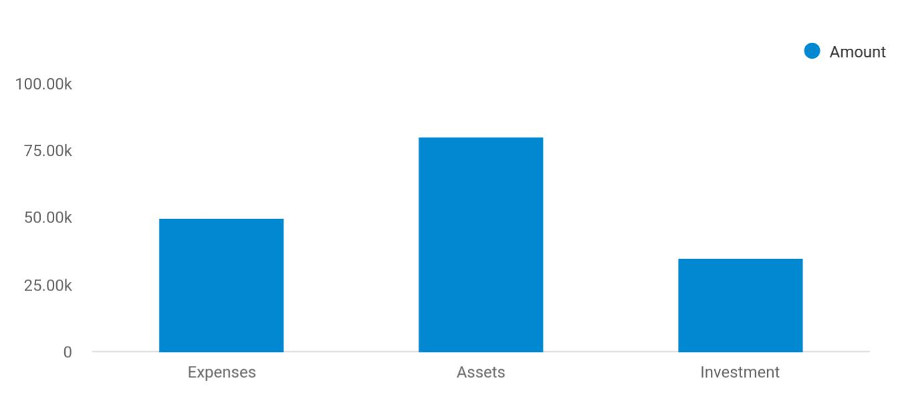

Cost distribution | Amount
Expenses | 50,000
Assets | 80,000
Investment | 35,000

Start-up Expenses | Amount
Legal | $75,500
Consultants | $0
Insurance | $62,750
Rent | $22,500
Research and Development | $42,750
Expensed Equipment | $42,750
Signs | $1,250
TOTAL START-UP EXPENSES | $247,500
Start-up Assets | $0
Cash Required | $322,500
Start-up Inventory | $52,625
Other Current Assets | $222,500

Moving Company | Business Plan [YEAR] 11/36

Start-up Expenses | Amount
Long-term Assets | $125,000
TOTAL ASSETS | $121,875
Total Requirements | $245,000
START-UP FUNDING | $0
START-UP FUNDING | $273,125
Start-up Expenses to Fund | $121,875
Start-up Assets to Fund | $195,000
TOTAL FUNDING REQUIRED | $0
Assets | $203,125
Non-cash Assets from Start-up | $118,750
Cash Requirements from Start-up | $0
Additional Cash Raised | $118,750
Cash Balance on Starting Date | $121,875
TOTAL ASSETS | $0
Liabilities and Capital | $0
Liabilities | $0
Current Borrowing | $0
Long-term Liabilities | $0
Accounts Payable (Outstanding Bills) | $0
Other Current Liabilities (interest-free) | $0
TOTAL LIABILITIES | $0
Capital | $0
Planned Investment | $0
Investor 1 | $312,500
Investor 2 | $0
Other | $0
Additional Investment Requirement | $0
TOTAL PLANNED INVESTMENT | $695,000

Moving Company | Business Plan [YEAR] 12/36

Start-up Expenses | Amount
Loss at Start-up (Start-up Expenses) | $313,125
TOTAL CAPITAL | $221,875
TOTAL CAPITAL AND LIABILITIES | $221,875
Total Funding | $265,000

Moving Company | Business Plan [YEAR] 13/36

3.

Products and services

Moving Company | Business Plan [YEAR] 14/36

 Maxwell Moving

Maxwell Moving Services is established with the aim of maximizing profits in The Moving and Storage industry. We want to compete favorably with the leading moving and storage companies in the United States, which is why we will ensure that every service carried out or
To unlock help try Upmetrics! 

Start writing here..


Local and long-distance
Warehousing and
transportation of
storage services
household and office goods

Process, Distribution,

Packing and and Logistics

Packaging services Consulting and

Advisory Services

Merchandise sales

and other related

services

Moving Company | Business Plan [YEAR] 15/36

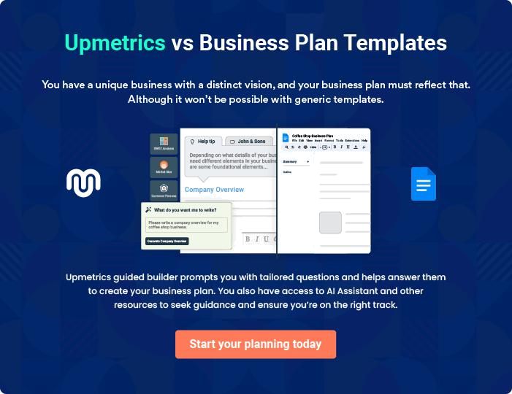

Moving Company | Business Plan [YEAR] | 16/36

4.

Market Analysis

Market Trends

Target Market

Market Segmentation

Moving Company | Business Plan [YEAR] 17/36

The most important component of an effective Moving services business plan is its accurate marketing analysis. If you are starting on a smaller scale, you can do marketing analysis yourself by taking help from this Moving
To unlock help try Upmetrics! 

Market Trends

 Maxwell Moving

The market trends as it involves The Moving and Storage industry especially in the United States and Canada are indeed dynamic and at the same time challenging.
To unlock help try Upmetrics! 

Start writing here..

Target Market

 Maxwell Moving

Our target market is basically everyone (organizations and individuals as well who have a cause to move goods and materials from one location to another. In other words, our target market is the whole of the United States of America, and below is a list of the people and organizations
To unlock help try Upmetrics! 

Start writing here..

Market Segmentation

 Maxwell Moving

According to the latest census data, there are over 600,000 housing units. Considering move-in and move-out rates of approximately 30% each, there is the potential of nearly 360,000 (60%) customer households considering full-service moving or rental services. The National Kidney
To unlock help try Upmetrics! 

Start writing here..

Moving Company | Business Plan [YEAR] 18/36

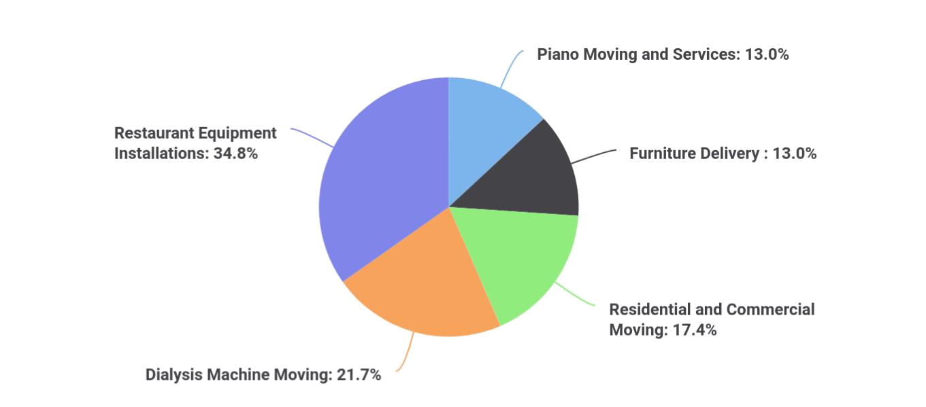

Moving Company | Business Plan [YEAR] | 19/36

5.

SWOT Analysis

Moving Company | Business Plan [YEAR] 20/36

 Maxwell Moving
To unlock help try Upmetrics!

Going by our vision, our mission, and the kind of business we want to set – up, we don’t have any other option than to follow due process. Following due process involves hiring a business consultant to help us conduct a SWOT analysis for our business.



Start writing here..

Moving Company | Business Plan [YEAR] 21/36


Strength

Our strengths include; strong management, strong fleet operations, our transportation network serves some of the largest population centers in the U.S., size advantages, cost advantages, customer loyalty, and a strong reputation amongst domestic and industry players.

Basically, our business is centrally located in a densely populated industrial and residential estate in Detroit; our location is in fact one of our major strengths. Another strength that counts for us is the power of our team; our workforce and management. We have a team that is considered experts in the moving and storage industry, a team of hardworking and dedicated individuals.

Weakness


Our weakness could be lack of finance, high debt burden, cost structure, lack of scale compared to our peers who have already gained ground in the industry. As a new business that is owned by an individual (family), and we may not have the financial muscle to sustain the kind of publicity we want to give our business. As a new business, we are also quite aware that it will take time for us to build trust with our clients.


Opportunity

The opportunities that are available to us as a moving and storage company in the United States include; online market, new services, new technology, and the opening of new markets. We are centrally located in one of the busiest industrial areas in Detroit and we are open to all the available opportunities that the city has to offer. Our business concept has also positioned us to be the preferred choice in Detroit.

The truth is that there are no standard and well-equipped moving and storage companies within the area where ours is going to be located; the closest moving and storage company to our proposed location is about 15 miles away. In a nutshell, we do not have any direct competition within our target market area.

Threat

Some of the threats that we are likely going to face include; mature markets, a bad economy (economy downturn), stiff competition, volatile costs, and rising fuel prices. Other threats that are likely going to confront Jolly Brothers Moving and Storage Service are unfavorable government policies, seasonal fluctuations, demographic/social factors, the downturn in the economy which is likely going to affect consumers spending, and of course the emergence of new competitors within the same location where ours is located.

Moving Company | Business Plan [YEAR] 22/36

6.

Strategy &

Implementations

Advertising Strategy

Pricing Strategy

Sales Forecast

Milestones

Moving Company | Business Plan [YEAR] 23/36

After identifying the market demand, market trends, and the potential customers of the startup, the next step is to define an effective strategy for attracting those customers. Like marketing analysis, sales strategy is also an
To unlock help try Upmetrics!
To unlock help try Upmetrics! 

Advertising Strategy

 Maxwell Moving

Any business that wants to grow beyond the corner of the street they are operating from must be ready and willing to utilize every available means (both conventional and non – conventional means) to advertise and promote the business.



Start writing here..

Pricing Strategy

 Maxwell Moving

Maxwell Moving Services Company has a lease arrangement with various companies and the company’s pricing is based on miles per thousands of tons of goods and materials transported. We have perfected our plans to charge competitive rates since we have minimal overhead
To unlock help try Upmetrics! 

Start writing here..

Sales Forecast

 Maxwell Moving

We are well-positioned to take on the available market in the U.S. and we are quite optimistic that we will meet our set target of generating enough income/profits from the first month of
operations and grow the business and clientele beyond Detroit to other states in the U.S. and
To unlock help try Upmetrics! 

Start writing here..

Moving Company | Business Plan [YEAR] 24/36

Milestones
To unlock help try Upmetrics!

 Maxwell Moving

To achieve the sales and marketing goals that have been outlined in this business plan and continue the company's expansion, COMPANY NAME will implement the objectives as outlined in this business plan. Some of these are outlined below:



Start writing here..

Moving Company | Business Plan [YEAR] 25/36

7.

Financial Plan

Important Assumptions

Brake-even Analysis

Projected Profit and Loss

Projected Cash Flow

Projected Balance Sheet

Business Ratios

Moving Company | Business Plan [YEAR] 26/36

The last component of a moving service business plan is an in-depth financial plan. The financial plan crafts a detailed map of all the expenses needed for the startup and how these expenses will be met by the earned
To unlock help try Upmetrics! 

 Maxwell Moving

The company will be financed by John himself and he will control the direction of the business to make sure that it is expanding at the forecasted rate. As for the moving service business start-up, no equity funding or outside loans will be required. With the help of financial experts,
To unlock help try Upmetrics! 

Start writing here..

Important Assumptions

The financial projections of the company are forecast on the basis of the following assumptions. These assumptions are quite conservative and are expected to show deviation but to a limited level such that the company’s major financial strategy will not be affected.

 | Year 1 | Year 2 | Year 3
Plan Month | 1 | 2 | 3
Current Interest Rate | 10,00% | 11,00% | 12,00%
Long-term Interest Rate | 10,00% | 10,00% | 10,00%
Tax Rate | 26,42% | 27,76% | 28,12%
Other | 0 | 0 | 0

Brake-even Analysis

Monthly Units Break-even | 5530
Monthly Revenue Break-even | $159 740
Assumptions:
Average Per-Unit Revenue | $260,87
Average Per-Unit Variable Cost | $0,89
Estimated Monthly Fixed Cost | $196 410

Moving Company | Business Plan [YEAR] 27/36

Projected Profit and Loss

Revenue

Local Moving Services

Unit Sales

Unit Price

Long-Distance Moving Services

Unit Sales

Unit Price

Packing and Packaging Services

Unit Sales

Unit Price

Cost Of Sales

General Costs

Transportation Costs

Fuel Costs

Vehicle Maintenance

Labor Costs

Driver Salaries

Loading and Unloading

Labor

Revenue Specific Costs

Personnel Costs (Direct Labor)

2024 | 2025 | 2026
$1,437,127 | $2,632,154 | $4,906,799
$843,520 | $1,697,365 | $3,415,375
1,687 | 3,395 | 6,831
$500 | $500 | $500
$354,845 | $506,005 | $721,380
710 | 1,012 | 1,443
$500 | $500 | $500
$238,762 | $428,784 | $770,044
2,388 | 4,288 | 7,700
$100 | $100 | $100

$253,616.57 | $437,696.01 | $784,329.82
$253,616.57 | $437,696.01 | $784,329.82
$38,047.52 | $42,872.91 | $48,309.97
$25,364.99 | $28,581.81 | $32,206.53
$12,682.53 | $14,291.10 | $16,103.44
$215,569.05 | $394,823.10 | $736,019.85
$143,712.70 | $263,215.40 | $490,679.90
$71,856.35 | $131,607.70 | $245,339.95
$0 | $0 | $0
$0 | $0 | $0

Moving Company | Business Plan [YEAR] 28/36

Gross Margin

Gross Margin (%)

Operating Expense

Payroll Expense (Indirect Labor)

Management Team

General Manager

Operations Manager

Moving Crew

Truck Drivers

Movers and Packers

Administrative Staff

Office Administrator

Customer Service

Representatives

General Expense

Office and Administrative Expenses

Office Rent

Utilities

Marketing and Advertising Expenses

Online Advertising

Print Advertising

Vehicle and Transportation Expenses

Vehicle Insurance
2024 2025 2026

$1,183,510.43 $2,194,457.99 $4,122,469.18

82.35% 83.37% 84.02%

$1,381,342.97 | $1,508,694.07 | $1,723,676.55
$1,210,560 | $1,236,451.20 | $1,262,910.60
$168,000 | $173,040 | $178,231.20
$90,000 | $92,700 | $95,481
$78,000 | $80,340 | $82,750.20
$777,600 | $793,152 | $809,015.04
$345,600 | $352,512 | $359,562.24
$432,000 | $440,640 | $449,452.80
$264,960 | $270,259.20 | $275,664.36
$48,960 | $49,939.20 | $50,937.96
$216,000 | $220,320 | $224,726.40
$170,782.97 | $272,242.87 | $460,765.95
$38,047.55 | $42,872.74 | $48,309.92
$31,706.31 | $35,727.40 | $40,258.40
$6,341.24 | $7,145.34 | $8,051.52
$114,970.16 | $210,572.32 | $392,543.92
$71,856.35 | $131,607.70 | $245,339.95
$43,113.81 | $78,964.62 | $147,203.97
$17,765.26 | $18,797.81 | $19,912.11
$14,000 | $14,560 | $15,142.40

Moving Company | Business Plan [YEAR] 29/36

Vehicle Registration and Licensing

Bad Debt

Amortization of Current Assets

EBITDA

Additional Expense

Long Term Depreciation

Gain or loss from Sale of Assets

EBIT

Interest Expense

EBT

Income Tax Expense / Benefit

Total Expense

Net Income

Net Income (%)

Retained Earning Opening

Owner's Distribution

Retained Earning Closing

Projected Cash Flow

2024 | 2025 | 2026
$3,765.26 | $4,237.81 | $4,769.71
$0 | $0 | $0
$0 | $0 | $0

($197,832.54) $685,763.92 $2,398,792.63

$25,762.93 | $23,828.77 | $21,775.31
$20,616 | $20,616 | $20,616
$0 | $0 | $0
($218,448.54) | $665,147.92 | $2,378,176.63
$5,146.94 | $3,212.76 | $1,159.29
($223,595.47) | $661,935.15 | $2,377,017.32
$0 | $0 | $0

$1,660,722.47 | $1,970,218.85 | $2,529,781.68
($223,595.47) | $661,935.15 | $2,377,017.32
(15.56%) | 25.15% | 48.44%

$0 | ($243,595.47) | $398,339.68
$20,000 | $20,000 | $20,000
($243,595.47) | $398,339.68 | $2,755,357

Moving Company | Business Plan [YEAR] 30/36

 | 2024 | 2025 | 2026
Cash Received | $1,437,127 | $2,632,154 | $4,906,799
Cash Paid | $1,640,106.47 | $1,949,602.85 | $2,509,165.68
COS & General Expenses | $424,399.54 | $709,938.88 | $1,245,095.77
Salary & Wages | $1,210,560 | $1,236,451.20 | $1,262,910.60
Interest | $5,146.94 | $3,212.76 | $1,159.29
Sales Tax | $0 | $0 | $0
Income Tax | $0 | $0 | $0
Net Cash From | ($202,979.47) | $682,551.15 | $2,397,633.32
Operations | ($202,979.47) | $682,551.15 | $2,397,633.32

Assets Sell | $0 | $0 | $0
Assets Purchase | $120,000 | $0 | $0
Net Cash From | ($120,000) | $0 | $0
Investments | ($120,000) | $0 | $0

Amount Received | $150,000 | $0 | $0
Loan Received | $100,000 | $0 | $0
Common Stock | $0 | $0 | $0
Preferred Stock | $0 | $0 | $0
Owner's Contribution | $50,000 | $0 | $0
Amount Paid | $51,359.35 | $53,293.51 | $55,347.12
Loan Capital | $31,359.34 | $33,293.52 | $35,347.14
Dividends & Distributions | $20,000 | $20,000 | $20,000
Net Cash From | $98,640.65 | ($53,293.51) | ($55,347.12)
Financing | $98,640.65 | ($53,293.51) | ($55,347.12)

Summary

Moving Company | Business Plan [YEAR] 31/36

 | 2024 | 2025 | 2026
Starting Cash | $0 | ($224,338.82) | $404,918.82
Cash In | $1,587,127 | $2,632,154 | $4,906,799
Cash Out | $1,811,465.82 | $2,002,896.36 | $2,564,512.80
Change in Cash | ($224,338.82) | $629,257.64 | $2,342,286.20
Ending Cash | ($224,338.82) | $404,918.82 | $2,747,205.02

Projected Balance Sheet

 | 2024 | 2025 | 2026
Assets | ($124,954.82) | $483,686.82 | $2,805,357.02
Current Assets | ($224,338.82) | $404,918.82 | $2,747,205.02
Cash | ($224,338.82) | $404,918.82 | $2,747,205.02
Accounts Receivable | $0 | $0 | $0
Inventory | $0 | $0 | $0
Other Current Assets | $0 | $0 | $0
Long Term Assets | $99,384 | $78,768 | $58,152
Gross Long Term Assets | $120,000 | $120,000 | $120,000
Accumulated Depreciation | ($20,616) | ($41,232) | ($61,848)
Liabilities & Equity | ($124,954.81) | $483,686.82 | $2,805,357
Liabilities | $68,640.66 | $35,347.14 | $0
Current Liabilities | $33,293.52 | $35,347.14 | $0
Accounts Payable | $0 | $0 | $0
Income Tax Payable | $0 | $0 | $0
Sales Tax Payable | $0 | $0 | $0
Short Term Debt | $33,293.52 | $35,347.14 | $0

Moving Company | Business Plan [YEAR] 32/36

 | 2024 |  |  | 2025 |  | 2026
Long Term Liabilities | $35,347.14 |  |  | $0 |  | $0
Long Term Debt | $35,347.14 |  |  | $0 |  | $0
Equity | ($193,595.47) |  | $448,339.68 |  |  | $2,805,357
Paid-in Capital | $0 |  |  | $0 |  | $0
Common Stock | $0 |  |  | $0 |  | $0
Preferred Stock | $0 |  |  | $0 |  | $0
Owner's Contribution | $50,000 |  |  | $50,000 |  | $50,000
Retained Earnings | ($243,595.47) |  | $398,339.68 |  |  | $2,755,357
Check | $0 |  |  | $0 |  | $0
Business Ratios
 |  | Year 1 | Year 2 |  | Year 3 | Industry Profile
Sales Growth |  | 4,35% | 30,82% |  | 63,29% | 4,00%
Percent of Total Assets
Accounts Receivable |  | 5,61% | 4,71% |  | 3,81% | 9,70%
Inventory |  | 1,85% | 1,82% |  | 1,79% | 9,80%
Other Current Assets |  | 1,75% | 2,02% |  | 2,29% | 27,40%
Total Current Assets |  | 138,53% | 150,99% |  | 163,45% | 54,60%
Long-term Assets |  | -9,47% | -21,01% |  | -32,55% | 58,40%
TOTAL ASSETS |  | 100,00% | 100,00% |  | 100,00% | 100,00%
Current Liabilities |  | 4,68% | 3,04% |  | 2,76% | 27,30%
Long-term Liabilities |  | 0,00% | 0,00% |  | 0,00% | 25,80%
Total Liabilities |  | 4,68% | 3,04% |  | 2,76% | 54,10%
NET WORTH |  | 99,32% | 101,04% |  | 102,76% | 44,90%
Percent of Sales

Moving Company | Business Plan [YEAR] 33/36

 | Year 1 | Year 2 | Year 3 | Industry Profile
Sales | 100,00% | 100,00% | 100,00% | 100,00%
Gross Margin | 94,18% | 93,85% | 93,52% | 0,00%
Selling, General & Administrative Expenses | 74,29% | 71,83% | 69,37% | 65,20%
Advertising Expenses | 2,06% | 1,11% | 0,28% | 1,40%
Profit Before Interest and Taxes | 26,47% | 29,30% | 32,13% | 2,86%
Main Ratios
Current | 25,86 | 29,39 | 32,92 | 1,63
Quick | 25,4 | 28,88 | 32,36 | 0,84
Total Debt to Total Assets | 2,68% | 1,04% | 0,76% | 67,10%
Pre-tax Return on Net Worth | 66,83% | 71,26% | 75,69% | 4,40%
Pre-tax Return on Assets | 64,88% | 69,75% | 74,62% | 9,00%
Additional Ratios
Net Profit Margin | 19,20% | 21,16% | 23,12% | N.A.
Return on Equity | 47,79% | 50,53% | 53,27% | N.A.
Activity Ratios
Accounts Receivable Turnover | 4,56 | 4,56 | 4,56 | N.A.
Collection Days | 92 | 99 | 106 | N.A.
Inventory Turnover | 19,7 | 22,55 | 25,4 | N.A.
Accounts Payable Turnover | 14,17 | 14,67 | 15,17 | N.A.
Payment Days | 27 | 27 | 27 | N.A.
Total Asset Turnover | 1,84 | 1,55 | 1,26 | N.A.
Debt Ratios
Debt to Net Worth | 0 | -0,02 | -0,04 | N.A.
Current Liab. to Liab. | 1 | 1 | 1 | N.A.
Liquidity Ratios
Net Working Capital | $120 943 | $140 664 | $160 385 | N.A.
Interest Coverage | 0 | 0 | 0 | N.A.
Additional Ratios

Moving Company | Business Plan [YEAR] 34/36

 | Year 1 | Year 2 | Year 3 | Industry Profile
Assets to Sales | 0,45 | 0,48 | 0,51 | N.A.
Current Debt/Total Assets | 4% | 3% | 2% | N.A.
Acid Test | 23,66 | 27,01 | 30,36 | N.A.
Sales/Net Worth | 1,68 | 1,29 | 0,9 | N.A.
Dividend Payout | 0 | 0 | 0 | N.A.
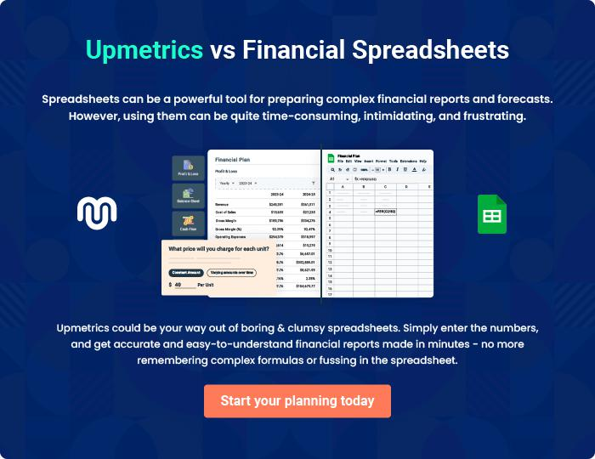

Moving Company | Business Plan [YEAR] 35/36


Create a winning business plan that gets you funded

Creating a stunning and investment-ready plan requires no writing, graphic designing, or financial planning expertise.

Upmetrics has all the features required to help you create a comprehensive business plan—from start to finish. Make no mistakes, it’s the modern way of planning to structure ideas, make plans, and create stunning pitch decks to awe investors.

Pitch decks that impress investors

Create pitch decks that provide a visual representation of your business, engage investors, and make them want to invest in your business idea.

Interactive plans in no time

Import business plan sections like—SWOT analysis, comparison tables, and others to create an interactive business plan. No designing skills are required.

Stunning cover page designs

With Upmetrics, you have the liberty to choose from multiple stunning cover page designs. Choose a creative design and make your plan stand out.

Online sharing made simple

Upmetrics makes online sharing quick and easier for users. Easily share your business plans with a link while tracking reader activity.

500+ sample business plans

Simply import a template from our library of sample plans into the editor and start customizing it to make it yours. It takes only a few clicks to get started.

Collaborate with team in real-time

Invite team members, initiate conversations, discuss ideas & strategies, share feedback, and work on a business plan in real-time.

